 | Midocean Journal for Research and Studies  https://  e-ISSN: | 

Enhancing Brain Tumor Classification Using Deep Learning

Mohammed Albreem – Mohammed Allbed
0009-0002-0112-5107,
MSc in Artificial Intelligence - College of Informatics – Midocean University – UAE
m7mmad.b@gmail.com , allbed.mohammed@gmail.com
Dr. Hager Saleh 0000-0001-6184-7107 Computer Science and Artificial Intelligence, College of
Informatics, Midocean University – UAE, Email: hager.saleh.fci@gmail.com

Abstract
This study aims to enhance the classification of brain tumors using advanced deep learning models applied to magnetic resonance imaging (MRI) images. The methodology involves applying pre-trained Convolutional Neural Networks (CNNs) including ResNet50, MobileNet, and Inception v2, and transformer models such as Vision Transformer (ViT) and Shifted Window (Swin). A hybrid model combining MobileNet and Swin was developed to improve classification accuracy. Data augmentation and image enhancement techniques were applied to optimize model performance. The models were rigorously evaluated using metrics such as accuracy, precision, recall, and F1-score. Among the models tested, MobileNet-Swin achieved the highest classification with accuracy of 99.65 and precision of 99.82 and recall of 99.82 and F1-score of 99.82. The findings support the effectiveness of hybrid deep learning models in assisting radiologists and improving clinical decision-making for brain tumor classification. Future work should focus on expanding the dataset and exploring additional deep learning architectures to further enhance classification accuracy.
Keywords: brain tumors, deep learning, MRI classification, MobileNet, Swin Transformer.

- INTRODUCTION

According to the (World Health Organization, 2021), tumors are one of the most cause of death globally, making them a serious health concern. With improvements in early detection techniques, it is still very challenging to correctly identify and diagnose different tumor kinds, and according to (Li et al., 2023), this difficulty is made worse by symptoms that frequently resemble those of other disorders. In locations with limited resources, traditional diagnostic methods sometimes rely for specialized imaging and skilled personnel, which might be difficult to get by (Anesi & Kerlin, 2021), as a result of the potential for faster and more accurate tumor categorization, there is growing interest in creating trustworthy automated diagnostic models using Deep Learning (DL) approaches (Chan et al., 2020).

Convolutional neural networks, or CNNs, have become more effective tools for image classification tasks in recent years (Krizhevsky et al., n.d.). Accurate classifications can result from these networks' automated feature extraction from raw MRI images. But even with improvements in DL techniques, models that can adjust to different picture quality and limited data availability are still needed. This work seeks to offer important insights into the automated categorization of brain cancers by utilizing the advantages of these advanced structures, finally supporting clinical decision-making and enhancing patient outcomes. To classify brain tumors, a several research has used transformer models like Vision Transformer (ViT) and Shifted Window (Swin) in conjunction with pre-trained CNN models like ResNet50, MobileNet, and Inception v2(Dosovitskiy et al., 2020.

The diagnostic accuracy of these models has shown notable gains. The main objective of this study is to develop a hybrid model that combines MobileNet and Swin, improving classification performance by using methods for image and data improvement.

- Previous Studies:

This section presents different previous studies that were applied DL and ML models to predict brain tumor:

(Tiwari et al., 2022) analyzed global mortality data and discovered brain tumors as the tenth leading cause of death worldwide, focusing attention on the urgent need for improved diagnostic and classification methods. Although advances in technology have enhanced detection speed. Their study assessed the effectiveness of Convolutional Neural Networks (CNNs), particularly the VGG16 model, achieving an accuracy of up to 95%. While promising, other models have shown even higher performance levels.

(Reddy et al., 2024) investigate the performance of fine-grained vision transformers (FTVTs), including FTVT-b16, FTVT-b32, FTVT-l16, and FTVT-l32, in classifying brain tumors. These models were compared against conventional architecture such as ResNet50, MobileNet-V2, and EfficientNet-B0. The study found that FTVTs achieved up to 98% accuracy, surpassing traditional deep learning models. These findings advise that FTVTs are promising and should be considered for further growth and clinical testing.

(Islam et al., 2024) focused on the importance of early detection in the diagnosis of brain tumors. Using the EfficientNetB3 model on a dataset of 3,064 images, they achieved better accuracy. Clinical validation of the model supports its potential as a reliable tool for early diagnosis. However, additional independent studies are needed to confirm their accuracy in a variety of cases.

(Saeedi et al., 2023) suggest a hybrid approach combining discrete convolutional deep learning and machine learning methods for brain tumor detection in MRI scans. Demonstrating the potential of hybrid architecture. However, the approach requires large datasets for effective training, calling for further research with wider data.

(Latif, 2022) presented an integrated detection system that combines Wiener adaptive filtering, neural networks, and autonomous systems. This model achieved a detection speed of 0.43 seconds. Significantly surpassing traditional methods. However, more information is needed regarding the diversity and size of the data set used in the study.

(Dehkordi et al., n.d.)The classification of brain tumors has been greatly enhanced by deep learning, with CNNs such as VGG16 and ResNet outperforming more conventional techniques. Accuracy has been further improved via feature fusion methods and hybrid models. Transformer-based models, like Swin Transformer, have recently demonstrated potential in capturing intricate elements of images. The presented work suggests a hybrid model that combines MobileNetV2 with Swin Transformer to improve classification accuracy while lowering computing costs.

(Kibriya et al., 2022) developed a classification model using the Dense EfficientNet architecture and min-max normalization on 3,260 contrast-enhanced MRI images. However, the study does not provide sufficient details on the evaluation methods used, and it is recommended that further testing be conducted with larger datasets.

(He et al., n.d.) introduced the groundbreaking Deep-Tumor framework, which seamlessly integrates segmentation, classification, and detection of brain tumors in MRI images using a sophisticated attention-guided deep learning model. Highlighting its remarkable potential for clinical application. However, the model's substantial computational demands may pose challenges for implementation in low-resource settings, underscoring the need for ongoing research and development to enhance its accessibility.

(Kolla et al., 2022) introduced a pioneering CNN-based model that effectively integrates Local Binary Pattern (LBP) features with a multi-layer Support Vector Machine (SVM) classifier. However, despite its remarkable performance, the model is hampered by extensive processing times and a lack of evaluation across a comprehensive dataset, which significantly restricts its practical application in clinical environments. Enhancing these aspects could unlock its full potential for real-world use.

(Amin et al., 2022) conducted a compelling study on an ensemble transfer learning approach that leverages a quantum variational classifier. Their findings reveal marked improvements in classification performance, alongside a notable reduction in overfitting. However, it is important to acknowledge that this innovative approach necessitates substantial computational resources, which could pose challenges to its practical implementation.

(Arif et al., 2022) adeptly combined genetic algorithms with the U-Net architecture to achieve remarkable segmentation and classification of brain tumors. Their innovative approach not only accurately delineated tumor boundaries but also highlighted the transformative potential of evolutionary computing in medical imaging. However, the challenge of optimizing parameters for peak performance demands substantial computational resources, underscoring the need for further exploration and refinement in future research.

- Methodology:

This study classifies brain tumors using DL models following a structured approach. The methodology's structure is essentially four main steps: data collection, data augmentation, classification models, and Evaluation models as shown in Figure 1.

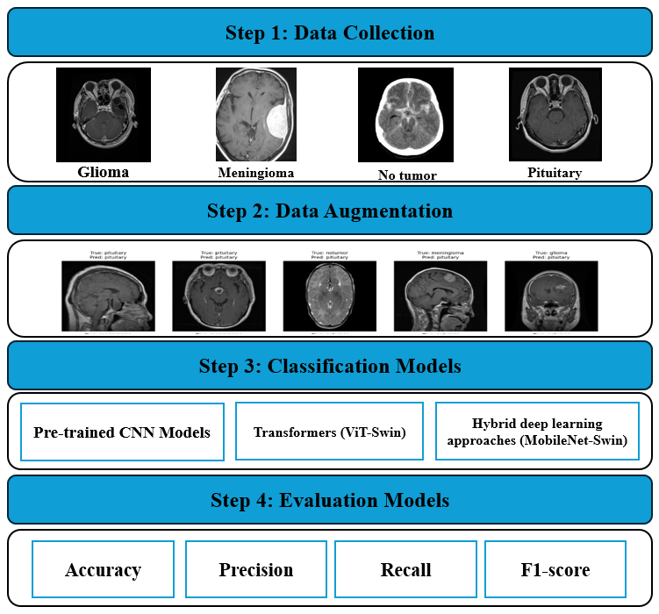
Figure 1: The steps of methods

step 1: Data Collection

First, we collect and compile the brain MRI image dataset. The dataset includes various types of brain tumors, such as:

- Glioma: Cancerous tumors that Initiate in glial cells of the brain.

- Meningioma: Non-cancerous tumors that make protective layers around the brain.
- No Tumor: Normal brain scans that do not show any tumors.

- Pituitary: Tumors impacting the pituitary gland, which can be cancerous or non-cancerous.

Labeled MRI images of high quality are sourced from publicly available medical repositories and the archives of medical hospitals. For this study, we utilized the Brain Tumor MRI Dataset available on Kaggle (Masoud Nickparvar, 2021). To achieve uniformity in size, resolution, and format, the images are also preprocessed.

This preprocessing step is essential as it facilitates the utilization of deep learning models, improving efficiency and ensuring consistent data. Images are properly labeled to enable supervised learning for tumor classification, utilizing characteristics that differentiate among the various tumor types as shown in Figure 2.

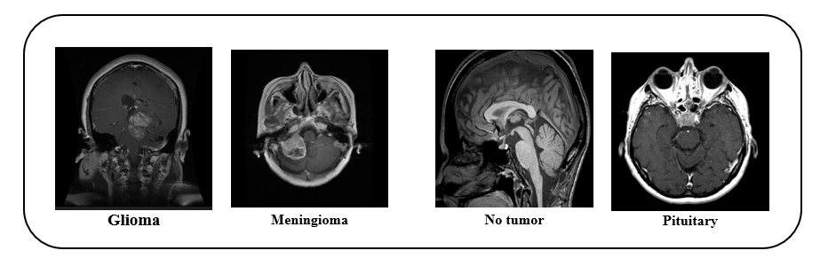
Figure 2: The sample image from each class

Step 2: Data Augmentation

DL models require large images of input to achieve high accuracy and avoid overfitting. However, medical image datasets might be limited, the use of data augmentation techniques to artificially increase the dataset (Li et al., 2023).

Various augmentation strategies are employed during training to introduce variability, including rotation, flipping, contrast adjustment, brightness correction, noise addition, and cropping. Rotating images at different angles helps the model generalize the appearance of tumors from various views.

We apply horizontal flips, resize = 224 x244, and normalization = rescale to [0, 1]. These augmentation strategies help ensure that the model can effectively generalize across different tumor views and imaging conditions.

Step 3: Classification Models

Multiple DL architectures are necessary to classify brain tumors accurately. In that regard, the main models used in this study are pre-trained CNNs, Transformers and hybrid models. Fully connected Neural Networks, including the Inception v2, ResNet50 and MobileNet, are used due to their high feature extraction skills. The results of these models help us understand how tumor types are distinguished by significant spatial patterns and top-to-bottom characteristics derived from brain MRI scans.

Transfer learning is also used, whereby the pre-trained CNN models used here are trained on every image to exploit experience on image representation garnered from prior datasets. Besides, shifted window Transformers (Swin) are considered because of their enhanced throughput for global features through self-attention.

While CNNs are formulated on local patterns of the image pixel dependency, Swin encodes long dependencies, which makes them more useful for complex medical image classification tasks. As a result, a Swin Transformer, a hierarchical vision transformer model, is incorporated into the proposed framework to improve classification performance.

Pre-trained CNNs models:

- ResNet50: To address the vanishing gradient issue and enable the training of deeper networks, ResNet50, a 50-layer deep convolutional neural network, adds residual connections (He et al., n.d.).

- MobileNet: is a lightweight CNN architecture optimized for mobile and embedded vision tasks (Howard et al., 2017). It uses depth wise separable convolutions, which split standard convolutions into two layers: a depth wise convolution that applies a single filter per input channel, and a pointwise convolution (1×1) that combines outputs across channels. The architecture consists of an initial standard convolution layer, followed by multiple blocks of depth wise and pointwise convolutions, batch normalization, and ReLU activations. This design significantly reduces computation and model size while maintaining strong classification performance.

- Inception v2: is an improved version of the original Inception architecture, designed to enhance computational efficiency and accuracy in image classification tasks (Szegedy et al., n.d.). It builds on the concept of Inception modules, which apply multiple convolution filters (1×1, 3×3, 5×5) in parallel to capture features at different scales. Inception v2 introduces factorized convolutions to reduce computational cost, and it incorporates batch normalization after each convolution to accelerate training and improve stability. The architecture includes convolutional, pooling, and fully connected layers, structured to balance depth and width efficiently.

Transformers models:

- ViT: applies the Transformer architecture, originally developed for natural language processing, to image classification tasks (Dosovitskiy et al., 2020). It divides an input image into fixed size patches, flattens them, and embeds each patch into a vector. These vectors are then passed through a standard Transformer encoder, which consists of multi-head self-attention layers, position embeddings, and feed-forward networks. Unlike CNNs, ViT relies entirely on attention mechanisms to capture global context, enabling competitive performance on large-scale image datasets.

- Swin: is a hierarchical vision Transformer that enhances scalability and efficiency for high-resolution image tasks (Liu et al., n.d.). It divides the image into non-overlapping windows and performs self-attention within each window. To enable cross-window interaction, it introduces shifted windows between layers. Swin features a multi-stage architecture, with each stage containing patch merging layers, window-based multi-head self-attention, and MLPs. This design enables both local and global feature representation, making it highly effective for classification, detection, and segmentation tasks.

Proposed model:

We suggest a hybrid model that combines the strengths of MobileNet and Swin Transformer. MobileNet is great at extracting local features because of its simple design and efficient use of resources, making it ideal for devices with limited computing power.

On the other hand, the Swin Transformer uses an attention mechanism to capture both local and global features, giving it a deeper understanding of the image. By combining these two models, the hybrid model takes advantage of MobileNet easy-to-understand feature extraction and Swin's ability to capture complex relationships in the image.

This combination improves accuracy and decision-making while still maintaining high performance and clear interpretability, combining the best of both pre-trained CNNs and Transformers.

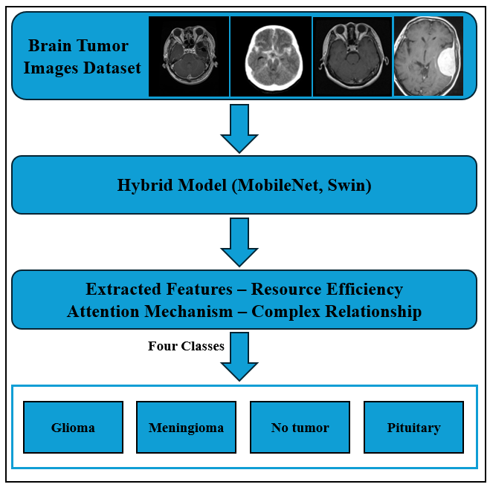
FIGURE 3: Proposed Hybrid model (MobileNet, Swin)

Step 4: Evaluation Models

A set of metrics is applied to evaluate the efficiency of the classification models.
Formula:

$$Accuarcy=\frac{(TP+TN)}{(TP+FP+TN+FN)}$$

$$Precision=\frac{TP}{TP+FP}$$

$$Recall=\frac{TP}{TP+FN}$$

$$F1 score=\frac{2 x Precision x Recall}{Precision+ Recall}$$

TP = True Positives
TN = True Negatives
FP = False Positives
FN = False Negatives

- Results and Discussion:

  - Experimental setup

The models were applied in Anaconda environment by using Jupyter for coding and compiling. A desktop equipped with an Intel Core i7-6700 processor and 16GB RAM was used for the experiment. In data splitting we have a training set which is used to train the model. The model learns patterns, features, and relationships in the data from this set, usually around 70% to 80% of the total dataset, also we have a test set which is used to evaluate the final performance of the model after training. It provides how the model is expected to perform on real-world data, usually around 10% to 15% of the total dataset. In each of them has four classes which are glioma, meningioma, notumor and pituitary. Table 1 shows the number of images in each class that were used in the dataset during this experiment.

Table 1: Number of images in each class
Dataset | Class label | Training | Testing | Total
Brain MRI | glioma | 1321 | 300 | 1921
Brain MRI | meningioma | 1339 | 306 | 1951
Brain MRI | notumor | 1595 | 405 | 2405
Brain MRI | pituitary | 1457 | 300 | 2057

  - Results of model performance

Table 2 shows the average performance of each model based on different evaluation methods: accuracy, precision, recall, F1-score. MobileNet outperformed others, achieving excellent results with an accuracy of 93.34%, precision of 100%, recall of 81%, and an F1-score of 89%. ResNet50 recorded the lowest performance, with an accuracy of 54.28%, precision of 63%, recall of 22%, and an F1-score of 33%. Inception v2 performance recorded, with an accuracy of 88.20%, precision of 91%, recall of 80%, and an F1-score of 85%. The Transformer-based models also showed strong performance, with ViT achieving an accuracy of 95.73% and 94.33% precision, recall, and F1-score. and Swin excelling with an accuracy of 99.08%, precision of 99.66%, recall of 98%, and F1-score of 98.82%. To further enhance performance, a hybrid model combining MobileNet and Swin was developed, resulting in the highest average performance: 99.65% accuracy, 99.82% precision, recall, and F1-score.

Where MobileNet from pre-trained CNN and Swin from the transformers have achieved the best performance then we combine both in a hybrid model to achieve the best average performance.

Table 2: Models performance average
Approaches | Models | Accuracy | Precision | Recall | F1-score
Pre-trained CNN | ResNet50 | 54.28 | 63.00 | 22.00 | 33.00
Pre-trained CNN | MobileNet | 93.34 | 100 | 81.00 | 89.00
Pre-trained CNN | Inception v2 | 88.20 | 91.00 | 80.00 | 85.00
Transformer | ViT | 95.73 | 94.33 | 94.33 | 94.33
Transformer | Swin | 99.08 | 99.66 | 98.00 | 98.82
Hybrid models | MobileNet- Swin | 99.65 | 99.82 | 99.82 | 99.82

  - Results of model for each class

Table 3 shows the performance of various models across four tumor types: glioma, meningioma, no tumor, and pituitary. In Glioma ResNet50 model scores: precision: 63.00%, recall: 22.00%, F1-score: 33.00%, this model struggles significantly, particularly in recall, indicating poor detection of gliomas, and Inception v2: Precision: 91.00%, Recall: 80.00%, F1-score: 85.00%, this model performs well, balancing false positives and negatives better than ResNet50, and MobileNet Precision: 100%, Recall: 81.00%, F1-score: 89.00%, this model with perfect precision, effectively identifying predicted glioma cases, and ViT Precision: 94.33%, Recall: 94.33%, F1-score: 94.33%, this model maintains a strong balance between precision and recall, indicating similar performance, and Swin: Precision: 99.66%, Recall: 98.67%, F1-score: 99.16%, this model Excellent capability in detecting pituitary tumors with very few errors less than ViT, and Hybrid Model (MobileNet-Swin): Precision: 99.39%, Recall: 99.39%, F1-score: 99.39%, this model strong performance, outperforming other models in this category, indicating its dissimilar.

In Meningioma ResNet50 model scores: precision: 55.00%, recall: 33.00%, F1-score: 41.00%, this model has limited effectiveness, particularly in recall, leading to many missed cases, and Inception v2: Precision: 77.00%, Recall: 74.00%, F1-score: 75.00%, this model shows similar performance to MobileNet but slightly lower in precision and recall, and MobileNet Precision: 82.00%, Recall: 81.00%, F1-score: 82.00%, this model demonstrates improved performance compared to ResNet50, maintaining a solid balance, and ViT Precision: 97.19%, Recall: 90.52%, F1-score: 93.07%, this model exhibits excellent performance with high precision indicating reliability in positive predictions, and Swin Precision: 97.13%, Recall: 99.67%, F1-score: 98.39%, this model shows high recall, indicating very effective detection of meningiomas, and Hybrid Model (MobileNet-Swin) Precision: 99.77%, Recall: 99.77%, F1-score: 99.77%, this model consistently performs well across all metrics, showcasing its strength in detecting meningiomas.

In notumor ResNet50 model scores: precision: 72.00%, recall: 81.00%, F1-score: 76.00%, this model shows moderate performance, with room for improvement in precision, and Inception v2: Precision: 91.00%, Recall: 97.00%, F1-score: 94.00%, this model performs well, but is slightly less effective than MobileNet, and MobileNet Precision: 97.00%, Recall: 98.00%, F1-score: 97.00%, this model demonstrates strong performance, effectively distinguishing between tumor and non-tumor cases, and ViT Precision: 99.25%, Recall: 98.52%, F1-score: 98.88%, this model shows very high performance, indicating reliability in identifying non-tumor cases, and Swin Precision: 99.75%, Recall: 99.75%, F1-score: 99.75%, this model indicates excellent performance with minimal false positives and negatives, and Hybrid Model (MobileNet-Swin) Precision: 99.99%, Recall: 99.99%, F1-score: 99.99%, this model demonstrates near-perfect performance, showcasing exceptional capability in classifying the "no tumor" category.

In Pituitary ResNet50 model scores: precision: 46.00%, recall: 85.00%, F1-score: 59.00%, this model has low precision, indicating many incorrect predictions among those labeled as pituitary tumors, and Inception v2: Precision: 90.00%, Recall: 97.00%, F1-score: 93.00%, this model performs well, balancing precision and recall effectively, and MobileNet Precision: 84.00%, Recall: 100%, F1-score: 91.00%, this model shows strong recall, effectively detecting all pituitary tumors, though it has some false positives, and ViT Precision: 91.36%, Recall: 98.67%, F1-score: 94.87%, this model exhibits high performance, similar to Inception v2, and Swin Precision: 99.66%, Recall: 98.67%, F1-score: 99.16%, this model shows excellent capability in detecting pituitary tumors with very few errors, and Hybrid Model (MobileNet-Swin) Precision: 99.39%, Recall: 99.39%, F1-score: 99.39%, this model indicates strong performance, outperforming other models in this category, showcasing its dissimilar.

As a result, the hybrid model (MobileNet-Swin) records the highest performance for all classes demonstrating exceptional capability in detecting these tumor types and no tumors.

Table 3: Models performance in each class
Approaches | Models | Classes | Precision | Recall | F1-score
Pre-trained CNN | ResNet50 | glioma | 63.00 | 22.00 | 33.00
Pre-trained CNN | ResNet50 | meningioma | 55.00 | 33.00 | 41.00
Pre-trained CNN | ResNet50 | notumor | 72.00 | 81.00 | 76.00
Pre-trained CNN | ResNet50 | pituitary | 46.00 | 85.00 | 59.00
Pre-trained CNN | MobileNet | glioma | 100 | 81.00 | 89.00
Pre-trained CNN | MobileNet | meningioma | 82.00 | 81.00 | 82.00
Pre-trained CNN | MobileNet | notumor | 97.00 | 98.00 | 97.00
Pre-trained CNN | MobileNet | pituitary | 84.00 | 100 | 91.00
Pre-trained CNN | Inception v2 | glioma | 91.00 | 80.00 | 85.00
Pre-trained CNN | Inception v2 | meningioma | 77.00 | 74.00 | 75.00
Pre-trained CNN | Inception v2 | notumor | 91.00 | 97.00 | 94.00
Pre-trained CNN | Inception v2 | pituitary | 90.00 | 97.00 | 93.00
Transformer | ViT | glioma | 94.33 | 94.33 | 94.33
Transformer | ViT | meningioma | 97.19 | 90.52 | 93.07
Transformer | ViT | notumor | 99.25 | 98.52 | 98.88
Transformer | ViT | pituitary | 91.36 | 98.67 | 94.87
Transformer | Swin | glioma | 99.66 | 98.00 | 98.82
Transformer | Swin | meningioma | 97.13 | 99.67 | 98.39
Transformer | Swin | notumor | 99.75 | 99.75 | 99.75
Transformer | Swin | pituitary | 99.66 | 98.67 | 99.16
Hybrid models | MobileNet- Swin | glioma | 99.82 | 99.82 | 99.82
Hybrid models | MobileNet- Swin | meningioma | 99.77 | 99.77 | 99.77
Hybrid models | MobileNet- Swin | notumor | 99.99 | 99.99 | 99.99
Hybrid models | MobileNet- Swin | pituitary | 99.39 | 99.39 | 99.39

  - Discussion

As shown in Table 4 recently many methodologies have developed for brain tumor classification using DL, each some highlight and limitations. Tiwari et al. (2025) achieved good accuracy in tumor classification; however, their methods are complex and have a limited dataset. Also, Reddy et al. (2025) introduced the FTVT model, which reduces error rates, but its requirement for high-specifications hardware and large datasets brining challenges for practical implementation.

EfficientNet-B3, which was developed by Islam et al. (2025), exceeded other models in regarding accuracy but also required high-specifications devices, which limited accessibility. Although the results of Saeedi et al. (2023) were limited by dataset differences, which may have an impact on generalization across other populations, they showed that attention-guided DL could enhance classification performance.

By using image enhancement techniques, Latif et al. (2022) were able to analyze images more quickly and with better quality. However, the generalizability of their findings is limited by their focus on a single dataset along with specific tumor types. However, Amin et al. (2022) only focused on binary classification, which may have ignored the complexity of multi-class scenarios. They achieved reduced processing costs by combining clustering and classification algorithms.

Dense EfficientNet, which was presented by Kibriya et al. (2022), successfully lowers overfitting but requires an important amount of computing power. To improve feature extraction, Kolla et al. (2022) integrated CNN with support vector machines (SVM) and local binary patterns (LBP); nonetheless, they encountered significant computational complexity, which would restrict real-time applications. Amin et al. (2022) also investigated ensemble techniques, which required a lot of data and processing power but were successful in lowering overfitting.

Finally, Arif et al. (2022) used a hybrid strategy that combined genetic algorithms with U-Net. This method showed promise in increasing accuracy but required preprocessing and parameter tuning. Although Zhang et al. (2021) suggested a deep tumor architecture that enhanced segmentation, its actual implementation was made more difficult by the need for a sizable dataset and substantial processing power.

All things considered, even though this research progresses the field of DL-based brain tumor classification, issues including dataset constraints, processing requirements, and the requirement for generalizable models continue to be common. Future studies should concentrate on creating more effective algorithms that function well in a variety of computational contexts and datasets.

Table 4: Previous Studies Summary
References | Methods | Datasets
(Tiwari et al., 2022) | CNN | 3,264 images (826 glioma, 822 meningioma, 395 no tumor, 827 pituitary)
(Reddy et al., 2024) | FTVT-b16/b32/l16/l32 | 7,026 MRI images (gliomas, meningiomas, pituitary)
(Islam et al., 2024) | EfficientNet-B3 | 3,064 MRI images (glioma, meningioma, pituitary)
(Saeedi et al., 2023) | Attention-Guided Deep Learning | 5,000+ MRI images
(Latif, 2022) | Image Enhancement + Classification | 3,064 CE-MRI images (930 pituitary, 708 meningiomas, 1,426 gliomas)
(Dehkordi et al., n.d.) | VGG16 + ResNet | Figshare Dataset (3,064 images)
(Kibriya et al., 2022) | Dense EfficientNet | 3,260 T1-weight contrast-enhanced MRI images
(Kolla et al., 2022) | CNN + LBP + SVM | MRI dataset with LBP features
(Amin et al., 2022) | Ensemble TL + Quantum Classifier | MRI images
(Arif et al., 2022) | Genetic Algorithm + U-Net | T1-weighted MRI dataset
(He et al., n.d.) | Deep Tumor Framework | Multi-modal MRI dataset

- Conclusion:

This study proposed the effectiveness of advanced DL models in enhancing the classification of brain tumors using MRI images. We obtained notable gains in classification measures, such as accuracy, precision, recall, and F1-score, by merging pre-trained CNN and transformer architectures, especially the hybrid model combination (MobileNet, Swin). The findings show that our hybrid model not only performs better than conventional classification techniques but also offers radiologists a dependable tool to help them make prompt and precise diagnoses. The model's excellent performance highlights how DL technologies have the potential to revolutionize clinical procedures, especially in areas with limited access to skilled medical imaging specialists.

Furthermore, the use of data augmentation techniques has been crucial in overcoming the difficulties presented by small datasets, allowing for the creation of more dissimilar models that can generalize across a range of imaging situations. Given the increased frequency of brain tumors worldwide, this strategy is in line with the urgent need for efficient diagnostic technologies. Future studies should concentrate on growing the dataset, investigating different DL structures, and confirming the model's functionality in actual clinical contexts. We can increase the precision of brain tumor classifications and eventually help improve patient outcomes in the oncology area by further improving these approaches.

In summary, the findings of this study make further advancements in automated medical diagnostics and highlight the significant role of DL in the future of healthcare.

References:
Amin, J., Anjum, M. A., Sharif, M., Jabeen, S., Kadry, S., & Moreno Ger, P. (2022). A New Model for Brain Tumor Detection Using Ensemble Transfer Learning and Quantum Variational Classifier. Computational Intelligence and Neuroscience, 2022, 1–13. https://doi.org/10.1155/2022/3236305
Anesi, G. L., & Kerlin, M. P. (2021). The impact of resource limitations on care delivery and outcomes: routine variation, the coronavirus disease 2019 pandemic, and persistent shortage. In Current Opinion in Critical Care (Vol. 27, Issue 5, pp. 513–519). Lippincott Williams and Wilkins. https://doi.org/10.1097/MCC.0000000000000859
Arif, M., Jims, A., F., A., Geman, O., Craciun, M.-D., & Leuciuc, F. (2022). Application of Genetic Algorithm and U-Net in Brain Tumor Segmentation and Classification: A Deep Learning Approach. Computational Intelligence and Neuroscience, 2022, 1–11. https://doi.org/10.1155/2022/5625757
Chan, H. P., Samala, R. K., Hadjiiski, L. M., & Zhou, C. (2020). Deep Learning in Medical Image Analysis. In Advances in Experimental Medicine and Biology (Vol. 1213, pp. 3–21). Springer. https://doi.org/10.1007/978-3-030-33128-3_1
Dehkordi, A. A., Hashemi, M., Neshat, M., Mirjalili, S., & Sadiq, A. S. (n.d.). Brain Tumor Detection and Classification Using a New Evolutionary Convolutional Neural Network 1*.
Dosovitskiy, A., Beyer, L., Kolesnikov, A., Weissenborn, D., Zhai, X., Unterthiner, T., Dehghani, M., Minderer, M., Heigold, G., Gelly, S., Uszkoreit, J., & Houlsby, N. (2020). An Image is Worth 16x16 Words: Transformers for Image Recognition at Scale. http://arxiv.org/abs/2010.11929
He, K., Zhang, X., Ren, S., & Sun, J. (n.d.). Deep Residual Learning for Image Recognition. http://image-net.org/challenges/LSVRC/2015/
Howard, A. G., Zhu, M., Chen, B., Kalenichenko, D., Wang, W., Weyand, T., Andreetto, M., & Adam, H. (2017). MobileNets: Efficient Convolutional Neural Networks for Mobile Vision Applications. http://arxiv.org/abs/1704.04861
Islam, T., Hafiz, M. S., Jim, J. R., Kabir, M. M., & Mridha, M. F. (2024). A systematic review of deep learning data augmentation in medical imaging: Recent advances and future research directions. Healthcare Analytics, 5, 100340. https://doi.org/10.1016/J.HEALTH.2024.100340
Kibriya, H., Amin, R., Alshehri, A. H., Masood, M., Alshamrani, S. S., & Alshehri, A. (2022). A Novel and Effective Brain Tumor Classification Model Using Deep Feature Fusion and Famous Machine Learning Classifiers. Computational Intelligence and Neuroscience, 2022, 1–15. https://doi.org/10.1155/2022/7897669
Kolla, M., Mishra, R. K., Zahoor ul Huq, S., Vijayalata, Y., Gopalachari, M. V., & Siddiquee, K.-A. (2022). CNN-Based Brain Tumor Detection Model Using Local Binary Pattern and Multilayered SVM Classifier. Computational Intelligence and Neuroscience, 2022, 1–9. https://doi.org/10.1155/2022/9015778
Latif, G. (2022). DeepTumor: Framework for Brain MR Image Classification, Segmentation and Tumor Detection. Diagnostics, 12(11). https://doi.org/10.3390/diagnostics12112888
Li, S., Wang, C., Chen, J., Lan, Y., Zhang, W., Kang, Z., Zheng, Y., Zhang, R., Yu, J., & Li, W. (2023). Signaling pathways in brain tumors and therapeutic interventions. In Signal Transduction and Targeted Therapy (Vol. 8, Issue 1). Springer Nature. https://doi.org/10.1038/s41392-022-01260-z
Liu, Z., Lin, Y., Cao, Y., Hu, H., Wei, Y., Zhang, Z., Lin, S., & Guo, B. (n.d.). Swin Transformer: Hierarchical Vision Transformer using Shifted Windows. https://github.
Masoud Nickparvar. (2021). Brain Tumor MRI Dataset. Kaggle. https://www.kaggle.com/dsv/2645886
Reddy, C. K. K., Reddy, P. A., Janapati, H., Assiri, B., Shuaib, M., Alam, S., & Sheneamer, A. (2024). A fine-tuned vision transformer based enhanced multi-class brain tumor classification using MRI scan imagery. Frontiers in Oncology, 14. https://doi.org/10.3389/fonc.2024.1400341
Saeedi, S., Rezayi, S., Keshavarz, H., & R. Niakan Kalhori, S. (2023). MRI-based brain tumor detection using convolutional deep learning methods and chosen machine learning techniques. BMC Medical Informatics and Decision Making, 23(1). https://doi.org/10.1186/s12911-023-02114-6
Szegedy, C., Vanhoucke, V., Ioffe, S., & Shlens, J. (n.d.). Rethinking the Inception Architecture for Computer Vision.
Tiwari, P., Pant, B., Elarabawy, M. M., Abd-Elnaby, M., Mohd, N., Dhiman, G., & Sharma, S. (2022). CNN Based Multiclass Brain Tumor Detection Using Medical Imaging. Computational Intelligence and Neuroscience, 2022, 1–8. https://doi.org/10.1155/2022/1830010
World Health Organization. (2021). The top 10 causes of death. https://www.who.int/news-room/fact-sheets/detail/the-top-10-causes-of-death

