النَّشـــاطــات البــرمجيَّــة الأسبــوعيَّـــة – الأخيـــرة
الاسم: | زينـــب جعفـــر العبــدالعــال | الشهر: | أغسطــــس | السنة: | 2023
التَّـــاريــخ: 19/08/2023
python CODE – SNIPPET – print number pattern (HALF pyrammid)
create a program that generates and prints this pattern. You can achieve this using nested loops, where the outer loop controls the number of rows, and the inner loop controls the number of elements in each row.
rows = int(input('Enter the number of rows: '))
# outer loop
for z in range(1,rows+1):
# nested loop
for j in range(1,z+1):
# display number
print(j, end=' ')
# new line after each row
print('')
print("\n\nProcess Finished With Exit Code 0")
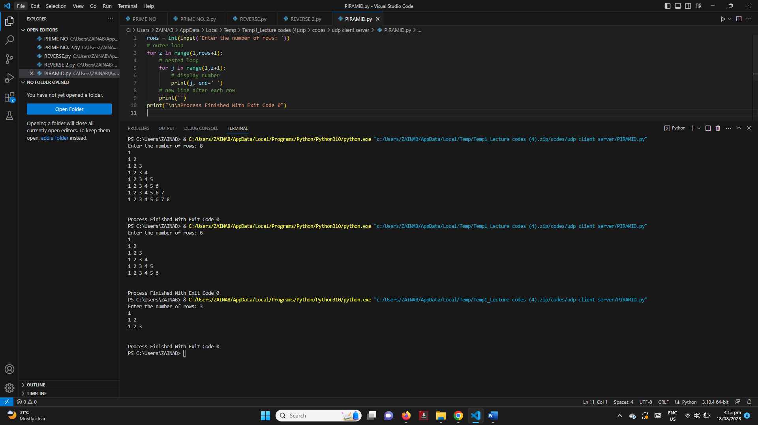

C⁺⁺ CODE - SNIPPET – SNIPPET – print number pattern (HALF pyrammid)
create a program that generates and prints this pattern. You can achieve this using nested loops, where the outer loop controls the number of rows, and the inner loop controls the number of elements in each row.
#include <stdio.h>

int main()
{
int n;
printf("Enter the Number of Rows: ");
scanf("%d", &n);
for (int z = 1; z <= n; ++z)
{
for (int j = 1; j <= z; ++j)
{
printf("%d", j);
}
printf("\n");
}
return 0;
}
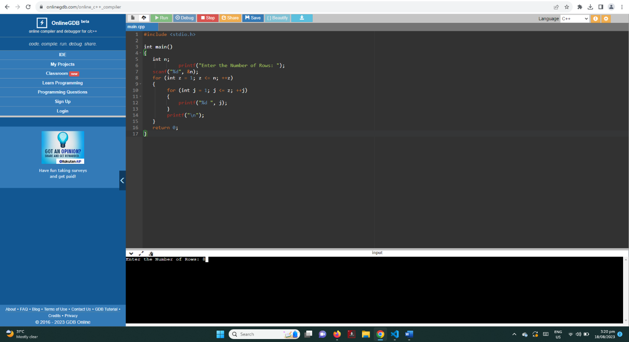

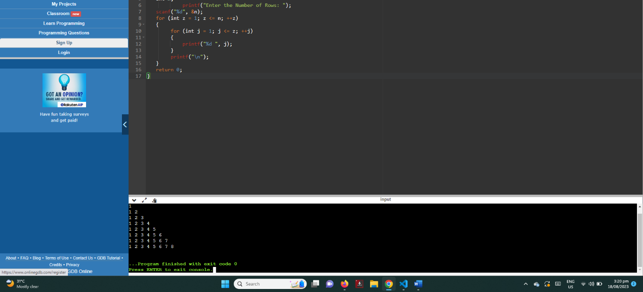

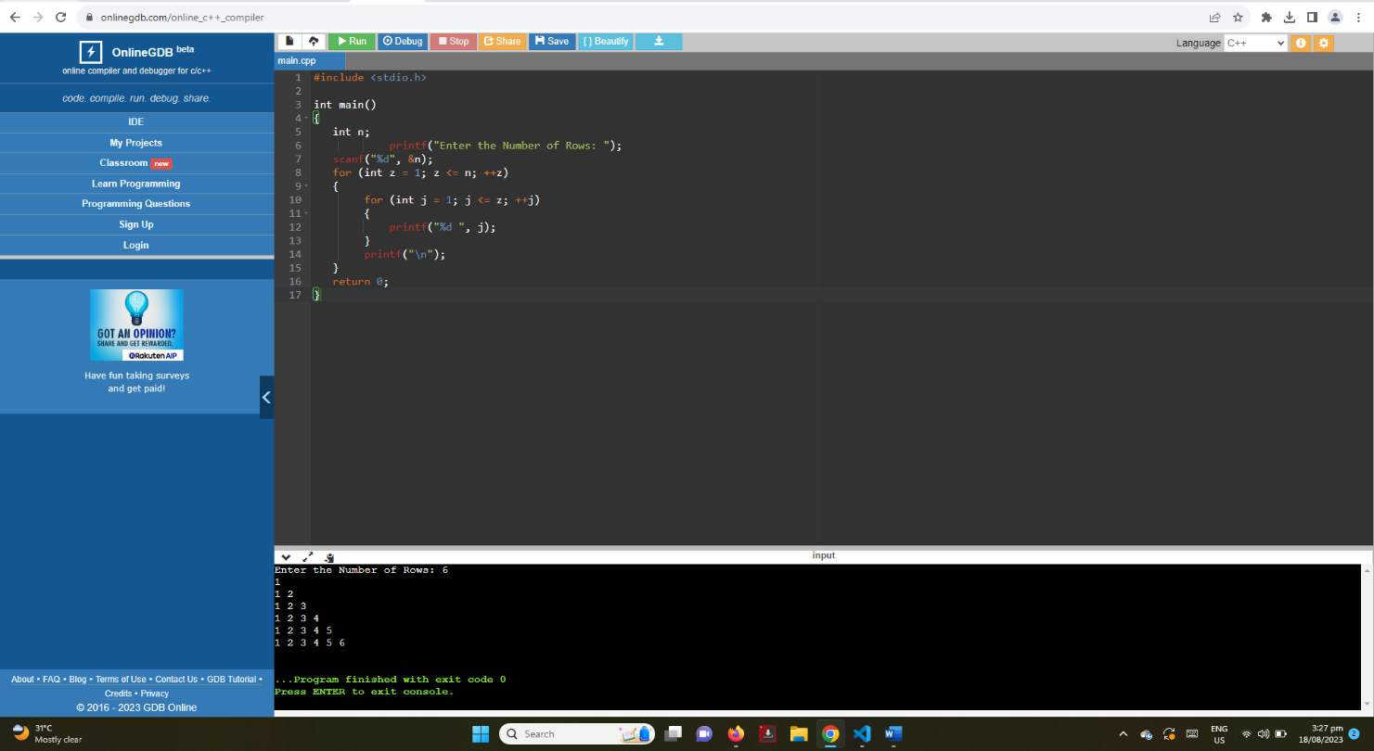

UNI ID
213000602
ZAINAB JAFFER I. AL ABDULAL

