
جامعة ميد أوشن
كلية الإدارة

اسم الطالب
Ammar Basheer Ali Algarash
الرقم الأكاديمي
241002383

المشرف الرئيسي المشرف الثاني
Asma Abuanzeh

العام الجامعي
2024/2025

project managements
ادارة المشاريع


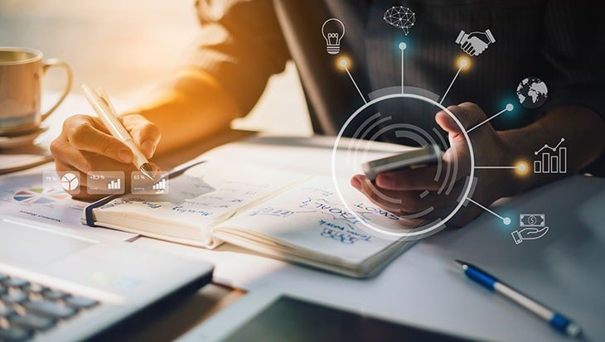

Table
1-Interdication.
2.What is definition project management and project?
3.The five stages of project management processes
4.Why is project managements important?
5- Main benefits of project management
6- Project management methodologies
7- Combining multiple project management methodologies
8-Research Questions, Purpose of the Study and Research Methods.
9- References

1.Interdiction
Many people and organizations today have a new/renewed interest in project management whilst In the past, the project management primarily focused on providing schedule and resource data to top management in just a couple of industries, such as the military and construction industries, and Today’s project management involves much more, and people in every industry and every country manage projects. New technologies have become a significant factor in many businesses, and the use of interdisciplinary and global work teams has radically changed the work environment.
Project management is a multifaceted discipline essential to the successful execution of projects across industries, involving structured planning, resource management, and effective leadership to meet specific objectives within defined timeframes and budgets. This research investigates contemporary project management practices, highlighting essential methodologies, the growing role of technology, risk management strategies, and team dynamics as critical components of effective PM. By examining the strengths and limitations of prominent methodologies, such as Agile, Waterfall, and Lean, this study provides insights into their suitability for various project types and organizational contexts.

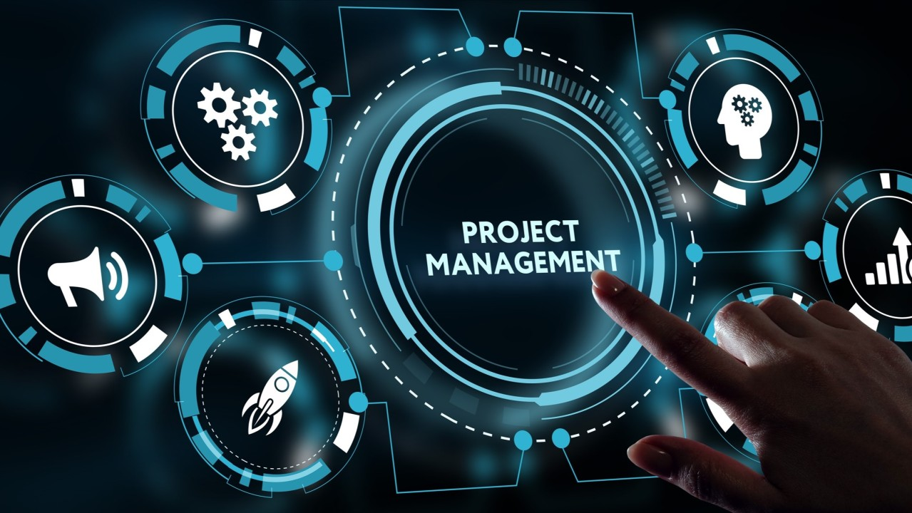
Figure 1 project management

2.What is definition project management and project?

Project management is the discipline of planning, organizing, motivating, and controlling resources to achieve specific goals within a defined scope, time, cost, and quality constraints. It involves leading a team to accomplish a project's objectives effectively and efficiently. Today many people and organizations have a new /renewed interest in project management. In the past, project management primarily focused on providing schedule, resource data to top management in just a few industries, such as the military and construction industries. Today’s project management involves much more, and people in every industry and every country manage projects. New technologies have become a significant factor in many businesses, and the use of interdisciplinary and global work teams has radically changed the work environment.
Project management is “the application of knowledge, skills, tools and techniques to project activities to meet the project requirements.” Project managers mustn’t only strive to meet specific scope, schedule, cost, resource, risk, and quality requirements of projects, they must also facilitate the entire process to meet the needs and expectations of the people involved in or affected by project activities.
A project is “a temporary endeavor undertaken to create a unique product,service, or result.”
3.The five stages of project management processes

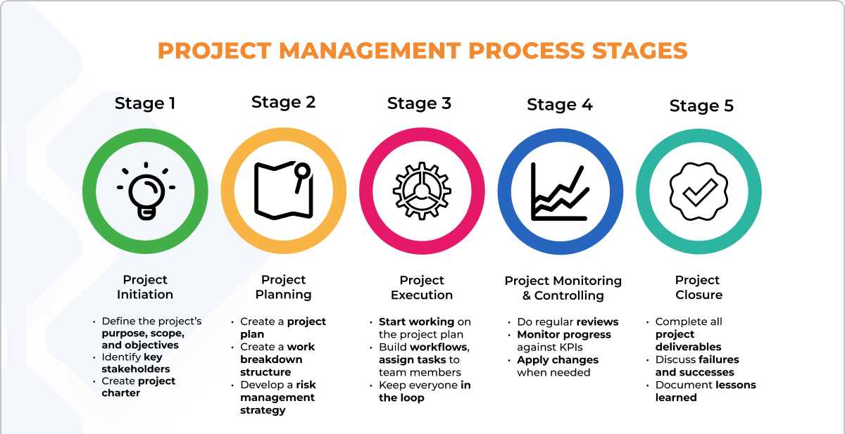
Figure 2 project management stages

- Stage 1.Initiation: Defining project objectives, scope, and feasibility.
1. Defining Project Objectives:
- Clear and Measurable: Objectives should be stated in clear, concise, and measurable terms. They should be SMART (Specific, Measurable, Achievable, Relevant, and Time-bound).
- Aligned with Business Strategy: Project objectives should align with the overall business strategy to ensure that the project contributes to the organization's goals.
- Stakeholder Involvement: Involve key stakeholders in defining the objectives to ensure their buy-in and support.
2. Defining Project Scope:
- Project Boundaries: Clearly define the boundaries of the project, including what is and is not included.
- Deliverables: Identify the specific products, services, or results that the project will deliver.
- Success Criteria: Establish the criteria that will be used to determine project success.

3. Assessing Project Feasibility:
- Technical Feasibility: Evaluate the availability of resources, technology, and expertise to complete the project.
- Economic Feasibility: Assess the financial viability of the project, including costs, benefits, and return on investment.
- Schedule Feasibility: Determine if the project can be completed within the desired timeframe.
- Legal Feasibility: Ensure that the project complies with all relevant laws and regulations.
- Operational Feasibility: Evaluate the project's impact on the organization's operations and resources.

- Stage 2. Planning: Developing a detailed project plan, including tasks, timelines, resources, and budget.
Project planning is a critical phase in the project lifecycle where a detailed roadmap is created to guide the execution of the project. This plan outlines tasks, timelines, resource requirements, and the budget, ensuring that the project is delivered on time, within budget, and to the desired quality.
There are some Key Components of a Project Plan such:
- Work Breakdown Structure (WBS): A hierarchical decomposition of the project into smaller, manageable tasks.
- Task List: A detailed list of all the activities required to complete the project.
- Task Dependencies: Identifying the relationships between tasks, such as which tasks must be completed before others can begin.
- Task Estimates: Estimating the time, resources, and cost required for each task.
- Timeline or Gantt Chart: A visual representation of the project schedule, showing the start and end dates for each task.
- Resource Allocation: Assigning the necessary resources (people, equipment, materials) to each task.
- Budget: Creating a detailed budget for the project, including both costs and revenues.
- Risk Management Plan: Identifying potential risks and developing strategies to mitigate or avoid them.
- Communication Plan: Outlining how information will be shared among stakeholders.

- Stage 3.Execution: Carrying out the project plan, managing resources, and monitoring progress.
Project execution is the phase where the project plan is put into action. It involves managing resources, monitoring progress, and making adjustments as needed to ensure the project is delivered on time, within budget, and to the desired quality.
Key Activities in Execution:
- Resource Allocation: Assigning the necessary resources (people, equipment, materials) to each task based on the project plan.
- Task Assignment: Assigning specific tasks to team members, considering their skills and availability.
- Communication: Maintaining open and transparent communication with stakeholders, team members, and other parties involved in the project.
- Team Management: Leading and motivating the project team to ensure they are working effectively and efficiently.
- Monitoring Progress: Tracking the progress of each task against the project plan.
- Quality Control: Ensuring that the work being done meets the project's quality standards.
- Risk Management: Identifying and addressing potential risks to the project.
- Change Management: Managing changes to the project scope, schedule, or budget as needed.

- Stage 4. Monitoring and controlling: Tracking project performance, identifying and addressing issues, and making necessary adjustments. Project monitoring and controlling involves tracking project performance, identifying, addressing issues, and making necessary adjustments to ensure the project is delivered on time, within budget, and to the desired quality.

Key Activities in Monitoring and Controlling:
- Performance Measurement: Tracking project progress against the established baseline, using key performance indicators (KPIs) to measure performance.
- Risk Management: Continuously monitoring risks and taking corrective actions as necessary.
- Quality Control: Ensuring that the work being done meets the project's quality standards.
- Variance Analysis: Identifying and analyzing deviations from the project plan, such as schedule delays, cost overruns, or quality issues.
- Issue Identification: Proactively identifying potential or actual problems that could impact the project.
- Issue Resolution: Developing and implementing strategies to address identified issues.
- Change Management: Managing changes to the project scope, schedule, or budget as needed.

- Stage 5. Closure: Completing the project, delivering the final product or service, and evaluating project success.

Project closure is the final stage of the project lifecycle, where the project is formally completed, the final product or service is delivered, and the project's success is evaluated.

Best Practices for Project Closure:
- Thorough Evaluation: Conduct a comprehensive evaluation of the project's performance against the original objectives.
- Document Lessons Learned: Capture and document key lessons learned from the project, which can be used to improve future projects.
- Celebrate Success: Recognize and reward the team for their contributions to the project's success.
- Conduct Post-Project Review: Conduct a formal review with stakeholders to discuss the project's outcomes and identify areas for improvement.

4-Why is project managements important?

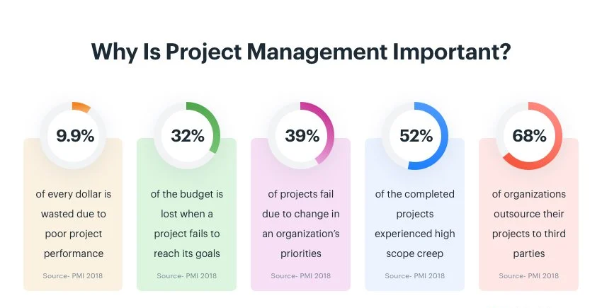
Figure 3 Survey by PMI 2018

According to a survey by the Project Management Institute (PMI), only 58% of organizations realize the actual importance of project management and how it allows them to effectively tackle the issues they face. Similarly, the percentage of companies that use standardized project management practices across the board is only 23%.
Find below some points for the importance of project managements.
1. Foundation for Success Successful projects are based on proper and effective project management. Imagine a building with a poorly constructed foundation. Again, this poses a threat to the entire structure, and project management ensures that the project is completed within a specific scope, timeframe, and at a specific cost. For example, a software development project may have milestones and deadlines to prevent the team from going off track to deliver the product on time and within budget.
2. Risk Mitigation and Planning Project management requires detailed planning and preliminary hazard analysis to identify potential problems. Imagine a marketing campaign, where the team prepares for potential problems such as market trends or new competitors. Risk mitigation strategies allow project managers to develop contingency plans so that the project does not go off track even if unexpected challenges arise.
3. Resource Optimization For a project to be successful, the right resources must be allocated. Imagine any manufacturing company that is focused on reducing raw materials, machinery, and labor to increase productivity. Resource allocation is done effectively through project management, which reduces waste and maximizes performance, thereby improving cost efficiency.
4. Stakeholder Communication : is the glue that holds a project together. In a construction project, the stakeholders can be architects, contractors, and clients. As a communication facilitator, the project manager helps ensure that all stakeholders understand the requirements and goals and are actively involved in the implementation of a particular project. Clear communication prevents misunderstandings and ensures internal harmony.
5. Adaptability and flexibility Projects may also change due to changes. Let's say customer requirements change during a software development project. Project management methodologies such as Agile provide a framework for making adjustments while maintaining project goals. This flexibility allows projects to adapt to changing circumstances.
6. Measurable performance and continuous improvement Project management involves setting key performance indicators (KPIs) and metrics to measure project progress. In a healthcare IT project, KPIs may include timely implementation of electronic health records. By analyzing these metrics, project managers can identify areas for improvement and promote a culture of continuous improvement in future projects.
7. Client Satisfaction and Quality Assurance Meeting client expectations is critical. Imagine a graphic design project where client satisfaction depends on the quality of the final product. Project management methods include quality assurance processes and client feedback loops to ensure that the results meet high standards. Satisfied clients not only enhance the reputation of the project team, but also contribute to positive word of mouth and repeat business.

Below figure explain in short the importance of project managements.

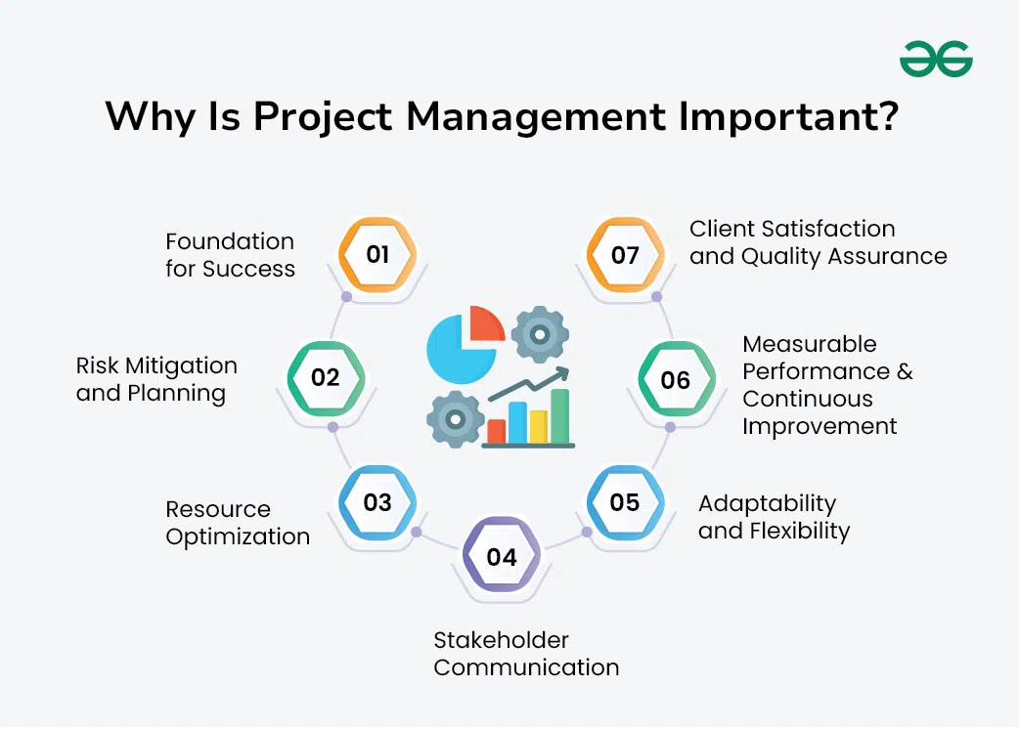
Figure 4 The importants of project managements

5- main benefits of project management
1. Consistent communication: No project plan is complete without a solid communication structure. Communication in project management is an extremely important aspect that can have a significant effect on the performance of a team. A study analyzed the reasons for project failure in the UK’s finance sector and found that communication breakdown was the main cause of failure for 57% of the studied projects.
Project managers must ensure that the whole team shares a collective end-goal and work together to achieve it. The overall efficiency and productivity of the entire team get significantly improved which leads to other benefits as well.
2. Effective resource allocation: The biggest resource any project managers have at their disposal is the team members. The project team consists of people of different backgrounds and departments and they might have other commitments. Through proper project planning, you can ensure that they are available when needed.
Similarly, other resources like the budget, tools, machinery, and others can be arranged effectively to avoid project delays during the execution. By properly allocating each resource in the beginning, you can also monitor the phases that are more demanding and prepare accordingly.
3. Higher productivity:
The field of project management is interconnected with being productive. Through proper utilization of resources and having an efficient system in place, a project team can easily get more work done in a shorter amount of time and increase productivity.
4. Improved customer satisfaction:
Retaining clients is considered more important than acquiring new ones and a guaranteed way of doing it is by offering unparalleled services. An effective set of operations that focuses on quality and efficiency, would naturally leave the clients feeling satisfied. This means that they would return with more business in the future.
A satisfied client would also refer your organization to other potential customers, which means free marketing for you. This can be an extremely effective marketing strategy for businesses.
5. More flexibility:
As you increase your customer base, your organization would be able to gain more capital which it can use to expand the business and hire new talent.
6. Higher risk tolerance:
Proper planning means that you are ready for potential ‘what-if’ scenarios that may occur. This means that you are somewhat prepared to tackle any unforeseen occurrences that may negatively impact your project.
7. Improved morale:
With continuous success and effective performance, your team gains more confidence. Effective project managers inspire their team by incentivizing and regularly rewarding top performers to keep everyone motivated.

8. Better planning
Planning a project effectively right from the start lays the foundation for a successful project. Project management includes a phase for a project plan where you can clearly define:
- project goals and objectives,
- project scope, and
- project timelines.
It keeps your team from slowing down and avoids unnecessary bureaucracy.
While it may be tempting to dive straight in, project management helps you in the longer run. With a solid project plan, you can ensure that you have an agreement with the client’s requirements, get all project stakeholders on the same page, and flag risks in advance.
9. Quality control
Most project managers are under enormous pressure to complete the project on time. When deadlines are missed, project schedules get tightened, work is rushed, and corners are cut, resulting in poor quality work.
Methodologies like Agile ensure the quality and applicability of the delivered product by creating a separate phase for examining and testing at every step. Proper project management also gives you control over the timelines and resources.
10. Learning by retrospection
As a project manager, you can’t afford to make the same mistake twice. It’s also key to do more of what went right and less of what went wrong. And, projects generate a tremendous amount of knowledge.
Almost every project management methodology includes a retrospective stage at the end of the project to facilitate this. Frameworks like Scrum include periodical retrospection so you can learn from what went wrong throughout the course of the project.
Properly recorded documentation allows you to keep track of all activities, enabling the team to learn from successes and project failures. The learnings from a project can be applied to all future projects. It’s also a great tool to estimate costs and project timelines.

6- Project management methodologies:

A project management methodology is a set of tools and guidelines that help you organize projects in a way that optimizes efficiency and performance.
A given project management method helps you more easily manage a project by providing a repeatable series of steps and principles. The goal of any framework is to promote collaboration, increase operational efficiency, keep the project on budget, and enhance the quality of the final deliverable.
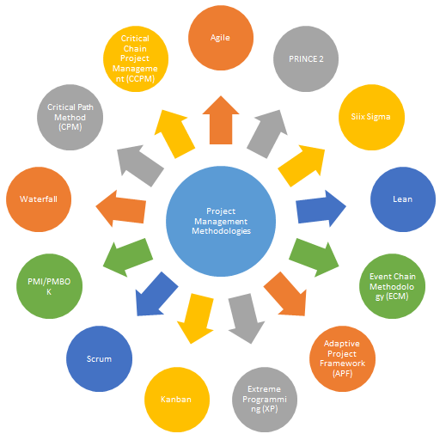
Figure 5 Methodologies
The following are some of the most well-known project management methodologies:
A-Waterfall: A linear approach where each phase must be completed before moving to the next.
  - Advantages of the Waterfall Model:
- Simple and easy to understand: The sequential nature of the model makes it straightforward to follow.
- Well-defined phases: Each phase has clear deliverables and milestones.
- Suitable for projects with well-defined requirements: When requirements are stable and known upfront, the waterfall model can be effective.
  - When to Use Waterfall:
- Projects with well-defined requirements: When the scope of the project is clear and stable.
- Projects with predictable timelines: When the project's duration and milestones can be accurately estimated.
- Projects with low levels of uncertainty: When there is a high degree of confidence in the project's outcomes.
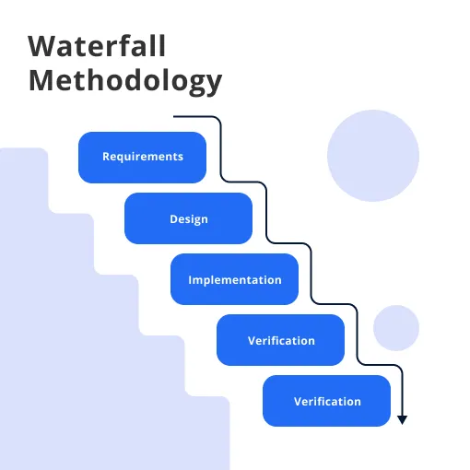
Figure 6 Waterfall model

B- Agile: An iterative approach that emphasizes flexibility and adaptability to change.

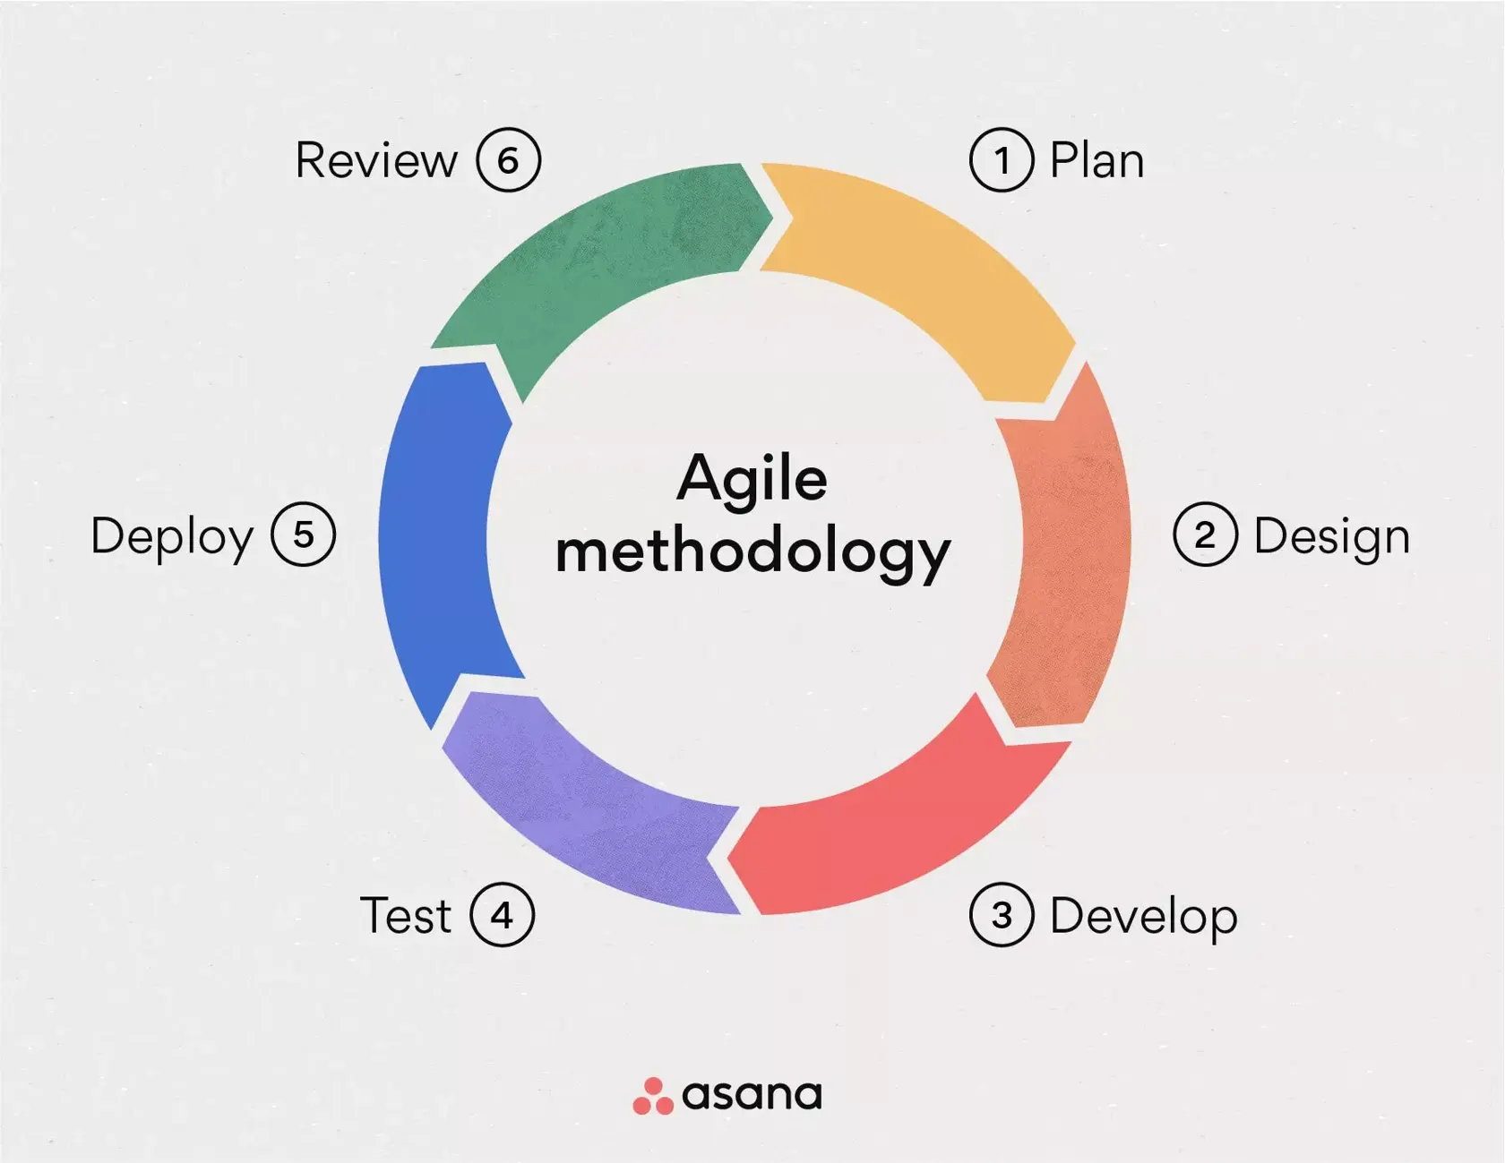
Figure 7 Agile model
    - When to Use Agile:
- Projects with uncertain requirements: When the exact scope of the project is not fully defined.
- Projects that require frequent changes: When the project is likely to experience changes in requirements or priorities.
- Projects where customer satisfaction is a top priority: When it's important to deliver value to customers early and often.
- Projects that benefit from collaboration and teamwork: When a collaborative and cross-functional team approach is desired.
    - Agile Frameworks:
- Scrum: A popular agile framework that uses time-boxed iterations called sprints to deliver incremental value.
- Kanban: A visual system for managing work that focuses on continuous flow and limiting work in progress.
- Extreme Programming (XP):: A disciplined approach to software development that emphasizes simplicity, communication, feedback, and courage.
    - Benefits of Agile:
- Increased flexibility: Agile allows for changes in requirements throughout the project lifecycle.
- Improved customer satisfaction: By delivering working software early and often, agile teams can gather feedback and ensure the product meets customer needs.
- Reduced risk: Agile's iterative approach helps identify and address risks early in the project.
- Enhanced team collaboration: Agile fosters a collaborative and supportive team environment.

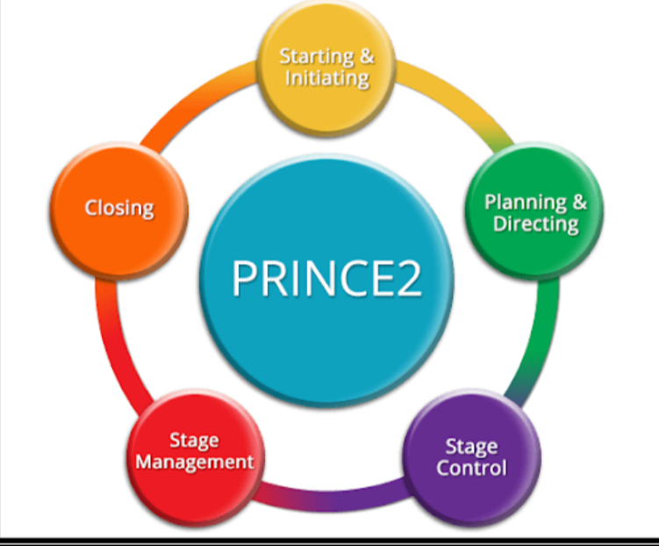
Figure 8 PRINCE2

- PRINCE2: A structured approach that provides a framework for managing projects of varying complexity.

- PRINCE2 benefits:
- Increased project success: PRINCE2 provides a structured approach that can help improve project outcomes.
- Improved control: The stage-based approach allows for better control and management of project resources.
- Flexibility: PRINCE2 can be adapted to different project environments and needs.
- Enhanced stakeholder engagement: PRINCE2 emphasizes the importance of stakeholder involvement and communication.
- Standardized approach: PRINCE2 provides a common language and framework for project management, which can improve collaboration and efficiency.
- Key principles of PRINCE2:
- Control: Projects are divided into stages, each with its own objectives, deliverables, and budget. This allows for greater control and management of project resources.
- Flexibility: PRINCE2 is adaptable to different project environments and can be tailored to specific needs.
- Product-based: The focus is on delivering products or services that meet the project's objectives.
- Iterative: Projects can be broken down into smaller iterations, allowing for flexibility and responsiveness to change.
- Tailored: PRINCE2 can be customized to fit the specific needs of an organization or project.
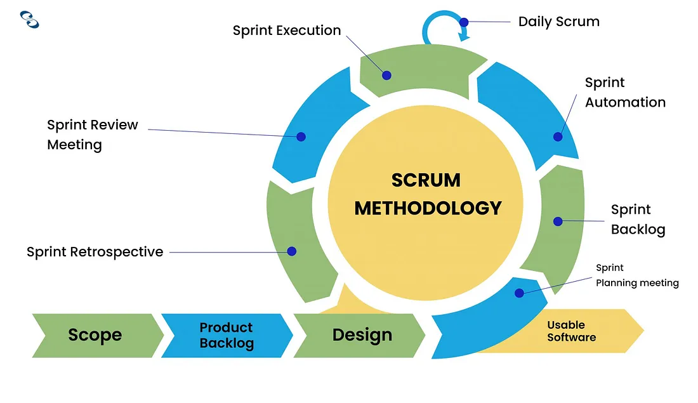
Figure 9 SCRUM

- Scrum: A subset of Agile, focusing on delivering work in short cycles (sprints) and adapting quickly to change.
Below some scenarios when using Scrum is beneficial:
  - Complex Projects(Uncertainty and Complexity: If the project involves complex requirements or is subject to changing conditions, Scrum's iterative nature allows teams to adapt and respond quickly.)
  - Frequent Changes(Evolving Requirements: When the project requirements are likely to change based on customer feedback or market conditions, Scrum facilitates regular reassessment and adjustment.)
  - Collaborative Teams (Cross-Functional Teams: Scrum thrives in environments where team members possess diverse skills and work collaboratively, enabling faster problem-solving and innovation.)
  - Customer Involvement(Stakeholder Engagement: If you can involve stakeholders throughout the project, Scrum’s regular reviews and feedback loops help ensure that the product aligns with their needs.)
  - Time-Sensitive Deliverables(Tight Deadlines: Scrum’s time-boxed Sprints allow teams to focus on delivering increments quickly, making it suitable for projects with deadlines or that require frequent releases.)
  - Product Development(Software and Technology: Scrum is widely used in software development, where rapid iteration and customer feedback are crucial for success. It’s also applicable in other areas like product design and marketing.)
  - Learning and Experimentation (Innovation Projects: For projects that require exploration and innovation, Scrum encourages experimentation and learning through its iterative cycles.)
  - Scaling Needs (Large Projects: Scrum can be adapted for larger projects by employing frameworks like Scrum of Scrums or SAFe (Scaled Agile Framework), enabling multiple teams to work in sync.)
  - High-Visibility Work (Transparent Processes: If you need high visibility into work progress and challenges, Scrum’s regular ceremonies (like Daily Scrums and Sprint Reviews) foster transparency.)
  - Team Empowerment (Self-Organizing Teams: When you have empowered teams that can self-organize, Scrum promotes ownership and accountability, leading to better engagement and productivity.

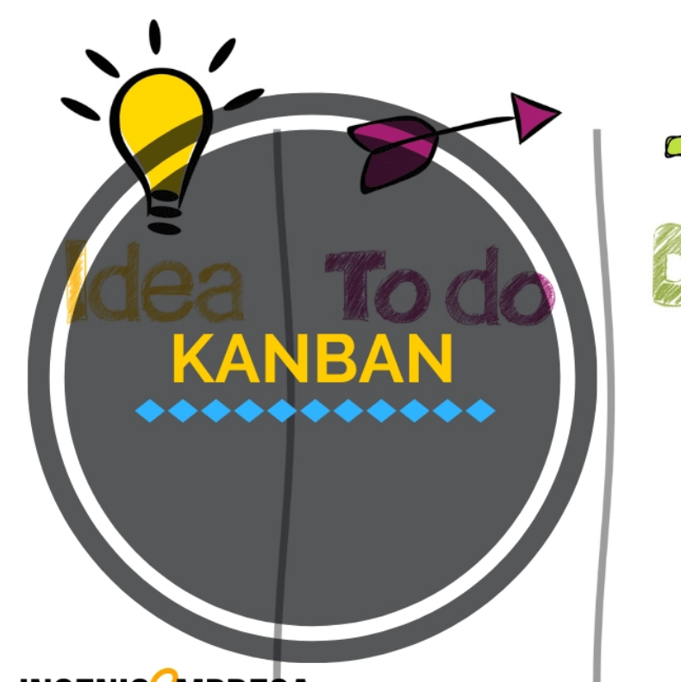
Figure 10 KANBAN

E- Kanban is another agile framework designed for visualizing work, limiting work in progress, and optimizing flow.
Kanban It’s particularly useful for managing ongoing work and improving efficiency in teams. below are the key components and principles of Kanban:
  - Key Components
- Visual Board:A visual representation of work items, usually divided into columns that represent different stages of the workflow (e.g., "To Do," "In Progress," "Done"). This helps the team see the status of work at a glance.
- Work Items:Each task or work item is represented by a card on the board. Cards often include details such as descriptions, assignees, and deadlines.
- WIP Limits:Work In Progress Limits: Kanban sets limits on the number of work items allowed in each column. This helps to prevent bottlenecks and ensures that the team focuses on completing tasks before starting new ones.
- Continuous Delivery:Kanban emphasizes continuous delivery and improvement, allowing teams to release updates and increments frequently without being constrained by time-boxed iterations like in Scrum.

  - When to Use Kanban
- Ongoing Work
- Flexible Requirements
- Visual Management
- Scaling Needs.
  - Principles of Kanban
- Visualize Work:
  - Make all work visible to everyone involved to enhance understanding and collaboration.
- Limit Work In Progress:
  - Set limits on how much work can be in progress at any given time to improve flow and efficiency.
- Manage Flow:
  - Focus on monitoring and optimizing the flow of work through the system. Analyze lead times, cycle times, and throughput to identify areas for improvement.
- Make Process Policies Explicit:
  - Clearly define and communicate the rules and processes for moving work items through the Kanban system. This ensures everyone is on the same page.
- Implement Feedback Loops:
  - Use regular meetings and reviews to gather feedback on processes and improve workflows continuously.
- Improve Collaboratively, Evolve Experimentally:
  - Encourage a culture of continuous improvement by experimenting with changes and collaborating as a team to refine processes.
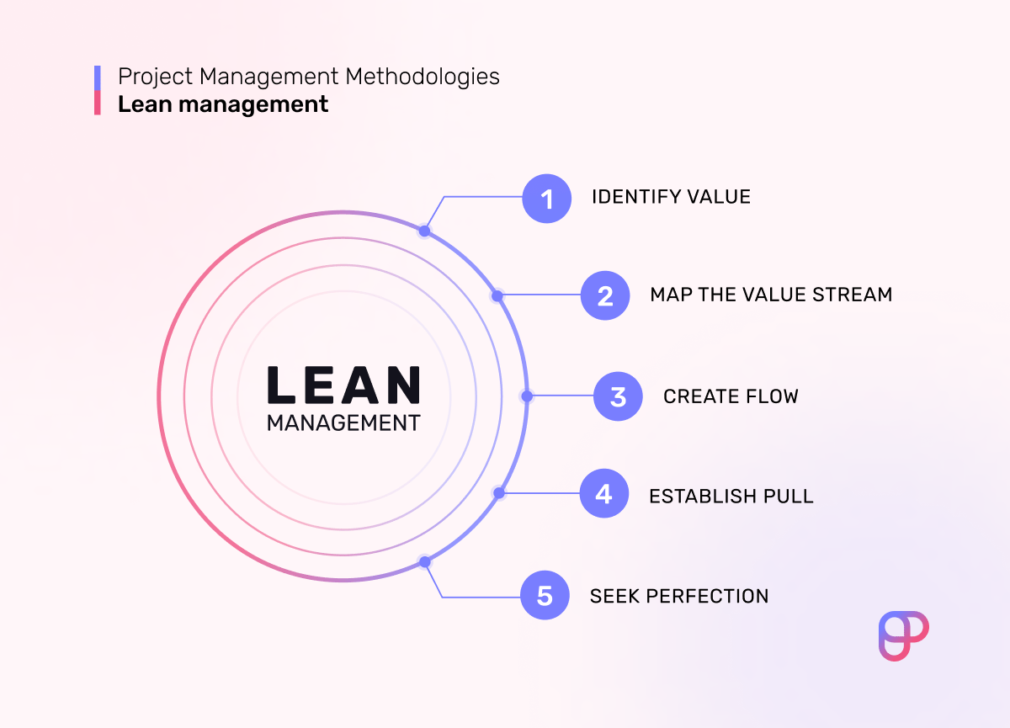
Figure 6 LEAN

F- Lean: is a way of thinking about creating needed value with fewer resources and less waste” and “a practice consisting of continuous experimentation to achieve perfect value with zero waste.
Lean was first developed in the form of a Lean manufacturing system in Toyota. It also called the Toyota Production System (TPS), this system is based on the just-in-time method of production (production of only what is needed for the next phase) and jidoka (translated as automation with a human touch).
The five principles of Lean.
- Identify value,
- Create the value stream,
- Create flow,
- Establish pull, and
- Seek perfection.
Advantages of Lean.
- Reduced costs, by Identifying and eliminating waste in your project workflow is guaranteed to reduce overall costs. And one of the important things is make sure that waste reduction reduces only the costs of production while leaving the quality of the product as is.
- Shorter time frame,
- Higher customer satisfaction, Since Lean focuses on delivering value from the customer’s perspective, it stands to reason that Lean practices lead to higher customer satisfaction.
- Improved employee experience. for having a successful business with experienced and expert employees, positive employee experience is vital as the employees are not overburdened with work, which means there is a lower chance of burnout.The elimination of Muri (waste of effort) and Mura (waste caused by uneven workload) helps create a healthy work environment.

To help make you better at identifying waste, we’ll familiarize you with the waste terminology used in the Toyota Production System, i.e. the following 3 types of waste:
- Muda,
- Mura, and
- Muri.
Muda — a waste of resources
,Muda refers to a waste of resources — something that doesn’t increase value from the customer’s perspective yet still costs you. You can think of it as manufacturing waste.
In actuality, the term Muda (無駄) is the only one among these 3 that can be translated as waste — although a more common translation would be useless or futile.
Taiichi Ohno, the man behind the Toyota Production System, categorized the following 7 types of Muda:
- Overproduction,
- Waiting,
- Conveyance (transportation),
- Processing,
- Inventory,
- Motion, and
- Correction.
If you’re in doubt as to whether or not some of these processes constitute waste, simply ask yourself whether they provide value from the customer’s perspective.
Mura — waste caused by uneven workload,
Mura refers to waste caused by uneven workload.
In Lean project management, the term Mura (斑) is correctly translated as uneven and the idea is that uneven input is bound to result in uneven output, and uneven output is patently undesirable. Those seeking to be Lean should make every effort to ensure their processes are standardized.
Muri — a waste of effort
Muri refers to a waste of effort, generally brought about by overburdening workers or equipment.Although often mistranslated as overburden in the context of Lean project management, the 2 kanji used to depict Muri (無理) are most accurately translated as unreasonable.

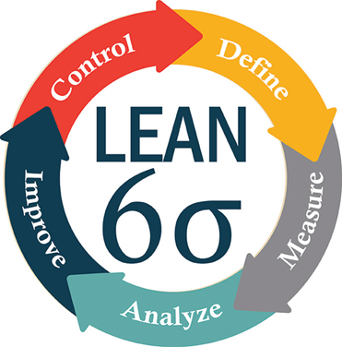

Figure 7 six sigma or σ
G- Six Sigma is a set of methodologies and tools used to improve business processes by reducing defects and errors, minimizing variation, and increasing quality and efficiency. The main goal of Six Sigma is to achieve a level of quality that is nearly perfect, with only 3.4 defects per million opportunities. This is achieved by using a structured approach called DMAIC to identify and eliminate causes of variation and improve processes.
Six Sigma is a disciplined and data-driven approach widely used in project management to achieve process improvement and minimize defects and it also provides a systematic framework to identify and eliminate variations that can impact project performance.
The etymology is based on the Greek symbol "sigma" or "σ," a statistical term for measuring process deviation from the process mean or target. "Six Sigma" comes from the bell curve used in statistics, where one Sigma symbolizes a single standard deviation from the mean. If the process has six Sigmas, three above and three below the mean, the defect rate is classified as "extremely low."
- The Six Sigma Methodology
Each of the methodology has its own set of recommended procedures to be implemented for business transformation.
1-DMAIC is a data-driven method used to improve existing products or services for better customer satisfaction. It is the acronym for the five phases: D – Define, M – Measure, A – Analyse, I – Improve, C – Control. DMAIC is applied in the manufacturing of a product or delivery of a service.
2-DMADV is a part of the Design for Six Sigma (DFSS) process used to design or re-design different processes of product manufacturing or service delivery. The five phases of DMADV are: D – Define, M – Measure, A – Analyse, D – Design, V – Validate. DMADV is employed when existing processes do not meet customer conditions, even after optimization, or when it is required to develop new methods. It is executed by Six Sigma Green Belts and Six Sigma Black Belts and under the supervision of Six Sigma Master Black Belts.
- The Six Sigma Process of the DMAIC method has five phases and each phases have three steps:
- DEFINE
The Six Sigma process begins with a customer-centric approach.
Step 1: The business problem is defined from the customer perspective.
Step 2: Goals are set. What do you want to achieve? What are the resources you will use to achieve the goals?
Step 3: Map the process. Verify with the stakeholders that you are on the right track.
- MEASURE
The second phase is focused on the metrics of the project and the tools used in the measurement. How can you improve? How can you quantify this?
Step 1: Measure your problem in numbers or with supporting data.
Step 2: Define performance yardstick. Fix the limits for "Y."
Step 3: Evaluate the measurement system to be used. Can it help you achieve your outcome?
- ANALYZE
The third phase analyzes the process to discover the influencing variables.
Step 1: Determine if your process is efficient and effective. Does the process help achieve what you need?
Step 2: Quantify your goals in numbers. For instance, reduce defective goods by 20%.
Step 3: Identify variations using historical data.
- IMPROVE
This process investigates how the changes in "X" impact "Y." This phase is where you identify how you can improve the process implementation.
Step 1: Identify possible reasons. Test to identify which of the "X" variables identified in Process III influence "Y."
Step 2: Discover relationships between the variables.
Step 3: Establish process tolerance, defined as the precise values that certain variables can have, and still fall within acceptable boundaries, for instance, the quality of any given product. Which boundaries need X to hold Y within specifications? What operating conditions can impact the outcome? Process tolerances can be achieved by using tools like robust optimization and validation set.
- CONTROL
In this final phase, you determine that the performance objective identified in the previous phase is well implemented and that the designed improvements are sustainable.
Step 1: Validate the measurement system to be used.
Step 2: Establish process capability. Is the goal being met? For instance, will the goal of reducing defective goods by 20 percent be achieved?
Step 3: Once the previous step is satisfied, implement the process.
- The Six Sigma Tools:
- Cause and Effect Analysis
- Flow Chart
- Pareto Chart
- Histogram
- Check Sheet
- Scatter Plot
- Control Chart
- The six sigma Techniques:
- Brainstorming
- Root Cause Analysis/The 5 Whys
- Voice of the Customer
- The 5S System
- Kaizen (Continuous Improvement)
- Poka-yoke (Mistake Proofing)
- Benchmarking
- Become a Quality Management Professional
- Value Stream Mapping

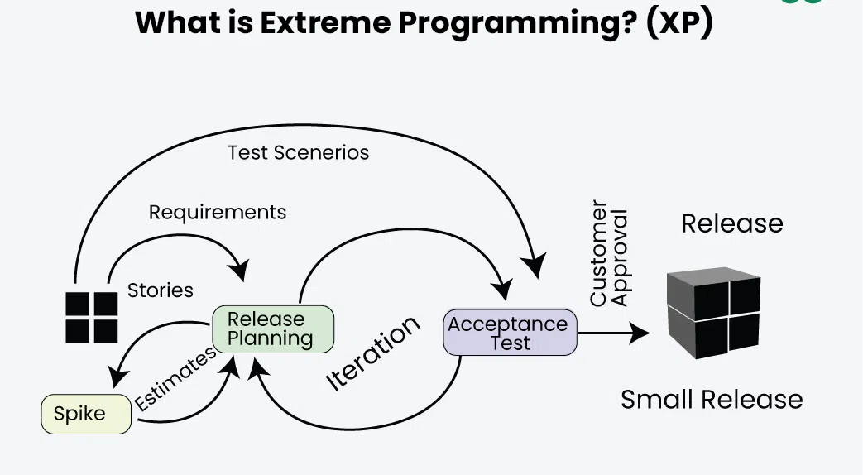
Figure 8 XP

H- Extreme Programming (XP) is an agile methodology created in the late 90s for software development and It's a methodology that aims to create high-quality systems based on close interaction with customers, continuous testing, and short development cycles.
- How does Extreme Programming work?
the main goal is to perform fast, continuous, and incremental delivery cycles in order to achieve the results expected by clients.
In XP, this is done based on predefined practices and stages so processes achieve maximum effectiveness. The software (or another project) is developed in weekly cycles, with regular meetings between customers and the development team.
- Planning game: at the start of the week, the team meets with customers to list the most important features and to clarify expectations , needs regarding the project. At this point, you define the scope. This meeting is called the planning game.
- On-site customer: the client is present at all times to address any questions, scope priorities, and alterations.
- Small releases or deliveries: at the end of the week, customers receive small versions of the project to test and suggest improvements.
- Metaphor: the strategy used by the tech field to facilitate communication with customers, translating the particularities of the system into their reality. By easing understanding, you gain time and align expectations.
- Simple design: the simpler the code and the search for results expected by the customers, the better. Simplicity must focus on results(an easy-to-develop code doesn't always represent the simplest solution for customers).
- User testing: the time when customers and analysts test deliveries.
- Sustainable pace: Extreme Programming assumes respect for the human factor , seeks motivation and harmony among those involved. Cycles must comprise weeks of up to fourty hours, with a healthy work pace for the team.
- Collective ownership: developed projects must be known and accessible to the entire team without the need for permission in order to accelerate the process and make it more transparent, in line with the principles of visual management.
- Pair programming: 2 programmers work on a single computer to ensure that development is being constantly revised and each professional's learning grows throughout the process. Two heads are better than one, and this idea encourages programmers to share business rules knowledge and equalize their technical skills.
- Coding standard: in the case of software development, the code has to be standardized so that everyone follows the same rules and the code looks as if it was edited by one person as a result.
- Test-oriented development: unit tests are essential for project quality. Create unit tests, and only then, create the code needed for them to work.
- Refactoring: a process that allows for continuous improvement of a project, making it clearer, with fewer chances of mistakes or duplicate processes.
- Continuous integration: new functionalities must be rapidly integrated into the system's current version, because the sooner you perform tests, the sooner you will discover problems that can be fixed.
- Good Practices in Extreme Programming:
- Code Review: Code review detects and corrects errors efficiently.
- Testing: Testing code helps to remove errors and improves its reliability.
- Incremental development: Incremental development is very good because customer feedback is gained and based on this development team comes up with new increments every few days after each iteration.
- Simplicity: Simplicity makes it easier to develop good-quality code as well as to test and debug it.
- Design: Good quality design is important to develop good quality software. So, everybody should design daily.
- Integration testing.
- Advantages of Extreme Programming (XP)
- Slipped schedules.
- Misunderstanding the business and/or domain
- 3Canceled projects.
- Staff turnover.
- Costs incurred in changes.
- Business changes.
- Production and post-delivery defects.
- When to Use XP
XP is particularly well-suited for projects with:
- Volatile requirements
- Teams committed to solid engineering practices
- A culture of close collaboration
- A need for rapid delivery and high code quality
7- Combining multiple project management methodologies

A hybrid PM methodology is a combination or two or more of the many different approaches to delivering projects. It's taking elements of a few project methodologies (often the waterfall method or one of the agile methodologies) and making it your own to fit the needs of your project.
And this notion of hybridizing or tailoring your project approach is not as uncommon as some folks have led you to believe. In fact, a study from ProjectManager.com reported that 60 % of the surveyed practitioners were using a hybrid approach or a tailored blend of many styles.

1. Waterfall + Agile
- When to Use: This hybrid approach works well in projects where certain phases require strict documentation and linear progression (like in regulatory or compliance-based projects), but other phases can benefit from flexibility (like product development or design).
- How It Works:
  - Use Waterfall for high-level planning and initial requirements gathering, as it ensures documentation and clear milestone-based progression.
  - Once the project reaches the design or development phase, switch to Agile to manage iterative cycles, allowing for frequent feedback and adaptability.
- Example: Implementing a new software system in a healthcare setting. Use Waterfall for regulatory approval and requirement phases, then Agile for developing features, testing, and getting iterative feedback from users.
2. Scrum + Kanban
- When to Use: Combining Scrum and Kanban (often called Scrumban) is effective in projects where there’s a need for both time-boxed sprints (Scrum) and continuous delivery (Kanban).
- How It Works:
  - Apply Scrum principles to structure short-term goals and sprints, fostering teamwork and accountability.
  - Use Kanban to manage ongoing tasks, visualize workflow, and handle tasks that do not fit within a specific sprint.
- Example: In a customer support software project, Scrum could manage new feature development, while Kanban handles continuous bug fixes, maintenance, and minor updates.
3. Agile + Lean
- When to Use: This approach is ideal for projects focused on reducing waste, optimizing resources, and delivering value quickly to customers.
- How It Works:
  - Lean principles focus on removing waste from processes, optimizing team workflows, and increasing efficiency.
  - Agile principles encourage adaptability, customer feedback, and iterative improvement.
- Example: In product development for a tech startup, Lean minimizes resource use, while Agile sprints deliver small, testable increments, enabling fast market feedback and pivoting.
4. PRINCE2 + Agile
- When to Use: This combination is suitable for large projects where a high level of governance is required but where the project also benefits from Agile’s adaptability.
- How It Works:
  - Use PRINCE2 to provide an overall structure with stages, defined roles, and clear governance and accountability.
  - Within each PRINCE2 stage, adopt Agile methods for development tasks to increase flexibility and allow for iterative improvements.
- Example: A government IT project could use PRINCE2 for oversight, documentation, and formal stages, while using Agile to manage the development of user-facing software.
5. Waterfall + Lean Six Sigma
- When to Use: This hybrid approach works well in projects that require highly structured and controlled processes, like manufacturing, where quality and efficiency are crucial.
- How It Works:
  - Use Waterfall to define and sequence all project phases, ensuring each phase builds on the previous one with clear deliverables.
  - Within each Waterfall phase, apply Lean Six Sigma principles to minimize waste, reduce variability, and improve quality.
- Example: Implementing a new manufacturing line, where Waterfall guides the overall structure, and Lean Six Sigma ensures efficiency and minimizes errors in each phase.
6. Critical Path Method (CPM) + Agile
- When to Use: CPM and Agile together are valuable for projects with many dependencies that also benefit from iterative development cycles.
- How It Works:
  - Use CPM to identify the longest path of dependent tasks and manage schedule constraints.
  - Use Agile within non-dependent tasks or those on shorter paths to allow flexibility, feedback, and iterative development.
- Example: In a construction project where design elements are on a critical path, CPM can manage the schedule, while Agile is used by the software team to iteratively design a companion app for project management.
7. PMBOK Guide (Process-Based) + Scrum
- When to Use: This approach is ideal for larger projects that require extensive planning and standardization, while smaller components or modules can be managed iteratively.
- How It Works:
  - Use the PMBOK Guide to set up foundational processes like risk management, quality assurance, and procurement.
  - Use Scrum to manage development phases, breaking the project into sprints, iterating on deliverables, and incorporating stakeholder feedback.
- Example: In a product launch with strict budget and quality requirements, PMBOK ensures comprehensive planning, while Scrum manages the creative design and marketing strategy in iterative sprints.

- To determine if a hybrid approach is suitable for your project consider the following factors:
  - Project flexibility and adaptation: Agile is ideal for project parts that need continuous innovation and change. If your project requires frequent adjustments, incorporating agile components can be beneficial.
  - Clear steps and processes: The traditional waterfall approach works best for tasks with a sequential order and specific requirements. If your project involves parts with well-defined steps, incorporating waterfall elements can provide structure and clarity.
  - Team familiarity with methodologies: Ensure your team members understand and can adapt to new methods. Training and support may be necessary to facilitate a smooth transition to a hybrid approach.
  - Resource availability: Combining methodologies requires sufficient resources, including time, budget, and personnel. A dedicated project team that can collaborate daily is critical to successfully implementing a hybrid approach.
  - Client and stakeholder alignment: Securing stakeholder buy-in is essential for implementing a hybrid strategy. Stakeholders must be willing to provide frequent feedback and support the flexibility of a hybrid approach.
  - Budget flexibility: A hybrid approach often requires a flexible budget due to evolving deliverables and the need for adaptation. Consider whether your project's budget can accommodate potential changes throughout the project lifecycle.
  - Team communication and collaboration: A hybrid approach demands strong communication and teamwork. Assess your team's ability to collaborate effectively and regularly to ensure a successful implementation.
  - Continuous evaluation and improvement: A hybrid approach requires regular feedback, adjustments, and enhancements for success. Your team must be open to change and dedicated to refining the process continually.

- Benefits of a Hybrid Approach:
- Flexibility and Structure: Enables project teams to benefit from structured frameworks (e.g., Waterfall or PRINCE2) and the adaptability of Agile or Lean.
- Improved Risk Management: Allows for better risk assessment and management through structured processes, while iterative methods provide room for adjustments as issues arise.
- Enhanced Stakeholder Engagement: Agile-based methodologies keep stakeholders engaged with continuous feedback loops, while traditional methods ensure all requirements are documented and tracked.

- Challenges of a Hybrid Approach:
- Complexity in Management: Managing multiple methodologies simultaneously can be complex and require strong coordination and expertise.
- Resource Allocation: Balancing resources between traditional, time-bound phases and flexible, iterative phases can be challenging.
- Potential for Misalignment: If not well-integrated, team members may face confusion over methodology boundaries and responsibilities.
8-Research Questions, Purpose of the Study and Research Methods.
- Research Questions
This review paper aims to find answer to the following questions:
First what are the main challenges for project management in this century that influence the overall performance and efficiency of project management?
second what are the key parameters under each project management challenges that need to be addressed?
- Purpose of the Study.

This paper aims to highlight some on the wide range of issues that the PM professionals have faced within past decades, which could be consolidated into a list of major hurdles.

- Research Methods.

There has been an increasing necessity to align project management with the strategic objectives and performance enhancement of organizations. In this context, recognizing the common challenges encountered by organizations in project management can contribute to the advancement of this essential field of knowledge. This paper primarily aims to examine the key challenges faced by project managers in the contemporary era to support the development of the future built environment. A systematic literature review was conducted, analyzing over 256 published research articles from the last 15 years, specifically covering the period from 2003 to 2018. The findings of this investigation revealed 18 significant challenges and more than 125 parameters associated with project-related difficulties identified in the existing literature. The principal sources of the reviewed papers included publications from ScienceDirect,, Emerald, and John Wiley & Sons, Inc. Through an extensive literature review, several major challenges for project managers were identified based on their frequency in the analyzed papers, encompassing areas such as scope management, information technology,, team dynamics, customer satisfaction, lean management,, communication, and quality, among others. Table 1 presents the top 12 challenges highlighted in the existing literature. This table also identifies and summarizes the parameters of the challenges. According to our findings and based on the number of repetitions and different perspectives of the challenges in the literature researchers were interested in risk management, human resource management, and project definition and planning ranked first on the list. We were able to order these challenges in our ranking system with three challenges that were not clearly differentiated. Based on this, we decided that risk management, human resource management and scope management were the top challenges faced by project managers in managing various projects. Based on the analysis of the current literature which focuses on stakeholder management as well as value management and sustainability also ranked fourth among the identified challenges faced by project managers. However, these concepts can be in some industries, such as the construction industry, which is at the core of sustainable development in different countries, more extensively. Therefore, managing the stakeholder and addressing their requirements in line with value to the project and sustainability issues are among the key challenges for PMs. End the list of challenges continues until Innovation and Creativity as the final ranked challenge. Project managers(PM) working in imaginative or creative projects such as software development are challenged by loosely defined innovative processes. Innovation, therefore, is counted as one of the necessary areas for improvement as the innovation that will result from advancement is unknown until the project commences. Therefore, innovation in agile projects usually associated with high tech industries such as those in information technology projects.

Table 1 Top challenges
1 | Challenges  Risk Management | - Financial Risk  - Legal & Contractual Risk political Risk  Operational Risk  - Force Majeure  Technological Risk  Construction Risk  Maintenance Risk  Environmental Risk  Organizational Risk  Schedule Risk  Design Risk  Project Sponsor Risk | References  Hwang & N! (2013); Sawhney & Paul (2014); padalkar & Gopinath, (2016);  Sanchez-Cazorla.  & Alfalla-l-uque. (2014):  Kululanga & Kuotcha (2010); Dziadosz— Tomczyk. & Kaplihski,  (2015)
 | Human Resource Management | Staff Recruitment Issues  Teamwork  Virtual teams  Cultural challenges  Labor related challenges  • Cross-cultural skills  Transformational leadership | Hwang & Ng (2013): Sawhney &  Paul (2014): Padalkar & Gopinath (2016): Marrewijk (2010): Aarseth et al. (2014): Ainamo et al. (2010); Tabassi & Bakar (2009): Tabassi.  Randi, & Bakar. (2012)
 | Project Definition and Planning | Project Scope Management Project Location | Hwang & Ng (2013): Khan et al. (2018)
2 | Performanee  Management | Relationship between standards and  • Method to align intangible outcomes  Systematic biases and influence Of culture in project outcomes ject management maturity  Key performance indicators | Sawhney & Paul (2014): Padalkar  & Gopinath (2016); Elonen &  Artto (2003): Crawford (2005);  Nogeste & Walker (2008); Shore  Yazici (2009); Ogunlana (2010);  D010i, Sawhney. lyer. & Rentala  (2012); Meng (2012)
3 | Knowledge Management | Knowledge competencies in project organizations Knowledge sharing  Tacit knowledge acquisition and sharing Integration in cross-functional projects  Knowledge creation in interdisciplinary project | Padalkar & Gopinath (2016):  Dogbegah. Owusu-Manu. &  Omoteso (2011 )
4 | StakeholderManagement | Internal stakeholders  External Stakeholders  - Stakeholder Relationship  - Trust Building  - Knowledge Sharing | Aarseth et al. (2014);  (2013):  Padalkar & Gopinath (2016)
 | Value Management and | Environmental sustainability Energy Efficiency  Water Efficiency  Ecology  Conservation  Material Efficiency  Pollution Control  • Land Utilization  Indoor Environmental quality  Social sustainability  Quality of Life  Health  Transportable  Aesthetics  Safety | Sawhney Paul (2014); Zhang.  Shen & wu (2011);  Tagaza & Wilson (2004);  Williams & Dair (2007)

Nuisance to Neighbours
Economic sustainability
Building Affordability
Exßnditure in Renovating and developing
Business enhancement
Legislation Compliance
Profitability
Waste management
 | Cost Management | Estimation  - Cost Monitoring and Controlling  Value analysis  - Life Cycle Cost Of Building | Hwang & Ng (2013):  Nian al. (2016);  Padalkar & Gopinath (2016)
6 | Agile Project Management | Fluctuation of prices of materials  - Shortages Of materials  Changes in material  - slxeification and type  - Communicating  - changing culture and mind-set  - Day-to-day operational prc%lems  - Delay in delivery of materials  - Ecpipment availability and failure  - Late delivery Of equipment  - Insufficient number of equipment  - High of machinery  - Process not understood  - JIN-in-time Inventory Asstk•iated Risks  - Single Source Alliance Asqxiated Risks  - Just-in-Time Management General Risks | Hwang & Ng (2013):  Sawhney & Paul (2014): Golini &  Kalchschmidt•s (2015)
 | Conflict and Dispute Management | - Conflict management strategies  - Identifying sourcæ of conflict  - Conflict and Innovation | Hwang & Ng (2013):  Niazå al. (2016):  Sawhney & Paul (2014): Tabassi.  Rou fechaei. Baku. & NorAini  (2017)
 | Health and safety managenrnt | Leadership mindset and corporate commitment Life cycle approach to OH. investment in infrastructure and management systems  - Awareness. Education Training  - Regulatory framework and compliance  Use ofTechnology as a strategic enabler | Hwang & Ng (2013): Sawhney & Paul (2014)
 | Communication Management | Rapid advancement of information and communication technologies Virtual communications  Maintaining the authenticity and tmstworthine.ss of electronic records Violating Confidentiality | Hwang & Ng (2013);  Padalkar & Gopinath (2016)
10 | Claim Management | - Inconsistent Service Delivery  Increasing Customer Demand  - Supplier performance | Dogbegah et al. (2011)
 | Information Technology Management | - BIM Adaptation (construction industry)  - Client demand  - Lack ofBIM skills and exlkllise in technical and system requirements  - Significant adoption cost to implementing  BIM  - Lack about BIM  - Lack of BIM guidelines and standards Primavera as a tools for managing projects not used widely by PMS  - Computing and security issues | Aarseth et al. (2014);  Sawhney & Paul (2014);
12 | Procure  Management | Contract Documents  - Sub-contract nunagement  - Supplier Preselection System | Padalkar and Gopinath (2016); Johnson & Flynn (2015):  Soilish & Sernanik (2012)
Supplier Performance Measurement
- Negotiation
- Contract Dispute and Resolutions
The main object in almost all teambased activities is clearly set for the team to perform in a stress-free atmosphere. Thus, the project manager is acting as a facilitator and needs to understand the cultural variations and possible sensitivities of different individuals to be able to attempt to gain alignment and coordination of the team to perform cohesively on current and forthcoming projects. Team members’ perception of the way in which their desired goals may be affected by actions of others or the project managers significantly influences both the nature of interactions and the final results of conflict management (Tabassi et al., 2017). Consequently, one of the main challenges of project managers in international projects is dealing with different cultures that may possibly use different methods in dealing with conflict in the course of managing multi-cultural teams (Tabassi et al., 2017.
- Findings
It is clear that the cultural background of team members, and the environment in which the project teams operate, are two significant aspects in figuring out inspiration drivers for team performance. As a result, further exploration of the prominent culture and values of individuals, is recommended, along with the features of working conditions, prior to application of appropriate motivational theories, or activation of action specific management tactics. It could be suggested that the outcomes received by preceding studies are limited, or in other words they could be relevant only to that particular cultural feature, thereby there is a lack to declare majority of lessons learned from the literature to generality in the international outline, End according to the findings of this review, future trends of project management are not very different from the ones that have been witnessed in recent years. Complexity is expected to increase, on a global basis. Project teams will be more diverse and virtually-based, so the focus of the project manager will remain communication (Hartono, 2018). Clients’ participation will rise and collaboration between stakeholders will start earlier. New tools, technological models and risks will emerge, and new methods, specifically lean and agile, will become implemented more fully. Project managers in the future are expected to have many different skills. Of prime importance are soft skills, social, communication and leadership skills, broad knowledge about economy, law, industry, tools and methods. Finally, technological skills will be more and more important in the successful delivery of projects.
- Conclusion
To sum up, the initial literature review across a broad range of journals has been conducted but few articles revealed anything specifically about trends and challenges within projects, End It is noted that several topical themes such as performance, risk, governance & control, project complexity or uncertainty, and organizational factors involve a high degree of interdependence, intractable or unknown variables, and human cognitive factors.

9-References
  - Padalkar, M., & Gopinath, S. (2016). Six decades of project management research: Thematic trends and future opportunities. International Journal of Project Management, 34, 1305–1321.
  - PMI. (6th Ed.). (2017). A Guide to the Project Management Body of Knowledge (PMBOK Guide). Pennsylvania, US: Project Management Institute.
  - Tabassi, A. A., Roufechaei, K. M., Bakar, A. H. A., & NorAini, Y. (2017). Linking Team Condition and Team Performance: A Transformational Leadership Approach. Project Management Journal, 48(2), 22-38.
  - Muller, R., & Jugdev, K. (2012). Critical success factorsin projectsPinto, Slevin, and Prescott – the elucidationof project success. International Journal of Managing Projects in Business, 5(4), 757- 775.
  - Project Management Institute. 2017. The Standard for Project Management. Newtown Square, PA: Author.
  - Project Management Institute. 2013. The Standard for Portfolio Management – Third Edition. Newtown Square, PA: Author.
  - Project Management Institute. 2017. The Standard for Program Management – Fourth Edition. Newtown Square, PA: Author.
  - Project Management Institute. 2016. The PMI Lexicon of Project Management Terms. Available from http://www.pmi.org/lexiconterms
  - Project Management Institute. Code of Ethics and Professional Conduct. Available from
  - http://www.pmi.org/codeofethics
  - Project Management Institute. 2013. Managing Change in Organizations: A Practice Guide. Newtown Square, PA: Author.
  - Project Management Institute. 2015. Business Analysis for Practitioners: A Practice Guide. Newtown Square, PA: Author.
  - Project Management Institute. 2016. Governance of Portfolios, Programs, and Projects: A Practice Guide. Newtown Square, PA: Author.
  - Project Management Institute. (2013). PMI’s Pulse of the Profession® In-Depth Report: The Competitive Advantage of Effective Talent Management. Available from http://www.pmi.org
  - Project Management Institute. 2015. White Paper, Complexity Management for Projects, Programmes, and Portfolios: An Engineering Systems Perspective, March 2015. Newtown Square, PA: Author.
  - Project Management Institute. 2014. Navigating Complexity: A Practice Guide. Newtown Square, PA: Author.
  - Project Management Institute. 2016. Requirements Management: A Practice Guide. Newtown Square, PA: Author.
  - Project Management Institute. 2006. Practice Standard for Work Breakdown Structures (WBS). Newtown Square, PA: Author.
  - Project Management Institute. 2011. Practice Standard for Earned Value Management – Second Edition
  - International Standards Organization. 2015. ISO 9000:2015 Quality Management Systems—Fundamentals and Vocabulary. Geneva: Author.
  - Project Management Institute, Inc., A Guide to the Project Management Body of Knowledge (PMBOK® Guide) – Sixth Edition (2017).

  - PMI (2017). Project Management Job Growth and Talent Gap Report 2017 to 2027. Web. Available at: www.pmi.org/learning/careers/job-growth [Accessed 24 September 2020]

  - Excelling in Software Development with Scrum Methodology Part 2 by Tokay Korkut https://blog.stackademic.com/excelling-in-software-development-with-scrum-methodology-part-2-e2d0b29437ce

  - Toyota Production System. (n.d.) Retrieved July 31, 2023. https://global.toyota/en/company/vision-and-philosophy/production-system/
  - Toyota Production System. (n.d.) Retrieved July 31, 2023. https://global.toyota/en/company/vision-and-philosophy/production-system/
  - Bubernak, C., & Schweikert, M. (2012, March 23). Lean Software Development. University of Colorado.
  - https://home.cs.colorado.edu/~kena/classes/5828/s12/presentation-materials/schweikertmarcbubernakchris.pdf
  - Lean Enterprise Institute (n.d.) What is Lean? Retrieved July 31, 2023 from https://www.lean.org/explore-lean/what-is-lean/
  - Toyota UK Magazine. (2013, May 31). Muda, Muri, Mura — Toyota Production System Guide. https://mag.toyota.co.uk/muda-muri-mura-toyota-production-system/
  - Why is Project Management Important? 01 Jul, 2024 https://www.geeksforgeeks.org/why-is-project-management-important/
  - • Kerzner, H. (2017). Project Management: A Systems Approach to Planning, Scheduling, and Controlling. 12th Edition. John Wiley & Sons, Inc.
  - Harold Kerzner's work covers practical tools and techniques for managing complex projects, with insights into budgeting, scheduling, and risk management—key components of the CRM system implementation project.
  - • Salesforce.com, Inc. (n.d.). Salesforce Implementation Guide. Retrieved from Salesforce official website.
  - Salesforce provides detailed guides and best practices for CRM customization, data migration, and user training. This is essential for understanding the technical aspects of the CRM implementation.
  - • Kotter, J. P. (1996). Leading Change. Harvard Business Review Press.
  - John Kotter’s change management model provides insights into managing resistance and fostering adoption, which are crucial to the change management strategies in the CRM implementation.
  - • Becerra-Fernandez, I., & Sabherwal, R. (2014). Knowledge Management: Systems and Processes. M.E. Sharpe.
  - This book details knowledge management processes that support project execution and change management, focusing on tools that help collect, integrate, and utilize organizational data effectively.
  - • Wysocki, R. K. (2019). Effective Project Management: Traditional, Agile, Extreme. John Wiley & Sons, Inc.
  - Covers adaptive project management techniques and risk mitigation approaches suitable for tech-related projects, like CRM implementations, which often face integration and user training challenges.
  - • Anderson, D., & Anderson, L. A. (2010). Beyond Change Management: How to Achieve Breakthrough Results Through Conscious Change Leadership. Pfeiffer.
  - This book covers effective strategies for leading change initiatives, including stakeholder engagement and fostering a collaborative environment, which is applicable to CRM adoption and user training.
  - • Alter, A. (2016). Analytics for Managers: With Excel and JMP. Chapman and Hall/CRC.
  - Provides insights on leveraging analytics in business projects, including CRM systems, which offer critical data insights that were one of the main goals of ABC Corporation's CRM implementation.

