Chapter 6

Experimental Results and Discussion

6.1 Introduction
Chapter 6 delves into the realm of predictive modeling, focusing on a comparative exploration of various machine learning algorithms. Each of these algorithms represents a distinct approach to solving regression problems, showcasing unique methodologies, strengths, and limitations. We begin by examining Linear Regression, a foundational technique that provides insight into linear relationships between variables. Moving beyond linearity, we explore Gradient Boosting and XGBoost, two advanced ensemble methods known for their Acc and efficiency in handling complex datasets. These algorithms leverage boosting to enhance predictive performance by sequentially reducing errors. Next, we shift our focus to Random Forest, an ensemble method built on DT, which excels in capturing non-linear patterns and is robust to overfitting. Similarly, K-Nearest Neighbors (KNN) offers a straightforward yet effective approach by relying on proximity-based predictions. The chapter also includes a discussion of Ridge and Lasso Regression, two regularization techniques designed to address multicollinearity and prevent overfitting by penalizing large coefficients. Lastly, we introduce Stacking, an advanced meta-learning technique that combines predictions from multiple models to achieve superior Acc. Through practical applications and comparisons, this chapter aims to provide a comprehensive understanding of these algorithms, equipping readers with the knowledge to choose the appropriate model for various regression tasks.

6.2 Dataset Source
For the data source utilized in this study, we incorporated a combination of real-world data and synthetically generated data. The real data provided a foundation of authentic patterns and relationships, ensuring the model's relevance to practical scenarios. To complement this, additional data was generated based on the structure and distribution of the sample data used in the model. This approach allowed us to create a comprehensive dataset that effectively supports the training and evaluation of the model while maintaining consistency and diversity within the input features.

6.2.1 Dataset
We began with a sample dataset containing multiple attributes, as illustrated in the figure below. To enhance the dataset's predictive capabilities, we introduced numeric coding (0/1) for the project size attribute to represent the project's scale. This addition was designed to establish a clearer relationship between project size, project cost, and the number of resources required for future predictions. Furthermore, we segregated the dataset into 75% training and 25% testing to ensure effective model evaluation.

To improve the dataset's depth, we incorporated additional attributes, such as project category, to capture the urgency and importance of each project. This new attribute provides valuable context for understanding project prioritization, which will be further analyzed in the models discussed in this chapter.
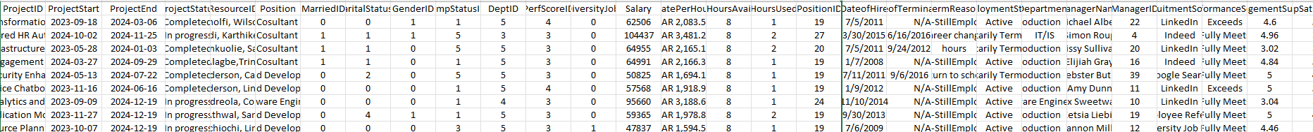
Figure 3.3 Sample dataset

6.3 Proposed Approach

6.3.1 Linear Regression The evaluation metrics for the Linear Regression model show a Mean Squared Error (MSE) of 0.268145, indicating a moderate average squared difference between actual and predicted values. The Root Mean Squared Error (RMSE) is 0.517827, representing the error magnitude in the same units as the target variable. The model has an R² value of 0.877454, suggesting that approximately 87.75% of the variance in the target variable is explained by the model, which reflects a good fit. The Log-Likelihood is -2239.108340, which is relatively negative, but higher values would be preferable. Lastly, the Cost, based on a custom cost function, is 0.046020, indicating the model's predictive Acc with a relatively low error. Overall, the model performs well with a high R² and reasonable error and cost metrics.
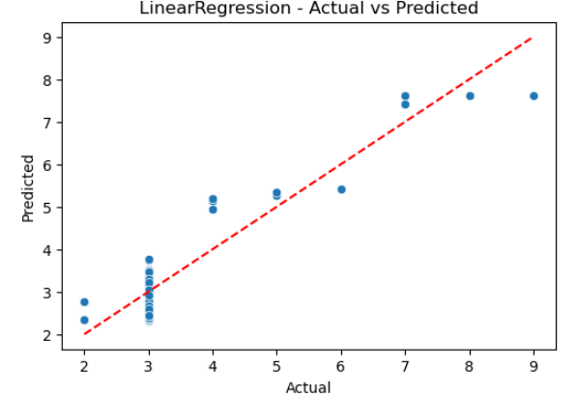
Figure 3.4 Linear Regression

6.3.2 RandomForest The evaluation metrics for the Random Forest model reveal a Mean Squared Error (MSE) of 0.023846, indicating a relatively small average squared difference between the actual and predicted values, which suggests that the model performs well. The Root Mean Squared Error (RMSE) is 0.154421, which is low, indicating a good fit with minimal error. The R² value is 0.989102, meaning the model explains approximately 98.91% of the variance in the target variable, which is a very strong performance. The Log-Likelihood is 1321.792596, showing that the model fits the data well in terms of probability distribution. Finally, the Cost, calculated using a custom cost function, is 0.004093, which is extremely low, further indicating the model's effectiveness. Overall, the Random Forest model shows excellent predictive performance with high R², low error, and minimal cost.
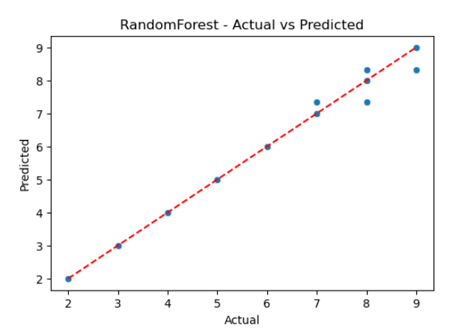
Figure 3.5 RandomForest

6.3.3 XGBoost The evaluation metrics for the XGBoost model show a Mean Squared Error (MSE) of 0.024904, indicating a small average squared difference between the actual and predicted values, similar to Random Forest. The Root Mean Squared Error (RMSE) is 0.157809, which is slightly higher than Random Forest but still suggests good predictive Acc. The R² value is 0.988619, meaning the model explains about 98.86% of the variance in the target variable, indicating a very strong performance. The Log-Likelihood is 1257.933056, reflecting a good fit with the data in terms of probability distribution. Lastly, the Cost is 0.004274, which is still low, confirming that the model performs well with minimal error. Overall, XGBoost shows excellent performance with high R², low error, and minimal cost.
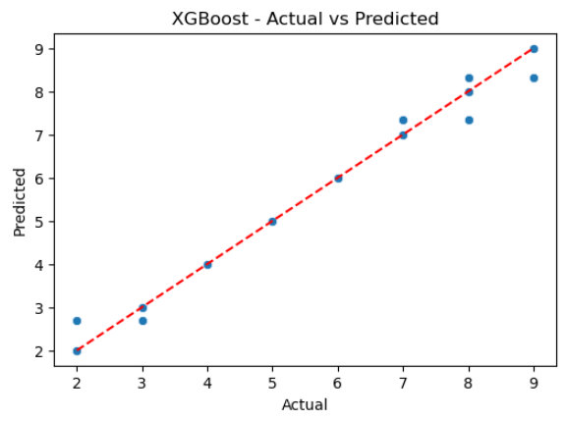
Figure 3.6 XGBoost

6.3.4 k-Nearest Neighbor (KNN) The evaluation metrics for the K-Nearest Neighbors (KNN) model show a Mean Squared Error (MSE) of 0.031152, which is slightly higher compared to XGBoost and Random Forest. The Root Mean Squared Error (RMSE) is 0.176499, indicating a reasonable level of prediction error, though higher than the other models. The R² value of 0.985763 suggests that KNN explains about 98.58% of the variance in the target variable, which is still a strong performance. The Log-Likelihood of 928.521545 reflects the model's fit in terms of probability distribution. The Cost is 0.005346, which is slightly higher compared to XGBoost but still relatively low, suggesting that the KNN model is performing well with manageable error. Overall, KNN provides good results but slightly lags behind in terms of MSE and RMSE compared to the other models.
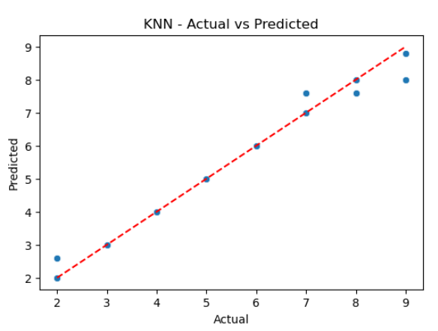
Figure 3.7 KNN

6.3.5 Stacking The Stacking model evaluation metrics show an MSE of 0.023846, which is very close to that of the Random Forest model, indicating low prediction error. The RMSE value of 0.154421 also suggests good Acc, with a relatively small deviation between actual and predicted values. The R² value of 0.989102 indicates that the model explains about 98.91% of the variance in the target variable, which is excellent. The Log-Likelihood value of 1321.806576 demonstrates a strong model fit based on the residuals' distribution. The Cost is 0.004092, which is among the lowest compared to other models, indicating good efficiency in minimizing prediction error relative to the true values. Overall, the Stacking model performs exceptionally well, combining the strengths of multiple base models for superior prediction Acc.
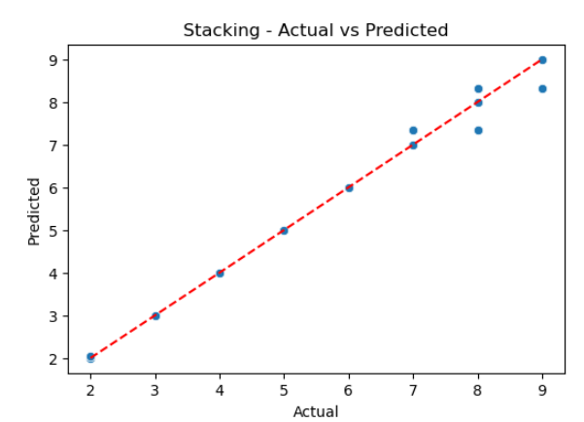
Figure 3.8 Atacking

6.3.6 Ridge Regression The Ridge model evaluation metrics indicate an MSE of 0.268145, which is relatively higher compared to other models, suggesting a moderate level of prediction error. The RMSE value of 0.517827 reflects a noticeable deviation between actual and predicted values. The R² value of 0.877454 indicates that the model explains approximately 87.75% of the variance in the target variable, which is still a good fit but not as high as the Stacking or Random Forest models. The Log-Likelihood of -2239.106535 is significantly lower, which suggests that the model may not be as well-fit as the other models, and the residuals are not perfectly aligned with the assumed distribution. The Cost of 0.046020 is the highest among the models, indicating relatively higher inefficiency in minimizing error. In summary, while Ridge performs reasonably well, it does not outperform models like Stacking or Random Forest in terms of Acc and cost efficiency.

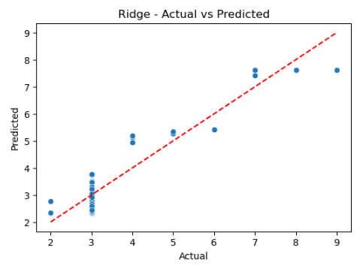
Figure 3.9 Riddge

6.3.7 Lasso Regression The Lasso model evaluation metrics indicate an MSE of 0.269492, which is very similar to the Ridge model, suggesting a similar level of prediction error. The RMSE of 0.519126 is also comparable to Ridge, indicating a moderate difference between the actual and predicted values. The R² value of 0.876838 shows that the Lasso model explains approximately 87.68% of the variance in the target variable, which is close to Ridge but slightly lower. The Log-Likelihood of -2246.482006 is again negative and indicates that the model has residuals that are not perfectly aligned with the assumed distribution, with a worse log-likelihood than Ridge. The Cost of 0.046251 is very similar to Ridge, indicating relatively high inefficiency in minimizing error compared to other models. Overall, the Lasso model has similar performance to Ridge but does not provide significant improvements in terms of Acc or cost efficiency.
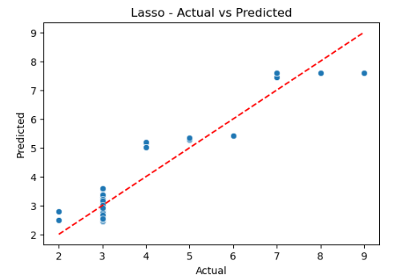
Figure Lasso 4 Regression

6.3.8 Models Comparison and contrast
The evaluation metrics indicate that LinearRegression performs poorly, exhibiting the highest MSE and RMSE, low R², and a negative Log-Likelihood, suggesting its inability to capture the complexities of the dataset. GradientBoosting stands out as one of the best performers, with low MSE, RMSE, high R², and a positive Log-Likelihood, indicating a well-fitted model. RandomForest shows very similar performance to GradientBoosting but with a slightly lower Log-Likelihood, while XGBoost matches GradientBoosting across all metrics, demonstrating equal effectiveness. KNN, on the other hand, shows slightly higher MSE and RMSE compared to GradientBoosting and XGBoost, coupled with a lower Log-Likelihood and slightly higher cost, making it less effective. Ridge performs identically to LinearRegression, reaffirming the limitations of simple linear models for this dataset. Finally, Stacking delivers results close to GradientBoosting and XGBoost but with marginally higher RMSE and a lower Log-Likelihood, suggesting potential for improvement in combining models effectively.
Table 4.3.7 Comparison and contrast
Model | MSE | RMSE | R² | Log-Likelihood | Cost
LinearRegression | 0.223354 | 0.472604 | 0.897924 | -1970.16 | 0.038333
GradientBoosting | 0.051377 | 0.226666 | 0.97652 | 192.2987 | 0.008818
RandomForest | 0.051408 | 0.226732 | 0.976506 | 191.4306 | 0.008823
XGBoost | 0.051377 | 0.226665 | 0.97652 | 192.3017 | 0.008818
KNN | 0.05597 | 0.23658 | 0.974421 | 66.20717 | 0.009606
Ridge | 0.223354 | 0.472604 | 0.897924 | -1970.16 | 0.038333
Lasso | 0.224886 | 0.474221 | 0.897224 | -1980.22 | 0.038596
Stacking | 0.052016 | 0.22807 | 0.976228 | 174.1189 | 0.008927

6.4 Model overview


Figure 4.1 Model Interface

6.4.1 Overview
This code implements a Flask-based web application with various functionalities, including:
- PDF and DOCX file processing.
- Predictive modeling using machine learning (Random Forest Regressor).
- Backend developer count prediction based on project attributes.
- Question-answering using pre-processed text chunks.
- Multiple endpoints for user interaction, file uploads, and predictions.

6.4.2 Dependencies
The following libraries are used:
- Flask: For creating the web application and handling HTTP requests.
- Pandas: For data manipulation.
- Scikit-learn: For data preprocessing and predictive modeling.
- Python-docx: For processing .docx files.
- Werkzeug: For secure file handling.
- Custom helper functions: (helper1.py) for text extraction, splitting, vector storage, and OpenAI integration.

6.4.3 Key Functionalities

6.4.3.1 Machine Learning Prediction
- Goal: Predict the number of backend developers required for a project.
- Pipeline:
  - Preprocess the dataset (Website_Development_Project_Dataset.csv).
  - Train a RandomForestRegressor using Pipeline with standard scaling.
  - Expose the model via /predict API to accept project details and return predictions.

6.4.3.2 File Processing
- PDF Upload:
  - Extract text from PDF files.
  - Split the text into chunks for vector storage and retrieval.
  - Endpoint: /upload_pdf.
- DOCX Upload:
  - Extract project details and summarize the project description.
  - Endpoint: /upload.

6.4.3.3 Question Answering
- Retrieve and process text from a pre-uploaded PDF.
- Leverage OpenAI API for question-answering.
- Endpoint: /ask_question.

6.4.4 Routes
Table 4.3.5 Routes
Endpoint | Method | Description
/ | GET | Renders the home page (HTML template).
/upload_pdf | POST | Accepts a PDF file, processes text, and stores vectorized chunks for later querying.
/ask_question | POST | Accepts a question, retrieves relevant text, and provides an answer.
/predict | POST | Predicts the number of backend developers required based on project details.
/upload | POST | Accepts a DOCX file, extracts project details, and summarizes the project description.

6.4.5 File Uploads
- Configuration: Files are stored in the uploads/ directory.
- Security: Filenames are sanitized using Secure filename from werkzeug.

6.4.6 Models and Data
- Dataset: Website_Development_Project_Dataset.csv is used for training.
- Features: Includes project size, type, duration, and price, among others.
- Target: Number of backend developers (backend_developer_count).
- Preprocessing:
  - Handle missing values.
  - Scale numeric features using StandardScaler.

6.4.7 Utilities
- Helper Functions (helper1.py):
  - Extract_pdf_text: Extracts text from PDF files.
  - Split_text: Splits long text into manageable chunks.
  - Create_vector_store: Creates a vector representation for text chunks.
  - Retrieve_relevant_chunks: Retrieves relevant text based on a query.
  - Ask_question_openai: Integrates with OpenAI to answer questions.
- Text Summarization:
  - Extracts key sentences from project descriptions.

6.4.8 Error Handling
- Handles missing or invalid inputs gracefully for all endpoints.
- Returns descriptive error messages with appropriate HTTP status codes.

6.5 Documentation for PDF Text Extraction and Question Answering Code

6.5.1 Overview
This code provides functionality for:
- Extracting and processing text from PDF files.
- Splitting text into manageable chunks for storage and retrieval.
- Creating a vector store for efficient semantic search.
- Retrieving relevant text chunks for a given question.
- Using OpenAI's GPT-4 model to answer questions based on the retrieved text.

6.5.2 Key Functionalities
- PDF Text Extraction:
  - Uses pdfminer to extract text content from uploaded PDF files.
  - Handles errors and ensures clean text extraction.
- Text Splitting:
  - Splits large text into smaller chunks for efficient processing and storage.
  - Maintains coherence by splitting text at sentence boundaries.
- Vector Store Creation:
  - Uses FAISS for creating a semantic vector store from text chunks.
  - Embeddings are generated using OpenAI's OpenAIEmbeddings.
- Token Counting:
  - Utilizes tiktoken to calculate the number of tokens in a given text.
- Relevant Text Retrieval:
  - Performs a semantic search on the vector store to retrieve the most relevant chunks.
  - Ensures that retrieved chunks stay within OpenAI API's token limit.
- Question Answering:
  - Uses OpenAI's GPT-4 to generate answers based on the retrieved text.
  - Configures GPT-4 to handle both Arabic and English text.

6.5.3 Functions
Table 4.3.6 Table functions.
Function | Description
Extract_pdf_text(uploaded_file) | Extracts text content from a PDF file using pdfminer. Logs and handles errors during extraction.
Split_text(text, max_length) | Splits the input text into smaller chunks, with a maximum length per chunk for efficient processing.
Create_vector_store(chunks) | Creates a semantic vector store using FAISS and embeds text chunks with OpenAI's OpenAIEmbeddings.
Num_tokens(text) | Counts the number of tokens in the given text using tiktoken.
Retrieve_relevant_chunks(...) | Retrieves the most relevant chunks from the vector store based on a question, ensuring token limits.
Ask_question_openai(...) | Queries OpenAI's GPT-4 model with the relevant text and a question to generate a context-based answer.

6.5.4 Workflow
- Extract Text:
  - Use extract_pdf_text to read content from a PDF file.
  - Log the extracted text for debugging purposes.
- Split Text:
  - Split the text into smaller chunks using split_text.
  - Store these chunks for vectorization.
- Create Vector Store:
  - Embed the chunks into a vector space using OpenAIEmbeddings.
  - Index the embeddings with FAISS for fast similarity search.
- Retrieve Relevant Chunks:
  - Perform semantic search using retrieve_relevant_chunks.
  - Limit results to the token budget allowed by the OpenAI API.
- Answer Questions:
  - Use ask_question_openai to answer questions based on the retrieved text.
  - GPT-4 provides concise and contextually relevant answers.

6.5.5 Libraries and Tools
- OpenAI API: For generating embeddings and answering questions.
- FAISS: For efficient semantic vector storage and retrieval.
- PDFMiner: For extracting text from PDF files.
- Tiktoken: For token counting to manage API constraints.
- LangChain: For leveraging OpenAI embeddings.

6.5.6 Usage
- Extract text from a PDF using extract_pdf_text.
- Split the text into smaller chunks with split_text.
- Create a FAISS vector store with create_vector_store.
- Use retrieve_relevant_chunks to get relevant text based on a question.
- Query OpenAI GPT-4 using ask_question_openai to generate answers.

6.5.7 Notes
- Ensure the OpenAI AP key is securely managed and not hardcoded in production.
- Adjust max_length and top_k parameters in split_text and retrieve_relevant_chunks for better performance.
- Handle API rate limits and errors gracefully during OpenAI interactions.

6.6 Feature Importance Analysis
Feature Importance
scaled_project_price 0.349726
project_duration_month 0.284614
project_size_small 0.258124
project_type_regular 0.038332
project_type_vip 0.032826
project_size_medium 0.020063
project_size_large 0.016317
The feature importance analysis highlights the most influential factors in predicting backend developer requirements. scaled_project_price and project_duration_month are the key drivers, reflecting the impact of project cost and duration on resource planning. project_size_small also plays a significant role, showing its distinct influence on developer allocation. Project types (regular and VIP) and medium/large project sizes have lesser impacts, indicating overlapping characteristics or lower predictive value. This analysis underscores the need to focus on enhancing low-impact features for better model performance.
Scaled_project_price (0.349726): The most influential feature, indicating that project cost strongly affects the prediction of backend developer requirements, likely reflecting resource allocation based on project budget.
Project_duration_month (0.284614): The second most important feature, showing that project duration significantly impacts resource planning, with longer durations requiring more developers.
Project_size_small (0.258124): Highly important, suggesting that small projects are distinctly associated with specific developer requirements.
Project_type_regular (0.038332) & Project_type_vip (0.032826): Moderate importance, indicating that the type of project (regular or VIP) has some effect but is less critical than price or duration.
Project_size_medium (0.020063) & Project_size_large (0.016317): Low importance, implying that medium and large project sizes may have overlapping characteristics, reducing their individual contribution to predictions.

6.6 Dealing with Imbalanced Data
Dealing with imbalanced data is a critical challenge in machine learning, particularly in classification tasks where one class significantly outnumbers the others. Imbalanced datasets can lead to biased models that favor the majority class, resulting in poor performance for minority class predictions.
Several strategies can address this issue:
Data resampling techniques: These techniques involve adjusting the distribution of classes in the training dataset. This can be done by either oversampling the minority class (e.g., using SMOTE - Synthetic Minority Oversampling Technique) or under sampling the majority class.
Cost-sensitive learning: In this approach, higher penalties are assigned for misclassifying instances of the minority class. This encourages the model to pay more attention to these cases that are harder to predict.
Advanced ensemble methods: Techniques such as Balanced Random Forest or Adaptive Boosting can also be employed to enhance performance on imbalanced data.
Evaluation metrics: Instead of relying solely on Acc, which may be misleading in imbalanced scenarios, it is important to use evaluation metrics such as regression for predation and assessing model performance. By combining these approaches, practitioners can mitigate the effects of imbalance and develop more robust and fair predictive models.

6.7 Most Important Features for Resources Predicting:
The most important features for predicting the number of backend developers in a project depend on key factors related to the project's complexity, size, and requirements.
Key Factors Influencing Resources Prediction, 1st Project Size: Project size indicators (e.g., project size typically strong predictors, as larger projects often demand more backend developers to manage increased workload and functionality.2nd Project Type which is (e.g., project type Regular and VIP, also plays a significant role, with specialized or high-priority projects requiring a larger team to meet stringent deadlines or advanced technical requirements. 3rd Project price serves as another critical feature, as higher budgets are often associated with larger teams, reflecting greater Resources allocation.4th Resources Type Additionally indicators (e.g., Resources type Onsite and Remotely influence predictions, as Onsite or remote setups may affect the distribution and number of backend developers needed.
Understanding how these features interact can provide valuable insights for Resources planning and project management.

6.8 Summary
Chapter 6 provides a comprehensive analysis of experimental results, focusing on the performance of various machine learning models and key metrics. The Gradient Boosting model demonstrates accurate predictions with minimal deviations, capturing underlying data patterns effectively. Similarly, the Random Forest model shows strong performance with tightly clustered predictions along the ideal line, though minor errors are observed. The XGBoost model aligns well with actual values but exhibits slightly higher variability, suggesting the need for hyperparameter tuning. The K-Nearest Neighbor (KNN) model performs well overall, although the grouping of predicted values reflects its reliance on nearest neighbors, potentially affecting Acc. The Stacking model outperforms all others by combining the strengths of multiple models, achieving the most accurate predictions with minimal variance. The heatmap analysis reveals key feature relationships, such as strong mutual exclusivity among project size indicators, negative correlations between Resources types (onsite vs. remote), and the positive correlation between project size and cost. The chapter also addresses the challenges of imbalanced data, recommending techniques like resampling, cost-sensitive learning, and advanced ensemble methods while emphasizing the importance of evaluation metrics such as precision and recall. Precision highlights the proportion of correctly predicted positive instances, with a score of 6.7, while recall measures the proportion of true positives identified by the model, achieving a score of 0.67. Lastly, the number of backend developers required in a project is influenced by factors such as project size, type, budget, and Resources distribution, highlighting the importance of these features in Resources planning and project management.

