
Midocean University
College of Administration
Department / Master’s in Business Administration

Research Title:
Challenges, opportunities and the impacts of Vision 2030 on the Ductwork Manufacturing Sector in Riyadh, Saudi Arabia

Tareq Abdulhaleem Alkhouli
243001737
Master of Business Administration

Main Supervisor: Second Supervisor:
Dr. Al-Faisal Abdul Hamid Dr. Faiz Jarad

Academic Year:
2025

جامعة ميدأوشن
كلية الإدارة
قسم / تخصص ماستر في إدارة أعمال

عنوان البحث
التحديات والفرص وتأثيرات رؤية 2030 على قطاع تصنيع مجاري الهواء في الرياض، المملكة العربية السعودية.

طارق عبد الحليم سليمان الخولي
243001737
ماجستير في إدارة الأعمال

المشرف الرئيسي المشرف الثاني
د. الفيصل عبد الحميد د. فايز جراد

العام الدراسي:
2025
Copyright notice

All copyright notices are owned by Midocean University. All the content, information and research are owned by Midocean University and cannot be used in any way without the permission of the university.

المـــلخـص

مشروع التخرج النهائي لهذا الماجستير يسلط الضوء ويحقق في التحديات والفرص والتأثيرات التي يحملها رؤية 2023 في المملكة العربية السعودية على قطاع التصنيع، خاصة على مصانع أنظمة التدفئة والتهوية وتكييف الهواء و تصنيع أنابيب التهوية وملحقاتها.
يهدف هذا البحث إلى تحليل أهداف واستراتيجيات رؤية 2030، مثل تنويع الصناعات، إدخال تقنيات جديدة إلى القطاع، وتشجيع الممارسات البيئية المستدامة، والتي ستؤثر على نمو وتطوير مصنعين أنابيب التهوية وملحقاتها لأنظمة التدفئة والتهوية وتكييف الهواء في الرياض، المملكة العربية السعودية.
استخدمت الدراسة منهجاً وصفياً وتحليلياً. تم جمع البيانات الأولية من خلال استبانة وُزّع على عينة عشوائية من المديرين، المهندسين، المحاسبين، وموظفي المشتريات العاملين في مصانع التهوية وتكييف الهواء في الرياض، المملكة العربية السعودية. تم استلام إجمالي 436 استبياناً، وبعد المراجعة، تبين أن 390 منها صالحة للتحليل. تم تحليل البيانات واختبار الفرضيات باستخدام برنامج SPSS.
تُظهر النتائج أن رؤية 2030 للمملكة العربية السعودية تؤثر على ضغط الجدول الزمني على مصنع أنظمة التهوية، وأداء المشاريع، وتدفق السيولة النقدية للشركات العاملة في المجال. كما أظهرت النتائج وجود تأثير على مدة التنفيذ، والتكلفة، والنطاق، والجودة، ورضا الأطراف المعنية.
قدمت الدراسة عدة توصيات لتحسين إدارة ضغط الجدول الزمني وتقليل التأثيرات السلبية.

الكلمات المفتاحية المستخدمة في البحث: رؤية 2023 السعودية، مصنع أنظمة التدفئة والتهوية وتكييف الهواء، أداء مشاريع السعودية، تطوير أداء المشاريع، مدينة الرياض.

Abstract

This Master’s Final Project Indicate and investigates the challenges, opportunities and impacts that Vision 2023 in Saudi Arabia on the Manufacturing Sector especially on the HVAC System – Duct work and Duct accessories Manufacturer.

This research aims to analyze the goals and strategies of Vision 2030 – such as diversifying industries, bringing new technologies to the industry, encourage to be more environmentally friendly that will affect the growth and development of the manufacturers for the Duct work and Duct accessories HVAC system Manufacturers in Riyadh Saudi Arabia.

The study used a descriptive and analytical approach. A questionnaire was used to collect initial data. The questionnaire was given to a random sample of managers, engineers, accountants and procurements etc. working on HVAC Manufacturer in Riyadh, Saudi Arabia. A total of 436 questionnaires were received, and after checking, 390 were found to be valid for analysis. The data was analyzed, and the hypotheses were tested using the SPSS program.

The results shows that Vision 2030 of Saudi Arabia impact the schedule pressure on HVAC Manufacturer, project performance and cash flow of the HVAC companies. Also, the results showed that there is an impact on duration, cost, scope, quality, and stakeholder satisfaction.

The study offered several recommendations to improve schedule pressure management and reduce negative impacts.

Key Words used in the research: Vision 2023 Saudi Arabia, HVAC Manufacturer, Saudi Arabia Projects performance, develop the project performance and Riyadh City.

Acknowledgments

I would like to thank Mighty God (Allah) for giving me the knowledge to start and finish the final project. Also, I would like to thank my parents who encourage me to keep going in my education levels. I would like to thank my wife and my two kids that give me the motivation, and I would like to thank my father-in-Law who always pray for me all the time to finish my master.

Furthermore, I would like to thank Midocean University for providing me with a warm environment and the necessary resources that made my research complete. Also, I would like to express my grateful expression to Dr. Al Faisal Abdul Hamid and Dr. Faiz Jarad for their usual support, guidance, assistance and encouragement which greatly contributed to completing this research.

Lastly, I would like to thank everyone, especially my friends and my classmates that supported me and give me the inspiration which greatly contributed to the completion of this research.

List of Contents
1 CHAPTER 1: INTRODUCTION 10
1.1 Introduction 11
1.2 Problem Statement 12
1.3 Study Purposes 14
1.4 Study Importance 15
1.5 Study Questions 16
1.6 Research Hypotheses 17
1.7 Theoretical Model 18
2 CHAPTER 2: LITERATURE REVIEW 19
2.1 Introduction 20
2.2 Dependent Variable 21
2.3 Independent Variable 21
2.3.1 Factories independent variable 21
2.3.2 Projects independent variable 22
2.4 Scope of the Research: 26
2.5 Summary of Past Studies 27
2.5.1 English Version 27
2.5.2 Arabic Research 35

Figures List:
Figure 1: Dependent variable and independent variable on Duct work Factories 22
Figure 2: Projects independent variable 23
Figure 3: Scope of Research 25
Figure 4: Saudi Arabia HVAC Ductwork Market Overview 26
Figure 5: Saudi Arabia HVAC Ductwork Market Forecast 27
Figure 6: Application Insights: 29

Table List:

CHAPTER 1: INTRODUCTION

Introduction

In a swiftly changing global economy, Saudi Arabia's manufacturing sector finds itself at a crucial juncture where tradition intersects with innovation. As the Kingdom seeks to reduce its reliance on oil, the need for transformation has reached an unprecedented level. Are Saudi manufacturers prepared to adapt to the future, or will they fall behind due to rapid technological advancements? This pressing question arises as companies navigate the complexities of automation, sustainability, and digital transformation.

April 2016, Prince Mohammed bin Salman, launched Saudi Arabia's Vision 2030 which will be an ambitious initiative to transform the Kingdom's economic, social, and cultural framework. An extensive examination of Saudi Arabia's Vision 2030 reveals its objectives, strategic sectors for economic diversification, global implications, and advancements towards reducing reliance on oil.

Acknowledging the necessity to break free from a traditional dependency on oil revenues, this strategic plan seeks to position Saudi Arabia as a global frontrunner in tourism, technology, renewable energy, and entertainment. Central to Vision 2030 is a dedication to creating a sustainable and inclusive economy that aligns with the aspirations of its citizens and equips the Kingdom for a future beyond oil. Vision tackles crucial socio-economic issues, such as youth unemployment and the push for a more diverse workforce, while aiming to decrease reliance on governmental financial support

This all-encompassing blueprint underscores the importance of integrating women into the workforce and improving educational frameworks to cultivate a skilled, competitive labor pool. Furthermore, it envisions the establishment of a strong infrastructure that attracts foreign direct investment (FDI), thus facilitating further economic diversification. In addition to its economic aims, Vision 2030 seeks to modernize Saudi society through social reforms, fostering a vibrant cultural atmosphere that supports the economic shift.

This analysis explores the goals, primary sectors, achievements to date, obstacles faced, and the global significance of Vision 2030, providing insights into how the Kingdom plans to fulfill its ambitious aspirations and reshape its global standing.

Problem Statement

The Kingdom is currently moving towards local manufacturing as one of the most strategically sound options, and it is indeed the fastest route for achieving the country's economic goals. However, with the formation of this future economic climate, characterized by strong openness, along with intense competition and the rapid pace of global economic developments, several forms of challenges or obstacles arise that face all economies and business sectors worldwide. Consequently, significant barriers or challenges have emerged for the future of the industrial sector in the Kingdom.

As a result, the industrial sector in the Kingdom will need to confront these challenges or obstacles with strength on multiple fronts. This article will address what these challenges or obstacles are, as well as the means for overcoming.
.
There are several challenges that the national industry in the Kingdom of Saudi Arabia may face, which can be outlined through the following points:

Dependence on Oil and Gas: The Saudi industry relies heavily on oil and gas, which constitute over 90% of export revenues. This makes the Saudi economy vulnerable to fluctuations in global oil and gas prices.

Weak Industrial Structure: The industrial structure impacts industries in Saudi Arabia, and it is important to note that this structure encompasses not only the physical aspect but also the managerial side within companies and factories

Government Regulations and Policies: National industries encounter challenges related to governmental regulations and policies, such as bureaucratic complexities and lengthy procedures.

Skilled Labor Shortage: National industries face a shortage of skilled labor capable of working in various industrial sectors.

Weak Innovation: Saudi industrial companies face challenges in innovation and development, limiting their ability to compete in global markets.

Weak Infrastructure: The industrial infrastructure in the Kingdom of Saudi Arabia remains incomplete, limiting companies' ability to grow and expand.

High Costs: Industrial companies in Saudi Arabia suffer from high labor, energy, and transportation costs.

Global Competitiveness: Saudi industrial companies face intense competition from industrial firms in other countries, which enjoy advantages such as lower costs and proximity to markets.

Lack of Investors: Some investors may perceive significant investments as a major risk, but if substantial investments were to occur, it would greatly rejuvenate the Saudi market in the economic industry.

Study Purposes

Here are the keys of the objectives of the study that solve the challenges that Saudi Arabia faces on manufacturing sector in 2030 vision
Developing the Industrial Sector:

This study will focus on developing the industrial and manufacturing sector. The study will focus on enhancing Saudi manufacturing and supporting local products.
Furthermore, the study is focusing on the below point that helps to face the challenges that will increase the productivity and improve manufacturing sector in Saudi Arabia to the peak in 2030 vision.

Increase the numbers of Industrial Cities:
Establishing and developing industrial cities such as Jubail and Yanbu, which are among the largest centers for heavy and petrochemical industries

Enhancing the Commercial Sector and Expansion of E-commerce:
The Kingdom supports digital transformation by developing IT infrastructure and encouraging e-commerce as part of programs like Vision 2030

International Trade Development:
Strengthening trade relations by signing partnership agreements with countries and global economic organizations

Study Importance

Saudi Arabia is placing a new position in the world and looking for to be one of the top countries in the manufacturing sector. Saudi Arabia is looking for to be country exporting industrial products.
The Kingdom of Saudi Arabia is placing significant emphasis on the development of its industrial and commercial sectors within the framework of Saudi Vision 2030, which aims to diversify the national economy and enhance sustainability.
Here are the keys of the importance points of the study that solve the challenges that Saudi Arabia faces on manufacturing sector in 2030 vision
Developing Industrial Management: It is well known that improving performance and productivity in industrial facilities primarily depends on the efficiency and quality of management within these establishments. Thus, more attention should be given to this aspect in industrial units, particularly medium and small enterprises, which according to statistics constitute most operational industrial units in the Kingdom.

Enhancing the Competitive Capabilities of National Products: Improving the competitiveness of national products to reach a global level is vital for the national industry currently.

Keeping Up with Rapid Developments in Global Markets: As we see now, the development and change in global markets, particularly in technology, occur at an unprecedented speed, posing a significant challenge for business sectors around the world, especially in industry

Transferring and Localizing Technology: Technology currently plays a significant role in increasing productivity, which directly impacts the competitiveness of industrial products.

Focusing on Environmental Sustainability in the Industrial Sector: It is certain that the current focus on the industrial environment will gain increasing momentum in the future.

Study Questions

To determine the questions and challenges to develop the manufacturing sector to reach the peak in 2030 we need to understand the history of Saudi Arabia in Industry and manufacturing sector.
Increase in the Number of Factories: Numerous factories have been constructed across the kingdom, with their number totaling approximately 7,007 in 2015.
Increase in Investment Capital: The invested capital reached about $1.1 trillion in 2015
Increase in the Workforce: The number of workers rose in 2015 to around 990,000.
Establishment of Modern Industrial Cities: Many cities have been created and equipped with the necessary services and facilities.
Establishment of the Saudi Authority for Industrial Cities: An independent body overseeing everything related to industrial cities and their development.
Advancements in Industrial Production: There has been significant progress in industrial production in recent years
Increase in GDP for Manufacturing Products: The GDP for manufacturing products (the process of converting raw materials into usable products) increased from 32 billion Riyals in 1974 to approximately 296 billion Riyals in 2015.
Development in Saudi Exports: The Kingdom has prioritized exports, especially "petrochemical products," which compete strongly in global markets in terms of both quality and price.

The above points give a small view of Saudi Arabia history where during time Saudi Arabia focus on how to develop the county in Industries and manufacturing sector. Furthermore, the above points can give many questions and answer on how the study help to solve all the challenges to improve the Saudi Arabia manufacturing sector.

Research Hypotheses

The below points are some of the potential research hypotheses for the Challenges, opportunities and the impacts of Vision 2030 on the Ductwork Manufacturing Sector in Riyadh, Saudi Arabia:

1- The impact of Vision 2030 on HVAC manufacturers has a significant positive impact on the growth opportunities.

2- Part of the challenges of Vision 2030 are the same challenges that HVAC manufacturers are facing.

3- The challenges faced by ductwork manufacturers in Riyadh are significantly influenced by regulatory changes introduced as part of Vision 2030.

4- There is a good relationship between the new technologies that have been used and approved in Vision 2030 and HVAC Factories.

5- The new relationship between Saudi Arabia and other countries in the Vision 2030 such as China and USA will give a competitive advantage to HVAC field.

6- Vision’s 2030 is working on emphasis on the local content and Saudization policies has led to increased challenges for foreign-owned ductwork manufacturing firms in Riyadh.

7- The availability of skilled labor influenced by Vision 2030’s educational and vocational reforms affect the operational efficiency of ductwork manufacturing companies in Riyadh.

8- The overall perception of Vision 2030’s impact on the ductwork manufacturing sector is predominantly positive among industry stakeholders.

Theoretical Model

Here is some thermotical model will indicate the impact of Vision 2023 on HVAC manufacturers in Riyadh Saudi Arabia:

1- Vision 2030 Initiatives
Saudia Arabia Vision 2030 focus improve the local manufacturing and Saudization. These efforts focused to make row material and products to be Saudi made. This will affect the foreign companies but with a goal of improving the local companies by giving many chances to local people gain more skills and experience in the international companies and transfer it to local ones.

2- Promote new technologies to the field
Saudi Arabia Vision encourage to use the new technologies to local industries to deduct the cost, increase the production and give the best quality that match internationals standards

3- Government Support
Saudi’s government give the support to local companies and the priority for the large project. Saudi government in big projects choose the local manufacturers over the foreign companies which will encourage the local companies to match the internation standards and be local made.

CHAPTER 2: LITERATURE REVIEW

Introduction

Saudi Arabia Vision 2030 is planning to develop the country’s economy to make it first world countries such as USA, Canda and UK etc. Also, Saudi Arabia working to create new opportunities for growth and replace the oil with industries manufacturing. The HVAC manufacturing industry is one of the most important industries that supply duct work and duct accessories system for the main and important project. This chapter is looking to focus on what researchers; industry experts and representatives of the HVAC industry talked about the challenges and opportunities this industry faces that can be improve during the years to achieve the vision of Saudi Arabia on 2030.

Furthermore, one of the goals of Saudi Arabia vision 2030 are to increase the capacity of local manufacturer and make the quality of the local production matching with internation standers. It also discusses how the vision might change the way companies work, use new technology, and develop their workforce. By reviewing this information, we can better understand the current situation of the ductwork industry in Riyadh and what the future might hold for it within Saudi Arabia’s bigger plans for growth.

Dependent Variable

The section is studying the overall success of HVAC industry in Saudi Arabia Riyadh. The dependent variable includes how Saudi Arabia Vision 2023 is affecting how well the industries of the ductwork system is doing, how the products were and how they are now, and focusing on how fast it is growing.

Independent Variable

Factories independent variable
This can be shown in a few points as below:
- Production of Duct work factories level
- The share of Duct work factories in the Saudi Arabia’s market
- Increase the number of local factories.
- Revenue growth
- Innovation and adoption of new technologies
- Employment rates within the sector
- Quality standards that factories are complying with.
- Replace oil production growth to industry’s production growth.

Projects independent variable
- Impact on Quality of the material delivered to the site
- Impact on Project Timeline
- Impact on Project Cost
- Impact on Owner Satisfaction
By studying these indicators, we can analyze the influences of the vision 2030 along with showing the challenges and opportunities, impacts the development and success of the ductwork manufacturing industry in Riyadh. Figure 1 shows the shape of dependent variable and independent variable that related to the research

Figure 1: Dependent variable and independent variable on Duct work Factories

Figure 2: Projects independent variable

Factories independent variable

- Production of Duct work factories level
- The share of Duct work factories in the Saudi Arabia’s market
- Increase the number of local factories.
- Revenue growth
- Innovation and adoption of new technologies
- Employment rates within the sector
- Quality standards that factories are complying with.
- Replace oil production growth to industry’s production growth.

Projects independent variable
- Impact on Quality of the material delivered to the site
- Impact on Project Timeline
- Impact on Project Cost
- Impact on Owner Satisfaction

Scope of the Research:

Spatial Domain: This study was applied to duct work industries and construction projects in the Riyadh region of Saudi Arabia.
Human Domain: The study was conducted on a random sample of engineers working in construction projects and duct work industries in the Riyadh region.
Temporal Domain: The study was carried out from January to August 2025.
Thematic Domain: This study focused on the impact of Saudi Arabia Vision 2030 on Duct work industries in the Riyadh region.

Figure 3: Scope of Research

Summary of Past Studies

English Version

(Saudi Arabia HVAC Ductwork Market Size, 2025)

The HVAC ductwork market in Saudi Arabia was worth about USD 989 million in 2024. By 2033, experts expect it to grow to around USD 2.36 billion, with an annual growth rate of about 9.1% from 2025 to 2033. The growth is mainly driven by the increasing need for energy-saving ventilation systems and smart building technologies. Large infrastructure projects under Saudi Arabia’s Vision 2030 also support the growth of HVAC ductwork in both commercial and residential buildings
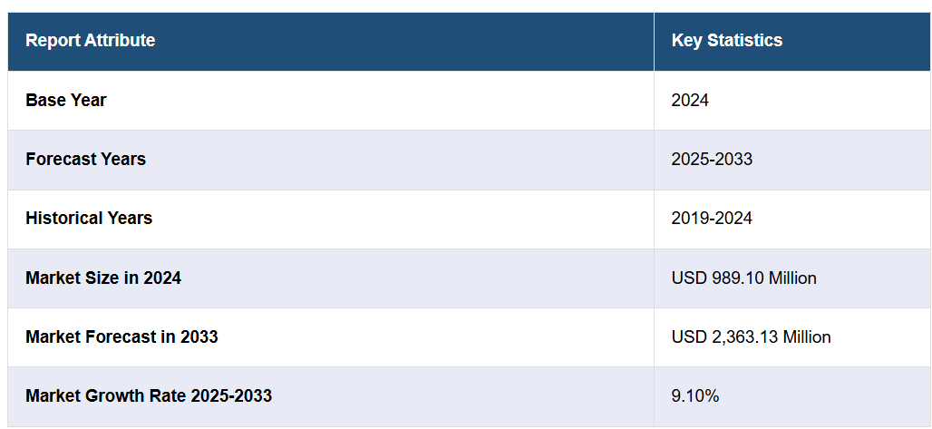
Figure 4: Saudi Arabia HVAC Ductwork Market Overview
‌

In Saudi Arabia, the HVAC ductwork market is changing thanks to new technology that makes systems more energy-efficient and reliable. For example, in April 2025, AFICO started using an AI-based system from Nanoprecise Sci Corp that predicts maintenance needs. This system monitors HVAC performance in real-time, helping companies find and fix energy problems and equipment issues before they cause breakdowns.
This predictive maintenance helps businesses run their HVAC systems better, reduce unexpected repairs, and save energy. By using smart machines and sensors, AFICO is leading the way in creating energy-saving, smart HVAC solutions. As the demand for greener and smarter systems grows in Saudi Arabia, more innovations are coming to reduce waste and make equipment last longer. With environmental concerns in mind, predictive maintenance is expected to become common, helping company’s’ lower costs, meet regulations, and support Saudi Arabia’s sustainability goals. All of this is helping the HVAC ductwork market grow even more.

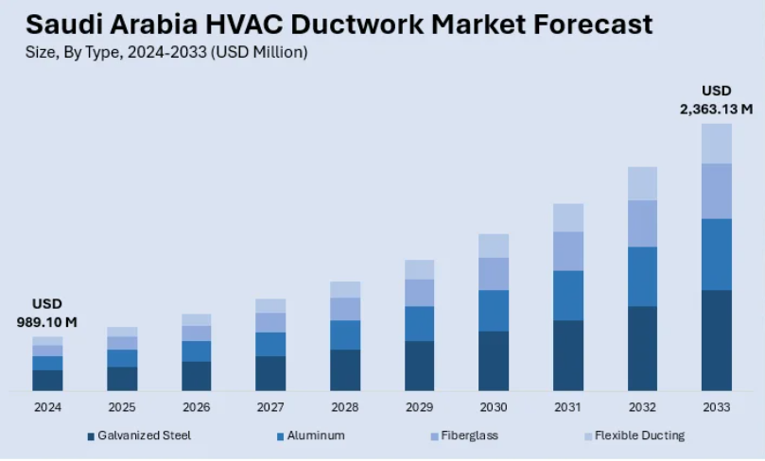
Figure 5: Saudi Arabia HVAC Ductwork Market Forecast

Sustainability and Performance in HVAC Solutions
The HVAC ductwork market in Saudi Arabia is quickly moving towards systems that are both high-performing and energy-efficient, as sustainability becomes more important in building projects. At the ISH Expo 2025, VTS Group introduced new products like the VENTUS Platinum AHU and a home ventilation unit, showing how the industry is focusing on greener building solutions.

The VENTUS Platinum AHU is designed to use very little energy and includes smart features that work well with existing systems, while also improving indoor air quality. These new systems are useful for both commercial buildings and homes, as urbanization and infrastructure projects grow fast in Saudi Arabia.
Companies are increasingly looking for energy-saving, cost-effective, and healthy indoor environments. These advanced HVAC systems are expected to play a big role in growing the ductwork market, supporting Saudi Arabia’s Vision 2030 goals for better energy use and sustainable building practices. This shift marks an important change in how the Saudi HVAC market is developing.

Saudi Arabia HVAC Ductwork Market Segmentation:
This study explained the main parts of the market, including future growth from 2025 to 2033. They divided the market into different groups based on type, shape, and use.
Type Details:
Galvanized Steel
Aluminum
Fiberglass
Flexible Ducts
Shape Details:
Rectangular Ducts
Round Ducts
Oval Ducts
Use Details:
The report also explains how the ducts are used in different areas, but that part wasn’t included in your message. Overall, the market is split into these groups to better understand what’s available and what’s growing.
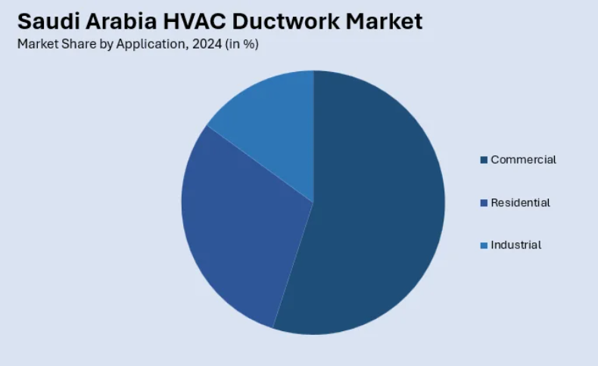
Figure 6: Application Insights:

Applications:
Commercial (business buildings, offices)
Residential (homes)
Industrial (factories and large plants)
The report explains how the ductwork is used in these different areas.
Regional Insights:
Northern and Central Region
Western Region
Eastern Region
Southern Region
The study gives a detailed look at each of these major regions to show how the market is doing in different parts of Saudi Arabia.

Competitive Landscape:
The report also looks at the competition in the market. It explains the market setup, the main companies, their strategies, how they compare, and detailed profiles of all big companies.
Saudi Arabia HVAC Ductwork Market News:
May 2025: Mada Gypsum Company launched new HVAC duct boards that meet strict quality standards. These boards are strong, flexible, and suitable for both inside and outside buildings. They are fire-resistant and resist moisture, making buildings safer and better.
January 2025: ClimateCrete, part of the NovusCrete group and supported by Saudi Arabia’s Oil Sustainability Program, improved HVAC ductwork by adding special fibers and recycled materials into concrete. This made their products eco-friendlier and more sustainable, helping Saudi Arabia move toward greener building options. (Saudi Arabia HVAC Ductwork Market Size, 2025)

Summary of the Study

The industry report gives a clear and detailed look at the Saudi Arabia HVAC ductwork market. It includes data and analysis of different market parts, past and present trends, future predictions, and how the market behaves from 2019 to 2033.
The report also shares the latest information about what drives the market, the challenges it faces, and new opportunities.
Porter’s five forces analysis helps stakeholders understand how new companies might enter the market, how tough the competition is, the power of suppliers and buyers, and the risk of other products replacing HVAC ductwork. This helps them see how competitive the market is and whether it’s a good place to invest.
The competitive landscape part shows stakeholders who the main companies are, where they stand in the market, and what their strengths and weaknesses are.

(Alotaibi, 2025)

Saudi Arabia, located in the middle of the Arabian Peninsula, is going through a huge change. The country is shifting its economy under a plan called Vision 2030.
For many years, oil and gas were the main sources of money for Saudi Arabia. Now, the country is working hard to create other types of industries so it can compete with other countries around the world.
Today’s factories are not just making products; they are part of a big effort to build a modern economy that focuses on technology, knowledge, and smart infrastructure.

Industrial Cities and Tech Clusters Across Saudi Arabia

This change is happening through a connected system of industrial areas and special zones in different sectors like aviation (airplanes), cars, food, mining, and chemicals.
There are already 40 industrial cities in the country. By 2035, Saudi Arabia plans to have around 36,000 factories. These cities are more than just places to make products — they are becoming important economic centers connected to global markets via modern ports, railways, and highways.

Big Investments Boosting Industry Growth
Saudi Arabia is spending a lot of money to build new industrial areas and improve infrastructure. The country knows it needs to develop different types of industries, not just oil.
Some important industrial cities are Jubail and Yanbu. These cities are famous around the world for making chemicals and plastics, helping Saudi Arabia stay strong in energy and chemicals.
Ras Al-Khair Industrial City, on the Gulf coast, is a key place for mining. It has Ma’aden, one of the biggest aluminum and mineral factories in the world.
In the south, Jazan Industrial City is becoming important for big industries and energy projects, as well as food and farming.
King Abdullah Economic City (KAEC) is a special city that combines factories, ports, and homes. It has one of the world’s most advanced ports and helps with international trade.
In central Saudi Arabia, Sudair Industrial City focuses on making medicines, food, and small products. It helps build the country’s supply chain—how goods are made and moved.

Special Industry Clusters for the Future
Saudi Arabia is also creating special groups of industries called clusters. These are set up to help develop new and future industries that will be important for the country's growth.

Jeddah’s New Aviation and Food Industries
In Jeddah, a new big project called “Aero Park One” was built. It covers a large area and is a special center for airplanes, space, and defense technology. It is near the airport and port, making it easy to send and receive goods. The goal is to make Saudi Arabia a main hub for air travel and technology.

Electric Cars
In King Abdulaziz City for Industry and Commerce (KAEC), they are building a factory for electric cars. This will help Saudi Arabia become more eco-friendly and work with big car companies from around the world. They want to make cars and parts here and create strong supply chains.

Food Security and Food Industry
Jeddah also has a big food factory area with 75 factories and large warehouses. It has attracted over $5 billion from other countries. The goal is to make more food in Saudi Arabia, reduce imports, and become a big name in food production and exports.
In April, Saudi built a new dairy factory area in Al-Kharj. It covers 2 million square meters and will have factories for making dairy products, packaging, and feeding animals. This will help Saudi Arabia produce most of its dairy needs and sell to nearby countries.

Ports and Railways
Ports and trains are very important for business. Jeddah’s main port handles food trade. Other ports focus on minerals and exports. There is a railway connecting mines, factories, and ports. Soon, a new land bridge railway will connect the Red Sea to the Arabian Gulf, making trade faster and easier.

Saudi’s Growing Industry
Saudi Arabia’s industries are growing fast. From factories in Jeddah to high-tech labs and auto plants, the country is building a modern, innovative economy. Modern ports and fast transport help attract international investments.
By working on Vision 2030, Saudi Arabia is becoming a global leader in making and exporting products, not just selling raw materials. This is a real industrial revolution — a big change that shows the country’s strong plans.

Summary of Saudi Arabia’s Industrial Growth Under Vision 2030
Saudi Arabia is changing its economy to become more diverse and modern. Instead of mainly relying on oil, the country is building new industries and factories. By 2035, they want to have about 36,000 factories across many different sectors like aviation, cars, food, mining, and chemicals.
Big investments are helping this growth. Important industrial areas include Jubail, Yanbu, Ras Al-Khair, Jazan, and King Abdullah City. New projects include a special aviation hub, electric car factories, and large food factories, including a dairy farm in Al-Kharj.
Ports and trains also support this growth. New railway projects will make it easier to move goods around the country and to other countries.
This big change is happening now. Saudi Arabia is becoming a place that makes and exports many different products, not just a country that sells oil. The goal is to build a strong, innovative, and sustainable economy by 2030 and beyond

Arabic Research

(Al-Ghamdi, 2024)

Saudi Arabia's Efforts in Developing Industry and Commerce

Saudi Arabia is working hard to develop its industries and commerce as part of its Vision 2030. This plan aims to make the economy more diverse and sustainable. Here are the main points

Development Industry

Improving Key Industries

- Petrochemicals: Saudi Arabia is one of the biggest producers of chemicals made from oil, with companies like SABIC and Aramco
- Mining: The country has started programs to use its minerals and grow mining industries
- Military: The goal is to produce half of the military equipment inside the country by 2030

Building Industrial Cities

- Cities like Jubail and Yanbu are big centers for heavy industries and chemicals.
- Economic cities like King Abdullah City attract foreign companies.
- About 36 industrial cities are managed across the country.

Supporting Small and Medium Businesses
- Small companies get help through banks and programs like Musharakah, which provide money and support.

Boosting Business and Trade

Growing Online Shopping

Saudi Arabia is improving internet and digital systems to support online buying and selling

Making Business Easier

- Ports like Jeddah and King Abdullah help with importing and exporting goods
- Platforms like Fasah make customs and paperwork faster

Expanding International Trade

-Saudi Arabia is signing trade agreements with other countries
- It joined the World Trade Organization (WTO), opening new markets for exports

Supporting Local Markets

-Traditional markets and modern shopping malls are being improved
- Foreign companies are encouraged to invest in retail and wholesale businesses

Attracting Investments

- Making it easier for foreign companies to invest by reducing rules and offering tax benefits
- The Public Investment Fund (PIF) finances big projects to help grow the economy.

Focusing on Sustainability and Innovation

- Promoting green industries and renewable energy projects like NEOM
- Using new technology like artificial intelligence and robots to modernize industries

Results of these efforts

- Industry contributes more to the country’s economy
- Saudi Arabia is becoming a key logistics hub for trade
- More jobs are created, helping local people and the economy grow

These efforts show Saudi Arabia’s strong plan to build a sustainable and growing economy that keeps up with global changes.

Summary of the study

Saudi Arabia is working to grow its industries and businesses as part of Vision 2030. The country is developing key industries like petrochemicals, mining, and military equipment, and building industrial cities. It supports small and medium businesses and makes trading easier through better ports and online platforms. Saudi Arabia is also attracting foreign investments, promoting green energy, and using new technologies like AI and robots. These efforts are helping the economy grow, creating jobs, and making the country a major hub for trade and logistics.

(Abousaq, 2024) National Committee for Industry: Challenges and Solutions to Support the Industrial Sector considering Saudi Vision 2030

Goals of the National Industry Committee
The committee wants to support and develop the industrial sector in Saudi Arabia so it can help diversify the economy, in line with Vision 2030. They aim to remove problems faced by factories, help them stay strong, and make them more competitive both inside the country and abroad.

Why industry investors aren’t using ministry programs enough

The Ministry of Industry has created good programs to help factories, such as

- Future Factories: To help factories use advanced technology
- Promising Factories: To support small and medium-sized factories
- Green Factories: To encourage the use of clean energy

But many investors aren’t benefiting much from these programs because

- Procedures are complicated: Long and confusing rules make it hard to get support
- Approval takes a long time: It takes too much time to get projects approved
- Competition system: Using competitions limits many investors from benefiting

The Factory Sustainability Program Failed

- The committee tried to create a program to help struggling factories stay open and grow. But unfortunately, the program was canceled before it started, without making any real progress.
- What this shows: The committee isn’t good at turning plans into real actions. This means they need to improve their planning and how they work to better help factories in trouble.

Other Challenges Facing the Industry

- Many fees: There are lots of charges like environmental and industrial city fees, which increase costs for investors, especially at the beginning
- Poor coordination: Different government agencies don’t work well together, causing confusion
- No help for struggling factories: Factories facing money or operational problems don’t get practical support from authorities

How to Improve the Committee’s Role

- Reactivate the factory support program: Make a clear plan to help struggling factories, with special teams to find solutions
- Simplify procedures: Make rules easier and faster so investors can get help quickly
- Unify fees: Create a single online platform where all fees and procedures are managed under the Ministry’s supervision, making things clearer and more transparent
- Promote programs like "Future Factories" and "Promising Factories" and remove the competition system to include more investors

A Central Industrial Platform

To make everything easier, there should be a single online platform for industrial matters
- Easy registration: Investors can submit and track their requests easily
- Transparency: Clear rules about fees and programs
- Monitoring: The Ministry can keep an eye on challenges and respond quickly
This way, supporting factories and developing the industry will become smoother and more effective

Summary of the study

The Saudi Arabia industry group wants to help factories grow and improve the economy. But investors face problems like complicated rules, slow approval processes, and too many fees. Some programs to support factories haven't worked well. To fix this, they should make rules simpler, combine all fees into one online system, promote helpful programs, and improve teamwork among government agencies. An online platform where investors can easily apply, check their progress, and see clear information will make supporting factories much easier and help the industry grow faster.

