Chapter One:
Introduction

1.1. Introduction:
The construction sector is one of the most important sectors globally. Over the course of decades, experts have developed project management methods and principles to track and enhance the projects’ effectiveness and efficiency. With the increased demand of global project management to coup with the economic exchange and cultural diversity, there is always a need to study the similarities and variations of the markets between different regions. Such comparative studies can assist leaders and professionals in decision making as it provides a better understanding of construction trends. While there will always be a certain level of risk that can’t be eliminated, comprehensive research will assist mitigating the risk for people who are interested in expanding their business or willing to educate themselves about the latest construction trends in other regions.
Both United Arab Emirates and the Australian construction markets have witnessed substantial growth over the past few years. UAE has proven that the impossible is achievable and the future is here, and Australia has a robust economy and promising migration target for construction experts. The construction development is driven by a high infrastructure and housing demand, making the construction sector a unique phenomenon that is worthy to observe and learn from.
The combined value of the Australian and UAE construction market size in 2024 was over USD 221 Billion (Accura Consulting,2024) marking the significant and the importance of construction market in both countries, and highlighting the potential lay within these markets.
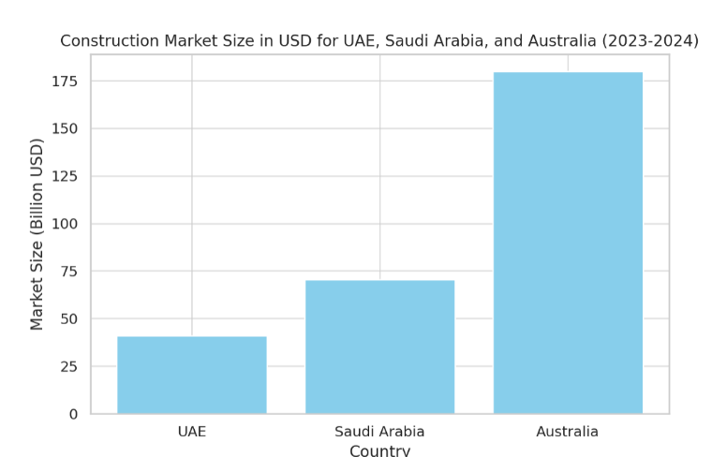
Figure 1.1: Construction Market Size in USD for UAE, Saudi Arabia, and Australia (2023-2024). Accura Consulting, 2024

None the less, there are noticeable differences between the two markets’ structures and traits. The regular requirements, workforce composition, market conditions, and environmental expectations have complex layers of uniqueness developing both opportunities and challenges for engineers, managers, and organisations working across these regions.
As someone who has worked in both regions, it’s important to emphasise that construction experts will encounter difficulties in transitioning between the two markets. The planning and delivery of projects differ significantly, making the survival in both markets by adopting the same approaches a large stretch and a step into the unknown.
Despite all the challenges and the importance of the matter, especially for new migrants, there is a deficiency in the academic studies addressing the issues and proposing suggested solutions. The little available guidance to distinguish the markets’ variations in staging and delivery often makes it harder for people moving between Australia and UAE to adapt.
I put this research in the reader’s hands to address this knowledge gap by identifying the key differences between construction projects in Central Queensland and Abu Dhabi. It’s an endeavor to investigate how such variations may affect different stages of construction and try to provide a practical insight with a focus on supporting migrant engineers in adopting different markets approaches and fundamentals.
1.2. Problem Statement:
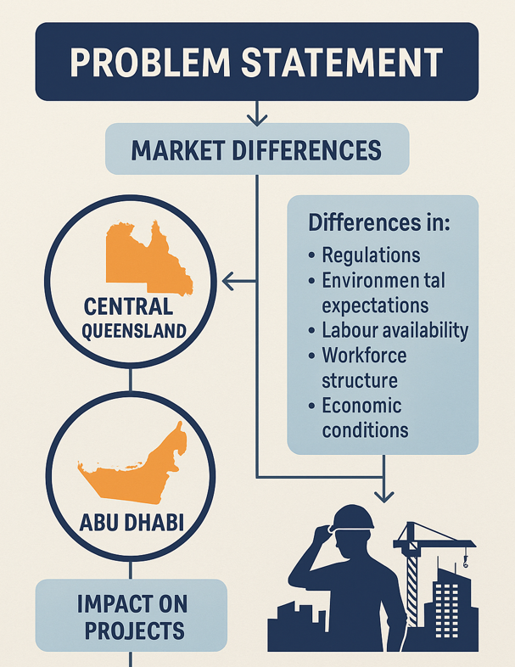
Projects have global characteristics, but there are significant differences exist between markets that affect how projects are planned, staged, and delivered. Engineers and construction managers working across different regions often face challenges in adjusting to these differences, which can lead to delays, inefficiencies, and increased project risks.
Particularly, the construction markets of Central Queensland, Australia, and Abu Dhabi, UAE, show clear differences in regulations, environmental expectations, labour availability, workforce structure, and economic conditions. However, there is a lack of research comparing how these market differences influence the staging and delivery.

Figure 1.2: Problem Statement
As I have experienced myself, this knowledge gap creates challenges for construction professionals and companies operating in these regions. This research aims to investigate the key market differences between Central Queensland and Abu Dhabi and how they affect project staging and delivery. The study will also explore how construction professionals, particularly migrant engineers, can better adapt to these market conditions to improve project outcomes and reduce risks.

1.3. Research Importance:
During my initial preparations of this research, I tried to reflect on previous studies comparing the construction market in UAE and Australia, and it was obvious that there are limited studies in this regard. This increase the importance and significance of this study. Deficiency in information available about such matter may produce a reluctant approach towards a new market, in other words, it may represent a miss-chance for the developers who decide to eliminate the risk by avoiding any business involvement in a market that is considered unknown to them. I consider this comparison study important to reduce the uncertainty and the risk related to expanding business between the two areas.
This study primarily is useful for engineers, construction managers, and everyone working in construction projects, especially those who are involved in small and medium sized project in both Queensland, Australia and Abu Dhabi, UAE. As I have gone through this experiments myself, I’m hoping this research will help new migrants to Australia to settle in more easily as it’s often challenging to adapt and find their feet in a busy and tough market with substantial differences in a lot of stages and aspects of such projects. In the same way, it shall provide the beneficiaries in UAE with an understanding of what the Australia market looks like. Both parties can use this study to seek development, reduce mistakes and learn lessons.
Additionally, the research should provide policymakers with educated decisions about opportunities and challenges in expanding the market globally by pointing out the key differences in the two markets and how they interact with demands, projects’ delivery and supply chains.

1.4. Research Objectives and Purposes:
1.4.1 From a theoretical perspective: the research significance will fall in the following areas:
- Contribution in the academic understanding of how the differences affect the staging and delivery of the construction projects.
- Adding to the limited number of comparison studies in construction field between Central Queensland and Abu Dhabi.
- Enriching project management theories in linking the markets and delivery efficiency.
- Build a bridge of knowledge for the targeted group of the research.

1.4.2 From a practical point of view, I’m aiming for my study to:
- Provide actionable insights for engineers and managers to adapt during the different stages of the projects.
- Provide a better planning opportunity for people who are interested in doing business between Central Queensland and Abu Dhabi.
- Support new migrants in their efforts to start a professional career, especially considering the difficulties of entering the market without local experience, something I have personally experienced.
- Measure the tangible parameters using the project management theories to identify the areas of improvements in both markets.
- Mitigating risk for the professionals aiming to start business exchange and seeking global expansion.

The main objective of the research is to summarise the professional experiences of construction specialists -and researcher’s experience- who have worked in both Central Queensland and Abu Dhabi, with the aim of facilitating a smoother transition for construction projects and professionals moving between these two regions.

1.5. Research Questions:
The main question of my study is how do market differences between central Queensland, Australia, and Abu Dhabi, UAE, influence the staging and delivery of small and medium sized construction projects? Within this question, there are a few sub-questions the study will answer:

- What are the key market differences between the two areas when it comes to construction projects?
- How do these differences impact the various stages of the project, especially execution phase?
- What are the main challenges that engineers and managers face when moving in between the two regions?
- How can construction professionals adapt and overcome these challenges.
- How to mitigate the risk when approaching the other market from an investment perspective?
- What are the lessons learnt from this comparison?
- What causes of delays and failure to expect in both markets?
- How can the community habits and trends affect the construction stages differently?
- What role does the environment and sustainability play in both regions?
- What are the opportunities and threats of either market?

1.6. Research Hypotheses
There are a few assumptions and hypotheses for my research explained below:
- First Hypotheses:
The construction industry is significantly different in the UAE compared to the construction in Central Queensland.
- Second Hypotheses:
While the main stages outline is generally the same in both countries, there are substantial differences in the way the stages are carried out in practice.
- Third Hypotheses:
The Australian construction market is more affected by the fluctuations in global material pieces and interest rates compared to the UAE market.
- Fourth Hypotheses:
The Major factors contributing to projects’ cost and lead times differ significantly between the two regions.
- Fifth Hypotheses:
Environmental requirements, standards and procedures are strictly enforced in Central Queensland compared to Abu Dhabi.
- Sixth Hypotheses:
There are noticeable variations in gender and age distribution of the construction workforce between the two regions.
- Seventh Hypotheses:
It is generally easier to enter the construction industry in Central Queensland compared to the UAE.
- Eighth Hypotheses:
The construction sector plays a major role in driving other industries in both countries.
- Ninth Hypotheses:
Migrant construction experts moving from UAE to Australia are capable handling the challenges of the Australian construction market.
- Tenth Hypotheses:
The different weather conditions in both regions enforces different approaches.
- Eleventh Hypotheses:
The size of the regions and their population density play a direct role in influencing variations trends.

1.7. Theoretical Model:
To measure how accurate the concepts and hypothesis of this study, I have adopted a model of measuring the key factors affecting any construction market. Not only the mere cost and timeframes, but also the attributes of working place and community may affect the construction projects.
The main areas I’m trying to cover are:
- Community and softs skills effects.
- Laws and regulations effects.
- Environmental effects.
- Resources effects.
- Economy and finance effects.
The multi factors interact with each others to produce a unique model for each market, which requires different dynamics to absorb expected and unexpected challenges.
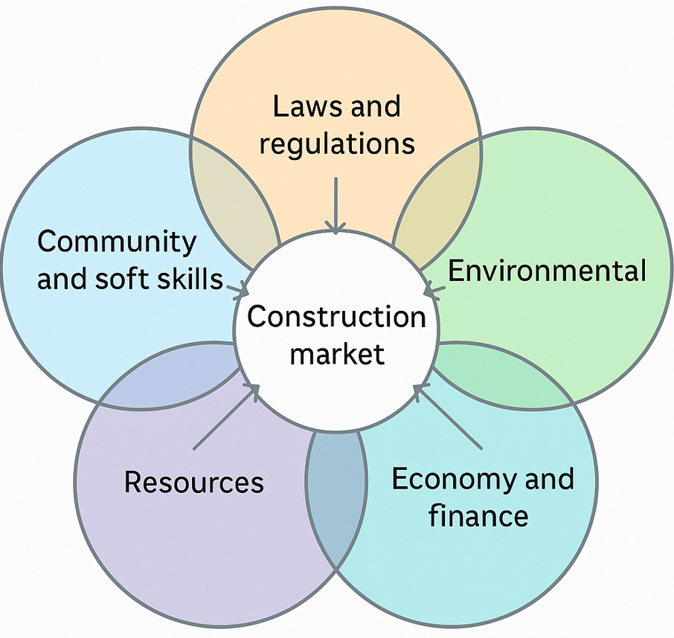
Figure 1.3: Theoretical research areas
While this research isn’t detailed enough to explain all the puzzle pieces due to time restrictions, it may be considered a trigger for further research and thorough considerations for me, other researchers, interested individuals, and migrants.
It’s important to mention that the choice of Abu Dhabi and Central Queensland as the targeted areas is because the researcher has worked in both regions. This means the input and interpretations throughout the study can be directly reflected through firsthand professional experience. Such familiarity offers deeper contextual understanding and enhances the practical relevance of the research, particularly when analysing the opportunities, challenges, and dynamics of each market.

Chapter Two:
Previous Studies

2.1 Introduction
While there is a limited amount of construction research comparing the Emirati market and the Australian market generally, and Abu Dhabi and Central Queensland particularly, there is a fair volume of studies focusing on each country separately because the construction market contributes in the local economy with billions of dollars in both UAE and Australia, leading to place the construction market aspects and trends under the microscope.
I tried to summarise the researches in a focused manner that provides the reader with relevant substances. The findings of the previous studies might match or differ with my findings at the end of this research, all depending on the perspective and approach. I must notify the reader that most of the previous studies I included probably have a higher level of reliability when compared to my own, especially in the case of studies published by official entities and statistics covered over the course of a few years.
Additionally, I have tried to avoid cherry picking to eliminate any bias in presenting the information to the reader, while trying to stay balanced in choosing the most relevant studies assisting in the correct establishment of my research foundations.

2.2. Previous Studies:
- Project Management Performance in the UAE Construction Industry. (American Society of Civil Engineers,2014)
This study highlighted the gap between the adaptation of project management tools and monitoring the actual performance and outcomes. The authors concluded that adopting the traditional project management tools doesn’t lead to an automatic improved performance. The actual main factor affecting the success is the effective implementation of the project management tools, it’s how not what you implement.
Additionally, the research pointed out the importance of continuity in training to develop the skills and bridge the gap between the takeaways and the tools utilisation.
- UAE Construction Market Intelligence Q1 (Laura Morgan, 2024).
This report shed light on the construction market trends and economics. By explaining how financial markets are affected by the supply chain distribution and labor shortages, the report explained how resilient the UAE construction sector is with not much fluctuation.
The key lesson learnt is adopting dynamic strategies, UAE was successful in absorbing any possible economic damage, not only that, but it’s also how risk is anticipated and managed in the favor of the construction sector.
- Queensland region Construction Supply and Demand Analysis 1995-2029. (National Institute of Economic and Industry Research (NIEIR), 2019).
A detailed governmental report to analyse the construction supply and demand trends in Queensland. It provides an insight into the regional construction activities in the period of 1995-2019, and a forecast of how the trend would look like in the following decade.
The study showed the importance of effective planning in achieving long-term development objectives. It has also suggested how to eliminate or mitigate the risks associated with potential challenges in the Australian construction market based on data-driven approaches. Another fact discussed is the need for labor force support policies and legislation protecting expansion and retention.
Additionally, the research suggested that the development of regional infrastructure alongside the supply chain availability plays a significant role in construction projects delivery.
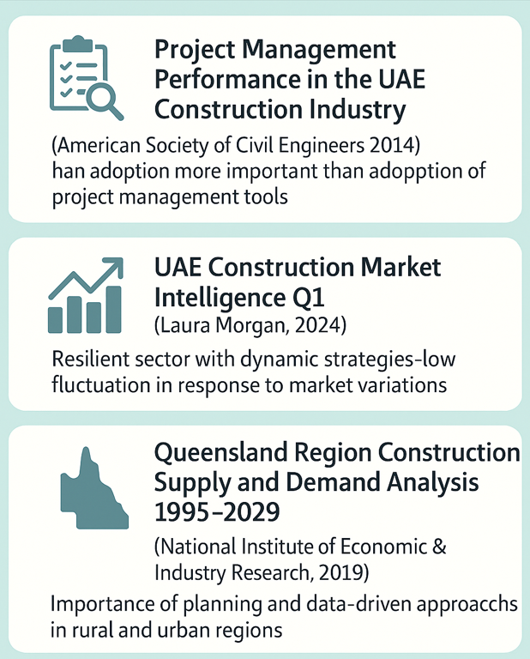
Figure 2.1: Previous Studies’ Outcome
- CSQ Industry Outlook 2024-2025 (CSQ, 2024)
This report examines the resilience of Queensland’s construction industry and how it could fight the high interest rates and rising living costs. The report stipulates that innovation is a key factor in success and developing workforce methods is the shelter from economic instability. It has also showed that supporting growth in Queensland construction market can be achieved by strategic planning and proactive measures against the risks and uncertainties.
The report also highlights the fact that the construction sector is contributing significantly to the state’s economy supported by statics and numeric proofs.
- Barriers to Employment for Migrant Engineers (Engineers Australia, 2021).
An official research study carried out by Engineers Australia. The study dives into the employment challenges faced by the overseas-born engineers that have moved recently to work and live in Australia. Despite being 58% of the national engineering workforce, the migrant engineers suffer from higher unemployment rate when compared to their Australia-born peers.
The study suggests that there are a lot of reasons of this issue, including:
- Lack of local experience: employers tend to prioritise the local workforce over the newcomers.
- Skepticism of engineering credentials and recognition of overseas qualifications.
- Limited references and professional network: new migrants lack local connections that might assist their efforts in finding jobs.
- Communication and culture factor: New country, new culture means difficulties in blinding in the local communications styles.
The study has concluded a few solutions of the case, including providing supportive programs for migrant engineers, employers’ engagement by the government to explain the importance of assisting newcomers, and policy implications that can make the lives of migrants easier by finding their first job.
- How Forensic Quantity Surveyors impact construction dispute resolutions, a UAE, KSA, Australia Comparison.
This comparative study highlights how forensic quantity surveys helps in resolutions of construction disputes in KSA, UAE and Australia. It suggested that both markets faces delays and cost overruns. However, the approach in the dispute resolution differs much:
- The total value of construction sector value exceeds USD 41 Billion in UAE and exceeds USD 180 Billion in Australia.
- The Australia market has a longer average resolution time but lower average dispute value when compared to UAE.
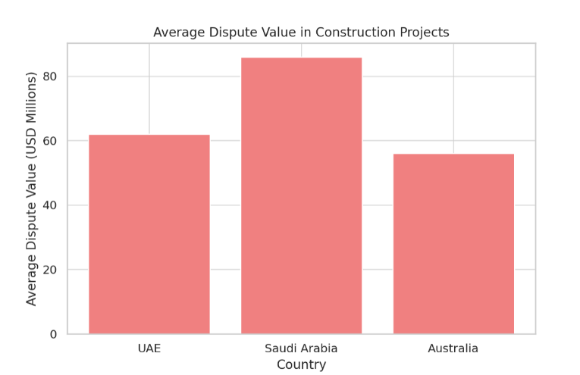
Figure 2.2 (from source): Average Dispute Value in Construction Projects (USD Millions)
- Disputes in Australia are generally due to complex contractual issues while the main reason of disputes in UAE is due delayed claims and unclear scope.
- Forensic Quantity Surveys are more commonly used in Australia, however, the awareness in UAE is increasing about the mitigating risk and avoiding litigation. Litigation rate percentage is higher in Australia.
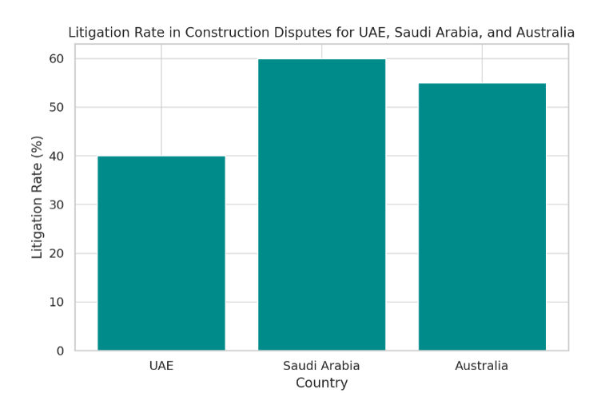
Figure 2.3 (from source): Litigation Rate in Construction Disputes for UAE, Saudi Arabia, and Australia
- There is an increased adoption of proactive cost assessment in UAE including early dispute identification.

The following figure puts the comparison in summary:
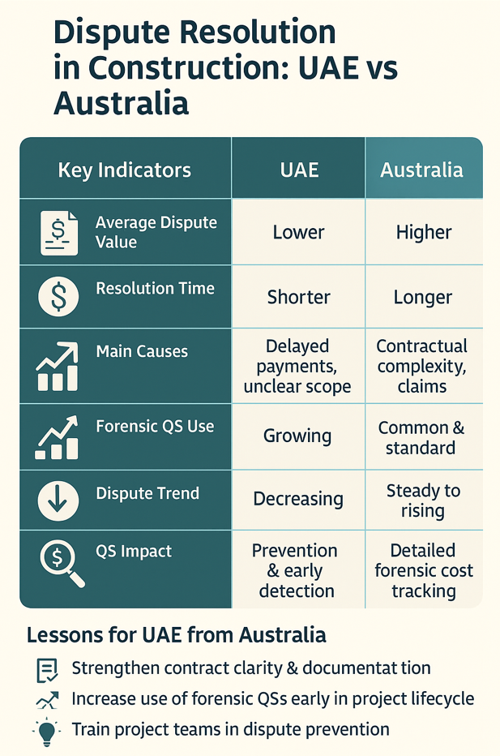
Figure 2.4: Conclusion of How Forensic Quantity Surveyors impact construction dispute resolutions
- Barriers to Implementing Environmental Sustainability in UAE Construction Project Management: Identification and Comparison of ISO 14001-Certified and Non-Certified Firms (Various Authors, MDPI,2024)

This study explains the key barriers in the UAE market hindering effective implementation of environmental controls. It covered 90 firms -both ISO 14001 certified and non-certified). The study rates the barriers as follows:
- Prioritising economics over sustainability.
- Lack of policymaker support.
- Difficulties in reduction of energy usage during construction phase.
It’s worth mentioning that ISO accreditation had no significant impact on how firms adhere to sustainability matters. The study suggested that regulations must be enforced in a better manner and transparently, and awareness levels about the importance of green construction must be raised to achieve better environmental adherence.
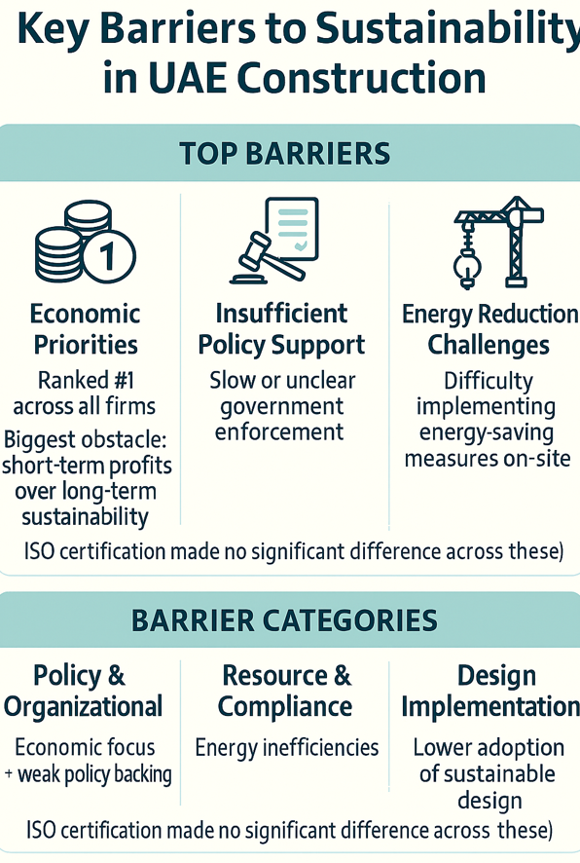
Figure 2.5: Conclusion of Barriers to Implementing Environmental Sustainability in UAE Construction Project Management

2.2.1 Conclusion from Previous Studies:
- The construction sector is well-represented in both UAE and Australian economy.
- Adoption of project management tools alone is not sufficient to lead to successful delivery of construction projects.
- Continuous training and development are essential to fill the gaps between the theories of management and actual project performance.
- The UAE construction sector has shown resilience with dynamic strategies and proactive risk management.
- The importance of effective planning is highlighted while studying construction trends in urban and rural areas of Queensland
- Data-driven decisions are often the best decisions.
- Innovation and developing workforce methods are vital for economic resilience in central Queensland.
- The cost of litigations in disputes are higher in Australia compared to UAE.
- High interest rates and rising living costs affect the construction industry of Central Queensland.
- Environmental regulations are applied better in Australia and there are barriers in such application in UAE.
- Migrant engineers coming to Australia are facing significant barriers to employment including local experience and culture shock.

2.2.2 Recommendations based on Previous Studies:
- Managers must focus on practical implementations rather than adopting formal tools and standards.
- Construction professionals in both regions should engage in continuous professional development to adapt to evolving market demands.
- Dynamic and proactive risk management strategies should be applied to reduce the impact of market fluctuations.
- Authorities and industry bodies in both regions should develop policies to support workforce development, with special attention to migrant workers.
- In Queensland, strategies to support regional infrastructure development and strengthen supply chains are recommended to improve project delivery.
- Supportive programs, networking opportunities, and recognition of overseas qualifications should be enhanced to ease the integration of migrant engineers into the Australian construction workforce.
- Construction experts must offer incentives for green practices and strengthen environmental framework.

2.3. Research Theoretical Framework:
This research is based on various theories and their concepts to explain the major market differences between Central Queensland and Unite Arab Emirates influencing the construction projects.
    - Project management Theories: Emphasising the traditional management tools and concepts:
a. Planning of projects.
b. Execution and monitoring projects.
c. Resources and timeframes.
d. Budgeting and costs.

    - Market Environment Theories: Exploring the market trends and conditions:
a. Economic conditions.
b. Labour markets and finance.
c. Supply chain.

    - Human Resources and Adaptation Theories:
3.a. Migration workforce.
3.b. Work culture.
3.c. Expectations and standards.

    - Finance And Laws Theories:
4.a. Local regulations.
4.b. Taxation.
4.c. health and Safety.

By using the combination of such theoretical foundations, this research will provide a handy source for any entity or personnel interested in the Emirati and/or Australian construction pool especially when it comes to adaptations and utilisation of efforts, time, and money.
The above-mentioned theories and concept are used to validate my research conclusions and outcomes.

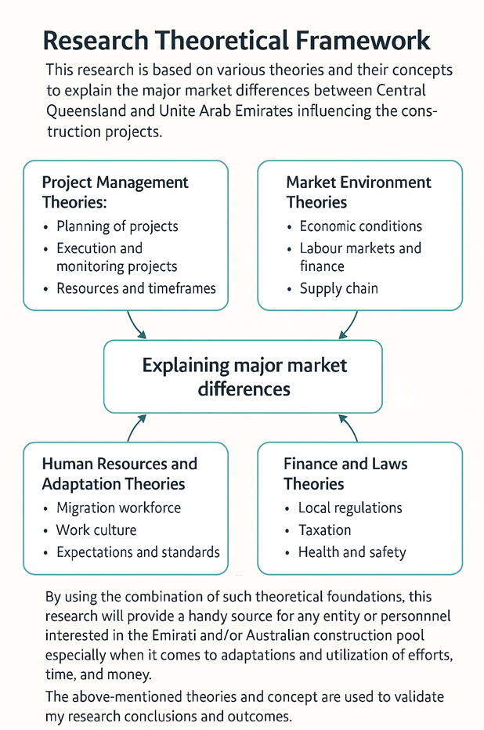
Figure 2.6: Research Theoretical Framework

