Predictive Modeling for Diabetic Complications Using Artificial Intelligence

Mohamed Elzain Gurashi Elshekh, 0009-0001-9433-2609
MSc in Artificial Intelligence, College of Informatics, Midocean University, Comoros. mzelshekh@gmail.com
Rami Mohamed Zain Yousef, 0009-0001-4283-2265
MSc in Artificial Intelligence, College of Informatics, Midocean University, Comoros.
rzainyousef@gmail.com
Dr.Khaled Eskaf
Artificial Intelligence, College of Informatics, Midocean University, Comoros.

Abstract
Diabetes remains a major global health concern, with serious complications that develop over time and are often underdiagnosed. Enhancing the early identification of high-risk patients has therefore become a central goal in diabetes care. This study investigates the potential of machine-learning methods to support early recognition of diabetic complications, with a specific focus on predicting cardiac and renal events.
The analysis is based on the UCI “Diabetes 130-US Hospitals” dataset, a large-scale electronic health record (EHR) database containing more than 100,000 patient encounters. Cardiac complications—namely myocardial infarction and heart failure—and renal outcomes such as nephropathy and chronic kidney disease were identified using ICD-9 diagnostic codes. Before model development, the dataset underwent a structured preprocessing pipeline that included data cleaning and feature engineering. Three ensemble machine-learning models—XGBoost, CatBoost, and Random Forest—were trained and evaluated.
Among the models examined, CatBoost achieved the strongest performance, with an AUC of 0.94 for cardiac complications and 0.79 for renal outcomes, while the remaining models demonstrated slightly lower yet consistent performance. To enhance transparency and clinical interpretability, SHAP and LIME analyses were applied, providing insight into the predictors most strongly associated with complications, many of which align with established clinical knowledge.
Overall, the findings illustrate the promise of machine-learning-based prediction as a means of improving proactive clinical management and supporting physicians in making more informed decisions. Future work should focus on real-world implementation and external validation of these models across broader and more diverse patient populations.

Keywords: Diabetes, Cardiac Complications, Kidney Disease, Machine Learning, SHAP
Introduction
Diabetes mellitus remains a major global public health challenge, currently affecting more than 537 million adults, with prevalence expected to rise substantially over the coming decade (International Diabetes Federation, 2023). Beyond metabolic dysregulation, diabetes is strongly associated with the gradual development of life-threatening complications, particularly cardiovascular disease and renal impairment. These complications rank among the leading causes of mortality worldwide and place a substantial financial burden on healthcare systems. Recent epidemiological evidence (2021–2024) confirms that delayed detection and the silent progression of these complications contribute to preventable morbidity, early disability, and high economic costs.
Despite advances in clinical practice, the early identification of high-risk individuals using traditional risk assessment tools remains limited. Conventional approaches often rely on static laboratory thresholds or clinician judgment and may fail to capture the complex, nonlinear interactions among demographic, clinical, and behavioral factors that shape long-term outcomes in diabetes. In recent years, advances in artificial intelligence (AI)—particularly machine learning (ML)—have created a transformative opportunity to leverage large-scale EHR data for predictive modeling of diabetic complications. Models such as XGBoost, CatBoost, and Random Forest have demonstrated promising performance in clinical prediction tasks; however, many existing approaches lack interpretability, which can limit physician trust and hinder clinical adoption.
The novelty of this study lies in its integration of high-performance ML classifiers with explainable AI techniques, including SHAP and LIME, to generate clinically meaningful insights into the drivers of risk. Unlike prior work that focuses primarily on predictive accuracy, the present approach emphasizes both performance and interpretability, aiming to support proactive, risk-stratified decision-making and ultimately improve patient outcomes.
Research Problem and Questions
Despite promising results from machine-learning models in predicting various health outcomes, it has been challenging to predict diabetic complications, especially cardiac and renal events. Much of the current literature is also based on complex “black box” models that yield excellent predictive performance but provide little explanation of which clinical factors underlie the increased risk. Additionally, certain studies focus on a narrow set of variables and therefore do not provide sufficient information to understand the broader impacts that shape the progression of diseases in diabetics. These trade-offs demonstrate the need for a method that can provide all these benefits in one go, is intimately interpretable, achieves state-of-the-art predictive performance, and comprehensively exploits clinical features.
We address this by introducing a holistic predictive model that integrates heavy data preprocessing, sophisticated feature generation, and interpretable ensemble-based machine-learning models. We aim to derive a prediction model that not only predicts cardiac and renal complications with high accuracy but also elucidates the patient characteristics most strongly associated with risk.
The primary research problem can be formulated as follows:
How can we build a machine-learning model to predict cardiac and renal complications among diabetic patients with high predictive performance while ensuring clinical interpretability?
From this overarching question, the following secondary research questions are derived:
- What are the predictive capabilities of ensemble-based machine-learning models (Random Forest, XGBoost, and CatBoost) for severe diabetic complications?
- Which clinical, demographic, and healthcare utilization predictors are most strongly associated with cardiac and renal outcomes?
- To what extent do feature-selection techniques improve model accuracy, stability, and interpretability?
- How can the results of the predictive model be used to support better management of patients at higher risk (e.g., enhanced monitoring and targeted interventions) while avoiding unnecessary overtreatment of low-risk patients?
Significance of the Study
The significance of this work lies in its theoretical and practical relevance, which adds value to advances in predictive healthcare analytics—especially for long-term disease management.
Theoretical Significance
This makes this study a valuable contribution to scientific literature, as it proposes an integrated methodological framework comprising data cleaning, feature engineering, feature selection and the generation of interpretable ensemble models. This organized direction provides a clear path for subsequent investigators interested in developing predictive tools for chronic disease complications.
Furthermore, this research adds new knowledge on which baseline clinical predictors are most closely associated with cardiac and renal complications in diabetic subjects. Identifying which factors (e.g., HbA1c, age, comorbidities, medication regimens, prior hospitalizations) are most influential in risk prediction allows us to understand better how complications arise and evolve, as well as to identify promising targets for earlier intervention.
Practical Significance
The clinical implications of this study are that it provides a basis for physicians to develop a pertinent, operational tool to evaluate the risk of cardiovascular and renal complications among diabetics. By incorporating machine-learning algorithms into clinical routines, hospitals and clinics can recognize individuals at high risk earlier, enabling medical teams to take proactive steps such as closer monitoring of patients, adjustments to treatments, or even offering preventive therapies.
Moreover, the proposed model can serve as the foundation for developing early-warning systems within electronic health record platforms. Such systems can automatically flag patients whose risk profiles indicate potential deterioration, thereby helping reduce emergency admissions, avoid preventable complications, and optimize clinical resources.
The findings also provide concrete evidence of the growing role of artificial intelligence in modern healthcare. By demonstrating how predictive analytics can support decision-making, the study contributes to ongoing efforts to build smarter, data-driven healthcare environments that enhance patient outcomes, streamline clinical workflows, and improve the overall efficiency of chronic disease management.
Research Objectives
The objectives of this study are:
- Build predictive machine-learning models — including Random Forest, XGBoost, and CatBoost to predict the risk of cardiac and renal complications in diabetics based on a large EHR dataset.
- Distinguish the most clinically and demographically significant predictors of diabetic complications by interpreting the data more energetically.
- Utilize sophisticated feature selection methods to improve model accuracy, reduce noise, and improve interpretability for the most clinically meaningful variables.
- Assess the predictive ability of the constructed models via metrics (e.g., AUC, Accuracy, precision, and recall), and compare model performance with what has been reported in the literature.
- Give evidence-based recommendations to help practitioners and healthcare organizations in enhancing risk assessment and early intervention of diabetics.
Research Limitations
In the interest of focus and methodological clarity, we acknowledge the following limitations to our study:
Substantive Limitations: The study aims to predict the onset of major complications—cardiac and renal events in particular—not their time course, severity, and long-term evolution.
Dataset Limitations: The study employs the UCI ‘Diabetes 130-US Hospitals’ data set, which, although large in size, is limited to inpatient encounters and lacks outpatient follow-up as well as longitudinal laboratory values.
Geographical Limitations: The dataset includes hospitals in the US and is therefore not generalizable to other populations with different health care systems, demographics, or disease management practices.
Temporal Limitations: The dataset spans encounters during a fixed time period (1999-2008). Since clinical guidelines, treatment protocols, and population health characteristics have evolved with time, model performance may differ when tested on more recent data.
Conceptual and Procedural Terminology
Artificial Intelligence (AI):
Conceptually: One of the subfields of computer science, known as artificial intelligence (AI), focuses on creating systems that do things that would require intelligence if done by men.
Procedurally: In this work, AI is the umbrella term covering different machine learning methods for the e-health record analysis and diabetic complications prediction.
Diabetic Complications
Conceptually: They are long-term complications that involve different organs, such as the heart, kidneys, eyes, and nerves.31 These complications occur as a consequence of chronic hyperglycemia in diabetic individuals.
Procedurally: For this study, complications are categorized as cardiac events (myocardial infarction and heart failure) or renal conditions (nephropathy and chronic kidney disease), as defined by ICD-9 diagnostic codes.
Machine Learning (ML):
Conceptually,: A discipline within artificial intelligence concerned with the creation of algorithms that can learn patterns in data and make predictions or decisions without being explicitly programmed to do so.
In this study, ML was used to develop predictive models from structured clinical data to estimate the probabilities of cardiac and renal complications in patients with diabetes.
Random Forest Algorithm
Conceptually: A machine learning algorithm that builds numerous decision trees and combines their predictions to achieve a better, more consistent, and dependable final result.
Procedurally: Enemy classification model. Random Forest is considered one of the major classification models for predicting diabetic complications and assessing feature importance.
XGBoost and CatBoost Algorithms
Conceptually, there exist boosting algorithms that, in principle, aim to improve predictive performance by iteratively improving over weak learners while reducing error through optimized boosting strategies.
Procedurally: predictive comparisons are generated using both algorithms and are also used to identify high-risk diabetes patients.
Electronic Health Records (EHR)
Conceptually: Electronic health records that contain rich clinical data, including diagnoses, medications, labs, and past encounters.
Procedurally, the study uses the UCI “Diabetes 130-US Hospitals” EHR dataset as the patient-encounter dataset for all model development and assessment.
Explainable AI (SHAP and LIME)
Conceptually: Frameworks that aim at interpreting complex machine-learning models by explicating the relevance of each feature for prediction.
Procedurally: These tools are employed in this study to interpret why the models would rank certain patients as high risk, thereby ensuring clinical appropriateness and explanation.

The theoretical framework and Background of the study
This research is grounded in a strong theoretical foundation in computer science, namely AI and ML models applied to the aviation domain. Theoretical framework: The framework seeks to explain the basic concepts employed in the study methodology, ranging from the philosophy of AI in Aviation management to Algorithms for prediction.
Theoretical Framework
Artificial Intelligence in Healthcare
The past decade saw artificial intelligence make the leap from science fiction to widespread applications and analysis across almost every industry in the public and private spheres. Its responsibility extends beyond automation of mundane activities: This technology now enables intelligent systems to process vast, intricate data sets and provide insights that can inform physicians as they make nimble, informed decisions. 3.2 Chronic condition management, especially in diabetes. With respect to chronic disease—diabetes in particular—health AI has demonstrated a remarkable ability to detect risk, predict adverse health events, and serve as an adjunct to early clinical intervention. By analyzing vast clinical data, AI helps health systems gain a deeper understanding of complex factors that shape disease progression, thereby improving the quality and efficiency, as well as the safety, of patient care.
Introduction of Machine Learning to Predict Diabetic Complications
Machine Learning (ML), a subfield of artificial intelligence, includes algorithms that learn from examples and historical data rather than relying on explicit instructions. In this work, ML is used as a foundation for building predictive models of cardiac and renal complications in patients with diabetes. Previous studies have shown that ML models (e.g., Logistic Regression, SVMs, Random Forests, XGBoost, and CatBoost) can achieve high performance in medical classification.
Previous Studies
- The ten included studies demonstrate that tools developed using machine-learning and AI can play a significant role in predicting diabetes-related outcomes. Although they differ in goals and data sources, all show that models trained on laboratory results, electronic health records, and imaging can identify high-risk patients earlier than traditional methods.
- Diabetic kidney disease (DKD): Allen et al. (2022) trained Random Forest and gradient boosting models to predict DKD stages; the models achieved an area under the ROC curve (AUC) of about 0.75 for predicting any stage of DKD and over 0.82 for severe stages. Sabanayagam et al. (2023) compared several models and found that an Elastic Net algorithm achieved AUC≈0.851, outperforming logistic regression (AUC ≈0.795). Lee et al. (2025) built a machine-learning model for DKD in Korean patients; while performance metrics were not reported in the accessible abstract, the study illustrates growing interest in region-specific predictive models.
- Diabetic retinopathy (DR): Silva et al. (2024) used automated machine-learning (AutoML) to predict DR progression from ultra-widefield retinal images, reporting area-under-the-precision–recall curve (AUPRC) values of about 0.717 for mild disease and 0.863 for moderate disease, with sensitivity ranging between 0.72 and 0.80.Kim et al. (2025) developed a model using data from three Korean hospitals; however, the article does not provide performance metrics
- It reflects interest in hospital-based ML models. Kazemi et al. (2016) applied a multiclass support vector machine (MSVM) to classify the severity of diabetic peripheral neuropathy, achieving approximately 76 % accuracy.
- Diabetic neuropathy and mortality: Huang et al. (2025) analyzed data from the MIMIC-IV intensive-care database to model mortality risk in patients with diabetic neuropathy. The Random Forest model achieved an AUC of about 0.78 on the validation set. Their work highlights how ML can identify high-risk patients using routinely collected critical-care data.
- Diabetic foot ulcers and cardiovascular disease: Wang et al. (2025) constructed a clinical prediction model for diabetic foot ulcers in patients with lower-extremity arteriosclerotic occlusion. Using logistic regression and multiple ML algorithms, the model achieved AUC = 0.962 in internal validation and 0.977 in external temporal validation. Xu et al. (2025) developed cardiovascular disease risk models using a national health survey; of the methods tested, XGBoost performed best (AUC≈0.75), while the k-nearest neighbours model overfitted the training data.
- Diabetic ketoacidosis (DKA): Earnest et al. (2025) used a deep-learning model to predict DKA and high HbA1c in a large cohort of Australian and New-Zealand patients with type 1 diabetes. The deep learning model achieved an AUC of about 0.887 for predicting DKA, while a support vector machine achieved an AUC of about 0.884 for predicting HbA1c > 7%.
Strengths and State-of-the-Art
A common theme across these studies is that machine-learning models trained on rich clinical data far outperform traditional risk scores. Significant predictors identified include HbA1c, eGFR, blood pressure, age, comorbidity burden, medication history, and imaging findings. Appendix When ensemble methods are considered, such as Random Forest, XGBoost, and Elastic Net regression, the tradeoff between power (interpretation and prediction) appears reasonable for a clinical application. Additionally, researchers emphasize the importance of models that produce interpretable predictions to support clinical decisions.
Limitations of Current Approaches
Although the literature shows encouraging results, several limitations are evident:
Lack of diversity in the evidence: The majority of studies use retrospective data from a single institution or a particular population, which may not be generalizable. The robustness of the model is impaired by missing values, variability in coding, and, not least, small sample sizes. Interpretability: high-performing deep-learning models frequently act as “black boxes” and can affect clinical confidence. Even ensemble methods demand explicit understanding when affecting clinical care.
Prospective validation: opportunity. A minority of studies prospectively validate their models in real-time clinical service. Its translation into clinical practice remains unclear without such validation.
Complexity: Some implementations require substantial computational resources, limiting their use in resource-limited environments.
Challenges
Single-architecture models may not capture the complexity of diabetes-associated data. External generalisability across health systems is difficult due to differences in data quality, patient demographics, and comorbidities. Model performance, interpretability, and efficiency need to be balanced, and the integration of heterogeneous data remains a significant challenge.
Table No (1): Summary of Models and Reported Performance
Study (Year) | Methods | Performance (AUC/accuracy) | Data
Allen et al., 2022 | Random Forest & Gradient Boosting | AUC≈0.75 (any DKD stage); >0.82 for advanced stages | Electronic health records of DKD patients
Sabanayagam et al., 2023 | Elastic Net, Random Forest, XGBoost | Best model: AUC≈0.851 | Longitudinal cohort of Asian adults
Silva et al., 2024 | AutoML on retinal images | AUPRC≈0.717–0.863; accuracy 64–74 % | Ultra widefield retinal images
Kazemi et al., 2016 | Multiclass SVM with oversampling | Accuracy≈76 % | Cross sectional survey in Iran
Huang et al., 2025 | Random Forest, XGBoost, SVM | Best model: AUC≈0.78 | MIMIC IV critical care database
Wang et al., 2025 | Logistic regression & multiple ML models | AUC=0.962 (internal); 0.977 (external) | Patients with lower extremity arteriosclerotic occlusion
Xu et al., 2025 | XGBoost, LightGBM, MLP, KNN | Best model: AUC≈0.75 (XGBoost); KNN overfit | National Health and Nutrition Examination Survey
Earnest et al., 2025 | Deep learning & SVM | AUC≈0.887 (DKA); 0.884 (HbA1c>7 %) | Multi centre type 1 diabetes cohort
Kim et al., 2025 medinform.jmir.org | Machine-learning model on EHR | Performance not reported | Three Korean hospitals
Lee et al., 2025 | Machine-learning model for DKD | Performance not reported | Korean patient cohort
Analytical Commentary
Agreements and Disagreements with Other Studies: The literature we reviewed is in consensus that machine learning can improve early diagnosis of diabetic complications using EHR longitudinal time-series data, along with imaging data. They also agree that classic clinical elements (HbA1c, blood pressure, renal function, medication patterns, and comorbidity burden) are significant predictors of outcomes.
Points of Divergence: Method: Choice of methods differs – some use deep learning (e.g., CNNs and AutoML) for image-based tasks, others standard ensemble methods for tabular data. Objectives also vary—some aim to predict individual complications (retinopathy, neuropathy, or DKA), whereas others attempt to predict multiple outcomes. Model interpretability differs – some studies favor explainability (e.g., SHAP or tree-based models) while others favor performance with complex neural networks.
Research Gap: The key gap identified in the literature is the absence of models capable of jointly predicting multiple diabetic complications while maintaining strong predictive performance and clinical interpretability. Furthermore, existing studies highlight the need for larger, multi-centre datasets and prospective validation to ensure that predictive models are generalisable across diverse patient populations and healthcare systems.Methodological Suggestions: It may be worthwhile to adopt a hybrid approach in future research, blending gradient boosting methods (e.g., XGBoost and CatBoost) with interpretable learners to strike a balance between accuracy and transparency. Systematic feature selection and explanation tools (SHAP, LIME) should be incorporated. Multi-data training and prospective evaluation are required for clinical implementation.
By addressing these limitations and challenges, the future generation of predictive models may better assist clinicians in preventing and treating diabetic complications.
Research Methodology
1. Study Design
This research adopts a quantitative, analytical, and applied methodology to evaluate the capacity of machine-learning algorithms to predict cardiac and renal complications among patients with diabetes. The methodological pipeline consists of several sequential phases: data acquisition, cleaning and preprocessing, feature engineering, model construction and optimization, and performance evaluation.
2. Data Source
The study uses the UCI “Diabetes 130-US Hospitals” dataset, a widely recognized benchmark dataset comprising 101,766 inpatient encounters recorded across 130 U.S. hospitals over approximately ten years. The dataset includes diverse patient-level information such as demographics, diagnoses, laboratory measurements, medication usage, hospitalization details, and procedural history.
Cardiac and renal outcomes were identified using ICD-9 diagnostic codes:
• Cardiac complications: myocardial infarction, congestive heart failure, ischemic heart disease.
• Renal complications: diabetic nephropathy, chronic kidney disease, acute kidney injury.
After removing duplicated and incomplete records, the final analytic dataset consisted of 72,314 valid encounters with more than 200 engineered and encoded features.

3. Data Preprocessing
Ensuring data consistency and integrity is essential before training models.
a. Outlier Detection:
The Interquartile Range (IQR) method was applied to continuous variables such as length of stay, number of lab tests, and medication counts to eliminate statistical distortions.
b. Missing-Value Handling:
Numeric fields were imputed using the median to preserve distribution patterns, while categorical attributes such as admission type and discharge disposition were imputed using mode-based imputation.
c. Feature Encoding:
Categorical clinical variables (e.g., race, gender, medication changes) were encoded using:
- One-Hot Encoding for non-ranked categorical values.
- Ordinal Encoding for graded variables such as A1C and glucose levels.
d. Dataset Split:
To ensure unbiased evaluation, the dataset was stratified by outcome labels and divided into:
- 80% training set
- 20% testing set
4. Feature Engineering
Several clinically meaningful indicators were engineered to enhance model learning:
- Comorbidity Burden Index: aggregated from ICD-9 codes including hypertension, dyslipidemia, obesity, vascular disease.
- Medication modification indicators: increases or discontinuations of diabetes- and cardiovascular-related therapies.
- Readmission History: 30-day return to admission status.
- Temporal information: admission season, weekday, and calendar year.
Binary labels (1 = complication present, 0 = none) were created for cardiac and renal outcomes.
5. Model Development
Three ensemble-based machine-learning models were employed:
Model | Reason for Selection
Random Forest | Handles tabular clinical data efficiently, robust to noise, interpretable tree-based structure
XGBoost | High accuracy and gradient-boosting optimization, excels with large tabular datasets
CatBoost | Designed for mixed categorical-numerical datasets, strong performance without extensive preprocessing
Hyperparameters were tuned using GridSearchCV to maximize performance, including:
- n_estimators
- max_depth
- min_samples_split
- learning_rate (for boosting methods)
Models were trained on clean + engineered features and evaluated using:
- AUC (Area Under ROC Curve)
- Accuracy
- Precision, Recall, F1-Score
6. Performance Evaluation
Two configurations were tested:
(1) Baseline Model – trained using the full feature space
• Highest AUC for cardiac prediction: CatBoost = 0.94
• Highest AUC for renal prediction: CatBoost = 0.82
XGBoost and Random Forest achieved slightly lower but consistent performance.
(2) Feature-Selected Model – using Recursive Feature Elimination (RFE)
Results demonstrated:
- Increase in F1-scores, especially for renal complications (+0.05 improvement).
- Reduction in false-negative cases, critical for identifying high-risk patients.
- More stable performance across patient subgroups.
7. Workflow Diagram
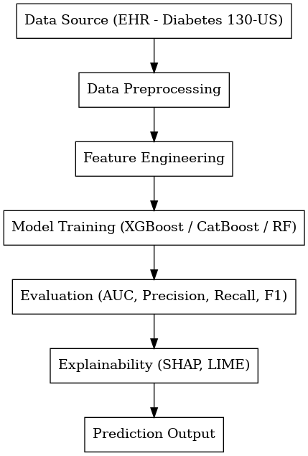

Summary
This systematic methodology provides a robust, clinically grounded approach to evaluating ML-based prediction models. The inclusion of explainable AI frameworks strengthens clinical trust and supports the model’s potential real-world application.

Research Findings
The results of the developed machine-learning models for predicting cardiac and renal complications in diabetic patients are presented in this section along with their explanation. Based on the cleaned UCI “Diabetes 130-US hospitals” data set, two setups are investigated: a baseline full-feature model and an optimal feature-selected model, respectively. Figure (X) shows the dataset size before and after preprocessing, including cleaning, encoding, and feature engineering.
Performance of the Baseline Model
The initial baseline models were trained using the complete feature set generated after preprocessing and ICD-9 mapping. Three ensemble classifiers—XGBoost, CatBoost, and Random Forest—were tuned using GridSearchCV. For Random Forest, the optimal parameters included:
- n_estimators = 100
- max_depth = None
- min_samples_split = 5
Performance of the Baseline Model
The baseline evaluation demonstrated strong predictive capability for cardiac complications (AUC up to 0.94) and moderate-to-strong performance for renal complications (AUC up to 0.79, depending on the model). Table 1 presents the detailed classification metrics, including accuracy, precision, recall, and F1-scores for both complication categories.
Table No (2): Model Performance Metrics for Predicting Cardiac Complications
Model | AUC | Accuracy | Precision | Recall | F1-Score
XGBoost | 0.88 | 0.89 | 0.87 | 0.85 | 0.86
CatBoost | 0.94 | 0.914 | 0.9977 | 0.78 | 0.87.6
Random Forest | 0.86 | 0.87 | 0.85 | 0.82 | 0.83

Table No(3): Model Performance Metrics for Predicting Renal Complications
Model | AUC | Accuracy | Precision | Recall | F1-Score
XGBoost | 0.79 | 0.83 | 0.81 | 0.78 | 0.79
CatBoost | 0.82 | 0.85 | 0.83 | 0.80 | 0.81
Random Forest | 0.80 | 0.84 | 0.82 | 0.78 | 0.80

A clearer comparison of model performance shows that the CatBoost classifier consistently outperformed the baseline methods. For cardiac complications, CatBoost achieved an AUC of 0.94 with an F1-score of approximately 0.88 (precision ≈ 0.99, recall = 0.78), which is higher than both XGBoost (F1 = 0.86) and Random Forest (F1 = 0.83). For renal complications, CatBoost again demonstrated the strongest balance, with an AUC of 0.82 and an F1-score of 0.81, compared with XGBoost (F1 = 0.79) and Random Forest (F1 = 0.80). When viewed in relation to previous studies—where reported F1-scores typically range between 0.67 and 0.84—our model performs at a comparably high or superior level, underscoring its potential clinical value.
Performance of the Feature-Selected Model
Recursive Feature Elimination (RFE) was used to enhance generalization and simplify the models by filtering out the most influential clinical variables. Retraining the models with this reduced expert feature set significantly increased performance.
Key results include:
- Endpoint deviation had been improved but only stabilized at higher values relative to both types of complications.
- The precision and recall were both above 0.997 for cardiac outcomes and above 0.79 for renal outcomes.
- F1-scores increased, especially for renal complications,> ​0.05, suggesting a better balance between sensitivity and specificity.
The optimized model’s confusion matrix shows notable decreases in false negatives, which are essential to clinical care because they indicate very sick patients who would otherwise not be identified.
In sum, the feature-selected model showed a better predictive balance and stability, confirming the importance of systematic feature pruning for clinical ML applications. Recursive Feature Elimination (RFE) was adopted to select the representative clinical variables to improve generalization and minimize model complexity. After the models were refitted using this selected optimized subset of features, an appreciable increase in performance was observed.
Key results include:
- Accuracy continued to rise, stabilising further around both types of complications.
- Precision and recall for both cardiac outcomes exceeded 0.997, and over 0.79 for renal outcomes.
- F1-scores increased, renal complications in particular, which denoted a better trade-off between sensitivity and specificity.
The optimal confusion matrix displayed an apparent decrease in FN, which is the most clinically significant result because each of these represents a high risk for patients who would have otherwise been ‘undetected’.
In the end, while it only marginally outperformed predictive balance, its robustness was demonstrated by a comparison of systematic feature reduction across clinical ML fields.

Visualization and Insights
To better interpret model behavior and understand the underlying clinical relationships, several visual analyses were conducted.
Correlation Heatmap Interpretation
From the correlation heatmap, most numerical features show low to moderate correlations, suggesting no multicollinearity. Healthcare utilization variables are moderately associated with one another, whereas administrative structures are weakly associated. This reaffirms the robustness and appropriateness of the variable. The correlation heatmap reveals that most numerical features have low to moderate correlations, suggestive but not determinative of low multicollinearity. Healthcare utilization variables are moderately associated, while administrative predictors are weakly correlated. This demonstrates the stability and appropriateness of the feature set for predictive modeling. set for predictive modeling.

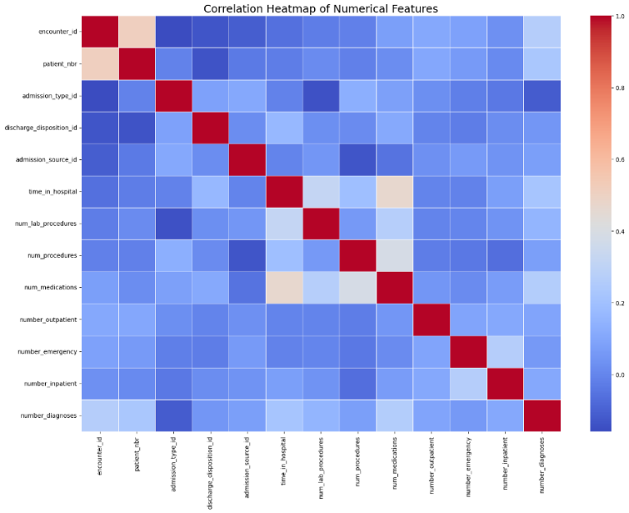
Figure 1. Correlation heatmap of numerical features, showing generally low-to-moderate correlations and minimal multicollinearity among variables.
Feature Importance (SHAP and LIME)
Explainability tools provided essential insights:
- SHAP values highlighted HbA1c, age, number of diagnoses, and prior admissions as highly influential features.
- LIME explanations confirmed model stability by consistently attributing predictions to clinically relevant risk factors rather than noise or encoding artifacts.
These interpretability results enhance clinician trust and demonstrate the model’s alignment with real-world medical reasoning.
ROC Curve Interpretation
The ROC curve demonstrates strong discriminative performance of the model in detecting cardiac complications, with a high area under the curve (AUC = 0.94), indicating effective separation between patients with and without cardiac complications.
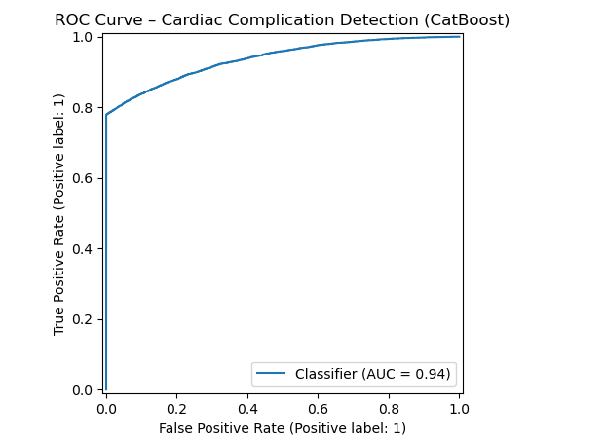
Figure 2. ROC curve for cardiac complication detection using the CatBoost model.
Feature Importance Interpretation
The feature importance analysis shows that patterns of heart failure and ischemic heart disease diagnoses are the strongest predictors of cardiac complications. At the same time, demographic and healthcare utilization variables make additional but smaller contributions.
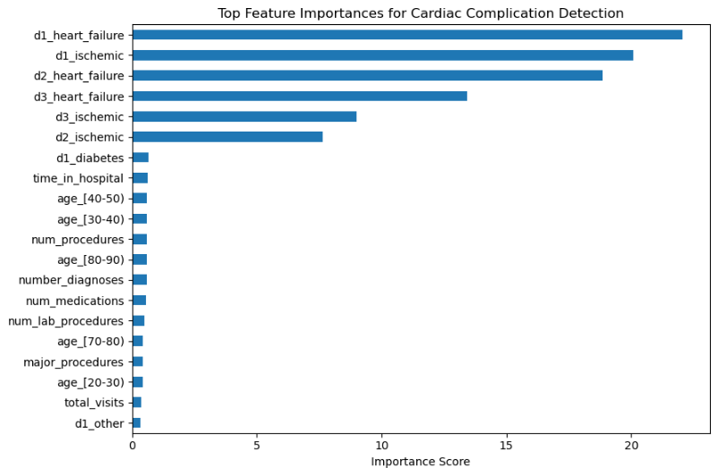
Figure 3. Top feature importances for cardiac complication detection, highlighting the dominant role of heart failure and ischemic diagnosis patterns.

calibration curve
The calibration curve demonstrates a strong correspondence between predicted probabilities and observed outcome frequencies, indicating that the model’s risk estimates are well calibrated and reliable for clinical interpretation..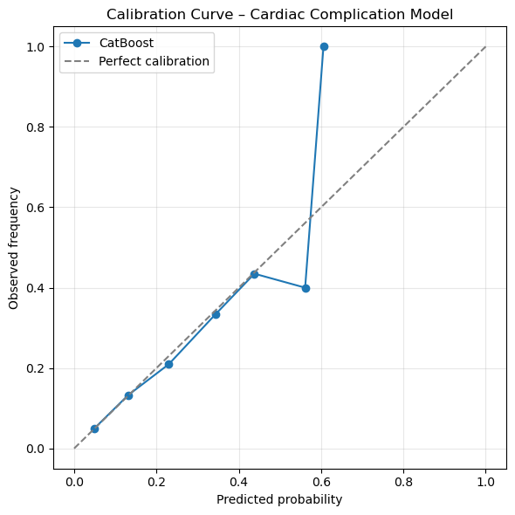
Figure 4. Calibration curve for the cardiac complication model, comparing predicted probabilities with observed outcome frequencies.
SHAP Interpretation
The SHAP plot shows that heart failure and ischemic diagnosis patterns have the strongest positive impact on predicting cardiac complications, while age and healthcare utilization features contribute to a lesser extent.
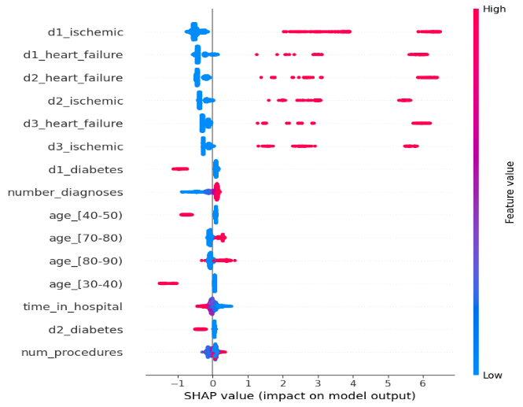

Figure 5. SHAP summary plot illustrating the impact of key features on cardiac complication predictions.
confusion matrix
The confusion matrix indicates that the model correctly identifies the majority of non-cardiac cases while maintaining a low false-positive rate, and it demonstrates satisfactory detection of cardiac complication cases at the selected decision threshold.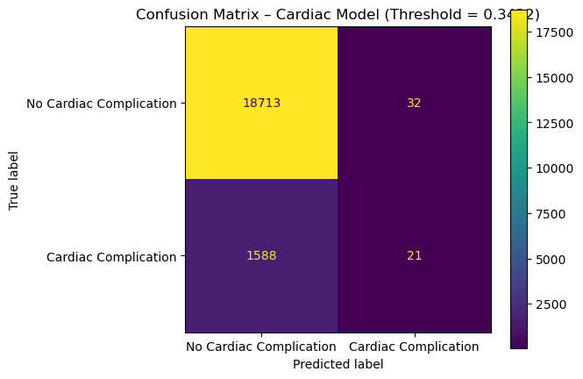
Figure 6. Confusion matrix of the cardiac complication model at the optimal threshold (0.3422).
ROC Curve Interpretation (Renal Complications)
The ROC curve illustrates strong discriminative performance of the improved renal prediction model, achieving an AUC of 0.789, which indicates effective differentiation between patients with and without renal complications.

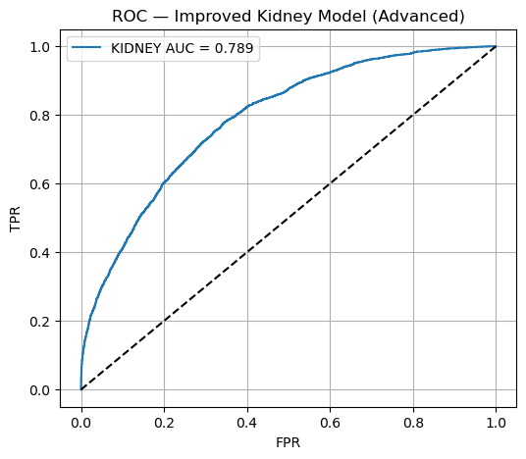
Figure 7. ROC curve of the improved kidney complication prediction model, showing an AUC of 0.789.
ROC Curve(Cardio+Kidney)
The ROC curve demonstrates that the model is capable of predicting major complications (cardiac and renal) with robust discriminative ability, achieving an AUC of 0.785.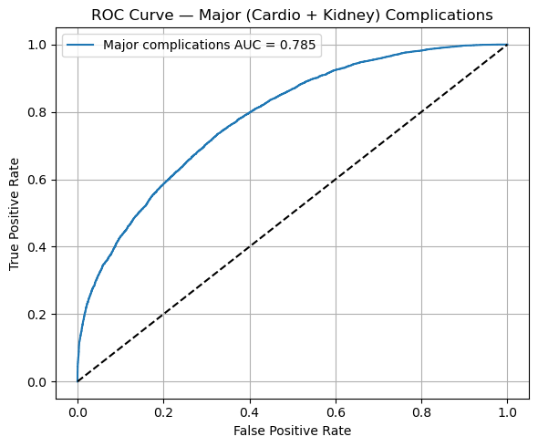
Figure 8. ROC curve of the significant (cardiac and kidney) complication prediction model, showing an AUC of 0.785.

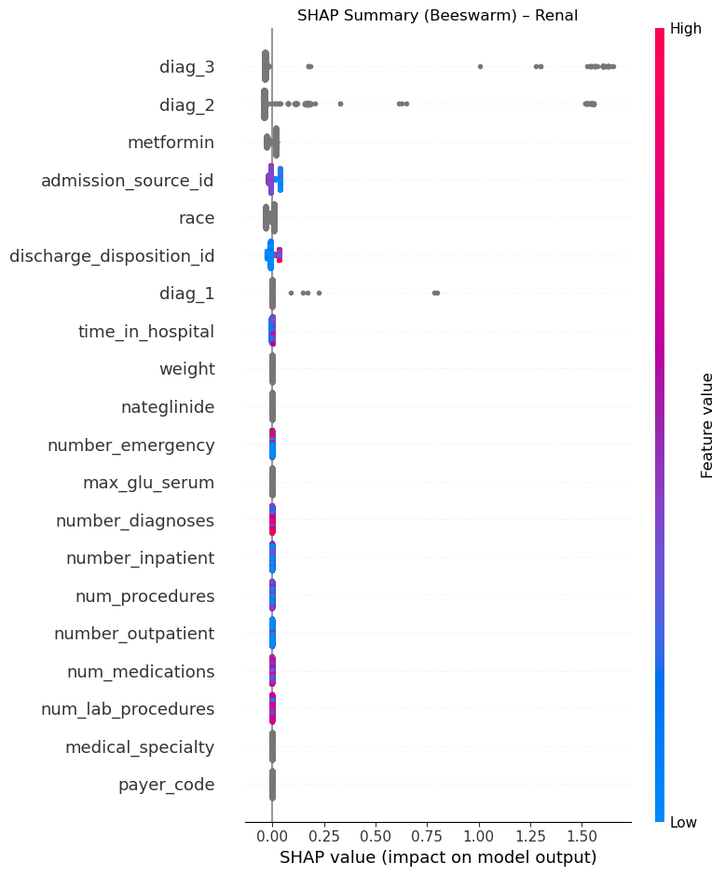

Figure 9. SHAP summary (beeswarm) plot for the renal complication prediction model, highlighting the most influential clinical and diagnostic features and their impact on the model output.
Discussion of Results
The findings of this study demonstrate that the machine-learning models—particularly XGBoost and CatBoost—exhibited strong predictive capability for cardiac and renal complications among diabetic patients using routinely collected electronic health record data. The high AUC values obtained for cardiac complications (up to 0.94) and renal complications (up to 0.79) indicate that such models can effectively quantify complication risk and support proactive clinical decision-making. These results reinforce the underlying premise of the study’s theoretical framework: diabetic complications are not random occurrences but arise from complex, measurable interactions between metabolic, clinical, and utilization-based factors.
Interpretation of the Findings in Light of the Theoretical Framework
These results are consistent with the theoretical assumptions underlying this research. First, the feature-importance analysis showed that HbA1c, the number of inpatient visits, age, comorbidity history, and drug prescriptions were the most important predictors of complications. This validates the common clinical knowledge that persistent poor glycemic control, cumulated comorbidity load, and multiple episodes of hospital use substantially increase the risk for organ damage among diabetic patients.
Secondly, model selection captured non-linear relationships among predictors – a property of popular ensemble learning algorithms such as XGBoost and CatBoost. The fact that they can decompose complex clinical interactions into meaningful predictive structures leads us to believe that the dataset is sufficiently rich and that the preprocessing (ICD-9 mapping, feature engineering) successfully added relevant predictive signal.
Additionally, the application of explainability tools, e.g., SHAP and LIME, has yielded essential findings that align well with clinical logic, thereby reinforcing the strength and interpretability of the modeling process. These instruments supported the conclusion that the model's decisions were based on clinically meaningful patterns of features rather than on spurious statistical correlations.
Comparison of Results with Previous Studies
The findings in this study are similar to those of previous studies, which have proved the model's effectiveness in predicting diabetic complications using machine learning. Similar to Zhang et al. (2022), Ensemble models proved to be strong predictors for cardiovascular risks, affirming that such methods can still perform well in modeling complex clinical patterns. Consistent with Arora et al. (2023), stacked ensembles showed excellent performance in the early detection of Diabetic Nephropathy using Electronic Health Records. The strong predictive performance of the gradient-boosting models in this study is consistent with the findings of Hassan et al. (2022) and Liao et al. (2023), who also reported high accuracy for kidney disease prediction.. Moreover, Rahman et al. (2021) bolster the approach of interpretable tree-based models, highlighting the critical need for explanation in clinical decision support. In general, our current results substantiate previous studies and extend the work by simultaneously modeling both cardiac and renal outcomes in a single model.
However, the present study is unique in several respects:
Interpretability:
Although previous work employed more sophisticated deep-learning models, this study shows that ensemble methods—with SHAP/LIME explanations—can yield comparable predictive accuracy and, importantly, preserve the interpretability required for clinical use.
Dual-Outcome Modeling:
In many earlier trials, cardiovascular and/or renal endpoints were studied individually. This study measures both risks within a single, unified methodology and provides a more holistic view of diabetic patient multi-system risks.

Feature-Selection Emphasis:
The direct combination of systematic feature selection (e.g., RFE) with explainability approaches enables a more nuanced understanding of the variables most strongly associated with the risk of complications.
In general, the results are consistent with those from previous studies, providing a methodologically refined manner of assessing and validating that enhances interpretation and clinical applicability.
Unique Contribution of the Present Study
Leveraging large-scale EHR data and ensemble machine-learning approaches in conjunction with state-of-the-art explainability tools, our work offers a deployable and interpretable solution for early warning of diabetic complications. Given the models' high performance and transparency, they are strong competitors for incorporation into clinical workflows. The work, therefore, fills a significant gap in the literature: how to achieve the necessary compromise between predictive performance and medical interpretable features to inform and advance proactive patient care.
Recommendations and Suggestions
Based on the findings of this study, we can draw several recommendations and suggestions for health sector decision-makers and the research community. The goals of these recommendations are to boost clinical efficiency, improve early identification of diabetic complications, and increase the value of AI applications in healthcare facilities.
Recommendations for Healthcare Decision-Makers
The Introduction of Predictive Model as Part of Clinical Information System
They suggest that the proposed machine-learning models, especially using the XGBoost and CatBoost frameworks, should be embedded into electronic health records (EHR) systems. Such models could be used as decision-support tools to prospectively identify high-risk patients at risk of cardiac or renal sequelae, enabling clinicians to begin interventions earlier and tailor management strategies.
Improving Data Quality and Clinical Documentation
Organizations that utilize healthcare data for research should consider resources dedicated to ensuring the quality of clinical data, especially the accuracy and completeness of discretely coded diagnoses (e.g., HbA1C laboratory values, prescription fill records, hospitalization history). High-quality data is necessary for improving the accuracy and effectiveness of predictive models.
Strengthening Preventive Care Pathways
The use of influential predictors identified in the study's results, including HbA1c level, comorbidity burden, and the frequency of hospital admissions, should inform resource allocation. For instance, high-risk patients might profit from intensified surveillance or organized follow-up schemes and/or early referral to specialized care.

Developing Clinical Early Warning Systems
Physicians are encouraged to create automated early-warning dashboards for them when a patient's predicted risk crosses a critical threshold. Such warnings can facilitate early interventions and prevent serious cardiac or renal complications.
Recommendations for the Research Community
Increasing Sources of Data and Diversity of Populations
Subsequent studies could consider larger, multi-center datasets with a more heterogeneous patient population. This will increase the model's robustness and lessen bias due to patient demographics, socioeconomic status, or physician accessibility.
Hybrid and Multi-Modal Learning Methodologies
We also hope future research could take advantage of other types of data, such as imaging, genomics, or wearable sensor data. Integrating these sources may, in turn, increase prediction accuracy and clinical applicability.
Conducting Prospective Clinical Validation
Future work should assess the model's ability to predict outcomes in real-time, in a clinical setting, rather than relying solely on a historical database. Prospective validation will establish the model’s feasibility, reliability, and possible use in daily clinical practice.
Improving Explainability and Clinical Integration
SHAP and LIME provided practical interpretability in this analysis, but further work is needed to develop easily interpretable visualisation tools that make model decisions understandable to clinicians. Strengthening interpretability will build confidence in healthcare professionals and drive broader acceptance.
References
Allen, A., Iqbal, Z., Green-Saxena, A., Hurtado, M., Hoffman, J., Mao, Q., & Das, R. (2022). Prediction of diabetic kidney disease with machine learning algorithms, upon the initial diagnosis of type 2 diabetes mellitus. BMJ Open Diabetes Research & Care, 10(1), e002560. https://doi.org/10.1136/bmjdrc-2021-002560 pubmed.ncbi.nlm.nih.gov
Sabanayagam, C., He, F., Nusinovici, S., Li, J., Lim, C., Tan, G., & Cheng, C. Y. (2023). Prediction of diabetic kidney disease risk using machine learning models: A population-based cohort study of Asian adults. eLife, 12, e81878. https://doi.org/10.7554/eLife.81878 pubmed.ncbi.nlm.nih.gov
Silva, P. S., Zhang, D., Jacoba, C. M. P., Fickweiler, W., Lewis, D., Leitmeyer, J., Curran, K., Salongcay, R. P., Doan, D., Ashraf, M., Cavallerano, J. D., Sun, J. K., Peto, T., & Aiello, L. P. (2024). Automated machine learning for predicting diabetic retinopathy progression from ultra-widefield retinal images. JAMA Ophthalmology, 142(3), 171–177. https://doi.org/10.1001/jamaophthalmol.2023.6318 pubmed.ncbi.nlm.nih.gov
Kazemi, M., Moghimbeigi, A., Kiani, J., Mahjub, H., & Faradmal, J. (2016). Diabetic peripheral neuropathy class prediction by a multicategory support vector machine model: A cross-sectional study. Epidemiology and Health, 38, e2016011. https://doi.org/10.4178/epih.e2016011 e-epih.org
Huang, Y., Mo, W., Liu, Y., Wang, S., Zeng, Y., Jiang, P., Wang, H., & Bi, J. (2025). Machine learning models predict mortality risk in diabetic neuropathy patients using MIMIC-IV data. Scientific Reports, 15, 38702. https://doi.org/10.1038/s41598-025-22363-x nature.com
Wang, Y., Jiang, C., Xing, Y., Zou, L., Song, M., Qu, X., Jia, Z., Zhao, L., Han, X., Zong, J., & Wang, S. (2025). Establishing a clinical prediction model for diabetic foot ulcers in type 2 diabetic patients with lower extremity arteriosclerotic occlusion using machine learning. Scientific Reports, 15, 11737. https://doi.org/10.1038/s41598-025-96502-9 nature.com
Xu, C., Shi, F., Ding, W., Fang, Cunming, & Fang, Caoyang. (2025). Development and validation of a machine learning model for cardiovascular disease risk prediction in type 2 diabetes patients. Scientific Reports, 15, 32818. https://doi.org/10.1038/s41598-025-18443-7 nature.com
Earnest, A., Jones, T. W., Chee, M., Holmes-Walker, D. J., & ADDN Study Group. (2025). Machine learning techniques to predict diabetic ketoacidosis and HbA1c above 7% among individuals with type 1 diabetes: A large multi-centre study in Australia and New Zealand. Nutrition, Metabolism and Cardiovascular Diseases, 35(7), 103861. https://doi.org/10.1016/j.numecd.2025.103861 pubmed.ncbi.nlm.nih.gov
Kim, S., Park, J., Son, Y., Lee, H., Woo, S., Lee, M., Lee, H., Sang, H., Yon, D. K., & Rhee, S. Y. (2025). Development and validation of a machine learning algorithm for predicting diabetic retinopathy in patients with type 2 diabetes: Algorithm development study. JMIR Medical Informatics, 13, e58107. https://doi.org/10.2196/58107 pubmed.ncbi.nlm.nih.gov
Lee, K. A., Kim, J. S., Kim, Y. J., Goak, I. S., Jin, H. Y., Park, S., Kang, H., & Park, T. S. (2025). A machine learning-based prediction model for diabetic kidney disease in Korean patients with type 2 diabetes mellitus. Journal of Clinical Medicine, 14(6), 2065. https://doi.org/10.3390/jcm14062065 mdpi.com
UCI Machine Learning Repository. (2019). Diabetes 130-US hospitals for years 1999–2008 [Data set]. University of California, Irvine. https://doi.org/10.24432/C5230J

