جامعة ميدأوشن

كلية الإدارة
تخصص/ ماجستير إدارة المخاطر.

UNDERSTANDING THE RISK PERCEPTION OF SAUDI E-CONSUMERS: A LENS OF EXTENDED TECHNOLOGY ACCEPTANCE MODEL

STUDENT NAME:
ABDULRAHMAN MUTIEB ALMUTIRI
STUDENT ID# 242001094

إشراف/
د.الفيصل عبد الحميد
د.فايز جراد

العام الدراسي:
2024

CHAPTER 1: INTRODUCTION

Background
It is equally important for a risk management student to comprehend the complex interrelationships of risk management and risk perception, particularly in the area of e-commerce. Therefore, it is relevant to identify factors that influence consumer behavior toward buying from e-shopping sites like Amazon, eBay, Jarir, Noon, and others since the expansion of e-shopping sites for consumer goods has occurred quickly (Alshahrani, 2020). Most consumers tend to buy products online when they are shopping (Brosdahl & Almousa, 2013). This trend offers a promising avenue of study, particularly with regards to examining how different factors affect consumers’ buying behavior during e-shopping, especially in markets that experience a constantly increasing connectivity to the Internet and digital media literacy, such as Saudi Arabia.
An important factor of this research is to determine the factors that influence consumers’ behavioral intent to purchase or buy from online sites. Some of the factors that are the determinants of such a decision include: – necessities like the confidence or trust of the users on the website, secure payments, simplicity, convenience, availability of the product, and good customer service provision (Chishty & Sayari, 2024). Risk perception studies carried out by Brosdahl and Almousa (2013) suggest that consumers’ risk perception when shopping online is not standard. Customers may experience risks associated with monetary loss, exposure of identity, and security of shared information. Hence, e-commerce firms need to reduce these perceived risks actively by improving the features of their site’s security, coming up with better customer service, and making their working process clear.
On the regional level, Saudi Arabian e-commerce is also quite remarkable, owing to outstanding sales growth rates in the Middle East. According to Statista (2023), improvements in the Internet connection, together with more users subscribing to social media, have boosted the growth of online shopping in the country. In the last couple of years, the Kingdom has experienced a tremendous increase in internet connectivity. This has serious recognition for e-commerce since the population is gradually evolving to be more techno-savvy (Chishty & Sayari, 2024). The Saudi population section of the youth is actively participating in online buying, and it has been found that more mobile devices are used for buying products online.

Saudi E-commerce Market and Factors:
The statistics of the present e-commerce market of Saudi Arabia, reckoned to be almost USD 13.61 billion, are an example. Estimations also show that this market might reach an enormous figure of USD 27.37 billion by 2029, at a CAGR of 15.01 percent (Mordor Intelligence, 2024). Besides this, there are several other factors behind the swift growth of Saudi e-commerce. Firstly, there are current efforts by the Saudi Arabian government to popularize Vision 2030 as a strategic plan aimed at diversifying the economy away from oil dependence and improving digital infrastructure. Such endeavors include enhancing digital access, financing business ventures, and promoting innovation in general and e-commerce in particular (Khoirunnisa & Nurhaliza, 2024).
In addition, perceived cultural values as a determinant are also influential in Saudi Arabia when it comes to consumer buying behavior (Kononova et al., 2024). This activity is not new and has been focused on the physical or tangible aspect, mainly investigated in terms of sales from stores and markets. However, with time, the help of internet connection enhancement, and the change in social culture, this view has slowly started changing (Wijesekara et al., 2020). It is becoming more acceptable to order goods online, and customers are starting to value the opportunity to make purchases at online stores. Social media influencers and marketing campaigns associated with youths especially enhance this shift because people now believe that online shopping is more stylish and innovative than normal retailing (Wang & Zhai, 2022).
One more important factor considered to contribute to the e-commerce of Saudi Arabia is what is more known as mobile commerce (m-commerce). With new mobile device sales, more consumer defaults are using their phones and tablets to shop online (Wasiq et al., 2022). This shift looks to create ways for e-commerce businesses to continue interacting with consumers through interfaces that are mobile-friendly, targeted advertising, and through apps and other applications for shopping. Any social media platform that bothers to build the mobile experience and make it as smooth as possible shall capture the attention of consumers (Wang & Zhai, 2022).
Another factor linked to the economic growth of Saudi Arabia is the development of new trends in the sphere of e-commerce (Khoirunnisa & Nurhaliza, 2024). The growing middle-income class, as indicated by improved disposable incomes and increased product consumption, is behind this growth. Since consumers are now open to experimenting with new brands and products, e-commerce companies have encountered several opportunities and challenges. Also, local business players are beginning to make an effort to go online and expand their customer base, increasing competition and fostering innovation in this sector.

Problem Statement
Nevertheless, the practice of e-commerce in Saudi Arabia has revealed several challenges that need to be solved. Challenges that are common with logistics and delivery structures, as well as rules and regulations, affect the general functioning of e-commerce businesses (Al-Tayyar et al., 2021). For example, the transportation of goods from factories or different cities to large urbanization and rural areas may not be an easy task, and this may result in transmittal delays and customer complaints. Hence, it is crucial to improve the variety of supply chains and overcome any specific organizational obstacles to the formation of an efficient e-commerce environment.
Furthermore, there is a set of issues connected with regulation, such as the problem of payments and services, consumer rights restriction, protection, data retention, and usage. In light of this progress, the legal system must match up with the rate of advancement in e-commerce so as to work for the benefit of the customers. Companies are required to follow national laws and regulations as well as practice good ethical standards and, of course, transparency to improve brand reputation.
Based on the above-mentioned notion, this study aims to investigate the impact of perceived risk, perceived usefulness, and perceived ease of use on the attitudes and intentions to buy from male and female Saudi consumers. The study will help us understand the role of gender in the intention to buy.

Study Purposes
This research highlights the value of comprehending risk management based on Saudi Arabian data in the e-commerce market. Given the continued forecasts of growth, and not least with the Vision 2030 initiative being instrumental in driving the digital economy forward (Chishty & Sayari, 2024; Mordor Intelligence, 2024; Statista, 2023), Saudi Arabia provides a specific case for analyzing how risk perception influences consumer conduct within the specific context of e-commerce. As consumers in Saudi Arabia are starting to come online and experience e-shopping, the following are the key factors that should be considered. This research will have theoretical implications that can be useful in defending Saudi consumers against threats, as well as practical implications of value to businesses, policymakers, and other researchers. In so doing, it seeks to create a safer, secure, and satisfying electronic trading environment that is aligned with the nation’s vision of economic progression and embracing information technology.

Study Importance
Risk management in the context of e-commerce will be of multiple importance for various reasons, especially when dealing with rapidly progressing active markets such as Saudi Arabia (Alshahrani, 2020). As the e-commerce industry extends into the worldwide market, it would be of paramount necessity to factor in both perceived risk and real risk in customers’ transactions. The analyzed elements can be explained using Saudi Arabia’s e-commerce market, which has recently emerged as one of the fastest-growing industries in the Kingdom (Mordor Intelligence, 2024); however, we need to consider certain specificities of Saudi Arabian socio-economy and culture (Kononova et al., 2024). In turn, the result achieved from the study of this market can help to develop not only accurate theoretic models but also may help firms from all around the world manage their processes similarly to firms from regions experiencing similar rates of growth.
The rapid growth of adoption of technology in Saudi Arabia is taking place in a context that includes trust in online transactions, acceptance of technology, and consumers’ confidence, which are relatively novel (Chishty & Sayari, 2024). Still, Saudi buyers are quite young in the experience of digital shopping, and there are some fears that, for now, still remain quite important and should be considered more thoroughly when compared with those markets where advanced online shopping has been taking place for many years. This research seeks to understand from the list of factors that promote or discourage purchase behavior what could explain the buying behavior of Saudi consumers and general reasons that may make them avoid e-commerce. That way, the study will make a valuable contribution to consumer behavior research in general as well as to risk perception in e-markets, particularly in Middle Eastern markets, which are underrepresented in the global e-commerce context.
Consumer behavior is influenced by the risks related to the purchase of the service, especially the perception of risks (Alshahrani, 2020). From the Saudi Arabian consumers’ perspective, risks may not necessarily be associated with product quality or delivery, or even the possibility of payment platforms, but data privacy and consumers’ attitude to fraud, or cultural factors that are poles apart from those dictated by Western culture (Brosdahl & Almousa, 2013). Thus, investigating these aspects allows the researcher to contribute to an improved understanding of the effect of perceived risk on consumer interactions with e-commerce platforms.
In terms of business relevance, the present research is important as it provides recommendations to guide a targeted e-commerce business approach for the Saudi market. Companies on the international and local levels, like Amazon Noon and Jarir, can adopt this information to determine how the trust of Saudi consumers can be earned and reduce the perceived risks. For instance, cash on delivery (COD) and smart customer support could be more important to a company in Saudi Arabia than in other markets where digital methods of payments are recognized and embraced. Such insights are significant for e-business firms and can be used to tailor their offerings for the Saudi Arabian market and to achieve even greater levels of future growth (Al-Tayyar et al., 2021).
From a theoretical perspective, this research aims to enrich the presented models of risk perception with additional components relevant to emerging markets. It will expand on earlier research by Brosdahl and Almousa (2013) that identified antecedents of e-commerce adoption in similar environments and Statista (2023) that showcased the future employment of Saudi Arabia’s digital economy. Saudi Arabia provides a unique setting in which to develop and gradually modify such models. It might help develop more inclusive theories of risk perception and consumer behaviors when seeking products online that take into account the variety of e-commerce.

Study Questions
Given this backdrop, the current study utilizes the extended Technology Acceptance Model (E-TAM) proposed by Crespo et al. (2009) to investigate the risk perception behavior of Saudi e-consumers and compare the behavioral differences among genders. Below are the research questions this study proposes:
- Do perceived risk (comprised of financial, performance, social, time, psychological, and privacy), perceived ease of use, and perceived usefulness impact Saudi consumers’ attitudes toward buying from e-commerce websites?
- Do perceived risk (comprised of financial, performance, social, time, psychological, and privacy), perceived ease of use, perceived usefulness, and attitudes impact Saudi consumers’ buying behavior on e-commerce websites?
- Does attitudes mediate the relationship of perceived risk (comprised of financial, performance, social, time, psychological, and privacy), perceived ease of use, and perceived usefulness with Saudi consumers’ buying behavior on e-commerce websites?
- Does sex (male vs female) moderate the impact of perceived risk (comprised of financial, performance, social, time, psychological, and privacy), perceived usefulness, and perceived ease of use on attitudes and buying intention of Saudi e-consumers?

Research Hypotheses
Based on the study questions, this study develops the following research hypothesis:
H₁: Perceived Risk (comprised of financial, performance, social, time, psychological, and privacy) has a significantly negative impact on Saudi consumers’ attitudes toward buying from e-commerce websites.
H₂: Perceived ease of use has a significantly positive impact on Saudi consumers’ attitudes toward buying from e-commerce websites.
H₃: Perceived usefulness has a significantly positive impact on Saudi consumers’ attitudes toward buying from e-commerce websites.
H₄: Attitudes have a significantly positive impact on Saudi consumers’ intention to buy from e-commerce websites.
H₅: Perceived Risk (comprised of financial, performance, social, time, psychological, and privacy) has a significantly negative impact on Saudi consumers’ intention to buy from e-commerce websites.
H₆: Perceived ease of use has a significantly positive impact on Saudi consumers’ intention to buy from e-commerce websites.
H₇: Perceived usefulness has a significantly positive impact on Saudi consumers’ intention to buy from e-commerce websites.
H₈: Attitudes have a significantly positive mediation effect between the relationship of (i) Perceived Risk (comprised of financial, performance, social, time, psychological, and privacy), (ii) perceived ease of use, and (iii) perceived usefulness with Saudi consumers’ intention to buy from e-commerce websites.
H₉: Sex (male vs. female) has a significantly positive mediation effect between the relationship of (i) Perceived Risk (comprised of financial, performance, social, time, psychological, and privacy), (ii) perceived ease of use, and (iii) perceived usefulness with Saudi consumers’ intention to buy from e-commerce websites.

Theoretical Model

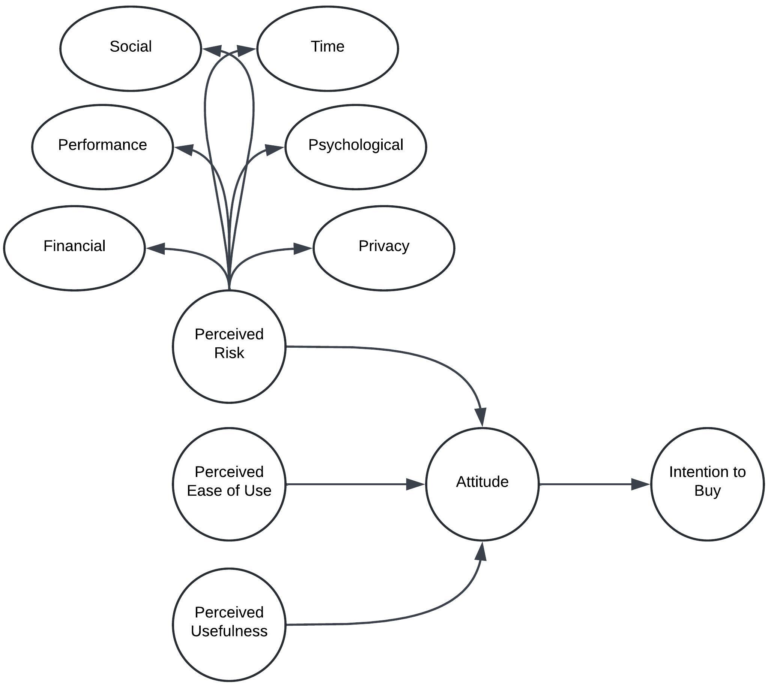
Figure 1: Theoretical Model

Research Limitations
The limitations of the research on the differences in Saudi e-consumers’ intention to shop online are as follows: Based on the nature of the study and the methodology described, several potential limitations can be inferred:
- Generalizability: In the given circumstances, randomization is not possible as the sampling frame of the consumers is not available. Therefore, the best option is to use convenience sampling to find the relationships among different variables. As a result, it will be more challenging to generalize the findings of the specified genders and generations to other regions in Saudi Arabia.
- Sample Size: The study involves and expects a sample of 200 participants from Riyad City. While this is a substantial number, it may not fully represent all consumers in Saudi Arabia.
- Self-Reported Data: The study relies on self-reported data through questionnaires, subject to biases such as social desirability bias, where respondents may underreport undesirable behaviors or overreport desirable ones. This lack of balance can introduce biases that affect the generalizability of findings.
- Limited Scope of Factors: While the study identifies several factors associated with perceived risk (i.e., financial, performance, social, time, psychological, and privacy), there may be other influencing factors that are not considered or measured in this research. The scope of the study is limited.

CHAPTER 2: LITERATURE REVIEW

Introduction
This section summarizes the previous literature investigating the extended technology acceptance model (E-TAM), mainly evaluating the impact of perceived ease of use, perceived usefulness, and attitudes on intention to shop online using e-commerce platforms.
Tong (2010) tested the applicability of an E-TAM for online shopping in the USA and China. The research established that consumers’ perceived usefulness and perceived risk of shopping through the Internet on online purchase intentions are invariant, while perceived usage of the Internet for shopping is not. Perceived ease of use, like perceived usefulness, has an equally positive impact. Perceived risks are directly influenced by prior online shopping experience; similarly, perceived ease of use is also influenced by prior online shopping experience. Nonetheless, there is a quite contrasting impact of prior internet buying experience on perceived usefulness between the two countries.
Fayad and Paper (2015) found that e-commerce is another crucial medium for the performance of business transactions. Theoretical and practical experts in the field, especially market executives, are now heading towards understanding the different theories of consumer behavior within online markets. In their empirical study, Fayad and Paper (2015) recommend the use of E-TAM in contextual e-commerce. The original model of TAM was augmented by including four predictor variables. Outcome satisfaction, expectations, process satisfaction, and e-commerce use are the four predictor variables in this study. Moreover, the actual TAM was expanded by capturing actual behavior instead of capturing intentions as a proxy for behavior in prior TAM utility studies. They proposed specifying the actual use variable in terms of four criterion variables—purchase, access number, access total time, and access average time.
Ofori and Appiah-Nimo (2019) found that owing to the enhanced penetration rate of the Internet and technology in the world, e-commerce is boosting. This has been occasioned by rising innovations in the telecommunication and financial sectors to deepen financial liberalization. They investigated the factors that influence the behavior of students from tertiary institutions who engage in online shopping by using the lens of TAM. The survey covered a sample of 580 undergraduate students. It was found that the effect of ease of use on usefulness was very significant, as the TAM has postulated. Out of all the independent variables analyzed in the study, perceived cost emerged as having the highest impact on the actual use of online shopping among students; nonetheless, the perceived cost had no impact on purchase intention. A significant relationship was observed between perceived risk and purchase intention (PI) but not between perceived risk and actual use.
Recently, Wibasuri et al. (2024) analyzed Indonesian consumers’ behavior when they opted for online shopping. Self-organized specified factors influencing consumer attitudes: perceived usefulness positively influenced consumer attitudes; perceived ease of use positively influenced consumer attitudes; Self-organized specified factors influencing purchase intentions: perceived ease of use influenced purchase intentions; perceived ease of use fortified by perceived risk influenced purchase intentions; Consumer attitudes fortified by security influenced purchase intentions; consumer attitudes fortified by e-trust influenced purchase intentions.
Chishty and Sayari (2024) suggest that consumers’ buying behavior is a complex phenomenon, and under such conditions, it becomes challenging to predict consumer activity, particularly in online markets, and the knowledge of this field is essential for the formation of strategies by newcomers on the market, such as online retailers. Currently, Saudi Arabia has a rapidly increasing number of online users. The outcomes of their research are as follows: perceived enjoyment, perceived ease of use, social norms, and perceived risk are the key factors that exert strong positive effects on the online shopping behavior of college students in Saudi Arabia.
Alateeg and Alhammadi (2023) examine the determinants that influence traditional retail firms’ decisions to embrace e-commerce in the digital retail business in Saudi Arabia. The analysis shows that there is perceived usefulness among the greatest influencers, which has a positive correlation with the intention of choosing e-commerce. Furthermore, the results reveal that perceived usefulness and ease of use play major roles in attitude towards e-commerce, key insight, and conductive and user-friendly platforms. On the other hand, high perceived costs bear the potential of negativism about the potential relationship. Technological barriers are also useful as they serve analytical purposes and can help cultivate a positive attitude. Surprisingly, organizational and environmental factors had a modest effect on attitude, suggesting that internal and personal factors exert the most influence on the attitudes of traditional Saudi Arabian retailers. The knowledge produced by this study would be of great relevance to the conventional retail sector, government bodies, and all other stakeholders who are concerned with the transformation of KSA’s established retail sector, including e-commerce. This integration is critical to sustaining competitive advantage when placed in the environment of technology-infused retail. It is important to comprehend these factors as the retail environment transforms gradually, integrating both corporate and online segments of retail selling.

Perceived Risk:
Defined by Bauer in early 1960, perceived risk has been seen as a significant variable in consumer behavior and perhaps the most critical component of communicating browsers into buyers (Mitchell, 1992; Mitchell & Greatorex, 1993; Dowling & Staelin, 1994). While the academic literature has yet to agree on an accepted definition of perceived risk, for the purpose of this study, then we shall define it as suggested by Stone and Gronhaug (1993) as when an individual feels that he/she is set for a loss (Herrero Crespo et al., 2009).
Through the years, most research has built toward the consensus that there are five different types of perceived risk: social, psychological, economic, performance, time, economic, and psychological. Social risk is the potential for embarrassment, disappointment, or status loss from family and friends due to a bad choice, while psychological risk is the threat to an individual’s ego due to a bad choice (Herrero Crespo et al., 2009; Jacoby and Kaplan, 1972). Perceived economic risk is when an individual may feel that he is likely to be monetarily worst off at the point of purchase of a product or service along with its future costs that might be incurred in maintaining the product or being fraudulently cheated (Herrero Crespo et al., 2009).
According to Stone and Gronhaug (1993), performance risk may be described as the belief that there is a lack of adequate performance of a product or service and that it loses its positive values.
The time risk perceived is felt by the consumer when confronted with the loss of time that could have been used when researching for or making a purchase. Besides the five other kinds of perceived risk, which have been isolated in many prior studies concerning Internet shopping adoption, there is another type of risk known as privacy risk (Herrero Crespo et al., 2009; Jarvenpaa & Todd, 1997; Featherman & Pavlou, 2003; Forsythe & Shi, 2003; Miyazaki & Fernandez, 2001). Privacy risk can be defined as the probability of a potential loss of control over information about a person, for example, if one’s privacy has been infringed or retailers may sell information to other individuals (Miyazaki & Fernandez, 2006).
Consumer behavior related to Internet purchasing, including the perception of risk for purchasing products online, became an area of interest right from the beginning of the use of the Internet for residential purposes in the early 1990s. However, research has shown that consumers perceive the benefits of using the Internet (Salisbury et al., 2001; O’Cass & Fenech, 2003; Park et al., 2004). From the perception of risk, there are also negative consequences, including a negative effect on shoppers’ attitude to online shopping, as highlighted by Shih (2004) and Heijen et al. (2003), and a negative impact on a person’s attitude toward going online shopping as described by Korgaonkar and Wolin (1999). As indicated earlier, Jarvenpaa and Todd (1997) considered perceived risk from a multidimensional angle. As the findings of this study indicate, it is possible to identify the economic, social, performance, physical, and privacy risks that can affect the attitudes to online shopping the consumers experience increased risk while shopping online (Jarvenpaa & Todd, 1997; Featherman & Pavlou, 2003). Heijen et al. (2003) also weighed the antecedents of perceived risk in materializing e-commerce disadvantage.
While examining risk from each of the six perspectives and not from a multiple perspective, Jarvenpaa and Todd (1997) and Featherman and Pavlou (2003) discovered that consumer feels the risk of their privacy loss during an online shopping event when they have to enter personal and credit card numbers. Similarly, Forsythe and Shi (2003) have revealed that performance, time, and economic risks influence the purchase frequency of online shopping. Likewise, Herrero Crespo et al. (2009) stated that the protracted economic and performance risk factors motivate firms to embrace e-commerce more than social and time risk factors.

Theoretical Framework of the Study
Figure 1 shows variables in the model.
The model has six dimensions of perceived risk: financial, performance, social, time, psychological, and privacy. These have been obtained from the model of Crespo et al. (2009). Besides, the model has perceived ease of use and perceived usefulness, leading to attitudes and Saudi consumers’ intention to shop online.
Figure 2: Study Model Adopted from Crespo et al. (2009)

