Chapter 4: Results

4.1 Introduction
This chapter presents the experimental results obtained by applying the methodology described in Chapter 3 to the three transfer learning models: ResNet50, EfficientNetB0, and MobileNetV2. The experiments were implemented in Python and executed on Google Colab with GPU acceleration. The PlantVillage dataset consisting of 20,638 leaf images distributed across 15 healthy and diseased classes of pepper, potato, and tomato plants used for training and evaluation. The dataset divided to 70% training, 10% validation, and 20% testing using a fixed random seed (42) to ensure reproducibility. For each model, the overall test set performance is presented first followed by classification results and an analysis of the confusion matrix.
Finally, a comparative evaluation is performed to identify the best performing model based on classification accuracy and other evaluation metrics.

4.2 Results of ResNet50
ResNet50 evaluated on the test set to assess its performance in classifying plant leaf diseases. The model achieved an overall accuracy of 96.47% with a macro-averaged precision of 96.55% macro-averaged recall of 96.20% and macro-averaged F1-score of 96.33%. In addition, the weighted F1-score reached 96.46% indicating that the model maintained consistent performance across both majority and minority classes despite the class imbalance in the dataset.

Class | Precision | Recall | F1-score | Support
Pepper bell Bacterial spot | 0.985 | 0.995 | 0.990 | 201
Pepper bell healthy | 1.000 | 0.987 | 0.993 | 297
Potato Early blight | 0.990 | 0.985 | 0.987 | 200
Potato Late blight | 0.956 | 0.980 | 0.968 | 200
Potato healthy | 0.968 | 0.968 | 0.968 | 31
Tomato Bacterial spot | 0.979 | 0.967 | 0.973 | 427
Tomato Early blight | 0.966 | 0.840 | 0.898 | 200
Tomato Late blight | 0.945 | 0.979 | 0.962 | 383
Tomato Leaf Mold | 0.953 | 0.958 | 0.956 | 191
Tomato Septoria leaf spot | 0.949 | 0.986 | 0.967 | 355
Tomato Spider mites Two spotted spider mite | 0.916 | 0.976 | 0.945 | 336
Tomato Target Spot | 0.903 | 0.887 | 0.894 | 282
Tomato Tomato YellowLeaf Curl Virus | 0.998 | 0.966 | 0.982 | 643
Tomato Tomato mosaic virus | 1.000 | 0.960 | 0.980 | 75
Tomato healthy | 0.975 | 0.997 | 0.986 | 319
Macro average | 0.965 | 0.962 | 0.963 | 4140
Weighted average | 0.965 | 0.965 | 0.965 | 4140
Table 4.1. Per-class precision, recall, F1-score, and support for ResNet50 on the test set.
Table 4.1 shows that ResNet50 performed strongly and consistently across most classes. Pepper bell healthy reached perfect precision (1.000), and Pepper bell Bacterial spot achieved the highest F1-score (0.990) together with Potato Early blight (0.987). The weakest classes were Tomato Target Spot (F1 = 0.894) and Tomato Early blight (F1 = 0.898); the latter showed the lowest recall of any class (0.840), meaning a relatively larger share of Early blight leaves were missed.
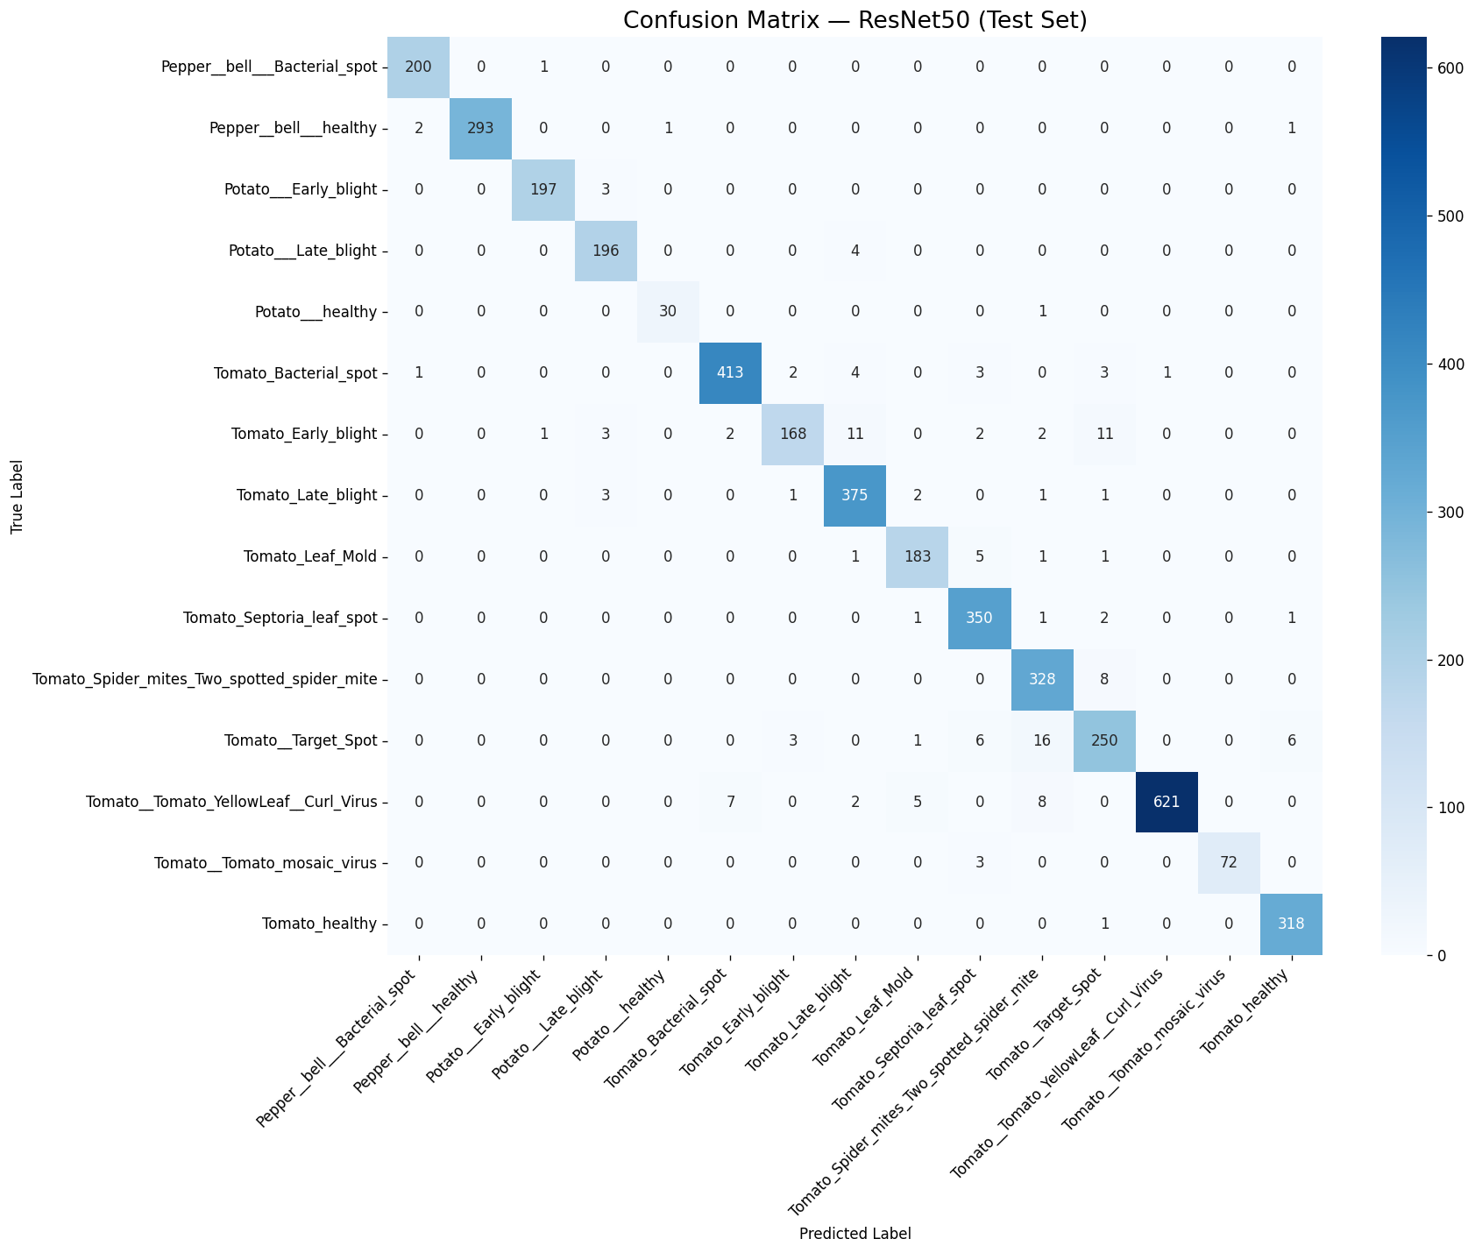
Figure 4.1. Confusion matrix for ResNet50 on the test set.
The confusion matrix in Figure 4.1 shows that ResNet50's errors were concentrated among a small group of visually similar tomato diseases rather than spread across unrelated classes. The most frequent confusion was 16 Tomato Target Spot leaves predicted as Tomato Spider mites, followed by Tomato Early blight being confused with both Tomato Target Spot (11 cases) and Tomato Late blight (11 cases). A smaller amount of confusion also occurred between Tomato Yellow Leaf Curl Virus and Tomato Spider mites (8 cases) and Tomato Bacterial spot (7 cases). The pepper and potato classes, by contrast, showed almost no cross-class confusion, with most of their errors, where present, occurring only between the two potato blight classes.

4.3 Results of EfficientNetB0
Following the same evaluation protocol, EfficientNetB0 was assessed on the identical held-out test set. It reached a test accuracy of 95.97%, with macro-averaged precision, recall, and F1-score of 95.80%, 95.74%, and 95.67% respectively — slightly below ResNet50 across all four headline metrics, but within one percentage point.
Class | Precision | Recall | F1-score | Support
Pepper bell Bacterial spot | 0.980 | 0.990 | 0.985 | 201
Pepper bell healthy | 0.997 | 0.983 | 0.990 | 297
Potato Early blight | 1.000 | 0.960 | 0.980 | 200
Potato Late blight | 0.956 | 0.985 | 0.970 | 200
Potato healthy | 0.939 | 1.000 | 0.969 | 31
Tomato Bacterial spot | 0.976 | 0.967 | 0.972 | 427
Tomato Early blight | 0.959 | 0.825 | 0.887 | 200
Tomato Late blight | 0.940 | 0.990 | 0.964 | 383
Tomato Leaf Mold | 0.994 | 0.895 | 0.942 | 191
Tomato Septoria leaf spot | 0.935 | 0.975 | 0.954 | 355
Tomato Spider mites Two spotted spider mite | 0.931 | 0.929 | 0.930 | 336
Tomato Target Spot | 0.839 | 0.940 | 0.886 | 282
Tomato Tomato YellowLeaf Curl Virus | 0.995 | 0.986 | 0.991 | 643
Tomato Tomato mosaic virus | 0.937 | 0.987 | 0.961 | 75
Tomato healthy | 0.990 | 0.950 | 0.970 | 319
Macro average | 0.958 | 0.957 | 0.957 | 4140
Weighted average | 0.961 | 0.960 | 0.960 | 4140
Table 4.2. Per-class precision, recall, F1-score, and support for EfficientNetB0 on the test set.
EfficientNetB0 reached its highest F1-scores on Tomato Yellow Leaf Curl Virus (0.991), Pepper bell healthy (0.990), and Pepper bell Bacterial spot (0.985). As with ResNet50, the two weakest classes were Tomato Target Spot (F1 = 0.886) and Tomato Early blight (F1 = 0.887), though the pattern differs: EfficientNetB0's Target Spot precision was notably lower (0.839) while its recall was higher (0.940), the opposite trade-off to ResNet50 on the same class. Tomato Leaf Mold also stands out, with very high precision (0.994) but comparatively lower recall (0.895), indicating the model was conservative in predicting this class.
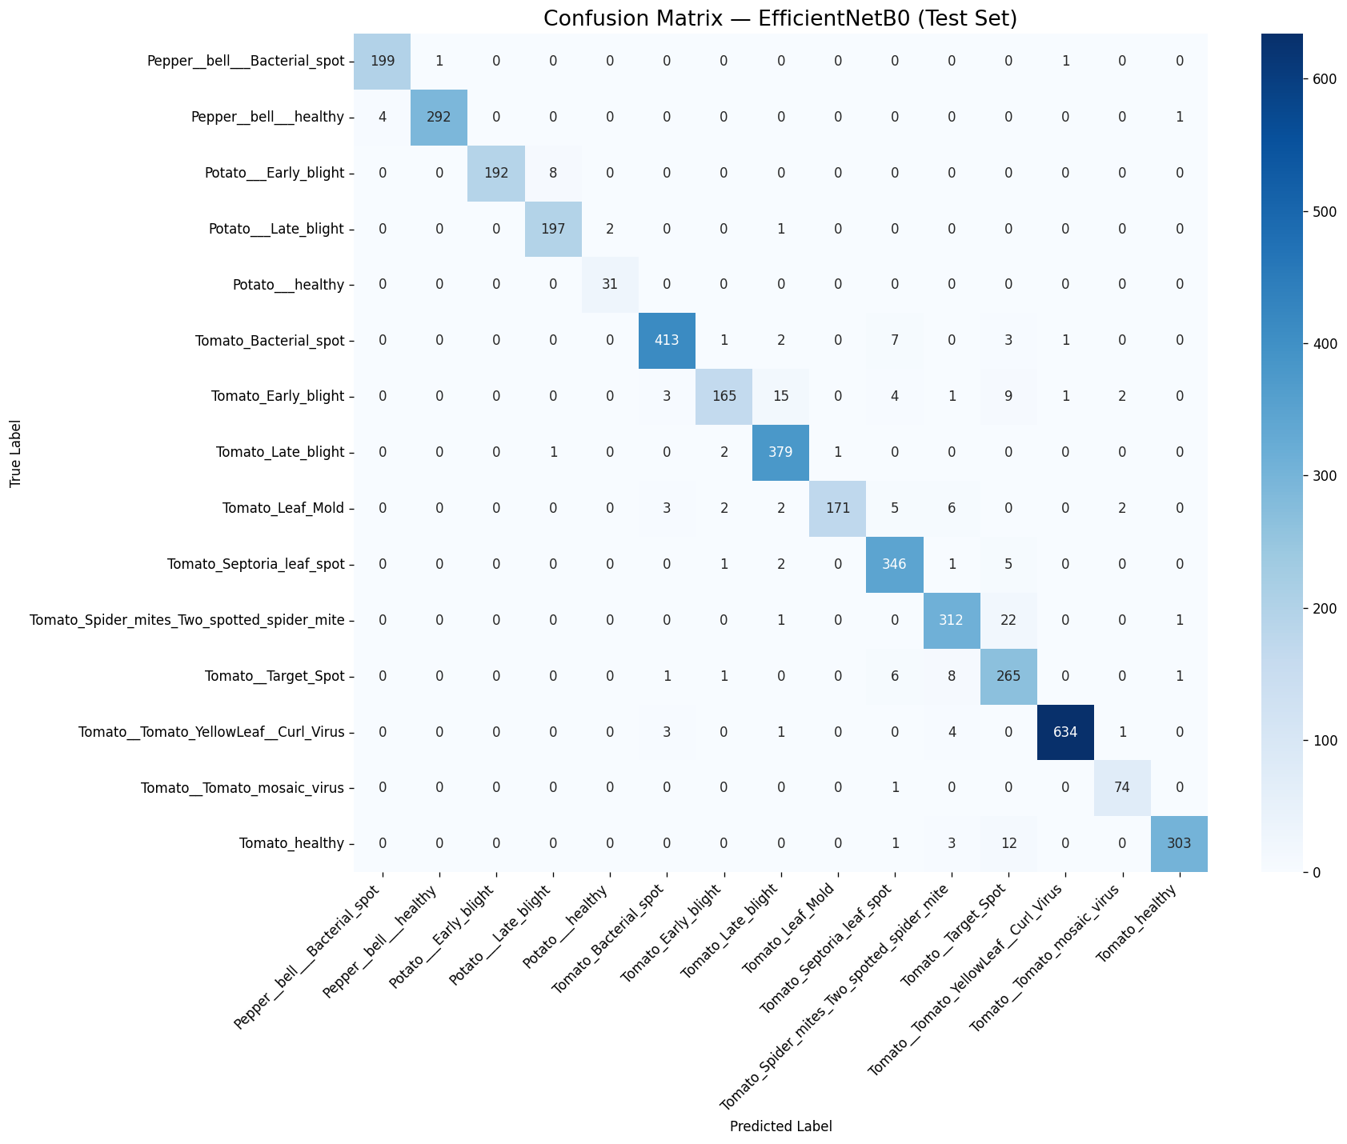
Figure 4.2. Confusion matrix for EfficientNetB0 on the test set.
Figure 4.2 shows that EfficientNetB0's largest single confusion was 22 Tomato Spider mites leaves predicted as Tomato Target Spot, followed by 15 Tomato Early blight leaves predicted as Tomato Late blight and 12 Tomato healthy leaves predicted as Tomato Target Spot. A smaller cross-confusion appeared between Potato Early blight and Potato Late blight (8 cases), a pair that remained essentially error-free for ResNet50. Overall, EfficientNetB0's confusions were concentrated in the same tomato-disease cluster (Target Spot, Spider mites, Early blight, Late blight) that also affected ResNet50, suggesting these classes share visual characteristics that both architectures find difficult to fully separate.

4.4 Results of MobileNetV2
The third and lightest backbone, MobileNetV2, was evaluated under the same protocol and produced the lowest headline metrics of the three models: a test accuracy of 92.13%, macro-averaged precision of 92.08%, macro-averaged recall of 91.75%, and macro-averaged F1-score of 91.69%, consistent with it having the smallest parameter count of the three architectures.
Class | Precision | Recall | F1-score | Support
Pepper bell Bacterial spot | 0.975 | 0.965 | 0.970 | 201
Pepper bell healthy | 0.983 | 0.987 | 0.985 | 297
Potato Early blight | 0.965 | 0.975 | 0.970 | 200
Potato Late blight | 0.969 | 0.950 | 0.960 | 200
Potato healthy | 0.968 | 0.968 | 0.968 | 31
Tomato Bacterial spot | 0.936 | 0.956 | 0.946 | 427
Tomato Early blight | 0.944 | 0.680 | 0.791 | 200
Tomato Late blight | 0.929 | 0.922 | 0.925 | 383
Tomato Leaf Mold | 0.892 | 0.911 | 0.902 | 191
Tomato Septoria leaf spot | 0.901 | 0.873 | 0.887 | 355
Tomato Spider mites Two spotted spider mite | 0.786 | 0.949 | 0.860 | 336
Tomato Target Spot | 0.801 | 0.759 | 0.780 | 282
Tomato Tomato YellowLeaf Curl Virus | 0.987 | 0.969 | 0.978 | 643
Tomato Tomato mosaic virus | 0.845 | 0.947 | 0.893 | 75
Tomato healthy | 0.930 | 0.953 | 0.941 | 319
Macro average | 0.921 | 0.918 | 0.917 | 4140
Weighted average | 0.924 | 0.921 | 0.921 | 4140
Table 4.3. Per-class precision, recall, F1-score, and support for MobileNetV2 on the test set.
MobileNetV2's strongest classes were Potato Early blight (F1 = 0.970), Tomato Yellow Leaf Curl Virus (F1 = 0.978), and Pepper bell healthy (F1 = 0.985). Its weakest class by a wide margin was Tomato Early blight, with a recall of only 0.680 and an F1-score of 0.791 — markedly lower than the corresponding recall for ResNet50 (0.840) and EfficientNetB0 (0.825) on the same class. Tomato Target Spot was again the second-weakest class (F1 = 0.780). Tomato Spider mites shows the inverse pattern, with low precision (0.786) but high recall (0.949), meaning the model over-predicted this class at the expense of other tomato diseases.
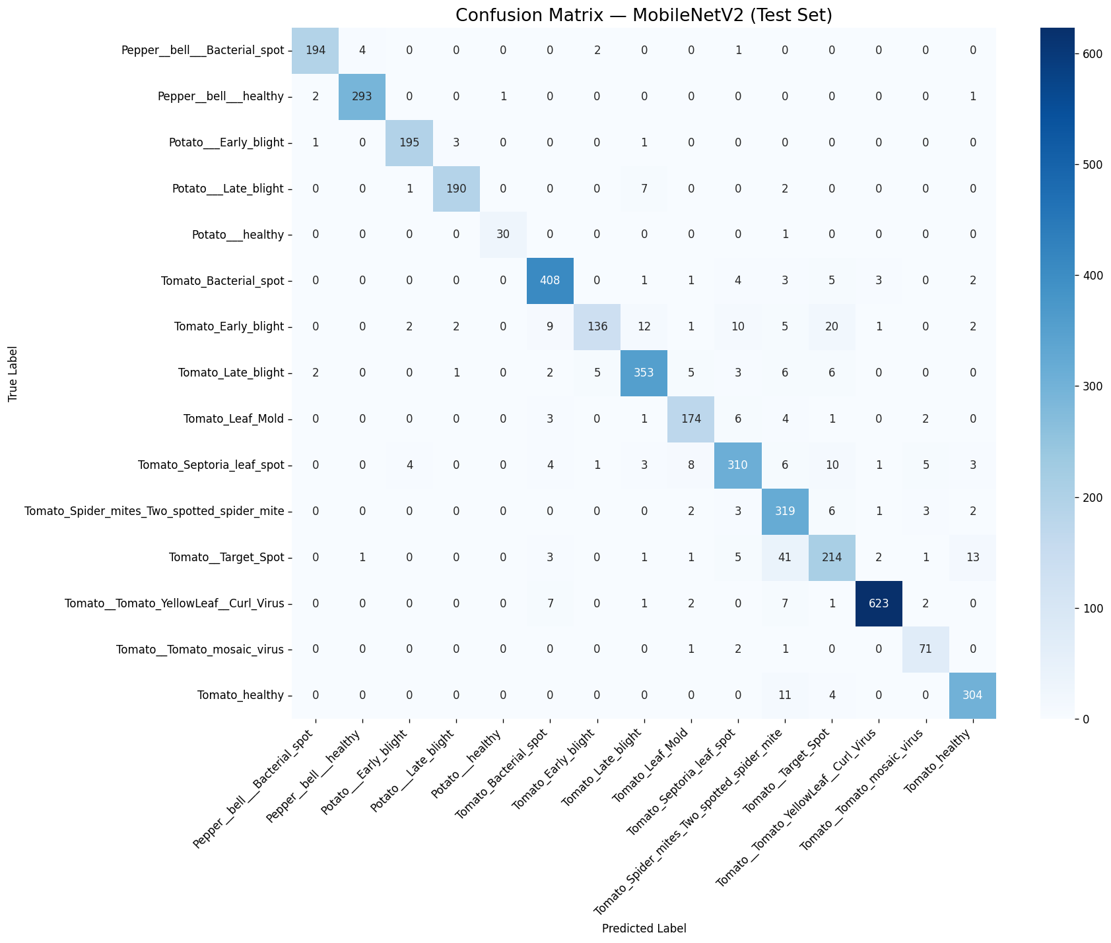
Figure 4.3. Confusion matrix for MobileNetV2 on the test set.
Figure 4.3 shows that MobileNetV2 produced substantially more cross-class confusion than the other two models, particularly within the tomato classes. The single largest error was 41 Tomato Target Spot leaves predicted as Tomato Spider mites, more than twice the equivalent confusion for EfficientNetB0 (22) and more than 2.5 times that of ResNet50 (16). Tomato Early blight was also scattered across several other classes, being confused with Tomato Target Spot (20 cases), Tomato Late blight (12 cases), Tomato Septoria leaf spot (10 cases), and Tomato Bacterial spot (9 cases). This broader spread of errors across the tomato-disease cluster, rather than a single dominant confusion pair, is consistent with MobileNetV2's comparatively lower capacity to separate visually similar tomato diseases.

4.5 Comparative Analysis
Table 4.4 summarizes the headline test-set metrics, parameter counts, and training times for all three models, ranked by accuracy.
Model | Accuracy | Precision (macro) | Recall (macro) | F1 (macro) | F1 (weighted) | Params | Train time
ResNet50 | 96.47% | 96.55% | 96.20% | 96.33% | 96.46% | 24,116,111 | 63.5 min
EfficientNetB0 | 95.97% | 95.80% | 95.74% | 95.67% | 95.97% | 4,381,362 | 66.0 min
MobileNetV2 | 92.13% | 92.08% | 91.75% | 91.69% | 92.07% | 2,589,775 | 63.2 min
Table 4.4. Comparative summary of ResNet50, EfficientNetB0, and MobileNetV2 on the held-out test set, ranked by accuracy.
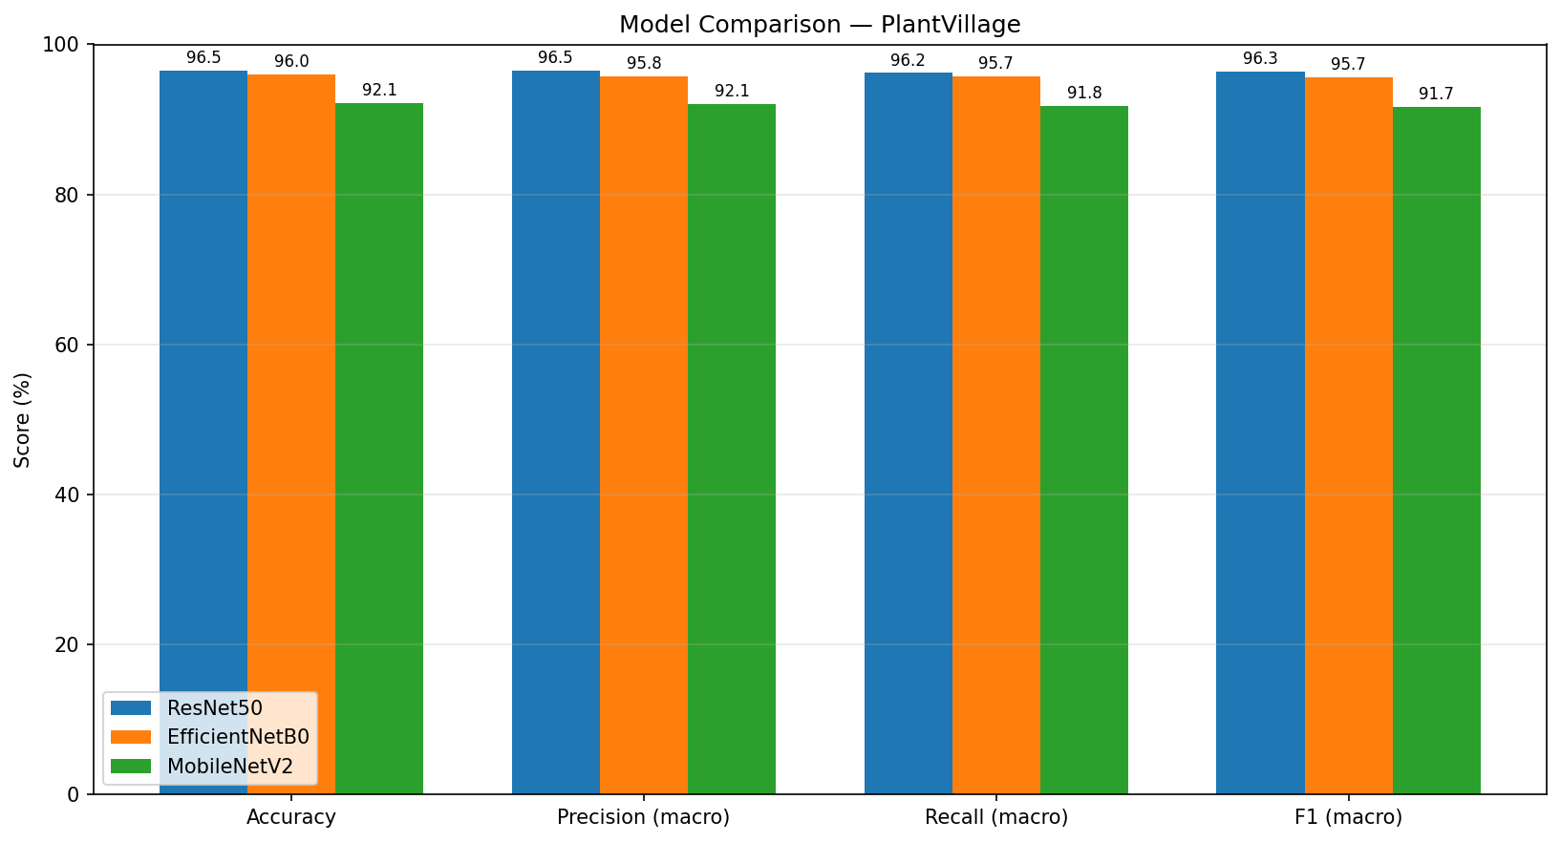
Figure 4.4. Grouped bar chart comparing accuracy, precision, recall, and F1-score (macro) across the three models.
ResNet50 achieved the best overall performance, with an accuracy of 96.47% and a macro F1-score of 96.33%, narrowly ahead of EfficientNetB0 (95.97% accuracy, 95.67% macro F1). MobileNetV2 trailed both models by a larger margin, reaching 92.13% accuracy and 91.69% macro F1.
This ranking closely tracks model capacity rather than training time. ResNet50 has 24,116,111 parameters — roughly 5.5 times more than EfficientNetB0 (4,381,362) and about 9.3 times more than MobileNetV2 (2,589,775) — yet all three models trained in a comparable amount of time (63.5, 66.0, and 63.2 minutes respectively), since only the lightweight classification head was trained in every case while each convolutional base remained frozen. EfficientNetB0 therefore offers the strongest accuracy-to-size trade-off of the three: it comes within half a percentage point of ResNet50's accuracy while using less than one-fifth of its parameters, making it an attractive candidate where deployment on resource-constrained hardware is a priority. MobileNetV2, despite having the lowest accuracy, remains the lightest model by a further margin and may still be preferable when memory and inference-speed constraints dominate over the last few points of accuracy.
A consistent pattern also emerges across all three confusion matrices: the same cluster of tomato diseases — Target Spot, Spider mites, Early blight, and Late blight — accounts for the majority of misclassifications in every model, with Tomato Target Spot and Tomato Early blight ranking among the two lowest-F1 classes for all three architectures. This is consistent with the underlying plant pathology rather than a weakness specific to any one architecture: Target Spot, Early blight, Late blight, and Septoria leaf spot are all necrotic-lesion diseases that produce visually similar brown-to-dark, roughly circular spotting on the leaf surface, and Spider mite damage can produce comparable leaf discoloration and stippling at the resolution of the PlantVillage images. Since even the highest-capacity model in this comparison (ResNet50) was unable to fully resolve this confusion, the bottleneck appears to lie in the visual similarity between these categories themselves rather than in model capacity.

4.6 Summary
This chapter reported the test-set performance of ResNet50, EfficientNetB0, and MobileNetV2 under the identical protocol described in Chapter 3. ResNet50 achieved the best overall accuracy and F1-score, followed closely by EfficientNetB0, with MobileNetV2 trailing both. All three models struggled with the same subset of visually similar tomato diseases, most notably Target Spot and Early blight, indicating a shared, dataset-level source of difficulty rather than an architecture-specific weakness. These findings support EfficientNetB0 as a favorable accuracy-efficiency trade-off among the three backbones evaluated, while ResNet50 remains the top choice when accuracy is the primary objective and computational cost is a secondary concern.

