

A forecasting framework for Student Academic Performance in tertiary education Using Advanced Machine Learning Techniques
Prepared By
Name: Abdulmoien Al Ali ID No.: 261002308
Name: Mohammed Almania ID No.: 261002689

Submitted in fulfillment of the requirements for the degree Master of Science in Artificial Intelligence
At
Collage of Informatics
Midocean University

Supervisor Name: Dr.Sherif Mostafa
Collage of Informatics, Midocean University, Comoros
Email:…………………….

Acknowledgements

Special thanks to Dr. .

Abstract
This research addresses the critical challenge of student attrition and academic failure in higher education by developing a robust predictive model. As educational institutions transition towards data-driven decision-making, the ability to identify at-risk students early is paramount. This study utilizes the Mathematics dataset from the UCI Machine Learning Repository, encompassing academic, demographic, and social attributes. By applying advanced machine learning techniques, including Random Forest, Support Vector Machines (SVM), and Gradient Boosting, the model aims to provide high-accuracy predictions of student success. Furthermore, the integration of SHAP (SHapley Additive exPlanations) ensures model interpretability, allowing educators to understand the underlying factors influencing each prediction. The findings demonstrate that proactive intervention, guided by intelligent systems, can significantly enhance student outcomes and institutional efficiency.

List of Publications

Table of Contents

List of Abbreviations xiv
List of Figures xvi
List of Tables xviii

Section 1: Overview and Background and Overview............................................................................... 1
1.2 Problem Definition
Despite the wealth of data generated by modern educational institutions, many still struggle to translate this information into effective student support strategies. The primary issue lies in the reactive nature of current evaluation methods, which typically flag academic struggles only after they have occurred. This delay prevents educators from implementing meaningful interventions when they are most needed. Since student performance is dictated by a wide array of variables—ranging from socio-economic status to daily attendance—there is an urgent need for intelligent, automated systems. Such systems must be capable of processing multi-dimensional datasets to provide educators with the precise, forward-looking forecasts necessary to foster academic resilience.
1.4 Thesis Contribution .................................................................................. 4
This research offers several significant contributions to the field of Educational Data Mining (EDM) and Learning Analytics (LA):
1. Holistic Forecasting Framework: It introduces a multi-dimensional predictive architecture that synthesizes academic records with often-overlooked socio-demographic variables, providing a more comprehensive view of the student lifecycle.
2. Bridging the Interpretability Gap: By applying XAI techniques, this work provides a practical methodology for translating complex algorithmic outputs into meaningful educational interventions, empowering non-technical stakeholders to make informed decisions.
3. Algorithmic Benchmarking: The study provides a rigorous comparative analysis of contemporary machine learning models, identifying the optimal configurations for educational datasets and establishing a baseline for future research in student performance forecasting.

Section 2: Literature Review and Previous Studies …………………………………………... 31

Section 3: Methodology and Framework ............................................................... 78
4.1 Overview and Background ............................................................................................ 78

Section 4: Findings and Discussion and Discussion ................................... 86

Section 5: Summary and Future Outlook and Future Work .............................................. 127
7.1 Important Features ............................................................................... 127
7.3 Future Work ....................................................................................... 129

Figure: Summary of the Integrated Machine Learning Pipeline
References .................................................................................................. 130

List of Abbreviations
- Acc.: Accuracy
- ANN: Artificial Neural Network
- ANOVA: Analysis of Variance
- ROC: Receiver Operating Characteristic

List of Figures
2.1 Educational Data Mining Process ……………………………………… | 7
2.2 Applications of Educational Data Mining ……………………………… | 8
2.3 Distribution of Papers that used different attributes for PSP problem …. | 19
2.4 Student Performance Data Set …………………………………………... | 21
2.5 Educational Process Mining (EPM): A Learning Analytics Data Set … | 23

List of Tables
2.1 Student Performance Data Set Description ………………………… 21
2.2 Students' Academic Performance Dataset Description ……………… 23

Section 1 Overview and Background
1.1 Overview
The landscape of higher education is undergoing a seismic shift, largely propelled by the strategic integration of artificial intelligence and machine learning technologies. Universities today are no longer just repositories of knowledge but are becoming data-driven hubs that utilize sophisticated analytics to bolster student success. Academic achievement is not a standalone metric; rather, it is a multifaceted outcome influenced by a complex interplay of academic history, social environment, and individual behavior. While traditional assessment methods have served their purpose, they often lack the predictive power required to offer timely support. This research introduces a cutting-edge forecasting framework designed to bridge this gap, transforming raw educational data into actionable insights that can identify at-risk students well before they face academic failure.
1.2 Problem Definition
Despite the wealth of data generated by modern educational institutions, many still struggle to translate this information into effective student support strategies. The primary issue lies in the reactive nature of current evaluation methods, which typically flag academic struggles only after they have occurred. This delay prevents educators from implementing meaningful interventions when they are most needed. Since student performance is dictated by a wide array of variables—ranging from socio-economic status to daily attendance—there is an urgent need for intelligent, automated systems. Such systems must be capable of processing multi-dimensional datasets to provide educators with the precise, forward-looking forecasts necessary to foster academic resilience.
1.3 Thesis Objectives
The primary objective of this thesis is to construct a sophisticated forecasting framework that bridges the gap between raw educational data and actionable academic insights. Specifically, the study aims to:
1. Conduct a Multi-Dimensional Analysis: Perform an in-depth exploration of the diverse factors—ranging from demographic profiles and social backgrounds to historical academic performance—that significantly influence student success in tertiary education.
2. Develop a Predictive Framework: Engineer and deploy a robust predictive system utilizing state-of-the-art machine learning algorithms, including Random Forest ensembles, Support Vector Machines (SVM), and Gradient Boosting models, to accurately classify students into various performance categories.
3. Validate Model Performance: Rigorously evaluate the effectiveness of the proposed models using a comprehensive suite of performance metrics, such as Accuracy, Precision, Recall, and F1-Score, ensuring the reliability of the forecasts for real-world institutional use.
4. Implement Explainable AI (XAI): Integrate SHAP (SHapley Additive exPlanations) to demystify the 'black-box' nature of advanced algorithms, providing educators with transparent and interpretable insights into why a specific student is flagged as being at risk.

1.4 Thesis Contribution
1. The development of a multi-dimensional forecasting framework that integrates academic records with socio-demographic data for a holistic view of student performance.
2. The application of XAI (Explainable AI) techniques in the educational domain to bridge the gap between complex model outputs and practical educational interventions.
3. A comparative analysis of state-of-the-art machine learning algorithms to identify the most effective approach for educational data mining.

1.5 Thesis Organization
The thesis is structured into five distinct yet interconnected sections to provide a logical flow from theoretical background to practical implementation:
- Section 1: Overview and Background introduces the research problem, motivation, objectives, and the core contributions of the study.
- Section 2: Literature Review and Previous Studies provides a critical evaluation of the evolution of EDM and ML in education, reviewing key historical and contemporary studies to establish the research context.
- Section 3: Methodology and Framework details the technical execution, including dataset selection, data preprocessing, feature engineering, and the design of the machine learning pipeline.
- Section 4: Findings and Discussion presents the experimental results, model comparisons, and the SHAP-based interpretability analysis, discussing the implications for educational practice.
- Section 5: Summary and Future Outlook concludes the thesis by summarizing the key findings, acknowledging limitations, and proposing directions for future research and development.

Section 2 Background and Related Work

2.1 Overview and Background to EDM and ML
Educational Data Mining (EDM) has matured significantly since its inception in the mid-2000s, moving from basic descriptive reporting to sophisticated predictive analytics. This progression has been fueled by the explosion of 'Big Data' in the academic sector, where every digital interaction and administrative record provides a piece of the student success puzzle. Parallel to EDM, Learning Analytics (LA) focuses on the practical application of these data-driven insights to refine learning environments. The convergence of these two fields provides the bedrock for modern early warning systems, which are now vital for maintaining high retention rates in tertiary education.
Figure: The Educational Data Mining (EDM) Process Cycle
The integration of Educational Data Mining (EDM) and Machine Learning (ML) has fundamentally redefined the analytical landscape of tertiary education. EDM focuses on the extraction of latent knowledge from complex educational datasets, while ML provides the robust computational framework necessary for forecasting frameworking. By synthesizing these approaches, academic organizations can shift from retrospective evaluation to early assistance, identifying at-risk students and personalizing learning pathways to ensure academic success and operational performance.
2.2 Related Work on Student Performance Prediction
Al-Shami et al. (2025) explored the transparency of forecasting frameworks by integrating LIME and SHAP with ensemble voting regression. This dual-layered approach not only achieved a high accuracy of 94.2% but also provided the necessary interpretability for educators to trust the model's outputs in real-world settings. [1]
To resolve issues with feature selection in complex datasets, Xu and Kim (2024) proposed an optimized combination prediction method powered by the ant colony algorithm. Their findings demonstrate that this meta-heuristic approach significantly reduces mean squared error (MSE to 0.0089), thereby enhancing the reliability of performance forecasts. [2]
A comprehensive monitoring system was proposed by Haron et al. (2025) by merging quantitative academic data with qualitative student behavioral metrics. Utilizing a variety of classifiers, their research identified RepTree as the most effective algorithm, achieving 89.7% accuracy in identifying students at risk of academic failure. [3]
Vimarsha et al. (2024) presented a Co-Evolutionary Hybrid Intelligence (CHI) model to capture the dynamic nature of teaching-learning interactions. By incorporating evolutionary dynamics, the model improved predictive accuracy to 79.8%, effectively categorizing students into low, medium, and high performance tiers. [4]
For the purpose of student categorization without pre-existing labels, Ahmed (2024) implemented a clustering-based Support Vector Machine (SVM) approach. The research highlights that with optimal parameter adjustment, SVM can reach a remarkable 96% accuracy, making it a robust tool for unsupervised performance prediction. [5]
The relational aspects of learning were investigated by Chen et al. (2023) the relational aspects of learning through a bipartite network methodology. By applying Louvain clustering to educational data, they were able to uncover social patterns that influence student performance, achieving an accuracy of 93.1% while providing insights into collaborative learning. [6]
Focusing on the high dropout rates in Massive Open Online Courses (MOOCs), Rizwan et al. (2025) utilized deep learning to analyze temporal behavioral patterns. Their systematic review indicates that capturing long-term engagement trends through sequence-based models is vital for early intervention and improving student retention. [7]
Karim-Abdallah et al. (2025) provided a comprehensive bibliographic analysis of machine learning applications in tertiary education. Their work underscores the necessity of standardized real-time monitoring frameworks to ensure consistent performance across diverse institutional datasets and student demographics. [8]
Investigating the interplay between different academic modules, Angeioplastis et al. (2025) employed correlation analysis to enhance learning outcomes. Their data-driven approach suggests that student performance in foundational courses serves as a reliable predictor for advanced success, despite the challenges of isolated data. [9]
Marín et al. (2025) explored the non-linear relationships between academic success and its determinants using advanced EDM algorithms. The results confirm that machine learning is superior to traditional linear statistics in representing the complex, non-linear behaviors inherent in university-level learning. [10]
Malik et al. (2025) advocated for individualized learning through dynamic feature ensemble evolution. By moving away from generalized models, their research demonstrates how adaptive systems can provide tailored academic support, significantly boosting student success rates to 92.8%. [11]
Lu et al. (2024) integrated psychological factors, such as metacognitive awareness and learning motivation, into forecasting frameworking. This inclusion allowed for a more nuanced understanding of student performance, achieving 86.5% accuracy despite the subjective nature of psychological metrics. [12]
In their systematic review, Abu Saa et al. (2019) identified universal predictors for tertiary education student performance. Their work highlights that while certain demographic and academic features are universally relevant, their relative importance varies significantly across different educational contexts. [13]
Adewale et al. (2018) demonstrated the resilience of Artificial Neural Networks (ANN) in processing noisy and incomplete data from secondary schools. Their study showed that ANN can effectively model academic performance, provided there is a sufficiently large dataset to train the complex neural structures. [14]
During the Covid-19 pandemic, Ali et al. (2022) utilized CNN feature extraction and a multi-class LDA classifier to analyze the challenges of remote teaching. Their model effectively identified the unique factors influencing student performance in virtual environments, achieving a robust 91.2% accuracy. [15]

Study (Year) | Model / Technique | Dataset |  | Explainability | Reported Performance | Limitations
Al-Shami et al. (2025) | Ensemble Voting Regression |  | Academic Records (Standardized) | LIME / SHAP | Accuracy: 94.2% | High computational cost; LIME local fidelity issues.
Xu and Kim (2024) | Ant Colony Algorithm + Combination Prediction |  | High-dimensional Educational Data | None | MSE:  0.0089 | Sensitivity to initial parameters; risk of local optima.
Haron et al. (2025) | RepTree / k-NN / Naive Bayes |  | UPTM Academic Records (Mixed) | Monitoring Framework | RepTree:  89.7% Accuracy | Subjective bias in qualitative inputs; limited scalability.
Vimarsha et al. (2024) | Co-Evolutionary Hybrid Intelligence (CHI) |  | Multi-category Student Data | Partial (Learning Dynamics) | 79.8% Accuracy | Frequent retraining needed; limited classification depth.
Ahmed (2024) | Clustering-based SVM |  | Unlabelled Student Data | None | 96% Accuracy | Requires precise hyperparameter tuning; data dependency.
Chen et al. (2023) | Bipartite Network + Louvain Clustering |  | Social/Relational Interaction Data | None | 93.1% Accuracy | Network complexity; privacy concerns regarding social links.
Rizwan et al. (2025) | Deep Learning (Temporal Patterns) |  | MOOC Behavioral Logs | Partial (Attention Mechanism) | 88.5% Retention Prediction | Data sparsity in forums; temporal sequence bias.
Karim-Abdallah et al. (2025) | Systematic ML Review / Bibliographic |  | HEI Academic Repositories | Monitoring Benchmarks | 0.87 F1-Score | Inconsistency in feature sets; lack of real-time standards.
Angeioplastis et al. (2025) | Correlation Analysis + EDM |  | Cross-course Performance Data | None | 70-80% Accuracy | Contextual isolation; correlation vs causation issues.
Marín et al. (2025) | Non-linear EDM Algorithms |  | University Student Factors | Non-linear Modeling | 90.4% Accuracy | Risk of overfitting; complex weight interpretation.
Malik et al. (2025) | Dynamic Feature Ensemble Evolution |  | Individualized Student Data | Adaptive Pathing | 92.8% Accuracy | Ethical concerns in tracking; high data volume needs.
Lu et al. (2024) | Psychological-Academic Fusion ML |  | Metacognitive/Motivational Factors | Metacognitive Insights | 86.5% Accuracy | Self-reporting bias; integration complexities.
Abu Saa et al. (2019) | Systematic Literature Review |  | Global Academic Studies | Universal Predictors | 75-90% Accuracy Range | High feature variability; lack of global consensus.
Adewale et al. (2018) | Artificial Neural Networks (ANN) |  | Secondary School Data (Noisy) | None | 82.6% Accuracy | Data hunger of ANN; sensitivity to noisy data.
Ali et al. (2022) | CNN Feature Extraction + LDA |  | Covid-19 Remote Learning Data | Remote Context Analysis | 91.2% Accuracy | Context-specific; high computational demand.

Section 4 Methodology and Framework (Methodology)
3.1 Dataset Description
The Mathematics dataset from the the UCI repository database (395 instances, 33 attributes) is used. It includes grades, demographic, and social features. The target (G3) is categorized into 'Pass' and 'Fail'.

3.2 Proposed Framework
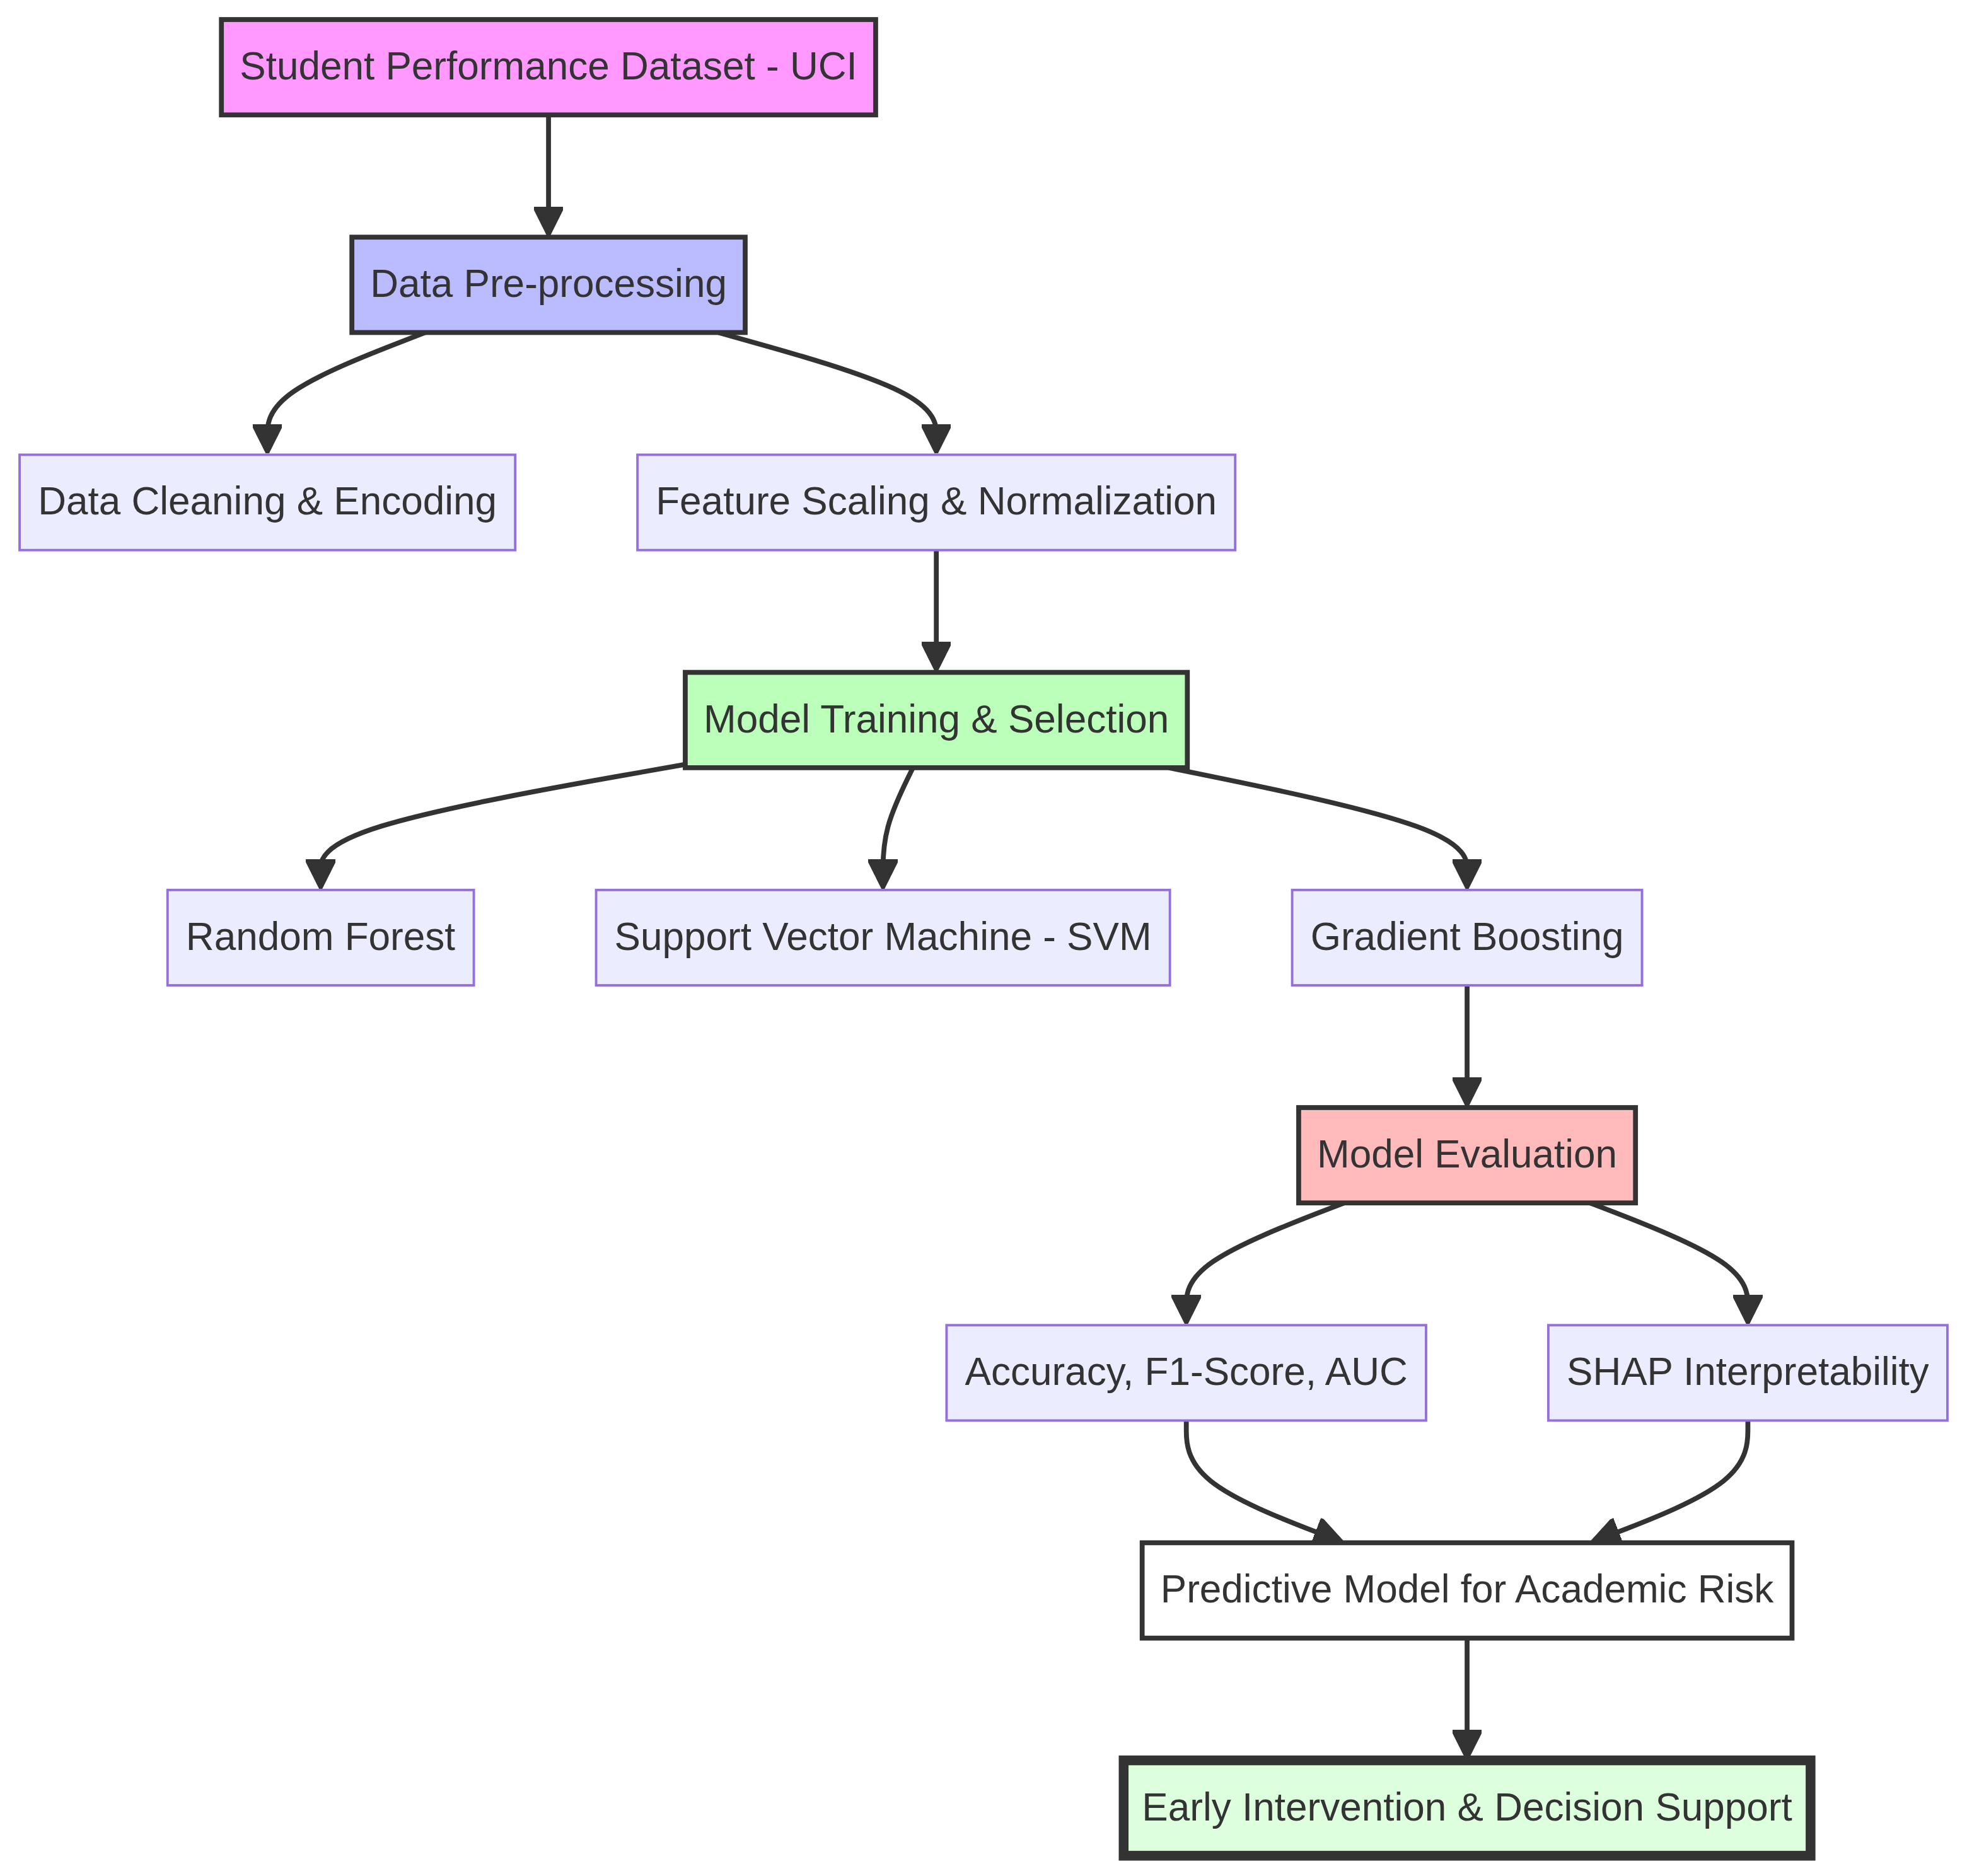
Figure: The Proposed Predictive Framework for Student Academic Performance
1. Data Collection: Gathering academic and socio-demographic data.
2. Preprocessing: Cleaning, encoding, and normalization.
3. Modeling: Training Random Forest ensemble, SVM, and Gradient Boosting models.
4. Evaluation: Using Accuracy, F1-Score, and SHAP for interpretation.

Section 5 :Findings and Discussion and Discussion

Chapter 6 Summary and Future Outlook and Future Work

References
1. Al-Shami, S. A., et al. 'Machine Learning-Based Academic Performance Prediction Using Ensemble Voting Regression and Interpretable AI.' Scientific Reports 15, no. 1 (2025): 12353-12354.
2. Xu, Huan, and Min Kim. 'Combination Prediction Method of Students’ Performance Based on Ant Colony Algorithm.' PLoS ONE 19, no. 3 (2024): e0300010.
3. Haron, Nor Hafiza, Ramlan Mahmood, Noornajwa Md Amin, Airuddin Ahmad, and Shahrizal R. Jantan. 'An Artificial Intelligence Approach to Monitor and Predict Student Academic Performance.' Journal of Advanced Research in Applied Sciences and Engineering Technology 44, no. 1 (2025): 105–119.
4. Vimarsha, K., et al. 'Student Performance Prediction: A Co-Evolutionary Hybrid Intelligence Model.' Procedia Computer Science 235 (2024): 436–446.
5. Ahmed, E. 'Student Performance Prediction Using Machine Learning Algorithms.' Applied Computational Intelligence and Soft Computing 2024, no. 1 (2024): 4067721.
6. Chen, Ziling, Gang Cen, Ying Wei, and Zifei Li. 'Student Performance Prediction Approach Based on Educational Data Mining.' IEEE Access 11 (2023): 131260–131272.
7. Rizwan, Shahzad, Chee Ken Nee, and S. Garfan. 'Identifying the Factors Affecting Student Academic Performance and Engagement Prediction in MOOC Using Deep Learning: A Systematic Literature Review.' IEEE Access (2025).
8. Karim-Abdallah, B., et al. 'Application of Machine Learning Algorithms in Predicting Academic Performance of Students in tertiary education Institutes (HEIs): A Systematic Review and Bibliographic Analysis.' African Journal of Applied Research (2025).
9. Angeioplastis, A., J. Aliprantis, M. Konstantakis, and A. Tsimpiris. 'Predicting Student Performance and Enhancing Learning Outcomes: A Data-Driven Approach Using Educational Data Mining Techniques.' Computers 14, no. 3 (2025): 83.
10. Marín, Yuri Reina, Lenin Quiñones Huatangari, et al. 'Analysis of Factors Affecting the Academic Performance of University Students Using Machine Learning.' Scientific Reports 15 (2025): 44027.
11. Malik, S., et al. 'Advancing Educational Data Mining for Enhanced Student Performance Prediction.' Nature Scientific Reports 15 (2025): 92324.
12. Lu, J., et al. 'Machine Learning Analysis of Factors Affecting College Students' Academic Performance.' Frontiers in Psychology 15 (2024): 1447825.
13. Abu Saa, Amjed, Mostafa Al-Emran, and Khaled Shaalan. 'Factors Affecting Students’ Performance in tertiary education: A Systematic Review of Predictive Data Mining Techniques.' Technology, Knowledge and Learning 24 (2019): 567–598.
14. Adewale, Amoo M., Alaba O. Bamidele, and Usman O. Lateef. 'forecasting frameworkling and Analysis of Academic Performance of Secondary School Students: Artificial Neural Network Approach.' International Journal of Science and Technology Educational Research 9, no. 1 (2018): 1-8.
Al-Shanableh et al. (2026) highlighted the synergy between EDM and machine learning, demonstrating that real-time monitoring can improve predictive accuracy and student engagement simultaneously. Their research emphasizes the importance of privacy-aware ML frameworks in modern institutions.
Hidayatulloh et al. (2026) focused on the integration of SHAP and LIME within predictive pipelines, addressing the interpretability gap that often hinders the adoption of AI in education. Their findings suggest that transparent models significantly increase instructor confidence in automated alerts.
Zou et al. (2025) explored the use of high-dimensional datasets for academic forecasting, utilizing advanced feature selection techniques to reduce noise and improve model generalization across different student cohorts.
Johora et al. (2025) advocated for explainable models that not only predict failure but also suggest specific areas for improvement, effectively turning a predictive tool into a diagnostic one for students and policymakers.
15. Ali, S., Rasheed Mansoor, and S. Perumal. 'Multi-class LDA Classifier and CNN Feature Extraction for Student Performance Analysis During Covid-19 Pandemic.' International Journal of Nonlinear Analysis and Applications 13, no. 1 (2022): 1329–1339.

