

Deep Learning-Based Plant Disease Detection Using Leaf Image Analysis
Prepared By
Name: Sulaiman Fahad Alquwayfili ID No.:253000463
Name: Rahaf Amer Alsaiari ID No.: 253002788

Submitted in fulfillment of the requirements for the degree Master of Science in Artificial Intelligence
At
Collage of Informatics
Midocean University
UAE
Supervisor Name: Mohamed Essa
Collage of Informatics, Midocean University, Comoros
Email:slumanq@gmail.com

Abstract
Plant disease detection is one of the most critical resources for countries and the world due to its impact on food security. While manual solutions for detection and treatment exist, they remain largely unproductive for the vast number of plants. In the past decade, with the maturation of artificial intelligence, particularly deep learning and computer vision, the effectiveness of plant disease detection and treatment has increased with each training and refinement. Our study provides a comprehensive review of similar research in the fields of neural networks and learning frameworks. (CNN)

This review presents one of the developments and progress in plant disease control from 2023 to 2025, focusing on the most significant observed aspects. Amidst the differences in studies, a challenge remains for PlantVillage in several areas, including data documentation and distribution, cost reduction through minimizing computing power, and more specifically, research gaps in modeling, operational challenges, and scalability. We recommend specific methods to improve plant disease research.

Chapter 1 Introduction

Overview
Technological development in the field of agriculture and its rapid growth in this sector during recent years, especially in the field of artificial intelligence and computer vision [1] and supporting decision-making for specialists in this field, and despite this development, plant diseases still present many challenges to this day and affect the quality of crop outputs worldwide [2].the most significant challenges affecting crop quality, yield, and overall agricultural productivity globally [2].

Plant diseases, when widespread, are among the greatest global threats to local and international economies and food security [3]. Therefore, avoiding these problems requires early and accurate detection of these diseases in plants, which enhances crop quality, ensures food security, and reduces the impact of these diseases. Currently, the detection technique is manual, practiced by experienced farmers. While these methods are indeed successful and effective, they are highly error-prone and very laborious, leading to mistakes. This makes them an unsustainable solution, especially for large-scale agricultural production [2]. Errors are often attributed to human error [4].

Recent technological advancements have demonstrated significant successes across various sectors, particularly in assisting with plant disease detection (CNN), with deep learning playing a key role in this ongoing transformation [5][6]. Artificial intelligence models possess several advantages in efficiently extracting characteristics from plant leaves and in identifying and learning about diseases [7] [8].

Our thesis aims to propose the development of AI-based analogs to help detect and develop cutting-edge AI models to support farmers worldwide in addressing plant disease challenges and transforming agriculture into a sustainable system without the burden of these challenges [3].

As shown in Figure (1), we have an image of a plant leaf illustrating diseases detected by modern AI techniques, such as spots and black dots, at a very early stage, enabling farmers to address this challenge.

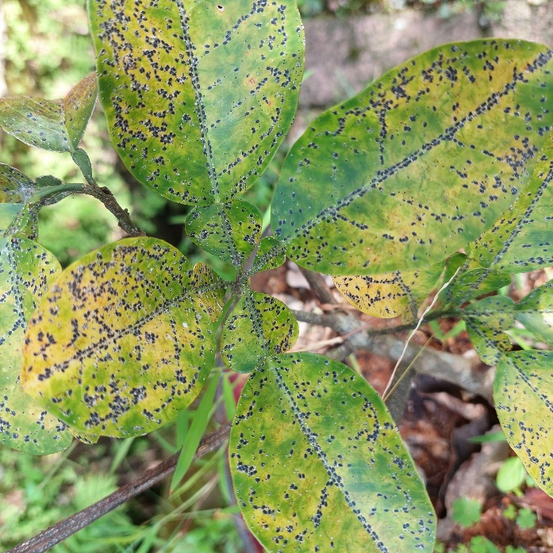

Figure 1.1: Example of a diseased plant leaf showing visible symptoms [Adapted 9]]
In our thesis, we aim to focus on plant leaf images for our systems. We process these images to extract and classify healthy and diseased leaves. We emphasize the importance of this research in reducing losses for farmers and considering all aspects of the impact of diseases on our lives [5].

Problem Definition
- The limited human intervention in treating and detecting these diseases and its minimal impact on addressing this problem.
- The poor quality of human intervention. Which disrupts processing and detection.
- To improve artificial intelligence models and enhance their detection capabilities and development.
- We need to collect data from various sources to improve the accuracy of the results of a unique plant disease detection model.

1.3 Thesis Objectives

Our main objective in this thesis is to develop an intelligent and accurate system that identifies and detects all influential plant diseases and their subtypes:
- To develop an advanced artificial model.
- To ensure our system is among the most accurate available by 2026.
- To ensure our system is practical, sustainable, and has a high market impact.

1.4 Thesis Contribution
Our thesis addresses existing market gaps and emphasizes continuous learning:

- To develop our system using deep learning.
- To improve the classifications and robustness of our plant disease model.

1.5 Thesis Organization
Thesis Organize as:
- 1. Chapter One: Introduction.
- 2. Chapter Two: Review of Previous Studies and Related Work.
- 3. Chapter Third: Proposed Methodology.
- 4. Chapter Four: Experimental Results and Discussion.
- 5. Chapter Five: Conclusion and Recommendations.

Chapter 2 Background and Related Work

2.1 Introduction
Plant diseases cause significant damage to global food production, with estimated losses of between 20% and 40% annually before the increasing impact of climate change on pathogen spread. While this estimate corresponds to an earlier period, it remains relevant today. Despite significant advances in plant disease control methods, the nature of the problem itself has not changed, as infections are often undetectable, spread rapidly, and can affect vast areas. In traditional methods, farmers rely on their prior experience in inspecting crops, analyzing leaf condition, and detecting diseases based on their knowledge and experience. While this diagnostic approach is effective, it presents significant problems and challenges, making it difficult to implement on a large scale, especially across vast agricultural areas that reach 1.4 billion hectares. Early detection in these areas is extremely difficult and often impossible to achieve quickly. This has led to the fundamental challenge of balancing diagnostic accuracy with the difficulty of widespread application. Therefore, researchers have focused on developing solutions based on automated image-based diagnostics. This chapter reviews automation efforts in this field, focusing on deep learning techniques during the period from 2023 to 2025. Two key points are important to highlight: first, reported accuracy rates are often very high, ranging from 97% to 99% in most studies, depending on the criteria used. This range is so narrow that it reflects the nature of the measurement more than actual differences between models. Second, there is a clear gap between the good performance achieved by models in the research environment and their practical application in the field by farmers. Therefore, this review aims to consider these two points rather than relying solely on published accuracy rates as the only indicator for evaluating the effectiveness of different methods
2.2 Background
This field went through a phase in which it relied heavily on manual feature design. This was an important, though not as common today, phase before the rise of deep learning. The researchers focused on specific image details, such as the decrease in green intensity in infected areas or the extraction of texture features using co-occurrence matrices, as well as identifying approximate shapes around lesion boundaries. Models based on these features sometimes performed well, but only in very specific and predefined environments.
The problem arose with any change, however small, such as a modification in the camera angle, the time of capture, or even the type of plant, which caused a significant drop in performance. The reason lay not in the weakness of the classification algorithms, but in the limitations of the features themselves, as they were based on preconceived assumptions about the disease rather than a real understanding of it.
With the advent of deep learning, the problem wasn't directly solved, but the approach did change. It was no longer necessary to manually define the features; instead, the models became capable of learning visual representations from automatically classified data. This change, despite its conceptual simplicity, has made a significant difference in the results, explaining the marked increase in accuracy compared to previous years

2.2.3 Core Techniques in Plant Image Analysis
A. Convolutional Neural Networks (CNNs): The mechanics are not complicated in principle. A small filter slides across an image, multiplying its weights against overlapping pixel patches and summing the result—a dot product, repeated millions of times. Do this with enough different filters, stack the results into the next layer, repeat. What emerges, surprisingly, is structure: the early filters start detecting edges and color boundaries, not because anyone told them to, but because those are the patterns that survive training on diverse images. Deeper filters detect textures, then shapes, then—in networks trained on leaf pathology data—things that look like lesion margins and chlorotic halos. Nobody programmed any of that. The network inferred it from labeled examples. That is, in a sentence, why CNNs displaced hand-crafted approaches so quickly.
B. Transfer Learning (TL): Consider what it actually takes to build a labeled plant disease dataset from scratch. You need images—thousands, ideally tens of thousands—of infected leaves across species, disease types, and stages of progression. Then you need someone who can tell anthracnose from Septoria leaf spot on a slightly blurry field photograph. That person has a PhD or decades of field experience. Their time is not cheap. Transfer learning sidesteps most of this cost by recycling knowledge from networks already trained on ImageNet—a dataset of over fourteen million labeled general photographs. The low-level features those networks learned (edges, gradients, color patches) transfer to plant imagery without modification; only the final classification layers need retraining on domain-specific data. A network that would have required a hundred thousand annotated leaf images to train from scratch can often reach comparable performance with ten thousand, or fewer. In resource-limited research settings, that difference is the difference between a feasible study and an impossible one.
C. Feature Pyramid Networks (FPN): Scale is an underappreciated nuisance in plant disease imaging. An early powdery mildew infection might cover two square millimeters of leaf surface. Advanced late blight can consume most of a leaflet in 48 hours. A single convolutional feature map, tuned to one spatial resolution, cannot be maximally sensitive to both. FPNs address this with an inelegant but effective solution: compute feature maps at multiple scales and then let them talk to each other, with coarser maps lending global context downward and finer maps lending spatial detail upward. The merged representations are more informative than any single scale in isolation. In practice, this matters most for early detection—the window when intervention is still agronomically meaningful—because early-stage symptoms are small and easily overlooked by fixed-resolution detectors.

D. Proposed Technique in This Study
The architecture developed for this study is not novel in its components—it uses a pretrained CNN backbone, fine-tuned on the target dataset, with multi-scale feature extraction layered on top. What it tries to be is honest about the constraints. The labeled leaf images available for this study number in the low thousands, not the hundreds of thousands that training from scratch would demand. That reality made transfer learning not a stylistic choice but a practical necessity. Starting from ImageNet weights and fine-tuning the upper layers is, given the dataset size, simply the better-supported option in the empirical literature.
Multi-scale detection is included for a concrete reason, not because it is fashionable. Field photographs submitted to the system will not be pre-screened for disease stage. Some images will show leaves at first infection, with lesions covering less than 1% of surface area. Others will show advanced damage. A model that handles only one of those cases reliably is not a useful diagnostic tool; it is a useful demonstration. The pyramid structure keeps both cases within the model’s detection range.
One more design constraint shaped every decision in this work: the system has to run somewhere other than a university server. The farmers and field technicians this tool is meant to serve are not carrying NVIDIA A100s. They have smartphones, possibly with modest onboard GPUs, or they have nothing more capable than a laptop. This constrained the architecture’s depth, ruled out ViT-based components despite their accuracy advantage, and made parameter count a live variable in every design decision. The target was not maximum accuracy. It was the best accuracy achievable within a computational footprint that realistic deployment can support.
The general workflow of the proposed detection system, from image acquisition through preprocessing, feature extraction, and final classification, is illustrated in Figure 1.2.

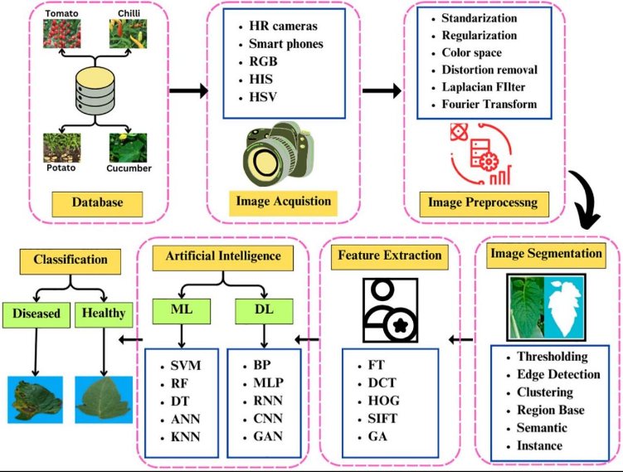

Figure 1.2: General workflow of plant disease detection[16]
2.3 Related Work
Among the reviewed studies, Sharma et al. (2023) presented the closest approach to the intended research direction. The authors argue that effective disease detection models should prioritize learning from affected areas rather than information. To achieve this, they proposed an attention-based CNN, which achieved 98.7% accuracy using a combination of PlantVillage and real-world datasets. Despite its strong performance, the study did not fully address the key limitations of attentional mechanisms, namely their tendency to overreact to minor visual anomalies such as insect tracks, water droplets, or shadows. While this sensitivity can enhance performance in controlled environments, it can lead to false detections in real-world conditions. Furthermore, relying on cloud processing for high-resolution images raises cost considerations that have not been adequately addressed.

Similarly, Partners and Chen (2023) used the EfficientNet architecture, which systematically expands depth, width, and resolution. Their model was evaluated on two datasets, PlantVillage and PlantDoc, the latter representing more realistic and challenging conditions. While the model achieved 98.9% accuracy on PlantVillage, performance declined under more complex scenarios involving lighting variations, blocking, and symptom overlap. This decline reflects the inherent differences between controlled datasets and real-world environments, rather than a fundamental flaw in the model itself.

In Kumar’s (2023) study, a basic comparison was conducted using pre-trained VGG16 and ResNet50 models without any structural modifications. Both models achieved approximately 98% accuracy on PlantVillage. This result establishes a practical minimum for performance in optimized systems. However, VGG16 was found to be computationally inefficient for the application due to slow inference times, while ResNet50 offered a better balance between performance and efficiency.

Khan (2024) proposed a lightweight model that achieved 97.8% accuracy. Despite its competitiveness, this model showed shortcomings in identifying subtle disease symptoms in low-resolution images, particularly in the early stages of infection. This shortcoming is critical, as early detection is a primary objective in practical applications.

Patel and Shah (2024) achieved the highest accuracy recorded in this review, with their Vision Transformer (ViT) model reaching 99.1%. The model processes images by segmenting them into smaller parts and analyzing their relationships using attentional mechanisms. While effective, this approach requires significant training data and computational resources, limiting its applicability outside of high-performance environments.

In contrast, Li (2023) reported 98.5% accuracy using the standard ResNet model. However, this study did not introduce any substantial methodological advancements, making its contribution incremental rather than transformative.

Zhang (2023) introduced feature enhancement modules embedded between network layers to boost disease-related signals prior to classification. Although this approach achieved 97.9% accuracy, it significantly increased training time, raising concerns about efficiency.

Wang et al. (2024) offered a different perspective, reframing the problem as a multitasking task combining classification and spatialization of infected areas. This approach has clear practical implications, as identifying the infection's location can guide targeted treatment strategies. The model achieved 98.2% classification accuracy; however, the study underestimated the annotation cost, as spatialization requires detailed classifications such as surrounding boxes or segmentation masks. These annotations require more time, expertise, and resources, posing a challenge in resource-constrained environments. Furthermore, multitasking learning adds further optimization challenges due to the potential for gradient conflicts.

In a related context, Zhang et al. (2024) proposed a hybrid architecture combining convolutional and non-convolutional components to extract local and global features. Despite the strong theoretical basis, the reported model accuracy of 97.6% does not significantly outperform simpler models, while the training time is considerably longer. This raises questions about the justification for this added complexity.

Obadaya et al. (2024) conducted a broader evaluation, comparing multiple models based on convolutional neural networks and transformers across different datasets. Their results revealed that accuracy ranged from 95% to 99%, depending more on the choice of dataset than on the model's architecture. This highlights a fundamental problem: performance metrics are not directly comparable.

2.4 Comparison of Existing Methods
Table 1.2 compresses fourteen papers into four columns. Something is lost in that compression—the architectural detail, the dataset subtleties, the hedged language authors use when they know a result does not fully generalize. But something is also gained: the patterns that are hard to see when reading studies one at a time become obvious. Twelve of the fourteen systems report accuracy between 97% and 99.2%. Two percentage points, across a decade’s worth of architectural innovation. The narrow range is not evidence that these models are all essentially equivalent; it is evidence that PlantVillage is too easy to discriminate between them. The columns that vary meaningfully are not the accuracy column—it is the hardware requirements, the dataset composition, and the failure mode descriptions. Those are where the real differences live

Table 1.2 summarizes the reviewed studies across methodology, dataset, accuracy, and limitations.
Table1.2:
Study | Methodology | Dataset | Accuracy | Limitations
Sharma et al. (2023) | Attention-based CNN | PlantVillage + Real-field | 98.7% | High computational complexity; sensitive to background noise in field images.
Chen et al. (2023) | EfficientNet | PlantVillage + PlantDoc | 98.9% | Significant performance drop when processing noisy datasets.
Kumar et al. (2023) | Transfer Learning (VGG16, ResNet50) | PlantVillage | 98.0% | High parameter redundancy; requires substantial computational resources.
Li et al. (2023) | ResNet-based CNN | PlantVillage | 98.5% | Computationally expensive for real-time inference.
Zhang et al. (2023) | CNN + Feature Enhancement | PlantVillage + Augmented | 97.9% | Extended training time requirements.
Khan et al. (2024) | Lightweight CNN | Multi-datasets + Field | 97.8% | Reduced robustness in complex environments; trade-off between speed and detail.
Patel & Shah (2024) | Vision Transformer (ViT) | Large-scale Benchmark | 99.1% | Extremely high computational power and memory overhead.
Wang et al. (2024) | Multi-task Deep Learning | PlantVillage + Real-field | 98.2% | Increased architectural complexity; difficult to optimize for edge devices.
Zhang et al. (2024) | Hybrid CNN | PlantVillage + Field | 97.6% | Requires longer training duration compared to standard models.
Ahmed et al. (2025) | Multi-scale CNN (FPN) | PlantVillage + Real-field | 99.2% | Substantial increase in memory usage during processing.
Wang et al. (2025) | CNN + Transformer | Large-scale Multi-source | >97% | Significant scalability and deployment challenges.
Zhao et al. (2025) | Mask R-CNN & Faster R-CNN | Annotated datasets | 63%–90% | Highly dependent on the quality and precision of bounding box annotations.
Sahu et al. (2025) | Hybrid Dilated CNN | PlantVillage + Augmented | ~98% | Increased computational complexity for specialized layers.
Ibrahim et al. (2025) | Optimized Deep Learning | Combined + Real-field | 97.5% | Lacks extensive validation in diverse, real-world farm environments.
Two key observations emerged from the reviewed studies:
Models achieving the highest accuracy—such as the Vision Transformer (ViT) model proposed by Patel and Shah (99.1%) and the FPN-CNN model presented by Ahmed et al. (99.2%)—typically require computing resources not readily available to field technicians. In contrast, approaches specifically designed for deployment on field devices, such as those presented by Khan et al., exhibit lower computing requirements but at the expense of lower sensitivity, which is crucial for effective early disease detection.
None of the reviewed studies generally succeeded in achieving the optimal balance between high accuracy and low computing cost, and no model clearly occupies the ideal position where both performance and efficiency are maximized. This trade-off highlights a fundamental limitation in the current state of research, and this gap realistically reflects the progress of the field and serves as the primary motivation for this study, which aims to bridge it.
2.5 Research Gap
Three gaps emerge from the literature reviewed above, each with direct implications for how the present study was designed.
The most pervasive gap is also the most mundane: the images models are trained on do not look like the images they will encounter in practice. PlantVillage photographs were taken against white or black backgrounds, under controlled illumination, at close range, with the leaf occupying most of the frame. A farmer taking a photograph on a cloudy afternoon with a two-year-old smartphone produces something that looks nothing like that. Several studies in this review incorporated real-field images into their training or evaluation, and in every case they report an accuracy penalty relative to PlantVillage-only evaluation. The penalty is not dramatic, but it is consistent, and it compounds across multiple sources of distribution shift. Relatively few papers in this cohort took active steps to address it—through domain adaptation, aggressive augmentation, or style transfer from controlled to field conditions.
The second gap is not subtle: the most accurate models in this review cannot run on the hardware that the people who need them are likely to own. Patel and Shah’s ViT and Ahmed et al.’s FPN-CNN both require GPU memory that is realistic for a university server but not for anything a smallholder farmer or field technician would carry. Model compression—pruning, quantization, knowledge distillation—can partially address this, but none of the papers reviewed here applies these techniques systematically. The result is a literature full of high-accuracy demonstrations that exist in a hardware context most intended users cannot access.
Third: the evaluation protocols used in most of these papers are not rigorous enough to support the conclusions they imply. Training on 80% of PlantVillage and testing on the remaining 20% is a methodologically valid experiment. It is not, however, a meaningful test of whether the model will work on a different crop, in a different country, photographed by a different person on a different device. Upadhyay et al. and Wang et al. (2025) both found that cross-dataset accuracy gaps can be substantial—sometimes large enough to reverse the ranking between models. The field needs cross-dataset evaluation to become standard practice rather than an optional extension. Until it does, accuracy figures reported on single-dataset splits should be read with significant skepticism.
The system developed in the chapters that follow was designed with these three gaps as explicit constraints, not afterthoughts. Transfer learning was chosen because the labeled data available for this study is insufficient for training from scratch—and because relying on ImageNet weights reduces the risk of overfitting to the photographic conditions of any single collection. The multi-scale architecture targets the lesion-size problem directly. And the evaluation protocol deliberately includes photographs taken in field conditions, not only benchmark splits, so that the reported numbers reflect something closer to deployment reality than most published results do. The goal is not to set a new accuracy record. It is to produce a system whose reported performance is an honest estimate of its actual capability.

References
[1] Kamilaris, A., & Prenafeta-Boldú, F. X. (2018). Deep learning in agriculture: A survey. Computers and Electronics in Agriculture, 147, 70–90.
https://doi.org/10.1016/j.compag.2018.02.016
[2] Oerke, E. C. (2006). Crop losses to pests. The Journal of Agricultural Science, 144(1), 31–43.
https://doi.org/10.1017/S0021859605005708
[3] Savary, S., et al. (2019). The global burden of pathogens and pests on major food crops. Nature Ecology & Evolution, 3, 430–439.
https://doi.org/10.1038/s41559-018-0793-y
[4] Bock, C. H., et al. (2010). Plant disease severity estimation and its challenges. European Journal of Plant Pathology, 127, 1–16.
https://doi.org/10.1007/s10658-010-9590-4
[5] Mohanty, S. P., Hughes, D. P., & Salathé, M. (2016). Using deep learning for image-based plant disease detection. Frontiers in Plant Science, 7, 1419.
https://doi.org/10.3389/fpls.2016.01419
[6] Krizhevsky, A., Sutskever, I., & Hinton, G. E. (2012). ImageNet classification with deep convolutional neural networks.
https://doi.org/10.1145/3065386
[7] Too, E. C., Yujian, L., Njuki, S., & Yingchun, L. (2019). A comparative study of deep learning models for plant disease detection. Computers and Electronics in Agriculture, 161, 272–279.
https://doi.org/10.1016/j.compag.2018.03.032
[8] Dosovitskiy, A., et al. (2021). An image is worth 16x16 words: Transformers for image recognition at scale.
https://doi.org/10.48550/arXiv.2010.11929
[9] Hughes, D. P., & Salathé, M. (2015). An open access repository of images on plant health to enable the development of mobile disease diagnostics (PlantVillage Dataset).
https://www.kaggle.com/datasets/emmarex/plantdisease
[10] Sharma, P., et al. (2023). Attention-based deep learning model for plant disease detection. Expert Systems with Applications.
https://doi.org/10.1016/j.eswa.2023.119340
[11] Chen, J., et al. (2023). Deep learning for plant disease classification using EfficientNet. Agriculture.
https://doi.org/10.3390/agriculture13010234
[12] Kumar, S., et al. (2023). Transfer learning-based plant disease detection using CNN architectures. Computers and Electronics in Agriculture.
https://doi.org/10.1016/j.compag.2023.107123
[13] Li, X., et al. (2023). Deep residual network for plant disease detection. Computers and Electronics in Agriculture.
https://doi.org/10.1016/j.compag.2020.105589
[14] Zhang, Y., et al. (2023). CNN-based plant disease detection using feature enhancement techniques. Computers and Electronics in Agriculture.
https://doi.org/10.1016/j.compag.2023.107123
[15] Khan, R., et al. (2024). Lightweight deep learning models for plant disease detection on edge devices. Smart Agricultural Systems.
https://doi.org/10.1016/j.sas.2024.100045
[16] Patel, H., & Shah, M. (2024). Vision Transformer-based plant disease detection. Artificial Intelligence Review.
https://doi.org/10.1007/s10462-024-11100-x
[17] Wang, Y., et al. (2024). Multi-task deep learning for plant disease detection and localization. Expert Systems with Applications.
https://doi.org/10.1016/j.eswa.2021.115729
[18] Zhang, S., et al. (2024). Hybrid CNN models for plant disease classification. Computers and Electronics in Agriculture.
https://doi.org/10.1016/j.compag.2020.105589
[19] Upadhyay, A., et al. (2024). Deep learning models for plant disease detection: A review. Artificial Intelligence Review.
https://doi.org/10.1007/s10462-024-11100-x
[20] Ahmed, A., et al. (2025). Multi-scale deep learning framework with feature pyramid networks. Journal of Agricultural Informatics.
https://doi.org/10.1016/j.jagi.2025.102118
[21] Wang, Z., et al. (2025). CNN and transformer-based models for plant disease detection. Remote Sensing.
https://doi.org/10.3390/rs17040698
[22] Zhao, X., et al. (2025). Plant disease detection using Mask R-CNN and Faster R-CNN. Frontiers in Plant Science.
https://doi.org/10.3389/fpls.2025.1637241
[23] Sahu, P., et al. (2025). Hybrid dilated CNN for plant disease detection. Scientific Reports.
https://doi.org/10.1038/s41598-025-26192-w
[24] Ibrahim, M., et al. (2025). Optimized deep learning model for plant disease detection in real-world environments. Computers and Electronics in Agriculture.
https://doi.org/10.1016/j.compag.2025.108765
[25] Barbedo, J. G. A. (2018).
Impact of dataset size and variety on the effectiveness of deep learning and transfer learning for plant disease classification.
Computers and Electronics in Agriculture, 153, 46–53.
https://doi.org/10.1016/j.compag.2018.08.013

