CHAPTER 1
- INTRODUCTION
  - Overview
Climate change is the main topic in tremendous meetings and environmental conferences around the world such as united nations – UNEP, environment ministers in the Islamic world, Saudi Environmental Society – SENS, etc. which discusses how to implement new methodology to overtake the effects of the 21st century life style implies on the environment.
Construction industry have a direct impact on the environment where it contributes in the emissions of green gas, generate waste material, consumption of raw material and to overcome the negative impact of the industry researchers, governments, and Engineers are working together to fined innovative solutions.
In the kingdom of Saudi Arabia and toward accomplishing the kingdom’s 2030vision, one of its main focuses are to maintain sustainability through waste recycle, solar power etc. according to the environmental protection in the kingdom of Saudi Arabia.
In this study there are three key words will be focused on sustainability, project management, and construction industry where in chapter 2 these words will be discussed in the literature review to understand the correlation between them and to mitigate a way to maintain it in the industry. The search engine used to find articles cited in chapter2 mainly Google Scholar, Research Gate, Science Direct, etc. to get the most recent articles.
Chapter 3 will be the methodology, and this chapter the chosen technique will be discussed in order to maintain the answers of the research objectives and questions.
Chapter 4 through chapter 6 it will include discussion and results, recommendation and limitation, and conclusion sequentially.
At the end references used and appendixes will be listed.

  - Problem Statement
industry significantly impact the environment, economy and people both in good and in a bad; construction industry contributes to half of the economic income in Saudi Arabia but also it affects the environment dramatically.
The aim of this research is to find a way to mitigate the disadvantages through the implantation of sustainability and project management principles that is used in the market.

  - Research importance
Finding a way to ensure implementation of sustainable project management in construction industry in the kingdom of Saudi Arabia.
  - Research Objectives
The objectives of this research are:
- Investigate the general understanding of sustainability concept among professionals
- Investigate the current state of sustainable project management in the organizations.
- Investigate the challenges facing integrating sustainability in construction project management.
- Investigate the level of integration sustainability in project management in Saudi Arabia
  - Research Questions
By the end of this research the answers of the following questions will be gathered:
- How to ensure general understanding of sustainability concept among professionals?
- What are the current state of sustainable project management in the organizations?
- What are the challenges facing integrating sustainability in construction project management?
- At what level of integration sustainability in project management in Saudi Arabia is?

CHAPTER2
- LITRETURE REVIEW
  - Introduction :
On way to generate new values in the modern era is through projects which creates assets that then can derive benefits to people and economics; where half of all the assets created come from construction industry.(Graham M. Winch, 2010) in KSA about 5.5% of the national income generated through construction industry in 2023.(DATA SAUDI, 2024); on the other hand, one important factor is missing environment, where construction industry is a main factor in causing air pollution, landfill wastes, climate change, carbon emission, waste generations.(Alwan et al., 2017; Tabassum Ira, 2021)
To over come the disadvantages of these industries an updated idea saw light that focuses on environment, economics and social referred to in term of three dimensions/pillars which known as sustainability. (Kuhlman & Farrington, 2010; Moshood et al., 2024)
The impact of environmental crises can be managed with full responsibility of the whole society individuals and organizations.(Scopelliti et al., 2018). To maintain the aspects of sustainability and to ensure it effective implementation during the project life cycle project management have to be addressed.
  - Sustainability :
The interpretation of United Nation Brundtland Commission, 1987, Sustainability is the ability to fulfilling the needs of present generation without compromising the future generations to meet their needs.
According to (Hasna, 2012), the main challenge with Brundtland commission’s definition lays in defining “needs”; where the needs are different from person to another as well it is difficult to define the needs of the future generations; despite the argument on the definition some factors will affect both the future and present generations if not control for example environmental issues.
On the other hand, in modern definitions sustainability became more elaborative and mostly introduced as three pillars which are environmental, economic and social.(Silvius & Schipper, 2014)
  - Sustainability dimensions:
As discussed earlier to maintain the needs of the present without affecting the future generation to meet their own needs the, three dimensions or pillars of sustainability was developed also as construction industry generates both profit in money and cause harm to the environment, understanding the implementation of sustainability in the industry is needed.

    - Environmental sustainability benefits
Adapting sustainable techniques will be reflected in reducing environmental impact enhancing and improving it by implementing systems like Green Building techniques that uses renewable materials that can be recycled after it period due, also implementing green roofs and more efficient energy systems which will help in reducing the carbon footprint, enhancing ecosystem and saves resources. (Elkington, 1997; Edwards et all, 2023 Kibert, 2016; Purvis et all, 2019).
    - Economic sustainability benefits
Also, the benefits extend to economy, were energy efficient, the usage of sustainable materials may directly influence in reduction of utility and maintenance cost subsequently as well as increasing property values; also, it contributes in job creation and economic growth as skilled labors are needed to meet the demand and invigorate competitiveness. (Elkington, 1997; Edwards et all, 2023 Kibert, 2016; Purvis et all, 2019).
    - Social sustainability benefits
Also, for people, sustainable construction projects provide quality ecosystem in which it depends on natural light, better and more natural ventilation systems, usage of nontoxic materials, as well as sustainable construction designed to be safer and have longer life span, in general the system puts the community life style as priority. (Elkington, 1997; Edwards et all, 2023 Kibert, 2016; Purvis et all, 2019).

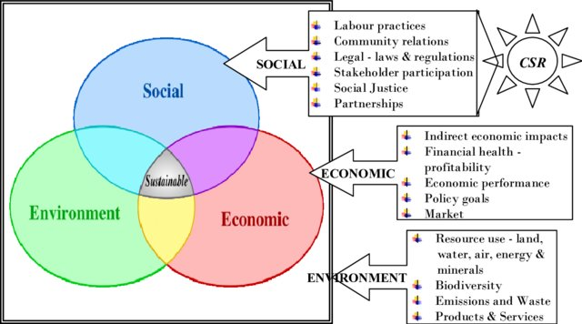

  - Sustainable development
Sustainability development show the evaluation of society from responsible economic perspective incompliance with environmental and natural process.(Glavič & Lukman, 2007)

    - United nation sustainable development goals
United Nations (UN) has adapted by all of its members states in 2015 agenda for sustainable development to be accomplished in year2030 which focuses on “peace and prosperity for people and planet for now and future”. As a result of the agenda UN 17 sustainable development goals illustrated in the figure below have resin which all the members have to implement an immediate action toward them. (United Nations, 2024).
The following are the 17 sustainable development goals: -
- No poverty.
- Zero hunger.
- Good health a well-being.
- Quality education.
- Gender equality.
- Clean water and sanitation.
- Affordable and clean energy.
- Decent work and economic growth.
- Industry, innovation, and infrastructure.
- Reduced in qualities.
- Sustainable cities and communities.
- Responsible consumption and production.
- Climate action.
- Life below water.
- Life on land.
- Peace, justice, and strong industries.
- Partnerships for the goals.
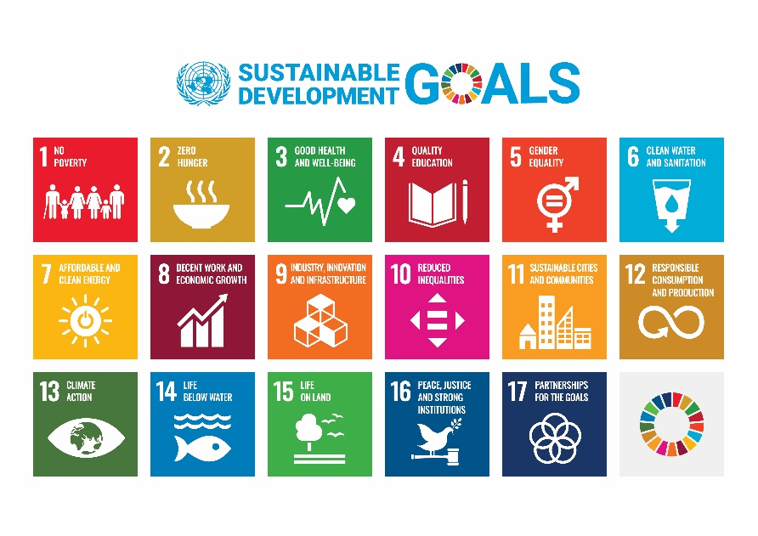
The goals set by the UN have contained all the sustainability dimension which carried about environment, social, and economy. As per UN latest progress report 2024, the countries participating have shown a huge progress despite of the drawback that have hit the world such COVID-19 Pandemic and the unstable situation the world facing.(UNITED NATIONS, 2023).

  - Sustainable construction
In continuation to UN SDG, construction industry has the most effect on environment, people, and economy. Therefore, sustainable construction are focusing on achieving the required objective of project success with least impact on the environment while motivate social and economic improvement at local and global level.(Häkkinen, 2007).
In addition, sustainable construction involve practices of adopting effective, efficient, better, and healthier ways in planning, construction with focusing on optimizing construction resources and using recycled and renewable materials for an enhanced environment and life quality.(Oke & Aigbavboa, 2017).

    - Principle of sustainable construction
Achieving sustainable construction is challenging and to ensure achieving it, acts such as Climate Change Act,2013 came out with 7 principles of sustainable construction: -
- Sustainable design – including sustainability in the initial planning and design will lead to log-term environmentally benefits throughout the project life span.
- Durability – using durable material will positively affects the environment and economy.
- Energy efficiency – depending on energy efficient technology throughout the implementation of the construction project and after completion will positively affect the economy by reducing cost and environment by decreasing the gas emissions.
- Waste reduction - considering using recycled material from other demolished project to new construction project.
- Indoor air quality – as we implement better ventilation in the new designs the cost of using fuel will reduce also the gas emission will reduce as will.
- Water conservation – considering recycling water in new construction project such as using rain water and sink water to irrigate plants or car washes.
- Sustainable building materials – depending on sustainable material such adding glass waste material in to concrete and reduce cement etc. it will be beneficial to economy and environment. (BuildPASS,2024).

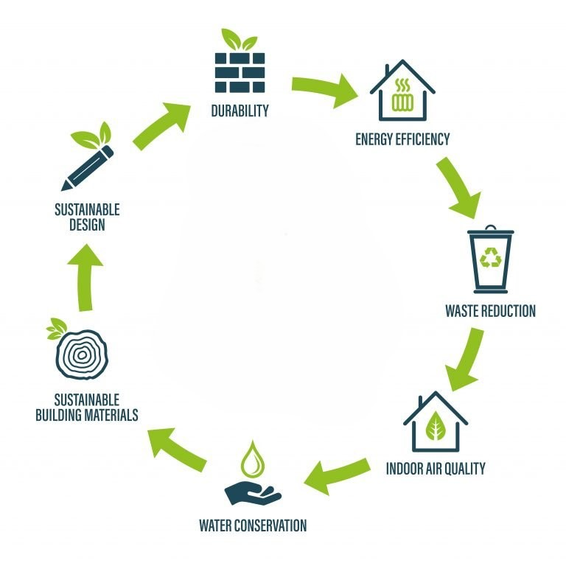
Figure 1: 7 Principles of sustainable construction (BuilsPass, 2024)
  - Sustainability in Saudi Arabia
To address the challenges, sustainability has been integrated as a core pillar of vision 2030, the shift in perspective has paved the way for the adoption of green building practices, energy efficient technologies, and the use of sustainable materials. (Saudi construction consulting, 2024).
Moreover, Saudi Arabia and toward accomplishing the 2030 vision, sustainable construction has taken a big part, with developing new cities, buildings, parks that aim to provide environmental, social, and economical improvement some of the project such as: -
- NEOM
- The Red Sea Project
- Amaala
- King Salman Park
- KAEC

  - Project management
As human developed from cave’s man to building the pyramid to landing on the moon to the construction of tallest building in the world and as projects moved to be more sophisticated and tremendous number of people working together toward achieving common goal, without a proper management it will not be possible to achieve.
So, introducing project management is the key to success. (Take the reference from phone ultimate guide to pm) but before diving in; first understanding projects is essential it can be unique or repetitive work that achieving the organization or customer’s goals within constrains of time, budget, and specifications.(KERZNER, 2017)
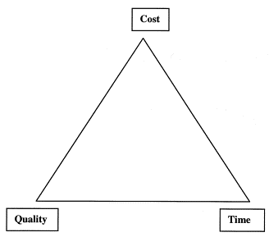

In addition, projects are different than any regular standard business activities as they:
- Are unique, every project has its own set of rules and processes however it may seem to regular people it is the same for example construction work.
- Have specific timescale, each project as a preset start and end date whin the objective have to be met.
- Have approved budget, projects allocate a specific cash flow to handover the deliverable to the end user.
- Achieve beneficial change,
- Have limited resources, a limited equipment, material, work man power are allocated for the project beforehand to successfully deliver it within time and budget.

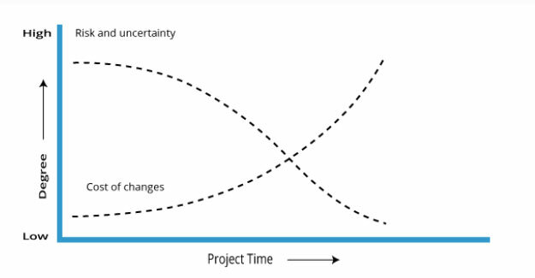
- Involve a degree of risk, projects have high level of uncertainty through the project’s lifecycle especially at the beginning as illustrated in figure. (Project Management Institute., 2008; Westland, 2006)

Project management can be referred to as the application of skills, knowledge, and tools compulsory to complete the project’s requirements and to the customers satisfaction. Usually the skills, knowledge, and tools are grouped into activities or processes.(KERZNER, 2017). That can be explained as project life cycle that consist of five stages. (Project Management Institute., 2008)
In short, project management book 37-unlocked page 37

  - Project life cycle
All construction projects follow a systematic step known as project lifecycle, this systematic approach is crucial for a successful project management in which it affirms the efficient allocation of resources, risk control, and successful delivery within the pre-set constrains of cost, time, quality.
As mentioned, approve project lifecycle consist of five phases:
- Project initiation
Initiation phase marks the start of a project, in this phase the project’s scope and objectives are established, needs are identified, project team chosen, and the feasibility is assessed, and this phase consider the foundation of the entire project.
- Project planning
Planning phase, is second in order were a detailed projects plans, work requirements and quality, resources needed, schedules, budgets, and risk evaluations are developed.
- Project execution
Execution phase, in this phase the real work starts, project manager and team member are fully active, material and equipment procured. This phase required high level of attention to details and effective coordination between the project team and stakeholders to maintain successful deliverables.
- Project monitoring and controlling
As illustrated in the figure below this phase begins from planning phased and throughout execution phase, were tracking progress, comparing the actual outcomes to assumed outcome, analyzing variance and impacts, and making adjustments as it goes to maintain the project objectives, schedule and cost.
- Project closure
This phase marks the completion of the project, verifying that all the work is done, contractual closure, financial closure, and administrative closer of the paperwork. (KERZNER, 2017; Project Management Institute., 2008; Westland, 2006)

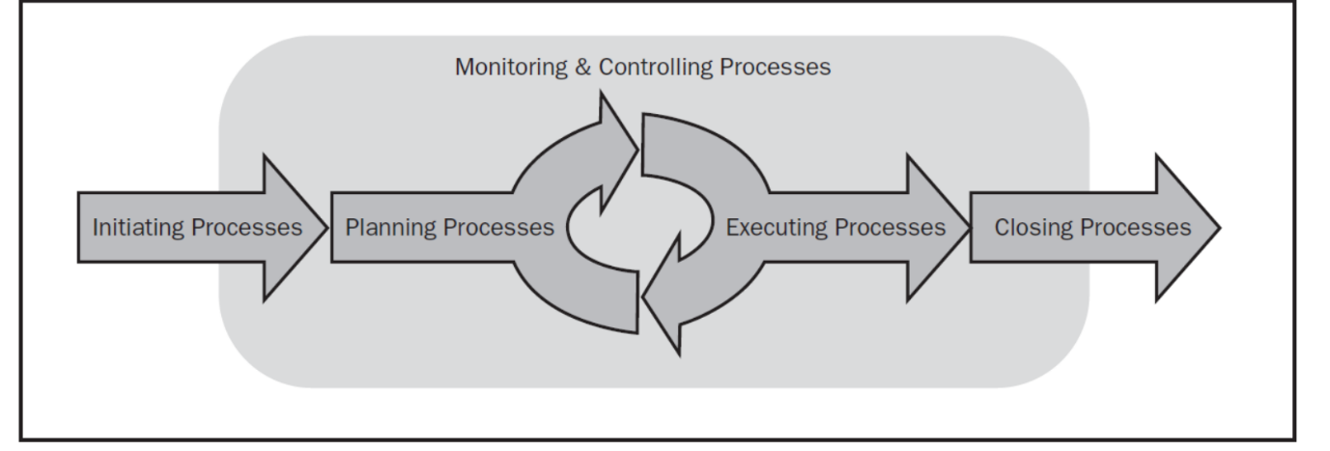
To sum up, project life cycle is a process that guide the project from intention to closure; by following this structure project professionals can enhance project efficiency, mitigate risks and deliver high end results.
  - Project management types
There are three main types of project management traditional or waterfall, agile and hybrid, in the construction industry were the objectives are well defined from the start and doesn’t have numerus scope changes in the project, waterfall approach is followed as it is sequentially done and easily represented in Gant chart, a downside of it it may take loge time for the approval of scope changes.
On the other hand, agile approach, are more flexible and mostly adopted in software development projects as the requirements are not fully understood at the start and may need some degree of experimentation which causes change in the scope, there for the customer involvement is needed to address Quick changes and have to have collaborative involvement by all participants as the project begun with a fixed budget and schedule it may need to reevaluate it. For this type of project more flexible approach is needed.
As the project became to be more complex (e.g. The construction of The line in Saudi Arabia) this cognitive city is stretching across 170 kilometers and planned to accommodates nine million people (Neom, 2024), such a project is first time to be done in the world for these types of innovative project which carries a high level of uncertainty, depending on a rigid approach such waterfall nor flexible approach as agile may be beneficial for the project. Hybrid approach is the most beneficial for such projects were it easily to follows a specific order of work and flexibility if any change has to be done.(KERZNER, 2017; Project Management Institute, 2021)

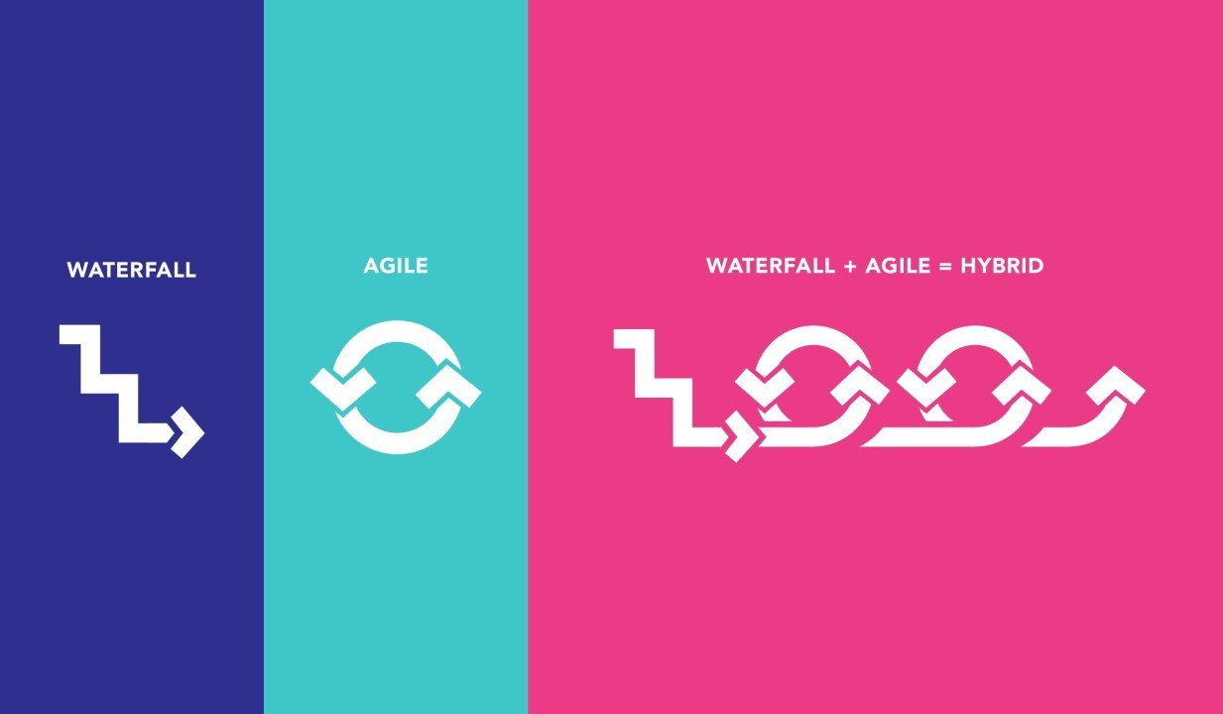

  - Project management office
To ensure the best project execution and resource allocation within any project, a new structure has been emerged in organizations which project management office (PMO).(Monteiro et al., 2016), PMO can be defined as follow “An organizational body or entity who are assigned various responsibilities related to the centralized and coordinated management of those projects under its domain. The responsibilities of the PMO can rang from providing project management support functions, to actually being responsible for the direct management of a project”.(Project Management Institute, 2021).
Moreover, over the last ten years many organizations have implemented one or multiple project management offices as integral part of organizational project management, attributing a variety of operational, tactical, and strategic levels of their PMOS.(Aubry et al., 2010). At an operational level, PMO provides essential centralized support to individual projects, and guarantying professionalism and excellence through the application of vast range of accepted principles and preferred project management practices to each one. (Hill, 2004). At a tactical level, PMO services provides much more added value by coordinating multi-project and the management of cross-project dependencies. This can involve integrating resources across project and ensuring adherence to project management disciplines. Lastly, at strategic level, PMO includes all functions of the operational and tactical PMO and it is also armed with authority to properties projects according to the organization objectives and strategic goals, it also advises senior management on the feasibility of project investment.(Desouza & Evaristo, 2006).
Sustainable project management office (SPMO) cab be defined as project management office that integrates stainability principles into its practices, framework, and governance structure. Sustainability concept does not focus just on environmental aspects but also social and economic aspects ensuring the project positive commitment to social goals, ethical guideline, and have minimal negative impact on the environment.
In addition, SPMO characteristic includes integration of environment, social, governance criteria into project selection, implementation, and evaluating process, also it encourages long-term value creation for present stakeholders and the futures generations, and resources efficiency by optimizing resource usage, waste minimization, and environmental footprint reduction of projects. (PMO Global Institute,2024).
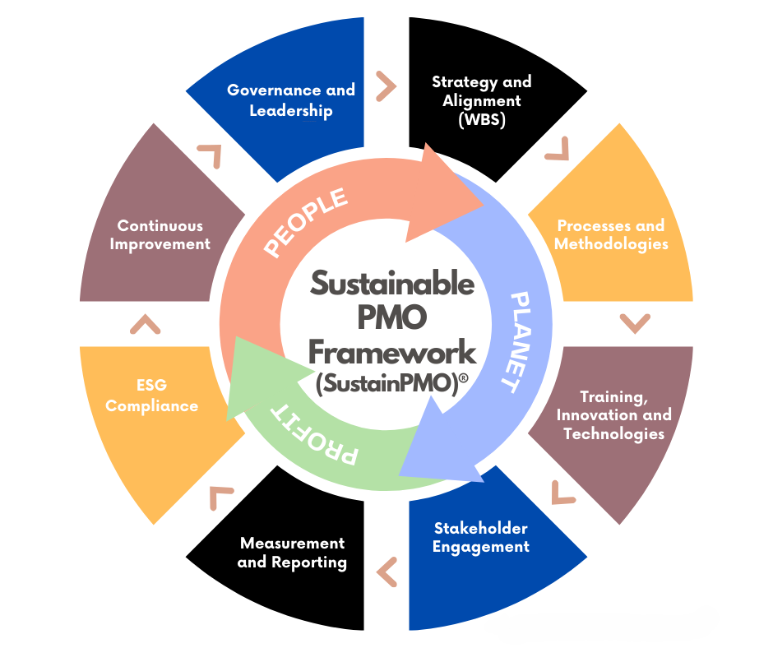
Figure 2: Sustainable PMO framework (PMO Global Institute,2024).

  - traditional project management VS sustainable project management
As mentioned above in section 2.7, traditional project is a sequential order of event that utilize five phases; initiating, planning, executing, monitoring / controlling, and closing.(RICHARD, 2021). Furthermore, the success of traditional construction project management depends mainly on the construction project objectives to all forms of contractors, subcontractors, and team; the successful delivery of the project in consideration to the client requirement and acceptable standards, within the assumed cost, and specified duration; measures in return for profit to the organization.(Oke & Aigbavboa, 2017).
Moreover, the construction industry significantly affecting the environment from sourcing raw material to generating and disposal of wastes during or after construction, the impact of construction projects cannot be described. The use of materials or parts of demolished project and recycle them for example is a positive move toward sustainability and this phase should be integrated into the planning stage of any construction projects to ensure that the projects will be beneficial to the environment not only for its intended purpose but also after it expected life due.
In recent years designs have become more competitive and the addition of those regulations such as sustainability, and other measures have added more complexity to the construction projects and as a result of the shift in construction and its related activities sustainable construction have risen which provided projects that are environmentally, socially, and economically useful for the stakeholders, including this generation and the future generation. In addition, the Studies shown that for a better management focusing on environmental aspects should not be enough but a wider view which include social and economy as well.(Oke & Aigbavboa, 2017)
Here sustainable project management comes in place which contributes not only to cost, quality and time but also to the environment, people and economy as illustrated in the figure below.
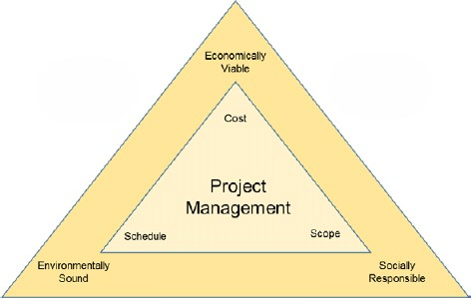
Figure 3: the integration of sustainability in to project management Snoey, A. (2013).

  - Integrating sustainability into project management
As project management profession evolved it is diverting what project success is, organizations are moving away from its traditional objective focusing on time, cost, and quality to assert on delivering objectives in a business frame maintaining the life cycle asset as illustrated in the figure below.(Carboni et al., 2018).
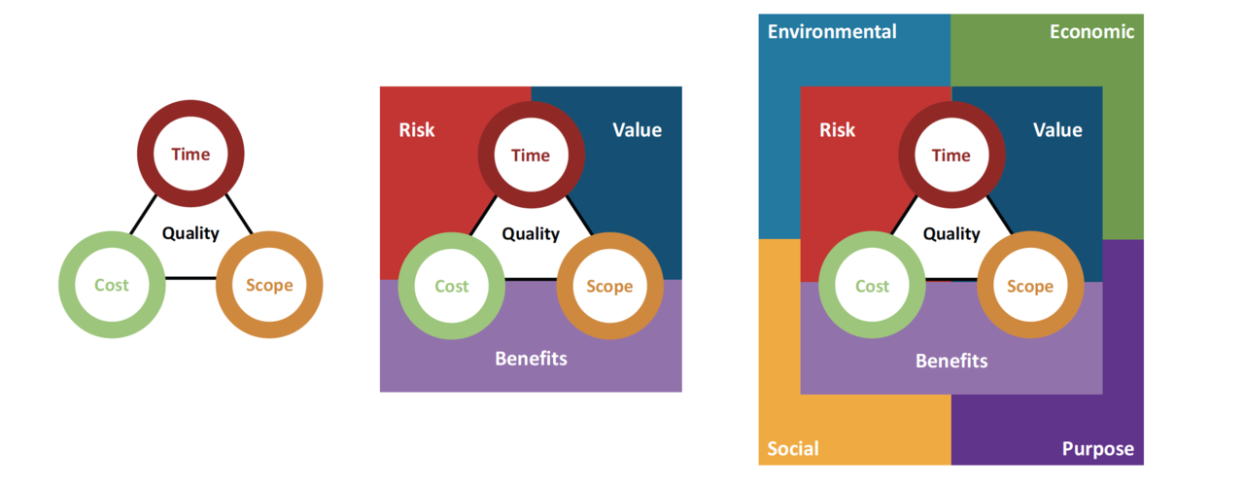
Moreover, sustainable project management is important because it ensures the effective and efficient utilization of project resources. Also, sustainable project management ensure achieving project goals and long-term impact are delivered, as Sustainable project management is not focusing only on short term benefits of the projects. Ensuring the success of projects that adopt sustainable principles helps also in securing future fund opportunities to the organization. (LINQ Consulting, 2023).

  - Sustainable project managers
Sustainable projects management cannot exist without highlighting the ethics of the project manager and his team and the commitment toward long-term and short-term objective to the organization which are finishing the project to the client standards, defined duration, and within the cost and to sustainability three bottom line principles which focuses generating a project that will be environmentally beneficial, socially pleasing and efficient economically.(Marcelino-Sádaba et al., 2015).
In contrary, there are few challenges that project manager encounters to integrate sustainability principles in the projects few of those challenges are related to planning, project client, project team, labors, and external challenges they explained briefly, hereunder: -
  - Planning related challenges
planning related challenge focuses more on the organizational environment were project manager facing difficulties in adopting to different project delivery contract forms also it is hard to narrate the sustainable specification into the contracts, structure of the building, planning of different construction sequence, approval process for sustainable techniques takes longer time, and require longer time during preconstruction. (Aghaegbuna et al., 2020).
  - Project related challenges
Project related challenges lies in selecting suppliers and sub-contractors that provide sustainability services also it takes more time to design and construct on site sustainable construction projects. (Aghaegbuna et al., 2020).
  - Client related challenges
Client related challenges, the clients maybe hesitant to take decision as the uncertainty level is high in relation to the new principle and it depend on the risk that the client is willing to take in consideration to the specific budget and durability for construction sustainability project. (Aghaegbuna et al., 2020).
  - Project team related challenges
As sustainable building is considered to be new team may face difficulty in dealing with the specification, material, and equipment regarding sustainable principles, also the meeting and approvals from the sustainability specialists require more time. (Aghaegbuna et al., 2020).
  - Labor related challenges
The main challenge in relation to labors is encouraging them to change the traditional techniques and training them to be more sustainable the project manager have to work harder in monitoring to ensure the correct adoption of the principles without affecting the project objectives. (Aghaegbuna et al., 2020).
  - External challenges
External challenges are mainly focusing on changing the interception of the public toward the sustainable principles by good advertising and to deduce the uncertainty level to make its implementation in any project casual. (Aghaegbuna et al., 2020).

  - Previous studies
In this section of chapter 2 of literature review, some of the previous studies that are related to the sustainable project management, findings and authors recommendations will be discussed, and alter will be used to compare it with the results gained from this research.
    - Sustainable project management in Saudi Arabia
A study done by (Alharithi, 2022), aimed to investigate the integration of sustainability in project management for non-profit organization (NPOs) in the Kingdom of Saudi Arabia, the author in this research rely on two method to collect responses regarding the research objectives, and research questions were interviews and survey questions, were the author have divided in five parts, first part explained the Sustainable project management (SPM), second parts explored how the workers implemented SPM, third part investigate the development of sustainable three bottom line ( environment, social, and economic), fourth part drivers and barrier to implement sustainability in project management in NPOs, and fifth part focused on identifying stage of the implementation of SPO in the responses own organizations. The he five parts finding is sequential, the participants were aware of the sustainable project management concept, NPOs organization depend on sustainability in its strategy to overcome the limited support of the government, employes shows a lack of knowledge about environmental sustainability aspect on the other hand, social and economical sustainability aspect were adopted one because they were experts in social science and second to generate income as government suspended the support on NPOs, drivers won over barriers with the highest percentage as a result of the long term project success, finally the staff were aware of the benefits of applying SPM in NPOs.
Another study was carried by (Alzahrani, 2015), amid to develop a model to evaluate the sustainable project management implementation by organization in Saudi Arabia, method obtained by the author to collect the responses was via interviews and survey questions which targeted population of 494 individuals where the main focus was on project managers the study found that Saudi Arabia have no mature in sustainable project neither internally nor externally, also founds that Saudi Arabia organization lack the connection between project management and sustainable development, also it lacked the connection between project stockholders and project management in addition the connection between strategic management and organizational culture in Saudi organization was lacked as a result the existing promise no future continuity in relation to sustainable development.
According to (Al-Yami & Price, 2006), the aim of this study is to investigate sustainability in Saudi Arabia, the study conclusion drowns through literature review and interviews questions, the study fundings were the lack of awareness for sustainable construction project management principles within Saudi Arabia construction industry appear to be a problem, also that the public and agencies unaware of sustainable development implementation both in public and private sector in Saudi Arabia, author recommendations was to build a framework that reduce the conflict of interest the may happen among Government agencies, also set a particular authorities and duties for each agency.
    - Sustainable project management in other Countries
A study done by (Abdelkhalik & Azmy, 2022), aimed to investigate the role of project management in sustainable construction project success in Egypt, the author depends on qualitive method which includes online questionary and interview with sustainability specialized consultants and project managers that included 18 questions to define their point of view and the obstacles they faced throughout their experience; the finding were that movement toward suitable construction in Egypt is slow, according to the author it was as a result of lack knowledge or awareness by professionals in the industry toward certain elements, principles, or even criteria when it comes to SPM also, the lack of clear methodology governing SPM in Egypt, project manger is the sustainability consultant at most times, both the project manager and sustainability consultant have unclear roles regarding SPM; the author recommend the industry in Egypt have to develop simplified applied management methods, tools and techniques, there should be a set of indistinct roles and responsibility between project manager and sustainability consultant.
Another study done by (Khalil et al., 2021), aimed to investigate the difficulties regarding integrating sustainability in construction industry in Libya, the author carried out a survey and interview questionaries they includes government commitment and support, building codes, government legislation and policies, the awareness of stockholders on sustainability; the findings were that the stockholders are unaware or lack knowledge about sustainability and the key factor to its success is to educate the public about the sustainable development and the importance of sustainability have be raised among Libya’s construction organizations also, the government implement a stronger policies to enforce sustainability in all aspects, also adopting new technology and materials was a challenge due to high cost.
Another study held by (Mohammad et al., 2017), aimed to investigate how the integration of sustainability in project management will impact the construction project performance in UAE, the author carried out a qualitive analysis of structured interviews with project managers; the author founds that theoretically sustainability have been integrated in the industry however it’s not been put into practice in UAE as it should be; the author for see that for a better construction and performance within the industry it’s a mutual responsibilities on the government and organizations to enable to generalize sustainability on project management furthermore, the author recommend to include sustainability in to the training programs to all project managers, keep guideline improvement regarding SPM, enforce government legislation.
In a study done by (Atombo et al., 2015), aimed to explore the construction professionals’ views on the integration of sustainable construction in projects in Ghana, the author depend on a survey questionary to answer the research questions, the finding of the author focused in environmental aspects in which Ghana lacked the efficient use of material or recycled material, material wastage is high as most of the material came from non-renewable materials and that returned to the growth in population and economic factors as well as lack of knowledge about sustainability principles; the author recommend a waste management plan have to be enforced by the government as well as monitoring sustainable construction polices.
In summary, in this chapter it was divided in to three parts firstly, an overview about sustainability, sustainability bottom three lines, sustainable construction, and suitability in Saudi Arabia were discussed , secondly a detailed discussion about project management, project lifecycle, project management types, project management office and its relation to sustainable project management, a comparison between traditional project management and sustainable project management, and integrating sustainability into project management, lastly previous study regarding integrating sustainability in to project management held by 7 authors dated from 2015 to 2022 where the first 3 regarding Saudi Arabia and the 4 other studies was from different countries including UAE, Egypt, Libya, and Ghana, where it found as the years progressed the integration of sustainability in to project management and knowledge have increased but not to the degree in which it is fully developed also it depend on the financial situation of the country, and the political situation as well.

