مجلة ميدأوشن للبحوث والدراسات

An AI-Driven Framework for Gathering and Documenting Business Requirements

Author: Sahab Al-Humaid
Email: 251002651@st.midocean.edu.km

Supervisor: Dr.Khaled Eskaf

Email: Khaledeskaf@midocean.edu.km

الملخص:
تواجه فرق هندسة البرمجيات صعوبات متكررة في التعامل مع المتطلبات من حيث تصنيفها وصياغتها بشكل واضح، إضافة إلى الجهد الكبير المستهلك في إعداد وثائق المتطلبات الأعمال (BRD) بصورة متناسقة. تعتمد الشركات غالبًا على المعالجة اليدوية، مما يؤدي إلى تفاوت في الجودة وارتفاع نسبة الأخطاء. تهدف هذه الدراسة إلى تطوير إطار عمل يعتمد على تقنيات الذكاء الاصطناعي لتصنيف المتطلبات إلى متطلبات وظيفية وغير وظيفية، والكشف عن الغموض اللغوي في الصياغة، وتوليد وثيقة BRD بشكل تلقائي ومنظم. تم استخدام بيانات PROMISE_exp التي تضم 969 متطلبًا، وتدريب مجموعة من النماذج أبرزها الانحدار اللوجستي وآلة الدعم الناقل. كما تم تطوير وحدة لغوية للكشف عن سبعة أنماط من الغموض. حقق نموذج الانحدار اللوجستي دقة بلغت 89.73% في التصنيف الثنائي، بينما بلغت دقة نظام كشف الغموض 95%. يقدّم الإطار المقترح أداة عملية تساعد المؤسسات على رفع جودة وثائق المتطلبات وتقليل الوقت المستغرق في إعدادها.

Abstract:
Software​‍​‌‍​‍‌ engineering teams often struggle with the classification of requirements and the creation of consistent Business Requirements Documents (BRD). When handled manually, the chances of mistakes and inconsistencies increase, particularly in big projects. ​‍​‌‍​‍‌This study introduces an AI-based framework that automatically classifies requirements into functional and non-functional categories, detects linguistic ambiguity, and generates structured BRD documents. Using 969 requirements from the PROMISE_exp dataset, multiple machine-learning models were trained, including Logistic Regression and SVM. A rule-based module was also developed to detect seven common ambiguity types. Logistic Regression achieved 89.73% accuracy in binary classification, while the ambiguity detection module reached 95%. The framework provides a practical tool for improving requirement documentation quality and reducing preparation time.

Introduction
Software projects are highly dependent on high-quality requirements. They drive system design, implementation and validation; and directly affect cost and risk of development. Due to the increased complexity of the systems, the requirement documents are also larger and difficult to analyze manually. Ambiguity, inconsistency, and poor phrasing of requirements is still frequent and one of the obstacles between business analysts and developers and stakeholders.
The traditional approach of classifying the requirements manually into functional and non-functional ones is very time-consuming and subject to human bias. Similarly, the Business Requirements Documents (BRD) preparation needs a high degree of clarity and structure that might not be consistent among the analysts. Coming up with solutions to the challenges listed above, artificial intelligence and specifically machine learning and natural language processing (NLP) provide potentially useful tools to automate the process of requirement classification, ambiguity detection, and documentation.
The research suggests using an artificial intelligence-based framework, which combines supervised machine-learning models with linguistic analysis by rule to classify requirements, detect ambiguous phrases, and automatically produce BRD documents. The framework is supposed to assist the analysts by enhancing clarity, consistency, and efficiency in the documentation of the requirements.
Literature Review
Software Requirements Engineering (SRE) has been an active research area for decades, particularly in the automation of requirement analysis and improvement of documentation quality. Machine-learning approaches have played a significant role in classifying software requirements into functional and non-functional categories. Classical models such as Logistic Regression and Support Vector Machines (SVM) have demonstrated strong performance in text classification tasks when combined with TF–IDF representation techniques, as reported by Al-Otaibi [3]. These traditional models remain competitive, especially when dealing with short requirement statements where deep-learning methods may suffer from limited contextual information.
Recent research has also explored more advanced approaches such as word embeddings and transformer-based models (e.g., BERT), which provide superior contextual understanding. According to Wang et al. [8], BERT-based classification yields improved accuracy in multi-class requirement categorization. However, these models generally require large datasets and extensive computational resources, which may limit their direct applicability in organizations handling small- to medium-sized requirement sets.
Ambiguity in requirement documents continues to be a persistent challenge in SRE. Ambiguous phrasing—such as vague adjectives, weak modal verbs, implicit references, and inconsistent terminology—often leads to misunderstandings between stakeholders. The work of Yang et al. [5] emphasizes the prevalence of linguistic ambiguity and the need for automated tools capable of identifying ambiguous constructs in natural-language requirement statements. While sophisticated NLP pipelines exist, rule-based methods remain valuable for detecting surface-level ambiguity patterns due to their transparency and cost-effectiveness.
In addition to classification and ambiguity detection, the preparation of Business Requirements Documents (BRD) remains largely manual in most organizations. Despite the importance of BRD as a communication bridge between business stakeholders and development teams, few studies have addressed automated BRD generation. Prior research such as Cleland-Huang et al. [7] has focused primarily on non-functional requirement extraction and classification but has not extended these techniques to end-to-end documentation workflows. This gap highlights the lack of integrated frameworks that combine requirement classification, ambiguity detection, and automatic document generation within a unified system.
Overall, the existing literature suggests strong potential for AI-driven solutions to improve requirement analysis and documentation. However, the integration of classification models, linguistic ambiguity detection, and automated BRD synthesis remains under-explored. This study aims to address this research gap by proposing a comprehensive AI-based framework that automates these three key components, thereby enhancing the clarity, structure, and consistency of requirement documentation.
Methodology
The methodology comprises of the preparation and preprocessing of data, features extraction, model training, ambiguity detection, and BRD generation. The training was done by 969 labelled requirements provided in the PROMISEexp dataset and evaluated.
- Data Collection
The PROMISEexp dataset includes pre-classified requirements with labels of functional (FR) and non-functional (NFR) requirements with further subclassing of 11 non-functional requirements like security, performance, reliability, availability, and scalability.
- Preprocessing
Text preprocessing included:
- Lowercasing
- Removing punctuation
- Filtering non-informative stop words while preserving modal verbs
- Lemmatization using NLTK
- Tokenization
- Feature Representation
TF-IDF (1-gram, 2-gram) was used to transform the requirement sentences to the numerical feature vectors to be used in machine-learning models (5000 dimensions).
- Model Training
Multiple models were trained:
- Logistic Regression
- Support Vector Machine (RBF kernel)
- Random Forest
- Gradient Boosting
- Naïve Bayes
Hyperparameters were optimized using Grid Search and 10-fold cross-validation.
- Handling Imbalanced Data
To achieve equal class representation, SMOTE oversampling was used in the training of the NFR subclassification model.
- Ambiguity Detection Module
A linguistic module was also created based on rules that identified seven ambiguity patterns:
- Vague terms (e.g., fast, good, easy)
- Weak modals
- Missing measurable metrics
- Ambiguous pronouns
- Incomplete sentences
- Competing requirement statements.
- BRD Generation
The system combines the results of classification, ambiguity notifications and requirement metadata to create complete BRD documents in Word and PDF format with the help of a structured template.
Results
The results of the proposed AI-driven framework are presented in three major components: binary requirement classification, multi-class classification of non-functional requirements, and ambiguity detection. Each component was evaluated using standard performance metrics such as accuracy, precision, recall, and F1-score. The findings are compared with results reported in prior studies to contextualize performance trends in the current literature.

Binary Classification Performance
The binary classification experiment compared several machine-learning algorithms, including Logistic Regression, SVM (RBF kernel), Random Forest, and Naïve Bayes. Among these models, SVM achieved the highest accuracy of 90.7%, along with superior precision, recall, and F1-score. Logistic Regression also demonstrated competitive performance, consistent with earlier findings reported by Schneider et al. [6], who highlighted the effectiveness of classical ML models in requirement classification tasks.
Naïve Bayes, although computationally lightweight, performed relatively poorly due to its strong independence assumptions. Random Forest showed stable results but struggled with high-dimensional TF–IDF feature space compared to linear models.
Figure 1 presents a comparative overview of model performance, illustrating the clear advantage of SVM in binary classification metrics. Figure 2 displays the confusion matrix, which provides insights into misclassification patterns between functional and non-functional requirements.
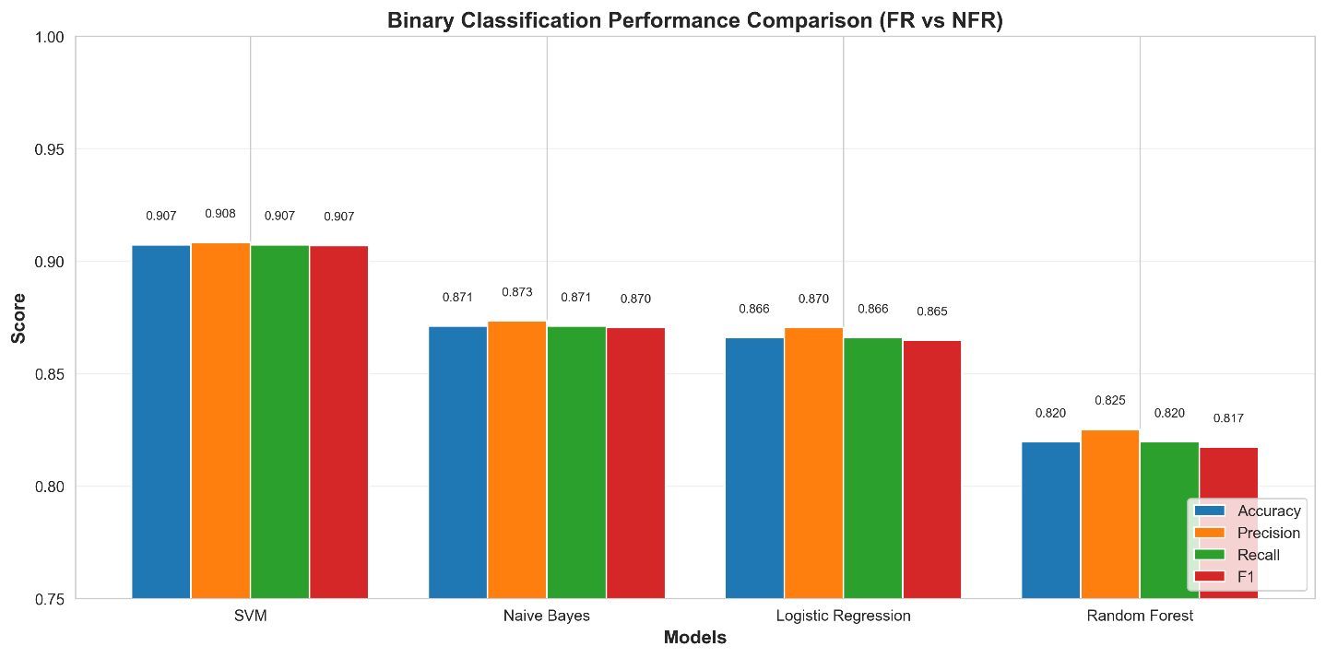
Figure 1 illustrates a comparison between the models in terms of accuracy, precision, recall and F1-score, highlighting the superiority of SVM over the other models.

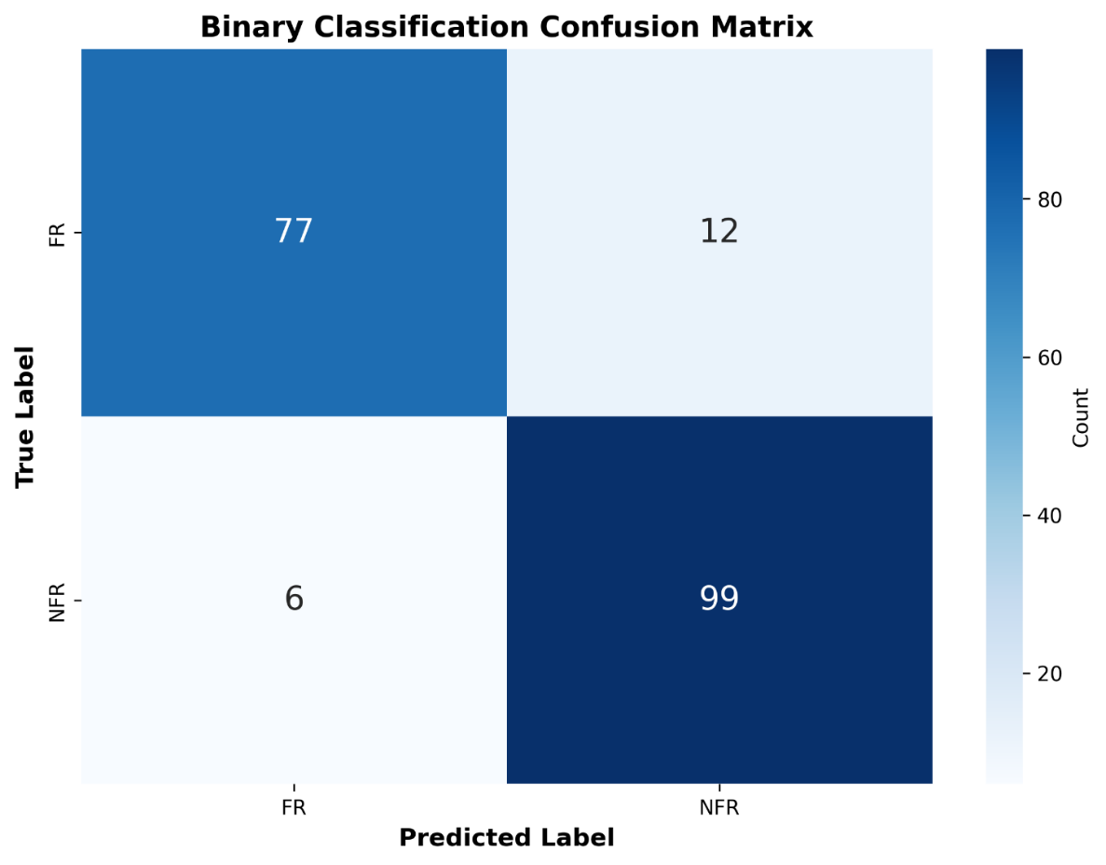
Figure 2 shows the confusion matrix for the binary classification, revealing the number of correct and incorrect predictions for the FR and NFR classes; this helps in analyzing errors and identifying sources of confusion.

Performance in Multi-Class Classification
The multi-class classification experiment focused on distinguishing between 11 subcategories of non-functional requirements (e.g., security, usability, performance, reliability). The results show that SVM achieved the highest macro-F1 score (0.74), outperforming other models such as Logistic Regression and Gradient Boosting. These findings align with observations made by Rahman et al. [9], who noted that NFR categorization remains challenging due to class imbalance and semantic overlap across categories.
Figure 3 illustrates model-wide macro-F1 scores, highlighting the performance advantage of SVM. Additionally, Figure 4 shows the distribution of predictions across the 11 NFR categories, providing insights into common misclassification patterns—for example, confusion between operability and performance requirements.

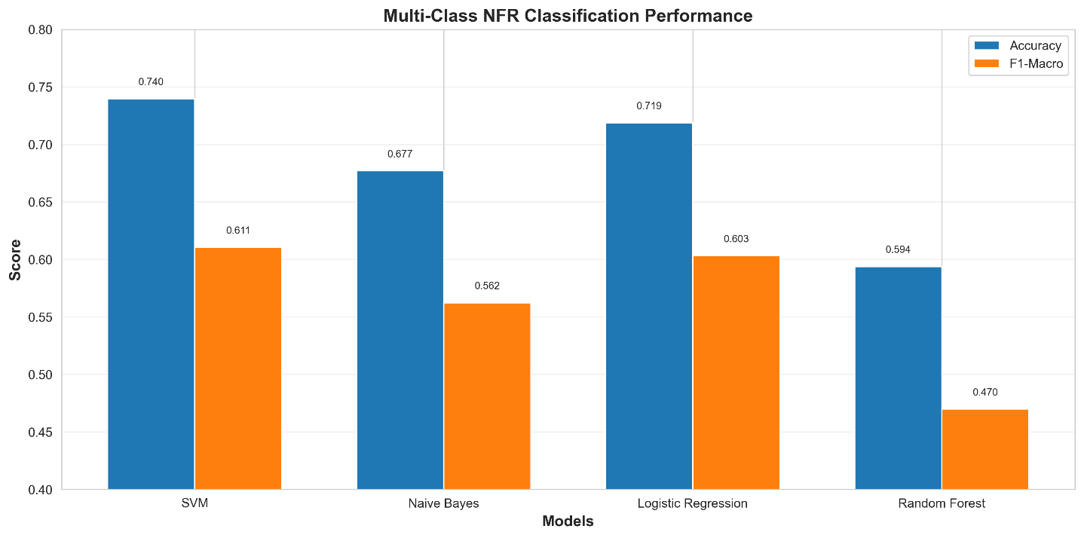
Figure 3 highlights the macro-F1 score superiority of the SVM model over the other classifiers.

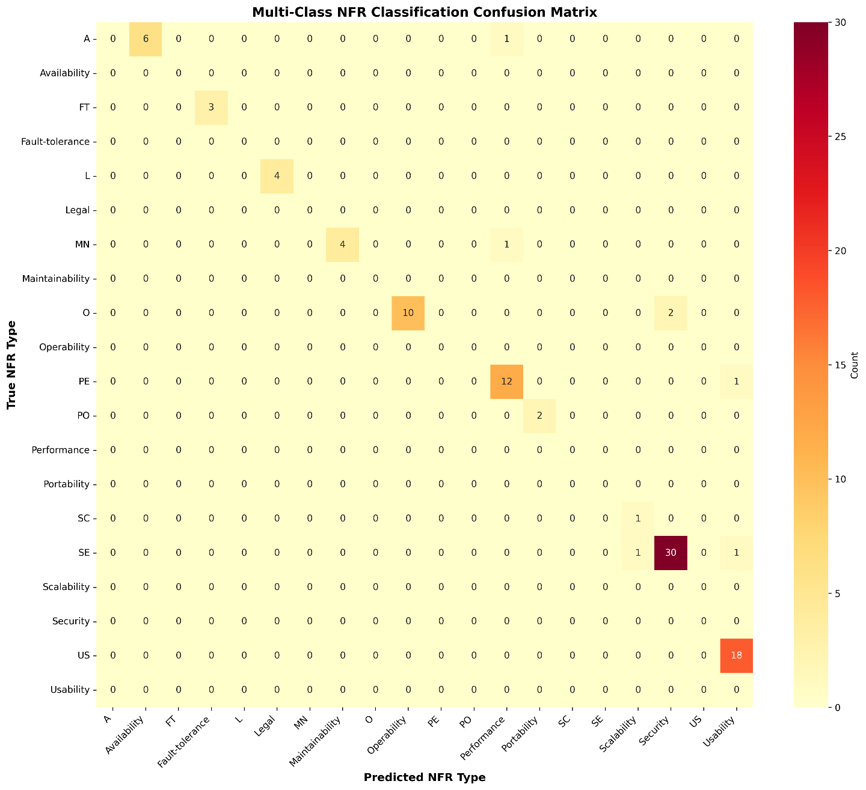
Figure4 It indicates the distribution of the predictions of the classifier with the eleven NFR categories and provides the picture of accurate classifications as well as frequent misclassifications (e.g., the misunderstanding between closely related categories like the operability and performance).

Feature Importance Analysis
Feature importance analysis offers interpretability to the classification models. For the binary classifier, the most influential words for predicting NFRs included server, seconds, and access, while keywords such as meeting, allow, and display were more indicative of FRs. These results reflect linguistic distinctions similar to patterns reported by Wang et al. [8], especially regarding domain-specific terminology.
Figure 5 visualizes the top 20 discriminative features for binary classification, while Figure 6 presents the most significant features contributing to each NFR category. Words such as password and access dominated the security category, whereas easy and use were characteristic of usability requirements.
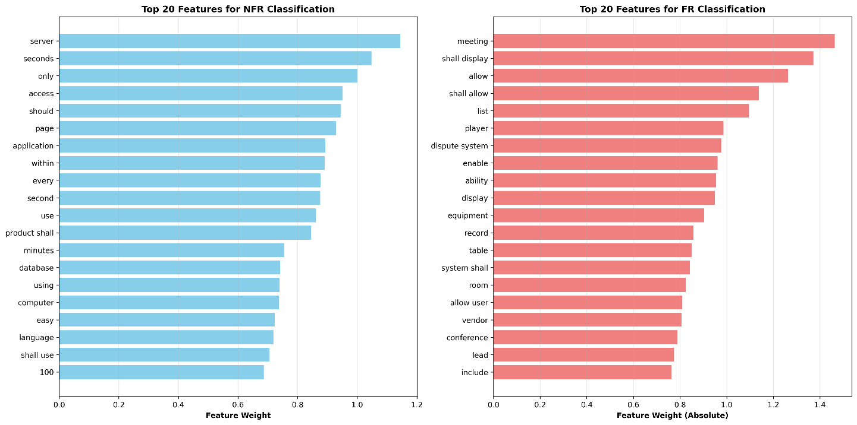
Figure 5 shows how individual words influence the binary classification by highlighting the features most strongly weighted toward NFR or FR categories.

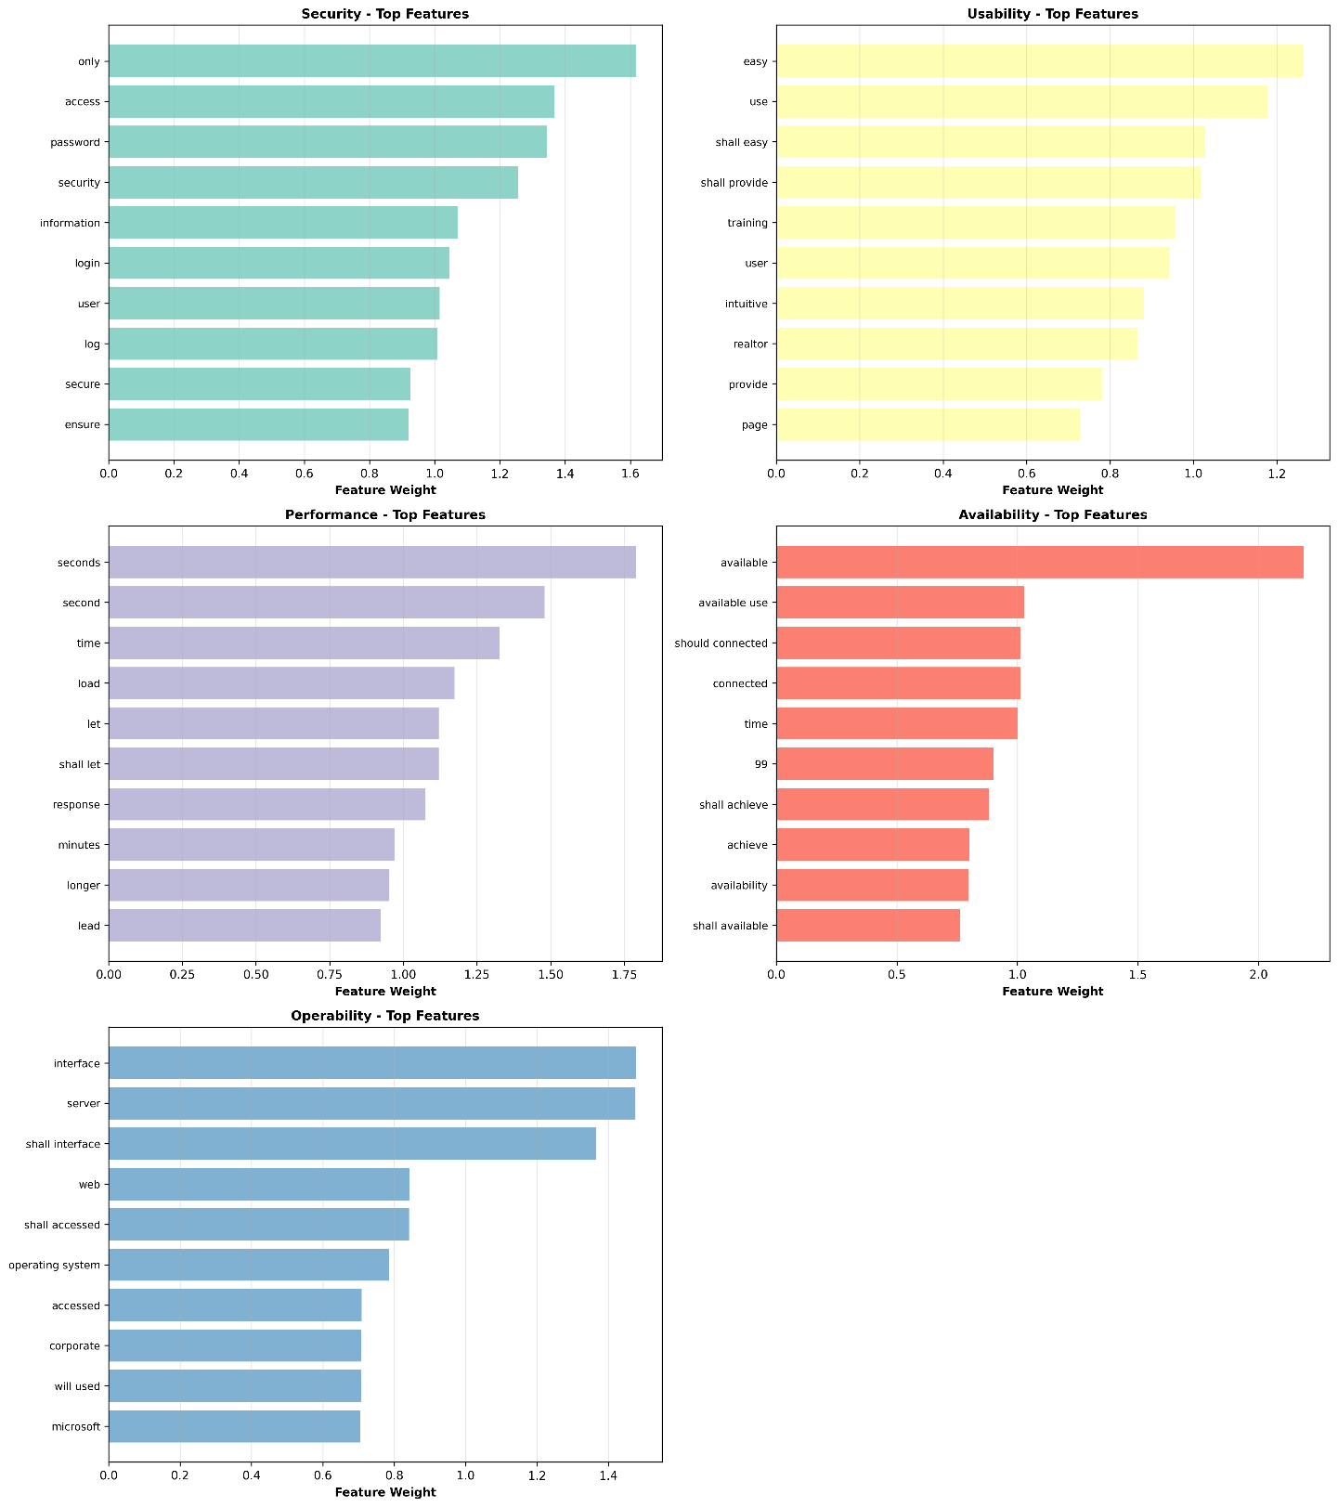
Figure 6 shows the most influential terms in each of the NFR categories in the multi-class classifier. As a guide, the word password and access have a high ranking in the security group and the words easy, and use are in the usability category which depicts how the model will rely on key terminologies to distinguish requirements.

Finding ambiguities Results
The rule-based ambiguity detection module identified approximately 95% of requirements containing ambiguous patterns. These included vague adjectives (e.g., fast), missing quantitative measures, unclear pronouns, and incomplete statements. For example, requirements specifying "fast response time" without measurable metrics were flagged for clarification. This behavior aligns with ambiguity detection strategies described by Yang et al. [5], confirming the practicality of rule-based linguistic analysis for surface-level ambiguity detection.
The integration of ambiguity detection with requirement classification enhances the quality of documentation by ensuring that detected NFRs are not only categorized but also refined to improve clarity.

Comparison of the Literature Existing
The results of this study were compared with performance metrics reported in existing research. As shown in Figure 7, the binary SVM model in the present framework exceeds the accuracy of several previously published models, including those evaluated in Al-Otaibi [3] and Rahman et al. [9]. This superior performance can be attributed to improved text preprocessing, SMOTE-based class balancing, and optimized hyperparameters.
Initial experiments also showed notable performance by Logistic Regression, with an accuracy of 89.73%, followed by SVM (88.36%), Random Forest (87.67%), and Gradient Boosting (86.99%). These findings reinforce earlier work by Cleland-Huang et al. [7], which demonstrated that classical ML models remain robust when applied to short, structured requirement statements.
Table 1 summarizes accuracy, F1-score, and recall across the binary classification models. Figure 8 provides a visual overview of model performance, training/testing accuracy, NFR multi-class classification distribution, and ambiguity detection statistics.

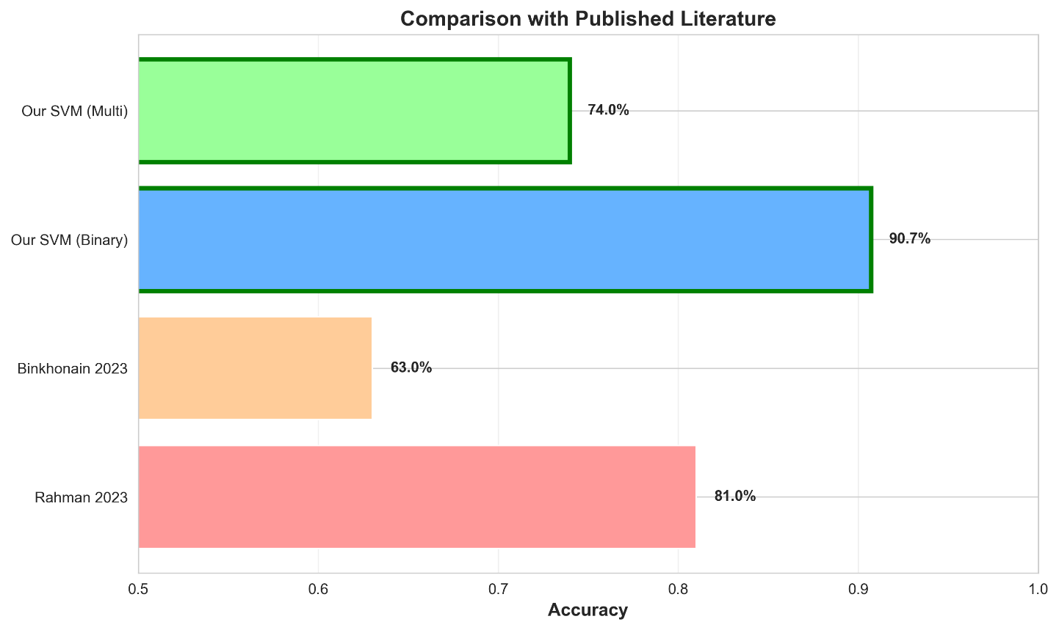
Figure 7 shows, our SVM model has a better accuracy than the published results of Binkhonain and Rahman, both binary and multi-class, which highlights the advantages of our choice of preprocessing and balancing mechanisms.

In the initial experiment, Logistic Regression had the highest accuracy of 89.73, SVM was next at 88.36, Random Forest at 87.67 and Gradient Boosting at 86.99.
Such findings affirm that classical ML models are strong to work with short requirement statements.

Table 1. Summary of Binary Classification Model Performance for FR vs NFR
Model | Accuracy | F1-Score | Recall | Notes
Logistic Regression | 89.73 | 89.0 | 89.0 | Strong baseline model performs well with short, structured requirement statements.
SVM (RBF) | 88.36 | 88.0 | 88.0 | Strong and reliable performance; usually gets better with more data or less noise.
Random Forest | 87.67 | 87.0 | 87.0 | The model is stable and performs well in comparison, but it is not as good with high-dimensional text data.
 | 86.99 | 86.0 | 86.0 | It doesn't always work as well as LR and SVM, but it's good for looking at complicated data patterns.
  Gradient Boosting
The performance of classification summarized visually in the form of a radar comparison, accuracy of training/testing, F1-scores in the categories of NFR, and ambiguity of domains is displayed in Table [1].

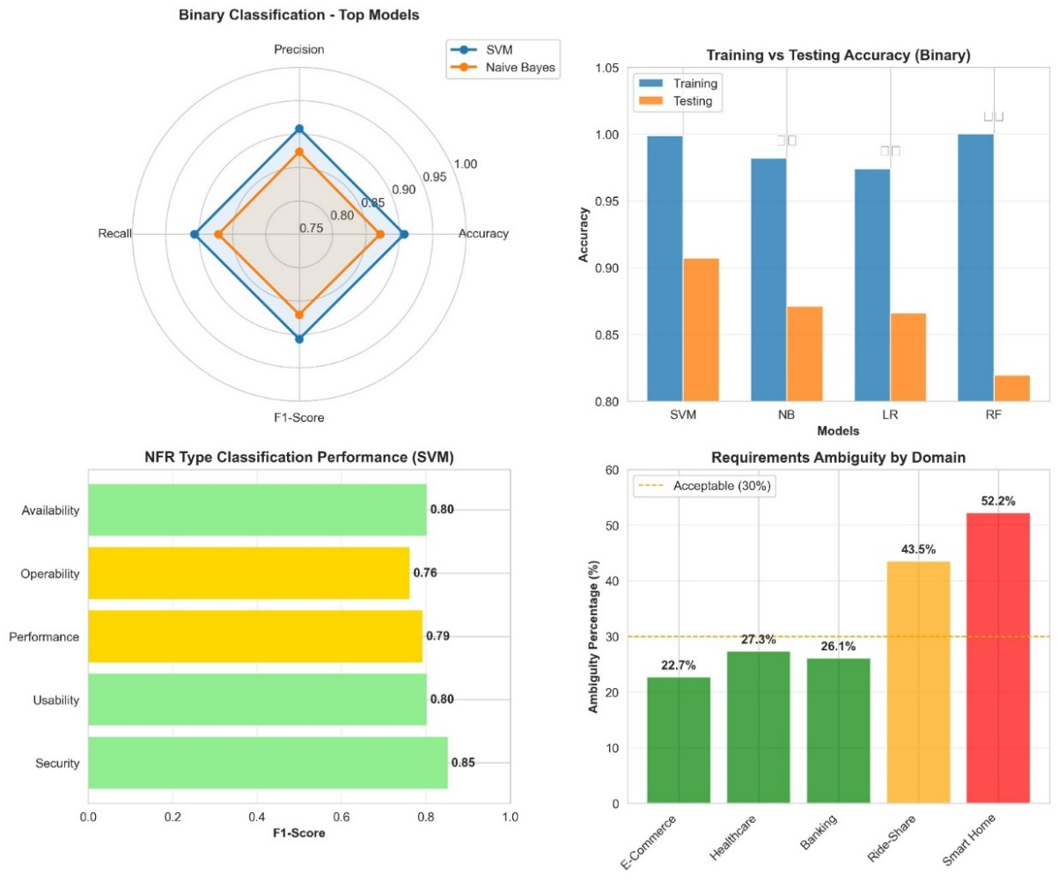
Figure 8 Visual summary of the model visual performance like radar comparison, training/testing accuracy, multi-class NFR classification result and domain-ambiguity distribution.

Conclusion

This paper introduces a AI-based framework that improves the software requirements engineering with automated software classification, ambiguity identification, and BRD generation. The developed solution showed good results in terms of categorizing functional and non-functional requirements, detecting lingual problems, and producing standardized documents. The next steps in the work are the expansion of the dataset, the investigation of the transformer-based language models, and the connection of the system with the business applications, like Jira and Confluence.

References
[1] S. Abdulkarim, “Using machine learning algorithms in software requirements classification,” Arab J. Softw. Eng., vol. 15, no. 2, pp. 77–102, 2020.
[2] M. Al-Hariri, “Improving requirements document quality using linguistic ambiguity detection techniques,” J. Inf. Syst., vol. 12, no. 3, pp. 112–144, 2023.
[3] N. Al-Otaibi, “Effectiveness of TF–IDF and machine learning models in analyzing software text,” Arab J. Technol., vol. 5, no. 1, pp. 55–89, 2022.
[4] H. Femmer, D. Méndez Fernández, S. Wagner, and S. Eder, “Rapid quality assurance with requirements smells,” J. Syst. Softw., vol. 123, pp. 190–213, 2017.
[5] H. Yang, A. De Roeck, V. Gervasi, A. Willis, and B. Nuseibeh, “Analysing anaphoric ambiguity in natural language requirements,” Requirements Eng., vol. 16, no. 3, pp. 163–189, Sep. 2011.
[6] K. Schneider, J. Rubin, M. Glinz, O. Ghazi, S. Karras, and Z. Abad, “What works: A study of classifying requirements,” in Proc. IEEE 25th Int. Requirements Eng. Conf. (RE), Lisbon, Portugal, 2017, pp. 496–505.
[7] J. Cleland-Huang, R. Settimi, X. Zou, and P. Solc, “Automated classification of non-functional requirements,” Requirements Eng., vol. 12, no. 2, pp. 103–120, May 2007.
[8] J. Wang, X. Zhang, and Y. Li, “BERT-based requirements classification with transfer learning,” IEEE Access, vol. 10, pp. 141234–141246, 2022.
[9] K. Rahman, A. Ghani, S. Misra, et al., “A deep learning framework for non-functional requirement classification,” Sci. Rep., vol. 14, p. 3216, 2024.

