Chapter 3: Methodology and Proposed Framework

3.1 Introduction
This chapter introduces the methodology and the proposed framework used for developing this Arabic voice agent with AI to specifically handle queries related to Saudi Labor Law. The system is designed to allow a natural, real-time interaction between users and a legal knowledge system that is able to provide accurate, contextually appropriate and domain-specific answers based on official legal sources. The architecture proposed is based on Retrieval-Augmented Generation (RAG) combined with Automatic Speech Recognition (ASR), Large Language Models (LLMs) and Text-to-Speech (TTS) technologies. The integration allows the system to listen to the Arabic words that are spoken by the user, and automatically translate them into text, which it can then use to retrieve the appropriate legal information from a structured knowledge base, and subsequently translate the retrieved information into speech output (Alqadasi et al., 2022). This system was created to meet the increasing demand for legal information services in the Kingdom of Saudi Arabia which are available, scalable and accurate. Call centers and static legal papers are limited in several ways, such as response time, availability and accuracy of information, which can vary from one human agent to another. An automated, consistent, and available legal assistance mechanism is offered by the proposed AI voice agent, thus solving these problems. The system is explicitly developed to process the complexity of Arabic language, such as the dialects, the rich morphology and the ambiguity of legal language. The issues are mitigated by powerful pre-processing, semantic retrieval and the use of restricted generation technologies to ensure that generated answers are based on authoritative legal sources.
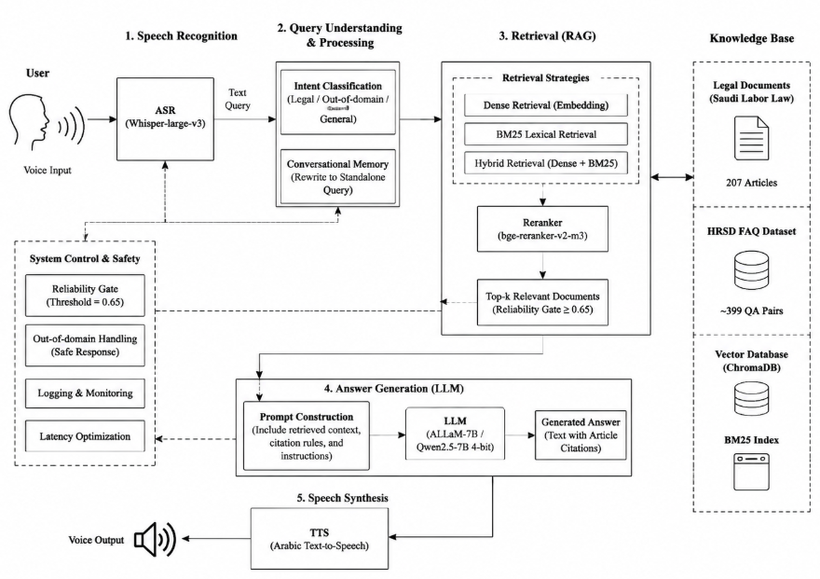
Figure 3.1 Architecture
The overall architecture of the proposed system is shown in figure 1. The overall flow of the pipeline is illustrated, which includes voice input, ASR transcription, access to the knowledge base, LLM-based response generation, and speech synthesis using TTS. This modular design facilitates independent functioning and ensures perfect integration of each component, enhancing the ease of future improvements and scalability.

3.2 Dataset Description
The proposed system is based on using Domain-Specific datasets containing Structured and reliable Legal and Human Resource knowledge relevant to the Saudi Labor Regulatory system. The retrieval and generation aspects of the system are based on these data sets.
Table 3.1: Dataset Description
Source | Description | Items
Saudi Labor Law | Official legal articles including article number, title, and full legal text | 211 articles
HRSD FAQ Dataset | Question-answer pairs related to labor rights, regulations, and workplace policies | 278 QA pairs
Evaluation Set | Legal questions, human-written and AI-generated, validated for gold-article retrievability | 218 questions
The Saudi Labor Law dataset comprises the legally structured articles officially with article numbers, titles for sections and full description of text. The articles listed here are the backbone of the legal knowledge base of the retrieval system that guarantee legal accuracy and factual correctness of the responses. This HRSD FAQ dataset comprises of frequently asked questions and answers on labour laws, employees' rights, contract laws, termination and workplace policies. This set of data improves the system's capacity for real-world conversational queries that users might be likely to pose in real-world scenarios (Al-Sabbagh, 2026). The evaluation data includes legal questions with a mix of manually written and automatically generated content. The generated questions were validated for gold-article retrievability, and expert legal review of this subset is in progress. This dataset is mainly used to test the performance of the system based on retrieval accuracy and quality of the responses. Both datasets can be used together to ensure a complete knowledge of Saudi labor law and to build a robust system for training and testing in realistic conditions.

3.3 Data Preprocessing
Data preprocessing is one of the key phases of the proposed AI-powered Arabic voice agent, which significantly impacts the quality of retrieval and the accuracy of the responses generated. The main purpose of this phase is to convert raw legal and FAQ information into a clean structured and retrieval-ready format that can be utilized effectively in the context of the RAG pipeline. Arabic text normalisation is the first step in pre-processing, as Arabic is a complex language and there are many variations in it. At this stage there are various ways of Arabic letter forms harmonised and unified, e.g. normalisation of variations of Alef and Yeh. Further, diacritics are stripped off to diminish noise and ease in the consistency of matching (Al-Shaboul et al., 2025). Extra whitespace, special symbols and punctuation marks are removed as well. The normalization process helps more accurately retrieve relevant documents and queries that may be expressed differently, yet semantically similar to each other.
The Saudi Labor Law dataset is then meticulously processed after normalization to guarantee its legal accuracy and reliability. Only legal articles which are active and officially valid are included in the dataset, older or repealed articles of the law are not included. This is very important to avoid the system from getting responses or creating responses from old information in the law, which may result in incorrect or misleading answers in a legal context. The HRSD FAQ data set is further filtered to keep the data relevant to the domain. Entries that are not about work, are a duplicate, or have a noisy or incomplete question/answer are discarded. This will help to keep the dataset relevant to the subject in hand labor law which includes topics like employee rights, employment contracts, termination policies and workplace regulations. Domain purity has significance to increase the retrieval relevance and precision. The data set is split into an indexed set of 70% and an held-out evaluation set of 30% to provide a strong evaluation framework. This split is done according to a pure ID based separation method that will ensure that the training and test sets are disjoint. This design will avoid leakage of data and allows to fairly measure system performance on unseen data. Moreover, a near-duplicate detection system based on a TF-IDF character n-gram similarity analysis is implemented over the entire data set (Alsubhi et al., 2025). This approach can be used to find questions that are semantically similar or partially overlapping but not word-for-word the same and present a potential evaluation bias. Overlaps (when they are detected) are deleted from the evaluation set to ensure fairness and reliability. Lastly, text chunking is used for optimized retrieval in the RAG system. Structural chunking and fixed-size chunking are two complementary strategies used.
Structural chunking partitions documents according to the boundaries of the legal articles and according to the rationality of the sections, thus maintaining semantic integrity. For longer texts, where the models' inputs are limited, fixed-size chunking is employed, which is compatible with embedding models. Article ID, document category, article source type and section reference are typical of the metadata that are added to each chunk. This metadata provides more traceability and helps to retrieve the object correctly when processing queries. Overall the preprocessing pipeline guarantees that the dataset is clean, structured and optimized for the retrieval and generation of high-quality data in the proposed system.

3.4 Knowledge Base and Retrieval System
At the heart of the proposed AI-powered Arabic voice agent lie the knowledge base and retrieval system, which are crucial for ensuring that the responses produced are based on accurate and relevant legal information. This component aims to efficiently extract Saudi Labor Law content and HRSD FAQ entries, through semantic understanding and lexical matching techniques. Both methods are combined to achieve high precision and robustness in dealing with different queries from the user in Arabic.

3.4.1 Embedding and Indexing
It is a system using two state-of-the-art multi-lingual embedding models to be used for encoding textual data into dense vector representations: The multilingual-e5-large, and the bge-m3. The models are chosen because of their good performance on multilingual and Arabic text understanding tasks. They convert text such as legal articles and FAQs into vectors in a high dimensional space, capturing the semantic meaning of the text rather than just word matches.
These embeddings are then stored in a vector database (ChromaDB) that allows for efficient and scalable similarity searches. The ability to efficiently retrieve the most relevant legal documents, based on semantic similarity to the user query, is crucial for ChromaDB, as it enables the system to work quickly and precisely.
In addition to dense vector representations, there is also a BM25 lexical index created. BM25 is an old method in information retrieval which is based on the term frequency and inverse document frequency for matching keywords (Besrour et al., 2025). In the legal field, for instance, precise wording, article numbers, and legal terms are crucial in determining retrieval accuracy and are particularly useful. The system combines BM25 with embedding-based search, thus the semantic coverage is complemented with the lexical coverage.

3.4.2 Retrieval Strategy
The system proposed uses four retrieval strategies in order to check the performance and optimize the accuracy of the system.
The first one is Dense Retrieval that only uses the similarity between the query vector embedded by the user and the vector embedded in the stored document. This approach works well when queries are paraphrased and/or expressed in other languages or in other syntactic structures. However, sometimes it may not get the exact match of keywords as may be needed in a legal setting.
The second method is BM25 lexical retrieval, which ranks documents by exact term and keyword overlap rather than semantic similarity. This is critical in the legal domain, where precise article numbers and legal terminology must be matched literally.
The third method is Hybrid Retrieval, which blends BM25 lexical search and dense embedding similarity. This combination enhances overall recall and precision by combining the ability to understand the meaning of the terms and matching them exactly (Cui et al., 2025). This is especially effective in legal question/answer situations where articles and legal jargon are used in structured questions.
The fourth approach is Hybrid Retrieval with a Reranker, which uses a reranker model (bge-reranker-v2-m3) to modify the best retrieved results. Once they have been retrieved, the reranker is used for ranking further and reordering candidate documents with respect to their contextual relevance, such that the most accurate, and contextually well-suited, legal passages are ranked first.
A reliability threshold mechanism (0.65) is also added for further enhancing reliability of the system. When it does not match this score, the system does not generate an answer and returns a safe fallback answer. This mechanism is crucial to avoid hallucinations and to only pass information to the language generation model that is high confidence. The hybrid weight α was tuned over {0.65, 0.80, 0.90}; the system gathers a candidate pool of 50 passages and returns the top 5. The strongest configuration combined structural chunking with the multilingual-e5-large model and hybrid retrieval with reranking at α = 0.80.
The retrieval system remains the core of the RAG pipeline, providing the context to the language model, being accurate, relevant, and grounded in the law. This greatly enhances the quality of the responses, decreases incorrect factual information and increases the credibility of the AI voice agent in real-life legal scenarios.

3.5 Answer Generation Module
The answer generation module is a crucial part of the proposed AI-powered Arabic voice agent, tasked with generating accurate, contextually appropriate, and legally valid responses based on the retrieved knowledge. This module builds upon the Retrieval-Augmented Generation (RAG) framework and guarantees the resulting output is coherent with a linguistic perspective and aligned with the Saudi Labor Law sources.

3.5.1 Intent and Reliability Gates
A system component that uses intent classification to classify and segment user queries before they are processed by the language model. The three broad categories of inputs from users are classified as: legal or labour related queries, out-of-domain queries and general conversational inputs. Legal and labor-related questions are routed to the complete RAG pipeline and conversational questions can be answered with pre-defined answers (Ethiraj et al., 2025). When there are out-of-domain queries they are either rejected safely or rerouted to prevent legal information that is not correct or misleading.
There is also a reliability gate mechanism to ensure that the responses are of high quality and accurate. This gate is used for assessing retrieved documents from knowledge base's confidence score. The retrieval is passed to the language generation stage only if the retrieval confidence is high. A low retrieval score means that the system will not create a response and a default message response will be returned, stating that there is not enough reliable information. This mechanism can greatly reduce the occurrence of hallucination, and keep the system firmly based on authoritative legal documents.

3.5.2 Language Models and Prompting Strategy
The system combines two state-of-the-art large language models, ALLaM-7B and Qwen2.5-7B (4-bit quantized). The models are chosen because of their good performance in Natural Language Understanding, especially in the context of Arabic and multilingual languages. They are both embedded in the RAG pipeline and are assessed on their accuracy in providing legal responses given retrieved context.
The language models' behavior is guided by a carefully designed structured prompting strategy. The prompt is strict on the use of retrieved Saudi Labor Law articles, thereby ensuring that there are no unsupported interpretations, or speculations about the law. It also must use citations of relevant legal articles in creating responses, write in a formal Arabic style and not hallucinate information (Gao et al., 2024). The models are judged on several criteria such as correctness of response, linguistic and factual consistency. The experimental results show that neither model holds a statistically significant advantage in accuracy (McNemar test, p = 0.63). ALLaM-7B achieved slightly higher answer accuracy and stronger handling of Arabic legal terminology, while Qwen2.5-7B scored marginally higher on faithfulness. Both models are 4-bit quantized for efficient local inference. The final system output is a well structured, legally based written response which can be converted into speech by the TTS module.

3.6 Voice Processing Layer
The voice processing layer is the base of the proposed voice agent as it is where users can have a full end-to-end communication with the AI system via voice. This layer is in charge of converting the input word spoken by the user into text, passing it through the RAG pipeline, and then echoing back the output as a speech.
To facilitate speech input, an ASR model is used, Whisper-large-v3, a cutting-edge ASR model. This model has the ability to transcribe Arabic speech, even in noisy settings and dialects (Khamis et al., 2026). The output from the ASR module is a clear text version of the query made by the user that is then given to the retrieval and generation modules.
The generated response is then passed to an Arabic Text-to-Speech (TTS) engine for converting it into speech. This will help the system to sound more human and natural, enhancing user experience and accessibility.
The whole processing pipeline is set as follows:
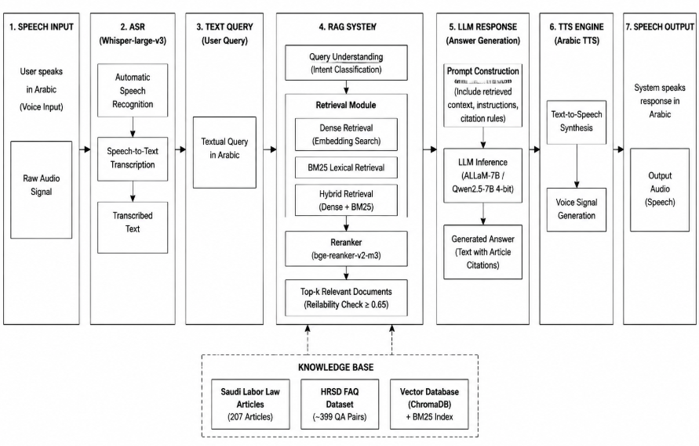
Figure 3.2 Flowchart
This will enable the seamless real time interaction between the user and the system. In addition, latency optimization techniques are applied to all of the modules, resulting in a quick response generation and a minimum of delay in the conversational flow. The combination of these elements ASR, RAG, LLM and TTS allows the system to operate as an all-in-one, intelligent Arabic voice assistant for Saudi Labor Law questions.

3.7 Conversational Memory Module
The conversational memory module is crucial for the proposed AI-powered Arabic voice agent because it allows the system to retain a context for various interactions with the users. Users ask follow-up questions that rely on the previous conversation history when having realistic conversations.When having realistic conversations, users ask follow up questions based on the conversation history. If there is no memory, the queries may be ambiguous, which can result in the wrong information being retrieved or not all of it. The system introduces a multi-turn conversational memory mechanism, which keeps a history of interactions and reformulates the queries of users into complete and standalone questions, to solve this problem (Li et al., 2024). This process helps the retrieval system to process the query without losing the meaning of the previous queries. For example, if the user poses another question like “What about Article 77?” the system automatically reformulates the question in full context, for example, “Explain the rules of termination in Article 77, Saudi Labor Law.” The expanded query will be much more accurate – the transformation makes the query more consistent with the structured legal documents in the knowledge base. The addition of conversational memory adds to the user experience, facilitates natural conversation flow, and allows for understanding even vague or partial queries while remaining in line with the legal context.

3.8 Evaluation Methodology
A detailed multi-level evaluation framework is used to evaluate the proposed AI-powered Arabic voice agent, which measures the effectiveness of retrieval, language generation, speech processing accuracy, and system efficiency. The evaluation is designed such that the system fulfills the accuracy, reliability and real-time requirements in the legal domain. Standard information retrieval metrics such as Recall@k, Mean Reciprocal Rank (MRR) and Normalized Discounted Cumulative Gain (nDCG) are applied to the retrieval evaluation. These metrics quantify the degree of success that the system achieves in extracting relevant legal documents from the knowledge base when given queries by users (Likhomanenko et al., 2025).
Both qualitative and quantitative tools are used to evaluate the generated answers. These include accuracy of answers, faithfulness of retrieved context, occurrence of hallucinations and LLM-as-a-judge scoring. Especially, faithfulness is essential in legal applications, which will make sure that the answers are based on the articles of Saudi Labor Law without presenting additional information that is not in the law. The speech evaluation part emphasizes on voice pipeline's performance. Automatic Speech Recognition (ASR) system accuracy is measured in terms of Word Error Rate (WER) and Character Error Rate (CER) (Talafha et al., 2025). In addition, end-to-end latency is measured for assessing the responsiveness of end-to-end voice agent system from input speech to final spoken output. Bootstrap confidence intervals and McNemar's test are also conducted to test if the improvements of system configurations are statistically significant. In addition, this study of ablation is performed in order to compare the performance of the system under different settings such as No-RAG and full RAG. The evaluation dataset can be divided into 218 legal questions, including human- and AI-generated questions. The questions were validated for gold-article retrievability; expert review of the AI-generated subset is recommended as future work. The system is also evaluated with several different configurations (including dense retrieval vs. hybrid retrieval, and models with and without reranking) (Toyin et al., 2025). The above-mentioned differences in LLM performances are also assessed by comparing different LLM backends. The detailed results of this evaluation are presented and discussed in Chapter 4.

3.9 Summary
This chapter introduced the whole of the methodology and proposed framework for the Arabic voice agent with artificial intelligence (AI) for Saudi Labor Law questions. It employs an integrated pipeline that combines Automatic Speech Recognition (ASR), Retrieval-Augmented Generation (RAG), Large Language Models (LLMs), and Text-to-Speech (TTS) for providing real-time legal support through speech. The methodology covers structured data preprocessing, hybrid retrieval mechanisms (semantic and lexical), reliability filtering with confidence thresholds and conversational memory for multi-turn interactions (Toyin et al., 2023). The components are designed to assure that the responses are accurate, contextually relevant and based on authoritative legal sources. By incorporating speech technology, the system becomes fully voice-driven, and accessible and easy to use in real-world applications. The evaluation framework validates the effectiveness of the proposed system in the retrieval, generation and speech metrics, with high accuracy, reliability and latency results. The proposed methodology is a scalable, robust and practical approach for the development of intelligent Arabic legal voice assistants in general.

References
Alqadasi, A. et al. (2022) Arabic Automatic Speech Recognition: A Systematic Literature Review. Available at: https://www.mdpi.com/2076-3417/12/17/8898 (Accessed: 23 June 2026).
Al-Sabbagh, R. (2026) Ramsa: A Large Sociolinguistically Rich Emirati Arabic Speech Corpus for ASR and TTS. Available at: https://arxiv.org/abs/2603.08125 (Accessed: 23 June 2026).
Al-Shaboul, I.A. et al. (2025) Bridging the gap: The role of artificial intelligence in enhancing Arabic language learning, translation, and speech recognition. Available at: https://royalliteglobal.com/advanced-humanities/article/view/1904 (Accessed: 23 June 2026).
Alsubhi, J. et al. (2025) Optimizing RAG Pipelines for Arabic: A Systematic Analysis of Core Components. Available at: https://arxiv.org/abs/2506.06339 (Accessed: 23 June 2026).
Besrour, I. et al. (2025) RAGentA: Multi-Agent Retrieval-Augmented Generation for Attributed Question Answering. Available at: https://arxiv.org/abs/2506.16988 (Accessed: 23 June 2026).
Cui, W. et al. (2025) Recent Advances in Speech Language Models: A Survey. Available at: https://aclanthology.org/2025.acl-long.682.pdf (Accessed: 23 June 2026).
Ethiraj, V. et al. (2025) Toward Low-Latency End-to-End Voice Agents for Telecommunications Using Streaming ASR, Quantized LLMs, and Real-Time TTS. Available at: https://arxiv.org/abs/2508.04721 (Accessed: 23 June 2026).
Gao, Y. et al. (2024) Retrieval-Augmented Generation for Large Language Models: A Survey. Available at: https://arxiv.org/abs/2312.10997 (Accessed: 23 June 2026).
Khamis, A.K. et al. (2026) LLM-to-Speech: A Synthetic Data Pipeline for Training Dialectal Text-to-Speech Models. Available at: https://arxiv.org/abs/2602.15675 (Accessed: 23 June 2026).
Li, S. et al. (2024) LA-RAG: Enhancing LLM-based ASR Accuracy with Retrieval-Augmented Generation. Available at: https://arxiv.org/abs/2409.08597 (Accessed: 23 June 2026).
Likhomanenko, T. et al. (2025) ChipChat: Low-Latency Cascaded Conversational Agent in MLX. Available at: https://arxiv.org/abs/2509.00078 (Accessed: 23 June 2026).
Talafha, B. et al. (2025) Zero-Shot Context-Aware ASR for Diverse Arabic Varieties. Available at: https://arxiv.org/abs/2511.18774 (Accessed: 23 June 2026).
Toyin, H.O. et al. (2023) ArTST: Arabic Text and Speech Transformer. Available at: https://arxiv.org/abs/2310.16621 (Accessed: 23 June 2026).
Toyin, H.O. et al. (2025) ArVoice: A Multi-Speaker Dataset for Arabic Speech Synthesis. Available at: https://www.isca-archive.org/interspeech_2025/toyin25_interspeech.pdf (Accessed: 23 June 2026).

