Chapter 1: Introduction

Study Problem
Communication is a foundational element in the healthcare environment, where the timely exchange of information, collaboration among team members, and accurate communication with patients can determine the quality and safety of care provided. In many healthcare systems, particularly in fast-paced and high-pressure environments like those in the Riyadh region, communication breakdowns can lead to serious consequences, such as medical errors, delayed treatments, and overall inefficiency in healthcare delivery. The growing complexity of healthcare services and the need for multidisciplinary collaboration among doctors, nurses, and other healthcare providers have increased the demand for effective communication skills.
Despite numerous technological advancements and the implementation of protocols, many healthcare providers still face significant challenges in maintaining clear and effective communication. This problem not only affects the internal functioning of healthcare institutions but also impacts patient safety, satisfaction, and overall health outcomes. Poor communication among healthcare professionals can lead to errors in diagnosis, mismanagement of patient care, duplication of efforts, and dissatisfaction among patients and staff. Therefore, the study aims to address these communication issues by examining the impact of healthcare providers' communication skills on healthcare delivery in the Riyadh region.

Importance of the Study
This study is of vital importance for several reasons. First, it highlights the critical role of communication in healthcare settings and its direct influence on the quality of care and patient outcomes. Effective communication ensures that healthcare providers can share important patient information, collaborate efficiently, and respond appropriately to critical situations, reducing the likelihood of medical errors and improving overall service delivery.
In the context of the Riyadh region, where the healthcare system is rapidly evolving and expanding, the study is especially relevant. It can provide valuable insights into the communication barriers faced by healthcare teams in this region and identify areas for improvement. Furthermore, by exploring the specific challenges related to communication in healthcare settings, the study can propose actionable strategies to enhance team collaboration, boost patient satisfaction, and optimize healthcare outcomes. This research also has the potential to contribute to policy development, helping healthcare institutions in Riyadh implement better communication training programs and protocols that align with international best practices.

Objectives of the Study
The primary objective of this study is to assess the communication skills of healthcare providers in the Riyadh region and evaluate their impact on healthcare delivery. Specifically, the study aims to:
- Examine the current state of communication skills among healthcare providers, including doctors, nurses, and other staff members, in the Riyadh region.
- Analyze the extent to which communication skills influence the quality of healthcare delivery, patient safety, and team efficiency.
- Identify key factors that affect communication among healthcare providers, such as professional training, cultural differences, team dynamics, and workload.
- Propose recommendations for improving communication within healthcare teams to foster better collaboration, reduce errors, and enhance overall patient care.
These objectives will help to not only understand the current communication challenges in the Riyadh region but also provide a framework for improving healthcare services through better communication.
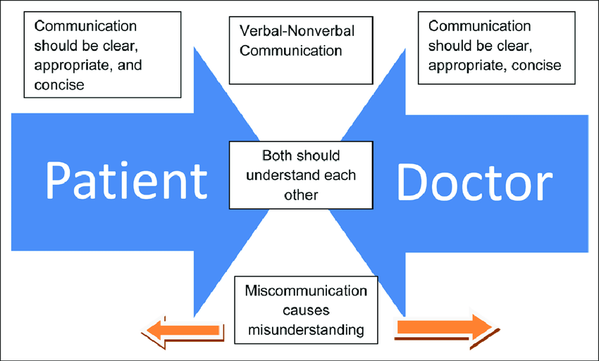
Figure 3: Effective communication in health care

Study Questions
To address the study problem and objectives, the following research questions will guide the investigation:
- What is the relationship between the communication skills of healthcare providers and the effectiveness of healthcare delivery in the Riyadh region?
- What are the most common communication challenges faced by healthcare providers in the Riyadh region?
- How do factors such as workload, team composition, and training impact communication effectiveness among healthcare providers?
- What strategies can healthcare institutions adopt to improve communication skills among healthcare teams in the Riyadh region?
These questions are aimed at uncovering both the strengths and weaknesses of current communication practices and identifying areas where interventions can make a significant impact on healthcare delivery.

Study Hypothesis
The central hypothesis of this study is that effective communication between healthcare providers positively impacts healthcare delivery, leading to improved patient outcomes, enhanced teamwork, and greater operational efficiency. Specifically, it is hypothesized that healthcare teams with strong communication skills are more likely to achieve higher patient satisfaction, lower rates of medical errors, and better overall performance in terms of healthcare delivery. This hypothesis will be tested through the data collected from healthcare providers in the Riyadh region.

Additionally, the study will explore sub-hypotheses, such as:
- H1: Healthcare providers with higher levels of formal communication training report better collaboration and patient care outcomes.
- H2: Communication challenges are more prevalent in larger teams or departments with diverse professional roles.
- H3: Increased workload and time pressures negatively affect the quality of communication between healthcare providers.
These hypotheses will guide the statistical analysis and provide a basis for evaluating the relationship between communication and healthcare outcomes.
Table 3: Common Communication Barriers Between Healthcare Providers
Communication Barrier | Description | Impact on Healthcare Delivery
Language Differences | Healthcare providers from different cultural or linguistic backgrounds may experience difficulties in communication. | Can lead to misunderstandings, delays in treatment, and inaccurate patient information exchange.
Time Constraints | Healthcare professionals often face time pressure, limiting effective communication. | May result in rushed interactions, incomplete information, and increased risk of medical errors.
Hierarchical Structures | The presence of rigid hierarchies in healthcare teams may inhibit open communication, especially from junior staff. | Limits the sharing of critical information, decreasing collaboration and patient safety.
Cultural Variations | Cultural differences among healthcare providers can affect communication styles and expectations. | Creates misinterpretations of verbal and non-verbal communication, leading to breakdowns in teamwork and care delivery.
Lack of Communication Training | Many healthcare providers do not receive sufficient formal communication training. | Results in ineffective communication, impacting patient care quality and team coordination.

Scientific Method
This study adopts a quantitative research approach to examine the impact of communication skills on healthcare delivery. A survey was designed and distributed to a sample of 50 healthcare providers, including doctors, nurses, and other medical staff, in healthcare institutions across the Riyadh region. The survey included both closed-ended and Likert scale questions to measure the communication skills of respondents, their perceptions of team communication, and the observed outcomes in healthcare delivery.
The study follows these key steps in its methodology:
- Data Collection: A structured questionnaire was administered to collect data on the communication practices of healthcare providers. The questionnaire covered areas such as clarity of communication, collaboration within teams, frequency of communication breakdowns, and the perceived impact on patient care.
- Sample Population: The sample size includes 50 healthcare providers, with a balanced representation from various departments, professional roles, and levels of experience. This diversity ensures a comprehensive understanding of communication dynamics in different healthcare settings.
- Data Analysis: Descriptive statistics were used to summarize the demographic data and overall communication patterns. Inferential statistics, including correlation and regression analyses, were applied to test the relationships between communication skills and healthcare outcomes. Cross-tabulations were performed to explore potential factors influencing communication, such as professional background and workload.
- Reliability and Validity: The reliability of the questionnaire was assessed using Cronbach's Alpha to ensure internal consistency. The validity of the findings was enhanced through the use of statistical tests to confirm the significance of the observed relationships.
- Ethical Considerations: Participants were assured of their anonymity, and the study followed ethical guidelines for informed consent and data privacy.
This scientific approach allows for a rigorous examination of how communication skills affect healthcare delivery, providing evidence-based insights and recommendations for improving communication in the healthcare sector.
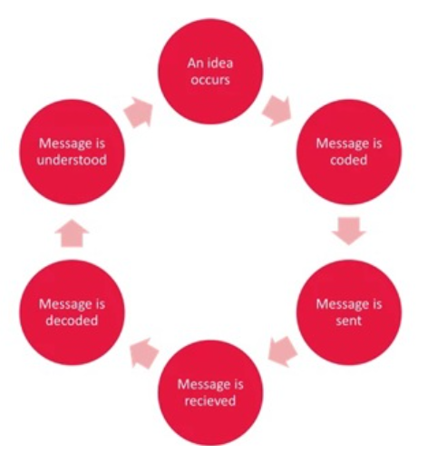
Figure 4: Argyle’s communication cycle

Chapter 2: Previous Studies/Research
Introduction:
Effective communication is a key element in healthcare delivery, especially in complex and dynamic environments where patient care involves multidisciplinary teams. Communication failures can lead to medical errors, delayed treatments, and poor patient outcomes. As healthcare systems have evolved and become more complex, research has increasingly focused on the importance of communication in ensuring patient safety and enhancing team collaboration. In this chapter, we will explore the body of literature related to healthcare communication, specifically focusing on its impact on patient safety, teamwork, and operational efficiency. Additionally, we will review relevant theories and frameworks that provide insights into how communication affects healthcare delivery.

Previous Studies/Research
1. Impact of Communication on Patient Safety
Patient safety is one of the most critical concerns in healthcare, and communication has been consistently identified as a key factor that influences safety outcomes. According to Sutcliffe, Lewton, and Rosenthal (2004), communication failures are a leading cause of medical mishaps, contributing to approximately 70% of sentinel events reported in hospitals. Their study underscores those errors in communication between healthcare providers, such as incomplete information exchanges, misunderstandings, and delayed transmissions, are significant contributors to diagnostic mistakes, improper treatment, and adverse drug events.
Another important study by Leonard, Graham, and Bonacum (2004) supports these findings. They highlight that communication failures are a primary cause of breakdowns in teamwork and collaboration, which are essential for patient safety. In their research, the authors emphasized that structured communication protocols, such as the SBAR (Situation, Background, Assessment, Recommendation) technique, can mitigate these risks by ensuring that healthcare providers exchange critical patient information more effectively. Their work has had a substantial impact on how healthcare institutions approach team communication, promoting the use of standardized communication tools to prevent errors.
The literature on communication and patient safety is vast, but there is consensus among scholars that improving communication is essential to reducing medical errors. For example, a systematic review conducted by Manser (2009) concluded that communication issues were prevalent in fast-paced healthcare settings such as emergency departments and intensive care units (ICUs). These settings require constant coordination and information exchange between healthcare providers, and even small communication failures can result in serious consequences for patients.
2. Communication and Teamwork in Healthcare
The relationship between communication and teamwork has been another major focus in healthcare research. Effective teamwork depends on the ability of healthcare professionals to communicate clearly, share information, and collaborate towards common goals. Research by Salas, Sims, and Burke (2008) identifies communication as one of the "Big Five" factors crucial to team effectiveness, alongside leadership, mutual performance monitoring, backup behavior, and adaptability. Their study highlights that teams with strong communication are more efficient in delivering care, make fewer mistakes, and are better at handling unexpected situations.
Manser (2009) also explored the role of communication in ensuring effective teamwork, particularly in dynamic healthcare environments. He found that communication breakdowns often occurred in settings where healthcare providers needed to coordinate rapidly changing information, such as ICUs. These breakdowns resulted in role ambiguity, delayed task execution, and patient safety risks. The study recommended regular team briefings and the use of structured communication tools to improve clarity and understanding among team members.
Further research by Lingard et al. (2004) examined the impact of interprofessional communication on operating room teams. They found that communication challenges between surgeons, anesthesiologists, and nursing staff were a significant source of tension and confusion, which in turn increased the likelihood of errors. This study highlighted the importance of fostering a culture of open communication and collaboration across professional boundaries in healthcare settings.
3. Training and Communication in Healthcare
Several studies have explored the role of training in improving communication skills among healthcare providers. Haig, Sutton, and Whittington (2006) conducted a landmark study on the use of the SBAR communication tool in healthcare settings. Their research demonstrated that training healthcare providers to use SBAR improved the clarity and accuracy of information exchanges between clinicians. This improvement led to fewer misunderstandings, enhanced confidence in communication, and better patient outcomes.
O'Daniel and Rosenstein (2008) also emphasized the importance of communication training programs in their review of healthcare team collaboration. Their study highlighted that communication barriers, such as hierarchical differences, cultural diversity, and time pressures, could be addressed through training interventions that fostered mutual respect and open dialogue. By training healthcare providers to communicate more effectively, institutions can reduce the number of communication-related errors and improve team dynamics.
In addition, a study by Weller, Boyd, and Cumin (2014) demonstrated the positive impact of simulation-based communication training on healthcare teams. Their research showed that simulation exercises helped healthcare providers practice clear and effective communication in high-pressure situations, leading to better performance in real-life scenarios. This training approach not only improved individual communication skills but also enhanced team collaboration, particularly in emergency and surgical settings.

Theoretical Framework
1. Communication Accommodation Theory (CAT)
The Communication Accommodation Theory (CAT), developed by Howard Giles, provides a useful framework for understanding how healthcare providers adapt their communication styles in response to their colleagues' communication behaviors. CAT posits that individuals modify their speech, tone, and body language to either converge (become more similar) or diverge (emphasize differences) during interactions. In healthcare settings, providers often adjust their communication styles based on the hierarchy of the team, cultural differences, and the urgency of the situation.
CAT is particularly relevant in multicultural healthcare environments, such as those found in the Riyadh region, where healthcare providers come from diverse backgrounds. Effective communication requires an understanding of these differences and an ability to accommodate various communication styles. According to Jones (2013), accommodating the communication needs of colleagues leads to more harmonious interactions, reduces misunderstandings, and fosters collaboration, especially in teams composed of professionals from different cultural and linguistic backgrounds.

2. Systems Theory of Communication
The Systems Theory of Communication views communication as part of an interconnected system in which each component influences and is influenced by other components. In healthcare, this means that the communication between providers, patients, and administrative structures should be seen as an integrated process. Failures in one part of the system, such as a breakdown in communication between a nurse and a physician, can lead to failures in other parts, such as incorrect patient care.
Manser (2009) applied the Systems Theory of Communication in his study of ICUs, emphasizing that communication must be continuous and adaptive to the rapidly changing conditions in high-stress healthcare environments. The theory highlights the importance of feedback loops, where healthcare providers continuously share information, reflect on patient care, and adjust their actions accordingly to avoid mistakes and improve outcomes.
3. Theory of Planned Behavior (TPB)
The Theory of Planned Behavior (TPB), developed by Icek Ajzen, suggests that an individual’s behavior is influenced by their attitudes, subjective norms, and perceived behavioral control. In healthcare, TPB can help explain why healthcare providers may or may not engage in effective communication. For instance, a provider’s attitude toward communication (e.g., whether they see it as important), the workplace norms (e.g., whether open communication is encouraged), and their confidence in their communication abilities all play a role in determining how effectively they communicate.
A study by Haggerty et al. (2013) applied TPB to understand communication behaviors among healthcare providers. Their findings suggest that communication training programs that focus on changing attitudes and improving perceived behavioral control can lead to significant improvements in communication skills, thereby enhancing teamwork and patient care.

