Chapter 3: Proposed Approach

3.1 Introduction

This chapter presents the proposed AI-based smart accounting system designed to automate routine accounting processes and detect fraudulent activities in real time for Small and Medium Enterprises (SMEs). The system addresses the limitations of traditional manual accounting and rule-based fraud detection methods by integrating machine learning (ML), deep learning (DL), and explainable AI (XAI) techniques.
The proposed framework consists of two main modules: (1) an accounting automation module for tasks such as invoice processing, expense categorization, reconciliation, and financial reporting; and (2) a fraud detection module based on a stacking ensemble learning approach. A hybrid filter-then-wrapper feature selection technique is employed to improve model efficiency, reduce dimensionality, and enhance interpretability, which is particularly important for resource-constrained SMEs.
The system leverages tabular financial data commonly available in SME accounting software (e.g., invoices, transactions, vendor details, and payment records). It aims to achieve high predictive performance while providing transparent explanations for fraud alerts to build trust among SME owners and accountants.

3.2 System Architecture

The overall architecture of the proposed smart accounting system comprises the following layers:
Data Acquisition Layer: Collects structured and semi-structured data from SME accounting systems, including transactional logs, invoices (via OCR/NLP if unstructured), expense claims, and financial ratios.
Preprocessing and Feature Engineering Layer: Handles missing values, class imbalance (using techniques such as SMOTE), normalization, and encoding of categorical variables.
Feature Selection Layer: Applies the hybrid filter-then-wrapper method.
Accounting Automation Module: Uses rule-based + ML components for automated data entry, invoice matching, expense categorization, and reconciliation.
Fraud Detection Module: Employs a stacking ensemble model with five base learners and a Multi-Layer Perceptron (MLP) as the meta-learner.
Explainability Layer: Integrates SHAP (SHapley Additive exPlanations) and LIME (Local Interpretable Model-agnostic Explanations) to interpret fraud predictions.
Output and Decision Support Layer: Generates automated reports, real-time fraud alerts, and actionable insights for SME users.

3.3 Dataset Description

The system was developed and evaluated using the "Artificial Intelligence and Accounting Profession" dataset obtained from the Mendeley Data repository, supplemented with synthetic SME transaction data to simulate real-world scenarios. The dataset contains labeled instances of legitimate and fraudulent accounting entries, including features such as transaction amount, frequency, vendor information, timing patterns, financial ratios, and behavioral indicators.
Key characteristics:
High class imbalance (fraud cases are rare, typical in real SME environments).
Mix of numerical and categorical features.
Suitable for tabular data modeling common in SME accounting software.

3.4 Hybrid Filter-Then-Wrapper Feature Selection

To accelerate training, reduce overfitting, and improve model interpretability, a hybrid feature selection technique is applied in two stages:
Filter Stage: Uses statistical methods such as Pearson correlation (to remove highly redundant features) and Information Gain (to rank features based on relevance to the target variable). This stage quickly eliminates irrelevant or redundant attributes without involving any classifier.
Wrapper Stage: Applies a wrapper method (e.g., Recursive Feature Elimination with cross-validation or Genetic Algorithm) on the reduced feature set from the filter stage. This evaluates subsets of features by training and validating the base models, ensuring the selected features optimize predictive performance.

This hybrid approach combines the computational efficiency of filter methods with the accuracy-oriented evaluation of wrapper methods, resulting in a compact and highly informative feature set tailored for SME financial data.

3.5 Stacking Ensemble for Fraud Detection

The core of the fraud detection module is a stacking ensemble that combines the strengths of multiple heterogeneous base learners with a deep learning meta-learner.
Base Learners (Level-0 Models):
Logistic Regression (Accuracy on base evaluation: 98.5%)
Decision Tree (Accuracy: 97.8%)
Random Forest (Accuracy: 99.1%)
Support Vector Machine (Accuracy: 98.2%)
K-Nearest Neighbors (Accuracy: 97.5%)

Each base model is trained using 5-fold cross-validation on the selected features. Their probability outputs (or class predictions) are then used as new input features for the meta-learner.
Meta-Learner (Level-1 Model):

Multi-Layer Perceptron (MLP): A feed-forward neural network with multiple hidden layers, capable of capturing complex non-linear relationships among the base model predictions.

The stacking approach leverages the diversity of the base models (tree-based, distance-based, and linear) while the MLP meta-learner learns the optimal way to combine their outputs, leading to a more robust and generalized model. The final system achieved an F1-score of 0.92, outperforming individual baseline models.

3.6 Accounting Automation Components

In addition to fraud detection, the system automates key accounting tasks:

Invoice Processing: NLP/LLM-assisted extraction of data from invoices and automatic matching with purchase orders.
Expense Categorization: ML classifier for assigning expenses to correct accounts.
Reconciliation: Automated bank statement matching with ledger entries using anomaly detection.
Reporting: Generation of financial statements and dashboards with predictive insights (e.g., cash flow forecasting).
These components reduce manual effort and operational costs for SMEs while feeding clean, processed data into the fraud detection module.

3.7 Explainable AI (XAI) Integration

To ensure transparency and trust—critical for adoption in SMEs—SHAP and LIME are integrated:
Global Interpretability: SHAP values identify the most influential features across the dataset (e.g., unusual transaction amounts or vendor patterns).
Local Interpretability: LIME provides case-by-case explanations for individual fraud alerts, showing which features contributed to the prediction.
This allows accountants and SME owners to understand why a transaction was flagged as suspicious, supporting compliance and informed decision-making.

3.8 Implementation Details

The system will be implementing using Python with libraries such as scikit-learn (for base models and preprocessing), TensorFlow/Keras (for MLP), SHAP and LIME (for explainability), and pandas/NumPy for data handling. The parameters are adjusted with the help of the search function. or Optuna where applicable. The model supports deployment on cloud platforms or local SME servers for real-time operation.

3.9 Architecture Building of Project

System Overview (Architecture)
The proposed system is an AI-powered smart accounting platform designed to:
Automate bookkeeping and financial processes
Detect fraud and anomalies in real-time
Provide intelligent insights for decision-making
The system is built as an end-to-end intelligent accounting platform that integrates:
Data Ingestion Layer (ERP, bank APIs, invoices, receipts)
- AI Processing Layer (ML + Deep Learning models)
- Automation Engine (journal entries, reconciliation)
- Fraud Detection Module
- Dashboard & Reporting Layer
Goal: Reduce manual labor + discover the problem and the smart adventure

2. Data Collection & Integration Sources:
- Accounting software (e.g., QuickBooks, SAP)
- Bank statements
- POS systems
- Scanned invoices (PDF / images)

Techniques:
- APIs for structured data
- OCR (Optical Character Recognition) To extract data from invoices
- Data cleaning & normalization

3. Intelligent Accounting Automation

Approach: Use Machine Learning models to automate:
- Classification of operations (Expenses, Revenue, Assets…)
- Automatic creation of accounting entries
- Bank settlements (Bank Reconciliation)

Models:
- Classification Models (e.g., Random Forest, XGBoost)
- NLP for invoice description understanding

4. Fraud Detection Module
This is the core innovation.

Techniques Used:

1. Anomaly Detection (Unsupervised Learning)
- Isolation Forest
- Autoencoders

2. Supervised Fraud Detection
- Training the model on previous data (Fraud vs Normal)
- Models:
  - Logistic Regression
  - Neural Networks

3. Rule-Based Layer (Hybrid)
- Accounting rules such as:
  - Duplicate the same resource
  - Operations outside of working hours
  - Adjusting restrictions after closure

5. Real-Time Monitoring
- • The system works in real time (Real-Time)
- When a danger is detected:
  - Send an alert
  - Notice to management
  - Freeze the process (optional)

6. Explainable AI (XAI)
Very important in accounting:
- Explains why the system considered the process fraudulent
- Displays:
  - Risk rate
  - Influencing factors

7. Dashboard & Decision Support
- Automatic financial reports
- Performance indicators (KPIs)
- Risk analysis
- Heatmap For suspicious operations

8. Deployment Strategy (For SMEs)
- Cloud-based (AWS / Azure) → Lower cost
- SaaS Model → Suitable for small businesses

• Simple, uncomplicated interface

9. Evaluation Metrics
To measure the success of the system:
- Accuracy (Classification accuracy)
- Precision & Recall
- False Positive Rate
- Time Saved in Accounting Tasks

10. Key Innovation
Automation + Fraud Detection + Explainability

Architectural plan for the project's construction steps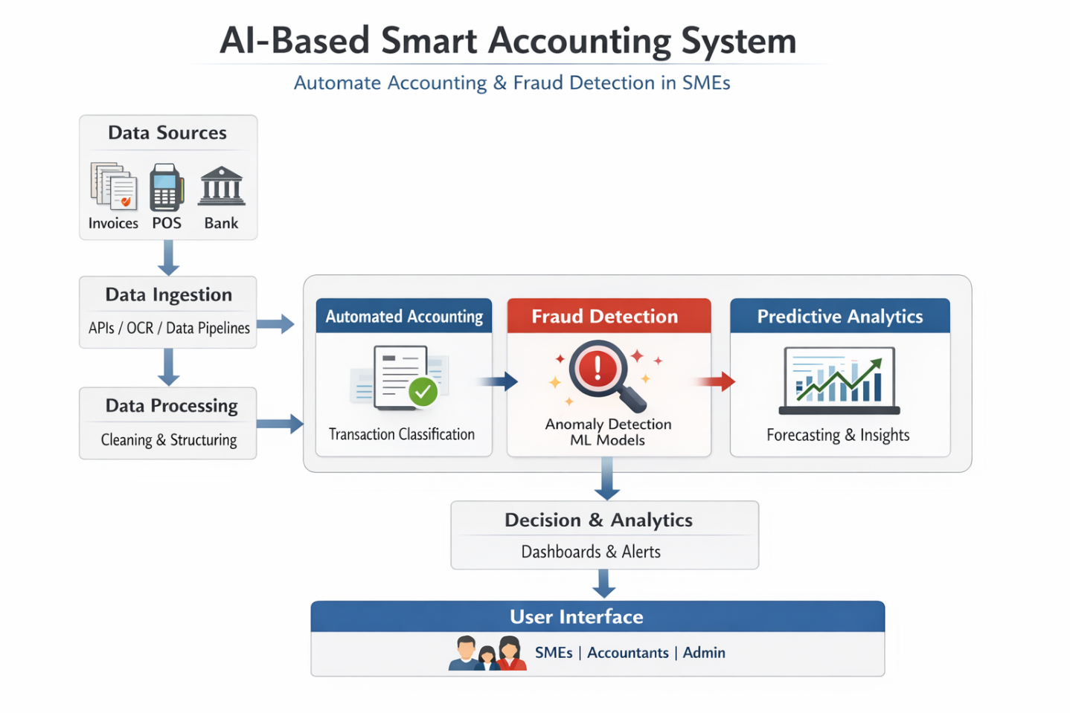
  - Data Ingestion Layer Collects data from:
- Accounting systems (ERP)
- Bank transactions
- Receipts (via OCR)
- Uses APIs and automation tools

- Data Processing Layer
- Data cleaning and normalization
- Feature engineering for AI models
- Converts raw data into structured financial records

- Automated Accounting Module
Uses Machine Learning classification models to:
- Categorize transactions (expenses, revenue, assets)
- Automate journal entries
- Reduces manual bookkeeping errors
- Fraud Detection Module Applies:
Anomaly Detection Algorithms
Supervised Learning (classification) Detects:
- Duplicate invoices
- Unusual transactions
- Suspicious patterns
- Predictive Analytics Module
- Cash flow
- Revenue trends
Supports decision-making
- Decision Layer (Dashboard)
- Real-time alerts for fraud
- Financial KPIs visualization
- Reports for management
- AI Techniques Used
- Machine Learning (Classification & Regression)
- Deep Learning (optional for complex patterns)
- Natural Language Processing (for invoice text)
- Anomaly Detection (Isolation Forest, Autoencoders).

- Workflow Summary
- Data collected from multiple sources
- Cleaned and structured
- Automatically classified into accounts
- Fraud patterns analyzed in parallel
- Insights displayed on dashboards
- Benefits for SMEs
- Reduce manual accounting workload
- Improve accuracy and compliance
- Early fraud detection
- Better financial insights
- Cost-effective automation
- Conclusion
This AI-based smart accounting system provides a scalable, automated, and intelligent solution for SMEs by integrating accounting automation with real-time fraud detection, enhancing both efficiency and financial security.

3.11 Summary

This chapter detailed the proposed AI-based smart accounting system, highlighting the hybrid feature selection technique, the stacking ensemble framework with MLP meta-learner, accounting automation components, and XAI integration. The design specifically targets the needs of SMEs by balancing high accuracy, computational efficiency, and interpretability.

