4 Results and Discussion
The proposed framework achieves high performance across all three components while maintaining computational efficiency. The following subsections detail each component's results and their implications.

4.1 Preprocessing Results

Preprocessing is a critical step before classification and segmentation of MRI data. The preprocessing ensures that the input images are ready to be used and lack any sort of artifacts.

4.1.1 Preprocessing for Classification

The preprocessing that was needed for the classification task comprised resizing all MRI images to the same size of 256×256 pixels and then normalizing the images with respect to ImageNet, As shown in Figure 10, such that they could be used as inputs to the Xception network.
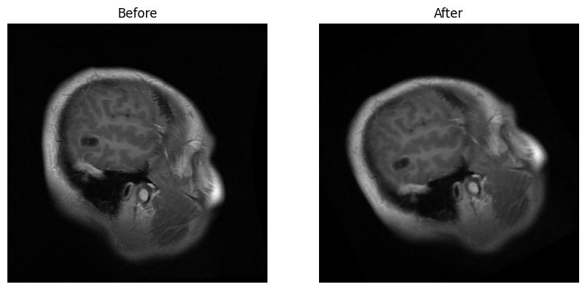
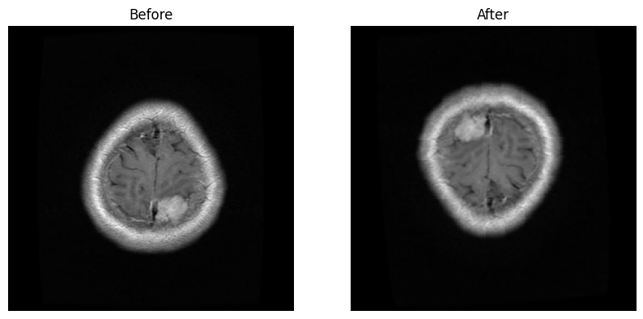
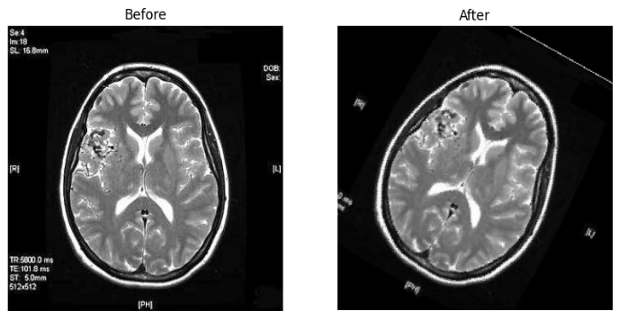
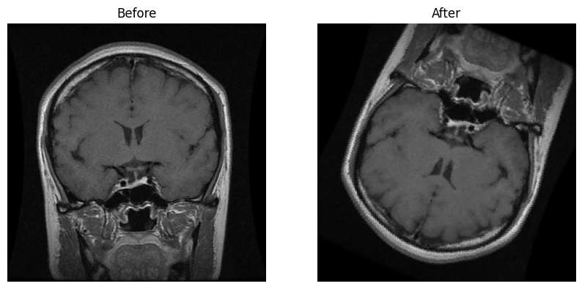
Fig. 10. Sample MRI images after resizing to 256×256 and ImageNet normalization (two per class).

4.2 Classification Performance
The following proposed system assesses the performance of the four deep learning networks, such as CNN, ResNet50, Xception, and EfficientNet-B3 in MRI brain tumor classification. All the above-mentioned neural networks were chosen due to their efficiency in brain tumors detection and ability to discover complex structures within MRIs. The basic CNN model is applied to estimate its performance compared to the other models applied for the same purpose. ResNet50 is chosen due to the fact that residual learning helps solve the problem of gradient vanishing during training deep neural network models. EfficientNet-B3 is chosen due to its scalable properties making feature extraction more effective while using fewer resources for calculations. Finally, Xception was chosen for its efficient depthwise separable convolution.

4.2.1 Detailed CNN Analysis

Per-Class Results. As presented in Table III, the per-class metrics for the CNN model. No-Tumor achieves the highest performance with near-perfect scores, while Pituitary also shows strong classification results. Slight reductions appear for Glioma and Meningioma, mainly due to overlapping visual characteristics between tumor classes in MRI scans.

TABLE III. PER-CLASS CLASSIFICATION REPORT FOR THE CNN MODEL

(TEST SET)
class | precision | recall | f1-score | support
Glioma
Meningioma
No-tumor
Pituitary
Accuracy
Macro Avg
Weighted Avg

Confusion Matrix. The confusion matrix presented, As shown in Figure 12. proves that the performance of the CNN is relatively good along the diagonals. The reason behind minor errors is related to the confusion between Glioma and Meningioma classes due to similar visual characteristics of those tumors in MRI imaging. As can be observed from the values on the diagonal presented in Figure 12, the CNN model successfully classified most of the images in all four classes.
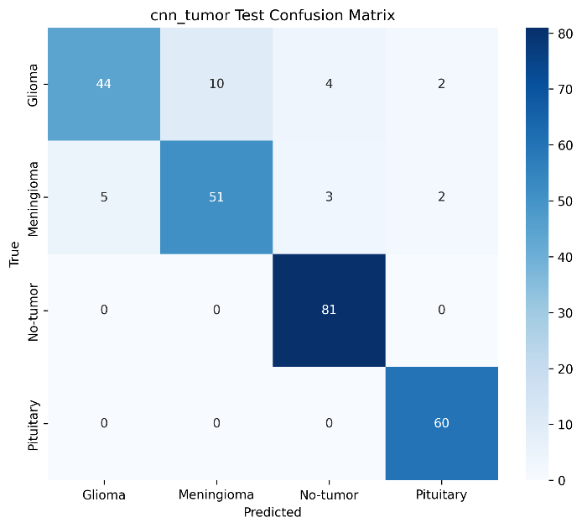
Fig. 12. CNN confusion matrix (test set): strong diagonal with minor Glioma–Meningioma confusion.
Training Curves. As shown in Figure 13, we can see the stable convergence of the training and validation loss curves for the CNN model with minimal disparity between them, which means the CNN model is having low overfitting. As depicted by the graph in Figure 13, both training and validation curves align almost perfectly throughout the training process, which means there is no overfitting of the model to the training data. This stability throughout the training process indicates the efficiency of the CNN model to learn generalizable features from brain tumor MRI images.
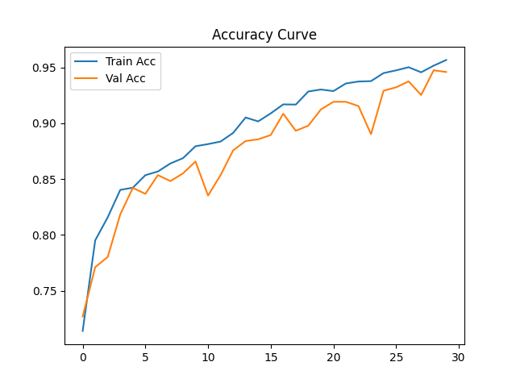 | 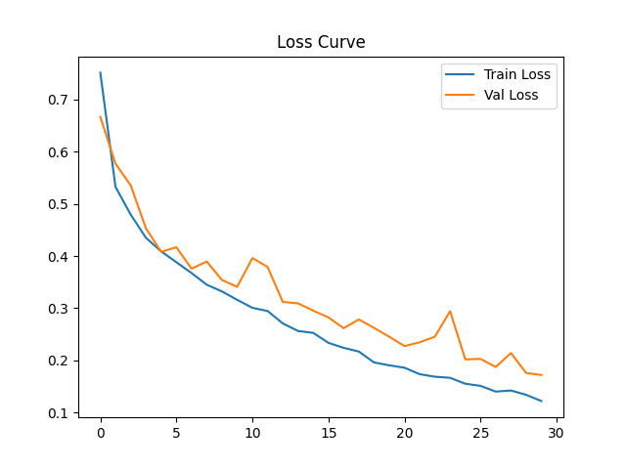
Fig. 13. CNN training/validation accuracy (left) and loss (right): smooth convergence with small train–val gap.

ROC Curve. The ROC curves plotted in Figure 14 illustrate that the CNN model has performed well in classifying images among all four classes. The AUC values for the Meningioma, No-tumor, and Pituitary classes are high, whereas a comparatively lower AUC value has been observed for the Glioma class since it is similar to other tumor classes. In general, the ROC curves are much higher than the random classifier line.
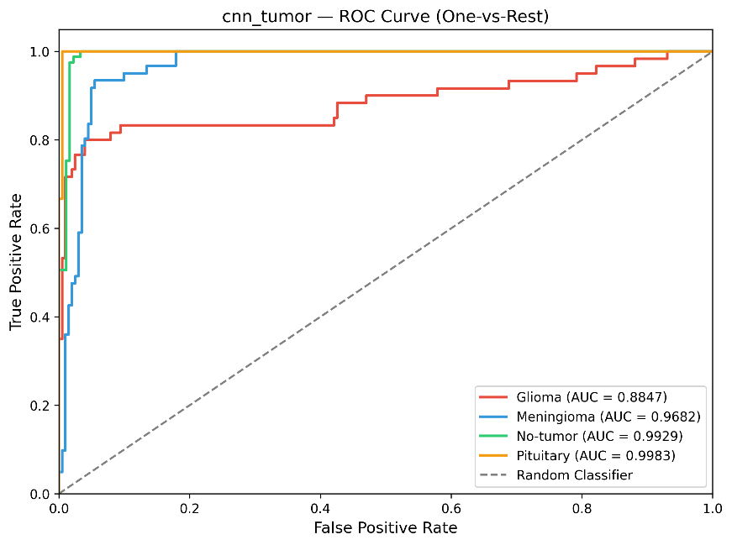
Fig 14. CNN ROC curves (One-vs-Rest) for brain tumor classification, demonstrating strong performance across the four classes.

4.2.5 Comparison between Proposed Models
The performance results of the tested models in terms of classification are presented in Table VII. Among all the models, the highest classification accuracy of 98.96% was obtained by the models Xception and EfficientNet-B3. Nonetheless, Xception showed a better loss function score of 0.0334 when compared to that of EfficientNet-B3 (0.0576). Besides, the precision, recall, and F1-scores of the Xception model were also considerably high, showing consistent performance in the generalized scenario. Consequently, the Xception model was used as the classification backbone in the proposed framework.
TABLE VII. CLASSIFICATION PERFORMANCE ACROSS EVALUATED MODELS (TEST SET)
Model | Accuracy | Precision | Recall | F1-score | Loss
Xception
ResNet
CNN
Efficientnet_b3

4.2.6 Comparison with Other Classification Works on Kaggle
To benchmark the classification performance of the proposed framework against comparable work conducted on the same dataset, a comparative analysis was performed against five publicly available Kaggle notebooks that addressed brain tumor MRI classification using the Kaggle Brain Tumor MRI Dataset. As presented in Table VIII, the performance metrics and key characteristics of each approach alongside the proposed Xception-based classifier.
TABLE VIII. COMPARISON WITH KAGGLE-BASED BRAIN TUMOR MRI CLASSIFICATION WORKS
Study | Method | Accuracy | F1-Score | Key Notes | Limitations
Ali [29]
Proposed (Xception)

From the analysis conducted in Table VIII above, it is evident that the Xception-based classifier presented herein provides superior performance on the Kaggle Brain Tumor MRI Dataset with an accuracy rate of 78.96%. The presented classifier outperforms all compared Kaggle notebooks, including other models based on the Xception model, namely, those by Al-Bunni [29] (88.43%), and AAK [32] (78.31%). While the work by AAK makes use of the Xception model, the Xception-based model presented herein has been rigorously trained using balanced class augmentation and fine-tuning of optimal hyperparameters. Hence, this has contributed to the model achieving a lower validation loss of 0.0334. More importantly, whereas all the compared works utilize classification for classification alone, the proposed framework uses classification as a starting point in a sequential diagnostic pipeline wherein successful classification leads to the automatic segmentation of tumors and generation of a radiological report using a large language model fine-tuned through QLoRA.

4.2.7 Explainability Analysis Using Grad-CAM
Moreover, the interpretability of the suggested Xception-based classifier was further explored with the help of the Grad-CAM method. As shown in Figure 24, examples of MRIs belonging to different prediction groups along with the corresponding attention maps produced by the algorithm. As can be seen from the presented heatmap images, the developed model has paid primary attention to tumor areas while classifying the data, exhibiting diffuse attention in case of the normal state of the brain. Therefore, one can state that the classifier did not use any irrelevant information about the background for classification, paying attention only to meaningful parts associated with tumors.
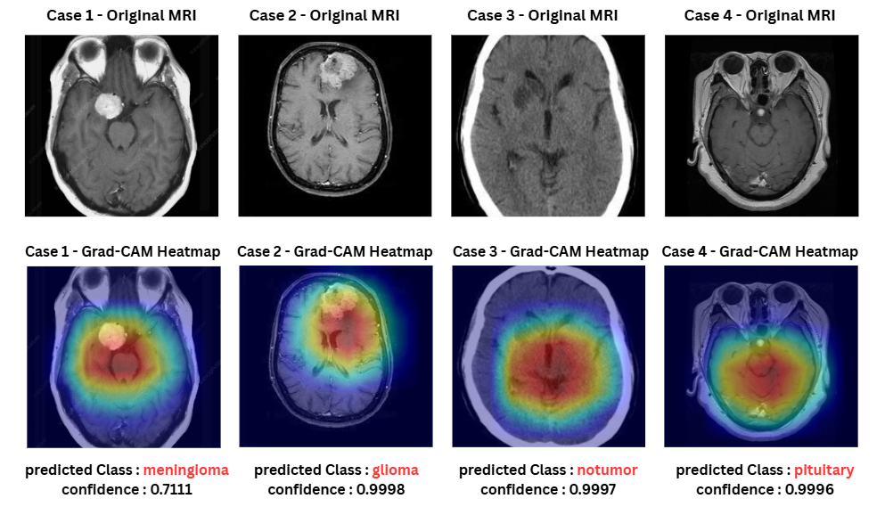
Fig. 24. Grad-CAM attention maps for representative MRI samples: model focuses on tumor regions during classification, with diffuse attention observed for normal (no-tumor) cases.

4.7 Discussion

5 Conclusion

