

AI-Based Early Warning System for Academic Risk Detection in Education
Prepared By
Student 1: Marya Mohammed Bawazir ID: 253000692
Student 2: Hala Haytham Hajjar ID: 253001456
Submitted in fulfillment of the requirements for the degree Master of Science in Artificial Intelligence
At
Collage of Informatics
Midocean University
UAE
Supervisor Name: Hager Saleh.
College of Informatics, Midocean University, Comoros

Abstract:
Early detection of students at risk is critical for educational institutions ,because timely intervention could help in achieving better academic results. However, prediction of students' academic performance using traditional models cannot be efficient due to complex relationships between their academic performance, engagement, and behavioral indicators collected in (LMS). In this study, an AI-based early warning system for the prediction of students' academic performance using supervised machine learning models is proposed. For the development of the proposed system, comprehensive data preprocessing was implemented, which included data transformation, feature selection by Random Forest feature importance method, class balancing by (SMOTE), and hyperparameter tuning via Grid Search.
To analyze the impact of preprocessing techniques on the prediction results, four different experimental setups have been used:Full Feature Set, Selected Feature Set, Full Feature Set with SMOTE, and Selected Feature Set with SMOTE. The eight machine learning models have been tested including (DT), (RF), (LR), (SVM), (KNN), (NB), (AB), and (XGB). Accuracy, Precision, Recall, F1-score, and Confusion Matrix analysis has been performed to evaluate the models' performance.
The experimental results have shown that XGB is the most efficient predictor of all machine learning algorithms considered in this research. Its maximum performance was achieved when using the full feature set: accuracy was equal to 82.80%, precision was 82.63%, recall was 82.80%, and F1-score was 82.42%. Even though the model (DT) has reached the same value of accuracy with the help of Grid Search optimization in one of the experimental settings, XGB demonstrated higher stability and generalizability for all cases considered. In addition, feature selection allowed reducing the number of input parameters without any negative impact on the performance of prediction models while SMOTE technique helped to recognize the minority classes better and improve the balance of classification results.
The proposed AI-Based Early Warning System provides an effective and reliable framework for predicting students' academic performance using LMS data. The developed model enables educational institutions to identify academically at-risk students at an early stage, supporting timely interventions, improving student success, and facilitating data-driven educational decision-making.

Table of Contents
List of Abbreviations...................................................................................... xiv
List of Figures................................................................................................. xvi
List of Tables.................................................................................................. xviii
Table of Contents
Chapter 1 Introduction 7
1.1 Problem Definition 7
1.2 Thesis Objectives 8
1.3 Thesis Contributions 8
1.4 Thesis Organization 9
Chapter 2: Background and Related Work 10
2.1 Background 10
2.2 Related Work: 18
Chapter 3 30
Methodology and Proposed Approach 30
Introduction 30
3.1 Dataset Description 31
3.2 Data Preprocessing 31
3.3 Data Splitting 31
3.4 Feature Selection 32
3.5 Experimental Configurations 32
3.6 Machine Learning Models 32
3.7 Model Optimization 33
3.8 Summary 33
Chapter 4 Results. 34
4.1 Experimental Setup 34
4.2 Class Distribution 34
4.3 Feature Importance Analysis 35
4.4 Results without Applying SMOTE 36
4.5 Results with Applying SMOTE. 41
4.6 Final Model Selection. 45
4.7 Summary of the Experimental Findings. 47
Chapter 5 Conclusion and Future Work 48
5.1 Conclusion 48
5.2 Future Work 49
References: 50

List of Abbreviations :
- Acc.: Accuracy.
- ANN: Artificial Neural Network.
- ML: Machine Learning.
- EL: Ensemble Learning.
- XAI: Explainable Artificial Intelligence.
- SVM: Support Vector Machine.
- RF: Random Forest.
- DT: Decision Tree.
- KNN: K-Nearest Neighbors.
- DL: Deep Learning.
- NV: Naïve Bayes.
- CNN: Convolutional Neural Network.
- LMS: Learning Management System.
- LR: Logistic regression.
- XGB: Extreme Gradient Boosting.
- SMOTE: Synthetic Minority Oversampling Technique.

List of Figures :
Figure 1. AI [2] 12
Figure 2. Types of ML [4] 13
Figure 3. DT structure[8] 14
Figure 4. RF algorithm structure[9]. 14
Figure 5. KNN classification [6] 15
Figure 6.SVM [3]. 16
Figure 7Proposed AI-Based Early Warning System Framework (Student Risk Classification) 33
Figure 8 . Distribution of Student Performance Classes with SMOTE. 38
Figure 9 Random Forest Feature Importance Ranking. 39
Figure 10 First experiment: Confusion Matrices of All Models 40
Figure 11 First experiment: Performance with and without Grid Search Optimization. 41
Figure 12 Second experiment: Confusion Matrices of All Models. 43
Figure 13 Second Experiment: Performance With and Without Grid Search Optimization. 44
Figure 14. Third experiment: Confusion Matrices of Traditional ML Models with Full Features after Applying SMOTE. 45
Figure 15. Third experiment: Performance with and without Grid Search Optimization 46
Figure 16. Fourth experiment: Confusion Matrices of Traditional Machine Learning Models 48
Figure 17 Fourth experiment: Performance with and without Grid Search Optimization. 49

List of Tables:
Table 1 Of The Reviewed Papers 27
Table 2. Distribution of Student Performance Classes 37
Table 3. First experiment: Results of Applying Machine Learning Models with Full Features 40
Table 4.First experiment: Performance with and without Grid Search Optimization 41
Table 5 Second experiment: Results of Applying ML Models with Selected Features 42
Table 6. Second Experiment: Performance With and Without Grid Search Optimization. 43
Table 7. Third experiment: Results of Applying Machine Learning Models with Full Features after Applying SMOTE. 45
Table 8. Third experiment: Performance with and without Grid Search Optimization. 46
Table 9: Fourth experiment: Results of Applying Machine Learning Models with Selected Features after Applying SMOTE. 47
Table 10.Fourth experiment: Performance with and without Grid Search Optimization. 48
Table 11. Final Performance of the Best Models Across the Four Experimental Configurations 50

Chapter 1 Introduction

1.1 Problem Definition
Despite the increasing availability of student data in educational sectors, many systems still face challenges in identifying students at academic risk at an early stage to allow them to intervene effectively. Traditional evaluation methods often rely on certain and usual results. This reduces the opportunity of providing timely support or implementing appropriate personalized intervention plans. The lack of this diagnostic plan is an additional risk, as each student's skills, goals, and needs vary, necessitating early diagnosis to provide individualized support.
Also, educational data is very complex and diverse. It includes demographic information, behavioral data, attendance records, and interactions within learning management systems (LMS). Such complexity makes it difficult to figure out which factors have the biggest effect on predicting academic performance. This data is also often enormous and challenging to understand, which makes it even harder to analyze and make decisions.
Besides, the presence of extraneous or less important features may lead to various difficulties in constructing prediction models, including overfitting, higher computation costs, and non-explainability of the models. Consequently, the use of feature selection techniques to extract only the most relevant features will have great potential for constructing accurate and explainable models.
In contrast, artificial intelligence (AI), such as machine learning (ML) and deep learning (DL), is able to analyze the information from the education field, recognize patterns, detect students' behaviors, and predict student performance. With the help of the proper dataset, it will be possible to determine whether a student will probably perform well or not and what factors may cause their failure. However, the effectiveness of AI algorithms depends on data quality, feature selection, and model interpretability.
Therefore, the application of a data-driven early warning system based on AI is necessary for predicting and identifying at-risk students at an early stage. In particular, a data-driven model can help classify at-risk students by their risk level (low, medium, and high).
This study attempts to tackle the issue of inefficient and ineffective detection systems of students that could benefit from additional assistance, through the application of Artificial Intelligence techniques on the information provided by the LMS. The ultimate goal is to boost student performance and avoid academic failure.

1.2 Thesis Objectives
The major goal of the research is the development of an early warning system that can be applied to classify students' risk levels in terms of their academic performance by using AI and ML methods. The project will rely on LMS data, including students' academic performance indicators, engagement, and demographics, to identify those who have risks of poor performance as early as possible. For this purpose, the target (Final Mark) is transformed into a classification problem (low, medium, high). The research uses the technique of data pre-processing and feature engineering to increase the quality of the data used for predictions. Several ML classifiers are implemented in a stacking ensemble model to make more accurate predictions. Accuracy, precision, and recall measures are used to evaluate the algorithm, where special attention will be paid to recall in order to increase the chances of detecting at-risk students.

1.3 Thesis Contributions
This thesis contributes in the following steps:
- Developed an AI-Based Early Warning System for predicting the academic performance of students based on educational engagement and assessment data obtained from (LMS). The system allows early detection of academically at-risk students for early educational intervention prior to assessments.
- Conducted a thorough comparative analysis of eight supervised machine learning algorithms including six traditional machine learning algorithms (DT, RF, LG, SVM, KNN, and NB) and two ensemble learning algorithms (AB and XGB) to select the most effective predictive algorithm.
- Design and evaluate four different experimental configurations to examine the effect of both Feature Selection and (SMOTE) to explore their individual and combination influence on prediction accuracy.
- Enhance the quality of data and improve prediction performance via preprocessing pipeline including data transformation, stratified train-test splitting, Feature Selection based on the Random Forest importance of features, and class balancing using SMOTE. The preprocessing techniques allowed decreasing the dimensionality of data, handling of class imbalance problems, and improving overall prediction performance.
- Improve classifier performance via hyperparameter tuning with the Grid Search method with cross-validation. The technique was proved to be effective in improving the performance of several classifiers, especially DT and RF. It was also shown that the high predictiveness of the model was stable for XGB.
- Select the most reliable prediction model by obtaining the best classification results using XGB model for all experimental configurations. Despite the fact that Decision Tree performed better than XGB for one experimental configuration regarding classification accuracy after hyperparameter tuning, it is a more stable and robust model. Therefore, XGB model was chosen as the final one.
- Proposed the practical framework which will help educational institutions detect academically at-risk students to conduct effective educational interventions.

1.4 Thesis Organization
The remainder of this thesis consists of as follows:
- Chapter 2 includes a literature review and previous work associated with student performance prediction, educational data mining, machine learning algorithms, feature selection, class imbalance, and AI-based early warning systems.
- Chapter 3 is devoted to the proposed methodology that involves the educational dataset, data pre-processing steps, feature selection procedure, experimental settings, machine learning models, hyperparameter tuning, and the proposed AI-Based Early Warning System approach.
- Chapter 4 covers the experimental results and gives a detailed performance analysis of the proposed machine learning models within the four experimental settings. It compares the efficiency of the analyzed models with classification metrics and finds the most efficient prediction model.
- Chapter 5 provides the major findings and contributions of the conducted research, the conclusions of the study, the limitations of the research and the further research recommendations.

Chapter 2: Background and Related Work

2.1 Background
2.1.1 AI
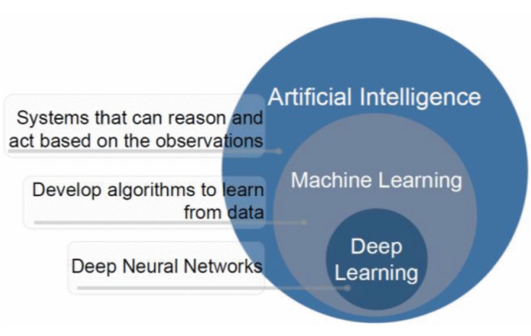
The ability of computer systems to do tasks like learning, reasoning, decision-making, and problem-solving that require human intelligence is known as AI. Systems analyze massive data using computational methods to produce predictions. AI is used more and more in the field of education to evaluate student data and assist with decision-making processes like identifying students who are at risk and enhancing learning outcomes[1].

Figure 1. AI [2]

2.1.2 ML
It is a branch of AI that focuses on creating algorithms that, without explicit programming, enable computers to recognize patterns in data and perform better. It can be used to predict or classify new data after being trained on historical data. Because it allows for examining massive amounts of data of students and finding their performance, ML is crucial to educational data mining and learning analytics. (Pattern Recognition and ML)[3].
2.1.3 Types of ML

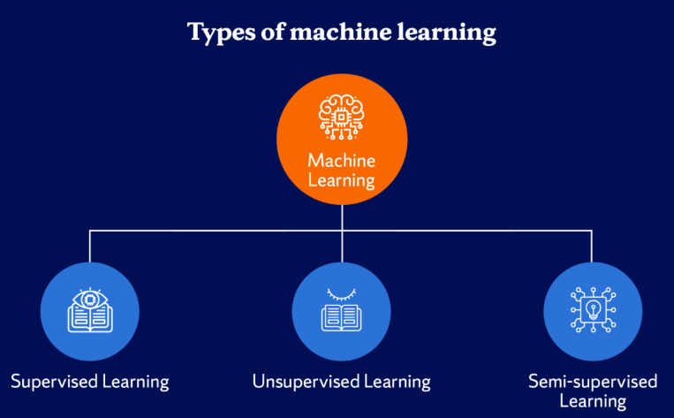
Figure 2. Types of ML [4]
1. Supervised Learning
The model is trained using labeled data in this ML method. There is an input and an output label for every training example. Learning a mapping between inputs and outputs is the aim of supervised learning, which enables the model to correctly predict the output for fresh, unseen data[4].
2. Unsupervised Learning
It uses unlabeled data to train models. In this kind of learning, the algorithm looks for unidentified patterns or structures in the data. In unsupervised learning, clustering and association rule learning are popular methods [3].
3. Semi-Supervised Learning
It includes both labeled and unlabeled data. This method works well when there is a lot of unlabeled data but little labeled data. By utilizing both kinds of data, it can enhance model performance[4].
2.1.4 Classification
Predicting a categorical label for a given input is the goal of this kind of supervised learning task. For instance, classification algorithms can be used in educational systems to assess a student's risk level based on behavioral and academic data[5].
2.1.5 ML Algorithms
1. DT
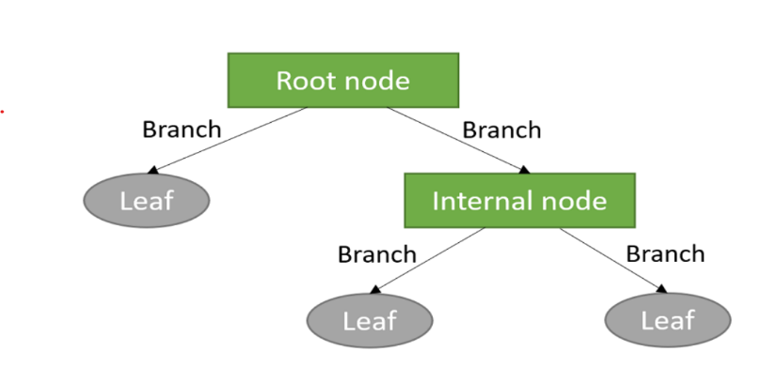
It is a supervised learning algorithm that uses a tree structure to represent decisions. A feature is represented by each internal node, a decision rule by each branch, and a class label by each leaf node. DT are frequently used in classification problems because they are simple to understand [6].

Figure 3. DT structure[7]

2. RF
Many DT are combined in the RF groups learning technique to increase prediction accuracy and decrease overfitting.it is subset of the dataset is used to train each tree in the forest, and the final prediction is produced by adding up all of the trees' predictions [6].
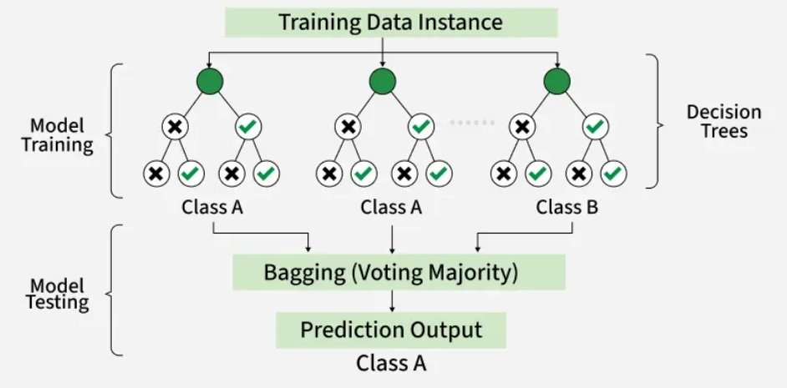
Figure 4. RF algorithm structure[9].

3. (KNN)
KNN uses the classes of a data point's closest neighbors in the feature space to predict the data point's class. It uses Euclidean distance, and other distance metrics are used by the algorithm to determine similarity [3].

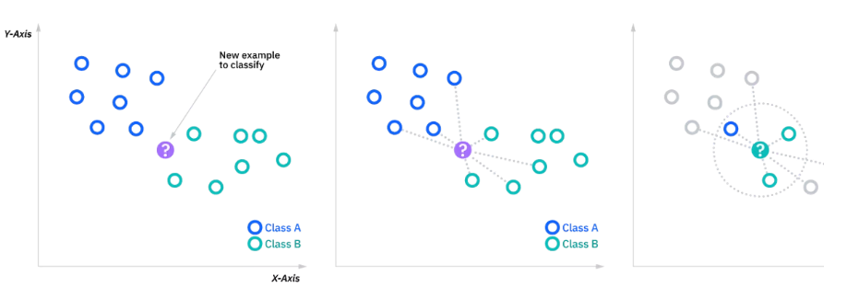
Figure 5. KNN classification [6]

4. SVM
It is a supervised learning algorithm for tasks involving regression and classification. To find the best hyperplane that divides data points from various classes, with the greatest margin, is how it operates [3].

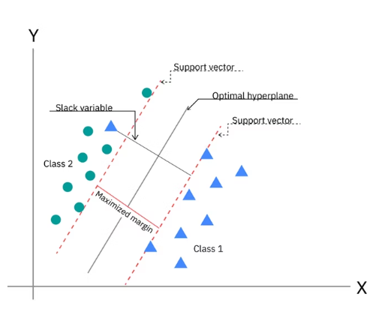
Figure 6.SVM [3].
5. NV
It is an algorithm of classification. It makes the assumption that features are conditionally independent, it makes computation easier, and enables the model to work great even with massive datasets[4].
2.1.6 Ensemble Learning
Ensemble learning is a type of machine learning approach wherein a combination of several base learners is employed in order to enhance the accuracy of predictions as opposed to employing only one learner model. Instead of depending on a single classifier, an ensemble approach involves using the output of several learners in order to achieve better accuracy and efficiency of the process [7, 9]. The principle behind the approach is that a set of different learners can compensate for each other’s weaknesses. The two main classes of ensemble learning approaches include Bagging and Boosting. Both techniques involve the use of several learner models but differ in their approach.

Boosting
Another type of ensemble algorithm that increases predictive ability through the sequential training of many weak learners is called boosting. In contrast to bagging, the observations misclassified in the preceding rounds are given more weight, and thus further learners can concentrate on the hard cases [9]. The prediction result is calculated as the sum of all weak learners, weighted:
$$F\left(x\right)=\sum_{m=1}^{M}{α_{m}}h_{m}\left(x\right)$$
in which: $h_{m}\left(x\right)refers to the prediction by them^{th}$weak classifier, $α_{m}$ is its corresponding weight, $M$is refers to the total number of boosting iterations.
As opposed to bagging, the boosting method tends to have better predictive accuracy due to the fact that each learner tries to fix the mistakes made by previous learners; however, these algorithms usually cost much more computing power and may be sensitive to noisy observations. The widely used boosting algorithms include AdaBoost and XGBoost , which were considered in this paper.
- AdaBoost
One of the oldest and highly successful boosting algorithms is called Adaptive Boosting (AdaBoost). Introduced by Freund & Schapire (1997), this method builds a composite strong classifier by combining weak classifiers iteratively and by modifying sample weights at each iteration.
H(x)=sign(m=1∑M​αm​hm​(x)
Which $H\left(x\right)$ refers to the final prediction, $h_{m}\left(x\right)$is the output of the $m^{th}$weak classifier, and $α_{m}$It shows the importance applied to that classifier.
- Extreme Gradient Boosting (XGBoost)
Extreme Gradient Boosting (XGBoost) is one of the modern implementations of the Gradient Boosting algorithm, which was invented to enhance efficiency and increase accuracy in predictions. The algorithm builds an ensemble of decision trees sequentially in such a way that the next tree minimizes the residual errors made by the preceding ones. Different from other boosting algorithms, XGBoost uses the regularized approach to avoid overfitting and preserve predictive performance [9].
The output of XGBoost is calculated as a sum of the outputs of all decision trees:
$${\hat{y}}_{i}=\sum_{k=1}^{K}{f_{k}}\left(x_{i}\right)$$
where
${\hat{y}}_{i}$ refers to the predicted output, $K$is refers to the total number of prediction trees used, $f_{k}\left(x_{i}\right)$ Refers to the output of the $k^{th}$decision tree.
The objective function of XGBoost is composed of two parts: the training loss and the regularization part.
2.1.7 Model Evaluation Metrics
We used it to check how well classification models work and make sure they make accurate predictions, which is especially important in serious situations like finding students who are at risk[5].
1. Accuracy
It is the percentage of correctly predicted cases among all of the model's predictions.
Accuracy = TP+TN / FP+FNTP+TN​
Where: TP = True Positives, TN = True Negatives, FP = False Positives, FN = False Negatives. It is simple and intuitive; however, not deal with imbalanced datasets[6].
2. Precision
It is the percentage of correctly predicted positive cases among all predicted positive cases.
Precision = TP/ FP + TP​ , where it is important when the cost of false positives is high[6].
3. Recall
It is sometimes referred to as sensitivity, which gauges how well the model can identify real positive examples.
Recall=TP/ FN+TP​
When there is a positive case (like a student who is at risk), recall is very important[6].
4. F1-Score
When working with imbalanced datasets, the F1-score—which is the harmonic mean of precision and recall—offers a fair assessment of model performance.
F1-Score=2×Precision×Recall​ / Precision + Recall
This is especially helpful when you have datasets that aren't balanced, and you need both precision and recall [6].
2.1.8 Feature Selection
Feature selection is a type of preprocessing technique that allows identifying the most significant features for model training and discarding redundant or irrelevant features. This can reduce the number of features, simplify the training process, lower the cost, and enhance the quality of the trained model by excluding noise from the input data [9].
2.1.9 Synthetic Minority Oversampling Technique (SMOTE)
Synthetic Minority Oversampling Technique (SMOTE) is the data balancing technique proposed as an improvement of the class imbalance problem. As opposed to replicating the samples that belong to the minority class, SMOTE creates synthetic samples based on interpolating between the neighbors from the minority class[10].
A synthetic sample is generated according to the following formula:
$x_{new}=x_{i}+λ\left(x_{nn}-x_{i}\right)$,
Where :$x_{i}$ refers to its nearest neighbor, $x_{nn}$ refers to its nearest neighbor, and $λ$is refers to a random number between 0 and 1.
2.1.10 Grid Search with Cross-Validation
Grid Search is a hyperparameter tuning technique that allows finding the optimal set of parameter values. Grid Search tests all possible combinations of parameters' values and chooses the best one, which gives the best result. For more reliable performance estimation, Grid Search is often employed together with k-fold cross-validation. In this case, the training dataset is split into k equal parts. Each time one part serves as a validation set, while the other parts form the training set. This procedure is performed until each part has served as the validation set[3]. The average cross-validation score is calculated as
$$CV_{score}=\frac{1}{k}\sum_{i=1}^{k}{S}core_{i}$$
where
- $k$is the fold number,
- $Score_{i}$is the evaluation score obtained from the $i^{th}$fold.

2.1.11 Impact of Artificial Intelligence in Education
The utilization of AI in the education sector makes it possible for teachers to recognize potential issues that students may have in their studies in a timely manner and, therefore, make necessary adjustments. Academic risks can be predicted through analysis of the information collected from the performance of students using various Machine Learning techniques. By employing predictive models powered by artificial intelligence, educational institutions can keep students[8, 9].

2.2 Related Work:

CR-NODE was proposed by Bettahi et al.[10], where continuous time was combined with completion-specific features to predict early dropout behavior. The dataset consists of longitudinal interactions recorded in the Canvas Learning Management System at a large public university spanning several terms. In the dataset, there are 100,878 students’ enrollments that have final grades, out of which we filtered 89,734 temporal interactions meeting the minimum observations requirement. To ensure temporal consistency and data quality, data preprocessing involved several steps. There were several steps in data preprocessing to make sure that the data was consistent over time and of good quality. They used six different baseline methods (Logistic Regression, RF, XGBoost, Gradient Boosting, LSTM, and Basic Neural ODE) to compare CR-NODE and set comprehensive performance benchmarks. The results showed that CR-NODE had the best balance between the rates of true positives and true negatives. XAI was used to understand model predictions.

Ujkani et al. [9]proposed a model based on CNN, LSTM, and XGBOOST. They used a dataset that was collected from the Open University Learning Analytics Dataset. It includes 32,593 students over a 9-month course period from 2014 to 2015. Different pre-processing steps were applied for predicting students’ success: Merge and Consolidate, Missing Value Handling, Feature Engineering, and Data Splitting. Different DL and ML models for forecasting students' success. To comprehend the prediction of models, the RF Classifier, Gradient Boosting Classifier, KNN, Multi-Layer Perceptron (Neural Network), First Custom Neural Network Architecture, Second Custom Neural Network Architecture, and XAI were employed. LSTMs were employed for training and assessment. Their findings show that, when compared to models for predicting students' success, their proposed models performed with the best accuracy, up to 94%. The models' predictions were analyzed using XAI, RF Classifier, and Gradient Boosting Classifier.

The proposed RADAR system by Embarak et al.[11] used statistical analysis and ML algorithms to identify patterns and trends in the data that indicate a student was at risk of falling behind or dropping out. A dataset of the students from a particular school district was taken to build the system; the information was gathered and processed properly through feature integration, data cleansing, and feature selection.This approach allows for the identification of the following elements of each particular individual student goals, strengths, weaknesses, identification of patterns that imply the student is in danger of dropping out of the educational institution, identification of the signs indicating the student is having difficulties, as well as providing necessary support. In this case, PAP can help in evaluating the ability of the student to continue studying in the future, as well as predicting the level of his/her success. With the help of such a comparison, Embarak et al. can emphasize the limitations of these methods. The machine learning system incorporating XAI can process multiple kinds of data and take into account other factors associated with the risks posed to students. Machine learning algorithms such as DT are applied to analyze the information and find patterns. Prediction of the students was done with the help of the specified criteria, thresholds, and patterns.
Subsequently, personalized interventions and evaluation became possible with the help of the findings of this stage.

Macfadyen [12]described how LMS data might be used to forecast the academic performance of students and determine which ones need extra help. The data sample for this research was obtained from the Blackboard Vista Learning Management System (LMS) at the University of British Columbia in Canada. The data sample contained logs of student activities such as participation in discussions, completion of assessments, sending emails, interactions, and frequency of logging into the LMS. These variables were then utilized to analyze student behavior on the internet and, thus, to forecast their performance. In the first place, the collected data were subject to further processing. Major predictors of student performance were established; they included participation in discussions, messaging, performance in tests/ quizzes, and frequency of logging into the LMS. Data cleaning was conducted, which entailed the elimination of observations that had missing values and structuring for predictive modeling (PM). The regression model (RM) technique was adopted for developing the predictive model (PM) for academic success using activity data from the LMS. LR was utilized to discover students at risk of poor performance and to predict their academic failure. Network analysis was also carried out to analyze patterns of interaction and determine which students are disengaged in discussion forums. According to the findings, activity data of students from the Learning Management System can be used to make accurate predictions regarding their performance. The regression model was able to explain more than 30% of the variance in the final grade. Additionally, the logistic regression model accurately predicted 81% of the failures.
Queiroga et al.[13] Presented a research paper that attempted to predict the at-risk students in high schools (secondary education level) by applying ML and learning analytics. The research presented the preprocessing techniques for the dataset, the modeling approaches, and the bias analysis conducted when constructing the predictive models. Additionally, the need for employing past student performance as predictors of future student performance was emphasized. The database for this study was sourced from the National Administration of Public Education (ANEP) of Uruguay. The database contained information on nine different education systems that covered the educational life journey of students from primary school to secondary school spanning 2015-2020. This included information on 258,440 students, encompassing their grades, attendance, demographics, and other features. Data preprocessing was also undertaken prior to modeling. Data preprocessing entailed the cleansing of data, integration of databases for multiple education systems, conversion of the database into a time series database, and derivation of additional attributes. Methodology: The methodological process undertaken was based on the CRISP-DM data mining methodology. Machine learning algorithms such as RF, DT, AdaBoost, LR, NB, and MLP were investigated. RF and MLP gave almost similar results; however, the latter model was preferred since it had a better performance and was more interpretable. From the analysis, it is clear that the ML models have done remarkably well through achieving a very high accuracy rate when predicting at-risk students. The AUROC and F1 scores produced a result above 0.90 and 0.88, respectively. Out of the eight models, seven were considered acceptable based on the bias score.
Bagunaid [14]introduced E-FedCloud, an AI-based e-learning system. The method was intended to predict student performance and identify potential difficulties that students may face. Recommendations were created and continually tracked in order to enhance the performance of the students. Engagement of the students was analyzed through federated learning, as well as Shannon entropy, which allowed secured data access. The application of deep reinforcement learning was achieved by using a method called ID2QN, which was used to predict the performance of students and categorize them according to their level of risk, such as students that might drop out of school, poor performers, and students that may fail the class. Also, ontology graphs, along with attention capsules, were used to create personal recommendations for each student. The
OULAD dataset comprising 32,593 students taking 22 courses was used as a training dataset. The dataset comprised demographic information, performance information, and learning behaviors data, including login behavior, assessment behavior, and interaction behavior. Preprocessing techniques were performed before using the modeling procedure.
These include data cleansing, feature selection, multiple sources' data integration, and preparing behavioral, academic and demographic variables. To improve data quality, additional preprocessing techniques such as contrast enhancement, denoising and image stabilization were carried out. In addition, various machine learning algorithms and deep learning algorithms were used. As a result, ID2QN Deep Reinforcement Learning algorithm was chosen for predicting academic performance. The majority voting multi-objective clustering algorithm was used to classify students based on the level of their involvement, and the Attention-based Capsule network was used for customization recommendation system. In terms of securing the collected data, federated learning and Cycle-GAN were applied. It is worth mentioning that the E-FedCloud framework exhibited a high prediction capability of identifying students who might experience difficulties. The accuracy of the model equaled almost 97%, and the F1-score equaled 95%.
Johora [15]developed an XML approach to predict the academic performance of undergraduate students in Bangladesh. In this research, a dataset consisting of 872 samples was created. It included demographic, academic, and behavioral data of the students. Preprocessing steps were followed, including handling of the missing data, elimination of the unimportant columns, and conversion of the categorical variables to numeric values using one-hot encoding. To overcome the class imbalance problem, SMOTE was used, and feature scaling was done. After that, several ML approaches were implemented. They included RF, GB, XGBoost, SVM, KNN, DT, and LR. As it can be seen, it was proved that stacking ensemble model is better in terms of its performance. In order to interpret the model and see what features play a key role in achieving success among students, SHAP and LIME methods were implemented in this research project. It should be noted that the highest accuracy reached 86.38% in terms of stacking ensemble model.
Christou et al. [16]have proposed a Machine Learning technique to forecast students’ future grades and study time based on past educational data. In this paper, the authors propose a feature selection and construction method called FSC4RBF which is implemented by Radial Basis Function Neural Networks using grammatical evolution. The data used in this study was collected from different departments of the University of Ioannina, Greece such as Physics, Philosophy, Primary Education, History, Mathematics, and Chemistry, which included students' educational data such as grades, course details, and study time. Preprocessing includes organizing and transforming student’s academic record data into suitable input features for machine learning models. Feature engineering helps in predicting accurate results. Comparison among different ML methods like DT, Bayesian Network, SVM, and various Neural Networks indicates that proposed (FSC4RBF) gives the best results. It obtained the lowest mean square error in most regression tasks and the highest accuracy in all classification tasks.
Realinho et al.[17] introduced a study in which a public higher education dataset containing 4424 student records with demographic, socioeconomic, macroeconomic, and academic features was developed to predict student dropout and academic success. The data were collected from multiple institutional sources, merged, cleaned, and preprocessed to support machine learning classification tasks. Several ML techniques were applied to analyse student performance and identify at-risk students. The study used a public dataset from the Polytechnic Institute of Portalegre, Portugal, containing 4424 student records with 35 attributes. The dataset included demographic, macroeconomic, socioeconomic, and academic performance data from enrollment until the end of the first and second semesters. Data collected from multiple sources, such as academic systems, national databases, The data were then combined into one single dataset. Data cleaning was done by eliminating duplicates, managing missing data, managing outliers, renaming the variable names, and selecting suitable features. The students were classified into groups according to their year of graduation.The analysis included the following ML models: RF, XGBoost, light gradient boosting machine (LightGBM), and CatBoost. Data integration and data preprocessing were performed, together with feature importance analysis conducted based on permutation feature importance. The project did not include the results about specific accuracy since the main goal was presentation and analysis of the dataset, but not the development of a single ML model. Nonetheless, the presented dataset allows predicting student drop-out and student achievement and can be used for benchmarking ML models and building learning analytics systems.
The employment of AI techniques to predict student academic performance within the BL environment of SEU was first done by Hamadneh [18]. The study sought to identify the major determinants of student academic achievement and develop a PD for student academic performance. Data for this study were extracted from the Blackboard LMS. The data contained the following predictors: type of study, participation in live lectures, exam results, and completion of assignments. Final exam marks were the target variable. Various data preprocessing techniques were employed. These techniques included descriptive statistics, correlation, multicollinearity test, and regression analysis, which used ordinary least squares, fixed-effects, and random-effects models. To determine the quality of the data and the key factors that determine students' academic success, the following procedures were followed. The researchers subsequently built a PD using the artificial neural network technique. The ANN in this case is a multilayer perceptron, whose input nodes are four, hidden nodes are ten, and the output node is one, which represents the final grade. The results indicated that the proposed hybrid neural network model achieved strong predictive performance with low prediction error.
The project of Skittou et al [19]developed an early warning system that took into account a number of socio-cultural, structural, and educational factors that have a direct impact on a student’s decision to drop out of school. They worked on an original database by aggregating data from several operational systems. The number of pupils in the study population is 125354, including 59384 girls. A considerable number of properties are deemed highly important for defining a student who is likely to drop out or not. dedicated to this issue, which reflected their approach of seeking exhaustiveness and precision in the choice of dropout indicators. The model they built performed very well, particularly with the KNN, with an accuracy rate of over 99.5% for the training set and over 99.3% for the test set. The database used is built specifically for this project's preprocessing; they used mainly ML analysis methods specialized in classification. Hence, the use of the best-known and most efficient methods for this aspect of analysis: SVM, RF, SGD, and KNN. The results are visualized using a Django application they developed for this purpose, and we show how this can be useful for educational planning.
David Bañeres et al. [8] created a new system with multiple contributions. The Gradual At-Risk (GAR) model was the first contribution, a predictive model. Such a model predicted students' chances of failing a course based solely on their grades. Using the dataset in a data mart, a thorough analysis of the model was carried out on the entire collection of university courses. They can see that, starting with the fall semester of 2016, the number of training registries rises every semester (20161). For every course and semester, they suggested a way to find the optimal classifier and training set. KNN, DT, NB, SVM, LR, Hierarchical Mixed models, and Neural Network models. The second is a technique to establish a cutoff point for classifying a course's trained GAR model as high- or low-quality. In an actual classroom, the GAR model gave students feedback according to their risk level. As a result, a teacher cannot afford to give a student incorrect advice or a message. The EWS uses GAR to modify the kind of message that is sent to the student. The third contribution involved using the EWS in two courses in an actual classroom. In terms of dashboards and feedback, the GAR model was utilized to give teachers and students useful information. They examine how well at-risk students are identified in such a real-world learning environment and how this affects the courses' final performance. Two undergraduate courses were used to test the system, and the results demonstrated a high level of accuracy in identifying students who were at risk.
Albreiki, Balqis, et al. [[8] stress the use of a customized rule-based system with the Risk Flag to identify and visualize at-risk students early in the course delivery. The dataset was gathered from an undergraduate programming course at the United Arab Emirates University's College of Information Technology. The information shows how well students performed in the introductory programming course during the academic years 2016–2017 (fall and spring), 2017–2018 (fall and spring), and 2018–2019 (fall and spring). The data was pre-processed to make it readable for the ML methods. To resolve any discrepancies, all files are first combined into a single structure. A Python script was used to combine the files into a single CSV file, and min-max normalization was used to normalize the marks. The averaged value of the same coursework components was used to replace the missing values, which were handled using imputation techniques. Time-wise, the results are still inefficient, and there are a lot of false predictions. They suggest a tailored rule-based model that provides at-risk students with prompt identification. It reacts in real time to the student's performance in the assessment component. It also helps the teacher identify the at-risk students and provide prompt intervention by visualizing them.
With various ML algorithms, Khan, Ijaz, et al. [20] created a set of prediction models. Because DT outperforms other models, they were further developed into a format that is simple to understand. The student academic records for a course taught at Buraimi University College, Sultanate of Oman, are used in the dataset. The college's registration department provides the data, and all ethical standards are strictly adhered to. Three semesters are covered by the training dataset. The training dataset contains 151 instances with one prediction class and ten prediction features. Students are categorized as "Low" or "High" based on the prediction. Data cleaning: The noise is either eliminated or minimized using a variety of methods. The training dataset contains 151 instances after the noisy instances are eliminated. WEKA, an open-source program with a variety of algorithms for data pre-processing, classification, clustering, regression, and association rules, was created at the University of Waikato in New Zealand. Four popular machine learning algorithms were chosen. They selected KNN, which is implemented as IBk in WEKA, from lazy algorithms. In WEKA, RepTree is a DT implementation. In a similar vein, they selected NV as the fourth algorithm and Multilayer Perceptron, a class of Artificial Neural Networks. They divided the training dataset into ten intervals of the same length using tenfold cross-validation. The tenth interval in each cycle is used to evaluate the algorithm's performance, while the first nine are used for learning. It was an iterative process; in each iteration, a new interval was chosen for testing. Both the teacher and the students seemed to find the prediction model beneficial. The prediction model appeared constructive and helpful for both the instructor and the students. By the sixth week of the semester, the students who were most likely to produce subpar results had been identified and warned. The model was praised by students who were on the verge of having a low CGPA, and an early warning inspired them to work hard and overcome their situation. Similarly, the students who achieved satisfactory results also followed the attendance advice, and by the end of the semester, very few students showed up for class. The improvement of the struggling students served as a gauge for the overall effects. Four out of five students were able to produce an end result that was acceptable. From the beginning of the course, students' performance is closely monitored as part of the supportive measures. Additionally, a series of preventive measures is implemented to provide extra support to students who are having difficulty.
Akçapınar et al.[21] studied 76 students enrolled in the Computer Hardware course in the Department of Computer Education and Instructional Technology at a state university in Turkey. The students' ages ranged from 21 to 23 years, with 41 women and 35 men. Data collected about the students' learning processes at the end of the term included 3803 sessions, 119,921 page visits, 4566 written texts, 62 discussion forum questions, 297 responses, 8601 evaluations, and 3937 tags used to label written messages. Both final term academic achievement scores and interaction among students data from the virtual classroom were taken into account in the analysis. They used two different preprocessing methods. These included techniques for data transformation and feature selection. The CN2 (86%) and kNN (86%) algorithms achieved the highest classification accuracy, and the Gini index was used to select the best features. According to the results of the study, at the end of the term, the kNN algorithm had an 89% accuracy rate in predicting students who would not succeed.

Table 1 Of The Reviewed Papers
Paper | Year | Models | Limitation | Dataset | Type | The best model | Result
Bettahi et al.[10] | 2025 | CR-NODE  LR, RF, XGBoost, Gradient Boosting, LSTM, and Basic Neural ODE | It focuses exclusively on predictive accuracy without evaluating whether deployment actually improves student outcomes. | large public university Dataset. | Private -Need request-. | CR-NODE | CR-NODE achieves the best balance
Ujkani et al[9] | 2024 | RF Classifier, Gradient Boosting Classifier, KNN, Multi-Layer Perceptron (Neural Network), First Custom Neural Network Architecture, Second Custom Neural Network Architecture, XAI, and LSTM. | The dataset used in this study is from a pre-pandemic period; it is important to acknowledge the broader context of how the COVID-19 pandemic may have altered students’ habits, motivations, and learning behaviors. | Open University Learning Analytics Dataset | Public https://analyse.kmi.open.ac.uk/open_dataset | Custom Neural Network Architecture | The proposed models performed with the best accuracy of up to 94% compared to models for predicting students’ success
Embarak & Hawarna [11] | 2024 | Data analysis, ML, feature selection, XAI, RADAR | The study relied on a specific dataset from a specific computing major, which may limit the generalizability of the findings to other situations. | Students from a school district Dataset. | Private | RADAR system | The RADAR system can help at-risk students receive better support and direction
Macfadyen & Dawson[12] | 2010 | Correlation analysis, Regression model, LR, Network analysis | Applied to one course only, a small dataset, not a full AI model, limited generalization | LMS dataset from Blackboard (student activity, messages, logins, assessments) | Private | LR model | Predicted at-risk students with 81% accuracy and explained 30% of the variation in final grades
Queiroga et al [13] | 2022 | RF, DT, AdaBoost, MLP, NB, LR | Needs annual data preprocessing and retraining; results based on Uruguay data only; one model showed bias and weak performance. | Nationwide K-12 dataset (Uruguay), 258,440 students; demographic data, grades, absences, social welfare, school data (2015–2020) | Private | RF | Achieved high performance (AUROC > 0.90, F1 > 0.88) and successfully predicted at-risk and dropout students early
Bagunaid et al[14] | 2024 | ID2QN (Deep Reinforcement Learning), MV-MOC Clustering, Att-CapsNet (DL), Federated Learning (CGAN), TSE (Entropy), LWEA + Blockchain | High computational complexity; requires multi-modal biometric data; privacy concerns; tested mainly on the OULAD dataset | OULAD dataset (32,593 students, 22 courses); demographic, academic, and behavioural LMS data | Public No Access | ID2QN (Improved Duelling Deep Q Network) | Achieved ~97% accuracy and ~95% F1-score; outperformed PCT, MST-FaDe, Fuzzy SVM, and AISAR; effectively predicted at-risk students early
Johora, Fatema Tuz, et [15] | 2025 | RF, Gradient Boosting, XGBoost, SVC, KNN, DT, LR, Stacking Ensemble, SHAP, LIME | Small dataset (872 students) from Bangladesh only; limited generalizability; based on survey data | 872 undergraduate students from multiple universities; demographic, academic, and behavioural features (31 features) | Private | Stacking Ensemble (RF + GB + SVC) | Achieved 86.38% accuracy; SHAP and LIME identified key factors such as attendance affecting student performance
Christou, Vasileios, et[16] | 2023 | RBF Neural Network, SVM, DT, Bayesian Network, Neural Networks | Data from one university only; limited generalization | Student academic records from several departments, University of Ioannina | Private | Feature selection and construction method for RBF network | Achieved the highest accuracy and the lowest error compared with other models in predicting grades and dropout
Realinho, Valentim, et al.[17] | 2022 | Random Forest, XGBoost, LightGBM, CatBoost | An imbalanced dataset, limited to one institution, and mainly focused on dataset description rather than proposing a strong predictive model. | Student Dropout and Academic Success Dataset – Polytechnic Institute of Portalegre | Public No Access | Not specified | Identified the most important factors for dropout prediction, such as grades, approved courses, tuition status, and course type
Hamadneh, Nawaf N., et al. [18] | 2022 | ANN, Multilayer Perceptron Neural Network, Multilayer Perceptron Neural Network with Firefly Algorithm | Limited to one university, a small dataset, and a few features | Dataset from the Blackboard Learning Management System at the Saudi Electronic University | Private | Neural Network trained by Firefly Algorithm | Achieved strong prediction performance with a root mean square error of 0.39 and identified midterm exams, assignments, attendance, and study mode as key factors
Skittou, et al [19] | 2023 | SVM, Random Forest, SGD, and KNN. | Lack interfaces for administration and data manipulation in dynamic and interactive ways, because aggregating data from several operational systems | The database used is built specifically for this project by aggregating data from several operational systems | Private- Need to request access from the author | (KNN) algorithm | Visualized using a Django application we developed for this purpose, and we show how this can be useful for educational planning.
Bañeres, David, et al.[8] | 2020 | DT, NB, SVM, LR, Hierarchical Mixed models, KNN, Neural Network models | When the assessment process is changed regarding the number of assessment activities or the contents of the activities, the model is invalid for the course. | This model has been tested using data available in an institutional data mart, where curated data from six semesters are available. | Private | Gradual At-Risk (GAR) model | The model showed a high accuracy in correctly detecting at-risk students.
Albreiki, Balqis, et al. [22] | 2021 | Statistical and ML techniques | The results still lack efficiency in terms of time and have high false predictions. In this study, we propose a customized rule-based model that offers timely identification for at-risk students. | The data was collected from a programming course taught for undergraduate students at the College of Information Technology (CIT), United Arab Emirates University (UAEU). | Private -Need request-. | Customized rule-based system (RBS) | It visualizes the at-risk students to support the educator in recognizing these students and offering timely intervention.
Khan, Ijaz, et al.[20] | 2021 | ML algorithms  KNN  RepTree  DT  (MLP)  (ANN) | The training dataset of a course may comprise a low number of total instances due to limitations on classroom size. | The student's academic records for a course taught at Buraimi University College (BUC), | Private -Need request-. | Developed a set of prediction models | The prediction model appeared constructive and helpful for both the instructor and the students.
Akçapınar, et al.[21] | 2019 | Prediction model  Classification model | Transferability and generalizability of prediction models into the different courses are still limited. | The study was conducted at a state university in Turkey with 76 students in online learning activities for a period of 14 weeks | Private -Need request- | (KNN) | The kNN algorithm accurately predicted unsuccessful students at the end of the term with a rate of 89%.

Chapter 3

Methodology and Proposed Approach

Introduction
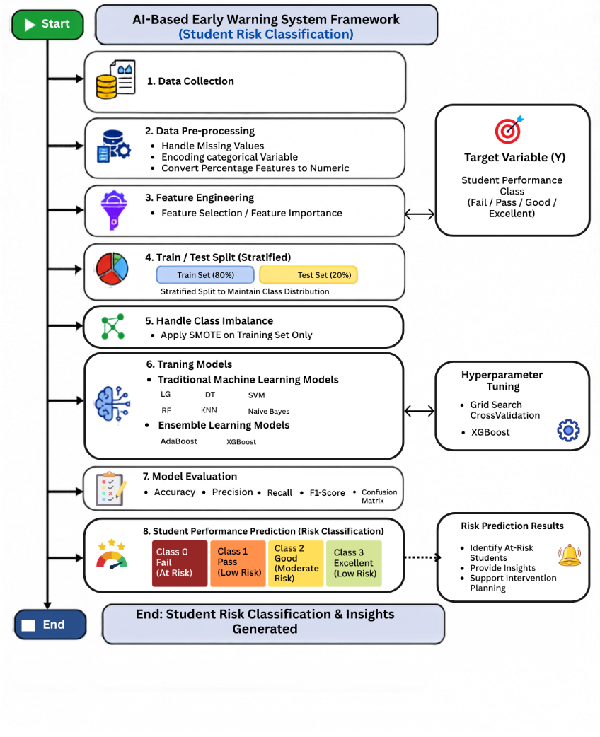
This section presents the methodology adopted to design, implement, and evaluate the proposed AI-Based Early Warning System for Academic Risk Detection in the Education sector. Figure 3.1 describes the basic framework and identifies students who are at risk of poor academic achievement using educational data collected from (LMS).
Figure 7Proposed AI-Based Early Warning System Framework (Student Risk Classification)

Figure 7 shows the proposed framework that follows different steps: Data Collection, Data Preprocessing, Stratified Train-Test Split, Feature Selection, Class Balancing using (SMOTE), Machine Learning Model Training, Hyperparameter Tuning using Grid Search, Model Evaluation, and Student Performance Prediction (Risk Classification). Data Collection

3.1 Dataset Description
We used a private educational dataset. It consists of 1,395 student records represented by 17 educational attributes describing students' academic performance, participation, assessments, virtual classroom activities, homework completion, discussion participation, attendance, and other engagement indicators. The target variable represents students' academic performance and classifies each student into one of the following four categories: Excellent, Good, Pass and Fail. These categories represent different levels of academic achievement and form the basis of the proposed early warning system for identifying students who require academic intervention.

3.2 Data Preprocessing
The data preprocessing is an important step in this process. It ensures the preparation of data for further analysis and improves its quality prior to modeling. The preprocessing includes the following steps:
- Handling missing values to ensure data quality.
- Converting percentage features into numerical values using the Pandas library in Python.
- Encoding categorical variables into numerical representations to ensure the compatibility with ML algorithms.
- Splitting dataset into 80% training and 20% testing subsets using the Stratified Train-Test Split technique.
- Applying (SMOTE) only to the training dataset to address class imbalance.
- Preparing the final dataset for feature selection and subsequent machine learning model development.

3.3 Data Splitting
The dataset was divided into 80% training data and 20% testing data using the Stratified Train-Test Split technique. Stratified sampling was adopted to preserve the original distribution of the four academic performance categories in both subsets, ensuring a fair evaluation of the developed models.

3.4 Feature Selection
Feature selection was done to determine which educational features made significant contributions in predicting the students' academic performance. Elimination of the less important variables makes the prediction process easier and less complicated. The steps involved in the feature selection include:
- Feature Importance Analysis: An RF classifier was used to generate the importance of each educational feature based on its ability to contribute to prediction accuracy. Feature Importance was determined by finding the average decrease in impurity of all the decision trees generated through the Random Forest algorithm.
- Feature Selection: From the determined feature importance, all the features were sorted in order of importance. Those features with insignificant importance, which included Teachers' Messages and Student Login Percentage, were discarded, while the others were retained for further machine learning analysis.

3.5 Experimental Configurations
In order to examine the effect of feature selection and class balancing on the performance of the prediction model, four experimental setups were created and tested separately. The four experimental setups allowed a thorough comparison of the impact of both preprocessing steps individually and together.
The following table describes the four experimental setups in brief:
- Experiment 1: Full Feature Set but no SMOTE.
- Experiment 2: Selected Feature Set but no SMOTE.
- Experiment 3: Full Feature Set with SMOTE.
- Experiment 4: Selected Feature Set with SMOTE.
Each experiment was conducted under similar conditions using the same machine learning models and the same evaluation criteria for comparison. After selecting the best models from each experiment, they were further optimized using Grid Search.

3.6 Machine Learning Models
To determine the most suitable predictive model for the proposed AI-Based Early Warning System, several supervised machine learning algorithms were implemented and evaluated under identical experimental conditions. The evaluated algorithms represent different learning strategies commonly used in educational data mining and classification problems. The evaluated models were divided into two categories.
3.6.1 Traditional Machine Learning Models
Six traditional classification algorithms were investigated in this study: DT, RF, LR, SVM, KNN, NB. These models represent different statistical, probabilistic, distance-based, and tree-based learning approaches, providing a comprehensive comparison of classical machine learning techniques for predicting students' academic performance.
3.6.2 Ensemble Learning Models
In addition to the traditional classifiers, two ensemble learning algorithms were evaluated:AB, XGB. These ensemble learning algorithms combine multiple learners to improve prediction accuracy, enhance model robustness, and reduce overfitting. Due to their strong predictive capabilities, they were included in the comparative analysis to evaluate their effectiveness in predicting students' academic performance.

3.7 Model Optimization
After evaluating the baseline machine learning models, hyperparameter optimization was performed to improve prediction performance. In this study, Grid Search with cross-validation was employed to identify the optimal hyperparameter values for the best-performing models from each experimental configuration. Specifically, Decision Tree (DT), Random Forest (RF), and XGBoost (XGB) were optimized whenever they achieved the highest performance. The optimized models were then retrained using the selected hyperparameters and evaluated on the testing dataset using the same evaluation metrics adopted throughout this study, including Accuracy, Precision, Recall, F1-score, and Confusion Matrix. The detailed optimization results are presented in the following chapter.

3.8 Summary
The methodology utilized in developing the AI-based Early Warning System for predicting the performance of students is discussed in this section. The education dataset, preprocessing techniques, feature selection methods, experimental setups, machine learning algorithms, and hyperparameters tuning were outlined in the section. Four experimental setups were created in order to investigate the impact of feature selection and SMOTE on the accuracy of predictions. Grid Search with cross-validation was used to optimize the best-performing models. In the following chapter, the experimental results and the performance of the investigated models are provided.

Chapter 4 Results.

4.1 Experimental Setup
Experiments were carried out via Google Colab using Python 3 as an implementation environment. The performance of the suggested framework was estimated on a private dataset that consists of 1,395 student instances and includes 17 academic and behavioral features, such as participation, assessments, attendance, and engagement measures. For data preprocessing, Pandas and NumPy libraries were used, while the ML models were built using Scikit-learn framework and the XGB library. To conduct a fair experiment, we split the dataset into 80% train and 20% test using stratified sampling. A feature selection technique was utilized in two experimental settings to examine the influence of shrinking the number of input features. Because of the imbalanced nature of our dataset, the SMOTE algorithm was applied exclusively to the train set during the corresponding experiments.

4.2 Class Distribution
The understanding of the distribution of the classes under study is a necessary condition prior to the use of the model since class imbalance can affect the learning process and the biases of classifiers towards the majority classes. From the information provided in Table 2, it is clear that the distribution of data in four academic performance classes was not even. In particular, the percentage of the Good class constituted 51.97% while the Pass class constituted only 7.67%. The rest of the data was related to Excellent and Fail classes (23.08% and 17.28%, correspondingly).
Table 2. Distribution of Student Performance Classes
Class | Number of Students | Percentage
Good | 725 | 51.97
Excellent | 322 | 23.08
Fail | 241 | 17.28
Pass | 107 | 7.67

As illustrated in Figure 8 below, it is clear that the problem of imbalance was solved using SMOTE. The Good class had more observations compared to other classes prior to oversampling. In the SMOTE-oversampled training dataset, there were equal numbers of observations in each class, meaning that the dataset was balanced. The balance dataset was then utilized for the SMOTE-based experiments.
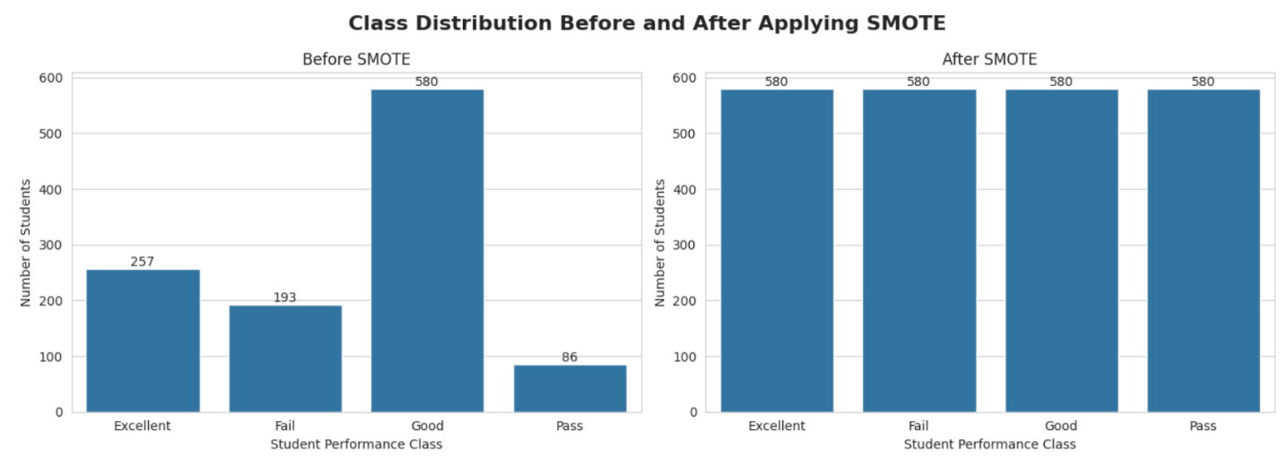
Figure 8 . Distribution of Student Performance Classes with SMOTE.

4.3 Feature Importance Analysis
The analysis of feature importance was done in order to understand which factors are more important in the prediction of student academic performance. An RF classifier was used for the estimation of the relative importance of each input variable. From the feature importance results shown in Figure 9, it is evident that the variables that have the highest importance in the prediction of student academic performance include Homework, Absence, and Interactive Contents. Other participation variables, such as Average Participation Percentage, Contents Participation Percentage, and Homework Participation Percentage, are also relatively highly important, showing the great role played by participation and continuous assessment activities of students in accurate prediction. However, Teacher Messages and Student Login Percentage have extremely low importance, implying that these variables contribute little in the prediction process.
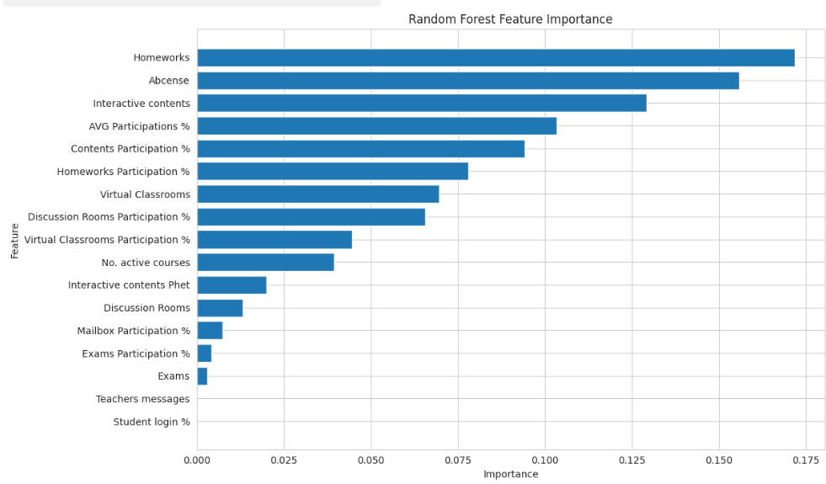
Figure 9 Random Forest Feature Importance Ranking.

4.4 Results without Applying SMOTE
5.4.1 Results of Applying ML Models with Full Features
The first experiment aimed at investigating the predictive capability of the proposed ML models based on the complete feature set without employing the SMOTE technique. In other words, the first experiment determined the baseline performance of the proposed models according to the original distribution of classes. The evaluation was conducted using the metrics of Accuracy, Precision, Recall, and F1-score, while the confusion matrix was applied for the detailed analysis of classification results. The evaluation results presented in Table 3 reveal significant discrepancies between the prediction capabilities of the investigated ML models. XGB turned out to be the most efficient classifier with an accuracy rate equal to 82.80%, followed by RF (79.57%) and DT (79.21%). The results prove that the application of the ensemble learning method provided better prediction capability than most traditional ML algorithms trained on the original data set. Among the traditional ML models, RF provided the best classification performance while DT managed to achieve similar results but with a slight discrepancy in terms of accuracy. LR, SVM, and KNN showed medium prediction capability. NB proved to be the least efficient classifier because of the unsuitability of its probabilistic assumptions to the peculiarities of the dataset under investigation.

Table 3. First experiment: Results of Applying Machine Learning Models with Full Features
Approach | Model | Accuracy | Precision | Recall | F1-Score
Traditional ML | RF | 79.57 | 79.64 | 79.57 | 78.77
Traditional ML | DT | 79.21 | 79.42 | 79.21 | 79.21
Traditional ML | LR | 70.97 | 70.99 | 70.97 | 69.36
Traditional ML | SVM | 68.46 | 71.63 | 68.46 | 65.12
Traditional ML | KNN | 63.08 | 62.77 | 63.08 | 62.89
Traditional ML | NB | 20.43 | 53.03 | 20.43 | 21.41
EL | XGB | 82.80 | 82.63 | 82.80 | 82.42
EL | AdaBoost | 74.19 | 73.91 | 74.19 | 72.70

Figure 10: Confusion matrices give us an additional understanding of the classification abilities of the examined models. The XGB, RF, and DT generated more observations that were correctly classified by the model on the main diagonal, which implies better classification ability in relation to all four categories. On the other hand, the LR, SVM, and KNN generated more confusion between neighboring categories, such as Good and Excellent, resulting in a greater number of misclassified observations. NB generated the worst results in terms of classification ability, with a lot of confusion between categories. In order to understand if the performance of the best models can be further improved, we conducted a grid search with cross-validation for RF and XGB.
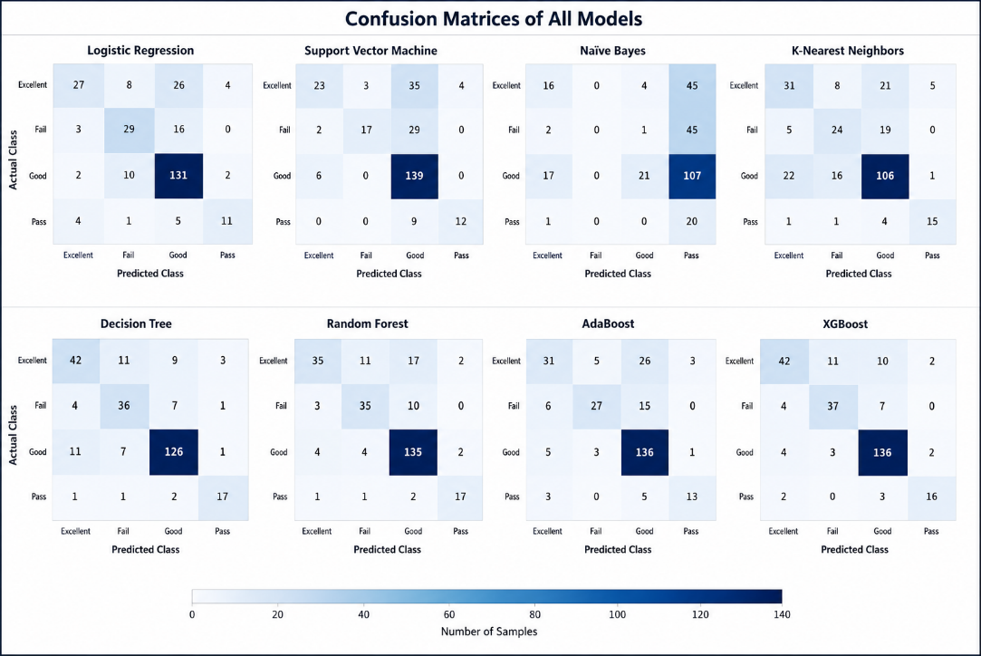
Figure 10 First experiment: Confusion Matrices of All Models

Optimization outcomes have proved that both models behaved differently during hyperparameter tuning. While RF showed some improvement through optimization in all performance measures, the performance of XGB only saw a slight drop but remained the most accurate classifier among all the tested classifiers. This implies that the default setting of hyperparameters for XGB was suitable for the data under analysis, and there was little chance for any improvement, as shown in Table 4 and Figure 11 .
Table 4.First experiment: Performance with and without Grid Search Optimization
Grid Search | Model | Accuracy | Precision | Recall | F1-Score
Without | XGB | 82.80 | 82.63 | 82.80 | 82.42
Without | RF | 79.57 | 79.64 | 79.57 | 78.77
With | XGB | 81.72 | 81.66 | 81.72 | 81.10
With | RF | 80.29 | 80.21 | 80.29 | 79.35

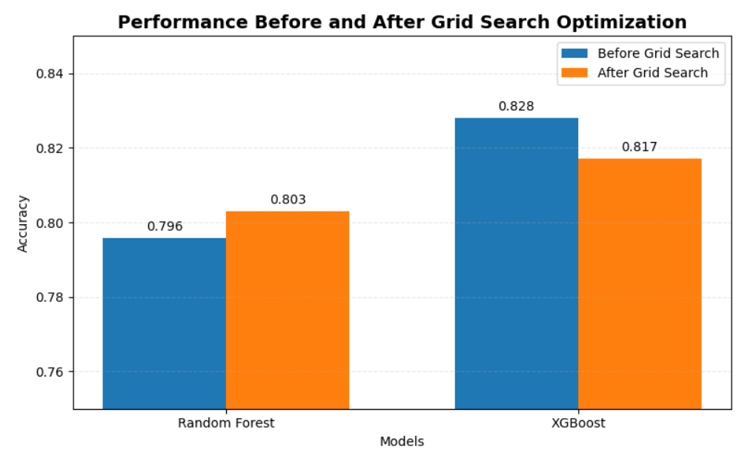
Figure 11 First experiment: Performance with and without Grid Search Optimization.

5.4.2 Results of Applying ML Models with Selected Features without SMOTE

In the second experiment, we have examined the influence of feature selection on the predictive performance of the models under examination. In this experiment, less relevant features were dropped before the model training, and the class distribution stayed the same. The aim of this experiment was to check whether the reduction in the number of features would help make the learning process easier but still not affect its predictive performance.

From the performance results provided in Table 5, it follows that feature selection affected the overall classification performance of the examined models insignificantly. The XGB was the best performing classifier, which demonstrated the best accuracy (82.80%). After it followed RF (79.57%) and DT (78.14%). From this, it can be concluded that the feature set that has been used in the research included all of the most informative features needed for making accurate predictions while reducing the dimensionality of the data. As for the traditional ML models, RF was superior to the rest of the classifiers, while DT showed comparable performance. LR, SVM, and KNN demonstrated good classification accuracy; however, NB showed the worst evaluation scores. Compared to the entire feature set, no significant changes were observed.

Table 5 Second experiment: Results of Applying ML Models with Selected Features
Approach | Model | Accuracy | Precision | Recall | F1-Score
Traditional ML | (RF) | 79.57 | 79.69 | 79.57 | 78.77
Traditional ML | (DT) | 78.14 | 78.27 | 78.14 | 78.14
Traditional ML | (LR) | 70.97 | 70.99 | 70.97 | 69.36
Traditional ML | (SVM) | 68.46 | 71.63 | 68.46 | 65.12
Traditional ML | (KNN) | 63.08 | 62.77 | 63.08 | 62.89
Traditional ML | (NB) | 16.49 | 43.97 | 16.49 | 16.07
EL | (XGB) | 82.80 | 82.63 | 82.80 | 82.42
EL | AdaBoost | 74.19 | 73.91 | 74.19 | 72.70

Figure 12 displays eight confusion matrices of classification performance of ML models for the four student performance categories (Excellent, Good, Pass, and Fail). In the figure, color intensity in each confusion matrix reflects the frequency of the observations in each class, where the more intense color corresponds to a higher frequency. Out of all considered models, XGB demonstrated the best classification performance, where most of the observations were correctly classified in the main diagonal of the matrix. RF and DT are also good performers among classifiers, generating a large number of correct classifications with fewer errors. At the same time, LR, SVM, and KNN demonstrated higher confusion in relation to Excellent and Good classes, resulting in larger amounts of incorrectly classified observations. In its turn, NB is the weakest performer among all, having confused a significant number of observations by classifying them as the Pass class.
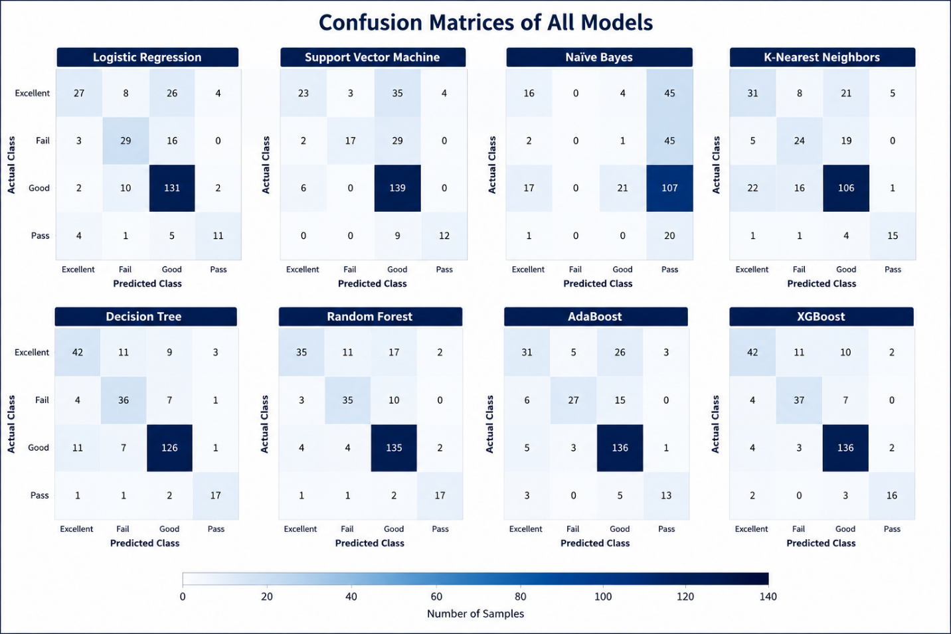
Figure 12 Second experiment: Confusion Matrices of All Models.
The outcome of optimization is summarized in Table 6, which clearly indicates the different responses of RF and XGB models to hyperparameter tuning. After optimization, RF was able to achieve an increase in accuracy, precision, recall, and F1-score. However, XGB showed very little change in performance but remained the best-performing model. This indicates that the initial setting of the hyperparameters for XGB was close to optimal values for the chosen features, as illustrated in Figure 13.
Table 6. Second Experiment: Performance With and Without Grid Search Optimization.
Grid Search | Category | Model | Accuracy | Precision | Recall | F1-Score
Without | Traditional ML | RF | 79.57 | 79.69 | 79.57 | 78.77
Without | Ensemble Learning | XGB | 82.80 | 82.63 | 82.80 | 82.42
With | Traditional ML | RF | 80.29 | 80.62 | 80.29 | 79.18
With | Ensemble Learning | XGB | 81.72 | 81.66 | 81.72 | 81.10

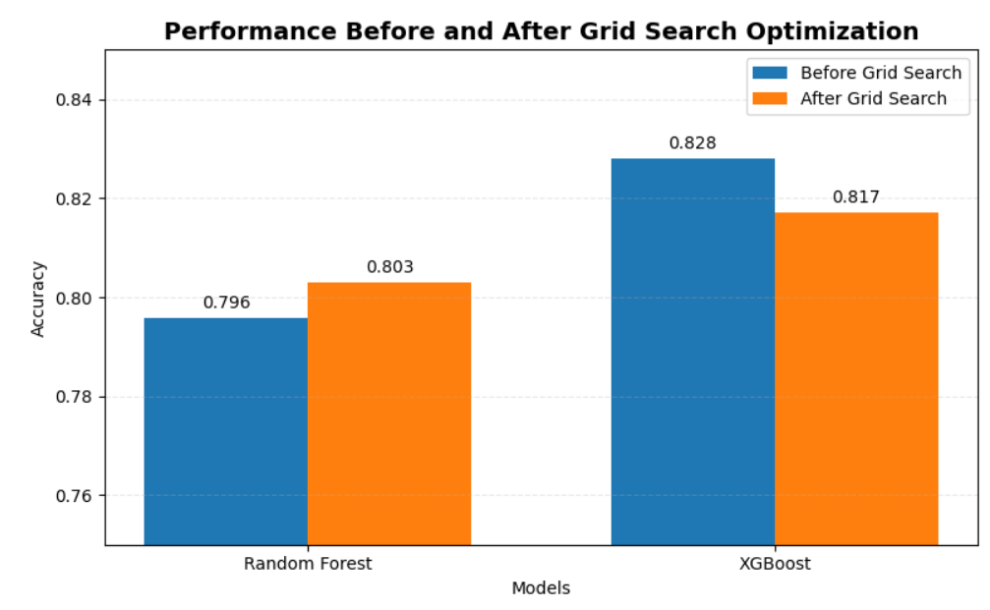
Figure 13 Second Experiment: Performance With and Without Grid Search Optimization.

4.5 Results with Applying SMOTE.
In the second step of the experiments, the impact of balancing the dataset through the use of SMOTE was examined. The initial dataset had an imbalance in its classes; thus, SMOTE was used on the training data to create new instances of the minority classes while still retaining the testing data. The objective was to determine whether balance in the classes would enhance the classification capability of ML and EL algorithms.
4.4.1 Results of Applying ML Models with Full Features with Applying SMOTE
For the third experiment, the full set of features was preserved, and the application of SMOTE to the training data set occurred before the models were developed. In this setup, the aim was to observe how the effect of balancing the classes affects the performance of the models without eliminating any of the input features. As can be seen from the evaluation results in Table 7 below, class balancing affected the performance of the models being tested differently. XGB maintained the highest overall classification accuracy (82.08%). In the conventional ML algorithms, DT performed marginally better than RF, registering an accuracy of 79.57% versus RF, which scored 79.21%. The other classifiers that performed relatively well were AB, LR, SVM, and KNN, while NB was again the poorest performing classifier. In comparison to the second experiment, where the same experiment was run without applying SMOTE to the training data set, the rankings of the models remained generally the same. However, with the training dataset, the models provided more balanced predictions for the four academic performance classes.

Table 7. Third experiment: Results of Applying Machine Learning Models with Full Features after Applying SMOTE.
Approach | Model | Accuracy | Precision | Recall | F1-Score
Traditional ML | DT | 79.57 | 79.82 | 79.57 | 79.51
Traditional ML | RF | 79.21 | 79.28 | 79.21 | 78.25
Traditional ML | LR | 66.67 | 70.98 | 66.67 | 66.74
Traditional ML | SVM | 60.93 | 66.83 | 60.93 | 61.01
Traditional ML | KNN | 60.93 | 65.40 | 60.93 | 61.90
Traditional ML | NB | 20.07 | 60.14 | 20.07 | 22.25
EL | XGB | 82.08 | 82.24 | 82.08 | 81.89
EL | AdaBoost | 71.33 | 73.89 | 71.33 | 70.92

The confusion matrices shown in Figure 14 further support the influence of class balancing. XGB had the largest number of accurately classified samples along the main diagonal, meaning that accurate predictions were made for all four performance categories. The classifiers DT and RF also performed well since there were only a small number of samples that were misclassified. Conversely, LR, SVM, and KNN had a higher confusion rate for classes that were adjacent, especially Good and Excellent, while NB had the highest number of misclassifications. Compared to the confusion matrices generated without the use of SMOTE, the use of class balancing led to an almost equal distribution of accurately classified samples for the minority classes. To determine if any further improvements can be made, Grid Search was performed on DT and XGB, which were determined to be the top-performing traditional and EL algorithms, respectively.
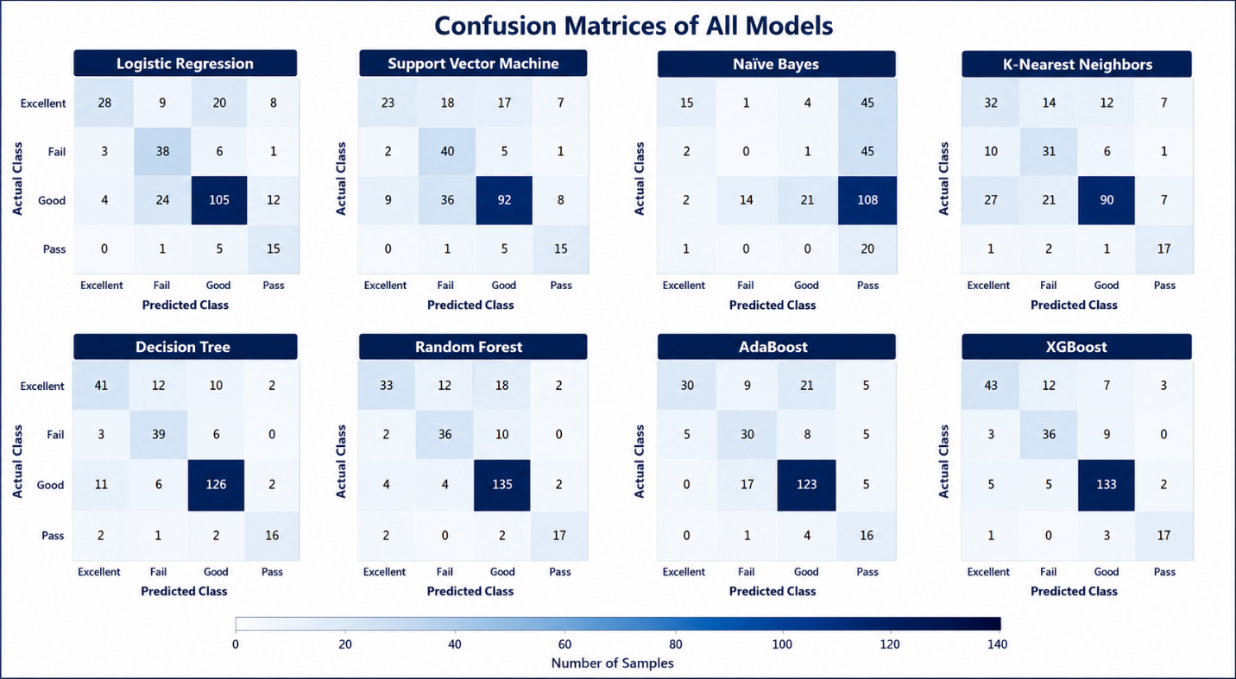
Figure 14. Third experiment: Confusion Matrices of Traditional ML Models with Full Features after Applying SMOTE.
From the results of the optimization, it is clear that there was a different response by the models to the hyperparameters in Table 8. After performing Grid Search, there was a little decrease in classification accuracy for DT as well as other parameters such as precision, recall, and F1-score. In contrast to this, XGB had the same classification accuracy, while the other parameters changed only negligibly. This means that there was a limited effect of hyperparameter tuning on the performance of both models, especially in XGB, which had good default parameter settings in view of its balanced data, as shown in Figure 15.
Table 8. Third experiment: Performance with and without Grid Search Optimization.
Grid Search | Category | Model | Accuracy | Precision | Recall | F1-Score
Without | Traditional ML | DT | 79.57 | 79.82 | 79.57 | 79.51
Without | EL | XGB | 82.08 | 82.24 | 82.08 | 81.89
With | Traditional ML | DT | 77.78 | 78.49 | 77.78 | 78.05
With | EL | XGB | 82.08 | 82.33 | 82.08 | 81.48

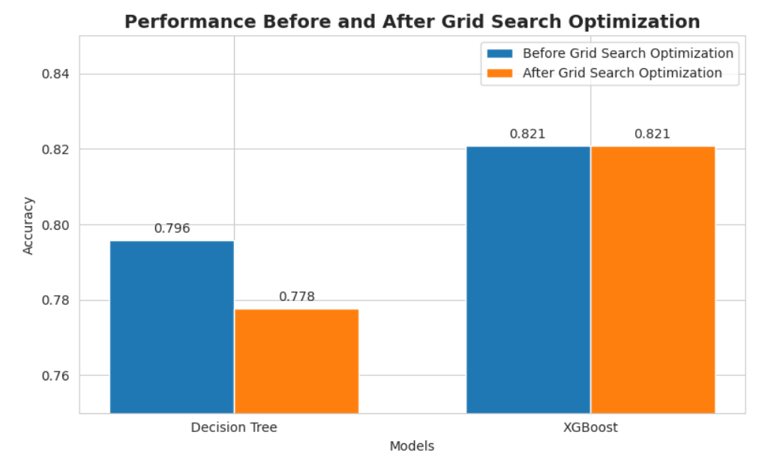
Figure 15. Third experiment: Performance with and without Grid Search Optimization
4.4.2 Results of Applying ML Models with Selected Features and Applying SMOTE
The fourth experiment aimed at exploring the interaction of feature selection and SMOTE in the process of predicting students' performances. Feature selection was implemented first to select those variables that are not significant in the process of making predictions. After that, SMOTE was used to balance the training data set, and feature subsets obtained after applying this technique were used to build and assess ML algorithms according to the criteria mentioned above. The findings presented in Table 9 demonstrate that the combination of feature selection and SMOTE ensured high prediction accuracy but at the same time decreased the number of input variables. The highest accuracy in classification (82.08%) was reached by XGB algorithm, and the best traditional ML model in terms of its performance was DT, which reached the accuracy level of 79.93%. Besides, the results obtained by RF were also rather good, whereas the performance of AB remained satisfactory. At the same time, the performance of LR, SVM, and KNN models can be considered as moderate, and NB still showed the worst performance in comparison with other models. As compared to previous experimental studies, the obtained results prove that a decrease in the feature space does not adversely influence the strongest models.
Table 9 Fourth experiment: Results of Applying Machine Learning Models with Selected Features after Applying SMOTE.
Approach | Model | Accuracy | Precision | Recall | F1-Score
Traditional ML | DT | 79.93 | 80.56 | 79.93 | 79.84
Traditional ML | RF | 79.21 | 79.52 | 79.21 | 78.27
Traditional ML | LG | 66.67 | 70.98 | 66.67 | 66.74
Traditional ML | SVM | 64.52 | 68.16 | 64.52 | 64.03
Traditional ML | KNN | 60.57 | 65.11 | 60.57 | 61.55
Traditional ML | NB | 16.13 | 43.96 | 16.13 | 16.05
EL | XGB | 82.08 | 82.31 | 82.08 | 81.82
EL | AdaBoost | 70.97 | 73.94 | 70.97 | 70.71

The confusion matrices shown in Figure 16 again demonstrate the effectiveness of using feature selection alongside SMOTE. XGB, DT, and RF classified most of the student data points since there was an accumulation of data points along the leading diagonal line. While there were still some misclassifications, especially among adjacent academic performance categories, the classification behavior of the algorithms became more even compared to the previous case. However, NB still kept misclassifying a substantial number of points in various classes. Grid Search was used on DT and XGB to see if further improvement was possible.
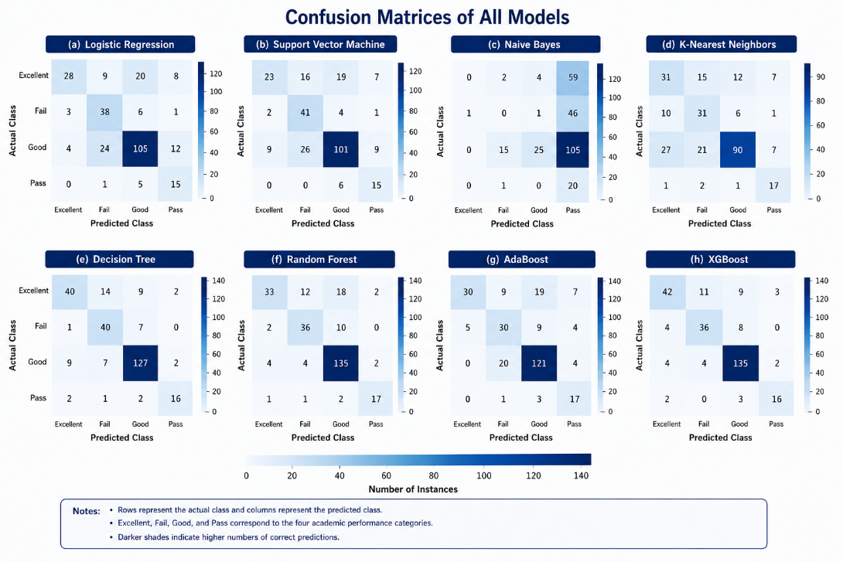
Figure 16. Fourth experiment: Confusion Matrices of Traditional Machine Learning Models
From the optimization process, various responses have been observed depending on the hyperparameter tuning method. The accuracy of classification improved significantly for DT through the use of Grid Search, where accuracy went up from 79.93% to 82.80%. On the other hand, XGB showed little performance decrease after the optimization process and achieved high evaluation scores throughout. This is an indication that DT was very sensitive to the hyperparameters tuning, while the default setting of XGB was almost optimal As seen in Table 10 and Figure 17.
Table 10.Fourth experiment: Performance with and without Grid Search Optimization.
Grid Search | Category | Model | Accuracy | Precision | Recall | F1-Score
Without | Traditional ML | DT | 79.93 | 80.56 | 79.93 | 79.84
Without | EL | XGB | 82.08 | 82.31 | 82.08 | 81.82
With | Traditional ML | DT | 82.80 | 82.56 | 82.80 | 82.37
With | EL | XGB | 81.72 | 81.66 | 81.72 | 81.10

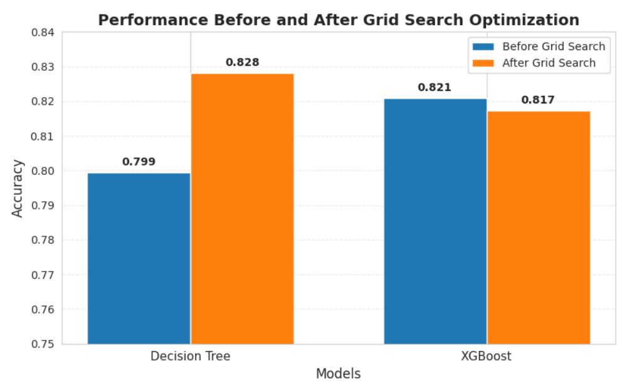
Figure 17 Fourth experiment: Performance with and without Grid Search Optimization.

4.6 Final Model Selection.
Four types of experiments were carried out with the aim of determining the impact of feature selection and SMOTE on the prediction capabilities of ML and EL algorithms. Since all four types of experiments gave rise to different results, the comparison of the results obtained was made in order to determine which model is suitable for predicting the academic performance of students.
As can be seen from the table (Table 11), XGB showed the best or second-best classification results in all four types of experiments. When using the entire feature set without SMOTE, the XGB had an 82.80% accuracy rate, and the same value was achieved after the application of feature selection, which means that the reduction of the number of input variables did not have any impact on the prediction performance of the algorithm. After SMOTE was used for balancing the training data, XGB demonstrated the best performance in terms of accuracy rate (82.08%).
Though DT exhibited the best accuracy score (82.80%) after performing Grid Search optimization using SMOTE for the selected feature set, it should be noted that this effect was recorded just in one experimental configuration. In its turn, XGB always occupied one of the leading places in all experiments performed during the current research, regardless of whether feature selection or SMOTE was used in the experiment.
Taking into account the above-described characteristics of the models, including both their predictive ability and stability, the choice of the final model in the form of XGB can be considered reasonable. It is important to note that the chosen model demonstrated high values of Accuracy, Precision, Recall, and F1-score on all experimental configurations. Consequently, XGB can be recommended as an effective model for predicting students' academic performance based on educational data with various academic and behavioral features. The superiority of XGB obtained in the current study is confirmed by previous studies on the subject. Thus, Johora et al. [21] stated that the XGB-based ensemble models outperform traditional ML algorithms, and Bettahi et al. [16] showed that advanced ensemble learning models can ensure the reliability of the predictions for finding risky students.
Table 11. Final Performance of the Best Models Across the Four Experimental Configurations
EXP | Experimental Configuration | Best Model | Accuracy | Precision | Recall | F1-Score
1 | Full Feature Set | XGB | 82.80 | 82.63 | 82.80 | 82.42
2 | Selected Feature Set | XGB | 82.80 | 82.63 | 82.80 | 82.42
3 | Full Feature Set + SMOTE | XGB | 82.08 | 82.31 | 82.08 | 81.82
4 | Selected Feature Set + SMOTE | DT | 82.80 | 82.56 | 82.80 | 82.37
4 | Selected Feature Set + SMOTE | XGB | 81.72 | 81.66 | 81.72 | 81.10

4.7 Summary of the Experimental Findings.
In conclusion, the experimental results described in this chapter confirm the importance of data preprocessing in enhancing the efficiency of the ML algorithm used to predict the academic performance of students. In particular, feature selection helped reduce the dimensionality of the dataset without loss of informative predictors, and SMOTE helped solve the problem of class imbalance by improving the representation of minority classes.
In all four experimental setups, XGB demonstrated better results compared to other ML algorithms and achieved the best overall predictive efficiency of models. Although the decision tree classifier reached the highest accuracy after Grid Search in one experimental setup, overall, XGB proved to be the most reliable algorithm in terms of high efficiency and stability in various preprocessing conditions.
As seen from the results, ensemble learning techniques outperform basic ML algorithms due to their ability to identify complex dependencies between the features of students' behavior and academic performance. Thus, feature selection, SMOTE, and ensemble learning provide an effective framework for predicting the academic performance of students and allow for achieving research goals.

Chapter 5 Conclusion and Future Work

5.1 Conclusion
In this thesis, an AI-Based Early Warning System has been designed to predict the academic performance of students using data gathered from the LMS. In the proposed framework, the processes of data preprocessing, feature selection, machine learning classification, and hyperparameter optimization have been considered to accurately determine academically at-risk students.
Comprehensive preprocessing procedures were conducted, which included the following steps: data transformation, stratified train-test splitting, feature selection according to Random Forest Feature Importance, and class balancing by using the SMOTE. The effect of the feature selection and SMOTE procedures on the prediction accuracy has been studied through four experimentally obtained configurations.
Eight machine learning algorithms have been applied: (DT), (RF), (LR), (SVM), (KNN), (NB), (AB), and (XGB). Experimental results have shown that ensemble learning algorithms are significantly superior to classical machine learning algorithms. Among all applied models, XGB provided the highest prediction accuracy with the value of 82.80% (precision 82.63%, recall 82.80%, F1-score 82.42%). However, despite the fact that the same prediction accuracy (82.80%) was observed after performing the Grid Search procedure for Decision Tree algorithm in one experimental configuration, XGB is more stable and always performed very well.
Experimental results have also proved that the feature selection procedure helped to reduce the number of input variables without affecting prediction accuracy, and that the use of SMOTE procedure enhanced the identification of minority classes. The hyperparameter optimization procedure slightly increased the accuracy of some machine learning models, especially of Decision Tree and Random Forest, while XGB showed excellent prediction accuracy even with the default parameter settings.
To summarize, it can be concluded that the proposed AI-based early warning framework has become an effective and reliable method to predict students' academic performance. Thus, the created system allows identifying academically at risk students at an early stage, making interventions in time, improving students' performance, preventing academic failures, and making data-driven decisions.

5.2 Future Work
The developed framework provided a promising level of predictive performance, there exist some other directions that can be explored in future research to enhance the framework further.
- Combine various sources of educational data, such as data about attendance, behavior, forum activity, submission times, and temporal learning analytics to create a more holistic picture of the learners' learning behaviors.
- Study more sophisticated deep learning methods, including LSTM, Transformer models, and hybrid machine learning and deep learning methods to predict sequential learning behaviors and possibly achieve better predictive performance.
- Create a real-time early warning AI system that will monitor the engagement of the students all through the semester and alert instructors, academic advisors, and students automatically.
- Test the validity of the proposed framework on larger and more diverse educational datasets collected at multiple educational institutions under various learning conditions to ensure the robustness of the created models.
- Implement explainable artificial intelligence techniques such as SHAP and LIME to explain the reasons behind the predictions and make the AI-assisted decision-making process more understandable for educators.
- Develop a personalized intervention recommendation system that not only recognizes the at-risk students but also recommends the corresponding academic interventions depending on each student's risk level.
- Implement the method of automated updating of the model and online learning of it to maintain its predictive performance with the flow of new educational data.

References:
[1] Y. Li, "Artificial Intelligence Technologies for Education," ed: MDPI-Multidisciplinary Digital Publishing Institute, 2025.
[2] A. Taghvaie, T. Warnakulasuriya, D. Kumar, F. Zare, R. Sharma, and D. M. Vilathgamuwa, "A comprehensive review of harmonic issues and estimation techniques in power system networks based on traditional and artificial intelligence/machine learning," Ieee Access, vol. 11, pp. 31417–31442, 2023.
[3] C. M. Bishop and N. M. Nasrabadi, Pattern recognition and machine learning (no. 4). Springer, 2006.
[4] S. U. S. o. I. Studies. "Data Science vs. Machine Learning." Syracuse University. https://ischool.syracuse.edu/data-science-vs-machine-learning/ (accessed july 4, 2026).
[5] K. P. Murphy, Machine learning: a probabilistic perspective. MIT press, 2012.
[6] T. Hastie, "The elements of statistical learning: data mining, inference, and prediction," ed: springer, 2009.
[7] T. Hastie, R. Tibshirani, and J. Friedman, "The elements of statistical learning," ed: Springer series in statistics New-York, 2009.
[8] J. R. Quinlan, C4. 5: programs for machine learning. Elsevier, 2014.
[9] D. Bañeres, M. E. Rodríguez, A. E. Guerrero-Roldán, and A. Karadeniz, "An early warning system to detect at-risk students in online higher education," Applied Sciences, vol. 10, no. 13, p. 4427, 2020.
[10] B. Ujkani, D. Minkovska, and N. Hinov, "Course success prediction and early identification of at-risk students using explainable artificial intelligence," Electronics, vol. 13, no. 21, p. 4157, 2024.
[11] A. Bettahi, H. Harroud, and F.-Z. Belouadha, "Early Student Risk Detection Using CR-NODE: A Completion-Focused Temporal Approach with Explainable AI," Algorithms, vol. 18, no. 12, p. 781, 2025.
[12] O. H. Embarak and S. Hawarna, "Automated AI-driven system for early detection of at-risk students," Procedia Computer Science, vol. 231, pp. 151–160, 2024.
[13] L. P. Macfadyen and S. Dawson, "Mining LMS data to develop an “early warning system” for educators: A proof of concept," Computers & education, vol. 54, no. 2, pp. 588–599, 2010.
[14] E. M. Queiroga, M. F. Batista Machado, V. R. Paragarino, T. T. Primo, and C. Cechinel, "Early prediction of at-risk students in secondary education: A countrywide k-12 learning analytics initiative in uruguay," Information, vol. 13, no. 9, p. 401, 2022.
[15] W. Bagunaid, N. Chilamkurti, A. S. Shahraki, and S. Bamashmos, "Visual data and pattern analysis for smart education: a robust DRL-based early warning system for student performance prediction," Future Internet, vol. 16, no. 6, p. 206, 2024.
[16] F. T. Johora, M. N. Hasan, A. Rajbongshi, M. Ashrafuzzaman, and F. Akter, "An explainable AI-based approach for predicting undergraduate students academic performance," Array, vol. 26, p. 100384, 2025.
[17] V. Christou et al., "Performance and early drop prediction for higher education students using machine learning," Expert Systems with Applications, vol. 225, p. 120079, 2023.
[18] V. Realinho, J. Machado, L. Baptista, and M. V. Martins, "Predicting student dropout and academic success," Data, vol. 7, no. 11, p. 146, 2022.
[19] N. N. Hamadneh, S. Atawneh, W. A. Khan, K. A. Almejalli, and A. Alhomoud, "Using artificial intelligence to predict students’ academic performance in blended learning," Sustainability, vol. 14, no. 18, p. 11642, 2022.
[20] M. Skittou, M. Merrouchi, and T. Gadi, "Development of an early warning system to support educational planning process by identifying at-risk students," IEEE access, vol. 12, pp. 2260–2271, 2023.
[21] I. Khan, A. R. Ahmad, N. Jabeur, and M. N. Mahdi, "An artificial intelligence approach to monitor student performance and devise preventive measures," Smart Learning Environments, vol. 8, no. 1, p. 17, 2021.
[22] G. Akçapınar, A. Altun, and P. Aşkar, "Using learning analytics to develop early-warning system for at-risk students," International Journal of Educational Technology in Higher Education, vol. 16, no. 1, p. 40, 2019.
[23] B. Albreiki, T. Habuza, Z. Shuqfa, M. A. Serhani, N. Zaki, and S. Harous, "Customized rule-based model to identify at-risk students and propose rational remedial actions," Big Data and Cognitive Computing, vol. 5, no. 4, p. 71, 2021.

