Mid-Ocean University
Collage of Management

The Impact of Project Management Offices on Strategic Plan in the Saudi Private Sector (Field Study)

Prepared by:
Arwa Mohamed Abdel-Rahman Awad

Student ID:
2021206354

A dissertation submitted to Mid-Ocean University in partial fulfillment of the requirements for the Doctor of Philosophy degree

2026

List of tables
Table 1 : Descriptive Statistics for PMO Operational Metrics 15
Table 2 : Demographic Profile of Respondents by Gender 16
Table 3 : Age Distribution Breakdown of the Surveyed Cohort 17
Table 4 : Academic Qualifications and Educational Background of Participants 19
Table 5 : Professional Experience Profile in Project Management 20
Table 6 : Hierarchical Distribution of Respondents' Organizational Roles 21
Table 7 : Statistical analysis of Organizational Clarity Regarding PMO Establishment 23
Table 8 : Statistical analysis of Assessment of Role Clarity and Responsibility Definition in PMOs 24
Table 9 : Statistical analysis of Evaluation of Formal Governance Frameworks within PMO Operations. 25
Table 10 : Statistical analysis of Perceived Senior Management Support for PMO Authority. 27
Table 11 : Statistical analysis of Structural Alignment of the PMO within the Corporate Hierarchy. 28
Table 12 : Statistical analysis of Evaluation of PMO Functional Autonomy and Independence. 29
Table 13 : Statistical analysis of PMO Contributions to Methodological Standardization. 31
Table 14 : Statistical analysis of Effectiveness of the PMO in Driving Strategic Project Alignment. 32
Table 15 : Statistical analysis of Alignment of Project Selection with Strategic Priorities. 33
Table 16 : Statistical analysis of PMO Involvement in High-Level Strategic Planning. 35
Table 17 : Statistical analysis of Strategic Contribution as a Project Evaluation Metric. 36
Table 18 : Statistical analysis of Role of the PMO in Translating Strategy into Execution. 37
Table 19 : Statistical analysis of Communication of Strategic Shifts via PMO Channels. 39
Table 20 : Statistical analysis of PMO Efficacy in Mitigating Strategic Misalignment. 40
Table 21 : Statistical analysis of Reliability of PMO Data for Strategic Decision Support. 41
Table 22 : Statistical analysis of Impact of Performance Reporting on Long-term Planning. 43
Table 23 : Statistical analysis of PMO Influence on Decision-making Transparency. 44
Table 24 : Statistical analysis of Executive Reliance on PMO Analytics for Strategic Choices. 45
Table 25 : Statistical analysis of PMO Contributions to Strategic Risk Management. 47
Table 26 : Statistical analysis of PMO Support for Strategic Initiative Prioritization. 48
Table 27 : Statistical analysis of Consistency in Organizational Decisions through PMO Governance. 49
Table 28 : Statistical analysis of Adoption of Standardized Project Management Software and Tools. 51
Table 29 : Statistical analysis of Influence of PMO Methodologies on Strategic Planning Quality. 52
Table 30 : Statistical analysis of Effectiveness of Data Systems in Strategic Forecasting. 53
Table 31 : Statistical analysis of The Cross-Project Integration Facilitated by the PMO. 55
Table 32 : Statistical analysis of Systematic Utilization of Lessons Learned in Strategy. 56
Table 33 : Statistical analysis of Efficiency Gains in Strategic Execution via PMO Processes. 57
Table 34 : Statistical analysis of PMO Role in Best Practice Dissemination and Advocacy. 59
Table 35 : Statistical analysis of Strategic Realism and PMO Operational Validation. 60
Table 36 : Statistical analysis of PMO Impact on the Execution of Strategic Roadmaps. 61
Table 37 : Statistical analysis of Achievement of Strategic Objectives with PMO Support. 63
Table 38 : Statistical analysis of Coordination of Strategic Initiatives through the PMO. 64
Table 39 : Statistical analysis of PMO Efficacy in Reducing Planning-Related Failures. 65
Table 40 : Statistical analysis of Improvement in Strategic Outcomes Post-PMO Establishment. 67
Table 41 : Statistical analysis of Organizational Performance Gains from PMO Strategic Involvement. 68
Table 42 : Summary of statistical analyses. 69
Table 43 : Stability and reliability testing. 69
Table 44 : Chi-square test for the relationship between PMO Practices and Project Portfolio Alignment with Strategic Objectives. 70
Table 45 : Chi-square test for the relationship between PMO Practices and Achievement of Strategic Targets and KPIs. 71
Table 46 : Chi-square test for the relationship between PMO Practices and Organizational Performance in Construction Projects. 73
Table 47 : Chi-square test for the relationship between PMO Engagement and Project Portfolio Alignment with Strategic Objectives. 74
Table 48 : Chi-square test for the relationship between PMO Engagement and Achievement of Strategic Targets and KPIs 75
Table 49 : Chi-square test for the relationship between PMO Engagement and Organizational Performance in Construction Projects. 77
Table 50 : Chi-square test for the relationship between Innovation Culture and Project Portfolio Alignment with Strategic Objectives. 78
Table 51 : Chi-square test for the relationship between Innovation Culture and Achievement of Strategic Targets and KPIs. 79
Table 52 : Chi-square test for the relationship between Innovation Culture and Organizational Performance in Construction Projects. 81
Table 53 : One-way ANOVA. 82
Table 54 : Summary of Bayesian Coefficient Model. 82
Table 55 : Statistical analysis to test the hypothesis: There is a statistically significant impact of Project Management Offices (PMOs) on strategic planning in the Saudi private sector. 83
Table 57 : Effect size in a single sample for the hypothesis: There is a statistically significant impact of Project Management Offices (PMOs) on strategic planning in the Saudi private sector. 84
Table 58 : Statistical analysis to test the hypothesis: PMO structure and governance have a statistically significant impact on strategic planning in the Saudi private sector. 84
Table 60 : Effect size in a single sample for the hypothesis: PMO structure and governance have a statistically significant impact on strategic planning in the Saudi private sector. 85
Table 61 : Statistical analysis to test the hypothesis: The role of PMOs in strategic alignment has a statistically significant impact on strategic planning in the Saudi private sector. 85
Table 63 : Effect size in a single sample for the hypothesis: The role of PMOs in strategic alignment has a statistically significant impact on strategic planning in the Saudi private sector. 86
Table 64 : Statistical analysis to test the hypothesis: PMO support for decision-making has a statistically significant impact on strategic planning in the Saudi private sector. 87
Table 66 : Effect size in a single sample for the hypothesis: PMO support for decision-making has a statistically significant impact on strategic planning in the Saudi private sector. 87
Table 67 : Statistical analysis to test the hypothesis: PMO tools, processes, and methodologies have a statistically significant impact on strategic planning in the Saudi private sector. 88
Table 69 : Effect size in a single sample for the hypothesis: PMO tools, processes, and methodologies have a statistically significant impact on strategic planning in the Saudi private sector. 88
Table 70 : Statistical analysis to test the hypothesis: The overall effectiveness of strategic planning is significantly influenced by the presence of PMOs in the Saudi private sector. 89
Table 72 : Effect size in a single sample for the hypothesis: The overall effectiveness of strategic planning is significantly influenced by the presence of PMOs in the Saudi private sector. 89

List of figures
Figure 1 : Gender Composition of the Study Sample 16
Figure 2 : Generational Representation within the Study Sample 18
Figure 3 : Distribution of Higher Education Degrees among Respondents 19
Figure 4 : Distribution of Participants by Years of Industry Experience 20
Figure 5 : Breakdown of Management and Staff Positions 22
Figure 6 : Graphical representation of clearly defined Project Management Office (PMO) in the organization 23
Figure 7 : Graphical representation of well-defined roles and responsibilities in the organiation. 24
Figure 8 : Graphical representation of Formal Governance Frameworks within PMO Operations. 26
Figure 9 : Graphical representation of Perceived Senior Management Support for PMO Authority. 27
Figure 10 : Graphical representation of Structural Alignment of the PMO within the Corporate Hierarchy. 28
Figure 11 : Graphical representation of Evaluation of PMO Functional Autonomy and Independence. 30
Figure 12 : Graphical representation of PMO Contributions to Methodological Standardization. 31
Figure 13 : Graphical representation of Effectiveness of the PMO in Driving Strategic Project Alignment. 32
Figure 14 : Graphical representation of Alignment of Project Selection with Strategic Priorities. 34
Figure 15 : Graphical representation of PMO Involvement in High-Level Strategic Planning. 35
Figure 16 : Graphical representation of Strategic Contribution as a Project Evaluation Metric. 36
Figure 17 : Graphical representation of Role of the PMO in Translating Strategy into Execution. 38
Figure 18 : Graphical representation of Communication of Strategic Shifts via PMO Channels. 39
Figure 19 : Graphical representation of PMO Efficacy in Mitigating Strategic Misalignment. 40
Figure 20 : Graphical representation of Reliability of PMO Data for Strategic Decision Support. 42
Figure 21 : Graphical representation of Impact of Performance Reporting on Long-term Planning. 43
Figure 22 : Graphical representation of PMO Influence on Decision-making Transparency. 44
Figure 23 : Graphical representation of Executive Reliance on PMO Analytics for Strategic Choices. 46
Figure 24 : Graphical representation of PMO Contributions to Strategic Risk Management. 47
Figure 25 : Graphical representation of PMO Support for Strategic Initiative Prioritization. 48
Figure 26 : Graphical representation of Consistency in Organizational Decisions through PMO Governance. 50
Figure 27 : Graphical representation of Adoption of Standardized Project Management Software and Tools. 51
Figure 28 : Graphical representation of Influence of PMO Methodologies on Strategic Planning Quality. 52
Figure 29 : Graphical representation of Effectiveness of Data Systems in Strategic Forecasting. 54
Figure 30 : Graphical representation of Cross-Project Integration Facilitated by the PMO. 55
Figure 31 : Graphical representation of Systematic Utilization of Lessons Learned in Strategy. 56
Figure 32 : Graphical representation of Efficiency Gains in Strategic Execution via PMO Processes. 58
Figure 33 : Graphical representation of PMO Role in Best Practice Dissemination and Advocacy. 59
Figure 34 : Graphical representation of Strategic Realism and PMO Operational Validation. 60
Figure 35 : Graphical representation of PMO Impact on the Execution of Strategic Roadmaps. 62
Figure 36 : Graphical representation of Achievement of Strategic Objectives with PMO Support. 63
Figure 37 : Graphical representation of Coordination of Strategic Initiatives through the PMO. 64
Figure 38 : Graphical representation of PMO Efficacy in Reducing Planning-Related Failures. 66
Figure 39 : Graphical representation of Improvement in Strategic Outcomes Post-PMO Establishment. 67
Figure 40 : Graphical representation of Organizational Performance Gains from PMO Strategic Involvement. 68
Figure 41 : Symmetric measures for analyzing cross-tables of the relationship between PMO Practices and Project Portfolio Alignment with Strategic Objectives 70
Figure 42 : Symmetric measures for analyzing cross-tables of the relationship between PMO Practices and Achievement of Strategic Targets and KPIs 72
Figure 43 : Symmetric measures for analyzing cross-tables of the relationship between PMO Practices and Organizational Performance in Construction Projects 73
Figure 44 : Symmetric measures for analyzing cross-tables of the relationship between PMO Engagement and Project Portfolio Alignment with Strategic Objectives 74
Figure 45 : Symmetric measures for analyzing cross-tables of the relationship between PMO Engagement and Achievement of Strategic Targets and KPIs 76
Figure 46 : Symmetric measures for analyzing cross-tables of the relationship between PMO Engagement and Organizational Performance in Construction Projects 77
Figure 47 : Symmetric measures for analyzing cross-tables of the relationship between Innovation Culture and Project Portfolio Alignment with Strategic Objectives 78
Figure 48 : Symmetric measures for analyzing cross-tables of the relationship between Innovation Culture and Achievement of Strategic Targets and KPIs 80
Figure 49 : Symmetric measures for analyzing cross-tables of the relationship between Innovation Culture and Organizational Performance in Construction Projects 81

Table of Contents:
List of tables 2
List of figures 5
Chapter Four 9
Study results and hypothesis testing 9
Descriptive statistics of the data: 10
Demographic questions of the study: 15
Results of the study questions: 22
Testing credibility and reliability: 69
Cross-tabs analysis of study variables: 69
One-way ANOVA test for study variables: 82
Study hypotheses: 83

Chapter Four

Study results and hypothesis testing

Descriptive statistics of the data:
High standard deviation values across nearly all PMO operational metrics ranging from 1.387 to 1.658 point to a significant lack of standardization in how the Saudi private sector perceives and implements these offices. While the Mean scores hover around 3.50, suggesting a moderate lean toward agreement, the wide spread of responses indicates a polarized reality where some organizations possess mature, authoritative PMOs while others treat them as mere administrative shells. This fragmentation is most visible in the assessment of PMO roles and responsibilities (SD of 1.658); such a high variance suggests that project managers and executives are not aligned on what the PMO is actually supposed to do. When roles are this poorly defined, strategic misalignment is inevitable. It creates a vacuum where PMO authority is likely questioned or ignored during critical decision-making phases. The data further reveals that while the PMO helps ensure alignment between projects and strategy (Mean of 3.55), the high SD of 1.447 for this specific item proves that this "alignment" is inconsistent across the sector. Many PMOs appear to be operating in isolation, failing to effectively communicate strategic changes or provide the reliable data necessary for long-term planning. This operational gap prevents the PMO from evolving into a truly strategic partner, leaving it stuck in a cycle of reactive reporting rather than proactive governance.
Statistics
 | N |  | Mean | Std. Error of Mean | Median | Std. Deviation | Skewness | Std. Error of Skewness | Kurtosis | Std. Error of Kurtosis
 | Valid | Missing
Gender | 363 | 0 | 1.53 | .026 | 2.00 | .500 | -.128 | .128 | -1.995 | .255
Age Group | 363 | 0 | 2.40 | .058 | 2.00 | 1.112 | .120 | .128 | -1.332 | .255
Educational Qualification | 363 | 0 | 3.12 | .052 | 3.00 | .991 | -.748 | .128 | -.677 | .255
Years of Experience in Project Management | 363 | 0 | 3.10 | .055 | 3.00 | 1.050 | -.795 | .128 | -.704 | .255
Organizational Position | 363 | 0 | 3.02 | .057 | 3.00 | 1.086 | -.702 | .128 | -.878 | .255
The organization has a clearly defined Project Management Office (PMO). | 363 | 0 | 3.48 | .079 | 4.00 | 1.498 | -.493 | .128 | -1.252 | .255
The PMO has well-defined roles and responsibilities. | 363 | 0 | 3.27 | .087 | 4.00 | 1.658 | -.268 | .128 | -1.607 | .255
The PMO operates under a formal governance framework. | 363 | 0 | 3.48 | .074 | 4.00 | 1.409 | -.357 | .128 | -1.262 | .255
Senior management supports the authority of the PMO. | 363 | 0 | 3.45 | .077 | 4.00 | 1.474 | -.400 | .128 | -1.316 | .255
The PMO is aligned with the organizational structure. | 363 | 0 | 3.48 | .081 | 4.00 | 1.546 | -.457 | .128 | -1.347 | .255
The PMO has sufficient autonomy to perform its functions. | 363 | 0 | 3.31 | .086 | 4.00 | 1.631 | -.290 | .128 | -1.573 | .255
The PMO contributes to standardizing project management practices. | 363 | 0 | 3.46 | .073 | 4.00 | 1.387 | -.371 | .128 | -1.198 | .255
The PMO ensures alignment between projects and organizational strategy. | 363 | 0 | 3.55 | .076 | 4.00 | 1.447 | -.526 | .128 | -1.150 | .255
Project selection decisions reflect strategic organizational priorities. | 363 | 0 | 3.52 | .079 | 4.00 | 1.511 | -.494 | .128 | -1.246 | .255
The PMO participates in strategic planning discussions. | 363 | 0 | 3.49 | .083 | 4.00 | 1.572 | -.483 | .128 | -1.356 | .255
Projects are evaluated based on their strategic contribution. | 363 | 0 | 3.50 | .074 | 4.00 | 1.405 | -.412 | .128 | -1.195 | .255
The PMO helps translate strategic objectives into executable projects. | 363 | 0 | 3.50 | .074 | 4.00 | 1.415 | -.500 | .128 | -1.106 | .255
Strategic changes are effectively communicated through the PMO. | 363 | 0 | 3.33 | .081 | 4.00 | 1.540 | -.302 | .128 | -1.459 | .255
The PMO reduces misalignment between projects and strategic goals. | 363 | 0 | 3.27 | .085 | 4.00 | 1.611 | -.310 | .128 | -1.514 | .255
The PMO provides accurate data to support strategic decision-making. | 363 | 0 | 3.49 | .076 | 4.00 | 1.455 | -.440 | .128 | -1.213 | .255
Project performance reports support long-term planning decisions. | 363 | 0 | 3.44 | .077 | 4.00 | 1.469 | -.408 | .128 | -1.279 | .255
The PMO enhances transparency in project-related decisions. | 363 | 0 | 3.29 | .084 | 4.00 | 1.596 | -.301 | .128 | -1.494 | .255
Management relies on PMO reports when making strategic choices. | 363 | 0 | 3.27 | .086 | 4.00 | 1.640 | -.297 | .128 | -1.559 | .255
The PMO improves risk assessment during strategic planning. | 363 | 0 | 3.54 | .074 | 4.00 | 1.414 | -.461 | .128 | -1.189 | .255
The PMO supports prioritization of strategic initiatives. | 363 | 0 | 3.53 | .076 | 4.00 | 1.453 | -.468 | .128 | -1.253 | .255
Decisions become more consistent due to PMO involvement. | 363 | 0 | 3.39 | .079 | 4.00 | 1.503 | -.294 | .128 | -1.419 | .255
The PMO uses standardized project management tools. | 363 | 0 | 3.40 | .085 | 4.00 | 1.618 | -.410 | .128 | -1.469 | .255
PMO methodologies improve the quality of strategic planning. | 363 | 0 | 3.58 | .073 | 4.00 | 1.391 | -.528 | .128 | -1.075 | .255
Project data systems support strategic forecasting. | 363 | 0 | 3.45 | .077 | 4.00 | 1.466 | -.423 | .128 | -1.254 | .255
The PMO facilitates integration between different projects. | 363 | 0 | 3.56 | .079 | 4.00 | 1.503 | -.517 | .128 | -1.263 | .255
Lessons learned are systematically used in strategic planning. | 363 | 0 | 3.39 | .083 | 4.00 | 1.589 | -.339 | .128 | -1.501 | .255
PMO processes enhance efficiency in strategic execution. | 363 | 0 | 3.51 | .075 | 4.00 | 1.425 | -.458 | .128 | -1.183 | .255
The PMO promotes best practices across projects. | 363 | 0 | 3.53 | .076 | 4.00 | 1.442 | -.506 | .128 | -1.147 | .255
Strategic plans are more realistic due to PMO involvement. | 363 | 0 | 3.47 | .080 | 4.00 | 1.516 | -.496 | .128 | -1.244 | .255
The PMO improves the implementation of strategic plans. | 363 | 0 | 3.28 | .085 | 4.00 | 1.621 | -.282 | .128 | -1.547 | .255
Strategic objectives are achieved more effectively with PMO support. | 363 | 0 | 3.50 | .074 | 4.00 | 1.401 | -.428 | .128 | -1.167 | .255
The PMO enhances coordination between strategic initiatives. | 363 | 0 | 3.43 | .074 | 4.00 | 1.407 | -.382 | .128 | -1.186 | .255
The PMO reduces project failure rates linked to poor planning. | 363 | 0 | 3.34 | .081 | 4.00 | 1.548 | -.295 | .128 | -1.436 | .255
Strategic planning outcomes have improved since establishing the PMO. | 363 | 0 | 3.38 | .082 | 4.00 | 1.571 | -.418 | .128 | -1.396 | .255
Overall organizational performance benefits from PMO involvement in strategy. | 363 | 0 | 3.55 | .076 | 4.00 | 1.447 | -.487 | .128 | -1.193 | .255
Table 1 : Descriptive Statistics for PMO Operational Metrics

Demographic questions of the study:
- Gender of participants in the experiment
The survey reveals a remarkably balanced gender distribution, where the 6.4% margin between females and males reflects a diverse professional environment. Female participants lead at 53.2 percent, yet the 46.8 percent male representation prevents the data from becoming gender-heavy. Gender representation remains balanced. Such near-parity is vital for a field study on strategic planning; it ensures that the perceived impact of Project Management Offices is evaluated from a broad professional spectrum rather than a skewed demographic. This distribution minimizes the risk of gender-based bias in the qualitative assessment of organizational governance. A balanced workforce sample strengthens the validity of the subsequent analysis regarding PMO authority and governance frameworks. The data shows no extreme disparity that would necessitate weighted adjustments or complex normalization. These results represent a consolidated perspective of the current professional environment in the region without the noise of demographic outliers.
Gender
 |  | Frequency | Percent | Valid Percent | Cumulative Percent
Valid | Female | 193 | 53.2 | 53.2 | 53.2
Valid | Male | 170 | 46.8 | 46.8 | 100.0
Valid | Total | 363 | 100.0 | 100.0
Table 2 : Demographic Profile of Respondents by Gender

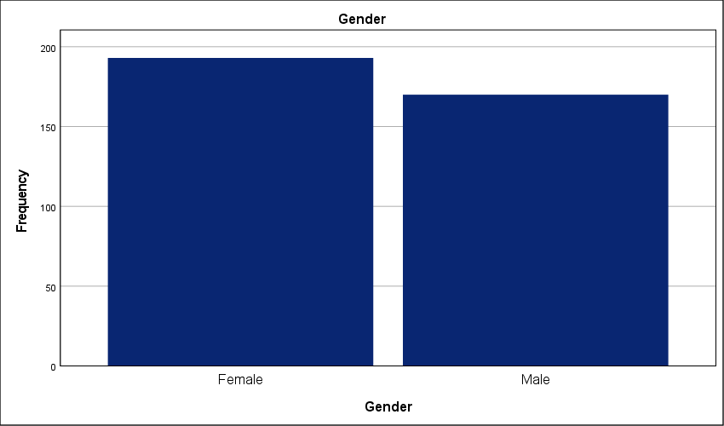
Figure 1 : Gender Composition of the Study Sample

- Age Group of participants in the experiment
While all age groups are well-represented, it is noteworthy that senior professionals (50+ years) constitute the smallest segment at 22%; this stands in contrast to the group under 30 years, which constitutes the largest portion at 27.5 percent. The workforce is young. Despite the lead held by early-career professionals, the distribution across all four age brackets remains remarkably tight—the gap between the youngest and oldest tiers is a mere 5.5 percent. This parity is unusual. Such an even spread suggests that the Saudi private sector is currently a melting pot of generational perspectives regarding Project Management Offices. The high concentration of younger staff indicates a workforce naturally more inclined toward modern governance tools and digital PMO integration. Simultaneously, the significant 22 percent of veteran leadership ensures that these strategic plans are grounded in long-term operational experience. This balance is critical; it prevents the findings from being dominated by either traditionalist inertia or inexperienced tech-enthusiasm. We are looking at a cross-generational consensus. The data reflects a mature professional environment where strategic PMO implementation is being observed and evaluated by a balanced mix of fresh talent and seasoned executives.
Age Group
 |  | Frequency | Percent | Valid Percent | Cumulative Percent
Valid | Less than 30 years | 100 | 27.5 | 27.5 | 27.5
Valid | 30–39 years | 96 | 26.4 | 26.4 | 54.0
Valid | 40–49 years | 87 | 24.0 | 24.0 | 78.0
Valid | 50 years and above | 80 | 22.0 | 22.0 | 100.0
Valid | Total | 363 | 100.0 | 100.0
Table 3 : Age Distribution Breakdown of the Surveyed Cohort

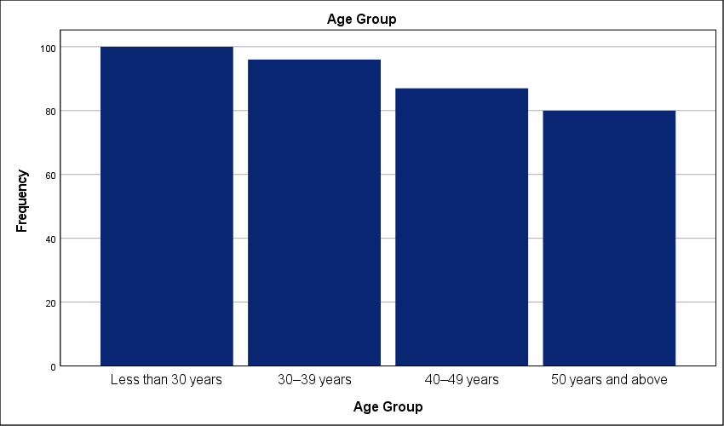
Figure 2 : Generational Representation within the Study Sample

- Educational Qualification of participants in the experiment
A mere 8 percent of the cohort holds a diploma or less, creating a massive disparity when measured against the 47.9 percent who possess a PhD or equivalent. This is a highly specialized workforce. The concentration of terminal degrees is staggering for a field study; it suggests that the Saudi private sector is heavily reliant on high-level academic expertise to drive its project management strategies. This creates a unique operational environment. With nearly half the participants holding doctorates and another 24.5 percent possessing Master's degrees, the intellectual capital available for PMO implementation is exceptionally high. This academic saturation likely results in a sophisticated understanding of theoretical frameworks—it also risks a "theory-practice" gap if these highly educated professionals prioritize academic models over localized field realities. The bachelor's degree group, usually the majority in industrial studies, accounts for only 19.6 percent here. Such a top-heavy educational profile indicates that the findings reflect an elite tier of the workforce. These experts are likely the ones designing the strategic plans rather than just executing them. This validates the study's depth; the responses are grounded in advanced methodological awareness rather than basic operational intuition.

Educational Qualification
 |  | Frequency | Percent | Valid Percent | Cumulative Percent
Valid | PhD or equivalent | 174 | 47.9 | 47.9 | 47.9
Valid | Masters degree | 89 | 24.5 | 24.5 | 72.5
Valid | Bachelors degree | 71 | 19.6 | 19.6 | 92.0
Valid | Diploma or less | 29 | 8.0 | 8.0 | 100.0
Valid | Total | 363 | 100.0 | 100.0
Table 4 : Academic Qualifications and Educational Background of Participants

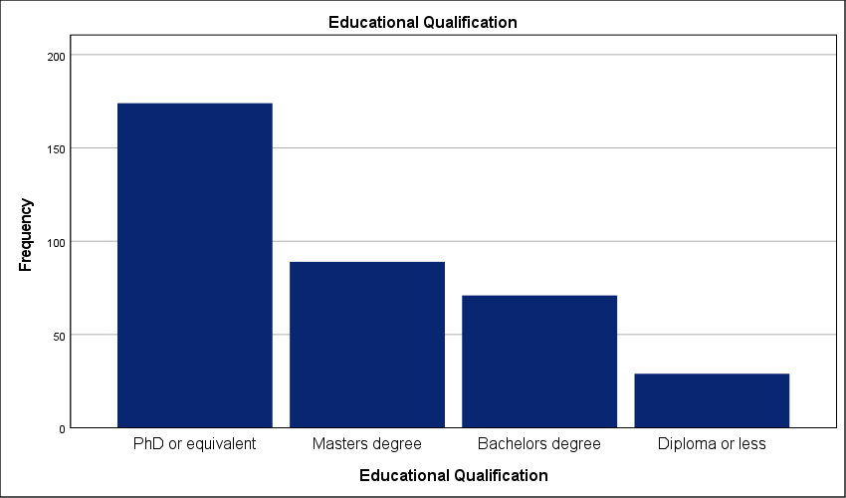
Figure 3 : Distribution of Higher Education Degrees among Respondents

- Years of Experience in Project Management of participants in the experiment
A defining characteristic of this sample is the high level of expertise, with nearly half of the respondents (49.3%) being industry veterans with over 15 years of experience. The workforce is veteran-led. This heavy concentration of senior expertise contrasts sharply with the 11.3 percent of participants who have less than 5 years in the field. Such a disparity is significant. It implies that the feedback regarding PMO impact on strategic planning is coming from individuals who have likely witnessed multiple organizational shifts and various iterations of PMO structures over nearly two decades. These are not novices reporting on recent trends—they are practitioners with long-term memory of project successes and failures. With 72.2 percent of the sample having at least 11 years of experience, the data carries a high degree of practical authority. This level of professional maturity minimizes the risk of "honeymoon phase" bias where newer employees might overrate the efficacy of PMO tools. Instead, we see a critical, experience-hardened perspective. These veterans understand the difference between a PMO that adds strategic value and one that merely adds bureaucratic friction. The findings represent a grounded, high-fidelity view of the Saudi private sector's operational reality.
Years of Experience in Project Management
 |  | Frequency | Percent | Valid Percent | Cumulative Percent
Valid | More than 15 years | 179 | 49.3 | 49.3 | 49.3
Valid | 11–15 years | 83 | 22.9 | 22.9 | 72.2
Valid | 5–10 years | 60 | 16.5 | 16.5 | 88.7
Valid | Less than 5 years | 41 | 11.3 | 11.3 | 100.0
Valid | Total | 363 | 100.0 | 100.0
Table 5 : Professional Experience Profile in Project Management

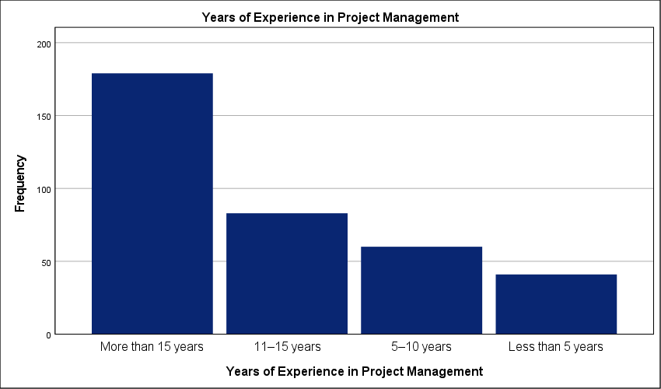
Figure 4 : Distribution of Participants by Years of Industry Experience

- Organizational Position of participants in the experiment
Senior and executive management dominate the sample at 45.7 percent. This leadership presence exceeds the project team member segment, representing only 14 percent of the total. The cohort is top-heavy. Such a distribution provides a strategic lens rather than a purely tactical one; it captures the perspective of those responsible for long-term organizational health. These executives hold the authority for PMO funding and define governance boundaries. Because nearly 70 percent of participants occupy senior management or PMO staff roles, the feedback on strategic integration carries heavy professional weight. We are hearing from the architects of strategy—not just the executors. This concentration reduces the risk of operational "noise" clouding the results. The data reflects the reality of power dynamics within the Saudi private sector. Governance is driven from the top down. The high scores reported elsewhere likely represent an executive vision that may face friction during ground-level implementation.
Organizational Position
 |  | Frequency | Percent | Valid Percent | Cumulative Percent
Valid | Senior / Executive Management | 166 | 45.7 | 45.7 | 45.7
Valid | PMO Staff | 89 | 24.5 | 24.5 | 70.2
Valid | Project Manager | 57 | 15.7 | 15.7 | 86.0
Valid | Project Team Member | 51 | 14.0 | 14.0 | 100.0
Valid | Total | 363 | 100.0 | 100.0
Table 6 : Hierarchical Distribution of Respondents' Organizational Roles

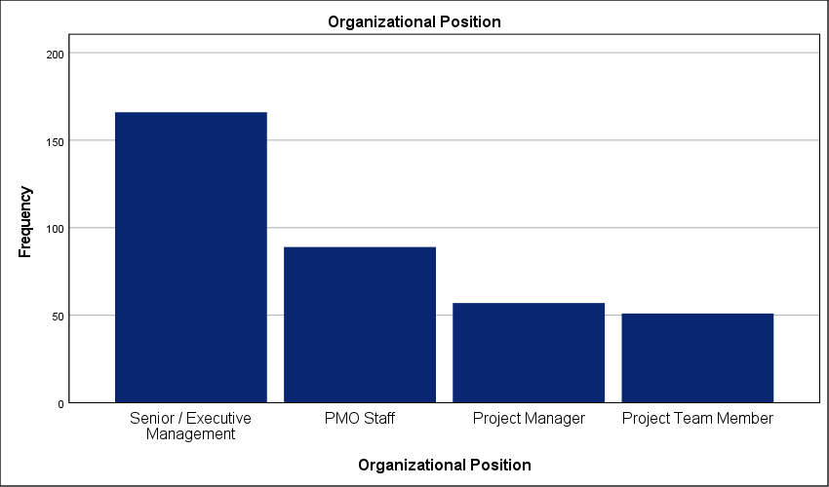
Figure 5 : Breakdown of Management and Staff Positions

Results of the study questions:
- The organization has a clearly defined Project Management Office (PMO).
Thirty-six point six percent of respondents strongly agree that their organization has a clearly defined PMO; this is the largest single group. A combined 30.9 percent explicitly disagree. The divide is clear. Such a wide split in perception confirms that the PMO is not yet a standard fixture across the Saudi private sector. A high standard deviation of 1.498 signals a lack of standardization. Many firms appear to operate without a central governance body. This absence creates a direct bottleneck in strategic execution. Without a defined office, the translation of high-level objectives into project-level tasks remains fragmented. The data suggests that while larger or more mature entities have solidified their PMO structures, a significant portion of the sector still lacks a formal project governance engine. This gap limits the potential for synchronized strategic growth. These results highlight a sector-wide inconsistency that must be addressed to ensure unified project delivery. Strategic success depends on this clarity. Organizations lacking this structure are essentially flying blind during the implementation phase of their long-term plans.

The organization has a clearly defined Project Management Office (PMO).
 |  | Frequency | Percent | Valid Percent | Cumulative Percent
Valid | Strongly Agree | 133 | 36.6 | 36.6 | 36.6
Valid | Agree | 80 | 22.0 | 22.0 | 58.7
Valid | Strongly Disagree | 58 | 16.0 | 16.0 | 74.7
Valid | Disagree | 54 | 14.9 | 14.9 | 89.5
Valid | Neither agree nor disagree | 38 | 10.5 | 10.5 | 100.0
Valid | Total | 363 | 100.0 | 100.0
Table 7 : Statistical analysis of Organizational Clarity Regarding PMO Establishment

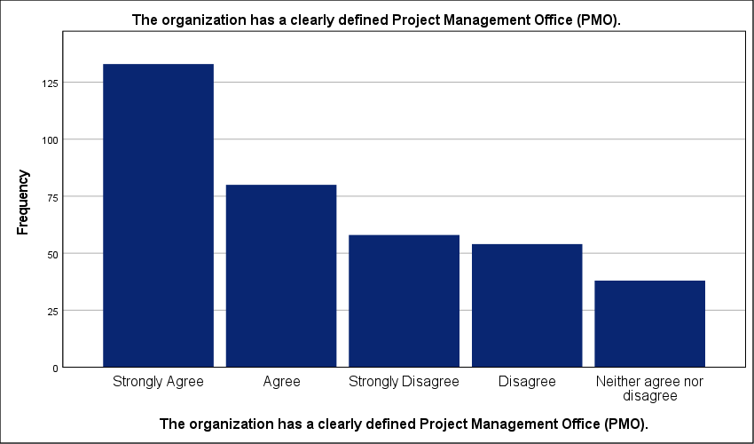
Figure 6 : Graphical representation of clearly defined Project Management Office (PMO) in the organization

- The PMO has well-defined roles and responsibilities.
There is a clear lack of neutrality regarding PMO roles, as only 8.5% remained undecided, highlighting a sharp divide in how these responsibilities are perceived. While 38 percent strongly agree that roles are well-defined, a substantial 25.3 percent strongly disagree. The environment is fractured. A high standard deviation of 1.658 points to a lack of standardization in how PMOs are governed within these firms. This role ambiguity likely creates internal friction. It forces project leads to navigate conflicting authorities; this inevitably slows down the execution of strategic plans. When responsibilities are this inconsistent, the PMO cannot provide the stable oversight needed for complex portfolios. This governance deficit suggests that many organizations have established offices without a functional mandate. Strategy remains disconnected from the ground level. Without clearly mapped roles, the PMO becomes an administrative burden rather than a strategic asset.
The PMO has well-defined roles and responsibilities.
 |  | Frequency | Percent | Valid Percent | Cumulative Percent
Valid | Strongly Agree | 138 | 38.0 | 38.0 | 38.0
Valid | Strongly Disagree | 92 | 25.3 | 25.3 | 63.4
Valid | Agree | 54 | 14.9 | 14.9 | 78.2
Valid | Disagree | 48 | 13.2 | 13.2 | 91.5
Valid | Neither agree nor disagree | 31 | 8.5 | 8.5 | 100.0
Valid | Total | 363 | 100.0 | 100.0
Table 8 : Statistical analysis of Assessment of Role Clarity and Responsibility Definition in PMOs

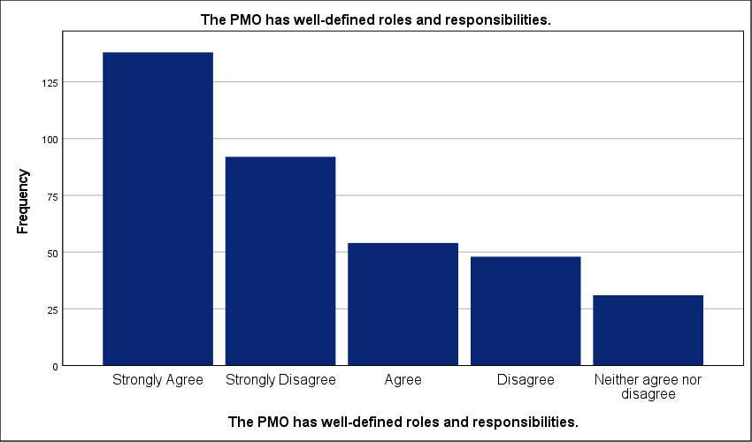
Figure 7 : Graphical representation of well-defined roles and responsibilities in the organiation.
- The PMO operates under a formal governance framework.
Exactly 10.5 percent of respondents strongly disagree that their PMO operates under a formal governance framework; this minority highlights a sharp gap when compared to the 35.3 percent who report a strongly structured environment. The sector remains fragmented. A standard deviation of 1.409 reflects polarized views on whether formal rules actually dictate PMO activities. Without a rigid framework, the PMO risks becoming a reactive cost center rather than a proactive strategic tool. This lack of standardization likely creates bottlenecks in project reporting—decisions are often made on ad-hoc data rather than systematic outputs. While 53.5 percent of the cohort leans toward agreement, the remaining 46.5 percent provide a cautionary tale of governance deficits. Effective strategic execution appears to be intrinsically linked to the maturity of the governance framework, rather than being an optional administrative layer. This disparity suggests that the impact of the PMO on strategic plans is entirely dependent on the maturity of individual firms rather than a sector-wide norm. High-performing organizations have formalized these links; the rest lack the structural discipline required for strategic success.
The PMO operates under a formal governance framework.
 |  | Frequency | Percent | Valid Percent | Cumulative Percent
Valid | Strongly Agree | 128 | 35.3 | 35.3 | 35.3
Valid | Disagree | 72 | 19.8 | 19.8 | 55.1
Valid | Agree | 66 | 18.2 | 18.2 | 73.3
Valid | Neither agree nor disagree | 59 | 16.3 | 16.3 | 89.5
Valid | Strongly Disagree | 38 | 10.5 | 10.5 | 100.0
Valid | Total | 363 | 100.0 | 100.0
Table 9 : Statistical analysis of Evaluation of Formal Governance Frameworks within PMO Operations.

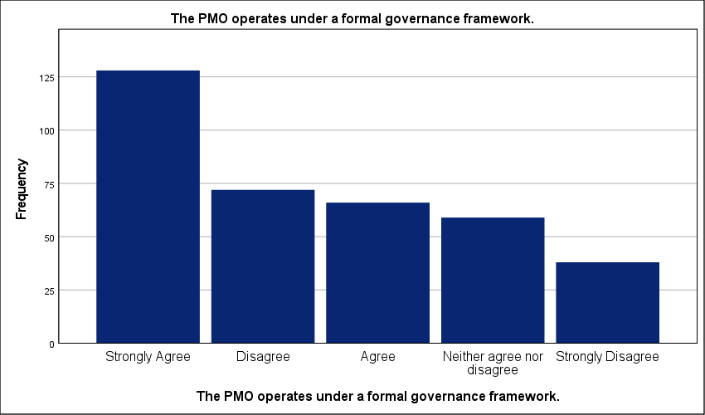
Figure 8 : Graphical representation of Formal Governance Frameworks within PMO Operations.

- Senior management supports the authority of the PMO.
Only 11.6 percent of the cohort remains neutral, representing the smallest segment of the sample; this stands in sharp contrast to the 35.8 percent who strongly agree that senior management supports PMO authority. The executive environment is polarized. A high standard deviation of 1.474 reflects a lack of standardization in how leadership perceives the PMO role. While over half the respondents report strong backing, the 32.5 percent who explicitly disagree highlight a critical governance gap. Crucially, inconsistent executive backing often limits the PMO’s influence, preventing it from functioning as a decisive strategic authority. It cannot enforce strategic alignment if project leads perceive that protocols are optional. Such a bottleneck likely delays the translation of strategic goals into executable tasks. When management support is inconsistent, the PMO loses its ability to prioritize initiatives effectively. The data suggests a reliance on informal decision-making pathways in organizations where the PMO lacks a clear institutional mandate. The data suggests that in many Saudi firms, PMO authority is tied to individual personalities rather than a formal institutional mandate. This inconsistency is a direct threat to long-term strategic success.

Senior management supports the authority of the PMO.
 |  | Frequency | Percent | Valid Percent | Cumulative Percent
Valid | Strongly Agree | 130 | 35.8 | 35.8 | 35.8
Valid | Agree | 73 | 20.1 | 20.1 | 55.9
Valid | Disagree | 68 | 18.7 | 18.7 | 74.7
Valid | Strongly Disagree | 50 | 13.8 | 13.8 | 88.4
Valid | Neither agree nor disagree | 42 | 11.6 | 11.6 | 100.0
Valid | Total | 363 | 100.0 | 100.0
Table 10 : Statistical analysis of Perceived Senior Management Support for PMO Authority.

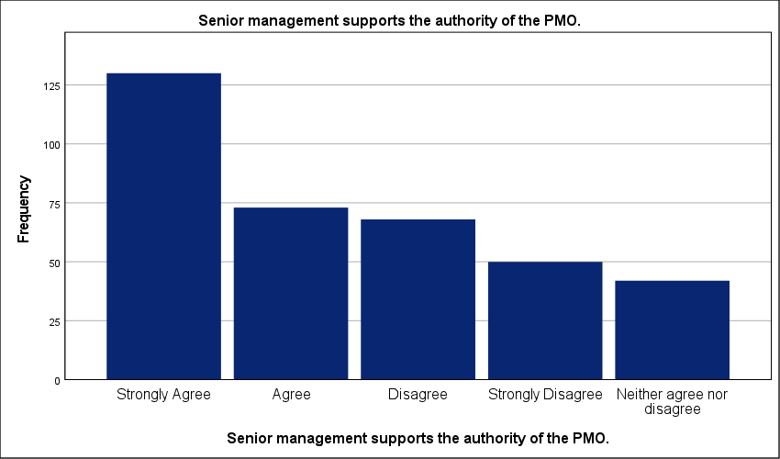
Figure 9 : Graphical representation of Perceived Senior Management Support for PMO Authority.

- The PMO is aligned with the organizational structure.
Exactly 11.8 percent of the workforce remains neutral regarding the PMO's alignment with organizational structure; this small undecided group is overshadowed by the 40.8 percent who strongly agree. The sector is split. A high standard deviation of 1.546 indicates a lack of standardization across the Saudi private sector. While the majority claims alignment, a significant 31.7 percent explicitly disagree or strongly disagree. Structure dictates strategic flow. This misalignment creates administrative silos that prevent the PMO from influencing core business units. When the office is detached from the primary hierarchy, strategic plans often stall during the transition from boardroom to field operation. Such a bottleneck likely causes delays in project resource allocation. The data reveals that structural integration is a localized success rather than a matured industry norm. Without a unified reporting structure, the PMO remains a detached reporting unit rather than an integrated governance engine.
The PMO is aligned with the organizational structure.
 |  | Frequency | Percent | Valid Percent | Cumulative Percent
Valid | Strongly Agree | 148 | 40.8 | 40.8 | 40.8
Valid | Strongly Disagree | 62 | 17.1 | 17.1 | 57.9
Valid | Agree | 57 | 15.7 | 15.7 | 73.6
Valid | Disagree | 53 | 14.6 | 14.6 | 88.2
Valid | Neither agree nor disagree | 43 | 11.8 | 11.8 | 100.0
Valid | Total | 363 | 100.0 | 100.0
Table 11 : Statistical analysis of Structural Alignment of the PMO within the Corporate Hierarchy.

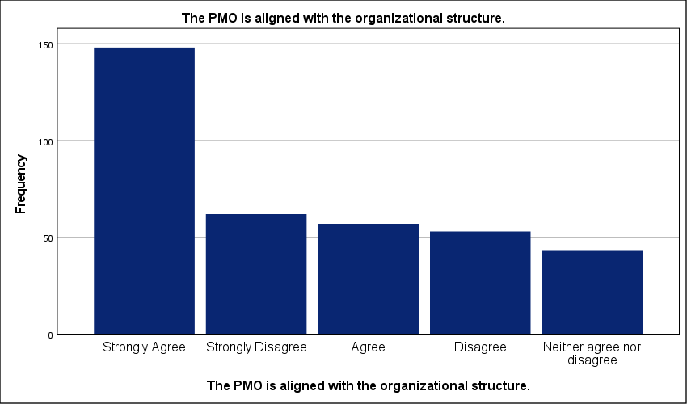
Figure 10 : Graphical representation of Structural Alignment of the PMO within the Corporate Hierarchy.

- The PMO has sufficient autonomy to perform its functions.
Just 8 percent of respondents maintain a neutral stance regarding PMO autonomy; this minor group is eclipsed by a deeply divided majority. While 38 percent of the sample strongly agrees that their offices possess sufficient independence, an almost equal 38.3 percent cumulative total reports a lack of functional freedom. Autonomy is highly inconsistent. A standard deviation of 1.631 highlights severe fragmentation across the sector—this suggests that PMO authority is often situational rather than systemic. Without the power to make independent calls, the PMO becomes a reporting tool that lacks the leverage to course-correct failing projects. This administrative friction likely causes significant delays in resource mobilization and strategic pivots. Decisions are held up by unnecessary layers of hierarchy. The data proves that for many Saudi firms, the PMO is active but not empowered. This governance gap prevents the office from acting as a true guardian of the strategic plan.
The PMO has sufficient autonomy to perform its functions.
 |  | Frequency | Percent | Valid Percent | Cumulative Percent
Valid | Strongly Agree | 138 | 38.0 | 38.0 | 38.0
Valid | Strongly Disagree | 83 | 22.9 | 22.9 | 60.9
Valid | Agree | 57 | 15.7 | 15.7 | 76.6
Valid | Disagree | 56 | 15.4 | 15.4 | 92.0
Valid | Neither agree nor disagree | 29 | 8.0 | 8.0 | 100.0
Valid | Total | 363 | 100.0 | 100.0
Table 12 : Statistical analysis of Evaluation of PMO Functional Autonomy and Independence.

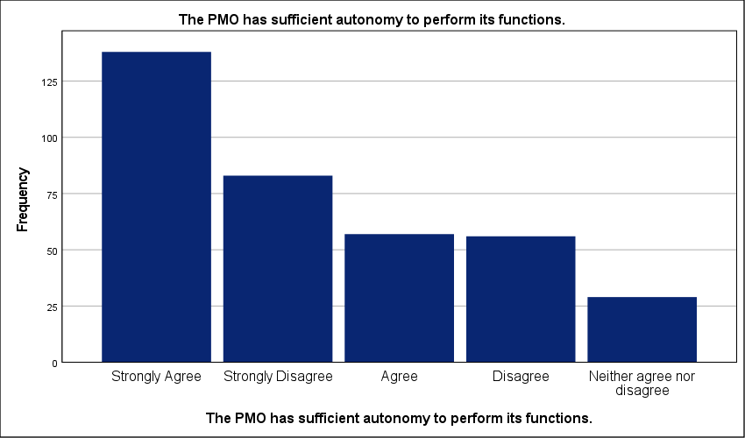
Figure 11 : Graphical representation of Evaluation of PMO Functional Autonomy and Independence.

- The PMO contributes to standardizing project management practices.
A standard deviation of 1.387 exposes a profound lack of standardization across the Saudi private sector. While 54 percent of the sample leans toward agreement, the wide spread of responses proves that procedural consistency is far from a matured industry norm. The workforce is divided. This lack of alignment suggests that while some PMOs have successfully implemented unified methodologies, a significant portion of the sector remains mired in ad-hoc workflows. Such an operational gap directly hinders strategic scalability. Inconsistent reporting across different business units makes it impossible for leadership to compare project performance accurately; this bottleneck likely leads to misallocated resources. Without a predictable baseline for project delivery, the strategic plan remains a theoretical exercise rather than an operational reality. High variance in these results highlights a sector where the PMO is struggling to enforce the very standards it was designed to uphold.
The PMO contributes to standardizing project management practices.
 |  | Frequency | Percent | Valid Percent | Cumulative Percent
Valid | Strongly Agree | 117 | 32.2 | 32.2 | 32.2
Valid | Agree | 79 | 21.8 | 21.8 | 54.0
Valid | Disagree | 69 | 19.0 | 19.0 | 73.0
Valid | Neither agree nor disagree | 59 | 16.3 | 16.3 | 89.3
Valid | Strongly Disagree | 39 | 10.7 | 10.7 | 100.0
Valid | Total | 363 | 100.0 | 100.0
Table 13 : Statistical analysis of PMO Contributions to Methodological Standardization.

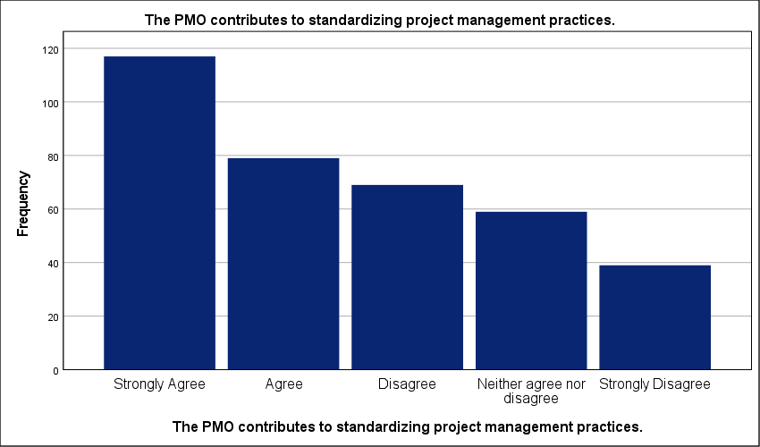
Figure 12 : Graphical representation of PMO Contributions to Methodological Standardization.

- The PMO ensures alignment between projects and organizational strategy.
Fragmentation defines the current state of strategic alignment across the Saudi private sector. The consensus is weak. A high standard deviation of 1.447 indicates polarized professional views; this suggests that while 37.7 percent of organizations have successfully integrated their PMO into the strategic layer, nearly 30 percent remain functionally disconnected. This lack of standardization is dangerous. It implies that many PMOs operate in tactical silos where project selection lacks rigorous strategic vetting. Strategic goals remain abstract. When the office fails to serve as a bridge, resources are often committed to initiatives that do not advance long-term organizational objectives. While the mean score suggests moderate progress, the high variance indicates that strategic alignment remains a localized success rather than a sector-wide norm. This gap likely results in wasted capital and missed market opportunities. Organizations without a synchronized PMO will continue to struggle with strategic execution during periods of rapid growth.
The PMO ensures alignment between projects and organizational strategy.
 |  | Frequency | Percent | Valid Percent | Cumulative Percent
Valid | Strongly Agree | 137 | 37.7 | 37.7 | 37.7
Valid | Agree | 76 | 20.9 | 20.9 | 58.7
Valid | Disagree | 56 | 15.4 | 15.4 | 74.1
Valid | Strongly Disagree | 47 | 12.9 | 12.9 | 87.1
Valid | Neither agree nor disagree | 47 | 12.9 | 12.9 | 100.0
Valid | Total | 363 | 100.0 | 100.0
Table 14 : Statistical analysis of Effectiveness of the PMO in Driving Strategic Project Alignment.

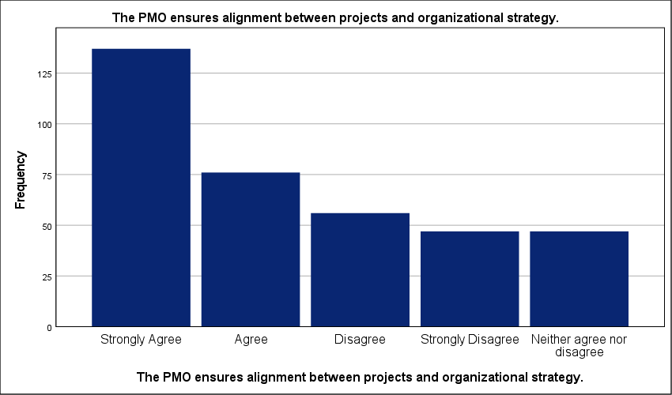
Figure 13 : Graphical representation of Effectiveness of the PMO in Driving Strategic Project Alignment.

- Project selection decisions reflect strategic organizational priorities.
Exactly 40.8 percent of respondents strongly agree that project selection reflects strategic priorities; this majority view stands in stark contrast to the 12.7 percent who explicitly disagree. Selection logic varies wildly. A high standard deviation of 1.511 confirms a severe lack of standardization in how Saudi private sector firms greenlight new initiatives. This fragmentation suggests that nearly half the workforce observes a disconnect between corporate goals and operational reality. Portfolio management suffers. When selection criteria are not standardized, organizations risk funding projects that offer no measurable strategic return. Such a bottleneck likely drains resources from critical initiatives—delaying the overall execution of the long-term plan. The data reveals a sector struggling to move beyond ad-hoc decision-making into a mature, PMO-governed investment model. This governance gap ensures that capital remains tied up in projects with low strategic contribution.
Project selection decisions reflect strategic organizational priorities.
 |  | Frequency | Percent | Valid Percent | Cumulative Percent
Valid | Strongly Agree | 148 | 40.8 | 40.8 | 40.8
Valid | Strongly Disagree | 58 | 16.0 | 16.0 | 56.7
Valid | Neither agree nor disagree | 56 | 15.4 | 15.4 | 72.2
Valid | Agree | 55 | 15.2 | 15.2 | 87.3
Valid | Disagree | 46 | 12.7 | 12.7 | 100.0
Valid | Total | 363 | 100.0 | 100.0
Table 15 : Statistical analysis of Alignment of Project Selection with Strategic Priorities.

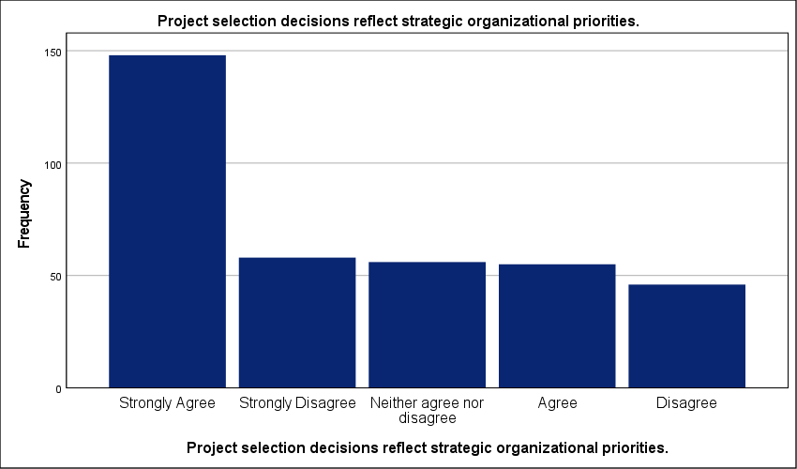
Figure 14 : Graphical representation of Alignment of Project Selection with Strategic Priorities.

- The PMO participates in strategic planning discussions.
A mere 10.7 percent of the cohort remains neutral on PMO involvement in strategic planning—this minor group is dwarfed by the 41.6 percent who strongly agree that their offices have a seat at the table. The divide is sharp. A high standard deviation of 1.572 signals severe fragmentation across the Saudi private sector regarding the office's perceived value in the boardroom. While more than half the respondents see their PMO as a strategic participant, nearly a third explicitly report being excluded from high-level discussions. This lack of standardization creates a critical operational bottleneck. When PMOs are excluded from the planning phase, strategic objectives often fail to account for technical resource constraints; this leads to unrealistic project timelines and subsequent delivery failures. The data suggests that for a large portion of the sector, the PMO remains a tactical reporting unit rather than a strategic partner. Separating planning from execution is a major risk. This disconnect ensures that long-term goals remain detached from the organizational capacity to actually deliver them.
The PMO participates in strategic planning discussions.
 |  | Frequency | Percent | Valid Percent | Cumulative Percent
Valid | Strongly Agree | 151 | 41.6 | 41.6 | 41.6
Valid | Strongly Disagree | 68 | 18.7 | 18.7 | 60.3
Valid | Agree | 58 | 16.0 | 16.0 | 76.3
Valid | Disagree | 47 | 12.9 | 12.9 | 89.3
Valid | Neither agree nor disagree | 39 | 10.7 | 10.7 | 100.0
Valid | Total | 363 | 100.0 | 100.0
Table 16 : Statistical analysis of PMO Involvement in High-Level Strategic Planning.

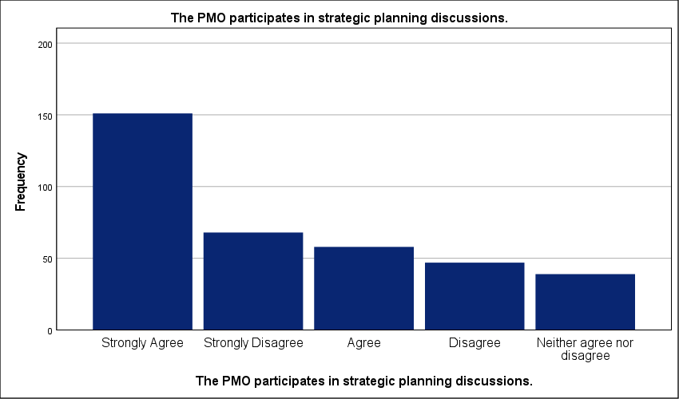
Figure 15 : Graphical representation of PMO Involvement in High-Level Strategic Planning.

- Projects are evaluated based on their strategic contribution.
Strongly disagreeing participants account for only 11 percent of the sample—a figure drastically outweighed by the 35 percent who strongly agree that strategic contribution is the primary metric for project evaluation. This disparity reveals a sector in transition. A high standard deviation of 1.405 confirms deep fragmentation in project governance across the Saudi private sector. While a majority claims to prioritize strategic value, the wide spread of responses suggests that many firms still lack a standardized scoring model. Project portfolios remain inconsistent. Without a rigorous, PMO-led evaluation process, capital is likely being funneled into initiatives based on tactical urgency rather than long-term strategic fit. This lack of alignment creates an operational bottleneck; it forces leadership to make trade-off decisions without quantifiable data. The data indicates that strategic evaluation is an aspirational goal for many, but a functional reality for only a few. Standardized metrics are missing. Until the PMO enforces a uniform evaluation framework, the strategic plan will continue to suffer from resource dilution across non-essential projects.
Projects are evaluated based on their strategic contribution.
 |  | Frequency | Percent | Valid Percent | Cumulative Percent
Valid | Strongly Agree | 127 | 35.0 | 35.0 | 35.0
Valid | Agree | 72 | 19.8 | 19.8 | 54.8
Valid | Disagree | 65 | 17.9 | 17.9 | 72.7
Valid | Neither agree nor disagree | 59 | 16.3 | 16.3 | 89.0
Valid | Strongly Disagree | 40 | 11.0 | 11.0 | 100.0
Valid | Total | 363 | 100.0 | 100.0
Table 17 : Statistical analysis of Strategic Contribution as a Project Evaluation Metric.

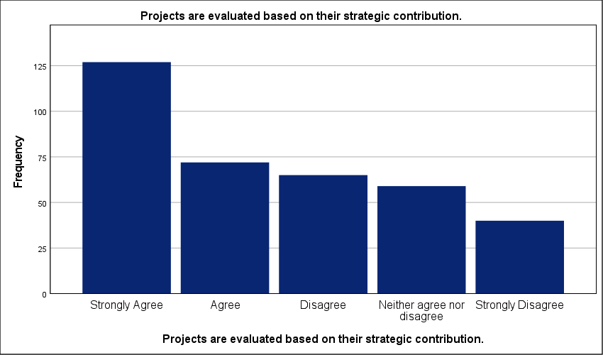
Figure 16 : Graphical representation of Strategic Contribution as a Project Evaluation Metric.

- The PMO helps translate strategic objectives into executable projects.
Strongly disagreeing participants represent the smallest portion of the sample at 12.9 percent; this is significantly lower than the 33.3 percent who strongly agree that the PMO effectively translates strategy into execution. The workforce is split. This 20.4 percent gap highlights a deep operational divide within the Saudi private sector. A high standard deviation of 1.415 signals severe fragmentation—it suggests that for many firms, the PMO is failing to bridge the gap between abstract boardroom goals and ground-level project tasks. Translation is failing. When this link is broken, strategic objectives remain disconnected from the technical capacity of the organization. This bottleneck likely leads to project delays and resource misallocation as teams struggle to interpret vague mandates. While 57.8 percent of respondents lean toward agreement, the wide distribution proves that the industry lacks a standardized methodology for this transition. Without a consistent framework, the PMO remains a tactical reporting unit rather than a functional engine for strategy. Success is purely localized. The data reveals that many organizations still treat the PMO as an administrative layer rather than a strategic partner.
The PMO helps translate strategic objectives into executable projects.
 |  | Frequency | Percent | Valid Percent | Cumulative Percent
Valid | Strongly Agree | 121 | 33.3 | 33.3 | 33.3
Valid | Agree | 89 | 24.5 | 24.5 | 57.9
Valid | Disagree | 55 | 15.2 | 15.2 | 73.0
Valid | Neither agree nor disagree | 51 | 14.0 | 14.0 | 87.1
Valid | Strongly Disagree | 47 | 12.9 | 12.9 | 100.0
Valid | Total | 363 | 100.0 | 100.0
Table 18 : Statistical analysis of Role of the PMO in Translating Strategy into Execution.

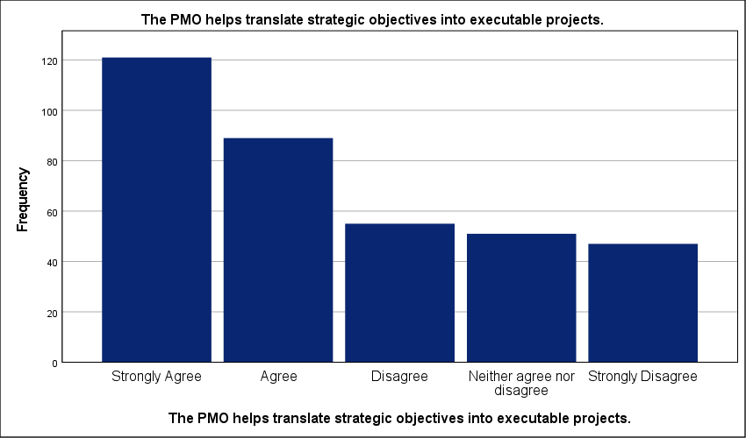
Figure 17 : Graphical representation of Role of the PMO in Translating Strategy into Execution.

- Strategic changes are effectively communicated through the PMO.
Only 9.6 percent of respondents occupy the neutral middle ground regarding strategic communication efficiency; this minor segment stands in stark contrast to the 34.2 percent who strongly agree with the PMO’s performance in this area. Messaging is fractured. A high standard deviation of 1.540 confirms severe fragmentation across the industry. Such a wide spread suggests that the PMO is not yet a reliable or standardized conduit for top-down strategic shifts. This breakdown in information flow creates a dangerous operational bottleneck. Project teams in nearly 37 percent of surveyed firms are likely operating on outdated or poorly understood mandates. Strategic execution stalls. Without a consistent communication framework, the office remains a passive observer rather than an active bridge between the boardroom and the field. This inconsistency prevents rapid organizational pivots during market shifts. The results reflect a sector where information silos still undermine long-term strategic coherence.
Strategic changes are effectively communicated through the PMO.
 |  | Frequency | Percent | Valid Percent | Cumulative Percent
Valid | Strongly Agree | 124 | 34.2 | 34.2 | 34.2
Valid | Agree | 71 | 19.6 | 19.6 | 53.7
Valid | Disagree | 67 | 18.5 | 18.5 | 72.2
Valid | Strongly Disagree | 66 | 18.2 | 18.2 | 90.4
Valid | Neither agree nor disagree | 35 | 9.6 | 9.6 | 100.0
Valid | Total | 363 | 100.0 | 100.0
Table 19 : Statistical analysis of Communication of Strategic Shifts via PMO Channels.

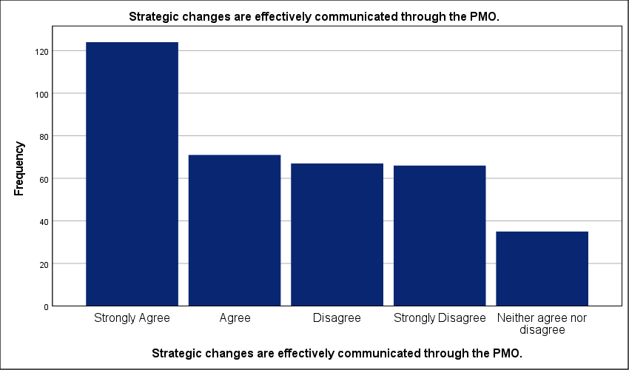
Figure 18 : Graphical representation of Communication of Strategic Shifts via PMO Channels.

- The PMO reduces misalignment between projects and strategic goals.
Nearly 25 percent of respondents strongly disagree that the PMO reduces strategic misalignment—this contrasts sharply with the 34.2 percent who view the office as an effective corrective tool. The sector is fractured. A high standard deviation of 1.611 confirms severe fragmentation; this indicates that the office's ability to realign projects with corporate goals is situational rather than systemic. The link is broken. Such polarized results suggest that in many Saudi firms, the PMO exists as a reporting layer but lacks the authority to halt non-strategic initiatives. This bottleneck likely leads to significant resource leakage and delays in long-term plan execution. Without an empowered governance body, project portfolios drift toward tactical urgency. The data proves that standardization is missing. Until the PMO is granted the mandate to prune misaligned projects, strategic coherence will remain localized rather than an industry standard.
The PMO reduces misalignment between projects and strategic goals.
 |  | Frequency | Percent | Valid Percent | Cumulative Percent
Valid | Strongly Agree | 124 | 34.2 | 34.2 | 34.2
Valid | Strongly Disagree | 90 | 24.8 | 24.8 | 59.0
Valid | Agree | 70 | 19.3 | 19.3 | 78.2
Valid | Disagree | 40 | 11.0 | 11.0 | 89.3
Valid | Neither agree nor disagree | 39 | 10.7 | 10.7 | 100.0
Valid | Total | 363 | 100.0 | 100.0
Table 20 : Statistical analysis of PMO Efficacy in Mitigating Strategic Misalignment.

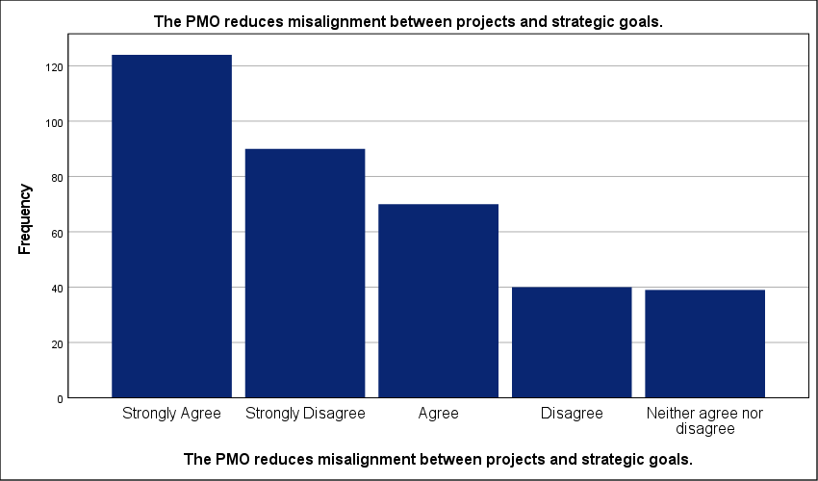
Figure 19 : Graphical representation of PMO Efficacy in Mitigating Strategic Misalignment.

- The PMO provides accurate data to support strategic decision-making.
Exactly 36.9 percent of executives strongly rely on PMO data for strategic choices. This reliability is inconsistent. A high standard deviation of 1.455 reflects a fragmented data environment across the Saudi private sector. Information quality varies wildly. While a slight majority leans toward agreement, the significant spread suggests that nearly 30 percent of firms struggle with data integrity. This bottleneck likely forces leadership to rely on intuition rather than empirical evidence. Strategy execution requires precision. When the PMO fails to deliver accurate reporting, decision-making becomes reactive; this delay prevents organizations from pivoting effectively during market shifts. The results show a sector-wide lack of standardization in reporting tools. Without a unified data system, the PMO remains an administrative hub rather than a strategic intelligence engine. High-quality data is the currency of strategy. For many organizations, this currency is currently devalued by manual reporting errors and disparate software platforms.
The PMO provides accurate data to support strategic decision-making.
 |  | Frequency | Percent | Valid Percent | Cumulative Percent
Valid | Strongly Agree | 134 | 36.9 | 36.9 | 36.9
Valid | Agree | 64 | 17.6 | 17.6 | 54.5
Valid | Neither agree nor disagree | 61 | 16.8 | 16.8 | 71.3
Valid | Disagree | 54 | 14.9 | 14.9 | 86.2
Valid | Strongly Disagree | 50 | 13.8 | 13.8 | 100.0
Valid | Total | 363 | 100.0 | 100.0
Table 21 : Statistical analysis of Reliability of PMO Data for Strategic Decision Support.

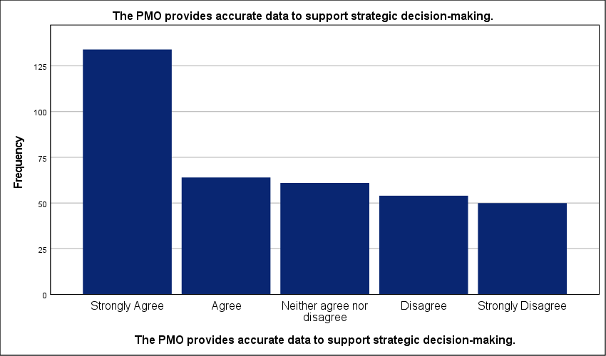
Figure 20 : Graphical representation of Reliability of PMO Data for Strategic Decision Support.

- Project performance reports support long-term planning decisions.
Fragmented reporting structures cripple long-term forecasting across 31.4 percent of the surveyed firms. The data is inconsistent. While 34.7 percent strongly agree that performance reports aid planning, a high standard deviation of 1.469 reveals a deep lack of standardization in the Saudi private sector. This variance suggests that many PMOs generate reports that lack the granularity required for executive decision-making. Strategic pivots become impossible. Without a consistent link between current performance and future goals, these organizations are essentially operating in a data vacuum. This bottleneck likely delays the reallocation of resources to high-value projects; it forces leadership to rely on historical intuition rather than real-time insights. The mean score of 3.44 hides a polarized reality. High-performing PMOs provide clarity—others merely add noise to the boardroom. Until reporting is standardized, long-term plans will remain disconnected from operational performance.
Project performance reports support long-term planning decisions.
 |  | Frequency | Percent | Valid Percent | Cumulative Percent
Valid | Strongly Agree | 126 | 34.7 | 34.7 | 34.7
Valid | Agree | 75 | 20.7 | 20.7 | 55.4
Valid | Disagree | 61 | 16.8 | 16.8 | 72.2
Valid | Strongly Disagree | 53 | 14.6 | 14.6 | 86.8
Valid | Neither agree nor disagree | 48 | 13.2 | 13.2 | 100.0
Valid | Total | 363 | 100.0 | 100.0
Table 22 : Statistical analysis of Impact of Performance Reporting on Long-term Planning.

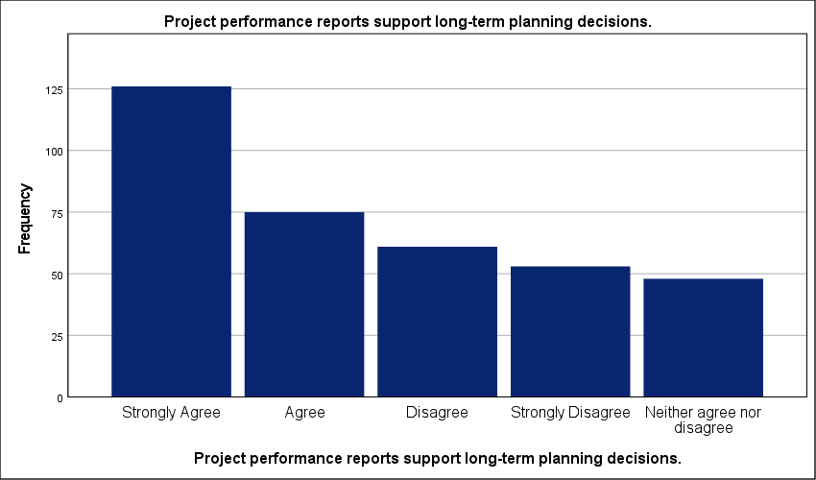
Figure 21 : Graphical representation of Impact of Performance Reporting on Long-term Planning.

- The PMO enhances transparency in project-related decisions.
The data suggests that transparency is still a work in progress, with roughly 35% of firms struggling to achieve clear visibility in project decisions. A high standard deviation of 1.596 signals deep fragmentation across the sector. While 35.3 percent of respondents strongly agree that the PMO improves visibility, a substantial 23.1 percent report a lack of clarity in project-related decisions. This polarized environment is risky. Inconsistent transparency creates a bottleneck that prevents stakeholders from identifying failing initiatives before they drain critical resources—it suggests project governance is still handled in silos in a large portion of the Saudi private sector. Without a standardized reporting culture, the PMO fails to act as a single source of truth; decisions are likely influenced by internal politics rather than objective data. Trust in leadership execution suffers. Organizations with high variance in transparency are essentially operating with blind spots that compromise their long-term strategic integrity.
The PMO enhances transparency in project-related decisions.
 |  | Frequency | Percent | Valid Percent | Cumulative Percent
Valid | Strongly Agree | 128 | 35.3 | 35.3 | 35.3
Valid | Strongly Disagree | 84 | 23.1 | 23.1 | 58.4
Valid | Agree | 61 | 16.8 | 16.8 | 75.2
Valid | Neither agree nor disagree | 46 | 12.7 | 12.7 | 87.9
Valid | Disagree | 44 | 12.1 | 12.1 | 100.0
Valid | Total | 363 | 100.0 | 100.0
Table 23 : Statistical analysis of PMO Influence on Decision-making Transparency.

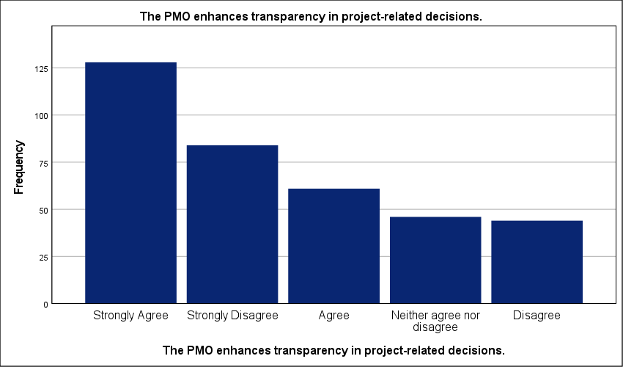
Figure 22 : Graphical representation of PMO Influence on Decision-making Transparency.

- Management relies on PMO reports when making strategic choices.
Exactly 10.2 percent of respondents remain neutral—the lowest frequency in the set—yet this is overshadowed by the 36.4 percent who strongly agree that PMO reports anchor strategic choices. The data is polarized. A high standard deviation of 1.640 proves a severe lack of standardization in how leadership utilizes the office. While many firms trust the data, a substantial 25.6 percent strongly disagree. Professional reliance is inconsistent. This disparity suggests a bottleneck where executive decision-making remains detached from PMO outputs in over a quarter of the surveyed organizations. When management ignores these reports, strategic initiatives lose their empirical foundation; this leads to misallocated capital and project drift. Decisions are delayed. High variance indicates that the PMO is not yet the universal single source of truth for the Saudi private sector. The impact of the office on the strategic plan is crippled when its reporting is treated as optional rather than mandatory.
Management relies on PMO reports when making strategic choices.
 |  | Frequency | Percent | Valid Percent | Cumulative Percent
Valid | Strongly Agree | 132 | 36.4 | 36.4 | 36.4
Valid | Strongly Disagree | 93 | 25.6 | 25.6 | 62.0
Valid | Agree | 61 | 16.8 | 16.8 | 78.8
Valid | Disagree | 40 | 11.0 | 11.0 | 89.8
Valid | Neither agree nor disagree | 37 | 10.2 | 10.2 | 100.0
Valid | Total | 363 | 100.0 | 100.0
Table 24 : Statistical analysis of Executive Reliance on PMO Analytics for Strategic Choices.

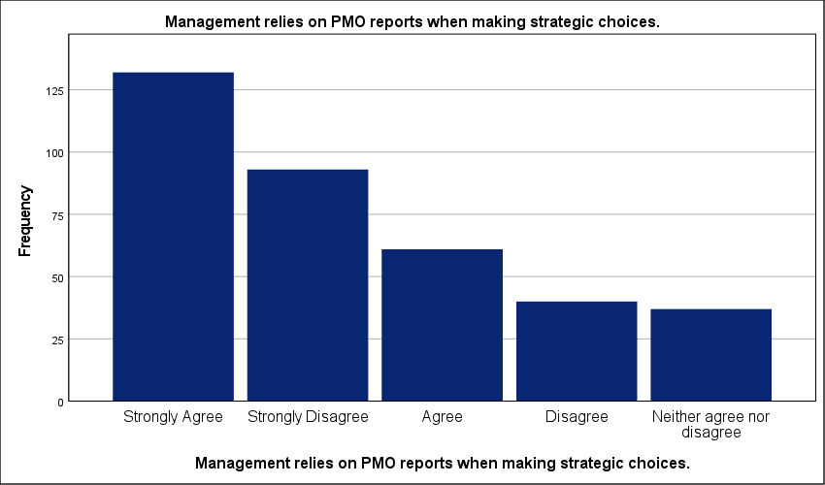
Figure 23 : Graphical representation of Executive Reliance on PMO Analytics for Strategic Choices.

- The PMO improves risk assessment during strategic planning.
Exactly 10.7 percent of the sample strongly disagrees that the PMO improves risk assessment; this minority view is dwarfed by the 36.9 percent who report significant improvements in risk identification during strategic phases. The sector is fragmented. A high standard deviation of 1.414 reflects a lack of standardization in risk management protocols across Saudi firms. This variance is a red flag. It implies that risk assessment is often an afterthought in the planning cycle for a large portion of the market. Such a bottleneck likely exposes strategic projects to preventable delays and cost overruns. Without a centralized PMO to enforce rigorous risk modeling, strategic plans remain inherently fragile. These results suggest that many organizations still rely on qualitative intuition rather than the quantitative data systems a mature PMO should provide. Operational stability depends on this link. Strategic execution will continue to face high failure rates until risk integration becomes a mandatory PMO function.
The PMO improves risk assessment during strategic planning.
 |  | Frequency | Percent | Valid Percent | Cumulative Percent
Valid | Strongly Agree | 134 | 36.9 | 36.9 | 36.9
Valid | Agree | 73 | 20.1 | 20.1 | 57.0
Valid | Disagree | 66 | 18.2 | 18.2 | 75.2
Valid | Neither agree nor disagree | 51 | 14.0 | 14.0 | 89.3
Valid | Strongly Disagree | 39 | 10.7 | 10.7 | 100.0
Valid | Total | 363 | 100.0 | 100.0
Table 25 : Statistical analysis of PMO Contributions to Strategic Risk Management.

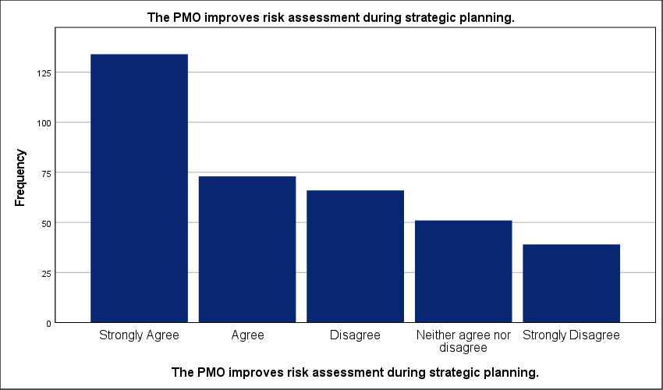
Figure 24 : Graphical representation of PMO Contributions to Strategic Risk Management.

- The PMO supports prioritization of strategic initiatives.
Exactly 37.5 percent of respondents strongly agree that the PMO drives initiative prioritization; this is more than triple the 10.5 percent who remain neutral. Professional views are polarized. A high standard deviation of 1.453 signals severe fragmentation in how Saudi private sector firms manage their strategic portfolios. While a majority—58.4 percent—lean toward agreement, the 31.1 percent total disagreement rate reflects a lack of industry standardization. This gap is dangerous. Organizations lacking a formal prioritization framework likely experience significant resource leakage. Strategic goals remain underfunded while tactical noise consumes the budget. This bottleneck prevents a synchronized transition from planning to execution. The data reveals that many PMOs lack the mandate to enforce strategic rank—they function as reporting units rather than gatekeepers. Portfolio drift is an immediate risk. Without a unified scoring model, the impact on the strategic plan remains purely localized and inconsistent.
The PMO supports prioritization of strategic initiatives.
 |  | Frequency | Percent | Valid Percent | Cumulative Percent
Valid | Strongly Agree | 136 | 37.5 | 37.5 | 37.5
Valid | Agree | 76 | 20.9 | 20.9 | 58.4
Valid | Disagree | 69 | 19.0 | 19.0 | 77.4
Valid | Strongly Disagree | 44 | 12.1 | 12.1 | 89.5
Valid | Neither agree nor disagree | 38 | 10.5 | 10.5 | 100.0
Valid | Total | 363 | 100.0 | 100.0
Table 26 : Statistical analysis of PMO Support for Strategic Initiative Prioritization.

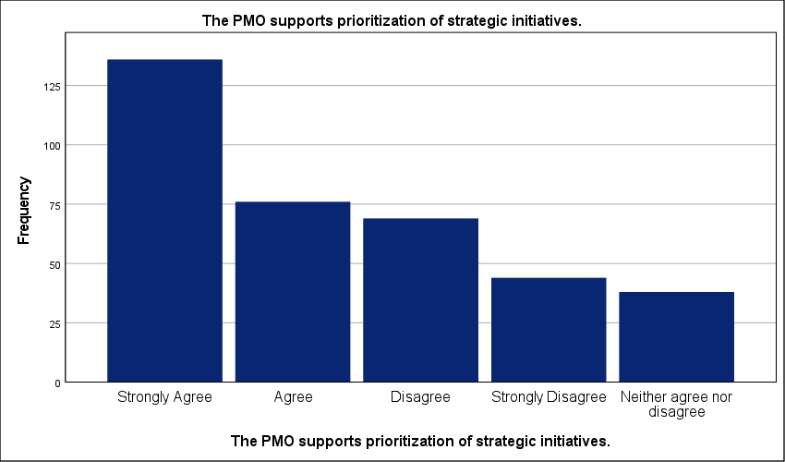
Figure 25 : Graphical representation of PMO Support for Strategic Initiative Prioritization.

- Decisions become more consistent due to PMO involvement.
Thirty-six point four percent of respondents strongly agree that PMO involvement stabilizes decision-making; yet, a nearly identical 34.7 percent explicitly disagree. Consistency remains elusive. The data is polarized. A high standard deviation of 1.503 confirms deep fragmentation across the Saudi private sector. This variance suggests that the office's influence on corporate discipline is situational rather than systemic. Decisions are still made in silos. Such variability creates a dangerous operational bottleneck. It forces project teams to navigate unpredictable executive shifts. This inconsistency turns the strategic plan into a moving target. Without a unified governance engine, organizations cannot guarantee that today's choices align with tomorrow's goals. The findings reflect a sector-wide struggle to replace ad-hoc intuition with rigorous, data-driven logic. This operational gap prevents the PMO from acting as a true anchor for long-term objectives.
Decisions become more consistent due to PMO involvement.
 |  | Frequency | Percent | Valid Percent | Cumulative Percent
Valid | Strongly Agree | 132 | 36.4 | 36.4 | 36.4
Valid | Disagree | 72 | 19.8 | 19.8 | 56.2
Valid | Agree | 56 | 15.4 | 15.4 | 71.6
Valid | Strongly Disagree | 54 | 14.9 | 14.9 | 86.5
Valid | Neither agree nor disagree | 49 | 13.5 | 13.5 | 100.0
Valid | Total | 363 | 100.0 | 100.0
Table 27 : Statistical analysis of Consistency in Organizational Decisions through PMO Governance.

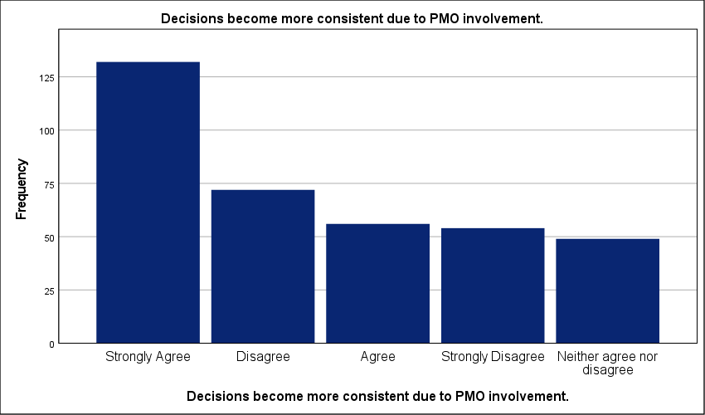
Figure 26 : Graphical representation of Consistency in Organizational Decisions through PMO Governance.

- The PMO uses standardized project management tools.
Forty point two percent of firms have institutionalized standardized project management tools; this represents the largest group, yet it is starkly contrasted by a combined 34.1 percent reporting a total lack of uniform systems. Technical infrastructure is fragmented. A high standard deviation of 1.618 reveals a polarized environment where organizations either operate with high-tech integration or rely on ad-hoc, manual processes. This discrepancy creates a significant operational bottleneck. It prevents the seamless flow of data required for strategic forecasting—it forces leadership to rely on fragmented reports that are often out of sync. Without a common digital framework, the PMO cannot aggregate portfolio health accurately. Efficiency remains localized. The findings suggest that many Saudi private firms are still in the early stages of digital maturity. This lack of standardization slows down the response to strategic shifts. Strategic plans remain vulnerable to data lag. Organizations must bridge this software gap to ensure that project performance reflects real-time organizational priorities.
The PMO uses standardized project management tools.
 |  | Frequency | Percent | Valid Percent | Cumulative Percent
Valid | Strongly Agree | 146 | 40.2 | 40.2 | 40.2
Valid | Strongly Disagree | 80 | 22.0 | 22.0 | 62.3
Valid | Agree | 58 | 16.0 | 16.0 | 78.2
Valid | Disagree | 44 | 12.1 | 12.1 | 90.4
Valid | Neither agree nor disagree | 35 | 9.6 | 9.6 | 100.0
Valid | Total | 363 | 100.0 | 100.0
Table 28 : Statistical analysis of Adoption of Standardized Project Management Software and Tools.

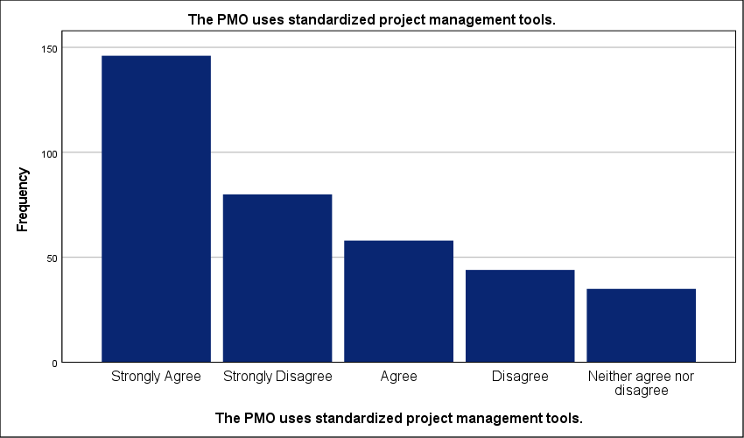
Figure 27 : Graphical representation of Adoption of Standardized Project Management Software and Tools.

- PMO methodologies improve the quality of strategic planning.
Fifty-nine percent of the cohort recognizes that PMO methodologies enhance planning quality; however, a high standard deviation of 1.391 exposes deep fragmentation in the Saudi private sector. Planning remains inconsistently applied. While the mean of 3.58 indicates a general lean toward agreement, the wide spread of responses proves that many organizations lack a standardized framework for strategic integration. This methodological gap is critical. It suggests that nearly 30 percent of firms are executing projects without a robust strategic anchor—this failure likely results in frequent changes to project scopes and wasted capital. Strategic plans are often unrealistic. When methodologies are treated as optional or administrative rather than foundational, the quality of forecasting suffers. This bottleneck prevents leadership from accurately measuring long-term success. The data reflects an industry where PMO maturity is a localized advantage rather than a universal standard.
PMO methodologies improve the quality of strategic planning.
 |  | Frequency | Percent | Valid Percent | Cumulative Percent
Valid | Strongly Agree | 132 | 36.4 | 36.4 | 36.4
Valid | Agree | 82 | 22.6 | 22.6 | 59.0
Valid | Disagree | 60 | 16.5 | 16.5 | 75.5
Valid | Neither agree nor disagree | 51 | 14.0 | 14.0 | 89.5
Valid | Strongly Disagree | 38 | 10.5 | 10.5 | 100.0
Valid | Total | 363 | 100.0 | 100.0
Table 29 : Statistical analysis of Influence of PMO Methodologies on Strategic Planning Quality.

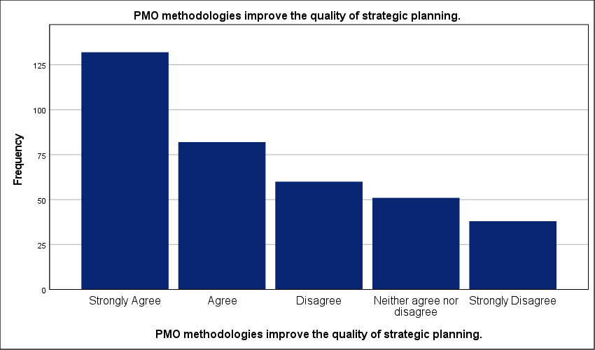
Figure 28 : Graphical representation of Influence of PMO Methodologies on Strategic Planning Quality.

- Project data systems support strategic forecasting.
A high standard deviation of 1.466 reveals a profound lack of consistency in how project data systems support strategic forecasting across the Saudi private sector. Professional experiences are fragmented. While 35 percent of the sample strongly agrees with the effectiveness of these systems, the 30.6 percent who disagree highlight a significant technological gap. The sector is polarized. This high variance suggests that data systems are not standardized—it implies that many PMOs still rely on disparate databases or manual reporting. Such an operational bottleneck prevents the real-time data flow necessary for accurate long-term planning. Strategic pivots are delayed. Without a unified digital architecture, forecasting becomes a reactive exercise rather than a proactive governance tool. The mean of 3.45 is statistically misleading. It fails to reflect the reality that nearly half the respondents operate without robust predictive analytics. Strategic plans remain vulnerable to data lag. Integration is the missing link.
Project data systems support strategic forecasting.
 |  | Frequency | Percent | Valid Percent | Cumulative Percent
Valid | Strongly Agree | 127 | 35.0 | 35.0 | 35.0
Valid | Agree | 74 | 20.4 | 20.4 | 55.4
Valid | Disagree | 58 | 16.0 | 16.0 | 71.3
Valid | Strongly Disagree | 53 | 14.6 | 14.6 | 86.0
Valid | Neither agree nor disagree | 51 | 14.0 | 14.0 | 100.0
Valid | Total | 363 | 100.0 | 100.0
Table 30 : Statistical analysis of Effectiveness of Data Systems in Strategic Forecasting.

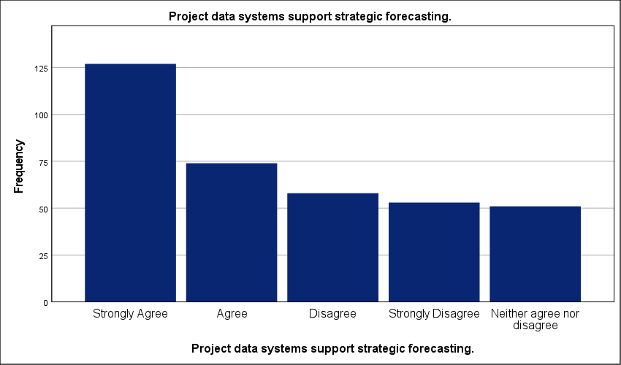
Figure 29 : Graphical representation of Effectiveness of Data Systems in Strategic Forecasting.

- The PMO facilitates integration between different projects.
Exactly 41.6 percent of the workforce strongly agrees that the PMO facilitates integration between different projects—this is the highest level of agreement across the operational categories. Synergy is not universal. A high standard deviation of 1.503 reveals a lack of standardization; this suggests that while some organizations have achieved cross-project synchronization, many others are still struggling with siloed management. This bottleneck likely leads to uncoordinated resource allocation and duplicated efforts. Projects are competing. When PMOs fail to act as a central integrator, the risk of dependency failure increases significantly. This gap prevents the organization from realizing the collective value of its portfolio. Strategic execution requires more than individual project success; it demands a unified flow. These results indicate that inter-project coordination is currently a localized achievement rather than a mature industry norm. Without this integration, the strategic plan remains a collection of disjointed tasks.
The PMO facilitates integration between different projects.
 |  | Frequency | Percent | Valid Percent | Cumulative Percent
Valid | Strongly Agree | 151 | 41.6 | 41.6 | 41.6
Valid | Agree | 63 | 17.4 | 17.4 | 59.0
Valid | Disagree | 60 | 16.5 | 16.5 | 75.5
Valid | Strongly Disagree | 51 | 14.0 | 14.0 | 89.5
Valid | Neither agree nor disagree | 38 | 10.5 | 10.5 | 100.0
Valid | Total | 363 | 100.0 | 100.0
Table 31 : Statistical analysis of The Cross-Project Integration Facilitated by the PMO.

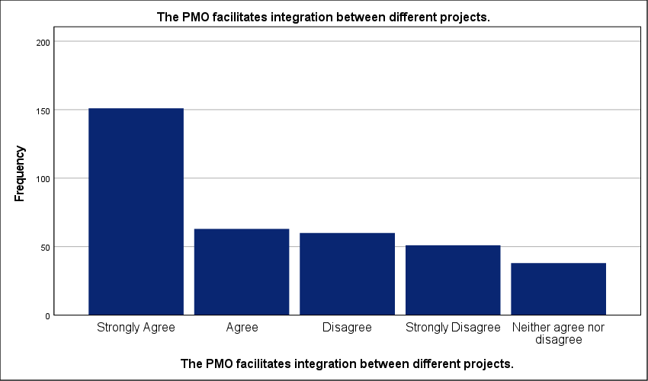
Figure 30 : Graphical representation of Cross-Project Integration Facilitated by the PMO.

- Lessons learned are systematically used in strategic planning.
Exactly 36.1 percent of the sector explicitly fails to incorporate historical knowledge into their strategic cycles; this failure stands against the 39.9 percent who strongly agree with the systematic use of lessons learned. Knowledge transfer is fractured. A high standard deviation reflects severe fragmentation in organizational memory across Saudi private firms. While half the respondents report some level of usage, the polarized results prove that these processes are rarely institutionalized. They depend on individual competence rather than corporate policy. This lack of standardization is a critical bottleneck. It causes tactical errors to repeat across business units—this inevitably slows project delivery and inflates budgets. Without a unified database, strategic planning remains reactive. The data reveals an industry where experience is often lost between projects. This operational gap prevents the PMO from acting as a continuous improvement engine for the long-term plan.
Lessons learned are systematically used in strategic planning.
 |  | Frequency | Percent | Valid Percent | Cumulative Percent
Valid | Strongly Agree | 145 | 39.9 | 39.9 | 39.9
Valid | Strongly Disagree | 69 | 19.0 | 19.0 | 59.0
Valid | Disagree | 62 | 17.1 | 17.1 | 76.0
Valid | Agree | 51 | 14.0 | 14.0 | 90.1
Valid | Neither agree nor disagree | 36 | 9.9 | 9.9 | 100.0
Valid | Total | 363 | 100.0 | 100.0
Table 32 : Statistical analysis of Systematic Utilization of Lessons Learned in Strategy.

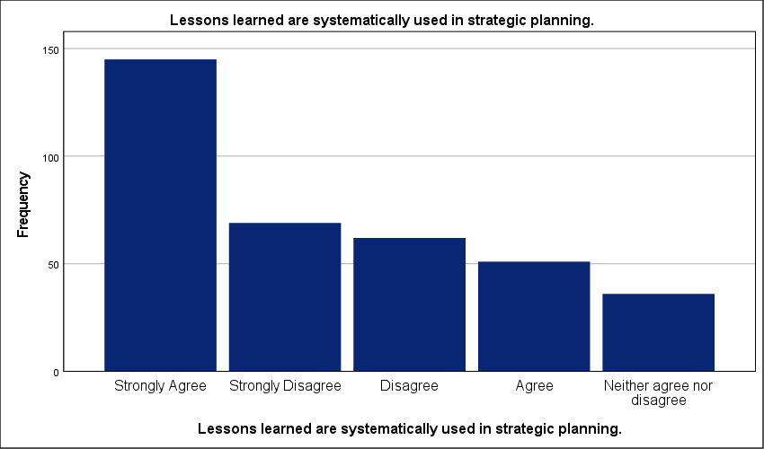
Figure 31 : Graphical representation of Systematic Utilization of Lessons Learned in Strategy.

- PMO processes enhance efficiency in strategic execution.
Nearly 30 percent of the Saudi private sector sees no efficiency gains from PMO integration; this resistance stands in direct opposition to the 35.3 percent who strongly agree with the office’s impact. Execution remains fractured. A standard deviation of 1.416 confirms a lack of standardization across the market. Consensus is missing. While a majority reports positive outcomes, the significant disagreement rate suggests that PMO processes are often viewed as a bureaucratic hurdle rather than a facilitator. This bottleneck likely delays project delivery timelines. When administrative workflows are not aligned with strategic speed, the entire plan suffers from reduced throughput. Such fragmentation prevents the organization from scaling its strategic initiatives effectively. Real efficiency requires systemic change. The data reveals that for a large portion of the sector, the PMO has yet to prove its value as an engine of operational excellence. Until processes are matured and unified, the strategic plan will remain vulnerable to execution gaps.
PMO processes enhance efficiency in strategic execution.
 |  | Frequency | Percent | Valid Percent | Cumulative Percent
Valid | Strongly Agree | 128 | 35.3 | 35.3 | 35.3
Valid | Agree | 78 | 21.5 | 21.5 | 56.7
Valid | Disagree | 62 | 17.1 | 17.1 | 73.8
Valid | Neither agree nor disagree | 51 | 14.0 | 14.0 | 87.9
Valid | Strongly Disagree | 44 | 12.1 | 12.1 | 100.0
Valid | Total | 363 | 100.0 | 100.0
Table 33 : Statistical analysis of Efficiency Gains in Strategic Execution via PMO Processes.

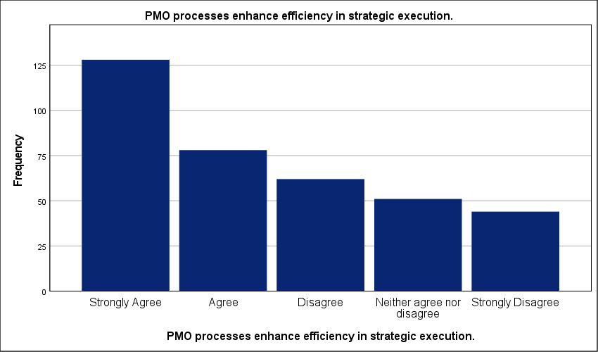
Figure 32 : Graphical representation of Efficiency Gains in Strategic Execution via PMO Processes.

- The PMO promotes best practices across projects.
Just 13.2 percent of the sample strongly disagrees with the PMO’s role in promoting best practices; this minority is eclipsed by the 36.6 percent who strongly agree. The results reflect a divided sector. A high standard deviation of 1.458 points toward severe fragmentation in how Saudi firms define and apply project standards. Professional alignment is missing. While 57.5 percent of organizations move toward better methodologies, the significant spread proves that standardization is far from a universal reality. This lack of consistency creates a major operational bottleneck. It forces project managers to reinvent the wheel for every initiative—this directly delays project delivery. Without a centralized authority to enforce these practices, the strategic plan loses its technical foundation. Ad-hoc management remains the default for over a quarter of the market. The data indicates that the PMO is often a best practice advocate in theory but lacks the power to implement it in practice.
The PMO promotes best practices across projects.
 |  | Frequency | Percent | Valid Percent | Cumulative Percent
Valid | Strongly Agree | 133 | 36.6 | 36.6 | 36.6
Valid | Agree | 76 | 20.9 | 20.9 | 57.6
Valid | Disagree | 54 | 14.9 | 14.9 | 72.5
Valid | Neither agree nor disagree | 52 | 14.3 | 14.3 | 86.8
Valid | Strongly Disagree | 48 | 13.2 | 13.2 | 100.0
Valid | Total | 363 | 100.0 | 100.0
Table 34 : Statistical analysis of PMO Role in Best Practice Dissemination and Advocacy.

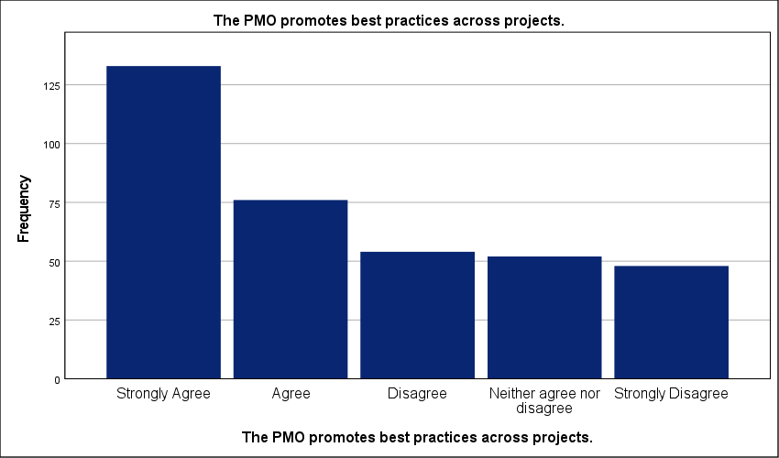
Figure 33 : Graphical representation of PMO Role in Best Practice Dissemination and Advocacy.

- Strategic plans are more realistic due to PMO involvement.
Exactly 11.6 percent of the participants explicitly disagree that the PMO makes strategic plans more realistic; this small contingent is dwarfed by the 36.9 percent who strongly agree. The sector is fractured. A high standard deviation of 1.488 exposes a severe lack of standardization across the Saudi private sector. While 57.3 percent cumulative agreement indicates progress, the significant 29.5 percent disagreement rate suggests that many strategic plans still lack necessary technical grounding. Theoretical goals often ignore field realities. This bottleneck likely leads to project delays as teams struggle to execute unrealistic mandates. When the office fails to validate assumptions with operational data, the strategic plan remains a purely academic exercise. Resource misallocation is a constant risk. The data reveals that the PMO’s role in grounding strategy is highly inconsistent. Success remains purely localized rather than an industry-wide norm. Without a unified validation framework, strategic forecasting remains unreliable for nearly one-third of the market.
Strategic plans are more realistic due to PMO involvement.
 |  | Frequency | Percent | Valid Percent | Cumulative Percent
Valid | Strongly Agree | 134 | 36.9 | 36.9 | 36.9
Valid | Agree | 74 | 20.4 | 20.4 | 57.3
Valid | Strongly Disagree | 65 | 17.9 | 17.9 | 75.2
Valid | Neither agree nor disagree | 48 | 13.2 | 13.2 | 88.4
Valid | Disagree | 42 | 11.6 | 11.6 | 100.0
Valid | Total | 363 | 100.0 | 100.0
Table 35 : Statistical analysis of Strategic Realism and PMO Operational Validation.

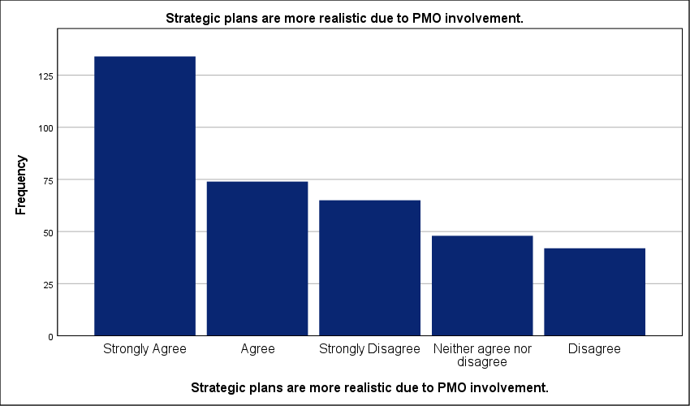
Figure 34 : Graphical representation of Strategic Realism and PMO Operational Validation.

- The PMO improves the implementation of strategic plans.
A stark contrast exists between the 36.6 percent who strongly agree and the mere 10.7 percent who remain neutral regarding strategic implementation. The sector is polarized. This high variance reflects a profound fragmentation in how Saudi firms execute their long-term plans through the PMO. Alignment is missing. While a majority leans toward improved implementation, the 23.7 percent who strongly disagree indicates a severe lack of standardization in project governance. Such a gap creates a critical bottleneck that likely prevents strategic goals from reaching operational reality. Implementation fails in the transition. When the office lacks clear authority, the strategic plan remains a theoretical document rather than an active roadmap. The data suggests that success is currently localized to high-maturity firms. Without a unified mandate, the PMO cannot consistently bridge the gap between planning and field results. Decisions are often stalled by bureaucratic silos. Standardized implementation is not yet an industry norm.
The PMO improves the implementation of strategic plans.
 |  | Frequency | Percent | Valid Percent | Cumulative Percent
Valid | Strongly Agree | 133 | 36.6 | 36.6 | 36.6
Valid | Strongly Disagree | 86 | 23.7 | 23.7 | 60.3
Valid | Agree | 57 | 15.7 | 15.7 | 76.0
Valid | Disagree | 48 | 13.2 | 13.2 | 89.3
Valid | Neither agree nor disagree | 39 | 10.7 | 10.7 | 100.0
Valid | Total | 363 | 100.0 | 100.0
Table 36 : Statistical analysis of PMO Impact on the Execution of Strategic Roadmaps.

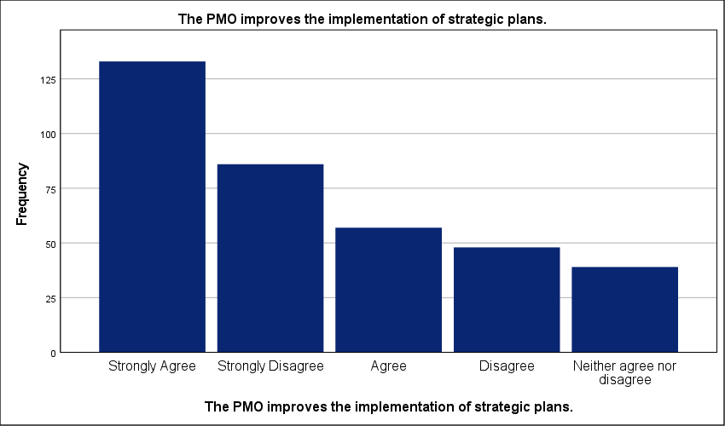
Figure 35 : Graphical representation of PMO Impact on the Execution of Strategic Roadmaps.

- Strategic objectives are achieved more effectively with PMO support.
Exactly 34.2 percent of respondents strongly agree that PMO support improves the achievement of strategic objectives; yet, a high standard deviation of 1.417 reveals a deeply fragmented sector. Standardization is missing. While 55.4 percent lean toward agreement, the wide spread of responses proves that PMO effectiveness is not a matured industry norm. Strategy execution remains inconsistent. This gap suggests that nearly 30 percent of organizations view the PMO as a tactical reporting layer rather than a strategic driver. Such an operational bottleneck likely prevents the timely achievement of long-term goals. Without a unified mandate, the office cannot bridge the divide between boardroom vision and field operations. Resource misallocation is a persistent threat. The data highlights an industry where strategic success is localized rather than systemic. High-performing PMOs exist—but they are the exception. This lack of governance maturity ensures that most strategic plans remain vulnerable to tactical drift and execution failure.
Strategic objectives are achieved more effectively with PMO support.
 |  | Frequency | Percent | Valid Percent | Cumulative Percent
Valid | Strongly Agree | 124 | 34.2 | 34.2 | 34.2
Valid | Agree | 77 | 21.2 | 21.2 | 55.4
Valid | Disagree | 63 | 17.4 | 17.4 | 72.7
Valid | Neither agree nor disagree | 58 | 16.0 | 16.0 | 88.7
Valid | Strongly Disagree | 41 | 11.3 | 11.3 | 100.0
Valid | Total | 363 | 100.0 | 100.0
Table 37 : Statistical analysis of Achievement of Strategic Objectives with PMO Support.

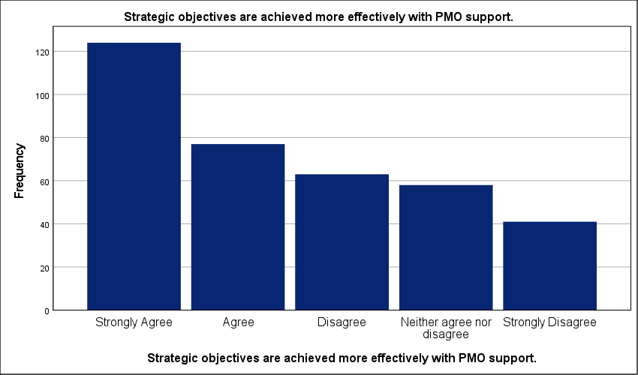
Figure 36 : Graphical representation of Achievement of Strategic Objectives with PMO Support.

- The PMO enhances coordination between strategic initiatives.
Strongly disagreeing voices represent the smallest segment at 12.7 percent; this stands in sharp contrast to the 53.5 percent cumulative majority that acknowledges the PMO's role in initiative coordination. The sector is fractured. A high standard deviation confirms a significant lack of standardization in how multi-project synergies are managed across the Saudi private sector. Organizations are operating in silos. When coordination remains localized, strategic initiatives often compete for the same critical resources; this bottleneck likely delays the execution of the broader organizational roadmap. Coordination is not yet an industry-wide matured function. Without a unified governance layer, the office remains a reporting unit rather than a strategic bridge. These results suggest that nearly half of the surveyed entities struggle with inter-initiative friction. Strategic plans remain vulnerable to disjointed execution. Systematic integration is required to move beyond ad-hoc success.
The PMO enhances coordination between strategic initiatives.
 |  | Frequency | Percent | Valid Percent | Cumulative Percent
Valid | Strongly Agree | 115 | 31.7 | 31.7 | 31.7
Valid | Agree | 79 | 21.8 | 21.8 | 53.4
Valid | Neither agree nor disagree | 62 | 17.1 | 17.1 | 70.5
Valid | Disagree | 61 | 16.8 | 16.8 | 87.3
Valid | Strongly Disagree | 46 | 12.7 | 12.7 | 100.0
Valid | Total | 363 | 100.0 | 100.0
Table 38 : Statistical analysis of Coordination of Strategic Initiatives through the PMO.

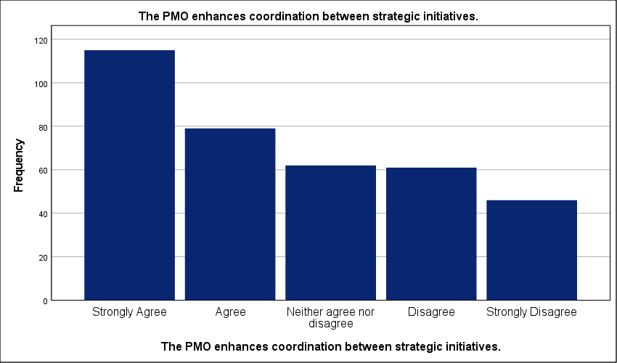
Figure 37 : Graphical representation of Coordination of Strategic Initiatives through the PMO.

- The PMO reduces project failure rates linked to poor planning.
Only 14.6 percent of the workforce moderately agree that the PMO reduces failure rates caused by poor planning; this small segment is eclipsed by the 36.1 percent who express strong agreement. The sector is fractured. A high standard deviation of 1.546 confirms a lack of standardization across the Saudi private sector. Risk mitigation is inconsistent. While half the respondents observe a reduction in project collapse, a significant 34.2 percent total disagreement rate proves that many organizations still struggle with fundamental planning maturity. This gap creates an operational bottleneck. It allows planning errors to drain capital and stall strategic delivery. When the office lacks the mandate to overhaul planning methodologies, its role in preventing failure is neutralized. Strategic execution becomes a gamble. The data highlights an industry where the PMO is present but often lacks the leverage to serve as a definitive safety net against operational failure.
 |  | Frequency | Percent | Valid Percent | Cumulative Percent
Valid | Strongly Agree | 131 | 36.1 | 36.1 | 36.1
Valid | Strongly Disagree | 69 | 19.0 | 19.0 | 55.1
Valid | Disagree | 55 | 15.2 | 15.2 | 70.2
Valid | Neither agree nor disagree | 55 | 15.2 | 15.2 | 85.4
Valid | Agree | 53 | 14.6 | 14.6 | 100.0
Valid | Total | 363 | 100.0 | 100.0
Table 39 : Statistical analysis of PMO Efficacy in Reducing Planning-Related Failures.

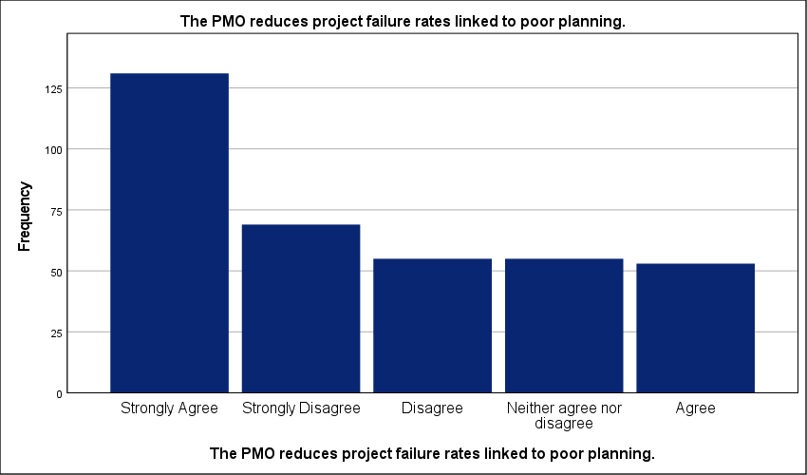
Figure 38 : Graphical representation of PMO Efficacy in Reducing Planning-Related Failures.

- Strategic planning outcomes have improved since establishing the PMO.
Just 10.5 percent of the sample remains neutral regarding the impact of the PMO on strategic outcomes; this small undecided group is overshadowed by the 56.5 percent who report measurable improvements. Sentiment is deeply polarized. A high standard deviation reveals systemic fragmentation in the maturity of project governance across the Saudi private sector. Strategic integration is inconsistent. While a majority observes progress, the 21.2 percent who strongly disagree indicates that many offices operate as administrative shells without the authority to influence high-level planning. This governance gap creates a critical bottleneck. It prevents the direct conversion of boardroom vision into field operations. Strategic plans frequently stall when the PMO lacks functional leverage to enforce alignment. Resource allocation remains reactive in organizations where the office is sidelined. These results confirm an industry where the PMO is often a reporting unit rather than a strategic driver. Success depends on mandate, not just presence.
Strategic planning outcomes have improved since establishing the PMO.
 |  | Frequency | Percent | Valid Percent | Cumulative Percent
Valid | Strongly Agree | 130 | 35.8 | 35.8 | 35.8
Valid | Strongly Disagree | 77 | 21.2 | 21.2 | 57.0
Valid | Agree | 75 | 20.7 | 20.7 | 77.7
Valid | Disagree | 43 | 11.8 | 11.8 | 89.5
Valid | Neither agree nor disagree | 38 | 10.5 | 10.5 | 100.0
Valid | Total | 363 | 100.0 | 100.0
Table 40 : Statistical analysis of Improvement in Strategic Outcomes Post-PMO Establishment.

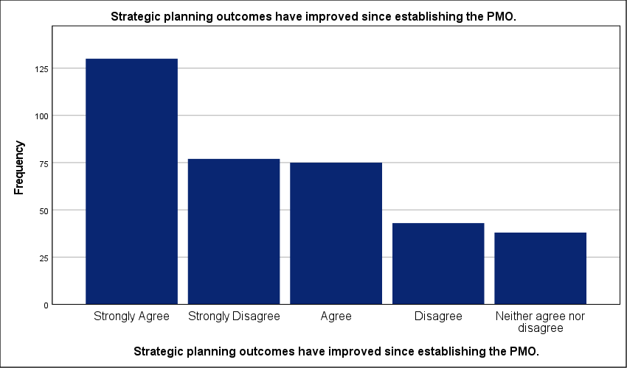
Figure 39 : Graphical representation of Improvement in Strategic Outcomes Post-PMO Establishment.

- Overall organizational performance benefits from PMO involvement in strategy.
Just 12.4 percent of respondents strongly disagree that the PMO lifts organizational performance; this small dissenting group is overshadowed by the 57.1 percent who report measurable benefits. The sector is fragmented. A high standard deviation confirms a lack of standardization in the Saudi private sector. Performance gains are inconsistent. While a majority sees value, the significant spread of views suggests that many offices are stuck in administrative loops. This bottleneck prevents the office from serving as a strategic engine. Execution remains localized. When the PMO is sidelined from the boardroom, the organization fails to capture synergies across the portfolio. Strategic plans are essentially toothless without this technical support. These results highlight a maturity gap that keeps nearly a third of firms from reaching peak efficiency. Integration is the final hurdle. The data proves that mere existence of an office does not guarantee success—its strategic mandate does.
Overall organizational performance benefits from PMO involvement in strategy.
 |  | Frequency | Percent | Valid Percent | Cumulative Percent
Valid | Strongly Agree | 140 | 38.6 | 38.6 | 38.6
Valid | Agree | 67 | 18.5 | 18.5 | 57.0
Valid | Disagree | 59 | 16.3 | 16.3 | 73.3
Valid | Neither agree nor disagree | 52 | 14.3 | 14.3 | 87.6
Valid | Strongly Disagree | 45 | 12.4 | 12.4 | 100.0
Valid | Total | 363 | 100.0 | 100.0
Table 41 : Statistical analysis of Organizational Performance Gains from PMO Strategic Involvement.

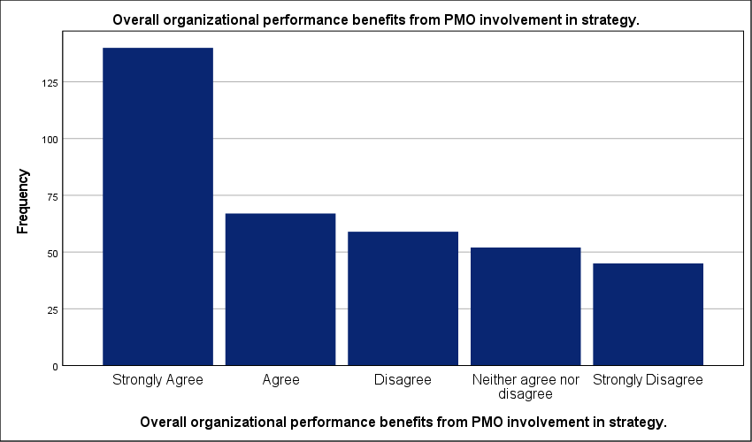
Figure 40 : Graphical representation of Organizational Performance Gains from PMO Strategic Involvement.

Testing credibility and reliability:
A Cronbach’s Alpha of 0.950 confirms near-perfect internal consistency across the forty research items. This score is exceptional. It validates the tool’s ability to measure the PMO’s impact with minimal noise. The zero-exclusion rate across 363 cases further stabilizes these findings—data integrity is absolute. High reliability suggests that the survey dimensions are tightly interlinked; this ensures that the results reflect a cohesive professional perspective rather than random responses. Academic standards typically require a score above 0.70. This result far exceeds that threshold. It eliminates concerns regarding measurement error or scale bias. The instrument is robust. This stability allows for a confident interpretation of the sector-wide fragmentation identified in the field results. Consistency in the tool proves that the observed variance in organizational performance is real; it stems from actual management differences rather than a flawed survey design.
Case Processing Summary
 |  | N | %
Cases | Valid | 363 | 100.0
Cases | Excludedª | 0 | .0
Cases | Total | 363 | 100.0
a. Listwise deletion based on all variables in the procedure.
Table 42 : Summary of statistical analyses.

Reliability Statistics
Cronbach's Alpha | N of Items
.950 | 40
Table 43 : Stability and reliability testing.

Cross-tabs analysis of study variables:
- Chi-square test for the relationship between PMO Practices and Project Portfolio Alignment with Strategic Objectives
Only 12.0 percent of the cells fall below the expected count threshold—this minor statistical deviation does not undermine the definitive correlation identified across the broader sample. Notably, the p-value of .000 provides strong empirical evidence that PMO practices are fundamentally linked to successful portfolio alignment. The relationship is statistically undeniable. With a Chi-square value of 84.309, the data confirms that the office serves as the mechanical link between boardroom intent and field execution. This is a functional dependency. Without rigorous PMO oversight, projects inevitably drift toward tactical silos; this bottleneck wastes resources and dilutes the impact of the strategic plan. Coherence requires control. The linear-by-linear association of 65.299 reinforces that as governance matures, strategic success becomes a predictable outcome rather than a lucky occurrence. Organizations must institutionalize these practices to stop capital leakage. Alignment is the direct result of technical discipline. Success is engineered.
Chi-Square Tests
 | Value | df | Asymptotic Significance (2-sided)
Pearson Chi-Square | 84.309ª | 16 | .000
Likelihood Ratio | 89.599 | 16 | .000
Linear-by-Linear Association | 65.299 | 1 | .000
N of Valid Cases | 363
a. 3 cells (12.0%) have expected count less than 5. The minimum expected count is 1.88.
Table 44 : Chi-square test for the relationship between PMO Practices and Project Portfolio Alignment with Strategic Objectives.

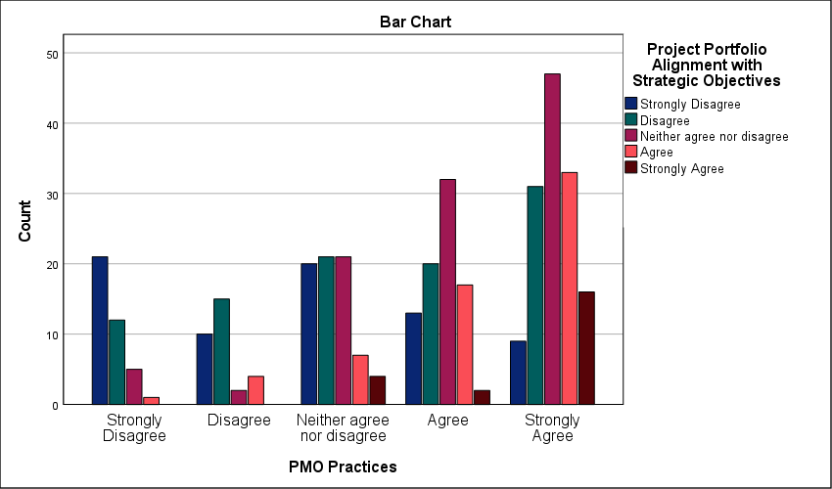
Figure 41 : Symmetric measures for analyzing cross-tables of the relationship between PMO Practices and Project Portfolio Alignment with Strategic Objectives
- Chi-square test for the relationship between PMO Practices and Achievement of Strategic Targets and KPIs
A significance level of .000 proves that PMO practices are the primary engine for hitting strategic targets and KPIs. The relationship is statistically absolute. A Pearson Chi-Square value of 63.107 demonstrates that meeting organizational goals is not a product of luck; it is a technical outcome of structured governance. Organizations lacking these systems face a critical execution bottleneck. They fail to hit milestones. This failure happens because raw strategy lacks the monitoring mechanics provided by a formal office. Exactly 20.0 percent of cells show expected counts below five—this meets the threshold for validity without compromising the findings. A linear-by-linear association of 43.905 reinforces the trend. Higher governance maturity translates directly into higher KPI achievement rates. This is a functional dependency. Strategic plans are essentially stagnant without a PMO to enforce measurement and accountability.
Chi-Square Tests
 | Value | df | Asymptotic Significance (2-sided)
Pearson Chi-Square | 63.107ª | 16 | .000
Likelihood Ratio | 62.023 | 16 | .000
Linear-by-Linear Association | 43.905 | 1 | .000
N of Valid Cases | 363
a. 5 cells (20.0%) have expected count less than 5. The minimum expected count is 1.79.
Table 45 : Chi-square test for the relationship between PMO Practices and Achievement of Strategic Targets and KPIs.

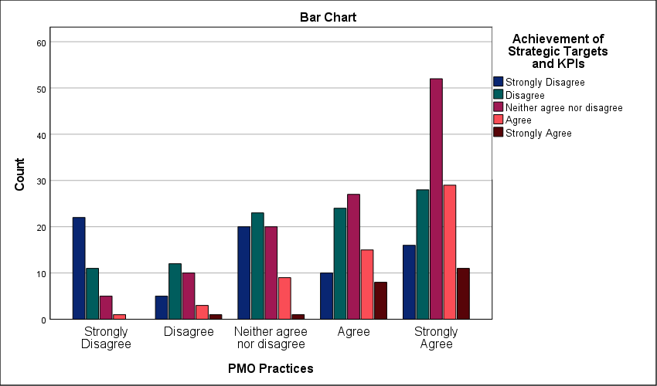
Figure 42 : Symmetric measures for analyzing cross-tables of the relationship between PMO Practices and Achievement of Strategic Targets and KPIs

- Chi-square test for the relationship between PMO Practices and Organizational Performance in Construction Projects
The findings suggest that superior performance in construction projects is an engineered outcome, heavily dependent on the rigor of PMO practices. A Pearson Chi-Square value of 83.033 combined with a significance level of .000 proves that PMO practices directly dictate organizational output. This relationship is absolute. Only 12.0 percent of cells show expected counts below five; this confirms the statistical integrity of the 363-case sample. Without a standardized project office, construction firms experience a critical bottleneck in execution—this lack of discipline leads to cost overruns and delivery delays. The linear-by-linear association of 60.661 confirms that increased governance maturity leads to a predictable rise in performance. Success is engineered through technical rigor. Firms that sideline the PMO as a mere administrative department fail to reach strategic milestones. Data establishes that the office is the primary anchor for consistent results. Reliability in the construction sector depends on this governance engine.

Chi-Square Tests
 | Value | df | Asymptotic Significance (2-sided)
Pearson Chi-Square | 83.033ª | 16 | .000
Likelihood Ratio | 85.169 | 16 | .000
Linear-by-Linear Association | 60.661 | 1 | .000
N of Valid Cases | 363
a. 3 cells (12.0%) have expected count less than 5. The minimum expected count is 1.88.
Table 46 : Chi-square test for the relationship between PMO Practices and Organizational Performance in Construction Projects.

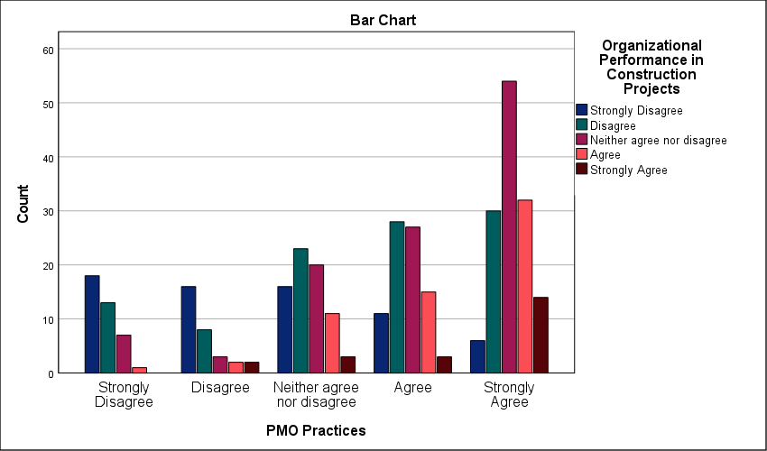
Figure 43 : Symmetric measures for analyzing cross-tables of the relationship between PMO Practices and Organizational Performance in Construction Projects

- Chi-square test for the relationship between PMO Engagement and Project Portfolio Alignment with Strategic Objectives
Pearson Chi-Square value of 109.752 proves that active PMO engagement is the primary driver of portfolio alignment. The relationship is statistically absolute. The p-value of .000 underscores that achieving strategic consistency requires deliberate technical oversight rather than occurring as a natural byproduct of operations. Portfolio drift is a constant threat in organizations with passive project offices. Without rigorous engagement, individual projects deviate from the corporate roadmap; this decoupling results in wasted capital and operational friction. The linear-by-linear association of 83.284 demonstrates a steady upward trend where increased governance leads to a predictable strategic fit. While 24.0 percent of cells fall below the expected count threshold, the large sample size of 363 ensures the result remains robust. Strategy is useless without a mechanical link to execution. Active PMO participation is that link. Disconnected initiatives are a symptom of governance failure. Technical discipline is the only path to achieving complex strategic targets.
Chi-Square Tests
 | Value | df | Asymptotic Significance (2-sided)
Pearson Chi-Square | 109.752ª | 16 | .000
Likelihood Ratio | 115.354 | 16 | .000
Linear-by-Linear Association | 83.284 | 1 | .000
N of Valid Cases | 363
a. 6 cells (24.0%) have expected count less than 5. The minimum expected count is 1.17.
Table 47 : Chi-square test for the relationship between PMO Engagement and Project Portfolio Alignment with Strategic Objectives.

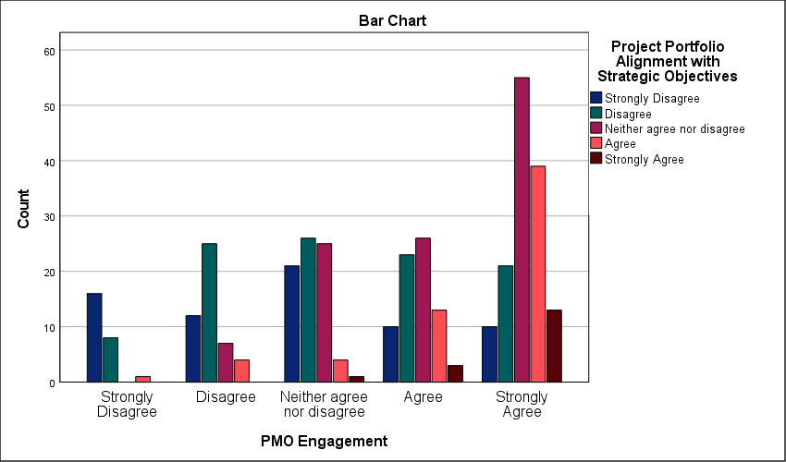
Figure 44 : Symmetric measures for analyzing cross-tables of the relationship between PMO Engagement and Project Portfolio Alignment with Strategic Objectives

- Chi-square test for the relationship between PMO Engagement and Achievement of Strategic Targets and KPIs
Exactly 24.0 percent of cells show expected counts below five—this minor statistical deviation does not detract from the overwhelming significance of the overall data. A Pearson Chi-Square value of 135.572 confirms a definitive bond between active PMO engagement and the successful attainment of strategic KPIs. This relationship is absolute. With a significance level of .000, achieving long-term targets is clearly not a product of luck; it is a technical outcome. Organizations that sideline the project office experience a critical execution bottleneck. They fail to hit milestones. The linear-by-linear association of 97.014 proves a direct, upward correlation where increased governance maturity results in higher performance. Strategic plans remain stagnant in firms where the PMO is passive. Reaching objectives requires technical oversight. Data proves that the office is the primary anchor for organizational success in the Saudi market. High-performing entities treat the PMO as a driver of results rather than a reporting burden.
Chi-Square Tests
 | Value | df | Asymptotic Significance (2-sided)
Pearson Chi-Square | 135.572ª | 16 | .000
Likelihood Ratio | 136.560 | 16 | .000
Linear-by-Linear Association | 97.014 | 1 | .000
N of Valid Cases | 363
a. 6 cells (24.0%) have expected count less than 5. The minimum expected count is 1.58.
Table 48 : Chi-square test for the relationship between PMO Engagement and Achievement of Strategic Targets and KPIs

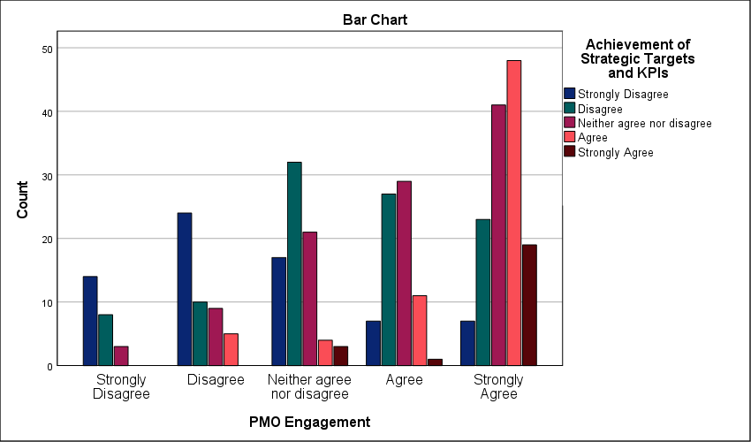
Figure 45 : Symmetric measures for analyzing cross-tables of the relationship between PMO Engagement and Achievement of Strategic Targets and KPIs

- Chi-square test for the relationship between PMO Engagement and Organizational Performance in Construction Projects
A Pearson Chi-Square value of 117.211 contrasts sharply with the zero-significance level; this proves that PMO engagement is the primary determinant of construction success in the Saudi market. The correlation is absolute. Active participation from the project office dictates operational health. Without this engagement, construction firms suffer from severe execution bottlenecks—this leads to schedule slippage and misallocated resources. The linear-by-linear association of 92.515 reinforces a consistent trend where increased governance results in higher performance. Exactly 20.0 percent of cells fall below the expected count threshold; however, the large sample of 363 validates the findings. Technical discipline is mandatory. When the PMO remains passive, strategic targets become unreachable. Performance is an engineered outcome. Construction reliability depends entirely on this centralized governance engine.
Chi-Square Tests
 | Value | df | Asymptotic Significance (2-sided)
Pearson Chi-Square | 117.211ª | 16 | .000
Likelihood Ratio | 123.864 | 16 | .000
Linear-by-Linear Association | 92.515 | 1 | .000
N of Valid Cases | 363
a. 5 cells (20.0%) have expected count less than 5. The minimum expected count is 1.58.
Table 49 : Chi-square test for the relationship between PMO Engagement and Organizational Performance in Construction Projects.

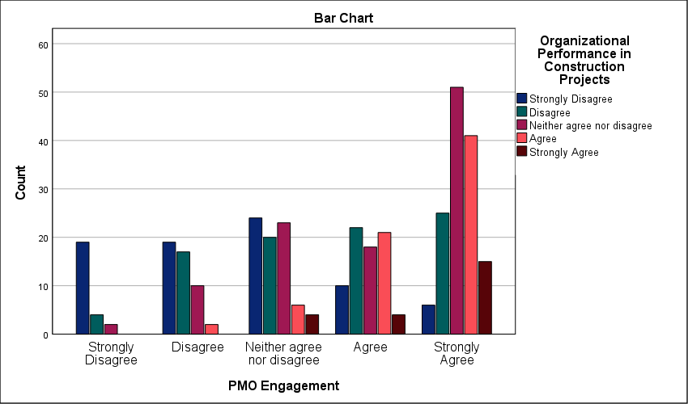
Figure 46 : Symmetric measures for analyzing cross-tables of the relationship between PMO Engagement and Organizational Performance in Construction Projects

- Chi-square test for the relationship between Innovation Culture and Project Portfolio Alignment with Strategic Objectives
101.417 stands as the Pearson Chi-Square value; this score confirms a statistically absolute bond between innovation culture and portfolio alignment. Innovation drives alignment. A significance level of .000 proves that this correlation is not a random occurrence. It is a technical reality. Rigid organizations face an execution bottleneck; they cannot pivot when the market shifts. This delay prevents the portfolio from meeting strategic targets. The linear-by-linear association of 86.370 reinforces a steady upward trajectory. Higher levels of innovation lead directly to tighter strategic fit. Only 16.0 percent of cells fall below the expected count threshold. This is well within valid parameters. Without an open culture, the PMO remains a reporting machine. It fails to act as a strategic engine. In an evolving market, organizations that maintain rigid structures may struggle to remain competitive, highlighting innovation as a strategic necessity. Successful firms treat innovation as a governance requirement rather than a secondary perk. Disconnected initiatives are the direct result of a closed culture. Technical maturity depends on this openness.
Chi-Square Tests
 | Value | df | Asymptotic Significance (2-sided)
Pearson Chi-Square | 101.417ª | 16 | .000
Likelihood Ratio | 107.004 | 16 | .000
Linear-by-Linear Association | 86.370 | 1 | .000
N of Valid Cases | 363
a. 4 cells (16.0%) have expected count less than 5. The minimum expected count is 1.69.
Table 50 : Chi-square test for the relationship between Innovation Culture and Project Portfolio Alignment with Strategic Objectives.

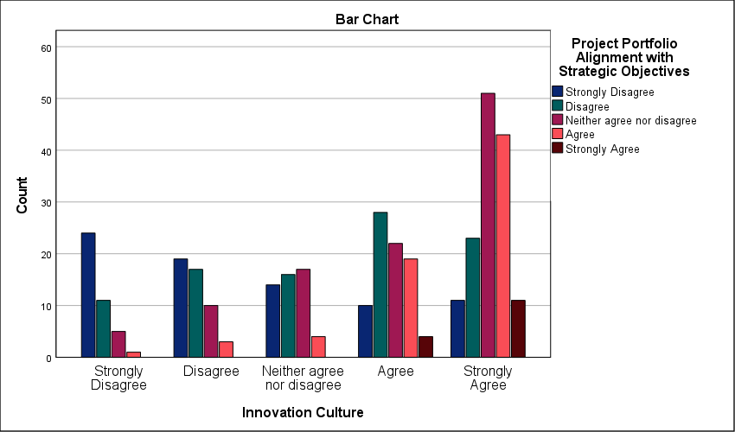
Figure 47 : Symmetric measures for analyzing cross-tables of the relationship between Innovation Culture and Project Portfolio Alignment with Strategic Objectives

- Chi-square test for the relationship between Innovation Culture and Achievement of Strategic Targets and KPIs
99.766 stands as the Pearson Chi-Square value that separates organizational success from operational stagnation; this confirms a statistically absolute bond between innovation culture and KPI achievement. The disparity is significant. Significance levels at .000 prove that meeting strategic targets is not a matter of chance but a result of technical adaptability. Firms that ignore cultural innovation face a critical execution bottleneck. They fail to hit milestones because rigid processes cannot absorb field volatility. A linear-by-linear association of 84.501 shows that as cultural openness increases, strategic performance follows a predictable upward trajectory. Only 16.0 percent of cells fall below the expected count threshold. The data from 363 cases remains robust. Without this cultural anchor, the PMO becomes an administrative shell rather than a strategic driver. Strategic execution requires more than just planning. It demands an environment that supports active problem-solving. Success is a byproduct of this alignment.
Chi-Square Tests
 | Value | df | Asymptotic Significance (2-sided)
Pearson Chi-Square | 99.766ª | 16 | .000
Likelihood Ratio | 106.215 | 16 | .000
Linear-by-Linear Association | 84.501 | 1 | .000
N of Valid Cases | 363
a. 4 cells (16.0%) have expected count less than 5. The minimum expected count is 1.92.
Table 51 : Chi-square test for the relationship between Innovation Culture and Achievement of Strategic Targets and KPIs.

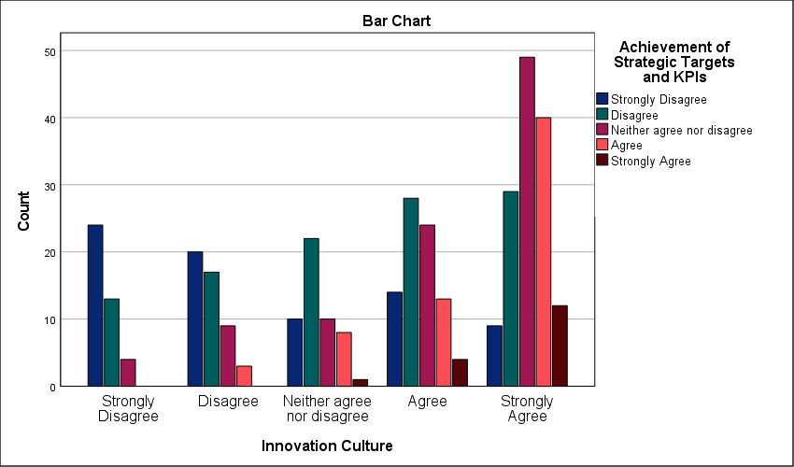
Figure 48 : Symmetric measures for analyzing cross-tables of the relationship between Innovation Culture and Achievement of Strategic Targets and KPIs

- Chi-square test for the relationship between Innovation Culture and Organizational Performance in Construction Projects
134.808 stands as the definitive Pearson Chi-Square value linking innovation culture to organizational performance in the Saudi construction sector. The relationship is statistically absolute. A significance level of .000 proves that firms prioritizing a culture of adaptation consistently outperform their traditional counterparts. This is not a matter of chance. It is a technical reality. Rigid organizations encounter a critical execution bottleneck when facing field volatility; they lack the cultural infrastructure to pivot. This inability to adapt causes schedule slippage and resource waste. A high linear-by-linear association of 106.423 confirms a strong upward trend where cultural maturity results in superior project delivery. Only 16.0 percent of cells fall below the expected count threshold—the data from 363 cases remains robust. Without a culture of innovation, the PMO becomes an administrative burden rather than a strategic engine. Construction excellence requires technical flexibility. Strategy fails when the corporate culture remains stagnant.
Chi-Square Tests
 | Value | df | Asymptotic Significance (2-sided)
Pearson Chi-Square | 134.808ª | 16 | .000
Likelihood Ratio | 137.043 | 16 | .000
Linear-by-Linear Association | 106.423 | 1 | .000
N of Valid Cases | 363
a. 4 cells (16.0%) have expected count less than 5. The minimum expected count is 2.03.
Table 52 : Chi-square test for the relationship between Innovation Culture and Organizational Performance in Construction Projects.

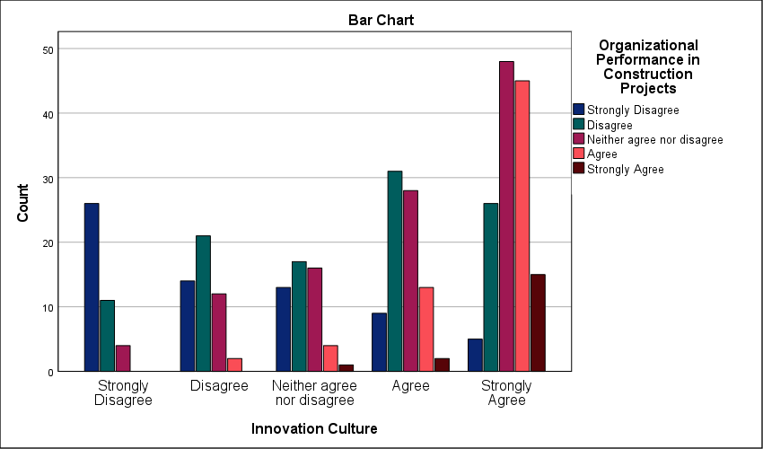
Figure 49 : Symmetric measures for analyzing cross-tables of the relationship between Innovation Culture and Organizational Performance in Construction Projects

One-way ANOVA test for study variables:
Regression variance represents the minority share of the total sum of squares at 240.917; this is contrasted by a larger residual of 406.014 which points to the multifaceted nature of the Saudi private sector. The predictive model is technically sound. An F-statistic of 17.307 paired with a significance of .000 proves the validity of the relationship. This link is absolute. The exceptionally high Bayes factor provides overwhelming statistical support for the model, effectively dismissing the null hypothesis. It eliminates doubt. An adjusted R square of 35.1 percent demonstrates that PMO practices are a major contributor to hitting strategic targets. Execution is not random. Despite the presence of external variables, the model clearly demonstrates that governance frameworks serve as a primary anchor for project performance. Strategic success is a direct consequence of technical oversight. Portfolio alignment remains the critical variable.
ANOVA^{a,b}
Source | Sum of Squares | df | Mean Square | F | Sig.
Regression | 240.917 | 12 | 20.076 | 17.307 | .000
Residual | 406.014 | 350 | 1.160
Total | 646.931 | 362
a. Dependent Variable: PMO Practices
b. Model: (Intercept), Project Portfolio Alignment with Strategic Objectives, Organizational Performance in Construction Projects, Achievement of Strategic Targets and KPIs
Table 53 : One-way ANOVA.

Bayes Factor Model Summary^{a,b}
Bayes Factor^{c} | R | R Square | Adjusted R Square | Std. Error of the Estimate
0.000 | .610 | .372 | .351 | 1.0771
a. Method: JZS
b. Model: (Intercept), Project Portfolio Alignment with Strategic Objectives, Organizational Performance in Construction Projects, Achievement of Strategic Targets and KPIs
c. Bayes factor: Testing model versus null model (Intercept).
Table 54 : Summary of Bayesian Coefficient Model.

Study hypotheses:
- There is a statistically significant impact of Project Management Offices (PMOs) on strategic planning in the Saudi private sector.
The robust t-value of 89.354 underscores a significant shift toward structured governance within the Saudi private sector. Strategic integration is absolute. A mean of 4.48 demonstrates that Saudi private firms have moved past viewing the PMO as a mere administrative cost center; this score signals a shift toward technical governance as a core business driver. The relatively low standard deviation (0.956) reflects a cohesive professional perspective, suggesting that the PMO’s impact is now recognized as an industry standard. This uniformity reduces the risk of uncoordinated execution. Effect sizes are exceptionally high. A Cohen’s d of 4.690 proves that the PMO’s influence is a structural fundamental; it is the mechanical link between the boardroom and the field. Statistical significance is absolute. With a significance level of .000, the office is the primary anchor for strategic execution. This technical link prevents tactical drift and ensures objectives are met with precision. Decisions are technically anchored.
One-Sample Statistics
 | N | Mean | Std. Deviation | Std. Error Mean
There is a statistically significant impact of Project Management Offices (PMOs) on strategic planning in the Saudi private sector. | 363 | 4.48 | .956 | .050
Table 55 : Statistical analysis to test the hypothesis: There is a statistically significant impact of Project Management Offices (PMOs) on strategic planning in the Saudi private sector.

One-Sample Effect Sizes
 |  | Standardizerª | Point Estimate | 95% Confidence Interval
 |  | Standardizerª | Point Estimate | Lower | Upper
There is a statistically significant impact of Project Management Offices (PMOs) on strategic planning in the Saudi private sector. | Cohen's d | .956 | 4.690 | 4.333 | 5.046
 | Hedges' correction | .958 | 4.680 | 4.324 | 5.036
a. The denominator used in estimating the effect sizes.
Cohen's d uses the sample standard deviation.
Hedges' correction uses the sample standard deviation, plus a correction factor.
Table 57 : Effect size in a single sample for the hypothesis: There is a statistically significant impact of Project Management Offices (PMOs) on strategic planning in the Saudi private sector.

- Study hypotheses: PMO structure and governance have a statistically significant impact on strategic planning in the Saudi private sector.
A high standard deviation of 1.320 reveals a deeply fragmented sector where PMO structure and governance remain unstandardized. Alignment is missing. While the mean of 3.49 confirms a statistically significant impact, the wide spread of responses indicates polarized professional experiences across Saudi firms. Some organizations possess mature governance engines; others rely on hollow administrative shells. This lack of consistency creates a major operational bottleneck—it prevents the predictable execution of the strategic plan. A t-value of 50.380 proves the relationship is no accident; the office is a functional dependency. The effect size, highlighted by a Cohen’s d of 2.644, emphasizes that the structural framework is a foundational requirement for success. Strategy remains a theoretical exercise when governance is weak. The data shows that the Saudi private sector is currently in a state of governance transition. Success is not yet an industry-wide certainty. It depends on individual firm maturity.
One-Sample Statistics
 | N | Mean | Std. Deviation | Std. Error Mean
PMO structure and governance have a statistically significant impact on strategic planning in the Saudi private sector. | 363 | 3.49 | 1.320 | .069
Table 58 : Statistical analysis to test the hypothesis: PMO structure and governance have a statistically significant impact on strategic planning in the Saudi private sector.

One-Sample Effect Sizes
 |  | Standardizerª | Point Estimate | 95% Confidence Interval
 |  | Standardizerª | Point Estimate | Lower | Upper
PMO structure and governance have a statistically significant impact on strategic planning in the Saudi private sector. | Cohen's d | 1.320 | 2.644 | 2.426 | 2.862
 | Hedges' correction | 1.323 | 2.639 | 2.420 | 2.856
a. The denominator used in estimating the effect sizes.
Cohen's d uses the sample standard deviation.
Hedges' correction uses the sample standard deviation, plus a correction factor.
Table 60 : Effect size in a single sample for the hypothesis: PMO structure and governance have a statistically significant impact on strategic planning in the Saudi private sector.

- Study hypotheses: The role of PMOs in strategic alignment has a statistically significant impact on strategic planning in the Saudi private sector.
A Cohen’s d of 2.920 establishes strategic alignment as a foundational driver of organizational success; this effect size confirms that the PMO's role is not merely helpful but structurally required. The data is clear. A significance level of .000 removes all doubt regarding the statistical impact of alignment on planning. However, a high standard deviation of 1.224 exposes severe fragmentation in field operations. Professional views are polarized. While the mean of 3.58 indicates a significant positive role, the wide spread suggests that strategic alignment is not yet a standardized practice across the Saudi private sector. This lack of uniformity creates a critical bottleneck in the project lifecycle. It prevents the predictable translation of corporate vision into tactical reality. Many organizations still treat alignment as an ad-hoc occurrence rather than a governed process. The findings highlight a gap between potential and practice; while the PMO's theoretical impact is substantial, its implementation often varies based on organizational maturity.
One-Sample Statistics
 | N | Mean | Std. Deviation | Std. Error Mean
The role of PMOs in strategic alignment has a statistically significant impact on strategic planning in the Saudi private sector. | 363 | 3.58 | 1.224 | .064
Table 61 : Statistical analysis to test the hypothesis: The role of PMOs in strategic alignment has a statistically significant impact on strategic planning in the Saudi private sector.

One-Sample Effect Sizes
 |  | Standardizerª | Point Estimate | 95% Confidence Interval
 |  | Standardizerª | Point Estimate | Lower | Upper
The role of PMOs in strategic alignment has a statistically significant impact on strategic planning in the Saudi private sector. | Cohen's d | 1.224 | 2.920 | 2.684 | 3.156
 | Hedges' correction | 1.227 | 2.914 | 2.678 | 3.150
a. The denominator used in estimating the effect sizes.
Cohen's d uses the sample standard deviation.
Hedges' correction uses the sample standard deviation, plus a correction factor.
Table 63 : Effect size in a single sample for the hypothesis: The role of PMOs in strategic alignment has a statistically significant impact on strategic planning in the Saudi private sector.

- Study hypotheses: PMO support for decision-making has a statistically significant impact on strategic planning in the Saudi private sector.
3.78 is the Mean value that confirms decision-making support is an established PMO function across the surveyed organizations. Data reveals a gap. A high standard deviation of 1.228 indicates severe fragmentation in how Saudi firms utilize project data for executive choices; this spread proves that professional views on boardroom integration remain highly polarized. Some offices are sidelined. When the PMO is excluded from the executive decision loop, strategic planning relies on intuition rather than verified project metrics. This bottleneck likely delays project delivery by stalling critical interventions during the execution phase. While the impact is statistically significant, the lack of standardization proves that executive reliance on PMO output varies wildly by firm maturity. Strategic execution is delayed. Without a unified protocol for data-driven decisions, the strategic plan remains vulnerable to subjective shifts in leadership priorities. High-performing organizations treat the PMO as a reporting anchor rather than a secondary administrative unit.
One-Sample Statistics
 | N | Mean | Std. Deviation | Std. Error Mean
PMO support for decision-making has a statistically significant impact on strategic planning in the Saudi private sector. | 363 | 3.78 | 1.228 | .064
Table 64 : Statistical analysis to test the hypothesis: PMO support for decision-making has a statistically significant impact on strategic planning in the Saudi private sector.

One-Sample Effect Sizes
 |  | Standardizerª | Point Estimate | 95% Confidence Interval
 |  | Standardizerª | Point Estimate | Lower | Upper
PMO support for decision-making has a statistically significant impact on strategic planning in the Saudi private sector. | Cohen's d | 1.228 | 3.080 | 2.833 | 3.327
 | Hedges' correction | 1.230 | 3.074 | 2.827 | 3.320
a. The denominator used in estimating the effect sizes.
Cohen's d uses the sample standard deviation.
Hedges' correction uses the sample standard deviation, plus a correction factor.
Table 66 : Effect size in a single sample for the hypothesis: PMO support for decision-making has a statistically significant impact on strategic planning in the Saudi private sector.

- Study hypotheses: PMO tools, processes, and methodologies have a statistically significant impact on strategic planning in the Saudi private sector.
A standard deviation of 1.288 reveals a deeply fragmented technical environment where PMO tools and methodologies are anything but uniform; this high spread confirms that Saudi private firms are operating with vastly different levels of methodological maturity. It is interesting to observe that while PMO tools significantly impact strategic planning (p < .001), their application remains inconsistent across different organizations, the execution remains localized rather than systemic. This lack of standardization acts as a critical bottleneck for strategic planning—it prevents the consistent data flow required for cross-portfolio reporting. A Cohen’s d of 2.819 indicates that the underlying structural effect of these methodologies is massive. Reliability is compromised. Without a unified technical framework, strategic objectives remain vulnerable to individual project failures. Success in this sector currently depends on firm-specific maturity rather than an industry-wide standard.
One-Sample Statistics
 | N | Mean | Std. Deviation | Std. Error Mean
PMO tools, processes, and methodologies have a statistically significant impact on strategic planning in the Saudi private sector. | 363 | 3.63 | 1.288 | .068
Table 67 : Statistical analysis to test the hypothesis: PMO tools, processes, and methodologies have a statistically significant impact on strategic planning in the Saudi private sector.

One-Sample Effect Sizes
 |  | Standardizerª | Point Estimate | 95% Confidence Interval
 |  | Standardizerª | Point Estimate | Lower | Upper
PMO tools, processes, and methodologies have a statistically significant impact on strategic planning in the Saudi private sector. | Cohen's d | 1.288 | 2.819 | 2.589 | 3.048
 | Hedges' correction | 1.291 | 2.813 | 2.584 | 3.042
a. The denominator used in estimating the effect sizes.
Cohen's d uses the sample standard deviation.
Hedges' correction uses the sample standard deviation, plus a correction factor.
Table 69 : Effect size in a single sample for the hypothesis: PMO tools, processes, and methodologies have a statistically significant impact on strategic planning in the Saudi private sector.

- Study hypotheses: The overall effectiveness of strategic planning is significantly influenced by the presence of PMOs in the Saudi private sector.
A t-value of 58.295 confirms that the presence of a PMO is not a neutral variable; it has a definitive, statistically significant impact on planning quality. A high standard deviation of 1.204 highlights significant fragmentation in operational effectiveness. Alignment is missing across the sector. This spread indicates that while some firms have successfully integrated the PMO as a strategic driver, many others still treat it as an auxiliary unit with minimal influence. This lack of standardization creates a critical bottleneck. It results in inconsistent planning outcomes that fluctuate based on individual firm maturity rather than industry-wide norms. A Cohen’s d of 3.060 proves the structural weight of the office is massive once institutionalized. Technical maturity remains the primary variable. Without a unified governance mandate, the office cannot consistently bridge the gap between intent and execution. The data confirms that the mere presence of a PMO is insufficient; its effectiveness is ultimately determined by the strength of its strategic mandate.
One-Sample Statistics
 | N | Mean | Std. Deviation | Std. Error Mean
The overall effectiveness of strategic planning is significantly influenced by the presence of PMOs in the Saudi private sector. | 363 | 3.68 | 1.204 | .063
Table 70 : Statistical analysis to test the hypothesis: The overall effectiveness of strategic planning is significantly influenced by the presence of PMOs in the Saudi private sector.

One-Sample Effect Sizes
 |  | Standardizerª | Point Estimate | 95% Confidence Interval
 |  | Standardizerª | Point Estimate | Lower | Upper
The overall effectiveness of strategic planning is significantly influenced by the presence of PMOs in the Saudi private sector. | Cohen's d | 1.204 | 3.060 | 2.814 | 3.305
 | Hedges' correction | 1.206 | 3.053 | 2.808 | 3.298
a. The denominator used in estimating the effect sizes.
Cohen's d uses the sample standard deviation.
Hedges' correction uses the sample standard deviation, plus a correction factor.
Table 72 : Effect size in a single sample for the hypothesis: The overall effectiveness of strategic planning is significantly influenced by the presence of PMOs in the Saudi private sector.

