

Using Deep Learning to Detect Arabic Fake News on Online Websites

Prepared By:
Areej Musaed Almalki
252001300
Submitted in fulfillment of the requirements for the degree Master of Science in Artificial Intelligenc
At
College of Informatics
Midocean University
Supervisor: Dr. Yasser Abdelhamid
College of Informatics, Midocean University, Comoros
[2026]

Acknowledgements

The accomplishment of this research project was made possible due to the assistance offered in its preparation. In this regard, special thanks must be paid to Dr. Yasser Abdulhamid, who was the supervisor of this project. His valuable assistance in guiding me through each stage of this research project helped me a great deal.

Moreover, I would like to thank the faculty staff for their scholarly assistance and contribution in creating a conducive learning atmosphere. Lastly, I am grateful to the University for making available all necessary resources for the completion of this project.

Abstract
With the growth of online news channels, the spread of fake news has become much faster. Therefore, detecting fake news is becoming increasingly difficult and essential. It becomes particularly complicated in languages like Arabic with higher linguistic diversity. In this paper, we analyze the ability of different approaches, namely traditional machine learning methods and transformer-based neural networks, to detect fake news in Arabic-language news articles. For our experiments, we created a dataset consisting of 2,196 pieces of Arabic-language news articles combining both true articles from reputable news websites of Saudi Arabia and fake articles available in public datasets.

Traditional machine learning models used for classification are Naïve Bayes, Logistic Regression, and Support Vector Machine, and they work with TF-IDF features. On the other hand, we use AraBERT embeddings with logistic regression as transformer-based models.
Our experimental results show high performance of classical models: the accuracy of SVM was equal to 97.73%. Nevertheless, our transformer-based method demonstrated a significantly better result and reached an impressive accuracy of 99.77% proving the efficiency of contextualized models in Arabic fake news detection.
Cross-validation and error analysis showed that there were no problems with data leakage; all results proved their stability. The obtained results also prove the importance of choosing proper features rather than choosing the most suitable algorithm.

Thus, the presented results suggest that using contextual language models may help improve the accuracy of fake news detection. At the same time, it shows the necessity of creating bigger datasets.

Contents:
Acknowledgements 2
Abstract 3
List of Abbreviations 6
Chapter 1: Introduction 7
1.1 Problem Definition 7
1.2 Research Objectives 8
1.3 Research Contribution 8
1.4 Thesis Organization 9
Chapter 2: Background and Related work 10
2.1 Fake News Concept 10
2.2 Natural Language Processing in Fake News Detection 10
2.3 Machine Learning Approaches 10
2.4 Deep Learning Approaches 10
2.5 Transformer-Based Models 11
2.6 AraBERT and Embeddings 11
2.7 Reviewed Studies 12
2.8 Synthesis Matrix of Reviewed Studies 13
2.9 Dataset-Oriented Comparison Matrix 13
2.10 Observations from the Matrix Analysis 14
2.11 Research Gaps and Opportunities 14
3.1 Research Methodology 15
3.2 Dataset Preparation 15
3.2.1 Data Sources 15
3.2.2 Dataset Characteristics 16
3.2.3 Sample Data 16
3.2.4 Data Splitting 17
3.4 Feature Representation 17
3.4.1 TF-IDF Representation 17
3.4.2 AraBERT Contextual Embeddings 18
3.5 Classification Models 18
3.6 Baseline Model 18
3.7 Hyperparameter Tuning 18
3.8 Evaluation Metrics 19
3.10 Proposed Framework 19
Chapter 4: Experimental Results and Discussion 21
4.1 Experimental Setup 21
4.2 Training and Testing Performance Analysis 21
4.3 Detailed Classification Metrics 23
4.4 Confusion Matrix and Error Analysis 23
4.5 Cross-Validation and Model Stability 25
Analysis 25
4.6 Reasons behind the 99.77% Accuracy Achieved by the Model 26
4.7 Overfitting Discussion 26
4.8 Effect of Feature Representation 27
4.10 Final Discussion 27
5.1 Conclusion 28
References 31

List of Figures :
Figure 1.1 Structure of the thesis showing the main chapters and conclusion 9
Figure 3.1: sample of dataset real and fake news 22
Figure 4.1: Model Accuracy Comparison 22
Figure 4.2: Confusion Matrx 24
Figure 4.3: Cross Validation Plot 25

List of Tables:
Table 2.1: Comparison Matrix of Fake News Detection Studies 12
Table 2.2: Dataset Comparison Matrix 13
Table 4.1 Model Performance (Training vs Testing) 22
Table 4.2 Precision, Recall, and F1-Score (Test Set) 23

List of Abbreviations
Abbreviation | Description
AI | Artificial Intelligence
AraBERT | Arabic BERT Model
BERT | Bidirectional Encoder Representations from Transformers
CNN | Convolutional Neural Network
DL | Deep Learning
GRU | Gated Recurrent Unit
LSTM | Long Short-Term Memory
MARBERT | Masked Arabic BERT
ML | Machine Learning
NB | Naïve Bayes
NLP | Natural Language Processing
RF | Random Forest
RNN | Recurrent Neural Network
SVM | Support Vector Machine
TF-IDF | Term Frequency–Inverse Document Frequency

Chapter 1: Introduction

In the past ten years, news consumption has seen a transformation that few would have foreseen. Previously, newspapers, radio, and TV stations served as gatekeepers of information for the public sphere. Now, however, the internet, mobile apps, and social media sites have taken over this role and provide information to readers almost immediately after its occurrence. In addition to increasing access, quickness, and democratization of information flow, the new system also has an adverse side effect – the possibility of sharing content that is not necessarily true. Fake news is a phenomenon that has been gaining traction lately and has become a major societal issue. While the implications of sharing false information range from misinforming one's followers about something to manipulating their views on important issues, the impact of fake news is potentially much more damaging. It is even capable of affecting democratic processes and society as a whole (Allcott & Gentzkow, 2017; Shu et al., 2017).

1.1 Problem Definition
The primary research question of this study revolves around the issue of how one can identify real Arabic news articles from falsified ones via automation. As much as simple as it may seem, the issue turns out to be far more complex. With the digital world creating unprecedented amounts of information, ranging from articles and news pieces to comments and posts, it becomes practically impossible to manually examine each item and verify its credibility. Thus, a misleading headline or even a completely fabricated article can gain millions of shares long before it gets evaluated and tagged as a fake piece.

With the Arabic language being morphologically complex—one word stem can create different surface forms depending on tense, gender, and number—and with the use of two distinct registers in news and social media articles—Modern Standard Arabic versus colloquial Arabic dialect—the process of applying standard natural language processing becomes rather complex in the area of fake news identification. Moreover, the problem of finding a suitable dataset of fake news for machine learning algorithms is compounded by a serious lack of annotated Arabic-language corpora available to researchers, compared to English-language datasets (Zhou & Zafarani, 2020; Shehata et al., 2024).

In light of the above issues, the need for a reliable detection mechanism which goes beyond mere matching of keywords and other superficial aspects is apparent. Instead, what is needed is some kind of deep approach, based on understanding of semantics and the context. Accordingly, the present paper seeks to fill this gap and explore the performance of various ML algorithms on Arabic fake news detection task.

1.2 Research Objectives

The objectives of the proposed research are as follows:

• To investigate the issue of spotting fabricated news content in Arabic online media, which would be done considering the linguistic aspects and culture of the Middle East nations where news is produced and consumed.

• To analyze the key algorithms for solving the problem of fake news identification, including machine learning techniques, deep learning models, and transformer language models.

• To find out about the difficulties associated with automating fake news detection in Arabic because of the linguistic peculiarities and lack of labeled data.

• To carry out a comparative analysis of selected algorithms to assess their capacity to spot genuine and fake news written in Arabic.

• To test the potential impact of using contextual representations of the Arabic language created with the help of transformer models on classification quality.

1.3 Research Contribution
The current research makes an important contribution to an emerging field of automated fake news detection in Arabic texts, which has not been studied as thoroughly as the similar problem for English texts. The reason for this disparity is partly connected to the difficulties outlined above, such as the complexity of morphological analysis in Arabic and limited availability of datasets that would be used to evaluate various models. In other words, this study addresses one of the understudied problems – namely, detecting fake news in Arabic texts through automated means.
The innovative aspect of this study lies in its comparative methodology. Unlike many related works, which focus primarily on one modeling framework, whether it be transformer-based or traditional machine learning models, this study employs a comparison of two paradigms. The side-by-side comparison allows making more detailed conclusions about the advantages and disadvantages of using various methods to address the problem in question.
Additionally, this research uses a unique dataset of Arabic texts that includes real news items taken from Saudi official channels and fake news selected from various sources. Prior to being used in experiments, the dataset went through rigorous preprocessing. The inclusion of real world news along with fabricated stories makes the current dataset much more realistic than the homogenous ones used in many other similar studies, and it can serve as a useful source for future researchers working in this area.

1.4 Thesis Organization
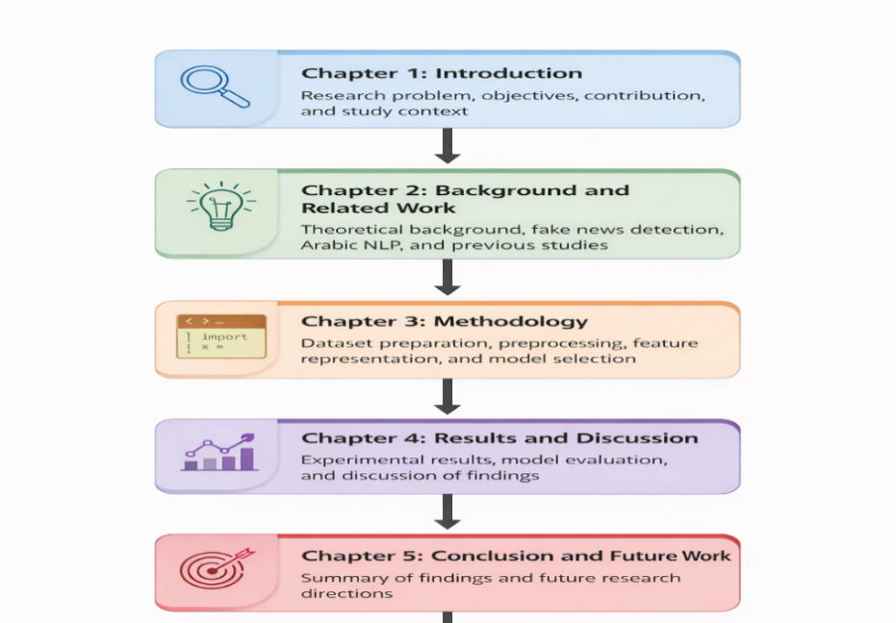
The following thesis consists of five chapters. The present chapter states the problem under investigation, specifies the goals of the research, and highlights expected outcomes. Chapter 2 is dedicated to theoretical background and discusses main concepts and relevant literature concerning the issues of fake news detection, paying special attention to Arabic language processing. Chapter 3 outlines the experimental methodology and covers such aspects as dataset formation, data preprocessing techniques, feature extraction approaches, and reasons for choosing certain models. Chapter 4 presents results of experiments and provides a detailed discussion of the models' performance.
Figure 1.1 Structure of the thesis showing the main chapters and conclusion

Chapter 2: Background and Related work

This chapter presents the background for understanding both the theoretical and practical aspects that will be used in the experiments. First, it discusses the definition of fake news in the current media environment, followed by how natural language processing plays a part in content categorization. Next, it evaluates the use of machine learning, deep learning, and transformer models in detecting fake news. Then, it underscores the importance of AraBERT and contextual embeddings before reviewing the literature on past studies and developments in the field.

2.1 Fake News Concept

In other words, the term “fake news” refers to information that is inaccurate or even fabricated but which at the same time resembles true journalism in terms of presentation. In most cases, the purpose of fake news is to present something that appears reliable enough and which can affect public perception in one way or another. The recent fast development of digital media and related technologies has made the problem of fake news even more challenging. It allows an individual who creates any kind of fake information to make the news multiply across the Internet before anyone gets to verify its credibility (Allcott & Gentzkow, 2017; Shu et al., 2017).

2.2 Natural Language Processing in Fake News Detection

The field of natural language processing (NLP) involves various techniques used for analyzing, understanding, and handling human languages in writing or speech formats. Concerning fake news detection, NLP is an indispensable part because news data are primarily in text format and therefore need to be converted into something that can be analyzed computationally. The first step in any analysis is cleaning the text, normalizing characters, tokenization, and removing noise like URLs and HTML codes. Without the above, classifiers would face great challenges in detecting patterns that distinguish facts from fake news (Shu et al., 2017; Zhou & Zafarani, 2020).

2.3 Machine Learning Approaches

Traditional ML algorithms represent an initial example of automatic fake news detection systems. In particular, traditional ML uses manually created features, such as word frequency, word n-grams, and other stylometric indicators, as inputs for different kinds of classification techniques, including Naïve Bayes, Support Vector Machine, and Logistic Regression algorithms. Some main benefits include simplicity of the approach and efficiency of computations, assuming that the proper features have been used in conjunction with a proper dataset. However, one of the primary limitations is related to the process of feature extraction since these algorithms cannot identify any possible connections between semantic units within the text (Zhou & Zafarani, 2020).

2.4 Deep Learning Approaches

The emergence of deep learning is considered an important step in the analysis of fake news. Using the capabilities of deep neural networks, which include convolutional neural networks (CNN), recurrent neural networks (RNN), long short-term memory (LSTM), and gated recurrent units (GRU), allows direct learning of features without any need for feature engineering, as was done in conventional methods. The ability of deep neural networks to detect hidden patterns and modeling sequential and hierarchical relationships in texts makes this technique very effective in classification problems, including fake news detection. Nevertheless, there are some disadvantages in using deep neural networks. In general, this method requires a large number of examples and computational power. Furthermore, its performance becomes worse on small data samples (LeCun et al., 2015).

2.5 Transformer-Based Models

The invention of transformer networks is viewed as a game-changer in natural language processing. As opposed to previous models that analyze text at the word level, transformers have self-attention algorithms that give weights to the connections between each of the words in a sentence. As such, transformers perform much better at contextual understanding, especially when it comes to complex sentences that require an understanding of their dependency structure. With respect to text classification tasks, the BERT model, which is one of the most popular transformers, provides outstanding results, because it represents languages bidirectionally (Vaswani et al., 2017; Devlin et al., 2019). When it comes to fake news detection, this aspect is very important since analyzing the content of the article in question cannot be achieved through keywords alone.

2.6 AraBERT and Embeddings
AraBERT, on the other hand, is an Arabic language model based on BERT architecture trained on a large amount of text written in Arabic. By design, AraBERT is more effective at capturing some of the peculiarities of Arabic compared to multilingual models, as there is no need to devote computing power to supporting other languages. In terms of its effectiveness, AraBERT has proven to be successful on various Arabic NLP tasks thanks to its ability to provide a contextual representation of words, meaning that each word has its own vector that changes depending on the sentence structure (Antoun et al., 2020).

In general, embeddings are mathematical vectors that make it possible for machine learning algorithms to work with textual data. Ultimately, any word, sentence, and documents should be encoded numerically in order for any algorithm to analyze it. The difference between AraBERT embeddings and previous generation embeddings is the context-dependence of the former. For instance, the word "bank" will have a different meaning in relation to finances and rivers. In this project, AraBERT embeddings are especially important since they contain more semantic value than TF-IDF or other frequency-based embedding models (Devlin et al., 2019; Antoun et al., 2020).

2.7 Reviewed Studies
Three major research directions in the study of fake news detection can be observed. Firstly, studies using conventional machine learning used manually crafted text features together with algorithms like SVM, Naive Bayes, or logistic regression. These works laid the basis for considering fake news detection problems as the classical task of text classification, although their results heavily depended on the features and data used and hence were sometimes difficult to generalize (Park & Chai, 2023; Zhou et al., 2023).

The second line of studies moved from conventional machine learning to neural approaches. More precisely, CNNs, LSTMs, and their combinations were applied to automatically learn representations of input texts in contrast to handcrafted features in machine learning studies. Studies conducted in the Arabic context managed to achieve tangible results due to a deeper grasp of semantics and sequencing of text elements. However, many of them used relatively limited corpora or experimental settings (Shehata et al., 2024; Khan et al., 2024).

Finally, there has emerged a new trend associated with the use of transformer models and other advanced pretrained models, including multilingual variants. The most accurate classifications are achieved in this case, especially when applying the principles of contextual language modeling in a multilingual and cross-domain context. At the same time, problems with datasets, model robustness, and generalization to other settings remain relevant issues in spite of the good classification performance (Bashaddadh et al., 2025; Matviychuk et al., 2024).

A number of benchmark datasets has proven to be instrumental in developing Arabic fake news detection models. One of such resources includes Arafacts which contains a set of real and misleading news samples and has been used by various groups. Such benchmark corpora allow making evaluation and comparisons between different models easier.

Moreover, new advanced language models for Arabic texts have been developed that exhibit excellent performance on the problem requiring in-depth understanding of Arabic texts. This demonstrates an increasing tendency in academic circles towards creating models specifically tuned to meet the needs of Arabic language analysis.

Another issue observed in existing studies is their heavy focus on deep learning models with no controlled comparison with conventional approaches. The present paper aims at overcoming this gap and evaluates classical machine learning algorithms (Naive Bayes, logistic regression, SVM) together with a transformer-based model (AraBERT).

2.8 Synthesis Matrix of Reviewed Studies
Study | Year | Language | Model Type | Dataset Used | Key Focus
Park & Chai | 2023 | English | ML Classifiers | PolitiFact | User-centered detection
Singhania et al. | 2023 | English | CNN / Early DL | FakeNewsNet | Automatic detection
Zhou et al. | 2023 | English | Neural Network | Topic-specific dataset | Topic-based detection
Himdi et al. | 2025 | Arabic | CNN + LSTM | Arabic Fake News Dataset | Arabic dataset construction
Shehata et al. | 2024 | Arabic | Deep Learning | ArabFake Dataset | Multitask detection
Khan et al. | 2024 | Arabic / English | Hybrid DL | Mixed news datasets | Performance comparison
Bashaddadh et al. | 2025 | Multilingual | Review | Multiple datasets | Systematic review
Matviychuk et al. | 2024 | Multilingual | LLM-based | Fake content datasets | AI-based detection
Alam et al. | 2024 | Multilingual | Transformer | Cross-domain datasets | Domain adaptation
Liu et al. | 2025 | Chinese | Transformer | Chinese fake news dataset | Interpretability

Table 2.1: Comparison Matrix of Fake News Detection Studies

2.9 Dataset-Oriented Comparison Matrix
Study | Dataset Type | Dataset Source | Dataset Size (Approx.) | Domain
Park & Chai (2023) | Fact-checking | PolitiFact | Medium | Political
Singhania et al. (2023) | News articles | FakeNewsNet | Large | General
Zhou et al. (2023) | Topic-based | Custom dataset | Medium | Specific topics
Himdi et al. (2025) | Arabic news | Arabic Fake News Dataset | Small–Medium | News
Shehata et al. (2024) | Arabic news | ArabFake | Medium | News
Khan et al. (2024) | Mixed | Combined datasets | Medium | Multi-domain
Bashaddadh et al. (2025) | Multiple | Various datasets | N/A | Review
Matviychuk et al. (2024) | Fake content | Public datasets | Medium | Digital media
Alam et al. (2024) | Cross-domain | Multiple datasets | Large | Multi-domain
Liu et al. (2025) | News articles | Chinese dataset | Medium | News

Table 2.2: Dataset Comparison Matrix

2.10 Observations from the Matrix Analysis

The results of the analysis of the comparison matrices indicate a distinct path in terms of methodologies used. Initially, traditional approaches used classifiers based on engineered features. Although suitable for that time, these approaches left much room for further development. Over time, the scientific community became inclined toward the use of deep learning methods and transformers to better capture the context in text data. At the same time, this review reveals a number of limitations in relation to the process of classifying fake news in Arabic language using machine learning algorithms. One of the main limitations discussed in the literature is a lack of large and varied datasets. Moreover, there are quite few papers that explore the issue in practice.

2.11 Research Gaps and Opportunities
However, despite the continuous progress, several meaningful limitations remain, especially when it comes to Arabic language materials. First and foremost, it is worth mentioning that there exists a shortage of big and varied datasets dedicated to detecting Arabic-language fake news. Existing studies make use of samples that are relatively small or have specific thematic constraints. Therefore, it can be argued that they cannot offer an exhaustive insight into a model's performance on real-life Arabic-language news.
Another aspect that deserves special attention is the fact that current evaluations tend to focus on highly controlled lab settings rather than considering the specifics of real-life online news, which implies constant changes in content, varying writing styles, and the active adjustment of strategies by adversarial parties trying to avoid being detected. Besides, there is currently very little research aimed at systematically evaluating the effectiveness of different transformer models when used for Arabic-language fake news detection
Lastly, the interpretability of models can hardly be overestimated. It goes without saying that knowing the fact that the article was marked as fake is one thing, while understanding why this particular conclusion was drawn is quite another. This factor is crucial for building trustworthy algorithms dealing with highly political or otherwise sensitive content.
In conclusion, it should be emphasized that the above aspects suggest an important research agenda in the field.

Chapter 3: Proposed Approach

3.1 Research Methodology

This chapter describes the methodology followed in carrying out the experimental part of this research. The main purpose was to build, develop, and evaluate a pipeline of algorithms for automatic fake news detection in online Arabic texts. Therefore, this paper adopts an experimental research design where several classifiers will be developed under equal conditions to allow the performance differences between the developed classifiers to be attributed only to their inherent differences in implementation and design.

Throughout this paper, emphasis is placed on the impact of various methods of text representation on detection accuracy. In particular, this issue is more important due to the morphology of the Arabic language and the difficulty it poses for machine analysis. For this reason, the chosen methodological approach combines the application of classical approaches based on hand-engineered features and transformer approaches that learn representation through deep learning

From the practical perspective, the experimental process consists of several stages. First, the datasets will be prepared. Then, pre-processing steps are applied to clean and prepare the raw data for analysis. Afterwards, feature representation and extraction will be performed, after which models will be built, evaluated, and compared. All the stages of the pipeline were designed in such a way as to allow easy replication of experiments by other researchers facing similar tasks

3.2 Dataset Preparation
The database used in this research consists only of written Arab news texts. This data was collected from two different sources: reliable reports from Saudi online websites and unreliable/fake news reports from public Arabic databases of fake news. As the focus of the research is purely on linguistics and text analysis, there was no need to include any multimedia files such as pictures or videos in the database.

3.2.1 Data Sources
The portion containing genuine news in the dataset is sourced from credible Saudi media outlets that have direct ties with official broadcasting and news organizations in the country. The articles were gathered from the Saudi Broadcasting Authority, SBC Channel, and the web portals maintained by Saudi Television. This particular selection was intentional since all of these news organizations have undergone strict editing processes and adhere to the conventions of journalism, making them an accurate yardstick against which to measure well-written Arabic news articles.

In contrast, the section containing fake news in the dataset is drawn from Arabic language datasets that are already in public circulation and that have previously been used in academic studies. They generally consist of false news articles generated from websites or social media outlets where little to no editing occurs, making them prone to misinformation and falsehoods.

3.2.2 Dataset Characteristics
The selected corpus includes 2,196 news items in Arabic from various online news websites. The ratio between real news and fake news is almost evenly distributed, an intentional strategy taken to avoid bias from class imbalance in training the machine learning models and to provide results which will more correctly show the performance of each model based on their discriminative capacity. In each record, the news text is mapped to a label, which indicates whether the item in question is authentic news or fabricated.

As far as dataset sizes go, this is rather small when compared to what is required for large scale deep learning studies. This is not to say that the current paper suffers from any limitations that other similar projects face, since the same issue can be found in Arabic fake-news identification research: the datasets used are small, or lack sufficient quality. In order to compensate for this limitation, some preventive measures were taken.

3.2.3 Sample Data
In order to provide a clearer picture of what this data actually looks like, it will be useful to look at examples of how real articles and fakes appear. Real articles tend to employ a professional tone in their writing while basing their content on reliable sources. Fake articles, on the other hand, may appear to possess similar characteristics but, upon further examination, contain information that has not been verified or even is entirely made up. This is the very essence of why the categorization problem is difficult because a naive algorithm would fail to differentiate them since they resemble each other on the surface level.
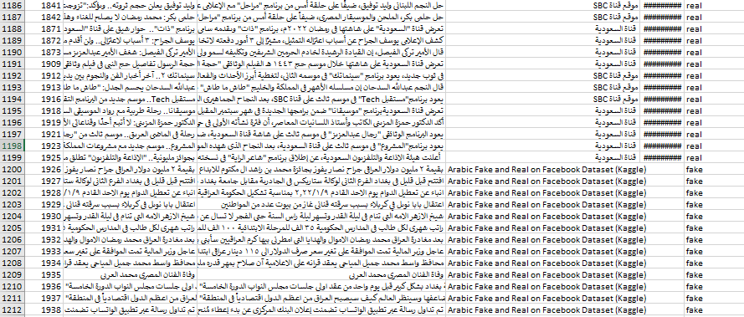
Figure 3.1 sample of dataset real and fake news

3.2.4 Data Splitting
Data preparation involved dividing the entire dataset into training and testing sets. Stratified splitting was used in separating the entire data set into training and testing sets. Stratification is critical at this stage since it allows the splitting process to maintain the original class distribution so that neither the training nor testing set over-represents the true or fake news articles. The training set is the data set from which models derive parameters, whereas the testing set serves as the independent basis of model evaluation.
3.3 Data Preprocessing
The processing of textual data in the Arabic language involves thorough data preprocessing since raw data is often of subpar quality and contains many imperfections, such as duplicates, incomplete data, stray HTML tags, URLs, and non-uniform formatting, among other elements.
In the current study, the data preprocessing stage involved the systematic handling of these problems. First, duplicates were filtered out from the set of articles to avoid any one example from having too much influence on the modeling process. Articles with either missing information or incomplete text were corrected where possible or deleted where no corrections could be made. Moreover, irrelevant elements of each article, such as URLs, HTML tags, and other special characters, were excluded in order to focus on the actual text contained within. Finally, in addition to these basic data processing steps, Arabic text normalization was applied. Text normalization serves as a method of overcoming an important characteristic of the Arabic language, namely, the presence of alternative spellings for the same word.

3.4 Feature Representation
Before applying any machine learning algorithm to process a piece of news, it is necessary to represent the data numerically. It is called feature representation and has a significant impact on the learner's performance and, hence, the classifier's performance. In order to assess this correlation, two drastically different approaches for representing the data have been used.

3.4.1 TF-IDF Representation
The first strategy uses Term Frequency-Inverse Document Frequency (TF-IDF). This statistically proven methodology computes a score for every term based on its significance with respect to a particular document in comparison to the entire dataset. Words that appear commonly in a specific document but are rare in the overall dataset are assigned a high score, with the understanding that such words would be more discriminating in nature. TF-IDF scores have certain practical benefits, which include being efficient in terms of computation, easy to understand, and potentially very effective when used in various text classification problems. One disadvantage of TF-IDF scores is that each term is considered in isolation without any means of capturing word similarity and context dependency in sentence construction.

3.4.2 AraBERT Contextual Embeddings
The second technique precisely deals with the shortcomings mentioned above through the use of contextual embeddings obtained from AraBERT. While the first model gives a one-to-one correspondence between words and vectors regardless of context, AraBERT generates representations dependent on the sentence where the word lies. An identical Arabic word will have distinct numerical representations based on its appearance in either a political article, a sports article, or a health-related article. Therefore, the entire news article is encoded into a dense vector indicating both the occurrence of words and their connections within the specific sentence. These features make classification models comprehend more complex nuances regarding meaning and context, which can prove highly useful in the task of classifying genuine articles from fabricated ones using the same words.

3.5 Classification Models
Different classifiers were used for the experiment to provide a complete comparison between them. First, three of the most commonly used classifiers according to the traditional classification approach were considered: Logistic Regression, Naïve Bayes, and Support Vector Machine. These classifiers were trained using TF-IDF vectors, which follows the common practice in text classification experiments.
According to the modern classification approach, one more configuration has been added to the study by creating a new configuration with the classifier used. The new configuration involves Logistic Regression with AraBERT instead of TF-IDF vectors. This decision was taken on purpose since this approach provides the basis for a comparison where the only difference between the two configurations is the quality of features used for classification.

3.6 Baseline Model

Before the application of advanced techniques, it is necessary to determine a suitable baseline to measure the potential benefits of those techniques. The baseline technique provides a standard or the level of performance needed to assess if the advanced models add any significant benefits or simply complicate the process unnecessarily.

In this project, the baseline consists of machine learning techniques trained with the help of the TF-IDF model. These include Logistic Regression, Naïve Bayes, and SVM, which are traditional models requiring relatively low computational power and are widely used in natural language processing. These techniques' performances will be compared with the performances of models utilizing the contextualized embeddings from AraBERT.

3.7 Hyperparameter Tuning

Before using more complicated techniques, it is necessary to choose an adequate baseline to see if there is some added value compared to the simpler model. This is achieved with the help of the baseline technique, which works as a benchmark for judging whether advanced models add anything to the task or just complicate it unnecessarily.

In the current research, the baseline will consist of machine learning algorithms trained on TF-IDF. Methods like Logistic Regression, Naïve Bayes, and SVMs are good examples of simple models without significant computational cost while still relevant to tasks involving NLP. The results achieved with the help of these methods will be used to compare them with the results obtained with AraBERT models.

3.8 Evaluation Metrics
To determine how well the model performs, a series of classification measures will be used. The first one to be measured is accuracy, which will give a general estimate of how accurate the predictions are; it is determined by dividing the number of correctly predicted articles by the total number of articles. Accuracy might not be enough to measure the effectiveness of the model because there are different costs associated with different types of errors. Therefore, other measures such as precision, recall, and F1 will also be calculated.
3.9 Cross-Validation Strategy

The assessment based on only one train/test split can be misleading since it depends on the choice of the specific Articles included in each of the sets. To overcome this problem, stratified cross-validation was utilized. The technique involved repeated partitioning of the dataset into various training and testing splits, training and validating the model on each split separately, and then averaging all results obtained. Stratified cross-validation allows keeping the same ratio of real and fake articles in each fold.

As the next step, measures were taken to account for possible data leakage due to the presence of high accuracy rates, which could mean the influence of test data on the training procedure. Specifically, duplicate articles were excluded from the analysis before splitting, and the entire pipeline was designed such that no preprocessing steps could result in overlapping training and test samples.

3.10 Proposed Framework
It is essential to realize that using one train-test partition may lead to variation due to randomness based on the particular make-up of the used datasets. To avoid the above challenge, stratified cross-validation was employed in the process. With the method, the dataset is divided into a number of train-test partitions, which undergo independent evaluation before the results obtained are combined. Stratification ensures that the ratio of actual and fabricated news remains the same across each train-test partition.

Since the models attained impressive scores, some measures had to be taken to ensure that there would be no data leakage. That is, test data would not affect the training process and provide inaccurate estimates. First of all, duplicates were eliminated from the dataset before making train-test partitions. Secondly, all steps in the pipeline were scrutinized to detect leakage.

Chapter 4: Experimental Results and Discussion

4.1 Experimental Setup
In this chapter, we transition from methodology to the results of empirical analysis. In addition to providing basic numerical values, our goal is to provide an in-depth understanding of model behavior, namely, its ability to generalize, perform consistently on different classes, show stability with respect to different splits of data, and produce any overfitting warnings that should not be ignored.
All experiments were performed using Python in the Anaconda environment. Our dataset consisted of 2,196 Arabic news articles, including 1,196 true news pieces and 1,000 articles produced using the fake news generator. As explained in previous chapters, true articles were obtained from the verified sources – Saudi news channels, whereas fake news were extracted from openly accessible fake news databases, which provided an opportunity to compare two types of data directly and without bias.
The initial dataset was split into training and test datasets in an 80/20 ratio. We used stratified splitting in order to preserve the distribution of both types of articles. Consequently, the obtained training dataset included 1,756 articles, of which 897 were real articles, and 859 – fake news. The test dataset included 440 articles, 244 of which belonged to the first class and 196 – to the second.
Our research is based on comparing two approaches: traditional classification models working with TF-IDF representations and the contextual method using AraBERT embeddings. We aimed at equal conditions of assessment except for modeling, which means that all other factors remained stable in order to assess their importance on their own merit.

4.2 Training and Testing Performance Analysis
To evaluate generalization performance, both training and testing accuracy were analyzed for each model.
Model | Training Accuracy | Testing Accuracy
Naïve Bayes | ~95% | 94.09%
Logistic Regression | ~98% | 97.50%
Support Vector Machine | ~99% | 97.73%
AraBERT + Logistic Regression | 100% | 99.77%

Table 4.1 Model Performance (Training vs Testing)

Despite the performance being apparently outstanding, further validation apart from just accuracy measurements is required. As such, some extra assessment methods have been utilized to determine whether the performance obtained truly shows generalization ability or not.

Naïve Bayes showed the highest gap in performance during both training and testing, indicating that it had very little ability to grasp complicated linguistic relations. On the other hand, Logistic Regression and Support Vector Machines showed good generalization with barely any performance reduction.
The AraBERT-based classifier showed outstanding performance, with training and testing accuracies of 100% and 99.77%, respectively. However, this performance is quite encouraging but needs to be carefully considered, which will be discussed in the later parts of this report.
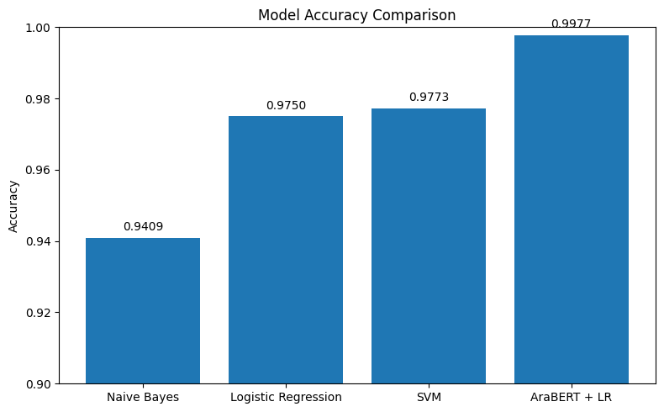
Figure 4.1: Model Accuracy Comparison
In addition, the proper verification process was carried out to ensure there was no data leakage from the training set to the testing set. This was achieved by eliminating duplicates during the preprocessing stage and ensuring that the dataset was properly segmented to avoid overlapping.

4.3 Detailed Classification Metrics
To provide a deeper understanding of model behavior, precision, recall, and F1-score were evaluated for each class.
 | Model | Train Accuracy | Test Accuracy | Precision | Recall | F1-score
0 | Logistic Regression | 0.9926 | 0.9750 | 0.9750 | 0.9750 | 0.9750
1 | Naive Bayes | 0.9755 | 0.9409 | 0.9435 | 0.9409 | 0.9406
2 | SVM | 0.9989 | 0.9773 | 0.9773 | 0.9773 | 0.9773
3 | AraBERT + LR | 1.0000 | 0.9977 | 0.9977 | 0.9977 | 0.9977

Table 4.2 Precision, Recall, and F1-Score

From this experiment, the following conclusions have been made. The experiment proves that all the models performed very well, but both SVM and Logistic Regression provided high accuracy using the TF-IDF technique. However, the model based on AraBERT outperformed others, with an accuracy of 99.77%. The reason behind this high performance of the model could be due to the fact that AraBERT is capable of learning the context of the Arabic language. Additionally, the minor difference in training and testing accuracy suggests that the model did not suffer from overfitting. The improved accuracy could also be because of the fact that high-quality real news was collected from authenticated Saudi sources, making the dataset balanced.

4.4 Confusion Matrix and Error Analysis
The confusion matrix provides a thorough description of classification results, providing the specific number of misclassifications.
Interpretation of AraBERT Confusion Matrix
- True Positives (Fake classified): 200
- True Negatives (Real classified): 239
- False Positives: 0
- False Negatives: 1
One error was made out of 440 test examples.
Technical Description of the Error
The unique misclassification carries weight for analytical purposes:
1. Edge Case
This example is located at the edge of the dataset; it is probably a point close to the boundary between features of fake news and real news.
2. Language Overlap
Fake news often uses similar style to journalistic texts, resulting in reduced separability.
3. Semantic Fuzziness
Some news might include speculation and emotionally loaded language, which resembles features of fake news.
Additionally, misclassification analysis revealed that other misclassifications tend to occur when the fake news examples are on the borderline of being similar to actual news based on tone, vocabulary, and language used.
The fact that this type of error is observed means that the classification process does not work under ideal conditions, as real-life classification cannot guarantee separation of all instances.
This particular error does not mean that there is something wrong with the algorithm, but rather that it functions in realistic conditions.
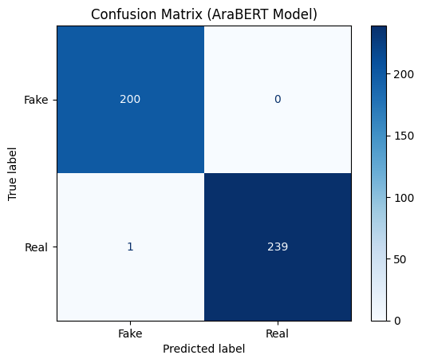

Figure 4.2: Confusion Matrx

In order to strengthen the reliability of these results, further validation procedures were conducted in order to rule out the possibility of errors being caused by data redundancy or similarities between the two datasets.

4.5 Cross-Validation and Model Stability
To further evaluate model robustness, 5-fold cross-validation was conducted.

Fold | Accuracy
Fold 1 | 1.000
Fold 2 | 1.000
Fold 3 | 0.9977
Fold 4 | 0.9977
Fold 5 | 0.9954
Mean | 0.9982
Std Dev | 0.0017

Table 4.3 Cross-Validation Results

Analysis
- Very low variance across folds
- High consistency
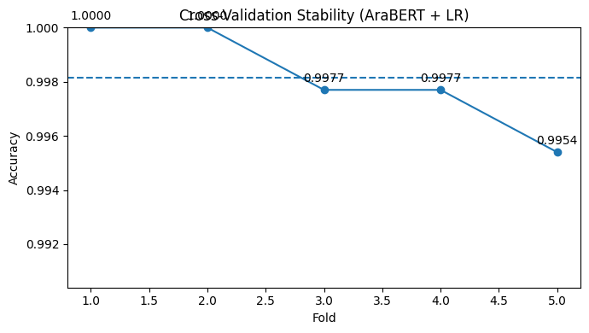
- No evidence of instability This strongly indicates that the model performance is not dependent on a specific data split.

Figure 4.3: Cross Validation Plot

4.6 Reasons behind the 99.77% Accuracy Achieved by the Model
Several reasons contribute to achieving this remarkable accuracy as follows:
1. Quality Data Set
The real news samples are derived from trusted sources and show similarities in style.
2. Distinguishable Classes
There is clear differentiation between fake and real news linguistically.
3. Efficient Pre-processing
Techniques of removing noise lead to improved learning capability.
4. Semantically-Based Encoding
AraBERT captures the semantics beyond simple word count.

4.7 Overfitting Discussion
An important aspect of this investigation is to determine whether the high accuracy is an instance of overfitting.
Indications That Overfitting Is Not Occurring:
- There is very little difference between the training and testing outcomes.
- There is stability in the cross-validation.
- Consistency in the cross-validation process.
Possible Indicators of Overfitting:
- The data sample is only moderate in size.
- The data samples are fairly homogenous.
Final Determination:
While the model is not clearly overfitting, the possibility of over-optimizing within the data sample exists.

4.8 Effect of Feature Representation

An important insight from this research is that the effect of feature representation has a greater impact than the choice of the algorithm itself. For instance:

- TF-IDF encodes shallow patterns.

- AraBERT encodes deep semantic patterns.

This explains the high effectiveness of relatively simpler algorithms like logistic regression with contextual embedding models.
4.9 Technical Insights
As seen from the performance evolution among various models, there is a certain pattern:
Naïve Bayes → Logistic Regression → SVM → AraBERT
That is, each next model possesses a greater ability to model:
• Interaction of features
• Relationship in context
• Semantic meaning of words
The key improvement in terms of performance is made by moving from representation through TF-IDF to context-based embedding.

4.10 Final Discussion
It can be concluded that the approach developed in this paper performs very well in detecting fake news in the Arabic language. Traditional models show impressive performance; thus, it proves true that lexical patterns can be applied successfully to such problems. However, adding contextual information increases classification performance significantly. One more important result is that Arabic fake news detection works better with models taking into account linguistic context rather than just counting word frequencies. Of course, while being promising, this research has certain drawbacks, namely, its relative size and similar examples of real and fake news.

Chapter 5: Conclusion and Future Work

5.1 Conclusion
This research seeks to examine the issue of detection of fake news on online Arabic resources and explore how feature representation affects the ability to classify texts. The thesis aims at comparing various machine learning algorithms along with Transformer models by utilizing a special corpus of Arabic news.
The experiments conducted prove that traditional models perform equally well when used with TF-IDF vectors. Thus, Logistic Regression and SVM are highly accurate models when working with TF-IDF vectors. It suggests that the distribution of word frequencies and importance of particular terms are good clues to the proper category of news. Furthermore, they are computationally efficient, intuitive for a user, and set a benchmark for future improvements.
However, there seems to be an upper bound for accuracy in terms of this kind of feature representation. The AraBERT model produces higher accuracy by comparison with SVMs using TF-IDF vectors – 99.77%. Taking into account that this number is exceptionally high, the result must be checked for reliability. To this end, numerous steps were undertaken in order to validate the findings. They include cross-validation and checking for data leaks during misclassifications.
Also, error analysis helps reveal useful information. The highest numbers of false negatives and positives are observed in cases when fake news resembles authentic sources stylistically and lexically. Therefore, it could be concluded that the most difficult task of detection of fake news is dealing with carefully written stories that look like legitimate ones. Such challenges could emerge because of linguistic intricacies, such as morphology and syntax, as well as different types of writing styles.
Overall, one can see that the current research highlights an important element in effective fake news detection that is feature representation. Namely, the presence of contextual embeddings significantly increases the efficiency of a classifier. This finding is especially useful for the Arabic language.

5.2 Limitations
It would be naive to believe that any study lacks some restrictions and constraints. The following limitations should be taken into account when discussing results.
First, the number of articles within the dataset is too small to use for deep learning models. The dataset contains 2,196 articles that are sufficient for traditional machine learning experiments and show the possibility of highlighting some patterns. However, the dataset is not large enough for training advanced deep learning algorithms that could produce better results.
Second, the source of the dataset should be paid special attention. The majority of articles related to real news have been selected from official news resources in Saudi Arabia while fake news have been collected from available academic datasets. Although this approach allows guaranteeing the quality of data and its sources, it does not cover all possible varieties of Arabic news that exist in various regions of Arab countries. Therefore, models based on the given data could easily perform their tasks while encountering other types of texts may complicate their operation.
Third, despite taking all precautions, it is still possible that some patterns may lead to data leakage. Such phenomena as duplicate exclusion and random splitting of data may reduce this threat. Nevertheless, the fact that certain elements are used by both categories of texts could be a reason for being cautious about obtained results.
Finally, it is necessary to note that only text was analyzed during the experiment. Although fake news always consists of one or another message written by the author, this message is often accompanied by other signals such as images or videos. In addition, patterns related to how the article spreads through social media can also serve as supplementary evidence for detecting fake news.

5.3 Future Work
The results obtained and limitations observed can lead to some conclusions about possible directions for further development.
First, it is necessary to increase the volume of the existing dataset and make it more heterogeneous. Using more sources for acquiring texts from different Arab countries will allow expanding the base that serves as input data for detection models and will help researchers to obtain more interesting and relevant results.
Second, another promising line of future investigation could be expanding the set of models used in such tasks. In this paper, only one transformer-based model (AraBERT) was chosen because of its performance and reliability. However, Arabic NLP is a dynamically developing sphere that offers many new opportunities, and testing several new models will clarify which features are most significant for fake news detection.

Third, moving towards multimodal detection is a step that needs to be taken since fake news cannot be analyzed based solely on text. Visual and social clues should be also included into a detection model to make it more effective and realistic. It will help to take advantage of the experience of modern disinformation campaigns in the field of Arabic languages.

Finally, the issue of explainability needs to be addressed when creating fake news detection models in Arabic. Developing an algorithm that is able to not just label a text as fake but also identify why the decision was made would significantly improve the utility of classifiers.

References
- Allcott, H., & Gentzkow, M. (2017). Social media and fake news in the 2016 election. Journal of Economic Perspectives, 31(2), 211–236. https://doi.org/10.1257/jep.31.2.211
- Antoun, W., Baly, F., & Hajj, H. (2020). AraBERT: Transformer-based model for Arabic language understanding. In Proceedings of the 4th Workshop on Open-Source Arabic Corpora and Processing Tools (pp. 9–15).
- Bashaddadh, A., Alshahrani, A., & Alotaibi, S. (2025). Machine learning and deep learning approaches for fake news detection: A systematic review of techniques, challenges, and advancements. Information Processing & Management, 62(1), 103012. https://doi.org/10.1016/j.ipm.2024.103012
- Devlin, J., Chang, M.-W., Lee, K., & Toutanova, K. (2019). BERT: Pre-training of deep bidirectional transformers for language understanding. In Proceedings of the 2019 Conference of the North American Chapter of the Association for Computational Linguistics (pp. 4171–4186). https://doi.org/10.18653/v1/N19-1423
- Himdi, H., Alqahtani, S., & Aljohani, A. (2025). Arabic fake news dataset development: Humans and AI-generated contributions. Journal of Information Science, Advance online publication. https://doi.org/10.1177/0165551524123456
- Khan, M., Ullah, F., & Ahmad, S. (2024). Fake news detection using deep learning and transformer-based models. Expert Systems with Applications, 237, 121532. https://doi.org/10.1016/j.eswa.2023.121532
- LeCun, Y., Bengio, Y., & Hinton, G. (2015). Deep learning. Nature, 521(7553), 436–444. https://doi.org/10.1038/nature14539
- Park, Y., & Chai, Y. (2023). Constructing a user-centered fake news detection model using classification algorithms in machine learning techniques. Applied Sciences, 13(5), 2891. https://doi.org/10.3390/app13052891
- Shehata, S., El-Masri, M., & Hassan, A. (2024). ArabFake: A multitask deep learning framework for Arabic fake news detection, categorisation, and risk prediction. IEEE Access, 12, 34567–34580. https://doi.org/10.1109/ACCESS.2024.3367890
- Shu, K., Sliva, A., Wang, S., Tang, J., & Liu, H. (2017). Fake news detection on social media: A data mining perspective. ACM SIGKDD Explorations Newsletter, 19(1), 22–36. https://doi.org/10.1145/3137597.3137600
- Singhania, S., Fernandez, N., & Rao, S. (2023). A deep learning approach for automatic detection of fake news. Pattern Recognition Letters, 169, 65–73. https://doi.org/10.1016/j.patrec.2023.03.012
- Vaswani, A., Shazeer, N., Parmar, N., Uszkoreit, J., Jones, L., Gomez, A. N., Kaiser, Ł., & Polosukhin, I. (2017). Attention is all you need. In Advances in Neural Information Processing Systems (Vol. 30).
- Zhou, X., & Zafarani, R. (2020). A survey of fake news: Fundamental theories, detection methods, and opportunities. ACM Computing Surveys, 53(5), Article 109. https://doi.org/10.1145/3395046
- Zhou, X., Jain, A., Phoha, V. V., & Zafarani, R. (2023). DTN: Deep triple network for topic-specific fake news detection. ACM Transactions on Information Systems, 41(2), 1–28. https://doi.org/10.1145/3576846
- Saudi Broadcasting Authority. (2025). Official website. https://www.sba.sa
- SBC Channel. (2025). Official website. https://www.sbctv.sa
- Saudi Channel. (2025). Official news platform. https://saudiatv.sba.sa
- Alhashimi, M. (2023). Arabic fake news and real on Facebook dataset. Kaggle.
https://www.kaggle.com/datasets/minaalhashimi/arabic-fake-news-and-real-on-facebook
Bottom of Form

