Midocean University
College of Administration
Master of Business Administration (MBA)

Evaluating the Strategic Impact of IKTVA on Supply Chain Performance, Supplier Development, and Local Value Creation:
Evidence from Saudi Aramco

Prepared By
Haitham Al-Haj
Student ID: 2021202510

Supervised By
Dr. Al-Faisal Hasan & Dr. Fayez Jarad
Faculty of Management
Midocean University

Academic Year
2026

ACKNOWLEDGEMENT

I would like to express my sincere gratitude and appreciation to my supervisors, Dr. Al-Faisal Abdul Hamid and Dr. Fayez Jarad, for their valuable and appreciated guidance, constructive and supportive feedback, and continuous support and motivation throughout the preparation of this research proposal.
I would also like to extend my great appreciation to the Faculty of Management at Midocean University for providing the superior academic environment and needed resources which are necessary for the successful completion of this work.
My sincere and honest thanks are extended to all participants and professionals who will contribute to this research by sharing their knowledge, extensive experiences, and insights related to the IKTVA program and supply chain management implementation and practices.
Finally, I am particularly grateful to my family for their level of understanding and continued support while balancing academic responsibilities, professional commitments, and family obligations throughout this MBA program.

Haitham Al-Haj
2026

DECLARATION

I hereby declare that this report was fully prepared and completed in accordance with the Midocean University guidelines following both academic and ethical compliance and standards. Moreover, all the sources of information have been acknowledged and referenced. Finally, this report is totally my own work as per the assignment shared with my academic supervisors.

Student Name: Haitham Al-Haj
Student ID: 2021202510
Date: 19 June 2026

ABSTRACT

Saudi Aramco introduced the In-Kingdom Total Value Add (IKTVA) program to enhance local content, strengthen domestic supply chains, and promote supplier development in direct and supportive alignment with Saudi Vision 2030. Despite the rising importance of localization initiatives in the Kingdom of Saudi Arabia, empirical verification regarding the practical effectiveness of the IKTVA program remains insufficient. This research aims to evaluate the strategic impact of IKTVA on supply chain performance, supplier development, and local value creation within the Saudi Aramco ecosystem.
The study adopts a quantitative research approach using a structured questionnaire distributed to employees, supply chain professionals, procurement specialists, supplier representatives, and other stakeholders involved in IKTVA-related activities. The study examines the influence of IKTVA Program Effectiveness as the independent variable on Supply Chain Performance, Supplier Development, and Local Value Creation as the dependent variables. Purposive samples will be used to collect approximately 200 responses. Full quantitative analysis which is done and executed via SPSS will include descriptive statistics, reliability testing, Pearson correlation, and multiple regression analysis.
The study is expected to provide valuable insights into the effectiveness of IKTVA initiatives and to highlight and identify opportunities which will result in enhancing the outcomes of localization. The outcomes and findings of the study will offer actionable insights into localization dynamics, identifying distinct operational opportunities to optimize industrial outcomes.
Keywords: IKTVA, Supply Chain Performance, Supplier Development, Local Value Creation, Saudi Aramco, Saudi Vision 2030, Localization.

TABLE OF CONTENTS

ACKNOWLEDGEMENT 2
DECLARATION 3
ABSTRACT 4
TABLE OF CONTENTS 5
LIST OF TABELS 8
LIST OF FIGURES 8
LIST OF ABBREVIATIONS 9
1. CHAPTER ONE 10
1.1 Background of the Study 10
1.2 Problem Statement 13
1.3 Research Aim 14
1.4 Research Objectives 14
1.5 Research Questions 14
1.6 Research Hypotheses 14
1.7 Significance of the Study 15
1.8 Scope of the Study 15
1.9 Delimitations of the Study 16
1.10 Definition of Key Terms 16
1.11 Assumptions of the Study 17
1.12 Study Limitations 18
1.13 Chapter Summary 18
2. CHAPTER TWO 19
LITERATURE REVIEW 19
2.1 Introduction 19
2.2 Saudi Vision 2030 and Localization Initiatives 19
2.3 Saudi Aramco Overview 20
2.4 The IKTVA Program: Development, Objectives and Strategic Role 21
2.5 Supply Chain Performance 22
2.6 Supplier Development 23
2.7 Local Value Creation 24
2.8 Theoretical Foundation 25
2.8.1 Stakeholder Theory 25
2.8.2 Resource-Based View (RBV) 25
2.9 Review of Previous Studies 26
2.10 Synthesis of Literature 28
2.11 Research Gap 29
2.12 Conceptual Framework 30
2.13 Chapter Summary 31
3. CHAPTER THREE 32
RESEARCH METHODOLOGY 32
3.1 Introduction 32
3.2 Research Philosophy 32
3.3 Research Approach 32
3.4 Research Design 33
3.5 Research Onion Framework 33
3.6 Data Sources 36
3.7 Research Population 36
3.8 Sampling Technique 37
3.9 Sample Size 37
3.9.1 Sources of Data 38
3.9.2 Primary Data 38
3.9.3 Secondary Data 38
3.10 Research Instrument 39
3.11 Validity of the Instrument 40
3.12 Reliability of the Instrument 40
3.13 Pilot Testing 41
3.14 Data Collection Procedures 42
3.15 Data Analysis Techniques 42
3.15.1 Descriptive Statistics 42
3.15.2 Reliability Analysis 42
3.15.3 Correlation Analysis 43
3.15.4 Multiple Regression Analysis 43
3.16 Assumption Testing 44
3.17 Ethical Considerations 44
3.18 Research Model 45
3.19 Research Timeline 46
3.20 Operational Definition of Variables 47
3.21 Chapter Summary 47
4. CHAPTER FOUR (Planned Data Analysis Framework) 48
4.1 Introduction 48
4.2 Descriptive Statistics 48
4.3 Reliability Analysis 48
4.4 Correlation Analysis 48
4.5 Multiple Regression Analysis 48
4.6 Expected Presentation of Results 48
4.7 Chapter Summary 48
5. CHAPTER FIVE (Expected Outcomes and Contribution) 49
5.1 Introduction 49
5.2 Expected Findings 49
5.3 Expected Academic Contribution 49
5.4 Expected Practical Contribution 49
5.5 Recommendations for Future Research 49
5.6 Chapter Summary 49
6. APPENDICES 50
APPENDIX A: Participant Information Sheet and Consent Form 50
APPENDIX B: Research Questionnaire 51
Section A: Demographic Information (8 Questions) 51
Section B: IKTVA Program Effectiveness (10 Questions) 52
Section C: Supply Chain Performance (10 Questions) 52
Section D: Supplier Development (10 Questions) 53
Section E: Local Value Creation (10 Questions) 53
REFERENCES 54

LIST OF TABLES

Table 1 Research Abbreviations 9
Table 2 Summary of Previous Studies 27
Table 3 Questionnaire Structure 39
Table 4 Five-Point Likert Scale 39
Table 5 Interpretation of Cronbach's Alpha Values 40
Table 6 Interpretation of Correlation Coefficients 43
Table 7 Research Variables and Hypotheses 45
Table 9 Operational Definition of Variables 47

LIST OF FIGURES

FIGURE 1 CONCEPTUAL FRAMEWORK OF THE STUDY 31
FIGURE 2 RESEARCH ONION FRAMEWORK ADAPTED FOR THE CURRENT STUDY 34
FIGURE 3 PROPOSED RESEARCH MODEL 45

LIST OF ABBREVIATIONS

Table 1 Research Abbreviations
Abbreviation | Full Meaning
APA | American Psychological Association
COPE | Committee on Publication Ethics
IKTVA | In-Kingdom Total Value Add
IRB | Institutional Review Board
KSA | Kingdom of Saudi Arabia
LVC | Local Value Creation
MBA | Master of Business Administration
SCM | Supply Chain Management
SD | Supplier Development
SDGs | Sustainable Development Goals
SME | Small and Medium Enterprise
SPSS | Statistical Package for the Social Sciences
RBV | Resource-Based View
WMA | World Medical Association

CHAPTER ONE: INTRODUCTION

Background of the Study
Global market instability forces modern organizations to apply changes on their business strategical plans, aiming to secure local supply chains, shifting national economic development from a secondary goal to a primary and strategic priority. Localization initiatives were implemented by both governments and large corporations worldwide, with an aim to increase domestic participation in economic activities, while working to develop local suppliers, and to create employment opportunities for locals. All of that, while promoting sustainable growth in economy and meeting future needs. Localization has become a strategic priority for the Kingdom of Saudi Arabia (KSA), specially under the Saudi Vision 2030, which reduce the dependence on oil revenues, improve the diversity of economy, support and strengthen the local industries, and develop and increase the contribution of the private sector to national development (Saudi Vision 2030, 2016)).
Saudi Aramco introduced the In-Kingdom Total Value Add (IKTVA) program in 2015, as part of the national transformation agenda. The IKTVA program was established and initiated as a strategic initiative which is designed to increase local content, promote the development of suppliers, encourage and support investment in local manufacturing, and to enhance the competitiveness of the Kingdom’s industrial sector. Saudi Aramco seeks to create a long-term economic value through this initiative. Not only that, but to encourage suppliers and contractors to have their international investments localized, while simultaneously improving the efficiency of operations and to have sustainability in the supply chain (Saudi Aramco, 2024).
Currently the IKTVA program is considered the largest initiatives in the Middle East for localization and a key component of the Saudi Arabia’s economic development strategy. The program simply focusses on increasing the local procurement, supporting the growth of Saudi-owned enterprises, develop workforce capabilities, facilitate the transfer of international technology to be locally, and attract the foreign international investment to be locally and actively in the Kingdom (Basahal et al., 2021). All of that can be achieved by encouraging suppliers to establish a network of local operations, and to expand their capabilities within the Kingdom and to resolve all their obstacles with a modern technique, to keep their momentum up for fast and quick transformation and exchange of expertise. Additionally, IKTVA aims to strengthen the resilience in supply chain, while making a positive contribution to the objectives of national economic. Localization initiatives have become increasingly important in supporting economic diversification, industrial development, and sustainable growth within Saudi Arabia (Saudi Vision 2030, 2016); Saudi Aramco, 2024).
To guarantee organizational success, the excellence performance of supply chain has become a critical factor. By increasing the effectiveness level of supply chain management, it can enable both the organization to improve its operational efficiency, along with reducing unnecessary build up costs, improving the quality of products by meeting their quality and reducing the number of defective units, helping in improving their delivery performance, all of that while increasing customer satisfaction by meeting their requirements and their actual needs and demand (Christopher, 2022; Chopra, 2023). If we focus on organizations that are operating in extremely competitive industries, like energy sector, we can easily note that maintaining a reliable and efficient supply chain is essential for achieving strategic objectives, all of that, while reducing the risk of the operation to the minimum or extremely zero level. Consequently, by understanding the impact of localization initiatives such as IKTVA on supply chain performance it is highly important for experts, policymakers and strategy developers (Krause et al., 2021; Truong et al., 2021).
Nowadays, supplier development is a key objective of modern supply chain strategies, additionally to improvement in the performance of supply chain. The scope of Supplier development has widely increased to include activities designed to enhance suppliers’ capabilities to improve their operational performance, to strengthen their quality standards, and to increase the compactivities as well. Organizations can help and assist suppliers to achieve higher levels of both performance and sustainability, through specified and focused training programs, high technical support, improved and modern knowledge transfer initiatives, and successful strategic partnerships. It is clear now that the IKTVA program emphasizes supplier development as a main mechanism for strengthening the local industrial base and supporting the growth in economics in the short and long-term plans (Porter & Kramer, 2019; Freeman, 2020).
Local value creation is another outcome development from localization initiatives, through IKTVA program. What we mean by local value creation is to generate in economic and social, and the total benefits within a specific geographic or region which resulted from a combination of multiple activities like investment, employment, procurement, and knowledge development and sharing. As per the context of Saudi Vision 2030, local value creation considered a critical item for the sustainable development. As result of increasing the local participation in supply chains and supporting domestic investment, programs such as IKTVA can easily contribute to job creation, industrial diversification, technology transfer and flexibility in economics.
It was noticed that limited research has examined IKTVA program’s overall effectiveness in achieving its intended objection, although overall agreement on IKTVA importance for the local development and supply chain improvement. The current existing studies have focused on the policy for localization, the diversification in economics, and the requirements for local content, while minimum attention has been given to evaluate the strategic impact of IKTVA on supply chain performance, supplier development, and local value creation from the point view of the key stakeholders. Furthermore, the degree of which IKTVA contribute to have a sustainable competitive advantage with Saudi Aramco’s supply chain ecosystem was not fully explored and only limited advantages wee mentioned with no full details and no full explanations, which makes it not explored as supposed to be.
Given the growing importance and demand of localization initiatives and Saudi Aramco's strategic role in supporting national economic development, there is a need for empirical research that evaluates the effectiveness of the IKTVA program. By fully understanding the relationship between IMTVA initiatives, implementation, supply chain performance, supplier effectiveness and performance, and local value creation, we can provide a valuable input for decision-makers, policymakers, and the international and local industry participants. Such knowledge sharing can support future plans for localization improvements, strategic allocating and to contribute to the final achievement of Saudi Vison 2030 goals.
As a result, this study seeks to evaluate the strategic impact of IKTVA on supply chain performance, in the development of supplier, and to the local value creating within the Saudi Aramco ecosystem. Our expectation from the findings are to contribute and participate in both the academic knowledge and practically through the right decision-makers, by identifying various opportunities which can enhance the overall effectiveness of IKTVA initiatives and to help maximizing the total contribution to a sustainable economic development in the Kingdom of Saudi Arabia and to achieve the Country 2030 vision .

Problem Statement
In order to strengthen domestic industries, to enhance and improve the diversifications of economic, and to reduce dependence on imported goods and services, the Kingdom of Saudi Arabia has implemented various initiatives on localization process. Among these initiatives, Saudi Aramco has emerged one of the most important initiatives and strategic mechanism for localization which is the In-Kingdom Total Value Add (IKTVA) program, by promoting local content, supplier development, and sustainable economic growth. It was clearly noticed and monitored by the country leaders and big international and national investors, that, since the implementation of IKTVA, by Saudi Aramco, it has encouraged various suppliers and both local and international contractors to increase their local investment, to develop workforce capabilities, and to establish manufacturing facilities within the Kingdom, in a total safe and encouragements ecosystem monitored, supported and supervised by Saudi Aramco leaders and IKTVA management teams.
Despite IKTVA’s main integration into Saudi Vision 2030, empirical data remains scare and limited regarding its direct operational impact on Aramco’s core supply chain performance, develop the enhancement of the suppliers and to create a sustainable local value add within Saudi Aramco’s supply chain ecosystem, the current existing studies have not extended their work and efforts and attention to examine the practical and operational impact of IKTVA from the main perspective of stakeholders, directly, who are involved in the activities of supply chain, but it focused only on the policies and standards at a macro level and with a general review only.
It is worth mentioning that organizations are still continuously facing challenges that are related to the efficiency of supply chain, the capability development of suppliers, the target for localization, the long- and short-term value creation and their real localization for their international money and experience for their international expertise and knowledge transfer. As a result, it is most common to have a continues to evaluate whether IKTVA initiatives are achieving their set up objectives and how effectively it is contributing to the organizational goals and the local developments as well. This study filling up this gap, by investigating the strategic impact of IKTVA on supply chain performance, development of suppliers, and creation for local value creation within the Saudi Aramco ecosystem.

Research Aim
The main aim of this study is to evaluate the strategic impact of the In-Kingdom Total Value Add (IKTVA) program on multiple aspects, which are: supply chain performance, supplier development, and local value creation within the Saudi Aramco ecosystem and to identify opportunities for enhancing the effectiveness of localization initiatives in alignment with Saudi Vision 2030.

Research Objectives
This study seeks to achieve the following objectives:
- To evaluate the impact of IKTVA implementation on supply chain performance within Saudi Aramco’s ecosystem.
- To assess the contribution of IKTVA to supplier development and capability enhancement.
- To examine the influence of IKTVA on local value creation within Saudi Arabia.

Research Questions
Main Research Question
What is the strategic impact of the IKTVA program on supply chain performance, supplier development, and local value creation within the Saudi Aramco ecosystem?
Sub-Research Questions
- How does IKTVA impact supply chain performance?
- How does IKTVA contribute to supplier development?
- How does IKTVA support local value creation?

Research Hypotheses
The study proposes the following hypotheses for empirical testing:
H1: There is a statistically significant positive relationship between IKTVA implementation and supply chain performance.
H2: There is a statistically significant positive relationship between IKTVA implementation and supplier development.
H3: There is a statistically significant positive relationship between IKTVA implementation and local value creation.

Significance of the Study
This study is expected to make a valuable contribution and to provide a valuable contribution that is not limited to academic knowledge but is extended to cover both the industry practices and the development in policies. From the academic point of view, the research will enrich the existing literature concerning the localization programs, supply chain management, supplier development, and local value creation. Additionally, the study will also contribute to better understanding how initiatives for strategic localization can influence the performance of organizations and to develop economic within emerging economies.
From practical perspective point of view, the outcomes can help Saudi Aramco, suppliers, various contractors, and decision-makers in evaluating how effective are the initiatives of IKTVA and to identify different opportunities for development and improvement. The research can support in developing more effective ways in strategical localizations, having better and stronger supplier relationships, and to enhance and improve the performance of supply chain.
At the national level, the study has full alignment with the objectives of Saudi Vision 2030. This can be achieved by examining different mechanisms that can contribute to diversity in economics,
growth in industry, generate opportunities for employment, and to have a satisfactory level in sustainability for local content development within initial economies. The study contributes to both academic knowledge and industry practice by examining the strategic role of localization initiatives in improving supply chain outcomes and creating sustainable value (Christopher, 2022; Chopra, 2023).

Scope of the Study
This study focuses on evaluating the strategic impact of the IKTVA program within the Saudi Aramco supply chain ecosystem. The research examines both the perceptions and experiences of employees, the professionals of supply chain, specialists in procurements, representatives of various suppliers, and the listed of stakeholders who are directly involved in the IKTVA-related activities.
The study investigates the relationship between IKTVA implementation and all three key dimensions, which are: supply chain performance, supplier development, and local value creation. All the data will be collected through a well determined and well-established structured questionnaire distributed among participants who are operating within the Kingdom of Saudi Arabia.
We have limited the geographical scope of this study to be limited only to the Kingdom of Saudi Arabia. Additionally, the scope of the organizational focuses only on Saudi Aramco and the organizations who are participating in the IKTVA initiatives. This study is conducted during the academic year 2026 and will rely on quantitative research methods for data collection and analysis.
The study does not evaluate confidential operational performance data from Saudi Aramco and protect that confidentiality information. Despite that, it focuses on perceptions of participants.

Delimitations of the Study
This study is delimited to stakeholders who are directly involved in Saudi Aramco’s supply chain ecosystem and IKTVA-related activities. The research focuses exclusively on three main outcomes variables, which are: supply chain performance, supplier development, and local value creation. Other potential outcomes, such as environment sustainability, financial performance, and international competitiveness, are beyond the scope of this study. Furthermore, the study adopts a quantitative approach and relies only on questionnaire responses which are collected during the research period.

Definition of Key Terms
For the purpose of this study, the following key terms are defined to provide a clear and better understanding of the concepts used throughout the research.
IKTVA (In-Kingdom Total Value Add)
Saudi Aramco introduced this strategic program, with an objective to increase the local content, develop suppliers domestically, promote and increase investments, and to enhance the creation of economic value specifically and particularly within the Kingdom of Sadi Arabia (Saudi Vision 2030, 2016).
Supply Chain Performance
The performance of supply chain measures the ability of organization supply chain in achieving a number of goals, listed as, operational efficiency, effectiveness in costs, improvement in quality of services and products, applying reliability in delivery, flexibility in operations, and the overall performance in business (Basahal et al., 2021).
Supplier Development
Various organizations assist suppliers via a systematic process, to improve the suppliers’ capabilities, performance in operations, standards in quality, technological competencies and competitiveness (Krause et al., 2021; Truong et al., 2021).
Local Value Creation
Economic generation, industrial and social development, the benefits in employment within a specific country or region through the supported and successful local investment, active procurements processes, development in workforce, and growth in industrial activities (Porter & Kramer, 2019; Freeman, 2020).
Localization
It is a strategic approach by decision makers, aiming to increase the participation of domestics in various activities of economics, through the local industries development, suppliers and workforce capabilities. Additionally, to widen the scale of investment opportunities.
Saudi Vision 2030
It covers the national framework of transformation, established and agreed on by the Government of Saudi Arabia, aiming to diversify the economy, enhance the local competitiveness, empower the local investment and industries, all of that while promote and advertise for a continuous and sustainable development (Saudi Vision 2030, 2016).

Assumptions of the Study
The study assumes that respondents possess enough and sufficient knowledge and experiences level regarding IKTVA-related activities within the Saudi Aramco supply chain ecosystem. It is also important to clarify that; it is also assumed that participants will provide honest and accurate responses to the provided and shared questionnaire. Furthermore, the study assumes that the selected sample of participants adequately represents the target population involved in IKTVA implementation and supply chain operations.

Study Limitations
It is important to explain that the study is limited to participants who are involved directly or indirectly in Saudi Aramco’s supply chain ecosystem and to the implementation of the IKTVA program. As per the previously mentioned, the findings may therefore not be fully generalizable to other industries or organizations outside the Kingdom of Saudi Arabia. In addition, the study adopts a cross-sectional design and relies on self-reported questionnaire responses, which may be influenced by both individual perceptions and level of experiences.
In addition, to what was mentioned earlier, the use of purposive sampling may limit the generalizability of findings to the group of wider population.

Chapter Summary
To summarize chapter one, it introduced the background and context of the study, by discussing the importance of localization initiatives and their highly contribution to develop the economic within Saudi Arabia. The chapter also presented multiple topics, like the research problem, research aim, research objectives, research questions, research hypotheses, research significance, research scope, research delimitations, and the key definitions which are relevant to the study. Chapter one established the foundation for examining the strategic impact of the IKTVA program on supply chain performance, supplier development, and local value creation. In the next chapter, we will review the relevant literature and theoretical foundations that best support the study.

CHAPTER TWO: LITERATURE REVIEW

Introduction
In this chapter we will review all the main literature which are associated with localization initiatives, performance of supply chain, development of supplier, and local value creation. The main purpose of literature review is to put the foundation for both theoretical and conceptual of the study, to be able to clearly identify the main key concepts which are related to the IKTVA program, and to examine the findings of previous research that are relevant to the research topic. Furthermore, the chapter explore the relationship between implementation of IKTVA and outcomes of organization performance within in Saudi Aramco ecosystem specifically. Additionally, the chapter clearly highlight and identify the current existing gaps in research and develop the theoretical framework which easily guide the current study.

Saudi Vision 2030 and Localization Initiatives
The main objective of Saudi Vision 2030 is to reduce the Kingdom’s dependence on only oil revenue and to create a new source of revenue through a both diversified and clean and sustainable economy, all of that through a smart and intelligent representation for a comprehensive national transformation strategy (Saudi Vision 2030, 2016).
Increasing the local content across various economic sectors is considered as one of the primary objectives of 2030 Vision of Saudi Arabia. What we meant by localization in a wider term, is to concentrate the initiative to encourage manufacturing domestically, improve the capabilities of workforce, create a backbone and strong support for small and medium-sized enterprises, and to have a great focus in attracting foreign investments which have a great contribute to the development of the national economic. The policies of localization are created in a way to strengthen supply chain resilience by reducing the dependent on both imported goods and services, and their direct delay in lead-time, controlled or uncontrolled due to dramatic global changes (Basahal et al., 2021).
In our current world, the energy sector has a vital role in supporting most of the objectives of localization. As Saudi Aramco considered the world largest energy company, it has implemented several smart and modern initiatives strategically to promote and encourage the idea of local content creating and to strengthen and support the capabilities of industry within the Kingdom. One of these great initiatives and proposals is the IKTVA program, which is a cornerstone of the Saudi Arabia strategical localization (Bohnenkamp et al., 2020).
Localization contributes to economic development through employment generation, industrial expansion, technology transfer, and increased investment opportunities. By continuing to create new opportunities for employment, putting clear guidelines and paths for supporting entrepreneurship ideas and projects, making the process of technology transfer easily and faster, all of that without forgetting to focus on industrial growth stimulate. As a result, by better understanding the effectiveness of localization programs and it is adding value, it is critical for a valid and correct evaluating for their positive contribution in sustaining national development.

Saudi Aramco Overview
Saudi Arabian Oil Company (Saudi Aramco) is one of the largest integrated for both energy and chemicals companies, worldwide. Additionally, Saudi Aramco plays a significant and important role in developing the economy of the Kingdom of Saudi Arabia. Saudi Aramco was established as a national energy company, to contribute to a fully sustainable gross domestic product (GDP), industrial development as per the international standards, employment generation for the local nations, and to provide an excellent international competitiveness to the Kingdom of Saudi Arabia.
Saudi Aramco is a strategic partner in supporting Saudi Vision 2030, this is beyond it is traditional role in the oil and gas sector. Saudi Aramco supporting the vision through various number of initiatives which are aimed to confirm diversifications in economic, local content development, perfection in technology transfer, and to enhance human capital. Saudi Aramco continuously invests in developing local industries and plays a great role in strengthening domestic supply chains to support short-term and long-term economic sustainability.
As part of its commitment to national development, Saudi Aramco successfully launched several successful localization initiatives, one of the greatest and most prominent of which is the In-Kingdom Total Value Add (IKTVA) program. Through IKTVA, Saudi Aramco closely seeks to increase the participation of local content, strengthen supplier capabilities, encourage local manufacturing, and create sustainable value for economic within the Kingdom of Saudi Arabia. Consequently, Saudi Aramco perfectly provide an appropriate and exceptional organization context for examining the relationship between localization initiatives and outcomes of supply chain performance. Saudi Aramco plays a central role in supporting industrial development and local content initiatives through various strategic programs, including the In-Kingdom Total Value Add (IKTVA) program (Saudi Aramco, 2024).

The IKTVA Program: Development, Objectives and Strategic Role
The In-Kingdom Total Value Add (IKTVA) program was successfully launched by Saudi Aramco in 2015 representing a strategic localization approved and supported initiatives designed specifically to increase local content, focused on strengthen domestic supply chains, closely support supplier development, Smartly attract both local and international investment, and to ultimately contribute to achieve the objectives of Saudi Vision 2030. The IKTVA program serves as a master key mechanism for enhancing the participation of local economic while promoting and encouraging sustainable growth for industrial within the Kingdom of Saudi Arabia. The IKTVA program serves as the main mechanism in achieving the objectives behind localization, all of that, while having full alignment with Sudi Vision 2030.
Since its successful introduction in 2015, IKTVA has evolved into a comprehensive framework, that encourages suppliers and contractors aiming to increase and expand local investments and not to forget to strengthen their operational capabilities within the Kingdom of Saudi Arabia. Participating organizations are evaluated using a range of performance indicators that assess local procurement activities, workforce localization efforts, supplier development initiatives, research and development contributions, and investments in local manufacturing capabilities.
If we highlight the primary objectives of IKTVA, it will include the following:
- Increasing local content spending within the Kingdom.
- Supporting supplier development and capability enhancement.
- Creating sustainable employment opportunities.
- Encouraging technology transfer and innovation.
- Enhancing industrial competitiveness.
- Promoting sustainable economic growth and diversification.
It is important to mention that, through these objectives, IKTVA continuedly and ultimately seeks to establish a resilient and competitive supply chain ecosystem while keeping in mind to generate sustainable value for Saudi Aramco, suppliers who participate, and the economy at national level. As localization continues to play an important and vital role in Saudi Arabia’s economic transformation agenda, that push all the organizations which are operating actively within the Saudi Aramco supply chain increasingly align their both operations and strategies with IKTVA clear and well identified and explained requirements. Consequently, the effectiveness of the IKTVA program can be perfectly evaluated through its influence on the performance of supply chain, supplier development, and local value creation, which represent the core listed and specified variables what are examined in this study.
By reviewing these objectives, it is clear that IKTVA seeking to establish a much more resilient and competitive supply chain, while generating both short and long-term value add for both Saudi Aramco and Saudi Arabia.
Nowadays, we can clearly notice the importance of the program, as organizations are seeking to align their operating and goals strategically with the localization requirements and to positively contribute to the Kingdom’s economic agenda for transformation. Previous studies have highlighted the positive impact of localization policies on economic diversification, industrial competitiveness, and local supplier development (Basahal et al., 2021; Savio, 2021).

Supply Chain Performance
The ability of a certain and specific organization’s supply chain to manage the flow of raw materials efficiently, the related information, and different resources from supplier to end user or customers, is what we mean by supply chain performance. Effective supply chain performance contributes significantly to organizational competitiveness, operational excellence, and customer satisfaction.
Several dimensions of supply chain performance were identified by different researchers, which include:
- Cost efficiency.
- Quality performance.
- Reliability in delivery.
- Flexibility in operations.
- Responsiveness to orders.
- Meeting Customer satisfaction.
Normally, organizations who manage to reach a high level of supply chain performance are positioned better in responding to most frequent changes in market, can easily manage to reduce their operational costs, can achieve a higher quality service, and which result in maintaining sustainable competitive advantages.
Supply chain performance might be influenced by several factors such as supplier capabilities, availability of local sourcing, competencies of workforce, and collaboration between different supply chain partners. That can better lead to, evaluating the impact pf IKTVA on supply chain performance is an essential for understanding the effectiveness of various strategies of localizations. Supply chain performance is commonly evaluated through measures such as efficiency, responsiveness, reliability, and cost effectiveness (Christopher, 2022; Chopra, 2023).

Supplier Development
The process where the organizations work in a full collaborative way with their suppliers in a way to improve their capabilities, top up their performance, improve their quality standards, and to reach higher competitiveness, is what we called Suppliers Development. Currently, modern supply chain management, recognizing suppliers as strategic partners rather than just a normal transactional vendor.
The activities for supplier development may include:
- Training programs.
- Technical assistance.
- Knowledge transfer.
- Performance monitoring.
- Technology support.
- Improvement joint initiatives.
If we concentrate on the primary goal of supplier development, then it will be clear to enhance both the supplier capabilities and to improve the performance of overall supply chain. Strong programs for supplier development can result in reducing operational risks, improving the quality of products, improving and increasing the innovations, and at most to have greater supply chain resilience.
If we focus within the IKTVA framework, we can notice that supplier development can represent a very important success factor because the objectives of localization depend on the ability of the domestic suppliers to meet both industry standards and to be able to effectively compete within global markets.
By simply strengthening supplier capabilities, different organizations can easily achieve economic objectives and operational improvements. Supplier development practices are essential for improving supplier capabilities, quality performance, and long-term competitiveness within supply chain networks (Krause et al., 2021; Truong et al., 2021).

Local Value Creation
If we highlight the total generated benefits in an industry, within a society and improving to the economy, within a specific geographic area through different business activities, various investment aspects, and multiple supply chain operation, then we are discussing the local value creation. Local value creation is a fundamental objective for the initiatives in localization, simply because it can contribute directly to the goals of national development.
Mentioning key dimensions of local value creation will include the following:
- Generation for employment.
- Generation for diversification in economics.
- Generation for development in multiple industries.
- Generation for a continues and secured knowledge transfer.
- Generation for a continued advancement in technology.
- Generation for an increased trust in local investment.
Within the Saudi Arabian context, local value creation plays a critical role in achieving the objectives of Vision 2030. Focusing on IKTVA program, among other programs, can show us, how it seeks to put more efforts to maximize the benefits of economic retained within Saudi Arabia, by mainly encouraging procurements domestically, manufacturing locally, and having a continues development into the local and nation workforce.
To know how effective the localization programs is, we often can measure them by simply, their ability to generate a sustainable local value while miniating the competitiveness of the organizations and effectively operate them.
As a result, by evaluating the IKTVA contribution into the local value creation, representing a significant component of the current research. Local value creation extends beyond financial benefits and includes employment generation, technology transfer, knowledge development, and economic sustainability (Porter & Kramer, 2019; Freeman, 2020).

Theoretical Foundation
Both Stakeholder Theory and Resource-Based View (RBV), are the primary support for this study.

2.8.1 Stakeholder Theory
In order to understand this theory better, we need first to identify the following. The Stakeholder Theory suggests that organizations can create value through effective relationships with all the stakeholders, including but limited to, employees, suppliers, different customers, governments, and local communities. When making strategic decisions, the theory emphasis the importance of balancing between the different stakeholder interests (Freeman, 2020).
Within the IKTVA perspective, we can clearly note that multiple stakeholders are directly involved to achieve the objectives of localizations, that include but not limited to, Saudi Aramco, suppliers, various contractors, group of employees, government and its related agencies, and finally, the local communities. Therefore, we can see that the Stakeholder Theory provides a framework, which is useful for better understanding how different initiatives for localization can contribute to generating value across different groups of stakeholders. Therefore, Stakeholder Theory provides a suitable lens for understanding how IKTVA creates value for multiple stakeholder groups within the Saudi Aramco ecosystem.

2.8.2 Resource-Based View (RBV)
It is important to keep in mind that the Resource-Based View proposes that to achieve suitability in competitive advantage, through valuable, rare, inimitable, and organizationally embedded resources and capabilities.
What can be considered as strategic resources are supplier capabilities, workforce competencies, expertise in technology, and capacity for local manufacturing, which can contribute to the performance of organizations. It is very important to know that the IKTVA program seeks to strengthen these resources, through multiple ways, like variable initiatives for localizations, implementing and applying specific and well oriented programs to develop suppliers, and different activities which result in capability-building.
As a result, RBV can provide a unique theoretical explanation for how IKTVA may positively contribute to improving the supply chain performance and in creating a local value (Barney, 1991; Barney et al., 2021). Consequently, RBV supports the argument that localization initiatives can enhance organizational performance through the development of valuable internal capabilities and strategic resources.

Review of Previous Studies
It was clearly noted that among multiple previous studies they have limitedly examined the impact of localization policies, practices for supply chain management, initiatives for developing suppliers, and diversification economic programs.
It was observed that research generally showed that localization initiatives contributed positively to generate employment, industrial development, and growth for economic. Additionally, several studies demonstrated that supplier development programs can improve supplier capabilities, performance for operations, and efficiency of supply chain.
It was mentioned by other researchers the importance of collaboration between both suppliers and organizations in achieving sustainable performance in supply chain. An effective supplier programs for development have been linked with enhanced quality performance, innovation, and competitive advantages.
Rarely have studies specifically examined the strategic impact of IKTVA on supply chain performance, supplier development, and local value creation simultaneously. Existing literature addressing these variables separately, which clearly create a wide gap in understanding their combined relationships with specifically the Saudi Aramco ecosystem.
Previous studies have generally reported positive outcomes associated with localization initiatives and supplier development programs. However, differences exist regarding the scope of analysis, methodological approaches, and industry contexts. While some studies focused on macroeconomic outcomes such as employment generation and economic diversification, others examined operational outcomes including supply chain efficiency and supplier capability enhancement. These differences highlight the need for a comprehensive examination of IKTVA within the Saudi Aramco ecosystem.
Table 2 presents a summary of selected previous studies relevant to localization initiatives, supply chain performance, supplier development, and local value creation. The reviewed studies play an important role by providing the foundation for understanding the relationships among the variables examined in the current research.
Table 2 Summary of Previous Studies
Author(s) | Year | Study Focus | Methodology | Key Findings
Basahal et al. | 2021 | Localization policies in Saudi Arabia | Quantitative | Localization initiatives positively supported industrial development and economic growth.
Savio | 2021 | IKTVA and Saudi Vision 2030 | Qualitative | IKTVA contributes to economic diversification and local content enhancement.
Bohnenkamp et al. | 2020 | Supply chain localization | Mixed Methods | Localization strengthens supply chain resilience and operational continuity.
Truong et al. | 2021 | Supplier development programs | Quantitative | Supplier development improves supplier capabilities and performance outcomes.
Khan et al. | 2022 | Supply chain performance | Quantitative | Strong supplier collaboration improves operational efficiency and responsiveness.
Alotaibi | 2022 | Localization initiatives in Saudi Arabia | Qualitative | Local content initiatives support employment creation and industrial growth.
Alqahtani & Ahmed | 2023 | Local value creation | Quantitative | Local value creation contributes positively to national competitiveness and sustainability.
Alharbi et al. | 2023 | Supplier capability development | Quantitative | Supplier development initiatives enhance competitiveness and innovation performance.

The group of different studies which are presented in table 2.1 collectively demonstrate that localization initiatives, supplier development programs, and supply chain performance improvement efforts contribute positively to both organization and economic outcomes. While research previously has examined these variables individually, a very low number, or very limited studies have investigated their interrelationships within the context of the IKTVA program. In particular, there is clearly insufficient empirical evidence examining how IKTVA influences supply chain performance, supplier development, and local value creation, all simultaneously, within the Saudi Aramco ecosystem. As per this limitation, it has provided the basis for the current study and highlights its potential contribution to the existing body of knowledge.
This research seeks to address this gap by providing an integrated assessment of strategic outcomes associated with successful IKTVA implementations.

Synthesis of Literature
The literature which was reviewed in this chapter focuses on the continues growing for the importance of localization initiatives to support economic diversification, industrial development, and supply chain resilience. By reviewing previous studies, they have consistently demonstrated that by using and implementing the local content programs, it can contribute positively to organizational performance, enhance the supplier capabilities, and develop national economic. Within the Saudi Arabia context, Saudi Vision 2030 has played a great role by further emphasized the high importance of localization as a strategic priority for achieving continues productive and sustainable growth and by reducing in the other hand , the dependency level on external resources, because of unstable global economic, that can affect negatively the economics of Saudi Arabia.
The review additionally indicates that the supplier development initiatives play such a significant and important role in improving operational efficiency, improving quality performance, which can be both related to quality of products or services as well, improving innovation capabilities, and long-term competitiveness. By following the same way, research on supply chain suggests that by strengthening the supplier relationships and by increasing local participation both can positively contribute to greater flexibility, ensure to have a faster responsiveness, and resilience in supply chain operations.
Although several studies have examined localization policies, practices of supply chain management, and initiatives of supplier development, separately, limited or no attention has been given to the combined impact of the In-Kingdom Total Value Add (IKTVA) program on supply chain performance, supplier development, and local value creation. Moreover, limited empirical evidence focused specifically on the Saudi Aramco supply chain ecosystem.
Therefore, the current study seeks to address this gap by providing an integrated assessment of how the IKTVA program contributed to organizational and economic outcomes. All the findings are expected to contribute to both academic knowledge and decision-making practically, regarding localization initiatives within Saudi Arabia. These findings collectively support the development of the proposed conceptual framework and the formulation of the study hypotheses.

Research Gap
A detailed review of the existing literature shows several important gaps that clearly justify the high demanded need for the current study. First, limited empirical research has successfully examined the effectiveness of the In-Kingdom Total Value Add (IKTVA) program from the perspective of supply chain stakeholders operating within the Saudi Aramco ecosystem (Khan et al., 2022).
Second, while majority of previous studies have primarily focused on the macroeconomic outcomes of localization initiatives, such as economic diversification, employment generation, and industrial development, it gave minimal attention to both organization and operational impacts.
Third, there is not enough research which investigates the relationship between IKTVA implementations, supply chain performance, supplier development, and local value creation within a single integrated theoretical framework. Most current existing studies have examined these variables independently rather than exploring their interrelationships.
Finally, a very limited number of exists evidence in regard to how these factors are interacting within Saudi Aramco’s supply chain environment and can contribute to the achievement of localization objectives. Consequently, this study seeks to address these gaps by providing empirical evidence on the strategic impact of IKTVA and identifying opportunities for enhancing supply chain performance, supplier development, and local value creation.
Based on the clearly highlighted and identified research gaps, the current study proposes an integrated framework to examine the relationship between IKTVA implementation and three key outcome variables; supply chain performance, supplier development, and local value creation. The conceptual framework presented in the following section illustrates and clearly explains the proposed relationships among these previously mentioned variables. Despite the growing body of literature on localization and supply chain management, limited empirical research has investigated the relationship between IKTVA implementation, supply chain performance, supplier development, and local value creation within a unified framework (Basahal et al., 2021; Khan et al., 2022). The identified gaps demonstrate the need for an integrated empirical investigation within the Saudi Aramco supply chain ecosystem. Accordingly, this study helps develop a conceptual framework that integrates IKTVA implementation, supply chain performance, supplier development, and local value creation within a single analytical model. This approach extends existing literature by examining the relationships among these variables simultaneously rather than independently, which adds value for the study and provides more valuable inputs for both readers and academic research.

Conceptual Framework
The conceptual framework for this study proposes that the effectiveness of IKTVA initiatives have a positive influence on supply chain performance, supplier development, and local value creation. That was based on the literature review and theoretical foundations.
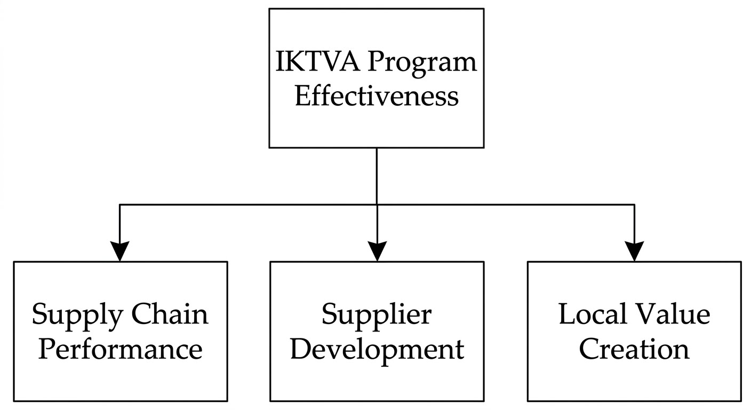
Figure 1 Conceptual Framework of the Study
Source: Developed by the Researcher (2026), adapted from Freeman (2020), Barney et al. (2021), and Basahal et al. (2021).
This framework assumes that the successful implementation of IKTVA initiatives will contribute positively to improving operational performance, having stronger capabilities for supplier, and greater benefits on local economic. The previously mentioned relationship will be empirically tested through a quantitative analysis, using data collected from surveys which is collected from participants involved in the ecosystem of Saudi Aramco supply chain.

Chapter Summary
This chapter reviewed the literature related to Saudi Vision 2030, localization initiatives, the IKTVA program, supply chain performance, supplier development, and local value creation. It also discussed the theoretical foundations of the study, reviewed previous research, identified the research gap, and presented the conceptual framework that guides the study.

CHAPTER THREE: RESEARCH METHODOLOGY

Introduction
In this chapter we will discuss and present the research methodology which is adopted to achieve all the objectives associated with this study. As per that the chapter clearly explain with details the research approach, the design of the research, the approximate target population, the sampling procedure, the methods for data collection, the design for questionnaire, both validity and reliability measures, the consideration for ethics, and the statistical techniques which is used for data analysis. The main purpose of this methodology is to provide a systematic framework, which is used for evaluating the strategic impact of the In-Kingdom Total Value Add (IKTVA) program on supply chain performance, supplier development, and local value creation within the Saudi Aramco ecosystem.

Research Philosophy
If we need to explain the research philosophy, then, we need to include all the beliefs and listed assumptions that both guide the research process and can influence all the methods used in data collections and data analysis. This study adopts a positivism research philosophy style, because it emphasizes measurement for objectives, quantitative analysis, and empirical investigation for the relationships among the selected variables.
If we need to explain why the positivist approach is the appropriate selection for this research, then we must mention the following. The study seeks to examine a measurable relationship between IKTVA implementation, supply chain performance, supplier development, and local value creation using statistical analysis techniques.

Research Approach
In this study, we need to mention that it implements a deductive research approach. Where the deductive approach begins with selected existing theories and concepts which are derived fully from previous literature and develops a determined hypothesis which can be tested empirically using quantitative data.
To mention why the deductive approach is suitable for this study, we have to highlight that as the study seeks to test predefined hypotheses regarding the relationship between both IKTVA implementation and the outcomes of organizational performance.

Research Design
This study clearly employs a quantitative cross-sectional research design.
The main purpose of selecting a quantitative design, as it enables the collection of data, which is collected numerically from many participants, additionally it allows to apply statistical analysis of relationships among multiple variables. What involved in cross-sectional design is data collected at a single point of time from different respondents who are directly involved in Saudi Aramco’s supply chain ecosystem. Quantitative research designs are widely used to examine relationships among variables and test research hypotheses (Creswell & Creswell, 2023; Sekaran & Bougie, 2020).
Why we can say, this is design is appropriate, as it facilitates efficient collection of data while providing sufficient information to evaluate the research selected hypotheses.

Research Onion Framework
The Research Onion Framework, which was developed by Sauders, Lewis, and Thornhill (2019) provides a clear structured approach for selecting appropriate methodologies research. The framework presents the different methodological layers that guide the research process, that include research philosophy, approach, strategy, methodological choice and selection, time horizon, and data collection techniques. The methodological choices adopted in this study are consistent with the Research Onion Framework proposed by Saunders et al. (2019). The current study adopts the methodological choices illustrated in Figure 2.

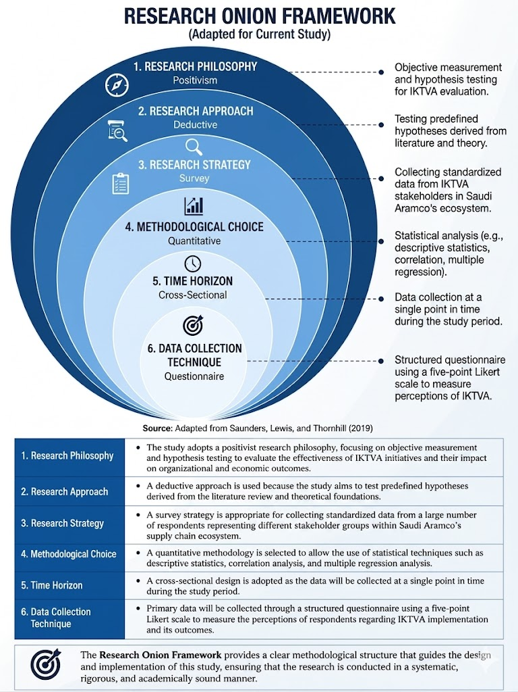
Figure 2 Research Onion Framework Adapted for the Current Study
Source: Adapted from Saunders, Lewis, and Thornhill (2019).
The Research Onion Framework provides an academic structured approach for selecting and aligning research methodologies. As illustrated in Figure 2, the outer layer represents research philosophy, where a positivist perspective is adopted to facilitate objective measurement and statistical examination of the relationships among the study highlighted variables. The study follows a deductive approach because it seeks to test and examine hypotheses developed from the literature review and theoretical foundations. A strategical survey is employed through a comprehensive structured questionnaire, which distributed to respondents within Saudi Aramco’s supply chain ecosystem. The methodological choice is quantitative which better enabling the application of statistical techniques to best examine the relationships among the selected variables. A cross-sectional time horizon is adopted because the data collection will be at a single point in time. Finally, questionnaires are used as the primary data collection instrument in gathering information from the selected sample. The framework demonstrates the alignment and arrangement between the study’s philosophical stance, research approach, methodological choices, and data collection procedures. For further details of each methodological layer are presented in the following section.
Research Philosophy
This study adopts a positivist research philosophy because it focuses on objective measurement, hypothesis testing, and statistical examination of the relationships among the study variables. The positivist approach is appropriate because the study seeks to evaluate measurable relationships between IKTVA implementation, supply chain performance, supplier development, and local value creation through quantitative methods.
Research Approach
A deductive approach will be adopted because the study seeks to test predefined hypotheses which are derived from the literature review.
Research Strategy
The study will employ a survey strategy using a structured questionnaire administered to the group of participants within the Saudi Aramco supply chain ecosystem. The survey instrument is specifically designed to collect quantitative data regarding IKTVA Program Effectiveness, Supply Chain Performance, Supplier Development and Local Value Creation. A copy of the questionnaire is provided in the Appendix at the end of the study report for refence.
Methodological Choice
The study follows a quantitative methodology to facilitate statistical analysis of the relationships among the study defined variables.
Time Horizon
A cross-sectional time horizon will be adopted because data will be collected at a single point in time.
Data Collection
Primary data will be collected through questionnaires which are distributed to groups of participants, that include employees, suppliers, and stakeholders involved in IKTVA-related activities.

Data Sources
The study will utilize both primary and secondary data sources. Primary data will be collected through a structured questionnaire which will be distributed to employees, suppliers, contractors, and stakeholders who are associated with the Saudi Aramco supply chain ecosystem. Secondary data will be obtained from academic journals, books, conference proceedings, industry reports, Saudi Aramco publications, and Saudi Vision 2030 documents relevant to localization and supply chain management.

Research Population
The population who are targeted consist of a group of individuals who are directly involved in supply chain and the activities of localization, which are associated with Saudi Aramco and IKTVA program.
The population of this study includes:
- Employees from Saudi Aramco.
- Professionals in supply chain.
- Specialists in procurement.
- Professionals in contracting.
- Representatives for suppliers.
- Vendor management personnel.
- IKTVA stakeholders.
Professionals in industry, who are involved in localization initiatives.
All these groups of participants possess relevant levels of both knowledge and expertise regarding the implementation of IKTVA and its impact on the performance of organizations.

Sampling Technique
In this study we are utilizing purposive sampling.
Simply we can define purposive sampling as a non-probability sampling technique in which all the participants will be selected based on their knowledge, level of experience, and their level of involvement in the subject being investigated.
We believe this is an appropriate technique, because this study requires respondents who possess and have a certain practical understanding about the implementation of IKTVA, operations used in supply chain, normal activities used for supplier development, and knowledge about value creation initiatives. Purposive sampling is particularly suitable because respondents must possess direct knowledge and practical experience related to IKTVA implementation and supply chain activities.

Sample Size
What we mean by sample size, is the total number of participants selected for the study among the overall target population.
In this study, we are targeting approximately 200 respondents who will be pursued. The minimum number of acceptances will be 150 respondents. The proposed sample size is consistent with recommendations for quantitative research and exceeds the minimum sample size commonly suggested for correlation and multiple regression analyses. According to Hair et al. (2022), a sample exceeding 150 respondents is generally considered adequate for testing relationships among multiple variables using regression techniques (Hair et al., 2022).
We believe the proposed sample size is adequate for quantitative research, and it supports reliable statistical analysis using SPSS. Moreover, the proposed sample size exceeds the minimum requirements which are commonly recommended for correlation and regression analysis.
What we are planning to have the distribution of respondents to include employees, managers, specialists, suppliers, and other stakeholders involved in Saudi Aramco’s supply chain ecosystem.

Sources of Data
In this study we will utilize primary and secondary sources of data simultaneously.

Primary Data
For primary data it will be collected through structured questionnaire which is distributed to the group of individual participants within the target population.
The distributed questionnaire will provide direct insights into the perception of respondents regarding:
- IKTVA implementation.
- Supply chain performance.
- Supplier development.
- Local value creation.

Secondary Data
Regarding secondary data, it will be obtained from:
- Academic journals.
- Collection of published books.
- Conference papers.
- Government publications.
- Saudi Vision 2030 documents.
- Saudi Aramco publications.
- Mixed industry reports.
- Previous research studies.
The main purpose of secondary sources is to provide support to the literature review and to provide a strong theoretical foundation for the study.

Research Instrument
We are using structured questionnaires as a primary research instrument for this study.We made sure and confirmed that the questionnaire has been designed to collect and gather quantitative data which is related to research variables and hypotheses.
The questionnaire items were adapted from previous studies related to localization initiatives, supply chain performance, supplier development, and local value creation, with modifications to suit the context of the IKTVA program and the Saudi Aramco supply chain ecosystem.
In order to understand the questionnaire better, it was designed to consist of five sections:
Table 3 Questionnaire Structure
Section | Number of Questions
Demographic Information | 8
IKTVA Program Effectiveness | 10
Supply Chain Performance | 10
Supplier Development | 10
Local Value Creation | 10
Total Questions: | 48 Questions
Structured questionnaires remain one of the most widely used instruments for collecting quantitative data in business and management research (Walliman, 2021).
While designing the questionnaire, we used a five-point Likert scale, as below:
Table 4 Five-Point Likert Scale
Scale | Meaning
1 | Strongly Disagree
2 | Disagree
3 | Neutral
4 | Agree
5 | Strongly Agree

Validity of the Instrument
If we need to define validity, then it is the extent to which the questionnaire measures accurately the intended research variables.
In order to ensure validity of content, we need to confirm the following:
- The questionnaire will need to be developed based on existing literature, not on something that does not exist.
- We need to confirm that survey items are aligned with objectives of the research.
- The questionnaire will need to be reviewed by subject matter experts and an academic supervisor as well, if needed.
- We need to confirm that the feedback received during the review process will be fully incorporated and integrated prior to data collection.
By applying these procedures, we can make sure it will enhance not only the accuracy, but also the relevance of the measurement instrument. Face validity and content validity will be assessed through expert review.

Reliability of the Instrument
We can easily define reliability as the consistency and stability of the results of the measurement.
The questionnaire’s reliability can be assessed using Cronbach's Alpha coefficient.
The interpretation of Cronbach's Alpha values will be as follows:
Table 5 Interpretation of Cronbach's Alpha Values
Alpha Value | Interpretation
0.90 and above | Excellent
0.80 – 0.89 | Good
0.70 – 0.79 | Acceptable
Below 0.70 | Requires Improvement
Minimum value of Cronbach’s Alpha will be considered as acceptable for this study. Reliability refers to the consistency and stability of a measurement instrument over time and across respondents (Sekaran & Bougie, 2020). A Cronbach's Alpha coefficient of 0.70 or higher will be considered acceptable for this study.

Pilot Testing
Prior to the process of data collection, a pilot study planned to be conducted using a small group of approximately 15 to 20 participants who possess characteristics like theses of the targeted population. The main purpose of the pilot study is to assess all the following, the clarity, relevance, and comprehensibility of the questionnaire items and to identify clearly any ambiguities or difficulties that may affect respondents; understanding and blocking his complete participation on the shared questionnaire. Pilot testing assists researchers in evaluating the clarity, relevance, and reliability of questionnaire items before full-scale data collection (Creswell & Creswell, 2023).
The feedback collected which will be obtained from the pilot participants will be used to refine the wording, sequence, and structure of the questionnaire where necessary and adding value. In addition, the pilot study will provide an initial assessment of the reliability of the measurement instrument before its full and final administration.
Conducting a pilot test is expected to improve the overall quality of the research instrument, enhance the accuracy of data, and increase the likelihood of obtaining reliable responses during the main survey. Any modifications resulting from the pilot study will be incorporated before final version of the questionnaire is distributed to the final sample of the team participants in the survey.
Participants involved in the pilot study will not be included in the final survey sample.

Data Collection Procedures
The process of data collection will involve the following steps:
- Obtain approval from the academic supervisor.
- Finalize the questionnaire.
- Conduct a pilot review if required.
- Distribute the questionnaire electronically.
- Collect completed responses.
- Verify data completeness.
- Code responses for statistical analysis.
- Enter data into SPSS software.
- Conduct statistical analysis.
- Interpret and report findings.

Data Analysis Techniques
In this study we are planning to analyze the collected data using the Statistical Package for the Social Sciences (SPSS).
The following analytical techniques will be employed:

Descriptive Statistics
Descriptive Statistics will play a great role in summarizing respondent characteristics and research variables through:
- Frequencies.
- Percentages.
- Means.
- Standard deviations.

3.18.2 Reliability Analysis
Reliability analysis will be conducted using Cronbach’s Alpha coefficient to assess the internal consistency of the questionnaire items. A Cronbach’s Alpha value of 0.70 or above will be considered acceptable for this study (Sekaran & Bougie, 2020).

Correlation Analysis
Correlation Analysis will be conducted using the Pearson Correlation Coefficient. This is to examine the strength and direction of the relationships among the selected study variables. Specifically, the analysis will assess the relationships between IKTVA Program Effectiveness, Supply Chain Performance, Supplier Development, and Local Value Creation. The results will help determine whether statistically significant associations exist among these variables and will provide preliminary and primary evidence regarding the proposed research hypotheses. Correlation coefficients (r) will be interpreted based on their magnitude and direction, with values ranging from -1 to +1. While positive values indicate a direct relationship between variables, negative values indicate the opposite, an inverse relationship. The significance level will be evaluated at p ≤ 0.05.
Table 6 Interpretation of Correlation Coefficients
Correlation Coefficient (r) | Interpretation
0.00 – 0.19 | Very Weak
0.20 – 0.39 | Weak
0.40 – 0.59 | Moderate
0.60 – 0.79 | Strong
0.80 – 1.00 | Very Strong
Source: Adapted from Sekaran and Bougie (2020).

Multiple Regression Analysis
The main advantages of using Multiple Regression Analysis will be to evaluate the effect of IKTVA Program Effectiveness on Supply Chain Performance, Supplier Development, and Local Value Creation. Adding to that, Regression analysis will help determine the predictive power of the independent variable and help to assess the statistical significance of the proposed hypotheses. The analysis shall include the coefficient of determination (R²), standardized beta coefficients, t-values, and significance levels (p-values). The findings and outputs will provide empirical evidence regarding the extent to which IKTVA contributes to organizational and economic outcomes within the Saudi Aramco ecosystem.
To evaluate the impact of IKTVA implementation, we will use multiple regression analysis on:
- Supply chain performance.
- Supplier development.
- Local value creation.
To determine the strength and significance of these relationships, we will use the Regression analysis.

Assumption Testing
Prior to conducting correlation and regression analyses, we will examine several statistical assumptions. These will include normality, linearity, multicollinearity, homoscedasticity, and independence of errors. Normality will be assessed by using skewness and kurtosis values, while multicollinearity will be examined through Variance Inflation Factor (VIF) and Tolerance values. By ensuring that these assumptions are met will improve the validity and reliability of the statistical results.

Assumptions of Statistical Analysis
As the study assuming that all respondents are providing accurate and honest responses, it is also assumed that all the collected data meets all the requirements for statistical analysis, including but not limited, normality, linearity, and independence of observations. The importance of these assumptions is that it supports the validity of the statistical procedures which are used to test the research hypotheses.

Ethical Considerations
In this study we will make sure to make it comply with the principles of the recognized research ethics. In order to do that, the following ethical measures will be implemented:
- Participation will be voluntary.
- Respondents will provide informed consent.
- Confidentiality will be maintained.
- Personal information will not be disclosed.
- Responses will be used solely for academic purposes.
- Participants may withdraw at any time.
- Data will be securely stored and protected.
In order to protect commercial sensitive information, which is associated with both Saudi Aramco and suppliers who participates, a special attention will be given and to confirm it is not leaked out. Ethical principles such as informed consent, confidentiality, and voluntary participation are fundamental to maintaining research integrity and protecting participants (Resnik, 2020; APA, 2020).

Research Model
This study proposes the following research model:
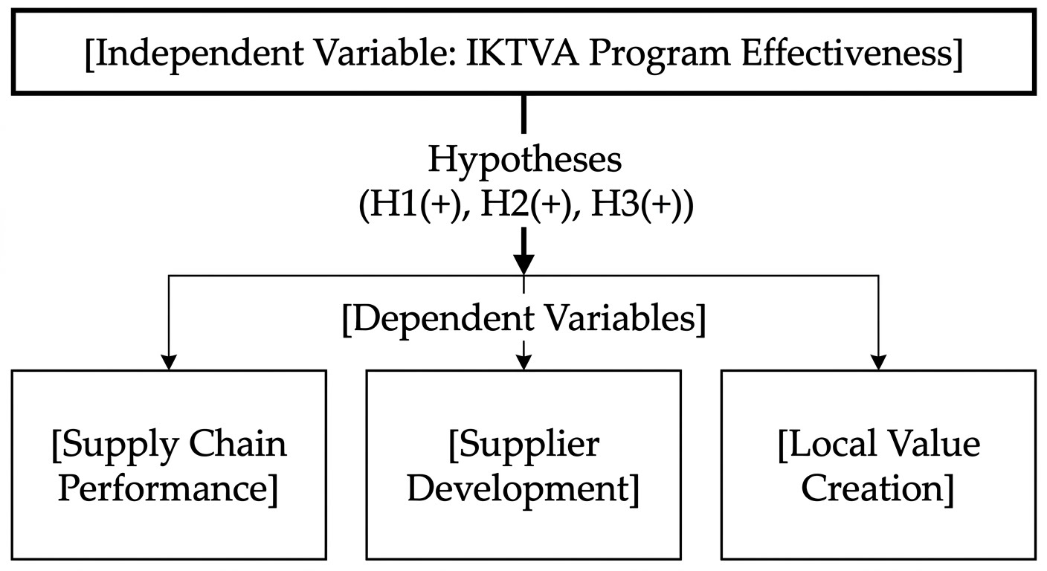
Figure 3 Proposed Research Model
Source: Developed by the Researcher (2026)
Table 7 Research Variables and Hypotheses
Hypothesis | Independent Variable | Dependent Variable
H1 | IKTVA Program Effectiveness | Supply Chain Performance
H2 | IKTVA Program Effectiveness | Supplier Development
H3 | IKTVA Program Effectiveness | Local Value Creation

This model assuming that IKTVA is implemented effectively and that it is influencing positively both economic and organizational outcomes within Saudi Aramco’s supply chain ecosystem.

Research Timeline
The research activities will be conducted according to the timeline presented in Figure 4. The schedule outlines the major stages of the study, including proposal development, literature review, data collection, data analysis, report writing, and final submission.
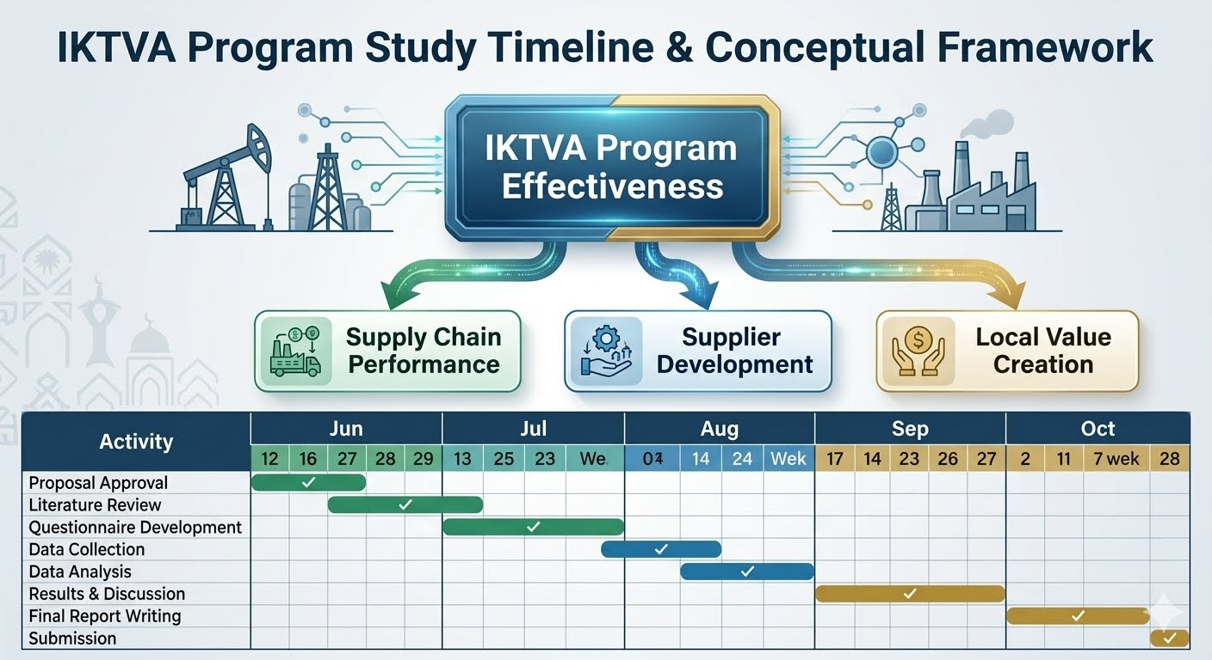
Figure 4 Research Timeline (Gantt Chart)
Source: Developed by the Researcher (2026)

Operational Definition of Variables
Table 9 Operational Definition of Variables
Variable | Definition | Measurement
IKTVA Program Effectiveness | Perceived effectiveness of localization initiatives implemented through IKTVA | 10 questionnaire items
Supply Chain Performance | Efficiency and effectiveness of supply chain operations | 10 questionnaire items
Supplier Development | Improvement of supplier capabilities and competencies | 10 questionnaire items
Local Value Creation | Economic and industrial value generated within Saudi Arabia | 10 questionnaire items

Chapter Summary
To summarize this chapter, it is clearly presented the methodology, which was adopted for the study, including the research philosophy, research approach, research design, population and sampling techniques, collection methods for data, research instrument, validity and reliability procedures, ethical considerations, and techniques for statistical analysis.
A systematic framework was provided by the methodology, to investigate the strategic impact of IKTVA on supply chain performance, supplier development, and local value creation. In the subsequent chapters we will present the collected data with their analysis, and we will discuss the findings in relation to the research agreed objectives and set-up hypotheses.

CHAPTER FOUR (Planned for DATA ANALYSIS AND FINDINGS)

Introduction

Descriptive Statistics

Reliability Analysis

Correlation Analysis

Multiple Regression Analysis

Expected Presentation of Results

Chapter Summary

CHAPTER FIVE (Planned for DISCUSSION, CONCLUSION AND RECOMMENDATIONS)

Introduction

Expected Findings

Expected Academic Contribution

Expected Practical Contribution

Recommendations for Future Research

Chapter Summary

APPENDICES

APPENDIX A: Participant Information Sheet and Consent Form
Dear Participant,
You are kindly invited to participate to share your feedback and opinion on a research study entitled:
Evaluating the Strategic Impact of IKTVA on Supply Chain Performance, Supplier Development, and Local Value Creation: Evidence from Saudi Aramco
The main purpose of this study is to investigate and examine the effectiveness of IKTVA initiatives and their impact on supply chain performance, supplier development, and to improve local value creation.
Participation is completely voluntary. All received and collected responses will remain totally confidential and will be used solely and only for academic research purposes. Finally, it is worth mentioning that no personal information will be disclosed.
At the end by completing the questionnaire, you fully indicate your valuable voluntary agreement to participate in this study.

Researcher:
Haitham Al-Haj
MBA Student
Midocean University

APPENDIX B: Research Questionnaire

Section A: Demographic Information (8 Questions)
- Gender
- Male
- Female
- Age Group
- Below 30
- 30–39
- 40–49
- 50 and above
- Nationality
- Saudi
- Non-Saudi
- Highest Qualification
- Diploma
- Bachelor's
- Master's
- Doctorate
- Current Position
- Years of Experience
- Organization Type
- Saudi Aramco
- Supplier
- Contractor
- Consultant
- Other
- Department / Function

Section B: IKTVA Program Effectiveness (10 Questions)
Use 5-point Likert Scale:
1 = Strongly Disagree
2 = Disagree
3 = Neutral
4 = Agree
5 = Strongly Agree
- IKTVA has increased local sourcing opportunities.
- IKTVA supports local industrial development.
- IKTVA encourages supplier investment within KSA.
- IKTVA contributes to workforce localization.
- IKTVA improves local manufacturing capabilities.
- IKTVA enhances collaboration with suppliers.
- IKTVA supports technology transfer.
- IKTVA contributes to economic diversification.
- IKTVA objectives are clearly communicated.
- IKTVA implementation is effective.

Section C: Supply Chain Performance (10 Questions)
- IKTVA has improved delivery performance.
- IKTVA has improved supply chain reliability.
- IKTVA has reduced procurement lead times.
- IKTVA has increased supply chain flexibility.
- IKTVA has improved supplier responsiveness.
- IKTVA has reduced operational disruptions.
- IKTVA has improved inventory management.
- IKTVA has improved quality performance.
- IKTVA has strengthened supply chain resilience.
- Overall supply chain performance has improved.

Section D: Supplier Development (10 Questions)
- IKTVA has enhanced supplier capabilities.
- Supplier training opportunities have increased.
- Local suppliers have improved quality standards.
- Suppliers are more competitive.
- Suppliers have increased technical expertise.
- Suppliers are investing more in innovation.
- Supplier performance monitoring has improved.
- Collaboration between suppliers and Saudi Aramco has improved.
- Supplier development initiatives are effective.
- Local suppliers are better prepared for future growth.

Section E: Local Value Creation (10 Questions)
- IKTVA contributes to job creation.
- IKTVA increases local economic activity.
- IKTVA supports SME growth.
- IKTVA encourages local investment.
- IKTVA contributes to industrial diversification.
- IKTVA promotes knowledge transfer.
- IKTVA strengthens local communities.
- IKTVA supports sustainable development.
- IKTVA enhances national competitiveness.
- IKTVA creates long-term economic value.

REFERENCES
- Alharbi, A., Alshammari, F., & Alotaibi, S. (2023). Supplier capability development and innovation performance in Saudi industrial organizations. International Journal of Supply Chain Management, 12(3), 45–58.
- Alotaibi, M. A. (2022). Localization initiatives and industrial growth in Saudi Arabia: Opportunities and challenges. Journal of Economic Development Studies, 10(2), 88–102.
- Alqahtani, M. A., & Ahmed, S. R. (2023). Local value creation and sustainable competitiveness in emerging economies: Evidence from Saudi Arabia. Sustainability, 15(7), 5678.
- American Psychological Association. (2020). Publication manual of the American Psychological Association (7th ed.). American Psychological Association.
- Barney, J. (1991). Firm resources and sustained competitive advantage. Journal of Management, 17(1), 99–120.
- Barney, J. B., Ketchen, D. J., & Wright, M. (2021). Resource-based theory and the competitive advantages of firms: A review and future directions. Journal of Management, 47(7), 1938–1963.
- Basahal, A. S., Alotaibi, B. M., & Alqahtani, M. A. (2021). Localization strategies and industrial development in Saudi Arabia. Sustainability, 13(18), 10189.
- Bohnenkamp, T., Schiele, H., & Bals, L. (2020). The role of supply chain localization in enhancing resilience and operational continuity. International Journal of Physical Distribution & Logistics Management, 50(9), 891–908.
- Chopra, S. (2023). Supply chain management: Strategy, planning, and operation (8th ed.). Pearson.
- Christopher, M. (2022). Logistics and supply chain management (6th ed.). Pearson.
- Creswell, J. W., & Creswell, J. D. (2023). Research design: Qualitative, quantitative, and mixed methods approaches (6th ed.). SAGE Publications.
- Freeman, R. E. (2020). Strategic management: A stakeholder approach. Cambridge University Press.
- Khan, S. A. R., Yu, Z., & Golpîra, H. (2022). Supply chain localization and sustainable economic development. Sustainability, 14(4), 2345.
- Krause, D. R., Handfield, R. B., & Scannell, T. V. (2021). Supplier development practices and performance outcomes. Journal of Supply Chain Management, 57(2), 45–62.
- Porter, M. E., & Kramer, M. R. (2019). Creating shared value. Harvard Business Review, 97(1), 62–77.
- Resnik, D. B. (2020). The ethics of research with human subjects: Protecting people, advancing science, promoting trust. Springer.
- Saudi Aramco. (2023). Annual report 2023. Saudi Aramco.
- Saudi Aramco. (2024). In-Kingdom Total Value Add (IKTVA) program overview. Saudi Aramco.
- Saudi Vision 2030. (2016). Saudi Vision 2030. Kingdom of Saudi Arabia.
- Saudi Vision 2030. (2024). Vision 2030 annual report. Kingdom of Saudi Arabia.
- Saunders, M., Lewis, P., & Thornhill, A. (2019). Research methods for business students (8th ed.). Pearson Education.
- Savio, M. (2021). The role of IKTVA in supporting Saudi Vision 2030 and economic diversification. Middle East Economic Review, 8(2), 77–92.
- Sekaran, U., & Bougie, R. (2020). Research methods for business: A skill-building approach (8th ed.). Wiley.
- Truong, H. Q., Sameiro, M., Fernandes, A. C., & Sampaio, P. (2021). Supply chain management and supplier development: A systematic literature review. International Journal of Production Economics, 235, 108093.
- Walliman, N. (2021). Research methods: The basics (3rd ed.). Routledge.

