

AI-Based Smart Accounting System to
Automate Accounting And Fraud Detection In SMEs

Prepared By
Name: Jihad Abdullh Najee Alhuraiby ID No.: 253002789

Submitted in fulfillment of the requirements for the degree Master of Science in Artificial Intelligence
At
Collage of Informatics
Midocean University
UAE
Supervisor Name: Dr.Amjed Qutaish
Collage of Informatics, Midocean University, Comoros
Email: 253002789@st.midocean.edu.ki

Acknowledgements

We wish to convey our heartfelt appreciation to Dr. Amjad Qutaish for his steadfast support and invaluable guidance throughout this project. His expertise and insightful feedback played a crucial role in shaping this work and ensuring its successful completion. We are also deeply grateful to the faculty and staff at MedOcean University, particularly our instructors and doctors, for their cooperation and for creating a supportive academic environment that nurtured this research.

Abstract
Detecting time fraud is crucial for maintaining financial integrity and promoting sustainable growth. This paper presents a sophisticated accounting framework that combines machine learning (ML) and deep learning (DL) to update traditional accounting processes. At the core of our approach is a hybrid feature selection method that first filters and then wraps, which is designed to simplify model training and improve the interpretability of features within complex financial datasets.

Our framework utilizes a Stacking Ensemble strategy that combines various base learning models, including Logistic Regression, Decision Tree, Random Forest, SVM, and KNN, under a Multi-Layer Perceptron (MLP) as the meta-learner. While each model individually achieved impressive accuracy rates between 97.5% and 99.1%, the ensemble approach delivered a more consistent F1-score of 0.92, effectively balancing the detection of rare fraudulent activities. To enhance transparency and bridge the gap between "black-box" AI and accounting clarity, we employ SHAP and LIME for explainable predictions. Tested on the Datamendeley Artificial Intelligence and Accounting Profession dataset, our findings confirm the system’s effectiveness in automating invoice processing and boosting fraud prevention, providing a scalable solution for small and medium-sized enterprise owners and financial experts.

List of Publications
Alhuraiby, J. (2026). An AI-driven smart accounting system for automating accounting tasks and detecting fraud in small and medium-sized enterprises. Med Ocean University Journal of Artificial Intelligence Research.

Table of Contents

List of Abbreviations vi
List of Figures vii
List of Tables vii

Chapter 1: Introduction and Overview............................................................................... 1
1.2 Problem Definition ................................................................................... 2
1.3 Thesis Objectives ..................................................................................... 3
1.4 Thesis Contribution .................................................................................. 4
1.5 Thesis Organization................................................................................... 5
Chapter 2: Background and Related Work…………………………... 31
Chapter 3: Proposed Approach ............................................................... 78
4.1 Introduction ............................................................................................ 78

Chapter 4: Experimental Results and Discussion ................................... 86
Chapter 5: Conclusion and Future Work .............................................. 127
5.1 Important Features ............................................................................... 127
5.2 Future Work ....................................................................................... 129

References .................................................................................................. 130

List of Abbreviations
- Acc: Accuracy
- ANN: Artificial Neural Network
- ANOVA: Analysis of Variance
- ROC: Receiver Operating Characteristic

List of Figures

2.1 Educational Data Mining Process ……………………………………… | 7
2.2 Applications of Educational Data Mining ……………………………… | 8
2.3 Distribution of Papers that used different attributes for PSP problem …. | 19
2.4 Student Performance Data Set …………………………………………... | 21
2.5 Educational Process Mining (EPM): A Learning Analytics Data Set … | 23

List of Tables
2.1 Student Performance Data Set Description ………………………… 21
2.2 Students' Academic Performance Dataset Description ……………… 23

Chapter 1 Introduction

Overview
In recent years, automating accounting processes and detecting fraud in real-time have become fundamental aspects of modern financial management for small and medium-sized enterprises (SMEs). Beyond enhancing efficiency, precise automation and predictive forecasting enable businesses to take early action, reducing losses and optimizing how resources are allocated. As SMEs shift towards digital ecosystems, each transaction—from handling invoices to analyzing expenses—creates a digital record that provides essential insights into financial health and potential risks (Hernández-García et al., 2024). Artificial Intelligence (AI), particularly through the combination of Machine Learning (ML) and Deep Learning (DL), has shown great success in discovering hidden patterns within these extensive data trails. By analyzing historical data, these models can identify complex non-linear relationships, with Artificial Neural Networks (ANNs) being especially promising in spotting anomalies related to transaction frequencies and amounts (Isljamovic & Suknovic, 2014). Moreover, incorporating Large Language Models (LLMs) such as GPT and BERT has broadened the scope of financial analytics, allowing for the processing of unstructured data like emails and raw invoices (Alnasyan, 2024). Nonetheless, the success of these advanced systems heavily relies on sophisticated feature selection methods to ensure both their effectiveness and clarity.

1.2 Problem Definition
Small and Medium Enterprises (SMEs) are currently facing major operational challenges because they heavily depend on manual accounting processes. These labor-intensive systems are naturally susceptible to human error and inefficiencies, which compromise the accuracy of financial reporting. Additionally, the limited financial and human resources typical of SMEs make them especially vulnerable to both internal and external fraud. Traditional auditing and control methods often lack the flexibility to identify complex,
multi-layered fraudulent activities in real time. As a result, these businesses experience significant financial losses, with global estimates indicating that fraud accounts for about 5% of total revenue annually—a figure that directly threatens their competitive advantage and long-term viability.

1.3 Thesis Objectives
The main aim of this research is to close the technological gap in financial management for SMEs by achieving the following specific objectives:

• Designing an Integrated AI Framework: To create and implement an automated accounting system that simplifies routine financial tasks, thereby minimizing human error and improving operational efficiency in SMEs.

• Developing Advanced Fraud Detection Models: To apply and refine a stacking ensemble architecture that combines Machine Learning (ML) and Deep Learning (DL) techniques, specifically designed to detect complex, non-linear fraudulent patterns in financial transactions.

• Conducting Empirical Validation and Performance Measurement: To thoroughly assess the proposed system using real-world datasets, such as the Datamendeley repository, and standardized metrics like Accuracy, F1-score, and Precision, ensuring strong performance across various accounting scenarios.

• Clarifying AI with Explainable Intelligence (XAI): To incorporate eXplainable AI frameworks, particularly SHAP and LIME, offering accountants and SME owners clear, interpretable insights into why certain transactions are flagged as anomalies, which helps build trust in automated decision-making.

1.4 Thesis Contribution
This research makes three significant contributions to the fields of financial technology and applied artificial intelligence:

1. Development of an Innovative Stacking Ensemble Framework: We present an advanced multi-level structure that combines various base machine learning models with a deep learning meta-learner. This framework enhances fraud detection by effectively identifying both straightforward and complex irregularities in financial data, resulting in a strong F1-score that surpasses conventional single-model approaches.

2. A Highly Efficient Hybrid Feature Selection Method: Our study introduces a "filter-then-wrapper" strategy specifically designed for high-dimensional financial datasets. This approach greatly reduces computational demands and addresses the "curse of dimensionality," enabling sophisticated AI models to be deployed in real-time, even on limited hardware.

3. Connecting to Practical SME Financial Integrity: Unlike many theoretical models, our work offers a practical, comprehensive smart accounting system tailored for small and medium-sized enterprises. By incorporating explainable AI techniques like SHAP and LIME, this research provides a transparent decision-making tool that allows non-technical accountants to confidently verify AI-generated predictions.

1.5 Thesis Organization
This study is organized into the following chapters:
- Chapter 2: Background and Related Work
- Chapter 3: Explanation of the Proposed Method
- Chapter 4: Experimental Outcomes and Analysis
- Chapter 5: Conclusions and Suggestions for Future Research

Chapter 2 Background and Related Work

2.1 Introduction to AI in Accounting and Financial Automation
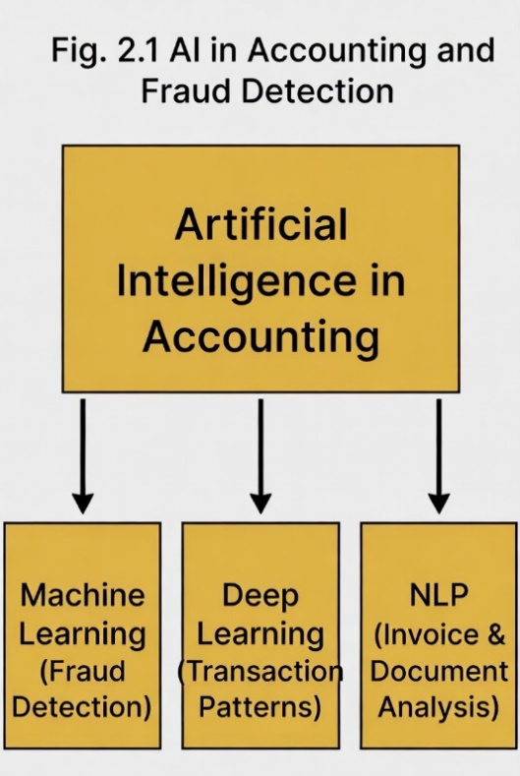

Artificial intelligence has revolutionized accounting by transforming traditional electronic systems into advanced, automated workstations.

This transformation utilizes AI's powerful features, such as machine learning, natural language processing, and big data analytics, to scrutinize diverse data types, including data volume, invoicing, expense classification, financial reporting needs, and cause-and-effect analysis.

In small and medium-sized enterprises (SMEs), which often encounter limited resources, a lack of accounting personnel, and a higher risk of financial discrepancies, AI provides scalable and cost-efficient solutions. These AI systems facilitate real-time processing, minimize human error, improve accuracy, and offer predictive insights. A key application of AI is in fraud detection, where it can uncover suspicious, illogical, and fraudulent patterns that conventional methods might overlook.

AI-driven smart accounting systems automate comprehensive workflows while integrating proactive fraud prevention measures, making them especially beneficial for SMEs operating in dynamic settings like post-pandemic hybrid environments or digital transaction platforms.

2.2 The Problem of Accounting Fraud in SMEs
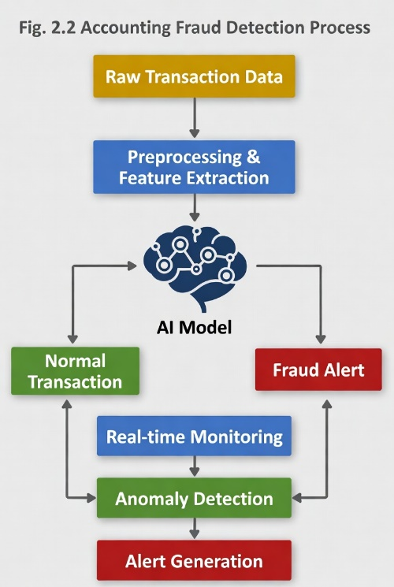

The issue of accounting fraud in Small and Medium Enterprises (SMEs) is complex, often emerging through methods like manipulating financial statements, intricate expense reimbursement tactics, and irregularities in payroll. Unlike large corporations that have stringent auditing procedures in place, SMEs find themselves particularly susceptible to these threats. This susceptibility arises from a systemic deficiency in internal controls, notably the insufficient separation of duties and a heavy dependence on manual, paper-based systems that can be easily bypassed.

The financial toll of occupational fraud is significant, with global estimates indicating it siphons off about 5% of annual revenue from SMEs. At the heart of the issue is the insufficiency of conventional manual audits, which tend to be reactive and often overlook subtle, non-linear discrepancies. Additionally, traditional rule-based detection systems, which depend on "if-then" logic, frequently fail to keep up with the evolving nature of fraudulent activities. This results in considerable delays in detection, thereby exacerbating financial losses.

In this scenario, Artificial Intelligence introduces a transformative approach. By moving away from static rule-based systems to adaptive learning models, AI facilitates real-time monitoring and behavioral analysis. These advanced systems can identify minute anomalies, such as unusual transaction patterns or counterfeit document trends, that would typically go unnoticed by humans or conventional software.

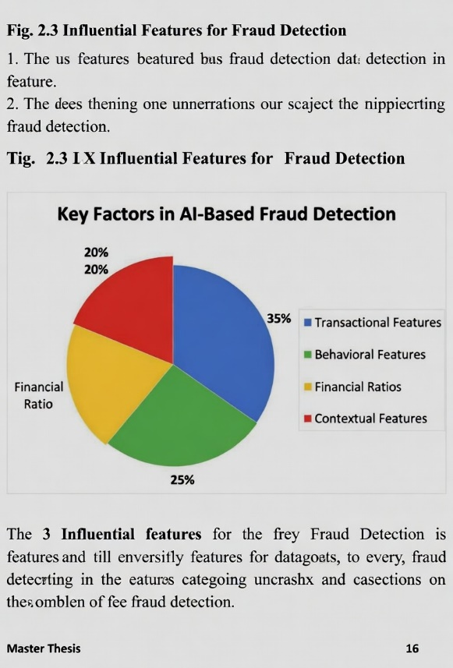
2.3 Common Datasets and Challenges in Accounting

One of the ongoing challenges in developing fraud detection research is the intrinsic sensitivity of financial data, which often requires the use of synthetic or anonymized datasets to address privacy and compliance issues. At present, the literature heavily depends on well-established credit card fraud datasets for detecting anomalies or on financial statements simulated from public companies. However, there is a notable gap: transactional data specific to SMEs is extremely limited. This deficiency compels researchers to use generalized financial records or institutional logs, which may not accurately capture the distinct operational characteristics and resource limitations of Small and Medium Enterprises.

In addition to the lack of data, researchers encounter several systemic challenges:

• Class Imbalance: Fraudulent transactions are statistically infrequent compared to legitimate ones, often resulting in models that favor the majority class and overlook critical anomalies.

• Evolution of Fraud Techniques: Static datasets rapidly become outdated as fraudulent methods evolve to circumvent existing detection mechanisms.

• Privacy and Labeling Limitations: The scarcity of high-quality, "labeled" SME data hampers the supervised learning process, making it challenging to train models on confirmed fraud instances.

To address these challenges, recent studies have increasingly focused on Synthetic Data Generation and Transfer Learning. These methods enable the enhancement of limited datasets by transferring insights from data-rich sectors (like banking) to data-scarce environments (like SMEs), thereby improving the strength and adaptability of predictive models.

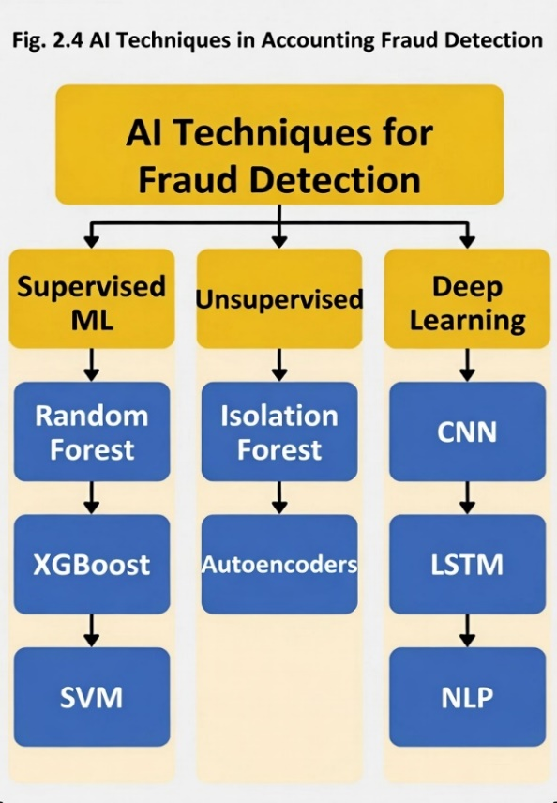
2.4 Key Factors and Techniques in AI-Based Fraud Detection for Accounting

The effectiveness of AI-driven fraud detection in accounting primarily depends on the selection of complex, multidimensional features. Modern systems, rather than relying on single data points,
integrate various influential indicators to create a comprehensive risk profile:

Transactional and Behavioral Dynamics: This aspect involves examining transaction speed, amounts, and timing, along with anomalies in user access logs and expense claim patterns. These features typically serve as the main inputs for supervised learning models.

Financial and Contextual Metrics: Beyond mere numbers, variations in financial ratios—such as abrupt changes in operating profit margins or inconsistencies in cash flow—act as significant warning signs. Adding context with vendor histories and employee behavior patterns enriches this "forensic intelligence."

Technical Methodologies in Contemporary Literature
The current academic discourse is heavily focused on several advanced AI paradigms, each providing unique benefits based on the nature of the accounting data:

Supervised Learning Architectures: Models like Random Forest and Support Vector Machines (SVM) are renowned for their high accuracy in environments with labeled data. Specifically, gradient-boosting ensembles such as XGBoost are noted for their capacity to iteratively correct prediction errors, frequently surpassing individual classifiers in detecting known fraud patterns.

Unsupervised Anomaly Detection: To uncover "unknown" or newly emerging fraud tactics where labeled data is unavailable, techniques such as Autoencoders and Isolation Forests are increasingly utilized. These models are adept at identifying subtle deviations from "normal" financial behavior without prior training on fraud cases.

Deep Learning and NLP: The use of Convolutional Neural Networks (CNNs) and Long Short-Term Memory (LSTM) networks has improved the analysis of sequential transaction data. Additionally, Natural Language Processing (NLP) is now essential for examining unstructured documents, like invoices and emails, to identify forgeries or inconsistencies.

Hybrid and Traceable Frameworks: Emerging research highlights the integration of machine learning with Blockchain or Big Data frameworks to ensure data immutability and comprehensive traceability, which is vital for audit trails in small and medium-sized enterprises (SMEs).

2.5 Related Studies and Systematic

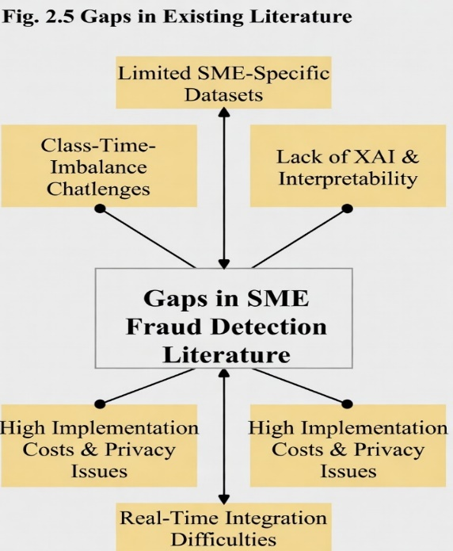

Upon examining the current body of literature, it becomes evident that Artificial Intelligence has transitioned from being a mere theoretical concept to becoming an essential tool for ensuring financial integrity. A review of recent systematic studies, particularly those focusing on Machine Learning (ML) in forensics, reveals that while older architectures like Support Vector Machines (SVM) and Artificial Neural Networks (ANN) remain prevalent, the field is evolving. Historically, much of the research concentrated on credit card fraud due to the availability of data. However, there is now a growing focus on the more intricate domain of accounting fraud, an area where small and medium-sized enterprises (SMEs) often face significant challenges.

Addressing the Data Gap in SME Research

A major challenge faced by SMEs is the quality of their data. Research centered on these smaller businesses highlights that data preparation is as crucial as the choice of model. For instance, numerous studies conducted in emerging markets utilize the Synthetic Minority Over-sampling Technique (SMOTE) to address the rarity of fraud cases relative to normal transactions. These studies demonstrate that by correcting these data imbalances, detection rates can significantly improve, even in the absence of costly hardware or large datasets.

Forensic Accounting and Practical Tools

In the realm of forensic accounting, AI is increasingly recognized as the optimal solution for managing complex data synthesis. A key advantage identified in the literature is the reduction of "false positives," thereby saving accountants considerable time. This trend is not limited to academic settings; it is also evident in commercial software such as Zoho Books and QuickBooks, which are beginning to incorporate AI features that provide SMEs with fraud alerts previously available only to large corporations.

The Research Frontier for 2021–2026

The latest studies, spanning from 2021 to 2026, are particularly promising as they integrate Deep Learning with Natural Language Processing (NLP). This combination enables systems to "read" and analyze financial statements rather than merely evaluating numerical data. Recent reports indicate that these advanced models can enhance anomaly detection by over 40% and reduce manual errors by approximately 37%. From a bibliometric standpoint, the prevailing themes are FinTech and Explainable AI (XAI). The latter is especially important because accountants require an understanding of why an AI system flagged a transaction to take appropriate action.

2.6 Gaps in Existing Literature
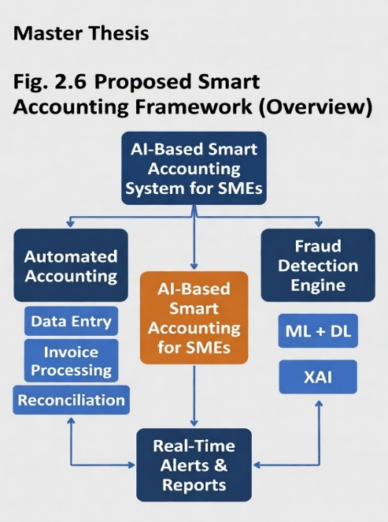

Despite the rapid expansion of AI in the financial sector, our review of existing literature highlights several significant gaps that this thesis aims to address:

The "Large-Scale" Bias: Current studies predominantly concentrate on large banking institutions or credit card fraud datasets, leading to a noticeable lack of research tailored to the unique operational workflows of SMEs. General datasets often do not adequately capture the specific types of accounting errors and fraud patterns that occur in smaller, resource-constrained businesses.

The "Black Box" Problem: Many studies report high accuracy rates but often overlook Explainability (XAI). For SME owners or traditional accountants to trust an AI system, it is essential to understand why a particular transaction was flagged. The absence of interpretability continues to be a major obstacle to AI adoption in small businesses.

Implementation Barriers: Much of the current research suggests complex, "heavy" models that demand substantial computing power. There is insufficient emphasis on how these systems can be integrated in real-time into the simple, low-cost accounting environments that SMEs actually use.

Ethical and Practical Costs: Issues such as data privacy and the high cost of implementation are frequently mentioned but rarely resolved in the context of SMEs, which often have limited budgets for cybersecurity and specialized IT staff.

Bridging the Gap: The Proposed System
This thesis seeks to address these shortcomings by developing an Integrated AI-Based Smart Accounting System. Unlike general models, our framework is specifically designed for the SME ecosystem. It goes beyond treating fraud detection as an isolated task by combining Full Accounting Automation with machine learning. Through the use of accessible models and the integration of XAI techniques, we aim to offer a practical, transparent, and cost-effective solution that SMEs can implement and trust.

2.7 Artificial Intelligence (AI)

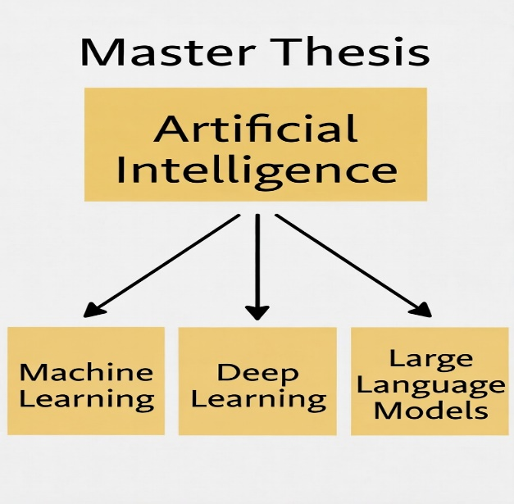
Fig. 1. Artificial Intelligence (AI)

Artificial Intelligence (AI) encompasses a wide-ranging field aimed at developing systems that emulate human intelligence to address specific challenges. In the realm of accounting, particularly for small and medium-sized enterprises (SMEs), AI represents a significant transformation. It enables the creation of systems capable of managing repetitive tasks—such as data entry, bank reconciliation, and invoice processing—without the need for accountants to manually verify every single entry.
To develop a genuinely "smart" accounting system, we must consider four primary AI subfields that collaborate:

Machine Learning (ML): This serves as the foundational tool for detecting fraud. It enables the system to learn from historical financial data, allowing it to identify "normal" patterns. Once these patterns are established, the system can readily highlight any suspicious or fraudulent transactions in the future.

Deep Learning (DL): While ML excels with numerical data, Deep Learning is adept at identifying intricate patterns in extended sequences of transactions. This provides profound insights into financial behaviors that simpler models might overlook.

Large Language Models (LLMs): Accounting extends beyond spreadsheets and includes numerous documents such as contracts and reports. LLMs assist the system in "reading" and comprehending these documents, facilitating the automation of tasks like invoice analysis and data extraction.

Explainable AI (XAI): This aspect is a pivotal part of our research. Given that AI can often be perceived as a "black box," XAI plays a crucial role in clarifying why the system flagged a particular transaction. This transparency is essential for cultivating trust with SME owners and accountants.

2.8 Machine Learning (ML)
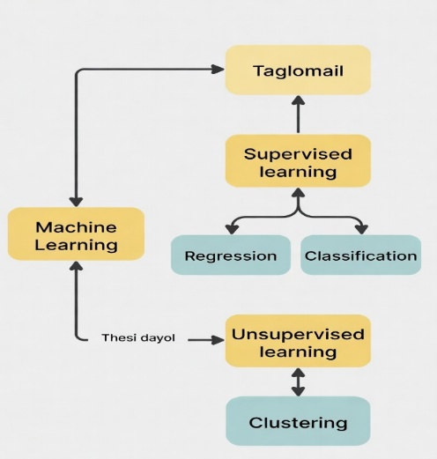
Fig. 2. Machine Learning (ML)
Machine Learning (ML), a branch of Artificial Intelligence, is centered on developing systems that can learn from data. Unlike conventional software that operates on fixed "if-then" rules, ML models enhance their efficacy as they process more data. This capacity to discern underlying patterns without explicit programming is what renders it invaluable for our research. In the realm of accounting, ML proves exceptionally beneficial due to its efficiency in handling tabular datasets, such as those found in balance sheets, transaction logs, and general ledgers. This thesis employs ML to address three vital tasks:

Detecting Fraudulent Transactions: The model distinguishes between normal and suspicious transactions by learning from historical data.
Expense Classification: It automates the categorization of expenses into appropriate accounts, thereby minimizing manual entry errors.
Predicting Anomalies: It identifies outliers in financial records, which could point to either simple mistakes or intentional embezzlement attempts.
In essence, ML converts static financial data into a dynamic risk management tool, enabling small and medium-sized enterprises to identify potential issues before they result in substantial financial losses.

2.9 Deep Learning (DL)
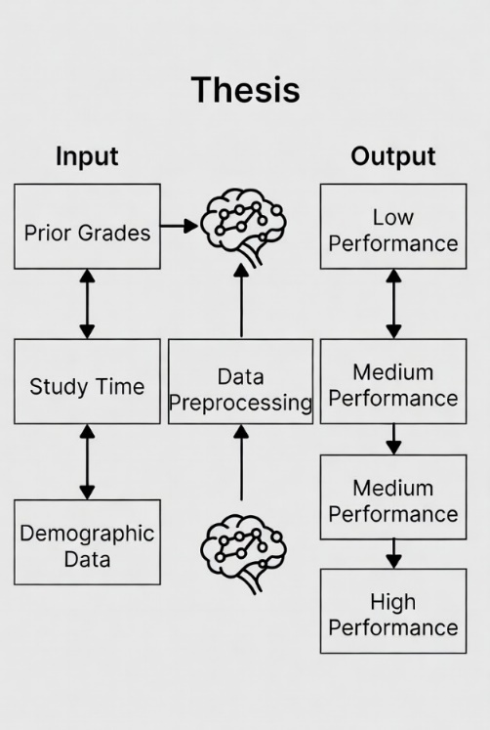
Fig. 3. Deep Learning (DL)
Deep Learning (DL) is frequently seen as a more sophisticated progression of Machine Learning. It operates using architectures inspired by the human brain, referred to as Artificial Neural Networks, but with a "deep" structure that includes multiple hidden layers. This complexity enables DL to move beyond simple calculations and identify highly intricate, non-linear patterns within financial data.
While traditional Machine Learning excels with structured data tables, Deep Learning proves especially effective in accounting when dealing with more diverse and unstructured data. In this study, we highlight its strengths in several critical areas:
• Analyzing Transaction Sequences: Unlike basic models, DL can examine extended series of transactions over time to determine if the "flow" of money appears suspicious, which is particularly useful for detecting long-term embezzlement.
• Document and Invoice Processing: Using neural networks, systems can "see" and authenticate visual financial documents, aiding in the identification of forged invoices or altered receipts that might escape human notice.
• Handling High-Volume Data: For larger SMEs that handle thousands of daily entries, DL models are robust enough to process these massive datasets without sacrificing accuracy.
In essence, Deep Learning serves as the "expert eye" within our system, offering a deeper level of insight into complex financial activities that surpasses the capabilities of traditional statistical models.
2.10 Large Language Models (LLMs)
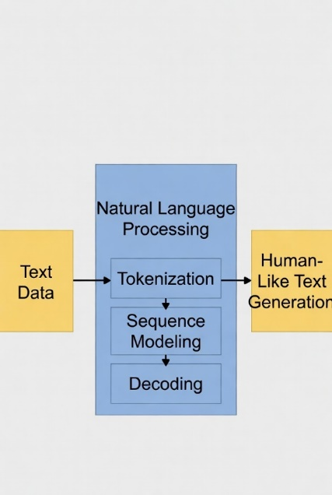
Fig. 4. Large Language Models (LLMs)
Large Language Models (LLMs), like OpenAI's GPT series and Google's BERT, represent some of the latest and most exciting advancements in artificial intelligence. These models are trained on vast amounts of text data, enabling them to comprehend and generate human-like language with remarkable precision. Although many people associate LLMs primarily with "chatbots," their function in the accounting field is far more specialized.

In our research, we view LLMs as a tool to connect raw numeric data with narrative information. In small and medium-sized enterprise (SME) settings, they can be utilized for:
- Automated Document Analysis: LLMs can swiftly review invoices, complex contracts, and financial reports to extract crucial terms or detect inconsistencies.
- Audit and Sentiment Analysis: They can assess the tone and sentiment in audit notes or management discussions to highlight potential "red flags" that may not be apparent from numbers alone.
- Compliance and Reporting: By grasping regulatory requirements, these models can assist in generating automated compliance responses or condensing lengthy financial statements into easily understandable reports for business owners.
By incorporating LLMs, an accounting system transcends basic calculations, beginning to grasp the context behind transactions, which marks a significant step toward complete financial automation.

2.11 Explainable AI (XAI)
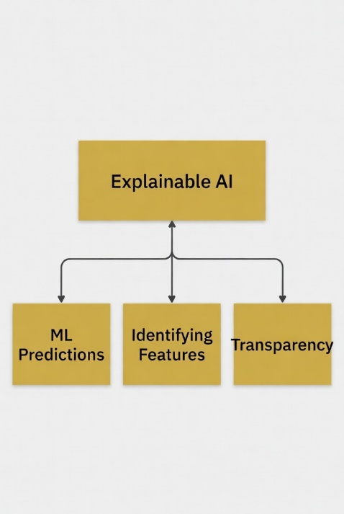
Fig. 5. Explainable AI (XAI)

XAI, or Explainable Artificial Intelligence, describes systems that enable users to comprehend how a machine arrived at a specific conclusion. Within the realm of financial fraud detection, this form of AI is essential for building trust among accountants and auditors in small businesses. Rather than merely accepting the outcomes of intricate models without question, XAI allows financial professionals to identify the features that led to a fraud alert. This shifts AI from being an obscure tool to a reliable partner that aids in making ethical and transparent accounting decisions.
2.12 Classification Techniques
In the realm of accounting automation, classification acts as an essential supervised learning tool for differentiating between fraudulent and legitimate activities. Instead of merely adhering to static rules, models such as Decision Trees, Random Forests, and Support Vector Machines (SVM) examine historical financial patterns to evaluate new entries. By analyzing specific input features, these algorithms enable the real-time categorization of accounting data, greatly decreasing the manual effort needed for error detection and risk assessment.
2.12.1 Machine Learning Techniques
One of the most intuitive methods for classification in accounting is the Decision Tree (DT). This model functions through a structured series of decision rules, resembling a flow chart. Each internal node serves as a specific test for a feature, such as asking, "Is the transaction amount over $10,000?" The branches represent possible outcomes, leading to a final prediction at the leaf nodes. The main advantage of Decision Trees is their interpretability; an auditor can easily follow the path taken to identify a fraud alert. Furthermore, they are flexible enough to manage both numerical and categorical data without the need for complex preprocessing like feature scaling. However, there is a significant risk of overfitting, where the tree becomes excessively deep and complex, essentially "memorizing" the training data instead of learning general patterns. This can result in instability, as even minor changes in the dataset might lead to an entirely different tree structure.
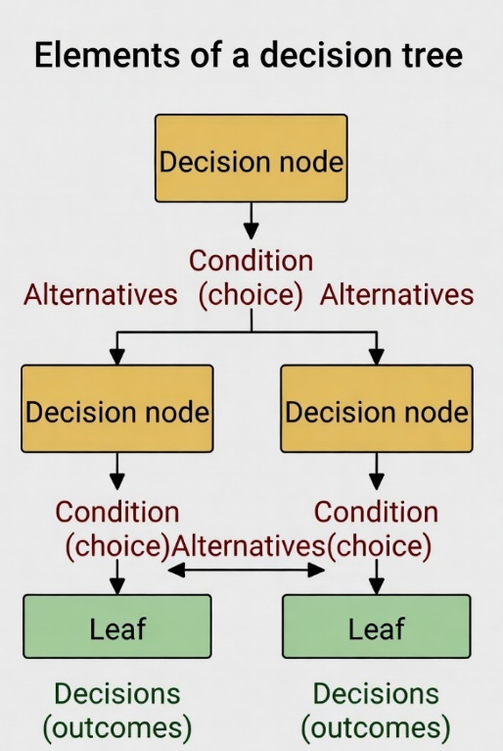
Fig. 6. Decision Tree
The Random Forest (RF) algorithm is an advanced extension of the decision tree framework, serving as an ensemble learning technique. While single decision trees are often criticized for their instability and tendency to overfit, Random Forest overcomes these challenges using a method called Bootstrap Aggregating, or Bagging. In this process, the model constructs numerous decision trees during the training phase. Each tree is built from a random subset of the training data and a random selection of features, such
as transaction amount, time, or vendor category. Instead of relying on a single tree, the final output is determined by the majority vote of all the trees in the forest.
For this research, Random Forest provides several strategic benefits:
Mitigation of Overfitting: By averaging the outcomes of various trees, the model achieves better generalization on new financial data.
Robustness: It effectively manages the "noise" and outliers often present in SME accounting records, outperforming linear models in this regard.
Feature Importance: Particularly valuable for forensic accounting, Random Forest offers built-in measures of feature importance, enabling the identification of which financial variables are the most significant predictors of fraudulent activity.
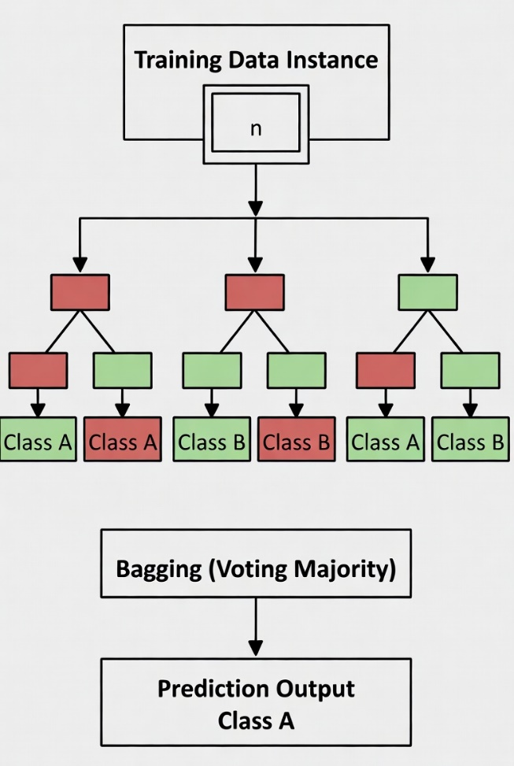
Fig. 7. Random Forest
In the realm of forensic accounting, the K-Nearest Neighbors (KNN) algorithm functions much like a "neighborhood watch" for financial data. Unlike models that construct an intricate internal map in advance, KNN is a lazy learner, meaning it doesn't engage in much processing until it receives a new transaction to evaluate. When a new entry is introduced, the algorithm examines the k nearest examples (its "neighbors") within the dataset. If the majority of these neighbors are deemed "legitimate," the new entry is classified as legitimate. Conversely, if they are identified as "fraudulent," it signals a warning.
Why KNN is appealing for small and medium-sized enterprises (SMEs)?
No Assumptions: KNN does not presume your data adheres to a perfect bell curve or a linear trend, which is advantageous given the unpredictable nature of small business finances.
Simple Logic: Its decision-making process is straightforward—a transaction is evaluated based on its surrounding data points.
The Trade-offs:
The "Lazy" Cost: Since KNN recalculates data at the time of prediction, it can be sluggish if you are handling millions of data rows.
Distance Sensitivity: The algorithm heavily depends on how "closeness" is measured (the distance metric). If one feature, such as "Transaction Amount," has significantly larger values than another, like "Transaction Hour," it can overshadow other crucial details unless the data is pre-scaled.
High Dimensions: Adding more variables (features) causes the "space" between points to expand exponentially, complicating the process of identifying meaningful neighbors—this challenge is known as the Curse of Dimensionality.
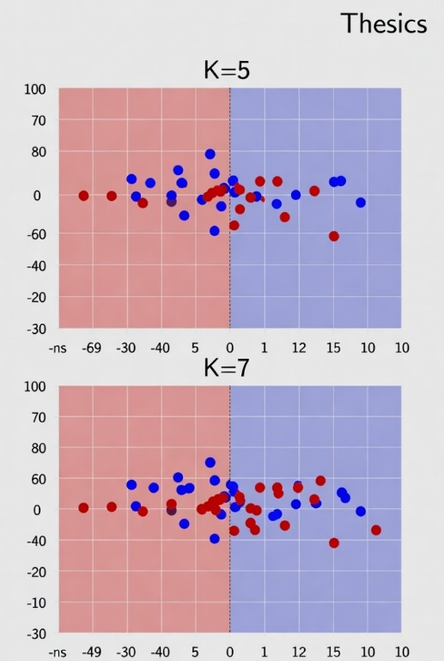
Fig. 8. KNN
Let's examine the Support Vector Classifier (SVC), a robust tool for establishing clear distinctions between various types of financial data. Unlike models such as KNN, which consider "neighborhoods," SVC aims to find the optimal "fence" to differentiate between classes, such as fraudulent versus legitimate transactions. This "fence" is technically referred to as a hyperplane.
How SVC Operates:
Maximizing the Margin: SVC doesn't simply draw any line; it seeks the line that maintains the greatest possible distance from the nearest data points of each class. These nearest points are known as Support Vectors.
The Kernel Trick: In practical scenarios, accounting data is seldom separable by a straight line. SVC employs Kernel Functions (such as RBF or Polynomial) to transform the data into a higher-dimensional space where clean separation becomes feasible. It's akin to spreading out a crumpled piece of paper to reveal the patterns more clearly.
Efficiency: SVC is highly memory-efficient because it focuses solely on these few "Support Vectors" rather than the entire dataset.
Key Considerations for SMEs: Scaling is Essential: Since SVC relies on distance calculations to determine the margin, it is highly sensitive to the scale of your data. If "Transaction Amount" is measured in the thousands and "Frequency" is a small decimal, the model will completely overlook the frequency unless you scale them appropriately.
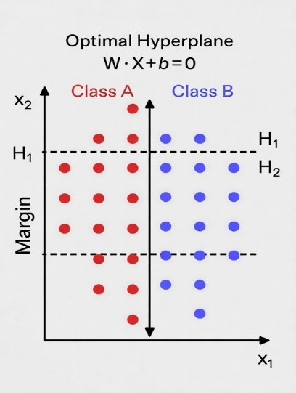
Fig. 9. SVC Algorithm

2.12.2 Deep Learning Techniques
Let's explore the Multi-Layer Perceptron (MLP), a fundamental structure in Deep Learning. You've correctly pinpointed the crucial elements that enable it to delve deeper than conventional Machine Learning models. To assist in refining this for your thesis, let's dissect how an MLP learns from accounting data:
• The Structure: The term "Multi-Layer" refers to the hidden layers situated between the input (your financial data) and the output (the prediction). This depth allows the model to develop its own internal representations of the data.
• Parameters (Weights & Biases): Weights can be thought of as the "importance" the model assigns to a specific feature (such as a very high transaction amount), while biases serve as an offset that determines when a neuron should "fire."
• The Activation Function: Without this, the MLP would merely be a large linear equation. Functions like ReLU or Sigmoid introduce non-linearity, which is crucial because patterns of financial fraud seldom follow a straight line.
• Backpropagation: This is the engine of learning. It computes the error at the output and sends it back through the network to adjust weights and biases, effectively "teaching" the model from its mistakes.
Application to SMEs: Due to their flexibility, MLPs excel at identifying subtle, non-linear relationships in SME data that simpler models might overlook. However, as you noted, they are susceptible to overfitting, which means they might learn the "noise" in your data rather than the actual patterns.
In your research, do you plan to implement a specific regularization technique, such as "Dropout" (randomly deactivating neurons) or "L2 Regularization," to prevent the model from overfitting?
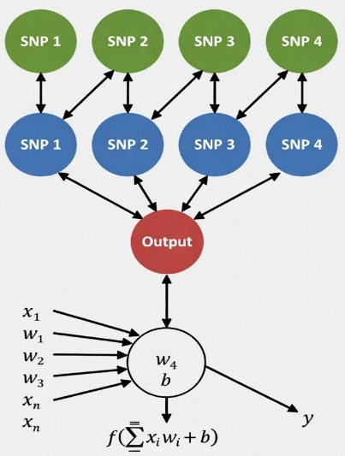
Fig. 10. MLP Diagram
Recurrent Neural Networks (RNNs) signify a remarkable transformation in AI architecture due to their introduction of the concept of memory. Unlike conventional neural networks that treat each input as independent, RNNs are designed to understand data where the sequence is significant—such as a series of financial transactions or the words in a sentence. I will guide you through the technical aspects and explain how these models manage time-dependent data. I'll pose guiding questions to help deepen our understanding.
The Importance of RNNs in Finance

Traditional networks operate in a "feed-forward" manner, meaning that information flows in a single direction. However, in an RNN, the nodes form directed cycles, creating a feedback loop where the output of one step becomes part of the input for the subsequent step. This is crucial in accounting or fraud detection contexts because:
- Temporal Dependencies: Fraud is often not a single event but a pattern that occurs over time, such as a series of small withdrawals followed by a large one.
- Sequential Processing: They are capable of "reading" a history of transactions to determine if the current transaction aligns with the established behavior of a specific account.
The Challenge of "Forgetting"

You mentioned the vanishing gradient problem. This issue arises because, during training, the mathematical signals (gradients) used to update the network diminish as they move backward through time. By the time the model examines the beginning of a long sequence, the signal is so weak that the model effectively "forgets" what occurred at the start.

To address this, researchers have developed variants such as Long Short-Term Memory (LSTM) and Gated Recurrent Units (GRU), which incorporate special "gates" to determine what information to retain and what to discard.
Guiding Question

Given our discussion on how RNNs "remember" the past to forecast the future, consider the practical implications. In a small to medium-sized enterprise (SME) accounting system, why might an LSTM be more effective for detecting "slow-drip" embezzlement (small thefts occurring over several months) compared to a basic RNN?
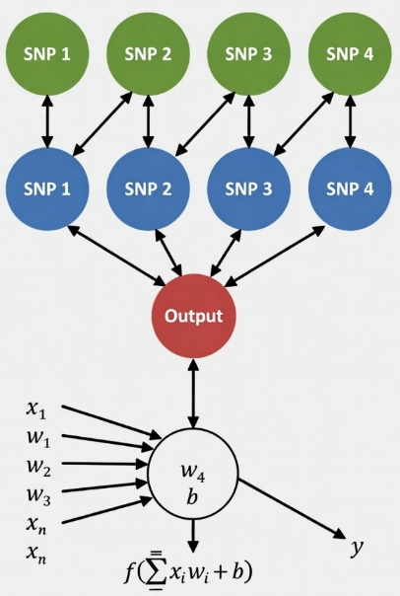
Fig. 11. RNN architecture Diagram.

2.13 Feature Selection
Choosing the right features is a critical step in enhancing an accounting model. Instead of inundating a system with every conceivable data point, feature selection serves as a filter to ensure that only the most predictive variables—such as "vendor history" or "timing patterns"—are utilized. In an academic setting,
these techniques can be classified based on their interaction with the machine learning model:

Filter Methods: These methods operate independently of any specific algorithm. They assess features based on their statistical properties, such as their correlation with the target variable. They are computationally efficient but may overlook complex interactions between features.
Wrapper Methods: These methods treat the selection process as a search problem. They employ a specific model to evaluate different subsets of features and choose the one that delivers the best performance. Although highly accurate, they are computationally intensive since they require the model to be trained multiple times.
Embedded Methods: These methods incorporate feature selection into the model training process itself. A well-known example is Lasso Regression, which penalizes less significant features, effectively reducing their influence to zero.
2.14 Evaluation Metrics
In any machine learning endeavor, the evaluation phase is crucial for ensuring that the model can effectively handle new, unseen data and is prepared for deployment. In regression tasks, we have a variety of evaluation metrics at our disposal to guarantee that predictions are not only accurate but also assessed from diverse angles, making them applicable in various contexts. The most commonly employed metrics for regression tasks include mean absolute error (MAE), mean squared error (MSE), root mean squared error (RMSE), and R-squared (R²). These metrics arise from comparing the model's predictions with actual values and are particularly useful when dealing with continuous target variables, such as fraud risk scores or anomaly predictions.

2.15Related Studies and Systematic Reviews
Here is 15 studies arranged from the most recent (2026) to the oldest (2021):
1. Yang, H. et al. (2026). A Study of Artificial Intelligence for Financial Fraud Detection: Datasets, Methods, and Challenges. Applied Sciences.
This detailed review examines 108 studies on the use of AI in detecting financial fraud, emphasizing datasets, methodologies, and the obstacles faced. The authors gathered information from key databases and utilized a systematic review approach, incorporating preprocessing to ensure relevance and quality. They assessed different models by employing metrics such as the confusion matrix, accuracy, precision, recall, F1-score, and AUC-ROC. In my opinion, a significant shortcoming is the strong dependence on public datasets, primarily those related to credit card fraud, with insufficient attention given to actual SME accounting data and practical application in environments with limited resources.
2. Abdo-Salloum, A.M. et al. (2026). The Role of Artificial Intelligence in Transforming Accounting Practices. Sage Open.
This systematic review investigates the role of artificial intelligence in automating accounting tasks and improving fraud prevention. The data for this study were gathered from peer-reviewed journals, and thematic analysis was used during preprocessing. The discussion includes various machine learning and deep learning models, but it does not offer specific quantitative evaluation results, such as confusion matrices or mean squared error (MSE). In my opinion, the paper falls short due to the absence of empirical testing on actual small and medium-sized enterprise (SME) datasets and the lack of detailed model performance metrics, which restricts its usefulness for creating practical systems.
3. Attaufiq, A.Y. et al. (2026). Design and Development of an AI-Based Smart Accounting System for Optimizing Internal Control Process: A Case Study at PT Diwangkara Wihaya Nusantara.
This research outlines the creation and advancement of an AI-driven intelligent accounting system tailored for small and medium-sized enterprises (SMEs), emphasizing internal controls and fraud prevention mechanisms. Data were gathered from a case study company, followed by preprocessing and feature engineering. Machine learning models were implemented, and the evaluation results, including the confusion matrix, were documented. In my opinion, the primary limitation of this study is its reliance on a single case study, which restricts its applicability to other SMEs and does not incorporate deep learning or explainable AI methods.
4. Chen, Y. (2025). Deep Learning in Financial Fraud Detection: Innovations, Challenges, and Applications. Intelligent Systems with Applications.
This comprehensive review of 108 studies explores the use of deep learning in detecting financial fraud. The approach included gathering data from academic databases and conducting preprocessing to ensure quality screening. Model evaluations were carried out using metrics such as the confusion matrix, accuracy, and AUC. In my view, while the review underscores significant challenges, it falls short of suggesting a novel hybrid model or concentrating specifically on tabular data for SMEs and the automation of accounting processes.
5. Almalki, F. et al. (2025). Financial Fraud Detection Using Explainable AI and Stacking Ensemble Methods. arXiv preprint.
This study introduces a stacking ensemble method combining XGBoost, LightGBM, and CatBoost, enhanced by SHAP and LIME, to detect fraudulent activities. The approach was tested using the IEEE-CIS Fraud Detection dataset, which includes over 590,000 transactions after thorough preprocessing. The model demonstrated excellent performance, achieving 99% accuracy and an AUC of 0.99, supported by a detailed confusion matrix and SHAP-based explanations. In my opinion, despite its high accuracy, the model is primarily centered on credit card data and does not fully address the integrated accounting processes within small and medium-sized enterprises (SMEs).
6. Siam, A.M. et al. (2025). Hybrid feature selection framework for enhanced credit card fraud detection using machine learning models. PLOS ONE.
The study presents an innovative framework combining a hybrid filter with embedded feature selection for detecting credit card fraud. Public datasets underwent preprocessing through normalization and balancing. Various machine learning models were evaluated, demonstrating enhanced performance as evidenced by confusion matrices and other metrics. In my view, although the framework is effective for reducing features, it requires further validation using datasets specific to small and medium-sized enterprises (SMEs) and should be integrated with automation modules.
7. Cai, M. (2025). Research on the automation of intelligent accounting information processing based on deep learning. Scientific Reports (Nature).
This study introduces NeuroLedger-Net, a system combining LSTM, autoencoders, and MLP, designed for automated accounting and anomaly detection. The model was tested on Kaggle financial datasets after they were preprocessed for sequential data analysis. It attained an accuracy rate of 96.3%, with a minimal false-positive rate. In my opinion, while the system excels in automation, it could benefit from enhanced explainability tools and a hybrid feature selection method better suited for small and medium-sized enterprises (SMEs).
8. Alruwaili, T.F. et al. (2025). The impact of artificial intelligence on accounting practices. Humanities and Social Sciences Communications.
This study explores how AI influences accounting efficiency and fraud detection within small and medium-sized enterprises (SMEs). The research employed a literature review approach rather than collecting new empirical data. It did not include an assessment of specific models, such as using a confusion matrix or mean squared error (MSE). In my view, while the paper offers valuable insights, it remains largely theoretical and does not suggest a practical integrated system for implementation.
9. Jin, J. et al. (2025). The analysis of fraud detection in financial market under stacking ensemble learning algorithm. Scientific Reports.
The paper introduces a stacking ensemble method incorporating logistic regression, decision trees, random forests, gradient boosting trees, support vector machines, and neural networks, enhanced with dynamic weighting. The model was trained using preprocessed real financial transaction data and demonstrated exceptional performance, characterized by high accuracy and a low false alarm rate, as indicated by the confusion matrix. In my opinion, while the dynamic weighting approach is innovative, the study could benefit from the integration of explainable AI and a focus tailored to subject matter experts.
10. Kibriya, M.G. et al. (2025). Explainable AI (XAI) Transparency for Financial Fraud Detection. IEEE Conference.
This study utilizes SHAP and LIME techniques on publicly available fraud datasets to enhance the transparency of the models. Standard preprocessing methods were applied. The evaluation process involved the use of a confusion matrix and metrics related to interpretability. In my view, although these methods are excellent for enhancing explainability, they fall short in integrating stacking with accounting automation, which is essential for practical deployment in small and medium-sized enterprises (SMEs).
11. Moura, L. et al. (2025). AI and Financial Fraud Prevention: Mapping the Trends and Institutional Implications. Journal of Risk and Financial Management.
This mapping study examines the trends in using AI for fraud prevention. It employs bibliometric and literature analysis methods. However, it does not introduce any new model implementations or provide quantitative results. In my opinion, it highlights significant gaps in the adoption of AI by SMEs but does not propose any technical solutions or assess performance.
12. Mienye, I.D. et al. (2023). A Machine Learning Method with Hybrid Feature Selection for Credit Card Fraud Detection. Applied Sciences.
The research integrates Information Gain as a filter method and Genetic Algorithm as a wrapper approach for hybrid feature selection. Public datasets underwent preprocessing. The models demonstrated enhanced accuracy when evaluated with a confusion matrix. In my view, while the hybrid approach is significant, it requires modification to suit SME tabular accounting data and should be combined with stacking ensembles.
13. Zhang, Z. et al. (2022). Financial Fraud Identification Based on Stacking Ensemble Learning Algorithm. Computational Intelligence and Neuroscience.
This paper employs a stacking approach that combines both textual and financial data. In the preprocessing phase, feature engineering was conducted using the management discussion sections. The stacking model demonstrated superior performance compared to the baseline models, as indicated by the confusion matrix results. In my opinion, while integrating unstructured data proves to be beneficial, the system is not specifically designed for the real-time automation of accounting tasks in small and medium-sized enterprises (SMEs).
14. Hamal, S., & Senvar, O. (2021). Comparing the performance and effectiveness of machine learning classifiers in detecting financial accounting fraud for Turkish SMEs. International Journal of Computational Intelligence Systems.
The study assesses seven machine learning classifiers using the financial statements of 341 Turkish small and medium-sized enterprises (SMEs). The process involved data preprocessing and feature selection. Random Forest and ensemble methods yielded the most favorable results based on the confusion matrix and accuracy metrics. In my view, the study is very pertinent to SMEs, but it falls short by not incorporating deep learning meta-learners and explainable AI techniques.
15. Zhu, X. et al. (2021). Intelligent financial fraud detection practices in post-pandemic era: A systematic literature review. Computers & Security.
This review examines fraud detection practices in the post-pandemic era, employing a systematic literature methodology. It compares different models and datasets, though it does not present new empirical findings. In my opinion, while it emphasizes the necessity for real-time solutions, it falls short of covering integrated automation or hybrid feature selection specifically for small and medium-sized enterprises (SMEs).

Ref (author) year | Paper Title | Description | Dataset | Methods | Results | Advantage | Disadvantage
Yang, H. et al. (2026) | Study of Artificial Intelligence for Financial Fraud Detection: Datasets, Methods, and Challenges | Comprehensive review of AI methods, datasets, and challenges in financial fraud detection | Public fraud datasets | Systematic literature review | Comparative metrics (Accuracy, AUC, F1) | Broad coverage of current trends | Limited focus on SME accounting data
Abdo-Salloum, A.M. et al. (2026) | The Role of Artificial Intelligence in Transforming Accounting Practices | Systematic review on AI in accounting automation and fraud prevention | Literature review | Thematic analysis | Qualitative benefits | Strong emphasis on SME benefits | No empirical model testing
Attaufiq, A.Y. et al. (2026) | Design and Development of an AI-Based Smart Accounting System | Case study on AI smart accounting for internal control and fraud prevention | Company case data (Indonesia) | ML models + case study | Confusion Matrix | Practical real-world SME implementation | Limited generalizability (single case)
Chen, Y. (2025) | Deep Learning in Financial Fraud Detection: Innovations, Challenges, and Applications | Systematic review of 108 studies on DL in fraud detection | Various public datasets | Systematic review + DL models | AUC, Accuracy, F1-score | Deep technical insights on DL | No new proposed model
Almalki, F. et al. (2025) | Financial Fraud Detection Using Explainable AI and Stacking Ensemble Methods | Stacking ensemble with SHAP & LIME for fraud detection | IEEE-CIS Fraud Detection (590k transactions) | Stacking (XGBoost, LightGBM, CatBoost) + XAI | 99% Accuracy, 0.99 AUC | High performance + excellent explainability | Focused mainly on credit card data
Siam, A.M. et al. (2025) | Hybrid feature selection framework for enhanced credit card fraud detection | Hybrid filter + embedded feature selection framework | Credit card datasets | Hybrid FS + ML classifiers | Improved accuracy & reduced features | Efficient feature reduction | Not tested on SME accounting data
Cai, M. (2025) | Research on the automation of intelligent accounting information processing based on deep learning | NeuroLedger-Net for automated accounting and anomaly detection | Kaggle financial datasets | LSTM + Autoencoders + MLP | 96.3% Accuracy | Strong in accounting automation | Limited use of XAI
Alruwaili, T.F. et al. (2025) | The impact of artificial intelligence on accounting practices | Impact of AI on efficiency and fraud detection in SMEs | Literature review | Systematic review | Qualitative improvements | Good SME relevance | Purely theoretical
Jin, J. et al. (2025) | The analysis of fraud detection in financial market under stacking ensemble | Stacking ensemble with dynamic weighting | Real financial market data | Stacking (LR, DT, RF, SVM, NN) | High accuracy, low false alarm rate | Innovative dynamic weighting | Lacks explainable AI
Kibriya, M.G. et al. (2025) | Explainable AI (XAI) Transparency for Financial Fraud Detection | Application of SHAP and LIME for model transparency | Public fraud datasets | ML models + SHAP + LIME | Good interpretability metrics | High transparency | No automation module
Moura, L. et al. (2025) | AI and Financial Fraud Prevention: Mapping the Trends and Institutional Implications | Bibliometric mapping of AI trends in fraud prevention | Literature | Bibliometric + literature review | Trend analysis | Identifies institutional gaps | No technical implementation
Mienye, I.D. et al. (2023) | A Machine Learning Method with Hybrid Feature Selection for Credit Card Fraud Detection | Hybrid filter-wrapper feature selection | Credit card datasets | Information Gain + Genetic Algorithm | Improved model performance | Effective hybrid FS technique | Not adapted for SME tabular data
Zhang, Z. et al. (2022) | Financial Fraud Identification Based on Stacking Ensemble Learning Algorithm | Stacking using textual + financial data | Financial reports + transaction data | Stacking ensemble | Superior to baselines | Integration of unstructured data | Not real-time SME focused
Hamal, S., & Senvar, O. (2021) | Comparing the performance of ML classifiers in detecting financial accounting fraud for SMEs | Performance comparison of 7 ML classifiers on Turkish SMEs | 341 Turkish SMEs financial data | ML classifiers (RF best) | Best results with ensembles | Highly relevant to SMEs | Old (2021), no DL or XAI
Zhu, X. et al. (2021) | Intelligent financial fraud detection practices in post-pandemic era | Systematic review of post-pandemic fraud detection practices | Various | Systematic literature review | Qualitative + model comparison | Highlights real-time needs | No new proposed system

Chapter 3: Proposed Approach

Chapter 4 Experimental Results and Discussion

Chapter 5 : Conclusion and Future Work

References
[Yang et al., 2026]
Yang, H. et al. “A Review of Artificial Intelligence for Financial Fraud Detection: Datasets, Methods, and Challenges”. Applied Sciences. 2026.
[Abdo-Salloum et al., 2026]
Abdo-Salloum, A.M. et al. “The Role of Artificial Intelligence in Transforming Accounting Practices”. Sage Open. 2026.
[Attaufiq et al., 2026]
Attaufiq, A.Y. et al. “Design and Development of an AI-Based Smart Accounting System”. Proceedings of ICEBEF. 2026.
[Chen, 2025]
Chen, Y. “Deep Learning in Financial Fraud Detection”. Intelligent Systems with Applications. 2025.
[Almalki et al., 2025]
Almalki, F. et al. “Financial Fraud Detection Using Explainable AI and Stacking Ensemble Methods”. arXiv preprint. 2025.
[Siam et al., 2025]
Siam, A.M. et al. “Hybrid feature selection framework for enhanced credit card fraud detection”. PLOS ONE. 2025.

[Cai, 2025]
Cai, M. “Research on the automation of intelligent accounting information processing based on deep learning”. Scientific Reports. 2025.
[Alruwaili et al., 2025]
Alruwaili, T.F. et al. “The impact of artificial intelligence on accounting practices”. Humanities and Social Sciences Communications. 2025.
[Jin et al., 2025]
Jin, J. et al. “The analysis of fraud detection in financial market under stacking ensemble”. Scientific Reports. 2025.
[Kibriya et al., 2025]
Kibriya, M.G. et al. “Explainable AI (XAI) Transparency for Financial Fraud Detection”. IEEE Conference. 2025.
[Moura et al., 2025]
Moura, L. et al. “AI and Financial Fraud Prevention: Mapping the Trends”. Journal of Risk and Financial Management. 2025.
[Mienye et al., 2023]
Mienye, I.D. et al. “A Machine Learning Method with Hybrid Feature Selection”. Applied Sciences. 2023.
[Zhang et al., 2022]
Zhang, Z. et al. “Financial Fraud Identification Based on Stacking Ensemble”. Computational Intelligence and Neuroscience. 2022.

[Hamal and Senvar, 2021]
Hamal, S., and Senvar, O. “Comparing the performance of ML classifiers in detecting financial accounting fraud for SMEs”. International Journal of Computational Intelligence Systems. 2021.
[Zhu et al., 2021]
Zhu, X. et al. “Intelligent financial fraud detection practices in post-pandemic era”. Computers & Security. 2021.

