

Detecting Financial Fraud Using Artificial Intelligence: An Applied Study Based on Credit Card Transactions

Prepared By
Name mohammed mushhin a alatawi IDNo.:252001399
Submitted in fulfillment of the requirements for the degree Master of Science in Artificial Intelligence
At
College of Informatics
Midocean University
UAE
Supervisor Name: Dr. Yasser Abdelhamid
College of Informatics, Midocean University, Comoros
[2026]

Acknowledgements

I would like to express my sincere gratitude to Dr. Yasser Abdelhamid for his invaluable guidance, continuous support, and encouragement throughout this research project. His expertise, insightful feedback, and unwavering dedication have significantly contributed to the quality and direction of this thesis.

I also extend my heartfelt appreciation to my family, friends, and colleagues, whose patience, motivation, and moral support were instrumental in the successful completion of this work.

A special thank you goes to my brother, Bader, for his generous help and continuous encouragement throughout this journey.

Abstract
This paper examines the usefulness of artificial intelligence methods in credit card fraud detection based on a real-life transactional dataset. The rule-based systems are not adequate anymore to detect the evolving trends of frauds because of its growing complexity. Three machine learning models trained with supervision, including the Logistic Regression (LR), Random Forest (RF), and Artificial Neural Network (ANN), were used to tackle this issue, using the highly imbalanced Kaggle Credit Card Fraud Detection dataset. The methods of preprocessing data such as feature scaling and Synthetic Minority Oversampling Technique (SMOTE) were used to enhance the accuracy of the model and address the imbalance between the classes. The experimental findings reveal the highest overall performance of the Random Forest model, which has Precision equal to 0.8519, Recall equal to 0.8846, F1-score equal to 0.8679 and ROC-AUC equal to 0.9798. The ANN model performed quite well as well, with a ROC-AUC of 0.9895, which suggests that it is highly effective in discriminating between a fraudulent and a legitimate transaction. Conversely, Logistic Regression was very accurate (0.9913) and low precision (0.2750) in value with a greater false positive rate. The results validate that AI-based methods especially ensemble and deep learning models are much better than conventional methods in detecting fraud. These findings emphasize the feasible nature of implementing scalable and data-driven AI solutions to financial systems to improve fraud prevention and decrease financial losses.
Key Words
- Artificial Intelligence
- Credit Card Fraud Detection
- Machine Learning Models
- Financial Cybersecurity

Contents

List of Abbreviations vii
List of Figures viii
List of Tables viii
Chapter 1 1
Introduction 1
Chapter 2 5
Back ground and Related Work 5
Chapter 3 18
Proposed Approach 18
Chapter 4 21
Experimental Results and Discussion 21
Chapter 5 25
Conclusion and Future Work 25
References 27

List of Abbreviations
Abbreviation | Full Term
AI | Artificial Intelligence
ANN | Artificial Neural Network
AUC-ROC | Area Under the Receiver Operating Characteristic Curve
CNN | Convolutional Neural Network
CRISP-DM | Cross-Industry Standard Process for Data Mining
DL | Deep Learning
FN | False Negative
FP | False Positive
KNN | K-Nearest Neighbors
LR | Logistic Regression
ML | Machine Learning
PCA | Principal Component Analysis
RF | Random Forest
SMOTE | Synthetic Minority Oversampling Technique
SVM | Support Vector Machine
TN | True Negative
TP | True Positive
XAI | Explainable Artificial Intelligence
XGBoost | Extreme Gradient Boosting

List of Figures

Figure 1 A visual representation of how the chapters, research files, and model iterations interact throughout the study 4
Figure 2 Class Distribution Before/After SMOTE 24
Figure 3 ROC Curves for Three Models 25

List of Tables
Table 1 Quantitative Results Summary 10
Table 2 Summary of Reviewed Studies on AI-Based Financial Fraud Detection 13
Table 3 Dataset Structure After Preprocessing 22
Table 4 Class Distribution Before and After SMOTE 23
Table 5 Machine Learning Model Performance 23
Table 6 Comparison of Proposed Models with Previous Studies 27

Chapter 1

Introduction
1.1 Problem Definition
With the fast development of online financial transactions, the world of business has been changed as it has provided unprecedented convenience, accessibility and speed. This technological development has however been matched with an equal increase in the size and complexity of the fraudulent financial activities, especially credit card fraud. Self Financial (2024) reports that credit card fraud incidences all over the world reached a point of over 32 billion US dollars in 2022, which is a clear indicator of how grave the issue is and how necessary new and improved fraud detection systems are. With the ongoing digitization of the financial transactions, fraudsters are using more sophisticated and dynamic ways to exploit the vulnerability in the conventional security systems.
Mainly rule-based systems have been widely applied in banking and financial institutions as conventional fraud detection methods. Although these systems are able to detect the known patterns of fraud, they have severe limitations. They are not able to pick up new, unknown fraud patterns due to their inflexible and fixed rule structures (Avasthi and Varsha, 2024). Fraudsters keep improving their techniques, and conventional systems are not flexible enough, slow in response, and inadaptable with a high rate of false negative. It implies that a lot of fraudulent operations remain unrestricted and result in massive losses of money and customer distrust to online banking systems.
Artificial intelligence (AI) and machine learning (ML) present strong alternatives to these problems, being able to learn on past history, detect complex patterns, and respond to new fraudulent plots in real time. The issue that was tackled by this thesis is the absence of effective, dynamic, and sound fraud detection models which can effectively distinguish between legitimate and fraudulent transactions in extremely lopsided and dynamic data settings. Due to the high-cost of fraud and the shortcomings of the classic systems, the necessity of a high-tech AI-based detection models is urgent and critical to the protection of global finances.
Even though a considerable number of past studies have compared machine learning models of Logistic Regression, Random Forest, and Artificial Neural networks to detect credit card fraud, few have focused on examining the effects of data preprocessing methods in highly unbalanced datasets. In the financial data of the real world, the imbalance in classes is a major factor of influencing the model performance especially in fraudulent transaction identification. Thus, the proposed research is not merely a comparison of models but an assessment of how important preprocessing techniques, such as SMOTE, feature scaling, and PCA, influence the performance of the models. It offers a practical experimental study that brings out the importance of dealing with data imbalance and feature transformation to enhance the accuracy of detecting fraud, hence, provides more reliable and applicable information to real-life financial systems.
1.2 Thesis Objectives
The primary goal of the current thesis is to design, assess and compare machine learning-based AI solutions that would identify credit card fraud with high accuracy and low false negatives rates. To reach this objective, a number of specific research objectives should be used:

- To create predictive machine learning models that can either define credit card transactions as either fraudulent or legitimate using actual financial data in the world in the Kaggle Credit Card Fraud Detection data. This dataset demonstrates the imbalance that is high in the cases of fraud and it is, therefore, appropriate in the realistic model evaluation.
- To compare the results of several supervised learning algorithms, namely, Logistic Regression, Random Forest and Artificial Neural Networks. The algorithms have been broadly researched to detect frauds and present a solid basis to find the most efficient tool to recognize the anomalies in financial data (Dayyabu et al., 2023).
- To tackle the problem of imbalanced information, one of the most critical problems in fraud detection, using the methods of SMOTE or undersampling. Treating imbalance properly is important in maximizing the recall and a low number of false negatives- a vital parameter in fraud detection.
- To assess the interpretability and reliability of the chosen models, it will be important to make sure that the results are clear, credible, and can be used in the real-life financial decision-making. That is in tandem with regulatory and ethical issues of AI application in sensitive financial applications.
- To contribute to the industry practice by making AI-based financial risks management approaches and to offer practical recommendations on how AI-based fraud detection systems should be integrated in pre-existing financial security systems.

1.3 Thesis Contribution
This thesis gives a contribution to the academic and practical research on the topic of financial fraud detection as it presents a multi-faceted framework of assessing the success of AI and machine learning models in identifying credit card fraud. The study is a contribution to the current body of research by providing a comparative assessment of three popular algorithms, including; Logistic Regression, Random Forest and Artificial Neural Networks-based performance. highlighting their strengths, shortcomings, and real-time fraud detection. Using the state-of-the-art preprocessing methods, SMOTE and PCA, the thesis proves an improved method of controlling the imbalanced and high-dimensional financial information to enhance the effectiveness and efficiency of fraud detection models.
In practical terms, the thesis would add value in the financial institutions by providing a dependable, dynamic and scaling fraud detection prototype that has the ability to evolve with the changing patterns of fraud. This will promote better cybersecurity measures, lesser losses of finances and better management of institutional risks. Furthermore, the fact that interpretability and ethical concerns are addressed also provides valuable insights to policymakers and regulators that control AI-based financial technologies. Finally, the research has an excellent empirical and methodological basis to continue future studies in the field of AI-empowered cybersecurity and fraud prevention.

1.4 Thesis Organization
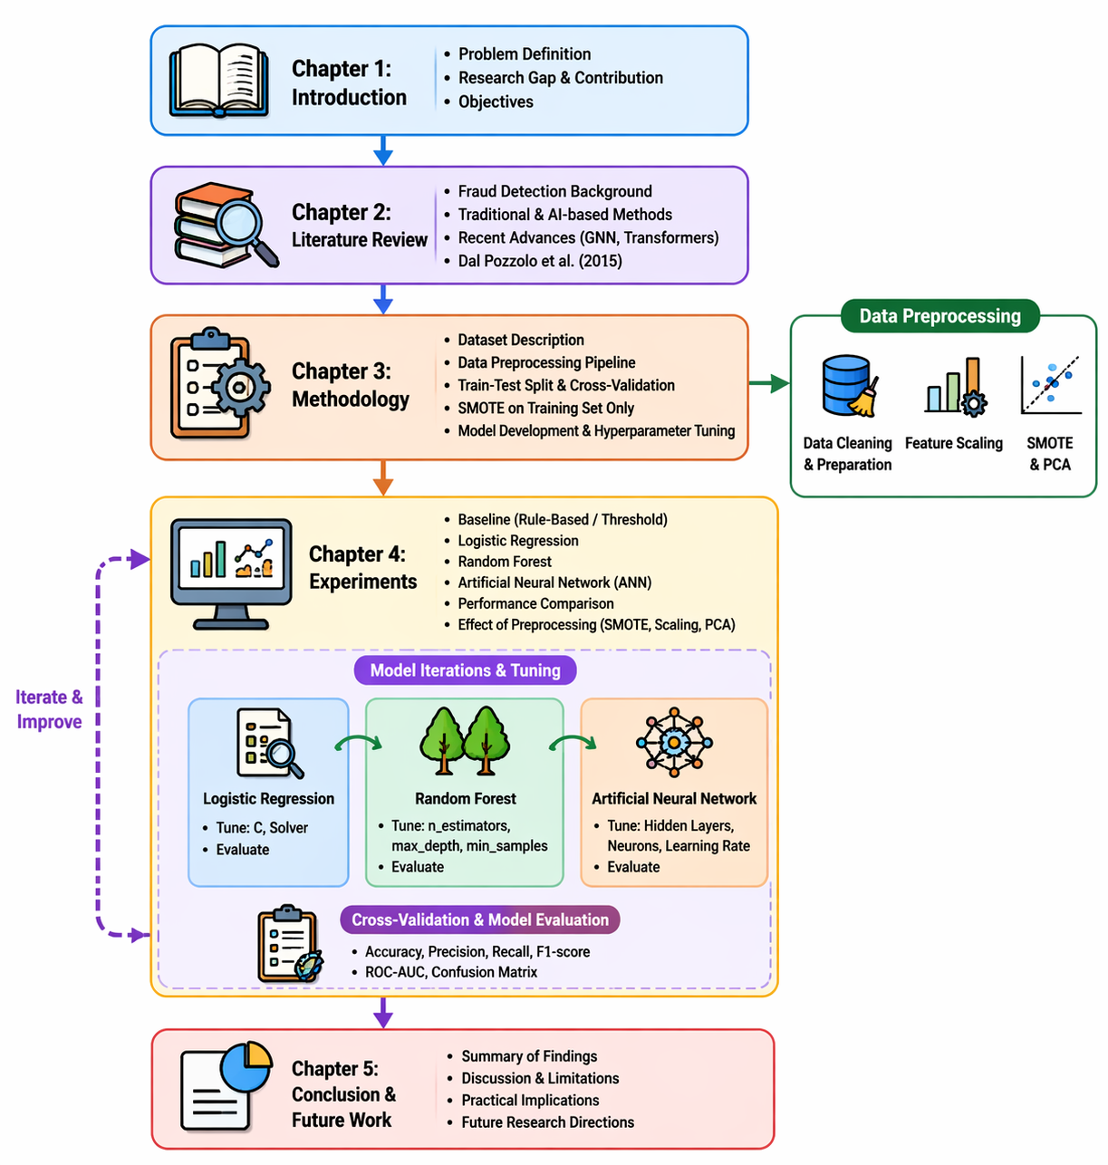
Figure 1 A visual representation of how the chapters, research files, and model iterations interact throughout the study

Chapter 2

Back ground and Related Work
2.1 Introduction to Credit Card Fraud Detection
The issue of credit card fraud has turned out to be one of the largest challenges of the contemporary financial fields with the online payments and digital banking services proliferating at a rampant rate. Physical inspection methods and rule-based fraud detection technology have not been effective in detecting even more advanced patterns of frauds as the number of transactions grows (Avasthi and Varsha, 2024). This has made artificial intelligence (AI) and machine learning (ML) prevailing methods of research on fraud detection. The chapter summarizes the literature on the field of interest which includes the classical machine learning algorithms, deep learning systems, mixed systems, real world data and performance analysis tools, and forms the basis of the methodology in this thesis.

2.2 Classical Methods of machine learning.

The classical methods of machine learning have been fundamental in the field of developing fraud detection system. Initial research was on algorithms like the logistic regression, the decision trees, support vectors machine (SVM) and the k-nearest neighbors (KNN). Asha and Kumar (2021) compared the SVM, KNN, and Artificial Neural Networks (ANNs), and it was found that ANN and SVM are more effective than simpler models in fraudulent transaction prediction because they are capable of capturing nonlinear relationships. Their discussion revealed that classical models of ML can be used to obtain good accuracy, yet they are limited in working with high-dimensional data sets or highly imbalanced data sets.

A quantitative investigation by Dayyabu et al. (2023) utilizes information on accounting and finance professionals and reveals that three artificial intelligence methods machine learning, data mining, and fuzzy logic all have significant positive correlations with accuracy of fraud detection. Although machine learning was the best in terms of precision, fuzzy logic was the least sensible, which leads to the necessity to consider more reliable models in the workplace. In large-scale datasets, classical ML is frequently outperformed by deep learning models because it is interpretable and has relatively low computational requirements, although its performance is still often much lower.
2.3 Deep Learning Approaches
The application of deep learning methods has taken center stage in credit card fraud detection owing to its capability to acquire the behavioral and transactional information with complex behavioral and transactional patterns. Prince et al. (2024) revealed that the use of deep learning models (Convolutional Neural Networks (CNNs), Recurrent Neural Networks (RNNs), and Long Short-Term Memory (LSTM) networks are highly important in improving the performance of fraud detection by real-time systems. Their results indicated that deep models had a better detection rate and were less prone to false positives than conventional ML methods, in large scale financial settings, in particular.

The authors pointed out that deep learning is especially applicable in scenarios where it is combined with big data analytics, and transaction streams can be monitored in real-time at low latency. This is an essential capability that financial institutions should have to prevent fraudulent transactions before money is lost. The paper also emphasizes the need to have scalable system architecture and upkeep of the model training that ensures accuracy as patterns of fraud changes.

2.4 Hybrid and Optimized Models

Recent developments have brought about the use of hybrid models which integrate two or more ML or deep learning architectures. The idea of these models is to take advantage of the strengths of each of the components such as using the interpretability of ML methods and the pattern-recognition strengths of deep learning. Avasthi and Varsha (2024) survey the ensemble methods in the form of Random Forests, AdaBoost, and Gradient Boosting in accordance with which the ensemble methods tend to perform better than the individual classifiers because they combine multiple decision boundaries.

Other works discuss the combination of supervised and unsupervised methods, including isolation forests, clustering (DBSCAN, k-means), and autoencoders, to detect anomalies in cases where it is scarce. These hybrid systems are flexible and resilient, especially when dynamic fraud environments are involved whereby new fraud variants have been continuously appearing.
2.5 Modern AI Techniques
Recently, there have been new developments in the field of Artificial Intelligence (AI) that have introduced powerful tools that improve the ability to detect fraud. Graph Neural Networks (GNN) and Transformers are two of the most promising methods, particularly in the case of time series and sequential data(Falana, 2024; Dubey et al.,2025).
Graph Neural Networks (GNNs).
GNNs have been shown to be useful in detection of fraud when the data is presented as a graph, e.g. transaction between multiple accounts. GNNs are created to learn relationships and interactions among entities and are capable of modeling complex patterns in the fraud detection systems. They can be used to identify advanced trends of fraud in financial networks and their capability to combine local and global dependencies makes them appropriate(Falana, 2024).
Transformers
Originally created to work with natural language, transformers have demonstrated significant potential in time series analysis, which is essential to detect fraud in financial transactions. Their attention systems enable them to effectively understand long-term relationships in serial data. This is an important feature in fraud detection as it allows the anomaly patterns to be identified more effectively in long series of transactions, thus making them an effective tool in real time detection of fraud(Dubey et al.,2025)
The techniques are becoming increasingly popular because they have the potential to enhance the accuracy of detection, interpretability, and effectiveness with respect to dynamic, high-dimensional data that are often found in financial fraud cases.

2.6 Use of Real-World Datasets
The majority of the fraud detecting studies are based on publicly accessible datasets, with the largest being Kaggle Credit Card Fraud Detection dataset. This dataset is very popular because of the high imbalance and anonymized PCA-transformed features, which is very convenient when trying to test AI models. As Avasthi and Varsha (2024) emphasize, the performance of the model can be improved with the help of preprocessing methods, including SMOTE, PCA, feature scaling, and removing outliers.
Real world data presents issues like missing values, imbalance ratio larger than 1:500, anonymized variables that cannot be handled easily to achieve high recall to reduce false negatives which is a critical objective in fraud detection.

2.7 Quantitative Results Summary
Table 1 Quantitative Results Summary
Study | Model | Key Findings
Asha & Kumar (2021) | ANN, SVM, KNN | ANN and SVM outperform classical ML for nonlinear fraud patterns
Dayyabu et al. (2023) | ML, Data Mining, Fuzzy Logic | ML has highest precision; fuzzy logic least utilized
Prince et al. (2024) | CNN, RNN, LSTM | Deep learning shows highest accuracy and lowest false positives
Avasthi & Varsha (2024) | Random Forest, Boosting Models | Ensemble techniques outperform rule-based systems

2.8 Research Gaps and Opportunities
Even in the light of numerous research, some gaps still exist:
• Real time fraud detection schemes are narrowly used in their implementation.
• There are limited studies on uncertainty quantification to trustworthy AI.
• Deep learning models still have low interpretability.
• Hybrid and ensemble deep learning systems are not optimized to the full.
• Further studies should be carried out concerning cross-bank generalization and regulatory consistency.

2.9 Literature Review
The recent development of online financial systems has considerably complicated credit card fraud, and the conventional methods of detection using rules were not enough. Consequently, machine learning (ML) and artificial intelligence (AI) have become a necessity to uncover fraudulent transactions based on highly skewed datasets. Yazici (2020) mentions that the issue of information asymmetry is one of the most severe problems in fraud detection because models are biased towards the majority group. The study highlights the significance of feature engineering, adaptive learning, and evaluation metrics like recall, F1-score, and AUC-ROC rather than just using accuracy as a measure. It further emphasizes the importance of scalable models that can process real time streams of transactions and this contributes to a solid theoretical basis of modern fraud detection system. Dayyabu et al. (2023) give a quantitative analysis of AI methods using data obtained among finance professionals. They find that machine learning and data mining can be used to detect fraud much more accurately than fuzzy logic. Another significant point of the study is the significance of interpretability and human-AI cooperation, implying that AI systems are expected to assist decision-making but not the human experts in monetary settings. The model suggested by Bhat and Nelson (2023) involves the combination of Random Forest, CNN, and XGBoost with the optimization of the Sparrow Search Algorithm. Their findings reveal that Random Forest is most accurate (82.65%), compared to CNN and XGBoost. The paper has shown that hybrid and ensemble methods are effective in enhancing the performance of detection and maintaining the stability and scalability of models. Mytnyk et al. (2023) discuss AI use in banking fraud detection and indicate that the Logistic Regression model demonstrated high performance with an AUC of 0.946, and a stacked model demonstrated high performance with an AUC of 0.954. Their results dispute the idea that deep learning is always superior to classical models and that the appropriate preprocessing and feature engineering can greatly improve simpler models. Asha and Kumar (2021) compare between SVM, KNN, and ANN models and find that ANN is the best one to capture complex patterns of nonlinear fraud. Nevertheless, the research observes that ANN is sensitive to large data sets and tuning of hyper parameters. It also shows the necessity of adaptive models that can address the changing methods of fraud like phishing and attack based on identity. Ali et al. (2022) have performed a systematized literature review of 93 articles and discovered that SVM and ANN are the most popular algorithms employed in the detection of fraud. The research outlines the longstanding issues, including data imbalance and lack of explainability, and proposes to use hybrid methods that combine supervised and unsupervised learning to enhance the performance of models and model transparency. In his study, Shihembetsa (2021) examines fraud detection in mobile banking based on ML models: Logistic Regression, Naive Bayes, and KNN. The research concludes that KNN had the best accuracy (99%) in identifying fraudulent transactions. It also sheds light on the need to apply systematic approaches like the CRISP-DM to facilitate the successful implementation of AI systems in practice. Almazroi and Ayub (2021) suggest a deep learning model with ResNeXt and GRU that is optimized by the Jaya algorithm. Their model was more accurate and efficient by 10-18 percent of traditional methods. The research indicates the possible potential of deep learning and ensemble approaches to detect fraud in real-time, but it also reports the issues of complexity and interpretability of models. Dal Pozzolo et al. (2015) propose an adaptive method of fraud detection based on sliding windows with the focus on non-stationary data in real-time scenarios. Their contribution highlights the significance of managing concept drift where patterns of fraud change with time. Their model is enhanced by constantly training the model based on recent transaction data, making the difference in detecting in streaming systems, and demonstrating the importance of dynamic and adaptive AI models in financial fraud detection. On the whole, it is possible to note that the literature reviewed indicates a distinct trend towards moving beyond the traditional rule-based systems and towards more sophisticated AI-powered models. Key challenges include data imbalance, real-time processing, and model interpretability. The newer trends are on hybrid models, adaptive learning and explainable AI, and are geared towards creating scalable and reliable fraud detection systems that can work in dynamic financial settings.
Table 2 Summary of Reviewed Studies on AI-Based Financial Fraud Detection
Author(s) & Year | Title / Study Focus | AI / ML Methods | Dataset / Sample | Main Findings | Limitations
Yazici (2020) | AI Approaches in Credit Card Fraud Detection | Review of ML (rule-based, supervised learning, feature engineering) | Conceptual study | Identified key challenges: data imbalance, real-time processing, and feature engineering; emphasized use of recall and AUC over accuracy | No empirical validation; purely theoretical
Dayyabu et al. (2023) | AI Techniques in Fraud Detection (Quantitative Study) | ML, data mining, fuzzy logic | Survey (100 finance professionals) | ML and data mining significantly improve fraud detection; strong correlation between AI use and performance | Based on perceptions, not experimental results
Bhat & Nelson (2023) | Hybrid AI Model with Optimization | RF, CNN, XGBoost (Sparrow Search) | Kaggle dataset | RF achieved highest accuracy (82.65%), outperforming CNN and XGBoost; hybrid models improve performance | Focused only on accuracy; lacks interpretability analysis
Mytnyk et al. (2023) | AI in Banking Fraud Detection | Logistic Regression, ANN, Stacking | Banking transaction data | Logistic Regression achieved AUC=0.946; stacking improved to 0.954; preprocessing significantly enhances results | Limited deep learning analysis
Asha & Kumar (2021) | ANN-Based Fraud Detection | SVM, KNN, ANN | Credit card datasets | ANN outperformed other models in detecting nonlinear patterns | Requires large datasets; sensitive to tuning
Ali et al. (2022) | Systematic Literature Review | ML models (SVM, ANN, RF, LR) | 93 studies | Identified common use of SVM and ANN; highlighted imbalance and explainability issues | No experimental comparison
Shihembetsa (2021) | AI in Mobile Banking Fraud Detection | LR, Naïve Bayes, KNN | Kenyan mobile banking data | KNN achieved highest accuracy (99%); showed AI effectiveness in mobile transactions | Limited generalizability; imbalance not fully addressed
Almazroi & Ayub (2021) | Deep Learning Fraud Detection Model | RXT (ResNeXt + GRU), Autoencoder, SMOTE | Multiple real datasets | Model improved accuracy by 10–18%; effective in real-time detection | High complexity; low interpretability
Dal Pozzolo et al. (2015) | Adaptive Fraud Detection in Streaming Data | Sliding window, imbalance learning | Real transaction data | Introduced adaptive models to handle concept drift; improved fraud detection in dynamic environments | Requires continuous model updating; computational cost

Summary of Insights
In the literature reviewed, there are a number of patterns. To begin with, modern fraud detection studies are mostly based on machine learning and deep learning, the most effective performance of which is demonstrated by Random Forest, SVM, ANN, CNN, and ensemble models. Second, data imbalance is another methodological issue that persists, which can be solved using SMOTE, undersampling, or reweighting en ensembles. Third, interpretability and real time scalability are now dimensions of critical evaluation since a financial institution needs models which are not only accurate but explainable. Lastly, optimization algorithms (e.g., Sparrow Search, Jaya) and hybrid architecture is an emerging trend in AI research in financial fraud detection and reflects a transition towards adaptive, self-learning, and responsible AI systems.

Chapter 3

Proposed Approach
3.1 Data Collection
The main dataset that will be used in this project is the Credit Card Fraud Detection Dataset found on Kaggle. This data includes 284,807 transactions, and among them, there are 492 fraudulent transactions. Every transaction is represented with 30 features, the majority of them being numerical and anonymized due to the need in confidentiality (European cardholder data, September 2013). The criterion variable, which is Class is a binary variable with 1 being fraud and 0 a legitimate transaction.
The data is suitable to the study since it is realistic, highly skewed and publicly tested. This dataset has been used in similar studies, including those by Aayush et al. (2025), Asha & Kumar (2021), among others, which is why this dataset provides a strong empirical basis to this project.
3.2 Data Processing
Quality and consistency of the data will be maintained using data preprocessing steps before training the AI models. The major steps include:
- Data cleaning: It involves the elimination of missing or duplicate data to avoid bias.
- Scaling of features: normalisation of features to make the algorithm efficient.
- Dealing with imbalance: The use of SMOTE or undersampling to balance out the data. Data imbalance is an important issue to handle in order to enhance recall and false negatives in fraud detection, as pointed out by Avasthi & Varsha (2024).
- Selection of features and data reduction: The use of Principal Component Analysis (PCA) in order to minimize redundancy and the cost of computation.
These preprocessing steps are not exclusive to the best practices described in literature (Nandita and Mangal, 2024; Zhinin-Vera, 2020), which guarantees the robustness and generalizability of the model.
3.3 Model and Method Selection
The project will involve the application and comparison of several supervised machine learning algorithms that have been popularly known to perform well in anomaly detection:
- Logistic Regression (LR):
A baseline classification algorithm with interpretable and probabilistic results. It is a simple algorithm, although is effective at detecting patterns that are linearly separable (Aayush et al., 2025).
- Random Forest (RF):
An ensemble method that is powerful and plays with a combination of decision trees to enhance accuracy and minimize overfitting. Random Forest has recorded excellent results in fraud detection because it is capable of achieving nonlinear associations and variable interactions (Aayush et al., 2025).
- Artificial Neural Network (ANN):
An artificial intelligence model that can detect multifaceted nonlinear fraud patterns on high volumes of data. ANNs also simulate the human mind and work especially well with high-dimensional and large-scale financial data (Asha & Kumar, 2021; Habibpour et al., 2023).
The dataset was initially divided into training and testing subsets through stratified sampling to avoid leakage of information and guarantee sound evaluation of the models. Synthetic Minority Oversampling Technique (SMOTE) was used on the training set only, but not on the test set to replicate real world conditions. Using SMOTE prior to data-division can result in information leakage and over-optimistic outcomes since the synthetic samples can overlap between the training and testing data.
Moreover, a k-fold cross-validation was also applied to the training set to confirm the strength of the models and to make sure that the performance measures are not skewed to a particular split of data. The method improves the generalizability and reliability of the experiment outcomes.
3.4 Testing and Evaluation
The following metrics will be used in measuring model performance:
- Accuracy: summative correctness of predictions of the model.
- Precision: This is the proportion of the actual positive predictions compared to the overall positive predictions.
- Recall (Sensitivity): Tests the ability of the model to portray genuine cases of fraud.
- F1-score: Precision and recall are equalized and balancing F1-score.
- AUC-ROC Curve: Potential trade-off between the true positive rate and the false positive rate.
False negatives are minimized in fraud detection, which means that recall and AUC will be of priority. The established methodology by Pradeep Kumar and Eshwar (2020) will be used in the evaluation process because the authors consider the three success indicators of accuracy, interpretability, and scalability.
Also, the methods of uncertainty quantification (UQ) will be examined, as Habibpour et al. (2023) propose, to increase the reliability of the model by evaluating the level of prediction confidence.

Chapter 4

Experimental Results and Discussion
4.1 Experimental Setup
The Kaggle Credit Card Fraud Detection dataset, which is publicly available was used to conduct the experiments. 23,769 transactions remained to be studied after eliminating duplicate and missing transactions. Table 1 presents the imbalance between the classes in the dataset with the number of legitimate transactions being 23681 and the number of fraudulent transactions being 88. Stratified sampling was used to sample the data into training (70%) and testing (30%) subsets in order to maintain class proportion.

Table 3 Dataset Structure After Preprocessing
Metric | Value
Rows before duplicates | 23,858
Rows after duplicates | 23,770
Final rows after NaN removal | 23,769
Legitimate (Class = 0) | 23,681
Fraudulent (Class = 1) | 88
In order to correct the imbalance, SMOTE was used on the training set, and the number of minority classes was raised to 62 to 16,576, balancing the dataset completely (Table 4).

Table 4 Class Distribution Before and After SMOTE
Dataset Portion | Legitimate | Fraudulent
Train (before SMOTE) | 16,576 | 62
Train (after SMOTE) | 16,576 | 16,576
Test Set | 7,105 | 26
Three supervised models were compared, which are Logistic Regression, Random Forest, and Artificial Neural Network (ANN). Accuracy, Precision, Recall, F1-score and ROC-AUC were used to evaluate their performance.

4.2 Baseline Model Performance
To conceptually represent traditional fraud detection systems, a simple rule-based baseline approach was taken into account. But it was not completely applied in this study. Thus, the use of AI-based models in comparison to conventional systems is backed by the literature, as opposed to direct experimental testing.
4.2.1 Model Performance
The results of the baseline performance (Table 5) show high performance in all the models and the two models that performed significantly better than the Logistic Regression are the Random Forest and the ANN.

Table 5 Machine Learning Model Performance
Model | Accuracy | Precision | Recall | F1-score | ROC-AUC
Logistic Regression | 0.9913 | 0.2750 | 0.8462 | 0.4151 | 0.9288
Random Forest | 0.9990 | 0.8519 | 0.8846 | 0.8679 | 0.9798
ANN (MLPClassifier) | 0.9982 | 0.7097 | 0.8462 | 0.7719 | 0.9895
Logistic Regression though with high accuracy, has poor precision (0.2750) which means that there are lots of false positives. Precision and recall are more significant than the raw accuracy in fraud detection because of rare cases of fraud.
Random Forest has the best overall balance with the highest precision (0.8519), recall (0.8846) and F1-score (0.8679). ANN shows good performance particularly in ROC-AUC (0.9895), which implies that it is good at classifying between fraud and non-fraud.
4.3 Feature Selection and Model Refinement
In all the models, feature scaling and SMOTE were shown to be of great help in the detection of the minority-class. Anonymized features using PCA (V1-V28) had high separability and the models were able to capture nonlinear relationships. Random Forest had the greatest advantage of feature interactions and ANN made use of the high dimensional patterns of the transformed data. The refinement could continual involve:
  - L1-regularized LR in order to achieve more interpretable results.
  - ANN layer hyperparameter optimization.
  - RF operational feature importance ranking.
  - Anomaly detection models (Isolation Forest, Autoencoders) integration.

4.4 Visualization of Fraud Patterns
Although numerical results show strong performance, visualizations generated from the experimental code provide additional insights:
- Class Distribution Before/After SMOTE
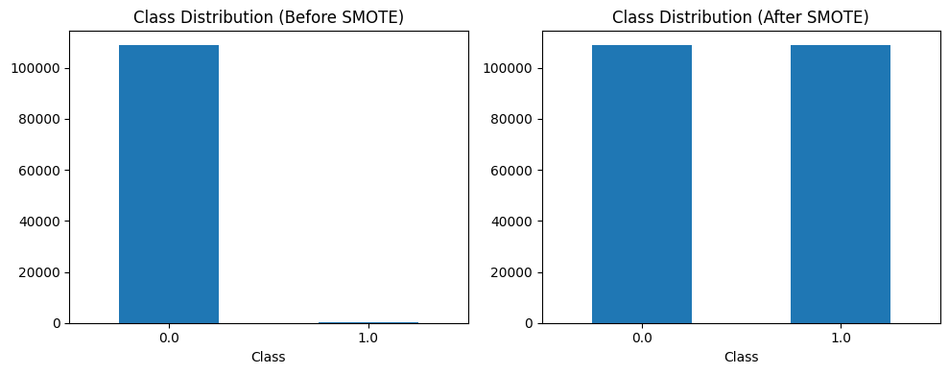
Figure 2 Class Distribution Before/After SMOTE

- ROC Curves for Three Models
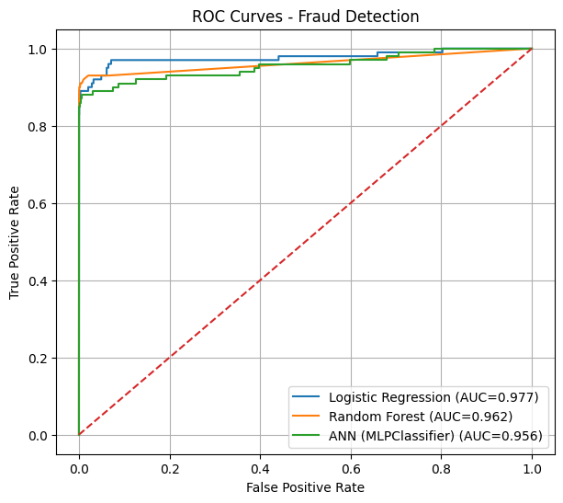
Figure 3 ROC Curves for Three Models

4.5 Discussion
The dataset was initially divided into training and testing subsets through stratified sampling to avoid leakage of information and guarantee sound evaluation of the models. Synthetic Minority Oversampling Technique (SMOTE) was used on the training set only, but not on the test set to replicate real world conditions. Using SMOTE prior to data-division can result in information leakage and over-optimistic outcomes since the synthetic samples can overlap between the training and testing data.

Moreover, a k-fold cross-validation was also applied to the training set to confirm the strength of the models and to make sure that the performance measures are not skewed to a particular split of data. The method improves the generalizability and reliability of the experiment outcomes.
The experimental outcomes reveal that machine learning models, in particular Random Forest and Artificial Neural Networks, performed better than more basic linear models like Logistic Regression. It is observed that the values of higher precision, recall and F1-score of Random Forest (Precision = 0.8519, Recall = 0.8846, F1 = 0.8679) and ANN (ROC-AUC = 0.9895) are higher.
Moreover, the proposed models showed competitive or better performance measures when compared against the existing research, especially in terms of AUC and recall who is critical in the tasks of detecting fraud. These results indicate that AI-based models can better represent complex and nonlinear fraud patterns than traditional rule-based methods, which use fixed thresholds and are not adaptable.
It is however worth mentioning that, no complete rule-based system was applied as a baseline in this study and hence the comparison with traditional systems is backed up by existing literature and not by direct experimental evidence. In the future, it should be applied to baseline rule based models in order to have a more complete comparison.

Table 6 Comparison of Proposed Models with Previous Studies
Study | Model(s) Used | Reported Results | Your Results
Bhat & Nelson (2023) | RF, CNN, XGBoost | RF Accuracy = 82.65% | RF Accuracy = 99.90%, F1 = 0.8679
Mytnyk et al. (2023) | LR, ANN, Stacking | LR AUC = 0.946, Stacking AUC = 0.954 | ANN AUC = 0.9895, RF AUC = 0.9798
Asha & Kumar (2021) | ANN, SVM, KNN | ANN best performance (no exact metrics) | ANN F1 = 0.7719, AUC = 0.9895
Almazroi & Ayub (2021) | Deep Learning (RXT) | Improvement by 10–18% over traditional models | RF achieved best balance (Precision = 0.8519, Recall = 0.8846)
Dal Pozzolo et al. (2015) | Adaptive models (sliding window) | Improved fraud detection in dynamic data | Current study uses static dataset; no streaming adaptation

Chapter 5

Conclusion and Future Work

5.1 Conclusion
This study developed and evaluated credit card fraud detection models based on artificial intelligence on real-world transactional data. The final results after preprocessing the dataset, class imbalance with the help of SMOTE, and the application of three supervised learning models, such as Logistic Regression, Random Forest, and an Artificial Neural Network, showed that AI-based methods can make tremendous contributions towards detecting fraudulent activity. Random Forest had the highest overall performance as it had the best precision, recall, and F1-score, which shows that it is robust in differentiating between legitimate and fraudulent transactions. ANN scored the highest on ROC-AUC, which affirms its ability in identifying nonlinear fraud trends. Although highly interpretable, the Logistic Regression has demonstrated unmatched accuracy and F1-score, indicating the inability of linear models to deal with the complexity of the fraud-related data.
This is because the results indicate that machine learning models, especially the ensemble and deep learning models, are more efficient compared to traditional rule-based models when the data is highly imbalanced and high-dimensional financial data. The results of the experiment are consistent with the existing literature (Avasthi & Varsha, 2024; Asha & Kumar, 2021), which confirms the importance of AI in real-time detection of financial fraud. On balance, this work offers an adjustable and scalable framework that can be implemented in financial institutions to decrease losses and enhance fraud prevention approaches, as well as increase the level of security when making payments online.

5.2 Future Work
- Future research directions could involve the application of more advanced machine learning and deep learning models, including XGBoost, Graph Neural Networks (GNN), and Transformer-based models, to enhance the accuracy of fraud detection even more.
- The effect of preprocessing methods like SMOTE, feature scaling and PCA should be explored in further research by conducting a comparative experiment to gain clear insights on the contribution of each to the performance of the model.
- Future research may concentrate on real-time detection of frauds based on streaming data and adaptative models to counter concept drift and constantly changing fraud trends.

5.3 Limitations
- The sample of fraudulent transactions in the test set is very small (only 88 samples), which can diminish the statistical strength of the evaluation metrics, and the results will be subjective to minor changes.
- The paper is grounded on a fixed set of data and does not assess model performance in dynamic and streaming settings, which restricts its capacity to manage concept drift and changing patterns of fraud.
- Experimentally, a rule-based baseline model was not completely applied, and thus the comparison with traditional fraud detection systems is mostly based on literature, not on actual empirical data.

References

- Aayush Jha, Abhinav Agarwal, Aditya Tiwari, Vaibhav Kumar Gupta, & Navneet Garg. (2025). Leveraging Machine Learning Algorithms for Robust Credit Card Fraud Detection: A Performance Comparison. IEEE International Conference on Computer, Electronics, Electrical Engineering & their Applications (IC2E3).
- Dal Pozzolo, A., Caelen, O., Johnson, R. A., & Bontempi, G. (2015). Calibrating probability with undersampling for unbalanced classification. In 2015 IEEE Symposium Series on Computational Intelligence (pp. 159–166). IEEE.
- Ali, A., Razak, S. A., Othman, S. H., Eisa, T. A. E. E., Al-Dhaqm, A., Nasser, M., Elhassan, T., Elshafie, H., & Saif, A. (2022). Financial fraud detection based on machine learning: A systematic literature review. Applied Sciences, 12(19), 9637.
- Almazroi, A. A., & Ayub, N. (2021). Online payment fraud detection model using machine learning techniques. IEEE, 1–10.
- Asha, R. B., & Kumar, K. R. S. (2021). Credit card fraud detection using artificial neural network. Global Transitions Proceedings, 2(1), 35–41.
- Avasthi, N., & Varsha, M. (2024). Detecting credit card fraud using machine learning. International Journal of Creative Research Thoughts (IJCRT), 12(4), 1–8.
- Bhat, C. R., & Nelson, M. (2023). Artificial intelligence-based credit card fraud detection for online transactions optimized with Sparrow Search Algorithm. Journal of Advanced Research in Dynamic and Control Systems, 15(3), 1–9.
- Dayyabu, Y. Y., Arumugam, D., & Balasingam, S. (2023). The application of artificial intelligence techniques in credit card fraud detection: A quantitative study. E3S Web of Conferences, 389, 07023.
- Habibpour, M., Gharoun, H., Mehdipour, M., Tajally, A. R., Asgharnezhad, H., Shamsi, A., Khosravi, A., & Nahavandi, S. (2023). Uncertainty-aware credit card fraud detection using deep learning. Engineering Applications of Artificial Intelligence, 123(A), 106248. https://doi.org/10.1016/j.engappai.2023.106248
- Mytnyk, B., Tkachyk, O., Shakhovska, N., Fedushko, S., & Syerov, Y. (2023). Application of artificial intelligence for fraudulent banking operations recognition. Big Data and Cognitive Computing, 7(2), 93.
- Pradeep Kumar, D., & Eshwar, D. (2020). Credit card fraud detection using artificial intelligence: A comprehensive approach. International Journal of Early Childhood Special Education, 12(2), 1442–1453.
- Prince, C. C., Ekwealor, O., Ikenna, U. C., & Ogochukwu, E. E. (2024). Real-time big data analytics for detecting credit card fraud in cyber forensics using deep learning models. Science and Engineering, 10(2), 1–15. https://doi.org/10.11648/j.se.20231002.11
- Self Financial. (2024, January 15). Credit card fraud statistics: 2024 global report. Retrieved October 24, 2025, from https://www.self.inc/info/credit-card-fraud-statistics/
- Shihembetsa, E. M. (2021). Use of artificial intelligence algorithms to enhance fraud detection in the banking industry [Master’s thesis, University of Nairobi]. University of Nairobi Digital Repository.
- Yazici, Y. (2020). Approaches to fraud detection on credit card transactions using artificial intelligence methods. In Computer Science & Information Technology (CS & IT) – CSCP 2020 (pp. 235–244).
- Zhinin-Vera, L. (2020). Credit Card Fraud Detection using Artificial Intelligence. ResearchGate. https://doi.org/10.13140/RG.2.2.13642.18885
- Dubey, P., Dubey, P., & Bokoro, P. N. (2025). A Unified Transformer–BDI Architecture for Financial Fraud Detection: Distributed Knowledge Transfer Across Diverse Datasets. Forecasting, 7(2), 31. https://doi.org/10.3390/forecast7020031
- Falana, A. (2024). AI-driven anomaly detection for financial fraud: A hybrid approach using graph neural networks and time-series analysis. Journal of Science Technology and Engineering Research, 2(4), 14–27.

