

CAIRO UNIVERSITY
FACULTY OF GRADUATE STUDIES
FOR STATISTICAL RESEARCH CAIRO, EGYPT

A Machine Learning Approach to Predict Student Performance Using Educational Data Mining
BY
@@@@@@@@@@@@@@@@@@
A Thesis Submitted to
Department of Computer Science in Partial Fulfillment of the Requirements for the Master Degree of Computer Science
Under the Supervision of

Acknowledgements

Special thanks to Dr. .

Abstract

List of Publications

Table of Contents

List of Abbreviations xiv
List of Figures xvi
List of Tables xviii

Chapter 1: Introcudion .................................................................................. 1
1.1 Problem Definition ...................................................................................... 2
1.2 Thesis Objectives ........................................................................................ 3
1.3 Thesis Contribution ..................................................................................... 4
1.4 Thesis Organization..................................................................................... 5

Chapter 2: Overview on Educational Data Mining ..................................... 6
2.1 Introduction ................................................................................................. 6
2.2 Educational Data Mining ............................................................................ 6
2.3 Applications of Educational Data Mining .................................................. 7
2.3.1 Prediction ............................................................................................ 8
2.3.2 Clustering ........................................................................................... 9
2.3.3 Relationship Mining ......................................................................... 10
2.3.4 Discovery with Model ...................................................................... 11
2.3.5 Distillation of Data for Human Judgment ........................................ 12
2.4 Goals of Educational Data Mining ............................................................ 12
2.5 Predicting Student Performance ................................................................ 13
2.5.1 Students Previous Grades and Class Performance ........................... 14
2.5.2 Students e-Learning Activity ............................................................ 14
2.5.3 Students Demographics .................................................................... 15
2.5.4 Students Social Information ............................................................. 16
2.5.5 Students Environment ...................................................................... 16
2.5.6 Instructor Attributes.......................................................................... 17
2.5.7 Course Attributes .............................................................................. 18
2.5.8 Course Evaluations ........................................................................... 18
2.5.9 Students Experience Information ..................................................... 18
2.6 Dataset of Educational Data Mining ......................................................... 20
2.6.1 Student Performance Dataset ........................................................... 20
2.6.2 Educational Process Mining (EPM): A Learning Analytics Dataset ....
................................................................................................................... 22
2.6.3 Students' Academic Performance Dataset ........................................ 23
2.6.4 Student Performance: Standardized Testing Results ....................... 24
2.6.5 The Open University Learning Analytics Dataset (OULAD) .......... 25
2.7 Performance Measures in Educational Data Mining ................................ 26
2.7.1 Accuracy ........................................................................................... 26
2.7.2 Kappa Statistic .................................................................................. 26
2.7.3 Receiver Operating Characteristic ................................................... 27
2.7.4 Precision and Recall ......................................................................... 28
2.7.5 Mean Absolute Error ........................................................................ 28
2.7.6 Root Mean Square Error ................................................................... 29
2.8 Summary ................................................................................................... 29
Chapter 3: Related Work ………………………………………………... 31
3.1 Introduction ................................................................................................31
3.2 History ...................................................................................................... 31
3.3 Predicting Student Performance Using Statistical Analysis .................... 33
3.4 Predicting Student Performance Using Machine Learning ..................... 35
3.4.1 Predicting Student Performance Using Artificial Neural Networks 36
3.4.2 Predicting Student Performance Using Decision Trees .................. 38
3.4.3 Predicting Student Performance Using Support Vector Machines . 39
3.4.4 Predicting Student Performance Using Logistic Regression ........... 40
3.4.5 Predicting Student Performance Using Naïve Bayes ....................... 40
3.4.6 Predicting Student Performance Using k-Nearest Neighbor ........... 41
3.5 Predicting Student Performance Using Both Statistical Analysis and
Machine Learning ......................................................................................... 42
3.6 Predicting Student Performance Using Deep Learning ........................... 44
3.7 The-State-of-Art ....................................................................................... 45
3.8 Summary .................................................................................................. 47

Chapter 4: Background on Mahcine Learning .......................................... 48
4.1 Introduction ............................................................................................... 48
4.2 Conventional Programming vs. Machine Learning .................................. 48
4.3 Supervised Learning .................................................................................. 51
4.3.1 Bias-variance tradeoff ...................................................................... 53
4.3.2 Bias and Variance Test ..................................................................... 54
4.3.3 Hypothesis Space.............................................................................. 55
4.4 Unsupervised Learning ............................................................................. 56
4.5 Semi-supervised Learning ......................................................................... 57
4.6 Active Learning ......................................................................................... 59
4.7 Reinforcement Learning ............................................................................ 59
4.7.1 Difference between Reinforcement Learning and Supervised
Learning ..................................................................................................... 60
4.7.2 Relation between Reinforcement Learning and Dynamic
Programming ............................................................................................. 61
4.7.3 Component of Reinforcement Learning ........................................... 61
4.7.4 Deep Reinforcement Learning ......................................................... 62
4.8 Artificial Neural Network ......................................................................... 63
4.8.1 Common Structure of Artificial Neural Network ............................ 65
4.8.2 Backpropagation .............................................................................. 67
4.8.3 Types of Artificial Neural Networks ............................................... 67
4.9 Decision Trees and Random Forests ......................................................... 69
4.10 k-Nearest Neighbor ................................................................................. 71
4.11 Logistic Regression ................................................................................. 72
4.12 Support Vector Machine ......................................................................... 73
4.13 Naïve Bayes ............................................................................................ 74
4.14 Deep Learning ........................................................................................ 75
4.15 Summary ................................................................................................ 76

Chapter 5: Proposed Approach .................................................................. 78
5.1 Introduction ............................................................................................... 78
5.2 Approach Stages ....................................................................................... 78
5.2.1 Data Acquisition ............................................................................. 79
5.2.2 Data Cleaning .................................................................................. 80
5.2.3 Feature Extraction and Selection .................................................... 81
5.2.3.1 Filter Methods ........................................................................ 82
5.2.3.2 Wrapper Methods ................................................................... 83
5.2.3.3 Hybrid Methods ..................................................................... 83
5.2.3.4 Embedded Methods ............................................................... 83
5.2.3.5 The Chosen Feature Selection Methods ................................. 84
5.2.4 Data Encoding and Standariztion ................................................... 84
5.2.5 Training and Evaluation of Machine Learning Based Methods ..... 85
5.3 Summary ................................................................................................... 85

Chapter 6: Experimental Results and Discussion ..................................... 86
6.1 Introduction ............................................................................................... 86
6.2 Dataset Description ................................................................................... 87
6.2.1 Demographic Information .............................................................. 89
6.2.2 Activities Informaion ....................................................................... 89
6.2.3 Modules and Presentaions Information .......................................... 90
6.3 Preparing Combinations of Data ............................................................... 90
6.4 Dealing with Imbalanced Data ................................................................. 91
6.5 Parameters of ML models ......................................................................... 92
6.6 Performance Measures ............................................................................. 94
6.6.1 Confusion Matrix ............................................................................. 94
6.6.2 Accuracy ........................................................................................ 105
6.6.3 Precision ......................................................................................... 107
6.6.4 Recall or Sensitivity (True Positive Rate) ..................................... 107
6.6.5 F₁ Score .......................................................................................... 109
6.6.6 Area Under the Curve and Receiver Opearting Characteristic .... 110
6.7 Most Important Features for Predicting Student Performance ............... 120
6.7.1 Feature Selection Using Embedded Methods ................................ 120
6.7.2 Feature Selcction Using Filter Methods ....................................... 125
6.8 Summary ................................................................................................ 125

Chapter 7: Conclusion and Future Work ................................................. 127
7.1 Important Features .................................................................................. 127
7.2 Most Efficient Models in Educational Data Mining .............................. 129
7.3 Future Work ........................................................................................... 129

References ..................................................................................................... 130

List of Abbreviations
- Acc.: Accuracy
- ANN: Artificial Neural Network
- ANOVA: Analysis of Variance
- API: Application Programming Interface
- CM: Confusion Matrix
- CSV: Comma Separated Values
- DL: Deep Learning
- DM: Data Mining
- DT: Decision Tree
- EDM: Educational Data Mining
- FCBF: Fast Correlation Based Filter
- FSFS: Feature Selection Using Feature Similarity
- FN: False Negative
- FP: False Positive
- FPR: False Positive Rate
- ITS: Intelligent Tutoring System
- KNN: K-Nearest Neighbor
- LA: Learning Analytics
- LMS: Learning Management System
- LR: Logistic Regression
- MAD: Mean Accuracy Decrease / Mean Absolute Difference
- MAE: Mean Absolute Error
- MDI: Mean Decrease in Impurity
- MGSACO: Microarray Gene Selection based on Ant Colony Optimization
- ML: Machine Learning
- MPMR: Maximum Projection and Minimum Redundancy
- NB: Naïve Bayes
- OULAD: Open University Learning Analytics Dataset
- PSP: Predicting Student Performance
- RF: Random Forest
- RMSE: Root Mean Square Error
- ROC: Receiver Operating Characteristic
- RRFS: Relevance Redundancy Feature Selection
- SMOTE: Synthetic Minority Oversampling Technique
- SU: Symmetrical Uncertainty
- SVM: Support Vector Machine
- TN: True Negative
- TP: True Positive
- TPR: True Positive Rate
- UCI: University of California, Irvine
- VLE: Virtual Learning Environment

List of Figures
2.1 Educational Data Mining Process ……………………………………… | 7
2.2 Applications of Educational Data Mining ……………………………… | 8
2.3 Distribution of Papers that used different attributes for PSP problem …. | 19
2.4 Student Performance Data Set …………………………………………... | 21
2.5 Educational Process Mining (EPM): A Learning Analytics Data Set … | 23
3.1 Most Commonly Used ML Algorithms in EDM ……………………… | 35
4.1 Machine Learning Subfields …………………………………………… | 50
4.2 Supervised Learning ……………………………………………………. | 51
4.3 Unsupervised Learning …………………………………………………. | 56
4.4 Reinforcement Learning ………………………………………………... | 59
4.5 Simple ANN ……………………………………………………………. | 66
4.6 The relation between performances of deep learning algorithm compared to other traditional machine learning algorithms and the amount of data … | 76
5.1 The Proposed Approach …………………………….…………………... | 78
6.1 OULAD Database Schema ……………………………………………... | 88
6.2 A Bar Chart Shows Imbalanced Data …………………………………… | 91
6.3 Comparing Precisions …………………………………………………... 107
6.4 Comparing Recalls ……………………………………………………… 108
6.5 Comparing F₁-Scores …………………………………………………… 109
6.6 ROC curve of the ANN model on demographics without using SMOTE 110
6.7 ROC curve of the ANN model on demographics using SMOTE ……… 111
6.8 ROC curve of the ANN model on demographics and scores ………….. 111
6.9 ROC curve of the ANN model on demographics, scores, and VLE …… 112
6.10 ROC curve of the RF model on demographics ……………………….. 112
6.11 ROC curve of the RF model on demographics and scores …………… 113 6.12 ROC curve of the RF model on demographics, scores, and VLE ……… 113 6.13 ROC curve of the k-NN model on demographics ……………………… 114
6.14 ROC curve of the k-NN model on demographics and scores ………… 114
6.15 ROC curve of the k-NN model on demographics, scores, and VLE …… 115
6.16 ROC curve of the LR model on demographics ………………………… 115
6.17 ROC curve of the LR model on demographics and scores …………… 116
6.18 ROC curve of the LR model on demographics, scores, and VLE ……… 116
6.19 ROC curve of the NB model on demographics ………………………… 117
6.20 ROC curve of the NB model on demographics and scores …………… 117
6.21 ROC curve of the NB model on demographics, scores, and VLE ……… 118 6.22 ROC curve of the SVM model on demographics ………………………. 118
6.23 ROC curve of the SVM model on demographics and scores ………… 119
6.24 ROC curve of the SVM model on demographics, scores, and VLE ……. 119
6.25 Comparing AUCs ……………………………………………………. 120 6.26 MDI of Demographics ………………………………………………… 121
6.27 MAD of Demographics ……………………………………………….. 121
6.28 MDI of Demographics and Scores ……………………………………. 122
6.29 MAD of Demographics and Scores …………………………………… 123
6.30 MDI of Demographics, Scores, and VLE ……………………………… 124
6.31 MAD of Demographics, Scores, and VLE …………………………… 124

List of Tables
2.1 Student Performance Data Set Description ………………………… 21
2.2 Students' Academic Performance Dataset Description ……………… 23
2.3 School_data file fields Description ………………………………… 25

3.1 Summary of researches that used Machine Learning Based models … 43

6.1 Positions of True Positives, False Positives, True Negatives, and False
Negatives in the Confusion Matrix …………………………………… 94

6.2 CM of the ANN Model on Demographics without Using SMOTE … 96
6.3 CM of the ANN Model on Demographics Using SMOTE …………. 96 6.4 CM of the ANN on Demographics and Scores ……………………… 97
6.5 CM of the ANN on Demographics, Scores. And VLE ……………… 97 6.6 CM of the RF on Demographics only ……………………………….. 98
6.7 CM of the RF on Demographics and Scores ………………………… 98
6.8 CM of the RF on Demographics, Scores and VLE ………………….. 99 6.9 CM of the k-NN on Demographics ………………………………….. 99
6.10 CM of the k-NN on Demographics and Scores ……………………… 100
6.11 CM of the k-NN on Demographics, Scores, and VLE ……………… 100
6.12 CM of the LR on Demographics …………………………………….. 101 6.13 CM of the LR on Demographics and Scores ………………………… 101 6.14 CM of the LR on Demographics, Scores, and VLE …………………. 102
6.15 CM of the NB on Demographics ……………………………………. 102
6.16 CM of the NB on Demographics and Scores ………………………... 103
6.17 CM of the NB on Demographics, Scores, and VLE ………………… 103 6.18 CM of the SVM on Demographics ………………………………….. 104
6.19 CM of the SVM on Demographics and Scores ……………………… 104 6.20 CM of the SVM on Demographics Scores, and VLE ……………….. 105
6.21 Comparing Accuracies of Models on Different Data Combinations ... 106
6.22 Important Features Using Filter Methods …………………………… 125

Chapter 1 Introduction

1.1 Problem Definition

1.2 Thesis Objectives

1.3 Thesis Contribution

1.4 Thesis Organization

Chapter 2 Overview on Educational Data Mining

2.1 Introduction

2.2 Educational Data Mining
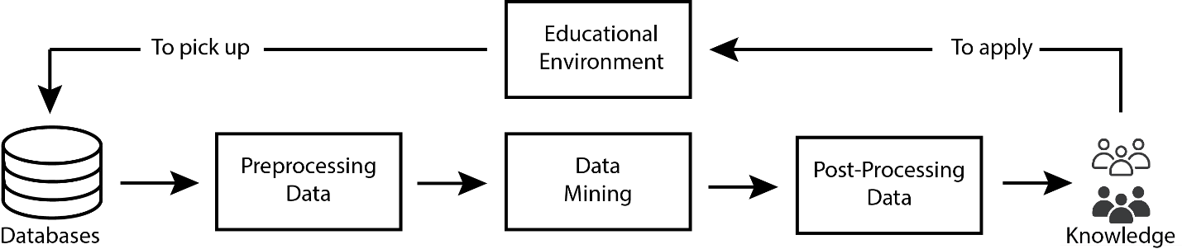
Figure 2.1 EDM Process (preprocessing, mining, and post-processing)

2.3 Applications of Educational Data Mining

2.3.1 Prediction

2.3.2 Clustering

2.3.3 Relationship Mining

2.3.4 Discovery with Model

2.3.5 Distillation of Data for Human Judgment

2.4 Goals of Educational Data Mining

2.5 Predicting Student Performance

2.5.1 Students Previous Grades and Class Performance

2.5.2 Students e-Learning Activity

2.5.3 Students Demographics

2.5.4 Students Social Information

Chapter 3 Related Work

3.1 Introduction

3.2 History

3.3 Predicting Student Performance Using Statistical Analysis

3.4 Predicting Student Performance Using Machine Learning
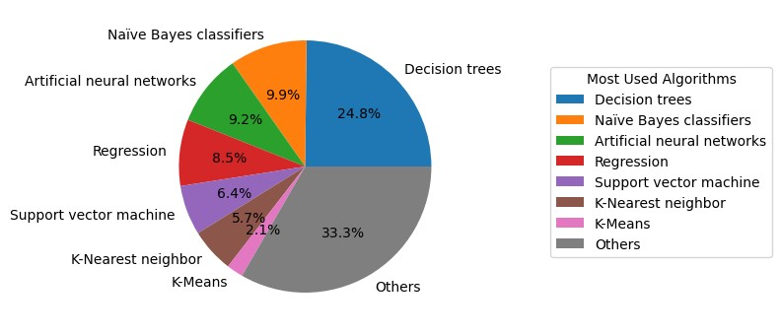

3.4.2 Predicting Student Performance Using Decision Trees
Kiu [Kiu 2018] built two models using J48 DT which depends on divide and conquer approach to classify students based on their logged activities during their learning process in LMS to predict their final results. The second model outperformed the first model according to the following evaluation metrics: (1) precision of the first model was 0.858 versus that of the second model which was 0.632, (2) recall of the first model was 0.855 versus that of the second model which was 0.726, and (3) Fmeasure of the first model was 0.850 versus that of the second model which was
0.669.

3.4.3 Predicting Student Performance Using Support Vector Machines
Table 3.1: summary of the researches that used ML-based models

3.6 Predicting Student Performance Using Deep Learning

3.8 Summary

Chapter 4 A Background on Machine Learning

4.2 Conventional Programming vs. Machine Learning

4.3 Supervised Learning
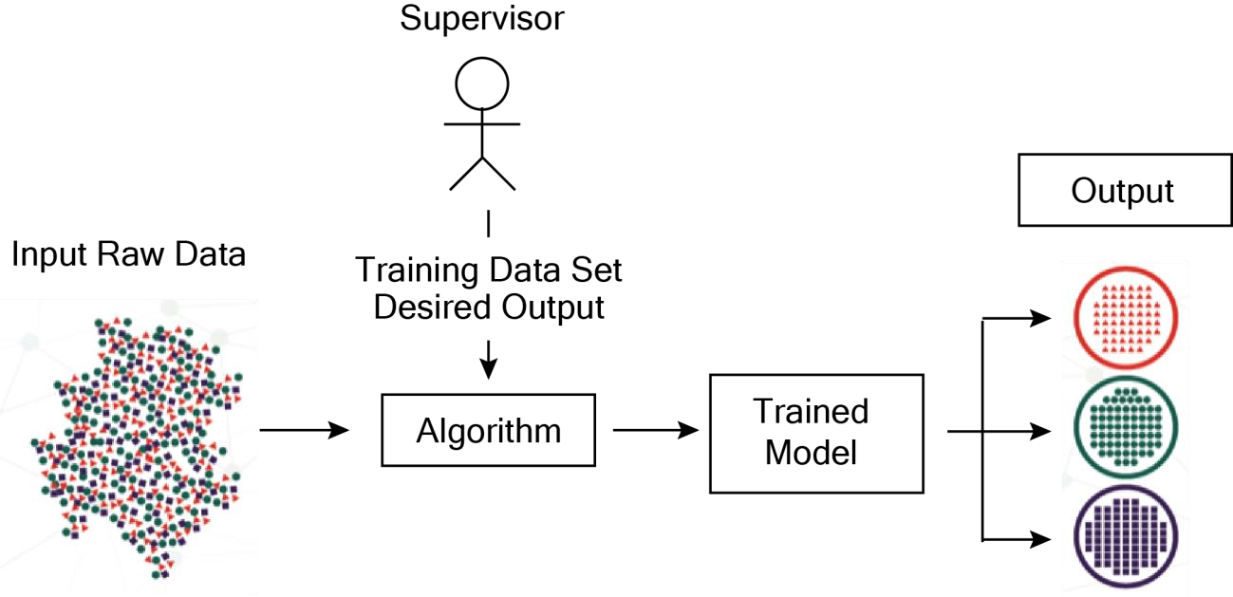
Figure 4.2 Supervised Learning
Supervised learning is a subfield of ML in which the algorithm uses labeled training data and build a general function that can map from the inputs (training data) to the desired labeled output [Mohri et al., 2018]. This function is a mathematical model which represents the relation between the inputs and the labeled output after being trained on some of the data. After the model being trained, it is tested on unseen data to evaluate its performance. For the algorithm to give accurate results, the input features must contain sufficient information for it to learn and suitable amount of training examples data [James et al., 2013]. As the dimensions (number of features) increase, the amount of data available should also increase. Because including unnecessary features may confuse the algorithm and reduce its performance, different dimensionality reductions techniques can be used to avoid what is known as curse of dimensionality.
Getting rid of unnecessary dimensions can be done by feature selection methods such as Mutual information, Chi-Square, ReliefF, and many others. Presence of very large number of dimensions makes the data sparse in a very large volume of the input space, and it would not be suitable for methods that need statistical significance to be used with such sparse data [Konstantinos and Sergios 2008]. Supervised learning depends on conditional probability distribution. Assume that X and Y are two random variables that are jointly distributed, the conditional probability distribution of Y given X means the probability distribution of Y when value of X is known.
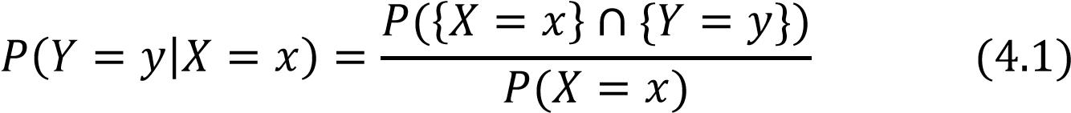
This function is for discrete random variables, the probability of occurrence of X must be positive (non-zero).
Classification algorithms and regression algorithms are among types of supervised learning. Classification algorithms are used when the output values are discrete (specified categories) or has limited set of values. If there are only two output classes, it is called binary classification problem, For example, classifying tumors to be benign or malignant, or classifying transactions to fraud or not.
In the case of presence of more than two classes for the algorithm to select from, it is called multi-classification problem. For instance, classifying various objects in pictures into different groups, classifying animals into different species, or classifying articles based on their topics. On the other hand, regression algorithms are used when the output values are continuous or in other words, they have any value in a certain range of values. For example, predicting the salaries, or estimating the prices of certain goods or services.
There are many supervised learning algorithms. For example, linear regression, logistic regression, neural networks (multilayer perceptron), DTs, naïve Bayes, linear discriminant analysis, and k-nearest neighbor. There are some qualities in certain algorithms that are not found in others. For example, neural networks can handle numerical data only while DTs work on categorical data with no need for encoding them. If categorical data has to be fed into neural networks, they should be encoded first and changed into numerical values. So, in ML or statistical learning, there is no one algorithm that can perform very well in all problems [Wolpert 1996].

4.3.1 Bias-variance tradeoff
Any model is built based on a finite and limited number of training examples no matter how big this amount of data, the future cases are always uncertain, so the model should rely on probabilistic measures and should generalize its experience after being trained on the available training set, so it can perform well on test data. The hypothesis formed by the model should not be much simpler than the function that represents the data, or the model is said to be underfitted or highly biased as it does not consider relevant features in the training set. Also, the hypothesis formed by the model should not be too complex, or the model is said to be overfitted or prone to the noise in the training set. Prediction error is the addition of bias to variance. [James 2003]. Model generalization should be balanced in order to decrease the generalization error which is the sum of bias, variance and a value called irreducible error that comes from the noise in the data. The objective is to generalize the model and to minimize both bias and variance. In other words, the model should have low bias and low variance, so it performs well on the training data and on the test data. The bias-variance decomposition is a method to measure generalization error [Sammut et al. 2011].

4.3.2 Bias and Variance Test

4.3.3 Hypothesis Space

4.4 Unsupervised Learning

4.5 Semi-supervised Learning
time which sometimes lasts for up to few days or even a week [Shi et al. 2016].

4.15 Summary

Chapter 5 Proposed Approach

5.1 Introduction

5.2.1 Data Acquisition

5.2.2 Data Cleaning

5.2.3.1 Filter Methods

Chapter 6

Experimental Results and Discussion

6.4 Dealing with Imbalanced Data
The following bar plot shows that the “Pass” class is more than 4 times greater than the “Fail” class and more than 10 times greater than the “Distinction” class!
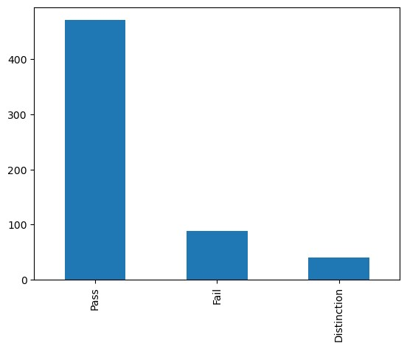
Table 6.21 Comparing Accuracies of Models on Different Data Combinations
Model | Demo. | Demo. & Scores | Demo., Scores, % VLE
RF | 79.86% | 90.78% | 94.68%
ANN | 78.80% | 85.82% | 90.43%
SVM | 74.56% | 87.94% | 86.52%
k-NN | 75.62% | 82.62% | 84.04%
LR | 66.78% | 89.01% | 87.94%
NB | 44.88% | 78.37% | 78.01%

6.6.3 Precision
Precision, also called positive predictive value, is a measure of accuracy of prediction of a specific class. For instance, it measures how much the model is accurate in predicting the “Distinction” class correctly. Precision can be calculated using equation (6.2):
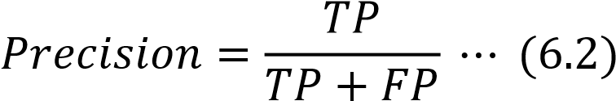
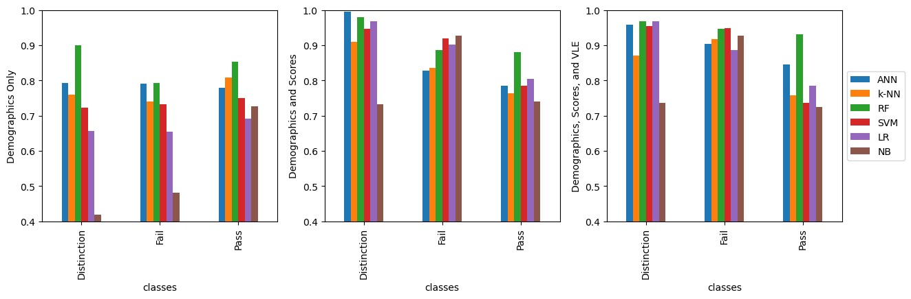
Figure 6.3 Comparing Precisions
Precision of all models on demographics in the left, on demographics and scores in the middle, and on demographics, scores, and VLE on the right. In most cases, RF and ANN has the highest precision than other ML models.

6.6.4 Recall or Sensitivity (True Positive Rate)
Recall, also called sensitivity or true positive rate, is the ratio of true positive predictions to the total number of actual members of that class. Its value ranges from

Table 6.22 Important Features Using Filter Methods
Data | Chi-Square | ANOVA | ReliefF
Demographics | age_band, studied_credits, and disability | age_band, studied_credits, and disability | age_band,  studied_credits, imd_band
Demographics and average assessment scores | studied_credits, disability, and score. | imd_band, age_band, and score | imd_band, studied_credits, and score
demographics, average scores, and VLE | disability, score, and sum_click | age_band, score, and sum_click | imd_band, score, and sum_click

6.8 Summary

Chapter 7 Conclusion and Future Work

7.1 Important Features

References

[Abiodun, Oludare Isaac, et al., 2018]
Abiodun, Oludare Isaac, Aman Jantan, Abiodun Esther Omolara, Kemi Victoria Dada, Nachaat AbdElatif Mohamed, and Humaira Arshad. “State-of-the-art in artificial neural network applications: A survey”. Heliyon 4. 2018.

[Abu Saa, Amjed, et al., 2019]
Abu Saa, Amjed, Mostafa Al-Emran, and Khaled Shaalan. “Factors Affecting Students’ Performance in Higher Education: A Systematic Review of Predictive Data Mining Techniques”. Tech Know Learn 24, 567–598., 2019.

[Adewale, Amoo M., et al., 2018]
Adewale, Amoo M., Alaba O. Bamidele, and Usman O. Lateef. “Predictive modelling and analysis of academic performance of secondary school students: Artificial Neural Network approach”. International Journal of Science and Technology Educational Research 9(1), 1-8, 2018.

[Ali S, Rasheed Mansoor, and S Perumal, 2022]
Ali S, Rasheed Mansoor, and S. Perumal. “Multi-class LDA classifier and CNN feature extraction for student performance analysis during Covid-19 pandemic”. International Journal of Nonlinear Analysis and Applications, 13(1), pp. 13291339., 2022.

[Alpaydin, Ethem, 2010]
Alpaydin, Ethem (2010). Introduction to Machine Learning. London: The MIT Press. ISBN 978-0-262-01243-0

