

Research Proposal
Using AI in Analyze and Improving Student Academic Performance
Prepared By
Name: Ahmed Almoairfi ID No.:251002473
Name: Ibrahim Alnakhli ID No.:251002688

Submitted in fulfillment of the requirements for the degree Master of Science in Artificial Intelligence
At
Collage of Informatics
Midocean University
UAE
Supervisor Name: Dr.Amjad Qatish
Collage of Informatics, Midocean University, Comoros

1.Project Overview
AI is the new evolution in this generation. It has led to improvement in all fields. It must be used to improve education and academic outcomes. Instead of just letting students use AI generative models, users should have a complete AI system that starts by creating a measurement process, monitors student performance, enhances the result, and suggests solutions.

Introduction
The rapid development of artificial intelligence (AI) technology is having a direct impact on learning, assessment, and interaction in educational institutions, bringing about profound changes in education. It is essential to rethink traditional methods of student assessment and adopt intelligent solutions that provide effective and appropriate recommendations based on data analysis.

Students' academic performance depends not only on cognitive ability but also on many factors, including motivation, learning environment, available resources, and interactions with teachers. Therefore, artificial intelligence (AI) is a powerful tool that can process massive amounts of data, identify students' weaknesses, predict learning problems, and provide intelligent solutions tailored to each individual student.

This research aims to build an integrated model that uses AI technology to analyze students' academic performance, monitor their performance, interpret their responses, and provide practical teaching recommendations, thereby accurately and effectively improving their academic performance.

Background
In recent years, the use of artificial intelligence (AI) and smart learning has increased in the field of education. Models are being developed that can predict student learning outcomes, including those that indicate academic success, and educators are proposing early intervention. However, much of this research, although detailed, has not yet been implemented in the classroom or is lacking in pedagogical and interpretive aspects, as seen in works such as Kalpana (2020) and Yağcı (2022).

On the other hand, recent studies such as Li and Botelho (2024) and Klymkowsky (2024) have discussed the importance of developing non-invasive tools to provide personalized and interpretive feedback on aspiration, but this research is still in its early stages. Some studies, such as Gonzalez-Klataide et al. (2021), identify a lack of pedagogical foundations for the use of AI tools, given the need to integrate these developments into real-world educational environments.

Considering these parameters, the present research is recognized for designing a set of learning techniques, such as artificial neural networks (ANN), support vector machines (SVM), random forests and others, together with natural language processing (NLP), which allows research on the integration between effective and practical analysis, interpretation and search applications in this field.

Research Scope
This research focuses on analyzing the academic performance of the students using predefined question and previous data using Machine Learning models. The study also aims to enhance performance through the implementation of AI-driven feedback tools over a single academic semester. The scope excludes non-academic performance and does not cover cross-institutional comparisons outside of Saudi Arabia.

Problem Definition
Students need guidance to cross over the changes, identify their weaknesses, and resolve them.

Research Questions
- How to analyze student performance using AI?
- How does artificial intelligence provide suggestions to improve student performance?

Thesis Objectives
Provide a suggested solution to enhance the weak points.

Problem Statement | Research Questions | Research Objective
Students need guidance to cross over the changes, identify their weaknesses, and resolve them. | How to analyze student performance using AI? | Create a ML model that analyzes students' performance
 | How does artificial intelligence provide suggestions to improve student performance? | Provide a suggested solution to enhance the weak points.

Related Works

Critical Analysis
Some studies like Kalpana (2020) and Yağcı (2022) excel in accuracy but lack classroom application. Li & Botelho (2024) and Ramaswami et al. (2022) emphasize explainability and personalization, but are in early development. González-Calatayud et al. (2021) critique the lack of pedagogy in current AI tools. Ouyang et al. (2023) stands out by testing AI integration in a live environment with measurable improvements.

Connections
The reviewed studies show how AI can predict student success (Kalpana, Yağcı), personalize feedback (Li, Ramaswami), and be integrated into educational practice (Ouyang). Collectively, they point toward a comprehensive AI ecosystem that informs, explains, and enhances learning.

Conflicts between the findings
While predictive models are accurate (Kalpana, Yağcı), their classroom impact is not always clear. Li & Botelho focus on explainable feedback, unlike Kalpana who emphasize only prediction. González-Calatayud critiques AI’s lack of pedagogy, a gap Ouyang’s integration model attempts to fill. These tensions reveal a need for holistic, explainable, and pedagogically grounded AI solutions.

Synthesis Matrix for Literature Review:

Study | Key Findings/Results | Methodology | Limitations | Advantages
Artificial Intelligence (AI) Towards Students’ Academic Performance,  Mallillin,2024 | AI enhance student.  learning and measures student. Attitude | Quantitative research use to Measure and detect the related  factors to enhance academic performance.  Qualitative research is used to evaluate and analyze the AI  Enhance the academic performance of  students among the respondents. | The study uses a mixed-methods approach (focus groups + survey), but lacks a control or comparison group to assess the effectiveness of AI interventions versus no intervention | Targets specific learning needs for improved outcomes.  And  Enhances motivation and attitudes toward learning.
Prediction and Analysis of University Student Performance Based on Machine Learning,  Xiaobo Zhu,  2024 | The model provide a good result for student performance R² = 0.55, RMSE = 4.68 and MAE=3.61. analysis predict the learning difficulties and curriculum enhancement. | Predictive model based on random forest that analyze student performance specifically on python course. | Limited amount of data used in the  research. Not all  indicators have  been used in this study such as classroom  interaction  frequency and  homework  completion time | Guidance for Early Warning  The study provides valuable guidance for the early identification of students who may be experiencing learning difficulties.  Curriculum Enhancement  It offers insights that can be used for the continuous improvement and enhancement of educational curricula.  Reference for Teaching Quality  The findings serve as a useful reference for improving the overall quality of teaching.  In summary, the study's advantages lie in its practical applications for identifying at-risk students, refining educational programs, and elevating teaching standards.
The end of multiple choice tests: using AI to enhance assessment,  Klymkowsky,  2024 | Dewey delivered a detailed analysis for students and define the miss understand concept by allowing student to explain why they choose this answer. Then the AI bot “Dewey analyze the student answers and identify misconceptions and missing knowledge | Develop a AI Bot | The current answer is unsure student understanding.  Training Data: Dewey’s accuracy depends on its curated knowledge base.  Adoption Barriers: Instructors must embrace formative assessment and redesign courses around feedback.  Expansion Needed: Larger trials across diverse subjects and student populations. | The use of AI to analyze student explanations provides rapid and informative feedback on their understanding, allowing instructors to identify specific misconceptions and gaps in knowledge, particularly in complex topics like genetic principles and molecular processes.  Incorporating AI-analyzed formative assessments enhances the depth of understanding by guiding instructors on how to address misunderstandings, ultimately leading to improved learning outcomes and a more accurate assessment of student comprehension compared to traditional multiple choice tests.
Data-Driven Insights: Using AI to Analyze Student Performance in English Language Courses,  Adlin Jerusha,  2024 | The study result in enhancing the performance by analyzing the the factors such as motivation and resource availability using AI.  This indicates that understanding these interconnections can lead to enhance educational strategies. | The study use SPSS for quantitative analysis to study the increase in student performance in English course as a second language.by using both descriptive and inferential statistics to analyze survey data that collected from student according to their study habits, demographics and the others factors. | The study focus on English courses student only, so the generalization in this research is limited | AI enhances personalized course development for students.  Identifies key factors influencing student success and performance.
Leveraging Artificial Intelligence for Student Performance Monitoring. International Journal of Research Publication and Reviews,  Rajeena,M., & Quraishi,  2024 | The study focus on detecting the positive effect of AI on students outcomes and how can AI provide a real time feedback.  The research found that how can AI access just handle simple management task to analyze student performance and enhance student outcome. | The study review existing researches in AI tools used in effectiveness in monitoring and evaluating student performance. Which include examining adaptive learning platforms, AI-driven tutoring systems. That will lead in detecting struggling students which will lead to enhance education outcome. | The study discuss the ethical issues and challenges related in Using AI. including privacy issues which is counted as main limitation in using AI in analyzing student performance. | Provides real-time feedback and personalized learning experiences.  Enables early intervention for struggling students.
Predicting Student Academic Performance Using Neural Networks: Analyzing the Impact of Transfer Functions, Momentum and Learning Rate,  Agarwal, M., & Agarwal,  2024 | The study get great result in prediction student performance. The prediction accuracy is 98% using artificial neural network. As a comparative analysis of various Machine Learning Algorithms the result the ANN achieve Better result than SVM, KNN, NB, DT and others ML algorithms indicate that ANN has the potential to improve student performance. | The study utilizes Artificial Neural Networks (ANN) as the primary method of analyzing student performance.  The study used SVM DT, KNN,LR,NB as comparative research to show the superiority of ANN with a 97% accuracy rate. | The dataset of students is not large which is less than 700 student. That can not lead to generalize the result.  The research omit some factors like students' social interactions, interpersonal skills and academic engagement which might indicate a gap in the understanding all variables that affect student outline | Why is it important?  This research used artificial intelligence specifically neural networks to predict student grades with very high  accuracy (98%).  - Can identify struggling students early, before failure occurs.  - Tested various configurations like learning rate and momentum to optimize performance.  - Compared many algorithms like SVM and Decision Trees, and neural networks came out on top.  - Used real data from 689 students, giving credibility to the findings.
Student Performance Analysis using Machine Learning. International Journal of Innovative Technology and Exploring Engineering,  Kalpana et al.,  2020 | Random Forest model to predict student outcomes using assessment data | Machine Learning (Random Forest) | No live classroom application; lacks qualitative evaluation | Why is it useful?  The goal is to help teachers detect students who need support early, based on their grades and classroom  behavior.  - Provides early warning system for at-risk students.  - Combines insights from psychology, education, and computer science.  - Improves communication between teacher, student, and administration.  - Includes user-friendly interface and auto-generated reports (PDFs and graphs).  - Helps institutions understand student levels and improve academic programs
Educational data mining: Prediction of students’ academic performance using machine learning algorithms,  Yağcı,  2022 | Midterm scores predict final grades with 70–75% accuracy | ML (SVM, RF, NB, KNN) | Simple features; lacks full behavioral data | What does it do?  Builds a model to predict final exam grades based on midterm scores and department/faculty data.  - Used real data from over 1800 students, ensuring robust and realistic outcomes.  - Tested multiple algorithms (Random Forest, Nave Bayes, etc.) and identified the most accurate.  - Helps detect at-risk students early through predictive insights.  - Supports smart learning environments driven by data analytics.
Bridging Human and AI Explanations to Support Students’ Revisions of Open-Ended Responses. Proceedings of the 17th International Conference on Educational Data Mining (EDM 2024), | Develops explainable feedback using LLMs; taxonomy of feedback types | LLMs + Text Analysis | Still theoretical; requires real classroom deployment | Intelligent Feedback Systems (Li & Botelho, 2024)  Development of explainable systems that provide human-like, precise feedback using large language models like GPT  Classification of feedback types according to specific educational objectives  Analysis of student-AI interactions to improve educational tools  Providing individualized feedback in large classrooms, enhancing educational equity
AI for Student Assessment - Systematic Review,  González-Calatayud et al.,  2021 | AI mostly used in formative assessment and auto-grading | Review of 22 studies | Lack of educational/pedagogical grounding | Why is it important?  This isn’t an experimental study but a review of 22 previous studies on AI-based student assessment.  - Highlights the use of AI in formative assessment and instant feedback.  - Confirms that AI tools can automate grading and save teachers time.  - Discusses differences between AI-enabled and traditional education.  - Stresses the need to train teachers on using AI pedagogically, not just technically.  - Offers useful recommendations for schools and universities aiming to adopt AI in assessment.

2. Project Goal
- Find challenges that face students in education.
- Find the existing solution for these challenges.
- How to improve these solutions.

3. Approach

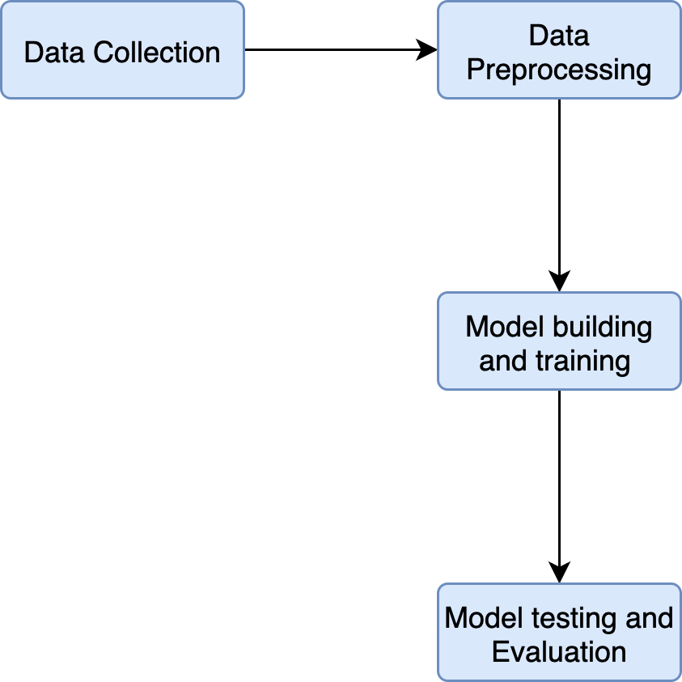
- Data Collection: The main part of the data will be collected from students at different educational levels. The remaining data resource will be from online available sources. Collecting data from our surrounding environment through parents' opinions about their children's academic performance.
- Data Processing: Grades in short quizzes and comprehensive exams.
Explaining their answers, whether correct or incorrect to evaluate the accuracy of their knowledge. Reviewing attendance and absence rates. Teachers’ evaluation of students. The percentage of homework completed and the accuracy of their responses.

- Model/Method Selection: The model will contain multiple ML models, which will result in an accurate prediction.
The following models will be used with MCQ answers: Random Forest, SVM, Nearest neighbors, Naive Bayes, and ANN. These models will analyze the student's answer and based on expert answers, the model will label the answers. The answers will be divided into groups; in each group, part of the data will be the testing set, and the remaining will be the training set.
And for the answer explanation: ANN will be used. Student MCQ answer will be analyze.
- Testing and Evaluation: Will use accuracy, recall, precision, and F1 score to ensure the accuracy of the model.
In addition, as the model will not just depend on one model, comparing the performance of the different models, as each group has a different testing set, will enhance the performance.

4. Project Steps and Timeline
Task | Date
Data Collection | Oct 11 - 25
Preparation | Oct 25 - Nov 1
Model Building | Nov 1- 22
Training | Nov 22 - 29
Testing and Evaluation | Nov 29 - Dec 6
Final Adjustments and Reporting | Dec 6 – 13

Week1: Data collection
Collect the data from multiple resources. The first resource is from the teachers' support, by examining the students and providing the results.
and from the online exam result.

Week2: Data preparation:
Prepare the data to be ready for training by integrating the data from multiple resources.

Week (3-5) Model Building:
Start building the ML models.
The models will be Random Forest, SVM, Nearest Neighbors, Naive Bayes, and ANN.
And NLP for answer explanation.

Week6 Training:
Train the data on the provided models and compare the result of reach model.

Week7 Testing and Evaluation:
Test each model using the test dataset
Finalize the best-performing models and improve them if necessary.
Use cross-validation to confirm model stability.
Analyze feature importance or confusion matrices.

5. Expected Results
- Create a ML model that analyzes students' performance.
- Provide a suggested solution to enhance the weak points.

6. Resources Needed

Python programming language, Pandas, Numby, Seaborn and matplotlib libraries for data analyzing and preprocessing, Tenserflow, Pytorch, Keros and Scikit-learn for Models creation.

7. References
- Mallillin, L. L. D. (2024). Artificial Intelligence (AI) Towards Students’ Academic Performance. Innovare Journal of Education, 16–21. https://doi.org/10.22159/ijoe.2024v12i4.51665

- Xiaobo Zhu. (2024). Prediction and Analysis of University Student Performance Based on Machine Learning. Academic Journal of Computing & Information Science, 7(8). https://doi.org/10.25236/ajcis.2024.070811

- Klymkowsky, M. W., & Cooper, M. M. (2024). The end of multiple choice tests: using AI to enhance assessment. https://doi.org/10.48550/arxiv.2406.07481

- Jerusha J, A., & Rajakumari, R. (2024). Data-Driven Insights: Using AI to Analyze Student Performance in English Language Courses. 533–539. https://doi.org/10.1109/icdici62993.2024.10810827

- Rajeena, M., & Quraishi, A. H. (2024). Leveraging Artificial Intelligence for Student Performance Monitoring. International Journal of Research Publication and Reviews, 5(5), 9642–9645. https://doi.org/10.55248/gengpi.5.0524.1364

- Agarwal, M., & Agarwal, B. B. (2024). Predicting Student Academic Performance Using Neural Networks: Analyzing the Impact of Transfer Functions, Momentum and Learning Rate. International Journal of Experimental Research and Review, 40(Spl Volume), 56–72. https://doi.org/10.52756/ijerr.2024.v40spl.005

- Kalpana, P., Arumarana, E., Hanif, S., & Deebak, T. (2020). Student Performance Analysis using Machine Learning. International Journal of Innovative Technology and Exploring Engineering (IJITEE), 9(6), 211–215. https://doi.org/10.35940/ijitee.F3585.049620

- Yağcı, M. (2022). Educational data mining: Prediction of students’ academic performance using machine learning algorithms. Smart Learning Environments, 9, Article 11. https://doi.org/10.1186/s40561-022-00192-z

- Li, Y., & Botelho, A. F. (2024). Bridging Human and AI Explanations to Support Students’ Revisions of Open-Ended Responses. Proceedings of the 17th International Conference on Educational Data Mining (EDM 2024), 100–109.

- González-Calatayud, V., Prendes-Espinosa, P., & Roig-Vila, R. (2021). Artificial Intelligence for Student Assessment: A Systematic Review. Applied Sciences, 11(12), 5467. https://doi.org/10.3390/app11125467

- Ouyang, F., Zhou, M., & Hwang, G.-J. (2022). Exploring the relationships among students’ self-efficacy, learning engagement, and academic achievement in online learning: A structural equation modeling approach. Smart Learning Environments, 9, Article 2. https://doi.org/10.1186/s40561-022-00192-z

