 | Midocean University  Faculty of Computers and Information Technology

AI-Driven Resource Optimization and Document Intelligence
BY

Eng. Amjad Homedan & Eng. Anas Alhabashi
A Thesis Submitted to
Faculty of Computers and Information Technology
Fulfillment of the Requirements for the Master Degree of Computer Science
Under the Supervision of

Prof. Dr. Yasser Abdelhamid
Associate Professor, Faculty of Computers and Information Technology (EELU)

Chapter 3 Related Work

3.1 Introduction
Resource optimization and AI question-and-answering (QA) assistants have become pivotal in improving efficiency and decision-making across various domains. Resource optimization focuses on maximizing utilization, minimizing costs, and achieving operational efficiency through techniques such as linear programming, genetic algorithms, and machine learning. Recent advancements have integrated AI to enable predictive analytics, real-time decision-making, and dynamic resource allocation. Similarly, AI QA systems, powered by natural language processing (NLP) technologies like transformer architectures and contextual embeddings, have revolutionized knowledge management and user interaction by delivering accurate, context-aware responses across applications in customer service, education, and healthcare. Combining resource optimization with AI QA assistants creates a powerful synergy, enabling organizations to efficiently manage resources by answering complex queries, monitoring performance, and suggesting optimization strategies, ultimately enhancing productivity and user satisfaction.

3.2 History
The integration of artificial intelligence (AI) into human resource management (HRM) represents a major evolution in the field, reflecting broader historical shifts in economic organization and technological advancements. Traditionally, HRM relied on manual processes for recruitment, performance management, and employee relations, but the advent of AI has introduced automation and data-driven decision-making, enhanced efficiency and reducing biases in recruitment (Jia et al., 2018; Vivek & Yawalkar, 2019). AI technologies like machine learning and data mining now enable organizations to analyze large amounts of data for strategic planning and performance evaluation, fundamentally transforming HR functions(Jia et al., 2018). This transition not only streamlines HR activities but also requires HR professionals to develop new skills to effectively interact with AI systems (Jia et al., 2018);(Sangeeta, 2019a). Similarly, the history of question answering (QA) in AI, which began with early systems like ELIZA, has evolved from simple rule-based approaches to advanced models leveraging machine learning and neural networks, such as BERT and DistilBERT (Pearce et al., 2023). These advancements, including the integration of external knowledge bases and representation learning, have improved the accuracy of responses and reflect the growing complexity of processing natural language and generating human-like answers(Goel et al., 2022). Both HRM and QA illustrate how AI's historical and technological progress is shaping the future of workforce management and natural language processing.

3.3 Predicting Document Reading and Resource Optimization Using Statistical Analysis
Resource optimization in organizations can be significantly enhanced through various statistical analysis methods, particularly in the context of human resource management. For instance, the use of process mining techniques allows for the analysis of event logs to understand resource behavior and improve allocation strategies, as demonstrated in studies that apply statistical models to optimize resource distribution based on performance metrics and constraints (Yeon et al., 2022). Additionally, the integration of data analytics in business processes supports the identification of patterns in employee performance, which can inform better decision-making regarding resource allocation (Votto et al., 2021). By leveraging accurate data, organizations can align their resources more effectively with operational needs, ultimately driving productivity and efficiency(Sangeeta, 2019a). Thus, statistical analysis serves as a critical tool in the ongoing effort to optimize resources within organizations. In addition, some authors highlighted the relationship between the workload and Performance of the workers.(Yeon et al., 2022). Figure 3.1, and
Statistical analysis plays a crucial role in the development and evaluation of question answering (QA) systems. Various QA methodologies utilize statistical measures such as exact match (EM), F1 score, in context also Author referred to the relationship between process performance and resource allocation.
(Yeon et al., 2022)
mean reciprocal rank (MRR) to assess the accuracy and effectiveness of their responses, particularly in datasets like SQuAD(Nuamah, 2021). Additionally, modern QA systems have evolved from simple rule-based approaches to more sophisticated models that incorporate statistical reasoning and machine learning techniques, allowing for improved performance in retrieving and generating answers (Nuamah, 2021). The integration of statistical methods enhances the interpretability and efficiency of QA systems, enabling them to handle complex queries across diverse modalities, including text and multimedia(Nuamah, 2021). Overall, statistical analysis is integral to refining QA systems and ensuring their reliability in providing accurate information.

Resource optimization in organizations can be significantly enhanced through various statistical analysis methods, particularly in the context of human resource management. For instance, the use of process mining techniques allows for the analysis of event logs to understand resource behavior and improve allocation strategies, as demonstrated in studies that apply statistical models to optimize resource distribution based on performance metrics and constraints (Yeon et al., 2022). Additionally, the integration of data analytics in business processes supports the identification of patterns in employee performance, which can inform better decision-making regarding resource allocation (Votto et al., 2021). By leveraging accurate data, organizations can align their resources more effectively with operational needs, ultimately driving productivity and efficiency(Sangeeta, 2019a). Thus, statistical analysis serves as a critical tool in the ongoing effort to optimize resources within organizations. In addition, some authors highlighted the relationship between the workload and Performance of the workers.(Yeon et al., 2022). Figure 3.1, and
Statistical analysis plays a crucial role in the development and evaluation of question answering (QA) systems. Various QA methodologies utilize statistical measures such as exact match (EM), F1 score, in context also Author referred to the relationship between process performance and resource allocation.
(Yeon et al., 2022)
mean reciprocal rank (MRR) to assess the accuracy and effectiveness of their responses, particularly in datasets like SQuAD(Nuamah, 2021). Additionally, modern QA systems have evolved from simple rule-based approaches to more sophisticated models that incorporate statistical reasoning and machine learning techniques, allowing for improved performance in retrieving and generating answers (Nuamah, 2021). The integration of statistical methods enhances the interpretability and efficiency of QA systems, enabling them to handle complex queries across diverse modalities, including text and multimedia(Nuamah, 2021). Overall, statistical analysis is integral to refining QA systems and ensuring their reliability in providing accurate information.

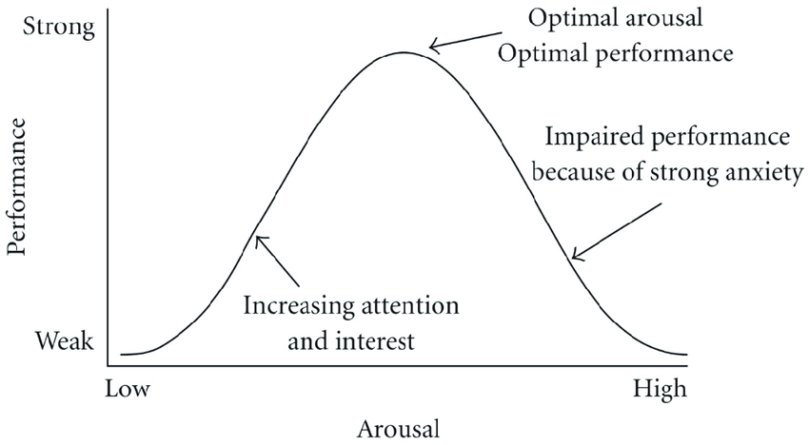
Figure 3.1 Hebbian version of the Yerkes-Dodson law

3.4 Predicting Document Reading and Resource Optimization Using TensorFlow and Kubernetes
This study presents significant contributions, including an artificial intelligence-based resource scheduling method that utilizes TensorFlow and CooperNet, tested and validated through experiments on an open controller. By establishing a resource scheduling model and optimization algorithm, the study achieves intelligent resource allocation and scheduling, evidenced by experimental results showing an improved scheduling efficiency of 10.2% and a response time reduced to 202 milliseconds—a marked improvement over traditional methods. As AI technology continues to evolve, more applications increasingly rely on AI-powered systems. For instance, in OpenEuler, TensorFlow configuration requires several key parameters, including model selection, input data from OpenStackDataFrame (which may be segmented for large datasets), and additional parameters to optimize training and testing, such as training set sizes and activation functions. Additionally, a TensorFlow model repository is maintained for efficient model management and monitoring, deployed through Kubernetes. Resource scheduling on Kubernetes is managed by implementing YARN (Yet Another Resource Negotiator) standards, where a YARN node is established with yarn.fit_layer_selection_data selected as the resource scheduler. This scheduler does not run as a traditional Kubernetes container; instead, it handles resource scheduling through Kubernetes functions. The article also delves into resource scheduler optimization formulas, primarily focusing on hardware resource management, which may also find applications in HRD systems. With OpenEuler built on OpenStack, this approach ensures seamless accessibility to required computing resources, facilitating reliable resource allocation for applications running on this platform.(Li & Zhang, 2024).

In the first experiment, as below Figure 3.2, the resource utilization rate of the rule-based resource scheduling method was 33.2%, peaking at 35.9% in the fifth experiment and recording 34.1% in the tenth experiment, with the lowest value of 30.1% observed in the third experiment. For the heuristic-based resource scheduling method, the utilization rate started at 28.2% in the first experiment, dropped to a minimum of 20.4% in the fifth, and reached 28.5% in the tenth, with the highest rate of 29.9% occurring in the eighth experiment. The resource scheduling method introduced in this study showed a utilization rate of 17.4% in the first experiment, increased to 19.4% in the fifth, reached a minimum of 10.2% in the tenth, and a maximum of 19.7% in the fourth experiment. These results indicate that the proposed resource scheduling method achieves a lower resource utilization rate, effectively minimizing system burden while maintaining smooth task execution.(Li & Zhang, 2024).
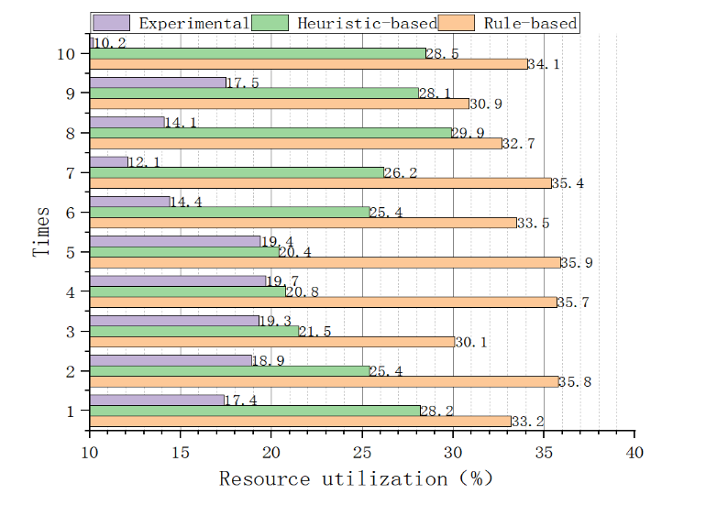
Figure 3.2 Resource Utilization Rate

3.5 Predicting Document Reading and Resource Optimization Using Machine Learning
Resource optimization in organizations can be significantly enhanced through the application of machine learning techniques, particularly in the context of human resource allocation. Various studies highlight the use of process mining and reinforcement learning to analyze operational data and improve decision-making regarding resource distribution. For instance, one approach involves mining event logs to uncover patterns that inform resource allocation strategies, thereby optimizing workflow efficiency and reducing execution time under specific constraints (Yeon et al., 2022). Additionally, the integration of human-centric networks allows for a more nuanced understanding of employee roles and their centrality within processes, which can further refine resource allocation decisions (Yeon et al., 2022). By leveraging these advanced methodologies, organizations can streamline their human resource management processes and enhance overall operational effectiveness (Votto et al., 2021; Yeon et al., 2022) .

Machine learning plays a crucial role in enhancing question and answering (QA) systems by enabling them to process natural language queries and extract relevant information effectively. For instance, a hybrid classification system, as described in one study, utilizes both machine learning and semantic rules to interpret user questions and generate structured queries for knowledge bases, thereby improving response accuracy (Goel et al., 2022). Additionally, the integration of deep learning techniques is emphasized for their ability to automate reasoning processes in QA, although they are often complemented by symbolic methods to achieve better interpretability and robustness(Nuamah, 2021). Furthermore, AI systems can automate repetitive tasks in QA, such as candidate screening in recruitment, showcasing the practical applications of machine learning in real-world scenarios(Sangeeta, 2019b). Overall, the combination of machine learning with traditional methods enhances the efficiency and effectiveness of QA systems across various domains.

3.6 Predicting Document Reading and Resource Optimization Using Deep Learning:
The integration of deep learning techniques into resource optimization is highlighted through various approaches, particularly in human resource management. One method involves using reinforcement learning to develop policies that optimize resource allocation during business process execution, as discussed in the context of human-centric networks. This approach emphasizes the importance of analyzing operational event logs to understand the relationships and centrality metrics of employees, which can inform more effective resource distribution. Additionally, the evolution of information technology and business process management systems supports the implementation of these deep learning strategies, enhancing overall organizational efficiency. Thus, leveraging deep learning in resource optimization can lead to improved decision-making and operational effectiveness in organizations.(Yeon et al., 2022).
Deep learning has significantly advanced question answering (QA) systems, leveraging models like BERT and GPT-3, which utilize powerful computing resources to enhance natural language processing capabilities(Research et al., n.d.). These models can be categorized into extractive and generative approaches, as seen with DistilBERT and T5, where the former retrieves answers directly from the context while the latter generates responses based on the input(Pearce et al., 2023b) . Additionally, hybrid systems that combine deep learning with traditional methods, such as symbolic reasoning, are proposed to improve interpretability and robustness in QA tasks(Nuamah, 2021). The integration of deep learning techniques allows for more effective handling of complex queries, making QA systems more efficient and user-friendly (#1 et al., n.d.; Goel et al., 2022).

3.8 Summary
In this chapter an AI application framework for human resource management (HRM), combining AI technology with six key HRM dimensions. By leveraging AI, the framework enhances the efficiency of HR management practices. The study analyzes case studies on recruitment and training, providing practical insights. Its ultimate goal is to guide enterprises in integrating AI into their HR processes effectively. (Jia et al., 2018). The role of artificial intelligence in human resource management, emphasizing the importance of effective workforce management. It highlights how new technologies aim to simplify HR tasks and improve efficiency. AI has the potential to enhance HR functions and support decision-making processes. Additionally, the paper addresses the challenges associated with implementing AI in HR practices. (Sangeeta, 2019a).
The paper explores the impact of AI on human resource management (HRM), focusing on how AI-assisted decision-making is transforming HR functions. It highlights the shift of HR departments into strategic decision-making centers within organizations. Additionally, the paper addresses the financial and legal implications of AI adoption, emphasizing the need for reskilling HR staff to effectively navigate these changes. (Sakka & El Hadi El Maknouzi, n.d.).
In this chapter, we have explores algorithmic reasoning in question answering (QA) and advocates for a hybrid AI approach that combines symbolic and sub-symbolic methods. It argues that neural networks alone are insufficient for effective algorithmic reasoning. The proposed method, known as Deep Algorithmic Question Answering (DAQA), focuses on enhancing interpretability, generalizability, and robustness in AI systems. (Nuamah, 2021). developing an intelligent learning system designed for processing text input and extracting knowledge to answer user questions. This system aims to advance research in the field of Question Answering (QA) and has practical applications in areas such as online assessments and lectures.(#1 et al., n.d.).
In deep learning in question-answering systems, with a particular focus on applications in hepatocellular carcinoma research. It discusses how advances in natural language processing (NLP) are enhancing human-computer language interaction. The study also analyzes practical AI-driven question-answering systems and highlights future prospects for NLP based on large-scale models.(Research et al., n.d.).

References
- The Role of AI in Human Resource Management Practices.(Rastogi & Pandya, 2023b)
- Influence of Artificial Intelligence in Human Resource Management: A Comprehensive Review(Nikita Saklani & Ashli Khurana, 2023).
- Artificial Intelligence in Tactical Human Resource Management: A Systematic Literature Review.(Votto et al., 2021a).
- Deep Algorithmic Question Answering: Towards a Compositionally Hybrid AI for Algorithmic Reasoning. (Nuamah, 2021a)
- Explanation as Question Answering based on a Task Model of the Agent’s Design. (Goel et al., 2022a)
- SPIE Proceedings Publications Deep Learning Approaches for Improving Question Answering Systems in.(Research et al., n.d.-a)
- Implementing AI-Driven Resource Scheduling on OpenEuler using TensorFlow and Kubernetes(Li & Zhang, 2024)
- AI and Business Planning: Revolutionizing Forecasting and Resource Allocation (Subrahmanyam et al., 2024a)
- AI and Business Planning: Revolutionizing Forecasting and Resource Allocation(Subrahmanyam et al., 2024b).
- Intelligent Question Answering System Based on Knowledge Graph(Feng et al., n.d.).
- Build-a-Bot: Teaching Conversational AI Using a Transformer-Based Intent Recognition and Question Answering Architecture(Pearce et al., 2023).
- Explanation as Question Answering based on a Task Model of the Agent's Design(Goel et al., 2022b).
- Review of artificial intelligence-based question-answering systems in healthcare(Budler et al., 2023).
- SPIE Proceedings Publications Deep Learning Approaches for Improving Question Answering Systems in(Research et al., n.d.-b).
- Question Answering System Based on Artificial Intelligence for Restricted Domain(#1 et al., n.d.).
- Association for Information Systems AIS Electronic Library (AISeL) A Conceptual Artificial Intelligence Application Framework in Human Resource Management Recommended Citation "A Conceptual Artificial Intelligence Application Framework in Human Resource Management"(Jia et al., 2018).
- Experimental Verification on Human-Centric Network-Based Resource Allocation Approaches for Process-Aware Information Systems.
(Yeon et al., 2022).

- Increased Productivity and Reduced Waste with Robotic Process Automation and Generative AI-powered IoE Services(Lo et al., 2024).
- A Study of Artificial Intelligence and its role in Human Resource Management(Vivek & Yawalkar, 2019).
- Human Resource Management and Artificial Intelligence(Sangeeta, 2019).

