
MIDOCEAN UNIVERSITY
MASTER OF BUSINESS ADMINISTRATION
Final_Project_MGM697_S3

Supply Chain Optimization at Amazon

PREPARED BY
Feras Afandy

SUPERVISED BY
Dr. Asma Abuanzeh
Dr. Ahmed Ahmed
Dr. Alaa Ahmed
Dr. Sara Faried
Dr. Serein Zoureik

ACADEMIC YEAR
202

CHAPTER ONE

CHAPTER ONE

INTRODUCTION:
Today’s developing global markets and the technological advancement on the crafting of supply chains has rated the paradigms. This paper aims to identify the current trends in the companies’ supply chain management strategies and its impact on competitive advantages, costs, and customer satisfaction. Holding the position of one of the most successful companies in the field of e-commerce, Amazon supplies the example of a supply chain management success that can be compared with the best supply chains around the world. (Meredith, 2023)
Amazon’s supply chain is extensive and perhaps one of the most complex commonly covering hundreds of thousands of suppliers, warehouses, and distribution centers across the globe. (Potiker, 2024) Product delivery has been a key strength area in the case of the company where its capacity to deliver its products to the customers quickly has been outstanding. However, it has to be duly noted that the dynamic environment of a global supply chain context tends to have always new challenges as well as new areas of improvement. These aspects are crucial and this thesis attempts to understand and analyses the effectiveness and efficiencies of the flow of activities constituting the supply chain of Amazon and the sort of changes that can be made to enhance the overall performance.
The reason for undertaking this study lies in the growing relevance of supply chain intervention in the realization of business objectives. Since corporates such as Amazon are continually expanding their services to ensure that they meet the customers’ needs, control costs, and deal with disruptions around the world, there is the need to know more about supply chain dynamics. In this sense, this research seeks to contribute to the existing knowledge by providing a possible view on the further improvement of the optimization strategies used by Amazon and the areas where future improvement can be made. Objectives of the Research
Thus, the main aim of the following research is to analyze the effectiveness and performance of the supply chain of Amazon. In this way, the study is longitudinal, which enables the authors to determine the strengths and weaknesses of the existing system and come up with improvements. Specific objectives include:
Evaluate Current Supply Chain Performance: Conduct a variance analysis of key supply chain measurements to evaluate the productivity of Amazon’s supply chain management.
Identify Bottlenecks and Inefficiencies: Identify which segments of the supply chain are likely to negatively influence the performance.
Explore Integration Opportunities: Search for opportunities to integrate into the supply chain to improve the management and the flow of goods in the relevant chain.
Optimize Logistics Operations: Suggest measures to optimize the flow of goods and their delivery, minimize expenses and time spent.
Promote Sustainability Initiatives: Assess where sustainability practice can be introduced in Amazon supply chain in order to minimize the company’s negative impact in the environment as well as advancing its corporate sustainability responsibility.

STUDY PROBLEM:
A vital component of Amazon India's operations, supply chain optimization affects everything from customer satisfaction to inventory management. Significant obstacles are presented by the intricacy of the Indian market, which is marked by a range of consumer preferences, regional variances, and infrastructure difficulties. Amazon has to handle these complexities while upholding its dedication to quick delivery and affordable prices. Amazon must maintain an effective supply chain in order to maintain its market dominance as e-commerce expands quickly in India. In addition to cutting expenses, optimization is required to improve service quality, which has a direct impact on consumer loyalty and brand reputation.
Because of its enormous geographic size and diverse regional demands, the Indian market poses particular supply chain optimization challenges. A customized approach to inventory distribution is required because different Indian states have different economic conditions, cultural preferences, and purchasing habits. Furthermore, forecasting and inventory management are made more difficult by the varying demand patterns that are impacted by local events, festivals, and seasons. Stockouts and overstock scenarios can result from this variability, which is bad for customer satisfaction and operational effectiveness. Amazon must thus comprehend these dynamics in order to effectively manage its supply chain and satisfy a wide range of customer demands.
In India, supply chain efficiency is frequently hampered by the infrastructure. Rural areas usually lack sufficient transportation and storage facilities, whereas urban areas may have sophisticated logistics networks. This discrepancy raises the lead times and expenses of shipping goods to places that are harder to reach. Furthermore, problems like poor road conditions, heavy traffic, and erratic weather patterns can interfere with logistics processes and affect delivery schedules. In order to overcome these obstacles, Amazon needs to make investments in cutting-edge logistics strategies and alliances that can improve last-mile delivery capabilities and guarantee that even customers who live far away receive their orders on time.
Amazon India's supply chain must be optimized by utilizing technology. Machine learning, artificial intelligence, and advanced data analytics can improve distribution plans, inventory control, and demand forecasting. Amazon can more precisely forecast customer behavior and modify its inventory by examining past sales data and market trends. Automation in warehouses can also speed up turnaround times, cut down on errors, and streamline operations. However, putting these technologies into practice calls for a large financial outlay as well as a workforce with the necessary skills to adjust to new systems. Maintaining operational efficiency while reducing disruptions requires striking a balance between human oversight and technology integration.
The competitive environment in India's e-commerce industry makes supply chain optimization even more difficult. Amazon is under pressure to keep improving its service offers while keeping costs under control because there are many competitors fighting for market share. Aggressive pricing tactics are frequently used by rivals, which can cause margin erosion and a race to the bottom. Amazon needs to innovate in areas like delivery speed, customer service, and returns management in addition to streamlining its supply chain to stay ahead of the competition. This calls for a calculated strategy that strikes a balance between cost effectiveness and the requirement to offer customers better value, guaranteeing that Amazon will continue to be a popular option in a crowded market.

IMPORTANCE OF THE STUDY:
Amazon's strong and incredibly effective supply chain management system is largely responsible for its success in the global market. Amazon, one of the biggest online retailers in the world, manages a huge amount of inventory and transactions. Amazon's supply chain optimization is essential because it allows the company to maintain low operating costs, guarantee consistent product availability, and quickly meet customer demand. With millions of customers worldwide, Amazon's competitive edge depends on its ability to streamline every stage of the supply chain, from fulfillment and delivery to inventory management and procurement. In addition to being essential for maintaining profitability and operational effectiveness, this optimization is also critical for customer satisfaction.
At Amazon, the significance of supply chain optimization goes beyond logistics and affects practically every facet of the company, from financial performance to customer experience. Fast and effective product delivery is a key differentiator in the fiercely competitive e-commerce industry. Amazon is able to anticipate demand trends and allocate resources appropriately thanks to its optimization strategies, which include sophisticated forecasting algorithms and real-time tracking systems. Amazon makes sure that customers receive their orders quickly, frequently within hours or days, by cutting down on delays, minimizing excess inventory, and optimizing product delivery routes. This increases customer satisfaction. Additionally, efficient supply chains assist Amazon in cutting expenses, especially those associated with labor, storage, and shipping, all of which have a direct effect on the company's profitability.

OBJECTIVES OF THE STUDY:
Finding the tactics and tools that have allowed Amazon to attain high levels of efficiency is the main goal of research on supply chain optimization at the company. Researchers and companies can gain a better understanding of how automation, artificial intelligence (AI), and data-driven decision-making lead to optimized operations by looking at Amazon's supply chain procedures. The purpose of the study is to identify the strategies Amazon employs to deal with issues like supply chain interruptions, demand volatility, and inventory imbalances. It also aims to investigate how Amazon uses warehouses, fulfillment centers, and distribution hubs, looking at how their placement, automation, and integration with cutting-edge technologies help to cut costs and lead times. Evaluating the effects of Amazon's supply chain innovations is another crucial goal.
Examining the innovative technologies that have transformed Amazon's operations and logistics is a major goal of researching supply chain optimization. Amazon's use of big data analytics, robotics, AI, and machine learning is essential to increasing productivity and cutting expenses. Robots can perform tasks like product picking, sorting, and packing in fulfillment centers thanks to automation, which expedites the process and lowers human error. Amazon's inventory management is improved by using AI and machine learning algorithms to better forecast demand and make sure the right products are stocked in the right quantities at the right times.
Analyzing Amazon's supply chain optimization's effects on resilience and sustainability is another important goal. Amazon has taken a number of steps to lessen its carbon footprint as pressure mounts on global supply chains to become more ecologically friendly. To cut emissions, the company is making significant investments in renewable energy sources, electric delivery trucks, and route optimization. Additionally, Amazon's use of cutting-edge supply chain optimization strategies strengthens its operations' resilience, especially when faced with natural disasters or global disruptions like the COVID-19 pandemic. Amazon can reduce risks and guarantee a steady flow of goods by utilizing predictive analytics to modify its supply chain strategies in real time.

RESREACH QUESTIONS:
To achieve the research objectives, the study will address the following questions: The KPIs employed in the evaluation of efficiency of Amazon’s supply chain include:
• To what extent do studies reveal Amazon’s supply chain performance issues and what are the
crucial root causes?
• In what a manner the integration of the supply chain can raise the efficiency of the Amazons
business processes?
• Based on the analysis of the case, the following recommendations could be made regarding
logistics optimization:
• What strategies can be employed when incorporating sustainability into Amazons supply
chain?

RESEARCH HYPOTHESES:
A strong technological foundation that unifies multiple data sources and facilitates quick decision-making is at the core of Amazon's supply chain optimization initiatives. Amazon collects real-time data on consumer behavior, product demand, inventory levels, and transportation conditions thanks to its extensive data collection capabilities. Predictive analytics and machine learning algorithms are used to process and analyze this data in order to improve supply chain efficiency overall, optimize stock levels, and make precise demand forecasts. Using past data, trends, and even outside variables like seasonal changes or economic indicators, predictive analytics is essential for predicting future consumer demand.
The layout of Amazon's extensive network of fulfillment centers, warehouses, and distribution hubs has a significant impact on supply chain optimization. These facilities are positioned thoughtfully throughout the globe to guarantee rapid access to important markets, enabling Amazon to offer its renownedly quick shipping times. The different kinds of centers that make up Amazon's fulfillment network are each designed to meet particular requirements. While sortation centers concentrate on classifying packages by region to expedite the delivery process, fulfillment centers manage the majority of picking, packing, and shipping. Before goods are shipped to consumers, delivery stations serve as the last stop where packages are loaded onto delivery trucks for the "last mile." Amazon prioritizes adaptability and scalability in the design of its supply chain networks.
One of the most important and difficult parts of the entire logistics network is the last mile of Amazon's supply chain, which is the final delivery of goods to customers. A large amount of shipping costs are incurred during last-mile delivery, and any inefficiencies in this phase may result in delays and higher operating costs. A diverse delivery network and technological innovation are at the core of Amazon's last-mile optimization strategy. Amazon has been using its own delivery infrastructure more and more, but last-mile delivery has historically depended on outside carriers like UPS, FedEx, and the USPS.

SCIENTIFC THEORY FOR RESEARCH PREPARATION:
A variety of scientific theories and methodologies from domains such as operations research, logistics, and data science form the foundation of Amazon's supply chain optimization strategy. Advanced machine learning techniques, predictive analytics, and algorithms are used to optimize the company's supply chain. The idea of inventory optimization, based on the Economic Order Quantity (EOQ) model, is one of the most well-known scientific theories that support Amazon's supply chain operations. By weighing the costs of ordering and inventory holding, EOQ assists Amazon in determining the most economical number of items to order. By combining sales data, customer demand forecasts, and real-time data from its extensive network of warehouses, the company improves EOQ and allows Amazon to predict demand with a high degree of accuracy.
The Traveling Salesman Problem (TSP), a key idea in combinatorial optimization, is another important scientific theory that Amazon applies to its supply chain optimization. Finding the shortest path that stops at a number of locations and returns to the starting point is the focus of the TSP. This theory is used by Amazon to optimize delivery routes for its enormous fleet of drones and trucks. Amazon uses sophisticated algorithms to optimize the route packages take from warehouses to customers, taking into account variables like route congestion, delivery windows, and traffic. To increase delivery efficiency iteratively, Amazon uses simulated annealing and genetic algorithms in addition to TSP.
Amazon's strong use of artificial intelligence (AI) and machine learning for decision-making constitutes the last element of its scientific approach to supply chain optimization. The business uses real-time data analytics and predictive models to promote ongoing supply chain improvement in all areas. Reinforcement learning, for instance, is used by Amazon to optimize dynamic pricing strategies and modify supply chain operations in response to shifting market conditions. Additionally, Amazon's AI systems are able to anticipate possible disruptions and adjust appropriately, including weather-related delays, transportation issues, and shifts in customer behavior. Amazon also uses multi-objective optimization techniques, which strike a balance between conflicting objectives like cost, speed, and customer satisfaction. This guarantees that the business can continue to offer its clients prompt, dependable service while optimizing operational efficiency. Additionally, by incorporating AI and deep learning into Amazon's supply chain, proactive decision-making is made possible by the ability to spot patterns and trends that humans might overlook. This is how cutting-edge technologies and scientific theories combine to produce a highly responsive, scalable, and economical supply chain that can satisfy the constantly rising demands of international e-commerce.

CHAPTER TWO
PREVIOUS STUDIES

CHAPTER TWO – PREVIOUS STUDIES

REVIEW OF PREVIOUS STUDIES:
The company's strategy for last-mile delivery has also been thoroughly examined in earlier research on Amazon's supply chain optimization. This is the last stage of delivery, in which items are delivered to the customer's door from a nearby fulfillment center. Since the speed and dependability of the delivery process have a direct impact on customer satisfaction, the significance of last-mile delivery cannot be emphasized. Researchers have looked at how Amazon has increased efficiency and decreased reliance on traditional delivery carriers through its investments in its own delivery network, which includes its own fleet of delivery vans and trucks, as well as partnerships with independent contractors through the Amazon Flex program. One noteworthy research topic has been Amazon's speedy product delivery, with Prime. Amazon's speedy product delivery—Prime members frequently receive same-day or next-day delivery—has been a noteworthy research topic. Numerous studies have examined how Amazon strategically positions its warehouses and distribution centers to cut down on shipping expenses, speed up delivery, and improve the flow of goods to customers. By investing in AI and machine learning algorithms, the company has been able to optimize delivery routes for drivers, making sure that they choose the most efficient routes based on weather, delivery priorities, and real-time traffic data. Furthermore, prior studies have examined how Amazon is experimenting with and deploying drone delivery technology in an effort to lower the expenses and wait times related to conventional delivery techniques. According to research, drones will eventually be very important. (Fig. 1, Page 21).

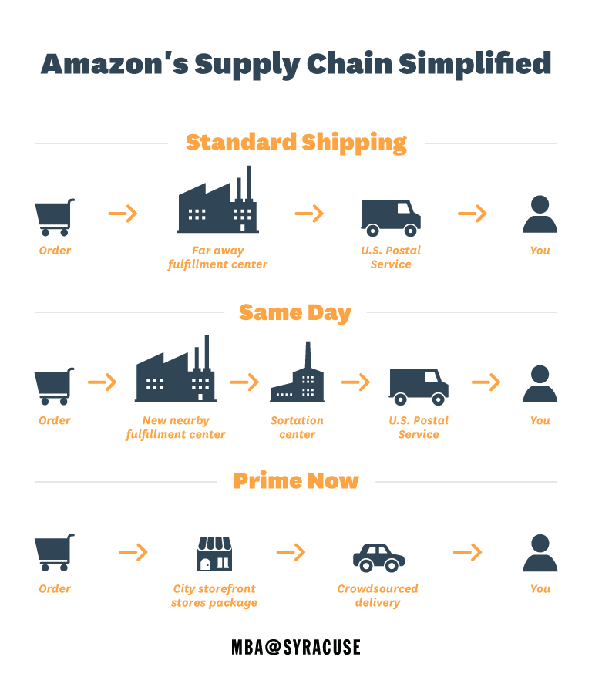

Figure.1 Amazon, Supply Chain Innovations Deliver Results | Syracuse University‏

THEORITICAL FRAMEWORK:
In this section, a study has been published by the researcher " Yanfang Qin”. Below is a Summary of the scientific paper.
ABSTRACT
In recent years, the e-commerce market has grown significantly, and the online retail market has become very competitive. Online retailers strive to improve their supply chain operations to reduce costs and to improve customer satisfaction. Value stream mapping (VSM), a tool created by the lean production movement to identify and reduce errors, losses, and lead time and to improve value-added activities, has been proven to be effective in many manufacturing processes. In this study, we investigate the application of value stream mapping (VSM) in the supply chain of an e-commerce retailer on Amazon. By visualizing the entire supply chain with VSM, the waste that is produced during the delivery process from the retailer to the customer was identified. The five whys method was then applied to find the root cause of the waste. Furthermore, a scoring method was developed to evaluate and compare two different supply chain logistic models to identify a strategy for improvement. This study provides a systematic methodology to understand, evaluate, and improve the entire e-commerce supply chain process utilizing VSM. It was demonstrated that the methodology could improve supply chain management efficiency, customer satisfaction, and cost reduction. (Fig. 2, Page 23).

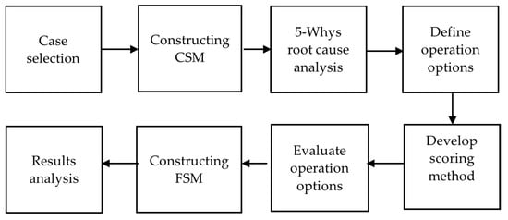

Figure.2 The methodology flow chart of the analysis processes.‏

