

Industrial Fire and Accident Risk Prediction Using Explainable Machine Learning

Prepared By
Name: Abdullah Hadi Alfaifi ID No.: 261002804

Submitted in fulfillment of the requirements for the degree Master of Science in Artificial Intelligence
At
College of Informatics
Midocean University
UAE
Supervisor Name: Dr. Mohamed Eassa
College of Informatics, Midocean University, Comoros
Email: abd.alfifi95@gmail.com

Chapter 1: Introduction

1.1 Overview
Recent advances in Industry 4.0 have transformed the way industrial systems are operated and managed. Modern manufacturing environments increasingly rely on interconnected devices and Industrial Internet of Things (IIoT) technologies to support production processes and enhance operational performance [2]. The availability of real-time data from various sensors has enabled organizations to monitor industrial processes more effectively and make informed decisions regarding safety and efficiency [2].
Maintaining safety in industrial environments remains a major challenge, particularly in facilities where hazardous conditions may lead to fires or workplace accidents. Such incidents can result in injuries, equipment damage, production downtime, and significant financial losses [4]. Therefore, improving safety and reducing operational risks have become important priorities for many industries.
Figure 1.1 illustrates the overall architecture of an Industrial IoT-based intelligent safety framework and highlights the flow of sensor data from industrial environments to intelligent decision support systems.
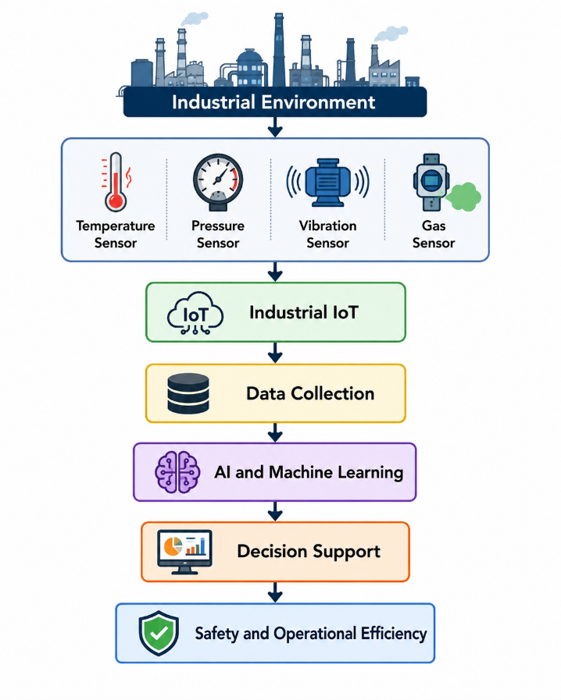
Figure 1.1: Overview of Industrial IoT-Based Intelligent Safety Framework
Conventional safety practices mainly rely on inspections and predefined rules to respond to incidents after they occur. Although these approaches have contributed to improving safety standards, they are often limited in their ability to identify potential hazards at an early stage [3]. Meanwhile, the increasing amount of sensor-generated data has created opportunities for more advanced approaches that support proactive risk management.
In recent years, Artificial Intelligence (AI) and Machine Learning (ML) have attracted considerable attention in industrial applications. These techniques can analyze large volumes of data and identify patterns that may not be easily recognized using traditional methods [3]. Consequently, predictive models are increasingly being utilized to support the early detection of abnormal conditions and reduce the likelihood of accidents [4].
In addition to risk prediction, the growing adoption of predictive analytics has enabled industries to implement early warning systems capable of identifying abnormal conditions before they develop into serious incidents. These systems provide timely insights that support preventive actions, reduce unplanned downtime, and improve overall operational resilience [5]. As a result, predictive analytics has become an essential component of modern safety management strategies and smart manufacturing environments [5].
The widespread adoption of IIoT technologies has further strengthened these capabilities by enabling continuous monitoring of variables such as temperature, pressure, humidity, vibration, and gas concentration [2]. Information collected from these sensors provides valuable insights into the operating condition of industrial systems and supports the transition from reactive safety practices to predictive risk management [5].
Despite the effectiveness of machine learning models, their lack of interpretability remains a concern, especially in safety-critical applications where understanding the reasons behind predictions is essential [1]. Therefore, Explainable Artificial Intelligence (XAI) has emerged as an important research area aimed at improving the transparency and trustworthiness of intelligent systems [1].
The integration of IIoT technologies, machine learning, and explainable AI offers new opportunities for developing intelligent safety systems capable of predicting industrial fire and accident risks. Such systems can improve situational awareness and support more effective risk mitigation strategies in modern manufacturing environments [5]. Accordingly, the integration of Explainable Machine Learning and Industrial IoT technologies represents a promising approach for enhancing industrial safety and enabling proactive risk management in smart manufacturing environments..

1.2 Problem Definition
Despite the continuous development of Industry 4.0 technologies and the increasing use of Industrial Internet of Things (IIoT) systems, industrial fires and workplace accidents remain a serious concern in many industrial sectors. These incidents can affect workers' safety, damage equipment, interrupt production processes, and lead to considerable financial losses [4].
In many industrial facilities, safety management still depends on routine inspections and predefined procedures. Although these practices have helped improve safety over the years, they mainly focus on responding to incidents rather than preventing them. As a result, hazardous conditions may not be recognized until an accident has already occurred [3].
With the growing availability of sensor data, machine learning techniques have become increasingly popular for industrial applications. Previous studies have shown promising results in areas such as fire detection, anomaly detection, and accident analysis [5]. However, most existing approaches address these problems separately and often emphasize prediction accuracy without providing sufficient explanation for the model outputs [1].
In safety-critical environments, accurate predictions alone may not be enough. Engineers and decision-makers also need to understand why a certain condition is considered risky in order to make appropriate decisions. This creates a need for more transparent and reliable approaches that combine predictive capabilities with model interpretability [1].
Therefore, there is still a need for a framework that can utilize Industrial IoT sensor data to predict both industrial fire and accident risks while providing explainable results that support proactive safety management and improve decision-making in modern industrial environments.

1.3 Thesis Objectives
- Examine the role of Industrial Internet of Things (IIoT) technologies and sensor data in supporting industrial safety applications.
- Develop machine learning models for predicting potential fire and accident risks based on operational and environmental parameters.
- Evaluate and compare the performance of different machine learning algorithms in terms of prediction accuracy and reliability.
- Explore the use of Explainable Artificial Intelligence (XAI) techniques to provide transparent and interpretable predictions.
- Investigate how explainable machine learning can support early warning capabilities and proactive risk management in industrial environments.

1.4 Thesis Contribution
- A machine learning-based approach for predicting industrial fire and accident risks using sensor data collected from industrial environments.
- A comparative evaluation of different machine learning algorithms for industrial risk prediction.
- An investigation into the use of Explainable Artificial Intelligence (XAI) techniques to improve the interpretability of prediction results.
- An assessment of the potential of combining Industrial Internet of Things (IIoT) technologies with explainable machine learning to support proactive safety management.
- Practical insights that may assist safety engineers and decision-makers in enhancing early warning.

1.5 Thesis Organization
The rest of this thesis is organized as follows.
Chapter 2 discusses the theoretical background and relevant research areas.
Chapter 3 presents the proposed methodology.
Chapter 4 analyzes the experimental results.
Chapter 5 concludes the study and suggests directions for future work.

Reference:
[1] Explainable AI in Manufacturing and Industrial Cyber–Physical Systems: A Survey (2024) https://www.mdpi.com/2079-9292/13/17/3497
[2] Integrating IoT Technology in Fire Safety Management (2025) https://www.researchgate.net/publication/394757433_Integrating_IoT_Technology_in_Fire_Safety_Management_Addressing_Readiness_Acceptance_and_Implementation_Challenges
[3] Application of Machine Learning to Construction Injury Prediction https://www.sciencedirect.com/science/article/abs/pii/S0926580516300966
[4] Predicting Human and Environmental Risk Factors of Accidents in the Energy Sector Using Machine Learning (2026) https://www.mdpi.com/2076-3417/16/3/1203
[5] Hybrid Machine Learning-Based Fault-Tolerant Sensor Data Fusion and Anomaly Detection for Fire Risk Mitigation in IIoT Environment (2025) https://www.mdpi.com/1424-8220/25/7/2146

