النَّشـــاطــات البــرمجيَّــة الأسبــوعيَّـــة - 5
الاسم: | زينـــب جعفـــر العبــدالعــال | الشهر: | أغسطــــس | السنة: | 2023
التَّـــاريــخ: 05/08/2023
python CODE – SNIPPET – USING (FOR …….. ELSE STATEMENT)
Write a Python program to check if a given positive integer is a prime number or not. A prime number is a natural number greater than 1 that has no positive divisors other than 1 and itself.
# Program to check if a number is prime or not
print("PRIME NUMBER CHECKER\n-------------------------------")
# To take the input from the user
num = int(input("Enter a positive integer: "))

if num == 1:
print(num, "is not a prime number")
elif num > 1:
# check for factors
for z in range(2,num):
if (num % z) == 0:
print(num,"is not a prime number")
print(z,"times",num//z,"is",num)
break
else:
print(num,"is a prime number")
# if the input number is less than
# or equal to 1, it is not prime
else:
print(num,"is not a prime number")

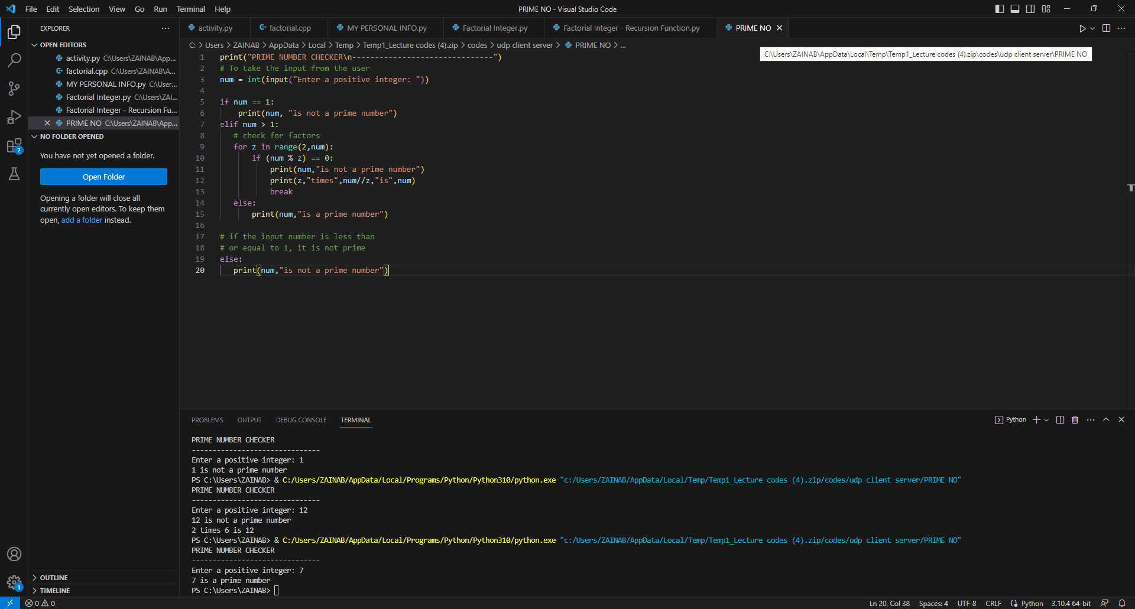

PYTHON CODE - SNIPPET – USING (FLAG VARIABLE)
Write a Python program to check if a given positive integer is a prime number or not. A prime number is a natural number greater than 1 that has no positive divisors other than 1 and itself.
# Program to check if a number is prime or not
print("PRIME NUMBER CHECKER\n-------------------------------")

# To take the input from the user
num = int(input("Enter a Positive Number: "))

# To define a flag variable
flag = False

if num == 1:
print(num, "is not a prime number")
elif num > 1:
# check for factors
for i in range(2, num):
if (num % i) == 0:
# if factor is found, set flag to True
flag = True
# break out of loop
break
# check if flag is True
if flag:
print(num, "is not a prime number")
else:
print(num, "is a prime number")

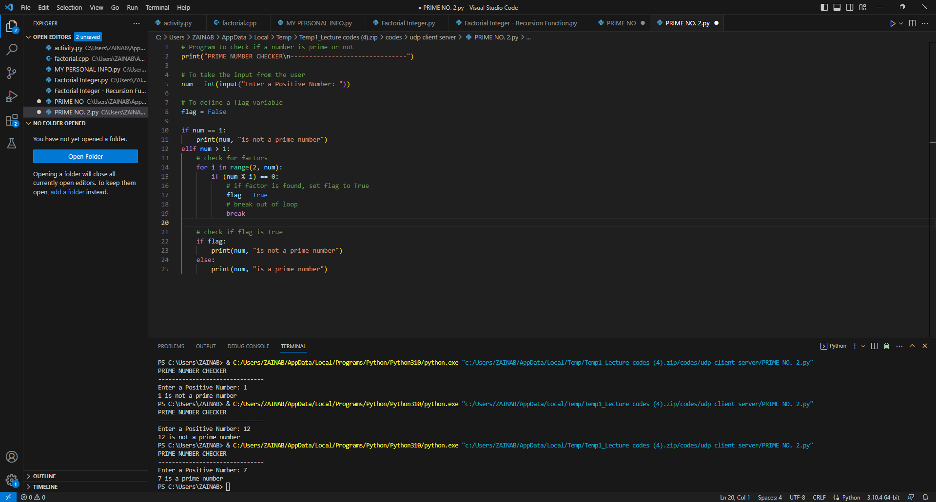

UNI ID
213000602
ZAINAB JAFFER I. AL ABDULAL

