
MIDOCEAN UNIVERSITY
College of Media & Marketing
Master of Digital Marketing

A Thesis Submitted in Partial Fulfilment of the Requirements for the Degree of Master of Digital Marketing
The Role of Social Media in Building Footballers’ Brand Identity and Boosting Their Profiles As Brands Ambassadors: “Jude Bellingham” Case Study

Submitted by:
Sarah Zouhair Chaher

Supervised by
Dr. Mohamed Ewies
2024-2025
Dedication
To the absence filling my life with his ever presence, though our time together was too short for you to see how hard I strive to fulfil the dreams you had for me, I promise to remain forever dedicated to them.
To My Dear Father, In Memory

Your words are the guide, your prayers are the lights that lead through, and no lexicon ever serves to explain you. More than this world, and more than my words.
Dear Mother

Partners, friends, and siblings: Your support is beyond expression, and your unwavering guidance always makes things easier for me, including this research. Every achievement in my life cannot be defined without your encouragement, which lights the path to success for me. Thank you for everything.
My sister, Al Khansa’a; My brothers, Majed, Basem, and Mahmoud

To the most beautiful thing that makes this life worth living, this is the first dedication to you, and hopefully it will not be the last. You embroidered this world with meaning and love, and breathed a new life into our family. Thank you for giving me a reason to continue every time.
My nephew, Abdulrahman; My niece, Atheel; My sister-in-law, Hadeel
Acknowledgement
Prof. Mohamed Ewies
Heartfelt gratitude for your patience throughout the semester, the time you dedicated to reading and commenting on the research, and your invaluable insights. Grateful indeed.

Midocean Professors
I am truly grateful to each of you for making this journey so enriching and rewarding. Every lecture offered valuable insights and presented novel, significant information in the marketing field. The enjoyable discussions we shared will continue to guide my approach to developing creative contributions in marketing.

Abstract
The study aims to investigate the relationship between curating an ideal brand identity for footballers on social media platforms, and how this invites brands to seek endorsement contracts with them. It discusses the major pillars footballers and their marketing teams should base the strategy of their identity creation on and sheds light on what brands should be looking for on athletes’ profiles. It focuses on the case study of the English football player Jude Bellingham and tracks the strategy of his identity establishment and how it secured him endorsements with mega global brands.
The study was conducted through semi-structured interviews with marketing and media specialists in Adidas headquarters in Dubai. Moreover, the research adapted the thematic analysis approach, deriving insights from the participants’ responses and comparing them to develop the study findings.
The study findings revealed a significant relationship between athletes’ strong digital brand identity and brands’ pursuit to sign partnerships with them. This correlation is evident in the interviewees’ experiences with the brand’s endorsed campaigns, and in the sustained collaborations the player Jude Bellingham consistently attracts.
The study recommends that footballers pay careful attention to the curation of their brand identity on social media, embedding their strategies with the human element of sharing professional and personal content to resonate more emotionally with their audience. On the other hand, the research emphasises the significance of brands’ collaborating with footballers, who personify the brand and ascribe their characteristics to it, exerting a powerful influence on the audience and shaping their perception of the brand.
Keywords: Brand identity, footballer, athlete, endorsement, collaboration, social media, brand, schema theory, brand identity theory, Jude Bellingham.

Content Table
Introduction ……………………………………………………………………………………………………………1
Literature Review …………………………………………………………………………………………………… 4
Literature Review Analysis ……………………………………………………………………………………. 17
Comments on Literature Review …………………………………………………………………………… 18
Research Problem Statement ………………………………………………………………………………… 19
The Significance of the Research …………………………………………………………………………… 20
Research Aims and Objectives …………………………………………………………………………….… 21
Research Hypotheses ………………………………………………………………………………………….… 21
Research Questions ……………………………………………………………………………………………… 22
Conceptual Definitions …………………………………………………………………………………………. 23
Operational Definitions ………………………………………………………………………………………… 24
Theoretical Framework ………………………………………………………………………………………… 25
Research Methodology ………………………………………………………………………………………… 26
Data Collection Tools and Study Measures ……………………………………………………………… 27
Scope of the Study ………………………………………………………………………………………………… 28
Proposed Qualitative Analysis Techniques……………………………………………………………… 28
Chapter II: Theoretical Framework ……………………………………………………………………….… 30
Introduction……………………………………………………………………………………………… 30
Brand Identity Building on Social Media……………………………………………………… 31
Brands’ Strategic Selection of High-Profile Footballers on Social Media for Their Endorsement Campaigns……………………………………..…………………………………… 35
The English Player Jude Bellingham As a Case Study…..………………………………. 37
Chapter III: Empirical Study and Methodological Framework…………………………………… 49
Introduction……………………………………………………………………………………………… 49
Research Population and Sample………………………………………………………………… 49
Interviews Analysis and Discussion ……………………………………………….…………… 50
Chapter IV: Findings, Recommendations, and Proposals …………………………..……………… 63
Introduction …………………………………..…………………………………………..……………… 63
Study Findings ………………………………..…………………………………………..……………… 63
Study Recommendations ………………..…………………………………………..……………… 66
Study Proposals ……………………………..…………………………………………..……………… 66
Reference ……………………………………………………………………………………………………………… 68
Figure Table
Figure | Page Number
Figure (1) | 38
Figure (2) | 40
Figure (3) | 41
Figure (4) | 42
Figure (5) | 44
Figure (6) | 44
Figure (7) | 45
Figure (8) | 45
Figure (9) | 46
Figure (10) | 47
Figure (11) | 47
Figure (12) | 58
Figure (13) | 58
Figure (14) | 62
Figure (15) | 62
Figure (16) | 65

Introduction
The advent of social media changed people’s perception of the world, where individuals’ identities took the shape of virtual handlers on these platforms, rather than their traditional forms. The recognition of this new global communication tool raised awareness of its effect in connecting people around the world, and in presenting any idea or product to them easily and efficiently. Hence, companies dedicated part of their marketing strategy to advertise on these platforms, and celebrities became aware that they need to adapt their famous personas to the new rules of the game. That is how they began building a calibrated social media presence that would respond to analytics and demonstrate the account’s promotional value to attract sponsorships once again in their new virtual sphere.
Similar to the celebrities in all fields, footballers have been going through the same funnel, starting from creating their virtual presence in the form of brand identity, to securing endorsement contracts, flooding their accounts with money and their resumes with elevation when they are linked with mega brands. And when their marketing strategy was deemed attractive, global brands did not hesitate to exploit their follower base to capitalise on their popularity. As big a brand as Adidas is, they mentioned in their 2024 annual report their reliance on some football stars to devise a new form of emotional attachment with the audience, the type which might lead not only to purchasing behaviour, but to resonance.
You Got This was born from consumer insights. In conversations with our consumers, we repeatedly heard that pressure makes everything feel impossible and that sport stops being fun when negative pressure comes from all angles. The most vocalised point was the disconnect from sport due to the expectations of others. (2024)
Implementing their campaign, Adidas chose what they perceived as influential footballers with whom the fans are emotionally attached to hit this chord of identification. Hence, these enthusiasts would see the brand now from their favourite athletes’ lens, experience with them the struggle they had been through all over the road, and live the euphoria of glory this suffering crafted. Among the names mentioned in this endorsing strategy was the English footballer Jude Bellingham, who was the solo star of a big production by Adidas, entitled “Hey Jude”, featuring the classical song by the Beatles, along with many familiar faces from English football, like David Beckham and Frank Lampard as Jude enthusiasts. The international tech platform DAIVID reported that the song “topped the chart after 52.8% of people watching the ad experienced intense positive emotions” (ExchangeWire, 2024). Indeed, the strategic identity branding of Jude Bellingham has recently attracted major attention. For example, it earned him and his media team the “Long-Form Content Award” from Sport Industry in association with Shutterstock for his YouTube series “Jude: Out of the Floodlights!” (Sport Industry Group, 2025). In a relevant context, it earned him remarkable signs to represent high-profile couture houses and sports giants around the world. That is why Adidas relied heavily on him in this campaign, “We amplified the success of our teams at the UEFA EURO and CONMEBOL Copa América football tournaments through the launch of the second chapter of our You Got This brand campaign: Stars including Jude Bellingham” (Adidas AG, 2024). The outcomes of his commitment to developing his identity did not only see him as one of the “high-profile athletes” in Adidas’s “brand partner portfolio rooted in sport” (Adidas AG, 2024). In August, 2024, the grand fashion house Louis Vuitton welcomed Bellingham “as the newest Friend of the House” on their Instagram account and YouTube channel (2024). Furthermore, most recently, EA SPORTS FC announced that Jude was featured on the game’s upcoming cover, and this was not the first time they used his stardom for promotional ends (2025). Consequently, his curated online presence was translated into unwavering outcomes that invited questioning the effect of social media in delivering the perfect formula where strategic presence drives big sum endorsement contracts.

Literature Review
This section highlights the previous research that tackled the concepts of building a brand identity for sports celebrities. It demonstrates the methods they used to construct their theories, the samples they approached, and the results they reached when it comes to the effective strategies of building the ideal brand identity of sportsmen.
On the other hand, it explores the research that analysed the relationship between these sport personas on the virtual platforms, and how it secured them mega endorsement contracts that reinforced their public profile and filled their bank accounts.
The first variable of this research revolves around “the role of social media in building footballers’ brand identity” and is supported by the following studies:
- Papp-Váry (2025) When the Face of the Ad Is Bigger than the Brand: How Zlatan Ibrahimović Redefined Advertising with Athletes
The main argument of this paper was the overshadowing concern between athletes and the brands they endorsed as to who or what will dominate the scene of advertisement. It took the Swedish player Zlatan Ibrahimović as a case study since his controversial presence and character were deemed a challenge when trying to assign him as a background endorser to a brand. Analysing the content of the commercials that featured Ibrahimović, the paper posited the claim that sometimes brands adapted athletes’ brand identity, rather than moulding it into their own.
In this study, the researcher applied the MABI on Ibrahimović’s media presence and analysed the factors with his students, whereby he described how each of them fitted into Zlatan’s characteristics. He also referred to the publications by the player himself and his documentaries. Covering all the prominent aspects of the footballer’s on- and off-field appearance, the author concluded that in some cases, it is better for the brand to stick to the athlete’s narrative to convey their message more closely and authentically to the audience.
- Biz and Schubert (2024) Perceptions of celebrity athletes involved in social cause endorsement
This study aimed to examine the relationship between athletes’ on-field performance and their credibility in endorsing social causes as an emotional brand. It relied on the stipulation that the audience expects congruence between the message athletes attempted to convey and their results in the stadium, as well as their sports ethics dealing with competitors. The authors applied the approach of peer review, where 400 articles were cross-referenced, to end up with 168 studies constituting the framework of this paper. It also interviewed 12 professional athletes from 4 different continents, of both sexes, and inclusive of people with disabilities, to take their perspectives on the case.
The research posited that athletes should benefit from the antecedents of media, social agents, impression management, oral communications, along with their sport and team (if relevant). It concluded that developing these antecedents positively, athletes could build a resonant brand identity with their fans, driving, as such, to increased credibility that would establish any cause or brand they are endorsing.
- Hallmann et al. (2024) Athlete Brand Congruence as a Measure to Evaluate Brand Identity and Image Fit
This study considered the importance of aligning the athlete’s brand identity and desired presentation with the consumers’ perception. It posited that this congruence increased the audience’s loyalty, driving endorsement contracts to amplify the figures of these iconic sportsmen. It deployed the schema theory along with brand identity theory, and evoked the notion of brand congruence to examine the case studies of Australian elite athletes.
Using a survey addressed to a total of 794 participants with an average age of 30 years, it questioned the fans’ perceptions of one of these athletes and compared the celebrity’s brand identity to measure the alignment level between them. It concluded that the brand identity and its recognition by the audience are affected by the appearance these athletes presented via social media, and that their managers should work hard on creating their public image, ensuring that it is aligned with the followers’ perception of them.
- Doyle et al. (2022) Athlete branding via social media: examining the factors influencing consumer engagement on Instagram
This study focused on how athletes could use social media to leverage their public position and gain greater exposure. It posited that a blend of onstage and offstage content, the former covering athletes’ sport life while the latter was related to their characteristics and lifestyle, would elevate fans’ interaction with them. The authors built on the MABI (Model of Athlete Branding) theory and developed it by investigating the same model, albeit via social media specifically. That is, they tracked 289 athlete Instagram public profiles, playing in (MLS) America’s Major League Soccer throughout a month. They evaluated what content attracted the most engagement in the form of likes and comments from the audience.
Aiming to gauge how content type impacted the audience’s engagement, the study concluded that there is a direct relationship between athletes’ self-presentation and the way consumers reacted to it. Hence, it proposed that athletes should not rely on only one type of content to shape their image, as different types of content trigger varying reactions from the fans.
- Hallmann et al. (2021) Athlete brand identity, image and congruence: A systematic literature review
Hallmann’s study presented itself as the base for research on the management mastery of athletes’ brands. It applied identity definition and features against sportspeople to delve into the dimensions of constructing their personal brands and how to utilise them in the market. It posited that a well-crafted brand image would enhance athletes’ credibility as a source, fostering a good reputation and increasing trustworthiness. Studying the literature on athletes’ brand, it proposed that the identity is a construction of the brand management’s strategies and how it was formed as an image in the consumers’ perception.
It confirmed that athletes’ brand factors extended beyond their on-pitch performance; thus, their managers should work out strategies that ensure the congruence of the representation. It also shed the light on the importance of social media platforms, as they provide an opportunity for athletes to curate their identity carefully away from the mainstream media. Thus, it proposed that they should leverage these channels by varying the content they post since the fans’ attachment towards a favourite celebrity had gone beyond the interest in their career. It concluded that such a deliberate brand identity creation would invite endorsement opportunities, translating the abstract strategic efforts into concrete revenue.
- Baker et al. (2020) The Rise of an Athlete Brand: Factors Influencing the Social Media Following of Athletes
This paper is intended to examine the nurturing environment that further boosted athletes’ social media following trends. Believing that sportsmen’s profiles on the virtual platform, especially Instagram and X (formerly Twitter), were affected by the league and team they played for, the authors observed their targeted athletes’ profile proliferation during the draft period of the National Football League in the United States. Using the schema theory, the authors inspected how athletes’ brands are affected by the teams they linked up with, while they also applied brand architecture to outline the hierarchy of the influence between the league and team as master brands to which athletes are sub-brands.
Collecting their data from public social media profiles, this study found that athletes moving to new clubs should take advantage and start developing their profiles prior to the draft. It concluded that when this preparatory step was taken, athletes’ social media accounts were flooded with new followers.
- Arai et al. (2019) The Role of Self-Brand Connection on the Relationship Between Athlete Brand Image and Fan Outcomes
The objective of this study was to examine the relationship between athletes’ on- and off-field brand representation and the commitment it generated in the consumers directly to them, as well as the brands associated with them. It explored how athletes’ attributes could perform as catalysts for the audience’s developed attachments towards the athletes per se, their teams, or even the leagues they played in to a wider extent, and sponsorship potentials.
An innovative approach was developed where the link of the survey was attached to a video designed by the authors and titled “Who is your favorite soccer player?” (Arai et al., 2019). The total number of respondents was 117 from different age groups, who listed their favourite international footballers in the top five European leagues. The paper concluded that athletes should leverage their on-field performance to get better sponsorship contracts, while they have to lean on their off-field content to attract the desired commitment for themselves and their teams and develop audiences’ self-brand connections.
- Arai et al. (2013) Athlete brand image: scale development and model test
This study was conducted to test the effectiveness of the Model of Athlete Brand Image (MABI) developed earlier by some of the same authors here. It investigated athletes’ on-field and off-field attributes to evaluate the most effective of them on consumers’ behaviour. With the literature review understudy in this research, the free thought-listing survey, and the person-to-person interviews held with doctoral students at the Department of Sports Management program in the USA, the authors reached out to the structure of the survey they finally distributed among 402 college students at the same university.
According to the results, the paper ascertained their findings concerning the factors that constituted athletes’ brand identity. They concluded that by personalising their content to cover more highlights of their personality, along with their professional performance, athletes could score the highest engagement rates.
- Arai et al. (2013) Branding athletes: Exploration and conceptualization of athlete brand image
A key study that formulated the MABI concept (Model of Athlete Brand Image) which was later used in endless numbers of research when approaching the construction of athletes’ brands. This model was built around three main factors related directly to the athletes’ field performance or personal attributes, like attractiveness and lifestyle.
They based the coinage of the definition of the athlete brand on the literature of human brand, and they differentiated between athletes as endorsers or brand identity per se. They also depended on the understanding of club branding as a skeleton for their model. Finally, the study concluded that athletes could construct a positive brand image regardless of their results on the field, as long as they could present their professional life on social media along with a deliberate packaging of presentability.
The second variable of this research tackles “footballers’ brand identity building and boosting their profiles attracts endorsements for them to act as brands ambassadors” and is supported by the following studies:
- Mohan (2025) Influence of celebrity endorsements in advertisements on the purchasing intentions among higher education students
This study examined the influence of celebrities’ endorsement on the higher education students’ buying intentions of some brands. It posited that the use of celebrities in advertisements captured higher interest from the otherwise busy consumers and made them take action on the endorsed product. The author argued that this positive influence was due to the credibility the audience ascribed to the famous persona, as well as their identification sense with the latter.
Conducting an online and offline questionnaire on 115 students of higher education along with qualitative interviews, the author hypothesised that the credibility and attractiveness of a celebrity, the audience’s tendency to identify with this celebrity, as well as the positive social position acquired due to this sense of identification, significantly affected consumers’ buying behaviour. The paper concluded that upon selecting a celebrity tailored to the targeted audience, there was an undeniable maximisation of the campaign’s influence on the samples understudy and their purchase intention.
- Yin (2025) An Analysis of the Influence of Brand Sponsorship and Social Media on the Reconfiguration of Athlete Value
This study delved into the results of football globalisation and the role of social media in the proliferation of these sports clubs, heightening the stardom of their players and amplifying their market value. It took a theoretical approach to examine the awareness of mega European football clubs of the virtual sphere, and how the adaptation of their strategies to this new form of media led to more exposure of the institution and its players, inviting massive sponsorships.
The research also studied the rise of Adidas and Nike as sports giants and provided examples of their endorsement experience that effectively impacted shaping the brand identity and position in the market. It concluded that social media was a key factor in the leap in revenue of all the people and entities involved in this exposure marathon.
- Alamoudi (2024) THE IMPACT OF CELEBRITY PRESENCE AND PERFORMANCES ON EVENT SPONSORSHIP AND BRAND ASSOCIATIONS
This study examined the relationship between celebrities’ performance, social presence, the endorsed brand image and the impact of celebrities’ appearance on sponsored events. It posited that famous representatives’ characteristics would be automatically transferred to the brand they promoted, to be embedded in consumers’ minds as whatever image they had already shaped about these people. Thus, it affirmed partnerships of this kind had become a key factor in any company’s marketing strategy, especially for the mega brands that always wanted to ensure their position in the market.
Conducting his study, the author used both questionnaires and interviews to collect the data that would support his findings. He concluded that celebrities had a high influence on the brand they were linked with as they magnified its exposure, becoming the personalised logo of that brand.
- Chen et al. (2024) The Positive Relationship Between Social Media Marketing, Brand Awareness, and Brand Association, and How Celebrity Endorsement Boost the Effects of SMM
This paper sought to shed light on the relationship between social media marketing, celebrity endorsements, and brand equity. It applied various methods, including investigating literature reviews and conducting a survey on 368 samples of Chinese people of different ages. Also, it analysed some case studies from European athletes and iconic brands to trace the potential advantages of the use of endorsements and their proliferation via the virtual platforms to ascertain a brand’s position in the market and emphasise its equity.
The research hypothesised transitive relationships among brands, their marketing tactics on social media, and the benefits of celebrity associations. Accumulating the results from all of its approaches, it goes on concluding that brands, even the giants among them, have to prioritise social media marketing strategies, and complement them with celebrity endorsement for substantial revenue.
- Gordillo-Rodriguez et al. (2024) Sports celebrities and advertising on Instagram: a case study of brand sponsorship in Spain
This study aimed to investigate how sports brands exploited sports celebrities’ presence on Instagram to pave their own way into the followers’ consuming perception and behaviour. The analysis here focused primarily on Instagram as it is the most interactive platform in Spain.
Following an empirical approach, the research developed a variety of axes to explore the strategies brands undertake to choose their celebrity endorsers in the field of sports, the forms of endorsement they communicated on Instagram, in addition to the characteristics and values required to be represented by their endorsers. It concluded that endorsement contracts with sportsmen brought remarkable revenue to the referred brands as the latter enjoyed a highly socially recognised presence among fans.
- Barbu et al. (2021) The Role of Social Media on Sponsorship Activation
This study explored the different sponsorship forms and linked them to the advent of social media and the opportunities created as such for the brands to leverage through the exploitation of audience turnout at these platforms. It classified sports sponsorship at the top since it attracted a broader fan base and proved to embed the endorsed brand deeper into the audiences’ minds. They aimed to establish that activating a sponsorship campaign with celebrities, especially in the football world, would put the affiliated company a step forward from its competitors.
Using a survey to gauge the pros and cons of sponsorships and involving 250 people in an online questionnaire, the authors were able to support their hypothesis that brands needed to root sponsorships in their marketing strategies. It concluded that not only linking with a celebrity like footballers would gain the brand more exposure, recall, and purchase intentions, but would also ensure the audiences’ brand loyalty.
- Breuer and Felbert (2021) How the type of sports-related endorser influences consumers’ purchase intentions
This research aimed to investigate the superiority of athletes in the endorsement markets over three other forms that included companies’ managers, peer consumers’ opinions and an external expert’s perspective. It attributed this precedence to the theory that fans are more prone to be affected by their favourite athletes than any other form of celebrity. Using serial mediation analysis, the findings of the study were drawn from the collected data of 240 participants who had responded to an online experiment. Proving themselves to be efficient in their careers, athletes could accordingly boost their trustworthiness among their fans, which strengthened their appeal as endorsers.
Therefore, the findings clarified that when it came to consumers of sports-related products, athletes would be easily recognised by the audience and more credible. The study suggested that this was even more effective when the consumers had already experienced a positive attitude towards the brands. Depending on the dominance of the results in favour of sports celebrities, the paper suggested that marketers should embed athletes’ endorsements within their strategies, tailoring them according to the product and brand specifications.
- Sadeghi (2020) The relationship between sport’s endorsement in social media and consumers’ attitude towards the advertising
This study was designed to evaluate brands’ success in affecting consumers’ behaviour when they linked their names with sports celebrities as public faces on social media. 236 Iranian students answered its questionnaire, and the sampling process was cluster random. Following a correlation approach, this research hypothesised that the congruence between the advertising message and the product, their involvement together, being endorsed by an athlete and the relevance of this athlete to the promoted product significantly influenced the consumer’s attitude towards the advertisement.
Using a survey descriptive and objective in style, the paper recommended that a brand should be aware of the relevance between the product they were endorsing and the athlete being chosen for this mission. It concluded that for increased credibility, athletes should be recommending something they had experience with to positively impact consumers’ attitude towards it.
- Halkias (2015) Mental representation of brands: a schema-based approach to consumers’ organization of market
Applying schema theory to the marketing domain, this research observed how consumers preserved a brand image in their unconscious. It looked closely at the various interactions consumers displayed when dealing with a brand, according to their previous experience with it or what they heard about it from their social group. It delved into the foundation of the theory, tracing how consumers position a brand, proposing that this process was mostly influenced by the interplay between product and advertising schemata.
Reading into the literature of the schema theory and marketing strategies, it tackled how consumers form brand knowledge through its associations, image, and personality. Managerially speaking, it posited that strategists should leverage these three dimensions to establish a brand equity that would guarantee a unique position in the market. Accordingly, it concluded that they should be done through a comprehensive knowledge of how consumers conceive the brand and their expectations of it, then provide a context that meets their assumptions.
- Carlson and Donavan (2013) Human Brands in Sport: Athlete Brand Personality and Identification
This study sought to measure the likelihood of athletes’ brand personality effects on attracting the audience to extend their affiliation to the organisations these sportsmen represented. Blending the literature of brand personality with the social identity theory, the authors aimed to provide a prediction on the extent to which consumers might develop a connection with athletes based on their desire to be identified with their characteristics. It also looked into the potentials of the athletes’ fans moving their attachment to the team stage, and whether this emotion caused increased games watching time or expenditure in the team’s retail points.
The authors administered a questionnaire to 226 participants who were advocates of a famous American football team. The research concluded that athletes’ brand identity remarkably affected consumers’ transitive attachment to the organisation linked with the athletes. Consequently, it emphasised that athletes’ endorsement was crucially important to brands, especially those related to sports, whether they desired to contract only the athlete or their team as a whole, since athletes turned out to be ascribing their identities to their teams as well.
Literature Review Analysis
Previous studies tackled the importance of building a curated brand identity on social media for celebrities to establish themselves as iconic personas. This postulation stemmed from the relationship between athletes’ efforts to enhance their social image and the fans’ growing attachment to them once they perceived them to be representing the better version of themselves, the version they aspired to become. The aforementioned research had mostly built on the MABI approach (Model of Athlete Branding), whereby the construction of the public image heavily relied on athletes’ performance, attractiveness, and marketable lifestyle, compromising both front stage and back stage attributes (Arai et al., 2013b).
The second part of studies revolved around the axis, arguing how global brands aimed to exploit the proliferation of athletes’ stardom in the new virtual sphere and leverage the engagement on the latter’s accounts to their benefit. The papers explored the strategic schema of some brands in linking up with some superstars, especially in sports, to convey their messages to the audience (Chen et al., 2024). In this way, brands benefited from being analogous to these athletes’ personas in people’s minds (Alamoudi, 2024). This proved to be a positive outcome whereby consumers’ purchase intentions towards these brands had increased, and the endorsement contracts were translated into revenue.
Analysing the literature review, a gap was found in the studies that combined both the focal points of athletes’ constructing their brand identity on social media and the endorsement contracts they gained. Furthermore, the examples mentioned in these studies had the least focus on the stars of European football, where instead they referred more to American football players and tennis cases. When these researchers cited examples from European football, they included players whose stardom had preceded the advent of the popularity of social media platforms, such as Cristiano Ronaldo and Lionel Messi (Chen, 2024).
Comments on Literature Review
- The previous studies confirmed the importance of creating athletes’ brand identity through calibrated marketing strategies, whereby athletes presented a resonant image in front of the audience that echoed their followers’ expectations.
- The researchers concluded that athletes should maintain a versatile social media grid, where they should vary their content to focus on on-field exploits, featuring their remarkable performance, but also showcase their off-stage lifestyle and inspiring mindset (Biz and Schubert, 2024, Arai et al., 2019, Arai et al., 2013b).
- Most of the papers tracked only one direction of the continuous marketing strategies transitive process, as they either focused on athletes ‘ brand-building efforts, or brands’ quests into choosing their persona. Thus, there was a gap in studying the cause and effect in one paper (Doyle et al., 2022, Barbu et al., 2021, Baker et al., 2020).
- This gap was heightened with the use of already established stars as examples of brands leveraging celebrities’ stardom to endorse their names and products. These icons had their images established before the proliferation of social media, so they did not practically have to construct their brand identity according to its device (Papp-Váry, 2025, Yin, 2025, Chen, 2024, Gordillo-Rodriguez et al., 2024 ).
- The outcomes and recommendations of these studies could be leveraged by both athletes with their marketing managers, and brands to devise their marketing strategies. Implementing the results these papers reached, both sides of the endorsement equation can utilise social media platforms to generate great revenue and enjoy elevated social status and loyalty.
Research Problem Statement
In light of social media prevalence over modern life, marketers have perceived it as the new Wall Street where they need to invest in their strategy stocks and bid for their profits. These virtual platforms emerged as a form of direct communication that literally turned the globe into a small village, yet they extended the purpose of their existence to turn into one big store where everything is on sale. Born into the age of globalisation and capitalisation, the internet platform polished the common notion of humans turning into commodities to make it translated into a profitable state that people can employ as a new source of living. This was even easier for celebrities, like footballers, since their names were already familiar among the audience (Barbu et al., 2021, Breuer and Felbert, 2021). All they had to do to utilise this popularity was devise a well-informed brand identity that resonated with the fans and invited more followship (Arai et al., 2019).
On the other hand, economic and commercial institutions saw the growth of this new medium as an opportunity to capitalise on for greater revenue. Moreover, people’s attachment to their favourite figures on the internet provided an insight for the corporations, represented by their brands, into an easier route to reach audiences’ awareness and catalyse their purchase intentions (Mohan, 2024). Accordingly, brands started embedding their marketing strategies with the necessity of personifying their representation by identifying it with a celebrity endorser. Being the most popular sport as it is, football provides one of the broadest fields for advertising as it attracts people on both teams’ level and individual players’ level (Keller & Swaminathan, 319).
Consequently, the focus on endorsement contracts with football entities or athletes has become a significant science to investigate. And where research has already approached athletes’ branding and brands’ marketing endorsement strategies separately, more studies need to review them in conjunction, tracking this cause-and-effect relationship through case studies.
The Significance of the Research
Theoretical Significance
- Analysing the importance of crafting a calibrated brand identity for the footballer Jude Bellingham and varying the content of his social media profile to attract more followers.
- Leveraging the use of platforms whereby he can curate different types of content compatible with the audience of these platforms.
- Exploring the relationship between the marketing strategy his social media management follows and his achievements in getting huge endorsement opportunities.
- Contributing to the science of athletes’ marketing and how they can capitalise on their popularity and virtual exposure to gain affirmed social status and turn it into revenue.
Practical Significance
- Bringing insights into the field of athletes’ marketing concerning building their identities to resonate with how fans perceive them as iconic personas.
- Contributing to strategists’ endeavours in detecting the best types of athletes’ content that promise to generate better reach on social media platforms.
- Measuring the effectiveness of personalising a brand through athletes’ specific attributes to affect the audience’s attachment or purchase behaviour towards a brand.
- Uncovering how brands can relate to athletes’ strategies to make the best use of their collaboration with them.
Research Aims and Objectives
- Getting to know the best practices of athletes’ brand identity building on social media, especially in the case of the footballer Jude Bellingham.
- Measuring the relationship between the strategies of constructing athletes’ brand identity and brands’ marketing pursuit to sign endorsement contracts with them
- Identifying the role of social media in providing a wider platform for such collaborations and turning footballers’ profiles into a profitable project brands race to invest in.
Research Hypotheses
Research has shown that there are strategy elements to be followed when celebrities, including footballers, build their brand identity, particularly on social media (Arai et al., 2013b). On the other hand, studies have supported the claim that famous people, like athletes, benefitted from constructing a good formula of virtual platforms appearance as they secured remarkable endorsement deals, some of which extended to a lifetime contract (Arai et al., 2019). Thus, crafting a well-represented image via social media seems to positively influence athletes, such as Jude Bellingham in this study, to gain endorsement opportunities, leading to the following research hypotheses:
H1. There is a statistical correlation between players’ commitment to building a brand identity on social media and their gaining better endorsement opportunities.
H2. There is a statistical correlation between brands’ hunting for established presence on social media and the choice of thriving footballers’ accounts on the platforms.
H3. There is a statistical correlation between players’ brands and the shaping of the content for a brand.
H4. There is a statistical correlation between social media proliferation and brands’ sponsorship activation.
H5. There is a statistical correlation between the types of content athletes share on their social media and athlete-brand partnerships.
According to the hypotheses formed based on the review of the previous studies and the scope of the current research, this paper poses the following questions.
Research Questions
- How important is a footballer’s social media presence in your decision-making when selecting a brand ambassador?
- What specific metrics or attributes do you analyse when evaluating an athlete’s social media profile for potential collaboration?
- Can you describe a case where a footballer’s online brand significantly influenced the success of your campaign?
- How do you ensure that the footballer’s brand aligns with your company’s identity and values before proceeding with an endorsement deal?
- To what extent do you collaborate with the athlete or their PR team on shaping the content for the brand partnership?
- Have you observed measurable differences in consumer engagement or sales when partnering with athletes who have strong digital identities?
- Do you believe athlete-brand partnerships are more effective when the athlete shares both professional and personal content on social media? Why or why not?
- How do you assess the long-term brand value gained from collaborations with athletes like Jude Bellingham?
- What role do emotional connection and storytelling play in your endorsement strategies with footballers?
Conceptual Definitions
- Brand: According to the American Marketing Association (AMA), “a brand is a “name, term, sign, symbol, or design, or a combination of them, intended to identify the goods and services of one seller or group of sellers and to differentiate them from those of competition”” (Keller & Swaminathan, 32)
- Brand Identity theory: It highlights how athletes are being presented as individual brands per se and, therefore, have to manage their social and virtual presence (Hallmann, 2024).
- Product Endorsement: This strategy is founded on the classical conditioning theory which stipulates that the audience builds a connection with an unconditioned stimulus, such as a product or service, because of a conditioned stimulus, represented by the endorser (Breuer and Felbert, 2021).
- Schema Theory: It proposes that there are factors besides the brand itself that affect the audiences’ decision-making, such as the background information they gained about it and their experience interacting with it, consequently shaping their opinions and perceptions (Hallmann, 2024).
- Digital Marketing: The strategy that companies use to advertise their products online to raise awareness about their brand and to encourage sales. It can be either organic, without payment, or sponsored, where the company has to pay an amount of money corresponding to their desired customer reach.
Operational Definitions
- Athlete: It will be used interchangeably with the word footballer.
- Brand Identity: This term will be used to refer to both athletes building their presence on social media to brand themselves, and the shaping of the companies’ brands and narratives.
- Collaboration: it will be used interchangeably with endorsement; however, with more focus on the cases where the brands specified a production line to the footballers, rather than only using them as endorsers to the company’s general products.
- Social Media: The various platforms where players, like Jude Bellingham, are active and curating their social representations.
- Sport Endorsement: It is the case when sports celebrities endorse a brand’s product, and where they are chosen for their public recognition among the fans (Breuer and Felbert, 2020).

Theoretical Framework
This research paper argues that brand identity building in the social media era is considered a valid investment for footballers to make a source of living that will outlast their career on the field, which is considered fairly short. The claim being postulated here depends on one of the basic pillars in the argument of marketing identity creation, which is the book authored by Kevin Lane Keller and Vanitha Swaminathan, Strategic Brand Management: Building, Measuring, and Managing Brand Equity.
According to the book, the study will be discussing the idea of brand as the marketable entity, be it a person or company, that has established a buzz in the industry (32). It identifies the point of difference of a brand as the sensation it evokes in consumers when they purchase it or see its advertisement (34). It highlights the data-driven approach marketing has taken, where digital platforms are acting like the storefront of the brands right now (40). It reaffirms the importance of rooting the brand identity deep in the consumers’ minds and suggests basic elements to do so.
Furthermore, brand identity theory will also be applied in this research to trace the public presentation of athletes as brands themselves. It posits that sportsmen and their managers must work hard on crafting the image and identity of the former to leverage it for better collaborations, deeming it a profitable asset as such (Hallmann, 2024). However, to understand the process through which audiences perceive the presentation of an athlete, schema theory emerges to cover the environment surrounding how customers form their perceptions of a brand, starting from their overview of the brand’s products and general associations, all the way to their direct interaction, and its outcome, be it positive or negative, with the former (Hallmann, 2024).
These theories collectively form the basis for the argument in this paper to understand what a brand is, how its identity is shaped, and the role of social media in presenting it. It also reflects this whole process on footballers and investigates how this leads to endorsement contracts with the brands. The research will also take the case of the English footballer Jude Bellingham as its main focus to apply the propositions to and reach its result. Throughout the study, the aforementioned theories will be integrated both individually and as a collective base in a cross-reference method.
Research Methodology
This research will follow a qualitative descriptive methodology to help conclude the case study examined here:
- It will explore the literature investigating the topics related to brand identity, footballers’ marketing, and brand endorsement.
- It will analyse the previous studies and theories to explore their findings on how endorsement affects consumers’ purchasing decisions.
- There will be interviews with digital marketing managers in the sports brands industry to gain insights about the strategies towards deciding the object of endorsement and the level of endorsement campaigns’ efficiency.
The insights collected and analysed through these interviews and the data from previous studies will be utilised to form a wider understanding of endorsement choices and their effects on the consumer.

Data Collection Tools and Study Measures
The main data collection tool used for this study is semi-structured interviews conducted with marketing managers working in brand industries that use promotions actively and tend to choose footballers to represent them publicly.
The interview questions are designed to elicit the perspectives they developed while drawing social media strategies across different platforms for the brands they work for, as well as how and where the footballers’ endorsements fit within this strategy. This purpose serves to investigate whether footballers’ careful brand identity shaping significantly begets endorsement contracts.
The interviews will be conducted face-to-face with marketing and media specialists working for global brands, and the participants’ consent will be taken as the first step of the interview.
Scope of the Study
This study explores footballers’ use of social media to construct a virtual identity, crafting an image that invites the audience to develop an attachment that transcends their athletic representations. It also delves into brands’ strategic use of athletes’ proliferation throughout the platforms and draws digital marketing professionals’ opinions on the processes and effects of these collaborations.
In geographical terms, the study will not specify a place as it refers to footballers in general, and to Jude Bellingham in particular, as extraterritorial-effect personas whose influence is known to be global, and their endorsement campaigns are displayed across the globe. Also, the paper features neither consumer-related data nor quantitative analysis, as it will utilise semi-structured interviews with marketing experts to gain established perspectives into endorsements, choice of endorsers, and the effects of these campaigns.
The basic intention of this research is to focus on strategic and professional insights, rather than directly measure consumers’ intentions in interacting with and purchasing an endorsed brand. The interviews will be held from July to August 2025. They will include 5 marketing experts chosen based on their relations with the brands that had or still have endorsement contracts with footballers, and in some cases, especially with Jude Bellingham, the case of this study.
Study Limitations
Subject limitations: The study focused on the case study of the player Jude Bellingham and the brands he endorses.
Spatial limitations: The interviews were conducted with the Adidas marketing and media team in Dubai only.
Temporal limitations: The study focuses on the last 5 years of the player’s professional life.
Human limitations: The interviews were designed to specifically target specialists from brands that maintain endorsement contracts with Jude Bellingham and whose headquarters were accessible.
Proposed Qualitative Analysis Techniques
The research will depend on thematic analysis techniques to explore the collected information. This approach will ensure:
- Familiarisation with the insights gained throughout the interviews by repeatedly reading the transcripts and focusing on recurrent data across them.
- Develop a coding process identifying patterns and themes within the answers.
- Organising these codes into overarching themes, such as social media effects, brand identity, branding strategies, footballers’ endorsement, and Jude Bellingham’s rise in the marketing industry.
- Defining main themes to guarantee coherence among these themes and their relevance to the main topic and questions of the research.
The research will maintain neutrality and may seek peer debriefing to ensure the accuracy of interpretations.

Chapter II: Theoretical Framework
Introduction
Social media platforms have become the primary channels through which people connect. This transformation has provided footballers with a fertile soil to integrate themselves into the platforms’ strategies, leveraging them as mediums to reach their audience and communicate their messages or agendas. Accordingly, great efforts have been made to curate the most convincing identity athletes could present to their audience, asserting their credibility and effectiveness. These efforts have been reflected in measurable reach and analytical outcomes, which, in turn, captured brands’ attention and invited them to invest in footballers’ brands. Hence, endorsement contracts in the digital space began to take shape, with endorsed items subtly embedding themselves into consumers’ awareness.
Accordingly, this research tackles brand identity building on digital platforms, its strategies and theories. It also covers its relation to brands’ decisions in signing the endorsement contracts, as well as the theoretical concepts the decision-making process relies on. Thus, this chapter will be divided into three main topics:
- Brand identity building on social media
- Brands’ strategic selection of high-profile footballers on social media for their endorsement campaigns
- The English player Jude Bellingham as a case study

Brand Identity Building on Social Media
Social media platforms opened unprecedented opportunities for celebrities, including footballers, to get in direct contact with their fans. However, it also increased the possibilities of being overexposed, which could leave extra room for miscommunication in a retentive digital world. Thus, it has become essential for athletes to perfect the art of their virtual presence by sticking closely to the tailored strategies their media team crafts for them. Investigating the patterns of athletes’ posting on social media platforms, researchers formulated theories and tested them to draw patterns of the ideal identity model that leverages their digital presence.
- The MABI Concept (Model of Athlete Brand Image):
One of the main theories in building athletes’ brand identity, which was later utilised in most research on leveraging sportsmen’s social presence. The theory was based on the assumption that athletes had become individual brands in their own right, as they possess distinctive names and features that define their personality and are reflected in their public image (Arai et al, 2013b). Furthermore, Arai et al. conceived athletes to be a distinct category of celebrities because they could be branded for multiple purposes; hence, their brand management proved to be a critical effort that, if executed properly, would guarantee them endless revenue in their post-career life.
The theory defined athletes’ brand in parallel with that of sports brand and considered it as the public persona athletes present to symbolise their value and characteristics in the social sphere and market (Arai et al., 2013b). It also posited that athletes’ brand equity primarily resides in their image since it served as the initial factor shaping audience perception of both athletes and their brands or brands’ associations (Arai et al., 2013b). Moreover, to construct this theory, the researchers investigated the literature on elements constituting celebrities’ brand image, then narrowed it down to three main dimensions that covered athletic performance, attractive appearance, and marketable lifestyle. They comprised the major umbrella for ten subdimensions the paper examined to formulate the MABI theory, divided as follows (Arai et al., 2013b):
  - Athletic performance: This axis studied every aspect related to athletes’ on-field performance. It examined their athletic expertise in their game, the competition style they mastered, the ethics of their sportsmanship, and the type of relations they uphold towards their rivals.
  - Attractive appearance: Following previous studies that suggested that attractiveness aspired more credibility to the persona, the theory also approached the effects of athletes’ external appearance. The factors discussed in this dimension were athletes’ physical characteristics that attracted spectators, the personal style that distinguished them, and their body fitness since it reflected their career in sports.
  - Marketable lifestyle: This element of the brand image delved more into the values athletes communicated through their life story message. It explored sportsmen’s personality traits that society deemed appropriate and inspected their attitude towards fans, audience, media, and sponsors.
Formulating these bases for their theory, Arai et al. next constituted the SABI (Scale of Athlete Brand Image) model to test it empirically and organise the identified dimensions according to their significance. Accordingly, it proposed that athletes’ marketable lifestyle was on top of the contributors to their brand image since it depicted how they presented themselves and how fans perceived this presentation. Athletic performance came second to relate to all sports-related aspects.
Lastly, athletes’ attractive appearance also proved to be a catalyst in their brand image, yet with less efficiency than the other two dimensions (Arai et al., 2013a). Consequently, the theory speculates that following this social media post mapping, “[W]ell-branded athletes who carry symbolic messages can attract companies seeking effective endorsers”, where the marketing management efforts would translate into personal and financial revenues (Arai et al., 2013b).
- Brand Identity Theory:
This theory proposes that athletes have turned into brands themselves and should, therefore, construct a well-structured identity that resonates with what people expect such role models to represent (Hallmann, 2024). The effectiveness of athletes’ brand-building strategy is measured by the perceived image by audiences and the endorsement opportunities their profiles attract (Hallmann, 2021). Given their distinct characteristics, athletes should capitalise on these traits to build their brands that, coupled with their popularity, will position them as a key factor in shaping audiences’ decision-making regarding certain brands or products.
According to this theory, athletes’ brand identities are the main pillar of their credibility, authenticity, and singularity in their environment (Hallmann, 2021). It posits that athletes’ branding value has extended beyond the pitch and athletic performance, as audiences nowadays relate to them in a more personalised sense. Thus, besides maintaining a public persona and boosting it across various media channels to invite endorsement opportunities, the theory hypothesises that providing glimpses into athletes’ personal lives with their fans communicates the precise brand image strategists aim to embed in consumers’ perceptions (Hallmann, 2021). It concludes that sharing both public and personal life updates on social media platforms contributes to athletes’ brand equity (Hallmann, 2021).

Brands’ Strategic Selection of High-Profile Footballers on Social Media for Their Endorsement Campaigns
This axis examines why a particular brand selects a specific athlete for a certain campaign. It investigates the factors shaping a brand’s strategic decision when contracting an ambassador for an endorsement campaign. It delves into the theoretical foundation of what brands should look for and focus on when developing their endorsement strategy. Thus, it presents the related and most established theories that have been applied in the marketing science.
Schema theory: It explores the audience’s mentality structure at work when retaining a certain brand or product. It suggests that a brand is embedded in individuals’ permanent memory storage through direct or indirect exposure, with their perception shaped as much by their social environment as by their interaction with the brand. The theory is also based on Keller’s position that this knowledge about the brand is a plain proof of its strategy efficiency (Halkias, 2015). It also refers to the marketing division of the consumers’ schemata into three main types: the product schema, the brand schema, and the ad schema.
- Product schema: The most generic of them; it divides the market into homogeneous segments that contain product categories, and ranks the products within each category based on how well they instantiate the related product type (Halkias, 2015).
- Brand schema: It focuses closely on the attributes that consumers relate to a brand, be it symbolic or functional, such as benefits and marketing position. Furthermore, it summarises consumers’ brand knowledge into four constructs: brand associations, brand image, brand personality, and brand concept (Halkias, 2015). It also builds on the studies that perceive the brand image to be a product of the “feeling-related associations”, in contrast to its personality that reflects its personification characteristics (Halkias, 2015, 11). Further, it highlights how powerful brand representation sometimes overlaps with category strata to become synonymous with it (Halkias, 2015).
- Ad schema: It functions through repetition, familiarising the audience more with a brand each time it is displayed in front of them. This schema structures the information to be displayed in an ad, including the layout, visuals, content, and all its other elements (Halkias, 2015). It is considered to be closely centred on the brand itself, narrowing the lens from the broader schemata previously mentioned. As well, it states that the perception of an ad is highly influenced by the consumers’ knowledge of the brand, so it reinforces the connection between brand familiarity and ad representations.
To sum up, this theory presumes that brand schema is a key factor in building consumers’ conception of a brand. Basically, it incorporates ad and product schemata to lead decision-making in the market. It concludes that a well-structured advertisement may set the rules of the brand and the category as a whole, rather than following their pre-established guidelines.

The English Player Jude Bellingham As a Case Study
According to the previously discussed theories, success does not come by coincidence; it is the outcome of well-informed strategies and meticulous execution. Social media platforms nowadays exist as revenue-generating tools if they are leveraged carefully, but they could serve as a life sentence when the calculation of their consumption behaviour is underestimated. An instance that has recently sparked marketing attention was the rise of the English footballer Jude Bellingham. Barely 22 years old, Bellingham has already fronted top-tier endorsement campaigns, representing the fashion giant, Louis Vuitton, as well as the sportswear archetype Adidas, both as an endorser and a collaborator. His brand portfolio has also been marked with the signatures of industry powerhouses, such as EA Sports, FIFA, and the energy drinks brand Lucozade.
Furthermore, his social media behaviour serves as a great example of how to translate the brand identity building and communication via the digital sphere. With decent digital strategies and management, Jude’s online presence ticks all the boxes that digital theories recommend for cultivating a strong personal brand. His well-maintained persona enables him to strategically engage fans, creating a stable base for the brands to build their marketing strategies on. His content across the digital channels complies with the book of the ideal character strategists look for to activate endorsement campaigns.
To examine the player’s strategic commitment, I will apply each element of the Model of Athlete Brand Image to the case of Jude Bellingham:
- Athletic performance
  - Athletic expertise: Jude Bellingham is most active on his Instagram account, where he focuses on sharing moments of his training, the best of his on-pitch performance, and his goals. Recently, he has achieved many individual accolades, including the Golden Boy award, the Kopa Trophy, as well as being selected for FIFA FIFPRO Men’s World 11 of 2023 and 2024 (Real Madrid, 2025). The audience also selected him for the EA Sports Team of the Year (TOTY) in 2024. In addition, he set a remarkable record at his start with Real Madrid, equalling Cristiano Ronaldo by scoring 10 goals in his first 10 matches (Fox Sports, 2023).
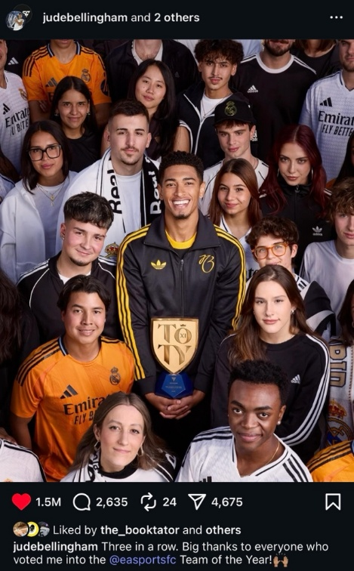
Figure (1) showing Jude with the (TOTY) trophy amid fans, illustrating that the award winners were determined by the audience
Source(s): Instagram
  - Competition style: Even though he is known to be a midfielder, Bellingham’s competitive play style inspired his coaches to use him sometimes as a false 9 player behind the attacking line. This position grants him extra opportunity to score goals that save the matches, and act as a team saviour in the fans’ eyes, to which his first year at Real Madrid bears witness.
  - Sportsmanship: This has crystallised in many instances throughout Bellingham’s career so far. Whenever a player from his or the opposite team gets a sudden cramp on the pitch, he provides his assistance in stretching. Moreover, when some unfortunate racist behaviour occurs against a colleague player, Jude stands for him, supporting him in conferences and on his platforms. For example, when his teammate Vinicius Junior was under a campaign of racial abuse, Bellingham addressed the case during a match conference and in one of the episodes of his short YouTube series (Jude Bellingham, 2024).
  - Rivalry: Despite Jude’s strong competitiveness and drive to achieve the best, this has not negatively affected his relationship with players from the opposing teams. When his team loses a match, or even a championship, cameras always record him congratulating the winning team and admitting their on-field supremacy in the post-game interviews.
- Attractive appearance
  - Physical attractiveness: Being attentive to his fitness as an athlete has paid off with Bellingham in other domains, where brands sought him to model their products. From fashion powerhouses to brands’ underwear lines and sports apparel, Jude is proving that ‘working out’ hard is yielding the results of his effort.
  - Symbol: Young of age, grand of mentality, that is what Bellingham’s representation on social media communicates. Becoming iconically famous at this young age, where his signature celebration has become an inspiration replicated by people of all ages worldwide, Jude has not exhibited any reckless public behaviour.
  - Body fitness: When it comes to a healthy physique, Bellingham has demonstrated his body fitness as well, as across the seasons, his match statistics rarely fail him or his fans. Whether through his attacking efforts or sudden transitions to support the defence, he often scores impressive records in pitch coverage.
- Marketable lifestyle
  - Life story: When Adidas announced Jude’s transfer to Real Madrid in 2023, they used the campaign slogan “From Birmingham to the Bernabéu”. This catchy phrase was possible to use only because of Jude’s calibrated social presence, which conveyed the narration of a middle-class boy with no special privileges, yet who rose to represent the biggest football club in the world. This depiction of Bellingham’s journey, while he is still at this young age, created a very inspiring story, both locally and internationally, for generations to come.
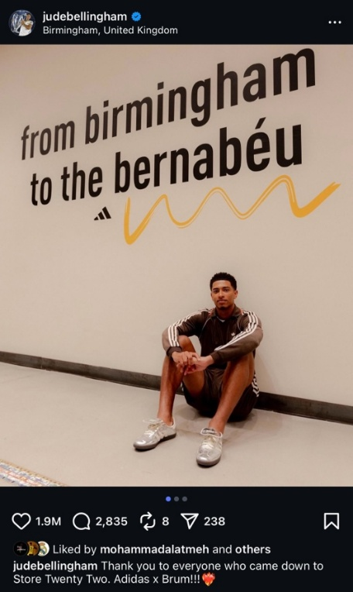
Figure (2) showing Jude with the sign that summarises his inspiring story
Source(s): Instagram
  - Role model: Since his first career goal with Birmingham FC, when his iconic celebration first saw light, and observing his effect worldwide with all generations and genders replicating it, the English international seems to have understood his social responsibility. Leaving his city club at the age of 17, not only did he get his graffiti along with the club’s legends, but he was also the first player to get his jersey number retired in the club, and on a world level in such an age. This happened because his commitment and dedication turned him into an icon that young generations aspire to emulate, which, in turn, inspired Adidas ‘Store Twenty-Two” campaign in Birmingham, in tribute to his number there. During this 90-minute campaign, Adidas Bellingham joined Adidas in handing out gifts of Jude’s kits and the latest Adidas launched boots to Birmingham residents, celebrating his cultural roots and how he could grow them internationally (Jones, 2023).
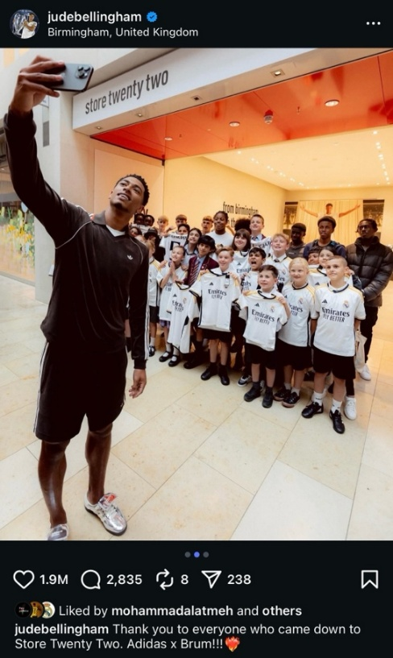
Figure (3) showing Jude taking a selfie with the kids at the event
Source(s): Instagram
  - Relationship effort: From retweeting some fan pages on X (previously Twitter) and sharing their Instagram posts on his story to dropping an unexpected comment to some fans on their birthday, Bellingham is committed to delivering the best social media experience to his audience. Cameras have also documented many times his behaviour with kids, how he deals compassionately with them, knowing that they may look up to him as a role model. Even after the worst game scenario, Jude would go to the sideline after the game and greet the fans, and he makes sure to thank them for their support on his Instagram account after every match. Moreover, this positive attitude has extended consistently to his interactions with the media, towards whom he has never displayed any negative attitude so far.
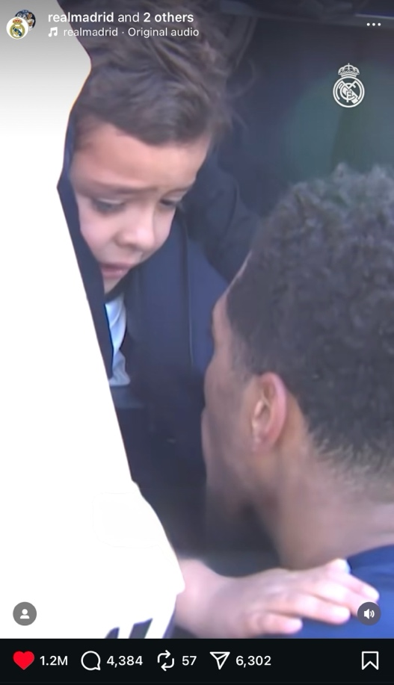
Figure (4) taken from a reel when Jude stopped to talk to a kid fan who was in tears for seeing him, and to give his shirt to the little kid
Source(s): Instagram
All in all, examining Jude Bellingham’s social presence and the way it is communicated via the digital channels against the MABI dimensions proves that the player’s marketing scheme abides by the rule. Therefore, the endorsement contracts he has signed so far demonstrate how his marketing team’s efforts in curating his brand identity were reflected in his career status and personal brand revenue.
In their pursuit of personas who can embed the brand positively in the audience’s mentality, industry leaders always seek remarkable figures with a well-structured personal identity representation. In line with the schema theory, these brands aim to contract ambassadors whose characteristics embody the brand’s ethos or offer a stronger accentuation to them. Thus, recognising Jude Bellingham’s crafted brand identity growth, major global brands undertook the efforts to secure his endorsement and utilise his image to personify their values in consumers’ minds, affecting their approach to the brand and their purchase intentions of its products.
For example, before he turned 20, he starred in the Adidas and Gucci collaboration campaign. Later on, the beverage and energy drinks company Lucozade signed a multi-year endorsement contract with him and launched a special edition of bottles featuring his photos. With his star shining in the branding market, Kim Kardashian did not miss the chance of getting him to model the men’s underwear line of her clothing brand, SKIMS. Within the same month, the sports gaming archetype EA Sports launched its FIFA 2025 edition that featured Bellingham’s photo on the cover.
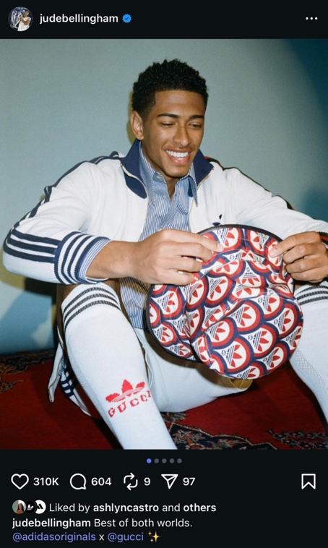
Figure (5) showing Jude wearing items from the Adidas X Gucci collaboration for the campaign promotion
Source(s): Instagram
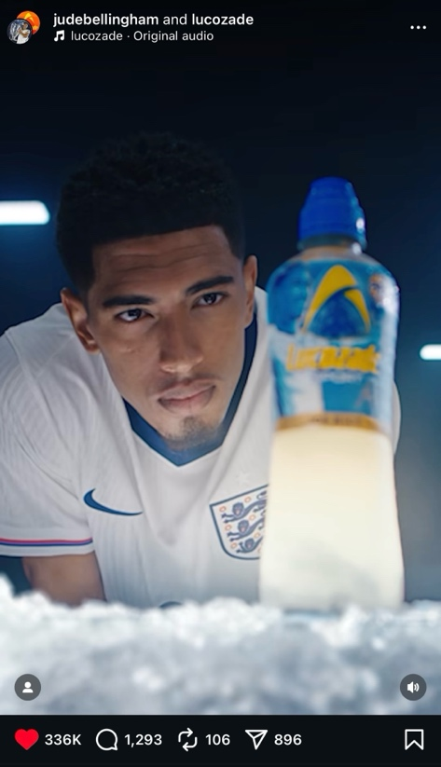
Figure (6) showing Jude from the Lucozade ad video
Source(s): Instagram
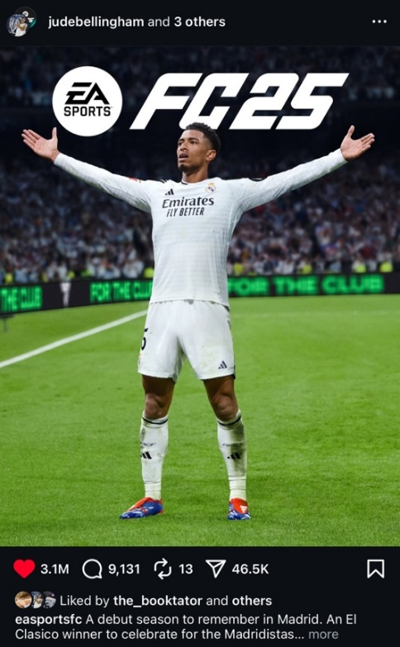
Figure (7) showing Jude on the EA Sports FIFA 2025 edition
Source(s): Instagram
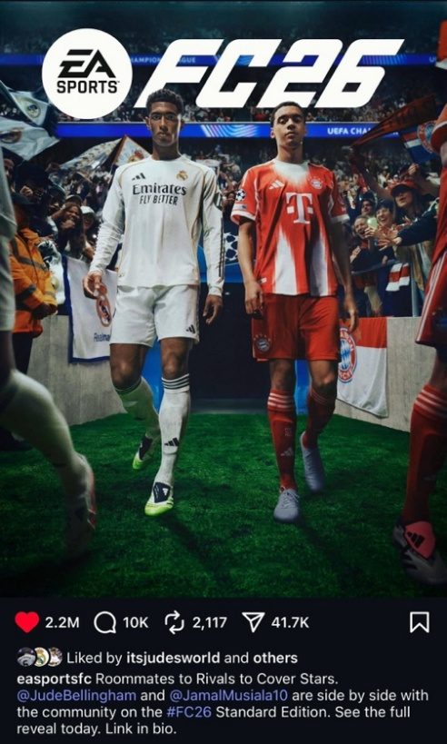
Figure (8) showing Jude (with his childhood friend and previous teammate Jamal Musiala) on the EA Sports FIFA 2026 edition
Source(s): Instagram
This was followed by the player’s ascent alongside football legends, like Messi and Beckham, through a collaboration with Adidas, producing his own line of apparel with his signature JB on the items. During these active endorsement and collaboration campaigns, it seemed that the powerhouse Louis Vuitton was watching the massive development of Bellingham’s brand, as they put their contract on his table as well, announcing him “Friend of the House” (2024). Towards the end of 2024, Adidas went further into a series of collaborations with him. They released another tracksuit featuring his iconic celebration, and they utilised his name in their revival campaign of the vintage ‘Gazelle’ boots. Finally, that year, came the “Belligold” boots, which are an edition of the Predator that has Jude’s signature on them.
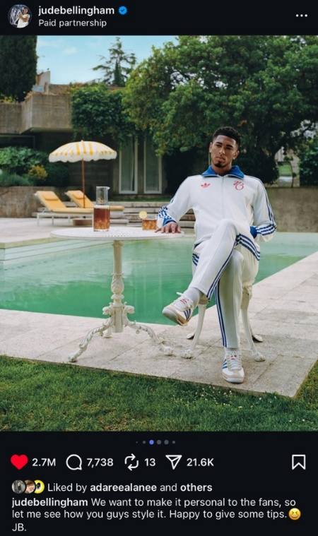
Figure (9) showing Jude in the tracksuit with his signature JB in collaboration with Adidas
Source(s): Instagram
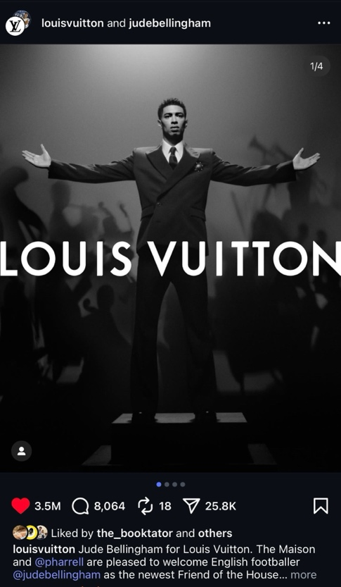
Figure (10) showing Jude from Louis Vuitton’s campaign announcing him as a new ambassador or “Friend of the House”
Source(s): Instagram

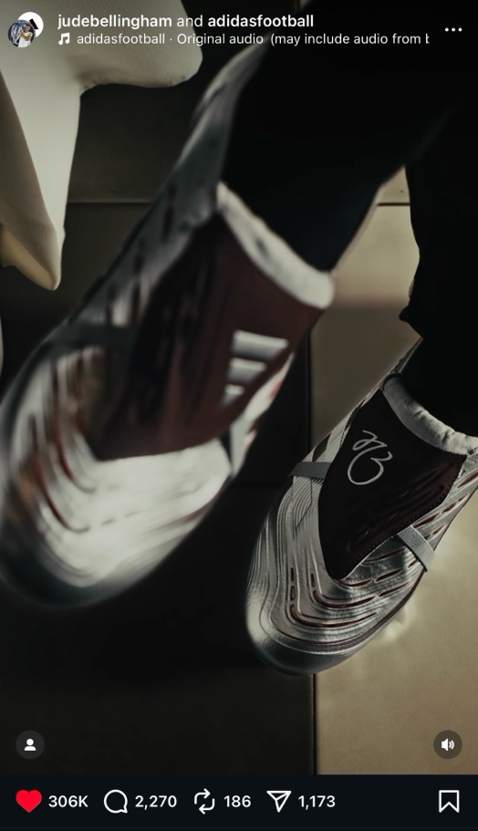
Figure (11) showing Jude’s Predator’s special edition with his JB signature
Source(s): Instagram
In conclusion, cross-checking Jude Bellingham’s social media behaviour against what marketing strategies recommend informs research that the player has ranked so high on the branding charts because, with his media teams, they calibrated his every image and speech. The outcome has been a brand identity that invited many giant brands to believe that this was the right persona to communicate their brand image to the audience.

Chapter III: Empirical Study and Methodological Framework
Introduction:
This chapter will be dedicated to presenting the interviews conducted with marketing managers and media specialists in the sports industry and to analysing their responses. It will assess the degree of congruence between the hypotheses formulated in this research and the practitioners’ insights derived from the context of their experience.
Research Population and Sample:
The study population consisted of marketing and media professionals working for the sports brands that have affiliations with footballers, including Jude Bellingham himself. Thus, the interviews were conducted with Adidas Sports Marketing managers, PR, and newsroom specialists. Since they were detailed interviews chosen carefully to approach the marketing mentality inside the global brands this study aimed to focus on, there were six interviewees who shared their valuable insights on the research hypotheses. Therefore, the interviews will be analysed manually, and parts of the interviewees’ responses will be directly quoted to enhance the value of the findings.

Interviews Analysis and Discussion:
The questions were deliberately divided to elicit structured insights from the interviewees, enriching the research arguments. Thus, the questions, with their responses and discussions, will be distributed below according to the hypothesis they relate to.
H1. There is a statistical correlation between players’ commitment to building a brand identity on social media and their gaining better endorsement opportunities.
To establish the argument of this hypothesis, two questions were asked.
RQ1: How important is a footballer’s social media presence in your decision-making when selecting a brand ambassador?
Analysis of the five participants’ responses revealed a clear consensus on the significance of a footballer’s social media presence in brand ambassador selection, though opinions varied on its relative importance compared to on-field performance. Several interviewees emphasised that a strong, professional social media profile enhances brand visibility, facilitates audience engagement, and allows consumers to connect with the athlete’s personality beyond sport. For example, one PR specialist noted that, “If you have a great social media account, it attracts brands to think: maybe this is the type of person that I want to sign” (Interviewee 1). Also, a digital marketing manager maintained, “I believe nowadays it is a primary element, because social media is the place where everyone is (Interviewee 3). Others considered performance and position within the team as primary factors, with social media presence serving as a valuable but secondary criterion. As one sports marketing manager explained, “It is important, but it comes second after the player’s performance” (Interviewee 2). A brand manager supported this statement to some extent, observing “I still believe that the player’s portfolio, if we might say, still has a big say in this, like if we are talking about their position in the team, like attackers, who are regarded as the highest influential position, or midfielders as well” (Interviewee 4). Yet, he conceded that “But yeah, nowadays, maybe the numbers of social media probably play a vital role in deciding the persona of our campaign or brand” (Interviewee 4). On the other hand, a marketing manager affirmed that “The better social media profile your contracted player has, the larger exposure your campaign will see”, yet mentioning that this will be more effective when paired with other qualities” that would resonate with the brand itself (Interviewee 5).
Overall, participants agreed that social media reach, content quality, and the athlete’s personal resonance with the brand collectively influence endorsement decisions. While also mentioning other traits related to their athletic performance, they mostly placed higher weight on digital presence than others.
RQ2: How do you assess the long-term brand value gained from collaborations with athletes like Jude Bellingham?
The analysis of the interviews reflected that they concurred on the remarkable brand value represented by Jude Bellingham. Some participants referred to the player’s success in securing a starting position in his teams at this young age, while others pointed out his line production of fashion and boots. They mostly agreed on the effect of his success at such a young age, with the sports marketing manager noting that “a young player, barely 22 years old, is a main player on the national team. He has his fashion line, and he delivers an outstanding performance on the field, in addition to his remarkable behaviour. All these factors make him a valuable asset to the brand.” (Interviewee 2). A digital marketing manager confirmed this viewpoint, “we are talking about a player who is not only an endorser, if I may say, for Adidas. Now, Bellingham has his own line in collaboration with Adidas, so I think this pretty much answers the question (Interviewee 3). A brand manager elaborated also on the influence of Bellingham’s position in the national team and club, adding “he is a role model for the young generation, yet his play style and even attitude, I dare say, makes him resonate with older fans as well. So, he is a good bet, I think” (Interviewee 4). Moreover, a marketing manager observed that “a player with his own line of tracksuits, boots, and name it, and he is barely 22 years old, I think we are already talking value” (Interviewee 5). On the other hand, a PR added that collaboration is at the core of the extended value, arguing that “you never know what the longevity is, but I think once you always work collaboratively, you do see the success of a campaign or a product that has a touch of the athlete, and I think it's always just working collaboratively with the person who is creating this product together with the brand, it goes a long way (Interviewee 1).
All in all, responses settled on the outstanding value Jude Bellingham’s name and identity contribute to the brand. With reference to the importance of collaboration while building and capitalising on this value, the majority of the answers expressed support for the positive impact Bellingham brings.
H2. There is a statistical correlation between brands’ hunting for established presence on social media and the choice of thriving footballers’ accounts on the platforms.
Covering the dimensions of this hypothesis, the following question was discussed with the specialists, and their responses were integrated to present a comprehensive understanding of brands’ mentality upon approaching an endorser.
RQ3: What specific metrics or attributes do you analyse when evaluating an athlete’s social media profile for potential collaboration?
Analysing the responses, there was an alignment among interviewees that digital analytics nowadays is a decision-maker when it comes to formulating their collaboration strategies. Credibility and authenticity also surfaced as important elements to consider when deciding on the relevancy of an endorser’s social media profile. A sport marketing manager noted that “We evaluate their authenticity and credibility before considering the number of followers. We also observe their storytelling and how it relates to their followers “(Interviewee 2). A brand manager shared the same view, observing “We also like to see clean and authentic posting strategy and content” (Interviewee 4). A PR specialist asserted that it “is all about data and insights at the end of the day, and we are so driven nowadays through them” while highlighting that, as a brand, they “always look at their reach, their engagements, their shareability, and their target audience” and “their age demographics” (Interviewee 1). A marketing manager agreed to this by stating that “it is so important to understand the demographics of their fans, like their ages, behaviours, and what interests them in following this athlete” as this will “help us a lot when later on we start formulating our campaign and its narrative guidelines” (Interviewee 5). A digital marketing manager summed up the viewpoints by calling the analytics “the hero of today’s campaign marketing” (Interviewee 3). He indicated that “we look into the engagement rates on their profile” and “evaluate the general atmosphere of interaction on the platform” (Interviewee 3).
Considering all the responses, a consensus emerged regarding the social media metrics analysed before collaborating with an athlete, with a recurring focus on demographics, various engagement types and rates, as well as authenticity. Some participants also highlighted the importance of the relatability between what the athlete posts and their fans’ interaction with it.
H3. There is a statistical correlation between players’ brands and the shaping of the content for a brand.
This hypothesis aims to measure how players’ brand identity can influence a brand’s campaign strategy.
RQ4: How do you ensure that the footballer’s brand aligns with your company’s identity and values before proceeding with an endorsement deal?
The analysis of participants’ viewpoints on this topic demonstrated a general emphasis on value brand-endorser alignment, authentic brand affinity displayed by the endorser, and brands’ vetting processes before proceeding with a collaboration. To make sure of an athlete’s compatibility with a brand, a PR specialist asserted that they look into the target endorser’s history to ensure that they have already “ingested Adidas DNA from before” (Interviewee 1). The participant also explained that “it is really doing good research, understanding the person, knowing their background as well, understanding their story, and does it resonate back to our identity?” referring to “You Got This” campaign and its reception by the audience as an example of such resonance (Interviewee 1). This was confirmed by a digital marketing manager who observed that “Players . . . who maybe wear Adidas from a young age, or . . . show love for the brand, this really helps turn the story of our campaign into a real thing that will resonate more with the consumers” (Interviewee 3). A marketing manager shared the same view but added, “We also look into their values and attitudes to measure how much they resonate back to the brand” (Interviewee 5). On the other hand, a sports marketing manager observed that “This is more related to the product being promoted itself,” elaborating on this by exemplifying their choice of Messi for the F50 boots and Bellingham for the Predator boots campaigns (Interviewee 3). A brand manager affirmed that, pointing out, “if you talk about resilience on-field, from this generation’s players, you immediately think of Jude, and that is why he was chosen for Predator, for example. Outside football, you look at Samuel L. Jackson narrating the story of Adidas Superstar ad” (Interviewee 4).
In general, the majority of interviewees agreed on the significance of the athlete’s authentic affinity to the brand, observing that this creates a natural flow for the endorsement campaign. However, some of them mentioned that the alignment is based on harmony between the athlete’s characteristics with those of the promoted item specifically.
RQ5: To what extent do you collaborate with the athlete or their PR team on shaping the content for the brand partnership?
Dissecting the respondents’ answers to this question, there was a consensus on the collaborative efforts between the brand and the athlete, with his management, to organise the terms of any endorsement and its activation requirements. A PR specialist mentioned that “it is always a collaborative effort” since athletes have “a big say in any campaign that we end up doing with them, because at the end of the day, you also want it to resonate back to the person” (Interviewee 1). A sports marketing confirmed that “There is a high level of collaboration” that starts on the PR level and ends with “the social media publishing team” (Interviewee 2). A digital marketing manager explained that “we prioritize hearing from the player’s side” because “This clarifies all the similar and different ideas and allows a space for discussing and agreeing together on the best deliverable that will benefit both sides” (Interviewee 3). A brand manager indicated that “We keep in contact with the player’s PR team because . . . he is the star of the campaign, so it is better to hear what he has to say about the processes and to provide him with circumstances that will easily make him resonate with the campaign (Interviewee 4). A marketing manager reemphasised the same point of view, stating that “We do collaborate with them through every step of any campaign we launch together . . . . And after agreeing on the final formula or version . . . the execution commences then” (Interviewee 5).
On the whole, the media and marketing professionals concurred that collaboration with the athlete’s media team is a core process during the campaign. They pointed out that the athlete’s side opinion is very crucial, and that only after arranging all details together does the campaign execution start.
H4. There is a statistical correlation between social media proliferation and brands’ sponsorship activation.
This hypothesis examines the relationship between a player’s established digital presence and brands’ decision to collaborate with him.
RQ6: Can you describe a case where a footballer’s online brand significantly influenced the success of your campaign?
Assessing viewpoints regarding this topic, interviews expressed high appreciation for the influence of the footballer’s online brand on the campaign’s outcomes. They agreed that the athlete’s identity gives a deeper context for the campaign, paving the way for its success. A PR specialist used the example of Adidas campaign with Al Ahly FC during their participation in the Club World Cup 2025 in the states, noting that “this really had a huge impact from an organic perspective” (Interview 1). The specialist explained that when “We launched the campaign on our social channels, we had two main characters, Wessam Abou Ali . . . . Their platforms made a significant impact on our campaign” (Interview 1). A sports marketing manager shared the same view, yet he added that the effect is also examined against “the market the player influences; hence, the percentage their followers constitute from their market” (Interview 2). A digital marketing manager illustrated the F50 campaign with Messi as an example, demonstrating that “When launching a campaign in collaboration with him, his fans start to like to see the product he promotes differently, like if I wear this, I will become like Messi” (Interview 3). Moreover, a brand manager cited the collaboration with Jude Bellingham in the Predator boots and in his own sportswear line as evidence, observing that “Jude has a charismatic presence, whether as a player or a person, so reflecting his identity on a campaign has a significant effect” (Interview 4). A marketing manager mentioned that “when we chose Bellingham for “You Got This”, his whole presence as the central player in the English National Team, with all this pressure on him in this young age, he gave the campaign a true meaning to which the fans can relate to” (Interviewee 5).
In summary, the prevailing view was that the athlete’s online brand identity directly influences the success of a campaign, basing their opinions on the digital analytical numbers. Moreover, some of them added that the magnitude of the success remains proportional, according to the size of the market or fan base they influence.
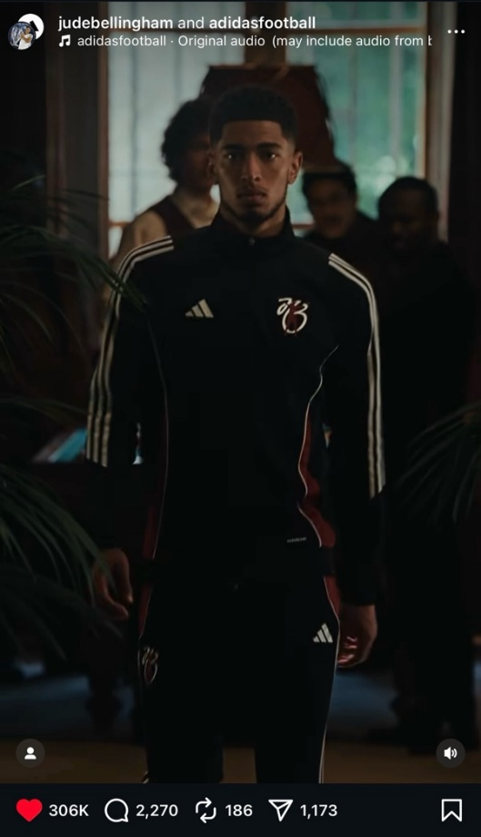
Figure (12) from a reel showing Jude in his JB line in collaboration with Adidas
Source(s): Instagram
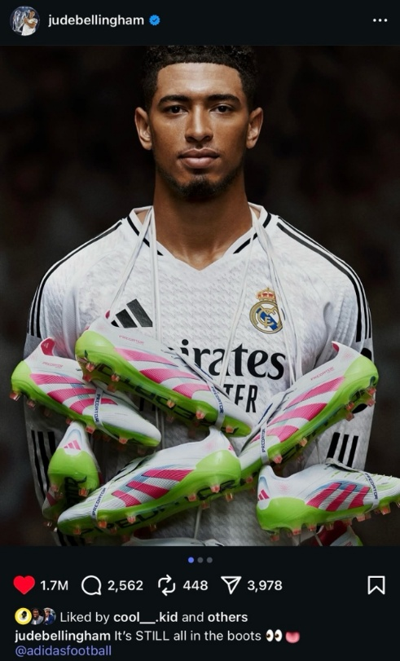
Figure (13) showing Jude promoting for Adidas Predator
Source(s): Instagram
RQ7: Have you observed measurable differences in consumer engagement or sales when partnering with athletes who have strong digital identities?
Studying the professionals’ responses to this question, interviewees agree that the athlete’s strong digital identity raised the stock of the item they promoted. They affirmed that the larger the athlete’s digital footprint, the stronger his influence on the engagement a campaign receives. A sports marketing manager pointed out that “That is why our digital team starts by doing the data analysis, examining the viewers of the player’s content. And they give the directions accordingly” (Interviewee 2). A digital marketing manager cited the collaboration with Messi, “when we launch a new campaign in collaboration with him, having the video featured on his account will make a lot of fans want to have this product to be like Messi” (Interviewee 3). A brand manager confirmed that “this happened almost with all the players we contract, since our social media team does the pertinent research that will inform the direction of the campaign,” and mentioned Mo Salah as a case of success (Interviewee 4). A marketing manager’s response resonated with the others’, confirming, “players and their digital identities do affect our campaigns”, referring to the cases of Messi, Mo Salah, and Jude Bellingham (Interviewee 5). On the other hand, a PR specialist added that “whether it is digital or just word of mouth, these things tend to go viral in a sense, and then get sold out at some point,” proposing that celebrities’ strong identities affect both digital and traditional sales (Interviewee 1).
By and large, the participants widely agree that linking a campaign to an athlete with a strong digital presence will positively influence consumers’ engagement and purchasing behaviour. Moreover, some of them observed that a well-established athlete’s name can generate substantial sales trends in both digital and traditional markets.
H5. There is a statistical correlation between the types of content athletes share on their social media and athlete-brand partnerships.
This hypothesis seeks to measure whether a relationship exists between the type of content athletes post and the success of the campaigns launched in collaboration with them.
RQ8: Do you believe athlete-brand partnerships are more effective when the athlete shares both professional and personal content on social media? Why or why not?
The assessment of the participants’ viewpoint on this subject reflects a collective opinion that is in favour of the athlete’s versatile posting trend. They based their argument on the presumption that, in contemporary sports culture, fans seek profound insights into their favourite player’s life, pursuing their personal updates with the same level of interest as their professional achievements. A PR specialist noted that “A lot of media, but also brands, tend to look out for these things because at the end of the day, you want something that looks a bit structured, that is clean” (Interviewee 1). A sports marketing manager confirmed that “when you like someone, you like to see their lives, because they become like a role model. This also provides a better context for shaping the narrative of the campaign you want to launch with them” (Interviewee 2). A digital marketing manager points out that with versatile content, players “leverage their relationship with the fans as they turn into their better version, which will affect the fans’ connection with the brand they represent as well (Interviewee 3). A brand manager confirmed that “this has a positive side for the brand because these fans will become more attached to it when they imitate the players they like” (Interviewee 4). A marketing manager asserted that “this really helps the brand when it wants to collaborate with a player, as it can promote its products through this player in various contexts (Interviewee 5).
Considering all the responses, athletes’ versatile social media content proves to be significantly influential on the productivity of any partnership that includes them. The participants view athletes' diverse posts as a solid foundation for the campaigns they launch with them.
RQ9: What role do emotional connection and storytelling play in your endorsement strategies with footballers?
Regarding this axis, the participants shared the viewpoint that storytelling is a key factor in outlining any endorsement strategy. They believe that it formulates the emotional connection that will later guarantee the campaigns’ resonance when launched with these endorsers. A PR specialist observed that “emotions and stories really resonate with consumers, and I think with the digital world, this is what really connects back to consumers” (Interviewee 1). A sports marketing manager illustrated its importance by referring to how “Adidas changed the brand message old campaign, 'Impossible is nothing', to the new one, 'You Got This'”, because they wanted “to come up with a message that resonates with the generation nowadays” (Interviewee 2). A digital marketing manager explained that “it is vital when building a campaign strategy”, citing how “in the ‘You Got This’ campaign, Jude Bellingham was one of the stars we collaborated with, using the story of the pressure he was under to get to win a trophy for England” (Interviewee 3). A brand manager noted that “stories and emotions . . . make the advertisement more of a story that the audience can relate to, instead of just a promoted product (Interviewee 4). Moreover, a marketing manager affirmed that “we need these inspiring stories to make the advertisement more related to the audience watching, as it will stir a feeling inside them” (Interviewee 5). Also, he referred to the old campaign ‘Impossible Is Nothing” with Zidane, the Predator campaign with Messi and Bellingham, as well as “most recently the ‘Magic Moment by Adidas’ which also featured Jude Bellinghm” (Interviewee 5).
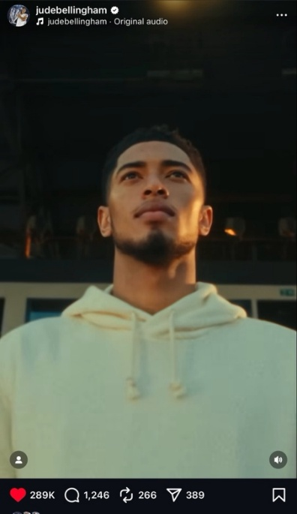
Figure (14) from a reel showing Bellingham in the ‘Magic Moment by Adidas’ campaign
Source(s): Instagram
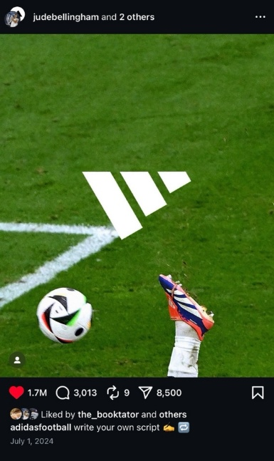
Figure (15) showing the famous bicycle kick goal Jude scored through the Euro24 tournament, where Adidas leveraged the upside-down position to eliminate featuring the Nike kit worn by the English National Team and focus on Jude’s Predator boots
Source(s): Instagram
Chapter IV: Findings, Recommendations, and Proposals
Introduction
This chapter encapsulates the findings of the study, derived from conducting and analysing interviews with professionals in the marketing and media sectors of a sports-related brand. It answers the research questions through either supporting or refuting its hypotheses. Moreover, the chapter elucidates some recommendations for professional practices and proposes future research based on the study findings.
- Study Findings
- Brands ascribe considerable importance to a footballer’s social media presence when building an endorsement strategy and selecting who will be representing them in the campaign, in agreement with the study of (Gordillo-Rodriguez et al., 2024)
- To arrive at their final decision in the selection process, brands analyse some digital metrics, like shareability, demographics, and engagement, while also vetting the engagement environment to ensure its positivity, in agreement with the study of (Yin, 2025) and (Barbu et al., 2021).
- Brands also look for authenticity and credibility when evaluating a footballer’s social media profile, and they assess the content relatability to the profile’s audience, in agreement with the study of Sadeghi (2020).
- Brands still consider the player’s status in the starting eleven and his position in the formation when selecting an endorser, with attackers and midfielders on top of the list, which resonates with one of (Arai et al., 2013) MABI’s dimensions and the findings of Dittmore (2012).
- Brands prefer players with authentic affinity to guarantee the alignment of their brand with the company’s identity and value.
- Brands search deeply to ensure that the players’ values and narrative resonate with the brand identity, in agreement with the studies of (Hallmann et al., 2024) and (Halkias, 2015).
- Brands also ensure the alignment through resonance between the player’s characteristics and the specifications of the item being promoted, in agreement with the study of (Papp-Váry, 2025).
- When signing a partnership or launching a campaign, brands highly collaborate with athletes and their PR team to guarantee providing the endorser athlete the perfect ambience to ensure campaign resonance with the audience.
- Footballers’ online brands have a significant effect on the outcomes of a brand’s campaign, , in agreement with the study of (Yin, 2025), (Gordillo-Rodriguez et al., 2024), (Barbu et al., 2021)
- Partnering with athletes who maintain strong digital identities generates high engagement rates and affects the consumers’ purchasing intentions, contributing to the sales as such, in agreement with the studies of (Mohan 2025) and (Breuer and Felbert, 2021).
- Brands recognise the significant value of athletes’ versatile social media content, as it fosters a profound relationship with the audience, providing a meaningful context for the campaigns they plan to launch with the athlete, in agreement with the studies of (Doyle et al., 2022), (Arai et al., 2019), (Arai et al., 2013a), and (Arai et al., 2013b).
- Brands acknowledge the importance of cultivating emotional connections with audiences through powerful storytelling on the athletes’ platforms, adapting marketing strategies that resonate with the expectations and values of the targeted generation, in agreement with the studies of (Doyle et al., 2022), (Arai et al., 2019), (Halkias, 2015), (Arai et al., 2013a), and (Arai et al., 2013b).
- The case study of the English football player Jude Bellingham indicates that he represents considerable brand value, which significantly influences the perception and performance of the brands he promotes and collaborates with.
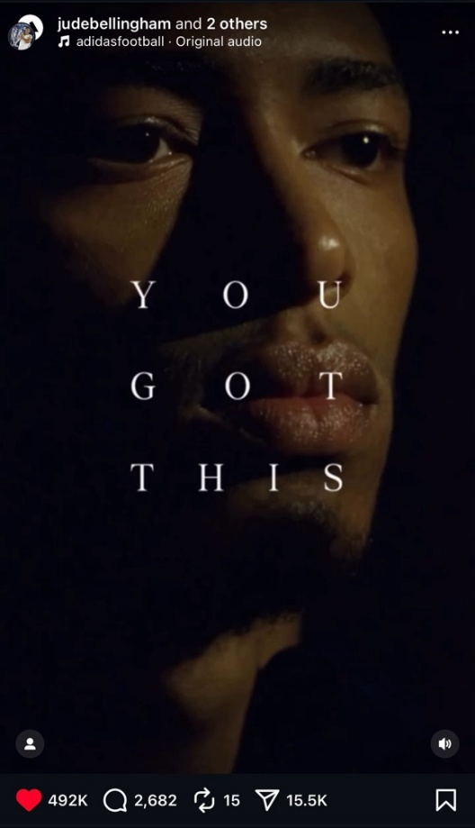
Figure (16) from a reel, showing Jude Bellingham from Adidas ‘You Got This’ campaign
Source(s): Instagram

- Study Recommendations
- Athletes have to ensure building a strong brand identity on social media platforms if they seek to enhance their portfolio and revenue with brand endorsement. This should be done through maintaining a versatile digital presence by sharing content from both their professional and personal life.
- Athletes’ managers should contribute to establishing their brand identity by calibrating their strategic appearance, influencing their public attitude and behaviour, and curating what to be published on their social media platforms and when.
- Athletes and their marketing teams are advised to incorporate powerful storytelling and emotional narrative to resonate deeply with the audience.
- Brands are advised to embed athletes’ endorsement within their marketing strategies, when relevant, regardless of the brand’s prominent marketing position.
- Brands have to curate a branding strategy that resonates with the targeted audience, and to align this strategy with the athlete who personifies its values and whose characteristics translate the theme of the promoted item.
- Brands are recommended to seek authenticity in the content of the endorser player, and preferably to attain authentic affinity if possible, with the brand itself, as this provides more impactful foundations to build their campaigns on.
- Study Proposals
- Conducting broader studies that collaborate with more brands to inspect the influence of their endorsement contracts with football players on their identity and equity.
- Conduct further studies on the audience to examine their interactions with the products endorsed by football players and to what extent this affects their purchasing intentions.
- Conducting comparative studies between brands and players’ cases where the endorsement campaigns experienced success and failure to draw the best techniques to adopt and the negative approaches to avoid.

Reference
Adidas AG. (2024). Annual report 2024. https://shorturl.at/Gn1Es
Alamoudi, A. M. (2024). The impact of celebrity presence and performances on event sponsorship
and brand associations. Academy of Entrepreneurship Journal, 30(4), 1-36.
Arai, A., Biscaia, R., Kunkel, T. & Agyemang, K. (2019). The role of self-brand connection on the
relationship between athlete brand image and fan outcomes. Journal of Sport Management, 34(3), 201–216.
Arai, A., Ko, Y. J. & Kaplanidou, K. (2013a). Athlete brand image: Scale development and model
test. European Sport Management Quarterly, 13(4), 383–403.
Arai, A., Ko, Y. J. & Ross, S. (2013b). Branding athletes: Exploration and conceptualization of
athlete brand image. Sport Management Review, 17(2014), 97-106.
Barbu, M., Bogdan, B., Diaconescu, D., Popescu, M., Păsărin, L. & Paula, A. (2021). The Role of
social media on sponsorship activation. Studia Universitatis Babes-Bolyai Sociologia, 66(1), 111–126.
Biz, M. & Schubert, M. (2024). Perceptions of celebrity athletes involved in social cause
endorsement. Frontiers in Sports and Active Living, 6, 1415382.
Breuer, C. & Felbert, A. V. (2021). How the type of sports-related endorser influences consumers’
purchase intentions. International Journal of Sports Marketing and Sponsorship, 22(3), 588-607.
Carlson, B. D. & Donavan, D. T. (2013). Human brands in sport: Athlete brand personality and
identification. Journal of Sport Management, 27(3), 193–206.
Chen, Y., He, Y, Hu, K., Wang, C. & Yang., Z. (2024). The Positive Relationship Between Social
Media Marketing, Brand Awareness, and Brand Association, and How Celebrity Endorsement Boost the Effects of SMM. Advances in Economics, Management and Political Sciences. 81 (1), 226-234.
Doyle, J. P., Su, Y. & Kunkel, T. (2022). Athlete branding via social media: Examining the factors
influencing consumer engagement on Instagram. European Sport Management Quarterly, 22(4), 506–526.
EA SPORTS FC [@easportsfc]. (2025, July 16). Roommates to Rivals to Cover Stars. [Photo].
Instagram. https://shorturl.at/iOCNM
ExchangeWire. (2024, June 25). Adidas campaign starring England star Jude Bellingham tops list
of most emotionally engaging EURO 2024 ads. ExchangeWire. https://shorturl.at/qiOj7
Gordillo-Rodriguez, M.-T., Marín-Montín, J. & Fernández Gómez, J. D. (2024). Sports celebrities
and advertising on Instagram: a case study of brand sponsorship in Spain. International Journal of Sports Marketing and Sponsorship, 25(4), 862–894.
Halkias, K. (2015).Mental representation of brands: a schema-based approach to consumers’
organization of market knowledge. Journal of Product & Brand Management, 24(5), 438–448.
Hallmann, K. & Hill, B., Linsner, A., Sotiriadou, P. (2024). Athlete Brand Congruence as a Measure
to Evaluate Brand Identity and Image Fit. Australasian Marketing Journal, 33(1), 47-57.
Hallmann, K., Hill, B., Linsner, A., Sotiriadou, P. (2021). Athlete brand identity, image and
congruence: A systematic literature review. International Journal of Sport Management and Marketing, 21(1-2), 103-133.
Jones, D. (2023, June 23). Jude Bellingham Opens Special Store In Birmingham For One Day
Only. SoccerBible. https://shorturl.at/7ujSr
Keller, K. L., & Swaminathan, V. (2019). Strategic Brand Management: Building, Measuring, and
Managing Brand Equity (5th ed.). Pearson.
Louis Vuitton [@louisvuitton]. (2024, Augus 16). Jude Bellingham joins the Maison as a Friend of
the House. [Photo]. Instagram. https://www.instagram.com/p/C-uS7lZAUwa/
Mohan, R. (2025). Influence of celebrity endorsements in advertisements on the purchasing
intentions among higher education students. IIMT Journal of Management, 2(1), 100–113.
Papp-Váry, Á. F. (2025). When the Face of the Ad Is Bigger than the Brand: How Zlatan
Ibrahimović Redefined Advertising with Athletes. Administrative Sciences,15(4), 136.
Ream Madrid. (2025, June 29). Bellingham turns 22. Real Madrid . https://shorturl.at/IzYRv
Sadeghi, S. (2020). The relationship between sport’s endorsement in social media and
consumers’ attitude towards the advertising. Journal of Administrative and Business Studies, 6(1), 21–28.
Sport Industry Group [@sportindustry]. (2025, May 16). Our Long-Form Content Award, in
association with @shutterstock, rewards outstanding sports-related video content over three minutes in length. [Photo]. Instagram. https://shorturl.at/BfmBW
Su, Y., Baker, B. J., Doyle, J. P. & Kunkel, T. (2020). The rise of an athlete brand: Factors
influencing the social media following of athletes. Sport Marketing Quarterly, 29(1), 33–46.
Yin, H. (2024). An Analysis of the Influence of Brand Sponsorship and Social Media on the
Reconfiguration of Athlete Value. Advances in Economics Management and Political Sciences 158(1):132-136.

الملخّص
هدفت الدراسة إلى التحقّق من العلاقة ما بين إنشاء هوية العلامة التجارية المثالية للاعبين على منصّات التواصل الاجتماعي وكيف يستقطب ذلك مساعي العلامات التجارية في توقيع عقود رعاية معهم. وناقشت الدراسة أهم الدعائم التي يجب أن يرسّخ عليها اللاعبون وفرقهم الإعلامية استراتيجية بناء هويتهم، كما سلّطت الضوء على الخصائص التي يجب أن تبحث عنها العلامات التجارية في حسابات اللاعبين. وركّزت الدراسة على تقصّي حالة اللاعب الإنكليزي جود بيلينغهام، وذلك من خلال تتبُّع استراتيجيّة إنشاء هويّته، والتي حقّقت له عقود رعاية مع كُبرى العلامات التجارية العالمية.
تم إجراء الدراسة من خلال القيام بمقابلات مع مختصين من قسمي التسويق والإعلام في مقر شركة أديداس في دبي. وتم اتّباع منهج التحليل الموضوعي، وذلك عبر استخلاص الرؤى التي عكستها إجابات المشاركين، ومقارنتها من أجل التوصّل إلى نتائج الدراسة.
وقد توصّلت نتائج الدراسة إلى وجود علاقة مباشرة بين تصميم هوية اللاعب الرقميّة بشكل مدروس ورغبة العلامات التجارية بتوقيع عقود شراكات معهم. وتم برهنة هذه العلاقة من خلال تجارب المشاركين في المقابلات مع حملات الرعاية التي قامت بها العلامة التجارية، وعبر استعراض أمثلة من عقود الشراكات التي لا يزال اللاعب جود بيلينغهام يحظى بها باستمرار.
وأوصت الدراسة بضرورة إيلاء اللاعبين الأهميّة القصوى لبناء هويّاتهم على منصّات التواصل الاجتماعي، وبأن يحرصوا على إضفاء الطابع الإنساني على استراتيجيّاتهم من خلال مشاركة لحظات من حياتهم الخاصّة إلى جانب المحتوى المتعلّق بحياتهم المهنية، لأن ذلك يخلق بعداً عاطفياً يستدعي تفاعلاً أكبر من الجمهور. من ناحية أُخرى، خلُص البحث إلى أهميّة تعاقد العلامات التجاريّة مع اللاعبين، إذ يؤدّي ذلك لتجسيد هذه العلامات بصورة اللاعبين، حيث يقومون بإضفاء خصائصهم عليها، ممّا يشكّل تأثيراّ قويّاً على الجماهير، ويُسهم في تكوين تصوّرهم عن هذه العلامة.
الكلمات المفتاحية: هوية العلامة التجارية، اللاعب، الإعلانات المدعومة، منصّات التواصل الاجتماعي، العلامة التجاريّة، نظرية المخطّطات المعرفيّة، نظرية هوية العلامة التجارية، جود بيلينغهام.

MIDOCEAN UNIVERSITY
College of Media & Marketing
Master of Digital Marketing

بحث مُقدّم لنيل درجة الماجستير في التسويق الرقمي
دور وسائل التواصل الاجتماعي في بناء هوية لاعبي كرة القدم وتعزيز مكانتهم كسفراء للعلامات التجارية: "جود بيلينغهام" دراسة حالة

إعداد الباحثة:
ساره زهير شاهر

إشراف الدكتور:
محمد عويس

2024-2025

