Methodology and Proposed Framework

Introduction
This chapter presents the methodology for an AI-powered Arabic voice agent for Saudi Labor Law inquiries, combining Automatic Speech Recognition (ASR), Retrieval-Augmented Generation (RAG), Large Language Models (LLMs), and Text-to-Speech (TTS) to support spoken and written interaction with official labor-law information [1], [2]. The central methodological requirement is that the system retrieves legal evidence before producing an answer, so that responses remain traceable to official Saudi Labor Law or HRSD FAQ content.
The methodology is organized around three design requirements:
  - Arabic user queries, including spoken input and common orthographic variation, are handled reliably [5], [6]
  - domain evidence is retrieved from a structured knowledge base rather than from the parametric memory of an LLM [3], [4]
  - the retrieval, generation, voice-processing, and latency layers are evaluated through defined metrics and reproducible procedures.
The framework is implemented as a nine-stage experimental pipeline: data collection, data preparation, retrieval evaluation, evaluation-set expansion, answer generation, rigorous evaluation, voice-layer implementation, baseline and ablation analysis, and latency analysis. Each stage is implemented in a separate notebook that produces persistent outputs consumed by later stages, supporting auditability, reproducibility, and a clear separation between methodology and results.

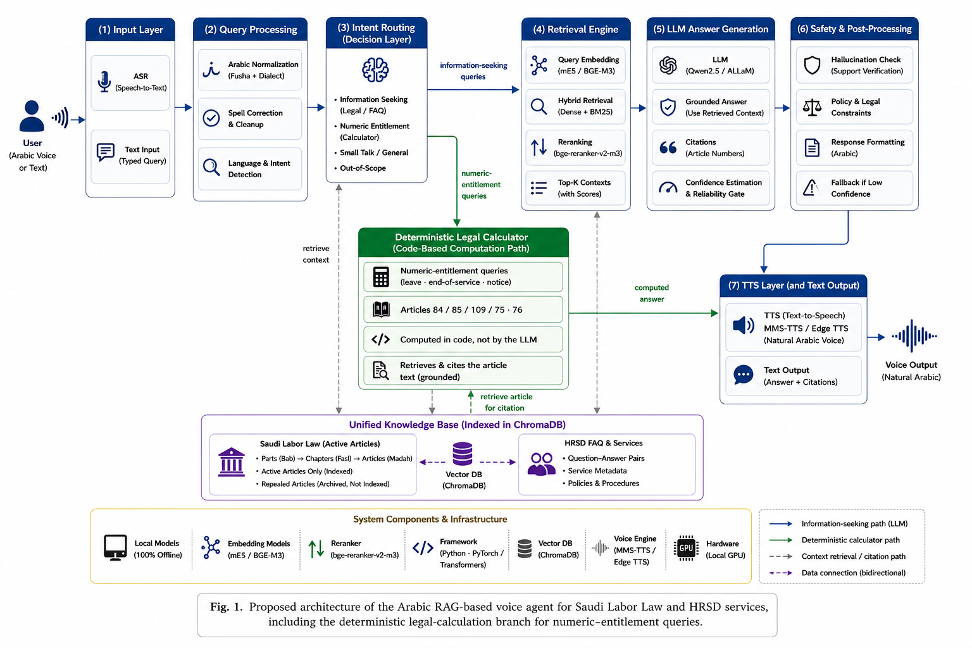
Figure 3.1. Proposed framework for the AI-powered Arabic voice agent for Saudi Labor Law inquiries.

Figure 3.1 presents the proposed framework as a sequence of connected stages rather than a single monolithic model:
- Step 1: Official Saudi Labor Law articles and HRSD FAQ records are collected as authoritative domain sources.
- Step 2: The collected records are cleaned, normalized, chunked, embedded, and stored in a persistent ChromaDB vector database.
- Step 3: Spoken user queries are transcribed by the ASR layer before being forwarded to the retrieval layer; typed queries are routed directly to retrieval.
- Step 4: The retrieval layer applies dense retrieval, BM25 lexical retrieval, hybrid fusion, and reranking to select legal evidence.
- Step 4b (parallel branch): When the intent classifier detects a numeric-entitlement query, such as annual-leave or end-of-service computation, the query is routed to a deterministic legal-calculation branch that computes the result in code from the relevant provisions (Articles 84, 85, 109, 75, and 76) and retrieves the corresponding article text for citation, instead of relying on the language model for arithmetic.
Step 5: For information-seeking queries, the generation layer receives the selected evidence and applies intent checking, reliability checking, guardrails, and safe refusal instructions before producing an Arabic answer.
Step 6: The TTS layer converts the final Arabic answer into speech when the user requests a voice response.
Step 7: The evaluation and latency modules assess each component separately, while the feedback loop is reserved for future improvement.

Dataset Description
In this study the dataset was constructed through web scraping from official Saudi Labor Law documents and HRSD service-information webpages [1], [2]. The Saudi Labor Law corpus was extracted at the article level and comprised 249 records. Of these records, 211 active articles were retained in the knowledge base, while 38 repealed articles were excluded from the searchable index to prevent the retrieval of obsolete legal information. In this step, the HRSD FAQ corpus was collected as 711 question-answer pairs, of which 703 entries remained after removing empty or malformed records. Domain filtering then retained 402 labor-related entries (301 excluded as out-of-scope). This labor-related subset was subsequently split into 278 entries for indexing and 124 entries held out for evaluation; after content-level leakage screening removed near-duplicate items, 121 FAQ questions remained in the final held-out subset. Combined with 24 manually curated legal-article questions and 15 out-of-scope questions, the complete held-out evaluation set comprised 160 items (145 retrieval-evaluable). This process resulted in two distinct Arabic textual corpora used to build the proposed system.
Source | Description | Role in the System
Saudi Labor Law | Official legal articles containing article identifiers, legal hierarchy, article status, and article text. A total of 249 articles were scraped, including 211 active articles and 38 repealed articles. | Primary legal knowledge source for article-grounded answers.
HRSD FAQ Dataset | Official question-answer records related to labor services and workplace procedures. A total of 711 FAQ entries were scraped; 703 remained after basic cleaning, 402 were retained after domain filtering, and 278 of those were assigned to the indexing subset. | Supporting source for service-oriented and procedural questions.
Evaluation Questions | Held-out legal, FAQ, and out-of-scope questions with gold references, kept separate from the index. The held-out evaluation set comprises 160 items in total (121 FAQ questions, 24 legal-article questions, and 15 out-of-scope questions), of which 145 are retrieval-evaluable. | Used only for retrieval and generation evaluation, not for answer generation during normal operation.
Table 3.1. Dataset sources and their roles in the proposed system.
The two datasets differ in structure and content. The Saudi Labor Law corpus consists of article-level legal provisions organized by part, chapter, article number, article status, and full legal text; the HRSD FAQ corpus consists of service-oriented question-answer records with related metadata, such as beneficiary category and sector. Missing values in some columns are therefore expected, since legal articles do not contain question-answer fields and FAQ records do not contain legal-article fields. To prevent data leakage, the indexed knowledge base was separated from the held-out evaluation questions before retrieval evaluation. Figure 3.2 illustrates these structural differences using actual screenshots of the two record types.
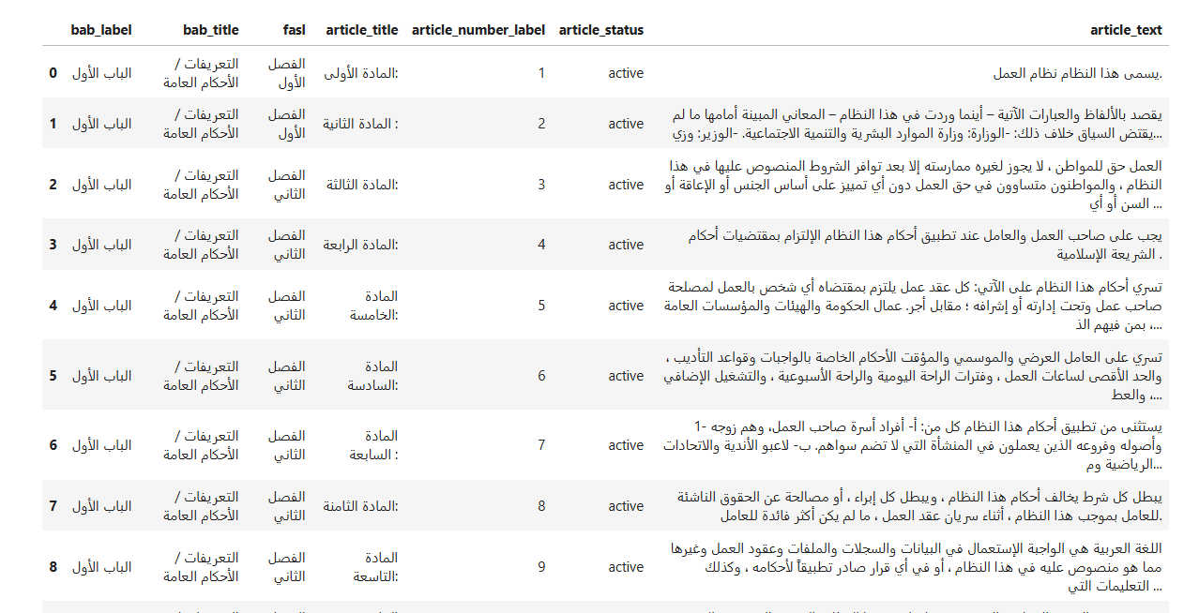
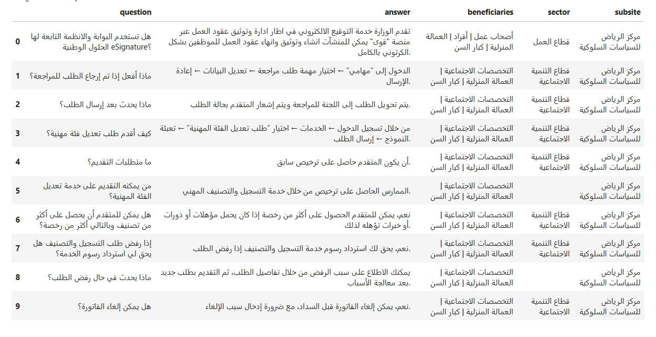
Figure 3.2. Actual screenshots of the structured legal and HRSD FAQ datasets.
The legal-article sample includes the legal hierarchy, article title, article identifier, article status, and article text; the FAQ sample includes the question, official answer, beneficiary category, sector, and subsite information. These fields confirm that the system operates on structured records rather than unprocessed free text. The structured fields support the retrieval metadata, traceable chunk identifiers, and grounded answer citations used later in the pipeline.

Data Collection and Web Scraping
The raw corpus was constructed directly from the official Saudi Ministry of Human Resources and Social Development (HRSD) website through web scraping, targeting two source types: Saudi Labor Law pages and HRSD FAQ pages. This preserved authoritative legal and service-information content before any cleaning, filtering, or indexing was applied.
The extraction procedure was implemented in Python using the requests library to retrieve web pages and the Beautiful Soup library to parse the HTML structure. The Saudi Labor Law was extracted at the level of individual articles while preserving its native legal hierarchy of part (bab), chapter (fasl), and article (madah). The HRSD FAQ records were extracted as question–answer entries together with their available service metadata. During collection, spelled-out Arabic article ordinals, such as “الحادية والخمسون بعد المائة”, were converted into canonical integer article numbers while preserving the “مكرر” (bis) marker when present. These normalized article identifiers were subsequently employed for citation, traceability, and gold-reference matching during retrieval evaluation.
Table 3.2. Examples of Arabic article-number normalization.
Raw Article Title (as scraped) | Normalized article_number_label | Note
المادة الحادية عشرة | 11 | Two-digit ordinal (10–19 range)
المادة التاسعة والسبعون | 79 | Units + tens combination (below 100)
المادة الحادية والثلاثون بعد المائة مكرر | 131مكرر | بعد المائة (+100 offset); مكرر (bis) marker preserved
المادة التاسعة والعشرون بعد المائتين | 229 | بعد المائتين (+200 offset)

Data Preprocessing
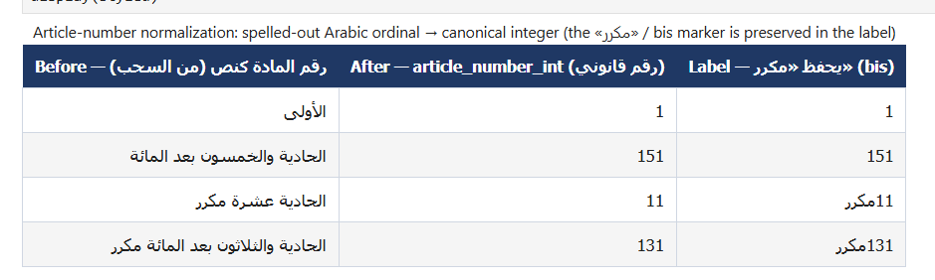
The preprocessing phase converted the raw web-scraped records into a clean, structured, leakage-safe, and retrieval-ready knowledge base. Because the Saudi Labor Law source was organized as legal articles and the HRSD FAQ source as question-answer pairs, the raw records contained heterogeneous fields. A sequence of preprocessing steps was therefore applied before indexing: schema standardization and integration, Arabic text cleaning and normalization, handling of repealed legal articles, domain filtering of FAQ records, leakage-safe separation between indexed and evaluation data, near-duplicate detection, and chunking with metadata attachment. Each step produced an intermediate output that was saved and inspected for auditability and reproducibility.

Schema Standardization and Data Integration
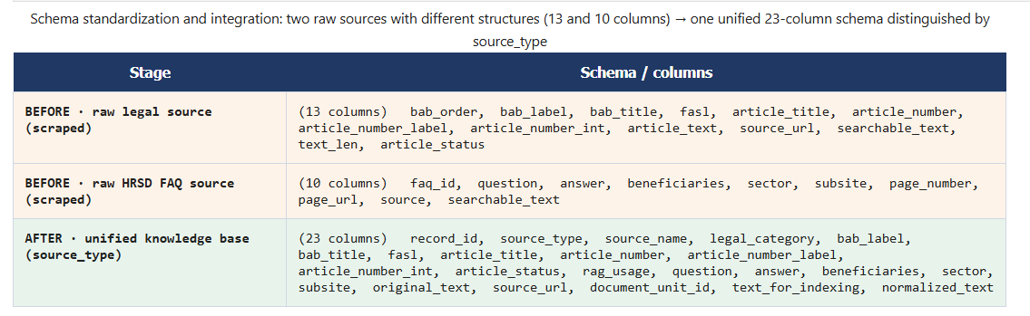
The raw files were loaded and their column names standardized into a consistent structure of identifiers, source labels, text fields, and metadata fields. Because the Saudi Labor Law and HRSD FAQ sources had different original structures, they were merged into a single unified table with a consistent 23-column schema, with the two record types distinguished by a source_type field. A sample of the merged records is shown in Figure 3.3.

The two sources were integrated into a single schema for four methodological reasons:
- First, a unified table lets cleaning, filtering, chunking, embedding, indexing, and retrieval operate over all records through one pipeline instead of two parallel workflows.
- Second, it enabled the agent to retrieve evidence from both formal legal articles and practical FAQ entries through a single search process.
- Third, the FAQ records complemented the legal articles by providing question-answer phrasing closer to the way users ask practical service questions.
- Fourth, the shared schema preserved traceability through explicit identifier and provenance fields (record_id, source_type, source_url, original_text, normalized_text, and document_unit_id), enabling each record to be traced to its origin and separated by source whenever disaggregated evaluation was required.

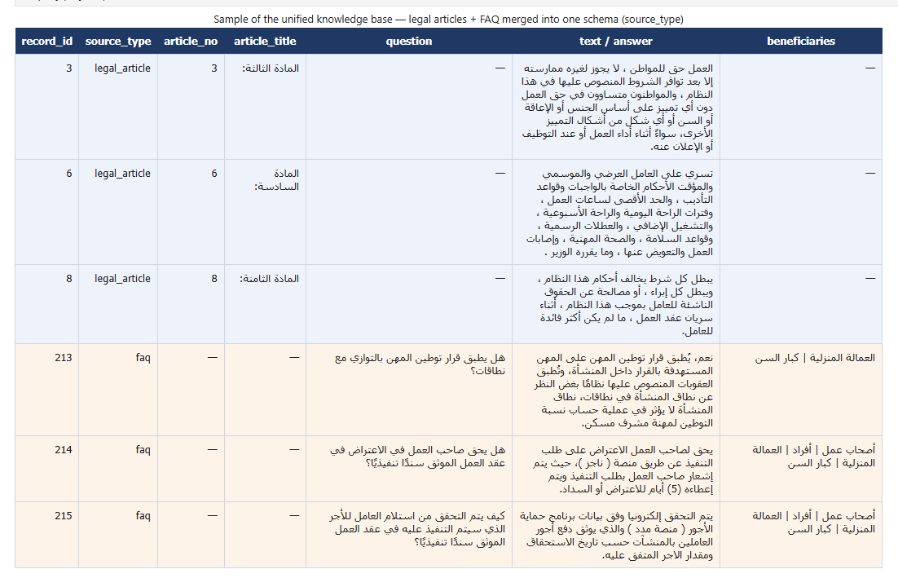
Figure 3.3. Sample of the unified knowledge base showing Saudi Labor Law articles and HRSD FAQ records integrated into a single schema and distinguished by the source_type field.

Arabic Text Cleaning and Normalization
Arabic text is normalized to reduce orthographic variation that would otherwise weaken retrieval: diacritics (tashkeel) and the elongation character (tatweel) are removed; common letter variants such as the different forms of Alef, Yeh, and Ta-marbutaare unified, and scraping artifacts and redundant whitespace are removed. Normalization is applied only to a separate indexing copy; the original wording is preserved in a parallel field so that the text presented to the user and synthesized into speech remains exactly as published. This dual-text design optimizes retrieval matching without altering legally sensitive wording. An example of a legal sentence before and after normalization is shown in Figure 3.4.

Figure 3.4. A legal-text example before and after Arabic normalization (removal of diacritics and tatweel and unification of the Alef, Yeh, and Ta-marbuta letter forms); the original wording is preserved separately.

Archiving and Exclusion of Repealed Articles
Every legal article is tagged with an explicit article_status field that records whether the article is active, repealed, or amended. Only active articles are retained in the searchable knowledge base; repealed and inactive articles are archived separately and excluded from retrieval, since a legal assistant must never cite an outdated or cancelled provision — surfacing a repealed article would give the user legally incorrect guidance. The archived articles remain available for inspection, preserving auditability without exposing them to retrieval at run time. A sample of these archived repealed articles is shown in Figure 3.5.
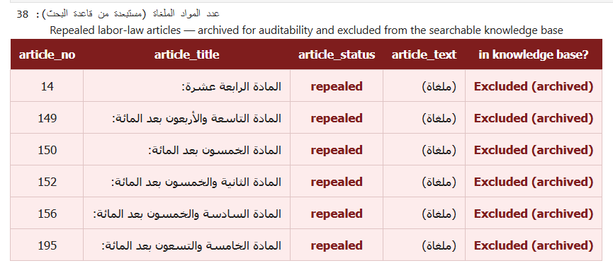
Figure 3.5. Sample of repealed (cancelled) labor-law articles that are archived for auditability and excluded from the searchable knowledge base.

FAQ Cleaning and Leakage-Safe Splitting
FAQ records are reviewed to remove incomplete, duplicated, noisy, or out-of-domain entries, retaining only records related to labor rights, employment contracts, termination, workplace regulations, and employment services. This keeps the FAQ collection focused on the labor-law domain. Examples of kept labor-related and excluded out-of-domain FAQ entries are shown in Figure 3.6.
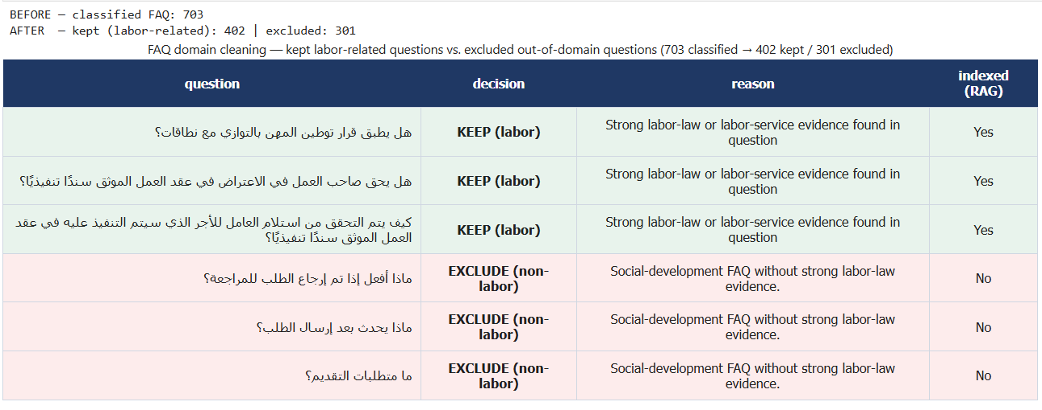
Figure 3.6. FAQ domain cleaning: examples of kept labor-related questions versus excluded out-of-domain questions (703 classified FAQ entries, of which 402 are retained and 301 excluded).
In this step, the FAQ records are separated into an indexed subset and a held-out evaluation subset using identifier-based separation. This design prevents evaluation items from being directly searchable during testing, thereby protecting the evaluation from data leakage.
Formally, this leakage-prevention constraint requires that the indexed record set and the held-out evaluation record set be disjoint: D_{index} ∩ D_{eval} = ∅, where D_{index} denotes the set of records placed in the searchable RAG knowledge base and D_{eval} denotes the held-out evaluation questions and gold references.

Near-Duplicate Detection
Duplicated or highly overlapping records were identified using a Term Frequency-Inverse Document Frequency (TF-IDF) representation computed over character n-grams (size 3–5, word-boundary analyzer); n-grams make the representation robust to partial textual overlap even when the wording is not identical. Each term was weighted by its TF-IDF value, as defined in Eq. (3.1), where tf(t, d) is the frequency of term t in record d, N is the total number of records, and df(t) is the number of records containing t. Cosine similarity was then computed between TF-IDF vectors: pairs reaching or exceeding a similarity of 0.90 were flagged as near-duplicate candidates, and pairs between 0.85 and 0.90 were flagged for manual review. Flagged candidates were reviewed and removed from the evaluation side when necessary to reduce evaluation bias [7].
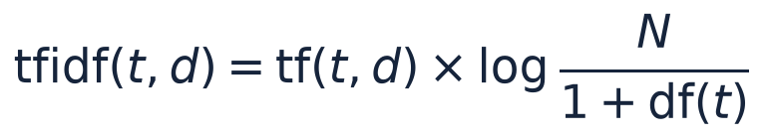
(3.1)

Chunking and Traceability
The corpus is segmented using two complementary strategies. Structural chunking splits the text along the natural legal-article and FAQ boundaries, so each chunk corresponds to a complete provision or question–answer pair, preserving the semantic unit. Fixed-size chunking, used as a baseline, splits the text into fixed windows of 500 words with an 80-word overlap that repeats a small number of words between consecutive chunks so information spanning a chunk boundary is not lost. Word-based rather than sub-word token-based windows are adopted because Arabic is a morphologically rich language; splitting at whitespace-delimited word boundaries reduces the risk of fragmenting a legal term, number, or article reference across two chunks. The two strategies are compared to measure their effect on retrieval quality in the experiments.
Each chunk is exported with traceability metadata — source type, article identifier, document category, section reference, and chunk identifier — and saved for use by the retrieval stage.
Preprocessing Output | Purpose
Cleaned legal articles | Provide standardized active legal records for the knowledge base.
Cleaned HRSD FAQ records | Provide service-oriented question-answer knowledge.
Held-out evaluation set | Support leakage-safe evaluation.
Structural chunks | Preserve article and FAQ boundaries.
Fixed-size chunks | Provide a baseline chunking strategy.
Data-quality and leakage audits | Document preprocessing checks and potential risks.
Table 3.3. Main preprocessing outputs.

Knowledge Base and Retrieval System
The knowledge base stores the legal and FAQ evidence employed by the answer-generation module. The retrieval system combines semantic retrieval, lexical retrieval, hybrid score fusion, and cross-encoder reranking to select evidence before any legal answer is generated.

Embedding and Indexing
The semantic retrieval component encodes legal articles and FAQ records into dense vector representations using multilingual embedding models, including multilingual-e5-large and bge-m3. The generated vectors are stored in ChromaDB, which provides persistent vector storage and similarity search [8], [9].
In parallel, a BM25 lexical index is constructed. BM25 is retained because exact legal terms, article references, and domain-specific expressions can be decisive in legal retrieval.

Retrieval Algorithms
The retrieval layer includes the following algorithms and retrieval configurations:
- Dense retrieval represents the query and each chunk as dense vectors produced by a multilingual neural embedding model, and ranks the chunks by their semantic similarity to the query, measured as the cosine similarity between the query vector q and the chunk vector d, as defined in Eq. (3.2). Because it operates on meaning rather than surface form, dense retrieval can recover relevant passages even when they do not share the exact wording of the query [10].
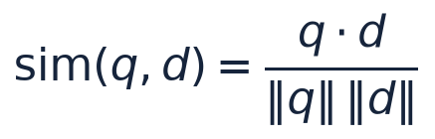
(3.2)
- BM25 retrieval is a classical lexical ranking function that scores a chunk by the frequency of the query terms it contains, weighted by their inverse document frequency and normalized by the chunk length, as defined in Eq. (3.3), where f(t, d) is the frequency of term t in chunk d, |d| is the chunk length, avgdl is the average chunk length, and k1 and b are tuning parameters set to k1 = 1.5 and b = 0.75. BM25 is effective for exact legal terminology, article numbers, and domain-specific expressions that a purely semantic model may overlook [11].
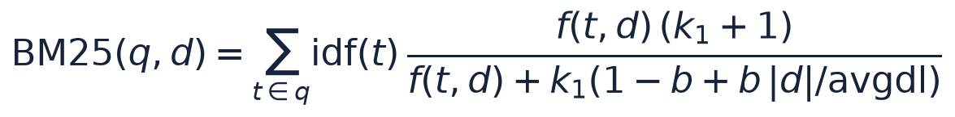
(3.3)
- Hybrid retrieval fuses the dense and BM25 scores into a single ranking using a weighted sum controlled by a parameter α (the dense weight), shown in the hybrid-score equation below, so semantic and lexical signals complement each other.
- Cross-encoder reranking re-scores the top hybrid candidates using a cross-encoder model (bge-reranker-v2-m3) that jointly encodes the query and each candidate passage. This joint encoding gives a more accurate relevance estimate than the independent encoding used in first-stage retrieval, reordering the candidates so the most relevant legal passage is ranked first [12], [13].
The hybrid score is computed as follows:
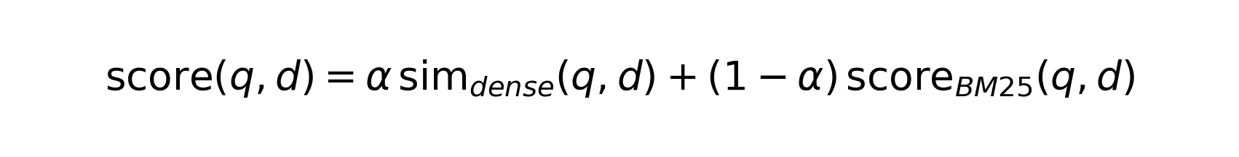
The dense and BM25 stages retrieved a candidate pool of 50 passages (candidate_k = 50), of which the top 5 (top-k = 5) were passed to the answer-generation layer. The hybrid weight α (the dense weight) was tuned over {0.65, 0.80, 0.90}, with α = 0.80 adopted in the final configuration; the reliability gate used a calibrated threshold of 0.65. The full comparison of these configurations and the selection of the best-performing setting are presented in Chapter 4.
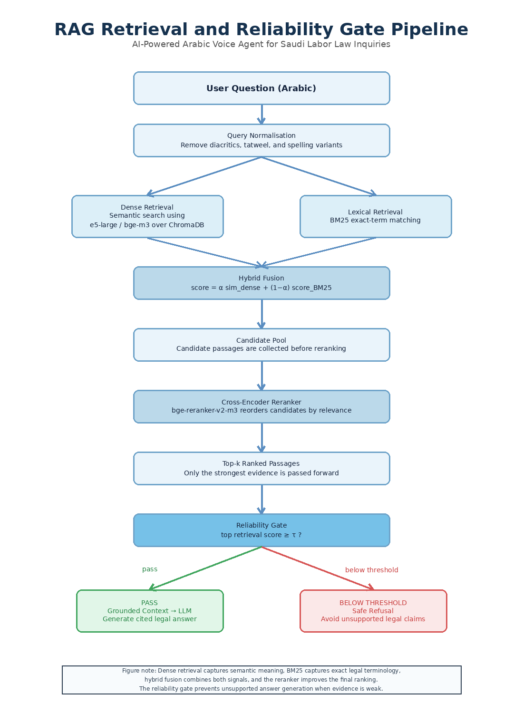
Figure 3.7. Retrieval, reranking, and reliability-gate pipeline used before grounded answer generation.
Figure 3.7 describes the retrieval pipeline. The Arabic query is first normalized to reduce orthographic variation. Dense semantic and BM25 lexical retrieval are then performed as complementary strategies, and their scores fused by hybrid scoring into a unified candidate ranking. A cross-encoder reranker reorders these candidates by joint query–passage relevance, after which the top-k evidence passages are selected for answer generation. Finally, the reliability gate checks whether the retrieved evidence is sufficiently strong; if it is not, the system activates a safe refusal instead of generating an unsupported answer.
The final retrieval configuration is selected through comparative evaluation on the held-out questions, combining the chunking strategies, embedding models, and retrieval algorithms described in this section. The numerical comparison, selected configuration, and latency trade-offs are presented in Chapter 4 to maintain the separation between methodology and results.

Answer Generation Module
The answer-generation module produces Arabic legal-information responses from retrieved evidence. The LLM does not query the knowledge base directly; it receives the selected evidence passages from the retrieval layer and answers only from that context.

Intent and Reliability Gates
An intent gate first classifies the user query as a legal-domain question, a conversational input, or an out-of-scope question. Legal-domain questions proceed through the full RAG pipeline. Conversational inputs are handled with controlled responses, and out-of-scope requests are refused to avoid unsupported legal statements. The reliability gate evaluates whether the retrieved evidence is sufficient for generation. If the retrieval confidence is below the calibrated threshold (τ = 0.65), the system abstains from generating a legal answer and returns a safe fallback response.

Language Models and Prompting Strategy
The generation layer employs local instruction-tuned LLM backbones, including ALLaM-7B and Qwen2.5-7B, under the same retrieval and prompting protocol. Both models were loaded with 4-bit NF4 quantization, and answer generation was capped at a maximum of 160 new tokens. Their comparative evaluation is presented in Chapter 4 [14], [15].
The prompt instructs the model to answer in Arabic, rely only on the retrieved Saudi Labor Law or HRSD FAQ context, cite the relevant legal article when available, avoid speculation, and refuse to answer when evidence is insufficient. This prompt design supports grounded legal-information assistance rather than unrestricted text generation.

Deterministic Legal Calculation Layer
Some labor-law inquiries require exact numerical computation, such as annual leave entitlement, end-of-service award, or notice period. For these cases, the system applies a deterministic calculation layer instead of relying on the LLM to perform arithmetic.
Computation | Article | Codified Rule
Annual leave | Article 109 | Annual leave entitlement is computed from service duration and prorated when required.
End-of-service award (termination) | Article 84 | The award is computed according to the termination entitlement formula stated in the law.
End-of-service award (resignation) | Article 85 | The resignation case applies the legally defined reduction levels according to service duration.
Notice period | Articles 75-76 | Notice-period entitlement and compensation in lieu are computed from contract and termination conditions.
When a numeric-entitlement query is detected, the layer extracts the required parameters from the user question, such as service duration, salary, and termination type. Missing parameters are requested from the user, and parameters supplied in earlier turns can be recovered from conversational memory. The calculation is then performed in code using codified legal rules.
Table 3.4. Legal provisions implemented in the deterministic calculation layer.

Although the numerical result is computed in code, the answer remains grounded because the system retrieves the relevant legal article text and presents it as supporting evidence. Interpretive questions that do not require calculation continue to follow the standard retrieval and generation pipeline. Figure 3.8 illustrates this hybrid routing, showing how a query is directed either to the deterministic calculator or to the RAG-LLM pipeline.
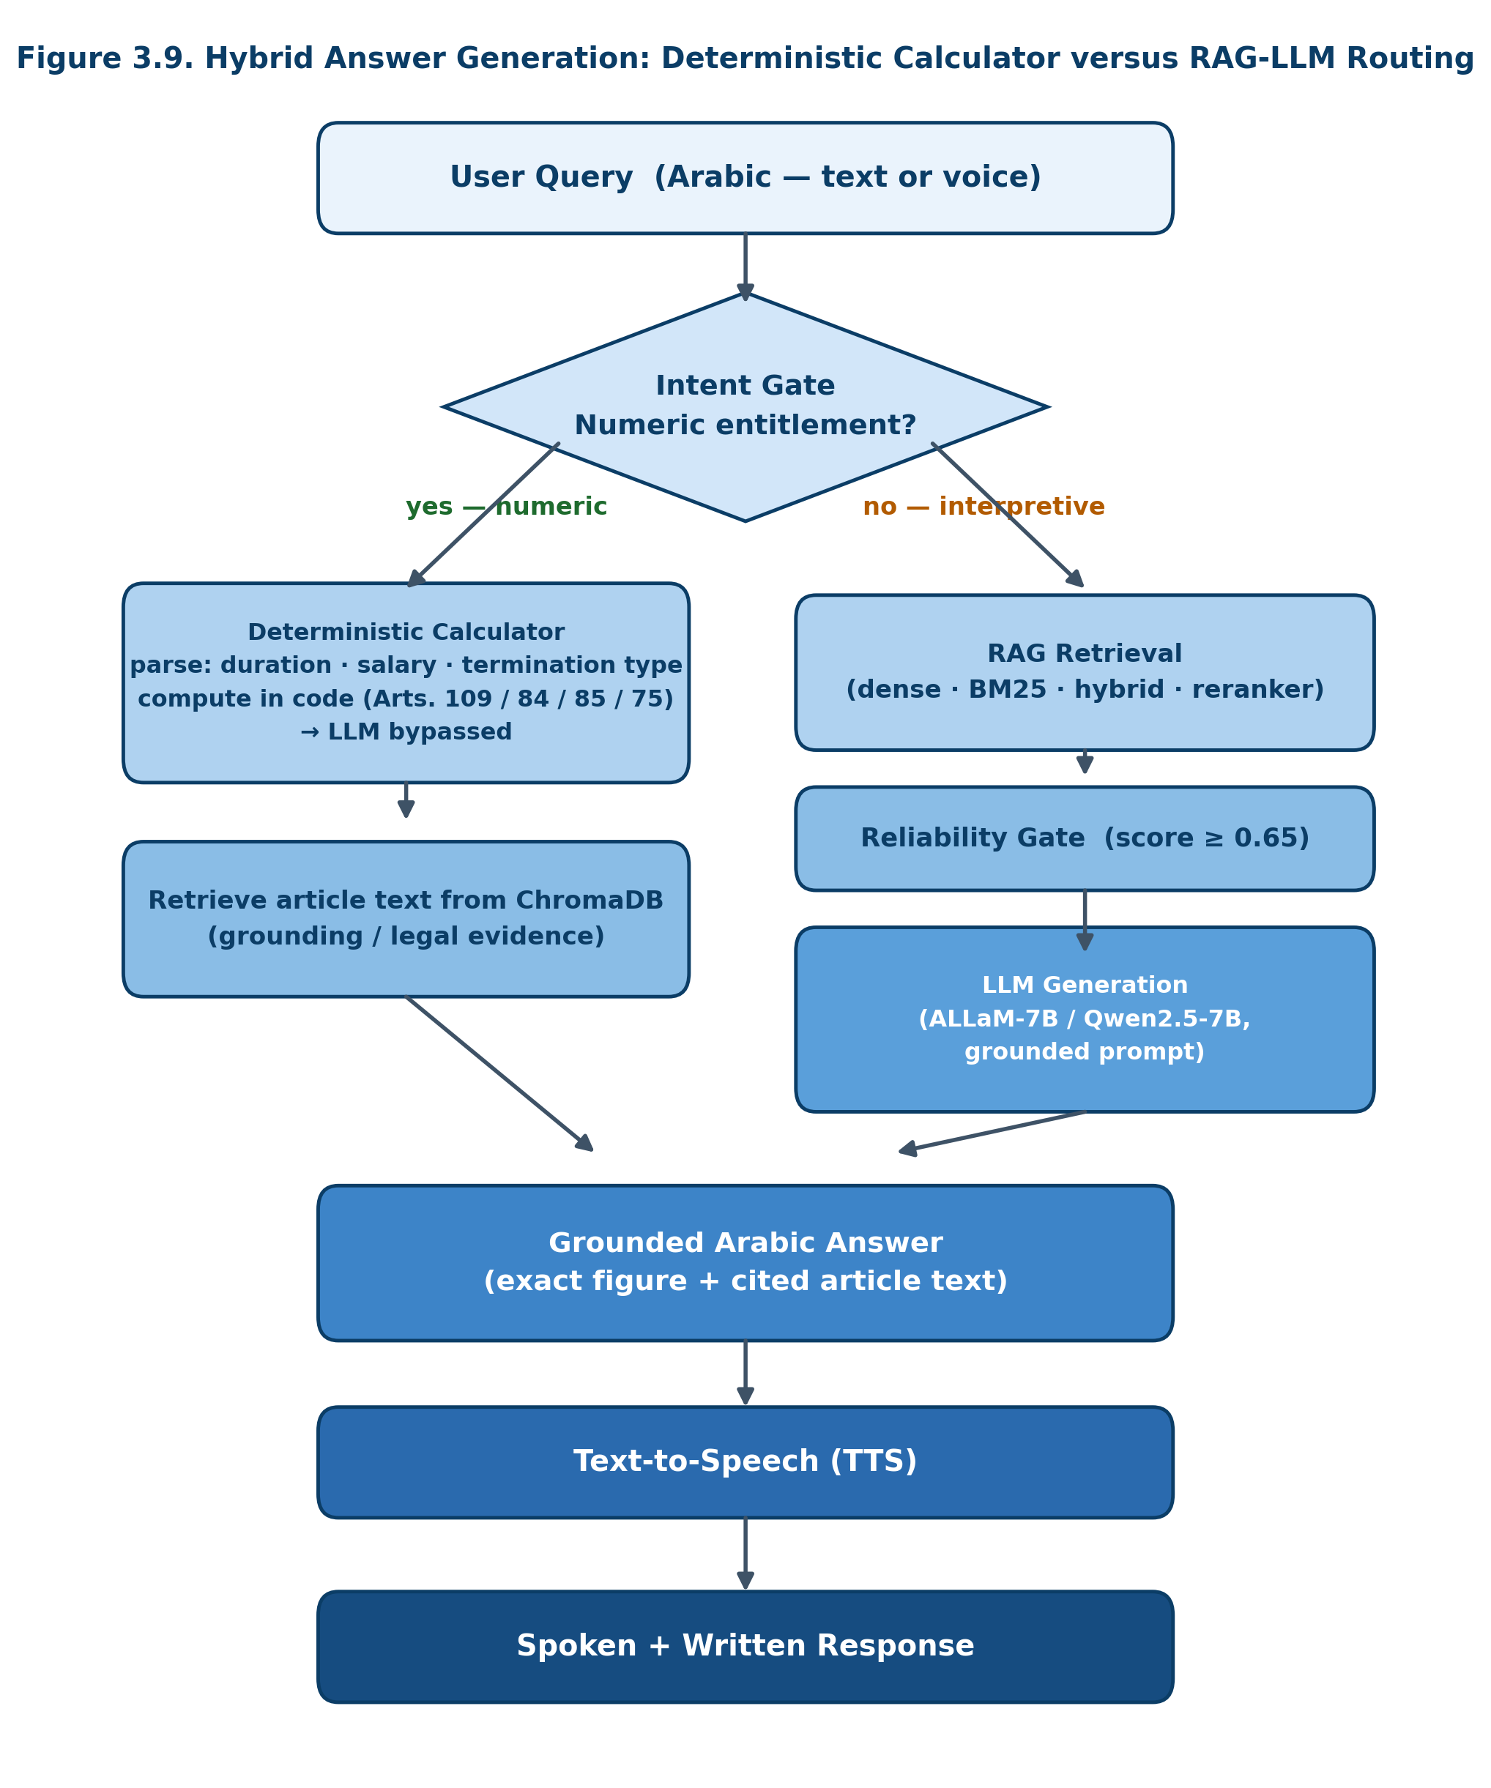
Figure 3.8. Hybrid answer generation: deterministic calculator versus RAG-LLM routing.

Voice Processing Layer
The voice-processing layer enables end-to-end spoken interaction. It converts user speech into text, routes the transcribed query through the same RAG pipeline used for typed questions, and converts the final Arabic answer into speech.
The ASR algorithm used in the main pipeline is Whisper-large-v3, with Whisper-small employed as a latency-oriented baseline. The TTS component, based on the MMS-TTS-Arabic model (facebook/mms-tts-ara), converts the generated Arabic text into audio output. The voice-layer evaluation is presented in Chapter 4 [5], [6].
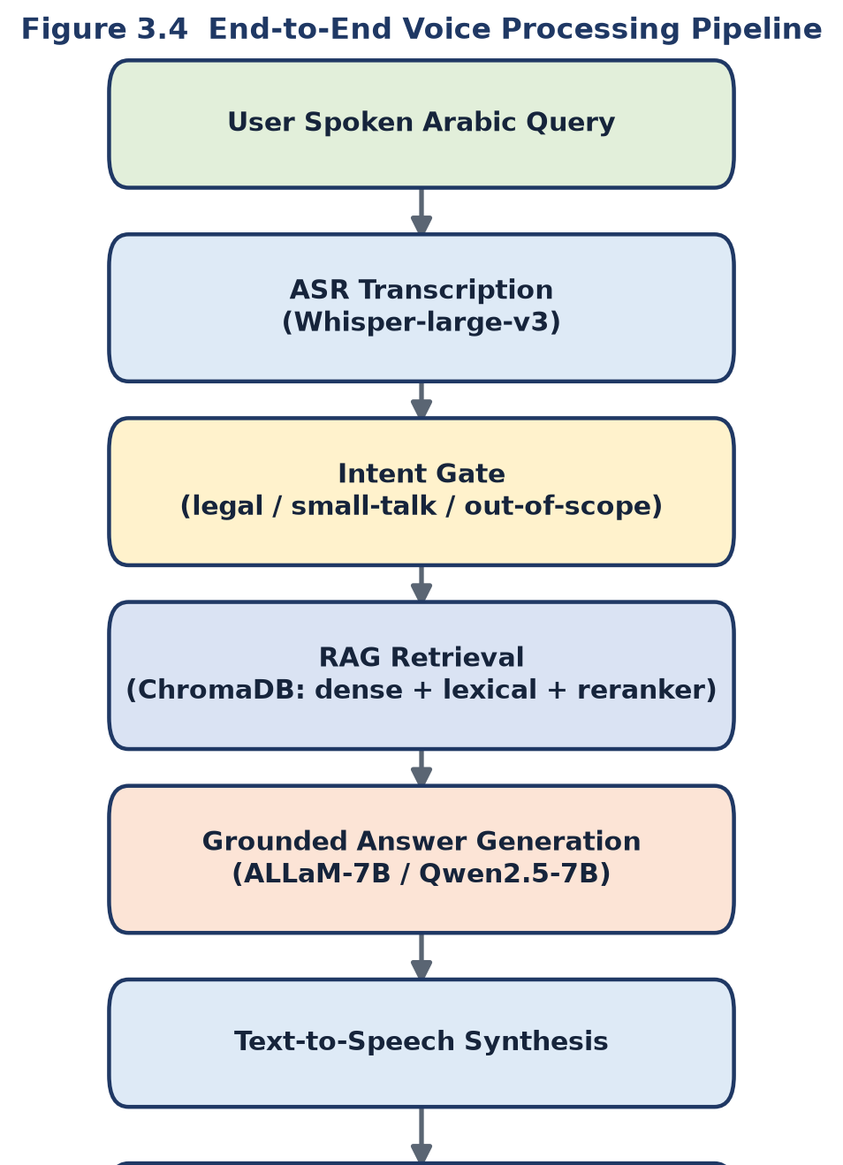
Figure 3.9. End-to-end voice processing pipeline.
Figure 3.9 describes the voice-processing pipeline step by step:
Step 1: The user submits a spoken Arabic query.
Step 2: The ASR algorithm transcribes the speech into text.
Step 3: The transcribed text is normalized and passed to the retrieval layer.
Step 4: The RAG layer retrieves relevant legal or FAQ evidence.
Step 5: The LLM generates a grounded Arabic answer from the retrieved evidence.
Step 6: The TTS engine synthesizes the final response as Arabic speech.
Step 7: The system returns both written and spoken outputs when voice mode is used.

Conversational Memory Module
The conversational memory module supports multi-turn interaction by retaining short-term conversational context. Its main function is query reformulation: a follow-up question is rewritten into a standalone legal query before retrieval.
Formally, the query reformulation is expressed as follows:
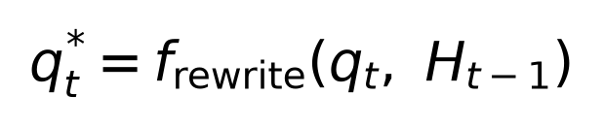
where q_t is the current user query, H_(t-1) is the previous conversation history, and q*_t is the rewritten standalone query that is passed to the retrieval layer.
For example, a follow-up such as "Can it be extended?" is expanded using the previous turn so that the retrieval layer receives a complete question. This design improves retrieval for ambiguous follow-up questions while preserving grounding in official sources.

Evaluation Methodology
The evaluation protocol assesses each layer of the system independently before interpreting the end-to-end behavior of the complete voice agent. The metrics are defined below by name, definition, formula, and methodological purpose. The numerical results are presented in Chapter 4.

Retrieval Evaluation Metrics
- Recall@k
Definition: Recall@k measures the proportion of evaluation questions for which the gold legal article appears within the top-k retrieved evidence passages.
Formula:
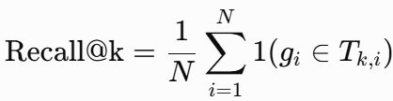
Use: This metric evaluates whether the retrieval layer retrieves the correct legal article within the evidence window.
- Mean Reciprocal Rank (MRR)
Definition: MRR is the average reciprocal rank of the first correct retrieved passage across evaluation questions.
Formula:
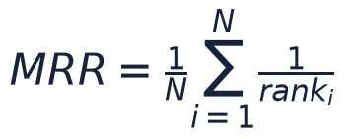
Use: This metric evaluates whether the correct legal article is ranked near the top of the retrieved list.
- nDCG@k
Definition: nDCG@k measures normalized ranking quality by rewarding relevant evidence placed at higher ranks.
Formula:
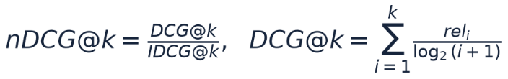
Use: This metric evaluates the ranking quality of the retrieved evidence passages.
- Reliability Threshold
Definition: The reliability threshold is the minimum retrieval confidence required before answer generation is enabled.
Formula:
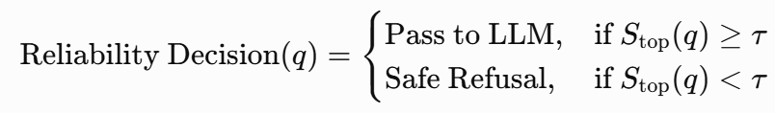
Use: This decision rule prevents the LLM from generating a legal answer when retrieved evidence is weak.
Precision@k is not employed as a primary metric in this setting because each legal question is associated with a single gold article. Recall@k and MRR are more informative for single-gold retrieval evaluation.

Answer Generation Metrics
- Answer Accuracy
Definition: Answer accuracy is the fraction of generated answers judged legally correct according to the evaluation rubric.
Formula:

Use: This metric supports comparison of LLM behavior under the same retrieved context.
- Faithfulness
Definition: Faithfulness measures the proportion of answer claims that are supported by the retrieved context.
Formula:
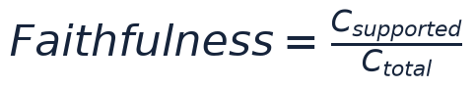
Use: This metric evaluates whether generated responses remain grounded in official retrieved evidence.
- Hallucination Rate
Definition: Hallucination rate is the fraction of generated answers that contain unsupported information or fabricated legal claims.
Formula:

Use: This metric quantifies the risk of unsupported legal generation.
- Wrong Citation Rate
Definition: Wrong citation rate is the fraction of generated answers that cite an incorrect or unsupported legal article.
Formula:
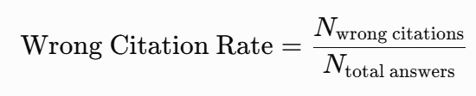
Use: This metric evaluates citation reliability in grounded and baseline generation settings.

Voice and Latency Metrics
- Word Error Rate (WER)
Definition: WER measures word-level transcription error in ASR output.
Formula:

Use: This metric evaluates Arabic ASR transcription quality.
- Character Error Rate (CER)
Definition: CER measures character-level transcription error in ASR output.
Formula:

Use: This metric captures Arabic spelling and character-level transcription errors.
- TTS Intelligibility Proxy
Definition: The TTS intelligibility proxy synthesizes text into speech, retranscribes the audio, and compares the transcription with the original text.
Formula:
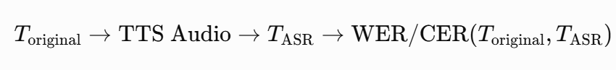
Use: This metric estimates whether synthesized Arabic speech remains understandable.
- End-to-End Latency
Definition: End-to-end latency is the total time from user input to final system response.
Formula:
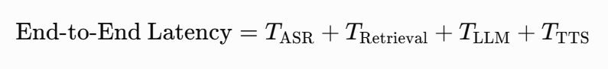
Use: This metric evaluates practical usability in real-time interaction.
- Time-to-First-Response (TTFR)
Definition: TTFR is the time until the first streamed response segment reaches the user.
Formula:
Use: This metric evaluates perceived latency when streaming is enabled.

Statistical Testing and Ablation Metrics
- Bootstrap 95% Confidence Interval
Definition: A bootstrap confidence interval is a non-parametric interval estimated by repeated resampling of the evaluation set.
Formula:
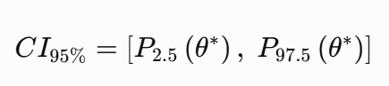
Use: This metric estimates uncertainty around retrieval, generation, voice, and latency measurements.
- McNemar Exact Test
Definition: McNemar’s exact test is employed for paired comparison when two systems are evaluated on the same questions. The variables b and c represent discordant paired outcomes.
Formula:

Use: This test examines whether the difference between two paired systems is statistically significant.
- Ablation Difference
Definition: Ablation difference measures the change in performance after removing or modifying a system component.
Formula:
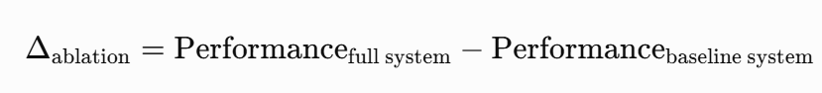
Use: This metric estimates the contribution of components such as RAG, reranking, or latency control.

Module | Metrics Defined
RAG Retrieval | Recall@k, MRR, nDCG@k, reliability decision rule
Answer Generation | Answer accuracy, faithfulness, hallucination rate, wrong citation rate
Voice Layer | WER, CER, TTS intelligibility proxy
Latency | End-to-end latency, time-to-first-response
Statistical and Ablation Analysis | Bootstrap confidence interval, McNemar exact test, ablation difference
Table 3.5. Metrics defined for the final experiments. Numerical results are discussed in Chapter 4.

Experimental Setup and Reproducibility
The experimental workflow was implemented in Python. Persistent intermediate outputs were saved after each stage so that later experiments could be repeated without rerunning the complete pipeline. The vector database was implemented using ChromaDB, and the retrieval and generation settings were documented in configuration files.
Local models were employed for embedding, reranking, ASR, and answer generation. The main embedding algorithms were multilingual-e5-large and bge-m3, the reranking model was bge-reranker-v2-m3, the ASR model was Whisper-large-v3, and the generation backbones included ALLaM-7B and Qwen2.5-7B. All performance values and selected hyperparameters are presented in Chapter 4 to maintain the separation between methodology and results. The hardware and software environment and the principal library versions are summarized in Table 3.6 and Table 3.7, respectively.
Component | Specification
Development platform | Anaconda (conda environment), Jupyter Notebook
Operating system | Windows 11 Pro
Programming language | Python 3.13
Processor (CPU) | AMD Ryzen 9 9950X3D (16-core)
Memory (RAM) | 128 GB
GPU | NVIDIA RTX 5090, 32 GB
CUDA toolkit | 12.8
Deep-learning framework | PyTorch 2.12
Random seed | 42 (fixed across all stochastic components)
Table 3.6. Hardware and software environment used in the experiments.
Library | Version
pandas | 3.0.3
NumPy | 2.4.6
scikit-learn | 1.9.0
BeautifulSoup4 | 4.14.3
Selenium | 4.44.0
Sentence Transformers | 5.5.1
Transformers | 5.12.1
ChromaDB | 1.5.9
PyTorch | 2.12.0
Table 3.7. Principal Python libraries and their versions.

Summary
This chapter presented the methodology and proposed framework for the AI-powered Arabic voice agent for Saudi Labor Law inquiries. The methodology covers official data collection, structured preprocessing, ChromaDB-based knowledge-base construction, hybrid retrieval with reranking, guarded LLM answer generation, deterministic legal calculation, ASR/TTS voice processing, conversational memory, and component-level evaluation metrics. The chapter intentionally avoids presenting experimental results; the numerical findings, model comparisons, and ablation outcomes are presented in Chapter 4.

References
[1] Saudi Ministry of Human Resources and Social Development (HRSD). Saudi Labor Law. Official HRSD legal-information webpage.
[2] Saudi Ministry of Human Resources and Social Development (HRSD). Frequently Asked Questions (FAQ). Official HRSD service-information webpage.
[3] P. Lewis, E. Perez, A. Piktus, F. Petroni, V. Karpukhin, N. Goyal, H. Kuttler, M. Lewis, W.-T. Yih, T. Rocktaschel, S. Riedel, and D. Kiela, 'Retrieval-Augmented Generation for Knowledge-Intensive NLP Tasks,' NeurIPS, 2020.
[4] Y. Gao, Y. Xiong, X. Gao, K. Jia, J. Pan, Y. Bi, Y. Dai, J. Sun, and H. Wang, 'Retrieval-Augmented Generation for Large Language Models: A Survey,' arXiv preprint, 2024.
[5] A. Radford, J. W. Kim, T. Xu, G. Brockman, C. McLeavey, and I. Sutskever, 'Robust Speech Recognition via Large-Scale Weak Supervision,' Proceedings of ICML, 2023.
[6] V. Pratap et al., 'Scaling Speech Technology to 1,000+ Languages,' Journal of Machine Learning Research, vol. 25, 2024.
[7] G. Salton and C. Buckley, 'Term-weighting approaches in automatic text retrieval,' Information Processing & Management, vol. 24, no. 5, pp. 513-523, 1988.
[8] L. Wang, N. Yang, X. Huang, et al., 'Multilingual E5 Text Embeddings: A Technical Report,' arXiv:2402.05672, 2024.
[9] J. Chen, S. Xiao, P. Zhang, et al., 'BGE M3-Embedding: Multi-Lingual, Multi-Functionality, Multi-Granularity Text Embeddings,' arXiv:2402.03216, 2024.
[10] N. Reimers and I. Gurevych, 'Sentence-BERT: Sentence Embeddings using Siamese BERT-Networks,' Proceedings of EMNLP, 2019.
[11] S. Robertson and H. Zaragoza, 'The Probabilistic Relevance Framework: BM25 and Beyond,' Foundations and Trends in Information Retrieval, vol. 3, no. 4, 2009.
[12] S. Xiao, Z. Liu, P. Zhang, and N. Muennighoff, 'C-Pack: Packed Resources for General Chinese Embeddings,' Proceedings of SIGIR, 2024.
[13] R. Nogueira and K. Cho, 'Passage Re-ranking with BERT,' arXiv:1901.04085, 2019.
[14] M. S. Bari et al., 'ALLaM: Large Language Models for Arabic and English,' arXiv preprint, 2024.
[15] Qwen Team, 'Qwen2.5 Technical Report,' arXiv:2412.15115, 2024.

