📚 Literature Review

AI-Based Early Warning System for Academic Risk Detection in Education

Student 1: Marya Mohammed Bawazir ID: 253000692
Student 2: Hala Haytham Hajjar ID: 253001456

Overview:
The goal of this project is to create an early warning system that uses AI to identify students who may face behavioral or educational issues. The system analyzes student behavior, including attendance, assignment performance, classroom participation, and patterns of digital activity, using actual data from the Classera platform. In order to support students and enhance academic performance, machine learning algorithms identify early indicators of risk and automatically send out alerts to teachers or school counselors. The Final Mark is the target variable (Y). It will be converted to a binary risk label in order to create an early warning system, with students falling below a predetermined threshold being categorized as at-risk. In order to anticipate this risk level in advance, the model will learn from engagement and behavioral characteristics.

Table of Contents
List of Abbreviations...................................................................................... xiv
List of Figures................................................................................................. xvi
List of Tables.................................................................................................. xviii

Chapter 1: Introduction…………………………………………………….…….……1
1.1 Problem Definition…………………………………………………………………...2
1.2 Thesis objectives……………………………………………………………..…...…3
1.3 Thesis Contribution……………………………………………………………..……4
1.4 Thesis Organization …………………………………………………….…..………5
Chapter 2: Background and Related Work…………………………………………….10
2.1 Background………………………………………………………………….………..10
2.1.1 Artificial Intelligence (AI)......................................................................10
2.1.2 Machine Learning (ML).......................................................................10
2.1.3 Types of Machine Learning……………………………………………….10
2.1.4 Classification……………………………………………………………….11
2.1.5 Machine Learning Algorithms……………………………………………11
2.1.6 Model Evaluation Metrics…………………………………………..……..12
2.1.7 Impact of Artificial Intelligence in Education……………………………..12
2.2 Related Work………………………………………………………………….………..10
Chapter 3: Proposed Approach ..............................................................................
4.1 Introduction ...........................................................................................................

Chapter 4: Experimental Results and Discussion ............................................

Chapter 5: Conclusion and Future Work ...........................................................
7.1 Important Features ...........................................................................................
7.3 Future Work .....................................................................................................

References .............................................................................................................27

List of Abbreviations :
• Acc.: Accuracy
• ANN: Artificial Neural Network
• ML: Machine Learning
• XAI: Explainable Artificial Intelligence
• SVM: Support Vector Machine
• RF: Random Forest
• DT: Decision Tree
• KNN: K-Nearest Neighbors
• DL: Deep Learning
•NV: Naïve Bayes
• CNN: Convolutional Neural Network
List of Figures :
Fig. 1 Artificial Intelligence (AI)….........................................................................
Fig. 2 Machine Learning (ML)…...........................................................................
Fig. 3 Decision Tree (DT)...................................................................................
Fig. 4 Random Forest (RF)..................................................................................
Fig. 5 k-Nearest Neighbors (KNN).......................................................................
Fig. 6 Support Vector Classifier (SVC) ................................................................
Fig. 10 Proposed Framework…………………………………………………………
Fig. 11 …...............................................................................
Fig. 12 …...............................................................................
Fig. 13 .................................................................................
Fig. 14 Results of Individual Models.......................................................................
Fig. 15

List of Tables:
2.2 Table of Reviewed Papers…………………………

Chapter 1 Introduction

1.1 Problem Definition
Despite the increasing availability of student data in educational sectors, many systems still face challenges in identifying students at academic risk on an early basis to allow them to intervene effectively.Traditional evaluation methods often rely on certain and usual results, This reduces the opportunity of providing timely support or implementing appropriate personalized intervention plans. The lack of this diagnostic plan is an additional risk, as each student's skills ,goals, and needs vary, necessitating early diagnosis to provide individualized support.
Furthermore, educational data is very complicated and varied. It includes demographic information, behavioral data, attendance records, and interactions within Learning Management Systems (LMS). This makes it difficult to figure out which factors have the biggest effect on predicting academic performance. This data is also often huge and hard to understand, which makes it even harder to analyze and make decisions.
Moreover, including irrelevant or less important features in predictive models can lead to several issues such as overfitting, higher computational cost, and reduced interpretability. This highlights the importance of applying effective feature selection techniques that focus on the most relevant variables and support the development of accurate and interpretable models.
On the other hand, Artificial Intelligence (AI), including Machine Learning (ML) and Deep Learning (DL), provides powerful tools to analyze educational data and predict student performance. These techniques can detect complex patterns in student engagement, participation, and learning behavior, enabling early identification of at-risk students. However, the effectiveness of these models depends on data quality, appropriate feature selection, and model transparency.
Therefore, there is a strong need to develop a data-driven Early Warning System based on AI techniques to predict students at risk at an early stage. Such a system can classify students into different risk levels (low, medium, high), allowing educational institutions to make proactive, data-driven decisions and provide timely and personalized interventions.
This research addresses the lack of intelligent and effective early detection mechanisms by developing a classification framework based on AI techniques using LMS data. The aim is to improve student performance, reduce academic failure and dropout rates, and enhance the overall quality of education.

1.2 Thesis Objectives
The primary objective of this study is to develop an AI-based early warning system to classify students’ academic risk levels using machine learning techniques. The system leverages data from Learning Management Systems (LMS), including academic performance, engagement behavior, and demographic attributes, to identify at-risk students at an early stage. The study transforms the outcome (Final Mark) into a classification problem (Low, Medium, High) to support more effective decision-making. It applies data pre-processing and feature engineering to enhance data quality and model performance. Multiple classification algorithms are employed within a stacking ensemble framework to improve predictive accuracy and reliability by combining the strengths of different models. Evaluation metrics such as accuracy, precision, and recall are used, with a particular focus on recall to ensure effective detection of at-risk students. Ultimately, the system aims to enable early intervention, improve student performance, and support data-driven decision-making in educational institutions.

1.3 Thesis Contribution
1.4 Thesis Organization

3 Framework Idea

Three-Class Classification Scheme:
- 🔴 Class 0 (Low – At Risk)
Final Mark < 50
- 🟡 Class 1 (Medium)
50 ≤ Final Mark < 75
- 🟢 Class 2 (High – Good)
Final Mark ≥ 75
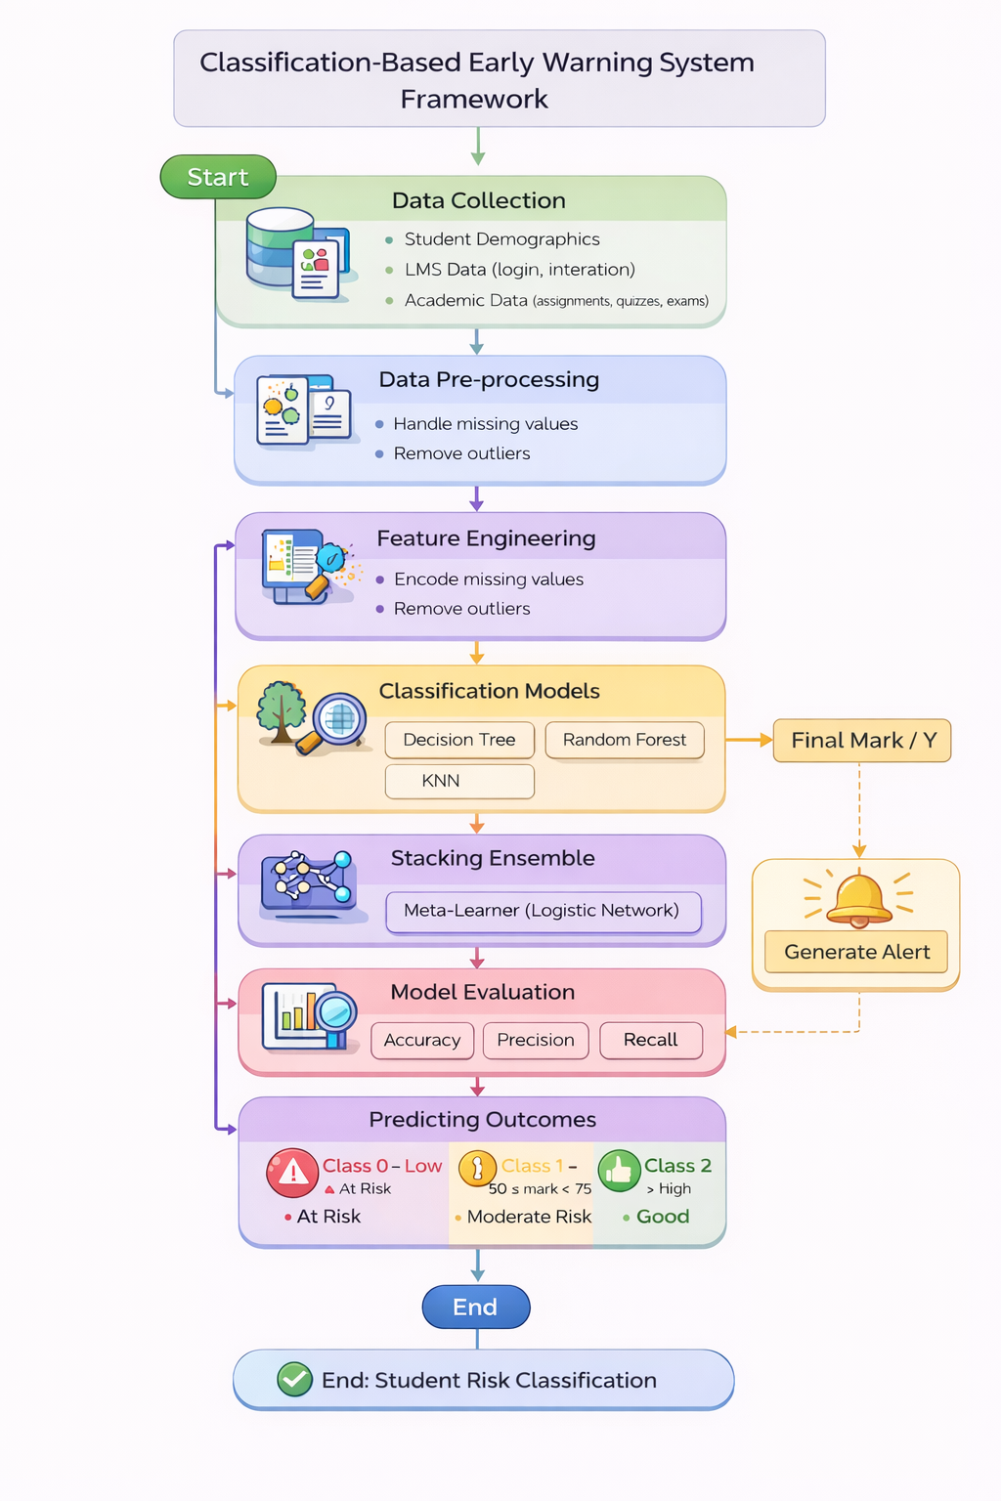
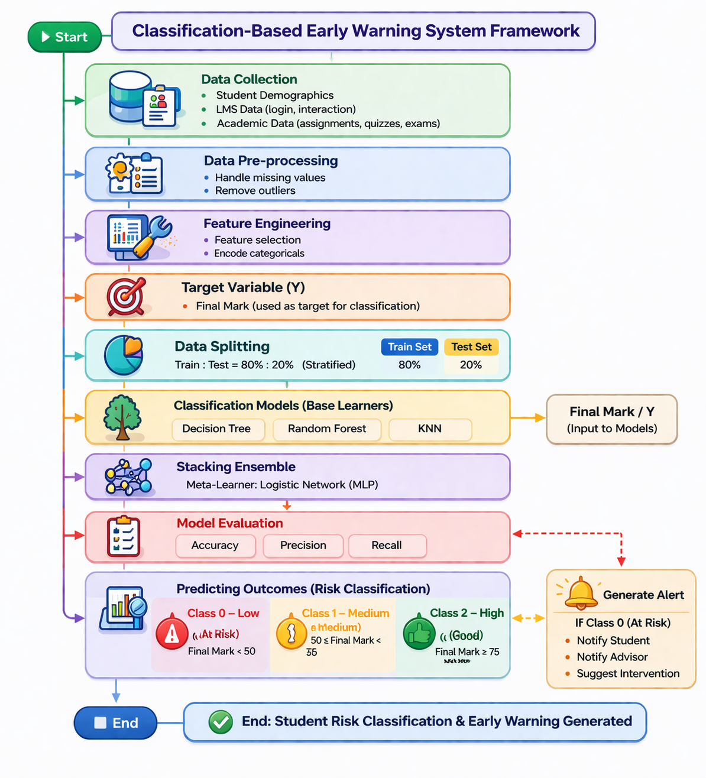
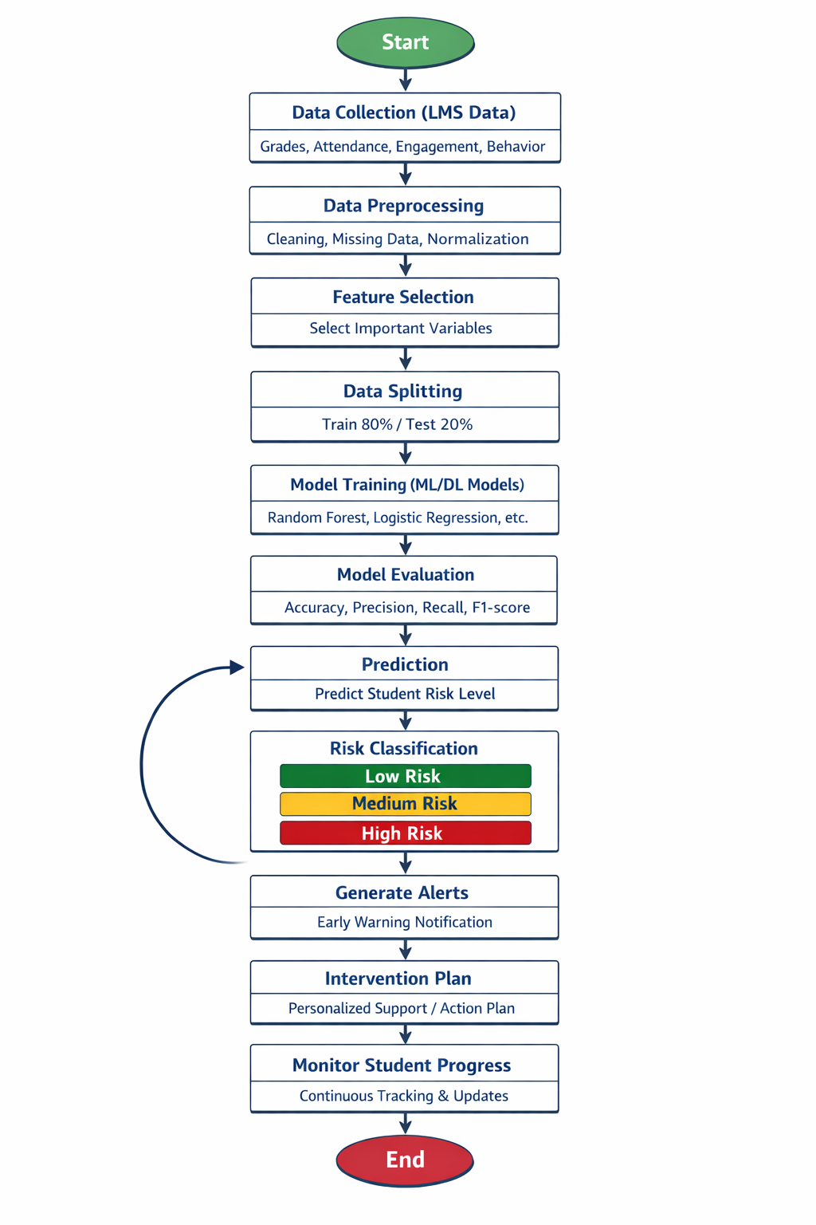
Chapter 2 Background and Related Work

2.1 Background

2.1.1 Artificial Intelligence (AI)
The ability of computer systems to do tasks like learning, reasoning, decision-making, and problem-solving that require human intelligence is known as Artificial Intelligence. Systems analyze massive data using computational methods to produce predictions. AI is used more and more in the field of education to evaluate student data and assist with decision-making processes like identifying students who are at risk and enhancing learning outcomes [16].
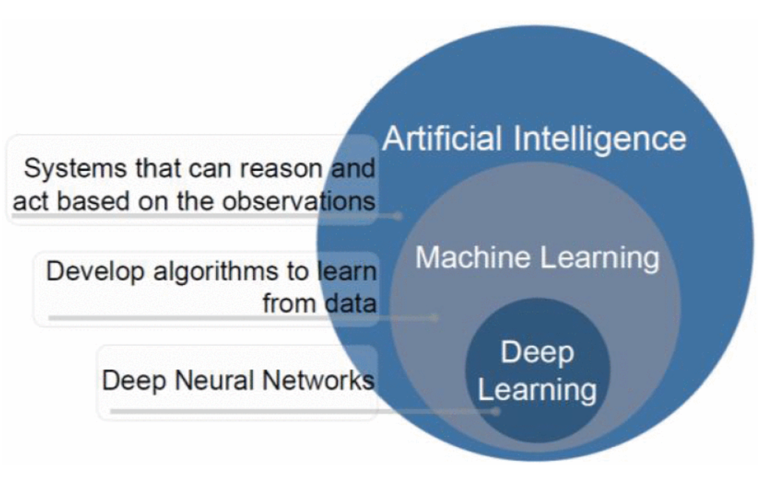Fig. 1. AI [22]

2.1.2 Machine Learning (ML)
It is a branch of artificial intelligence that focuses on creating algorithms that, without explicit programming, enable computers to recognize patterns in data and perform better. It can be used to predict or classify new data after being trained on historical data. Because it allows for examining massive amounts of data of students and finding their performance, machine learning (ML) is crucial to educational data mining and learning analytics. (Pattern Recognition and Machine Learning) [17] .

2.1.3 Types of Machine Learning(ML)
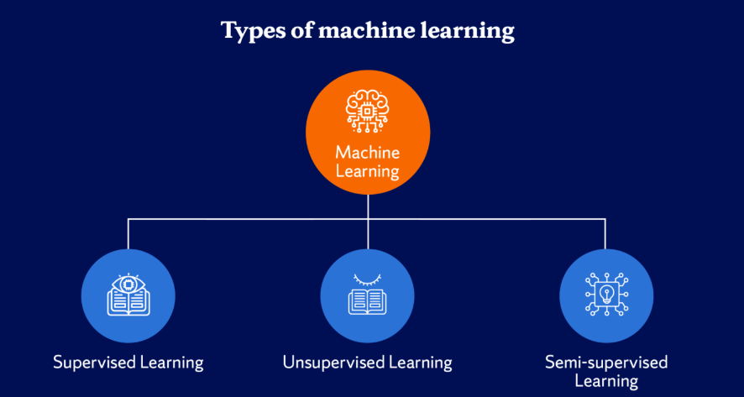

Fig. 2. Types of Machine Learning [23]

1. Supervised Learning
The model is trained using labeled data in this machine learning method. There is an input and an output label for every training example. Learning a mapping between inputs and outputs is the aim of supervised learning, which enables the model to correctly predict the output for fresh, unseen data [18].

2. Unsupervised Learning
It uses unlabeled data to train models. In this kind of learning, the algorithm looks for unidentified patterns or structures in the data. In unsupervised learning, clustering and association rule learning are popular methods[17] .

3. Semi-Supervised Learning
It includes both labeled and unlabeled data. This method works well when there is a lot of unlabeled data but little labeled data. By utilizing both kinds of data, it can enhance model performance [18] .

2.1.4 Classification
Predicting a categorical label for a given input is the goal of this kind of supervised learning task. For instance, classification algorithms can be used in educational systems to assess a student's risk level based on behavioral and academic data [19].

2.1.5 Machine Learning Algorithms

1. Decision Tree (DT)
It is a supervised learning algorithm that uses a tree structure to represent decisions. A feature is represented by each internal node, a decision rule by each branch, and a class label by each leaf node. Decision trees are frequently used in classification problems because they are simple to understand [19].
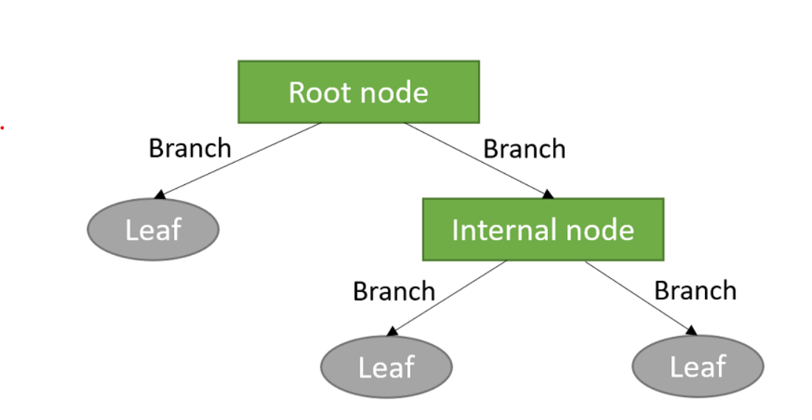

Fig. 3. Decision Tree structure [24].

2. Random Forest (RF)
Many decision trees are combined in the Random Forest groups learning technique to increase prediction accuracy and decrease overfitting.it is subset of the dataset is used to train each tree in the forest, and the final prediction is produced by adding up all of the trees' predictions [19].
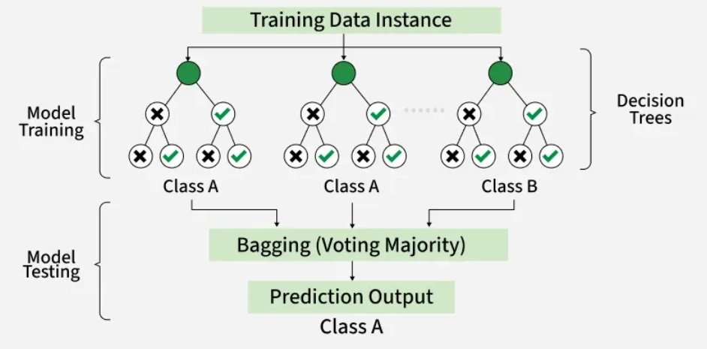
Fig. 4. Random Forest algorithm structure [25].

3. k-Nearest Neighbors (KNN)
k-Nearest Neighbors uses the classes of a data point's closest neighbors in the feature space to predict the data point's class. It uses Euclidean distance, and other distance metrics are used by the algorithm to determine similarity [17].

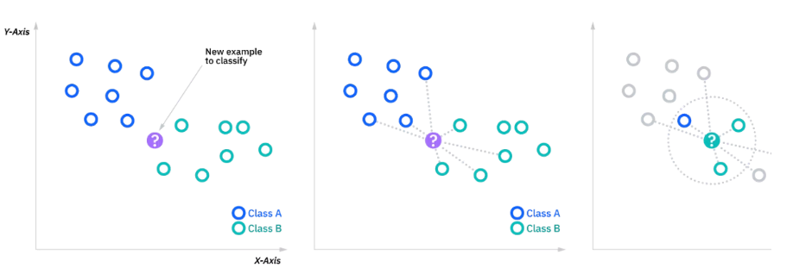

Fig. 5. k-Nearest Neighbors (KNN) classification [26].

4. Support Vector Machine (SVM)
It is a supervised learning algorithm for tasks involving regression and classification. To find the best hyperplane that divides data points from various classes, with the greatest margin, is how it operates [17].
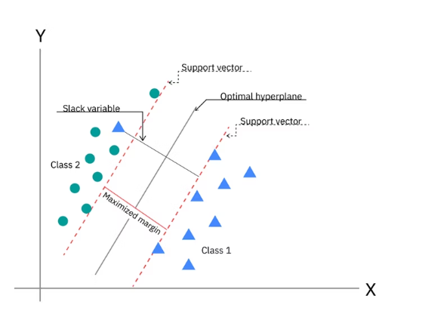

Fig.6. SVM [27].

5. Naïve Bayes (NV)
It is an algorithm of classification. it makes the assumption that features are conditionally independent, it makes computation easier, and enables the model to work great even with massive datasets [18].

2.1.6 Model Evaluation Metrics
Model evaluation metrics are used to check how well classification models work and make sure they make accurate predictions, which is especially important in serious situations like finding students who are at risk[19].

1. Accuracy
It is the percentage of correctly predicted cases among all of the model's predictions.
Accuracy = TP+TN / FP+FNTP+TN​
Where: TP = True Positives, TN = True Negatives, FP = False Positives, FN = False Negatives. It is simple and intuitive; however, not deal with imbalanced datasets [19].

2. Precision
It is the percentage of correctly predicted positive cases among all predicted positive cases.
Precision = TP/ FP + TP​ , where it is important when the cost of false positives is high[19].

3. Recall
It is sometimes referred to as sensitivity, which gauges how well the model can identify real positive examples.
Recall=TP/ FN+TP​
When there is a positive case (like a student who is at risk), recall is very important[19].

4. F1-Score
When working with imbalanced datasets, the F1-score—which is the harmonic mean of precision and recall—offers a fair assessment of model performance.
F1-Score=2×Precision×Recall​ / Precision+Recall
This is especially helpful when you have datasets that aren't balanced, and you need both precision and recall [19].

2.1.7 Impact of Artificial Intelligence in Education
using Artificial Intelligence (AI) in education, allowing teachers to identify possible academic challenges early on and take prompt corrective action. Academic risk can be predicted by analyzing student performance data using a variety of machine learning(ML) algorithms. Educational institutions can increase student retention, improve academic support strategies, and make better decisions about student success and educational planning by utilizing AI-based predictive models[20,21].

2.2 Related Work:

Bettahi et al.[1] introduced Completion-aware Risk Neural Ordinary Differential Equations (CR-NODE), which integrated continuous-time dynamics with completion-focused features to predict early dropout. Data collected from the Canvas Learning Management System at a large public university over multiple academic terms comprise comprehensive longitudinal records of student interactions. It includes 100,878 student enrollments with final grade information, from which we extracted 89,734 valid temporal sequences that satisfy the minimum observation requirements. To ensure temporal consistency and data quality, data preprocessing involved several steps. There were several steps in data preprocessing to make sure that the data was consistent over time and of good quality. They used six different baseline methods (Logistic Regression, Random Forest, XGBoost, Gradient Boosting, LSTM, and Basic Neural ODE) to compare CR-NODE and set comprehensive performance benchmarks. The results showed that CR-NODE had the best balance between the rates of true positives and true negatives. Explainable Artificial Intelligence (XAI) was used to understand model predictions.

Ujkani et al. [2]proposed a model based on a convolutional neural network(CNN), LSTM, and XGBOOST. They used a dataset that was collected from the Open University Learning Analytics Dataset. It includes 32,593 students over a 9-month course period from 2014 to 2015. Different pre-processing steps were applied for predicting students’ success: Merge and Consolidate, Missing Value Handling, Feature Engineering, and Data Splitting. Different deep learning (DL) and machine learning (ML) models for forecasting students' success. To comprehend the prediction of models, the Random Forest Classifier, Gradient Boosting Classifier, k-Nearest Neighbors (k-NNs), Multi-Layer Perceptron (Neural Network), First Custom Neural Network Architecture, Second Custom Neural Network Architecture, and Explainable Artificial Intelligence (XAI) were employed. LSTMs were employed for training and assessment. Their findings show that, when compared to models for predicting students' success, their proposed models performed with the best accuracy, up to 94%. The models' predictions were analyzed using Explainable Artificial Intelligence (XAI), Random Forest Classifier, and Gradient Boosting Classifier.

The proposed RADAR system by Embarak et al.[3] used statistical analysis and machine learning algorithms to identify patterns and trends in the data that indicate a student was at risk of falling behind or dropping out. A dataset of students from a school district was used to train the system; the data was gathered and appropriately preprocessed (feature integration, data cleaning, and feature selection). It could be used to set goals, assess strengths and weaknesses, identify patterns and trends that indicate a student is at risk of dropping out, identify early warning signs of a student struggling or falling behind, and provide targeted interventions and support. PAP could be used to evaluate a student's college readiness and predict their likelihood of succeeding in higher education. By comparing these systems, Embarak et al. pinpoint their shortcomings. Systems built on XAI can analyze a wide range of data sources and account for other risk factors for students. To analyze data and identify patterns, machine learning algorithms such as decision trees are employed. Students were predicted by the system using predefined thresholds, chosen features, and recognized patterns. Individualized interventions and ongoing evaluation were subsequently made possible by the prediction results. The results of the study demonstrate how the RADAR system can improve the guidance and support given to at-risk students, ultimately leading to improved academic performance.

Macfadyen [4] introduced how Learning Management System (LMS) data could be used to predict academic performance and identify at-risk students. The dataset for this study was collected from the University of British Columbia's Blackboard Vista Learning Management System (LMS) in Canada. This dataset included student activity logs, which contained information on discussion participation, assessment completion, email exchanges, interaction patterns, and login frequency. These metrics were then used to analyze students' online activities and, ultimately, to predict their academic results. During the preprocessing phase, data were extracted from the LMS and prepared for further analysis. Crucial factors pertinent to academic achievement were identified, encompassing discussion engagement, messaging frequency, assessment performance, and login patterns. The dataset underwent a cleaning process, entailing the removal of incomplete records, and was then structured for predictive modeling (PM). This investigation utilized regression modeling (RM) to construct a predictive model (PM) of student academic performance, leveraging activity data sourced from the Learning Management System (LMS). Furthermore, logistic regression (LR) was employed to pinpoint at-risk students and to anticipate potential academic failure. In addition, network analysis was performed to examine student interaction patterns and to identify students who were disengaged within discussion forums. The results indicated that LMS activity data could effectively predict student performance. The regression model explained more than 30% of the differences in students' final grades. Moreover, the logistic regression model correctly identified about 81% of the students who were likely to fail.
Queiroga et al.[5] Introduced a study that aimed to predict at-risk students in high school (secondary) education using machine learning and learning analytics. The study showed the dataset preprocessing steps, modeling methods, and bias analysis used to build predictive models. Furthermore, the significance of leveraging students' prior academic achievements to forecast their subsequent performance was emphasized. The dataset collected in this study was sourced from the National Administration of Public Education (ANEP) in Uruguay. This dataset encompassed nine distinct educational systems and documented students' academic trajectories from primary to secondary education, spanning the years 2015 to 2020. It comprised data pertaining to 258,440 students, encompassing grades, attendance records, demographic details, and school-specific information. Data preprocessing was applied as well before building the models. This included cleaning the data, integrating multiple educational databases, converting the data into a time-series format, and creating new features. Exploratory Data Analysis (EDA) and feature engineering were also used to prepare the dataset. The methodology followed the CRISP-DM process for data mining. Several machine learning models were evaluated, including Random Forest (RF), Decision Tree (DT), AdaBoost (AB), Logistic Regression (LR), Naive Bayes (NB), and Neural Network (MLP). Random Forest (RF) and MLP achieved similar results, but the Random Forest (RF) was selected because it provided a tremendous performance and was even easier to interpret. The results showed that the models achieved very high accuracy in predicting at-risk students. It obtained AUROC values above 0.90 and F1 scores above 0.88. After assessing the bias, seven of the eight models were approved for practical use. The study confirmed that machine learning models can be used to identify at-risk students early and support educational decision-making.

Bagunaid [6] introduced E-FedCloud, an AI-based e-learning system. This system was designed to predict student performance and identify those who might be struggling. It provided personalized suggestions and continuously tracked student progress to improve learning outcomes.To analyze student engagement, federated learning was used with Shannon Entropy for secure access. In addition, a deep reinforcement learning model, ID2QN, was used to predict student performance and categorize students into different risk groups, such as those at risk of dropping out, those with low performance, and those likely to fail. The system also used an ontology graph and an attention-based capsule network to create personalized recommendations for each student.The dataset used was the Open University Learning Analytics Dataset (OULAD), which included data from 32,593 students across 22 courses. It contained demographic data, academic performance, and learning behaviour such as login activity, assessments, and interactions with learning materials. Data preprocessing was applied before building the models. This included data cleaning, feature extraction, integration of multi-source data, and preparation of behavioural, academic, and demographic variables. To improve the quality of the data, we used preprocessing methods, including brightness adjustment, noise reduction, and image stabilization. The study then used a variety of machine learning and deep learning techniques. Following this, the ID2QN deep reinforcement learning model was chosen to predict student performance. Majority Voting Multi-Objective Clustering was used to classify students based on engagement level, and an Attention-based Capsule Network was used to generate personalized recommendations. To protect data privacy and security, federated learning and Cycle-GAN were used. The results showed that the E-FedCloud system performed well in predicting students at risk. The model achieved an accuracy of almost 97% and a 95% F1-score, which was better than existing models.

Johora [7] introduced an explainable machine learning (XML) methodology to forecast the academic success of undergraduate students in Bangladesh. The study collected a dataset of 872 student records, obtained from multiple universities. This dataset incorporated demographic, academic, and behavioral information. Data preprocessing procedures were undertaken, including the handling of missing values, the removal of unnecessary columns, and the transformation of categorical variables into numerical formats via one-hot encoding. To rectify class imbalances, SMOTE was employed, and feature scaling was performed to enhance model efficacy. Subsequently, several machine learning (ML) models were applied, specifically Random Forest (RF), Gradient Boosting (GB), XGBoost, SVM, KNN, Decision Tree (DT), and Logistic Regression (LR). The stacking ensemble model exhibited enhanced performance. To clarify the model's predictions and pinpoint the most significant features affecting student achievement, the research utilized Explainable AI techniques, specifically SHAP and LIME. The results revealed that the stacking ensemble model outperformed all other models, achieving an accuracy of 86.38%.
Christou et al. [8] introduced a machine learning approach to predict students’ future grades and study duration using historical academic data. The study introduced a feature selection and construction method based on grammatical evolution combined with Radial Basis Function neural networks (FSC4RBF). The dataset was collected from several departments at the University of Ioannina, Greece, including physics, philosophy, primary education, history, mathematics, and chemistry. It contained students’ academic records such as grades, course information, and study duration. During preprocessing, the dataset was prepared using feature selection and feature construction techniques. Student academic records were organised and transformed into suitable input features for machine learning models. Feature engineering was applied to improve prediction accuracy and model generalisation. The proposed model was compared with several machine learning methods, including decision trees, Bayesian networks, support vector machines, and other neural network models. The results showed that the proposed (FSC4RBF) model achieved the best performance. It obtained the lowest mean square error in most regression tasks and the highest accuracy in all classification tasks.

Realinho et al.[9] introduced a study in which a public higher education dataset containing 4424 student records with demographic, socioeconomic, macroeconomic, and academic features was developed to predict student dropout and academic success. The data were collected from multiple institutional sources, merged, cleaned, and preprocessed to support machine learning classification tasks. Several machine learning techniques were applied to analyse student performance and identify at-risk students. The study used a public dataset from the Polytechnic Institute of Portalegre, Portugal, containing 4424 student records with 35 attributes. The dataset included demographic, macroeconomic, socioeconomic and academic performance data from enrollment until the end of the first and second semesters. Data collected from multiple sources, such as academic systems, national databases, and macroeconomic data. The data were merged into a single dataset, cleaned by removing duplicates and handling missing values and outliers, renaming and selecting relevant features, and classifying students to graduate categories. Several machine learning models were used for analysis, including Random Forest, Extreme Gradient Boosting (XGBoost), Light Gradient Boosting Machine (LightGBM), and CatBoost. Data integration, preprocessing, and feature importance analysis using permutation feature importance were applied to identify the most influential factors affecting student performance and dropout. The study did not report specific accuracy values because it mainly focused on presenting and analysing the dataset rather than developing a single predictive model. However, the dataset supported the prediction of student dropout and academic success and could be used for benchmarking machine learning models and developing learning analytics systems for early detection of at-risk students.
Hamadneh [10] introduced the use of artificial intelligence methodologies to forecast student academic outcomes within a blended learning (BL) context at Saudi Electronic University (SEU). This research aimed to pinpoint the most significant determinants of student success and to construct a precise predictive model (PD) designed to facilitate proactive academic support. The dataset, comprising records from 234 students, was sourced from the Blackboard learning management system (LMS). The dataset included several input variables: the mode of study, attendance at live lectures, exam scores, and how well assignments were completed. The final exam score was the target variable. Several data preprocessing steps were applied. These steps included descriptive statistics, correlation analysis, multicollinearity testing, and regression analysis, which utilized ordinary least squares, fixed-effects, and random-effects models. To ensure data quality and identify the most important factors affecting academic performance, the following steps were taken. The authors then created a predictive model using an artificial neural network, specifically a multilayer perceptron. This neural network had four input neurons, ten hidden neurons, and one output neuron, which represented the final grade. To enhance the model’s predictive performance. The results indicated that the proposed hybrid neural network model achieved strong predictive performance with low prediction error.
The project of Skittou et al [11] developed an early warning system that took into account a number of socio-cultural, structural, and educational factors that have a direct impact on a student’s decision to drop out of school. They worked on an original database by aggregating data from several operational systems. The number of pupils in the study population is 125354, including 59384 girls. A considerable number of properties are deemed highly important for defining a student who is likely to drop out or not. dedicated to this issue, which reflected their approach of seeking exhaustiveness and precision in the choice of dropout indicators. The model they built performed very well, particularly with the K-Nearest Neighbor (KNN) algorithm, with an accuracy rate of over 99.5% for the training set and over 99.3% for the test set. The database used is built specifically for this project's preprocessing; they used mainly machine learning analysis methods specialized in classification. Hence, the use of the best-known and most efficient methods for this aspect of analysis: SVM, Random Forest, SGD, and KNN. The results are visualized using a Django application they developed for this purpose, and we show how this can be useful for educational planning.
David Bañeres et al. [12] created a new system with multiple contributions. The Gradual At-Risk (GAR) model was the first contribution, a predictive model. Such a model predicted students' chances of failing a course based solely on their grades. Using the dataset in a data mart, a thorough analysis of the model was carried out on the entire collection of university courses. They can see that, starting with the fall semester of 2016, the number of training registries rises every semester (20161). For every course and semester, they suggested a way to find the optimal classifier and training set. K-Nearest Neighbors (KNN), Decision Tree (DT), Naive Bayes (NB), Support Vector Machine (SVM), Logistic Regression, Hierarchical Mixed models, and Neural Network models. The second is a technique to establish a cutoff point for classifying a course's trained GAR model as high- or low-quality. In an actual classroom, the GAR model gave students feedback according to their risk level. As a result, a teacher cannot afford to give a student incorrect advice or a message. The EWS uses GAR to modify the kind of message that is sent to the student. The third contribution involved using the EWS in two courses in an actual classroom. In terms of dashboards and feedback, the GAR model was utilized to give teachers and students useful information. They examine how well at-risk students are identified in such a real-world learning environment and how this affects the courses' final performance. Two undergraduate courses were used to test the system, and the results demonstrated a high level of accuracy in identifying students who were at risk.

Albreiki, Balqis, et al. [13] stress the use of a customized rule-based system (RBS) with the Risk Flag (RF) to identify and visualize at-risk students early in the course delivery. The dataset was gathered from an undergraduate programming course at United Arab Emirates University's (UAEU) College of Information Technology (CIT). The information shows how well students performed in the introductory programming course during the academic years 2016–2017 (fall and spring), 2017–2018 (fall and spring), and 2018–2019 (fall and spring). The data was pre-processed to make it readable for the machine learning methods. To resolve any discrepancies, all files are first combined into a single structure. A Python script was used to combine the files into a single CSV file, and min-max normalization was used to normalize the marks. The averaged value of the same coursework components was used to replace the missing values, which were handled using imputation techniques. Time-wise, the results are still inefficient, and there are a lot of false predictions. They suggest a tailored rule-based model that provides at-risk students with prompt identification. It reacts in real time to the student's performance in the assessment component. It also helps the teacher identify the at-risk students and provide prompt intervention by visualizing them.

With various machine learning algorithms, Khan, Ijaz, et al. [14] created a set of prediction models. Because decision trees outperform other models, they were further developed into a format that is simple to understand. The student academic records for a course taught at Buraimi University College (BUC), Sultanate of Oman, are used in the dataset. The college's registration department provides the data, and all ethical standards are strictly adhered to. Three semesters are covered by the training dataset. The training dataset contains 151 instances with one prediction class and ten prediction features. Students are categorized as "Low" or "High" based on the prediction. Data cleaning: The noise is either eliminated or minimized using a variety of methods. The training dataset contains 151 instances after the noisy instances are eliminated. WEKA, an open-source program with a variety of algorithms for data pre-processing, classification, clustering, regression, and association rules, was created at the University of Waikato in New Zealand. Four popular machine learning algorithms were chosen. They selected k-Nearest Neighbors (k-NN), which is implemented as IBk in WEKA, from lazy algorithms. In WEKA, RepTree is a decision tree implementation. In a similar vein, they selected Naïve Bayes as the fourth algorithm and Multilayer Perceptron (MLP), a class of Artificial Neural Networks (ANN). They divided the training dataset into ten intervals of the same length using tenfold cross-validation. The tenth interval in each cycle is used to evaluate the algorithm's performance, while the first nine are used for learning. It was an iterative process; in each iteration, a new interval was chosen for testing. Both the teacher and the students seemed to find the prediction model beneficial. The prediction model appeared constructive and helpful for both the instructor and the students. By the sixth week of the semester, the students who were most likely to produce subpar results had been identified and warned. The model was praised by students who were on the verge of having a low CGPA, and an early warning inspired them to work hard and overcome their situation. Similarly, the students who achieved satisfactory results also followed the attendance advice, and by the end of the semester, very few students showed up for class. The improvement of the struggling students served as a gauge for the overall effects. Four out of five students were able to produce an end result that was acceptable. From the beginning of the course, students' performance is closely monitored as part of the supportive measures. Additionally, a series of preventive measures is implemented to provide extra support to students who are having difficulty.

Akçapınar et al.[15] studied 76 students enrolled in the Computer Hardware course in the Department of Computer Education and Instructional Technology at a state university in Turkey. The students' ages ranged from 21 to 23 years, with 41 women and 35 men. Data collected about the students' learning processes at the end of the term included 3803 sessions, 119,921 page visits, 4566 written texts, 62 discussion forum questions, 297 responses, 8601 evaluations, and 3937 tags used to label written messages, were Both final term academic achievement scores and interaction among students data from the virtual classroom were taken into account in the analysis. They used two different preprocessing methods. These included techniques for data transformation and feature selection. The CN2 (86%) and kNN (86%) algorithms achieved the highest classification accuracy, and the Gini index was used to select the best features. According to the results of the study, at the end of the term, the kNN algorithm had an 89% accuracy rate in predicting students who would not succeed.

Table 1 Of The Reviewed Papers

Paper | Year | Models | Limitation | Dataset | Type | The best model | Result
Bettahi et al.[1] | 2025 | CR-NODE  Logistic Regression, Random Forest, XGBoost, Gradient Boosting, LSTM, and Basic Neural ODE | It focuses exclusively on predictive accuracy without evaluating whether deployment actually improves student outcomes. | large public university Dataset. | Private -Need request-. | CR-NODE | CR-NODE achieves the best balance
Ujkani et al[2] | 2024 | Random Forest Classifier, Gradient Boosting Classifier, k-Nearest Neighbors (k-NNs), Multi-Layer Perceptron (Neural Network), First Custom Neural Network Architecture, Second Custom Neural Network Architecture, Explainable Artificial Intelligence (XAI), and LSTM. | The dataset used in this study is from a pre-pandemic period; it is important to acknowledge the broader context of how the COVID-19 pandemic may have altered students’ habits, motivations, and learning behaviors. | Open University Learning Analytics Dataset | Public https://analyse.kmi.open.ac.uk/open_dataset | Custom Neural Network Architecture | The proposed models performed with the best accuracy of up to 94% compared to models for predicting students’ success
Embarak & Hawarna [3] | 2024 | Data analysis, machine learning, feature selection, XAI, RADAR | The study relied on a specific dataset from a specific computing major, which may limit the generalizability of the findings to other situations. | Students from a school district Dataset. | Private | RADAR system | The RADAR system can help at-risk students receive better support and direction
Macfadyen & Dawson[4] | 2010 | Correlation analysis, Regression model, Logistic regression, Network analysis | Applied to one course only, a small dataset, not a full AI model, limited generalization | LMS dataset from Blackboard (student activity, messages, logins, assessments) | Private | Logistic regression model | Predicted at-risk students with 81% accuracy and explained 30% of the variation in final grades
Queiroga et al [5] | 2022 | Random Forest, Decision Tree, AdaBoost, MLP, Naive Bayes, Logistic Regression | Needs annual data preprocessing and retraining; results based on Uruguay data only; one model showed bias and weak performance. | Nationwide K-12 dataset (Uruguay), 258,440 students; demographic data, grades, absences, social welfare, school data (2015–2020) | Private | Random Forest | Achieved high performance (AUROC > 0.90, F1 > 0.88) and successfully predicted at-risk and dropout students early
Bagunaid et al[6] | 2024 | ID2QN (Deep Reinforcement Learning), MV-MOC Clustering, Att-CapsNet (Deep Learning), Federated Learning (CGAN), TSE (Entropy), LWEA + Blockchain | High computational complexity; requires multi-modal biometric data; privacy concerns; tested mainly on the OULAD dataset | OULAD dataset (32,593 students, 22 courses); demographic, academic, and behavioural LMS data | Public No Access | ID2QN (Improved Duelling Deep Q Network) | Achieved ~97% accuracy and ~95% F1-score; outperformed PCT, MST-FaDe, Fuzzy SVM, and AISAR; effectively predicted at-risk students early
Johora, Fatema Tuz, et [7] | 2025 | Random Forest, Gradient Boosting, XGBoost, SVC, KNN, Decision Tree, Logistic Regression, Stacking Ensemble, SHAP, LIME | Small dataset (872 students) from Bangladesh only; limited generalizability; based on survey data | 872 undergraduate students from multiple universities; demographic, academic, and behavioural features (31 features) | Private | Stacking Ensemble (RF + GB + SVC) | Achieved 86.38% accuracy; SHAP and LIME identified key factors such as attendance affecting student performance
Christou, Vasileios, et[8] | 2023 | RBF Neural Network, SVM, Decision Tree, Bayesian Network, Neural Networks | Data from one university only; limited generalization | Student academic records from several departments, University of Ioannina | Private | Feature selection and construction method for RBF network | Achieved the highest accuracy and the lowest error compared with other models in predicting grades and dropout
Realinho, Valentim, et al.[9] | 2022 | Random Forest, XGBoost, LightGBM, CatBoost | An imbalanced dataset, limited to one institution, and mainly focused on dataset description rather than proposing a strong predictive model. | Student Dropout and Academic Success Dataset – Polytechnic Institute of Portalegre | Public No Access | Not specified | Identified the most important factors for dropout prediction, such as grades, approved courses, tuition status, and course type
Hamadneh, Nawaf N., et al. [10] | 2022 | Artificial Neural Networks, Multilayer Perceptron Neural Network, Multilayer Perceptron Neural Network with Firefly Algorithm | Limited to one university, a small dataset, and a few features | Dataset from the Blackboard Learning Management System at the Saudi Electronic University | Private | Neural Network trained by Firefly Algorithm | Achieved strong prediction performance with a root mean square error of 0.39 and identified midterm exams, assignments, attendance, and study mode as key factors
Skittou, et al [11] | 2023 | SVM, Random Forest, SGD, and KNN. | Lack interfaces for administration and data manipulation in dynamic and interactive ways, because aggregating data from several operational systems | The database used is built specifically for this project by aggregating data from several operational systems | Private- Need to request access from the author | K-Nearest Neighbor (KNN) algorithm | Visualized using a Django application we developed for this purpose, and we show how this can be useful for educational planning.
Bañeres, David, et al.[12] | 2020 | Decision Tree (DT), Naive Bayes (NB), Support Vector Machine (SVM), Logistic Regression, Hierarchical Mixed models, K-Nearest Neighbors (KNN), Neural Network models | When the assessment process is changed regarding the number of assessment activities or the contents of the activities, the model is invalid for the course. | This model has been tested using data available in an institutional data mart, where curated data from six semesters are available. | Private | Gradual At-Risk (GAR) model | The model showed a high accuracy in correctly detecting at-risk students.
Albreiki, Balqis, et al. [13] | 2021 | Statistical and machine learning techniques | The results still lack efficiency in terms of time and have high false predictions. In this study, we propose a customized rule-based model that offers timely identification for at-risk students. | The data was collected from a programming course taught for undergraduate students at the College of Information Technology (CIT), United Arab Emirates University (UAEU). | Private -Need request-. | Customized rule-based system (RBS) | It visualizes the at-risk students to support the educator in recognizing these students and offering timely intervention.
Khan, Ijaz, et al.[14] | 2021 | Machine learning algorithms  (k-NN)  RepTree  decision tree  Multilayer Perceptron (MLP)  Artificial Neural Networks (ANN) | The training dataset of a course may comprise a low number of total instances due to limitations on classroom size. | The student's academic records for a course taught at Buraimi University College (BUC), | Private -Need request-. | Developed a set of prediction models | The prediction model appeared constructive and helpful for both the instructor and the students.
Akçapınar, et al.[15] | 2019 | Prediction model  Classification model | Transferability and generalizability of prediction models into the different courses are still limited. | The study was conducted at a state university in Turkey with 76 students in online learning activities for a period of 14 weeks | Private -Need request- | K-Nearest Neighbors  (KNN) | The kNN algorithm accurately predicted unsuccessful students at the end of the term with a rate of 89%.

References:

- [1]Bettahi, Abdelkarim, Hamid Harroud, and Fatima-Zahra Belouadha. "Early Student Risk Detection Using CR-NODE: A Completion-Focused Temporal Approach with Explainable AI." Algorithms 18.12 (2025): 781.
- [2]Ujkani, Berat, Daniela Minkovska, and Nikolay Hinov. "Course success prediction and early identification of at-risk students using explainable artificial intelligence." Electronics 13.21 (2024): 4157.
- [3]Embarak, Ossama H., and Shatha Hawarna. "Automated AI-driven system for early detection of at-risk students." Procedia Computer Science 231 (2024): 151-160.
- [4]Macfadyen, Leah P., and Shane Dawson. "Mining LMS data to develop an “early warning system” for educators: A proof of concept." Computers & education 54.2 (2010): 588-599.
- [5] Queiroga, Emanuel Marques, et al. "Early prediction of at-risk students in secondary education: A countrywide k-12 learning analytics initiative in uruguay." Information 13.9 (2022): 401.‏
- [6]Bagunaid, Wala, et al. "Visual data and pattern analysis for smart education: a robust DRL-based early warning system for student performance prediction." Future Internet 16.6 (2024): 206.
- [7]Johora, Fatema Tuz, et al. "An explainable AI-based approach for predicting undergraduate students academic performance." Array 26 (2025): 100384.
- [8]Christou, Vasileios, et al. "Performance and early drop prediction for higher education students using machine learning." Expert Systems with Applications 225 (2023): 120079.
- [9]Realinho, Valentim, et al. "Predicting student dropout and academic success." Data 7.11 (2022): 146.
- [10]Hamadneh, Nawaf N., et al. "Using artificial intelligence to predict students’ academic performance in blended learning." Sustainability 14.18 (2022): 11642.
- [11]Skittou, Mustapha, Mohamed Merrouchi, and Taoufiq Gadi. "Development of an early warning system to support educational planning process by identifying at-risk students." IEEE access 12 (2023): 2260-2271.
- [12]Bañeres, David, et al. "An early warning system to detect at-risk students in online higher education." Applied Sciences 10.13 (2020): 4427.
- [13]Albreiki, Balqis, et al. "Customized rule-based model to identify at-risk students and propose rational remedial actions." Big Data and Cognitive Computing 5.4 (2021): 71.
- [14]Khan, Ijaz, et al. "An artificial intelligence approach to monitor student performance and devise preventive measures." Smart Learning Environments 8.1 (2021): 17.
- [15]Akçapınar, Gökhan, Arif Altun, and Petek Aşkar. "Using learning analytics to develop early-warning system for at-risk students." International Journal of Educational Technology in Higher Education 16.1 (2019): 40.
- [16] Y. Liang, W. Wu, and Y. Li, Artificial Intelligence Technologies for Education: Advancements, Challenges, and Impacts, MDPI, 2025.
- [17] C. M. Bishop, Pattern Recognition and Machine Learning. New York, NY, USA: Springer, 2006.
- [18] K. P. Murphy, Machine Learning: A Probabilistic Perspective. Cambridge, MA, USA: MIT Press, 2012.
- [19] T. Hastie, R. Tibshirani, and J. Friedman, The Elements of Statistical Learning: Data Mining, Inference, and Prediction, 2nd ed. New York, NY, USA: Springer, 2009.
- [20] D. Bañeres, M. E. Rodríguez, M. Serra, and S. Caballé, “An early warning system to detect at-risk students in online higher education,” Applied Sciences, vol. 10, no. 13, p. 4427, 2020.
- [21] B. Ujkani, D. Minkovska, and N. Hinov, “Course success prediction and early identification of at-risk students using explainable artificial intelligence,” Electronics, vol. 13, no. 21, p. 4157, 2024.
- [22] Taghvaie, Amir, et al. "A comprehensive review of harmonic issues and estimation techniques in power system networks based on traditional and artificial intelligence/machine learning." Ieee Access 11 (2023): 31417-31442.
- [23] Syracuse University School of Information Studies, “Data Science vs. Machine Learning,” [Online]. Available: https://ischool.syracuse.edu/data-science-vs-machine-learning/
- [24] StatLect, “Decision Tree,” [Online]. Available: https://www.statlect.com/machine-learning/decision-tree
- [25] GeeksforGeeks, “Random Forest Algorithm in Machine Learning,” [Online]. Available: https://www.geeksforgeeks.org/machine-learning/random-forest-algorithm-in-machine-learning/
- [26] IBM, “k-Nearest Neighbors (KNN),” [Online]. Available: https://www.ibm.com/think/topics/knn
- [27] IBM, “Support Vector Machine (SVM),” [Online]. Available: https://www.ibm.com/think/topics/support-vector-machine

