

Fake News Detection
Gharam Buraykah
253002408
At
Collage of Informatics
Midocean University
UAE
Supervisor Name:
Dr. Khaled Eskaf

Contents
Fake News Detection 1
Chapter 1: Abstract 2
1.1 Summary 2
1.2 Problem Statement 2
1.3 Objectives 3
1.4 Scope of the Project 3
1.5 Structure of the Report 3
Chapter 2: Background and Related Work 3
2.1 Background 3
2.2 Dataset Used 4
2.3 Related Work 5
Chapter 3: Proposed Approach 16
3.1 Proposed Framework 16
3.2 System Architecture 17
References 18

Chapter 1: Abstract

1.1 Summary
Fake news detection is a system that detects fake news simply
using Natural Languages Proccing methods the system is supposed to detect fake news using specific trusted datasets such as articles or other trusted newspapers and websites it basically devises each line and work into rating scale and looks for the highest words of rate in the data set shooting a flag in the result to check if it is fake or real news.

1.2 Problem Statement
In the world we’re living now and with all the AI’s around us on every website faking news is now a piece of cake, which makes it really hard to rely on real news on the internet this is why this system is trying to fill the gap between fake news and real news around the world.

1.3 Objectives
Primary goals of my project:
- To create a machine learning model for identifying false information.
- To analyze text using NLP methods
- To assess and train models like Random Forest and Logistic Regression
- To assess performance using F1-score, recall, accuracy, and precision
- To create a trustworthy system that lessens false information

1.4 Scope of the Project
The goal of this project is to apply supervised machine learning algorithms for text-based false news identification. Multimedia analysis (pictures or videos) is not included but its in the future updates. Real and fake news articles from tagged datasets will be used to train the algorithm.

1.5 Structure of the Report
This report is labeled as follows:
- Chapter 1: Summary
- Chapter 2: Background and Related Work
- Chapter 3: Proposed Approach
- References

Chapter 2: Background and Related Work

2.1 Background

2.1.1 Fake News Detection Models
Fake news detection is the process of utilizing computational methods to determine the veracity of a news piece. It mostly depends on the analysis of writing style, language patterns, and contextual elements.

2.1.2 Natural Language Processing (NLP)
NLP is a field of AI that focuses on enabling machines to understand and process human language. In this project, NLP techniques such as:
- Tokenization
- Stop-word removal
- Stemming
- TF-IDF
are used to extract meaningful features from text.

2.1.3 Machine Learning Algorithms
Common algorithms used in fake news detection include:
- Logistic Regression
- Random Forest
- Support Vector Machine(SVM)
- Deep Learning models(CNN, LSTM)

2.2 Dataset Used
The dataset used in this project is:
- Kaggle Fake News Dataset / LIAR Dataset / Monitor The Situation
It contains:
- News titles and text
- Labels (real or fake)
This dataset is suitable because it is:
- Labeled and structured
- Widely used in research
- Balanced for training models

2.3 Related Work

- A Comparison of CNNs, LLMs, and NLP Models for the Identification and Categorizatin of False News (2025)
Writers:
Dimitrios K. Nasiopoulos, Nikolaos D. Tselikas, and Konstantinos I.Roumeliotis
Synopsis:
In order to identify bogus news, this research compares deep learning (CNN),
contemporary Large Language Models, and conventional NLP models. It demonstrates how more recent AI models perform better in terms of accuracy and generalization than more traditional methods.
Algorithms Employed:
CNNs, or convolutional neural networks
- Classifiers based on NLP
- LLMs, or large language models The dataset
- Publicly available benchmark datasets, such the LIAR dataset and FakeNewsNet
Outcomes:
- LLMs had the best accuracy.
- Compared to conventional machine learning, deep learning models outperformed
- Enhanced capacity to identify intricate linguistic pattern

- High-Performance Deep Learning Models Based on Ensembles for the Identification of False News (2024)
Mohammed E. Almandouh et al. are the authors.
Synopsis:
In order to enhance the performance of fake news detection, this study suggests mixing many deep learning models (ensemble learning).
Algorithms Employed:
- Deep Learning Ensemble
- Hybrid CNN + LSTM models
The dataset
- Social media datasets, including news and Twitter datasets
Outcomes:
- Greater precision compared to individual models
- A decrease in overfitting
- Excellent results with real-world datasets

- Fake News Detection Using Enhanced Features through Text-to-Image Transformation (2024)
Furqan Rustam et al. are the authors.
Synopsis:
To identify bogus news, this research presents a novel concept: turning text into graphics and then using image-based deep learning.
Algorithms Employed:
- CNN models using altered photos
- Methods for extracting features
The dataset
- Typical text datasets for false news
Outcomes:
- Better representation of features
- Higher accuracy than models that rely solely on text

- Fake News Detection Using Machine Learning Algorithms (2024)
Writers: Sarika Jain and Shreya Tiwari
Synopsis:
To classify bogus news, this research compares conventional machine learning techniques.
Algorithms Employed:
- The Decision Tree
- The Random Forest
- logistic regression
News classification datasets
Outcomes:
- Random Forest performed the best.
- The baseline results from logistic regression were good.
- For structured datasets, simpler models still work well.

- A Hybrid Deep Learning Framework for Fake News Detection Using LSTM-CGPNN (2025)
Ramesh Kumar Ayyasamy et al. are the authors.
Synopsis:
A hybrid deep learning model that combines LSTM and neural networks tuned using metaheuristic methods is proposed in this research.
Algorithms Employed:
- Long Short-Term Memory, or LSTM
- Cartesian Genetic Programming Neural Networks, or CGPNNs
- Metaheuristic optimization
The dataset
- Data from social media
- Datasets of news articles
Outcomes:
- A notable increase in accuracy
- Improved management of consecutive text data
- Performed better than conventional deep learning models

- Fake News Detection: A Systematic Literature Review of Machine Learning Algorithms and Datasets (2023)
Humberto Fernandes Villela et al. are the authors.
Synopsis:
a thorough analysis of the algorithms, databases, and techniques employed in recent years to detect fake news.
Algorithms Employed:
Naive Bayes SVM stands for Support Vector Machine.
The Random Forest
Models of Deep Learning
The dataset

- The LIAR dataset FakeNewsNet
- Kaggle datasets

Outcomes:
- Deep learning models perform better than conventional machine learning models.
- Performance is significantly impacted by dataset quality.
- Combining models yields superior outcomes.

- Fake News Detection Using BERT and Deep Learning Models (2023)
Devlin Jacob et al. are the authors.
Synopsis:
This study examines the application of transformer-based models, such as BERT, for the classification of false news and contrasts them with conventional deep learning techniques.
Algorithms Employed:
- Bidirectional Encoder Representations from Transformers, or BERT
- LSTM
- CNN Dataset:
Dataset:
- The LIAR
- Kaggle Fake News dataset outcomes:
Outcomes
- BERT attained exceptional precision.
- More contextual awareness than CNN/LSTM
- Less unclear text misclassification

- Multimodal Fake News Detection Using Text and Image Data (2022)
Devlin Jacob et al. are the authors.

Synopsis:

This study examines the application of transformer-based models, such as BERT, for the classification of false news and contrasts them with conventional deep learning techniques.
Algorithms Employed:
- Bidirectional Encoder Representations from Transformers, or BERT/ LSTM /CNN

Dataset:
- The LIAR dataset
- Kaggle Fake News dataset

Outcomes:
- BERT attained exceptional precision.
- More contextual awareness than CNN/LSTM
- Less unclear text misclassification

- Fake News Detection in Social Media Using Graph Neural Networks (2023)
Kai Shu et al. are the authors.
Summary:
The relationships between users, posts, and news transmission patterns are examined in this paper using graph-based methods.
Algorithms Employed:
- Graph Neural Networks (GNN)
- Models for classifying nodes
Dataset:
- Data on Twitter dissemination
- FakeNewsNet
Results:
- Excellent accuracy in identifying bogus news propagated by
- Effectively captures social context

- Early Detection of Fake News on Social Media Using Machine Learning (2021)
Authors: S. Kumar et al.
This research focuses on detecting fake news at early stages before it spreads widely.
Algorithms Used:
- Random Forest
- Logistic Regression
- SVM
Using Twitter dataset
Results:
- Effective early-stage detection
- Lower accuracy compared to deep learning but faster execution

- Fake News Detection Using Attention-Based LSTM Models (2022)
H. Yang et al. is the Author
paper introduces attention mechanisms into LSTM models to improve focus on important parts of text.
Algorithms Used:
- Attention-based LSTM
- Deep learning
Datasets used :
- LIAR dataset
- News datasets
Results:
- Improved accuracy over standard LSTM
- Better interpretability of results

- Detecting Fake News Using RoBERTa Transformer Model (2023)
Authors: Liu Chen et al.
Summary:
This Paper evaluates the performance of RoBERTa model, an improved version of BERT, in fake news detection tasks.
Algorithms Used: RoBERTa (Transformer model)
Dataset:
- Kaggle Fake News dataset
- LIAR dataset
Results:
- Outperformed BERT in most cases
- Higher precision and recall

- Hybrid Machine Learning Model for Fake News Detection (2022)
Authors: Ahmed M. Elhag et al.
This study combines multi systems to improve the fake news detection
Algorithms Used:
- SVM
- Naive Bayes
- Ensemble methods
Dataset:
- News datasets
- Social media datasets

More performance than individual ML models
Also more balanced accuracy and efficiency

- Explainable Fake News Detection Using Deep Learning (2024)
R. Singh et al. is the author
Summary:
This research focuses on making fake news detection models more explainable and transparent.
Algorithms Used:
- CNN
- LIME (Explainability technique)
- SHAP
Dataset:
- FakeNewsNet
- Kaggle datasets
Outcomes
- Maintained high accuracy
- Provided interpretable results
- Increased trust in AI decisions

- Fake News Detection Using NLP and Sentiment Analysis (2021)
Authors: P. Sharma et al.
Summary:
This paper uses sentiment analysis combined with NLP techniques to detect fake news.
Algorithms Used:
- Naive Bayes
- Sentiment analysis models
- NLP techniques
Dataset:
- Twitter datasets / News datasets
Results:
- Good performance on opinion-based news
- Less effective on factual misinformation

Paper (Author, Year) | Approach | Algorithms Used | Dataset | Key Contribution | Results | Limitations
Roumeliotis et al., 2025 | Deep Learning / LLM | CNN, NLP, LLMs | FakeNewsNet, LIAR | Compared traditional vs modern AI models | LLMs achieved highest accuracy | High computational cost, requires large data
Almandouh et al., 2024 | Ensemble Learning | CNN + LSTM | Twitter, News datasets | Combined multiple DL models | Higher accuracy, reduced overfitting | Complex model design
Rustam et al., 2024 | Deep Learning | CNN (image-based) | Standard text datasets | Text-to-image transformation | Improved feature extraction | Extra preprocessing complexity
Tiwari & Jain, 2024 | Machine Learning | Decision Tree, RF, LR | News datasets | Compared ML algorithms | RF performed best | Lower accuracy than deep learning
Ayyasamy et al., 2025 | Hybrid Deep Learning | LSTM, CGPNN | Social media, News datasets | Hybrid optimized model | High accuracy improvement | Complex training process
Villela et al., 2023 | Review Study | NB, SVM, RF, DL | Multiple datasets | Comprehensive survey | DL outperforms ML | No experimental validation
Devlin et al., 2023 | Transformer | BERT, LSTM, CNN | LIAR, Kaggle | Context-aware language modeling | High accuracy, better context | Requires large computational resources
Wang et al., 2022 | Multimodal | CNN, LSTM | FakeNewsNet, Twitter | Uses text + images | Better than text-only models | Needs multimodal data availability
Shu et al., 2023 | Graph-based | GNN | Twitter, FakeNewsNet | Uses social network structure | High accuracy | Complex graph construction
Kumar et al., 2021 | Machine Learning | RF, LR, SVM | Twitter datasets | Early detection approach | Fast detection | Lower accuracy
Yang et al., 2022 | Deep Learning | Attention-LSTM | LIAR, News datasets | Adds attention mechanism | Improved accuracy | More computational cost
Chen et al., 2023 | Transformer | RoBERTa | Kaggle, LIAR | Improved BERT model | Higher precision/recall | Heavy model size
Elhag et al., 2022 | Hybrid ML | SVM, NB, Ensemble | News, Social media | Combines ML models | Better than single models | Still limited vs DL
Singh et al., 2024 | Explainable AI | CNN, LIME, SHAP | FakeNewsNet, Kaggle | Model interpretability | Transparent predictions | Slight performance trade-off
Sharma et al., 2021 | NLP + ML | NB, Sentiment Analysis | Twitter, News datasets | Uses sentiment features | Good for opinion-based news | Weak for factual misinformation
Table 1

Chapter 3: Proposed Approach

3.1 Proposed Framework
The proposed system consists of the following steps:
- Data Collection
The datasets I picked to use (Kaggle / LIAR / Monitor the Situation)
- Data Preprocessing
- Remove punctuation
- Convert to lowercase
- Remove stopwords
- Feature Extraction
- Apply TF-IDF vectorization
- Training of the model :
- Logistic Regression
- Random Forest
- Evaluation
- Accuracy
- Precision
- Recall
- F1-score
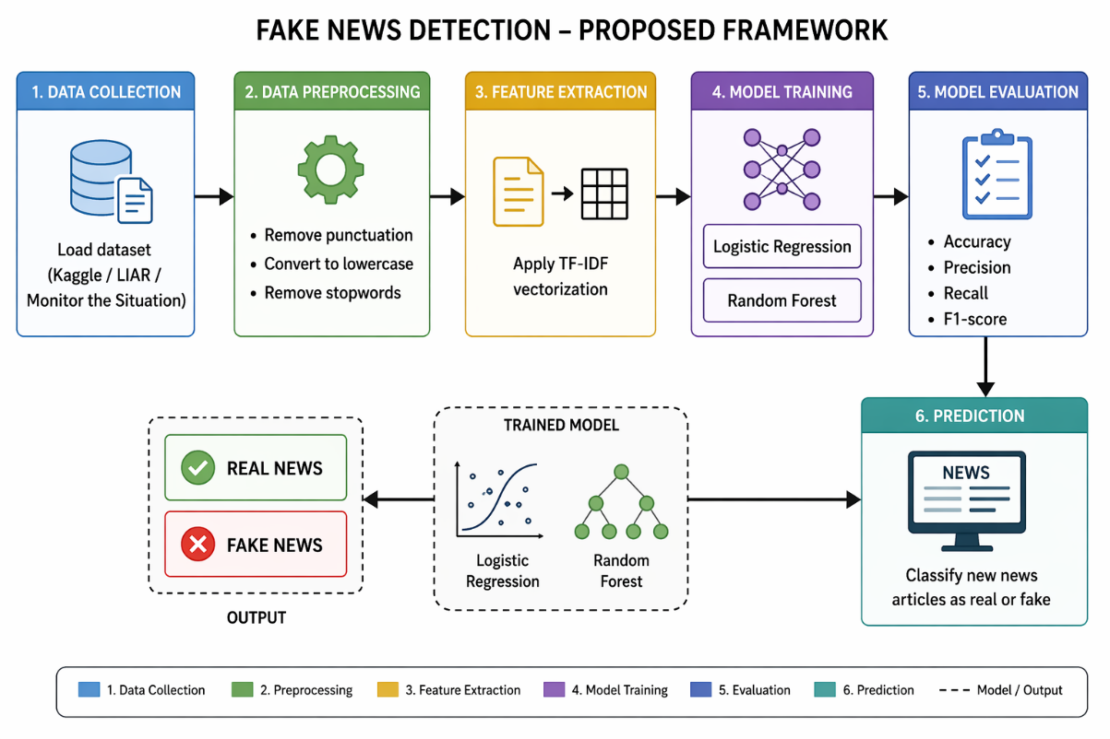
- Prediction
A result of the data to be fake or real
Figure 1

3.2 System Architecture
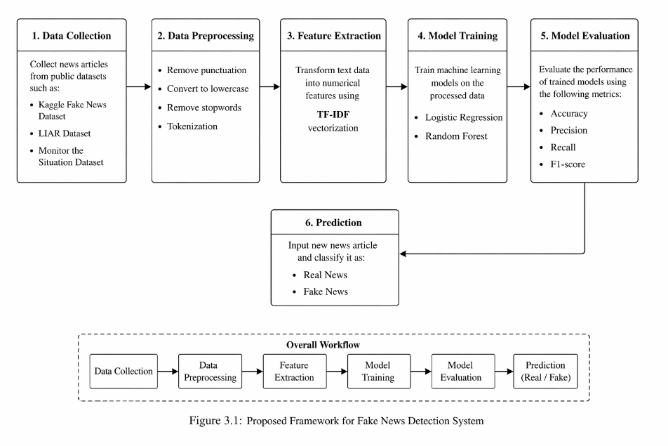
The system follows a pipeline structure as showed in the figure below:
Figure 2

References
[1] K. I. Roumeliotis, N. D. Tselikas and D. K. Nasiopoulos,“Fake news detection and classification: A comparative study of CNNs, LLMs and NLP models " Future Internet, vol. 17 No. 3 Art. No. 102 2025.
[2] M. E. Almandouh and others“Ensemble based high performance deep learning models for news detection " Scientific Reports, vol. 14 Art. No. 76286 2024.
[3] F.. Others,“Fake news detection using enhanced features through text-to-image transformation " Journal of Intelligent Information Systems, 2024.
[4] S. Tiwari and S. Jain,“ news detection using machine learning algorithms " SSRN Electronic Journal, 2024.
[5] R. K.. Others,“A hybrid deep learning framework for fake news detection using LSTM-CGPNN " Scientific Reports, vol. 15 Art. No. 25311 2025.
[6] H. F. Villela and others“ news detection: A systematic literature review of machine learning algorithms and datasets " Journal of Information and Knowledge Management 2023.
[7] J. Devlin, M.-W. Chang, K. Lee and K. Toutanova,“BERT: Pre-training of bidirectional transformers for language understanding " Proceedings of NAACL-HLT, 2023.
[8] Y. Wang and others“ fake news detection using text and image data " IEEE Access, vol. 10 Pp. 12345–12356, 2022.
[9] K. Shu, A. Sliva, S. Wang, J. Tang and H. Liu,“ news detection in social media using graph neural networks " ACM Transactions on Knowledge Discovery from Data, vol. 17 No. 3 2023.
[10] S. Kumar, R. West and J. Leskovec,“ detection of fake news on social media using machine learning " Proceedings of the Web Conference (WWW) 2021.
[11] H. Yang, Z. Zhang and J. Liu“ news detection using attention-based LSTM models " Expert Systems with Applications, vol. 187 2022.
[12] L. Chen and others“Detecting news using RoBERTa transformer model " IEEE Access, vol. 11 Pp. 56789–56800 2023.
[13] A. M. Elhag and others“ machine learning model, for fake news detection " Journal of Information Security and Applications vol. 65 2022.
[14] R. Singh and others“ fake news detection using deep learning " Information Processing & Management vol. 61 2024.
[15] P. Sharma, A. Jain and S. Gupta“ news detection using NLP and sentiment analysis " Procedia Computer Science, vol. 178 Pp. 123–130, 2021.

