
Midocean University
College of Management
Graduation Project

How Exercise and Sports Boost Economic Growth

By Student:

Sara Fayez Malaikah

241002306

Supervised by

Dr. Asmaa Abo Anza

Dr. Abdulrahim Nadir Abdulrahim Ismail

Abstract

Sports and physical activity are important for increasing economic growth in a number of ways. First of all, by encouraging a healthier workforce, they improve public health by lowering healthcare costs and raising productivity. Frequent exercise can reduce the prevalence of chronic illnesses, which lessens the financial strain on healthcare systems and improves economic efficiency in general. Second, the sports sector boosts local economies and creates jobs by bringing in large sums of money from event hosting, sponsorships, and merchandise sales. Investing in sports infrastructure frequently results in higher tourism and associated spending in cities, which boosts economic growth. Participation in sports and fitness programs also fosters social cohesion and can increase civic engagement, both of which can boost local economies. Sports participation among young people can also improve academic performance and future employability, producing a workforce with greater skill. All things considered, the interrelated advantages of physical activity and sports promote not only personal health but also significantly boost overall economic growth. Sports facilities and events can also boost tourism and generate employment in a variety of industries, including hospitality and event planning. A thriving local economy is promoted by investments in sports infrastructure, such as parks and stadiums, which also increase community involvement and draw in outside capital. Additionally, the sports sector as a whole—which includes professional teams, merchandise, and broadcasting rights—makes a significant amount of money and supports economic growth. Overall, the relationship between sports, exercise, and economic growth shows how important it is to encourage physical activity for both personal health and as a means of generating wider economic advantages.

Chapter One

INTRODUCTION

Sports and physical activity are important for promoting economic growth in a number of ways. Engaging in regular physical activity improves health on an individual basis, lowers healthcare costs, and boosts productivity. Generally speaking, the sports sector creates jobs, hosts events, and offers sponsorship opportunities that bring in a sizable amount of money.

Investing in sports infrastructure, like stadiums and leisure centers, boosts local economies by drawing tourists and encouraging involvement from the community. Large-scale athletic events, such as the Olympics or World Cups, can generate significant economic growth through merchandising, tourism, and hospitality.

Sports and exercise have long been known to have positive health effects, but they also have a big impact on economic growth. Investments in sports facilities and community initiatives are growing as societies realize the value of physical activity. This investment boosts local economies in addition to improving public health. Sports events boost local businesses, create job opportunities, and draw tourists. Furthermore, the fitness sector has experienced exponential growth, considerably boosting GDP in numerous nations. The creation of sports infrastructure frequently boosts property values and gives neighborhoods a boost. Engaging in physical activities and sports can promote a feeling of community, resulting in increased social cohesiveness and economic growth.
.

  - THE PROBLEM OF THE STUDY.

A complex issue that spans multiple dimensions, such as productivity, social impact, and health, is the relationship between exercise, sports, and economic growth. Knowing how sports and exercise support economic vitality is essential as societies struggle with rising healthcare costs and dwindling levels of physical fitness. Frequent exercise is associated with better health outcomes, which can lower healthcare costs and increase worker productivity. Businesses and national economies are directly impacted by a fit population's higher efficiency and lower absenteeism rates. Sports-related industries also create a lot of money and job opportunities, from event planning to equipment manufacturing. Disparities in access to sports facilities and programs, especially in underprivileged areas, can impede these advantages, raising concerns about inclusivity and equity in physical activity-driven economic growth. Furthermore, determining the exact economic impact of sports and exercise necessitates thorough data collection and analysis, which can be difficult. In order to maximize the financial advantages of physical activity and sports while removing obstacles to participation and fostering fair access for all groups, this study intends to investigate these dynamics.

    - THE ECONOMIC IMPACT OF SPORTS

Sports and exercise are becoming more and more acknowledged for their economic benefits. The manufacturing, retail, and services sectors are all included in the sports industry. Through ticket sales, merchandise sales, and broadcasting rights, it makes a sizable profit. Hosting sporting events boosts local economies as well because they draw tourists. Stadiums and leisure centers are examples of sports infrastructure that boosts employment and local development. Beyond just providing immediate financial gains, the economic impact also promotes social cohesion and community involvement. Investing in sports has the potential to lower healthcare costs while improving public health. Greater worker productivity is a result of healthier populations. Governments frequently acknowledge these advantages and support sports-related initiatives as components of public policy. Effective policymaking requires an understanding of the broader economic implications of physical activity and sports.

    - JOB CREATION AND INDUSTRY GROWTH

One important industry for job creation is sports. It offers job opportunities in a range of sectors, including facility maintenance, event planning, coaching, and sports administration. Jobs in the sports sector frequently assist the hospitality and transportation sectors. The demand for qualified professionals grows along with the popularity of sporting events. The emergence of e-sports has expanded job opportunities by generating new positions in game design, digital marketing, and streaming services. Seasonal jobs associated with major athletic events are a major driver of local economies. Investing in sports facilities can have long-term positive economic effects on a community. Sports employment growth may result in higher local economy spending. Moreover, companies frequently use sports sponsorships to raise awareness of their brands.

    - TOURISM AND EVENT HOSTING

Sports events can stimulate tourism in a significant way. Large-scale athletic events attract viewers from all over the world, which helps local economies. Hotel reservations and restaurant revenue rise in cities that play host to major events like the Olympics or World Cup. In addition to short-term financial benefits, hosting can leave a lasting legacy of increased tourism. Long after the games are over, the community frequently benefits from the infrastructure created for these occasions. Furthermore, sports tourism enhances cultural exchange by fostering international connections. The significance of grassroots sports is highlighted by the fact that smaller local events draw crowds as well. Cities can position themselves as desirable travel destinations by promoting sporting events. A tourist inflow frequently leads to the creation of jobs and an increase in local spending. In general, sports tourism is essential.

    - HEALTH BENEFITS AND ECONOMIC PRODUCTIVITY

Participating in sports and regular exercise have a major positive impact on public health. Government and individual healthcare costs are lowered when physical health improves. Populations that are healthier tend to be more productive, which has positive economic effects. Promoting sports can help reduce the negative effects of chronic illnesses on worker productivity. Because they understand the connection between productivity and health, businesses frequently fund employee wellness initiatives. Healthy workers typically have better morale and lower absenteeism rates. Exercise's positive effects on mental health also lead to a more attentive and motivated workforce. Public campaigns that promote physical exercise can improve the wellbeing of a community. Sports can help societies prioritize health and build stronger economies. All things considered, it is evident how economic growth, productivity, and health are related.

  - THE IMPORTANCE AND OBJECTIVES.

Sports and physical activity contribute significantly to economic growth through a number of important mechanisms. First of all, they create jobs in a variety of industries, from event management to the health and fitness sectors, by generating significant revenue through a variety of channels, including sports events, fitness programs, and wellness initiatives. Additionally, sports tourism draws tourists, boosting local economies through entertainment, transportation, and hospitality. Regular exercise also enhances public health, which lowers healthcare expenses and boosts productivity because a healthier workforce is more productive and less likely to get sick. Additionally, sports promote social cohesiveness and community involvement, which may result in more funding for regional infrastructure. Additionally, encouraging youth to participate in sports and exercise fosters the development of skills like discipline and teamwork that are useful in the workplace. In the end, exercise and sports play a critical role in promoting sustainable economic development by improving both individual well-being and community vitality.

    - HEALTH AND PRODUCTIVITY

Increased productivity is directly correlated with better health outcomes, which is a result of physical activity. People who are in better health typically take fewer sick days, which increases economic output. Frequent exercise can lower healthcare expenses, which is advantageous for both people and governments. Employees that place a high priority on fitness are frequently more engaged and productive. The financial effects of funding public fitness initiatives over the long run will be examined in this study. Exercise-based preventative health measures can help reduce the financial burden of chronic illnesses. Quantifying the cost savings linked to a healthier population is the aim. This information can be used to make a strong case for more financing for public health programs. Additionally, by being aware of these dynamics, companies can be inspired to encourage employee fitness.

    - YOUTH ENGAGEMENT AND FUTURE WORKFORCE

Playing sports as a young person develops important life skills like leadership, discipline, and teamwork. These qualities improve employability and are extremely valuable in the workforce. Communities can develop a more skilled workforce in the future by funding youth sports programs. The study will look at the connection between young athletes' involvement in sports and their academic success because motivated students typically do well in school. This correlation implies that early sports encouragement can have positive long-term effects on education. The idea is to demonstrate how early sports investment can result in a more skilled labor market. Effective youth sports programs can also lower the rates of juvenile delinquency, which promotes safer communities.

    - COMMUNITY DEVELOPMENT AND SOCIAL COHESION

Communities benefit from the unifying power of sports, which fosters cohesiveness and social interaction. Local sports leagues and events promote community involvement and a feeling of identity. The economic advantages of social capital created through sports will be investigated in this study. Stronger ties to the community can result in more volunteerism and local investment. Sports facilities can act as gathering places for the community by holding activities that unite various groups. The goal of the research is to show how sports can support community development through the analysis of case studies. The goal is to measure the economic effects of improved social networks that sports promote. Strong social cohesion is frequently associated with lower crime rates and greater levels of civic engagement in communities. An atmosphere that is more stable economically may result from this dynamic. In the end, encouraging sports in local communities can have more positive social and economic effects. The study will promote more funding for community service projects, public health campaigns, and sports facilities. Holistic development requires the involvement of several sectors, such as local governments, the healthcare system, and the educational system. By working together, we can make sure that the positive effects of sports are optimized in a variety of fields. Additionally, the study will suggest metrics for gauging success in terms of money, offering a foundation for upcoming evaluations.

  - QUESTIONS ABOUT THE STUDY

    - JOB CREATION AND EMPLOYMENT OPPORTUNITIES

The direct economic impact of sports is the creation of jobs. A wide range of workers are needed for sporting events, including security, hospitality, and event staff. Local unemployment rates can be considerably reduced by this inflow of job opportunities. A variety of professions are also included in the sports industry, such as coaching, sports medicine, and sports management. Administrators and coaches are also employed by grassroots sports programs. These workers' local spending of their earnings demonstrates the economic knock-on effect. In addition to providing jobs directly, building and maintaining sports facilities also helps to create jobs. Contracts pertaining to sporting events frequently benefit local vendors. Communities' overall economic activity is improved by this dynamic. Which particular jobs are directly generated by athletic events? In what ways does the sports sector support jobs that go beyond event personnel? What effects do community-based sports programs have on regional employment markets? How does newly hired people's local spending promote economic growth? What part does infrastructure development play in the long-term growth of the sports industry's employment base?

    - TOURISM AND ECONOMIC STIMULATION

Major tourism draws, like sporting events, bring people from all over the world. Through spending at restaurants, lodging facilities, and entertainment venues, these events boost local economies. A well-run sporting event has the power to make a city famous worldwide and inspire return visits. Large-scale competitions and wins frequently result in extensive media coverage, which raises awareness of a place. When tourists come back to see other attractions, this tourism may have long-term positive effects on the economy. Businesses in the area can prosper in this setting, which will increase and retain jobs. In addition to promoting sponsorship and advertising, sporting events also boost the local economy. All things considered, sports-related tourism plays a critical role in economic expansion. What effects do big-time athletic events have on city tourism trends? Which local businesses stand to gain the most from increased tourism brought on by sporting events? How does a location's visibility improve as a result of media coverage of sporting events? How can attending sporting events as a tourist result in long-term financial gains? What is the economic impact of sponsorship and advertising opportunities at sporting events?

    - HEALTH BENEFITS AND WORKFORCE PRODUCTIVITY

Frequent exercise is associated with better mental and physical health, which can raise productivity at work. Government and employers alike stand to gain from a healthier population's propensity to incur lower healthcare costs. Employers with robust wellness initiatives frequently observe lower absenteeism and higher staff morale. An increase in economic output may result from this productivity boost. Moreover, physical activity can lessen the burden that chronic diseases place on healthcare systems by lowering their prevalence. A healthier workforce has a substantial long-term economic impact. Communities that encourage physical activity also have better quality of life, which draws in visitors and businesses. Exercise's positive effects on health therefore result in significant financial benefits. What specific health advantages come with consistent exercise? What is the effect of better employee health on absenteeism rates? How might a more robust labor force contribute to higher economic output? Which chronic illnesses are most impacted by more exercise? In what ways can businesses be drawn to community initiatives that support active lifestyles?

  - ASSUMPTIONS ABOUT THE STUDY

    - INVESTMENT IN SPORTS INFRASTRUCTURE

The financial advantages of funding sports facilities constitute the third premise. It is assumed that constructing sports facilities boosts the local economy in addition to helping local teams. Just the building phase has the potential to boost local economies and generate a large number of jobs. Furthermore, well-kept buildings are capable of hosting a range of events, drawing guests all year long. Attendance at sporting events by large numbers of tourists may result in higher spending at nearby hotels, restaurants, and retail establishments. The research makes the assumption that these investments have advantages beyond just making money right away. Long-term effects include heightened social engagement and community pride as a result of increased sports participation. High-quality sporting facilities can also encourage the growth of talent, producing successful athletes who could boost the national economy. The underlying premise also states that funding sports can encourage innovation in adjacent sectors like apparel and sports technology. It follows that investing in sports infrastructure will likely have a wide range of economic effects.

    - SOCIAL AND COMMUNITY ENGAGEMENT

Sports are thought to promote community involvement and social cohesiveness. According to the study, neighborhood sports teams foster a feeling of identity and community. An increase in civic engagement may result from this social capital. It is assumed that local economies are typically stronger in engaged communities. It is also assumed that sports programs improve youth development, which will result in future financial gains. The study considers how athletic volunteerism plays a part in boosting economic activity. It is assumed that volunteer work results in experiences and abilities that are valuable to employers. The effect of sports on mental health is also taken into account, based on the idea that increased productivity can result from better mental health. In general, it is anticipated that more robust community connections will promote long-term economic expansion.

    - SPORTS AS A DRIVER OF TOURISM

The study also makes the assumption that sports are a major factor in tourism, which has a favorable impact on economic expansion. International travel is frequently attracted to major sporting events, increasing tourism income. Local economies can gain a great deal from this revenue, particularly in places that hold big events. It is assumed that jobs related to sports tourism are generated in a number of industries, such as transportation and hospitality. Sports-related tourism can also stimulate infrastructure investments that benefit the community as a whole. According to the study, towns that host major sporting events frequently profit in the long run from increased visibility. Beyond sports, increased visibility may open up new travel options in the future. Moreover, it is believed that sports tourism can strengthen a community's identity and draw in new citizens. This migration wave may boost regional economies and encourage cross-cultural interaction. In the end, it is anticipated that sports tourism will have an immediate and long-lasting economic impact.

    - SOCIAL AND ECONOMIC COHESION

Lastly, the study makes the assumption that playing sports promotes social cohesiveness, which has advantages for the economy. Playing team sports builds social networks and promotes community involvement. Strong social ties can improve resource sharing and collaboration, which is advantageous for nearby companies. It is assumed that communities with strong sports cultures have stronger economic resilience. Moreover, sports initiatives for disadvantaged populations can provide avenues for achieving financial stability. These initiatives can empower people by giving them leadership development and skill training. This presumption also includes the notion that programs promoting inclusive sports can lessen inequality. In communities, sports have the power to bring people together by fostering inclusion and diversity. It is assumed that a more stable economic environment results from this social cohesion.

  - THE SCIENTIFIC THEORY FOLLOWED TO PREPARE THE RESEARCH

Numerous scientific theories, mostly from the domains of economics, sociology, and public health, can serve as the foundation for studies on how physical activity and sports contribute to economic growth. One important theoretical framework is the Human Capital Theory, which holds that investing in personal qualities like athletic prowess and physical fitness increases economic output and productivity. According to this theory, people who are in better health make more valuable contributions to the workforce, which boosts economic activity. The Social Capital Theory also highlights the importance of sports in promoting social networks that can boost local economies by encouraging more people to attend events, travel, and build infrastructure. Additionally, by drawing tourists and generating employment, sporting events can boost local economies, according to the Economic Impact Theory. Together, these theories highlight the complex interrelationships between sports, exercise, and economic growth, emphasizing the value of funding physical activity programs for wider economic gains. The study intends to offer a thorough grasp of how sports and exercise not only enhance personal health outcomes but also act as stimulants for economic growth by investigating these interrelated theories.

Chapter Two

  - PREVIOUS STUDIES.

Numerous studies have examined the connection between sports, exercise, and economic growth, pointing to several ways that physical activity supports economic growth. First of all, exercise and sports participation can improve public health, which lowers healthcare expenses and boosts productivity. Because they tend to be more energetic and have lower absenteeism rates, healthier populations are generally more productive, which benefits the workforce. In addition, the sports sector itself stimulates economic activity by generating jobs in areas such as coaching, training, management, and event planning. Additionally, spending on sports facilities like stadiums and fitness centers boosts local economies by creating jobs in the construction industry and increasing tourism, as events attract tourists who spend money at nearby establishments. Sports programs can draw funding and increase student engagement, which benefits educational institutions as well by improving academic performance and fostering community cohesion. Additionally, exercising builds social capital by forming alliances and networks that may result in innovations and business opportunities. All things considered, the relationship between physical activity, sports, and economic expansion demonstrates a complex influence that extends to community vitality, infrastructure development, employment, and health. (Fig. 1).

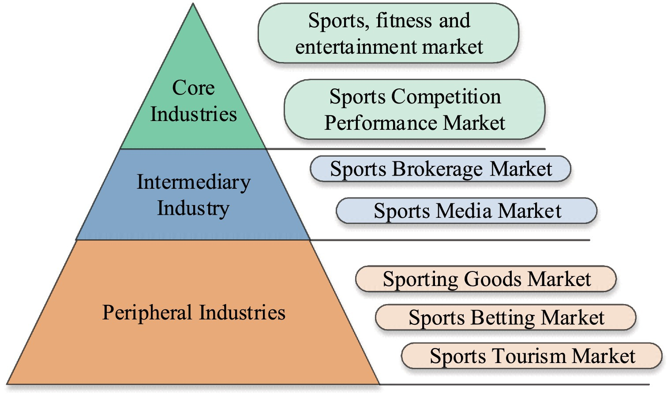
Figure.1 Summarized of Classification of the sports industry.
.

A STUDY PUBLISHED BY THE RESEARCHER " Emmanuel Acquah-Sam" THIS IS A SUMMARY OF THE SCIENTIFIC PAPER

Abstract
Several developing nations continue to face challenges in their efforts to industrialize and accelerate economic growth. In light of this, they keep looking for solutions to the problems caused by their underdevelopment. Athletics Many people advocate for development as a solution to the problems associated with underdevelopment in developing nations. The main issues that developing nations now confront, though, are how to grow sports and effectively utilize its advantages for development and economic prosperity. This essay aimed to investigate the problems associated with sports development in developing countries, the long-term pillars or complementary strategies that support sports development in these countries, as well as the advantages of sports development and how they affect the economic growth and development of these countries. To reach its conclusions, this paper used a narrative overview research methodology. It concludes that the development of ten long-term complementary strategies, or cardinal pillars, must be developed holistically in order for sports to flourish. Furthermore, the advancement of sports provides eight noteworthy advantages that can facilitate economic expansion and advancement in developing countries. One of the main conclusions of the study is that for sports development as well as economic growth and development in developing nations, there needs to be a sufficient and sustained level of investment in sports of all kinds, along with strong institutions, good governance, and workable and related policies.
Keywords
Sports Development, Service Sector Development, Economic Growth and Development, Linear Stages of Economic Growth, Developing Countries.
  - THEORETICAL FRAMEWORK OF THE STUDY

A STUDY PUBLISHED BY THE RESEARCHER " Wenhao Zhang" THIS IS A SUMMARY OF THE SCIENTIFIC PAPER

Abstract
With the continuous development of society, various industries are rising and developing rapidly. Against this background, the energy crisis has come quietly. Therefore, to improve the quality of life of residents and promote the comprehensive and sustainable development of society, it is essential to enhance the development of the sports industry and formulate public health strategies under the background of a low carbon economy (LCE). Based on this, to promote the low-carbon development of the sports industry and optimize the formulation of social public health strategies, firstly, this paper introduces the low-carbon economic structure and its role in society which shows that the sports industry is playing an increasingly important role in economic growth. And through the analysis of the development of M enterprise sports industry as a whole and in different directions, this paper shows that enterprises should reasonably control the development of various industries to provide impetus for the overall development of enterprises. The innovation of this paper lies in the innovative use of the sports industry as the primary research object, and its development under LCE is studied. This paper not only supports the sustainable development of sports industry in the future, but also contributes to improving public health strategy. (Fig. 2).

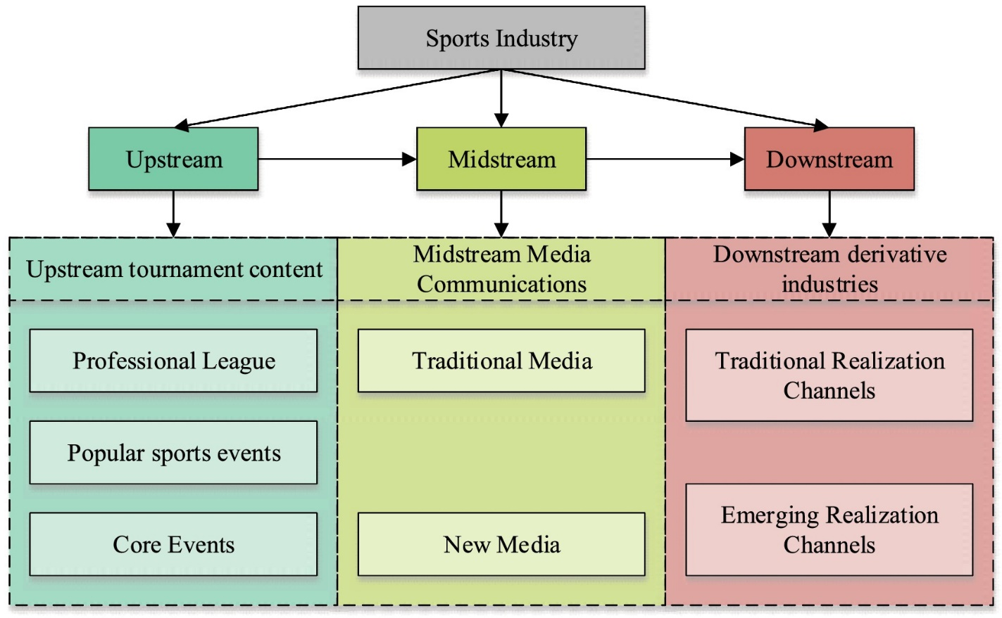

Figure.2 Summarized of Industrial chain structure of the sports industry.
.

