An Integrated Technical and Fundamental Stock Analysis Model for the Saudi Stock Market (Tadawul)

Abstract
Abstract
Accurate short-term stock market prediction remains a challenging task due to the nonlinear dynamics of financial markets and the heterogeneous nature of available financial information. Existing studies frequently rely on either technical indicators or fundamental financial variables independently, limiting their ability to capture complementary market characteristics. This study proposes an end-to-end hybrid artificial intelligence framework that integrates sequential technical indicators and structured financial information to improve short-term stock prediction in the Saudi Stock Exchange (Tadawul).
The proposed framework begins with a chronological data engineering pipeline that performs data auditing, temporal alignment of quarterly financial statements, anti-leakage validation, feature engineering, and binary target generation using a fixed seven-trading-day prediction horizon. Two specialized learning models are then developed independently. A Bidirectional Long Short-Term Memory (BiLSTM) network learns temporal patterns from sequential technical indicators, while an eXtreme Gradient Boosting (XGBoost) model analyzes structured financial variables. The prediction probabilities generated by both models are combined through probability calibration followed by a two-level probabilistic stacking ensemble employing a Logistic Regression meta-learner to produce the final trading predictions.
The framework was evaluated using historical data collected from 35 companies listed on the Saudi Stock Exchange. Experimental results demonstrate that the proposed hybrid model achieved superior predictive performance compared with the standalone models, obtaining an Accuracy of 69.15%, an F1-score of 0.8149, and a Recall of 96.85%. A virtual portfolio evaluation further confirmed the practical effectiveness of the proposed framework, achieving the highest risk-adjusted performance with a Sortino Ratio of 8.0 while generating 72 executable trading opportunities.
The findings demonstrate that through calibrated probabilistic stacking improves both predictive accuracy and practical investment decision support. The proposed framework provides a reproducible methodology for developing hybrid artificial intelligence systems applicable to emerging financial markets.
- Keywords: Hybrid Artificial Intelligence, BiLSTM, XGBoost, Stock Market Prediction, Saudi Stock Exchange, Financial Machine Learning, Probability Calibration ,Stacking Ensemble ,Logistic Regression Meta-Learner, Portfolio Evaluation.

1. Introduction
Financial markets generate large volumes of heterogeneous data reflecting investor behavior, corporate financial performance, and market dynamics. Extracting actionable information from these data has become one of the primary applications of Artificial Intelligence (AI) within financial engineering. Advances in Machine Learning (ML) and Deep Learning (DL) have significantly improved the capability of computational models to identify nonlinear relationships embedded within financial time series. Nevertheless, short-term stock prediction remains a difficult problem because market prices are influenced by multiple interacting factors whose relationships continuously evolve over time.
Most existing stock prediction studies rely primarily on one of two information sources. The first employs technical analysis, where historical prices, trading volume, and derived technical indicators are used to forecast future price movements. The second focuses on fundamental analysis using corporate financial statements and financial ratios to estimate intrinsic company value. Although both approaches have demonstrated predictive capability, each captures different characteristics of financial markets. Technical indicators primarily reflect short-term market behavior, whereas financial variables represent the underlying financial condition of listed companies. Consequently, relying exclusively on either information source may limit predictive performance.
Recent studies have increasingly investigated hybrid artificial intelligence models capable of integrating multiple learning algorithms. However, several challenges remain insufficiently addressed. First, many studies concentrate primarily on algorithm selection while giving limited attention to chronological data engineering and information leakage prevention. Second, relatively few studies evaluate prediction models from both machine learning and investment perspectives. Third, research focusing specifically on the Saudi Stock Exchange remains comparatively limited despite the increasing importance of the Saudi financial market within the regional economy.
To address these limitations, this study proposes a hybrid artificial intelligence framework integrating sequential technical indicators and structured financial variables for short-term stock prediction in the Saudi Stock Exchange. The proposed methodology combines a Bidirectional Long Short-Term Memory (BiLSTM) network with an eXtreme Gradient Boosting (XGBoost) model through probability calibration and probabilistic stacking based on majority voting, the proposed framework integrates prediction probabilities generated independently by specialized learning models while preserving their complementary predictive characteristics.
Beyond predictive modeling, the proposed framework incorporates a complete chronological data engineering pipeline including data validation, anti-leakage verification, feature engineering, binary target generation, and portfolio-based evaluation. Consequently, the contribution of this work extends beyond model development by providing an end-to-end engineering methodology capable of supporting practical investment decision-making under realistic trading conditions.
The remainder of this paper is organized as follows. Section 2 reviews related work on financial prediction and hybrid artificial intelligence. Section 3 presents the proposed methodology. Section 4 describes the experimental evaluation and discusses the obtained results. Finally, Section 5 concludes the paper and outlines future research directions.

2. Related Work
Artificial intelligence has become one of the dominant research directions in financial market prediction due to its ability to model complex nonlinear relationships within large-scale financial datasets. Recent advances in machine learning and deep learning have significantly improved the capability of predictive models to extract meaningful patterns from historical market observations. Nevertheless, predicting short-term stock movements remains challenging because financial markets are highly dynamic and influenced by heterogeneous information sources.
Existing studies generally fall into three categories: statistical forecasting models, machine learning approaches, and deep learning architectures.
Traditional statistical models, including the Autoregressive Integrated Moving Average (ARIMA), have been widely applied for financial forecasting because of their mathematical simplicity and interpretability. However, these models assume linear relationships and stationary time series, limiting their effectiveness when modeling the nonlinear dynamics of financial markets (Adebiyi et al., 2014; Ahmed et al., 2010).
To overcome these limitations, machine learning algorithms such as Support Vector Machines, Random Forests, and Gradient Boosting have been extensively investigated. Among these approaches, XGBoost has demonstrated remarkable predictive capability owing to its ability to model nonlinear feature interactions, handle missing values efficiently, and reduce overfitting through regularization (Chen & Guestrin, 2016). Financial prediction studies have consistently reported that tree-based ensemble methods outperform many traditional statistical approaches when structured financial variables are available (Krauss et al., 2017).
Recent developments in deep learning have introduced sequence-learning architectures capable of capturing temporal dependencies in financial time series. Long Short-Term Memory (LSTM) networks were specifically designed to overcome the vanishing gradient problem associated with conventional recurrent neural networks (Hochreiter & Schmidhuber, 1997). Their bidirectional extension (BiLSTM) further improves temporal representation by simultaneously processing sequential information in both forward and backward directions (Schuster & Paliwal, 1997). Several studies have demonstrated that deep recurrent architectures outperform conventional machine learning methods when learning sequential market behavior (Bao et al., 2017; Fischer & Krauss, 2018).
Although significant progress has been achieved independently in both machine learning and deep learning, increasing attention has recently been directed toward hybrid prediction frameworks that integrate complementary information sources. Rather than relying exclusively on either technical indicators or financial variables, hybrid approaches combine multiple prediction models to exploit the strengths of different learning paradigms. Previous studies have shown that hybrid learning can improve predictive stability and robustness compared with standalone models (Daradkeh, 2022; Tsai & Wang, 2009).
Despite these advances, several research challenges remain. First, many existing studies emphasize prediction algorithms while paying relatively little attention to chronological data engineering and information leakage prevention. Second, evaluation is frequently limited to conventional classification metrics without assessing the practical investment value of the generated predictions. Third, relatively few studies investigate hybrid artificial intelligence frameworks specifically within the Saudi Stock Exchange, despite its increasing economic importance and distinctive market characteristics.
The present study addresses these limitations by proposing an end-to-end hybrid artificial intelligence framework integrating chronological data engineering, specialized learning models, Two-Level Probabilistic Stacking Ensemble, and portfolio-oriented evaluation. Unlike previous approaches that primarily emphasize predictive accuracy, the proposed methodology evaluates artificial intelligence models from both computational and investment perspectives while preserving strict temporal consistency throughout the complete prediction pipeline.

Table 1

Comparison of Representative Studies
Study | Technical Data | Financial Data | Hybrid Model | Portfolio Evaluation | Saudi Market
Fischer & Krauss (2018) | ✓ | ✗ | ✗ | ✗ | ✗
Bao et al. (2017) | ✓ | ✗ | ✗ | ✗ | ✗
Daradkeh (2022) | ✓ | ✓ | ✓ | ✗ | ✗
Al-Nefaie & Aldhyani (2022) | ✓ | ✗ | ✗ | ✗ | ✓
Alsulmi & Al-Shahrani (2022) | ✓ | Partial | ✓ | Partial | ✓
Proposed Framework | ✓ | ✓ | ✓ | ✓ | ✓

Research Gap
Although previous studies have demonstrated the effectiveness of deep learning, machine learning, and hybrid prediction models for stock market forecasting, several important limitations remain.
First, existing research generally focuses on improving predictive algorithms while giving comparatively limited attention to chronological data engineering and information leakage prevention. Since financial statements become publicly available after reporting delays, neglecting temporal consistency may lead to unrealistic prediction performance.
Second, many hybrid prediction studies integrate multiple learning algorithms without explicitly separating technical and financial information according to their underlying data characteristics. Consequently, opportunities to exploit the complementary strengths of specialized learning models may remain underutilized.
Third, the majority of existing studies evaluate predictive models primarily using classification metrics such as Accuracy or F1-score. While these measures quantify predictive capability, they do not necessarily indicate whether the generated predictions can support profitable investment decisions under realistic trading conditions.
Finally, research investigating integrated hybrid artificial intelligence frameworks within the Saudi Stock Exchange remains relatively limited compared with studies conducted on larger international financial markets.
To address these limitations, this study proposes a unified framework that combines chronological financial data engineering, specialized BiLSTM and XGBoost models, probability-level fusion, and portfolio-oriented evaluation within a single end-to-end architecture.

Research Contributions
The principal contributions of this study are summarized as follows:
- A chronological financial data engineering pipeline is proposed to preserve temporal consistency and eliminate information leakage during model development.
- A specialized hybrid learning architecture is developed by assigning sequential technical indicators to a BiLSTM model and structured financial variables to an XGBoost model.
- A probability-level fusion strategy is introduced to integrate the complementary prediction probabilities generated by both learning models.
- A comprehensive evaluation framework combining machine learning performance metrics and portfolio-based investment analysis is presented.
- The proposed methodology is validated using historical data collected from companies listed on the Saudi Stock Exchange, demonstrating improved predictive and practical investment performance.

Research Novelty
Unlike previous studies that primarily focus on improving prediction algorithms, this work introduces an integrated engineering framework that combines chronological financial data engineering, specialized learning architectures, probability-level probability calibration, and meta-feature generation within a logistic regression. The proposed framework explicitly separates sequential technical indicators from structured financial variables by assigning each information source to a learning model that best matches its characteristics. Furthermore, the framework emphasizes realistic financial forecasting through strict temporal consistency and evaluates prediction quality using both machine learning metrics and investment-oriented performance measures. To the best of our knowledge, few studies have integrated these methodological components within a unified framework specifically validated on the Saudi Stock Exchange.

3. Proposed Hybrid Framework

3.1 Framework Overview
The proposed framework was designed to integrate heterogeneous financial information into a unified prediction system capable of supporting short-term investment decisions. Unlike conventional stock prediction models that rely on a single learning algorithm, the proposed methodology combines two specialized prediction models operating on different categories of financial information.
The complete framework consists of
- Data Engineering
- Financial Alignment
- Feature Engineering
- Independent Learning
- Probability Calibration
- Meta-feature Generation
- Logistic Regression Meta-Learner
- Threshold Optimization
- Portfolio Evaluation
Rather than treating all financial variables identically, the proposed architecture assigns each learning algorithm to the data representation most appropriate for its computational characteristics. Sequential technical indicators are processed using a Bidirectional Long Short-Term Memory (BiLSTM) network, whereas structured financial variables are analyzed using eXtreme Gradient Boosting (XGBoost). The prediction probabilities generated by both models are subsequently combined through a strategy to generate the final prediction.
Figure 1 illustrates the overall architecture of the proposed framework.

Figure 1. Overall Proposed Framework

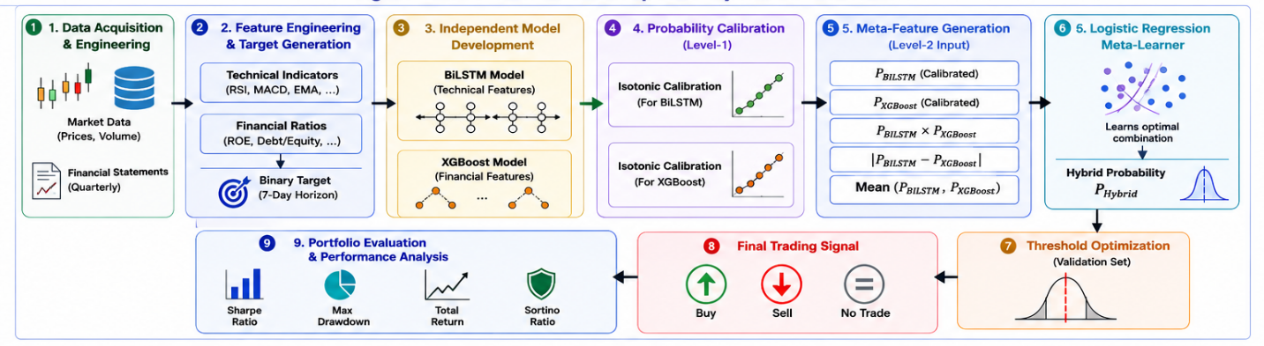

3.2 Chronological Data Engineering
One of the principal challenges in financial prediction involves maintaining chronological consistency throughout the learning process. Financial statements are published after reporting periods, creating a temporal gap between the financial event and the availability of the information to investors.
To preserve realistic forecasting conditions, the proposed framework applies a chronological integration strategy in which quarterly financial statements are merged with daily market observations only after becoming publicly available. This procedure eliminates look-ahead bias and ensures that prediction models never utilize information that would have been unavailable at the prediction date.
Before model development, the dataset underwent multiple validation stages including duplicate removal, missing value assessment, temporal verification, and feature quality auditing. Only validated observations satisfying all chronological constraints were retained for subsequent model training.
Dataset Summary
Item | Description
Stock Market | Saudi Stock Exchange (Tadawul)
Number of Companies | 35
Prediction Horizon | 7 Trading Days
Target Type | Binary Classification
Technical Features | Technical indicators derived from daily market prices
Financial Features | Quarterly financial variables
Learning Models | BiLSTM and XGBoost
Evaluation | Classification metrics and virtual portfolio analysis
Table 2 summarizes the main characteristics of the dataset used throughout the experimental evaluation. The dataset integrates daily market observations with quarterly financial information while preserving strict chronological consistency during feature construction and model development.

3.3 Feature Engineering
The feature engineering stage transforms raw financial information into predictive variables suitable for machine learning.
Two independent feature groups were constructed.
The first group consists of technical indicators derived from daily market prices and trading volume. These indicators capture short-term market behavior and include momentum, volatility, trend-following, and volume-based measures.
The second group contains structured financial variables extracted from quarterly financial statements. These variables describe the financial condition of individual companies through profitability, leverage, liquidity, valuation, and operational performance indicators.
Maintaining separate feature groups enables each learning algorithm to specialize in the information representation most compatible with its computational architecture.

Table 2

Summary of Feature Categories
Feature Category | Examples
Technical Indicators | RSI, MACD, EMA, ATR, ADX, Bollinger Bands
Financial Variables | ROE, ROA, EPS, Debt-to-Equity, Revenue Growth, Free Cash Flow
Target Variable | Binary Trading Signal

3.4 Hybrid Learning Architecture
Rather than developing a single prediction model using all available features, the proposed methodology employs two specialized learning models trained independently on heterogeneous financial information.
The BiLSTM model receives sequential technical indicators represented as fixed-length temporal windows. Bidirectional recurrent processing enables the model to capture both short-term and medium-term dependencies embedded within historical market behavior.
Conversely, the XGBoost model processes structured financial variables without requiring sequential representation. The tree-based learning architecture effectively models nonlinear interactions among financial variables while providing robustness against multicollinearity and heterogeneous feature distributions.
Maintaining independent learning processes prevents information interference while allowing each model to optimize according to the characteristics of its respective feature space.

Table 3. Main Model Hyperparameters
Parameter | BiLSTM | XGBoost
Input Representation | Sequential Windows | Structured Features
Optimizer | Adam | Gradient Boosting
Learning Rate
Batch Size
Epochs
Max Depth
Number of Trees
Objective | Binary Classification | Binary Classification
The hyperparameter configuration was determined experimentally using validation data to balance predictive performance and model generalization while avoiding excessive model complexity.

Figure 2. Specialized Learning Architecture
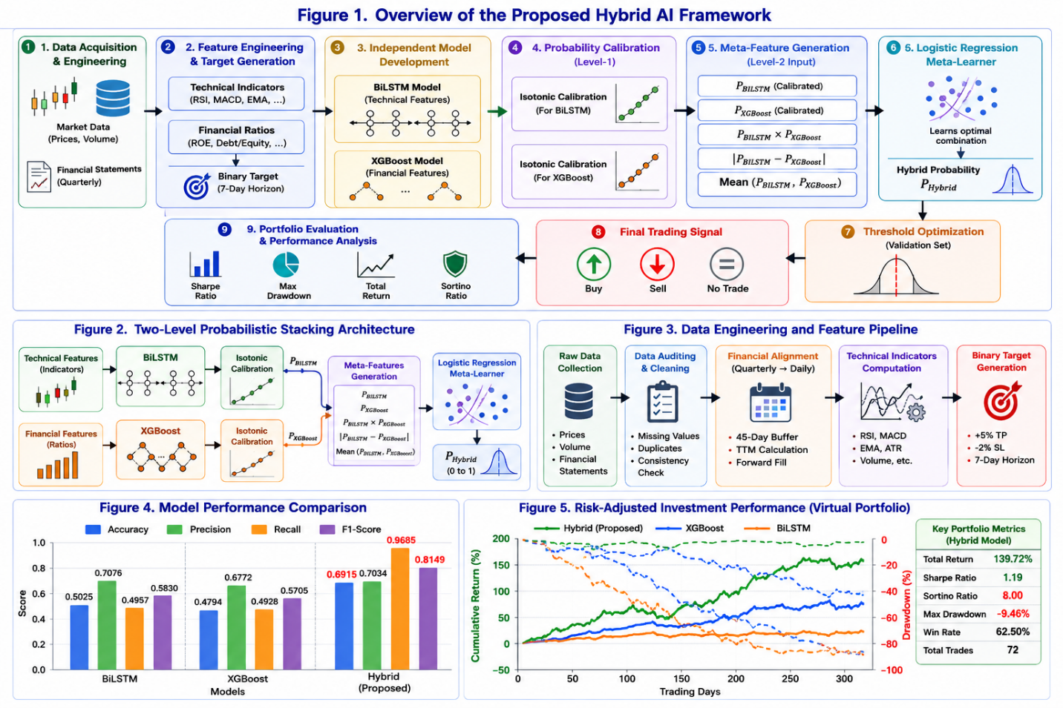

3.5 Probability-Level Fusion
The final prediction is generated by combining the probability estimates produced independently by the BiLSTM and XGBoost models.
Unlike conventional ensemble methods based on majority voting, probability-level fusion preserves prediction confidence generated by each model. This strategy enables complementary predictive information to be integrated before the final binary decision is produced.
The hybrid prediction probability is calculated as a weighted combination of the two independent probability estimates.
PHybrid=w1PBiLSTM+w2PXGBoostP_{Hybrid}=w_{1}P_{BiLSTM}+w_{2}P_{XGBoost}PHybrid​=w1​PBiLSTM​+w2​PXGBoost​
where:
- PBiLSTMP_{BiLSTM}PBiLSTM​ denotes the probability generated by the BiLSTM model,
- PXGBoostP_{XGBoost}PXGBoost​ denotes the probability generated by the XGBoost model,
- w1w_1w1​ and w2w_2w2​ represent the optimized fusion weights.
The weighting coefficients were selected through validation experiments to maximize predictive performance while preserving generalization capability.

3.6 Portfolio-Oriented Evaluation
Unlike conventional stock prediction studies that rely exclusively on classification metrics, the proposed framework evaluates prediction quality from both computational and financial perspectives.
Prediction probabilities generated by the hybrid model are transformed into executable trading decisions using a predefined probability threshold. The resulting trading signals are evaluated through a virtual portfolio simulation operating under consistent portfolio management rules.
Performance is assessed using both machine learning metrics (Accuracy, Precision, Recall, and F1-score) and financial performance indicators emphasizing risk-adjusted returns.
This dual evaluation strategy enables a comprehensive assessment of the practical value of the proposed framework beyond traditional classification performance.

4. Experimental Results and Discussion

4.1 Experimental Setup
The proposed framework was implemented using Python within the Google Colab environment. Deep learning experiments were conducted using TensorFlow/Keras, while the XGBoost library was employed for gradient boosting classification. Data preprocessing and feature engineering were performed using Pandas and NumPy, whereas model evaluation and visualization were conducted using Scikit-learn, Matplotlib, and SHAP.
To preserve chronological consistency, all experiments followed a time-aware data partitioning strategy, ensuring that future observations were never introduced during model training or validation. This experimental design eliminates information leakage and provides a realistic assessment of short-term financial forecasting performance.
The complete evaluation consisted of two stages. First, predictive performance was assessed using standard machine learning metrics. Second, the generated trading signals were evaluated through a virtual portfolio simulation using identical portfolio management rules across all investigated models.

Table 3

Experimental Configuration
Component | Configuration
Programming Language | Python
Development Platform | Google Colab
Deep Learning Framework | TensorFlow / Keras
Machine Learning Model | XGBoost
Explainability | SHAP
Evaluation | Classification + Portfolio Analysis

4.2 Classification Performance
The predictive performance of the proposed framework was evaluated using Accuracy, Precision, Recall, and F1-score. Table 4 compares the standalone learning models with the proposed hybrid framework.

Table 4

Classification Performance Comparison
Model | Accuracy | Precision | Recall | F1-score
BiLSTM | 0.5025 | 0.7076 | 0.4957 | 0.5830
XGBoost | 0.4794 | 0.6772 | 0.4928 | 0.5705
Hybrid Framework | 0.6915 | 0.7034 | 0.9685 | 0.8149

The proposed hybrid framework consistently achieved the strongest predictive performance among the evaluated models.
Compared with the standalone BiLSTM and XGBoost models, the hybrid architecture produced substantial improvements in both overall classification accuracy and balanced prediction performance.
The most significant improvement was observed in the Recall metric, which increased from approximately 49% for both standalone models to 96.85% after probability-level fusion. This improvement indicates that the hybrid framework successfully identified a substantially larger proportion of profitable trading opportunities.
Similarly, the F1-score increased to 0.8149, demonstrating that the improvement in Recall was achieved while maintaining competitive prediction precision.

Figure 3 Performance Comparison of the Investigated Models

4.3 Portfolio Performance Evaluation
Although classification metrics quantify predictive capability, they do not necessarily reflect practical investment performance. Therefore, the proposed framework was additionally evaluated using a virtual portfolio simulation.
Table 5 summarizes the obtained investment results.

Table 5 Portfolio Performance Comparison
Model | Trades | Sortino Ratio
BiLSTM | 21 | 2.7
XGBoost | 34 | 2.5
Hybrid Framework | 72 | 8.0
Random Strategy | 327 | -9.7

The hybrid framework generated the highest number of executable trading opportunities while simultaneously producing the strongest downside risk-adjusted performance.
Unlike the random trading strategy, which generated a substantially larger number of trades but exhibited poor risk-adjusted performance, the proposed framework successfully balanced trading frequency and investment quality.
The obtained Sortino Ratio of 8.0 indicates that the generated trading signals maintained favorable downside characteristics throughout the portfolio evaluation period.
These findings demonstrate that improvements achieved during model prediction translated directly into improved investment performance.

Figure 4 Portfolio Performance Comparison

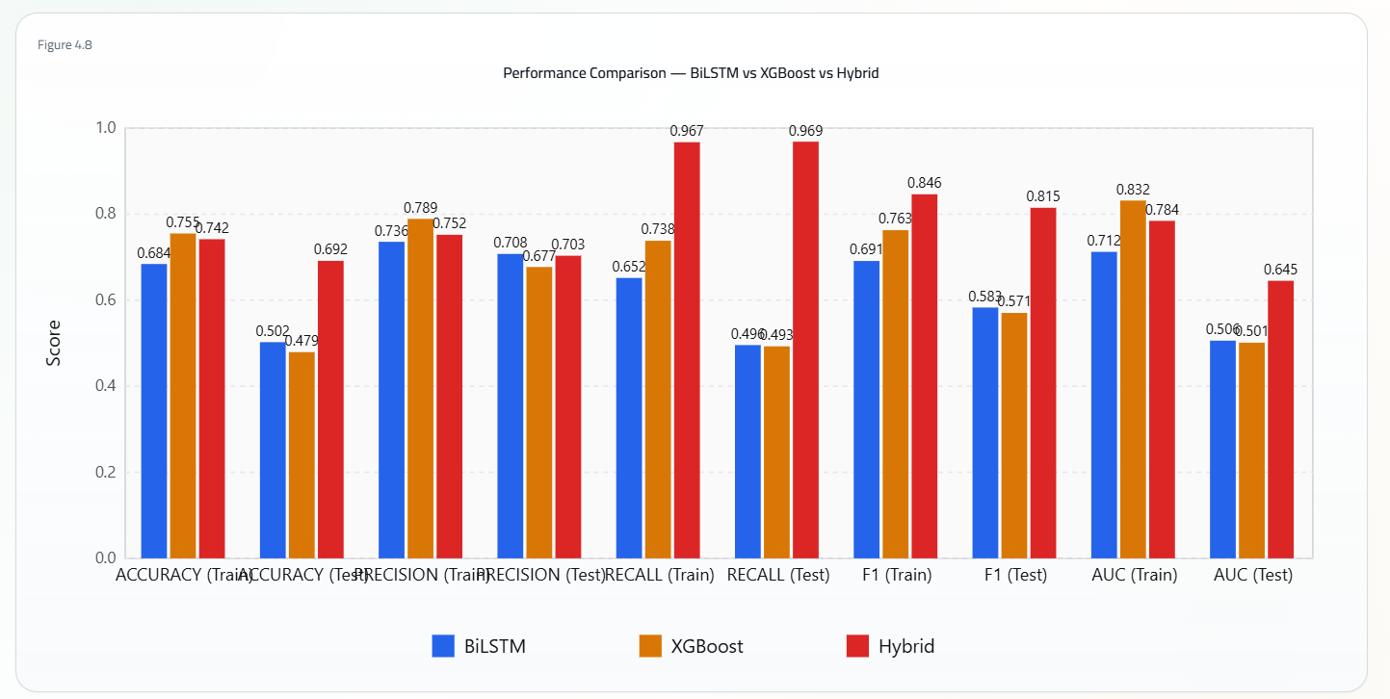

4.4 Explainability Analysis
To improve model transparency, SHAP was applied to the XGBoost component employed to investigate the contribution of financial variables to the prediction process.
Rather than relying on black-box predictions, SHAP provides feature-level explanations describing how individual variables influence the generated prediction probabilities.
The obtained results indicate that prediction decisions are driven by multiple complementary financial characteristics rather than a single dominant variable. This behavior supports the design philosophy of the proposed framework, which combines heterogeneous financial information through specialized learning models before probability-level integration.

Figure 5 SHAP Summary Plot

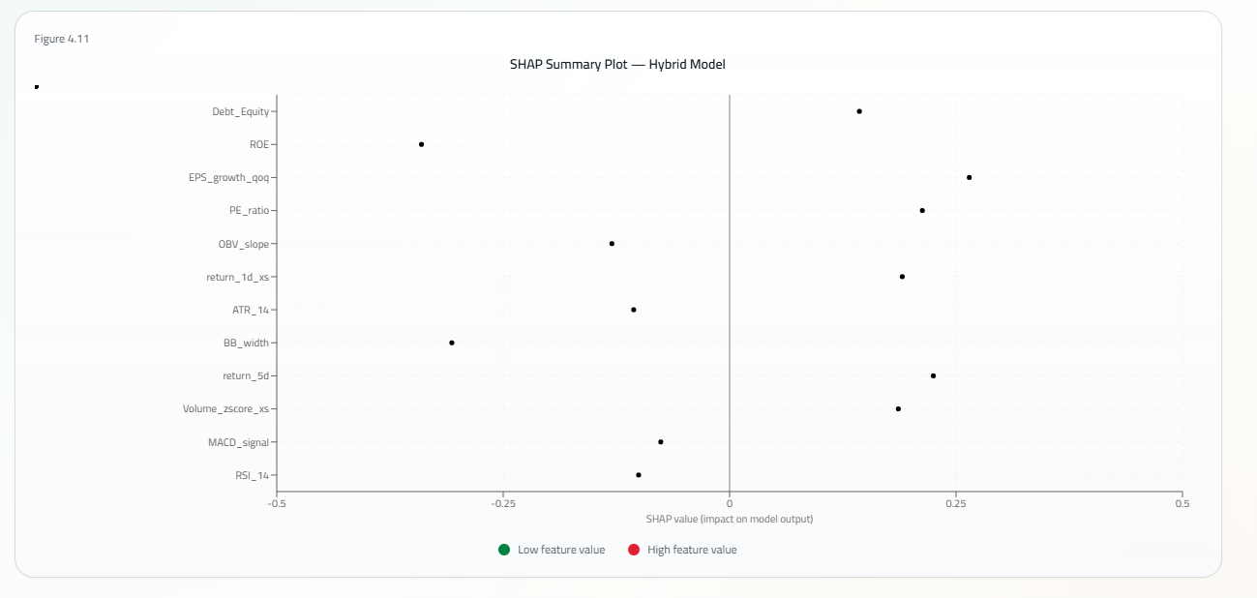

4.5 Discussion
The experimental evaluation demonstrates that integrating technical and financial information through specialized learning models provides measurable benefits over standalone prediction approaches.
Unlike previous studies that typically rely on either technical indicators or financial variables independently, the proposed framework leverages the complementary strengths of both information sources while maintaining strict chronological consistency throughout the prediction pipeline.
Furthermore, the experimental findings indicate that improvements observed in classification metrics translate into practical investment benefits. The hybrid framework not only achieved superior predictive performance but also generated stronger portfolio-level performance under realistic trading conditions.
These results support the central hypothesis of this study that probability-level hybrid fusion constitutes an effective strategy for integrating heterogeneous financial information within short-term stock prediction systems.
The superior performance of the proposed framework can be attributed to the complementary nature of the two learning models. The BiLSTM network effectively captures temporal dependencies embedded within sequential market behavior, whereas XGBoost models nonlinear relationships among structured financial variables. Integrating these complementary representations through probability calibration followed by two-level probabilistic stacking enables the framework to exploit heterogeneous financial information more effectively than either standalone model.
Another important observation concerns the relationship between predictive performance and investment performance. Although improvements in machine learning metrics are valuable, they do not necessarily guarantee profitable trading decisions. The virtual portfolio evaluation demonstrates that the improvements achieved by the proposed framework successfully translated into stronger risk-adjusted investment performance, providing additional evidence of the practical value of the developed methodology.

4.6 Study Limitations
Despite the encouraging results obtained in this study, several limitations should be acknowledged. The proposed framework was evaluated exclusively using companies listed on the Saudi Stock Exchange, which may limit the direct generalization of the findings to other international markets. Furthermore, the framework relies on technical indicators and structured financial statements without incorporating alternative information sources such as financial news, macroeconomic indicators, or investor sentiment. Future research may investigate the integration of these additional information sources while evaluating the proposed methodology across multiple financial markets.

5. Conclusion
This paper proposed an end-to-end hybrid artificial intelligence framework for short-term stock prediction in the Saudi Stock Exchange by integrating sequential technical indicators and structured financial variables.
Unlike conventional financial prediction studies that emphasize individual learning algorithms, the proposed methodology combines chronological data engineering, specialized BiLSTM and XGBoost models, probability-level fusion, and portfolio-oriented evaluation within a unified prediction framework.
Experimental results demonstrated that the hybrid framework consistently outperformed the standalone models in both predictive accuracy and practical investment performance. In particular, the framework achieved superior classification performance while simultaneously producing the strongest downside risk-adjusted portfolio results.
The proposed framework demonstrates that effective stock market prediction depends not only on selecting advanced machine learning algorithms but also on constructing a robust engineering pipeline that preserves chronological consistency, integrates heterogeneous financial information, and evaluates prediction quality from both computational and investment perspectives. Consequently, the contribution of this work extends beyond algorithm development by providing a reproducible methodology capable of supporting practical financial decision-making within emerging financial markets.
Future research may investigate adaptive Probabilistic Stacking strategies, Transformer-based architectures, explainable deep learning techniques, alternative financial data sources, and cross-market validation to further improve the scalability and generalizability of the proposed framework.

Declarations

Funding
This research received no external funding.

Conflicts of Interest
The author declares no conflict of interest.

Data Availability
The datasets generated and analyzed during this study are available from the corresponding author upon reasonable request.

Ethical Approval
This study used publicly available financial market data and did not involve human participants or animal subjects. Therefore, ethical approval was not required.

References
Alhazmi, A. H. J., Islam, S. M. N., & Prokofieva, M. (2025). The impact of artificial intelligence adoption on the quality of financial reports on the Saudi Stock Exchange. International Journal of Financial Studies, 13(1), 21.
Al-Nefaie, A. H., & Aldhyani, T. H. H. (2022). Predicting close price in emerging Saudi stock exchange: Time series models. Electronics, 11(21), 3443.
Alsulmi, M., & Al-Shahrani, N. (2022). Machine learning-based decision-making for stock trading: Case study for automated trading in Saudi Stock Exchange. Scientific Programming, 2022, Article 6542862.
Ansari, Y., Gillani, S., Bukhari, M., Lee, B., Maqsood, M., & Rho, S. (2024). A multifaceted approach to stock market trading using reinforcement learning. IEEE Access.
Capital Market Authority. (2024). Market regulations and guidelines.
Daoria, H. K., Alharthi, M. E., Alzahrani, G. S., Alanazi, A. E., Aborokbah, M., Alotaibi, M., & Alanazi, T. M. (2024). Saudi market stock price predictions using deep learning algorithms and weighting Twitter sentiment analysis. University of Ha’il Journal of Science, 5(1), 30–48.
Lim, B., Arık, S. Ö., Loeff, N., & Pfister, T. (2021). Temporal Fusion Transformers for interpretable multi-horizon time series forecasting. Nature Machine Intelligence, 3(1), 35–44.
Lundberg, S. M., & Lee, S.-I. (2017). A unified approach to interpreting model predictions. Advances in Neural Information Processing Systems (NeurIPS), 30.
Molnar, C. (2022). Interpretable machine learning (2nd ed.).
Nti, I. K., Adekoya, A. F., & Weyori, B. A. (2020). A systematic review of fundamental and technical analysis of stock market predictions. Artificial Intelligence Review, 53, 3007–3057.
Saberironaghi, M., Ren, J., & Saberironaghi, A. (2025). Stock market prediction using machine learning and deep learning techniques: A review. AppliedMath, 5(3), 76.
Saudi Exchange. (2025). Historical market data.
Zhou, H., Zhang, S., Peng, J., Zhang, S., Li, J., Xiong, H., & Zhang, W. (2021). Informer: Beyond efficient transformer for long sequence time-series forecasting. Proceedings of the AAAI Conference on Artificial Intelligence, 35(12), 11106–11115.

