
Midocean University
College of Management
Department of Business Administration

Title in English
The Impact of Digital Marketing on Consumer Behavior

Prepared by:
Zainah Tariq Amourah
Student ID: 241002299

Supervised by:
Dr. Al-Faisal Abd Al-Hameed Dr. Fayiz Jarad

Year:2024

Copyright Notice:

© Zainah Tariq Amourah, 2024. All rights reserved.
This thesis is submitted in partial fulfilment of the requirements for the degree of Master of Business Administration at Midocean University. The copyright of this thesis is owned by Midocean University. No part of this work may be reproduced, distributed, or transmitted without prior written permission from the university, except for brief quotations in critical reviews or for non-commercial purposes as permitted by law

Abstract:

This study examines how digital marketing affects brand perceptions of consumers, loyalty, and, thereby, the motivation to purchase. In this era of digital communication
between brands and consumers, the part of ingredients such as consistent
branding, attractive images, and social proof like reviews in building trust
cannot be overemphasized.
A survey was conducted among 50 respondents located in Saudi Arabia, which data was collected on how people interact with Assaf's digital marketing efforts, laying more
emphasis on social media engagement. These findings show that consumers are
more likely to trust and engage with brands that have a consistent online
identity. The study discloses the role that endorsements, as well as
user-generated content, play in instilling brand credibility and in the process
encouraging purchases. These bits of knowledge can influence companies to
finely adjust their digital strategies to be able to develop stronger
equality and loyalty-based interactions with consumers within the framework of
the digital age.

Keywords:
Consumer behavior, Digital Marketing, Psychological factors, Digital Marketing Channels, Effectiveness, Brand awareness, Brand Loyalty

Acknowledgement:
بِسْمِ اللَّـهِ الرَّحْمَـٰنِ الرَّحِيمِ
{وَمَا تَوْفِيقِي إِلَّا بِاللَّهِ ۚ عَلَيْهِ تَوَكَّلْتُ وَإِلَيْهِ أُنِيبُ}
Completing this thesis has been not only an academic challenge but also a profound journey of personal and professional growth.

I am immensely grateful to my mentors, Dr. Al-Faisal Abd Al-Hameed and Dr. Fayiz Jarad, for encouraging me to explore complex ideas and challenge conventional wisdom. Their guidance helped me navigate the intricacies of my research and deepened my analytical skills. I also want to acknowledge my fellow students, who provided a supportive and intellectually stimulating community.

Most importantly, I would like to express my heartfelt gratitude to my family, whose unwavering support has been the cornerstone of my academic journey. From the very beginning, they fostered an environment rich in intellectual curiosity, encouraging me to ask questions and explore new ideas. Their belief in my potential has been a constant source of motivation, particularly during the challenging moments of this thesis process.

My parents, with their commitment to education and personal growth, instilled in me a passion for learning that has guided my academic pursuits. They engaged in countless discussions, providing both emotional support and critical insights that have shaped my understanding of the subjects at hand. Their encouragement has been invaluable, reminding me of the importance of perseverance and resilience in the face of challenges.
Additionally, I am grateful for the love and understanding of my siblings, who have been my cheerleaders throughout this journey. Their support has often uplifted me during stressful times, reminding me to take breaks and enjoy the process of learning. This achievement is as much theirs as it is mine; it reflects the collective effort and belief in my capabilities that they have nurtured over the years.
This dissertation reflects not only my work but also the collective support of everyone who has touched my life academically and personally. The journey has taught me the value of questioning and the importance of diverse perspectives in enriching our understanding of complex business issues. I dedicate this work to my family, whose love and support have made it all possible

List of Abbreviations:

- SEO - Search Engine Optimization
- PPC – Pay-Per-Click
- WOM – Word of Mouth
- CX – Customer Experience
- DMS – Digital Marketing Strategy
- SERPs - Search Engine Result Pages
- SMM – Social Media Marketing
- ROI – Return on Investment
- DMA - The Data & Marketing Association
- CRM - Customer Relation Management
- NLP - Natural Language Processing
- NPS – Net Promoter Score
- CAC - Customer Acquisition Cost
- CRM - Customer Relationship Management

Chapter One.

  - Introduction:

In the contemporary world, digital marketing has changed the way brands connect with consumers. The traditional advertising methods have been replaced by the online platforms such as social media, search engines, and email. Digital marketing is not only about people activity but also it is about building relationships that affect customers’ attitude about brands, loyalty, and buying.

As almost all consumers now rely on digital channels to discover and evaluate products, a brand’s online presence is indeed more important than ever.
Elements such as a well-coordinated brand identity, an engaging and eye-catching visual, and social proof (think reviews or influencer recommendations) are all part of the equation to consumer trust and engagement. Social media has been the real deal to change the game, making it possible for the consumers to communicate easily with the brands and to be able to hear from their friends whom they trust, and as a result, the brand credibility increases.

The purpose of this study is to examine how digital marketing impacts consumer behavior, especially in the areas of engagement, loyalty, and purchases. Through investigating brand visibility, cultural influences, and social proof, this study attempts to uncover the factors that make digital marketing successful.

  - Research problem:

The rapid development of digital marketing has resulted in a great transformation in how companies interact with people, still, there is a lack of clarity on its precise effect on consumer behavior.
This research intends to determine how various digital marketing strategies, for
example, social media advertising, email marketing, and SEO (search engine
optimization) influence the consumer's decision-making process, brand loyalty,
and purchase intentions. Also, it aims to find out the main factors that
regulate these effects, which would give businesses the insights to improve
their digital marketing

1.3 Research Hypotheses:
- H1: Digital marketing strategies significantly impact consumer purchase intentions.
- H2: Higher levels of engagement with social media marketing are positively correlated with increased brand loyalty among consumers

1.4 Research Aim and Objectives:

1.4.1 Aim
This research aims to understand the impact of digital marketing on consumer behavior, focusing on how different digital marketing strategies influence consumer decision-making processes, brand loyalty, and purchase intentions.

1.4.2 Objectives
- To analyze the relationship between digital marketing strategies and consumer purchase intentions
- To examine how engagement on social media affects consumers' loyalty to a brand.
- To identify key factors that mediate or moderate the impact of digital marketing on consumer behavior.

1.5 Research Questions:
- How do different digital marketing strategies (e.g., social media, email marketing, SEO) influence consumer behavior?
- What role does consumer engagement with social media platforms play in shaping brand loyalty?
- What factors mediate the effects of digital marketing on consumer behavior?

1.6 Research Importance:
Recognizing consumer behavior is essential for marketers in today’s fast-paced world, as it involves understanding the choices people make when selecting, purchasing, using, and disposing of products and services. This behavior is influenced by a mix of societal, cultural, psychological, and individual factors that shape how consumers interact with brands.

In the digital marketing space, recognizing these influences lets businesses create strategies that truly revolve around their audiences. As more consumer interactions move online, understanding how people engage with digital platforms becomes vital for marketers aiming to fine-tune their approach and improve overall engagement, and increase profits.

1.7 Research Methodology:

1.7.1 Research Design:
This research will employ a qualitative secondary research approach, utilizing existing literature, case studies, and data from upstanding sources to analyze the impact of digital marketing on consumer behavior. This approach will provide a comprehensive understanding of the subject by integrating findings from various studies, reports, and articles.

1.7.2 Data Sources:
- Academic Journals: Peer-reviewed articles that discuss digital marketing strategies and consumer behavior.
- Industry Reports: Reports from marketing research firms and organizations that provide insights into current trends in digital marketing.
- Case Studies: Examples of companies that have successfully implemented digital marketing strategies and their impact on consumer behavior.
- Online Databases: Resources like Google Scholar, JSTOR, and industry-specific databases for relevant secondary data.

1.7.3 Data Analysis:
- Thematic Analysis: Identify and analyze themes related to consumer behavior patterns in response to digital marketing efforts.

  - Research Limitations:

- Scope of Research:
The focus on digital marketing may limit the exploration of other significant factors influencing consumer behavior, such as the impact of offline marketing strategies or interpersonal influences, which could provide a more comprehensive understanding of the consumer decision-making process.

- Time Constraints:
The limited timeframe provided by the university for this research necessitates a reliance on secondary data. This decision allows for a thorough exploration of existing literature without the lengthy processes associated with primary data collection, ensuring the research objectives can be met within the available period

- Dependence on Secondary Data:
The research relies entirely on existing literature and data, which may not capture the most recent trends or developments in digital marketing.

Chapter Two:

Literature Review

2.1 Overview of Consumer Behavior:
Consumer behavior is a diverse field that explores how individuals make decisions regarding acquiring, consuming, and disposing of goods and services. It includes a range of activities, from the initial recognition of needs to the final purchase and beyond, including post-purchase evaluation and potential disposal.
Understanding consumer behavior is crucial for businesses and marketers as it provides insights into the motivations, preferences, and influences that drive purchasing decisions

2.2 Consumer Behavior Definitions.

Several authors have defined consumer behavior in ways that highlight its diversity:

Author | Definition.
Faison and Edmund (1977) | “The assumption that people have series of needs which lead to drive state.”
Engel, et al. (1986 | “Those acts of individuals directly involved in obtaining, using, and disposing of goods and services, including the decision processes that precede and determine these acts”
Kotler (1994 | “The study of how people buy, what they buy, when they buy, and why they buy.”
Solomon et al. (1995) | “The study of the processes involved when individuals or groups select, purchase, use, or dispose of products, services, ideas, or experiences to satisfy needs and desires”
Blackwell et al. (2006) | “The activities and processes that individuals engage in when selecting, purchasing, using, and disposing of products, services, ideas, or experiences.”
Schiffman (2007) | “The behavior that consumers display in searching for, purchasing, using, evaluating, and disposing of products and services that they expect will satisfy their needs”
Table 1: Consumer Behavior Definitions
(Dudovskiy, n.d.)

The definitions of consumer behavior from various authors illustrate the field's complexity and its foundational role in understanding market dynamics. Faison and Edmund (1977) emphasize the intrinsic link between needs and drive states, suggesting that consumer decisions are rooted in a hierarchy of needs. Engel et al. (1986) expand this understanding by detailing the actions involved in the consumption process, highlighting the significance of pre-purchase decision-making.
Kotler (1994) provides a practical perspective by focusing on the fundamental questions of consumer purchasing: how, what, when, and why. Solomon et al. (1995) further enrich this discussion by framing consumer behavior as a process of selection and disposal, emphasizing the importance of satisfying needs and desires. Blackwell et al. (2006) and Schiffman (2007) both reinforce the notion that consumer behavior encompasses a range of activities that extend from searching to evaluating and disposing of products and services. Notably, Blackwell et al. (2006) highlight that consumer buying behavior itself is a complex, dynamic issue that cannot be easily or commonly defined. This complexity underscores that the concept of consumer buying behavior has been articulated in various ways by different researchers

Together, these definitions underscore that consumer behavior is not merely about transactions; it is a multifaceted process influenced by a variety of factors. Understanding these complexities is essential for businesses and marketers as they develop strategies to effectively engage consumers. As we dive into the impact of digital marketing on consumer behavior, these insights will serve as a foundation for analyzing how digital channels reshape consumer interactions and influence purchasing decisions.

2.3 What affects consumer behavior?
At its core, consumer behavior is shaped by various factors, including psychological, social, cultural, and economic influences. Key psychological factors affecting consumer behavior include motivation, perception, learning, beliefs, and attitudes. while social factors include family, friends, and broader societal influences (The wider range of societal factors that impact or shape individuals, groups, or communities). Cultural background also plays a significant role, in affecting consumer values and consumption patterns. Additionally, economic conditions can influence consumers’ purchasing power and willingness to spend. (Williams, 2024)

    - Psychological factors:
The psychological factors that influence an individual's decision to make a purchase are further categorized into the individual's motivations, perceptions, learning and his beliefs and attitudes (Callwood, 2013).

- Motivation:

Trehan suggests that motivation is an activated internal need state leading to goal-directed behavior to satisfy that need. Accordingly, motives can be defined as relatively enduring, strong, and persistent internal stimuli that arouse and direct behavior toward certain goals (Trehan, 2009) , (Durmaz, 2014)

While Maslow defines motivation as the drive to fulfill needs in a hierarchical manner and that unsatisfied needs are what motivate human behavior

According to Maslow (1943, 1954), human needs were arranged in a hierarchy, with physiological (survival) needs at the bottom, and the more creative and intellectually oriented ‘self-actualization’ needs at the top. (McLeod, 2024)
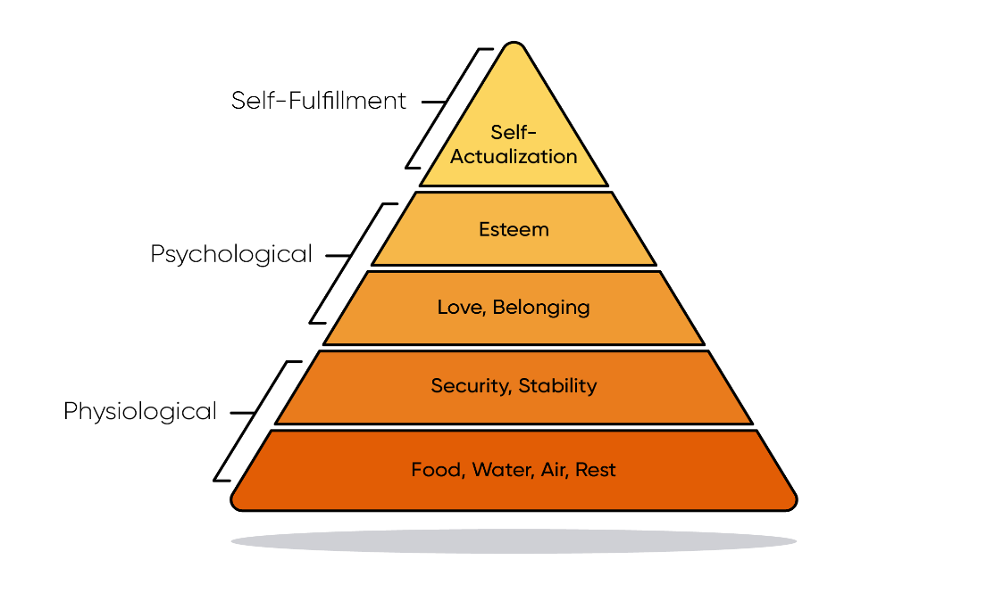
Figure 1: Maslow's Hierarchy of Needs

  - Physiological needs are the most basic needs for physical survival, such as food, water, rest…etc
After an individual’s physiological needs are met, the desire for security and safety becomes more notable.

  - Security/Safety is the need to feel safe in a particular environment. This includes personal, financial, and health-related security. After physiological and safety needs are satisfied, the next level of human needs is social, focusing on a sense of belonging and connection.

  - Social need is the need to be loved and accepted by others. Once safety is ensured, people seek social connections for a sense of belonging. This need is strongly wanted in childhood

  - Esteem needs: Maslow classified esteem needs into two categories, esteem for oneself ‘self-esteem’ (dignity, independence, achievement) , and the desire to be respected by others (Status, prestige) (Wahome, 2022)
Maslow indicated that the need for respect or reputation is most important for children and adolescents and precedes real self-esteem or dignity (Maslow A. , A Theory of Human Motivation, 1943 )

  - Self-Actualization Needs, we can find this need at the top of the pyramid as people strive to for personal growth.
Maslow describes this level as the desire to accomplish everything that one can, and “to become everything one is capable of becoming” (Maslow A. , 1943, 1987)
While Maslow believed that few individuals could attain full self-actualization, he maintained that everyone could experience temporary moments of self-actualization, known as 'peak experiences.' (Maslow A. , 1962)

- Perception:
Richard L. Solomon defines perception as “the process by which individuals organize and interpret their sensory impressions to give meaning to their environment.”
He further describes perception in consumer behavior as the process through which individuals interpret and make sense of sensory information related to products, brands, and marketing stimuli. This process involves several key stages: exposure, attention, interpretation, and retention.
- Exposure occurs when consumers encounter a stimulus through their senses.
- Attention is the selection of certain stimuli for further processing, influenced by factors like relevance and novelty.
- Interpretation is how consumers assign meaning to stimuli based on their past experiences, beliefs, and expectations.
- Retention involves storing this interpreted information for future reference, which can influence future purchasing decisions.
(Solomon, 2017)

- Learning:

Learning refers to the changes in an individual’s behavior that result from experience. Our perception in any given situation is influenced by our previous experiences, which create a preparatory set or expectations that help us categorize and organize new stimuli. In essence, we draw on our past experiences to achieve balance or consistency by relating to and interpreting new stimuli based on what we have previously learned. (Blythe, 2008)

According to Seongsin Lee, there are two main types of learning:
- Experiential Learning and it highlights the importance of real-life situations and practical application as this type of learning occurs when direct experiences lead to changes in behavior.
- Conceptual Learning:
On the contrary of experiential learning, this type of learning is acquired through indirect sources, such as books or lectures, and it involves understanding and applying concepts.
These distinctions help clarify how different types of learning can influence consumer behavior by shaping perceptions and expectations in various contexts (Lee, 2007)

- Beliefs and Attitudes:

Attitudes and beliefs represent another psychological factor that influences consumer behavior.
A belief is a conviction a person holds about something.
An attitude is a consistent view of something that encompasses the belief as well as an emotional feeling and a related behavior.

Research highlights that marketers can effectively shape consumer attitudes through strategic communication and branding efforts. By addressing and aligning with consumers’ beliefs, brands can foster positive attitudes, ultimately enhancing customer engagement and driving sales. (Kotler & Keller, 2016)

    - Social Factor:
Social factors are characteristics of individuals or groups that affect thought or behavior in social contexts and influence outcomes (American Psychological Association, 2022)

The social factor is one of the most affecting on consumer behavior, it includes family, group and status.
Family members often serve as primary sources of influence, impacting decisions from brand loyalty to purchasing preferences​
Groups, whether formal or informal, create reference points that help shape individual purchasing decisions. This influence often results in people adjusting their choices to align with the behaviors and expectations they perceive from these groups. Kotler defined the Group as “Two or more people who interact to accomplish individual or mutual goals” (Kotler P. , 2017)
Social Status can dictate the types of products and services individuals are interested to buy, often aligning with their identity and aspirations within their social context​.
Word of mouth (WOM) is also a powerful social factor that affect consumer behavior as it comes from a trusted source such as friends and family.
Kotler emphasizes the importance of personal recommendations in consumer behavior, stating that “the impact of the personal words and recommendations of trusted friends, family, associates, and other customers on buying behavior” can significantly influence purchasing decisions. (Kotler et Al, 2017)

    - Cultural Factors:
Kotler observed that human behavior is largely the result of a learning process and as such individuals grow up learning a set of values, perceptions, preferences and behavior patterns as the result of socialization both within the family and a series of other key institutions. From this we develop a set of values, which determine and drive behavioral patterns to a very large extent. According to Schiffman and Kanuk, values include achievement, success, efficiency, progress, material comfort, practicality, individualism, freedom, humanitarianism, youthfulness and practicality. This broad set of values is then influenced by the subcultures like nationality groups, religious groups, racial groups and geographical areas, all of which exhibit degrees of difference in ethnic taste, cultural preferences, taboos, attitudes and lifestyle.
Geert Hofstede also discussed how can culture affect behavior by stating: “Culture is more often a source of conflict than of synergy. Cultural differences are a nuisance at best and often a disaster.” (Hofstede, 2011).

Cultural factors include three main categories:

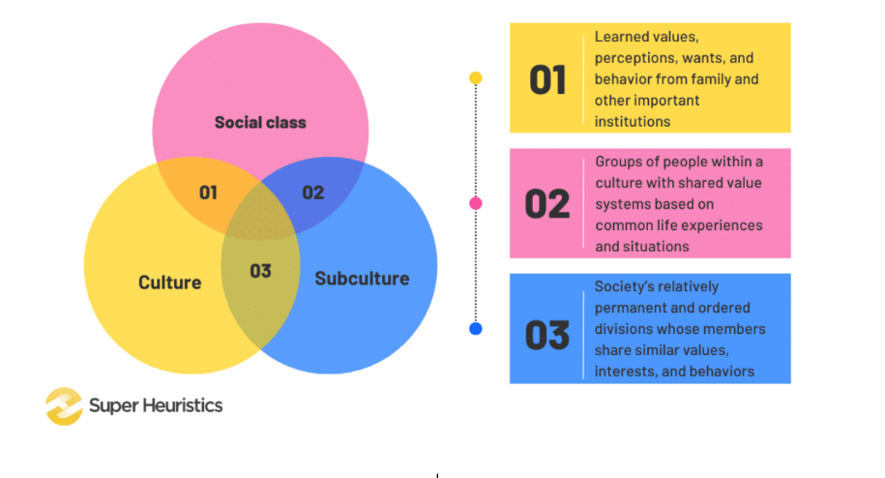

Figure 2: Cultural Factors Affecting Consumer Behavior
- Culture, which is the set of values, beliefs, norms and customs that shapes one’s identity and influence our actions. If affects everything in our life, from how greet each other to what we wear, as it is created and founded from early in human life, starting from infancy.

- Social class, which is influenced by factors such as income, education, and occupation, groups individuals who share similar life experiences and circumstances.
There are three different social classes in our society: Upper class consumers, who spend more to maintain their status. Middle class consumers, who purchase carefully and look for cheaper options by comparing. Lastly, lower class consumers, who buy on impulse.
Therefor, marketing managers should study these groups and decide whether they want to target upper, middle or lower class to take appropriate measures to appeal to the targeted audience.

- Subculture, each culture is made up of smaller subcultures that offer more specific identification and socialization opportunities for their members. A subculture represents a set of beliefs, values, and practices shared by a subgroup within the main culture, often defined by factors such as nationality, religion, ethnicity, or geographic location.
For example, regional differences can create subcultures that affect preferences for food, clothing, or even technology. There for, consumers in rural areas may have different priorities than those in urban centers. (Hoyer & MacInnis, , 2010)
(Ramya N & Ali, 2016)

    - Economic Factors:
This is the fourth factor that can influence consumer behavior, as the economic conditions of an individual can affect their purchasing decisions of a specific brand.
Hoyer and MacInnis noted that “The economic environment directly affect consumers' ability to spend and their willingness to make purchases, especially during periods of economic downturn.” (Hoyer & MacInnis, , 2010)
With that being said, personal and family income can make a huge impact in buying behavior. Higher income levels typically lead to increased purchasing power, enabling consumers to buy more products and services. In contrast, lower income can constrain spending and force consumers to prioritize essential items over luxuries.

2.4 Overview of Digital Marketing.
In this section, you’ll find an overview of Digital marketing and its strategies before talking about how it affects consumer behavior in detail.

Digital Marketing typically refers to online marketing campaigns that appear on a computer, phone, tablet, or other device. It can take many forms, including online video, display ads, search engine marketing, paid social ads and social media posts.
Digital marketing matured only in the late 1990s with the widespread of the internet all over the world. As businesses moved online, consumers started enjoying the convenience of shopping from home. What started as an occasional online shopping experience has grown into a regular habit for over two billion digital shoppers globally, reshaping how companies approach marketing entirely. (Mundra, 2024)

  - Digital marketing Definitions

Author | Definition
Chaffey (2013) | “Achieving marketing objectives through applying digital technologies and media, including the internet, mobile phones, and display advertising, to engage with consumers in the digital realm.” (Chaffey, 2013)
Kotler and Armstrong (2018) | The process of promoting products or services through digital channels, using online marketing strategies like search engine optimization (SEO), social media marketing, content marketing, and pay-per-click (PPC) advertising.” (Kotler & Armstrong, 2018)
Ryan Deiss and Russ Henneberry (2017) | "The art and science of creating and delivering relevant content to attract and engage a clearly defined and understood target audience." (Deiss & Henneberry, 2017)
Sterne, J. (2010) | “The use of social media and online platforms to connect with consumers, engage them, and drive sales." (Sterne, 2010)
Table 2: Digital Marketing Definitions

The definitions of digital marketing from different authors highlight its multifaceted nature and evolving significance in the modern marketplace. Chaffey (2013) emphasizes the strategic use of digital technologies to achieve marketing goals, while Kotler and Armstrong (2018) focus on the role of digital channels in promoting products and services. Deiss and Henneberry (2017) articulate digital marketing as both an art and science, centring on the creation of relevant content that resonates with targeted audiences.
Sterne (2010) further underlines the importance of social media and online platforms in fostering connections with consumers, showcasing how these tools are integral to driving engagement and sales. Collectively, these perspectives underscore that digital marketing is not just about the tools used but also about the strategic approach to engaging and understanding consumer behavior in a digital context.
In essence, effective digital marketing requires a comprehensive understanding of digital channels, consumer psychology, and the ability to create meaningful interactions that drive brand loyalty and business success.

Digital Marketing Strategy (DMS)

- Digital Marketing Strategy Definition:
Adobe Experience cloud team defined digital marketing strategy that “it is a strategy put in place by a brand to align with set objectives and goals to attract a specific type, or types, of customer using a combination of marketing techniques. These techniques include content marketing, social media marketing, earned marketing, and more.” (Adobe Experience Cloud Team, 2022)

A good and studied digital marketing strategy allows businesses to use different digital channels, such as social media, email marketing, search engine optimization (SEO) and pay per click (PPC), to connect with targeted customers and consumers interested in their products or services. A well-crafted strategy results in creating great customer experience (CX), customer loyalty, build a brand, bring potential customers, and more.

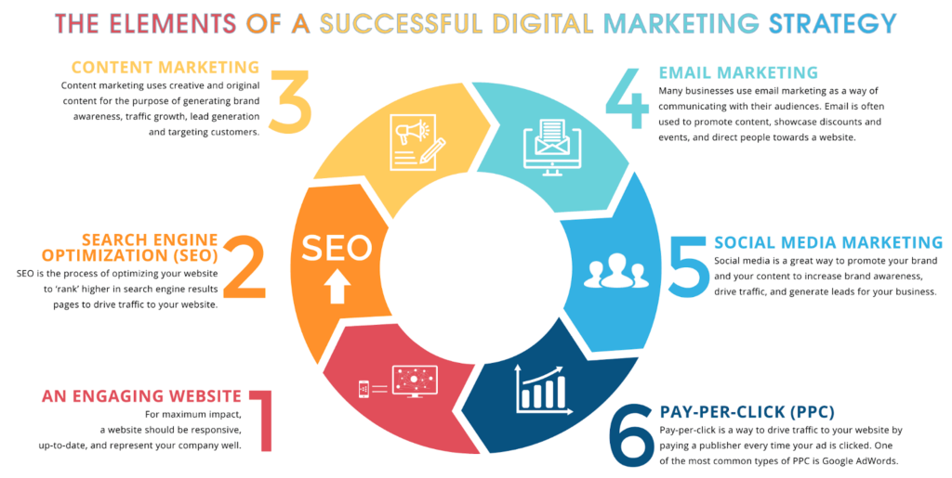
Figure 3: Elements of a Successful Digital Marketing Strategy

  - Digital Marketing Channels:

Understanding how Digital Marketing Channels works is essential for successful business as they allow businesses to reach their targeted audience efficiently and effectively. They build meaningful relationships and foster brand loyalty by offering real-time interaction with the consumer. These channels also provide measurable data, allowing companies to adjust strategies quickly based on consumer behavior and campaign performance. The main channels include:

- Search Engine Optimization (SEO):
Search engine optimization works by raising a website's appearance in search engine result pages (SERPs), which increases organic (unpaid) traffic coming from people searching relevant content. Effective SEO techniques include creating high-quality backlinks, optimizing on-page elements like content, and managing thorough keyword research to align with user searches. These strategies help improve a website's visibility and rankings on search engines and make it easier for consumers to find your website which will lead to a change in their purchasing behavior.
SEO can also enhance your online authority and credibility by improving your website’s ranking on search engines. The higher your site appears in search results, the more trustworthy it seems to both your target audience and search engines, reinforcing your business’s reliability and relevance. (MOZ, n.d.)

Marketers must understand search engine algorithms and consumer search behavior to properly optimize their content.
For example, companies such as MOZ offer resources and tools to assist marketers in enhancing their SEO tactics, which eventually results in more people visiting their websites

- Social Media Marketing (SMM):
Social media platforms, such as Instagram, X, Tik Tok, Snapchat, and Facebook, give brands the opportunity to interact directly with consumers, build brand recognition, and foster community engagement. The interactive elements of social media encourage two-way communication and allow companies to respond quickly to consumer comments and demands.

Mo Matcha, a Saudi-based online matcha store, engages with its customers through playful and interactive content on Instagram and TikTok. This approach boosts customer engagement and strengthens brand loyalty. As a result, this increased interaction and trust encourages more people to make purchases from the store, translating the positive social media presence into higher sales.
The entertaining content and direct engagement build a sense of community, making customers feel connected to the brand, which influences their purchasing decisions

- Email Marketing:
Email Marketing remains a powerful and effective way to reach customers and engage with them. One of the key benefits of email marketing that it has a high return on investment (ROI). The Data & Marketing Association (DMA) states that email marketing has an average ROI of $42 for every $1 spent. This is significantly higher compared to other digital marketing channels. Personalized email marketing may boost engagement and conversions by delivering tailored content straight to clients' inboxes. Segmentation and automation are two essential strategies for increasing email marketing's efficacy.
Email marketing offers comprehensive analytics that enable businesses to monitor various performance metrics, such as open rates, click-through rates, and conversion rates. This capability allows marketers to evaluate the success of their campaigns and make informed, data-driven decisions to enhance future strategies. (Morse, 2024)

- Content Marketing
Content marketing uses storytelling and information sharing to increase brand awareness. This strategy drives organic engagement and increases website traffic. A variety of media, such as blogs, videos, infographics, and podcasts, can be used for content marketing. This type of digital marketing helps in creating emotional connections with consumers which leads to building awareness, trust, and repeated interaction with the brand.
A great example for business using content marketing is Duolingo, a free app for learning languages. Duolingo targeted an audience, in the age group of 16 to 34 (GenZ and Millennials) who wants to learn a new language but doesn’t’ afford regular language classes/courses. Their genius way in content marketing using social media, especially Tik Tok, helped them in becoming a unicorn in the industry.
Duolingo uses a hilarious way to communicate their mission of “Free language education for the world” and showcases its fun personality with “just an owl tryna vibe.” Every post follows a definite brand style and an unhinged tone, while still packing a whole lot of entertainment. This resulted in great brand awareness as they now have more than 13 million followers and almost 318 million likes on Tik Tok. (Panigrahi, 2024)

- Paid Advertising (Pay-Per-Click Advertising):
Paid advertising is using sponsorship and paid media to promote businesses. it can provide a quick boost in visibility and help establish a foothold in new markets. Paid advertising, including social media ads and pay-per-click (PPC)campaigns, offers targeted reach and immediate visibility. Marketers must continually optimize these campaigns using customer behavior insights and performance analytics.
There is several types of paid ads like search ads, display ads, and social ads.
Socials ads are the most common due to the high number of users across social media networks. Social ads appear in social media feeds across different platforms. The ads are created on social media platforms such as Instagram and Snapchat, are targeted to a specific audience. Social ads are beneficial for advertisers who are looking to grow their brand or get users to engage with their products or services on their website. (Oviond, 2024)

Building a strategy for paid advertising can help you with:
Save time and money | spending some time on the strategy from the get-go will save you and your client a lot of money in the long run
Identify goals | you need to know exactly what you want to achieve with your paid advertising
Know your audience | you need to know who your paid ads will target and to understand your customers personas
Have a budget | this needs to be established in the strategy phase once you have determined your goals and audience
Decide which paid media channels to invest in | this will be the final step of your paid advertising strategy and will be based on the budget allocated to the paid advertising campaigns

Table 3: Benefits of a Well-Defined Paid Advertising Strategy

- Conclusion:
Digital marketing channels are essential to influencing customer engagement and behavior. Marketers can develop comprehensive strategies to engage with target audiences by leveraging paid advertising, social media, email, content, and search engine optimization. The effectiveness of digital marketing initiatives increases when one understands the distinct roles that different channels play.
Each channel has its unique advantages for engaging audiences and achieving specific goals. The table below outlines key channels, their engagement rates, and their ideal uses in a comprehensive marketing strategy.
Channel | Engagement Rate | Best for
SEO | High | Long-term visibility
Social Media Marketing | Medium | Brand engagement and awareness
Email Marketing | High | Direct communication and customer retention
Content Marketing | Medium | Establishing authority and thought leadership
Paid Advertising | High | Immediate visibility and targeted reach

Table 4: Digital Marketing Channels: Engagement Rates and Best Uses.

Digital Marketing Strategy (DMS) and its Impact on Consumer Behavior.

Digital Marketing Strategy plays a crucial part not only in promoting products and building a brand, but also for deeply influencing consumer behavior by shaping how customers perceive, engage with, and discover a brand, and how they think, feel and act, which leads to directly impact their decision-making process at all stages.

2.8.1 Key factors of how digital marketing strategies affect consumer behavior:

- Increasing awareness and reach (Brand Visibility):

Digital marketing strategies boost and increase consumer awareness and expand brand visibility by using different channels mentioned above. Using these channels like SEO and paid advertising, allows comopanis to appear in consumers' searches, ensuring that their brands are discovered when consumers are seeking information or solutions which leads to an ease of access to information. This increased accessibility to information, like product details, prices, and customer reviews, simplifies the research process and makes it easier for consumers to make purchasing decisions with confidence. (Smith, Bailey, & Brynjolfsson, 2000)
Chaffey (2013) mentions that digital technologies are applied to engage with consumers and build awareness through effective targeting of audiences via online channels.

(Rafikah, 2023)

- Building trust and authenticity:

Consumers today seek originality in brands, which digital marketing strategies can and aim to provide through transparent and consistent messaging. Social media platforms allow brands to directly interact with consumers, respond to their questions, and showcase customer reviews, which builds trust. Word-of-mouth (WOM) marketing, user-generated content, and influencer partnerships (a type of paid ads) further amplify this effect by adding credibility to the brand message which makes it seem and sound more relatable and trustworthy.
Deiss and Henneberry (2017) highlight that digital marketing is about creating meaningful interactions that build trust and engagement, which are essential for shaping consumer behavior.

- Customer Loyalty and Retention:
Digital marketing is not only about attracting new customers and building trust, but also about maintaining existing ones in a competitive environment. This can be done by building a well-structured strategy that keeps the brand’s competitive advantage and customer retention. Deiss and Henneberry (2017) emphasize that building long-term customer relationships through digital marketing is crucial to maintain these two things.
Loyalty programs, personalized offers, and consistent engagement via email marketing or retargeted ads help brands maintain long-term relationships with customers. By offering value beyond the initial purchase—such as exclusive deals or content—brands can ensure that consumers remain engaged and loyal, even in competitive markets.
Mickle Aancy stated that digital marketing, through factors like perceived convenience, and online accessibility, strengthens the relationship between brands and consumers by fostering trust and loyalty. He also suggests that consistent digital interactions and shared content help solidify these brand-consumer relationships, which directly impacts buying behavior and loyalty. (Aancy, 2023)
Take Apple for example, in 2023, the company that ranked first in brand loyalty was Apple. Apple has been in the top spot since 2022, overtaking Amazon, which had held that position for several years (Qualtrics, 2023). Apple has cultivated one of the most loyal brand followings ever seen, with users reporting that they do so because of ‘blind loyalty.’ Building this loyalty started with the brand’s clearly defined vision and mission statement, and Steve Jobs commitment to innovation, product quality and cutting-edge design.

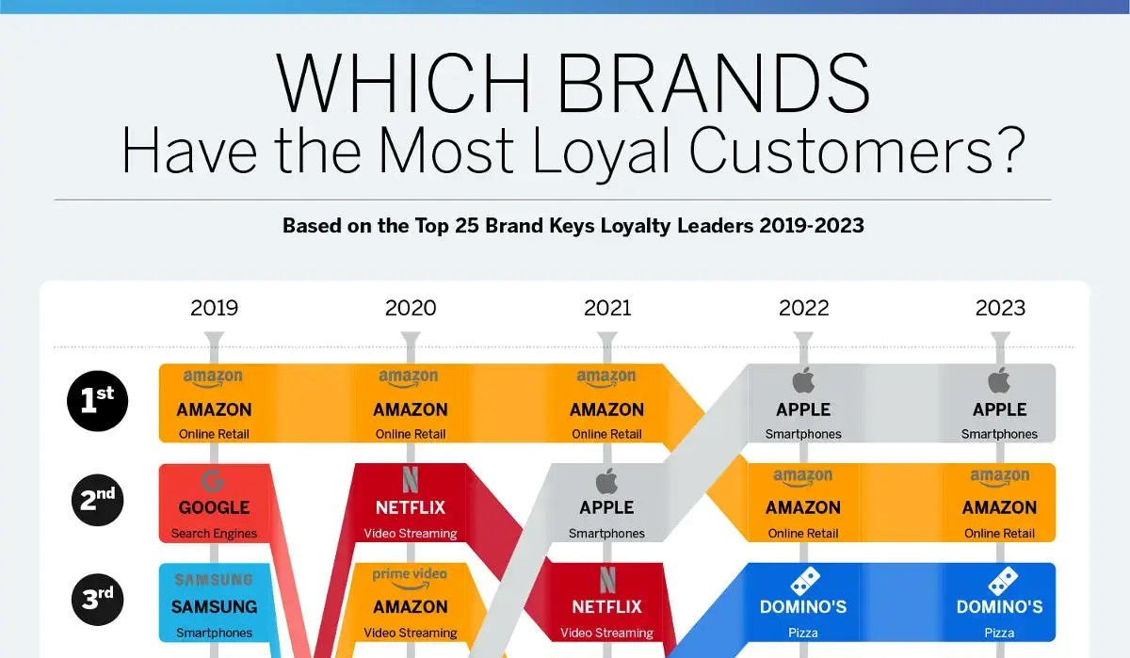
Figure 4: Top Brands with the Most Loyal Customers (2019-2023): Ranking Shifts and Trends

Lacey Ford, chief marketing officer at TrueCommerce said: “By creating and ‘living’ this kind of brand manifesto – by standing for something – you can create an emotional connection with your customers, too. This is often enough to preserve customer loyalty even when things go wrong. Many Apple users find themselves emotionally invested in the products they use, in large part because those products stand for an idea. Apple usage, itself, has slowly become an identity.”
(Ford, 2015)

- Personalization and Targeting (Personalized Consumer Experiences):
Personalized marketing is a game-changing strategy as it can target consumers based on their preferences and behavior by using tools such as SEO, customer relation management systems (CRM), and AI powered algorithms. These tools help businesses in customizing content and offers according to the consumer actions, searching behavior, past interactions and preferences.
Understanding what the consumers’ needs and what interests them by offering them a hyper-personalized experience that evolves with individual preferences enhance their loyalty and engagement which normally leads to a significant change in their purchasing behavior and choices, and an increase in their willingness to pay more. (Meduim, 2024)
Kotler and Armstrong (2018) say that digital channels like social media and email marketing are instrumental in delivering personalized experiences, helping companies foster deeper relationships with their customers.
An example of a business taking personalization to a whole new level is Sephora. As the beauty industry has a highly competitive market, Sephora knew that they needed to create not only loyal customers, but a loyal community. They achieved this by creating one of the best rewards programs in the US. Sephora encourage consumers by giving birthday gift samples to 'Meet and Greet events' to events where customers get to multiply their points. They also offer reservation assistant to book a makeover at one of their locations through a conversational interface. Clients tell the chatbot which service they need and in which store. The conversational interface uses natural language processing (NLP) to hold a conversation that feels like chatting with a friend. All clients have to do is say where they are, and the bot automatically finds them the closest location with a list of available times for appointments, and many more ways to create a great Personalized Digital Experiences.
(Gameball, 2024) (Caballé, 2023)

- Conclusion:
Digital marketing strategies has a strong impact on consumer purchase decisions by creating multiple touchpoints that guide and reinforce buying choices. Through channels like social media, email, and targeted ads, brands can keep their products in front of consumers and influence their behavior in real-time. For example, a consumer who visits a product page might see personalized ads reminding them of their interest, which can encourage them to finalize the purchase. This strategy, known as retargeting, subtly nudges consumers by keeping the brand top-of-mind.
Hoyer and MacInnis (2010) point out that consumers' purchasing decisions are increasingly shaped by the information they encounter online, whether through social media recommendations.
Social media and content marketing also play a big role. Brands use product reviews, blogs, and comparison charts to educate consumers, giving them the information they need to feel confident about a purchase. According to Sterne (2010), direct interaction on platforms like Instagram or X through comments, live chats, and social listening can strengthen relationships and foster loyalty, making consumers more likely to choose that brand when they're ready to buy.
By engaging consumers and providing useful content, digital marketing helps build trust, which ultimately drives purchasing decisions.

Key Performance Indicators (KPI):

To effectively assess the impact of digital marketing initiatives, several key performance indicators are vital:
- Conversion Rate: This KPI quantifies the percentage of visitors who take a specific action, such as making a purchase. A higher conversion rate signifies the success of marketing efforts, reflecting strong customer engagement and effective messaging that resonates with the target audience.
- Customer Acquisition Cost (CAC): CAC measures the total expenses incurred in gaining a new customer. Marketers must manage CAC to ensure it remains below the Customer Lifetime Value (CLV), as this balance is essential for sustaining long-term profitability and growth.
- Return on Investment (ROI): ROI evaluates the revenue generated from marketing activities relative to the costs involved. A high ROI indicates effective utilization of marketing resources and provides insights into the overall performance of campaigns.
- Engagement Metrics: Metrics such as likes, shares, and comments assess how users engage with content. High engagement levels demonstrate strong connections between the brand and its audience, often correlating with greater brand loyalty.
These KPIs are essential for evaluating the effectiveness of digital marketing tactics and aiding decision-makers in making informed choices that enhance overall performance.

Channel | ROI (%) | Effectiveness (%)
Email Marketing | 45% | 75%
Social Media Advertising | 30% | 80%
Search Engine Marketing | 25% | 70%
Pay-Per-Click | 20% | 65%
Table 5: ROI Comparison of Marketing Channels

Measurement Tools and Their Functions:

Effective measurement of digital marketing efforts requires a range of tools that facilitate data processing and performance tracking.
- Google Analytics: Analyzes website traffic, helping marketers track conversions, understand user behavior, and make informed decisions.
- Hootsuite: A social media management tool that allows for scheduling posts, analyzing engagement, and monitoring social media performance.
- Mailchimp: An email marketing and automation platform that simplifies designing and sending customized email campaigns, enhancing customer engagement and retention.
- SEMrush: An SEO and keyword research tool that assists businesses in improving organic traffic and search engine visibility.

Tool | Functionality | Use Case
Google Analytics | Website traffic analysis | Understanding user behaviour on websites
Hootsuite | Social media management and analytics | Scheduling posts and analysing engagement
Mailchimp | Email marketing and automation | Sending targeted email campaigns
SEMrush | SEO and keyword analysis | Improving search visibility and organic traffic
Table 6: Tool Functionality Overview
Conclusion:
Marketers should prioritize key performance indicators and metrics to assess the efficacy of their digital marketing strategies. By analyzing indicators such as conversion rates, engagement, and ROI, businesses can make data-driven decisions that enhance campaign effectiveness, ultimately leading to greater success in a competitive digital landscape.

  - The Influence of Digital Marketing on different factors.
By looking at the key factors that affect how consumers interact with digital marketing, this section directly answers the research question.
In the digital world, these elements which include psychological, social, cultural, factors have a significant impact on behavior.

2.11.1 Psychological Factors
Psychological factors, including motivation, perception, learning, beliefs, and attitudes, play a pivotal role in shaping consumer behavior, especially in the context of digital marketing.
- Motivation:
Digital marketing effectively influences consumer motivations by designing campaigns that address both basic need, and higher-level aspirations, such as the social status associated with luxury brands. Marketers strategically position products to align with different motivational drivers. To illustrate, luxury brands often market themselves as a symbol for status and prestige, to draw in customers who are looking for social approval.
By understanding Maslow’s hierarchy of needs mentioned before, marketers can create good communication that align with consumer aspirations, ultimately driving engagement and conversion rates. This alignment creates a deeper connection between consumers and brands, as individuals are more likely to purchase products that align with their personal motivations. (Inci, n.d.)

- Perception:
Consumers’ perceptions of brands through digital marketing channels directly influence buying decisions. Elements like visually appealing content, consistent branding, and clear messaging are crucial in shaping these perceptions. The marketplace’s perception of a brand or industry is extremely important, which is why well-known big brands work hard to ensure that the general perception surrounding them, and their industry is as positive as possible. Research from the University of Arkansas suggests that when a brand present a unified identity across different digital channels, they create a deeper connection with consumers
For example, Apple represented this strategy by developing a brand story that emphasizes innovation and excellence, and by fostering an emotional connection with their audience, as previously stated, Apple achieved “Blind loyalty” by using this strategy. (Belson, 2023)
Positive consumer perceptions are linked to increased loyalty, making it essential for brands to proactively manage their image. This involves not only maintaining visual consistency, but also aligning brand messages with consumer expectations and values.
- Learning:
Past experiences, whether positive or negative, shape expectations and willingness to engage with brands.
Learning occurs through two primary mechanisms:
    - Experiential engagement, where direct interactions influence and shape preferences,
    - Conceptual learning, where consumers absorb information from marketing communications.
Brands that prioritize delivering valuable and engaging content can create a rich learning environment, fostering consumer understanding and loyalty over time. Consistently providing relevant information results in brands to position themselves as a trusted source, encouraging repeat interactions and boosting customer lifetime value. Additionally, leveraging data analytics can help brands tailor their learning strategies to meet the variety of consumer preferences.

- Beliefs and Attitudes:
Consumer beliefs are often shaped by values, experiences, and social influences are one of the main factors that shapes attitudes toward brands. These attitudes include consumers’ consistent opinions and emotional responses, which directly impact purchasing behavior. Marketers can strategically influence these beliefs through targeted messaging that aligns with consumer values, such as sustainability or social responsibility. Brands that effectively communicate their commitment to ethical practices can positively shape consumer attitudes, capitalizing on the growing demand for responsible consumption.
One of the best examples of successful attitude branding come from large companies such as Nike, as it was on of the first companies to use this strategy through their slogan “Just do it”. This slogan doesn’t promote or a reference for their shoes but it strongly promotes the a life style that consumers would have by buying Nike priducts . John Dobie, a freelance Senior Graphic says: “All branding and marketing follows this line, with a focus on people achieving their exercise goals. The suggestion is: ‘With Nike products, you can be your best’.” (Dobie, 2021).

In summary, by addressing motivations, shaping perceptions, enhancing learning, and influencing beliefs and attitudes, brands can create meaningful connections with their audiences, ultimately leading to increased engagement and conversion rates.

2.11.2 Social Factors
Various influences from family, reference groups, and social status, plays a huge role in shaping behavior. In today’s digital enviroment, the rise of social media has enhanced these influences, with individuals increasingly seeking validation and approval from their networks before making purchasing decisions. This phenomenon underlines the importance of social proof, where positive reviews or recommendations from peers can significantly sway consumer choices.
- Influence of social media:
Social media platforms have emerged as a powerful tool for shaping consumer behavior by utilizing recommendations and social validation. Brands that engage effectively with consumers through social media can foster trust and enhance loyalty by creating authentic connections. Interactive campaigns that encourage sharing and engagement can amplify a brand's reach and credibility.
- Community Engagement:
Building online communities around a brand is essential for fostering consumer engagement and loyalty. Brands that interact actively with their audiences through social media, forums, and blogs cultivate a sense of belonging that encourages repeat purchases and advocacy. This two-way engagement deepens relationships and creates a more dedicated customer base. Brands that host online events or create discussion forums can enhance community bonds and drive brand loyalty.
Lego company is one of the best examples of brand communities, Lego Ideas originally started in 2008 in collaboration with a Japanese website and has since grown to become a major product ideation community. Here, Lego fans can submit construction ideas. By allowing members to submit their product ideas and launching contests, creative fans have the chance to choose what they want to see on the shelves next. Lego has managed to create a community that drives product ideation. (Harrower, 2021)
- Family and Group Dynamics:
Family members and reference groups play critical roles in shaping purchasing preferences and brand loyalty. Family influences choices through shared values and collective experiences, while friends can lead to conformity in buying behavior. In the digital age, social media amplifies these dynamics, making consumers more susceptible to group influences. Marketers must recognize the power of these social relationships in their strategies, as consumers are more motivated to purchase products suggested by family, trusted friends or influencers. (Liang, 2024).
- Social Status:
A consumer's social status often reflects their identity, aspirations, and lifestyle choices, significantly impacting brand preferences and purchasing decisions. Individuals with higher social status may gravitate toward luxury brands that signify prestige and exclusivity, while those with limited means may focus on value-driven choices. Understanding these social influences is important for marketers seeking to develop effective strategies that resonate with diverse consumer segments. crafting messaging and product positioning to align with the social aspirations of different demographic groups can enhance engagement and conversion rates.

2.11.3 Cultural Factors:
A marketing campaign that resonates in one cultural context may fall flat in another due to variations in humor, symbols, values, and social norms. For instance, humor that is well-received in one culture might be perceived as offensive in another, underscoring the necessity for culturally sensitive messaging.
So it is clear that marketers must understand what culture the targeted audience are from and act accordingly as the cultural factor is a two-edged sword, which means using a digital marketing strategy without underrating the culture may cause in huge loss to the brand.
- Culture:
At its core, culture comprises the shared values, beliefs, and practices that define a group’s identity and actions. These cultural elements inform consumer behavior, influencing preferences for specific products, brands, and advertising styles. Marketers must recognize that cultural nuances affect how consumers interpret marketing messages, making it crucial to tailor communications accordingly.
- Social Class:
Social class, determined by factors such as income, education, and occupation, significantly impacts purchasing behaviors and brand perceptions. Consumers from different social classes may prioritize different product attributes, leading to varying responses to marketing efforts. Understanding these dynamics enables marketers to craft strategies that resonate around targeted audience.
- Subcultures:
Within larger societies, subcultures represent smaller groups that exhibit distinct values and behaviors. These subcultures can influence specific consumption patterns and brand loyalty, necessitating targeted marketing strategies. Brands that recognize and cater to the unique preferences of subcultures, such as ethnic communities or lifestyle groups, can enhance their relevance and appeal.
- Global vs. Local Strategies:
The effectiveness of marketing strategies can differ significantly across cultural contexts. Successful brands, such as Coca-Cola, demonstrate the importance of adapting messaging to fit local cultures, ensuring that campaigns resonate with the values and preferences of specific audiences. This localized approach enhances brand acceptance and fosters deeper emotional connections with consumers.
Knowing cultural influences is paramount for marketers seeking to navigate the complexities of consumer behavior in the digital landscape. By acknowledging and respecting cultural differences, brands can create more effective, engaging, and relevant marketing strategies that resonate with diverse consumer groups.

Factor Category | Key Factors | Impact on Consumer Behavior | Examples
Psychological Factors | Motivation | Drives purchasing decisions based on needs (e.g., convenience, status). | Fast delivery from Amazon; exclusivity from luxury brands.
 | Perception | Shapes brand image through visuals and messaging. | Apple's design and innovative branding.
 | Learning | Past experiences affect future engagement and loyalty. | Positive service leading to repeat purchases.
Social Factors | Social Media Influence | Peer reviews and endorsements guide buying choices. | Instagram influencers affecting brand perception.
 | User-Generated Content | Builds trust and credibility through reviews. | High ratings on platforms like Yelp.
 | Community Engagement | Fosters loyalty through shared experiences. | Brands creating online forums or groups, like Lego
Cultural Factors | Cultural Norms | Marketing must resonate with diverse cultural backgrounds. | Nike's campaigns tailored to local markets.
 | Global vs. Local Strategies | Success in local markets requires tailored messaging. | Coca-Cola’s region-specific flavors.
Table 7: Summary of key factors

جامعة ميدأوشن

كلية الإدارة
قسم / تخصص إدارة الأعمال

العنوان باللغة العربية
تأثير التسويق الرقمي على سلوك المستهلك

إعداد الطالب/
زينة طارق عمورة
رقم الطالب/
241002299

إشراف/
د.الفيصل عبد الحميد د.فايز جراد

العام الدراسي:
2024

