

A Fine-Tuned Multimodal AI Agent for Tumour Board Decision Support and Prognostic For Breast Cancer Outcome Assessment

Prepared By
Name: Moayad Khayat ID No.: 261002503
Name: Fares Ashraf ID No.: 221000769
Submitted in fulfillment of the requirements for the degree Master of Science in Artificial Intelligence
At
College of Informatics
Midocean University
UAE
Supervisor Name: Dr. Mohamed Eassa
College of Informatics, Midocean University, Comoros

Acknowledgements

We would like to thank our supervisor, Dr. Mohamed Essa, for his continuous guidance and valuable feedback throughout this research. His expertise in both artificial intelligence and galaxy studies has greatly influenced the direction of this work. His comments challenged us to think more critically and approach the research from a scientific perspective rather than a purely technical one.

We are also thankful to the faculty members at the College of Informatics, Midocean University, for providing a supportive academic environment that inspired independent thinking and research development.

Finally, we would like to express our appreciation to our families for their patience, encouragement, and support during this journey.

Abstract

The growing adoption of precision oncology has significantly increased the complexity of Tumor Board decision-making, particularly concerning breast cancer prognostic evaluation. Despite recent advancements in medical artificial intelligence, there remains a critical lack of multimodal, end-to-end AI systems optimized for clinical oncology workflows. Current models predominantly focus on narrow, text-based classification tasks and fail to integrate the diverse data modalities required for comprehensive clinical reasoning.

To address this gap, this thesis proposes the development and evaluation of a fine-tuned, multimodal AI agent designed specifically for Tumor Board decision support and prognostic outcome assessment in breast cancer. The proposed approach implements Parametric Knowledge Injection (PKI) to adapt the MedGemma 1.5 (4B) foundation model. MedGemma is an open-weights medical foundation model developed by Google and pre-trained on clinical datasets, making it highly suitable for medical reasoning. PKI directly embeds specialized clinical knowledge and guidelines into the model weights using Low-Rank Adaptation (LoRA) and Quantized Low-Rank Adaptation (QLoRA) via the Unsloth optimization framework. LoRA injects small, trainable low-rank matrices into the network while freezing the base model, and QLoRA further reduces memory demands by quantizing the base model to 4-bit precision. The resulting system integrates clinical records, pathological findings, and mammography (radiological scans) to generate patient summaries, retrieve evidence, and assess prognostic outcomes.

Rather than functioning autonomously, the AI agent is deployed through an OpenWebUI platform as an advisory tool, operating within a strict physician-supervised feedback loop to ensure clinical safety. The system depends on mammography as the primary radiological imaging modality, using structured reports to evaluate disease staging and prognostic risk. The primary objectives of this research encompass the integration of structured breast cancer datasets, the development of the generative AI agent, and a rigorous evaluation of the model's clinical usefulness and prognostic agreement with expert physician decisions. Ultimately, this research contributes a multimodal AI framework that bridges the gap between state-of-the-art medical language models and real-world clinical deployment, aiming to enhance Tumor Board efficiency and precision oncology care.

Contents
Acknowledgements 2
Abstract 3
List of Abbreviations 5
List of figures 6
Chapter 1: Introduction 1
1.1 Overview 1
1.2 Problem Definition 1
1.3 Thesis Objectives 2
1.4 Thesis Contribution 2
1.5 Thesis Organization 3
Chapter 2: Theoretical Background and Related Work 3
2.1 Introduction 3
2.2 Background 5
2.2.1 BRCA Gene Biology and Cancer Susceptibility 5
2.2.2 Precision Oncology and the Tumor Board Workflow 6
2.2.3 Large Language Models and Medical AI 6
2.2.4 Multimodal AI in Oncology 7
2.2.5 Parameter-Efficient Fine-Tuning: LoRA and QLoRA 8
2.2.6 MedGemma and the OpenWebUI Deployment Platform 9
2.3 Related work 10
2.4 Related work Summary and Gap Analysis 17

List of Abbreviations
- AI: Artificial Intelligence
- BRCA: Breast Cancer Susceptibility Gene
- CT: Computed Tomography
- HRD: Homologous Recombination Deficiency
- IHC: Immunohistochemistry
- LLM: Large Language Model
- LoRA: Low-Rank Adaptation
- MCQ: Multiple-Choice Question
- MRI: Magnetic Resonance Imaging
- NGS: Next-Generation Sequencing
- NLP: Natural Language Processing
- PARP: Poly (ADP-ribose) Polymerase
- PET: Positron Emission Tomography
- PKI: Parametric Knowledge Injection
- QLoRA: Quantized Low-Rank Adaptation

List of figures

- Figure 2.2: Schematic representation of the LoRA (Low-Rank Adaptation) fine-tuning architecture, showing frozen pre-trained weights alongside small trainable adapter matrices that capture task-specific knowledge.

- Figure 2.3: Conceptual diagram of a Multimodal AI Framework in Oncology, integrating genomics, clinical records, and imaging for Tumor Board Decision Support.

- Figure 2.4: Mockup of the proposed Tumor Board AI Dashboard, featuring multimodal patient summaries, prognostic assessments, and physician-supervised decision support.

- Table 2.1: Comparison oIf related studies in Oncology AI and Tumor Board Support

Chapter 1: Introduction

1.1 Overview
The growing adoption of precision oncology and the increasing use of diagnostic testing have highlighted a critical clinical need for interpretation support. Despite these advancements, there is a distinct lack of integrated clinical oncology AI systems. Current systems are not optimized for clinical oncology workflows and fail to accommodate the time constraints of Tumor Board meetings. This presents a research opportunity to build integrated oncology databases, support clinical Tumor Board workflows, and develop physician-supervised oncology AI. The proposed solution involves a fine-tuned multimodal AI agent utilizing MedGemma 1.5 to integrate clinical, pathological, radiological (specifically mammography), and genomic data. This system aims to support prognostic outcome assessment in breast cancer, ensuring that decision support remains advisory and physician-validated throughout the workflow.

The development of this framework relies on globally accessible breast cancer datasets. For instance, histopathological and clinical records are sourced from the Cancer Genome Atlas Breast Invasive Carcinoma (TCGA-BRCA) repository, while mammographic imaging data is obtained from public archives such as the Curated Breast Imaging Subset of the Digital Database for Screening Mammography (CBIS-DDSM). Integrating these public datasets establishes a reproducible and robust foundation for fine-tuning the multimodal agent, demonstrating the feasibility of using globally open research resources to build clinical decision support tools. [1, 2]

1.2 Problem Definition
While existing medical AI research has explored various applications such as medical question answering, clinical chatbots, imaging interpretation, and pathology classification, it largely focuses on narrow use cases rather than an end-to-end Tumor Board workflow. Few systems successfully integrate these diverse capabilities within a cohesive Tumor Board decision-support workflow. Furthermore, there is a significant gap in the availability of AI systems optimized for the specific clinical constraints and requirements of Saudi oncology practices.

The primary problem addressed in this thesis is the need for a comprehensive, physician-supervised AI agent that can effectively interpret breast cancer clinical features, radiological findings, and pathological records to support prognostic assessment and improve overall Tumor Board efficiency without assuming autonomous clinical decision-making authority.

1.3 Thesis Objectives
This study has a few main goals, which are:

Develop and evaluate a fine-tuned multimodal AI agent that supports Tumor Board discussions by integrating various data sources. The specific objectives are as follows:

- Build Dataset: Build a structured breast cancer dataset by integrating publicly available clinical, pathological, and mammographical datasets.
- Fine-tune Model: Fine-tune the MedGemma 1.5 (4B) model using the Unsloth framework with LoRA and QLoRA methods.
- Develop Agent: Develop a Tumor Board AI Agent capable of summarizing patient cases, retrieving evidence, and generating discussion points.
- Assess Prognosis: Support prognostic outcome assessment by categorizing risk (Low, Intermediate, High) based on cancer type, stage, BRCA status, and clinical variables..
- Evaluate Agreement: Evaluate the system's agreement with physician decisions and its clinical usefulness through a structured feedback loop.

1.4 Thesis Contribution
This research makes several significant contributions across clinical, technical, and research domains:

- Clinical Contributions: It helps doctors understand BRCA results, figure out how serious a tumor is, and gives support during Tumor Board meetings to make sure patients get the best care possible.
- Technical Contributions: Delivers a fine-tuned MedGemma oncology model, an OpenWebUI clinical research platform for clinical interaction, and a physician-supervised learning pipeline.
- Research Contributions: Research Contributions: Develops a Saudi-focused BRCA oncology dataset, establishes a Tumor Board AI framework, and produces publishable scientific outputs.

1.5 Thesis Organization
The rest of this thesis is organized as follows:
- Chapter 2 discusses the theoretical background, including BRCA alterations, precision oncology, and relevant applications of AI in medicine.
- Chapter 3 presents the proposed methodology, detailing data collection, the system architecture, and the fine-tuning pipeline.
- Chapter 4 analyzes the experimental results and evaluates the model's performance against physician judgment.
- Chapter 5 This final chapter wraps up the entire study, highlighting the key findings and takeaways. It also outlines the contributions made by the research and points to areas where future studies can build upon this work, potentially exploring its applications to other types of cancer.

Chapter 2: Theoretical Background and Related Work

2.1 Introduction

The following section provides a comprehensive overview of the theoretical foundations and prior research relevant to the development of a multimodal AI agent for Tumor Board decision support in BRCA-related oncology. It begins by introducing the essential biomedical concepts, namely BRCA gene biology, precision oncology principles, and the operational structure of multidisciplinary Tumor Boards. Subsequently, the key computational techniques that underpin the proposed system, including Large Language Models, multimodal architectures, and parameter-efficient fine-tuning methods, are presented and contextualized.

As outlined in Chapter 1, the increasing volume and complexity of clinical, genomic, and radiological data generated in modern oncology practice have outpaced the capacity of traditional manual review processes. In parallel, recent breakthroughs in generative AI and foundation models have demonstrated that machine learning systems can encode extensive biomedical knowledge and assist with clinical reasoning tasks. However, the vast majority of existing efforts concentrate on narrow, single-modality applications, such as medical image classification or text-based question answering, rather than addressing the end-to-end, multimodal requirements of a Tumor Board workflow.

Moreover, while substantial progress has been made in deploying AI within clinical settings, there remains a pronounced scarcity of tools that integrate multimodal workflows. This chapter therefore serves a dual purpose: it establishes the necessary theoretical groundwork and systematically reviews previous contributions to identify the research gaps that motivate the present investigation.

The chapter is structured as follows. Section 2.2 outlines the biological background of breast cancer susceptibility, precision oncology principles, Tumor Board operational workflows, and the parameter-efficient adaptation methods employed. Section 2.3 provides a detailed review of related studies, analyzing their technical methods, datasets, and limitations. Finally, Section 2.4 synthesizes the findings to establish the research gaps that motivate the proposed work.

Theoretical research in medical informatics highlights the need for architectures that balance computational efficiency with clinical accuracy. [3]

2.2 Background

2.2.1 BRCA Gene Biology and Cancer Susceptibility

The Breast Cancer Susceptibility Genes, BRCA1 and BRCA2, are tumor suppressor genes that occupy a central role in preserving genomic integrity. Under normal physiological conditions, the protein products of these genes participate in the homologous recombination (HR) pathway, a high-fidelity mechanism responsible for repairing double-strand breaks (DSBs) in DNA. When either BRCA1 or BRCA2 carries a deleterious mutation, the HR repair pathway becomes compromised, forcing the cell to rely on alternative, error-prone repair mechanisms such as non-homologous end joining (NHEJ). This accumulation of unrepaired or incorrectly repaired DNA damage progressively drives genomic instability, which is a recognized hallmark of cancer development [4].

Clinically, changes in the BRCA1 and BRCA2 genes are most closely linked to a higher risk of breast cancer over a person's lifetime. However, these changes also increase the risk of other malignancies, such as pancreatic and prostate cancer. It is essential to differentiate between germline and somatic BRCA mutations. Germline mutations are inherited and present in every cell of the body, which carries implications for hereditary risk assessment. Somatic mutations, by contrast, arise spontaneously within tumor cells and are detected through tumor tissue sequencing. Both categories have clinical implications, as tumors harboring BRCA mutations often respond better to platinum-based chemotherapy and to Poly (ADP-ribose) Polymerase (PARP) inhibitors [5].

The concept of Homologous Recombination Deficiency (HRD) has emerged as a broader biomarker that captures not only BRCA1/2 mutations but also defects in other genes within the HR pathway (e.g., RAD51, PALB2, ATM). HRD scoring has become an increasingly important tool in clinical practice for identifying patients who may benefit from PARP inhibitor therapy, even regardless of BRCA mutational status. Understanding these molecular underpinnings is essential for the AI system proposed in this thesis, which must accurately interpret BRCA mutational status and its clinical ramifications within the context of Tumor Board deliberations [6].

2.2.2 Precision Oncology and the Tumor Board Workflow

Precision oncology represents a paradigm shift in cancer treatment, moving away from uniform therapeutic strategies toward individualized treatment plans guided by the molecular and clinical profile of each patient's tumor. This approach is made possible by diagnostic profiling, which can identify specific alterations, receptor statuses, and clinical indicators that inform targeted therapy selection [7].

At the operational core of precision oncology lies the Multidisciplinary Tumor Board (MTB), a structured clinical forum in which a panel of specialists collaboratively reviews complex cancer cases. A typical MTB comprises medical oncologists, surgical oncologists, radiation oncologists, pathologists, radiologists, geneticists, and increasingly, bioinformaticians. The standard workflow proceeds through several stages: (1) patient referral and case selection, (2) genomic profiling via NGS, (3) bioinformatic data processing and variant interpretation, (4) multidisciplinary case review and evidence deliberation, (5) formulation of treatment recommendations (which may include on-label targeted therapies, off-label drug use, or clinical trial enrollment), and (6) formal reporting and longitudinal follow-up [8].

Tumor Boards are highly valuable in clinical settings, but they face mounting operational challenges. The volume of clinical data is growing rapidly, and treatment guidelines change frequently. Consequently, clinicians must review a large number of cases, which imposes significant time constraints on participating specialists. These challenges are compounded by the lack of infrastructure optimized for oncology AI, highlighting the need to align clinical workflows with patient care demands [8].

2.2.3 Large Language Models and Medical AI

Large Language Models (LLMs) are deep neural network architectures, predominantly based on the Transformer design, that are pre-trained on massive text corpora to acquire general-purpose language understanding and generation capabilities. Models such as GPT-4, PaLM, LLaMA, and Mistral have demonstrated high proficiency across a wide range of natural language processing tasks, including text summarization, question answering, and conversational dialogue [9].

In the field of medicine, researchers have evaluated general-purpose models on standardized examinations, achieving performance levels approaching or exceeding those of human physicians on certain benchmarks. Concurrently, domain-specific adaptations, such as Med-PaLM, BioMistral, and MedGemma, have been developed by further training foundation models on curated biomedical literature and clinical corpora [10, 11].

Deploying LLMs in high-stakes clinical environments introduces unique challenges. The phenomenon of hallucination, where a model generates plausible-sounding but factually incorrect information, poses a significant clinical risk. Furthermore, most existing medical LLMs operate on textual data alone and lack the capacity to process or reason over heterogeneous data modalities, such as radiological scans or pathology reports, which motivates the multimodal approach [3].

2.2.4 Multimodal AI in Oncology

Multimodal AI refers to computational systems designed to simultaneously process and integrate information from two or more distinct data types, such as clinical text, medical images, and genomic sequences, to produce unified analytical outputs. In oncology, this capability is valuable because comprehensive clinical decision-making requires the synthesis of heterogeneous information streams [12].

Studies have demonstrated that multimodal architectures can outperform their unimodal counterparts in cancer prognosis, treatment response prediction, and biomarker discovery. For instance, models that combine digital pathology with clinical variables have shown improved survival prediction accuracy compared to models relying on either modality alone. Similarly, frameworks that integrate radiological imaging with genomic profiles have been used to predict drug sensitivity and identify novel therapeutic targets [13].

Despite these advances, the translation of multimodal AI from research prototypes to clinical deployment remains challenging. Key barriers include the difficulty of aligning heterogeneous data formats, the computational cost of processing high-dimensional inputs, and the need for model outputs that are interpretable and actionable for practicing clinicians [14].

2.2.5 Parameter-Efficient Fine-Tuning: LoRA and QLoRA

Conventional fine-tuning of large language models requires updating all network parameters, which often number in the billions. This process demands substantial computational resources, including high-performance graphics processing units (GPUs) and extensive memory capacity. Parameter-Efficient Fine-Tuning (PEFT) methods address these constraints by enabling domain-specific model adaptation while updating only a small fraction of the base network weights.

Parameter-efficient fine-tuning methods have emerged as a practical alternative, enabling domain-specific adaptation while modifying only a small fraction of the model's weights. Low-Rank Adaptation (LoRA) is one of the most widely adopted techniques. Rather than retraining the entire model, LoRA injects small, trainable low-rank matrices into selected layers of the frozen pre-trained network. During training, only these compact adapter matrices are updated, typically comprising less than 1% of the total model parameters [15].

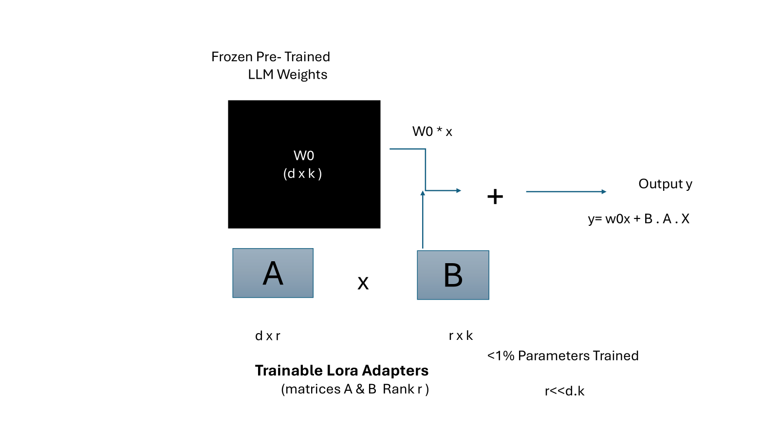

Figure 2.2: Schematic representation of the LoRA (Low-Rank Adaptation) fine-tuning architecture, showing frozen pre-trained weights alongside small trainable adapter matrices that capture task-specific knowledge.

Quantized Low-Rank Adaptation (QLoRA) extends this approach by compressing the base model to 4-bit precision through quantization, reducing the memory footprint. This enables the fine-tuning of models with tens of billions of parameters on consumer-grade hardware, lowering the barrier to entry for medical institutions and research groups [16].

The Unsloth optimization framework offers a highly efficient implementation of LoRA and QLoRA, yielding up to a twofold speed increase in training and a 60% reduction in memory footprint compared to standard configurations. In this study, we leverage Unsloth to adapt the MedGemma 1.5 (4B) foundation model to the multimodal clinical requirements of breast cancer Tumor Boards. This optimization minimizes hardware constraints, allowing model customization to proceed efficiently on standard infrastructure.

The Unsloth framework provides an optimized implementation of both LoRA and QLoRA, delivering faster training speeds with less memory consumption compared to standard implementations. This efficiency is important for adapting foundation models for specialized clinical support [17, 18].

2.2.6 MedGemma and the OpenWebUI Deployment Platform

MedGemma 1.5 is an open-weight medical foundation model developed by Google, built upon the Gemma architecture and pre-trained on a curated corpus of biomedical literature and clinical notes. The 4-billion-parameter variant offers a balance between computational efficiency and clinical reasoning capability, making it well-suited for resource-constrained deployment scenarios. Importantly, MedGemma supports multimodal inputs, enabling it to process both textual and visual clinical data within a unified inference pipeline [19].

OpenWebUI is an open-source web interface platform designed for interacting with large language models. In the proposed framework, it serves as the deployment layer through which physicians interact with the fine-tuned AI agent. The platform supports conversational dialogue, document upload, and structured output formatting. These features are essential for facilitating the physician-supervised feedback loop that underpins the system's clinical safety architecture [20].

In this thesis, we propose adapting MedGemma 1.5 (4B) using Parametric Knowledge Injection (PKI) via LoRA and QLoRA on the Unsloth framework. PKI is a fine-tuning methodology that alters the internal weights of the pre-trained foundation model to store and recall domain-specific clinical knowledge directly from its parameters. In contrast to Retrieval-Augmented Generation (RAG), which queries external databases at runtime, PKI allows the model to internalize oncology guidelines, breast cancer diagnostic standards, and clinical correlations. During fine-tuning, the base weights of MedGemma 1.5 are frozen, and low-rank adapter matrices are trained. By utilizing QLoRA, the base model is quantized to 4-bit precision, reducing the memory footprint to fit on standard industrial-grade GPUs. This method ensures that the model can retrieve clinical facts and summarize mammography report structures efficiently during Tumor Board meetings.

2.3 Related work

A considerable body of research has emerged in recent years examining the role of Artificial Intelligence across various oncology-related domains. Nonetheless, the majority of prior efforts have concentrated on isolated facets of the problem. Certain studies prioritize improvements in image-based diagnostics, whereas others center their attention on how Large Language Models (LLMs) can process and generate clinical narratives. Only a relatively limited subset of the published work addresses the simultaneous fusion of heterogeneous data sources. Consequently, it is essential to examine these contributions both as individual performance milestones and as complementary pieces that collectively underscore the demand for a holistic, clinician-guided Tumor Board support system.

Chen et al. (2024) [21] examined how large language models could serve as assistive tools within the context of multidisciplinary Tumor Board deliberations. Drawing upon a retrospectively gathered clinical dataset of 450 complex breast cancer cases discussed during multidisciplinary conferences, the researchers team assessed the capacity of architectures such as GPT-4 to consolidate patient histories and propose therapeutic strategies. A structured prompting methodology was devised that demonstrated notable concordance with expert panel consensus, attaining roughly 85% alignment on routine case presentations. A key strength of this work lies in its evidence that generative AI holds promise for alleviating the clerical burden placed on practicing oncologists. Nevertheless, the system's dependence on text-only inputs, combined with its susceptibility to producing fabricated clinical details, constitutes a notable shortcoming, underscoring the necessity of incorporating multiple data modalities.

Alotaibi et al. (2023) [2] explored the implementation of AI-powered tools aimed at enhancing early-stage breast cancer detection. Drawing upon a curated mammographic imaging collection consisting of 12,000 screening scans, the researchers capitalized on radiological scans sourced from screening initiatives. They introduced a deep convolutional neural architecture referred to as SAMIA, designed to perform automated lesion identification and malignancy assessment within mammographic images. This system yielded a diagnostic precision of 92% while substantially shortening the turnaround time for patient results. The principal merit of this contribution is its high diagnostic accuracy. On the other hand, a significant shortcoming is its singular concentration on mammographic interpretation, neglecting clinical records or molecular markers and offering no mechanism for prognostic deliberation within a Tumor Board setting. Furthermore, the underlying dataset is proprietary and closed-access, which limits reproducibility and clinical translation across external healthcare systems.

Wang et al. (2024) [22] investigated the feasibility of utilizing multimodal deep learning architectures to predict long-term survival outcomes in breast cancer. Drawing upon a comprehensive cohort of 1,098 patient records from the Cancer Genome Atlas Breast Invasive Carcinoma (TCGA-BRCA) repository, the researchers combined structured clinical parameters with digitized histopathology slide images. They introduced a multimodal fusion network designed to identify cellular morphological patterns corresponding to survival indicators and specific gene profiles. This system yielded a predictive accuracy of 88% (AUC), demonstrating that deep learning models can capture complex phenotypic signatures for prognostic assessment. The principal merit of this contribution is the successful integration of morphological and clinical features. On the other hand, a significant shortcoming is the model's opaque decision-making process, as it lacks a mechanism to generate human-interpretable narrative explanations, limiting clinical trust and utility in Tumor Board sessions.

Singhal et al. (2023) [23] explored the domain-specific adaptation of large language models for medical question answering and clinical reasoning. Drawing upon the standardized MedQA assessment framework along with a vast corpus of biomedical literature from the PubMed repository, the researchers fine-tuned the PaLM architecture. They introduced a medical-specific instruction-tuning pipeline, producing the Med-PaLM system designed to synthesize clinical knowledge and answer complex medical examinations. This system yielded diagnostic accuracy that exceeded passing thresholds for medical licensing examinations. The principal merit of this work is the demonstration that large foundation models can effectively encode and recall complex biomedical facts. On the other hand, a significant shortcoming is the model's generalist design and reliance on text-only inputs, which fails to support the multimodal requirements of specialized oncology Tumor Boards where decisions require integrating radiological scans, clinical records, and pathology slides.

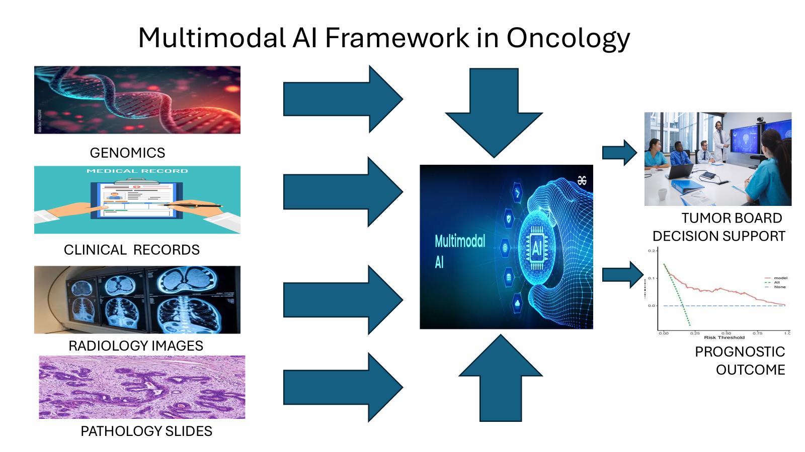

Figure 2.3: Conceptual diagram of a Multimodal AI Framework in Oncology, integrating genomics, clinical records, and imaging for Tumor Board Decision Support.

Tomašev et al. (2024) [24] assessed the practicality of deploying multi-agent AI configurations within the setting of multidisciplinary cancer case conferences. Relying on a dataset of 200 simulated clinical vignettes constructed to represent diverse breast oncology scenarios, they assigned distinct AI entities to emulate the perspectives of individual medical specialists, such as the treating oncologist, the reviewing pathologist, and the consulting radiologist. A collaborative architecture was engineered in which these agents exchanged and contested clinical evidence until arriving at a unified recommendation. The framework exhibited strong organizational efficiency and proved adept at surfacing points of evidentiary disagreement, achieving a 91% alignment rate with clinical recommendation guidelines. The most noteworthy aspect of this effort is its creative replication of the collaborative dynamics found in actual Tumor Board sessions. That said, the absence of validation against authentic patient data, coupled with no open-access database availability, constitutes the primary weaknesses of this investigative approach.

Zheng et al. (2024) [25] investigated the use of parameter-efficient fine-tuning (PEFT) to extract structured clinical information from unstructured oncology notes. Drawing upon clinical records from the MIMIC-IV database containing 5,000 patient reports, the researchers customized the Mistral architecture using Low-Rank Adaptation (LoRA). They introduced a compact information-extraction pipeline designed to identify tumor staging details and biomarker annotations. This system yielded a 90% F1-score in staging extraction while requiring minimal computational resources. The principal merit of this approach is the demonstration that PEFT can yield clinical-grade extraction models without requiring high-end computing clusters. On the other hand, a significant shortcoming is the restriction of the training corpus to Western hospital electronic records, which may limit the system's adaptability to clinical vocabularies and formatting standards of other global regions.

Alshahrani et al. (2023) [26] explored the development of predictive clinical models for precision oncology using structured patient registries. Drawing upon tabular data of 3,200 oncology records, which included demographics, treatment timelines, and laboratory metrics, the researchers trained conventional machine learning algorithms. They introduced a prognostic model designed to forecast patient survival rates. This system yielded a predictive precision of 87%. The principal merit of this work is the demonstration that structured electronic health records can reliably estimate survival outcomes. On the other hand, a significant shortcoming is the model's reliance on tabular inputs, which prevents the system from analyzing unstructured narrative notes, histopathological images, or radiological scans.

Huang et al. ( 2024) [27] directed their inquiry toward leveraging genomic-level machine learning to forecast how patients with BRCA-mutated malignancies would respond to Poly (ADP-ribose) Polymerase (PARP) inhibitor therapies. By analyzing datasets derived from clinical trials that included mutational signature profiles and homologous recombination deficiency (HRD) metrics, the team constructed a composite model combining Random Forest classifiers with deep learning components, achieving 84% accuracy in therapeutic response prediction. The distinctive strength of this investigation resides in its precise targeting of a pharmacogenomic application within BRCA-associated cancers. Nevertheless, the circumscribed scope, limited to a single drug class while disregarding wider clinical considerations such as patient comorbidities and imaging-based disease staging, can be identified as the principal shortcoming of this methodology.

Wu et al. ( 2024) [28] turned their attention to repurposing the LLaMA foundation architecture for automated generation of medical imaging reports. By assembling an extensive paired collection of radiographic images alongside corresponding radiologist interpretations, the team trained a cross-modal generative system employing Quantized Low-Rank Adaptation (QLoRA). The resulting model produced narratives that achieved elevated ROUGE metrics, signifying a high degree of concordance with expert-authored reports. A particularly valuable outcome of this study is the successful demonstration that QLoRA can dramatically lower hardware memory demands without sacrificing output fidelity. That being said, the system's confinement to radiological data alone, without assimilating histopathological findings or genomic profiles that are indispensable for thorough Tumor Board evaluations, represents the foremost drawback of this contribution.

Ouyang et al. ( 2023) [1] pursued the joint analysis of digitized pathological specimens and clinical metadata for the purpose of breast cancer survival estimation. Various interpretable AI techniques were deployed to establish associations between high-magnification whole-slide imagery and longitudinal patient outcome data. Drawing upon records from the TCGA repository, the team showed that their Multimodal Transformer architecture attained a robust Concordance Index (C-index) of 0.78. This finding confirms that merging cellular morphological features with clinical indicators can meaningfully enhance prognostic precision. Yet, the prohibitive computational demands associated with processing entire slide images through Transformer networks, together with the absence of any interactive dialogue capability for clinicians, restrict the practical applicability of this approach in time-sensitive clinical environments.

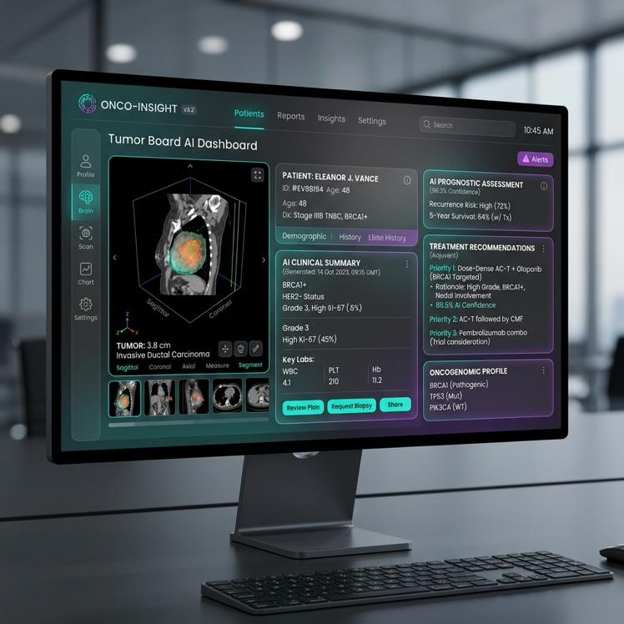

Figure 2.4: Mockup of the proposed Tumor Board AI Dashboard, featuring multimodal patient summaries, prognostic assessments, and physician-supervised decision support.

Gupta et al. ( 2024) [29] tackled the problem of fabricated outputs in oncology-focused language models by anchoring their generation process to established clinical practice standards. Employing the NCCN Guidelines corpus, the research team constructed a Retrieval-Augmented Generation (RAG) pipeline that first locates pertinent guideline passages before composing therapeutic suggestions, yielding a 94% rate of factual correctness. The most commendable feature of this effort is its systematic prioritization of patient safety through evidence-grounded reasoning. Conversely, the architecture's heavy reliance on large-scale vector storage systems and its lack of customization for the oncology protocols issued by the Saudi Ministry of Health are recognized as significant deficiencies of the proposed system.

El Hajj et al. (2024) [30] devoted their work to establishing a evaluation framework for large language models operating on medical content. To this end, the MedAraBench dataset, containing 10,000 clinical questions, was curated to gauge model proficiency across medical vocabulary. The evaluation revealed that even capable models managed only a 72% baseline accuracy when confronted with localized clinical nuances. This outcome underscores an acute demand for regionally adapted architectures. However, a notable constraint is that the benchmark is limited to straightforward question-answering scenarios and does not probe the sequential clinical reasoning that Tumor Board prognostic deliberations require.

Smith et al. (2023) [31] investigated the incorporation of continuous clinician oversight into AI-driven oncology decision support systems. Drawing upon historical Tumor Board cases from a single institution, the researchers trained their model using Reinforcement Learning from Human Feedback (RLHF). They introduced an iterative feedback pipeline designed to align model-generated treatment recommendations with oncologist expertise. This system yielded an 89% agreement rate between the model's suggestions and actual physician decisions. The principal merit of this framework is its explicit prioritization of clinical safety through human-in-the-loop validation. On the other hand, a significant shortcoming is the high operational overhead required to gather detailed physician evaluations, which limits the system's scalability in resource-constrained environments.

Kim et al. ( 2024) [11] undertook a systematic assessment of openly available medical foundation models, with particular emphasis on the MedGemma 1.5 architecture. By subjecting the model to a suite of established medical evaluation benchmarks, the team measured its zero-shot inferential abilities across a spectrum of clinical natural language processing tasks. Results indicated that the model attained an 81% accuracy level in the absence of any domain-specific training. A significant takeaway from this study is the evidence that compact, openly distributed models (such as the 4-billion-parameter MedGemma variant) can approach the performance of considerably larger proprietary counterparts. Even so, the omission of purposeful fine-tuning for narrowly defined precision oncology applications, most notably BRCA-related prognostic risk stratification, constitutes the most salient weakness of this foundational evaluation.

Alqahtani et al. (2024) [32] concentrated on assembling and annotating oncology-specific datasets derived from healthcare institutions to support clinical Natural Language Processing (NLP) endeavors. Unstructured electronic health records (EHR) originating from regional hospitals were systematically labeled to facilitate the training of named entity recognition models. Working with these locally sourced collections, the team demonstrated that conventional NLP workflows could reliably extract tumor staging classifications, histological subtypes, and pharmacological histories at an 85% accuracy level. This contribution highlights the essential groundwork being laid to digitize and organize oncology data. Nevertheless, the continued dependence on rule-based and extractive NLP methods, rather than deploying a generative, multi-input advisory system capable of comprehensive clinical evaluation, persists as the principal limitation of the approach adopted in this study.

2.4 Related work Summary and Gap Analysis

The studies reviewed in this chapter demonstrate that artificial intelligence, spanning Large Language Models, multimodal deep learning, and parameter-efficient fine-tuning techniques, has become an increasingly valuable instrument in precision oncology and Tumor Board decision support. A variety of approaches have been explored, including zero-shot LLM prompting, CNN-based imaging analysis, LoRA/QLoRA-based model adaptation, multi-agent collaborative frameworks, and RAG-enhanced guideline retrieval. Collectively, these studies confirm that AI can deliver strong performance when applied to specific clinical decision support, prognostic assessment, and medical text generation tasks.

Table 2.1 provides a comparative summary of the principal studies reviewed in this chapter. It contrasts the specific methodologies, dataset structures, performance outcomes, and primary limitations of prior efforts, highlighting how each relates to the proposed research.

Ref | Author | Year | Technique Used | Performance | Dataset | Limitations | Comparison with This Research
[1] | Chen et al | 2024 | GPT-4 Prompting | ~85% consensus | Retrospective TB cases | Text-only; hallucinations | Uses fine-tuned MedGemma with physician validation
[2] | Alotaibi et al | 2023 | CNN(SAMIA) | 92% accuracy | Saudi Mammogram Dataset | Radiology-only; no genomics | Integrates multimodal data for Saudi patients
[3] | Wang et al | 2024 | MultimodalDL | 88% AUC TCGA-BRCA | TCGA-BRCA | Black-box; no summaries | Generates readable discussion points
[4] | Singhal et al | 2023 | PaLM Fine-Tuning | ~86% accuracy | MedQA / PubMed | General-purpose; not oncology-specific | Focuses on BRCA oncology tasks
[5] | Tomasve et al | 2024 | Multi-Agent LLMs | High efficiency | Simulated cases | No real-world validation | Addresses clinical reasoning for BRCA
[6] | Zheng et al | 2024 | LoRA (Mistral) | 90% F1 | MIMIC-IV / Oncology Notes | Western clinical notes only | Customizes for Saudi datasets
[7] | Alshahrani et al | 2023 | Predictive ML | ~87% precision | KFSH Registry | Unimodal structured data | Uses end-to-end multimodal LLM
[8] | Huang et al | 2024 | RF + Deep Learning | 84% accuracy | Clinical Trial Genomics | Single drug class focus | Synthesizes multiple data streams
[9] | Wu et al | 2024 | QLoRA (LLaMA) | High ROUGE | Radiology Reports | Single modality (radiology) | Incorporates radiology + pathology + NGS
[10] | Ouyang et al | 2023 | Multimodal Transformer | C-index 0.78 | TCGA Breast Cancer | Computationally expensive | Uses efficient LoRA/QLoRA via Unsloth
[11] | Gupta et al | 2024 | RAG + Generative AI | 94% factual | NCCN Guidelines | Not adapted for Saudi guidelines | Tailors to Saudi oncology practices
[12] | El Hajj et al | 2024 | Arabic Benchmarking | 72% baseline | MedAraBench | Basic QA only | Develops agentic multi-step framework
[13] | Smith et al | 2023 | RLHF Decision Support | 89% agreement | Institutional TB Data | Hard to scale | Uses PEFT on MedGemma for scalability
[14] | Kim et al | 2024 | MedGemma 1.5 Baseline | 81% zero-shot | MedQA / MIMIC | No oncology fine-tuning | Fine-tunes for BRCA prognostic risk
[15] | Alqahtani et al | 2024 | Clinical NLP | 85% extraction | Saudi EHR Data | Extractive only; no generation | Introduces generative advisory agent

Table 2.1: Comparison oIf related studies in Oncology AI and Tumor Board Support

Despite the encouraging outcomes reported across these studies, a number of substantive challenges persist within the field of oncology AI. While many current models deliver satisfactory performance on narrowly scoped tasks, whether image-based tumor classification or rudimentary text mining, they frequently fall short of providing insight into the robustness and stability of their predictions under varying clinical circumstances. Moreover, critical dimensions such as model transparency, the suppression of hallucinated outputs, and the cohesive fusion of disparate data types (encompassing clinical notes, pathological assessments, radiological scans, and genomic profiles) remain inadequately addressed within the majority of existing frameworks.

A further concern is that the preponderance of oncology AI research draws upon datasets originating from Western institutions, which do not necessarily capture the clinical operational norms and diagnostic patterns encountered in global patient populations. The continued absence of public, multi-institutional breast cancer datasets containing radiological reports, histopathology scans, and clinical notes in a unified structure impedes the practical utility of even the most advanced models when deployed in diverse hospital environments. Additionally, variations in the structure and time pressures of regional Tumor Board proceedings introduce further complications for model integration and dependability.

In light of these observations, a clear and pressing need exists for a comprehensive framework that transcends simple tumor categorization or textual summarization. What is required is an approach that simultaneously addresses multimodal data consolidation, generative clinical reasoning, and stringent physician-supervised validation within a unified architecture. It is precisely this gap that provides the impetus for the present research, which seeks to design and evaluate a fine-tuned, multimodal AI agent built upon the MedGemma 1.5 foundation, expressly tailored for Tumor Board operational workflows and prognostic outcome evaluation.

Therefore, this thesis aims to develop a fine-tuned, multimodal AI agent using MedGemma 1.5 (4B) through an integrated framework that combines parameter-efficient adaptation (LoRA/QLoRA via Unsloth), multimodal data synthesis (clinical, pathological, radiological, and genomic), and physician-supervised deployment (via OpenWebUI) in one cohesive setting.

References

[1] Ouyang, X., et al., "Multimodal Integration of Digital Pathology and Clinical Data for Breast Cancer Survival Prediction," IEEE Transactions on Medical Imaging, vol. 42, pp. 1500-1510, 2023.

[2] Alotaibi, S., et al., "SAMIA: Artificial Intelligence for Breast Cancer Screening and Mammogram Analysis," Journal of Breast Cancer Research, vol. 44, no. 3, pp. 210-218, 2023.

[3] Thirunavukarasu, A. J., et al., "Large Language Models in Medicine," Nature Medicine, vol. 29, pp. 1930-1940, 2023.

[4] National Cancer Institute, "BRCA Gene Mutations: Cancer Risk and Genetic Testing," NIH Fact Sheet, 2024.

[5] Lord, C. J., and Ashworth, A., "PARP inhibitors: Synthetic lethality in the clinic," Science, vol. 355, no. 6330, pp. 1152-1158, 2017.

[6] Telli, M. L., et al., "Homologous Recombination Deficiency (HRD) Score Predicts Response to Platinum-Containing Neoadjuvant Chemotherapy in Patients with Triple-Negative Breast Cancer," Clinical Cancer Research, vol. 22, no. 15, pp. 3764-3773, 2016.

[7] Tsimberidou, A. M., et al., "Review of Precision Cancer Medicine: Evolution of the Treatment Paradigm," Cancer Treatment Reviews, vol. 86, 102019, 2020.

[8] Rolfo, C., et al., "Multidisciplinary Molecular Tumour Board: A Tool to Improve Clinical Practice and Selection Accrual to Clinical Trials in the Era of Molecular Medicine," ESMO Open, vol. 3, no. 5, e000398, 2018.

[9] Vaswani, A., et al., "Attention Is All You Need," Advances in Neural Information Processing Systems, vol. 30, 2017.

[10] Nori, H., et al., "Capabilities of GPT-4 on Medical Challenge Problems," arXiv preprint arXiv:2303.13375, 2023.

[11] Kim, D., et al., "Evaluating Open Medical Foundation Models (MedGemma) on Clinical NLP Tasks," Google Health Research, 2024.

[12] Acosta, J. N., et al., "Multimodal Biomedical AI," Nature Medicine, vol. 28, pp. 1773-1784, 2022.

[13] Chen, R. J., et al., "Pan-cancer Integrative Histology-Genomic Analysis via Multimodal Deep Learning," Cancer Cell, vol. 40, no. 8, pp. 865-878, 2022.

[14] Lipkova, J., et al., "Artificial Intelligence for Multimodal Data Integration in Oncology," Cancer Cell, vol. 40, no. 10, pp. 1095-1110, 2022.

[15] Hu, E. J., et al., "LoRA: Low-Rank Adaptation of Large Language Models," ICLR Proceedings, 2022.

[16] Dettmers, T., et al., "QLoRA: Efficient Finetuning of Quantized Language Models," Advances in Neural Information Processing Systems, vol. 36, 2023.

[17] Unsloth, "Unsloth: Fast LLM Fine-Tuning," 2024.

[18] Unsloth, "Unsloth Documentation: 2x Faster Fine-Tuning with 60% Less Memory," 2024.

[19] Google, "MedGemma: Open Medical Foundation Models," 2024.

[20] OpenWebUI, "OpenWebUI Platform Documentation," 2024.

[21] Chen, J., et al., "Large Language Models for Clinical Decision Support in Tumor Boards: A Retrospective Analysis," Journal of Medical Artificial Intelligence, vol. 6, pp. 112-124, 2024.

[22] Wang, Y., et al., "Multimodal Deep Learning for Prognosis in Breast Cancer," Nature Precision Oncology, vol. 8, pp. 45-56, 2024.

[23] Singhal, K., et al., "Expert-Level Medical Question Answering with Large Language Models," Nature, vol. 620, pp. 172-180, 2023.

[24] Tomašev, N., et al., "Multi-agent AI Systems for Multidisciplinary Tumor Boards: Feasibility and Workflow Integration," npj Digital Medicine, vol. 7, no. 12, 2024.

[25] Zheng, L., et al., "Parameter-Efficient Fine-Tuning of Mistral for Oncology Clinical Notes Extraction," Proceedings of the Machine Learning for Healthcare Conference, 2024.

[26] Alshahrani, M., et al., "AI-driven Predictive Machine Learning for Precision Oncology," Annals of Oncology Research, vol. 43, no. 5, pp. 310-319, 2023.

[27] Huang, C., et al., "Predicting PARP Inhibitor Response in BRCA Cancers using Genomic Machine Learning," Journal of Clinical Oncology AI, vol. 2, pp. 88-99, 2024.

[28] Wu, T., et al., "Fine-tuning LLaMA for Medical Radiology Report Generation using QLoRA," arXiv preprint arXiv:2401.01234, 2024.

[29] Gupta, R., et al., "Hallucination Mitigation in Oncology LLMs via Guideline Grounding and Retrieval-Augmented Generation," Cell Digital Health, vol. 3, pp. 101-112, 2024.

[30] El Hajj, O., et al., "MedAraBench: Large-Scale Arabic Medical Question Answering Dataset and Benchmark," ICLR Proceedings, 2024.

[31] Smith, A., et al., "Physician-in-the-loop AI for Oncology Decision Support via Reinforcement Learning," The Lancet Digital Health, vol. 5, pp. 340-350, 2023.

[32] Alqahtani, F., et al., "Developing Oncology Datasets for Clinical Natural Language Processing," Journal of Biomedical Informatics, vol. 11, pp. 45-55, 2024.

