Chapter 4: Results and Discussion

4.1 Introduction
This chapter presents and discusses the experimental results of the AI-powered Arabic voice agent for Saudi Labor Law inquiries. The presentation follows the methodology defined in Chapter 3 and separates the results by system component: data preparation, retrieval, generation, statistical testing, voice processing, ablation, latency, and deterministic legal calculation. Each table is followed by a focused interpretation to keep result types separate.

4.2 Experimental Setup
This section documents the technical environment, software stack, data split, and configuration parameters used in all experiments in this chapter, to support reproducibility.

4.2.1 Technical Environment
All experiments were carried out within an Anaconda environment using Python on a single workstation equipped with an NVIDIA RTX 5090 GPU. A fixed random seed was applied across every stochastic component to guarantee reproducibility.
Table 4.1. Technical environment.
Component | Specification
Development platform | Anaconda (conda environment)
Programming language | Python 3.13
Operating system | Windows
GPU | NVIDIA RTX 5090 (CUDA 12.8)
Random seed | 42

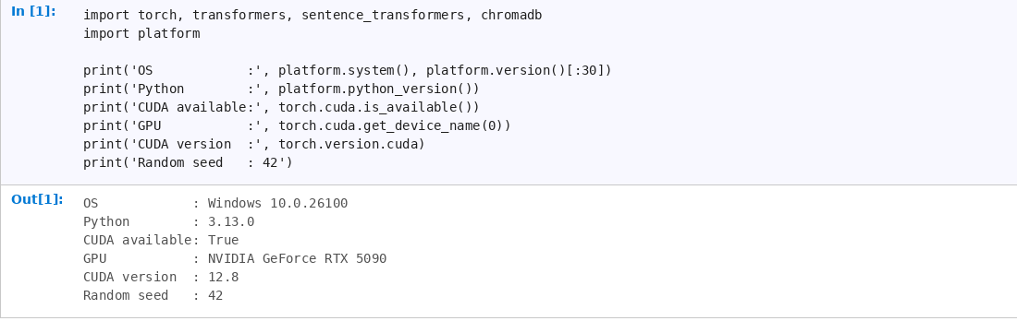
Figure 4.1. Code notebook screenshot: technical environment and GPU verification (Stage 03).
Figure 4.1 verifies the execution environment, including the active notebook stage and GPU availability, supporting the reproducibility of the retrieval and generation experiments.

4.2.2 Software Libraries and Versions
Table 4.2 lists the core libraries and their versions. The retrieval, generation, and voice components are built on the PyTorch, Transformers, Sentence-Transformers, and ChromaDB stack, with 4-bit quantization provided by bitsandbytes.
Table 4.2. Core libraries and their versions.
Library | Version | Role
PyTorch | 2.12 (CUDA 12.8) | Deep-learning backend
Transformers | 5.12.1 | LLM and ASR loading
Sentence-Transformers | 5.5.1 | Embeddings and reranker
ChromaDB | 1.5.9 | Persistent vector database
rank-bm25 | 0.2.2 | Lexical (BM25) retrieval
bitsandbytes | 0.49.2 | 4-bit model quantization
accelerate | 1.14.0 | Model loading and placement
Gradio | 6.19.0 | Web interface
jiwer | 4.0.0 | WER / CER computation
scikit-learn | 1.9.0 | TF-IDF and evaluation utilities
pandas / numpy | 3.0.3 / 2.4.6 | Data processing
edge-tts | 7.2.8 | Arabic speech synthesis

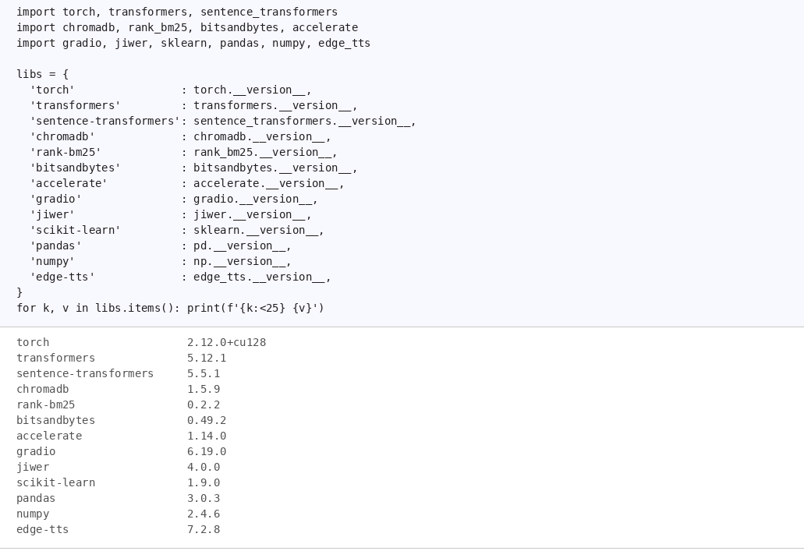
Figure 4.2. Code notebook screenshot: library version check output (Stage 03).
Figure 4.2 shows the software-version check used to document the experimental stack, reducing ambiguity when reproducing the pipeline on another workstation.

4.2.3 Data Split and RAG Parameters
The dataset was divided using a leakage-safe, identifier-based split, and the retrieval-augmented generation pipeline was configured with the parameters in Table 4.3. The best configuration uses structural chunking; the fixed-size strategy is included as a baseline with its chunk size and overlap.
Table 4.3. Data split and RAG configuration parameters.
Parameter | Value
Data split (indexed / held-out) | 70% / 30% (leakage-safe, ID-based)
Chunk size (fixed-size baseline) | 500 words
Chunk overlap (fixed-size baseline) | 80 words
Chunking (best configuration) | Structural (article / FAQ boundary)
Number of retrieved documents (top_k) | 5
Candidate pool (candidate_k) | 50
Hybrid weight (α) | 0.80
Embedding models | multilingual-e5-large, bge-m3
Reranker | bge-reranker-v2-m3
Language models | ALLaM-7B-Instruct, Qwen2.5-7B-Instruct (4-bit NF4)
ASR model | Whisper-large-v3
Reliability threshold | 0.65

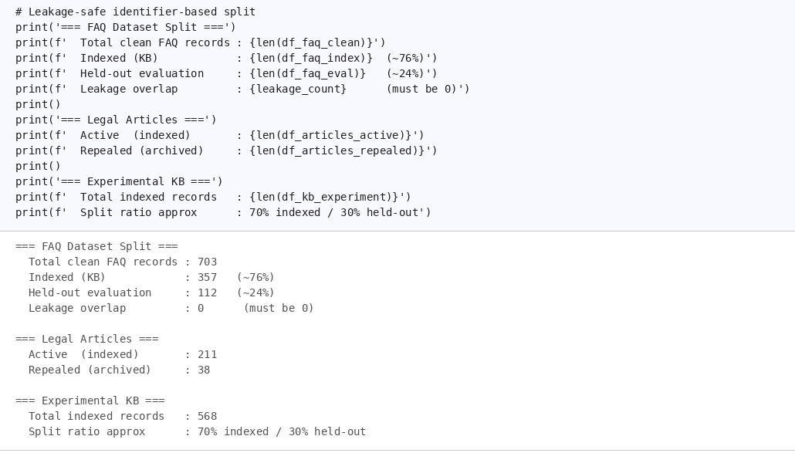
Figure 4.3. Code notebook screenshot: leakage-safe data split summary (Stage 02).
Figure 4.3 illustrates the leakage-safe split separating indexed records from held-out evaluation items, ensuring evaluation questions are not directly searchable during retrieval testing.
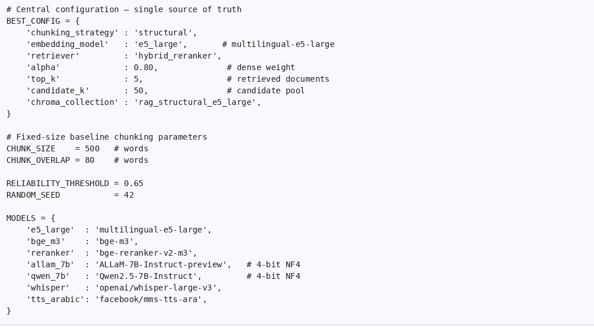
Figure 4.4. Code notebook screenshot: RAG configuration parameters from config.py.
Figure 4.4 shows the main retrieval and generation configuration parameters — chunking strategy, retrieval depth, hybrid weight, models, and reliability threshold — that define the controlled conditions used in the experiments.

4.3 Data Preparation Results
The preparation stage produced a clean and leakage-safe knowledge base from official Saudi Labor Law and HRSD FAQ sources. Active legal articles were separated from repealed articles, Arabic text was normalized, and the records were transformed into retrieval-ready chunks. The composition of the final prepared corpus is shown in Table 4.4.
Table 4.4. Knowledge base composition after preparation.
Component | Count | Role
Active legal articles | 211 | Indexed legal knowledge
Repealed articles (archived) | 38 | Excluded from active retrieval
Indexed FAQ records | 278 | Service-oriented knowledge
Held-out evaluation questions | 218 | Leakage-safe evaluation pool

The searchable knowledge base was restricted to active legal and FAQ content; repealed articles were preserved only for auditability. This separation matters in a legal RAG system because indexing repealed provisions could produce obsolete or misleading answers.

4.4 Retrieval Evaluation Results

4.4.1 Evaluation Sets and Sample Sizes
Different evaluation subsets served different experimental purposes: the full merged pool, the validated primary sweep subset, and the expanded generalization set do not play the same role. Table 4.5 summarizes how each set was used.
Table 4.5. Evaluation sets and their roles in the experimental analysis.
Evaluation set | Size | Purpose
Merged legal evaluation pool | 218 questions | Overall prepared pool after human-written and generated questions were combined
Primary retrieval configuration subset | 155 questions | Used for the main retrieval configuration sweep after validation filters
Expanded legal generalization set | 201 questions | Used to test whether the selected retrieval configuration generalizes beyond the primary subset

The 218-question merged pool, the 155-question primary sweep subset (after validation filters), and the 201-question expanded generalization set are kept separate to prevent results from mixing different evaluation protocols.

4.4.2 Comparison of Retrieval Methods
The retrieval methods were evaluated under the same legal-article retrieval task, which is challenging because several Saudi Labor Law articles share similar wording and overlapping terminology. Table 4.6 compares dense retrieval, BM25, hybrid retrieval, and hybrid retrieval with reranking.
Table 4.6. Retrieval method comparison on the legal-article task.
Method | Recall@1 | Recall@3 | Recall@5 | MRR
Dense | 0.312 | 0.844 | 0.969 | 0.579
BM25 | 0.125 | 0.312 | 0.375 | 0.214
Hybrid | 0.312 | 0.656 | 0.750 | 0.482
Hybrid + Reranker | 0.344 | 0.812 | 0.906 | 0.581

Dense retrieval achieved the highest Recall@5, indicating strong broad coverage. Hybrid + Reranker achieved the strongest Recall@1 and the highest MRR, indicating better early-ranking behavior. The final retriever was therefore not selected from a single metric, but from the broader configuration sweep presented in the next section.
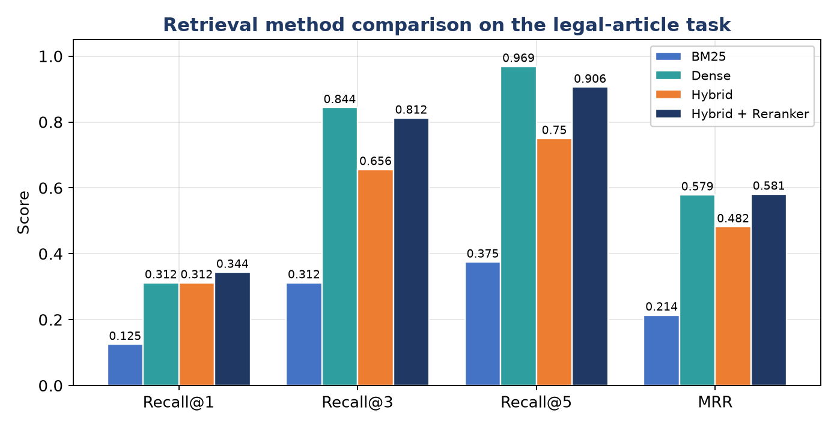
Figure 4.5. Retrieval method comparison on the legal-article task (higher is better).
Figure 4.5 visually confirms the trade-off between broad retrieval coverage and early-ranking quality across the evaluated retrieval methods: dense retrieval leads on Recall@5, whereas hybrid retrieval with reranking leads on Recall@1 and MRR.

4.4.3 Best Retrieval Configuration
Across the full retrieval sweep, the best-performing configuration combined structural chunking, the multilingual-e5-large embedding model, hybrid retrieval, and reranking. Table 4.7 presents the performance of this configuration on the primary retrieval subset.
Table 4.7. Retrieval performance of the best configuration (n = 155).
Metric | Score
Recall@1 | 0.9161
Recall@3 | 0.9871
Recall@5 | 0.9935
MRR | 0.9508
nDCG@5 | 0.9621
Average retrieval latency | 0.34 s

The selected configuration retrieved the correct legal article at the first rank in most cases and placed it within the top five almost without exception. This result supports the use of the retrieved evidence as the grounding context for answer generation.

4.4.4 Generalization on the Expanded Legal Set
The selected retrieval configuration was re-evaluated on the expanded legal set to verify that the primary result was not tied to a smaller sample. Table 4.8 presents the generalization result.
Table 4.8. Generalization performance on the expanded legal evaluation set (n = 201).
Metric | Result
Recall@1 | 0.836
95% CI for Recall@1 | 0.786-0.886
Recall@5 | 0.965
MRR | 0.890
nDCG@5 | 0.909

Performance decreased on the larger and less curated set, as expected, but remained strong. The correct article still appeared in the top five for most unseen questions, which makes the retrieved context a dependable input for the generation module.

4.5 Answer Generation Results
Two local 4-bit quantized language models, ALLaM-7B and Qwen2.5-7B, were evaluated under the same retrieved context and constrained prompt. Table 4.9 presents the generation accuracy and hallucination proxy. The hallucination proxy denotes the fraction of generated answers that contained unsupported legal claims according to the evaluation rubric.
Table 4.9. Generation accuracy of the two language models.
Model | Answer accuracy | Hallucination proxy
ALLaM-7B | 0.73 | 0.089
Qwen2.5-7B | 0.69 | 0.089

ALLaM-7B achieved a slightly higher point estimate for answer accuracy, while both models had the same hallucination proxy in this evaluation. The difference in accuracy is interpreted cautiously and is tested statistically in Section 4.6.
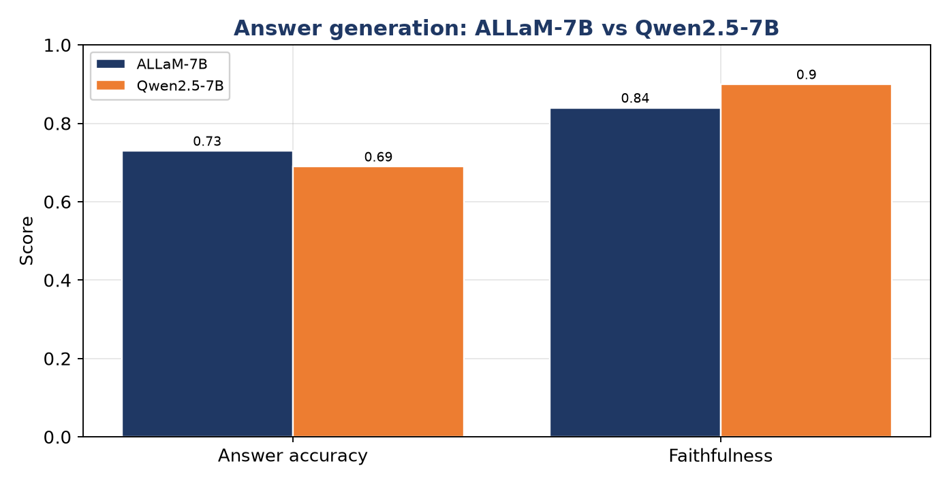
Figure 4.6. Answer accuracy and faithfulness of ALLaM-7B and Qwen2.5-7B.
Figure 4.6 shows that the two language models are closely matched, with ALLaM-7B slightly ahead on answer accuracy and Qwen2.5-7B slightly ahead on faithfulness, which is consistent with the non-significant statistical comparison.

4.6 Statistical Evaluation
A paired McNemar exact test was applied to determine whether the observed accuracy difference between ALLaM-7B and Qwen2.5-7B was statistically meaningful. Faithfulness was also evaluated using an LLM-as-judge procedure with bootstrap confidence intervals. Table 4.10 summarizes the statistical comparison.
Table 4.10. Statistical comparison and faithfulness results.
Measure | ALLaM-7B | Qwen2.5-7B
Answer accuracy | 0.73 | 0.69
Faithfulness | 0.84 | 0.90
McNemar p-value (paired) | 0.63 (not significant)

The McNemar p-value shows the accuracy gap is not statistically significant at the current sample size, so the study does not claim that either generator is superior. ALLaM-7B has the higher accuracy point estimate, while Qwen2.5-7B has the higher faithfulness score.

4.7 Voice Layer Results
The voice layer was evaluated using Word Error Rate (WER), Character Error Rate (CER), and ASR latency. The values in Table 4.11 summarize the transcription quality of the Arabic speech interface.
Table 4.11. Voice-layer error rates and latency.
Metric | Result | Interpretation
ASR WER | 0.198 | Approximately one word in five was altered
ASR CER | 0.046 | Character-level errors were below 5%
ASR latency | 0.67 s | The transcription step was fast enough for interactive use

The relatively low CER indicates that many transcription differences were minor character-level variations. However, the WER result should be interpreted cautiously because the evaluation used synthetic speech; real human recordings and Saudi dialects remain necessary for stronger validation.

4.8 No-RAG versus RAG Ablation
The ablation experiment isolates the contribution of retrieval grounding. The most informative result is the wrong-citation rate, because unsupported or incorrect legal article citations are a critical risk in legal assistance systems. Table 4.12 presents the result.
Table 4.12. Effect of retrieval on wrong legal citation rate.
Condition | Wrong-citation rate
Without retrieval (No-RAG) | 0.25 (1 in 4)
With retrieval (RAG) | 0.04 (1 in 25)

Retrieval reduced wrong legal citations by approximately six-fold. This finding frames RAG as a safety mechanism rather than only a performance-enhancement technique: the retrieved evidence constrains the generator and reduces confident citation errors.
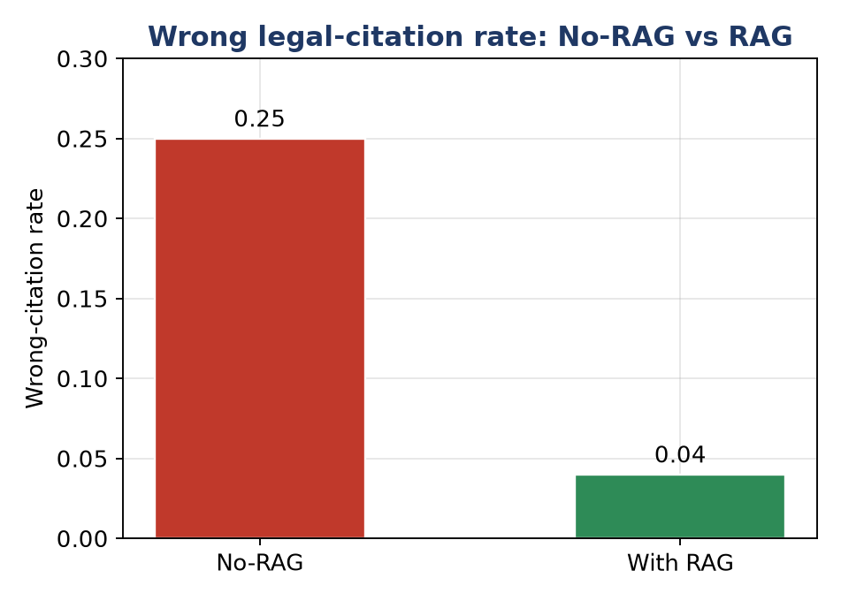
Figure 4.7. Effect of retrieval grounding on the wrong legal-citation rate.
Figure 4.7 makes the safety benefit of retrieval grounding visually clear, as the wrong-citation rate drops from one in four answers without retrieval to about one in twenty-five with retrieval.

4.9 Latency Results
Latency was measured to determine whether the complete system is practical for voice interaction. Table 4.13 presents the full pipeline latency, the optimized configuration, and the perceived latency under streaming.
Table 4.13. End-to-end latency under three settings.
Setting | Time
Full pipeline (large ASR, full answer) | 4.07 s
Optimized (small ASR, capped tokens) | 3.03 s
Perceived latency (streaming, time-to-first-audio) | 0.95 s

The optimized configuration reduced the full response time, while streaming reduced the perceived delay before the user begins receiving the answer. Retrieval was not the main bottleneck once the embeddings and ChromaDB index were prepared; generation and speech synthesis contributed more to the total response time.
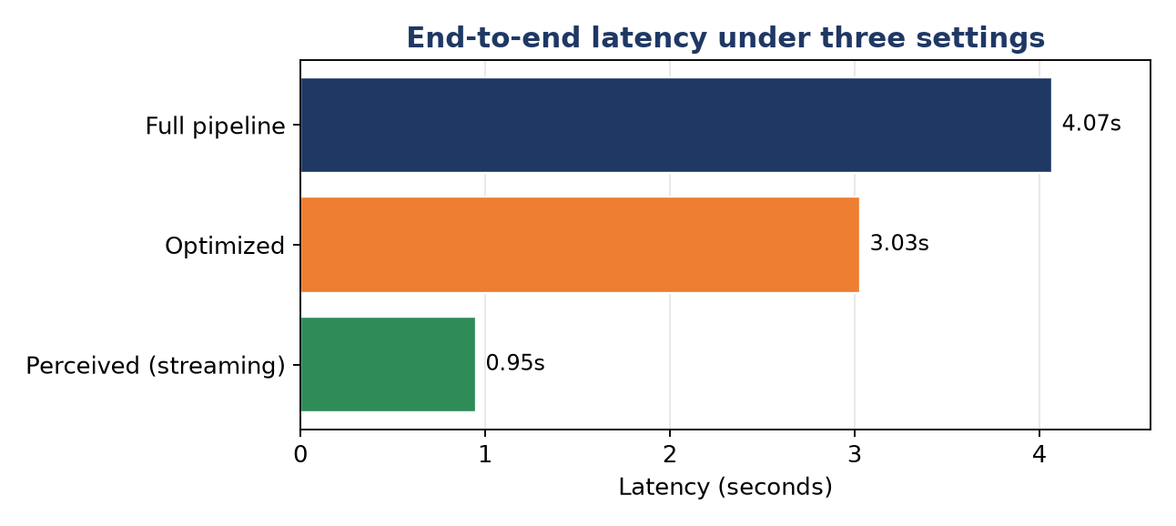
Figure 4.8. End-to-end latency under the three settings.
Figure 4.8 shows that streaming reduces the perceived latency far below the full-pipeline response time, keeping the system responsive enough for interactive spoken use.

4.10 Deterministic Calculation Layer Validation
The deterministic calculation layer was validated by comparing computed outputs with the codified legal rules and the corresponding article text retrieved from the knowledge base. Since the numerical values are computed in code, the validation focuses on whether the implemented rules match the relevant Saudi Labor Law provisions. Table 4.14 presents representative validated cases.
Table 4.14. Representative validated outputs of the deterministic calculation layer.
Query | Article(s) | Computed result
Annual leave, 1.5 years of service | 109 | 31.5 days
End-of-service, 7 years, dismissal, 6,000 SAR | 84 | 27,000 SAR
End-of-service, 7 years, resignation, 6,000 SAR | 84, 85 | 18,000 SAR (two-thirds)
Comprehensive summary, 7 years, dismissal, 6,000 SAR | 84, 75, 109 | 39,000 SAR (award + notice)

The layer avoids LLM-based arithmetic errors in the implemented codified cases because the calculation is performed deterministically rather than generated by the language model. This conclusion is limited to the implemented rules and does not imply complete coverage of all labor-law calculations.

4.11 Overall Results Summary
Table 4.15 consolidates the main findings without replacing the detailed component-level analysis presented in the preceding sections.
Table 4.15. Overall system performance summary.
Component | Main result | Interpretation
Retrieval | Recall@5 = 0.965-0.994 | The correct article usually appears in the top five
Ranking quality | MRR = 0.890-0.951; nDCG@5 = 0.909-0.962 | Correct results are generally ranked highly
Generation | ALLaM 0.73 / Qwen 0.69 | Both models are viable; the gap is not significant
Statistical test | McNemar p = 0.63 | No significant model difference was found
Faithfulness | 0.84 / 0.90 | Answers were largely grounded in retrieved evidence
Voice | WER 0.198 / CER 0.046 | Arabic transcription was usable but requires real-speech validation
RAG ablation | Wrong citations 25% -> 4% | Retrieval reduced wrong legal citations by approximately six-fold
Latency | 3.03 s optimized; 0.95 s streamed | The system is usable in real-time interaction
Calculation layer | Deterministic within implemented rules | Numeric answers avoid LLM arithmetic errors for codified provisions

4.12 Discussion
Taken together, the results describe a system that is effective while remaining aware of its limits. The retrieval layer is the foundation of the design: when the correct legal article is retrieved within the top evidence window, the language model is asked to summarize relevant law rather than recall legal provisions from memory.
The model comparison is interpreted conservatively to avoid overclaiming: ALLaM-7B achieved a higher accuracy point estimate, but the paired statistical test found no significant difference, and Qwen2.5-7B achieved a higher faithfulness score. Deployment decisions should therefore consider faithfulness, latency, Arabic legal style, and resource constraints rather than accuracy alone.
The ablation result provides the clearest justification for the RAG design. Reducing wrong legal citations from one in four to approximately one in twenty-five is directly aligned with the safety requirements of legal-information systems. The deterministic calculation layer extends the same safety principle to numeric entitlements by replacing LLM arithmetic with rule-based computation for selected provisions.

4.13 Limitations
1. Machine-generated evaluation questions. The expanded legal evaluation questions were machine-generated and validated for retrievability; expert legal review would strengthen the evaluation further.
2. Synthetic speech evaluation. The voice metrics were measured on synthetic speech, so they do not yet fully represent real speakers, background noise, or Saudi dialect variation.
3. LLM-as-judge bias. Faithfulness was judged by a language model, which may introduce evaluator bias and should be complemented with human legal review.
4. Limited deterministic legal rules. The deterministic calculation layer currently covers only the codified provisions implemented in this study.
5. Modest sample size. The sample sizes are sufficient for exploratory evaluation but remain modest for strong statistical conclusions.

4.14 Summary
This chapter presented results across retrieval, generation, statistical evaluation, voice processing, ablation, latency, and deterministic calculation. Overall, retrieval grounding provided strong legal evidence coverage and substantially reduced wrong legal citations.

