

Leveraging AI to Study the Impact of Climate Change on the Spread and Severity of Plant Diseases

Prepared By
Name: Fatima Mohammad Alkaff ID No.: 251001435
Submitted in fulfillment of the requirements for the degree Master of Science in Artificial Intelligence
At
Collage of Informatics
Midocean University
UAE
Supervisor Name: Dr. Hager Saleh
College of Informatics, Midocean University, Comoros

Acknowledgements
First and foremost, all praise and thanks are due to Allah, the Almighty, for His endless blessings, mercy, and guidance that have accompanied us throughout this research journey. Without His will, this work would not have been possible.
I extend my deepest gratitude to my esteemed supervisor, Dr. Hager Saleh, whose support, encouragement, and invaluable guidance inspired us from the first steps of this research to its final form. Her kindness, patience, and dedication were a source of motivation throughout the process.
This work is lovingly dedicated to my parents, whose unwavering love, sacrifices, and prayers have shaped who I am. Your faith in me and your constant support have been the pillars of my strength. I am forever grateful for your encouragement and for teaching us the value of perseverance and ambition.

Abstract
Quickly and correctly identifying plant diseases is a critical step that might result in a considerable increase in crop output, as well as a reduction of losses caused by climate change. Usually, visually detectable pathogens are those that are visible only to machines; however, these machines generally do not consider the effect of climatic and soil factors on the spread of the disease. This thesis presents a multimodal deep learning system that not include only visual features of the apple leaves, also uses environmental variables to help the disease classification be more accurate and robust. by uses the Multimodal Plant Disease Dataset created by Shubham Divakar, which deals with the correct identification of the infected apple leaves, such as Apple Scab, Black Rot, Cedar Apple Rust, and those that are Healthy.
In this thesis, the performance of three pretrained convolutional neural networks (CNNs), MobileNetV2, ResNet50, and InceptionV3, was compared for their image-based baseline. Climate and soil factors were considered in the study by developing a Multilayer Perceptron (MLP) that took temperature, humidity, pH, rainfall, and nutrient levels (N, P, K) as features. The fusion layer was employed to merge the two modalities for improved classification.
The experimental results show that MobileNetV2 is better than other image-only models in terms of performance, so it reliable example of lightweight architectures in the case of agricultural imaging tasks. The multimodal MobileNetV2 + MLP model achieved a precision of 78.25% which is better than the other, so the integration of environmental variables can significantly impact classification.

Table of Contents
List of Abbreviations v
List of Figures vi
List of Tables vii
Chapter 1 Introduction 1
1.2 Problem Definition 1
1.2 Thesis Objectives 2
1.3 Thesis Contribution 2
1.4 Thesis Organization 3
Chapter 2 Overview 4
2.1 Overview of Plant Diseases and Early Detection Challenges 4
2.2 Image-Based Deep Learning for Plant Disease Classification 4
2.2.1 MobileNetV2 4
2.2.2 ResNet50 5
2.2.3 InceptionV3 5
2.3 Role of Environmental and Climate Features 5
2.4 Multimodal Learning in Agriculture 6
Chapter 3 Related Work 7
Chapter 4 Proposed Approach 12
4.1 Dataset Description 12
4.1.1 Image Dataset - Plant Leaf Images 12
4.1.2 Structured Climate Dataset 13
4.2 Data Preprocessing 14
4.2.1 Image Preprocessing 14
4.2.2 Structured Data Preprocessing 14
4.3 Image Feature Extraction Models 14
4.4 Multimodal Fusion Architecture 14
4.5 Training Strategy 15
Chapter 5 Experimental Results and Discussion 16
5.1 Experimental Setup 16
5.1.1 Hardware and Software Environment 16
5.1.2 Dataset Splitting 16
5.2 Image-Only Model Results 16
5.3 Multimodal Fusion Model Results 17
5.4 Comparison Summary 19
Chapter 6: Conclusion and Future Work 21
6.1 Conclusion 21
6.2 Future Work 21
References 23

List of Abbreviations
- AI: Artificial Intelligence
- DL: Deep Learning
- ML: Machine Learning
- CNN: Convolutional Neural Network
- DNN: Deep Neural Networks
- NLP: Northern Leaf Blight
- SVM: Support Vector Machine
- MLP: Multi-Layer Perceptron
- KNN: K-Nearest Neighbors
- ALDD: Apple Leaf Disease Dataset
- BF: Bilateral Filtering
- EPO: Emperor Penguin Optimizer
- N: Nitrogen content in soil
- P: Phosphorus content
- K: Potassium content

List of Figures
Figure 1 Example of Apple Scab 12
Figure 2 Example of Black Rot 12
Figure 3 Example of Cedar Apple Rust 13
Figure 4 Example of Apple Healthy 13
Figure 5 System Architecture of the Multimodal Deep Learning Model 14
Figure 6 Multimodal Confusion Matrix 18
Figure 7 Model Performance Comparison (Apple Disease Detection) 19

List of Tables
Table 1 Summary of the Related Work 10
Table 2 Example of the Dataset 13
Table 3 Image-Only Model Results 16
Table 4 Multimodal Fusion Model Results 17

Chapter 1 Introduction

1.2 Problem Definition
Diseases of plants have become the main factors that cause the food supply system of the entire planet to be at risk [1]. The changing climate that is continuously affecting the distribution and the severity of pathogens is making the problem worse [2]. In fact, the diseases on the apple leaves, mostly caused by Apple Scab, Black Rot, and Cedar Apple Rust, are the factors that mainly contribute to the reduction of both the quality and the quantity of the crop [3]. Most of the methods for disease detection that have been implemented are human character-based assessments, and they use handcrafted image processing techniques, which are not feasible since they are subjective, time-consuming, and, to some extent, their accuracy is also limited [4].
It is a fact that deep learning methods have played an important role in the recognition of diseases from images; however, most of the current models still only focus on the visual features [5]. Plant diseases should be the last ones to be identified only from the images, as they are very dependent on the environment. Taking the example of temperature, humidity, rainfall, and soil nutrient levels [6]. Very few models even consider such factors, which is their disadvantage as they cannot provide stronger and climate-aware predictions.
As a result, the problem of selecting a multimodal method that merges image features with environmental data for disease detection at the local level is an immediate one. This study answers that question by creating and assessing a deep learning-based system that integrates climate and soil analysis with CNN-based image analysis for more accurate apple disease classification.

1.2 Thesis Objectives
This thesis is mainly concerned with creating and evaluating the performance of smart deep learning models that employ multimodal fusion strategies to accurately classify apple diseases. It is geared towards the preprocessing and fusing of varied sources of data, such as images and numerical environmental variables, to generate standardized and high-quality inputs for the models.
By training various CNN architectures such as MobileNetV2, ResNet50, and InceptionV3, the thesis attempts to locate reliable image-based reference points, while a Multilayer Perceptron is employed to study climatic and soil features that affect the prediction.
Subsequently, a multimodal intermediate fusion model is designed to integrate the visual embeddings with the environmental inputs, thereby enabling the system to have access to the supplementary data of different modalities. The aim is to figure out if the environmental variables raise the prediction accuracy, to become an insightful source of ideas for future climate-aware plant disease detection systems.

1.3 Thesis Contribution
- Evaluated the performance of three state-of-the-art CNN architectures, MobileNetV2, ResNet50, and InceptionV3, in capturing complex visual features of agricultural plant disease images. As a result, it stands as a scientifically based comparison of lightweight vs deep architectures in the agriculture sector.
- Constructed a multimodal intermediate fusion architecture combining CNN image embeddings with the soil variables (temperature, humidity, pH, rainfall, N, P, K). The framework demonstrates the use of integration of different data sources (visual + climatic).
- Conduct comparative performance experiments for image-only and multimodal models. The results demonstrate that environmental features do not necessarily improve image-based accuracy, which, in turn, highlights the problem of noise sensitivity and cross-modal imbalance.
- Identified the practical limitations and future potentials of multimodal plant disease systems, among them the difficulty of modality alignment, feature mismatch, and data fusion sensitivity. These insights can be considered as a set of pointers to the next research stages when developing scalable climate-aware agricultural AI models.

1.4 Thesis Organization
This thesis is organized into six chapters:
Chapter 1 – Introduction:
Presents the research problem, objectives, and contributions.
Chapter 2 – Overview:
Overview of the foundational concepts relevant to this research. It introduces deep learning techniques for image and structured data analysis, explains multimodal learning.
Chapter 3 – Related Works:
Summarizes previous work on plant disease detection, deep learning methods, environmental data modeling, and multimodal fusion.
Chapter 4 – Proposed Approach:
Describes the dataset, preprocessing steps, feature extraction procedures, and model development workflow.
Details the multimodal architecture, CNN models, MLP structure, and fusion strategy.
Chapter 5 – Experimental Results and Discussion:
Reports model performance, comparative evaluations, confusion matrices, and analysis.
Chapter 6 – Conclusion and Future Work:
Concludes the study and outlines potential directions for further research.

Chapter 2 Overview
This chapter talks about the foundational concepts relevant to this research. It shows how an imagined model was designed to combine visual and climatic features for apple disease detection.

2.1 Overview of Plant Diseases and Early Detection Challenges
Throughout history, plant diseases have been the major factors that have caused the decrease in food produced through agriculture all over the world [7]. A quick and accurate infection identification can, therefore, bring about a very significant reduction of crop losses and lessen the use of pesticides, thus making eco-friendly farming methods more feasible [8]. Beforehand, the most common method of disease identification was heavily reliant on the manual inspections carried out by agricultural experts. The entire process was not only time-consuming but also biased and thus could bring about incorrect diagnoses [9].
As a result of the limitations mentioned above, automated disease recognition systems have been devised to solve these problems, which in turn have led to the rapid development of datasets and machine learning technologies [10].

2.2 Image-Based Deep Learning for Plant Disease Classification
Usually, the key tools that brought about the revolutionary changes in the visual recognition of plant diseases in the last few years were Convolutional Neural Networks (CNNs) owing to their outstanding feature extraction abilities [11]. Different CNN-based architectures like MobileNetV2, ResNet50, and InceptionV3 have been extensively used, and their effectiveness has been validated by the agro-industrial sector [12].

2.2.1 MobileNetV2
MobileNetV2 is a minimal model that applies depthwise separable convolutions for the reduction of operations while maintaining a relatively good accuracy level [13]. In this regard, it can be a model that perfectly fits the needs of small-scale agricultural datasets. Several research papers have confirmed that MobileNet versions are very effective in achieving high precision in leaf disease classification with low overfitting.

2.2.2 ResNet50
ResNet50 is centered around the concept of residual connections, which allow deeper architectures without the problem of vanishing gradients. However, it is generally held that ResNet models give their best results when they are trained on large datasets; hence, their performance on small agricultural datasets may not be stable [14].

2.2.3 InceptionV3
InceptionV3 utilizes multi-scale convolutional modules that can locate very tiny details [15]. However, if faced with very similar disease classes or very few training samples, the method, which is generally highly competent in image recognition tasks, might face problems.
Essentially, methods based on CNN have advanced a lot in plant disease detection; however, just image-based models may not be capable of solving the problem of poor lighting, occlusions, or visually indistinguishable disease symptoms.

2.3 Role of Environmental and Climate Features
For the spread and the development of plant diseases, the major contributors have been confirmed to be environmental factors like temperature, humidity, and rainfall. Even more, the factors nitrogen (N), phosphorus (P), potassium (K), and pH in the soil are so important that they determine the health of the plants and their resistance to diseases [16].
Scientists who emphasize the significance of environmental features as predictors have also given their support points with these facts:
- The fungi that cause plant diseases may become very fast and very aggressive in situations that are humid and have long periods of leaf wetness [17].
- The temperature changes have a direct effect on the activity of pathogens.
- Excess or deficiency of nutrients weakens the plant's immune system and thereby makes it less resistant[18].
- The plant's immune system gets weaker and, therefore, less resistant if it is supplied with either too many or too few nutrients.
Machine learning models based on environmental attributes, such as Random Forest, SVM, and MLP, have been used for the prediction of disease risk levels in many research works [19]. However, since they do not consider visual symptoms, their effectiveness as a single is not that great.

2.4 Multimodal Learning in Agriculture
Multimodal learning stands for the utilization of various data sources to get a more complete understanding. The use of photos together with either environmental or sensor data has been the means of the agro-industrial sector in terms of disease prediction accuracy improvement [20].
Multimodal Fusion Types:
1. Early Fusion: The feature integration works before learning (extremely few).
2. Late Fusion: The final merging of the results from different models is done at the last stage.
3. Intermediate Fusion (Used in this thesis): The visual and environmental feature vectors are retrieved separately, then they are merged, and dense layers are applied for joint learning [21].

Chapter 3 Related Work
Zainab et al. [22] applied Convolutional Neural Network (CNN) models: ResNet152, VGG19, DenseNet169, and MobileNetv3 to detect plant diseases using the highly regarded PlantVillage dataset. In addition, image augmentation, Keras' Image Data Generator, was used to extend the training set. The results showed that MobileNetv3 had the best testing accuracy of 99.75%, ResNet152 accuracy of 98.86%, VGG19 accuracy of 99.07% and DenseNet169 accuracy of 99.22%.
Shoaib, Muhammad, et al. [23] applied U-Net and Modified U-Net to extract diseased tomato leaves, then they applied different CNN models from the Inception Net family, specifically InceptionNet1, InceptionNet2, and InceptionNet3, for classifying tomato leaf diseases that were trained over 18,161 segmented and non-segmented tomato leaf images from the PlantVillage dataset. In addition, an examination of the presentation of binary arrangement (healthy and diseased leaves), six-level classification (one healthy class and five distinct unhealthy classes: Fungi, Bacteria, Mould, Virus, and Mite), and ten-level classification (one healthy class and nine disease categories: Early blight, Septoria leaf spot, Target spot, Leaf mold, Bacterial spot, Late blight mold, Tomato Yellow Leaf Curl Virus, Tomato Mosaic Virus, and Two-spotted spider mite). They achieved high performance in both segmentation and classification of tomato leaf diseases. Using a modified U-Net model, it reached about 98.66% segmentation accuracy, 98.5% IoU score, and 98.73% percent on the dice.
Ahmad et al. [24] utilize transfer learning using five different pre-trained deep neural networks (DNN): InceptionV3, ResNet50, VGG16, DesneNet169, and Xception using five datasets consisting of foliar disease images in corn: namely PlantVillage, PlantDoc, Digipathos, northern leaf blight (NLB) dataset, and CD&S dataset. It was observed that using DenseNet169 resulted in the best generalization for plant disease identification, capable of achieving accuracies up to 81.60%, InceptionV3 up to 73.27%, ResNet50 up to 70.60 %, VGG16 up to 52.55% and Xception up to 78.80%.
Agarwal, Mohit, et al. [25] apply CNN: VGG16, InceptionV3, and MobileNet for disease detection and classification. Images of Tomato disease have been taken from the PlantVillage dataset, which includes over 50,000 images of 14 crops. Experimentally, they observed testing accuracy ranging from 76% to 100% for the classification. And the average testing accuracy of the model is 91.2% for the 9 diseases and 1 healthy class. Where the Custom CNN is the best accuracy up to 91.2%, VGG‑16 up to 77.2%, Inception V3 up to 63.4% and MobileNet up to 63.7%.
Chen, Junde, et al., [26] apply CNN models VGGNet, InceptionV3, ResNet50, VGGNet-19, and DesneNet201. They selected the VGGNet pre-trained on ImageNet for the identification of plant leaf diseases. Instead of starting the training from scratch, they initialize the weights using the pre-trained networks on the large, labeled dataset, ImageNet, including 500 rice images and 466 maize images. It achieves a validation accuracy of no less than 91.83% on the dataset.
DeChant, Chad, et al. [27] applied Several CNNs to detect Northern Leaf Blight (NLB) symptoms in maize. They trained CNNs to classify small regions of images containing NLB, then combined them into separate heat maps, and then fed them to a final CNN trained to classify the entire image as containing diseased plants or not. Data were used from two separate plantings, both grown at Musgrave Research Farm in Aurora, New York. Each planting consisted of two replicates, each containing 250 maize hybrids, including five experimental hybrids adapted to New York. The system achieved 96.7% accuracy.
Sharma, Rahul, et al. [28] applied DL-based computer vision techniques like CNN and ML-based image classifiers such as Support Vector Machine (SVM), K-Nearest Neighbors (KNN), Decision Tree, and Random Forest to identify plant diseases. The Rice Leaf Dataset with 5932 images and 1500 potato leaf images from PlantVillage was used. Results demonstrate that the proposed CNN model performed better when compared with other machine learning image classifiers, reaching an accuracy reach 99.58% on the rice dataset and 97.66% on the potato dataset.
Wang et al. [29] used apple black rot images in the PlantVillage dataset; a series of CNNs: VGG16, VGG19, Inception‑v3, and ResNet50 were trained to diagnose the severity of the disease. Results show that the best model is the deep VGG16 model trained with transfer learning, which yields an overall accuracy of 90.4%.
Too et al. [30] focus on fine-tuning and evaluation of deep CNN, VGG 16, Inception V4, ResNet with 50, 101, and 152 layers, and DenseNets with 121 layers for image-based plant disease classification. The data used for the experiment is 38 different classes, including diseased and healthy images of leaves of 14 plants from PlantVillage. Results proved that DenseNets tend to consistently improve in accuracy with a growing number of epochs, with no signs of overfitting and performance deterioration. Moreover, DenseNets require a considerably smaller number of parameters and reasonable computing time to achieve performance. It achieves a testing accuracy score of 99.75% to beat the rest of the architectures.
Eunice, Jennifer, et al. [31] applied CNN-based pre-trained models such as DenseNet-121, ResNet-50, VGG-16, and Inception V4 for efficient plant disease identification. They conducted experiments using the popular PlantVillage dataset, which has 54,305 image samples of different plant disease species in 38 classes. Experiments proved that DenseNet-121 achieved a classification accuracy of 99.81% and F1-score of 99.8%.
Atila, Ümit, et al. [32] proposed EfficientNet B5 and B4 models of DL architecture in plant leaf disease classification. All models were trained with the original and augmented PlantVillage datasets, having 55,448 and 61,486 images. They compared performance with other state-of-the-art DL models. The results showed that B5 and B4 models of EfficientNet architecture achieved the highest values compared to other DL models, with 99.91% and 99.97% respectively, for accuracy.
Jiang, Peng, et al. [33] propose a DL approach that is based on improved CNN (AlexNet, GoogLeNet, InceptionV3, ResNet-101, ResNet-50, ResNet-34, ResNet-18, and VGGNet-16) for the real-time detection of apple leaf diseases. They used the apple leaf disease dataset (ALDD), which is composed of laboratory images and complex images under real field conditions, including 26,377 images of diseased apple leaves. Based on that, they proposed the INAR-SSD (SSD with Inception module and Rainbow concatenation) model to detect these five common apple leaf diseases. Results show that the INAR-SSD model realizes a detection performance of 78.80% mAP on ALDD, with a high-detection speed of 23.13 FPS.
Amara, J, et al. [34] use the LeNet architecture as a CNN to classify and detect two famous banana diseases, which are banana sigatoka and banana speckle, using a real dataset of banana diseases obtained from the PlantVillage. The results demonstrated with 20% training and 80% testing, they achieved: 98.61% accuracy, 98.67% precision, 98.60% recall, and 98.64% F1-score.
Ashwinkumar, S. et al., [35] propose an automated model for detecting and classifying plant leaf diseases using an optimal mobile network-based CNN (OMNCNN) on the benchmark plant leaf disease dataset. Furthermore, they involve bilateral filtering (BF) based preprocessing and Kapur’s thresholding-based image segmentation to identify the affected portions of the leaf image, and the MobileNet model is applied as a feature extraction technique in which the hyperparameters are optimized using the emperor penguin optimizer (EPO) algorithm to enhance the plant disease detection rate. The experimental outcome has shown promising results of the OMNCNN model, a maximum precision of 0.985, a recall of 0.9892, an accuracy of 0.987, an F-score of 0.985, and a kappa of 0.985.
Bhattacharya et al [36] utilized the DenseNet201 neural network architecture with pre-trained ImageNet weights. Rather than assigning random weights, they initialized the model with these pre-trained weights and then trained the layers from scratch on their dataset, which consisted of five different classes of rice leaf diseases. The result shows better performance by achieving the training accuracy of 97.04 % and an accuracy of 95.44 % on the validation dataset.
Table 1 Summary of the Related Work
Papers | Year | Methods | Datasets | The best model | Results
[22] | 2025 | CNN models: ResNet152, VGG19, DenseNet169, and MobileNetv3 | PlantVillage | MobileNetv3 accuracy of 99.75% | MobileNetv3: 99.75% ResNet152: 98.86%  VGG19: 99.07%  DenseNet169: 99.22%
[23] | 2022 | DL, CNN and semantic segmentation models: U-Net and Modified U-Net.  Binary arrangement, six-level and ten-level classification | PlantVillage | Modified U-Net model | 98.66% segmentation accuracy, 98.5% IoU score, and 98.73% on the dice.
[24] | 2023 | DNN Models: InceptionV3, ResNet50, VGG16, DesneNet169, and Xception | PlantVillage, PlantDoc, Digipathos, NLB and CD&S dataset | DesneNet169 accuracy of 81.60%. | InceptionV3:73.27%  ResNet50:70.60 %  VGG16:52.55%  DesneNet169: 81.60 % Xception:78.80%
[25] | 2020 | VGGNet, InceptionV3, ResNet50, VGGNet-19 and DesneNet201 | Planet disease detects and ImageNet | VGGNet achieves a validation accuracy of no less than 91.83% | VGGNet 91.83%  InceptionV3 85% ResNet50 69.67% VGGNet-19 74.83% and DesneNet201 79%
[26] | 2017 | CNN | Musgrave Research Farm and NLB annotated public 2016 datasets | CNN accuracy reached 96.7% | The system achieved 96.7% accuracy
[27] | 2021 | CNN, SVM, KNN, Decision Tree and Random Forest | PlantVillage | CNN accuracy reaches 99.58% on rice and 97.66% on potato | CNN: 99.58% and 97.66%  SVM: 93.76% and 92%  KNN: 68.95% and 70%  Decision Tree: 90% and 66.66%  Random Forest: 96.83% and 85%
[28] | 2017 | CNN: VGG16, VGG19, Inception-v3 and ResNet50 | PlantVillage | VGG16 accuracy of 90.4%. | deep VGG16 model with transfer learning accuracy of 90.4%.
[29] | 2017 | CNN,VGG 16, Inception V4, ResNet with 50, 101 and 152 and DenseNets-121 | PlantVillage | DenseNet-121 achieved accuracy of 99.75% | DenseNet-121 achieved the highest testing accuracy of 99.75%, with robust performance, minimal overfitting, and fewer parameters compared to others
[30] | 2022 | Inception V4, VGG-16, ResNet-50 and DenseNet-121 | PlantVillage | DenseNet-121 achieved a classification accuracy of 99.81% and F1 score of 99.8%. | Inception V4: 97.59%  VGG-16: 82.75%  ResNet-50: 98.73%  DenseNet-121: 99.81%
[31] | 2020 | EfficientNet B5 and B4 | PlantVillage | EfficientNet achieved accuracy of 99.97% and 99.39% for precision. | EfficientNet with 99.91% and 99.97% respectively for accuracy and 98.42% and 99.39% respectively for precision.
[32] | 2019 | INAR-SSD AlexNet, GoogLeNet, InceptionV3, ResNet-101, ResNet-50, ResNet-34, ResNet-18 and VGGNet-16 | ALDD | INAR-SSD mAP 78.80% | INAR-SSD performance of 78.80% mAP with a high detection speed of 23.13 FPS.
[33] | 2017 | CNN: LeNet | PlantVillage | LeNet achieved accuracy of 98.61% | Accuracy: 98.61%, Precision: 98.67% Recall 98.60% and F1-score: 98.64%
[34] | 2021 | OMNCNN, BF, Kapur’s, EPO | Benchmark Dataset | OMNCNN accuracy of 98.70% | Maximum precision of 0.985, recall of 0.9892, accuracy of 0.987, F-score of 0.985, and kappa of 0.985.
[35] | 2021 | CNN DenseNet 201 | Balanced dataset | DenseNet 201 achieved accuracy of 97.04% | Training accuracy of 97.04 % and accuracy of 95.44 % on the validation dataset.

Chapter 4 Proposed Approach
This chapter explains a multimodal deep learning system that attempts to diagnose apple leaf diseases through the combination of visual data and environmental data. The method here is entirely dependent on the Multimodal Plant Disease Dataset by Shubham Divakar (Kaggle) [37], focusing on the apple subset. The approach integrates image feature extraction, structured data modeling, and multimodal fusion.

4.1 Dataset Description
The dataset consists of two main parts:

4.1.1 Image Dataset - Plant Leaf Images
The images are close-up shots of plant leaves of good quality, which show diseased leaves as well as the healthy ones. Images are suitable for training deep learning methods like CNNs, MobileNet, ResNet, or Inception.
Only the apple subset was used, including the following classes:
- Apple Scab
- Apple Black Rot
- Cedar Apple Rust
- Apple Healthy

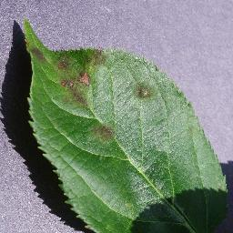
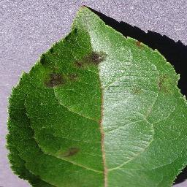
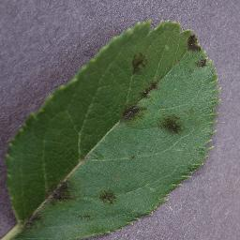
Figure 1 Example of Apple Scab

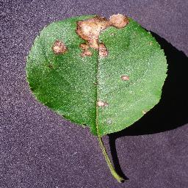
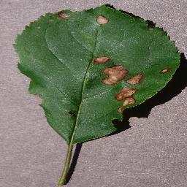
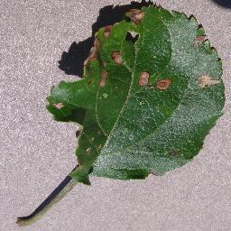
Figure 2 Example of Black Rot

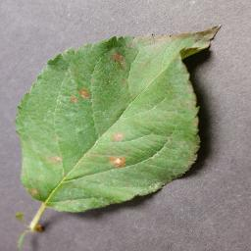
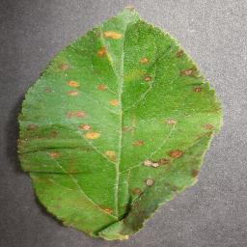
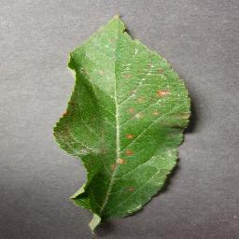
Figure 3 Example of Cedar Apple Rust

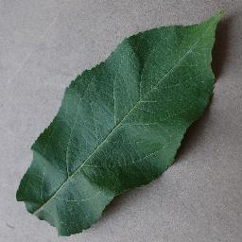
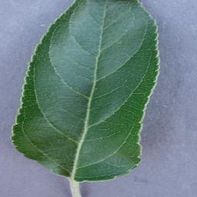
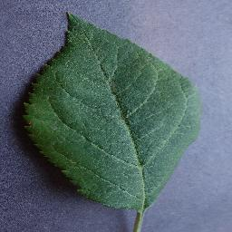
Figure 4 Example of Apple Healthy

4.1.2 Structured Climate Dataset
The structured dataset is the other half of the Kaggle multimodal dataset. The environment and soil are described with the following features:
- Nitrogen (N)
- Phosphorus (P)
- Potassium (K)
- Temperature
- Humidity
- Rainfall
- pH
All these variables refer to the air and soil that surrounded the sample locations.
Since the structured data is a part of the dataset, there's no need to get external data like NASA POWER or ERA5 for this work.

Table 2 Example of the Dataset
N | P | K | temperature | humidity | ph | rainfall | Label | Image
71 | 54 | 16 | 22.61359953 | 63.69070564 | 5.749914421 | 87.75953857 | Apple Black rot | 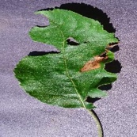

4.2 Data Preprocessing

4.2.1 Image Preprocessing
- Resizing the picture size to 224×224
- Normalization (0–1 scaling)
- Data augmentation: rotation, flipping, brightness adjustment, zoom, shifting

4.2.2 Structured Data Preprocessing
- Standardization using StandardScaler
- Pairing up the pictures with the correct pieces of structured data via the image_id keys
- Label encoding

4.3 Image Feature Extraction Models
The performance comparison experiment involved the consideration of three different pretrained CNN models:
- MobileNetV2
- ResNet50
- InceptionV3

4.4 Multimodal Fusion Architecture
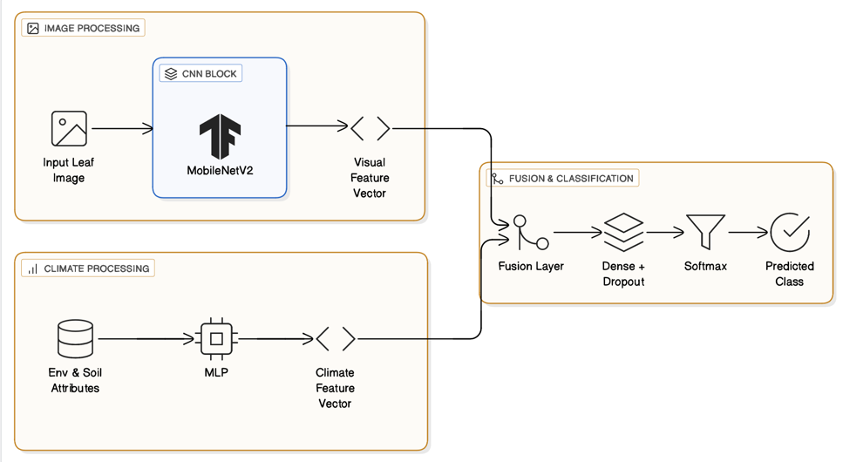
The suggested layout has two parallel processing streams, one for the image feature extractor based on CNN and the other for the climate feature extractor based on MLP. The outputs of both streams are concatenated and passed through the dense layers with dropout for the final classification with Softmax.

Figure 5 System Architecture of the Multimodal Deep Learning Model

4.5 Training Strategy
Training was done with a batch size of 32, Adam optimizer, 10 epochs, early stopping to limit overfitting, and class weights during the training of image-only models, to ease the problem of class imbalance that resulted in the differentially distributed images across the disease categories. Consequently, the model that was being biased toward the majority classes was excluded.

Chapter 5 Experimental Results and Discussion
This chapter presents the outcome of experiments on the Apple subset of the Multimodal Plant Disease Dataset by Shubham Divakar.

5.1 Experimental Setup

5.1.1 Hardware and Software Environment
The work has been done on the Mac OS platform, and the following packages have been used: Python, Jupyter Notebook, TensorFlow, NumPy, Pandas, and scikit learn.

5.1.2 Dataset Splitting
The data was divided into:
- 70% training
- 15% validation
- 15% testing

5.2 Image-Only Model Results
Table 3 Image-Only Model Results
Model | Dataset | Accuracy | Precision | Recall | F1-Score
MobileNetV2 | Apple Disease Dataset | 0.9895 | 0.9896 | 0.9895 | 0.9895
ResNet50 | Apple Disease Dataset | 0.5490 | 0.3996 | 0.5490 | 0.4370
InceptionV3 | Apple Disease Dataset | 0.6263 | 0.5792 | 0.6263 | 0.5340

The three image-based models whose performances differ drastically in their results. With an accuracy of 98.95% MobileNetV2 has been the one to make the most outstanding result, ResNet50 and InceptionV3 not very good. The result of MobileNetV2 because it compact model, depthwise separable convolutions, and ability to extract the most efficient features make it very powerful in datasets with a small number of images and high-class similarity, like apple leaf diseases.
On the other hand, ResNet50 is the one that has recorded the worst results (accuracy of 54.90%). The poor performance is a hint that ResNet50 may have overfitted the training data or is having trouble generalizing due to the limited size of the data set.
ResNet50 is a deep and complex model architecture designed for large-scale datasets like ImageNet, and, if not properly fine-tuned, it may not effectively capture the minimal features of leaf diseases.
Compared to ResNet50, InceptionV3 (accuracy 62.63%) was a bit better, but still a long way behind MobileNetV2. This can be explained by the fact that even InceptionV3 was built to extract multi-scale features, the limited variability of the dataset, and the closeness of some disease classes could have forced it to identify the fine-grained patterns of the leaf.
The results show that a simpler architecture like MobileNetV2 may have the potential to beat a deep model when dealing with small or medium-sized datasets from the agriculture domain.

5.3 Multimodal Fusion Model Results
Table 4 Multimodal Fusion Model Results
Model | Input Type | Accuracy | Precision | Recall | F1-Score
MobileNetV2 + MLP | Image +Climate | 0.7825 | 0.7858 | 0.7825 | 0.7805
ResNet50 + MLP | Image + Climate | 0.3200 | 0.1502 | 0.3200 | 0.2008
InceptionV3 + MLP | Image + Climate | 0.7400 | 0.7627 | 0.7400 | 0.7298

Different CNNs decode differently structured climate features, as can be seen above. The MobileNetV2 + MLP model was the best performer in terms of accuracy (78.25%), and hence it was proven that a light architecture is more feature-numerical data-friendly and more stable fusion representations. The performance of InceptionV3 + MLP was average (74.00%), whereas that of ResNet50 + MLP was extremely poor (32.00%), which led to the conclusion that a deep network needs a lot more data to be able to align its high-dimensional visual embeddings with structured features.
The main reason that the multimodal fusion turns out to be successful is that the image encoder is compatible with tabular data. MobileNetV2 is a good illustration of a model with simpler feature representations, which can more easily merge with climate data, whereas a deep model may generate embeddings that the fusion layer cannot combine efficiently.
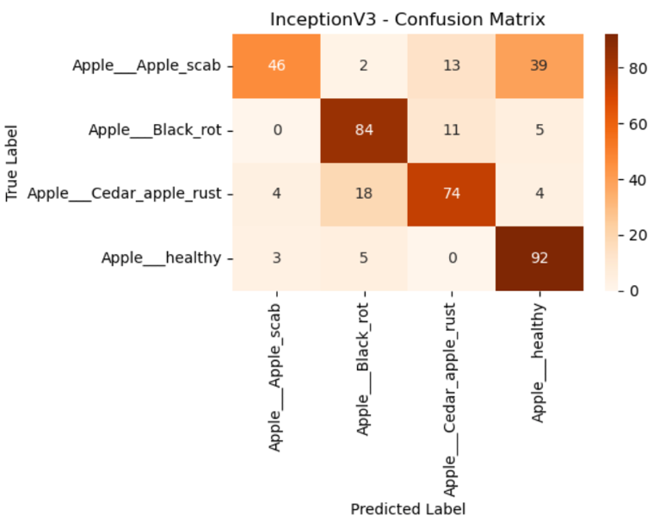
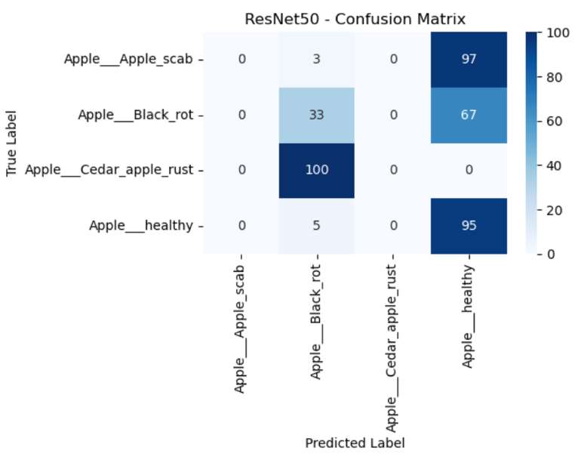
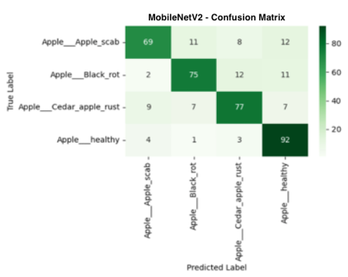
Figure 6 Multimodal Confusion Matrix

The confusion matrix for the fusion model MobileNetV2 + MLP is indicative of the fact that this model has made many mistakes for most of the diseases, though it has also correctly identified quite a few samples. The multimodal version showed less discrimination between classes as compared to the image-only MobileNetV2 model, which achieved almost perfect separation. It shows that adding climate and soil features did not help the visual feature representation. Instead, the fusion might have brought some noise that interfered with the already quite strong performance of the image encoder.
Hence, the analysis of the multimodal confusion matrix agrees with the fact that climate features can barely contribute to the visual classification and that better methods of fusion are needed for the two modalities.

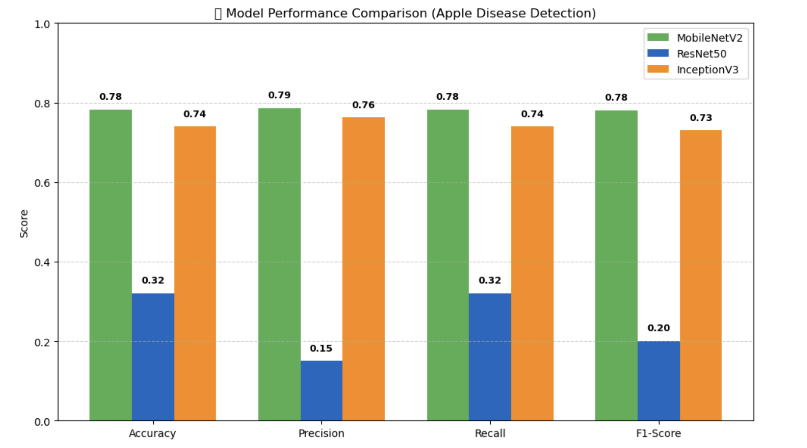
5.4 Comparison Summary
Figure 7 Model Performance Comparison (Apple Disease Detection)

The performance comparison figure acts as the main visual evidence for the ranking of the multimodal fusion models. The MobileNetV2 + MLP model was the top performer in all the evaluation metrics and, therefore, it represented the strongest compatibility of image-based visual features with structured climate data. The InceptionV3 + MLP model was the runner-up. It showed moderate and stable performance but could not get to the effectiveness level of MobileNetV2.
The ResNet50 + MLP model, on the contrary, was a very strong contrasting argument and had very low metric scores throughout the entire panel. One reason for that could be that its deeper and higher-dimensional feature representations were not properly aligned with the structured environmental features during fusion.
The graph works as a tool that reveals that CNN encoders do not get the same level of benefit from multimodal integration. A light model, such as MobileNetV2, gives feature embeddings that can very easily be fused with climate and soil attributes, whereas a deep network may need more data or employ advanced fusion strategies to achieve the same level.

Chapter 6: Conclusion and Future Work

6.1 Conclusion
This thesis is about disease detection on apple leaves using multimodal deep learning models. To improve the detection features coming from leaf images are being fused with data like temperature, air moisture, rainfall, and soil nutrient content. Studies proved that image-only CNNs should be the primary classifiers of plant diseases. Results show that MobileNetV2 was the model that obtained the highest accuracy out of the ones tested, which means that less resource-consuming models can be used in the agricultural sector, where there are few images, and the characteristics of the classes are highly similar. On the other hand, ResNet50 and InceptionV3, the deep models, had a weak overall generalization performance, therefore, indicating that network complexity does not necessarily result in better performance with limited data.
Moreover, connecting environmental features with the image-based through the middle multimodal fusion layer does not necessarily result in better classification outcomes. The integration of MobileNetV2 with an environmental data MLP led to average accuracy. The result demonstrates that different fusion modes not only need a fusion strategy but also that the problems of cross-modal noise. It still acknowledges that environmental factors, which are not always directly helpful for visual classification, can still be valuable contextual information for understanding the disease process and, therefore, have the potential of raising the level of predictive systems if correctly utilized.
The study implies that when using structured environmental data along with lightweight CNN models, simple concatenation may not be enough for multimodal integration, and that the quality and the relevance of the environmental features are the most important factors for accurate prediction. The problem pointed to here acts as a stepping stone for further research on plant disease detection that is climate aware, robust, and scalable, hence, can be implemented in real-world agriculture.

6.2 Future Work
The specified recommendations below are the results of the experimental evaluation of image-only and multimodal models for apple leaf disease detection:
- Widen the data set: Keep taking pictures of the infected leaves and note down the factors of the surroundings for more data points. To accurately determine the correlation between different modalities, it is very important that environmental factors (temperature, humidity, rainfall, pH, N, P, K) not only match the places but also the times of the leaf photos.
- Advanced Multimodal Fusion Techniques: Maybe you could integrate a more advanced fusion technique, such as attention-based fusion, cross-modal transformers, and gated fusion networks. These methods could potentially be a lot more efficient in merging image and structured features and could also reduce the noise between different modalities.
- Enhance the quality of environmental features: It is very necessary for the environmental features to be transformed into a time series with the weather data, rather than a simple snapshot of the times. In addition to leaf wetness duration, solar radiation and wind speed can also be considered as features for better disease risk factors.
- Lightweight CNN Architectures: MobileNetV2 was able to get excellent results with a small dataset. There are several other lightweight architectures like MobileNetV3, EfficientNet B0/B1, or ShuffleNet, which can be considered not only for better multimodal integration but also for their feasibility in field deployment purposes in the future.
- Real World Testing: This manner of experimenting or testing with models in real-life situations is very significant for them to be able to prove if their models are foolproof and can be generalized to other scenarios. Some issues they may face are changed lighting, background clutter, partial leaf occlusions, and different orchards.
- Modality Alignment: One can think of methods that enable more efficient alignment between image and structured data features, like contrastive learning, latent space matching, or modality normalization layers, etc., that can lead to further improvements of multimodal fusion results.

All these suggested future moves are to improve the precision and practicality of ground-level multimodal plant disease detection systems, which, directly and indirectly, can be a sustainable agriculture and better crop management support.

References
- Ristaino JB, Anderson PK, Bebber DP, Brauman KA, Cunniffe NJ, Fedoroff NV, Finegold C, Garrett KA, Gilligan CA, Jones CM, Martin MD. The persistent threat of emerging plant disease pandemics to global food security. Proceedings of the National Academy of Sciences. 2021 Jun 8;118(23):e2022239118. https://doi.org/10.1073/pnas.2022239118
- Awad DA, Masoud HA, Hamad A. Climate changes and food-borne pathogens: the impact on human health and mitigation strategy. Climatic Change. 2024 Jun;177(6):92. https://doi.org/10.1007/s10584-024-03748-9
- Ahmed I, Yadav PK. Predicting apple plant diseases in orchards using machine learning and deep learning algorithms. SN computer science. 2024 Jul 3;5(6):700. https://doi.org/10.1007/s42979-024-02959-2
- Upadhyay A, Chandel NS, Singh KP, Chakraborty SK, Nandede BM, Kumar M, Subeesh A, Upendar K, Salem A, Elbeltagi A. Deep learning and computer vision in plant disease detection: a comprehensive review of techniques, models, and trends in precision agriculture. Artificial Intelligence Review. 2025 Jan 17;58(3):92. https://doi.org/10.1007/s10462-024-11100-x
- Sadr H, Nazari M, Khodaverdian Z, Farzan R, Yousefzadeh-Chabok S, Ashoobi MT, Hemmati H, Hendi A, Ashraf A, Pedram MM, Hasannejad-Bibalan M. Unveiling the potential of artificial intelligence in revolutionizing disease diagnosis and prediction: a comprehensive review of machine learning and deep learning approaches. European Journal of Medical Research. 2025 May 26;30(1):418. https://doi.org/10.1186/s40001-025-02680-7
- Demilie WB. Plant disease detection and classification techniques: a comparative study of the performances. Journal of Big Data. 2024 Jan 2;11(1):5. https://doi.org/10.1186/s40537-023-00863-9
- Ristaino JB, Anderson PK, Bebber DP, Brauman KA, Cunniffe NJ, Fedoroff NV, Finegold C, Garrett KA, Gilligan CA, Jones CM, Martin MD. The persistent threat of emerging plant disease pandemics to global food security. Proceedings of the National Academy of Sciences. 2021 Jun 8;118(23):e2022239118. https://doi.org/10.1073/pnas.2022239118
- Ngugi HN, Ezugwu AE, Akinyelu AA, Abualigah L. Revolutionizing crop disease detection with computational deep learning: a comprehensive review. Environmental Monitoring and Assessment. 2024 Mar;196(3):302. https://doi.org/10.1007/s10661-024-12454-z
- Staal J, Alsma J, Mamede S, Olson AP, Prins-van Gilst G, Geerlings SE, Plesac M, Sundberg MA, Frens MA, Schmidt HG, Van den Broek WW. The relationship between time to diagnose and diagnostic accuracy among internal medicine residents: a randomized experiment. BMC Medical Education. 2021 Apr 21;21(1):227. https://doi.org/10.1186/s12909-021-02671-2
- Sadr H, Nazari M, Khodaverdian Z, Farzan R, Yousefzadeh-Chabok S, Ashoobi MT, Hemmati H, Hendi A, Ashraf A, Pedram MM, Hasannejad-Bibalan M. Unveiling the potential of artificial intelligence in revolutionizing disease diagnosis and prediction: a comprehensive review of machine learning and deep learning approaches. European Journal of Medical Research. 2025 May 26;30(1):418. https://doi.org/10.1186/s40001-025-02680-7
- Ngugi HN, Ezugwu AE, Akinyelu AA, Abualigah L. Revolutionizing crop disease detection with computational deep learning: a comprehensive review. Environmental Monitoring and Assessment. 2024 Mar;196(3):302. https://doi.org/10.1007/s10661-024-12454-z
- Shafik W, Tufail A, De Silva Liyanage C, Apong RA. Using transfer learning-based plant disease classification and detection for sustainable agriculture. BMC Plant Biology. 2024 Feb 26;24(1):136. https://doi.org/10.1186/s12870-024-04825-y
- Howard AG, Zhu M, Chen B, Kalenichenko D, Wang W, Weyand T, Andreetto M, Adam H. Mobilenets: Efficient convolutional neural networks for mobile vision applications. arXiv preprint arXiv:1704.04861. 2017 Apr 17. https://doi.org/10.48550/arXiv.1704.04861
- He K, Zhang X, Ren S, Sun J. Deep residual learning for image recognition. InProceedings of the IEEE conference on computer vision and pattern recognition 2016 (pp. 770-778). https://openaccess.thecvf.com/content_cvpr_2016/papers/He_Deep_Residual_Learning_CVPR_2016_paper.pdf
- Cao J, Yan M, Jia Y, Tian X, Zhang Z. Application of a modified Inception-v3 model in the dynasty-based classification of ancient murals. EURASIP Journal on Advances in Signal Processing. 2021 Jul 27;2021(1):49. https://doi.org/10.1186/s13634-021-00740-8
- Kumar D, Mukhopadhyay R. Climate change and plant pathogens: Understanding dynamics, risks and mitigation strategies. Plant Pathology. 2025 Jan;74(1):59-68. https://doi.org/10.1111/ppa.14033
- Cao Y, Shen Z, Zhang N, Deng X, Thomashow LS, Lidbury I, Liu H, Li R, Shen Q, Kowalchuk GA. Phosphorus availability influences disease-suppressive soil microbiome through plant-microbe interactions. Microbiome. 2024 Sep 28;12(1):185. https://doi.org/10.1186/s40168-024-01906-w
- Romero F, Cazzato S, Walder F, Vogelgsang S, Bender SF, van der Heijden MG. Humidity and high temperature are important for predicting fungal disease outbreaks worldwide. New Phytologist. 2022 Jun 1;234(5):1553-6. https://doi.org/10.1111/nph.17340
- Radwan M, Alhussan AA, Ibrahim A, Tawfeek SM. Potato leaf disease classification using optimized machine learning models and feature selection techniques. Potato Research. 2025 Jun;68(2):897-921. https://doi.org/10.1007/s11540-024-09763-8
- Warner E, Lee J, Hsu W, Syeda-Mahmood T, Kahn Jr CE, Gevaert O, Rao A. Multimodal machine learning in image-based and clinical biomedicine: Survey and prospects. International journal of computer vision. 2024 Sep;132(9):3753-69. https://doi.org/10.1007/s11263-024-02032-8
- Sung YL, Li L, Lin K, Gan Z, Bansal M, Wang L. An empirical study of multimodal model merging. arXiv preprint arXiv:2304.14933. 2023 Apr 28. https://doi.org/10.48550/arXiv.2304.14933
- Zainab Z, Mahum R. Plant disease detection using deep learning techniques. ICCK Journal of Image Analysis and Processing. 2025 Mar 20;1(1):36-44. https://doi.org/10.62762/JIAP.2025.227089
- Shoaib M, Hussain T, Shah B, Ullah I, Shah SM, Ali F, Park SH. Deep learning-based segmentation and classification of leaf images for detection of tomato plant disease. Frontiers in plant science. 2022 Oct 7;13:1031748. https://doi.org/10.3389/fpls.2022.1031748
- Ahmad A, El Gamal A, Saraswat D. Toward generalization of deep learning-based plant disease identification under controlled and field conditions. IEEE Access. 2023 Jan 26;11:9042-57. https://doi.org/10.1109/ACCESS.2023.3240100
- Agarwal M, Singh A, Arjaria S, Sinha A, Gupta S. ToLeD: Tomato leaf disease detection using convolution neural network. Procedia Computer Science. 2020 Jan 1;167:293-301. https://doi.org/10.1016/j.procs.2020.03.225
- Chen J, Chen J, Zhang D, Sun Y, Nanehkaran YA. Using deep transfer learning for image-based plant disease identification. Computers and electronics in agriculture. 2020 Jun 1;173:105393. https://doi.org/10.1016/j.compag.2020.105393
- DeChant C, Wiesner-Hanks T, Chen S, Stewart EL, Yosinski J, Gore MA, Nelson RJ, Lipson H. Automated identification of northern leaf blight-infected maize plants from field imagery using deep learning. Phytopathology. 2017 Nov 17;107(11):1426-32. https://doi.org/10.1094/PHYTO-11-16-0417-R
- Sharma R, Singh A, Jhanjhi NZ, Masud M, Jaha ES, Verma S. Plant Disease Diagnosis and Image Classification Using Deep Learning. Computers, Materials & Continua. 2022 May 1;71(2). https://doi.org/10.32604/cmc.2022.020017
- Wang G, Sun Y, Wang J. Automatic image‐based plant disease severity estimation using deep learning. Computational intelligence and neuroscience. 2017;2017(1):2917536. https://doi.org/10.1155/2017/2917536
- Too EC, Yujian L, Njuki S, Yingchun L. A comparative study of fine-tuning deep learning models for plant disease identification. Computers and Electronics in Agriculture. 2019 Jun 1;161:272-9. https://doi.org/10.1016/j.compag.2018.03.032
- Eunice J, Popescu DE, Chowdary MK, Hemanth J. Deep learning-based leaf disease detection in crops using images for agricultural applications. Agronomy. 2022 Oct 3;12(10):2395. https://doi.org/10.3390/agronomy12102395
- Atila Ü, Uçar M, Akyol K, Uçar E. Plant leaf disease classification using EfficientNet deep learning model. Ecological Informatics. 2021 Mar 1;61:101182. https://doi.org/10.1016/j.ecoinf.2020.101182
- Jiang P, Chen Y, Liu B, He D, Liang C. Real-time detection of apple leaf diseases using deep learning approach based on improved convolutional neural networks. Ieee Access. 2019 May 6;7:59069-80. https://doi.org/10.1109/ACCESS.2019.2914929
- Amara J, Bouaziz B, Algergawy A. A deep learning-based approach for banana leaf diseases classification. InDatenbanksysteme für Business, Technologie und Web (BTW 2017)-Workshopband 2017 (pp. 79-88). Gesellschaft für Informatik eV. https://dl.gi.de/items/13766147-8092-4f0a-b4e1-8a11a9046bdf
- Ashwinkumar S, Rajagopal S, Manimaran V, Jegajothi BJ. Automated plant leaf disease detection and classification using optimal MobileNet based convolutional neural networks. Materials Today: Proceedings. 2022 Jan 1;51:480-7. https://doi.org/10.1016/j.matpr.2021.05.584
- Bhattacharya A. A novel deep learning-based model for classification of rice leaf diseases. In2021 Swedish Workshop on Data Science (SweDS) 2021 Dec 2 (pp. 1-6). IEEE. https://doi.org/10.1109/SweDS53855.2021.9638278
- Divakar S. Multimodal Plant Disease Dataset. Kaggle; https://www.kaggle.com/datasets/shubhamdivakar/multimodal-plant-disease-dataset-by-subham-divakar

