

Title

AI Impact on Crowd Management Using AFC Gate Records, Time Table, and CCTV Footage in Riyadh Metro Operations

Prepared By
Name: Waleed Abdelgawad
ID No.: 253002839
A dissertation submitted in partial fulfillment of the requirements for the degree of AI
At
College of Informatics
Midocean University
UAE
Supervisor Name: Dr. Amjad Qataish
College of Informatics, Midocean University, Comoros

Acknowledgements

Appreciation to Dr. Amjad Qataish

It is my pleasure to express my sincere thanks to Dr. Amjad Qataish for his great support and constructive suggestions throughout this research process. His expertise and motivation have made a significant contribution to carrying out this research.

Table of Contents
ii
Title ii
Influence of Artificial Intelligence on Crowd Management Through CCTV Video in the Operation of Riyadh Metro System ii
Acknowledgements iii
Chapter 1 provides an introduction to the thesis, including its background, problem statement, objectives, and contributions. 3
Chapter 2 provides a review of the relevant literature related to crowd management, computer vision, and artificial
transportation systems. 3
Chapter 3 Methodology and Data 3
Chapter 4 Results and Analysis 3
Chapter 5 Implications and Proposed Implementation Framework 3
Chapter 6 Conclusions and Limitations 3
Chapter 2 Background and Related Work 3
2.1 Introduction 3
2.2 Artificial Intelligence in Metro Systems 4
2.3 Machine Learning and Deep Learning Approaches 42.5 Explainable AI and Decision Support 4
2.6 Crowd Management Challenges in Metro Systems 5
2.9 Cross-Paper Comparison Table 10
2.10 Methodological Comparison by Theme 15
References 15

Chapter 2 Background and Related Work
2.1 Introduction

Metro systems are essential components of urban transportation networks. As urban areas expand, passenger traffic keeps rising in metropolitan systems. Therefore, effective crowd flow management in metro systems has become one of the most important challenges in the metro domain. Currently, crowd flow management in metro stations relies on CCTV cameras for surveillance purposes. The system operates in a reactive way, without any prediction capabilities.
The development of AI technologies opens up new possibilities to optimize crowd flow management. Machine learning models enable pattern recognition, prediction of future behavior, and anomaly detection based on the video stream. Computer vision makes it possible to extract features from video data and process it further.
2.2 AI in Metro Systems
Artificial Intelligence can be defined as an algorithm that enables various functions such as pattern detection, prediction, and decision making. This type of algorithm is used in the metro system for automating various processes, allocating resources, and ensuring passengers' safety.In contrast to rule-based systems, AI learns to recognize patterns from historical data and live streams. Therefore, AI can detect anomalies and predict future congestion. These capabilities make AI applicable in dynamic metro environments such as Riyadh Metro
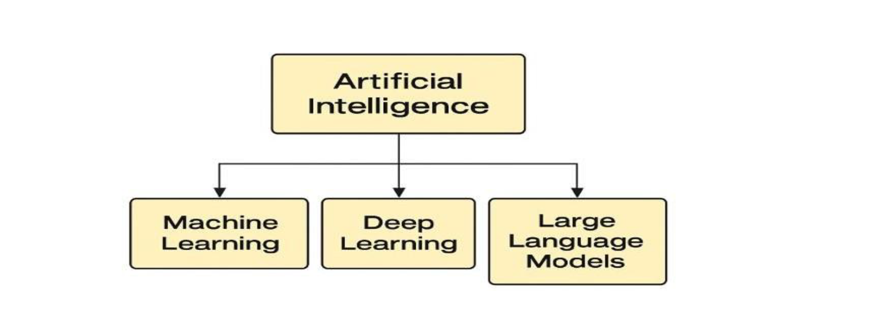

2.3 Machine Learning (ML) and Deep Learning Methods

ML allows computer programs to learn from the data and make predictions based on that data using algorithms without pre-programmed rules. ML applications in metro systems predict crowd behaviors based on analyzed historical and current data.

Deep Learning (DL) is an advanced method of ML involving the usage of multi-layered artificial neural networks able to extract more complicated features and patterns, especially related to images and video. DL techniques such as convolutional and recurrent neural networks are widely used to estimate crowd density and traffic flow.

This approach allows predicting rather than simply observing the crowd's behaviors.

2.5 Explainable AI and Decision Support

It should be noted that even though AI applications might be quite accurate, it is usually hard for people to understand why and how they work. To overcome this challenge, one can employ explainable AI (XAI).

With its help, it is possible to get insights into the reasons for making particular decisions in the processes of crowd detection and analysis.
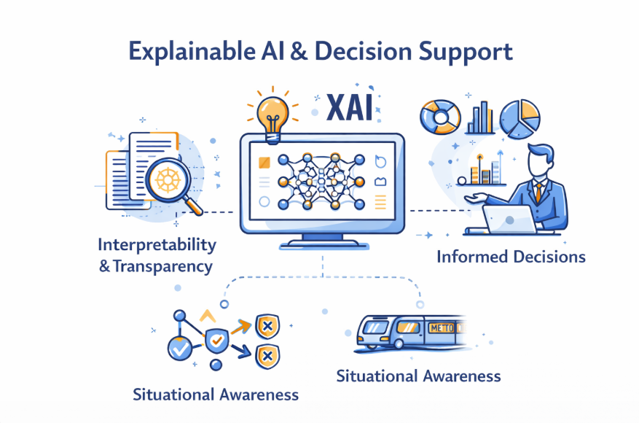

2. 6 Crowd Control Issues in Metro Stations

The metro environment is very complex and dynamic, hence making crowd control difficult. The large numbers of people at peak times, together with the small space available at the station and platforms, contribute to congestion. Incidents such as delays and emergencies create chaos and interrupt any usual pattern of movement. This is further hindered by the inefficiency of manual observation since the operator has to monitor several video streams.



