

Explainable Transformer-Based Anomaly Detection for Large-Scale System Logs

Prepared By
Name: Hesham Bashatah ID NO.: 253001893
Name: Anas Barro ID NO.: 253001086

Submitted in fulfillment of the requirements for the degree Master of
Science in Artificial Intelligence
At
College of Informatics
Midocean University
UAE
Supervisor Name:
Dr. Wesam Ahmed

Acknowledgements
We express our sincere appreciation to our supervisor, Dr. Wesam Ahmed, for his guidance, constructive criticism, and continued support throughout this research. We also acknowledge Midocean University and the College of Informatics for providing the academic environment required to complete this study. Finally, we thank our families and colleagues for their patience, encouragement, and support during the development, experimentation, and writing of this thesis.

Abstract
Large-scale computing systems generate extensive semi-structured logs that record operational events, warnings, errors, resource states, and component interactions. Manual inspection and static rules are increasingly inadequate because anomalous behavior often depends on semantic variation and the order of multiple events. This thesis presents LogMiniLM-XAI, a resource-conscious and explainable Transformer-based framework for anomaly detection in large-scale system logs. The framework normalizes BGL log messages, constructs fixed non-overlapping windows of ten events, encodes each unique normalized message using all-MiniLM-L6-v2, projects the 384-dimensional semantic representation to 128 dimensions, and processes each sequence using a compact one-layer Transformer classifier. Model development follows a strict temporal protocol: training and validation use the first 80% of the chronological sequence stream, while the latest 20% is reserved for final testing. Epoch selection and threshold tuning are performed exclusively on validation data. The selected decision threshold is 0.20, representing the midpoint of an equal-F1 validation plateau from 0.10 to 0.30. On the held-out test partition, the framework achieves 0.998419 accuracy, 0.991973 precision, 0.981642 recall, 0.986780 F1-score, 0.999309 ROC-AUC, and 0.992511 PR-AUC, with 45 false positives and 104 false negatives. A unified event-level explainability benchmark compares SHAP and Event Occlusion on the same 50 test sequences using three replacement baselines. The two methods demonstrate practically similar faithfulness, whereas Event Occlusion provides substantially stronger repeated-run stability, baseline robustness, and computational efficiency. Consequently, Event Occlusion is selected as the primary explanation method and SHAP is retained as a complementary attribution method. The study demonstrates that strong predictive performance can be combined with transparent, evidence-based evaluation of explanation quality, while maintaining a clear distinction between model explanation and operational root-cause analysis.
Keywords: system logs, anomaly detection, Transformer, MiniLM, explainable artificial intelligence, Event Occlusion, SHAP, BGL, faithfulness, stability.

Contents
Acknowledgements 2
Abstract 3
List of Figures 9
List of Tables 10
List of Abbreviations 11
Chapter 1: Introduction 12
1.1 Background and Motivation 12
1.2 Problem Statement 13
1.3 Research Questions 13
1.4 Research Objectives 13
1.5 Thesis Contributions 14
1.6 Scope and Boundaries 14
1.7 Thesis Organization 15
Chapter 2: Background and Related Work 16
2.1 Introduction 16
2.2 System Logs and Log Anomalies 16
2.2.1 Characteristics of System Logs 16
2.2.2 Types of Log Anomalies 16
2.3 Evolution of Log Anomaly Detection 16
2.4 Transformer-Based Sequence Modeling 17
2.4.1 Self-Attention 17
2.4.2 Positional Information 17
2.4.3 Advantages and Limitations 18
2.5 Semantic Representation of Log Messages 18
2.6 Window-Based Sequence Construction 18
2.7 Class Imbalance and Threshold Selection 19
2.8 Explainable Artificial Intelligence 19
2.8.1 Local Explanations 19
2.8.2 SHAP 19
2.8.3 Event Occlusion 20
2.8.4 Explanation Quality 20
2.9 Performance and Explainability Evaluation Metrics 20
2.9.1 Accuracy 21
2.9.2 Precision 21
2.9.3 Recall 21
2.9.4 F1-Score 21
2.9.5 True-Positive Rate 21
2.9.6 False-Positive Rate 21
2.9.7 ROC-AUC 22
2.9.8 Precision-Recall AUC 22
2.9.9 Explainability Evaluation Metrics 22
2.9.10 Comprehensiveness 22
2.9.11 Sufficiency 22
2.9.12 Decision-Flip Rate 22
2.9.13 Top-k Overlap 23
2.9.14 Jaccard Similarity 23
2.9.15 Spearman Rank Correlation 23
2.9.16 Repeated-Run Stability 23
2.9.17 Baseline Robustness 23
2.9.18 Attribution Concentration 23
2.9.19 Explanation Runtime 23
2.9.20 Cross-Method Agreement 24
2.9.21 Metric Interpretation in This Study 24
2.10 Related Work 24
2.10.1 Semantic and Transformer-Based Detection 24
2.10.2 Self-Supervised, Imbalance, and Uncertainty-Aware Methods 24
2.10.3 Transfer, Temporal, and Graph-Based Methods 25
2.10.4 Large Language Model and Data-Generation Methods 25
2.10.5 Operational and Explainable Detection 25
2.10.6 Comparative Synthesis 25
2.11 Research Gap 26
2.11.1 Lightweight Semantic Sequence Detection Gap 27
2.11.2 Reproducible Chronological Evaluation Gap 27
2.11.3 Objective Event-Level XAI Evaluation Gap 27
2.12 Chapter Summary 28
Chapter 3: Proposed Methodology 29
3.1 Methodological Overview 29
3.2 Dataset Description 30
3.3 Data Preprocessing 30
3.3.1 Loading and Label Extraction 30
3.3.2 Model-Input Construction and Normalization 31
3.3.3 Deterministic Event Mapping, Caching, and Reuse 31
3.4 Window Construction and Labeling 32
3.5 Temporal Dataset Split 33
3.6 MiniLM Semantic Encoding 34
3.7 Projection and Positional Representation 35
3.8 Lightweight Transformer Classifier 35
3.9 Class-Imbalance Handling 36
3.10 Training and Model Selection 36
3.11 Decision-Threshold Selection 37
3.12 SHAP Explanation Procedure 37
3.13 Event Occlusion Procedure 37
3.14 Unified Explanation Evaluation 38
3.15 Final Experimental Configuration 39
3.16 Algorithms 39
Algorithm 1: Detection Pipeline 39
Algorithm 2: Training and Selection Pipeline 40
Algorithm 3: XAI Evaluation Pipeline 40
3.17 Chapter Summary 40
Chapter 4: Experimental Results, Discussion, Conclusion, and Future Work 42
4.1 Introduction 42
4.2 Experimental Setup 42
4.3 Development Results 43
4.3.1 Preprocessing and Caching 43
4.3.2 Final Window Configuration 43
4.3.3 Imbalance Handling and Epoch Selection 44
4.3.4 Threshold Selection 44
4.4 Final Test Performance 44
4.5 Comparison with Baselines and Related Studies 45
4.6 Explainability Results 46
4.6.1 Common Benchmark Conditions 46
4.6.2 Faithfulness 47
4.6.3 Stability and Replacement-Baseline Robustness 47
4.6.4 Comparative XAI Decision 47
4.7 Computational Efficiency 48
4.8 Discussion 49
4.8.1 Contribution 1: Lightweight Semantic Transformer 49
4.8.2 Contribution 2: Reproducible Chronological Protocol 49
4.8.3 Contribution 3: Unified Event-Level XAI Benchmark 49
4.8.4 Answers to the Research Questions 49
4.9 Limitations and Threats to Validity 50
4.9.1 Internal Validity 50
4.9.2 Construct Validity 50
4.9.3 External Validity 50
4.9.4 Conclusion Validity 51
4.9.5 Operational Validity 51
4.10 Conclusion 51
4.11 Future Work 52
4.12 Chapter Summary 53
References 54

List of Figures
Figure 2.1 Conceptual development of log anomaly detection.
Figure 2.2 Window-based log sequence construction.
Figure 2.3 General event-level explainability methods for log anomaly detection.
Figure 3.1 Proposed LogMiniLM-XAI framework.
Figure 3.2 Log preprocessing and normalization flow.
Figure 3.3 Fixed non-overlapping event-window construction.
Figure 3.4 Chronological development, validation, and held-out test protocol.
Figure 3.5 Frozen MiniLM event encoding and reusable embedding cache.
Figure 3.6 LogMiniLM-XAI model architecture.
Figure 3.7 Unified SHAP and Event Occlusion evaluation workflow.
Figure 4.1 Evidence-based SHAP and Event Occlusion comparison.

List of Tables
Table 2.1. Modern related-work evidence core and comparison boundaries.
Table 2.2. Traceability from the research gaps to the proposed framework and evidence.
Table 3.1 BGL dataset and processed study counts.
Table 3.2 Final window-construction configuration.
Table 3.3 Final chronological dataset partitions.
Table 3.4 Unified XAI benchmark measures.
Table 3.5 Final experimental configuration.
Table 4.1 Final chronological dataset partitions.
Table 4.2 Final model and evaluation configuration.
Table 4.3 Validation threshold plateau and final selection.
Table 4.4 Confusion matrix on the held-out chronological BGL test partition.
Table 4.5 Final held-out detection results.
Table 4.6 Comparison tiers used in this thesis.
Table 4.7 Contextual comparison with representative published BGL studies.
Table 4.8 SHAP versus Event Occlusion benchmark results.
Table 4.9 Computational-efficiency evidence.

List of Abbreviations
Abbreviation | Meaning
AI | Artificial Intelligence
AP | Average Precision
AUC | Area Under the Curve
BCE | Binary Cross-Entropy
BGL | Blue Gene/L
FN | False Negative
FP | False Positive
PR | Precision-Recall
ROC | Receiver Operating Characteristic
SHAP | SHapley Additive exPlanations
TN | True Negative
TP | True Positive
XAI | Explainable Artificial Intelligence

Chapter 1: Introduction

1.1 Background and Motivation
System logs are one of the most important sources of operational evidence in modern computing environments. They record events, warnings, errors, resource conditions, component states, and interactions among applications, services, operating systems, and infrastructure. In traditional systems, administrators could often inspect logs manually or construct rules around known failure signatures. That approach no longer scales to cloud, distributed, and service-oriented environments, where millions of events may be generated in a short period and failures may emerge from subtle changes in event order, frequency, or meaning. [1], [2]
The analytical challenge is not limited to identifying unusual individual messages. Many operational anomalies are sequence-level deviations: a message that is harmless in isolation may become suspicious when it follows a particular warning, appears at an unexpected frequency, or replaces an expected event. As log volume and complexity increased, detection methods consequently evolved from manual inspection and static rules toward learning-based approaches capable of modeling semantic and sequential behavior. [3], [4]
Deep learning has improved the capacity to model these patterns. Recurrent networks introduced trainable sequence modeling, while Transformer architectures enabled stronger contextual learning through self-attention. More recent work has used BERT-family models, semantic sentence encoders, generative Transformers, contrastive learning, graph reasoning, and large language models. Despite these advances, achieving strong detection performance together with computational efficiency, reproducible evaluation, and credible explanation remains a practical challenge. [5], [6], [7], [8]
This thesis addresses these limitations through LogMiniLM-XAI, a lightweight, reproducible, and explainable framework for practical log anomaly detection. Rather than increasing model size, the study investigates whether compact semantic representations combined with a lightweight Transformer can provide strong sequence-level performance. MiniLM encodes normalized events, a compact Transformer models cross-event context, and post-hoc methods identify the event positions that influence each anomaly decision. Model development follows a strict chronological training, validation, and testing protocol, while detection and explanation are evaluated as related but distinct stages. [9]

1.2 Problem Statement
Large-scale software systems generate log data that are too voluminous, heterogeneous, and context-dependent for reliable manual analysis. Rule-based and conventional statistical approaches struggle when anomalies depend on semantic similarity or relationships among events in a sequence. Deep neural models can improve detection, but their opaque decisions are difficult to audit and may provide insufficient evidence for operator investigation. A practical solution must therefore combine accurate and efficient sequence-level detection with leakage-resistant temporal evaluation and event-level explanations that are faithful, stable, robust, and computationally feasible. [1], [4]
The research problem is therefore defined as follows: how can a lightweight Transformer-based framework detect anomalous sequences in large-scale system logs under a reproducible chronological evaluation protocol while producing faithful, stable, robust, and computationally practical explanations of the event positions that influence its decisions?

1.3 Research Questions
- How effectively can the proposed LogMiniLM-XAI classifier detect anomalous windows in the held-out chronological BGL test partition?
- To what extent can compact MiniLM semantic representations support sequence-level log anomaly detection within the proposed framework?
- How effectively does the combined preprocessing, chronological splitting, class-imbalance handling, and validation-based threshold-selection protocol support reproducible anomaly detection without test-set leakage?
- Can SHAP and Event Occlusion identify the event positions that most strongly influence the model's anomaly decision?
- How faithful, stable, robust, concentrated, and computationally efficient are the generated event-level explanations?

1.4 Research Objectives
- Prepare and normalize the BGL dataset while preserving chronological order and reproducible processing.
- Construct fixed, non-overlapping event windows and derive window-level anomaly labels.
- Investigate the effectiveness of frozen MiniLM embeddings as compact semantic representations for normalized log events.
- Design and evaluate a compact Transformer classifier for sequence-level anomaly detection.
- Evaluate a chronological training, validation, and testing protocol that prevents test-set leakage.
- Assess class-imbalance handling and validation-based threshold selection within the complete detection pipeline.
- Generate event-position explanations using SHAP and Event Occlusion.
- Compare the two XAI methods using faithfulness, stability, robustness, concentration, rank agreement, and runtime.
- Identify an evidence-based primary and complementary explanation strategy for the completed benchmark.
- Document the limits separating model explanation from causal root-cause analysis.

1.5 Thesis Contributions
- A lightweight semantic Transformer framework that combines frozen MiniLM event representations with a compact sequence classifier for large-scale log anomaly detection.
- A reproducible chronological evaluation protocol integrating deterministic preprocessing, fixed-window construction, temporal data partitioning, class-imbalance handling, and validation-only threshold selection.
- A unified event-level XAI benchmark that compares SHAP and Event Occlusion on identical cases using complementary faithfulness, stability, robustness, concentration, agreement, and runtime measures, leading to an evidence-based recommendation.

1.6 Scope and Boundaries
The empirical scope of this study is limited to supervised binary classification of the BGL dataset using fixed, non-overlapping windows of ten events. MiniLM is used as a frozen semantic encoder, while a separate compact Transformer performs sequence classification under a chronological training, validation, and testing protocol. The study does not evaluate alternative window sizes, overlapping or time-based windows, online or streaming detection, continual learning, or adaptation to concept drift. The explanation stage is applied after detection and attributes the model output to event positions using SHAP and Event Occlusion; these explanations describe model sensitivity rather than causal operational root cause. Cross-dataset generalization, production deployment, controlled operator-usability evaluation, cross-service root-cause analysis, and the integration of metrics, traces, topology, or dependency graphs are outside the current scope. Published comparisons are interpreted contextually because preprocessing and evaluation protocols differ across studies.

1.7 Thesis Organization
This thesis is organized into four chapters. Chapter 1 introduces the research background, problem, questions, objectives, contributions, and scope. Chapter 2 establishes the theoretical and empirical background, defines the evaluation metrics, reviews representative related work, and identifies the research gap. Chapter 3 presents the proposed methodology, including preprocessing, window construction, chronological splitting, semantic encoding, classifier architecture, training, threshold selection, and XAI evaluation. Chapter 4 reports the experimental results and integrates their discussion with the study limitations, conclusions, and future work.

Chapter 2: Background and Related Work

2.1 Introduction
This chapter establishes the theoretical and empirical foundation for the proposed framework. It first describes the characteristics of system logs and the main types of log anomalies. It then reviews the evolution of learning-based detection, Transformer sequence modeling, semantic representation, window construction, class imbalance, threshold selection, and explainable artificial intelligence. The chapter also defines all detection and explainability metrics used in the study, reviews representative research, and identifies the gap addressed by LogMiniLM-XAI.

2.2 System Logs and Log Anomalies

2.2.1 Characteristics of System Logs
System logs are typically semi-structured: a stable message pattern is combined with variable elements such as timestamps, node identifiers, process IDs, addresses, counters, and resource values. Logs are also sequential because event order carries operational meaning. Their volume is often very high, and anomalous events usually represent only a small fraction of the stream. These properties make log anomaly detection a large-scale, context-dependent, and imbalanced learning problem. [1], [2]

2.2.2 Types of Log Anomalies
An anomaly is an individual event that differs from expected behavior. A sequence anomaly occurs when the order or co-occurrence of otherwise common events is unusual. A contextual anomaly depends on the surrounding operational state, while a frequency anomaly appears when an event occurs too often or too rarely. Semantic anomalies are messages whose meaning deviates from normal behavior even when their surface syntax resembles common logs. [3], [4]

2.3 Evolution of Log Anomaly Detection
Early approaches relied on expert rules, signatures, statistical thresholds, clustering, principal component analysis, support vector machines, and isolation-based techniques. These methods remain useful in constrained settings but usually require manual feature design and cannot fully represent long event dependencies. Recurrent models improved sequential learning, and Transformer architecture later enabled parallel contextual modeling through self-attention. Explainable methods now extend the objective beyond detection accuracy to include transparency, stability, and operational usefulness. [3], [5], [6], [10]
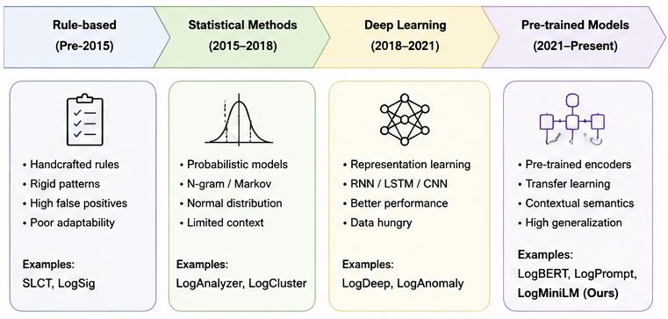
Figure 2.1 Conceptual development of log anomaly detection.

2.4 Transformer-Based Sequence Modeling

2.4.1 Self-Attention
Self-attention computes relationships among all event positions in a window. Each event is projected into query, key, and value vectors. Attention weights determine how strongly one event should use information from another. Multi-head attention allows the model to represent several relationship types simultaneously, including temporal dependency, repeated warning patterns, and interactions among components. [6], [11]
$Attention(Q,K,V) = softmax(QK^T / sqrt(d_k))V$ (1)

2.4.2 Positional Information
Because self-attention does not inherently encode order, positional information must be added to the event representations. In log analysis this is essential because identical messages appearing in different positions may represent different operational states. [11]

2.4.3 Advantages and Limitations
Transformers support parallel training and capture long-range dependencies more directly than recurrent networks. Their limitations include memory cost, parameter count, sensitivity to preprocessing, and limited transparency. Compact architectures are therefore attractive when training resources are constrained or when repeated large-scale inference is required. [6], [11]

2.5 Semantic Representation of Log Messages
Event IDs and one-hot encodings represent identity but not meaning. Static embeddings introduce similarity but do not fully adapt to context. BERT-family encoders generate contextual representations, although full-size models can be computationally expensive. MiniLM is a compressed Transformer designed to preserve much of the representational capability of larger models at lower cost. In this study, MiniLM is not the final anomaly detector; it converts normalized events into dense semantic vectors that are consumed by a separate sequence classifier. [5], [7], [12], [13]

2.6 Window-Based Sequence Construction
A continuous log stream must be transformed into learning instances. A fixed window contains a constant number of consecutive events. If the step equals the window size, the windows do not overlap. A smaller step creates overlapping samples but increases computation and can produce leakage when neighboring windows are distributed across different partitions. The label of a window is commonly defined as anomalous when at least one event in the window is anomalous. This rule improves sensitivity but means that anomalous windows may still contain many normal events. [5], [10]
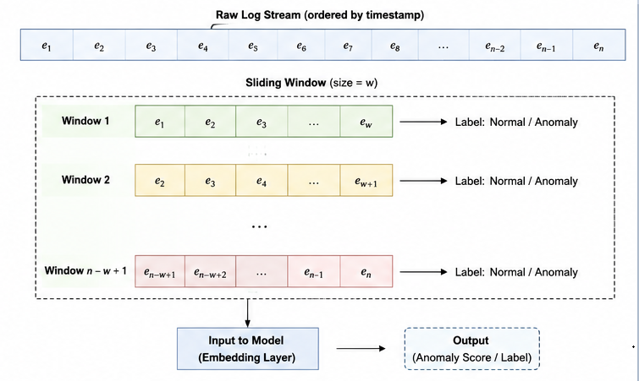
Figure 2.2 Window-based log sequence construction.

2.7 Class Imbalance and Threshold Selection
Normal windows dominate most system-log datasets. Accuracy can therefore appear high even when a model misses a large proportion of anomalies. Class-weighted loss, focal loss, over-sampling, under-sampling, and threshold tuning are common strategies. This study emphasizes class-weighted binary cross-entropy and validation-based threshold selection. The test set is reserved for final reporting and is not used to determine the operating threshold. [10], [14], [15]

2.8 Explainable Artificial Intelligence

2.8.1 Local Explanations
A local explanation describes why the model produced a particular output for one input. This is appropriate for anomaly detection because operators investigate individual alerts. Global explanations summarize general behavior but may obscure the details of a particular log sequence. [4], [16]

2.8.2 SHAP
SHAP assigns additive contribution values to features using Shapley-value principles. Positive values support the anomaly output and negative values oppose it. In event-level log explanation, each event position is treated as an interpretable feature. SHAP provides a distributional attribution view but is approximate, computationally expensive, and sensitive to sampling and replacement baselines. [9]

2.8.3 Event Occlusion
Event Occlusion is a direct perturbation method. Each event is replaced by a defined baseline representation, and the model output is recomputed. The signed logit change indicates whether the event supports or opposes the anomaly decision, while the magnitude measures influence. Occlusion is deterministic for a fixed model, input, and baseline, although it requires repeated model inference. [4], [16]

2.8.4 Explanation Quality
Explanation quality should not be inferred from visual plausibility alone. It can be evaluated using comprehensiveness, sufficiency, decision-flip rate, repeated-run stability, robustness across replacement baselines, rank correlation, top-k concentration, and runtime. Cross-method agreement is useful as a descriptive measure, but disagreement does not determine which method is more faithful. [4], [8], [9]
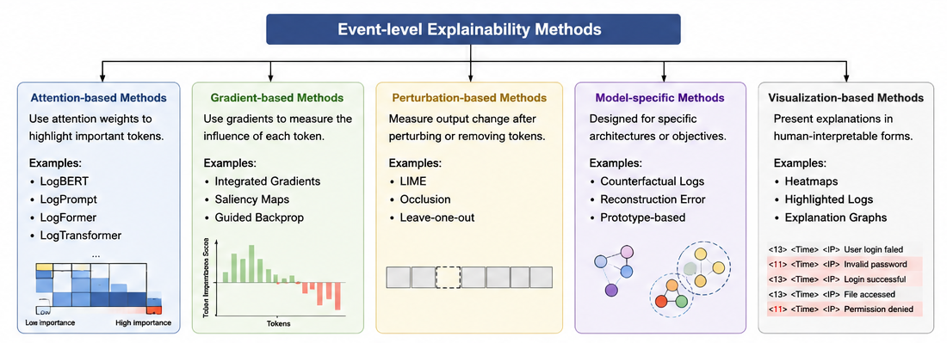
Figure 2.3 General event-level explainability methods for log anomaly detection.

2.9 Performance and Explainability Evaluation Metrics
The proposed framework is evaluated from two complementary perspectives. Detection performance is measured using classification and ranking metrics, while explanation quality is measured using faithfulness, stability, robustness, concentration, agreement, and computational cost. An anomalous window is treated as the positive class and a normal window as the negative class. [9], [14], [15]

2.9.1 Accuracy
Accuracy measures the proportion of correctly classified windows among all evaluated windows. It can be misleading under severe class imbalance and is therefore interpreted together with precision, recall, F1-score, and PR-AUC. [14], [15]
$Accuracy = (TP + TN) / (TP + TN + FP + FN)$ (2)

2.9.2 Precision
Precision measures the proportion of predicted anomalous windows that are actually anomalous. High precision indicates that the detector produces relatively few false alarms.
$Precision = TP / (TP + FP)$ (3)

2.9.3 Recall
Recalling measures the proportion of actual anomalous windows that are correctly detected. High recall indicates that relatively few anomalies are missing.
$Recall = TP / (TP + FN)$ (4)

2.9.4 F1-Score
The F1-score is the harmonic mean of precision and recall and is used as the primary model-selection metric in this study.
$F1 = 2(Precision x Recall) / (Precision + Recall)$ (5)

2.9.5 True-Positive Rate
The true-positive rate is equivalent to recall and is used in constructing the ROC curve.
$TPR = TP / (TP + FN)$ (6)

2.9.6 False-Positive Rate
The false-positive rate measures the proportion of normal windows that are incorrectly classified as anomalous.
$FPR = FP / (FP + TN)$ (7)

2.9.7 ROC-AUC
ROC-AUC summarizes the relationship between the true-positive and false-positive rates across thresholds. A value near one indicates strong ranking ability, although ROC-AUC can appear optimistic under strong imbalance. [14], [15]
$ROC-AUC = integral_0^1 TPR(FPR) d(FPR)$ (8)

2.9.8 Precision-Recall AUC
PR-AUC focuses directly on the positive class and is especially informative for imbalanced datasets. Average precision is used as the numerical summary of the Precision-Recall curve. [14], [15]
$AP = sum_n (R_n - R_\{n-1\})P_n$ (9)

2.9.9 Explainability Evaluation Metrics
Let z(X) denote the anomaly logit for log window X and p(X) = sigmoid(z(X)) the anomaly probability. Logit changes are emphasized because probabilities may become saturated near zero or one.
$p(X) = 1 / (1 + exp(-z(X)))$ (10)

2.9.10 Comprehensiveness
Comprehensiveness evaluates whether the top-ranked events genuinely support the original anomaly decision. Let T_k be the top-k events. A larger positive value is better.
$Comprehensiveness_k = z(X) - z(X \backslash T_k)$ (11)

2.9.11 Sufficiency
Sufficiency evaluates whether the top-ranked events alone preserve the original decision. A smaller logit gap is better.
$Sufficiency_k = |z(X) - z(X_\{T_k\})|$ (12)

2.9.12 Decision-Flip Rate
The decision-flip rate measures how often removal of the top-k events changes the predicted class. It is treated as supporting evidence because highly confident predictions can remain unchanged despite a meaningful logit reduction.
$DecisionFlip_k = (1/N) sum_i I[y_i != y_i^\{(-T_k)\}]$ (13)

2.9.13 Top-k Overlap
Top-k overlap measures the proportion of shared events between two top-k sets.
$Overlap_k(A,B) = |T_k^A intersect T_k^B| / k$ (14)

2.9.14 Jaccard Similarity
Jaccard similarity provides an alternative set-based agreement measure.
$J(A,B) = |A intersect B| / |A union B|$ (15)

2.9.15 Spearman Rank Correlation
Spearman correlation measures similarity between two complete event-importance rankings. Values range from -1 to 1.
$rho = 1 - [6 sum_i d_i^2] / [n(n^2 - 1)]$ (16)

2.9.16 Repeated-Run Stability
Repeated-run stability evaluates whether a method identifies the same events when applied repeatedly to the same input.
$RepeatStability_k = [2 / R(R-1)] sum_\{r<s\} |T_k^(r) intersect T_k^(s)| / k$ (17)

2.9.17 Baseline Robustness
Baseline robustness measures whether event rankings remain similar across different replacement baselines.
$BaselineRobustness_k = [2 / B(B-1)] sum_\{b<c\} |T_k^(b) intersect T_k^(c)| / k$ (18)

2.9.18 Attribution Concentration
Attribution concentration measures the proportion of total absolute attribution assigned to the top-k events. High concentration can improve readability but does not by itself prove faithfulness.
$Concentration_k = sum_\{i in T_k\}|a_i| / sum_j |a_j|$ (19)

2.9.19 Explanation Runtime
Runtime measures the mean computational time required to explain one sequence.
$MeanRuntime = (1/N) sum_i t_i$ (20)

2.9.20 Cross-Method Agreement
Cross-method agreement measures whether SHAP and Event Occlusion identify similar high-importance events. It is descriptive and is not used as the primary selection criterion.
$Agreement_k = |T_k^SHAP intersect T_k^Occ| / k$ (21)

2.9.21 Metric Interpretation in This Study
Detection is assessed primarily using F1-score, precision, recall, ROC-AUC, and PR-AUC; accuracy is reported as an additional overall measure. XAI methods are evaluated in the following order: faithfulness through comprehensiveness and sufficiency, repeated-run stability, robustness across replacement baselines, computational efficiency, attribution concentration, and descriptive cross-method agreement. When the central faithfulness difference between SHAP and Event Occlusion is below five percent, the methods are treated as practically comparable and the final choice is based on stability, robustness, and runtime. [9], [14], [15]

2.10 Related Work

2.10.1 Semantic and Transformer-Based Detection
Recent log anomaly detection research increasingly uses pretrained language models and Transformers to replace or complement symbolic event identifiers. LAnoBERT applies BERT masked-language modeling to parser-free anomaly detection, whereas LogFormer combines Transformer pretraining, adapters, and Log-Attention for cross-domain adaptation [5], [6]. LogELECTRA and ADALog also use self-supervised language-model objectives, but operate primarily at individual-log or token-reconstruction level rather than the supervised ten-event window classification used in this thesis [17], [18]. These studies support the value of semantic representations, but their anomaly units, supervision settings, and inference rules differ substantially from LogMiniLM-XAI.

2.10.2 Self-Supervised, Imbalance, and Uncertainty-Aware Methods
LogSD uses self-supervised dual-network learning and frequency-based masking to reduce the dominance of frequently occurring normal patterns [10]. LogEDL adds evidential deep learning to Transformer-based log modeling in order to quantify predictive uncertainty [19]. These approaches address important concerns—rare-event learning and uncertainty—but neither uncertainty estimates nor self-supervised reconstruction scores are equivalent to local event-position explanations. They are therefore treated as complementary research directions rather than direct XAI baselines.

2.10.3 Transfer, Temporal, and Graph-Based Methods
Cross-system studies extend anomaly detection beyond a single fixed environment. LogGT integrates BERT semantics, heterogeneous graph features, temporal intervals, and transfer learning, while LogETA emphasizes time-aware cross-system adaptation and inter-class boundary optimization [20], [21]. ELFA-Log applies enhanced pseudo-labeling and feature alignment to reduce the target-domain labeling requirement [22]. These studies demonstrate the importance of structural, temporal, and domain-shift information, but their cross-system objectives are outside the BGL-only scope validated in this thesis.

2.10.4 Large Language Model and Data-Generation Methods
Recent work has also explored substantially larger language models. LogLLM separates a semantic encoder, projection module, and Llama-based classifier, while LogLLaMA uses generative next-event modeling and reinforcement-learning-based anomaly identification [7], [23]. AnomalyGen uses large language models and program analysis to generate and label semantic log sequences for training and evaluation [24]. These studies expand the capabilities of log analysis, but also introduce different model scales, objectives, and training pipelines. Consequently, they motivate—rather than directly benchmark—the lightweight design adopted in LogMiniLM-XAI.

2.10.5 Operational and Explainable Detection
Operational and explanation-oriented studies reveal a further distinction between producing explanatory information and validating explanation quality. The ALICE O² framework combines BERT-based topic modeling, semi-supervised detection, and real-time visualization for operational monitoring [25]. TPLogAD separates template and dynamic-parameter representations, providing representation-level interpretability regarding different anomaly sources [26]. LLM-LADE jointly performs anomaly discrimination and natural-language explanation generation [8]. DeepEAD provides an earlier explicitly explainable system-log anomaly framework [4]. However, generated causes, topic keywords, representation decomposition, and post-hoc feature attributions answer different questions. None should be assumed faithful to a model decision without an explicit evaluation protocol.

2.10.6 Comparative Synthesis
Table 2.1 summarizes the fifteen-study modern evidence core. All studies are classified as published contextual comparisons because their preprocessing, anomaly unit, supervision, window construction, temporal partitioning, threshold selection, or metric implementation differs from the protocol used in this thesis. Their published performance values are therefore not used to claim direct numerical superiority. The comparison instead identifies method families, evaluation boundaries, and the unresolved combination addressed by LogMiniLM-XAI. [5], [6], [7], [8], [10], [17], [18], [19], [20], [21], [22], [23], [24], [25], [26].
Table 2.1. Modern related-work evidence core and comparison boundaries.
Study | Year / Status | Method | Task / Data | XAI | Relevance and Boundary
lanobert [5] | 2023 / Journal | BERT masked-language modeling | HDFS, BGL, Thunderbird; parser-free unsupervised | No objective event-level benchmark | Semantic BERT reference; objective and inference differ
logformer [6] | 2024 / Conference | Pretraining, adapters, Log-Attention | Cross-domain log datasets; transfer learning | No event-level faithfulness benchmark | Compact adaptation reference; cross-domain protocol differs
logllm [7] | 2024 / Preprint | BERT encoder, projector, Llama classifier | HDFS, BGL, Liberty, Thunderbird | No controlled event-level XAI | Related modular architecture, much larger scale
llm-lade [8] | 2025 / Journal | LLM anomaly detection and explanation generation | Multiple benchmark datasets | Generated explanations | Closest modern detection-plus-explanation study; different evidence standard
logsd [10] | 2024 / Research paper | Self-supervised dual networks and frequency masking | Three public datasets; semi-supervised | No matched SHAP–occlusion evaluation | Relevant to rare events and imbalance
logelectra [17] | 2024 / Preprint | ELECTRA self-supervision | BGL, Spirit, Thunderbird; individual logs | No window-level XAI | Contrasts point anomalies with sequence classification
adalog [18] | 2025 / Preprint | Adaptive MLM anomaly scoring | BGL, Thunderbird, Spirit | No matched event-window XAI | Relevant to semantics and adaptive thresholds
logedl [19] | 2024 / Journal | Transformer with evidential head | HDFS, BGL, Thunderbird | Uncertainty, not local explanation | Distinguishes confidence from attribution
loggt [20] | 2024 / Journal | BERT, heterogeneous graph, graph Transformer | Three systems; cross-system transfer | No matched attribution benchmark | Adds graph, component, and time information
logeta [21] | 2024 / Journal | Time-aware attention and boundary optimization | Cross-system datasets | No event-level attribution | Relevant to temporal transfer outside current scope
elfa-log [22] | 2025 / Journal | Pseudo-labeling and feature alignment | Cross-system benchmarks | No local XAI | Relevant to low-label adaptation and drift
logllama [23] | 2025 / Preprint | LLaMA2 generation and reinforcement learning | BGL, Thunderbird, HDFS | No matched perturbation benchmark | Represents generative LLM direction
anomalygen [24] | 2025 / Preprint | LLM-based semantic sequence generation | Hadoop/HDFS-oriented evaluation | Not an explanation method | Relevant to augmentation and data scarcity
alice o² framework [25] | 2025 / Journal | BERTopic, BERT embeddings, clustering | ALICE InfoLogger and BGL; real-time | Operational visualization | Adds deployment perspective; different task
tplogad [26] | 2024 / Preprint | Template and parameter embeddings | Four public datasets; unsupervised | Representation decomposition | Highlights information in dynamic parameters

2.11 Research Gap
The reviewed literature demonstrates substantial progress in semantic representation, self-supervised learning, transfer learning, graph modeling, uncertainty estimation, large-language-model processing, deployment, and explanation generation. Nevertheless, the studies cannot be ranked directly because they differ in preprocessing, anomaly unit, supervision, sequence construction, temporal splitting, threshold selection, and metric implementation. The evidence therefore supports three bounded research gaps rather than a universal claim that prior work lacks accurate or explainable detection. [5], [6], [7], [8], [10], [20], [21]

2.11.1 Lightweight Semantic Sequence Detection Gap
Existing methods frequently emphasize either symbolic sequence modeling, self-supervised pretrained Transformers, cross-system graph architectures, or large language models. Event identifiers offer efficient sequence abstraction but do not directly represent semantic similarity between differently worded messages. Conversely, larger semantic, transfer, graph, and generative models can introduce additional encoding, adaptation, or inference complexity. There remains a practical need to evaluate a compact framework that separates frozen event-level semantic encoding from lightweight across-event sequence modeling. [5], [6], [7], [23]

2.11.2 Reproducible Chronological Evaluation Gap
The reviewed studies use heterogeneous definitions of events, sequences, labels, splits, thresholds, and performance measures. This heterogeneity makes published scores unsuitable for direct comparison and can make temporal leakage or test-set influence difficult to assess from incomplete reports. A transparent protocol is therefore needed in which preprocessing and fixed-window construction are deterministic, development and testing are separated chronologically, class weights are derived without test information, the operating threshold is selected using validation data only, and the held-out test set is used once for final reporting. [5], [6], [10], [20], [21]

2.11.3 Objective Event-Level XAI Evaluation Gap
Recent studies provide uncertainty estimates, graph or topic-level interpretation, representation decomposition, generated textual explanations, or post-hoc attribution. These outputs are useful but are not methodologically interchangeable. In particular, explanation plausibility does not establish faithfulness to the model output, and generated root-cause statements do not constitute causal validation. A controlled benchmark remains needed in which multiple event-level explanation methods are applied to the same detected cases and evaluated using explicit measures of faithfulness, repeated-run stability, replacement-baseline robustness, attribution concentration, cross-method agreement, and runtime. [4], [8], [19], [25], [26]
Accordingly, this thesis addresses three connected needs through LogMiniLM-XAI: (1) a lightweight semantic anomaly detector using frozen MiniLM event representations and a compact Transformer classifier; (2) a reproducible chronological BGL evaluation protocol with validation-only threshold selection and strict test isolation; and (3) an objective event-position XAI benchmark comparing SHAP and Event Occlusion under common cases, replacement baselines, and metrics. The claims are limited to the BGL dataset, binary non-overlapping ten-event windows, and the completed experimental protocol.
Table 2.2. Traceability from the research gaps to the proposed framework and evidence.
Research Gap | Response in LogMiniLM-XAI | Evidence Location
g1: lightweight semantic sequence detection | Frozen all-MiniLM-L6-v2 embeddings, 128-dimensional projection, one-layer compact Transformer | Chapter 3 architecture; Chapter 4 detection and model-size results
g2: reproducible chronological evaluation | Deterministic preprocessing, window size 10/step 10, chronological development/test split, validation-only threshold | Chapter 3 protocol; Chapter 4 threshold sweep and held-out test results
g3: objective event-level xai evaluation | SHAP and Event Occlusion on identical cases, three baselines, unified faithfulness, stability, robustness, agreement, and runtime metrics | Chapter 3 XAI design; Chapter 4 comparative XAI results

2.12 Chapter Summary
This chapter established the theoretical and empirical foundations for the proposed study. The reviewed literature shows that log anomaly detection has advanced from rule-based and statistical techniques to recurrent, Transformer-based, generative, transfer-learning, graph-based, uncertainty-aware, and semantically enriched methods. However, the evidence also reveals three connected needs: compact semantic sequence modeling, transparent chronological evaluation with validation-only threshold selection, and rigorous event-level assessment of post-hoc explanations. These findings motivate LogMiniLM-XAI, which combines frozen MiniLM event representations with a compact Transformer classifier and evaluates SHAP and Event Occlusion as model-decision explanation methods rather than causal root-cause mechanisms. Chapter 3 describes the methodology used to implement and evaluate this framework. [5], [6], [7], [8], [10], [20]

Chapter 3: Proposed Methodology

3.1 Methodological Overview
The proposed LogMiniLM-XAI methodology is organized as a reproducible sequence of data preparation, fixed-window construction, semantic event encoding, lightweight across-event classification, validation-based model and threshold selection, held-out testing, and post-hoc explanation evaluation. Chronologically ordered BGL records are normalized while retaining the original event messages and selected metadata for reporting. Unique normalized events are encoded once using the frozen all-MiniLM-L6-v2 model, after which a trainable projection and compact Transformer classifier model relationships across ten consecutive event positions.
Development data are used for parameter optimization, epoch selection, and operating-threshold selection, while the held-out test partition is reserved for final reporting. SHAP and Event Occlusion then explain the anomaly logit at event-position level on a common benchmark sample and are compared using faithfulness, repeated-run stability, replacement-baseline robustness, attribution concentration, cross-method agreement, and runtime. The explanation outputs describe model sensitivity and are not treated as causal operational root-cause evidence. Configurations, model checkpoints, predictions, figures, tables, and XAI artifacts are saved to support reproducibility.
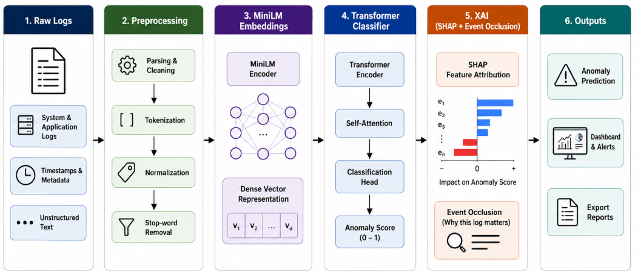
Figure 3.1 Proposed LogMiniLM-XAI framework.

3.2 Dataset Description
The Blue Gene/L (BGL) dataset contains chronologically ordered system logs collected from a large supercomputer environment. Each record includes a raw anomaly label and a structured sequence of operational fields followed by a textual event message. In the final implementation, the parser extracts the raw label, timestamp information, node, source, component, severity, and message text when these fields are available. A raw label of “-” is mapped to the normal class, while any other label is mapped to the anomalous class. [2]
The final preprocessing pipeline produced 4,713,493 usable log records, comprising 4,365,033 normal events and 348,460 anomalous events. After normalization, these records corresponded to 47,012 unique normalized messages. Preserving the original order, the records were grouped into 471,349 non-overlapping windows of ten consecutive events, of which 432,326 were normal and 39,023 were anomalous. BGL is appropriate for this study because it is large, chronologically ordered, strongly imbalanced, line-labeled, and widely used in log-anomaly research. Nevertheless, all detection and explanation conclusions in this thesis are bounded to BGL and the implemented binary ten-event window task.
Table 3.1 BGL dataset and processed study counts.
Property | Value
dataset | Blue Gene/L
processed usable lines | 4,713,493
normal lines | 4,365,033
anomalous lines | 348,460
unique normalized messages | 47,012
window size | 10 events
step size | 10 events
total windows | 471,349
normal windows | 432,326
anomalous windows | 39,023

3.3 Data Preprocessing

3.3.1 Loading and Label Extraction
The BGL file is read sequentially so that the original temporal order is preserved. Each line is split into whitespace-separated fields, and records containing fewer than ten fields are excluded using a deterministic parser rule. File decoding uses an ignore-on-error policy, which prevents interruption by undecodable characters but may omit unsupported byte sequences. A raw label of “-” is mapped to the normal class, while every other raw label is mapped to the anomalous class.

3.3.2 Model-Input Construction and Normalization
The model input is constructed from the source, component, severity, and event-message fields. Structured timestamps, dates, node identifiers, Unix timestamps, and labels are excluded from the model representation to reduce direct shortcut learning. The resulting text is converted to lowercase and normalized using an ordered set of regular expressions. IPv4 addresses, date strings, time strings, hexadecimal values, BGL-like node identifiers occurring inside the text, and standalone integers are replaced by the typed placeholders <ip>, <date>, <time>, <hex>, <node>, and <num>, respectively. Remaining punctuation is converted to spaces and repeated whitespace is collapsed.
The original event message and selected parsed metadata are retained for alert and XAI reporting, while the complete raw-line string is not duplicated in the lightweight metadata artifact. The implementation does not contain a dedicated session-identifier rule, and no such normalization is claimed.

3.3.3 Deterministic Event Mapping, Caching, and Reuse
After normalization, unique normalized texts are sorted and assigned deterministic integer event IDs. Every parsed log line is mapped to its corresponding event ID, and line-level labels are stored separately. This procedure produces 47,012 unique normalized messages, the unique-text vocabulary, line-level event-ID arrays, and line-level label arrays.
Semantic embeddings are generated once for the unique normalized messages and cached. The unique-text table, event IDs, labels, lightweight metadata, and embeddings are saved as reusable artifacts. The implemented cache check validates the number of stored rows against the current vocabulary size; it does not constitute full hash-based validation of the text content, encoder version, or normalization configuration.
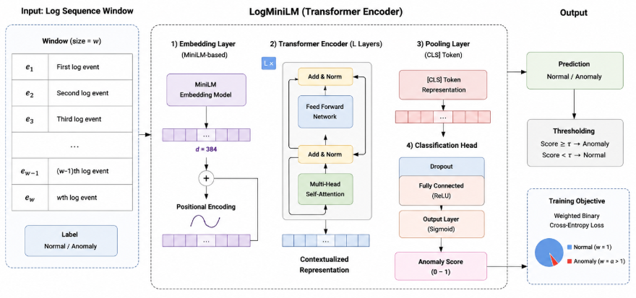
Figure 3.2 Log preprocessing and normalization flow.

3.4 Window Construction and Labeling
The normalized event stream is converted into fixed non-overlapping windows of ten consecutive log events. Let e_i denote the deterministic event ID for the i-th parsed record and l_i ∈ {0,1} its binary line label. Starting at indices 0, 10, 20, and so forth, each complete window is defined as X_s = [e_s, …, e_{s+9}]. The window label is computed as y_s = max(l_s, …, l_{s+9}); therefore, a window is labeled anomalous when at least one of its ten events is anomalous and normal only when all events are normal.
The step size equals the window size, so adjacent windows do not overlap and no log line is shared between them. Partial trailing windows are discarded rather than padded. From 4,713,493 parsed records, this procedure produced 471,349 complete windows, comprising 432,326 normal windows and 39,023 anomalous windows; the final three records were not included because they could not form a complete window. Each sequence is stored together with its inclusive start and end line indices for traceability.
Table 3.2 Final window-construction configuration
Property | Configuration
input unit | Parsed log event
sequence representation | Deterministic event IDs
window size | 10 events
step size | 10 events
overlap | 0
padding | None
partial final window | Discarded
window-label rule | Anomalous if any event is anomalous
total complete windows | 471,349
unused trailing records | 3
.
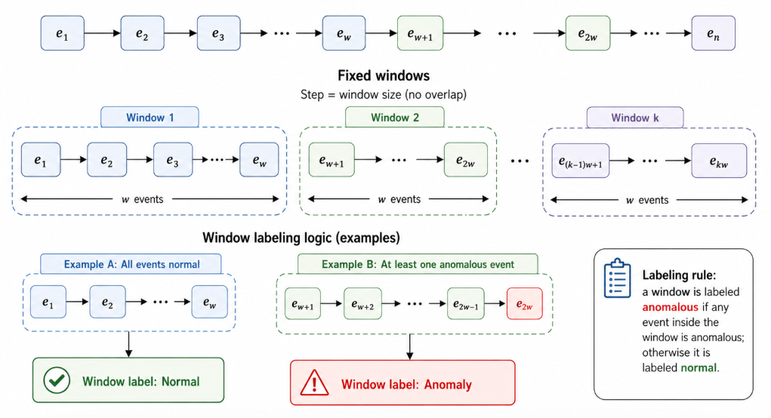
Figure 3.3 Fixed non-overlapping event-window construction.

3.5 Temporal Dataset Split
The complete chronological window stream is split only after window construction. The earliest 80% forms the development partition and the latest 20% forms the held-out test partition. Within the development partition, the earliest 90% is used for classifier training and the latest 10% for validation. No random shuffling is applied before partitioning.
The resulting development partition contains 377,079 windows, of which 339,372 are used during development training and 37,707 for validation. The held-out test partition contains 94,270 windows. Validation data are used for epoch selection and operating-threshold selection. After the best epoch is identified, the classifier is retrained on the full development partition, while the threshold selected from validation is frozen before test evaluation. The test partition remains untouched during model development and is used for final detection reporting and the XAI benchmark.
Class weights are derived without using test information. MiniLM embeddings may be computed and cached for unique normalized messages before classifier training because the encoder is frozen, does not use BGL labels, and is not optimized on the study dataset. Nevertheless, partition boundaries and all supervised model-selection decisions remain strictly chronological.
Table 3.3 Final chronological dataset partitions
Partition | Windows | Purpose
development training | 339,372 | Optimize classifier parameters and monitor development
validation | 37,707 | Select epoch and decision threshold
final retraining partition | 377,079 | Retrain the selected architecture for the chosen number of epochs
held-out test | 94,270 | Final detection and XAI evaluation only
.
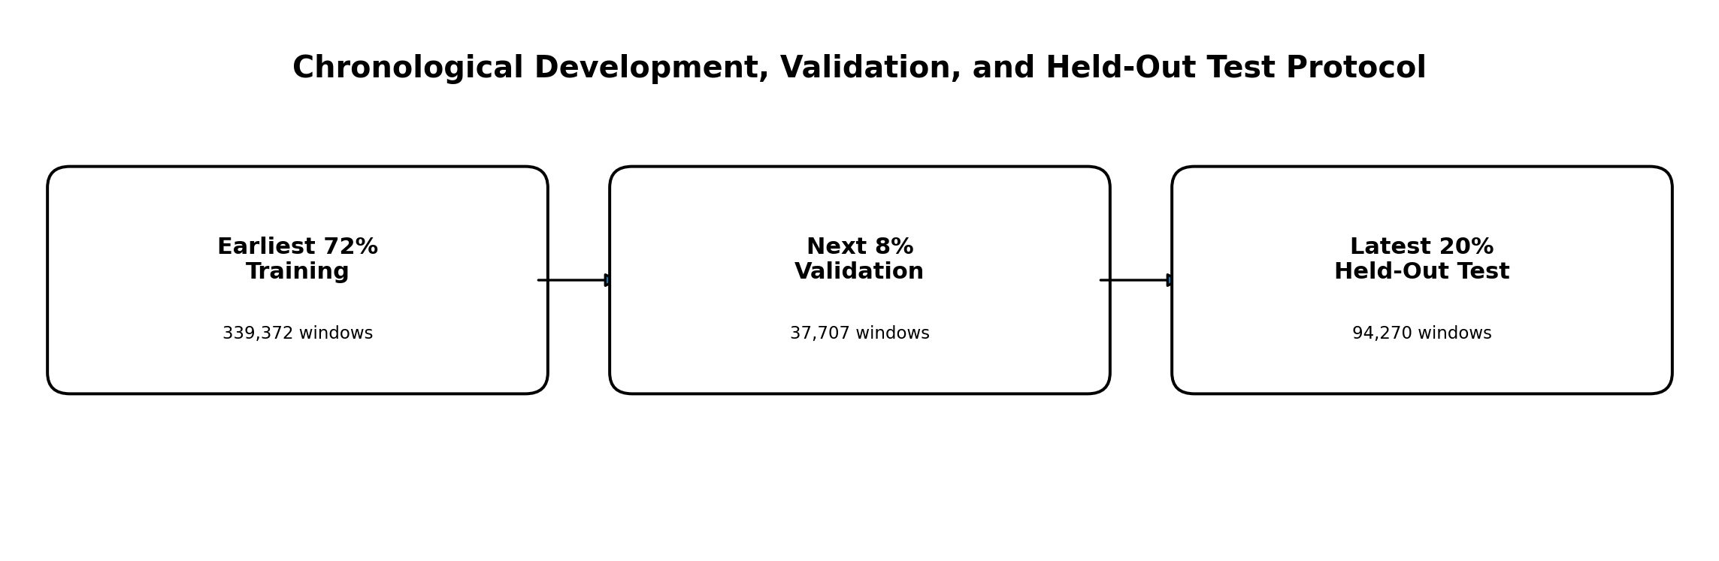
Figure 3.4 Chronological development, validation, and held-out test protocol.

3.6 MiniLM Semantic Encoding
Each unique normalized log message is encoded once using the frozen all-MiniLM-L6-v2 sentence-transformer model. Mean pooling is applied to produce a fixed 384-dimensional semantic embedding for each message. Because identical normalized messages reuse the same vector, only the 47,012 unique normalized messages are encoded, rather than all 4,713,493 parsed lines. [12], [13]
The MiniLM encoder is not fine-tuned on BGL and does not perform anomaly detection. Its role is to produce within-event semantic representations. Window-level anomaly discrimination is learned later by the trainable projection and compact Transformer classifier, which model relationships across event positions.
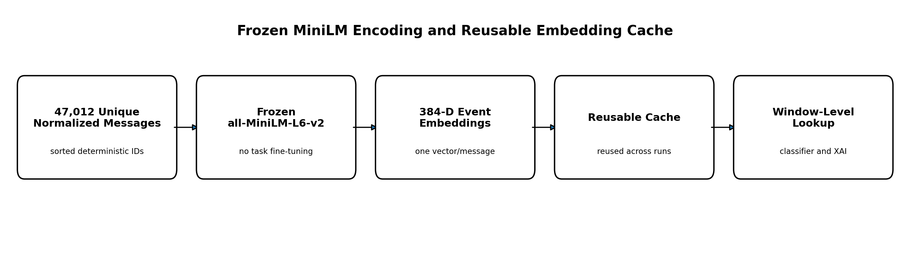
Figure 3.5 Frozen MiniLM event encoding and reusable embedding cache.

3.7 Projection and Positional Representation
A trainable linear projection maps every 384-dimensional MiniLM embedding to a 128-dimensional internal representation. This layer acts as a representation adapter between the frozen semantic encoder and the trainable sequence classifier. It reduces the parameter and memory cost of the subsequent attention and feed-forward operations without claiming to preserve all semantic information.
Learnable positional embeddings are added to the projected event representations so that the classifier can distinguish the ten positions in each window. This is necessary because self-attention alone is permutation-invariant.

3.8 Lightweight Transformer Classifier
The sequence classifier receives ten projected event vectors rather than raw text tokens. It consists of one Transformer encoder layer with two attention heads and a 256-dimensional feed-forward sublayer. Residual connections, layer normalization, and dropout support stable optimization. The architecture models contextual relationships across the ten-event window and does not claim unrestricted long-range sequence modeling.
Mean pooling aggregates the ten event-level outputs into one window representation. A linear classifier then produces the anomaly logit z(X), and the sigmoid function converts this value to the anomaly probability p(X) = 1 / (1 + exp(-z(X))). The complete system contains 18,236,033 parameters, of which 183,425 are trainable because the MiniLM encoder remains frozen.
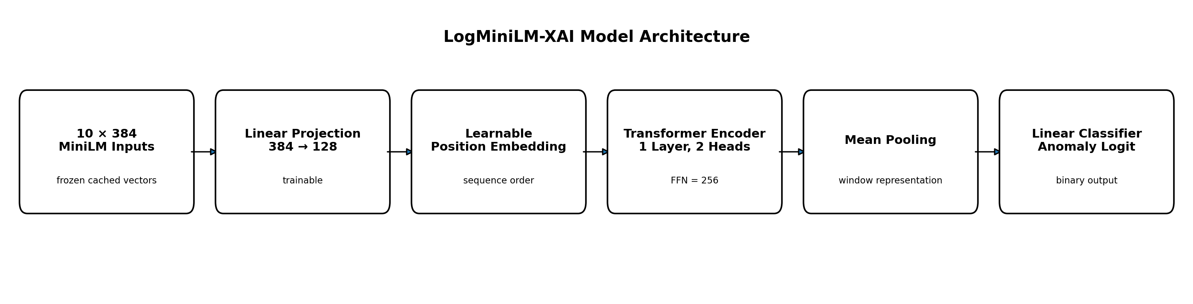
Figure 3.6 LogMiniLM-XAI model architecture.

3.9 Class-Imbalance Handling
Class imbalance is addressed using weighted binary cross-entropy. The anomaly-class weight is derived from the training distribution and multiplied by an anomaly-weight multiplier of 2.0. The resulting loss increases the penalty assigned to misclassified anomalous windows while preserving the original chronological sample order.
No oversampling, undersampling, SMOTE, or synthetic sequence generation is used in the final experiment. This avoids duplicating highly similar windows or introducing synthetic samples that could distort the temporal distribution.

3.10 Training and Model Selection
The trainable projection and Transformer classifier are optimized using AdamW with mini-batches, dropout, fixed random seeds, and class-weighted binary cross-entropy. The frozen MiniLM encoder is excluded from gradient-based updates. Validation F1-score is the primary criterion for selecting the training epoch, with validation loss used only as a tie-breaker. [27]
Epoch 3 yields the highest validation F1-score and is therefore selected. A fresh classifier is then trained for exactly three epochs on the complete development partition. This procedure distinguishes development-time epoch selection from final retraining and avoids selecting the last epoch by default. Fixed seeds improve reproducibility, although exact bitwise determinism is not claimed for all GPU operations.

3.11 Decision-Threshold Selection
The decision threshold is treated as an inference-time parameter rather than a training hyperparameter. A threshold sweep is conducted exclusively on the validation partition after epoch selection. Thresholds from 0.10 to 0.30 produce the same maximum validation F1-score of 0.965767 and identical validation predictions. The selected threshold is 0.20, the tested value closest to the midpoint of this stable plateau.
The threshold is frozen before the held-out test set is accessed and is not modified after observing test results. This maintains test isolation and prevents post-hoc threshold tuning.

3.12 SHAP Explanation Procedure
SHAP is applied after detection as a complementary event-position attribution method. Each of the ten event positions is treated as an interpretable feature, and the explained scalar output is the anomaly logit. Positive attribution values support the anomaly output, whereas negative values oppose it. [9]
The benchmark uses the same 50 held-out test sequences, three replacement baselines, three SHAP repeats, and 300 samples per explanation configuration. Repeated-run comparisons quantify stochastic stability, while cross-baseline comparisons quantify dependence on the replacement reference. SHAP explanations describe model sensitivity and do not identify the true operational cause of an anomaly.

3.13 Event Occlusion Procedure
Event Occlusion is evaluated on the same 50 test sequences and the same three replacement baselines. For event position j, the original embedding is replaced by the selected baseline representation, the anomaly logit is recomputed, and the signed attribution is calculated as a_j = z(X) - z(X_masked(j)). A positive value means that replacing the event reduced the anomaly evidence, while a negative value means that replacement increased it. [4], [16]
Each event position is perturbed separately without retraining the model. Event Occlusion is deterministic for a fixed model, input, inference mode, and baseline. It therefore provides a direct model-sensitivity measure, but it is not interpreted as causal root-cause evidence.

3.14 Unified Explanation Evaluation
The objective of the unified benchmark is not to determine which explanation method is universally superior, but to compare SHAP and Event Occlusion under an identical protocol. Both methods use the same classifier, held-out cases, replacement baselines, top-k values, and evaluation measures.
Faithfulness is assessed using comprehensiveness, sufficiency gap, and decision-flip evidence. Repeated-run top-k overlap measures stochastic stability. Cross-baseline top-k overlap and Spearman rank correlation measure replacement-baseline robustness. Attribution concentration summarizes how strongly importance is focused on the highest-ranked event positions. Cross-method agreement is descriptive and does not establish correctness. Runtime measures the mean time required to explain one sequence and excludes the one-time cached MiniLM embedding stage.
A five-percent practical-comparability rule is applied to the central faithfulness measures. When the relative difference between SHAP and Event Occlusion remains below this threshold, the methods are treated as practically comparable in faithfulness, and the final operational recommendation is based on stability, robustness, and computational efficiency.
Table 3.4 Unified XAI benchmark measures
Measure | Definition | Interpretation
comprehensiveness | Logit reduction after replacing top-k events | Higher positive values indicate stronger support for the original anomaly output
sufficiency gap | Absolute logit gap when only top-k events are retained | Lower values indicate that the selected events preserve more of the original decision
decision flip | Whether top-k replacement changes the predicted class | Supporting perturbation evidence
repeat stability | Top-k overlap across repeated explanations | Higher is better
baseline robustness | Top-k overlap and Spearman agreement across baselines | Higher is better
concentration | Top-k absolute attribution mass divided by total mass | Descriptive focus measure
cross-method agreement | Similarity between SHAP and Occlusion rankings | Descriptive only
runtime | Mean explanation time per sequence | Lower is better
.
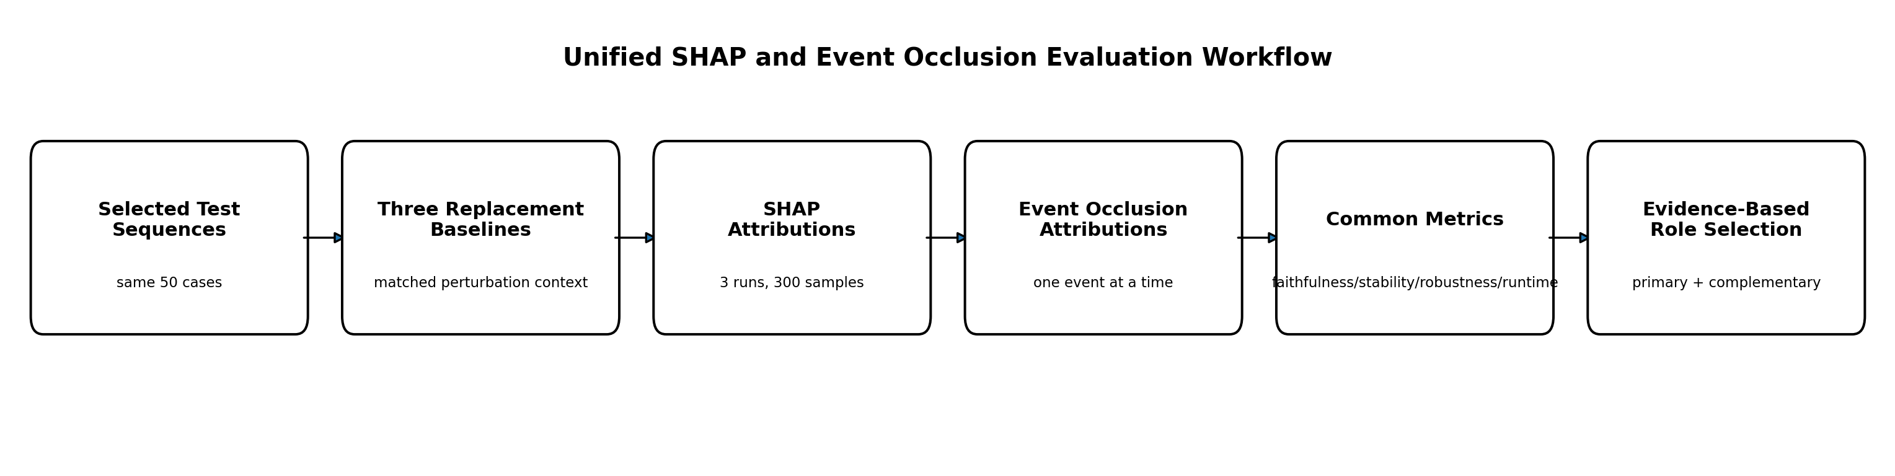
Figure 3.7 Unified SHAP and Event Occlusion evaluation workflow.

3.15 Final Experimental Configuration
Table 3.5 Final experimental configuration.
Component | Final Configuration
dataset | BGL system logs
processed usable lines | 4,713,493
unique normalized messages | 47,012
window method | Fixed, non-overlapping
window size / step | 10 / 10
semantic encoder | sentence-transformers/all-MiniLM-L6-v2
encoder status | Frozen
semantic embedding dimension | 384
projection dimension | 128
positional representation | Learnable positional embeddings
transformer encoder layers | 1
attention heads | 2
feed-forward dimension | 256
pooling | Mean pooling
trainable parameters | 183,425
optimizer | AdamW
loss | Weighted binary cross-entropy
anomaly-weight multiplier | 2.0
selected epoch | 3
threshold selection | Validation sweep only
selected threshold | 0.20
xai methods | SHAP and Event Occlusion
xai sample | 50 held-out test sequences
replacement baselines | 3
shap repeats | 3
shap samples | 300 per explanation configuration

3.16 Algorithms

Algorithm 1: Detection Pipeline
- Read BGL records sequentially and extract structured fields and binary labels.
- Construct the model text from source, component, severity, and event message.
- Apply the ordered normalization rules and retain original messages and selected metadata.
- Assign deterministic event IDs to sorted unique normalized messages.
- Construct fixed non-overlapping ten-event windows and derive any-anomaly labels.
- Split the window stream chronologically into development and held-out test partitions.
- Encode unique normalized messages once using frozen MiniLM and cache the embeddings.
- Project the embeddings, add positional representations, and apply the compact Transformer classifier.
- Apply the frozen operating threshold to generate final predictions.

Algorithm 2: Training and Selection Pipeline
- Divide the development partition chronologically into training and validation subsets.
- Calculate class weighting from development training data only.
- Train the projection and Transformer classifier with AdamW and weighted binary cross-entropy.
- Select the best epoch using validation F1-score, with validation loss as a tie-breaker.
- Retrain a fresh classifier for the selected number of epochs on the complete development partition.
- Sweep thresholds on validation outputs only and select the representative midpoint of the best-F1 plateau.
- Freeze the model configuration, selected epoch, and decision threshold before test evaluation.

Algorithm 3: XAI Evaluation Pipeline
- Select the common benchmark sequences from the held-out test partition.
- Compute each sequence’s original anomaly logit.
- Generate SHAP event-position attributions using the defined repeats, baselines, and sample budget.
- Generate Event Occlusion attributions by replacing one event position at a time.
- Compute faithfulness, stability, baseline robustness, concentration, agreement, and runtime.
- Apply the practical-comparability rule to the central faithfulness measures.
- Store operator-readable reports using the original event messages and selected metadata.

3.17 Chapter Summary
This chapter presented the complete LogMiniLM-XAI methodology. The first contribution is operationalized through frozen MiniLM event representations, a trainable 384-to-128 projection, and a compact one-layer Transformer classifier. The second contribution is implemented through deterministic preprocessing, fixed non-overlapping ten-event windows, chronological development and test separation, validation-based epoch and threshold selection, and strict held-out testing. The third contribution is implemented through a unified event-position benchmark that compares SHAP and Event Occlusion on identical cases and baselines using faithfulness, stability, robustness, concentration, agreement, and runtime.
The methodology therefore defines a single reproducible path from raw BGL logs to anomaly predictions, model-decision explanations, and saved experimental artifacts. Chapter 4 reports the resulting detection performance and XAI benchmark outcomes, evaluates the evidence supporting the three contributions, and discusses the limitations and implications of the completed study.

Chapter 4: Experimental Results, Discussion, Conclusion, and Future Work

4.1 Introduction
This chapter presents the empirical evidence generated by the completed LogMiniLM-XAI study. It first reports the finalized data partitions and implementation configuration, then documents the validation evidence used to select the training epoch and operating threshold. The held-out chronological BGL test results are subsequently presented using the confusion matrix, threshold-dependent classification metrics, and ranking metrics.
The chapter then distinguishes direct, reimplemented contextual, and published contextual comparisons, evaluates SHAP and Event Occlusion under a common event-level benchmark, and interprets the findings through the three thesis contributions. The discussion answers the research questions, identifies threats to validity, and closes the four-chapter thesis with a bounded conclusion and future-work agenda. Published results are treated contextually unless the full experimental protocol is equivalent, and explanation results are interpreted as evidence about model sensitivity rather than causal operational root cause.

4.2 Experimental Setup
The final experiment uses 471,349 fixed non-overlapping windows created from the chronologically ordered BGL stream. The earliest 80% forms the development partition and the latest 20% forms the held-out test partition. The development partition contains 377,079 windows; its earliest 339,372 windows are used for development training and its latest 37,707 windows for validation. The held-out test partition contains 94,270 windows.
Table 4.1 Final chronological dataset partitions
Partition | Total Windows | Normal | Anomalous | Purpose
development training | 339,372 | Not separately exported | Not separately exported | Parameter optimization
validation | 37,707 | Not separately exported | Not separately exported | Epoch and threshold selection
final retraining partition | 377,079 | 343,721 | 33,358 | Fresh retraining for selected epoch count
held-out test | 94,270 | 88,605 | 5,665 | Final evaluation only
.
The final architecture uses frozen 384-dimensional all-MiniLM-L6-v2 event embeddings, a trainable 128-dimensional projection, one Transformer encoder layer, two attention heads, a 256-dimensional feed-forward sublayer, learnable positional embeddings, mean pooling, and a linear binary classifier. The full system contains 18,236,033 parameters, of which 183,425 are trainable.
Table 4.2 Final model and evaluation configuration.
Component | Final Value
semantic encoder | all-MiniLM-L6-v2, frozen
semantic embedding dimension | 384
projection dimension | 128
transformer encoder layers | 1
attention heads | 2
feed-forward dimension | 256
pooling | Mean pooling
Trainable parameters | 183,425
total parameters | 18,236,033
loss | Weighted binary cross-entropy
anomaly-weight multiplier | 2.0
selected epoch | 3
selected threshold | 0.20

Only settings verified by the final notebook or saved artifacts are reported. The thesis does not infer unrecorded hardware, package versions, learning-rate values, batch size, or other optimizer details.

4.3 Development Results

4.3.1 Preprocessing and Caching
Preprocessing produced 47,012 unique normalized messages from 4,713,493 usable log records. These unique messages were encoded once using frozen MiniLM and stored in a reusable cache. This reduced repeated semantic-encoder inference during classifier retraining and the explanation experiments. The cache check in the implementation validates the stored row count against the current vocabulary size; it does not provide full content- or configuration-hash validation.

4.3.2 Final Window Configuration
The final configuration uses windows of ten events with a step of ten. Adjacent samples therefore do not share raw log lines. This preserves local event order, reduces duplicated neighboring samples, lowers overlap-related leakage risk, and reduces computational cost. The ten-event configuration is the final implemented design; it is not claimed to be universally optimal because alternative window sizes and time-based windows were not included in the final controlled study.

4.3.3 Imbalance Handling and Epoch Selection
Class imbalance is handled during training using weighted binary cross-entropy. The anomaly-class weight is derived without test information and is multiplied by an anomaly-weight multiplier of 2.0. Validation F1-score is the primary epoch-selection criterion. Epoch 3 achieved the strongest validation result and was therefore selected. A fresh classifier was then retrained for exactly three epochs on the complete 377,079-window development partition.

4.3.4 Threshold Selection
After epoch selection, a decision-threshold sweep was conducted using validation outputs only. Thresholds from 0.10 to 0.30 produced identical validation predictions and the same maximum validation F1-score of 0.965767. Threshold 0.20 was selected as the tested value closest to the midpoint of this stable plateau. It was frozen before held-out test evaluation and was not adjusted after observing test results. This procedure is decision-threshold selection rather than probability calibration.
Table 4.3 Validation threshold plateau and final selection.
Threshold Range | Precision | Recall | F1-score | Decision
0.10-0.30 | 1.000000 | 0.9338 | 0.965767 | Equal maximum plateau
0.20 | 1.000000 | 0.9338 | 0.965767 | Selected midpoint representative

4.4 Final Test Performance
The frozen operating configuration was evaluated once on the latest 94,270 chronological BGL windows. The confusion matrix contains 88,560 true negatives, 45 false positives, 104 false negatives, and 5,561 true positives. These counts are the authoritative threshold-dependent test evidence.
Table 4.4 Confusion matrix on the held-out chronological BGL test partition.
Actual / Predicted | Normal | Anomalous | Total
normal | 88,560 (TN) | 45 (FP) | 88,605
anomalous | 104 (FN) | 5,561 (TP) | 5,665
total | 88,664 | 5,606 | 94,270

Table 4.5 Final held-out detection results.
Metric | Final Value
accuracy | 0.998419
precision | 0.991973
recall | 0.981642
f1-score | 0.986780
roc-auc | 0.999309
average precision (pr summary) | 0.992511
selected threshold | 0.20

The precision of 0.991973 indicates that most predicted anomaly windows were correct, while the recall of 0.981642 shows that most anomalous windows were detected. The model nevertheless produced 45 false positives and missed 104 anomalous windows. These errors remain important limitations despite the strong aggregate score. Accuracy is reported for completeness, while F1-score and Average Precision provide more informative positive-class summaries under the imbalanced test distribution. ROC-AUC and Average Precision are ranking metrics derived from saved probability outputs and cannot be reconstructed from the thresholded confusion matrix alone.

4.5 Comparison with Baselines and Related Studies
Comparison claims are divided into three evidence tiers. Tier 1 contains direct comparisons executed under the same preprocessing, windowing, label rule, chronological split, threshold policy, and metric definitions. Tier 2 contains locally reimplemented methods with material protocol differences. Tier 3 contains published results reported under study-specific protocols. Numerical superiority claims are permitted only for Tier 1.
Table 4.6 Comparison tiers used in this thesis.
Tier | Definition | Allowed Interpretation
tier 1 - direct | Same final BGL protocol and metrics | Numerical comparison allowed
tier 2 - reimplemented contextual | Local implementation with material protocol differences | Contextual interpretation only
tier 3 - published contextual | Original study values under study-specific protocols | No direct superiority claim

The final Chapter 4 evidence does not contain a verified direct comparison table for the earlier LSTM, Transformer-classifier, or LogBERT-style experiments under the complete final protocol. Accordingly, unsupported placeholder rows are omitted from this reviewed version. LAnoBERT, LogGPT, LogFormer, and other published methods remain contextual references because their preprocessing, objectives, sequence construction, supervision, thresholds, or test protocols differ. [5], [6], [10]
The strongest current empirical statement is that LogMiniLM-XAI achieved F1 = 0.986780 on the held-out chronological BGL test partition under the documented protocol. The result supports the integrated framework and does not isolate the causal contribution of MiniLM, the projection layer, the compact Transformer, class weighting, or the ten-event window. Matched ablation evidence would be required for such component-level conclusions.
Table 4.7 positions the proposed framework against representative BGL results reported in the original studies. The values are reproduced for contextual positioning only because the studies use materially different anomaly units, supervision settings, sequence lengths, preprocessing procedures, split policies, and threshold-selection rules. [5], [6], [10].
Table 4.7 Contextual comparison with representative published BGL studies.
Study | Year | BGL Setting | Precision | Recall | F1 | Other Metric | Comparison Status
lanobert [5] | 2023 | Parser-free, unsupervised MLM; test-optimized F1 threshold | Not reported | Not reported | 0.8749 | AUROC 0.9721 | Tier 3 contextual
logformer [6] | 2024 | 20-log non-overlapping windows; supervised source-domain model | 0.9600 | 0.9700 | 0.9700 | Not reported | Tier 3 contextual
logsd [10] | 2024 | 100-log windows; self-supervised/semi-supervised protocol | 0.9600 | 0.9664 | 0.9627 | PRC 0.9716 | Tier 3 contextual
logminilm-xai | Current | 10-log non-overlapping windows; chronological held-out test | 0.9920 | 0.9816 | 0.9868 | AP 0.9925 | Current study
Note: Published values are shown for contextual positioning and do not establish direct numerical superiority. LAnoBERT reports its best test-set F1 threshold under an unsupervised protocol; LogFormer uses 20-log sequences and source-domain supervised training; LogSD uses 100-log windows and a different self-supervised evaluation design. These settings are not equivalent to the validation-selected, chronological ten-event protocol used by LogMiniLM-XAI.
The reported values were verified against the original publications: LAnoBERT Table 4, LogFormer Table 2, and LogSD Table 2. The comparison is therefore traceable to primary sources while remaining explicitly contextual.

4.6 Explainability Results

4.6.1 Common Benchmark Conditions
SHAP and Event Occlusion were evaluated using the same trained classifier, the same 50 held-out test sequences, the same three replacement baselines, and the same event-position interpretation unit. SHAP used three repetitions and 300 samples per explanation configuration. Event Occlusion replaced one event position at a time and recomputed the anomaly logit.

4.6.2 Faithfulness
SHAP achieved mean top-3 comprehensiveness of 0.465982 and mean top-3 sufficiency gap of 0.419759. Event Occlusion achieved corresponding values of 0.458191 and 0.422976. The symmetric relative differences are 1.686% for comprehensiveness and 0.763% for sufficiency gap, both below the predefined 5% practical-comparability boundary.
The approved interpretation is therefore that SHAP and Event Occlusion demonstrated practically comparable central faithfulness under the completed benchmark. SHAP is marginally stronger numerically on both central measures, but the differences are not treated as practically meaningful.

4.6.3 Stability and Replacement-Baseline Robustness
Event Occlusion achieved repeated-run top-3 stability of 1.000000, compared with 0.482222 for SHAP. Perfect repeated-run stability is expected for deterministic Occlusion under fixed model, input, inference, and baseline conditions. Cross-baseline robustness provides the stronger discriminator: Event Occlusion achieved top-3 robustness of 0.796667 and Spearman robustness of 0.720812, compared with 0.466667 and 0.234099 for SHAP.
SHAP’s lower repeated-run stability is specific to the implemented Kernel SHAP sampling budget and is not generalized to all SHAP variants or parameter settings.

4.6.4 Comparative XAI Decision
Table 4.8 SHAP versus Event Occlusion benchmark results.
Criterion | Event Occlusion | SHAP | Interpretation
comprehensiveness (k=3) | 0.458191 | 0.465982 | Practically comparable
sufficiency gap (k=3) | 0.422976 | 0.419759 | Practically comparable
repeat top-3 stability | 1.000000 | 0.482222 | Occlusion stronger
baseline top-3 robustness | 0.796667 | 0.466667 | Occlusion stronger
baseline spearman robustness | 0.720812 | 0.234099 | Occlusion stronger
runtime per sequence | 0.036889 s | 0.766334 s | Occlusion faster
selected role | Primary | Complementary | Evidence-based assignment
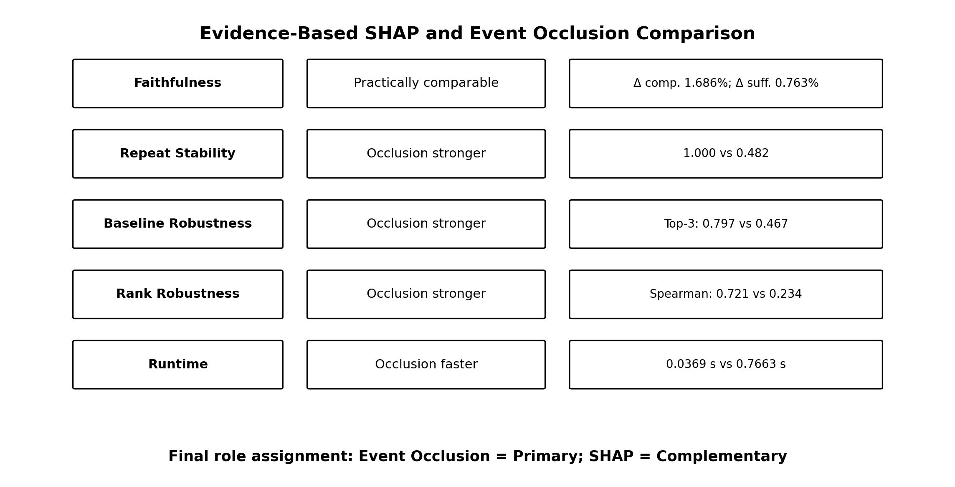
Figure 4.1 Evidence-based SHAP and Event Occlusion comparison.

4.7 Computational Efficiency
MiniLM embedding extraction is a one-time cacheable preprocessing cost over 47,012 unique normalized messages. During classifier training and explanation benchmarking, the frozen semantic representations are reused. Only 183,425 classifier parameters are trainable.
Event Occlusion requires an average of 0.036889 seconds per explained sequence, whereas SHAP requires 0.766334 seconds. SHAP is therefore approximately 20.77 times slower in the completed benchmark. This ratio applies only to the implemented explanation configurations and excludes the cached MiniLM embedding stage.
Table 4.9 Computational-efficiency evidence.
Stage or Method | Execution Mode | Measured Value | Interpretation
minilm embedding extraction | One-time, cacheable | 47,012 unique messages | Front-loaded cost
trainable classifier | Development training | 183,425 parameters | Compact trainable head
event occlusion | Per explained sequence | 0.036889 s | Primary method
shap | Per explained sequence | 0.766334 s | Complementary method

4.8 Discussion

4.8.1 Contribution 1: Lightweight Semantic Transformer
The held-out results support the effectiveness of the integrated lightweight semantic detector. Frozen MiniLM provides reusable event-level semantic representations, while the trainable projection and compact Transformer model relationships across the ten-event window. The final classifier achieved F1 = 0.986780 with only 183,425 trainable parameters. This supports the practical value of the integrated design, but no matched ablation isolates the independent causal contribution of MiniLM, the projection layer, or the Transformer.

4.8.2 Contribution 2: Reproducible Chronological Protocol
The study preserved chronological order, constructed deterministic non-overlapping windows, separated development from the latest held-out test period, selected Epoch 3 and threshold 0.20 using validation evidence only, and froze all supervised decisions before test reporting. This provides a transparent leakage-resistant evaluation chain. The selected threshold should be understood as a stable validation operating point rather than a universally optimal probability cutoff.

4.8.3 Contribution 3: Unified Event-Level XAI Benchmark
The benchmark produced a mixed but actionable result. SHAP was marginally stronger on the two central raw faithfulness measures, but the differences remained below the 5% practical boundary. Event Occlusion was substantially more stable, more robust across replacement baselines, and faster. Event Occlusion is therefore selected as the primary explanation method and SHAP is retained as a complementary attribution perspective.
This recommendation is stronger than selecting one method by convention because it is tied to an explicit common protocol. Nevertheless, both methods explain sensitivity of the trained anomaly logit to event-position perturbations and do not establish operational root cause.

4.8.4 Answers to the Research Questions
RQ1: LogMiniLM-XAI achieved 0.991973 precision, 0.981642 recall, 0.986780 F1-score, 0.999309 ROC-AUC, and 0.992511 Average Precision on the held-out chronological BGL test partition, with 45 false positives and 104 false negatives.
RQ2: The integrated classifier using frozen 384-dimensional MiniLM event embeddings, a 128-dimensional projection, and a compact Transformer achieved strong held-out performance with only 183,425 trainable parameters. This supports MiniLM’s usefulness within the pipeline but does not isolate its independent causal contribution.
RQ3: The protocol preserved chronology, used deterministic non-overlapping windows, derived model-development decisions from development data only, selected Epoch 3 and threshold 0.20 on validation evidence, and reserved the latest 20% for held-out testing.
RQ4: Both SHAP and Event Occlusion generated event-position attribution rankings tied to the anomaly logit. They identify influential event positions under the defined perturbation procedures but do not establish the true operational cause.
RQ5: The two methods were practically comparable on central faithfulness. Event Occlusion was more stable, more robust across replacement baselines, and approximately 20.8 times faster, supporting its role as the primary explanation method.

4.9 Limitations and Threats to Validity

4.9.1 Internal Validity
- The final score reflects an integrated pipeline; no matched ablation isolates each component.
- Threshold selection depends on the validation partition.
- Event replacement may create uncommon or semantically artificial sequences.
- Kernel SHAP results depend on the implemented sampling budget.
- Cache validation checks row count rather than a complete text/configuration hash.

4.9.2 Construct Validity
- A window is labeled anomalous when at least one event is anomalous, so many events in an anomalous window may still be normal.
- Comprehensiveness and sufficiency measure faithfulness to model output, not operational causality.
- Event-position attribution is a proxy for explanation quality.
- Average Precision is the numerical Precision-Recall summary and should not be confused with trapezoidal PR-AUC.

4.9.3 External Validity
- The empirical evaluation uses BGL only.
- Results may not generalize to HDFS, Thunderbird, enterprise logs, streaming systems, or changing environments.
- The fixed ten-event, non-overlapping window may not suit other systems.
- No cross-domain adaptation or concept-drift experiment was completed.
- The XAI benchmark uses 50 selected test sequences and three replacement baselines.

4.9.4 Conclusion Validity
- Published-study values remain contextual because protocols differ.
- No universal superiority claim is supported.
- Repeated end-to-end training runs and confidence intervals were not reported.
- Runtime values are environment-specific and apply only to the completed benchmark.

4.9.5 Operational Validity
- No controlled operator study was performed.
- Explanations were not tested for investigation-time reduction, trust, or decision quality.
- The framework does not perform multi-source root-cause analysis using metrics, traces, topology, or service dependencies.

4.10 Conclusion
This thesis addressed the problem of combining accurate system-log anomaly detection with computationally practical and objectively evaluated explanations. LogMiniLM-XAI integrates deterministic BGL preprocessing, fixed non-overlapping ten-event windows, frozen MiniLM event representations, a trainable 384-to-128 projection, and a compact one-layer Transformer classifier under a chronological development and held-out testing protocol.
On the held-out chronological BGL test partition, the framework achieved 0.991973 precision, 0.981642 recall, 0.986780 F1-score, 0.999309 ROC-AUC, and 0.992511 Average Precision, with 45 false positives and 104 false negatives. The classifier contained only 183,425 trainable parameters because MiniLM remained frozen and its semantic representations were cached.
The explainability contribution was evaluated through a controlled comparison rather than the untested adoption of a single explainer. SHAP and Event Occlusion demonstrated practically comparable central faithfulness. Event Occlusion was more stable, more robust across replacement baselines, and approximately 20.8 times faster in the completed benchmark. It was therefore selected as the primary explanation method, while SHAP was retained as a complementary attribution method.
The study contributes: (1) a lightweight semantic Transformer framework for sequence-level log anomaly detection; (2) a reproducible chronological evaluation protocol with validation-only epoch and threshold selection; and (3) a unified event-level XAI benchmark using common cases, baselines, and evaluation measures. The conclusions are limited to BGL, the implemented binary ten-event task, the final chronological protocol, and the 50-sequence explanation benchmark. The study demonstrates that strong held-out anomaly-detection performance can be combined with compact trainable modeling and explicit evaluation of explanation quality while preserving a clear boundary between model-decision explanation and operational root-cause analysis.

4.11 Future Work
- Validate the complete protocol on HDFS, Thunderbird, enterprise application logs, and multiple systems.
- Repeat end-to-end training with multiple seeds and report confidence intervals.
- Conduct matched ablations for MiniLM, the projection layer, Transformer versus LSTM, class weighting, and window size.
- Evaluate alternative event-count windows, time-based windows, adaptive segmentation, and controlled overlap.
- Adapt or fine-tune the semantic encoder using log-domain or contrastive objectives.
- Expand the XAI benchmark to larger stratified samples, additional replacement baselines, grouped-event Occlusion, and faster SHAP approximations.
- Evaluate uncertainty-aware explanations and interaction effects between event positions.
- Conduct controlled operator studies measuring trust, investigation time, and alert-triage usefulness.
- Integrate logs with metrics, traces, topology, and service dependencies to support multi-source root-cause analysis.
- Investigate concept-drift monitoring, cross-domain transfer, and deployment-time threshold adaptation.

4.12 Chapter Summary
This chapter reported the completed LogMiniLM-XAI evidence and closed the four-chapter thesis. The framework achieved F1 = 0.986780 on the held-out chronological BGL test partition. SHAP and Event Occlusion were practically comparable in central faithfulness, while Event Occlusion was more stable, more robust across replacement baselines, and substantially more efficient; it was therefore selected as the primary explanation method. The findings support the three bounded contributions of a lightweight semantic detector, a reproducible chronological protocol, and a unified event-level XAI benchmark, while remaining limited to BGL, the implemented final protocol, and the completed explanation sample.

References
[1] X. Ma et al., “Practitioners’ expectations on log anomaly detection,” IEEE Transactions on Software Engineering, 2025.
[2] A. Oliner and J. Stearley, “What supercomputers say: A study of five system logs,” in Proceedings of the IEEE International Conference on Dependable Systems and Networks, pp. 575–584, 2007.
[3] V. Chandola, A. Banerjee, and V. Kumar, “Anomaly detection: A survey,” ACM Computing Surveys, vol. 41, no. 3, Art. no. 15, 2009, doi: 10.1145/1541880.1541882.
[4] X. Wang, K. J. Kim, Y. Wang, T. Koike-Akino, and K. Parsons, “DeepEAD: Explainable anomaly detection from system logs,” Mitsubishi Electric Research Laboratories, Tech. Rep., 2023.
[5] Y. Lee, J. Kim, and P. Kang, “LAnoBERT: System log anomaly detection based on BERT masked language model,” Applied Soft Computing, vol. 146, Art. no. 110689, 2023, doi: 10.1016/j.asoc.2023.110689.
[6] H. Guo et al., “LogFormer: A pre-train and tuning pipeline for log anomaly detection,” in Proceedings of the AAAI Conference on Artificial Intelligence, vol. 38, no. 1, pp. 135–143, 2024, doi: 10.1609/aaai.v38i1.27764.
[7] W. Guan et al., “LogLLM: Log-based anomaly detection using large language models,” arXiv:2411.08561, 2024.
[8] Z. Zhang, S. Li, L. Zhang, J. Ye, C. Hu, and L. Yan, “LLM-LADE: Large language model-based log anomaly detection with explanation,” Knowledge-Based Systems, vol. 326, Art. no. 114064, 2025, doi: 10.1016/j.knosys.2025.114064.
[9] S. M. Lundberg and S.-I. Lee, “A unified approach to interpreting model predictions,” Advances in Neural Information Processing Systems, vol. 30, 2017.
[10] Y. Xie, H. Zhang, and M. A. Babar, “LogSD: Detecting anomalies from system logs through self-supervised learning and frequency-based masking,” ACM Transactions on Software Engineering and Methodology, 2024.
[11] A. Vaswani et al., “Attention is all you need,” in Advances in Neural Information Processing Systems, vol. 30, 2017.
[12] W. Wang, F. Wei, L. Dong, H. Bao, N. Yang, and M. Zhou, “MiniLM: Deep self-attention distillation for task-agnostic compression of pre-trained Transformers,” arXiv:2002.10957, 2020.
[13] N. Reimers and I. Gurevych, “Sentence-BERT: Sentence embeddings using Siamese BERT-networks,” in Proceedings of EMNLP-IJCNLP, pp. 3982–3992, 2019.
[14] J. Davis and M. Goadrich, “The relationship between Precision-Recall and ROC curves,” in Proceedings of ICML, pp. 233–240, 2006.
[15] T. Saito and M. Rehmsmeier, “The precision-recall plot is more informative than the ROC plot when evaluating binary classifiers,” PLOS ONE, vol. 10, no. 3, Art. no. e0118432, 2015.
[16] M. T. Ribeiro, S. Singh, and C. Guestrin, “Why should I trust you? Explaining the predictions of any classifier,” in Proceedings of ACM SIGKDD, pp. 1135–1144, 2016.
[17] Y. Yamanaka, T. Takahashi, T. Minami, and Y. Nakajima, “LogELECTRA: Self-supervised anomaly detection for unstructured logs,” arXiv:2402.10397, 2024.
[18] P. Pospieszny, W. Mormul, K. Szyndler, and S. Kumar, “ADALog: Adaptive unsupervised anomaly detection in logs with self-attention masked language model,” arXiv:2505.13496, 2025.
[19] Y. Duan et al., “LogEDL: Log anomaly detection via evidential deep learning,” Applied Sciences, vol. 14, no. 16, Art. no. 7055, 2024, doi: 10.3390/app14167055.
[20] P. Wang, X. Zhang, Z. Cao, W. Xu, and W. Li, “LogGT: Cross-system log anomaly detection via heterogeneous graph feature and transfer learning,” Expert Systems with Applications, vol. 251, Art. no. 124082, 2024, doi: 10.1016/j.eswa.2024.124082.
[21] K. Gong et al., “LogETA: Time-aware cross-system log-based anomaly detection with inter-class boundary optimization,” Future Generation Computer Systems, vol. 157, pp. 16–28, 2024, doi: 10.1016/j.future.2024.03.028.
[22] “ELFA-Log: Cross-system log anomaly detection via enhanced pseudo-labeling and feature alignment,” Computers, vol. 14, no. 7, Art. no. 272, 2025, doi: 10.3390/computers14070272.
[23] Z. Yang and I. G. Harris, “LogLLaMA: Transformer-based log anomaly detection with LLaMA,” arXiv:2503.14849, 2025.
[24] X. Li et al., “AnomalyGen: An automated semantic log sequence generation framework with LLM for anomaly detection,” arXiv:2504.12250, 2025, doi: 10.48550/arXiv.2504.12250.
[25] A. Techaviseschai, S. Tarnpradab, V. C. Barroso, and P. Phunchongharn, “A real-time semi-supervised log anomaly detection framework for ALICE O² facilities,” Applied Sciences, vol. 15, no. 11, Art. no. 5901, 2025, doi: 10.3390/app15115901.
[26] J. Lu and C. Wu, “TPLogAD: Unsupervised log anomaly detection based on event templates and key parameters,” arXiv:2411.15250, 2024.
[27] I. Loshchilov and F. Hutter, “Decoupled weight decay regularization,” in International Conference on Learning Representations, 2019.

