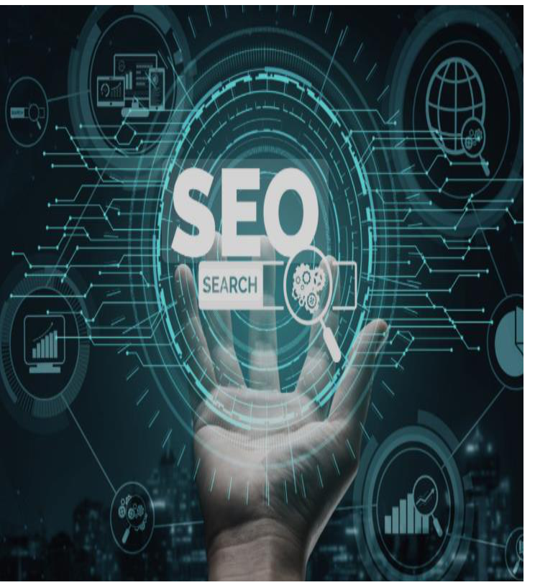SEO & Marketing Icons

Student Name : Abdulaziz Ahmed Al-Amoud

University Number : 221002412

Date : 2024-11- 02

Introduction

In today's digital age, search engines have become the primary tool for accessing information, services, and products. SEO (Search Engine Optimization) is a key strategy in digital marketing that helps businesses improve their visibility in search results, enhancing customer experience and ultimately boosting profits . The essential components of SEO include elements like titles, meta descriptions, keywords, and both internal and external links, all of which contribute to the content's effectiveness. This research aims to explore how these SEO components play a crucial role in achieving the digital goals they were designed to support

Background study

Search engine optimization (SEO) may not be a new concept, but its importance has grown significantly as more people rely on the Internet to search for products and services. Statistics show that around 75% of users never go beyond the first page of search results, making it crucial for websites to appear at the top. As a result, both large and small businesses depend on SEO strategies to strengthen their online presence. Research indicates that both technical and creative factors— such as optimizing icon design and crafting relevant content—are key to improving site rankings and attracting more visitors.

The importance of studying

The importance of this study lies in the need to better understand SEO strategies and how they contribute to the success of digital marketing. The goal of this research is to offer valuable insights and tools that can help business owners and marketers create sustainable strategies. These strategies aim to achieve concrete results, such as boosting revenue, improving customer experience, and strengthening a company’s digital presence in an increasingly competitive and fast-changing environment.

Studying the problem

Despite the crucial role SEO icons play, many companies struggle with implementing effective strategies to boost their online visibility. Common challenges include selecting the right keywords, crafting meta descriptions in an engaging way, and designing content that aligns with search engine standards. As a result, businesses need a deeper and more precise understanding of how to use these SEO elements effectively to ensure success in digital marketing and achieve their goals.

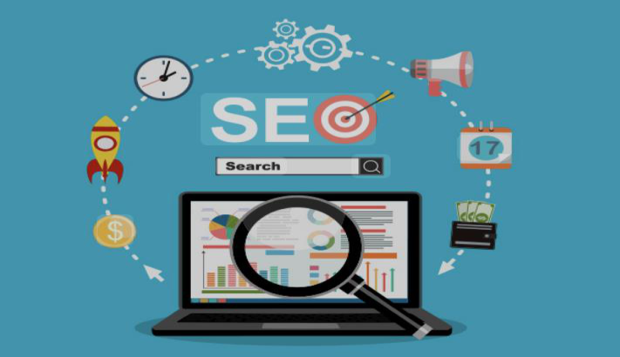The questions of this study revolve around the main aspects related to search engine optimization and its impact on digital marketing, and include the following:

What are the basic SEO icons that play a big role in improving the appearance of sites within search results?

How do these icons contribute to achieving corporate goals in the field of digital marketing?

What are the most prominent challenges that companies face when applying search engine optimization strategies?

Scientific significance:

This study helps promote academic understanding of how search engine optimization (SEO) icons affect digital marketing strategies. It provides a scientific framework that illustrates the impact of basic elements such as keywords and titles on the ranking of sites in search engines, which opens the way for further research in this sophisticated field.

Applied Importance:

In practice, this study contributes to helping companies and business owners effectively apply SEO strategies to improve their digital presence. It also offers practical solutions to the challenges that companies may face in search engine optimization, helping to increase website traffic, improve customer experience, and boost revenue.
Theory framework

The theoretical framework forms the foundation of this research, providing a structured understanding of the relationship between search engine optimization (SEO) and digital marketing. This study focuses on key elements of SEO, including keywords, compelling titles, meta descriptions, internal and external links, and the creation of content that aligns with search engine standards. The objective of the theoretical framework is to explore relevant theories and concepts in this field and demonstrate how these elements contribute to achieving digital marketing objectives effectively.

1. Search Engine Optimization (SEO) Concepts Definition of SEO
Search engine optimization (SEO) is the process of enhancing website performance to align with search engine criteria. This optimization improves the site's ranking in search results, increases its visibility to users, and ultimately helps attract a larger audience.
Theory framework

SEO Elements
Search engine optimization (SEO) involves several key components that play a critical role in determining a website’s ranking in search results. These elements include:
Keywords: Selecting and incorporating the terms that users frequently search for into the content.
Headings and Subheadings: Creating clear, engaging, and well-structured headings to make content easy to navigate and understand.
Meta Descriptions: Crafting concise and compelling summaries that appear in search results to attract user attention.
Theory framework

Image Optimization: Ensuring that images are properly sized, of high quality, and include relevant alt text to improve accessibility and SEO performance. Internal and External Links: Strategically using links to improve user navigation, enhance site credibility, and strengthen SEO.
Second: Digital Marketing Theories Internet Marketing Theory
This theory highlights that the success of digital marketing relies heavily on enhancing the user experience. Achieving this requires delivering engaging, easily accessible content through search engines, which helps attract visitors and achieve marketing objectives.

Previous Studies

Study Title:
"The Impact of Search Engine Optimization (SEO) on Digital Marketing Strategies: An Analytical Study of the Role of Fundamental Elements in Enhancing Website Visibility and Increasing Revenue"

Study Summary:
This study explores the impact of search engine optimization (SEO) strategies on the effectiveness of digital marketing by examining the role of key elements that enhance website rankings. These include keywords, titles, meta descriptions, internal and external links, and content aligned with search engine standards. The study was conducted on a selection of small and medium-sized businesses utilizing SEO techniques to improve their website visibility on search engines.

Previous Studies

Review of Previous Studies:
Study on Search Engine Optimization and Digital Marketing Trends: Authors: Mohammed Ahmed and Youssef Abdullah (2020)
Overview: This study analyzed the relationship between search engine optimization and digital marketing, focusing on the role of keywords and engaging titles in improving website rankings. It also highlighted the significance of meta descriptions and internal and external links in enhancing the digital visibility of websites.
Key Findings:
Keywords proved to be the most influential factor in boosting website rankings. Engaging titles significantly increased the number of link clicks.
Well-crafted meta descriptions enhanced user interaction with websites.

Research Methodology

Search title:
"Search Engine Optimization (SEO) Icons and Their Impact on Digital Marketing Strategies: An Analytical Study"
1. Research Design:
In this research, we relied on the analytical and descriptive approach to examine the relationship between search engine optimization (SEO) icons and their impact on digital marketing strategies, in order to understand how these icons affect business results in companies.
2. Study Sample:
The study included 50 small and medium-sized companies in fields as diverse as e-commerce and services, which apply SEO strategies to improve their websites.
Research Methodology

3. Data Collection Tool:
We used questionnaires sent to business owners and digital marketing officials to evaluate their use of SEO icons such as keywords, addresses and meta descriptions. We also interviewed 10 officials to gain insights into the implementation of these strategies.
4. Data collection method:
The data was collected through surveys and interviews, in addition to analyzing companies' websites to study the SEO strategies followed.
5. Data Analysis:
Statistical analysis methods such as SPSS were used to examine the relationship between SEO strategies and digital marketing performance, and open answers were analyzed to derive key trends.
Research Methodology

6. Study Limits:

The study covered a 3-month data collection period, focusing on small and medium-sized businesses in a particular area.

7. Possible expectations and results:

SEO strategies are expected to positively affect the success of digital marketing, as the underlying icons will increase traffic and interaction with content, contributing to increasing revenues and achieving digital marketing goals.

Analysis and Discussion of Results

1. Data Analysis:
The data was analyzed using statistical methods (SPSS) to assess the impact of SEO strategies on digital marketing performance. The analysis revealed that implementing key elements such as keywords, compelling titles, and meta descriptions significantly boosted website traffic and improved user engagement with content. These improvements directly contributed to higher revenue generation.

2. Discussion of Results:
The findings align with previous research emphasizing the critical role of SEO in enhancing digital presence and increasing the efficiency of marketing campaigns. The results further demonstrate that companies effectively utilizing SEO strategies can achieve measurable improvements in online visibility and customer engagement.
The conclusion

this study underscores the significance of exploring new dimensions that enhance understanding and
knowledge in the field. It is hoped that the findings provide both scientific and practical value while paving the way for further research and innovations that drive continuous progress in this area
Research recommendations

1. Optimize SEO Strategies: Companies should focus on enhancing their SEO practices, including selecting appropriate keywords, refining headings and meta descriptions, and improving internal and external linking structures.

2. Regular Content Updates: Continuously updating website content is crucial to maintaining top rankings in search results, driving engagement, and increasing traffic.

3. Leverage Analytical Tools: Businesses are encouraged to consistently use digital analytics tools to evaluate SEO performance and analyze data, enabling the identification .

