
Midocean University
College of Management
Department of Project Management

Title in English: Applied Study on The Impact of the Project Manager’s Interpersonal Skills on Projects Success

Prepared by: Ayman Fadlalmnan

Supervised by: Dr. Al Faisal Abdelhamid

Year: 2025

Table of Contents:
Chapter One
Introduction…………………………………………………………………………………………………………………………….…….1
Problem Statement: ………………………………………………………………………………………………………………………2
Purpose of the Study: ……………………………………………………………………………………………………………………3
Importance of the Research: …………………………………………………………………………………………………………4
Research Objectives: ……………………………………………………………………………………………………………………..5
Research Questions: ………………………………………………………………………………………………………………………6
Hypotheses of the research: …………………………………………………………………………………………………………..7
Scientific Theory Model Applied in the Research: …………………………………………………………………………8
Chapter Two
Introduction: …………………………………………………………………………………………………………………………….…….1
Dependent Variables: …………………………………………………………………………………………………………………….2
Independent Variables: ………………………………………………………………………………………………………………….3
Summary of Previous Studies: ………………………………………………………………………………………………………4
Research Gap: ……………………………………………………………………………………………………………………………..…5
Previous Studies: ……………………………………………………………………………………………………………………………6
The Theoretical Framework: ………………………………………………………………………………………………………….7
Chapter Three
Introduction: …………………………………………………………………………………………………………………………….…….1
Research Design: …………………………………………………………………………………………………………………………….2
Target Population: ……………………………………………………………………………………………………………………………3
Sample Characteristics: ……………………………………………………………………………………………………………………4

Chapter Four:
Introduction: …………………………………………………………………………………………………………………………….…….1
Data Collection: ……………………………………………………………………………………………………………………………..2
References: …………………………………………………………………………………………………………………………….………3
Citations: …………………………………………………………………………………………………………………………….………….4

Appendixes: …………………………………………………………………………………………………………………………….…….5

Tables List:
Table.1…………………………………………………………………………… Dependent Variable
Table.2…………………………………………………………………………… Independent Variables
Table 3……………………………………………………………………………. Age Frequency
Table 4……………………………………………………………………………. Soft Skills Frequency

Figures List:
Figure.1…………………………………………………………………………… Schematic of variable X and variable Y

:Abstract
Along with random samples from the Middle East, the study looked at how the interpersonal abilities of the manager affected the success of the SEVEN-Exit 15 Entertainment project in Saudi Arabia. In order to ascertain how project managers' interpersonal abilities affect project success, this study was directed by three distinct goals.
The study employed a case study design along with a quantitative and qualitative methodology. Data was gathered from a variety of respondents via questionnaires.
Keywords: Soft skills, ethics, communication, leadership, problem-solving, including project stakeholders, influence as a trade, establishing social networks, trust, personal attributes, emotional intelligence, and conflict resolution

Chapter One
Introduction

Introduction:
One of the most important fields that requires a wide variety of skills to ensure project success and the achievement of its key goals is project management. Possessing the required Interpersonal skills are essential for better communication, problem-solving, informed decision-making, and the successful completion of projects. Given the rapid changes and expanding issues in the modern workplace, developing interpersonal skills has become essential for everyone striving for project management excellence.
So how does one develop these attributes? Workshops, self-study, and courses can enhance a person's general business perspective and systemic thinking skills. Training programs improve emotional intelligence and communication. People can also learn how to manage their time and stress.
The purpose of this study is to investigate the connection between project management and interpersonal abilities.
In order to increase team productivity and project success, this study aims to explore the relationship between interpersonal skills and project management. The primary objectives will be to identify the core interpersonal skills that project managers should possess and to discuss different strategies and techniques for improving these skills.
There is no one management style or set of guidelines that are necessary to be a good project manager. Project management is too complicated a discipline to be dominated by one management approach or style.
Project managers that are successful are skilled at adapting their methods to the situation. We think that our research will increase academic and practical knowledge in the field of project management, as well as assist individuals in strengthening their capacity to complete their projects to the highest standard.
The project's success depends on a number of factors besides the team's performance. A project's success or failure is often determined by its stakeholders, who include senior management, department managers, clients, suppliers, contractors, and others.
In our research, we highlight the need of communicating and interacting with the project's stakeholders while discussing the differences between project management and project leadership. Project managers need a broad spectrum of influence to succeed in this field.
Several papers that examine influence and describe how project managers build social capital will be discussed. This management method is used by project managers, and it requires continuous communication with different groups of people. Special attention is paid to the need of leading by example and preserving the crucial relationship with upper management. A crucial element of project success is the importance of securing collaboration in methods that build and maintain trust with others.

Research Problem:
Project success will be impacted by the existing lack of emphasis on interpersonal skills in project management, which is the issue this study attempts to solve.
The soft skills necessary for success are determined in part by the nature of the problem, the environment, and the available resources. Project management in the construction sector can bring with it a variety of unanticipated challenges. Managing these efforts requires soft skills. Proficient project managers are able to adjust to evolving needs.
Experience can motivate a project manager's team to complete a project. The problem is in the absence of soft skills among project managers in the construction sector, which lowers the success rates of high-quality projects. The effectiveness of soft skills in contemporary settings and contexts is demonstrated by this study.
The goal of this study was to offer a framework for understanding how soft skills in the construction industry relate to project managers' effective completion rates. Numerous concepts, theories, and participants make up the study framework. These concepts encompass customers, construction management, the project team, and organizational leadership. Research-relevant theories were used to gain an understanding of the connections between soft skills and project outcomes.

Importance of the Research:
In the past, if the project manager just followed the project plan, the project would be completed. Everyone would then hurry forward after the project manager and others worked together to establish a timeframe, gather a team, track progress, and announce the next steps. But now. The project takes longer than expected, there are technological problems, participants grow angry, and they don't get along with one another. Other departments are also unable to fulfill their commitments. The project manager is responsible for reviving the project's momentum. A manager resolves technical problems, speeds up certain processes, resolves disputes when they occur, and strikes the best balance between project scope, budget, and timeline.
Project management seems to be a misleading discipline because the process has an underlying logic. There is a logical development from defining a project scope statement to creating a work breakdown structure (WBS), creating a network, adding resources, finishing a plan, and reaching milestones. But when it comes to actually implementing and completing projects, this logic can quickly unravel. The reality that project managers work in is usually more chaotic, contradictory, and paradoxical. Effective project managers need to be able to deal with the contradictory nature of their profession.
This study looks at how interpersonal skills affect project success, how they relate to improving team member and project performance, and practical ways that people and organizations may invest in and embrace interpersonal competences.

Research Objectives:
The project managers Interpersonal skills are essential for any effective project manager; they are not only "nice-to-haves." These skills help you become both a manager and a leader by improving the technical aspects of project management. Developing these skills can not only make you more productive in your role but also contribute to a more successful and tranquil workplace. The study's components that show how intrapersonal abilities support project success are as follows:
First, Identifying the interpersonal skills that are essential for enhancing performance on both an individual and team level comes first.
The second is looking at the relationship between interpersonal skills and project results, such as quality, time, and cost.
Interpersonal: The relationships among project team members are critical to the project's success. You don't have to be friends, but you have to be coworkers and team players. If the project team and stakeholders do not get along well, problems will arise. These interpersonal problems should be brought to the attention of senior management.
Third, the study seeks to provide practical recommendations for improving people's interpersonal skills, which will increase workplace efficiency.
Understanding how interpersonal skills impact the formation of strong relationships with clients and other stakeholders is the study's main objective.
By achieving these objectives, the study hopes to give companies and project managers useful information about the importance of investing in the development of interpersonal skills as a tactic for long-term project success.

Research Questions:
This research is shading the light on important aspects to understand the impact of interpersonal skills on project success.
1. What are the project manager’s soft skills affecting the team performance?
2. How do these skills improve the collaboration among the team members?
3. What is the relationship between development of the interpersonal skills and the outcome of the project?
4.How can interpersonal skills influence the relationship and engagement of different stakeholders of a project?
5. What type of strategies can be adopted to improve the soft skills among the project team individuals?

Hypotheses of the research:
First Hypothesis:
Strong leadership is generally preferable, although it is not always necessary to successfully complete a project. while the project manager only oversees the project plan, as may be the case while constructing a standard apartment complex, well defined projects with no significant surprises necessitate minimal leadership. On the other side, a project with a higher degree of uncertainty requires more leadership.
One of the traits that makes great project managers so advantageous to a business is their capacity to lead and oversee a project. By doing this, they recognize the need of creating a social network that will allow them to find out what needs to be done and obtain the cooperation needed to do it.
Second Hypothesis:
A project manager's ability to engage other groups will be influenced by how successfully he works with one group. Project managers must be able to calm customer concerns, keep the project supported at higher organizational levels, and quickly identify problems that could endanger project activities in order to safeguard the project's integrity and the interests of its participants.
In order to achieve the project's goals, the project manager must decide what needs to be done within this network of relationships and establish a cooperative network to do so.
Third Hypothesis:
Building Trust: The Key to Making Use of Influence Trust is an elusive idea. It is challenging to identify the precise factors that contribute to some project managers being trusted while others are not. It's a prevalent belief that expertise and character determine trust. While character focuses on individual goals (e.g., does he or she want to do the right thing?), competence focuses on the skills necessary to actualize motives (e.g., does he or she know the suitable things to accomplish?).
The significance of character was resurrected in the leadership literature by Stephen Covey's best-selling book, Seven Habits of Highly Effective People. Covey criticized popular management literature, which he called the personality ethic, for focusing on dishonest strategies and flimsy interpersonal skills. He argues that highly productive individuals are built on a solid foundation of personal values and principles, including respect, justice, service, dignity, and the pursuit of truth.

Fourth Hypothesis:
Characteristics of a Successful Project Manager Project management seems to be a misleading discipline because the process has an underlying logic. There is a logical development from defining a project scope statement to creating a work breakdown structure (WBS), creating a network, adding resources, finishing a plan, and reaching milestones. But when it comes to actually implementing and completing projects, this logic can quickly unravel. The reality that project managers work in is usually more chaotic, contradictory, and paradoxical. Effective project managers need to be able to deal with the contradictory nature of their profession.

8- Scientific Theory Model Applied in the Research:
A well-supported explanation of a feature of the natural world that has been repeatedly validated by experiment and observation is called a scientific hypothesis.
1. Theory of Transformational Leadership: The most popular leadership concept since the 1980s has been transformational leadership theory. Commitment, work satisfaction, performance, and other organizational norms and results have all been shown to be significantly impacted by it. Since transformational leadership offers strong support for project teams, organizational environment, culture, employee welfare, and organizational performance, it has been the focus of most leadership study over the last three decades. Transformational leaders provide a thorough explanation of the project's future and promote stakeholder meetings, which ultimately contribute to project success.
2. Emotional Intelligence (EQ) Theory: Emotional intelligence (EQ) is the capacity to identify, assess, and regulate one's own emotions as well as those of others. Although the concept of emotional intelligence (EQ) was first proposed in the 1920s, the public and business community didn't start paying attention to it until Daniel Goleman's book Emotional Intelligence.
3. Conflict Management Theory: Conflict is inevitable in projects, and performance can be enhanced when disagreements are handled well. The success of a project, however, can be gravely threatened by the emergence of dysfunctional conflict, a type of conflict that worsens employee relations and obstructs organizational growth. Because people are not accustomed to working together and have different opinions and values, conflicts may occur in projects that are outsourced.
To guarantee that disagreements are settled amicably, successful companies invest a great deal of time and energy on establishing the "rules of engagement" beforehand.
4. Contemporary Project Management Model: The fifth edition of the Guide to the Project Management Body of Knowledge (PMBOK® Guide) and the most recent versions of Microsoft® Project Professional 2013 are examples of contemporary improvements that are combined with tried-and-true project management techniques.
Extended role definitions, leadership principles, human strengths, agile planning and execution, and modern approaches to quality and communications are just a few of the many tools and insights that are used in modern project management. With more complex versions of core concepts for larger projects and simpler counterparts for smaller ones, modern project management is scalable.
When taken as a whole, these theories provide a comprehensive understanding of the part interpersonal skills play in project success and provide a basis for developing project management techniques that strengthen these competencies.

8.1 Definitions:
Since project management abilities have a significant impact on the performance and success of projects, we will focus on the primary characteristics of an effective project manager:
8.1.1 Managing versus Leading a Project
If the project manager simply followed the project plan, the project would ideally be completed. Everyone would then hurry forward after the project manager and others worked together to establish a timeframe, gather the team, track progress, and declare the next stages. It goes without saying that no one lives in a perfect world and that plans rarely work out. The project takes longer than expected, there are technological problems, participants grow angry, and they don't get along with one another. Other departments are also unable to fulfill their commitments. The project manager's job is to get the project moving again. The manager expedites some activities, resolves technical problems, resolves disputes when they occur, and achieves the ideal balance between project scope, budget, and timeline.
But often, project managers are responsible for more than just putting out fires and keeping the project on track. They also innovate and adapt to conditions that are always changing. They might have to deviate from the initial plan and make significant adjustments to the project scope and timeline in order to respond to unforeseen risks or opportunities.
For example, the clients' needs may change midway through the project, requiring significant design changes. Project deadlines may collapse due to new products from competitors. The project team may need to be reorganized if the working relationships among project members worsen.
Ultimately, the project's final results may be very different from what was first planned or expected. Project managers must combine the resources they have been given in order to complete the project on time. At the same time, they need to begin modifying schedules and plans since persistent problems make them unfeasible. In other words, managers want to keep the project going while making the necessary adjustments as it goes along.
According to Kotter (1990), these two distinct duties highlight the distinctions between management and leadership.
While management is about handling complexity, leadership is about adjusting to change. Good management establishes stability and order through setting goals and plans, establishing procedures and structures, monitoring performance against plans, and taking corrective action when necessary. Being a leader means recognizing and conveying the need to significantly alter the project's direction and operation, enlisting everyone on board, and motivating them to work together to overcome the challenges posed by the change and accomplish the new objectives.
Strong leadership is generally preferable, although it is not always necessary to successfully complete a project.
while the project manager only oversees the project plan, as may be the case while constructing a standard apartment complex, well defined projects with no significant surprises necessitate minimal leadership. However, the more uncertainty a project encounters—whether from changing project scope, technical dead ends, or inadequate interpersonal coordination—the more leadership is required. For example, outstanding leadership would be needed for a software development project with continuously changing specs to account for industry changes.
It takes a special person to excel in both jobs. Some individuals are great visionaries who can inspire others to welcome change.
while the project manager only oversees the project plan, as may be the case while constructing a standard apartment complex, well defined projects with no significant surprises necessitate minimal leadership. However, the more uncertainty a project encounters—whether from changing project scope, technical dead ends, or inadequate interpersonal coordination—the more leadership is required. For example, outstanding leadership would be needed for a software development project with continuously changing specs to account for industry changes.
It takes a special person to excel in both jobs. Some individuals are great visionaries who can inspire others to welcome change. By doing this, they come to the realization that they must create a social network that will assist them in determining what they must do and in motivating others to collaborate in order to do it.
8.1.2 Engaging Project Stakeholders
New project managers are eager to supervise their team and implement their own ideas in order to complete their project successfully. They soon learn that the project's success depends on the cooperation of a large number of individuals, many of whom do not directly report to them. During a system integration project, for example, a project manager was surprised at how much time she spent negotiating and working with vendors, consultants, technical specialists, and other functional managers.
When unskilled project managers do find time to work directly on the project, they far too often adopt a hands-on approach. Instead of being selfish, power-hungry people, they employ this strategy because they are driven to get results. They are irritated by how slowly things proceed, how many people must be brought on board, and how difficult it is to quickly obtain collaboration. Unfortunately, as this annoyance grows, there is a natural urge to exert greater pressure and get more involved in the project. These project managers quickly gain a reputation for "micro managing" and begin to lose sight of their true duty to guide the project.
Some new managers never do get out of this vicious cycle. Others soon learn that influence is not the same as power and that a key component of being a successful project manager is effectively managing a far more complex set of stakeholders. They discover a web of relationships that demand a much greater scope of influence than they thought necessary or even possible.
For example, a large project, such as building a new product, fixing a bridge, or establishing a new information system, will most likely include working in some capacity with multiple groups of stakeholders. First up is the core group of professionals assigned to complete the project. At different times, professionals who work on specific project parts are likely to join this group. Second, there are groups of people within the performing company who are either directly or indirectly involved with the project. The most important is top management, to whom the project manager reports.
Along with administrative support services like finance, human resources, and so on, there are other managers who provide resources and/or may be in charge of certain project components. Depending on the project type, the most important external group influencing the project's success is the client
for whom it is meant (see figure 2).
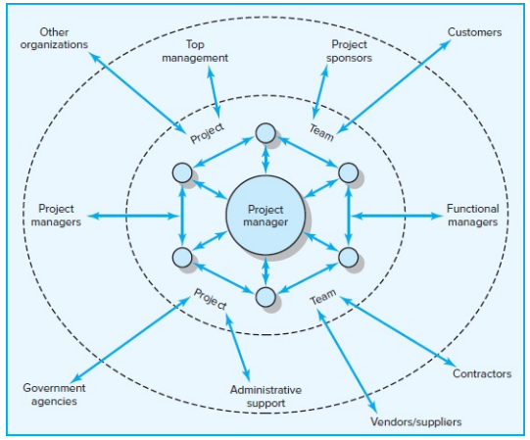
Figure. 2 (Network of Stakeholders)
Each of these stakeholder groups brings to the project specific standards, objectives, priorities, and areas of expertise. Stakeholders are people and organizations that actively participate in the project or whose interests may be touched by it in a positive or negative way, according to the Project Management Institute (2017).
The wide-ranging and complex nature of stakeholder relationships sets project management apart from regular management. To be successful, a project manager must understand how stakeholders might affect the project and develop techniques for managing dependencies. The nature of these dependencies is described as follows:
The project team supervises and completes the assignment. Even though most participants want to do well, they are also preoccupied with their other obligations and how their involvement in the project would help them achieve their goals. Project managers competing for resources and support from higher management is a common occurrence. Often, they must simultaneously share resources and exchange information.
Important support services are provided by administrative support organizations, such as those for human resources, maintenance, information systems, and purchasing agents. At the same time, they impose limitations and requirements on the project, such as the requirement to document spending and provide information in a timely and accurate manner.
Functional managers may have a minor or major influence on the project's success, depending on its structure. In matrix arrangements, they may be responsible for assigning project personnel, handling technical problems, and overseeing the completion of significant project work segments. Even with specialized project teams, functional managers' technical guidance can be beneficial, and internal initiatives may rely on their approval of completed work. The degree to which functional managers want to collaborate is limited. They are concerned with preserving their reputation within the organization as well as minimizing any delays the project might create to their own company.
The organization's top management determines the project's priorities and approves its funding. They choose what constitutes success and how to recognize accomplishments. Typically, major modifications to the budget, scope, and timetable require their consent. Although they have a natural interest in the project's success, they must also think about what's best for the organization as a whole.
Sponsors of the project: promote it and use their influence to have it approved. They need to be informed of any major developments because the success of the project will determine their reputation. They defend the project when it is threatened and are a valuable ally.

In certain situations, contractors may handle all of the actual work, with the project team only coordinating their input. In other situations, they are in charge of supporting areas of the project's scope. The main project team's work may be impacted by subpar work and timetable errors. Although delivering quality work is what builds contractors' reputations, they also have to balance their contributions with their own profit margins and their obligations to other clients.

Governmental organizations limit the scope of the project. It is necessary to secure permits. Construction must adhere to the code. New drugs must pass a rigorous set of tests set by the U.S. Food and Drug Administration. Safety rules, including those established by the Occupational Safety and Health Administration, must be followed by other products.

Suppliers and vendors supply the resources required to finish the project. Poor quality, shortages, and delays can cause a project to stall.

Depending on the project's nature, other organizations may have a direct or indirect impact. Environmental organizations, for instance, might contest or even halt project work. Governmental organizations may come under pressure from public interest groups. In order to safeguard their interests during a project, clients frequently employ consultants and auditors.

Customers determine the project's scope, and their pleasure is ultimately what determines the project's success. Project managers need to be able to adjust to their clients' shifting needs and requests while also meeting their expectations. Customers' top priority is getting a good deal, which invariably causes friction with the project team.
The interconnectedness of these partnerships is demonstrated by the fact that a project manager's ability to work with one group will impact his ability to involve other groups. For example, functional managers are likely to be less cooperative if they think upper management is losing interest in the project. However, if the project manager can shield the team from a client's intrusive interference, his standing with the team is likely to improve. The project management structure being used will determine the number and degree of external dependencies that must be included. One advantage of creating a specialized project team is that it reduces interdependence, especially inside the organization, as the project receives the majority of the resources. A functional matrix organization, on the other side, increases dependencies, increasing the project manager's reliance on functional peers for staff and work.
Snapshot from Practic.01 (Gray C. Project Management. The Managerial Process 8ed 2021)
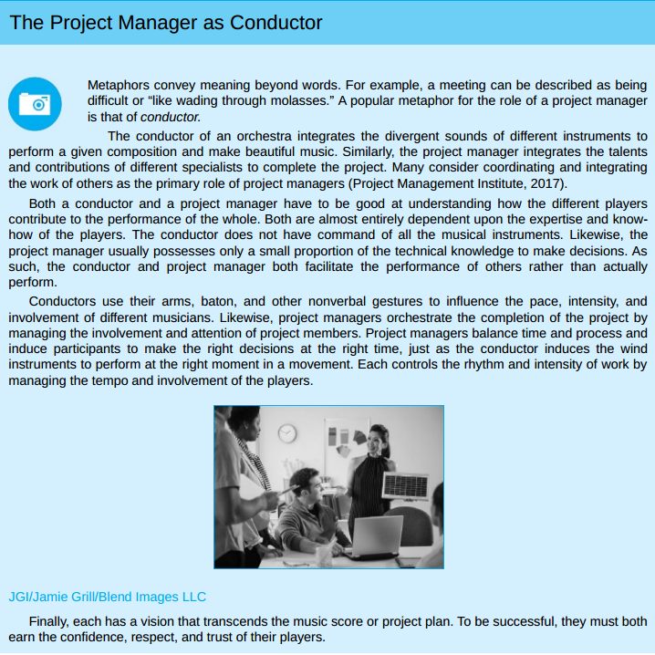

8.1.3 Influence as Exchange
Successful project management requires a manager to skillfully build a network of cooperative friends. Networks are beneficial partnerships that are usually governed by the law of reciprocity (Grant, 2013; Kaplan, 1984).
"One good deed deserves another, and likewise one bad deed deserves another" is the core principle. The primary tactic for obtaining cooperation is to provide resources and services to others in exchange for future resources and services.
A manager must be adept at creating a network of helpful friends in order to manage a project successfully. The law of reciprocity typically governs networks, which are advantageous collaborations (Grant, 2013; Kaplan, 1984).
The fundamental tenet is "One good deed deserves another, and likewise one bad deed deserves another" Offering resources and services to others in return for future resources and services is the main strategy for gaining their cooperation.
Table. – 3 Commonly Traded Organizational Currencies
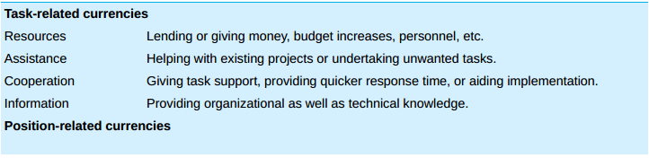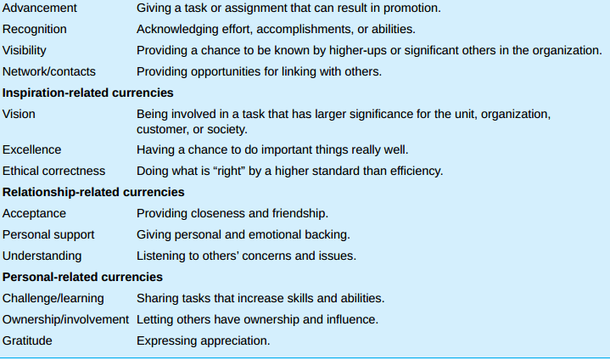
The following sections provide a more thorough discussion of the same Commonly Traded Organizational Currencies:
Task-Related Currencies
Task-related currencies, which can take many different forms, are based on the project manager's capacity to assist others in completing their duties. The most significant form of this currency is probably the capacity to respond to requests from subordinates for additional time, funds, or labor to complete a project segment. An additional example of this kind of currency is sharing resources with another project manager who is in need. On a more personal level, it can merely mean providing a colleague with practical assistance with a technical problem.
Supporting a colleague's idea or suggestion is another way to use this cash. Since most major action is likely to face some form of opposition, having a "friend in court" can be quite beneficial to the person trying to secure approval for a plan or proposal.
Another way to describe this money is as extraordinary effort. Responding to an urgent request to complete a design document in two days instead of the usual four days, for example, is likely to elicit gratitude. Finally, trading crucial knowledge that other managers could find useful is another way this money is employed.
Position-Related Currencies
The manager's capacity to elevate others' standing inside their company is the source of position-related currencies. A project manager can accomplish this by assigning a difficult task that will help the individual grow by enhancing her abilities and skills. Strong feelings of thankfulness are naturally produced when you are given the opportunity to prove yourself. Goodwill is created by sharing the praise and drawing attention to the successes and efforts of others from superiors.
Project managers reveal that figuring out how to make these individuals appear good to their superiors is a helpful tactic for winning over professionals in other departments or organizations. A project manager, for instance, collaborated with a subcontractor whose company had a strong commitment to total quality management (TQM). During high-level briefings, the project manager made it a point to highlight how the contractor's quality improvement initiatives helped with cost containment and issue avoidance.
Improving the standing of other employees inside the company is an additional form of acknowledgment. While "bad press" can rapidly cut someone off and make performance tough, "good press" can open up a lot of chances. This currency is also demonstrated by defending someone who has been wrongfully held responsible for project failures, therefore protecting their reputation.
Lastly, exchanging contacts with others is one of the most powerful ways to use this cash. Introducing people to important people and assisting them in growing their own networks inherently fosters gratitude.

Inspiration-Related Currencies
The most potent kind of impact is probably that which is associated with inspiration. The majority of inspiration comes from people's intense desire to change the world and give their life purpose. A project can inspire incredible dedication if an interesting, audacious concept is developed. For instance, the belief that project participants had an opportunity to alter the way people viewed computers was responsible for many of the technological innovations connected to the launch of the first Macintosh computer. An opportunity to achieve something truly well is presented by a different kind of vision. Many people are motivated by the ability to take pride in their work.
Frequently, inspiration comes from the project's very nature. People can feel good about what they are doing and that they are making a difference when they find a cure for a terrible disease, launch a new social program that will help those in need, or just build a bridge that will ease a significant traffic bottleneck. Rather than pressuring individuals to take action, inspiration works like a magnet, drawing them in.
Relationship-Related Currencies
More than completing project tasks, relationship-related currencies focus on improving the relationship with the other person. Building a relationship that goes beyond typical professional limits and into the realm of friendship is the essence of this type of influence. Personal and emotional support is necessary for the development of such relationships. Encouragement, confidence-boosting, and picking others up when they're feeling low all naturally foster goodwill. Another way to use this currency is to make tough circumstances enjoyable and to share a sense of humor. Relationships are also organically strengthened by participating in non-work-related activities like sports and family vacations.
Listening to others is arguably the simplest way to use this currency. According to psychologists, relationships end when people stop listening to one another, and most people have a strong need to be understood. A unique link is also formed between people when they are wise confidants and share personal secrets and goals.
Personal-Related Currencies
Individual needs and a strong sense of self-worth are addressed by personal currencies. Some think that helping people feel important and valuable will inevitably lead to goodwill, and that self-esteem is a fundamental psychological need. By asking for assistance and comments, giving people authority over their work, and letting them feel free to push themselves, a project manager can help a colleague feel more valuable. Sincere thanks for other people's contributions are another example of this type of cash. However, since appreciation is readily diminished when overused, care must be taken while expressing it. In other words, the first thank you is probably more important than the fifty.
In the end, a project manager will only have influence if she can provide something that other people find valuable. Additionally, a project manager needs to be able to acquire and use a variety of influence currencies since she depends on a wide range of people. This will be limited, in part, by the structure and character of the project. A project manager overseeing a committed team, for instance, has a lot more to offer team members than a manager tasked with coordinating the efforts of many specialists from various departments and organizations.
8.1.4 Social Network Building
Mapping Stakeholder Dependencies: Determining which stakeholders are essential to the project's success is the first stage in creating a social network. The following inquiries must be made by the project manager and his principal assistants:
Whose assistance will we require?
Whose consent or endorsement will we require?
Whose resistance would prevent us from completing the project successfully?
Making a map of these dependencies is useful for many project managers. For instance, a project manager in charge of implementing a new financial software system in her organization recognized the relationships shown in Figure 3.
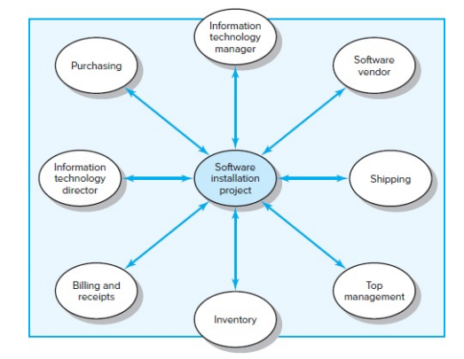
Figure. 3 (Stakeholder Map for Financial Software Installation Project)
Dependencies should always be overestimated rather than underestimated. Project managers who were otherwise gifted and successful have far too frequently been sidetracked by someone whose position or influence they did not expect. Once the stakeholders involved in your project have been identified, it is critical to evaluate their importance. The most important stakeholders are those who have the most influence on and interest in the project; they should receive the most attention. You must specifically "step into their shoes" and consider the project from their point of view by posing the following queries:
What aspects—goals, values, demands, working styles, and risks—differ between myself and the people I rely on?
How do these various individuals—supporters, apathetic, and adversaries—feel about the project?
How do my relationships with the folks I rely on stand right now?
In comparison to the people I rely on, what are my sources of influence?
Starting this examination will help you understand what other people value and what currency you might be able to offer as a foundation for a collaborative connection. You start to identify relationships where you have a present debit or no convertible cash as possible trouble spots. You may also predict how other people will feel and react to your choices and actions by assessing their viewpoints and the reasons behind them. In order to choose the best influence strategy and tactics and create win-win solutions, this information is essential.
Management by Wandering Around (MBWA):
After determining who the important actors are, you reach out to them and start establishing a rapport with them. Since managers at Hewlett Packard spend much of their time outside of their offices, establishing this relationship involves an interactive management style known as management by wandering around (MBWA).
Since there is a pattern or goal behind the "wandering," MBWA is a bit misleading. Project managers can stay informed about the true status of the project and foster the collaboration necessary for its success through in-person contacts.
Proficient project managers reach out to important stakeholders to stay updated on progress, foresee possible issues, offer support, and reaffirm the project's goals and vision. They have the ability to step in and settle disputes and avoid deadlocks. To put it simply, they "manage" the project. By remaining informed about several facets of the project, they become the information hub. Their primary function as project manager is further reinforced by the fact that participants look to them for the most up-to-date and thorough information about the project.
Successful project managers also make time to communicate with stakeholders farther away on a regular basis. They maintain communication with top management, vendors, suppliers, and other functional managers. By doing this, they stay acquainted with many parties, establish connections, find opportunities to provide a helping hand, and get insight into the needs and motivations of others. They promote their project's cause and remind others of their commitments. According to Snapshot from Practice 10.2: Managing Expectations, they also influence people's expectations.
By communicating often, they allay people's fears about the initiative, debunk rumors, alert individuals to possible issues, and provide the framework for handling setbacks more skillfully. Unless project managers are proactive in creating a network of support beforehand.
Snapshot from Practic.02 (Gray C. Project Management. The Managerial Process 8ed 2021)
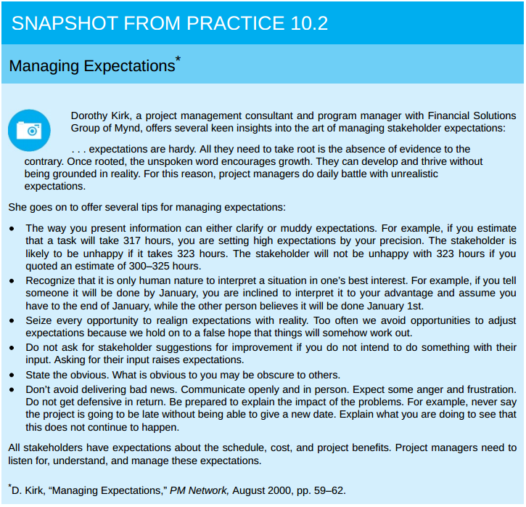
Building relationships before they are needed is something that seasoned project managers understand. They reach out to the important parties when there are no unresolved concerns or difficulties, and hence no misgivings or suspicions. They inherently participate in response banter and small conversation during these social events. They exchange information, offer consoling advice, and reply to others' appeals for assistance. By doing this, kids build positive relationships that will help them handle more difficult issues in the future.
Managing Upward Relations:
Studies repeatedly demonstrate that the level of top management support for a project has a significant impact on its success.3. An enough budget, flexibility in responding to unforeseen demands, and a clear communication to other members of the organization about the significance of the project and the necessity of collaboration are all examples of this kind of support.
In addition to being essential for gaining the support of other managers in an organization, visible top management support is also crucial for the project manager's capacity to inspire the project team. A manager's capacity to defend is what most clearly establishes his authority to lead.
Project managers must effectively advocate for their projects in order to gain the support of their team members. They must be able to persuade upper management to drop irrational demands, supply more resources, and acknowledge team members' achievements. Saying this is easier said than done.
Although it would seem illogical for a subordinate to "manage" a superior, smart project managers invest a great deal of time and energy on swaying and winning over upper management. Project managers must learn to be adept at influencing superiors and embrace significant variations in viewpoint.
Perspective differences are a major source of conflict between project managers and senior management. Naturally, project managers focus on what will work best for their project. Their project is the most important thing in the world to them. The priorities of top management ought to be distinct. They care about what's best for the organization as a whole. These two interests will naturally clash from time to time. A project manager might, for instance, vigorously advocate for more workers, only to have their request denied because upper management feels that the other departments cannot afford to cut back. The project manager must acknowledge that senior management will unavoidably have a different perspective on the world, even though regular contact might reduce discrepancies.
It's all about timing. It will be far more difficult to request more funding the day after the third quarter's dismal earnings are announced than it will be to do so four weeks later. Effective project managers choose the best time to win over upper management. To advocate for their cause, they recruit sponsors for their projects. They also understand that the allowances made by upper management are limited. The Lone Ranger analogy is relevant here: make good use of your limited supply of silver bullets.
Lastly, some project managers acknowledge that they overlook the line of command. They act without requesting permission if they are certain that a significant request would be denied by upper management and that their actions will advance the project. They assert that supervisors usually don't argue with success, despite the fact that this is quite dangerous.
Leading by Example
Project managers can use their most effective leadership tool—their own behavior—by adopting a highly visible, interactive management style, which is also crucial for establishing and maintaining cooperative relationships (Kouzes & Posner, 2012; Peters, 1988).
People frequently show a tendency to imitate the actions of those they respect and turn to others for guidance when faced with uncertainty. The actions of a project manager serve as a model for how other team members should approach the project. A project manager can affect how others behave and react to a range of project-related difficulties by modeling certain behaviors.
(For a striking illustration of this, see Snapshot from Practice 10.3: Leading at the Edge.)
Six aspects of leading by example are discussed as following (also refer to figure – 4):

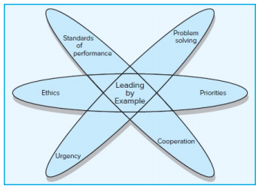
Figure. 4 (Leading by Example)

Snapshot from Practic.03 (Leading at the Edge) Gray C. Project Management. The Managerial Process 8ed 2021)
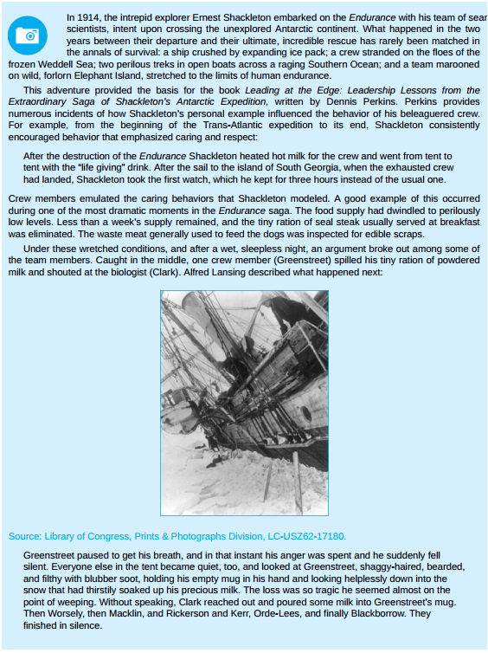
Priorities: Deeds are more powerful than words. The way that project managers use their time reveals their priorities to subordinates and others. All of a project manager's verbal pledges are likely to be ignored if she asserts that this project is crucial but is later seen as spending more time on other projects. On the other hand, a project manager who spends time observing a
The relevance of the testers and their work is confirmed by doing critical tests rather than only waiting for a report. Similarly, the questions that project managers ask convey priorities. A project manager might emphasize the significance of customer satisfaction by continually questioning how particular challenges relate to meeting the needs of the client.
Urgency: Project managers can communicate a sense of urgency by their behaviors, and this sense can permeate all aspects of project activities. Strict deadlines, regular status report meetings, and aggressive project-speeding solutions are some ways to communicate this urgency. To keep track of the project's rhythm, the project manager employs these tools as a metronome.
At the same time, if the project manager's conduct does not change in tandem, these tools will be useless. Project managers must work more quickly themselves if they expect people to work and solve issues more quickly. Their own behavior needs to pick up speed. Their interactions should be more frequent, they should walk and chat faster, they should arrive at work earlier, and they should depart later. Project managers can instill a sense of urgency in others by merely quickening the speed of their regular interactions.
Problem Solving: The way that project managers handle issues sets the standard for how others handle them. Others will be reluctant to share negative news if it is met with verbal abuse.4. Others will try to hide their tracks and shift the blame elsewhere if the project manager is more focused on identifying the guilty party than on how to stop issues from occurring in the future. Others are more likely to take a more proactive approach to problem solving, however, if project managers concentrate more on how they may use a problem as an opportunity or what can be learnt from a mistake.
Cooperation: Team members' interactions with external parties are influenced by the way project managers behave. When a project manager makes negative comments about the "idiots" in the marketing department, the team as a whole frequently adopts this viewpoint. It is more probable that others will follow suit if project managers establish the standard of showing respect and being attentive to the demands of outsiders.
Standards of Performance: Experienced project managers understand that they must surpass others' expectations of a competent project manager if they wish to see participants surpass project expectations. The caliber of their everyday interactions sets a high bar for project performance. They attend to others' needs promptly, plan and conduct meetings with precision, keep abreast of all the relevant issues, assist in addressing problems effectively, and maintain their position on crucial subjects.
Ethics: The way a project manager handles ethical quandaries during a project will impact how others handle similar situations afterwards. Team members frequently base their decisions on how they believe the project manager would react.
Project managers send a message to others that this type of behavior is acceptable if they purposefully misrepresent or omit important information from clients or upper management. Project management inevitably leads to a number of ethical conundrums; now would be a good time to get deeper into this subject.
8.1.5 Ethics and Project Management
Due to the complexity of project management, ethics always entail ambiguous regions of interpretation and judgment. For instance, it is challenging to discern intentional exaggeration of project payoffs from sincere optimism or malicious fabrication of projections from honest errors. Determining whether unmet promises were intentional deception or a suitable reaction to evolving circumstances becomes hard.
Many businesses and professional associations release a code of conduct to help clarify corporate ethics. Advocates contend that these documents are significant, if constrained, initial steps, while cynics view them as merely window dressing. Personal ethics are found at the intersection of one's work, family, education, profession, religious views, and everyday interactions rather than in formal statutes. According to the majority of project managers, they depend on their own personal moral compass, or what one project manager referred to as his "internal compass."
According to a lot of project managers, acting morally is rewarding in and of itself. Your behavior reflects your personal ideals when you act in accordance with your internal compass. According to some, acting morally has two benefits. In addition to being able to sleep at night, you also build a solid and respectable reputation. Such a reputation is crucial to building the trust required to successfully use influence, as will be discussed in the following section.

Snapshot from Practic.04 (The Collapse of Arthur Andersen) Gray C. Project Management. The Managerial Process 8ed 2021)

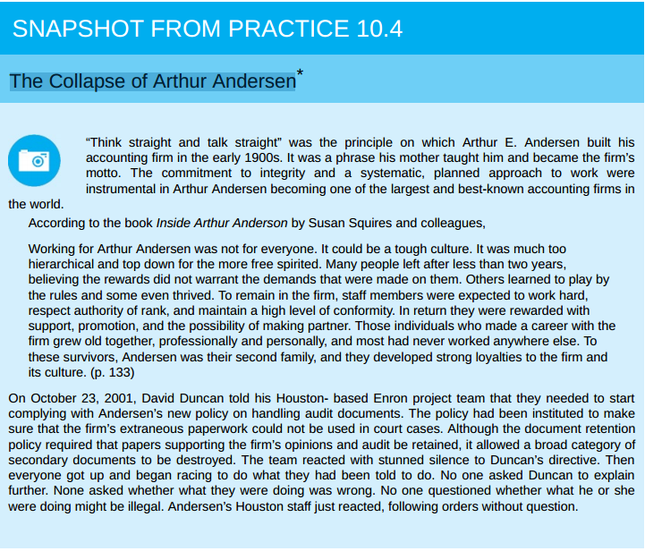

8.1.6 Building Trust: The Key to Exercising Influence
The absence of trust is a sign of its importance. Consider the difference in a working relationship between mistrusting and trusting the other person.
The concept of trust is elusive. The reasons why certain project managers are trusted while others are not are difficult to pinpoint in detail. The idea that trust is a function of competence and character is a common one. While competence focuses on the abilities required to actualize motives (e.g., does he or she know the proper things to do?), character focuses on personal motives (e.g., does he or she desire to do the right thing?).
Stephen Covey's best-selling book, Seven Habits of Highly Effective People, revived the importance of character in the leadership literature. Covey attacked popular management literature for emphasizing deceptive tactics and superficial human relations skills, which he called the personality ethic. He contends that a strong sense of personal values and principles, such as respect, justice, service, dignity, and the quest of truth, form the foundation of highly productive people.
Consistency is one of the qualities that set character apart. People are inherently more predictable when they follow a core set of principles since their behavior is in line with these values. Openness is another aspect of character. People are more open to others when they know exactly who they are and what they value. This characteristic gives them the ability to sympathize and the skill to bring disparate individuals together. Lastly, having a feeling of purpose is another trait of character. Characteristic managers are motivated by the greater good in addition to their own goals. What is best for the project and their organization, not for themselves, is their top priority. The respect, loyalty, and trust of others are earned by this readiness to put a greater good ahead of one's own interests.
Trust cannot be built on character alone. Before we can truly trust someone, we must first have faith in their competence (Kanter, 1979). We have all encountered well-meaning bosses that we like but do not trust due to their track record of breaking commitments. We may become friends with these managers, but we don't want to work for or with them.
Competence manifests itself on several levels. The first is task-related knowledge and abilities, which are demonstrated by the capacity to respond to inquiries, resolve technical issues, and perform exceptionally well in particular types of work. Secondly, interpersonal competence is proven through the ability to listen well, speak clearly, settle disputes, offer support, and so on. Organizational competence comes last.
This entails having the ability to organize productive meetings, establish worthwhile goals, cut down on inefficiencies, and create a social network. Young engineers and other professionals all too frequently have a tendency to overvalue technical or task proficiency. They undervalue the importance of being well-organized. Conversely, veteran professionals appreciate interpersonal and organizational abilities more and understand the significance of management.
One issue that new project managers face is that developing a feeling of competence and character takes time. When put to the test, such as when faced with a difficult decision or a challenging challenge to address, character and competency are frequently displayed. Experienced project managers benefit from a solid reputation and proven track record of accomplishment. Even though a rookie project manager can make a good first impression with the support of reputable sponsors, her actions will eventually determine whether or not she can be trusted.
8.1.7 Qualities of an Effective Project Manager
Since there is an underlying logic to the process, project management appears to be a deceptive discipline. From defining a project scope statement to establishing a work breakdown structure (WBS), building a network, adding resources, completing a plan, and hitting milestones, there is a logical progression. However, this reasoning can soon fall apart when it comes to actually carrying out and finishing initiatives. Project managers frequently deal with a messier, more contradictory, and paradoxical world. The paradoxical character of their work is something that effective project managers must be able to handle. The following is a list of some of those contradictions:
Maintain stability while innovating: Project managers must put out fires, reestablish order, and bring the project back on course. They must simultaneously be creative and create fresh, more effective methods of accomplishing tasks. Innovations disrupt routines and can lead to other disruptions that require attention.
See the big picture while getting their hands dirty: Project managers must have a broad perspective and understand how their project fits into their company's overall strategy. They occasionally have to become quite active with technology and project work. Who will care about the specifics if they don't?
Encourage individuals but stress the team: While preserving teamwork, project managers must inspire, persuade, and lure individual performers. They must take care to treat each team member as a unique individual while still being regarded as fair and consistent in their treatment of them.
Be hands-off/hands-on: Project managers must step in, break deadlocks, fix technical issues, and insist on alternative strategies. They must simultaneously know when it's acceptable to take a backseat and let others do the fighting.
Be flexible but firm: Project managers must be flexible and sensitive to the happenings and results of the project. However, there are moments when they must persevere and hold the line when everyone else wants to give up.
Manage team versus organizational loyalties: It is the responsibility of project managers to create a cohesive team whose members inspire each other to achieve exceptional results. However, they must simultaneously combat the team's intolerance to outside ideas and the excesses of cohesiveness. They must develop allegiances to the parent company as well as the team.
Being a successful project manager does not require a single management approach or set of rules. Project management is too complex a field to be governed by formulas. Effective project managers are adept at changing their approaches depending on the context.
Sometimes it seems like someone with superhuman abilities is needed to be a good project manager. There are certain fundamental qualities and abilities that can be cultivated to effectively manage a project, even though not everyone possesses these abilities. Eight of these characteristics are as follows:
Effective communication skills: For a project to be successful, communication is essential. Project managers must be sympathetic listeners and speak the language of many stakeholders.
Systems thinking: Instead of approaching projects in a reductionist manner, project managers need to be able to adopt a holistic approach. A systems approach concentrates on attempting to comprehend how pertinent project components interact collectively to produce project outcomes, as opposed to dissecting a project into discrete parts (budget, planning) and controlling it by comprehending each component. After then, controlling how various components interact rather than the components themselves becomes crucial to success.
Personal integrity: You must be able to lead and manage yourself before you can lead and manage others (Bennis, 1989). Establishing a clear understanding of your identity, values, and appropriate conduct should be your first step. This inner strength gives you the credibility you need to keep other people's trust and the buoyancy to weather the ups and downs of the project life cycle.
Proactivity: Effective project managers act before it's necessary to stop minor issues from becoming bigger ones. Instead of focusing on matters over which they have little control, they try to solve problems within their sphere of influence for the majority of the day. Project managers are not allowed to complain.
High emotional intelligence (EQ): Not everyone is cut out for project management. When things get a little out of control, project managers need to be able to regulate their emotions and react to people in a positive way. To learn more about this trait, see Research Highlight 10.2: Emotional Intelligence.
General business perspective: It is crucial for a manager to have a comprehensive understanding of business principles and how the many functional disciplines interact to contribute to a successful business, as the main responsibility of a project manager is to combine the contributions of various technical and business disciplines.
Effective time management: The most valuable resource for a manager is time. Time management skills and the ability to swiftly rearrange priorities are essential for project managers. To ensure that nobody feels overlooked, they must strike a balance in their interactions.
Optimism: Project managers must have a positive outlook. On a gloomy day, they must be able to discover rays of sunshine and have an optimistic attitude. A project manager's greatest assets are frequently a lighthearted disposition and a decent sense of humor.
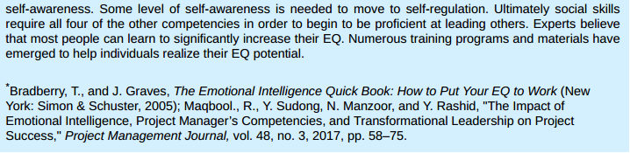
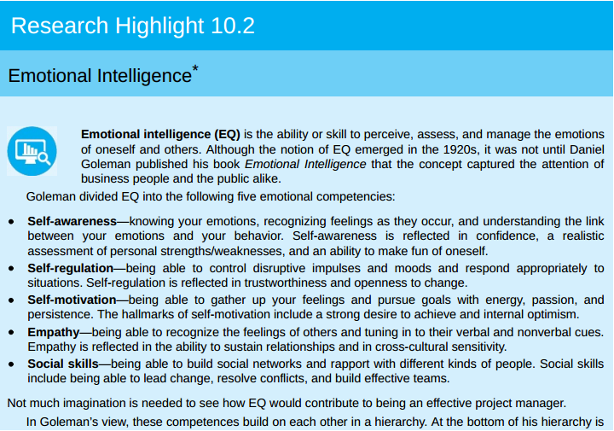
Research Highlight 10.2

How does one acquire these qualities, then? One can improve their ability to think in systems and their overall business viewpoint through workshops, self-study, and classes. Communication and emotional intelligence can be enhanced through training programs.
Techniques for managing time and stress can also be taught to people. However, we are not aware of any workshop or magic elixir that can give someone a sense of purpose when they lack one or turn a pessimist into an optimist. These characteristics strike at a person's core essence. Without an innate tendency to exhibit these, it is difficult to cultivate optimism, honesty, and even proactivity.

Chapter Two
Literature Review

Introduction:

In today's fast-paced and constantly evolving business world, interpersonal skills are crucial for project success, as demonstrated by earlier studies that emphasized and clarified their importance in project management.
The subjects covered in the list below include the impact of interpersonal skills in project management, the effect of leadership abilities on project success, and a number of driving competencies that break down the ways in which these attributes impact project success.
Recommendation, evidences and conclusions of these studies form a solid foundation leading to a better and enhanced training and development in the field of the Interpersonal skills.
Previous Studies:
1- Impact of Project Manager’s Interpersonal Leadership Skills on Project Success
Mr. Manazar Hussain Awan, Mr. Kashif Ahmed, Wajid Zulqarnain
https://iiste.org/Journals/index.php/JPID/article/view/19288
2- Importance of Soft Skills in Project Management
https://ijsrm.net/index.php/ijsrm/article/view/850/746
3- Do the Project Manager’s Interpersonal Skills Matter? Impacts of the Project Manager’s Emotional Intelligence, Trustworthiness, and Job Satisfaction on Project Success
https://www.mdpi.com/2076-3387/12/4/141
4- How do project managers’ competencies impact project success? A systematic literature review
https://journals.plos.org/plosone/article?id=10.1371/journal.pone.0295417
5- Analysis of The Success of Construction Projects Based on Labor Productivity
Malia Urrahmi1 0F*, Cut Zukhrina Oktaviani1, and Mubarak
https://www.e3s-conferences.org/articles/e3sconf/pdf/2024/06/e3sconf_aisce2023_01002.pdf

Dependent Variables:
Project success defined in the classic criterion from practice as a measure of the immediate performance of a project against its main design parameters—schedule (time), budget (cost), scope, and/or quality.
According to the traditional method, a post-project review evaluates performance by determining whether the project was finished "on time, within budget, and to specification." If all of them fell inside a small tolerance range, the project is considered successful. [10]
Punctuality, or the percentage of tasks you manage to do by the work unit's deadline, is frequently used to describe completing all scope activities on time. A 100% punctuality rate indicates that every assignment you are thinking about has been finished by the work unit's respective deadline.

Indicator |  | Variable
Competitive Cost | Y1 | Project Success (Y)
Quality Sustainability | Y2 | Project Success (Y)
Punctuality | Y3 | Project Success (Y)
Table 1. Dependent Variable

Independent Variables:
Project team performance is not the only factor that determines a project's success. The contributions of senior management, functional managers, clients, vendors, contractors, and others frequently determine whether a project succeeds or fails.
The paradoxical character of their work is something that effective project managers must be able to handle. The performance and success of the project will be impacted or improved by their interpersonal skills.

Indicator |  | Variable
Solving technical problems | X1.1 | Leadership (X1)
Serves as peacemaker when tensions rise | X1.2 | Leadership (X1)
Makes appropriate tradeoffs of time, cost, and scope | X1.3 | Leadership (X1)
build a cooperative network among divergent allies. | X1.4 | Leadership (X1)
Negotiating and working with different stakeholders | X2.1 | Engaging Project Stakeholders (X2)
Broader spectrum of influence | X2.2 | Engaging Project Stakeholders (X2)
Develop methods for managing the dependency | X2.3 | Engaging Project Stakeholders (X2)
Buffer the team from excessive interference from a client | X2.4 | Engaging Project Stakeholders (X2)
Sound communication skills | X2.5 | Engaging Project Stakeholders (X2)
Political savvy | X2.6 | Engaging Project Stakeholders (X2)
Provide services for others in exchange for future services | X3.1 | Influence as Exchange (X3)
Ability to contribute to others’ accomplishing their work. | X3.2 | Influence as Exchange (X3)
ability to respond to subordinates’ requests for additional resources | X3.3 | Influence as Exchange (X3)
Ability to enhance others’ positions within their organization | X3.4 | Influence as Exchange (X3)
Identifying the stakeholders on whom the project depends for success. | X4.1 | Social Network Building (X4)
Diagnosing others’ points of view | X4.2 | Social Network Building (X4)
Initiate contact and begin to build a relationship | X4.3 | Social Network Building (X4)
Working relationships with upper management | X4.4 | Social Network Building (X4)
Character ethic | X5.1 | Building Trust (X5)
Task related, Interpersonal and organizational Competency | X5.2 | Building Trust (X5)
Connecting, exhibiting warmth and concern | X5.3 | Building Trust (X5)
Innovate and maintain stability | X6.1 | Interpersonal Qualities (X6)
See the big picture while getting their hands dirty | X6.2 | Interpersonal Qualities (X6)
Encourage individuals but stress the team | X6.3 | Interpersonal Qualities (X6)
Be hands-off/hands-on | X6.4 | Interpersonal Qualities (X6)
Be flexible but firm | X6.5 | Interpersonal Qualities (X6)
Effective communication skills | X6.6 | Interpersonal Qualities (X6)
Self-awareness | X7.1 | Emotional Intelligence (X7)
Self-regulation | X7.2 | Emotional Intelligence (X7)
Self-motivation | X7.3 | Emotional Intelligence (X7)
Empathy | X7.4 | Emotional Intelligence (X7)
Social skills | X7.5 | Emotional Intelligence (X7)
Encouraging Functional Conflict | X8.1 | Conflict Management (X8)
Managing Dysfunctional Conflict | X8.2
Reading body language to identify unspoken disagreement | X8.3
Table 2. Independent Variables

Leadership (X1)

Engaging Project Stakeholders (X2)
Influence as Exchange (X3)
Social Network Building (X4)
Project Success (Y)
Building Trust (X5)
Interpersonal Qualities (X6)

Emotional Intelligence (X7)
Conflict Management (X8)

Figure -1. Schematic of variable X and variable Y

Summary of Previous Studies:
In their study of - Impact of Project Manager’s Interpersonal Leadership Skills on Project Success -Manazar Hussain, Mr. Kashif Ahmed and Wajid Zulqarnain where they test hypotheses were tested and all were accepted. The study amply highlights the importance of project mangers’ coordination skills and problem finding, analyzing and solving skills, refer to study no. 1 in the previous studies list.
Dr. Anupama Jena, Swasti Suvasweta Satpathy highlighted in his study titled: Importance of Soft Skills in Project Management Website: www.ijsrm.in ISSN (e): 2321-3418, that hard skills and soft skills
cross over each other in all the stages of project management. All the soft skills that a project manager needs are not one time endeavors but threads applied throughout the project. Since soft skills spread widely through personal and interpersonal attributes, it must be recognized from the simple gesture of day-to-day activities to the complex management activities at workplace. So, to fit the right soft skill at the proper place is the need of the hour.
Another study titled: Do the Project Manager ’s Soft Skills Matter? (by Marcela Castro, André Barcaui and Ronnie Figueiredo) concluded that there is a growing trend toward soft skills and reinforce the need to fill the gap between ‘hardcore’ measures of project success and its antecedents. Therefore, the findings contribute to the project management literature in terms of the integration of soft skills as impacting factors on project success.
Project managers’ competencies impact project success was studied by Paola Ochoa Pacheco , David Coello-Montecel, Michelle Tello, Virginia Lasio, Alfredo Armijos, December 7, 2023 and they concluded that firstly, project success is a multidimensional construct that comprises three main dimensions: impact on stakeholders, impact on the organization, and general project management. Secondly, the available data suggested that greater levels of project managers’ competencies are associated with improved project success rate.
Finally, in their study titled: Analysis of The Success of Construction Projects Based on Labor Productivity, Malia Urrahmi1 0F*, Cut Zukhrina Oktaviani1, and Mubarak, concluded that a successful project should have a valuable asset, namely a good workforce that can produce high productivity under the auspices of the project manager. Productivity is the dominant aspect that drives the effective use of resources in the construction industry. [refer to the list of previous studies in the next page]

Research Gap:
According to the previous studies discussed above, they highlight the importance soft/ interpersonal skills and the impact they have to the project success and performance. But their interdependencies, on the other hand, have been largely disregarded.
For this reason, it is important to shade the light at the different interpersonal skills taking into account their enhance factors for possessing them, and the impact of lack of those skills on the project success measuring their influence and interdependencies.
In practice, there are countless cases where the team members, project success affected directly by the project managers personal qualities or lack of exercising the good ones. Therefor, we will be studying those areas in addition to the individual qualities among the targeted population.
The Theoretical Framework:
A theoretical framework consists of concepts and, together with their definitions and reference to relevant scholarly literature, existing theory that is used for a particular study. The theoretical framework demonstrates an understanding of theories and concepts that are relevant to the topic of the research paper and that relate to the broader areas of knowledge being considered. [9]
The theoretical framework strengthens the study in the following ways:
- An explicit statement of theoretical assumptions permits the reader to evaluate them critically
- The theoretical framework connects the researcher to existing knowledge. Guided by a relevant theory, you are given a basis for your hypotheses and choice of research methods
- Articulating the theoretical assumptions of a research study forces you to address questions of why and how. It permits you to intellectually transition from simply describing a phenomenon you have observed to generalizing about various aspects of that phenomenon
- Having a theory helps you identify the limits to those generalizations. A theoretical framework specifies which key variables influence a phenomenon of interest and highlights the need to examine how those key variables might differ and under what circumstances
- The theoretical framework adds context around the theory itself based on how scholars had previously tested the theory in relation their overall research design (i.e., purpose of the study, methods of collecting data or information, methods of analysis, the time frame in which information is collected, study setting, and the methodological strategy used to conduct the research). [9]
The theoretical framework is not just a part of the research, it is the backbone that supports all aspects of the study, from defining the problem to analyzing the results.

Chapter Three
Research Methodology

Introduction:
The research methodology of this topic will involve a series of systematic steps aimed at comprehensively and accurately studying the impact of project managers’ interpersonal skills on project success. A quantitative research approach will be used, as it is suitable for objectively collecting and analyzing quantitative data.
The research adopted a positive approach philosophy, the arguments represent that the quantifiable effects of interpersonal skills on project success are studied. Soft skills can be viewed as a personal behavior. With project managers reactions to certain events during different phases of the project.
Research Design:
1- Questionnaires:
They will be designed to include a number of questions that measure the interpersonal skills of project managers, including communication skills, leadership, emotional intelligence, and conflict resolution. Participants in the study will be asked to evaluate the level of these skills and their impact on the success of the projects they manage. The questionnaire will be distributed to project managers that considered as well-informed individuals, calling on their insights and experience, who are better equipped to provide experience-based feedback than theoretical approaches or statistical methods. Their responses to these questionnaires are anonymous, which will provided a summary of opinions.
2- Random Sampling method:
This method will be used particularly to select random participants for the study. In which it will help reduce bias and increase the generalization of the results. The sample is expected to include project managers from different fields, whether from small or large organizations, providing different insights about the impact of personal skills in different contexts.
The step that will follow the data collection, will be analyzing the results using statistical analysis tools, such as regression analysis, to understand the relationship between interpersonal skills and project success. The analyses will help determine the importance of the relationship between the studied variables, providing strong evidence to support the proposed hypotheses.
Additionally, qualitative interviews will be conducted with several project managers to have an in-depth and extensive understanding of how interpersonal skills are applied and developed in the workplace. These interviews will provide additional insights into the challenges and opportunities managers face in using their personal skills to achieve project success.
In conclusion, the methodology will combine quantitative and qualitative data, allowing for a comprehensive analysis of the topic and enhancing the credibility of the findings.
This research is expected to contribute to the academic literature on project management as well as providing practical recommendations for managers to enhance their personal skills and improve the outcomes of the projects they manage. It also considered to be a methodical efforts to examine, investigate as well as restructure the realities, theories and applications.
Target Population:
The research targets projects directors, project managers, programme managers, senior resident/ resident engineers and functional managers across the middle east region, using an online form to gather different views from multi-discipline professionals.
Another group of data will be collected through personal interviews with programme/ projects directors and managers currently on the job within Diriyah Gate development project in Riyadh, KSA to express their practical experience via the different levels of involvement in the projects.
The selected project represents one of the five giga projects in the kingdom of Saudi Arabia, it is also a heritage and cultural iconic project with a mix use masterplan development, in which the interface, engineering and managers in the project is one of the challenges to be overcome. Collecting the input from different line managers in this project provide a practical experience-based knowledge of how possessing or lack of the interpersonal skills can affect the project performance and hence the project success.
Sample Characteristics:
First group who will participate via questionnaire, will be project managers that considered as well-informed individuals, calling on their insights and experience, who are better equipped to provide experience-based feedback. Their responses to these questionnaires are anonymous, which will provided a summary of opinions.
Second sample, the sample is expected to include project managers from different fields, whether from small or large organizations, providing different insights about the impact of personal skills in different contexts.
Also, qualitative interviews will be conducted with several project managers to have an in-depth and extensive understanding of how interpersonal skills are applied and developed in the workplace.

Chapter Four
Practical Study

Introduction:
The study will be conducted based on the three methods described in the research design section, with each of the methods the findings and reports will be analyzed to produce the final discussion and conclusion based on qualitive and quantitative results and measurement of interdependencies.
The collected data can be found in the attached appendixes section
Data Collection:
Data collected using questionnaire is attached in the appendixes
Data Analysis using IBM SPSS:
Overview:
This chapter presents and discusses the research on how a project manager's soft skills affect project success. The following five particular goals were sought after: I to determine the influence of a project manager's strong leadership abilities on project success; (ii) to determine the influence of a project manager's effective communication abilities; (iii) to determine the influence of a project manager's conflict resolution abilities on project success; (iv) to determine the influence of a project manager's proactivity; and (v) to determine the influence of a project manager's high emotional intelligence abilities on project success.
The sample characteristics and the study variables are described in the following Sections, which is based on indicators. The descriptive statistics and correlation.
Sample Description:
Four demographic variables were involved, namely name, gender, age and experience (Table 3). Respondents aged 20-30 were smallest group who constituted less than 3%. Those who are 30-40 were about 24.2% of all respondents. Respondents aged 40-50 were about 54.5%, whereas group aged 50-60 were about 12.1% and the group of the above 60 years of age is around 6.1%. In general majority of respondents were middle aged.
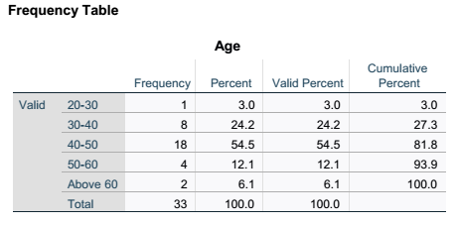

Table 3 Age Frequency.
Discussion of the Findings:
The study's objective was to determine the impact of project managers' soft skills on project success. Descriptive statistics were used to test the analytical hypothesis. The information derived from data analysis is elaborated in the discussion.
With reference to table 4 below, the most two characteristics that the project manager must have been found to be Strong Leadership Skills and Effective Communication Skills.
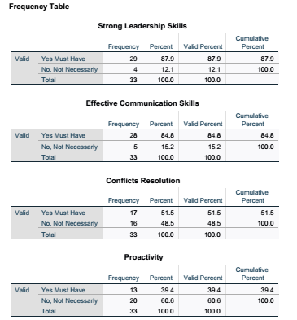

Table. 4 Soft Skills Frequency

References:

Foreign/ English References

1- Effective Project Management Traditional, Agile, Extreme (Author: Robert K Wysocki)

2- Project Management. The Managerial Process 8ed 2021 (Author: Erik W. Larson, Clifford F. Gray)

3- Contemporary Project Management, Timothy J. Kloppenborg Third Edition

Citations:
[1]: PMI, The Essential Interpersonal Skills Every Project Manager Needs
https://www.projectmanagement.com/blog-post/75514/the-essential-interpersonal-skills-every-project-manager-needs
[2]: PMI, Defining of project success
https://www.pmi.org/learning/library/defining-project-success-multilevel-framework-7096
[3] PMI, The Essential Interpersonal Skills Every Project Manager Needs
https://www.projectmanagement.com/blog-post/75514/the-essential-interpersonal-skills-every-project-manager-needs
[4] Project Management Quiz 10 review
https://quizlet.com/ca/905468797/pm-chapter-10-flash-cards/
[5] PMI, The significant role of the project manager in establishing and maintaining team morale
https://www.pmi.org/learning/library/team-morale-motivation-ideas-maintain-6175
[6] PMI, Increase project team effectiveness
https://www.pmi.org/learning/library/increase-project-team-effectiveness-steps-6070
[7] Project Central, Why Is Teamwork Important for Project Management Success?
https://www.projectcentral.com/blog/project-management-teamwork/
[8] National Library of Medicine. Transformational leadership and project success: The mediating role of trust and job satisfaction
https://pmc.ncbi.nlm.nih.gov/articles/PMC9520658/
[9] USC University of Southern California, Research Guides: Theoretical Framework
https://libguides.usc.edu/writingguide/theoreticalframework#:~:text=The%20theoretical%20framework%20is%20the,to%20investigate%20the%20research%20problem
[10] PMI, Defining project success
https://www.pmi.org/learning/library/defining-project-success-multilevel-framework-7096
Appendixes:

