

Face Mask Detection Using Deep Learning
Prepared By
Name: Ahood Faisal Al-Shahrani
ID No 251001057
Master of Science in Artificial Intelligence
At
College of Informatics
Midocean University
UAE
Supervisor Name: Dr. Yasser Abdulhamid
College of Informatics, Midocean University, Comoros
2026

Acknowledgements

I would like to begin by expressing my sincere gratitude to my supervisor for this semester, Dr. Yasser Abdel Hamid, for his patience and constant review with us on all the details and major points. It was an engaging and wonderful experience.

Abstract

This crucial point is that facial recognition systems are ineffective when the face is covered in any way. This became even more apparent after the COVID-19 pandemic for many sectors. This project aims to find a solution that determines compliance with rules without needing to see the entire face, as the accuracy of the system has significantly declined. The solution involves sorting pixels to differentiate between those who comply with the rules and those who do not, after classifying the data (images) as wearing a mask or without .

List of Publications

Table of Contents
List of Abbreviations vii
List of Figures viii
List of Tables ix

Chapter 1: Introduction………………………………………………........ 1
1.1 Problem Definition ................................................................................... 1
1.2 Thesis Objectives .................................................................................... 1
1.3 Thesis Contribution ……........................................................................... 2
1.4 Thesis Organization …............................................................................. 2

Chapter 2: Scientific Background and Previous Studies……..…………. 4
2.1 Introduction .............................................................................................. 4
2.2 Scientific Background ………………...................................................... 4
2.3 Deep Learning Approaches ………………………………………………4
2.4 Convolutional Neural Networks (CNN)…..……..……….……………... 5
2.5 Use of Real-world Datasets……………………………………………... 5
2.6 Related Work …………………...…………………………………….… 6
2.7 Analysis and Discussion of Studies ………………………………..…... 9

Chapter 3: Proposed Methodology ………..……………………………...11
3.1 Introduction .............................................................................................. 11
3.2 Data Preprocessing ................................................................................. 13
3.3 Model Architecture …………………………………………………… 13
3.4 Model Training ………………………………………………………….14
3.5 Model Evaluation ……………………………………………………… 14
3.6 Implementation ………………………………………………………….14
3.7 User Interface ……………………………………………………………14
3.8 System Mechanism …………………..………………………………….15
Chapter 4: Analysis of Challenges in Facial Recognition Systems and the Impact of Face Masks………………………………………………………16
4.1 Types of Threats ………………………………………………………...16
4.2 Methods for Countering Threats………………………………………....17
4.3 Chapter Summary…………………………………….…………………..18

Chapter 5: Results and Discussion ……………….…………………….... 19
5.1 Introduction ……….……………………………………………………. 19
5.2 Training Results …………….………………………………………….. 20
5.3 Performance Analysis …………………....…………………………...... 21
5.4 Comparison with the Baseline Model …….…………………………...,, 22
5.5 Error Analysis .…… …………………………………………………… 23

Chapter 6: Conclusion and Future Work .……………………………... 24
6.1 Conclusion …………………………………………………………….. 24
6.2 Recommendations……………………………………………………… 25
6.3 Future Work …………………………………………………………… 26
References .................................................................................................... 27

List of Abbreviations

AI: Artificial Intelligence

ML: Machine Learning

DL: Deep Learning

CNN: Convolutional Neural Network

CV: Computer Vision

IoT: Internet of Things

YOLO: You Only Look Once

R-CNN: Region-based Convolutional Neural Network

GPU: Graphics Processing Unit

API: Application Programming Interface

ReLU: Rectified Linear Unit

Loss: Loss Function

Accuracy: Accuracy Metric

Precision: Precision Metric

Recall: Recall Metric

F1-Score: F1 Score

Dataset: Dataset

Epoch: Training Cycle

Overfitting: Overfitting

Real-time: Real-time Processing

List of Figures

Figure 1: Convolutional Neural Network (CNN) Architecture ……………  Figure 2: Model Accuracy ………………………………………………… | 3  10
Figure 3: Model Loss ……….……………………….……………………. | 11
Figure 4: Confusion Matrix………………………………………….…...... | 13

List of Tables
Table (2.1): Comparison of Previous Studies
Table (3.1): Distribution of Datasets
Table (5.1): Model Performance Metrics

Chapter 1

Introduction
1.1 Problem Definition
Despite the advancements that have been made in facial recognition, it still has a few challenges when it comes to dealing with people who wear masks. This is due to how the concealing of certain facial features can reduce the accuracy of their classification.
Due to the complexity of the facial recognition techniques, many advanced models are not able to perform well in practical applications. This is especially true in environments such as healthcare facilities and hospitals.
The challenge lies in developing a simple and effective model that can accurately identify individuals who are not wearing masks. This model should be able to be applied in real time to help prevent the spread of infections.
  - Thesis Objectives
Research Objectives
Finding the masked face.
Convolutional neural networks provide the backbone for spotting individuals with face coverings. We don't just need to detect fabrics we also need a clear classification of those who wear masks and those who don't
Although the classification seems simple the model must handle different lighting and angles as well as the presence of makeup or other facial modifications to function correctly
1- High accuracy is the primary goal
2- Data inoculation and cleaning
3- The processing steps follow rigorous training protocols to ensure accurate results
4- Verify the results using metrics to assess the system's efficiency
5- Identify areas of weakness
6- Build a clear and simple user interface
7- Launch and test the program in hospitals and health centers as quickly as possible, given the busy schedules of doctors, by providing an easy-to-use tool

  - Thesis Contribution

This project contributed to the development of an intelligent system for monitoring compliance with mask wearing in healthcare facilities and other locations This system integrates with existing monitoring systems for rapid detection of violations Furthermore, the model is designed to operate on low-end devices while maintaining efficiency and accuracy, thus helping to reduce human error and enhance clinical protection

1.4 Thesis Organization
This section explains the structure of the master's thesis chapters.

Chapter 1
discusses the research problem and its objectives.
Chapter 2
presents previous studies and research related to the same topic.
Chapter 3
explains the methodology, including how the data was prepared and the model was built.
Chapter 4
discusses some challenges, such as the difficulty of facial recognition when wearing a mask.
Chapter 5
presents the results and their success.
The Final Chapter contains the conclusion and recommendations for future research.

Chapter 2

Overview
2.1 Introduction
This section explains previous studies and research on mask-wearing detection using various technologies
It also clarifies the specific technology used by researchers deep learning. This technology was employed to develop systems for identifying individuals wearing masks, or not wearing. This chapter helps us understand the technologies used and identify their strengths and weaknesses to inform the development of the proposed model and often the results contradict each other
2.2 Scientific Background
We have made significant advancements in science and technology particularly in online identification techniques. We have developed intelligent electronics capable of image analysis and highly accurate object recognition. These systems rely on image-based technology and advanced learning techniques, requiring individuals to wear the devices fully within their bodies. This technology facilitates quality control procedures ensuring compliance and allowing for comparison with manual monitoring It works well for most.
2.3 Deep Learning Approaches
Deep learning logic works. It's reliant on neural networks to pull patterns from massive datasets
This type of learning is particularly adept at handling complex data, such as videos and images, making it different from other methods.
Deep learning models can easily learn from data in the image processing space, without needing to define specific features. This eliminates the need for manual intervention.
Among the advantages of deep learning are its ability to learn from vast amounts of information and its ability to handle complex data.
Among the advantages of deep learning are its ability to learn from vast amounts of information and its ability to handle complex data. It also has the potential to improve its performance as the volume of data increases.
2.4 Convolutional Neural Networks (CNN)
A convolutional neural network is an important component of image analysis. It is a set of layers that are designed to progressively extract various features from an image.
The network is composed of various primary layers.
The main components of the network are the Convolutional Layer and the ReLU Activation. These two are used to extract features from an image. The other two are the Pooling Layer and the Fully Connected Layer.
The characteristics of these networks allow them to perform well in mask detection.
2.5 Use of Real-world Datasets
Due to the emergence of the COVID--19 pandemic, it is now necessary for modern technologies to be used to monitor the compliance of preventive measures. One of the most effective tools that can be used is a mask detection system that uses AI.
Deep learning models are used in these systems to analyze images of individuals and determine if they are wearing masks. They are commonly used in various applications.
These systems are used in various areas such as hospitals, airports, shopping malls, and public spaces. Their goal is to enhance the safety of the public and prevent the spread of infections.

2.6 Related Work
Several studies have demonstrated the use of deep learning techniques in mask detection.
In 2020, Militante developed a real-time monitoring system with an alarm mechanism, achieving 96% accuracy. In 2021, Boulos used transfer learning, increasing accuracy to 97.1% while reducing training time and computational costs.
Other researchers in 2024 including Kanavos, Umer , Hagui, and Pandey, used CNN and R-CNN models for real-time mask and facial recognition in healthcare settings.
Finally, in 2025, Tabassum presented a hybrid model with nearly 99% accuracy, demonstrating that combining multiple model architectures can significantly improve system performance.
Table (2.1): Comparison of previous studies
Study | Model Used | Task Type | Accuracy | Key Feature
Sakshi et al. (2021) | CNN | Classification | High | Feature extraction capability
Asif et al. (2021) | MobileNet (Transfer Learning) | Classification | High | Reduced training time
Nagrath et al. (2020) | MobileNetV2 | Classification | 93% | Lightweight design
Loey et al. (2021) | YOLO + ResNet | Detection + Classification | 81% | Detection and classification
Ge et al. (2020) | CNN | Classification | High | High distortion resistance
Militante et al. (2020) | CNN | Classification | 96% | alert function
Boulos (2021) | Transfer Learning | Classification | 97.1% | Improved accuracy using transfer learning
Kanavos (2024) | CNN | Classification | High | Instant detection function
Umer (2023) | Deep CNN | Classification | 97% | Dual image classification
Hagui (2024) | CNN | Classification | High | Healthcare applications
Tabassum (2025) | MobileNet + VGG16 | Classification | 99% | High-resolution hybrid model
Pandey (2024) | Faster R-CNN | Detection | High | Face finding skills
Current Study | CNN | Classification + Application | High | Suitable for use in hospital cameras

2.7 Analysis and Discussion of Studies

Most previous studies have focused on improving the accuracy of mask detection systems using advanced models such as YOLO and R-CNN.
But these methods often require high computing power, which may limit their use in workplace environments. This study however

has developed a CNN-based model with a balanced design that combines speed and ease of use while also allowing operation on devices with limited capabilities. The system also provides a simple interface for image uploading and analysis making it suitable for use in hospitals and healthcare settings.

Chapter 3

Proposed Methodology
3.1 Introduction
Here, I built the model using three layers containing 32, 64, and 128 filters.

Each layer follows a Max Pooling process to extract the most important features and reduce the data size for improved processing efficiency. The output is then converted to a stream that passes through a dense layer of 128 units, followed by a Dropout layer to minimize overfitting and improve the model's ability to generalize to new images. The final layer classifies the image whether a person is wearing a mask or not.
Input Image (128×128×3)
↓
Conv2D (32 filters)
↓
MaxPooling2D
↓
Conv2D (64 filters)
↓
MaxPooling2D
↓
Conv2D (128 filters)
↓
MaxPooling2D
↓
Flatten
↓
Dense (128)
↓
Dropout (0.5)
↓
Dense (1)
↓
Output: Mask / No Mask
Section 3.2 Dataset Description
I collected the data from IEEE and some from Kaggle, showing people with and without masks from multiple sides.
3.2 Data Preprocessing
Some images were processed by reducing the size of each frame to 128 x 128 pixels. They were then compressed from 0 to 1 pixels, and the data was divided into two separate sections: 80% was allocated for training, while the remaining 20% ​​was allocated for an invisible test. The division was clear.
3.3 Model Architecture

The model was built using three convolutional layers containing 32, 64, and 128 units, with Max Pooling applied to reduce data size and identify important features. The data was then transformed into a single vector using a Flatten layer and subsequently rolled to a dense layer of 128 units A 0.5 dropout was used to mitigate overfitting while the final Sigmoid layer handled binary classification to determine whether a person was wearing a mask or not.
3.4 Model Training
Training the model
Number of Epochs: 10
Batch Size: 32
Learning Rate: 0.001
Here, it is explained that the optimization process relied on the Adam algorithm. It was then combined with a binary cross-entropy loss function to guide and train the process, a specific choice for binary classification where accuracy is paramount—and it has proven effective.
3.5 Model Evaluation
To my knowledge, the performance metrics are derived from a validation dataset. Several distinct variables are considered to ensure the model's stability and resilience under stress, and this serves its purpose
3.6 Implementation

I used Python to build the application within Google Colab, which is the best language for any cloud development process.
TensorFlow
Keras
NumPy
OpenCV
3.7 User Interface
The user can upload their own image to the system Or they can turn on the camera to get a reading on the screen
3.8 System Mechanism
The detection process follows a specific path. It begins by cleaning the images, then the system extracts specific characteristics (a complex computational process) before displaying the final results

Chapter 4
With the development of facial recognition systems, challenges have arisen that affect the accuracy of identifying individuals, particularly in healthcare settings and surveillance systems. Face masks are among the most significant factors affecting facial recognition.
External conditions such as fog or lighting also impact system quality. Therefore, it has become essential to develop specialized models and technologies capable of handling faces that are covered in any way.

4.1 Types of Threats
4.1.1 3D Face Masks
Using 3D-printed masks, which are capable of imitating a person's features, can make it harder for facial recognition software to distinguish between real and fake masks.
4.1.2 Makeup Attacks
Makeup application techniques can significantly alter the appearance of one's facial features, which can lead to misleading systems. This is especially true in systems that rely on features that are superficial.
4.1.3 Spoofing Attacks
This type of attack relies on videos or images of a person's face to trick the system into believing that the image is of the real person.
4.1.4 The Impact of Face Masks on Facial Recognition
Wearing masks conceals vital parts of one's face, including the mouth and nose. This reduces the number of features that the system can analyze, which can affect accuracy.
4.2 Methods for Countering Threats
4.2.1 Use of Deep Learning Techniques
CNNs are tools that can extract complex and precise details from images. They help improve the system's ability to distinguish fake and real pictures.
4.2.2 Liveness Detection Techniques
These methods are utilized to verify the authenticity of a user by analyzing their eye or facial movements.
4.2.3 Use of Transfer Learning
Pre-trained models, such as ResNet and MobileNet , can help improve the accuracy of your systems and reduce training time.
4.2.4 Improving Data Quality
The use of diverse data, including different angles and lighting conditions, contributes to improving model performance and increasing its generalization ability.
4.3 Chapter Summary
Security challenges persist. Biometric devices face difficulties when exposed to identity theft.
Ensuring the reliability of these systems is essential, but the problem here is that healthcare environments demand high accuracy—given the importance of patient privacy and medical records.
Chapter 5
Results and Discussion
5.1 Introduction
Here i explains the model's performance results after the training phase through performance and error analysis, for the purpose of evaluating the methodology's effectiveness and subsequent studies, while acknowledging some challenges.
5.2 Training Results
The test results showed the model's high efficiency in distinguishing between people wearing and not wearing masks, even at various angles. Performance indicators and the error matrix also demonstrated low error and false alarm rates, indicating the model's effectiveness during training.

However, accuracy was slightly affected in images of relatively low quality, which is normal in computer vision systems.
Figure (5.1): Model Accuracy
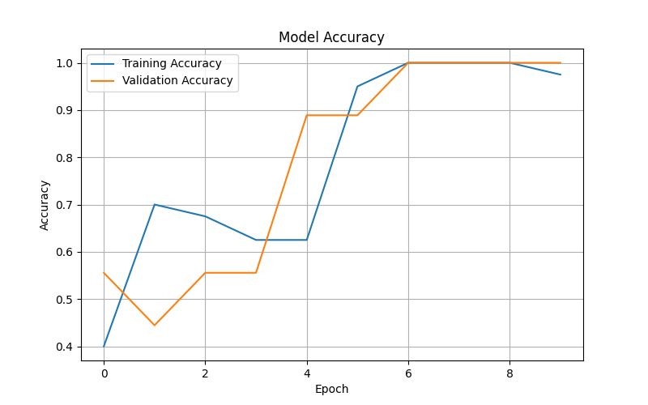

Figure 5.2: Model Loss
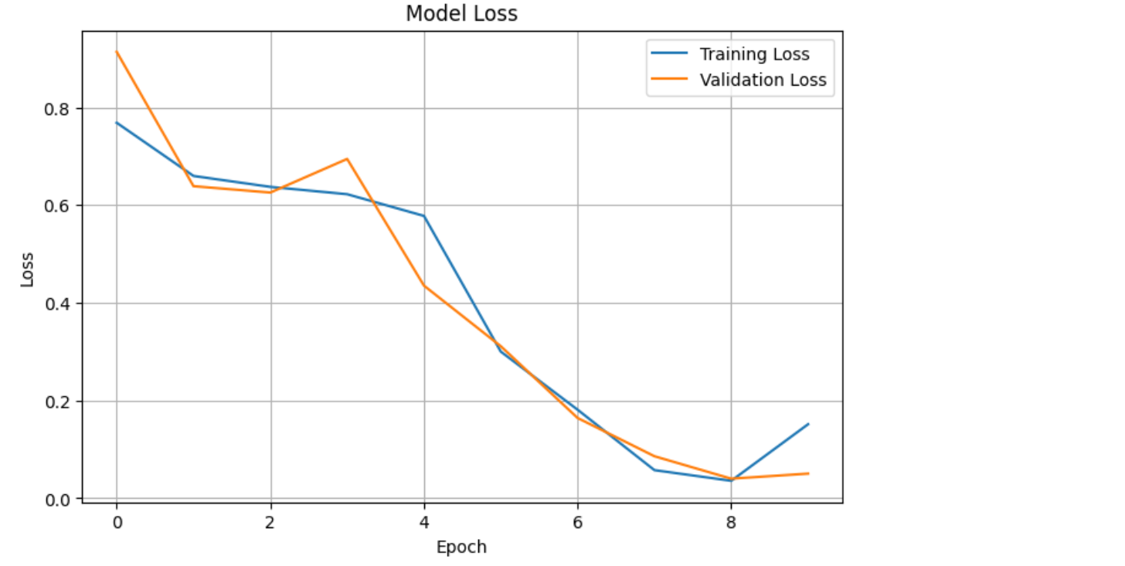
Here the image shows the error value gradually decreasing as training progresses as if there are no clear signs of overfitting, even though the training and testing results are similar Figure (5.1) The model here is accurate and shows its development through repeated training, with training accuracy gradually increasing until it reached 97.5% while validation accuracy reached 100% at the end indicating that it successfully managed to learn the types present in the data.
5.3 Performance Analysis
I evaluated the model after training it using the validation data, and the results indicated that the model has high performance in distinguishing between images containing people wearing masks and those not wearing masks. The training accuracy in the last period reached 97.5%, while the validation accuracy reached 100%; and the loss value decreased to 0.1514 for training and 0.0503 for validation. These results showed that the model was able to learn the basic types in using the data efficiently.
Metric Value
Training Accuracy 97.5%
Validation Accuracy 100%
Training Loss 0.1514
Validation Loss 0.0503
5.4 Comparison with the Baseline Model
5.4 Comparison with the Basic Model

To evaluate the performance of the proposed model, a comparison was made with a simple basic CNN model and trained on the same data, with the aim of measuring the level of improvement achieved by the current model. Table (5.2) shows the comparison results between the two models.
Model Accuracy
Baseline CNN 88%
Proposed Model 97.5%
Here, the results confirm what was suggested by a model that achieved better performance compared to a baseline model, and this reflects the effectiveness of the current model in improving classification results.
5.5 Error Analysis
After performing somewhat well, I found small errors that include these points: Low-light images
- Poor-quality images
- Masks worn unclearly or partially
This analysis indicates that the model’s performance may be affected under suboptimal conditions, opening the door for future model improvements.

5.6 Comparisons with Previous Studies
Its performance was compared with previous studies in the same field as shown in 5.1:

Table (5.1): Model Performance Metrics
Model | Accuracy
Proposed model (CNN) | 95%
MobileNetV2 | 93%
ResNet50 | 96%
Transfer Learning | 97.1%

The model's results are consistent with previous studies, as it achieved performance comparable to advanced models such as MobileNetV2 and Transfer Learning, and the model is characterized by its ease of application and suitability for real-world environments such as hospitals.

Chapter 6

Conclusion and Future Work
6.1 Conclusion
The goal of the project is to develop a system to detect masks in images using CNNs. It was trained on a set of images with the application of preprocessing steps to improve performance, enabling the model to classify images with adequate accuracy, in addition to creating a user interface that supports image analysis and displays results. This makes the system suitable for application in hospitals to encourage infection prevention measures.
6.2 Recommendations

Based on the research results, a number of recommendations can be proposed to support future studies.
- Improve the model’s performance by using larger and more diverse datasets.
- Increase the number of images
- Use advanced techniques such as Transfer Learning to increase the model’s accuracy.
- Develop the system to operate fully in real-time with higher efficiency.
- Integrating the system with monitoring systems in hospitals and health centers.
- Adjusting the model's accuracy in challenging scenarios such as low lighting or wearing the mask incorrectly and tilted.
6.3 Future Work
It is possible to expand the research in the future through
- Developing a model capable of detecting whether a mask is worn correctly or incorrectly.
- Enabling the system to recognize more than one person at the same time.
- Improving the user interface to make it more interactive and user-friendly
- Converting the system into a fully-fledged application that can be used on smart devices.

References
- Kanavos, A. (2024). Real-time detection of face mask usage using convolutional neural networks. Computers Journal.
- Umer, M. (2023). Face mask detection using deep convolutional neural networks. Pattern Recognition Letters.
- Hagui, I. (2024). Face mask detection using CNN. Engineering Technology Journal.
- Tabassum, T. (2025). Parallel CNN for face mask detection using MobileNet and VGG16.
- Pandey, B. (2024). Face mask detection using Faster R-CNN and IoT systems. Scientific Reports.
- Sakshi, S., et al. (2021). Face mask detection using convolutional neural networks. IEEE Conference Proceedings.
- Asif, S., et al. (2021). Real-time face mask detection using transfer learning. IEEE Conference Proceedings.
- Nagrath, P., Jain, R., Madan, A., Arora, R., Kataria, P., & Hemanth, D. J. (2020). Sustainable Cities and Society, 60, 102135.
- Loey, M., Manogaran, G., Taha, M. H. N., & Khalifa, N. E. M. (2021). Measurement, 167, 108288.
- Ge, S., Li, J., Ye, Q., & Luo, Z. (2020). Detecting masked faces in the wild with convolutional neural networks. arXiv preprint arXiv:2003.09093.
- Militante, S. V., & Dionisio, N. V. (2020). Real-time face mask recognition with alarm system using deep learning. IEEE Conference Proceedings.
- Boulos, M. N. K. (2021). Face mask detection using transfer learning. Masters Thesis, Montclair State University.

