Clarivision AI: An Explainable Hybrid Framework for Residential Property Valuation and Similar Property Retrieval Using Structured Data and ResNet50-Based Deep Visual Features
Hassan Mohammed Ahmed Alamer Khalifa
ORCID ID: 0009-0006-0611-1563
Collage of Informatics, Midocean University, Comoros
Email: hassanalamer2019@gmail.com
Supervisor Name: Dr / Amjad Qtaish

Abstract
Objectives: In this paper, I develop a Clarivision AI - an explainable hybrid framework for residential property valuation by combining structured property attributes and deep visual features from ResNet50 and improving model interpretability through Explainable Artificial Intelligence (XAI).
Study Location: Tested on the Real Estate with Images dataset comprising 15,474 residential properties along with structured and image data.
Methodology: Preprocessed structured attributes and combined them with ResNet50 deep visual embeddings to get hybrid features and built XGBoost regression model for valuation and SHAP to interpret feature contribution and included the Similar Property Retrieval mechanism based on cosine similarity and created an interactive decision support interface through AStreamlit.
Results: Obtained excellent valuation results: MAE = 0.20985, RMSE = 0.29112, R² = 0.67375 and provided an explanation of model predictions. Also provided decision support functionality with similar property retrieval and visualization tools.
Recommendations: To include more structured and visual property attributes. To test framework on datasets from other countries. To apply more XAI methods. To extend the framework with property classification and cloud deployment of AI models.
Keywords: (Residential Property Valuation, Explainable AI (XAI), Hybrid Machine Learning, ResNet50, XGBoost, Similar Property Retrieval)

- Introduction.
The real estate industry is critical to the growth of an economy and in making decisions. The accurate valuation of residential properties is critical for the buyers, sellers, financial institutions, and the government organizations. Nonetheless, the conventional methods of property valuation are majorly dependent on human knowledge and the structured data, hence making the process subjective, inconsistent and time-consuming because of the dependence on the quality of the information regarding the property.
However, recent developments in Artificial Intelligence (AI) and Machine Learning (ML) have greatly enhanced the accuracy of the Automated Valuation Models (AVMs). Some of the latest prediction algorithms like Random Forest, XGBoost, and Deep Learning have shown great performance in terms of their ability to identify non-linear relations between the attributes of the properties and market prices. However, most Automated Valuation Models (AVMs) still depend mainly on the structured attributes of the property while ignoring the visual information available from residential property pictures. Moreover, many of the AI valuation systems remain black boxes hence reducing the understanding of the valuation process.
In order to overcome the limitations described above, this paper puts forth Clarivision AI, a novel explainable hybrid approach for fusing structured property attributes with deep visual representations obtained via the ResNet50 convolutional neural network. Structured numerical property attributes and deep visual representations are fused in the hybrid learning architecture based on XGBoost, and SHapley Additive explanations (SHAP) are used for explaining predictions made by the model. In addition, Clarivision AI includes a Similar Property Retrieval component, where visually similar residential property listings are retrieved via cosine similarity measure over deep image embeddings.
Even though recent research showed significant improvements in residential property valuation by applying machine learning, multimodal learning, and XAI techniques, most of the available solutions consider these components separately. There are very few papers that introduce the framework combining all the discussed aspects into one decision-support solution. It is exactly this research gap that motivates the introduction of Clarivision AI hybrid framework.
The key contribution of the study is the creation of an integrated explainable decision support system which integrates hybrid property valuation, visual similarity search, model interpretability, and interactive reporting in one intelligent system. The experiment shows that the developed framework is not only better at valuating residential properties but also increases the transparency, usability, and trustworthiness of real estate decision making.

2. Research Problem
Although there have been tremendous advances made in the application of Artificial Intelligence (AI) in Automated Valuation Models (AVMs), some drawbacks continue to affect the accuracy, explainability, and usability of the available systems for residential properties. For instance, most of the valuation systems consider structural properties of the house such as size and number of rooms but ignore other visual cues about the property's appearance. Moreover, most of the existing deep learning-based valuation models are black box systems that make it hard for the user to comprehend how decisions are made by the valuation system. This limitation calls for the development of Explainable Artificial Intelligence (XAI) techniques to increase model explainability and user confidence. Although these models are capable of predicting prices accurately, they do not offer adequate explanations about their decisions, thus limiting the trust users have in such models. Additionally, previous research work focuses only on property price prediction without incorporating other decision support features like property matching, interactive visualization, and report generation.
Thus, it becomes necessary to have a hybrid explainable valuation system, which could incorporate structured property features, deep vision-based visual features, predictability and explainability, similar property searches, and decision support in an all-in-one intelligent system. Clarivision AI has been designed to overcome these drawbacks to provide precise and understandable valuation of residential properties.
Hence, the purpose of this study is to overcome the shortcomings of current residential property valuation systems and design an integrated Explainable Artificial Intelligence system, which would help with accurate predictions and decision making.

- Importance of the Study.
The significance of this research can be discussed in two different angles; an academic angle, and a practical angle. In terms of academic significance, this work will contribute to the emerging field of Explainable Artificial Intelligence (XAI) for residential property valuation through its suggested hybrid model which combines structured property attributes and visual features generated using the ResNet50 convolutional neural network. While conventional Automated Valuation Models (AVMs) lack explainability, the proposed model increases transparency in predictions via Shapley Additive explanations (SHAP) such that the user understands how the structured property attributes affect the predicted value.
On the other hand, in terms of practical significance, the proposed Clarivision AI framework offers an intelligent decision support tool combining the processes of residential property valuation, explainable prediction, Similar Property Retrieval, interactive visualization dashboards, and PDF generation into one.
In addition, this research also illustrates that multimodal data fusion can lead to improved valuation accuracy, interpretability, and usability at the same time. Through the combination of hybrid prediction, Explainable Artificial Intelligence, Similar Property Retrieval, and reporting functions into one intelligent system, Clarivision AI sets an example for future explainable residential property valuation solutions.

4. Study objectives
The key goals for this study include:
• Developing a hybrid residential property valuation model by combining structural and visual features from property attributes using ResNet50.
• Conducting research to increase the accuracy of residential property valuation using an XGBoost regression model.
• Increasing the transparency and explainability of the developed models using Shapley Additive explanations (SHAP).
• Creating a Similar Property Retrieval module using cosine similarity on ResNet50 visual features.
• Building an interactive decision support platform (Clarivision AI) that includes residential property valuation.
5. Theoretical Literature of the Study.
Real estate valuation has changed remarkably during recent decades from conventional valuations methods towards intelligent Artificial Intelligence (AI) approaches. The conventional approaches to real estate valuation heavily rely on professional appraisers who calculate property values using their market experience and property characteristics. However, despite the widespread use of these valuation methods, they are typically time-consuming and inconsistent.
The rapid advancement in Machine Learning (ML) has resulted in remarkable improvements in Automated Valuation Model (AVM) performance. Such ML algorithms as Decision Trees, Random Forest, Gradient Boosting Machines, and XGBoost have shown remarkable ability to model complicated nonlinear relations between property characteristics and market prices. They have been constantly showing superiority in capturing complicated nonlinear relations between property characteristics and market prices which resulted in more accurate property valuations than conventional statistical approaches.
In more recent times, however, Deep Learning approaches have brought new possibilities to the domain of property valuation in that they use visual information derived from property pictures. ResNet50 CNNs, for example, have demonstrated outstanding capability in capturing architectural specifics, visual appearance of the house, its external state, which is impossible to encode in numeric form. Structured data combined with deep visual features can thus be viewed as an effective solution to improving the accuracy of residential property valuation models.
However, even with the development of new solutions, many AI-based valuation models lack interpretability. In order to solve this problem, a new approach called Explainable Artificial Intelligence (XAI) was proposed. Being an approach that gives transparent explanations of model outputs, it makes models easier to interpret. One of the most commonly used XAI techniques is SHapley Additive exPlanations (SHAP). This transparency increases user confidence and makes AI-driven models easier to adopt. In terms of residential property valuation, SHAP allows users to find out how much every property attribute contributes to the predicted price of the house.
Thus, recent research efforts have concentrated on designing hybrid explainable valuation models by combining structured information with deep visual features. Extending this research line, the proposed Clarivision AI model is designed to integrate structured information, deep visual features using ResNet50 architecture, prediction using XGBoost algorithm, SHAP explanations, Similar Property Retrieval, and decision support functionality in an intelligent platform.
6. Review of Previous Studies.
The latest developments in Artificial Intelligence (AI) and Machine Learning (ML) have greatly revolutionized the field of residential property valuation. The current literature indicates that the earlier research works could be classified into four main categories:
(1) structured-data valuation approaches.
(2) deep learning and multimodal valuation.
(3) Explainable Artificial Intelligence.
(4) Intelligent Decision-Support Systems.

6.1 Structured-Data Valuation Models
Machine learning studies conducted at the initial stages have concentrated mainly on structured numerical property attributes like property size, property location, number of bedrooms, and historical records of transactions. Wang et al. (2022) have suggested the Geographically Neural Network Weighted Regression (GNNWR) model for evaluating the residential property in Shenzhen, China, indicating that geographic information can significantly improve the valuating accuracy as compared to the conventional regression model. Likewise, Mora-Garcia et al. (2022) have compared various machine learning algorithms used for predicting the housing price in the COVID-19 period and found that ensemble learning models outperform conventional statistical models.
These studies show the usefulness of the structured numerical attribute for automated property valuing, but they have considered only tabular data and did not take into account any visual attributes that can affect the residential property price.
This shortcoming motivated researchers to conduct the studies related to image-based and multimodal learning.

6.2 Deep Learning and Multimodal Property Valuation
To address the shortcomings of using structured data methods, more recent research used deep learning methods that could derive visual information from images of residential properties. Yazdani and Raissi (2023) introduced the idea of a self-supervised vision transformer model to be used in real estate valuation and found that the visual information obtained from residential property images enhances prediction accuracy. Deng et al. (2025) showed that the combination of structured property information with image-based deep learning features can help boost valuation accuracy due to multimodal learning. The same is confirmed by Huang et al. (2025).
It was found that multimodal fusion models are better than machine learning methods in that they use both visual and structured information. However, the main goal of these studies was the prediction performance, not the creation of a unified decision-making environment.

6.3 Explainable Artificial Intelligence in Property Valuation
In line with the complexity increase of machine learning models, efforts were made to enhance the transparency and interpretability of models. Specifically, Gunes (2024) examined the application of model-agnostic explainable artificial intelligence methods for valuation of residential properties and found that interpretable machine learning enhances users’ comprehension of the model. Likewise, Maselli and Nesticò (2025) stressed the need for Explainable Artificial Intelligence (XAI) to improve the transparency and trust of users in automated valuation models of property. Kee and Ho (2025) also underscored the significance of explainability in developing trustworthy AI models for residential property valuation, especially in decision-making processes.
Although these approaches enhanced the transparency of models, they failed to combine other decision support services like similar properties search, interactive dashboards, and automatic reports among others.
6.4 Intelligent Decision-Support Systems
Recently, studies have been carried out on intelligent decision support systems which go beyond mere property price prediction. For instance, Geerts et al. (2025) evaluated the use of large language models in real estate appraisal, thereby showing how they can be used to aid valuation processes. Nonetheless, the study was mostly concerned with textual reasoning and appraisal rather than a complete valuation system.
The recent body of research shows great advancements in prediction accuracy, multimodal learning, and explainable AI. However, most of the research carried out on these aspects does so individually without incorporating them into a single intelligent framework that aids real estate decision-making.
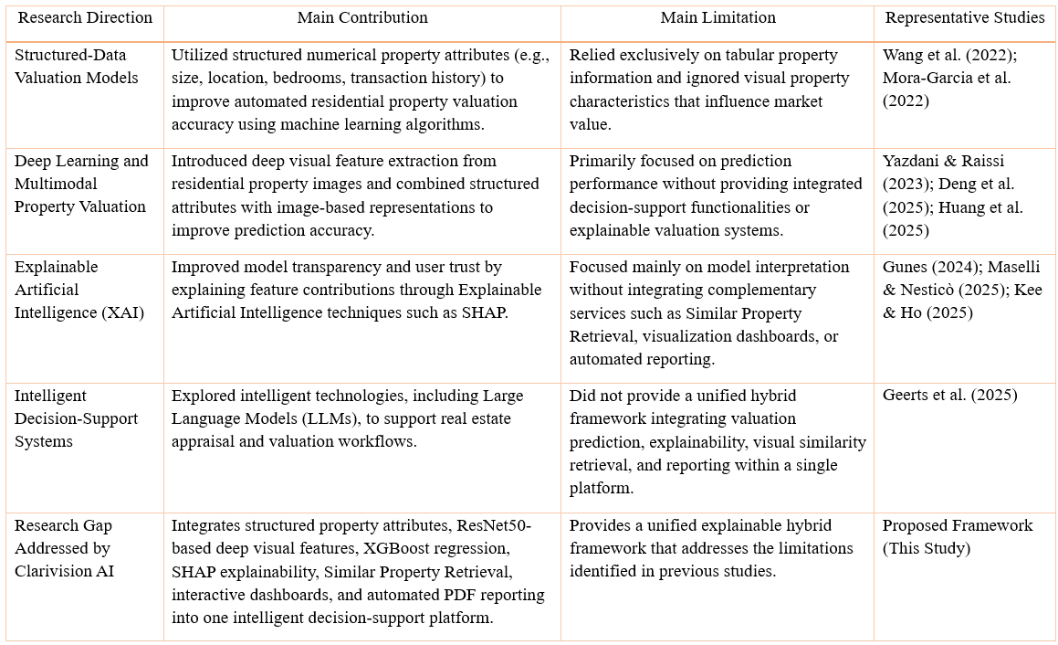
Unfortunately, there was still no proper integration among valuation prediction, visual similarity evaluation, explainability, and report generation.
Figure 1: Comparative Summary of Previous Research Directions in Residential Property Valuation

6.5 Research Gap
From the above literature review, previous research works have greatly enhanced residential property valuation using machine learning algorithms with structured data, multimodal learning techniques, and Explainable Artificial Intelligence (XAI). Nevertheless, to the best of the author's knowledge, none of the reviewed research works has come up with a comprehensive framework that combines structured property features, deep visual representations, hybrid property valuation, SHAP-based explainability, Similar Property Retrieval, interactive visualization dashboards, and automated PDF reporting in one intelligent decision support system.
In order to fill this gap, this research work introduces a new framework called Clarivision AI, which integrates structured property features with ResNet50-based deep visual representations using the XGBoost regression algorithm.
7. Methodology.
This research makes use of an experimental research methodology approach to develop, deploy, and test Clarivision AI, an explainable hybrid system for residential property valuation. This proposed methodology uses structured property features together with deep visual features that are derived from the image of the residential properties to increase the accuracy of valuation prediction with transparency of prediction through Explainable Artificial Intelligence (XAI). In total, the methodology is composed of five sequential phases as presented in Figure 1.
There are five distinct stages in this research methodology.
First involves the collection and preprocessing of structured property features that include the city, property size, number of bedrooms, and number of bathrooms. This was done simultaneously with the resizing of the residential property images.
Second entails extraction of the deep visual features by employing the pre-trained ResNet50 Convolutional Neural Network. These extracted image features were then combined with the structured property features in order to generate a hybrid feature vector representation of each residential property.
Third, the hybrid feature vectors were utilized to train an XGBoost regression model for valuing residential properties. Performance evaluation of the model was done using common regression metrics, which include the Mean Absolute Error (MAE), the Mean Squared Error (MSE), the Root Mean Squared Error (RMSE), and the Coefficient of Determination (R²). Moreover, k-fold cross validation was done in order to determine the robustness of the model and its generalizability.
Fourth, SHAP (Shapley Additive explanations) was used to explain how each structured feature contributed towards the value of the predicted residential property price.
Finally, the framework has been built with the Similar Property Retrieval module that finds out visually similar residential properties using cosine similarity on the feature vectors of ResNet50. All modules have been incorporated into Clarivision AI Platform built using AStreamlit.
Therefore, Clarivision AI extends the current state of the art by combining prediction accuracy, explainability, visual similarity retrieval, and practical decision-support functionalities within a single integrated framework.

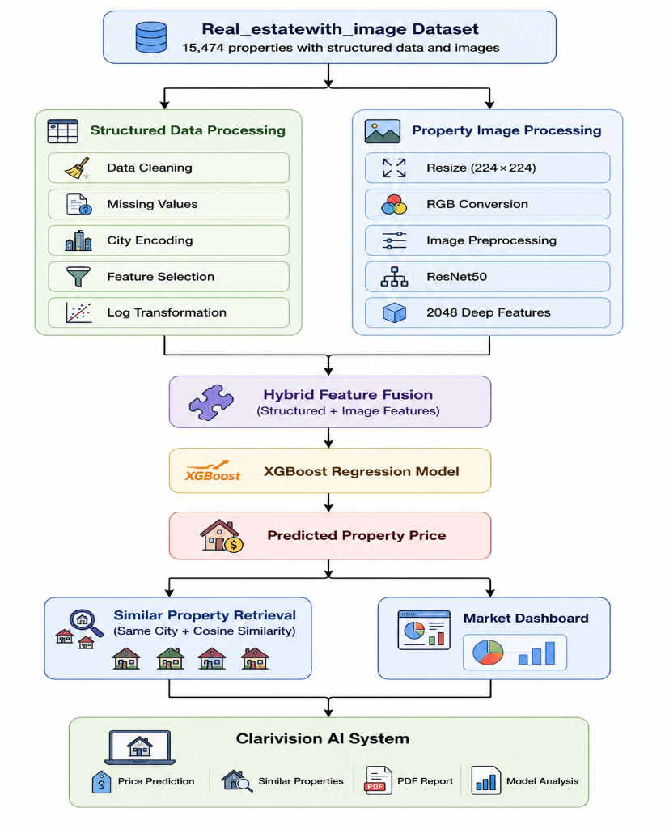
Figure 2: Overall Architecture of the Proposed Clarivision AI Framework
Figure 2 presents the architecture of the overall design of the proposed Clarivision AI framework. The framework starts from the real estate dataset in multimodal form that has structured property features and residential property images. The structured data goes through the process of data cleaning, data preprocessing, and feature engineering, and the images go through the processing by the ResNet50 convolutional neural network to extract the visual deep features. These two types of feature sets are combined in a unified hybrid form to be used as training data for the XGBoost regression model of residential property valuation. The resulting valuation is further used by the modules of Similar Property Retrieval and interactive visualization dashboard in the process of decision-making. Lastly, all the modules are combined in one Clarivision AI platform.

8. Results
Clarivision AI model has been tested on the dataset of Real Estate with Images which comprises of 15,474 residential properties with both structured data and the property images. The experimental testing was carried out in order to examine the viability of the proposed hybrid model for residential property appraisal. In particular, the experiments involved evaluating the model in the following four perspectives: (1) predictive ability using regression measures, (2) comparison of the model with traditional machine learning models, (3) importance of features using SHAP Explainability, and (4) efficiency of the Similar Property Retrieval module. The results provided below show the potential of the proposed model in supporting residential property valuation.

8.1 Performance Evaluation of the Proposed Hybrid Model
The accuracy of the proposed Clarivision AI framework is assessed in terms of four common regression-based metrics to conduct a complete evaluation of the proposed model’s effectiveness:
• MAE – Mean Absolute Error
• MSE – Mean Squared Error
• RMSE – Root Mean Squared Error
• R² - Coefficient of Determination
Each of these evaluation metrics reflects different characteristics of the prediction effectiveness such as average prediction error, the variation in the prediction error and the percentage of explained variance. As can be seen from the experimental results, the proposed hybrid framework shows good prediction accuracy as well as consistency of performance and stability of the model.
Table 1. Performance Evaluation of the Proposed Clarivision AI Framework
Metric | Value
Mean Absolute Error (MAE) | 0.20985
Mean Squared Error (MSE) | 0.08475
Root Mean Squared Error (RMSE) | 0.29112
Coefficient of Determination (R²) | 0.67375

From Table 1 above, it can be seen that the proposed Clarivision AI approach performed well in predicting the residential property valuations. The MAE value is 0.20985, while the RMSE value is 0.29112, which shows that there are low error rates in prediction. Additionally, the R² value of 0.67375 indicates that 67.4% of the variance in the residential property prices is accounted for by the proposed hybrid approach.

8.2 Comparison with Conventional Machine Learning Models
In order to assess the efficacy of the proposed AI framework called Clarivision, its prediction capabilities were assessed in comparison with a machine learning algorithm that relies only on structured property data (XGBoost).
Table 2: Performance Comparison Between the Structured XGBoost Model and the Proposed Clarivision AI Framework
Model | MAE | RMSE | R²
XGBoost (Structured Only) | 0.22924 | 0.31369 | 0.62749
Clarivision AI (Hybrid) | 0.20985 | 0.29112 | 0.67375

The comparative analysis conducted in Table 2 reveals the fact that the suggested Clarivision AI architecture consistently outperforms the structured data-only XGBoost architecture according to all evaluation criteria. In particular, the hybrid architecture decreases both the MAE and RMSE values and increases the R² value from 0.62749 to 0.67375. This suggests that incorporating deep visual features generated by ResNet50 allows capturing additional information that cannot be captured using only the structured numerical features.
8.3 Cross-Validation Results
In order to test the consistency and generalizability of the suggested Clarivision AI framework, five-fold cross-validation was carried out using the hybrid feature set. The model was tested and trained on the five validation folds, and the average predictive performance was calculated based on the same regression evaluation measures.
From the experimental results it can be seen that the suggested framework showed stable and reliable performance in all validation folds, thereby ensuring its stability and good generalization ability. The relatively low variations in the performance measures suggest that the hybrid model is robust and does not suffer from any signs of overfitting.
Table 3: Five-Fold Cross-Validation Results
Metric | Standard Deviation
MAE | 0.2099
RMSE | 0.0848
R² | 0.2911
The small value of standard deviation for all evaluation measures is evidence of the consistency of the prediction model within the hybrid framework in each of the five validation sets.
8.4 Feature Importance Analysis
The importance of features was analyzed using SHapley Additive exPlanations (SHAP) in order to show how much influence does the set of structured features have on the value predicted for residential properties. Using SHAP helps to improve transparency of machine learning model by quantifying the contributions of every single feature used in making predictions. As can be seen from Figure 2, the property size (sqft) turned out to be the feature having the biggest impact on the prediction process with its contribution amounting to about 50.16%. This was followed by city (28.56%), number of bathrooms (14.28%) and number of bedrooms (7.00%). It means that the size of the property is the most important factor influencing the predicted value of residential property, while the location and interior features provide some additional information that can be useful for improving prediction accuracy.

Sqft ██████████████████████████ 50.16%
City ███████████████ 28.56%
Bathrooms ███████ 14.28%
Bedrooms ███ 7.00%
Figure 3: SHAP Feature Importance of Structured Property Attributes

The SHAP analysis illustrates the relative contribution of each structured property attribute to the valuation model. Property size (sqft) contributed the most (50.16%), followed by city (28.56%), bathrooms (14.28%), and bedrooms (7.00%).

8.5 Similar Property Retrieval
The Similar Property Retrieval module, designed for use in residential property valuation based on retrieving visually similar properties using the cosine similarity algorithm calculated over the feature vectors generated by the ResNet50 convolutional neural network, was created to facilitate visual comparison of the properties. To increase the precision of retrieval, the search process was limited to properties located in the same city.
The visually similar residential properties retrieved had a high level of similarity to the query image. The effectiveness of the visual representation used allowed capturing visually significant characteristics of the objects. The possibility of visually comparing similar objects is a valuable functionality that gives an extra decision-making tool besides the numerical prediction of property value. Therefore, the Similar Property Retrieval module increases the practicality of the Clarivision AI application and makes it different from traditional Automated Valuation Models (AVMs) which usually make numerical price predictions only.
Unlike traditional residential property valuation systems that only estimate the market price of a property, Clarivision AI combines the estimation and visual comparison of the objects.

Figure 4: Similar Property Retrieval Results
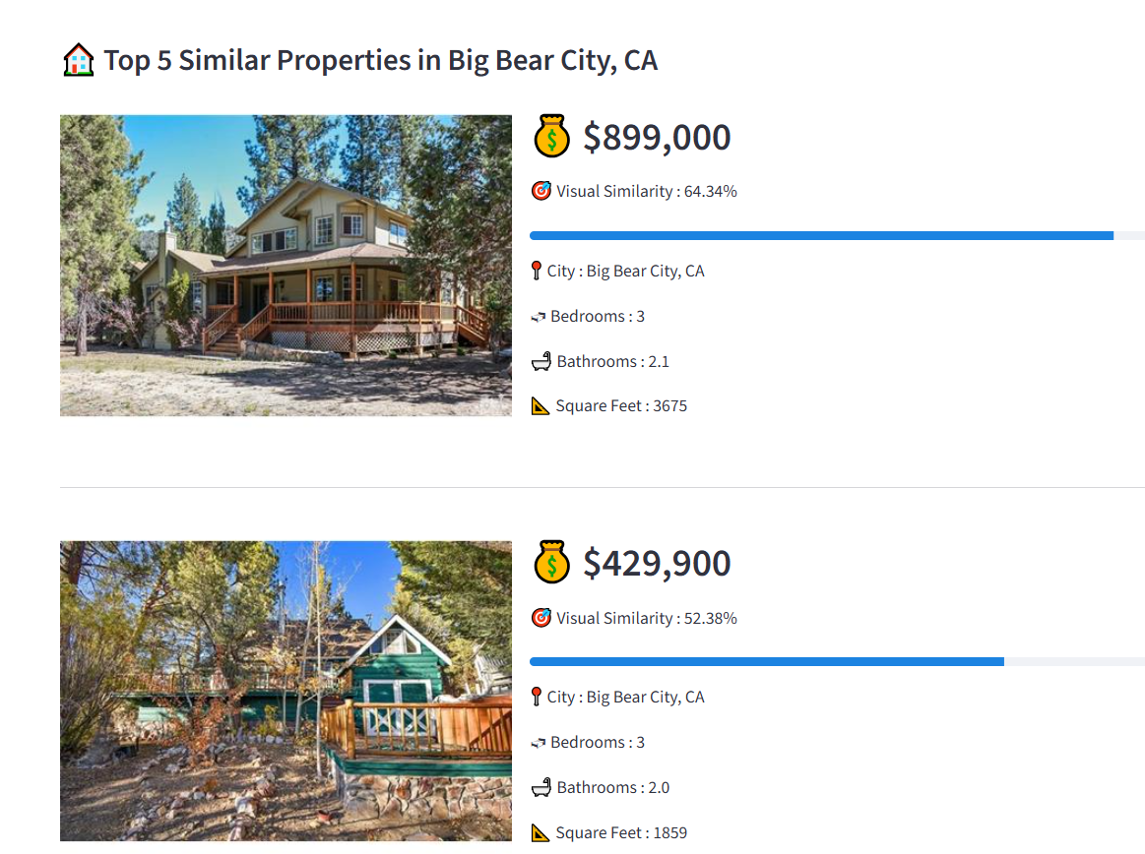
The Similar Property Retrieval module retrieves the Top-5 visually similar residential properties using cosine similarity over deep visual embeddings extracted by ResNet50. Each retrieved property includes its market price, similarity score, and key structured property attributes, providing additional evidence to support the estimated property valuation.

8.6 Property Information Interface
The Property Information Interface is the place where users can enter the required structured data related to the property, including city, number of bedrooms, number of bathrooms, size of the property (square feet), and uploading the image of the residential property. After entering the required data, users can click on the “Predict Property Price” button to find the predicted price of the property using the proposed Clarivision AI framework.
The proposed interface serves as the primary interface to access the system and is convenient for performing the process of residential property valuations.
The Clarivision AI framework design contains all the elements of the proposed framework in a decision support environment that allows users to perform the following actions: perform residential property valuations, view the SHAP explanations, retrieve visually similar properties, access the visualization dashboards, segment the market of residential property, and generate PDF reports.
In addition to that, the combination of all those abilities into one system improves the ease of use by delivering an effective, clear, and informative way of making decisions regarding real estate. As opposed to the common practice when AVMs only deliver numeric values, Clarivision AI delivers an interactive system combining valuation prediction, visual analysis, and intelligent decision-making service.

Figure 5. Main interface of the proposed Clarivision AI decision-support platform.
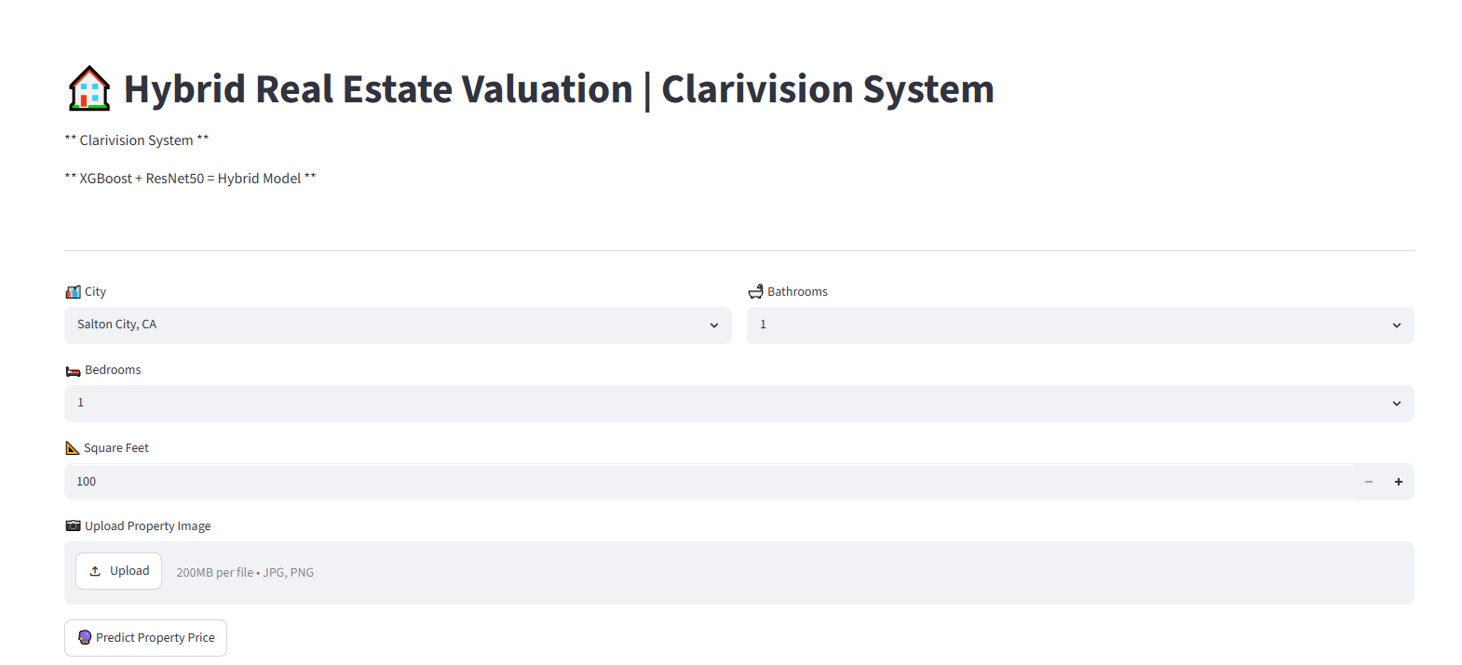
The user interface used to enter structured property attributes and upload a residential property image before performing property valuation using the proposed Clarivision AI framework.

8.7 Property Information and Price Prediction Interface
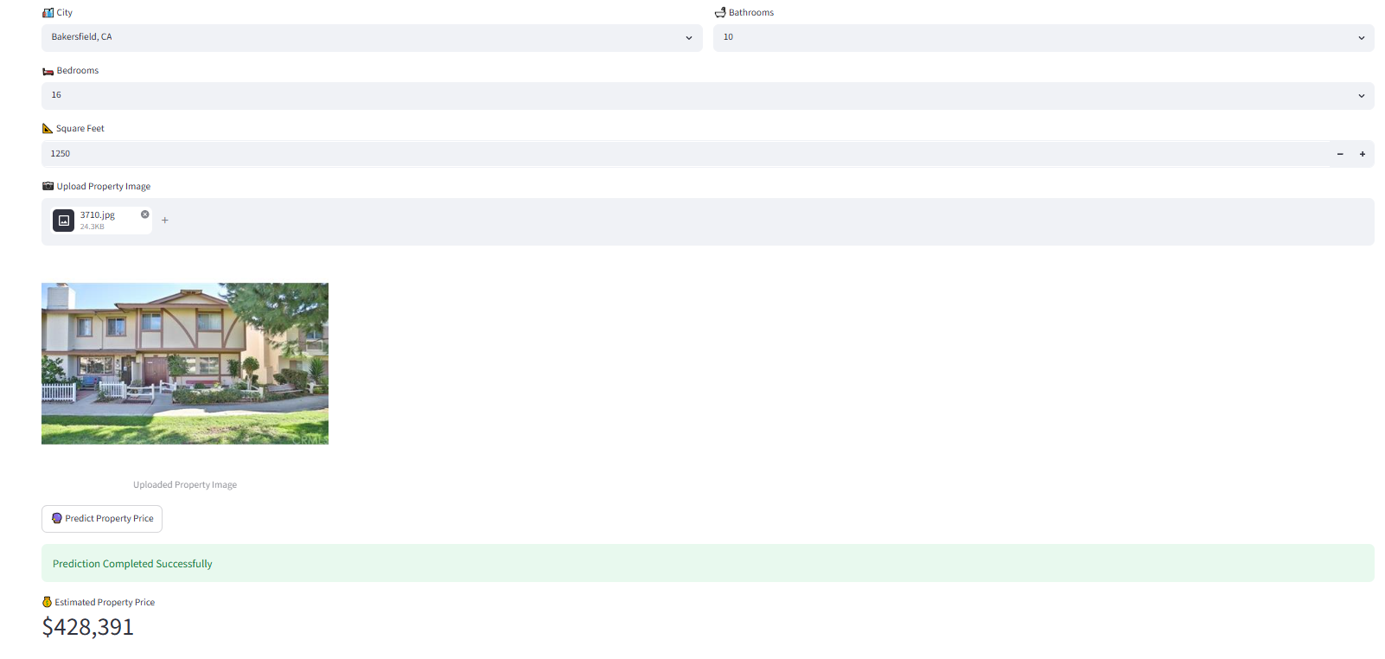
The first step in the proposed Clarivision AI-based method is to gather both the structured attributes of the property as well as the image of the residential property using a user interface. The users provide all the necessary details regarding the city, number of bedrooms, number of bathrooms, size of the property in square feet, and the property image. After gathering the necessary information, the system then evaluates the input data and estimates the value of the residential property based on the proposed hybrid model.
Figure 6: Property Information and Price Prediction Interface
Figure 6: Property Information and Property Value Prediction Interface. Users can use the interface to enter information about properties in the form of city name, number of bedrooms, bathrooms, total square feet of the property, and a picture of the residential property. Clicking on Predict Property Value will result in prediction of the residential property value using Clarivision AI model.

8.8Clarivision AI Prediction Dashboard
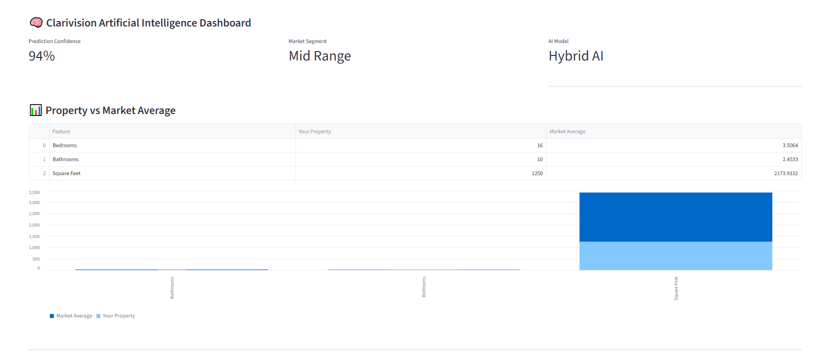
The Clarivision AI Dashboard provides an interactive visualization of the valuation results generated by the proposed framework. It presents the estimated market category, prediction confidence, AI model information, and a comparison between the evaluated property and the average market characteristics. This visualization enhances users' understanding of the valuation outcome and supports transparent decision-making through an intuitive graphical interface.
Figure 7: Clarivision AI Prediction Dashboard.
As shown in Figure 7, the Clarivision AI prediction dashboard displays the predicted value of the residential property, along with the prediction confidence score, the market classification, AI model details, and an interactive comparison of the property to be evaluated with the average market attributes. The dashboard enables users to have a clear visualization of residential property valuation.

8.9: Automatic PDF Report Generation
As per the proposed Clarivision AI architecture, once the prediction phase is complete, an automatically generated PDF valuation report is created by the system. The contents of the PDF report include the uploaded image of the residential property, attributes of the property, predicted market value, decision confidence level, market type categorization, AI generated decision conclusion, and similar residential properties that have been found by the system.

Figure 8: Automatically Generated PDF Valuation Report.
Figure 8 Automatically Generated PDF Report Valuation. An example of the automatically generated PDF report from the proposed Clarivision AI framework that contains information about the property, estimated market value, confidence level, market type, AI decision, and similar properties.

8.10 Automatic PDF Valuation Report
The proposed Clarivision AI framework automatically generates a comprehensive PDF valuation report after completing the prediction process. The report summarizes the valuation results in a structured format, enabling users to save, print, or share the valuation outcome. It serves as a practical decision-support document for real estate agencies, financial institutions, investors, and property owners.
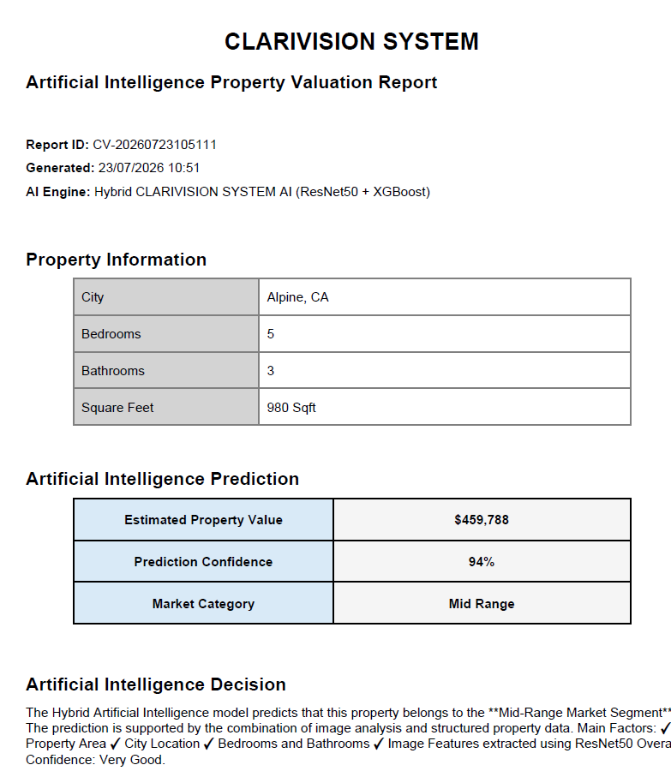

Figure 9: Automatically Generated Property Valuation Report.

Figure 10: Automatically Generated Property Valuation Report
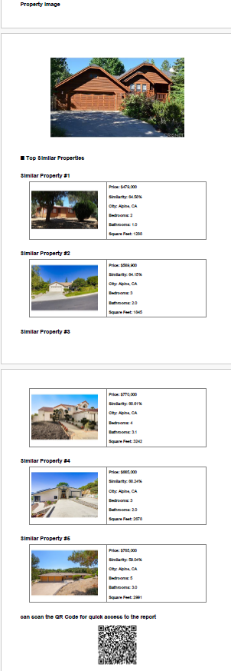
Figure 10. Similar Property Retrieval Results in the PDF Report. The automatically generated report summarizes the uploaded property and the Top-5 visually similar residential properties, including their market prices, similarity scores, and key property attributes to support valuation decisions.

9. Discussion.
As can be seen from the experimental results, the proposed Clarivision AI approach is effective in utilizing structured property features and deep visual representations for better prediction of the value of residential properties. In comparison with traditional structured data models, the hybrid approach performed better, which suggests that the visual features obtained using ResNet50 provide additional information not available from structured numerical features alone.
The exploratory data analysis demonstrated that the dataset is suitable for machine learning tasks and contains no missing values and well-distributed structured features. Besides, both correlation analysis and SHAP feature importance revealed property size (sqft), city, bathrooms number, and bedrooms number to be most important for valuation of property. This is consistent with existing studies on residential property valuation, which identified property size and location as the main determinants of its market value (Mora-Garcia et al., 2022; Wang et al., 2022).
The developed hybrid framework gave an R² score of 0.67375, implying that around 67.4% of variance in the price of residential properties could be attributed to the structured and visual feature set together. This finding is in line with existing evidence suggesting that multimodal learning contributes positively towards valuation performance through the use of complementary information extracted from disparate sources. The same has been corroborated by the findings of Deng et al. (2025) and Huang et al. (2025), who found that integration of structured property information and visual representations improves residential property valuation accuracy.
In terms of robustness validation, it was observed that the developed framework generalizes effectively across various partitions of data. Consistent predictive power with minor variance across five-fold cross-validation runs indicates that there is no overfitting problem in the model.
In contrast to existing studies that mainly concentrate on enhancing either the accuracy of prediction or interpretability of the models separately, the suggested framework combines several intelligent features in one decision-supporting framework. Apart from the evaluation of value of residential property, Clarivision AI features SHAP explanation, Similar Property Retrieval by means of cosine similarity in ResNet50 space, market category classification, dashboards for interactive visualization, and automatic generation of PDF reports. These features convert the framework from the traditional AVM to an explainable intelligent decision support system.
In summary, the experiment results indicate that the incorporation of multimodal learning and XAI is a promising way forward in the development of advanced residential property valuation systems by enhancing the accuracy of predictions, model explainability, and decision-making process.

.10Conclusion
In this study, we have suggested a new methodology named Clarivision AI, which is an explainable framework for residential property valuation combining structured property features and deep visual representation obtained via the use of the ResNet50 convolutional neural network. The proposed methodology includes multimodal feature fusion and XGBoost regression with the purpose to enhance the valuation accuracy and increase the model transparency via SHapley Additive exPlanations (SHAP).
Experimental results have shown that combining structured numerical data with deep visual representation provides significantly better residential property valuation than the traditional structured data approach. The proposed methodology demonstrated reliable prediction performance and strong generalization ability according to the cross-validation results. Moreover, the SHAP analysis helped in understanding the contribution of each property feature, increasing the valuation process transparency.
Whereas other research efforts were mostly concentrated on enhancing prediction performance, the introduced Clarivision AI approach includes several decision support functionalities in one package, such as Explainable Prediction, Similar Property Retrieval, categorization of the market category, interactive visualizing dashboards, as well as automated report generation in PDF format to provide the user with accurate valuation and understandable decision support.
In general, the introduced framework represents an explainable, accurate and useful intelligent framework for residential property valuation. The results illustrate the ability to design next-generation residential property valuation models using multimodal learning and Explainable Artificial Intelligence (XAI).

11. Recommendations
The following are the recommendations based on the results of this research study:
1. Future studies should include additional structured property attributes such as property age, property type, neighborhoods, accessibility, environmental information, and socio-economic information to improve the accuracy of valuating residential properties.
2. The proposed framework can be expanded through the use of more than one image of a property that will include interior, exterior, aerial, and street-view images.
3. Future research should test the proposed framework on residential property datasets from different countries and geographic locations to evaluate the robustness and scalability of the framework.
4. Other explainability techniques such as LIME, Grad-CAM, and Integrated Gradients can be included alongside SHAP for generating explanations of structured attributes and visual features.
5. The Similar Property Retrieval process can be improved through incorporating visual similarity with structured attributes such as geographical location similarity, property type, construction year, market trends, and property conditions.
6. Further developments of Clarivision AI may combine live market data and online real estate listing to enable live valuation of residential properties. The proposed framework may be customized as an operational decision support system for real estate agents, financial firms, mortgage providers and official valuation institutions by combining it with existing systems of real estate information.
7.The future versions of Clarivision AI may include residential property classification, whereby different types of properties are classified according to market segments (for example, Low, Medium and High-valued properties). This will aid further investment analysis and decision-making.
8.The framework may also be offered as a cloud-based intelligent valuation system to be used by real estate agents, financial firms and real estate investors via websites and mobile applications.

References

- Balila, A. E., & Shabri, A. B. (2024). Comparative analysis of machine learning algorithms for predicting Dubai property prices. Frontiers in Applied Mathematics and Statistics, 10, 1327376. https://doi.org/10.3389/fams.2024.1327376
- Despotovic, M., Koch, D., Leiber, S., Döller, M., & Zeppelzauer, M. (2023). Leveraging supplementary modalities in automated real estate valuation using comparative judgments and deep learning. Journal of European Real Estate Research, 16(2), 200–218.
- Deng, L., Chan, E. H. W., Ren, C., & Zhang, X. (2025). Machine learning pipelines for residential property valuation using multimodal features and explainable artificial intelligence. PLOS ONE, 20(5), e0321951. https://doi.org/10.1371/journal.pone.0321951
- Du, X., et al. (2023). DoRA: Domain-based self-supervised learning framework for low-resource real estate appraisal. arXiv. https://arxiv.org/abs/2309.00855
- Geerts, M., Reusens, M., Baesens, B., Vanden Broucke, S., & De Weerdt, J. (2025). On the performance of large language models for real estate appraisal. In Lecture Notes in Computer Science. Springer. https://doi.org/10.1007/978-3-031-94580-5_16
- Gunes, I. (2024). Model agnostic interpretable machine learning for residential property valuation. Journal of Property Investment & Finance. https://doi.org/10.1080/00396265.2023.2293366
- Hasan, M. H., Jahan, M. A., Ali, M. E., Li, Y.-F., & Sellis, T. (2024). A multimodal deep learning-based approach for house price prediction. arXiv. https://doi.org/10.48550/arXiv.2409.05335
- Huang, C., Liang, B., Li, Z., & Chen, F. (2025). Multimodal machine learning for real estate appraisal: A comprehensive survey. In Pacific-Asia Conference on Knowledge Discovery and Data Mining (PAKDD 2025). Springer. https://doi.org/10.1007/978-981-96-8183-9_26
- Kee, T., & Ho, W. K. O. (2025). Explainable machine learning for real estate: XGBoost and Shapley values in price prediction. Civil Engineering Journal, 11(5), 2116–2133. https://doi.org/10.28991/CEJ-2025-011-05-022
- Maselli, G., & Nesticò, A. (2025). Machine learning algorithms and explainable artificial intelligence for property valuation. Real Estate, 2(3), 12. https://doi.org/10.3390/realestate2030012
- Mora-Garcia, R.-T., Cespedes-Lopez, M.-F., & Perez-Sanchez, V. R. (2022). Housing price prediction using machine learning algorithms in COVID-19 times. Land, 11(11), 2100. https://doi.org/10.3390/land11112100
- Rodriguez-Serrano, J. A. (2025). Prototype-based learning for real estate valuation: A machine learning model that explains prices. Annals of Operations Research, 344, 287–311. https://doi.org/10.1007/s10479-024-06273-1
- Wang, Z., Wang, Y., Wu, S., & Du, Z. (2022). House price valuation model based on geographically neural network weighted regression: The case study of Shenzhen, China. ISPRS International Journal of Geo-Information, 11(8), 450. https://doi.org/10.3390/ijgi11080450
- Yazdani, M., & Raissi, M. (2023). Real estate property valuation using self-supervised vision transformers. arXiv. https://doi.org/10.48550/arXiv.2302.00117

