Chapter 3: Methodology

3.1 Introduction
The chapter presents the outline of the model that designed to fit the gaps that been identified in the synthesis of Chapter 2, the suggested system is a tracked deep learning pipeline that incorporates EfficientNet-B4 backbone with Convolutional Block Attention Module (CBAM) as shown in Figure 3.1.
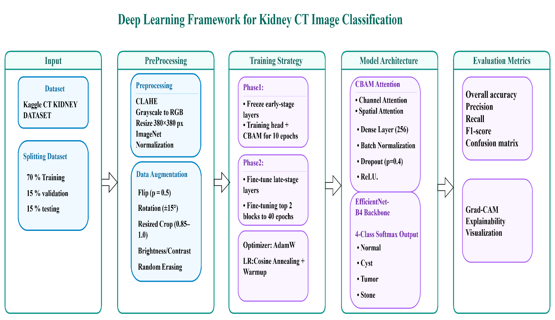
Figure 3.1 Overall Kidney CT Image Classification Framework

3.2 Dataset: Kaggle CT KIDNEY DATASET
The current dataset used in the paper is Kaggle CT KIDNEY DATASET: Normal Cyst Tumor Stone, The data set has 12446 CT image that consists of four classes as given in Table 3.1 and Figure 3.2.

Table 3.1. Class distribution of the Kaggle CT KIDNEY DATASET (12,446 images).
Class | Number of Images | Percentage of Dataset | Clinical Description
Normal | 5,077 | 40.8% | Healthy kidney parenchyma; no lesions or calcifications
Cyst | 3,709 | 29.8% | Fluid-filled renal cysts of varying size
Tumor | 2,283 | 18.3% | Solid renal masses including RCC subtypes
Stone | 1,377 | 11.1% | Calcified hyperattenuating lesions; smallest class
Total | 12,446 | 100% | Mixed axial and coronal CT acquisitions

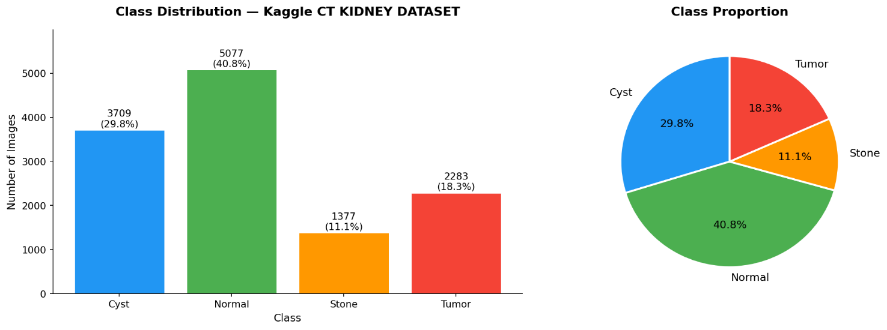
Figure 3.2 Class Distribution Per-Class Visualization

There is a huge imbalance of the classes in the dataset: the Normal is 40.8 percent of all images (5,077 samples), whereas the Stone is 11.1 (1,377 samples) only, which is about 3.7:1. This imbalance is typical in clinical practice of radiology, but causes a systematic training bias in naive deep learning training methods, where models can be very high average accuracy with a high percent correct to simply happen to have learned the major normal distribution mode quite well, at the cost of the rare but clinically important minority classes Tumor and Stone. This is exactly what is dealt with in this framework by the use of class-weighted focal loss as discussed in Section 3.7. The dataset consists of both axial and coronal CT reconstruction images and has both contrast-enhanced and non-contrast studies, therefore, providing scanner heterogeneity and acquisition variability, which puts a generalization test on the model. All the pictures are of JPEG format and difference in original residential spatial space of the picture before standardized in preprocessing.
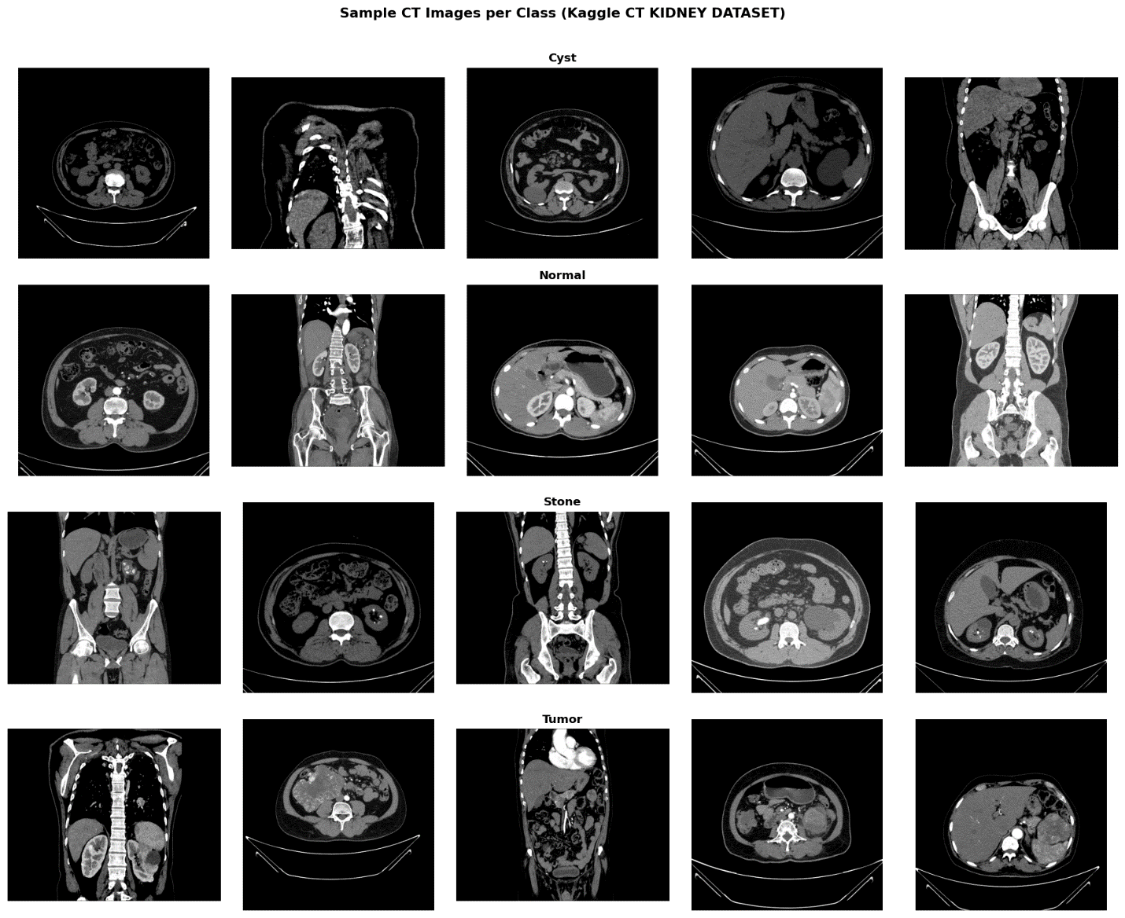
Figure 3.3 Sample Images per Class from Dataset

3.3 Data Preprocessing Pipeline
Before data fed into the deep learning model, a standardized preprocessing pipeline is run to process all the images. There are four consecutive steps in the pipeline, each of which will deal with a particular source of variability or quality reduction in CT imaging data.
Stage 1 — Grayscale to RGB Conversion: CT images are by default grayscale, but the EfficientNet-B4 derives backbone has been pretrained on ImageNet which is a three-channel RGB data source. In order to use the pretrained weights without a change of architecture, every single-channel grayscale image is duplicated into three channels to create a three-channel representation where all the channels store the same intensity information. This strategy aligned with the usual practice in medical image transfer learning and yields the complete advantage of ImageNet pretraining.
Stage 2 — Contrast-Limited Adaptive Histogram Equalization (CLAHE): CLAHE is used to each grayscale image before channel replication with the clip limit at 2.0 and tile grid size of 8 x 8. Without causing the artifacts in excessive amplification that come along with global histogram equalization, CLAHE increases the local contrast of low-intensity lesions edges, especially in the margins of small stones and early-stage tumors.
Stage 3- Space Resizing: this consists resize of all of the images to a 380 x 380 pixels image using bilinear interpolation. This resolution chosen as the ideal input size of EfficientNet-B4.
Stage 4 — Normalization The stage that normalizes pixel intensity values using ImageNet channel-wise mean (μ = [0.485, 0.456, 0.406]) and standard deviation (σ = [0.229, 0.224, 0.225]) which is the standard normalization protocol of all torchvision pre-trained models.

3.4 Data Augmentation Strategy
The concept of data augmentation is implemented only to the training set in order to artificially increase its potential diversity and decrease overfitting. Validation or test sets are not augmented in any way but only undergo preprocessing transformations as outlined in the Section 3.3. The augmentation strategy will be composed to reproduce clinically plausible CT acquisition variations without shifting any textural and morphological features of diagnostic importance. All the augmentations used, and the clinical reasons, are provided in Table 3.2.

Table 3.2. Data augmentation operations applied to the training set.
Augmentation Technique | Parameters
Random horizontal flip | p = 0.5
Random rotation | ±15°
Random brightness / contrast jitter | factor 0.2
Random resized crop | scale 0.85–1.0
Random erasing (Cutout) | p = 0.1, scale 0.02–0.1
CLAHE normalization (preprocessing) | clip limit 2.0, 8 × 8 grid

3.5 Train, Validation, and Test Split Protocol (Stratified 70/15/15)
The 12446 images are further divided into training, validation and test subsets with stratified split to preserve the class distribution across three subsets. The division of the ratio will be between 70/15/15 in which the total number of images they arrive at 8, 712 training images, 1 867 validation images and 1, 867 test images.

3.6 Proposed Deep Learning Architecture
The proposed architecture called KidneyCBAM-Net, which fuses two architecture aspects of which
(1) EfficientNet-B4 backbone comprising of feature extraction using frozen early-stage weights and with fine-tuned late-stage weights;
(2) CBAM attention applied to the final convolutional feature map; and custom classification head that was augmented with batch normalization and dual dropout regularization. A sketch of the all architecture provided in the diagram of figure 3.1.

3.6.1 Backbone: EfficientNet-B4
The models of EfficientNet rely on the scaling approach of compounds that is founded on the single set of coefficient 1 akin to depth and width of networks as shown in Figure3.4, which scale together with input resolution. The premise of compound scaling is following:
depth: d = α^φ, width: w = β^φ, resolution: r = γ^φ

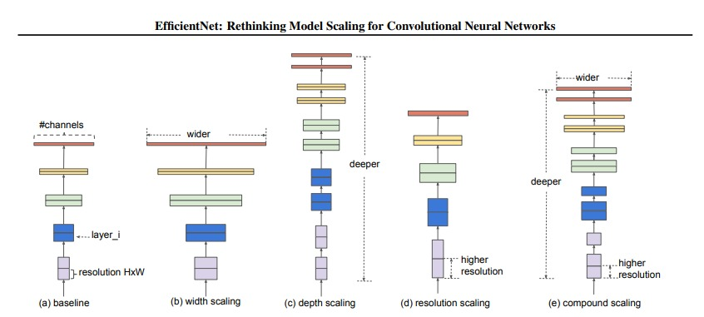
Figure 3.4 EfficientNet-B4 architecture illustrating

An EfficientNet-B4 model on 380 x 380 optimal input resolution and 4.2 billion floating-point operations per forward step is obtained in the instance of EfficientNet-B4, a tradeoff that allows it to compete with significantly lower computational cost than VGG16, ResNet50, or InceptionV3 hidden architecture models that was used in other published literature.
It uses the EfficientNet-B4 backbone loaded with the frozen weights using ImageNet-1K initial seven MBConv blocks (stages 0-6). The two blocks (stages 7 - 8), as well as the final convolutional layer (the 1 × 1 pointwise convolution that produces 1792 feature channels) are not fixed and are shared with the classification head. The two-stage fine-tuning model, where early layers encoding low-level edge and texture image features are held fixed during ImageNet pretraining and then the later stages descriptors of the semantic features are learned to be specialized to the kidney CT domain, is consistent with the existing best practices in medical image transfer learning .

3.6.2 Convolutional Block Attention Module (CBAM)
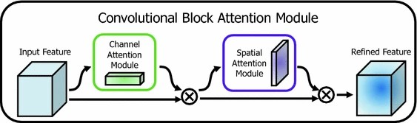
Figure 3.5 CBAM Overview

A CBAM as shown in above Figure3.5 is incorporated between the convolutional output and global averaging pooling layer. CBAM applies two consecutive attention tasks of channel attention and subsequently spatial attention of the now generated 1792 x 12 x 12 feature map which has undergone EfficientNet-B4 performing backbone on 380 x 380 inputs.
Channel Attention: Considering the feature map F O CxHW, the channel attention will produce a 1-dimensional feature map graspcer M c O C, which represents the significance of every channel of features. The two spatial dimensions are fed independently on the global average pooling and the global max pooling, resulting in two C-dimensional vectors which are independently fed into a single two-layer multilayer perceptron(MLP) with a reduction ratio of r = 16, which then has a resultant representation size of C/16 = 112 then projected back to C = 1792. The channel attention map is obtained with the help of the two MLPs and the output of one of them by a sigmoid activation:
M_c(F) = σ( MLP(AvgPool(F)) + MLP(MaxPool(F)) )
Spatial Attention: The mrefined channel-based feature map F F 5 (F ) F F is once more conveyed to the spatial attention sub-module. The channel dimension is averaged and maximized to come up with two H x W Descriptor maps, which are combined together and convoluted with a 7 x 7 convolutional filter to come up with the spatial attention map M s ∈ ℝ (H W):
M_s(F') = σ( Conv₇ₓ₇( [AvgPool_c(F'); MaxPool_c(F')] ) )
The final CBAM output is F'' = M_s(F') ⊗ F'. A serial channel-then-space attention refinement process is employed to delineate the serial channels of the irrelevant background tissue, and emphasis the attention on the space components of the CT image that elicit the most discriminative knowledge on the classification of kidney pathology the area-out-of-interest (ROI) shared by a CT scan as examined by a radiologist. Because CBAM is end to end that does not need additional parameters (teen percent more parameters), it is end to end trainable just like the rest of the network.

3.7 Loss Function and Class Imbalance Handling
In pure categorical cross-entropy loss, incorrect and correct samples have an equal amount of learning force with no consideration of their relative difficulty or their frequency of that classification. The regular training with cross-entropy has a systematic bias of gradient of the Kaggle CT KIDNEY DATASET, and the Normal class is 3.7 times greater than the Stone one. The balancing of this is done through two opposite mechanisms.
Class Weights: Class weights are determined based on the training set class distribution and incorporated on the cross-entropy term of the loss which is: c is class appropriate weight which is:
w_c = N_total / (N_classes × N_c)
and where N total is the total amount of training samples and N classes = 4 and N c is the amount of training samples in class c. Such weights put undue more loss on the misclassification of the minority classes Stone and Tumor that the gradient update would capture their clinical importance.
Focal Loss: The focal loss technique by Lin et al. is the training goal which is embraced using the class-weighted cross-entropy as the foundation of the focal loss technique (Lin, et al. 2017) . It employs focal loss, and the product of cross entropy loss, and (1 - p t) p, to reduce the impact of those samples that are simple to classify (large p t) and focus on the learning of hard, incorrectly classified samples:
FL(p_t) = −α_t (1 − p_t)^γ log(p_t)
where p t represents the sophistication of the ground-truth category by a model, and 2.0 as suggested in the original article ) and 8 / = the focus (defined above). Such concerted action of togetherness of the combined action of class weighting (correction of structural imbalance) and focal modulation (correction of sample difficulty) is an effective training indication of the Stone and Tumor minority classes (without remedial recap the processing by oversampling, which generates memorization artifacts).

3.8 Explainability: Gradient-weighted Class Activation Mapping (Grad-CAM)
To fill the explainability gap (that was previously noted in Chapter 2) when one out of fifteen studies reviewed [21] offered any type of interpretability mechanism, it was suggested to adopt Grad-CAM [27] to form the explainability part of the proposed framework. Grad-CAM creates an output heatmap that is class-discriminative and localizes the spatial areas of a CT image, which contributed most to the prediction of the right model without the need to modify the architecture or retrain the model.
Given a target class c and the last convolutional layer, with feature maps A k ∈ ℝ (H × W) (k 1, ., K channels), Grad-CAM originally computes the gradient of the target class score y o c with respect to each channel of feature maps:
α_k^c = (1 / Z) Σ_i Σ_j ( ∂y^c / ∂A^k_ij )
where by Z = H x W is a normalisation factor. These are averaged importance weights 50 -1 of each feature map channel k, corresponding to the importance weights of all spatial positions of that channel. A weighted average of the forward activation maps is then calculated to obtain the Grad-CAM heatmap L c = - RELU ( H W ) to maintain only those features that describe target class:
L^c_GradCAM = ReLU( Σ_k α_k^c · A^k )
A resulting heatmap is bilinearly upsampled to the original input resolution of 380 × 380 and superimposed on the original CT image as a saliency map in the form of colour-coded values with warm colours (red/orange) reflecting high class-discriminative response. When used in the clinical environment, such maps enable a radiologist to make sure that the model is focused on the appropriate anatomical structure the renal parenchyma in tumours, the collecting system in stones, or the perirenal space in cysts instead of irrelevant background or artifacts of the imaging. In this study, the image sample size is chosen randomly by sampling 20 correctly and one more 20 misclassified test images per class to predict with the help of the Grad-CAM, by the end of which 160 heatmap visualisations are obtained as a result of the qualitative analysis of the model diagnostic reasoning.

3.9 Training Protocol
All the training hyperparameters and their reasoning are illustrated in Table 3.3.

Table 3.3. Training hyper parameters and justification for each design choice.
Hyper parameters | Value
Input image size | 380 × 380 px
Batch size | 32
Initial learning rate | 1 × 10⁻⁴
Optimizer | AdamW
Weight decay (L2) | 1 × 10⁻⁵
LR scheduler | Cosine Annealing + Warmup
Maximum epochs | 50
Dropout (head, layer 1) | 0.50
Dropout (head, layer 2) | 0.30
Focal loss gamma (γ) | 2.0
FC hidden dimension | 512
Class weight strategy | Inverse frequency

The training process carried out in two stages. During Phase 1 (epochs 10), the head of classification along with the CBAM module are trained, and EfficientNet-B4 backbone is not trained at all. At Phase 2 (epochs 11-50), EfficientNet-B4 (top two MBConv blocks) along with CBAM and classification head are unfrozen and simultaneous training is performed at the lower learning rate governed by the cosine annealing-order. The Phase 2 is linear warmup using 5 epochs at the beginning of the phase to ensure the learning rate increased to its highest point,
Training is done with the AdamW optimizer with a weight decay coefficient of 1 × 10 -5 and. The early-stopping keeps track of the validation loss patience of 8 epochs; in case of 8 consecutive epochs that there is no improvement in the validation loss, the training is stopped and the checkpoint with the lowest validation loss is reinstated to be evaluated.

3.10 Evaluation Metrics
The held-out test set (1,867 images) used to evaluate model performance, applying a set of metrics of classification: overall accuracy, precision, recall, F1‑score, A confusion matrix generated to visualize class‑wise prediction performance.

References
[21] Bhandari, M., Yogarajah, P., Subash Muthu, K., & Condell, J. (2023). Exploring the Capabilities of a Lightweight CNN Model in Accurately Identifying Renal Abnormalities: Cysts, Stones, and Tumors, Using LIME and SHAP. Applied Sciences, 13(5), Article 3125. https://doi.org/10.3390/app13053125
[27] Selvaraju, R. R., Cogswell, M., Das, A., Vedantam, R., Parikh, D., & Batra, D. (2017). Grad-CAM: Visual explanations from deep networks via gradient-based localization. In Proceedings of the IEEE International Conference on Computer Vision (ICCV 2017), pp. 618–626. https://doi.org/10.1109/ICCV.2017.74

