النَّشـــاطــات البــرمجيَّــة الأسبــوعيَّـــة
الاسم: | زينـــب جعفـــر العبــدالعــال | الشهر: | يــوليـــو | السنة: | 2023
التَّـــاريــخ: 28/07/2023
python CODE
Create a program that calculates the factorial of a given number.
Num=int(input("Enter an Integer : "))
Factorial_No = 1
if Num < 0:
print("Error! Factorial of a negative number doesn't exist")
elif Num == 0:
print("The Factorial of 0 is : 1")
elif Num == 1:
print ("The Factorial of 0 is : 1")
else:
for z in range(1, Num+1):
Factorial_No = Factorial_No*z
print("The Factorial of ", Num, "is", Factorial_No)

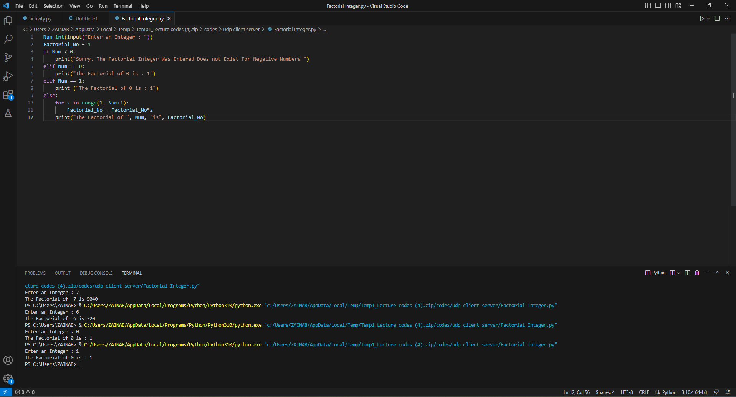

C++ CODE
Create a program that calculates the factorial of a given number.
#include<stdio.h>
int main() {
int z,fact=1,n;
printf("Enter an Ineger to find Factorial : ");
scanf("%d", &n);
for(z=1;z<=n;z++)
fact=fact*z;
printf("The Factorial of%dis%d",n,fact);
return 0;

}

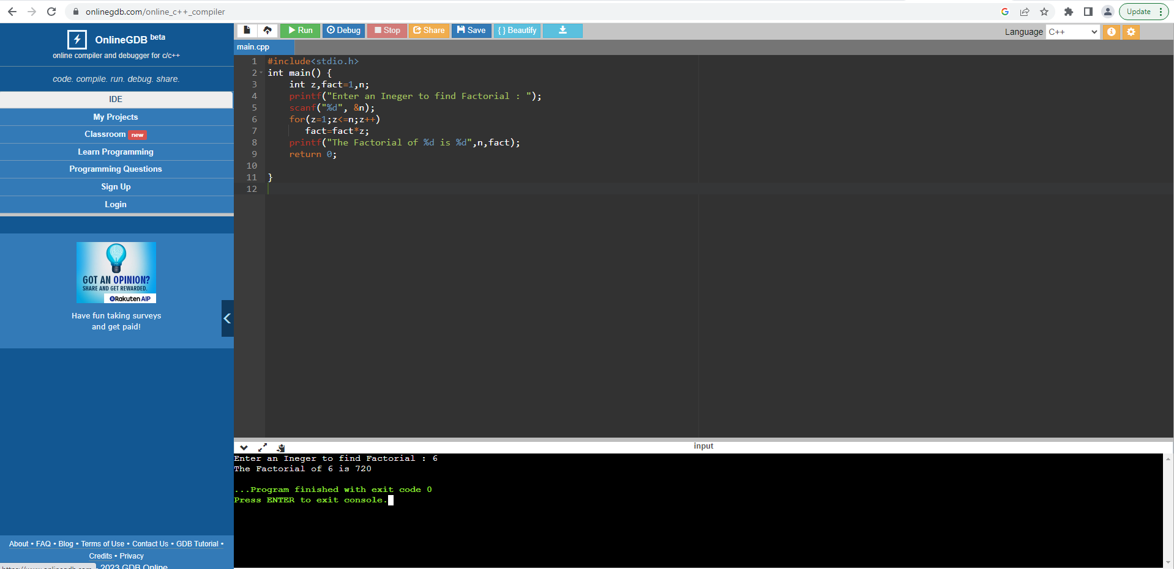

PYTHON CODE – FIND FACTORIAL USING RECURSION FUNCTION:
Create a program that calculates the factorial of a given number.
def Factorial_No (z):
if z == 0:
return 1
elif z == 1:
return 1
elif z < 0:
print("Error! Factorial of a negative number doesn't exist")
else:
return (z*Factorial_No (z-1))
Num = int (input("Enter an Integer to find Factorial : "))
result = Factorial_No (Num)
print("The Factorial of", Num, "is",result)
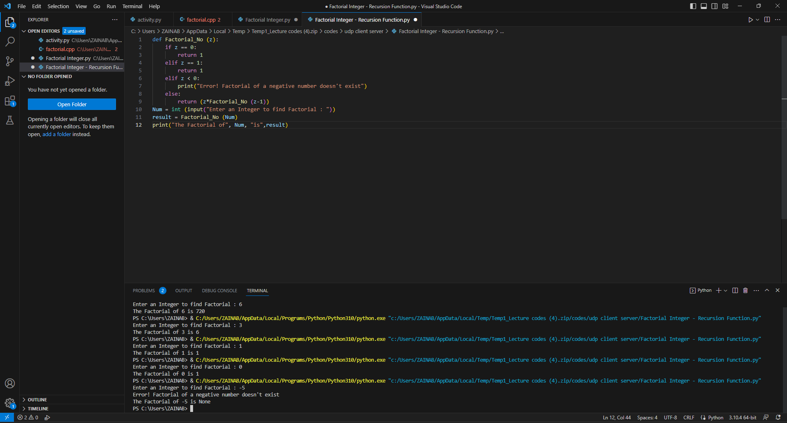

UNI ID
213000602
ZAINAB JAFFER I. AL ABDULAL

