Python Code Assignment

Program1: Write a program to accept a number from a user and calculate the sum of all numbers from 1 to a given number.

• Expected run of this program looks like the following:

Enter a number: 10

Sum of numbers to 10 is 55

Answer:
n = 10
res = sum(range(1, n + 1))
print("Sum of ", n, "numbers is: ", res)

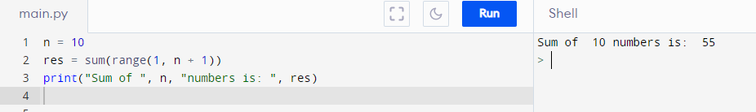
# Output Sum of numbers 10 is: 55

Program2: using this list [5, 10, 15, 20, 25, 50, 0]. Write a program to find the index of the value 20 in the list. Then add this index value to the list.

• Expected run of this program looks like the following:

The index value of 20 is: 3

The list after adding this value is [5, 10, 15, 20, 25, 50, 0, 3]

Answer:
list = [5, 10, 15, 20, 25, 50, 0]
index = list.index
index = list.index(20)
list.append (3)
print(index)
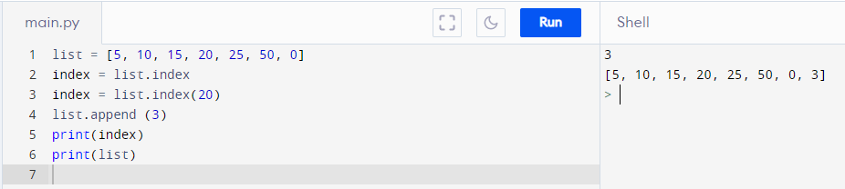
print(list)

