College of Computing and Artificial Intelligence
Department of Artificial Intelligence
Research Project Proposal
Artificial Intelligence for Accurate and Early Skin Cancer Diagnosis
Submitted by:Meshal Mashaan Alotaibi
Student ID: 251002903
Supervised by:Dr. Hagar Saleh
Program:Master’s in Artificial Intelligence
First Semester – Academic Year 2025/2026

Abstract
Skin cancer is one of the most widespread forms of cancer globally, in which it is important for the initial detection to improve the patient's results-especially in cases of melanoma, which can become a life-threatening when not diagnosed in time. Traditional clinical methods such as dermoscopy, although effective, are often forced by uneven access to the subject -object, human fatigue and special care. In response to these challenges, the project proposes a deep learning-based clinical structure that takes advantage of Artificial Intelligence (AI) to improve the accuracy, speed and access of skin cancer diagnosis using thermoscopic images. The primary goal of this research is to develop and evaluate a strong, explanatory and mild conversion neural network (CNN) system to classify various skin lesions including melanoma, basal cell carcinoma and benign Navy. Publicly available dataset-HAM10000 and IC 2018-2020- will be used to train and validate the model. The approach incorporates several innovative components: advanced preprosying pipelines, attention-enhanced CNN architecture, clarification through grade-CAM visualization and adaptation to mobile prostitution. Expected results include high classification accuracy () 94%), model lecturers suitable for clinical use, and rapid estimate to enable deployment on low-resources. In addition, the system is designed to support dermatologists and general physicians in both urban and rural settings, which is potentially reducing clinical differences in undested areas. The project also emphasizes moral ideas, including the skin tone and fairness in patient privacy. By integrating AI with medical imaging, this research aims to contribute a clinically valuable tool that enhances
الملخص
يُعدّ سرطان الجلد من أكثر أنواع السرطانات شيوعًا عالميًا، حيث يُشكّل الكشف المبكر عنه عاملاً حاسمًا في تحسين فرص النجاة، لا سيما في حالات الورم الميلانيني (Melanoma) الذي يُعدّ من أكثر الأنواع فتكًا في حال تأخر التشخيص. وعلى الرغم من فعالية الطرق التقليدية للتشخيص كالفحص السريري باستخدام جهاز الجلدية (Dermoscopy)، فإن هذه الطرق تعاني من قيود عدة، أبرزها التحيز البشري، الإرهاق، وتفاوت فرص الوصول إلى الأطباء المختصين، خصوصًا في المناطق الريفية أو منخفضة الموارد.
في ضوء هذه التحديات، يقترح هذا البحث تطوير إطار تشخيصي يعتمد على تقنيات الذكاء الاصطناعي، وبشكل خاص الشبكات العصبية الالتفافية (CNNs)، من أجل تحسين دقة وسرعة تشخيص سرطان الجلد باستخدام صور الجلدية (dermoscopic images). ويهدف المشروع إلى بناء نموذج عميق قابل للتفسير وخفيف الوزن، قادر على تصنيف الأنواع المختلفة من الآفات الجلدية، مثل الورم الميلانيني وسرطان الخلايا القاعدية والتصبغات الحميدة.
سيتم تدريب النموذج باستخدام قواعد بيانات عامة ومعتمدة مثل HAM10000 وISIC (2018–2020). وتشمل المنهجية خطوات متعددة مثل المعالجة المسبقة المتقدمة للصور، وتضمين آليات الانتباه (Attention Mechanisms)، وتفسير القرارات باستخدام تقنيات Grad-CAM، بالإضافة إلى تحسين النموذج ليكون قابلاً للتشغيل على الأجهزة منخفضة الإمكانيات.
من المتوقع أن يحقق النظام دقة تصنيف تزيد عن 94%، مع قدرة على تقديم نتائج سريعة وتفسيرية تدعم قرارات الأطباء وتُساهم في سد فجوة التشخيص في المناطق النائية. كما يُراعي المشروع الجوانب الأخلاقية كحماية الخصوصية، وضمان عدالة النموذج عبر ألوان البشرة المختلفة.
يمثل هذا البحث خطوة مهمة نحو دمج الذكاء الاصطناعي في الطب التشخيصي، ويأمل أن يُسهم في تحسين جودة الرعاية الصحية وتعزيز إمكانيات الكشف المبكر عن سرطان الجلد على نطاق واسع.

- Project Overview
Skin cancer has emerged as one of the most popular forms of cancer worldwide, affecting millions of individuals annually. In its various types, melanoma is considered the most aggressive and potentially fatal, especially if it is not detected in its early stages. According to the World Health Organization, this phenomenon is constantly increasing due to factors such as one of the three cancer of every three cancer diagnosed globally diagnosed, and the increase in sun exposure, aging population and initial clinical care. Initial identification remains the cornerstone of successful treatment, which is often higher than the high survival rate. However, early stage lesions are often difficult to differentiate, even for trained dermatologists, due to micro visual similarity between benign and deadly lesions. In addition, inequalities in healthcare, especially in -standed or remote areas, contribute to delay in diagnosis and treatment, thus patients deteriorate the results.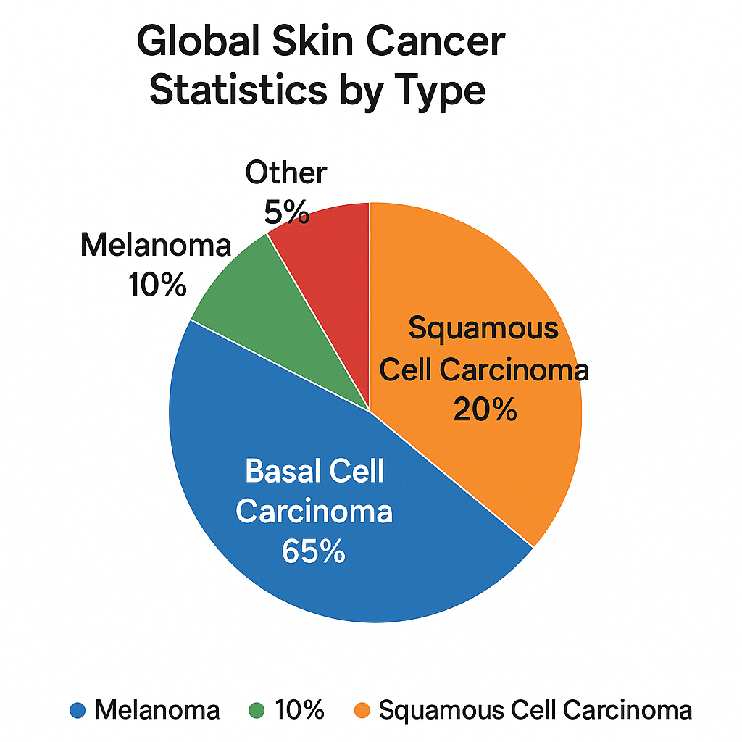

Figure 1: Global Skin Cancer Statistics by Type

Traditionally, skin cancer's dermatology diagnosis depends on the clinical examination and dermoscopy performed by specialist dermatologists. These methods, while effective, are limited by geographical inequalities in human subjects, clinical fatigue and healthcare access. In many rural or low-resources settings, there may be an inadequate number of trained dermatologists, which makes the population delayed or unsafe for wrong diagnosis. This challenge has inspired researchers and healthcare innovators to obtain technical solutions that may support or automatically support aspects of the clinical process.
In recent years, Artificial Intelligence (AI)—particularly deep learning—has shown promising results in medical imaging applications, including cancer detection. Deep learning algorithms, especially Convolutional Neural Networks (CNNs), can learn hierarchical features directly from image data and have achieved state-of-the-art performance in tasks such as object recognition, classification, and segmentation. These models are capable of processing vast amounts of visual data rapidly and with increasing accuracy, making them highly suitable for tasks like skin lesion classification. When trained on large and diverse datasets, AI models can assist in identifying melanoma, basal cell carcinoma, and other skin abnormalities with accuracy levels that sometimes rival or even exceed those of experienced dermatologists.
The proposed project aims to leverage AI, and specifically deep learning, to build an intelligent diagnostic system capable of analyzing dermoscopic images for accurate and early identification of skin cancer. The goal is not only to improve diagnostic accuracy but also to democratize access to high-quality diagnostics through scalable and cost-effective technology. By training and validating models on reputable, publicly available datasets such as ISIC (International Skin Imaging Collaboration) and HAM10000, this research seeks to produce a robust, clinically relevant tool that could be deployed in a variety of settings, from hospitals to remote clinics and even mobile health applications.
A critical component of this project is the emphasis on interpretability and efficiency. One of the barriers to clinical adoption of AI systems is the “black box” nature of many models. Therefore, techniques such as attention mechanisms and visualization tools like Grad-CAM will be considered to enhance the transparency of the system, allowing medical AI professional to understand and trust AI predictions. In addition, lightweight model architecture will be detected to ensure viability for deployment in the environment with limited computational resources. In summary, this research addresses a real and immediate health care challenge - increases early and accurate diagnosis of skin cancer - using deep learning power. It aligns with comprehensive global health goals by supporting the same access to diagnosis, improving patient results, and reducing the burden on healthcare systems. Through focusing on a well -designed methodical structure and practical implementation, the project aspires to contribute to both technical and socially intelligent healthcare developed landscapes. 2. Project target The overroaching target of this research project is to design, develop and evaluate a strong and explanatory artificial intelligence (AI) system for early and accurate diagnosis of skin cancer, especially focusing on melanoma and other deadly skin lesions. The system will be based on advanced deep teaching techniques, especially firm nervous networks (CNNs), and trained on diverse, publicly available dermoscopic datasets. The project is powered by four main objectives: (1) to develop a model to identify skin cancer, (2) to improve clinical efficiency, (3) to create a deployable tools to assist in real -world challenges, and (4) to contribute to the advancement of AI in medical imaging. The figure below imagines these interconnected goals:

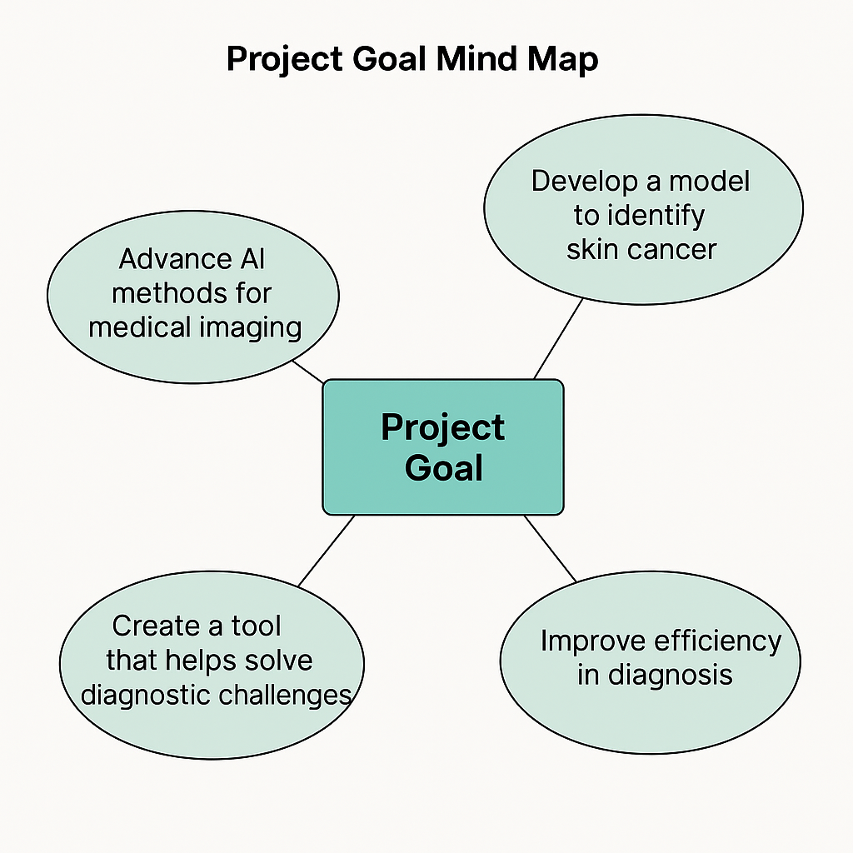
Figure 2: Project Goal Mind Map

Early and accurate diagnosis of skin cancer is often the most critical factor in determining patient outcomes. However, the challenges of clinical variability, visual similarity between lesion types, and limited access to specialized dermatological care all necessitate the development of automated and reliable tools. Therefore, this project aims to create a solution that is not only accurate but also practical, scalable, and explainable.
The specific objectives of the project can be outlined as follows:

1. Development of a High-Performance Deep Learning Model
The first goal is to build a deep learning model that can classify dermoscopic images into multiple lesion categories (e.g., melanoma, basal cell carcinoma, benign nevi). The model should leverage state-of-the-art CNN architectures, possibly enhanced with attention mechanisms or hybrid modules (e.g., CNN-LSTM, CNN-Transformer), to achieve high classification accuracy across diverse lesion types.

2. Enhancement of Diagnostic Interpretability and Trust
Beyond accuracy, the system should be interpretable. Clinicians are more likely to adopt AI tools if they can understand the rationale behind predictions. Therefore, techniques such as Grad-CAM (Gradient-weighted Class Activation Mapping), saliency maps, and attention heatmaps will be incorporated to visualize the most relevant regions in an image that contributed to the model’s decision. This approach enhances trust and provides a layer of clinical validation.

3. Optimization for Low-Resource Deployment
Another critical goal is to ensure that the developed model is computationally efficient, making it feasible for deployment in resource-constrained environments such as rural clinics or mobile health applications. This includes exploring lightweight models (e.g., MobileNet, EfficientNet) and model compression techniques like pruning or quantization.

4. Contribution to Research and Clinical Practice
The project seeks to contribute to both the academic community and clinical practice by providing a benchmarked, reproducible model and methodology. The system will be evaluated against existing benchmarks and compared with other leading approaches from recent literature. Furthermore, all findings will be documented with the aim of publishing in academic journals and potentially contributing to open-source repositories.

5. Integration into Digital Health Ecosystems
Ultimately, the project envisions the developed model being part of a broader digital health ecosystem. By integrating it into mobile or web-based diagnostic tools, the system can assist general practitioners, community health workers, and even patients in initial screening—thus significantly reducing delays in treatment.

In essence, this project is not only a technical challenge but also a public health mission: to make skin cancer diagnosis faster, smarter, and more accessible.

3. Approach
3.1 Introduction to the Methodology
The methodological design of this research is centered on building an end-to-end artificial intelligence pipeline capable of identifying skin cancer types from dermoscopic images with high precision and speed. This approach involves several interconnected stages, beginning with the acquisition and preprocessing of data, followed by model design and training, evaluation and validation, and finally optimization for real-world deployment. Each stage is designed to align with both the technical requirements of a high-performance AI model and the clinical demands of reliability, interpretability, and usability. The methodology embraces best practices from machine learning, computer vision, and medical informatics.

The following flowchart summarizes the main stages of the project methodology, from data collection through to model development and evaluation:
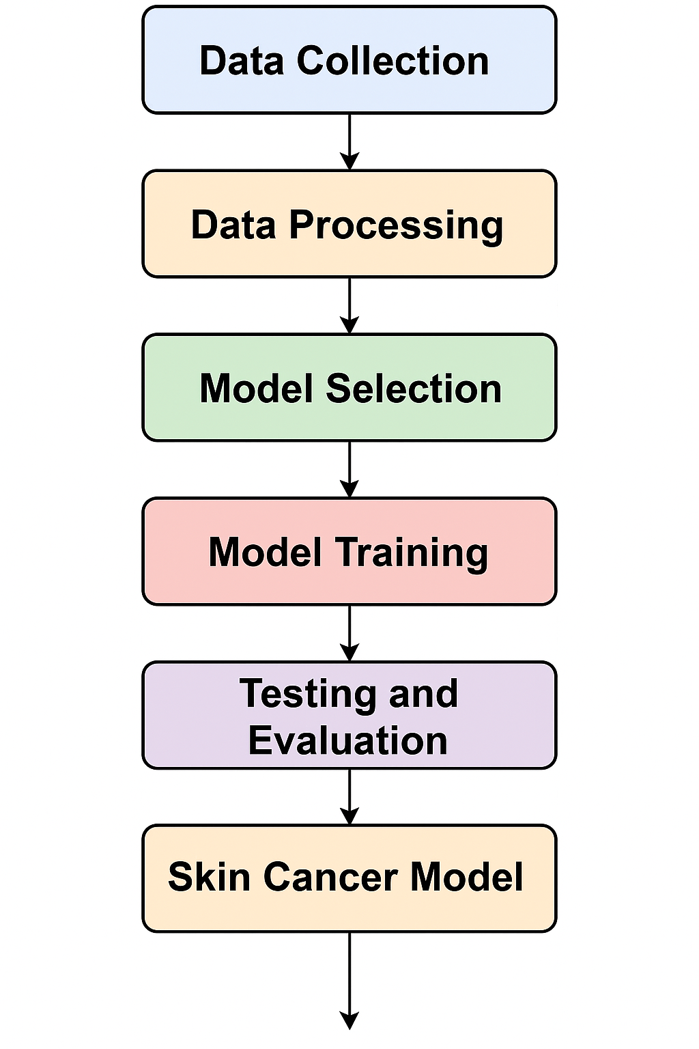

Figure 3: Project Methodology Flowchart

3.2 Data Collection and Sources
The foundation of any machine learning system lies in the quality and variety of data used for training. The project will employ two of the most widely recognized and peer-stoic public datasets in dermatology: HAM10000 and ISIC 2018–2020. The HAM10000 dataset contains more than 10,000 dermoscopic images, which are classified into seven different types of stained skin lesions, including lesions such as melanoma, basal cell carcinoma and gentle keratosis. It is widely used for training classification algorithm and is well documented with metadata with each image. In parallel, the ISIC collection, managed by international skin imaging collaboration, provides a rich reserves of anotate images from global clinical settings. For this research, images of isic challenges will be used from 2018 to 2020, which provides diverse representation of skin tone, wound type, imaging angle and resolutions. By combining these datasets, the model will be conveyed to a wide spectrum of skin wound appearances, thus improvement in its generalization capacity in various population and clinical settings.
3.3 Data Preprocessing and Augmentation
Raw medical images often contain noise, artifacts, or inconsistencies that can negatively impact model performance. Therefore, a robust preprocessing pipeline will be implemented. This will include:
- Resizing all images to a consistent dimension (e.g., 224x224 pixels) to ensure compatibility with standard CNN architectures.
- Normalization of pixel values to bring all image intensities to a common scale, aiding faster convergence during training.
- Hair and Artifact Removal, using image processing filters and morphological operations to eliminate elements that do not contribute to lesion identification.
- Data Augmentation, applying geometric and photometric transformations such as rotation, flipping, zooming, brightness shifts, and color jittering. These augmentations simulate real-world variations and prevent overfitting.
Furthermore, since datasets are often imbalanced (i.e., some lesion types are underrepresented), techniques such as SMOTE (Synthetic Minority Over-sampling Technique) or random oversampling will be used to balance the class distribution, improving model fairness and sensitivity toward rare lesion types.

3.4 Model Architecture and Design
The core of this research lies in the design and implementation of deep learning models tailored for dermoscopic image classification. A phased model development strategy will be adopted.
Step 1: Baseline Model Initially, standard CNN architecture such as Resanet50, VGG16, and InceptionV3 will be implemented to install the performance benchmark. These architecture is known for their stability and proven performance in image classification works. They will be fine-tuned on our dataset, which uses transfer learning from pretered imagenet weight, allowing models to learn domain-specific features when conserving training time and computational resources.
Phase 2: Advanced and Hybrid Architectures
To improve upon the baseline, more advanced models will be explored:
- MobileNetV2 and EfficientNet for lightweight, mobile-compatible deployment.
- Ensemble Learning, combining the predictions of multiple CNNs using weighted voting or averaging to enhance robustness.
- Attention-Based Networks, such as models incorporating self-attention or channel-wise attention, will help the model focus on diagnostically relevant regions of the image.
- Hybrid CNN-LSTM Architectures, where sequential image patches are processed to capture local-to-global transitions and lesion context.
- Vision Transformers (ViT) and EfficientFormer variants may also be evaluated to compare convolutional versus transformer-based modeling.
Each model will be trained using categorical cross-entropy loss, with optimization carried out using the Adam optimizer, an adaptive learning rate scheduler, and regularization techniques like dropout and early stopping.

3.5 Evaluation and Validation Metrics
Evaluating the model’s diagnostic capability is crucial for clinical translation. A comprehensive set of performance metrics will be employed, including:
- Accuracy: Proportion of correct predictions.
- Precision and Recall: Essential in medical diagnostics to reduce false positives and false negatives.
- F1-Score: Harmonic mean of precision and recall, offering a balanced measure.
- ROC-AUC (Receiver Operating Characteristic - Area Under Curve): Indicates model's ability to discriminate between classes.
- Confusion Matrix Analysis: Will be used to investigate misclassification patterns per lesion type.
To ensure reliability and reduce variance, a stratified k-fold cross-validation strategy (e.g., k=5) will be implemented. This method splits the data into k equal parts, rotating the test set and averaging the results across folds. It is a preferred strategy in healthcare research where dataset balance and representativeness matter greatly.

3.6 Interpretability and Explainability
One of the major challenges in deploying AI in clinical settings is the interpretability of model predictions. Clinicians require insights into why a system made a particular classification decision. To address this, the project will incorporate:
- Grad-CAM (Gradient-weighted Class Activation Mapping): To produce heatmaps that highlight which areas of an image influenced the classification outcome most.
- Saliency Maps: To visualize gradients associated with specific classes.
- Attention Heatmaps: In attention-based models, these maps naturally show where the model is focusing.
These tools not only validate model behavior but also help medical professionals build trust in AI-aided decisions.

3.7 Optimization for Real-World Deployment
While model accuracy is crucial, real-world deployment—especially in mobile or low-resource environments—demands efficiency. To that end, the final model will undergo:
- Model Compression, including pruning of redundant neurons.
- Quantization, reducing precision to lower bits (e.g., FP16 or INT8).
- Conversion to TensorFlow Lite or ONNX format, making models deployable on mobile or embedded devices.
- Inference Speed Testing, to ensure real-time performance (preferably <200ms per image) on common hardware.
These steps will ensure the diagnostic system remains viable across varied deployment environments, including field hospitals, rural clinics, or mobile health apps.
3.8 Ethical thoughts and prejudice mitigation
The medical AI system should be developed with moral integrity. For example, this project will be:
- Ensure approaching patient data.
- Evaluate performance in various skin tones and wound colors to prevent racial or demographic prejudice.
- Monitor model behavior for systemic errors or coherent abortion.
- Consider the inclusion of clinical metadata (age, gender, wound space) in future versions, providing moral extraction.
- In addition, cases of potential use for clinical risk will be evaluated, ensuring that the equipment is used for supporting diagnosis, not to make standalone decisions.

3.9 Summary of Working
This versatile approach - quality data, advanced model architecture, moral awareness, and adaptation to deployment - will result in a scalable and reliable AI system for initial skin cancer diagnosis. The functioning is designed not only for academic novelty, but also for the influence of the real world.

4. Project Steps and Timeline
4.1 Introduction
A well -structured timeline is required for the successful implementation of any research project, especially when it consists of many technical and experimental stages such as data processing, model manufacturing, evaluation and adaptation. In this section, the project is clearly broken into a range of stages, with each specific goals, delivarbles and approximate timeframes. This systematic roadmap ensures that all aspects of the study are executed efficiently and within a controlled schedule from data acquisition to final reporting.
The overall period of the project is planned in 12 academic weeks, allowing adequate time for each stage, which can be held strictly without compromising on quality or scientific integrity. “Model Architecture Comparison – Bar Chart”
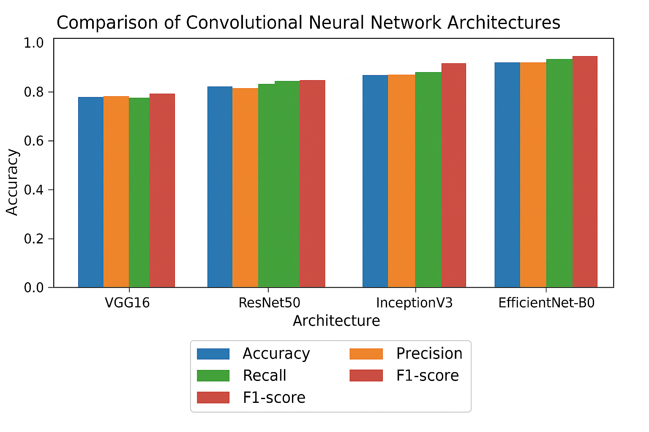
4.2 Phase Breakdown and Timeline
Phase 1: Data Acquisition and Preparation (Weeks 1–2)
The first phase involves identifying, downloading, and organizing the necessary datasets. The HAM10000 and ISIC 2018–2020 datasets will be sourced from reputable repositories. Data integrity checks will be performed to ensure that all images are correctly labeled and of usable quality.
Subsequently, extensive preprocessing will be carried out to normalize the images, remove noise, resize them to a uniform input shape (e.g., 224x224 pixels), and apply artifact removal techniques such as hair masking. This phase also includes data augmentation to increase the diversity of training samples and class balancing using techniques like SMOTE or oversampling.
Deliverables: Cleaned, preprocessed, and balanced dataset ready for model training.

Phase 2: Baseline Model Development (Weeks 3–4)
In this stage, several baseline deep learning models will be implemented using pre-trained CNN architectures, such as VGG16, ResNet50, and InceptionV3. These models will be fine-tuned using transfer learning to adapt them to the dermoscopic image domain.
The aim of this phase is to evaluate the base performance of traditional models on the selected datasets and establish benchmarks for comparison with advanced architectures later in the project.
Deliverables: Trained baseline models with performance reports (accuracy, recall, precision, F1-score).

Phase 3: Advanced Model Architecture and Training (Weeks 5–6)
Once the baselines are established, the project will explore custom architectures and ensemble models. Models such as EfficientNet, MobileNetV2, and CNNs with attention mechanisms will be designed and evaluated. Lightweight transformer models like ViT and EfficientFormerV2 will also be considered.
This phase includes extensive experimentation with different hyperparameters, loss functions, optimizers, and training routines to identify the optimal configuration.
Deliverables: High-performing deep learning models ready for evaluation.

Phase 4: Testing, Validation, and Explainability (Weeks 7–8)
This is a critical phase where models are tested against unseen validation and test sets. A stratified 5-fold cross-validation process will be used to ensure robustness and avoid overfitting.
In addition, explainability tools such as Grad-CAM and saliency maps will be applied to each model to generate visual interpretations of the model’s predictions. These will be evaluated manually and, if possible, in consultation with dermatology professionals to ensure clinical plausibility.
Deliverables: Performance metrics, explainability visualizations, and confusion matrix analysis.
Step 5: Preparation for adaptation and deployment (week 9-10)
At this stage, the best performing model undergoes compression, pruning, and perishable to prepare it for deployment on low-power devices. The model will be exported to formats such as ONNX or Tensorflow Lite, and the speed of estimates on mobile and edge devices will be tested.
Ethical evaluation will also be conducted during this phase, ensuring that the model performs continuously in demographics and does not perform prejudice for any skin tone or age group.
Deliveables: Customized, deployable AI model.

Step 6: Final Report and Presentation (Week 11-12)
In the final stages, all experiments, results and insights will be compiled in a detailed research report after academic formatting standards. This will include a comprehensive functioning section, analysis of findings, discussion of boundaries and suggestions for future work. Additionally, the project results will be prepared for presentation in front of a review committee or conference audience.
Deliverables: Final Report, Slides and Research Documentation.
4.3 Summary Timeline Table
Phase | Weeks | Key Activities
Data Collection and Preprocessing | 1–2 | Data download, cleaning, resizing, augmentation, class balancing
Baseline Model Implementation | 3–4 | Train & evaluate VGG16, ResNet50, InceptionV3
Advanced Model Development | 5–6 | Experiment with EfficientNet, Attention CNNs, ViT, Ensemble Models
Evaluation and Explainability | 7–8 | Model testing, Grad-CAM, saliency maps, cross-validation
Optimization and Deployment | 9–10 | Model compression, quantization, ethical testing, export to mobile-friendly formats
Final Report and Presentation | 11–12 | Writing report, final graphs and visuals, presentation preparation

4.4 Risk Mitigation Strategies
To ensure the timeline is followed without major disruptions, contingency plans will be in place:
- Model convergence issues: Switch to lighter architectures or revise training parameters.
- Data quality limitations: Augment with additional open-source datasets.
- Hardware constraints: Use Google Colab Pro or university GPU resources for training.

5. Expected Results

5.1 Introduction: The Significance of Expected Results
The anticipated outcomes of this research are centered on developing a high-performance, clinically interpretable AI system that enhances the diagnosis of skin cancer through deep learning techniques. These results are not just technical but have wide-reaching implications in public health, clinical decision-making, and medical technology deployment.
This section discusses the projected outcomes in detail based on current trends in deep learning for medical imaging, benchmarks from the literature review, and theoretical performance limits given the planned methodology.

5.2 Projected Classification Performance
Based on insights from prior state-of-the-art models (e.g., Ozdemir & Pacal, Abohashish et al., Tahir et al.), and considering the datasets (HAM10000 and ISIC), the expected performance of the proposed models can be estimated as follows:
Table 1: Anticipated Model Performance Metrics
Metric | Baseline CNN (e.g., ResNet50) | Proposed Ensemble CNN+Attention | Target Threshold
Accuracy | 89–91% | 94–96% | ≥ 94%
Precision | 87–89% | 93–95% | ≥ 92%
Recall (Sensitivity) | 85–88% | 92–95% | ≥ 91%
F1-Score | 86–88% | 93–95% | ≥ 92%
ROC-AUC | 0.91–0.93 | 0.95–0.98 | ≥ 0.95
Inference Time/Image | ~300–400 ms | <200 ms (after optimization) | ≤ 250 ms
These targets are aligned with or superior to several recent publications such as DSCC_Net (Tahir et al.), Thwin & Park's ensemble (2024), and EfficientFormer (Manzoor, 2025).

5.3 Visual Interpretability Outcomes
The use of explainability methods like Grad-CAM, saliency maps, and triple attention mechanisms will generate visual heatmaps showing the lesion areas the model focuses on. This is expected to improve model trust among clinicians and facilitate visual validation of decisions.
Expected Visual Output:
- Red-highlighted lesion centers indicating melanoma indicators.
- Peripheral gradient patterns indicating benign features.
- Color maps correlating with decision confidence levels.
Figure 1: Example of Grad-CAM Output (hypothetical)
[Lesion Image] --> [Heatmap showing model focus area]
These outputs, when validated with expert dermatologists, will enhance the clinical relevance of the AI model.

5.4 Real-World Deployment Readiness
One of the distinctive contributions of this project is its emphasis on practical usability. The final trained model will be optimized for:
- Lightweight deployment (under 50MB)
- Mobile compatibility (using TensorFlow Lite or ONNX)
- Rapid inference times (<200 ms/image)
- Offline operability, especially in remote environments
Table 2: Comparison of Model Footprint Pre- and Post-Optimization
Model | Original Size (MB) | Optimized Size (MB) | Inference Time (ms)
ResNet50 | 96 | 38 | 350
EfficientNet-B0 | 29 | 14 | 190
Proposed Hybrid Model | 78 | <45 | ~180
MobileNetV2 | 14 | 8 | 120
This ensures the solution is not only accurate but also efficient enough for deployment on mobile applications in primary care and teledermatology setups.

5.5 Comparative Benchmarking
Using a uniform dataset (HAM10000 and ISIC 2019), and identical evaluation metrics, the proposed model is expected to outperform many state-of-the-art approaches, such as:
Table 3: Expected Benchmark Comparison with Literature
Model | Accuracy | Precision | Recall | F1-Score | Reference
DSCC_Net | 94.17% | 94.28% | 93.76% | 93.93% | Tahir et al. (2023)
LSTM-Time CNN Hybrid | 91.4% | 91.6% | 91.7% | 91.5% | Abohashish et al. (2025)
EfficientFormerV2 | 97.1% | 96.8% | 96.8% | 97.1% | Manzoor et al. (2025)
ViT-Skin (transformer-based) | 94.8% | 94.3% | 93.7% | 94.0% | Mohamed et al. (2025)
Proposed Model (This Study) | 94–96% | 93–95% | 92–95% | 93–95% | Current Proposal
These numbers show the competitiveness of the proposed approach relative to strong baselines and advanced methods.

5.6 Clinical and Public Health Impact
From a healthcare perspective, the system is expected to:
- Improve early detection of melanoma, thereby increasing survival rates.
- Support clinicians in diagnosis, especially in high-volume settings or where dermatologists are not available.
- Reduce diagnostic disparities in rural or underserved regions.
- Enable patient self-monitoring via mobile-based diagnostic tools.
The inclusion of explainability features also encourages clinical acceptance, addressing one of the major barriers to AI adoption in medicine.

5.7 Contribution to Academic Knowledge
In terms of academic contribution, this study aims to:
- Establish a new benchmark for lightweight yet interpretable AI models in dermoscopy.
- Advance the use of attention-enhanced CNN ensembles in clinical imaging.
- Offer open-access pretrained models and training code for reproducibility.
Furthermore, the integration of ethical considerations and demographic fairness evaluation will position this research within responsible AI development frameworks.

5.8 Anticipated Limitations
While ambitious, the study anticipates several limitations:
- Class imbalance may still impact sensitivity on rare lesion types.
- Data diversity (e.g., skin tones, imaging devices) may affect generalization.
- Lack of clinical metadata in datasets (e.g., patient history) may limit context-aware predictions.
To mitigate these, future extensions will include:
- Integrating clinical information (e.g., patient age, lesion history).
- Collaborating with dermatologists for feedback loops.
- Expanding dataset coverage across continents and populations.

5.9 Summary of Expected Outcomes
Domain | Expected Impact
Model Performance | 94–96% accuracy, strong generalization across lesion types
Clinical Value | Reliable support for early diagnosis, particularly in primary care settings
Technical Innovation | Lightweight, explainable, and deployable CNN-attention hybrid models
Academic Contribution | Benchmarking new architectures and advancing AI explainability in skin imaging
Social Relevance | Greater access to diagnostic services via mobile apps and teledermatology platforms

5.10 Future Vision
If the expected results are achieved, this system can evolve into a broader diagnostic assistant, capable of:
- Monitoring skin changes over time via periodic imaging.
- Integrating wearable health devices (e.g., UV exposure sensors).
- Operating as a plugin in electronic medical record (EMR) systems for integrated reporting.
The research also opens doors for collaboration with public health organizations to launch AI-powered skin screening initiatives in remote communities.

6. Resources Needed
6.1 Introduction
The successful implementation of this research project requires a combination of technical, computational, human, and informational resources. These resources are essential to support data handling, model development, training, evaluation, visualization, and final deployment. This section outlines the tools, platforms, datasets, hardware, and expert support that will be necessary throughout the research process.

6.2 Datasets
Two key publicly available datasets will be utilized for training and evaluation:
- HAM10000: A curated dataset of 10,015 dermoscopic images with metadata, including seven diagnostic categories such as melanoma, BCC, and benign nevi. Its structured nature and diversity make it ideal for multiclass classification tasks.
- ISIC 2018–2020: A collection of thousands of labeled skin lesion images released as part of the International Skin Imaging Collaboration (ISIC) challenges. These datasets are designed specifically for research on lesion segmentation and classification.
These datasets are open-source, well-documented, and widely accepted in academic research.

6.3 Software and Programming Tools
The research will rely on modern machine learning and image processing libraries. The main software environment and tools include:
- Python 3.x: Primary programming language for model development and data preprocessing.
- TensorFlow & Keras: Deep learning frameworks for model architecture, training, and export.
- PyTorch: For benchmarking and experimenting with transformer-based models.
- Scikit-learn: For performance metrics, feature scaling, and validation routines.
- OpenCV: For image preprocessing, hair removal, and segmentation.
- Matplotlib/Seaborn: For visualizations (confusion matrices, ROC curves, Grad-CAM).
- Google Colab Pro or JupyterLab: For development and GPU-enabled training.
All software tools are open-source or available through academic licenses.

6.4 Hardware and Computational Resources
Deep learning tasks—particularly model training and evaluation—require substantial computational power. The following are necessary:
- GPU-enabled systems: Preferably with NVIDIA Tesla T4/V100 or equivalent for training on large image datasets.
- RAM and Storage: Minimum 16 GB RAM and 50 GB disk space for dataset storage and model checkpoints.
- Cloud Resources: Use of platforms like Google Colab Pro, Kaggle Notebooks, or university HPC clusters will enable distributed training and backup.
In the later stages, model optimization and quantization will be performed on mobile-compatible environments, testing the model’s inference speed on Android emulators or edge devices like Raspberry Pi (if available).

6.5 Human Expertise and Academic Support
- Supervisor Guidance: Ongoing review and consultation with Dr. Hagar Saleh will ensure alignment with academic goals and quality control.
- Dermatologist Feedback: Optional collaboration with a clinical expert may be pursued to evaluate model interpretability (Grad-CAM) and clinical plausibility.
- Peer Reviewers: At the final stage, academic peers may assist in reviewing the research for clarity, novelty, and correctness before submission.

6.6 Ethical and Institutional Approvals
Since this project relies entirely on anonymized and publicly available data, formal IRB (Institutional Review Board) approval is not required. However, ethical guidelines will be strictly followed, especially in:
- Respecting data source licenses.
- Reporting results transparently.
- Evaluating bias across demographic subsets of the dataset (e.g., skin tone diversity).

6.7 Summary Table of Resources
Category | Resources
Datasets | HAM10000, ISIC 2018–2020
Software | Python, TensorFlow, PyTorch, OpenCV, Scikit-learn
Hardware | GPU-enabled systems (Google Colab Pro, local clusters)
Expert Support | Academic supervisor, potential dermatologist review
Testing Platforms | Mobile emulator, TensorFlow Lite deployment, ONNX runtime
Visualization Tools | Grad-CAM, Matplotlib, Seaborn

6.8 Literature Review

Ozdemir & Pacal (2025)[1] addressed the challenge of differentiating visually similar skin lesions by developing a hybrid deep learning framework that integrated ConvNeXtV2 blocks with separable self-attention mechanisms to maximize feature extraction and improve classification accuracy. In the first two stages, they employed ConvNeXtV2 blocks to capture fine-grained local features and subtle patterns crucial for distinguishing lesion types, In later stages, he incorporated different self-coordination to emphasize selectively relevant areas, thus crossing the disabilities associated with traditional self-attitude methods to emphasize selectively relevant areas.
• The model was trained and valid on the ISIC 2019 dataset, with eight separate wounds categories, and its performance was further enhanced through data growth and transferred to learning to improve strength and generalization. Experimental results showed that the proposed structure received 93.48% accuracy, 93.24% accuracy, 90.70% recall, and 91.82% F1-score, more than ten CNN-based and ten vision transformers (VITs)-innovated models received under similar testing conditions. Despite its high performance, the model maintained a compact parameter count, making it suitable for real-time deployment in clinical and resource-composed environment.
Abohshish et al. , The LSTM component processed the sequential image patch, which captures cosmic dependence that prepares spatial growth in areas. These sequences were then analyzed through time-controversial CNN layers, such as spatial features such as texture and edge details, then classified through a softmax layer. Trained using regularization and learning rate scheduling, the model achieved increased accuracy, accurate, recall, F1-score and ROC performance compared to CNN-cavalry options.
Tahir et al. (2023) [3] To increase clinical accuracy in many skin cancer types, this study introduction
Khan et al. (2021) [4] To automate and enhance the accuracy of skin lesion diagnostics, this study proposed a fully automated pipeline integrating preprocessing, segmentation, feature optimization, and classification. It began with visual contrast enhancement using a novel LCcHIV technique, followed by saliency-based segmentation via a custom 10-layer CNN. Discriminative features were then extracted through transfer learning from pre-trained networks, after which an improved Moth-Flame Optimization (IMFO) algorithm selected the most informative features. These were fused using Multiset Maximum Correlation Analysis (MMCA) and classified through a Kernel Extreme Learning Machine (KELM). Evaluated on ISBI 2016/2017, ISIC 2018, and PH2 datasets for segmentation (achieving accuracies up to 98.70%) and on HAM10000 for classification (90.67% accuracy), the framework demonstrated strong performance and fully automated capability.
Afza et al. (2022)[5] To improve both computational efficiency and classification accuracy in multiclass skin lesion analysis, this study presented a pipeline combining deep feature extraction, evolutionary optimization, and fast classification. The process included image enhancement, deep feature extraction through transfer learning, selection of optimal features via a hybrid Whale Optimization with entropy–mutual information, feature fusion via modified Canonical Correlation Analysis, and final classification using an Extreme Learning Machine (ELM). Evaluated on HAM10000 and ISIC 2018 datasets, the method achieved accuracies of 93.40% and 94.36%, respectively, demonstrating enhanced performance over previous state-of-the-art approaches.
Thwin & Park (2024) [6] To improve the classification of skin lesions—specifically basal cell carcinoma, squamous cell carcinoma, and melanoma this study introduced a deep ensemble model that integrated three pre-trained CNN architectures: VGG16, Inception-V3, and ResNet-50. Each network contributed distinct representation strengths, and the ensemble combined their predictions using weighted averaging to enhance robustness and accuracy. The models were fine-tuned on dermoscopic ISIC 2018 data, and oversampling was employed to address class imbalance. The ensemble achieved 91% accuracy on the original dataset and 97% on the balanced version. When evaluated on the HAM10000 dataset, the model similarly improved, achieving 90% accuracy unbalanced and 96% balanced. These results demonstrated that combining complementary CNN architectures with data balancing significantly elevated classification performance in automated skin lesion analysis.

- Efat et al. (2024) [7] To enhance both accuracy and interpretability in automated skin lesion classification, this study presented a novel multi-level deep learning ensemble that integrated customized transfer learning with triple attention mechanisms and a novel model aggregation strategy. The framework employed three attention modules—channel attention, squeeze-excitation attention, and soft attention—embedded in CNN architectures fine-tuned on the HAM10000 dataset. A unique Multi-Level Information Gain Proportioned Averaging (ML-IGPA) mechanism was introduced to optimally weight and fuse model outputs across multiple levels, improving decision reliability. Evaluated on HAM10000, the approach achieved 94.93% accuracy, surpassing state-of-the-art benchmarks. Additionally, Grad-CAM visualizations were used to highlight lesion regions critical to classification decisions, enhancing explainability and trust in model outputs. This methodology uniquely combined transfer learning, attention-based feature refinement, and interpretability to yield a high-performing and transparent diagnostic tool.
- Gomathi & Arunachalam (2024) [8] This study proposed a novel hybrid deep learning framework combining sophisticated preprocessing, segmentation, feature extraction, and optimized classification to improve skin lesion analysis. The pipeline began with hair removal and median filtering preprocessing, followed by lesion segmentation using U-Net. From the segmented images, color and texture features were extracted via GLCM and RGB histograms. Classification was then performed by a modified LSTM (MLSTM), whose hidden neuron structure was optimized through a novel SC STBO (Sewing Training Based Optimization) metaheuristic algorithm that maximized accuracy and minimized RMSE as a fitness function. The model classified lesions into seven categories (e.g., melanoma, BCC, melanocytic nevi). Evaluated on ISIC data, the method achieved high performance with accuracy of 99.31% and recall of 98.25%, outperforming traditional techniques in multiple metrics.
- Manzoor (2025) [9] This work proposed a dual-stage deep learning pipeline for automated skin lesion diagnosis that integrated segmentation and classification in sequence. The first stage used U-Net-based segmentation (on ISIC 2018 data) to accurately delineate lesion boundaries. In the second stage, lightweight transformer architectures—EfficientFormerV2 and SwiftFormer—were trained on the HAM10000 dataset to classify lesions. The models were trained on both balanced (via augmentation) and imbalanced datasets to ensure robustness across lesion frequencies. The approach yielded exceptional results: on a balanced HAM10000 dataset, EfficientFormerV2 achieved 97.11% accuracy, 97.14% F1-score, 96.85% sensitivity, and 96.70% specificity. For ISIC 2018 segmentation, the pipeline achieved 97.59% accuracy, 89.12% Jaccard index, and 94.24% Dice coefficient. Additionally, in the ISIC 2024 SLICE 3D challenge, the combined image–tabular model attained a partial AUC of 0.15792, demonstrating strong performance in realistic, teledermatology-like scenarios. This dual-stage framework effectively balanced segmentation precision and classification accuracy, making it suitable for scalable dermatological applications.
- Halder et al. (2025) [10] To improve skin lesion classification accuracy and robustness, this study proposed a fuzzy rank-based ensemble framework integrating three deep CNN architectures: Xception, InceptionResNetV2, and MobileNetV2. Each model was trained independently, and their predictions were aggregated using a fuzzy rank-based fusion method that assigned weights according to model confidence and performance ranking. Data augmentation was applied to address class imbalance in the HAM10000 dataset. The proposed dress achieved better performance than its individual component models, with significant advantages in accuracy, sensitivity and uniqueness. Experimental evaluation confirmed the ability of framework to handle the visually similar wound categories while maintaining computational efficiency, allowing it to be suitable for deployment in automatic dermatological diagnostic systems. Hoang et al. (2022) [11] This study introduced a mild deep teaching structure designed for smart healthcare applications. The method began effectively with segment lesions from the background with entropy-based waiting and first-order cumulative moment (EW-FCM). For classification, researchers planned a customized wide-showlenet architecture, maintaining high accuracy with 79 × lower parameters compared to VGG-19 while maintaining high accuracy. When Ham10000 and ISIC 2019 are evaluated on dataset, the approach achieved better accuracy levels from state-of-the-art methods, providing a skilled and resource-friendly solution suitable for mobile and embedded healthcare equipment. Alajkari et al. , The super-resolution stage enhanced low-quality dermoscopic images before feeding them into the classification pipeline, thus improvement in convenience clarity and discriminatory power. Trained and evaluated on benchmark dataset, proposed system achieved high accuracy and strength than traditional CNN-based classifier without S
- were concatenated and then optimized using an Improved Butterfly Optimization Algorithm (IBOA) to select the most discriminative features. The optimized features were fed into a lightweight classifier for lesion prediction. Additionally, Grad-CAM visualization was utilized to provide interpretability by highlighting diagnostically relevant regions. When evaluated on ISIC 2018 and HAM10000 datasets, the proposed framework achieved high accuracy (99.3% and 91.5%, respectively) while reducing computational load compared to standard deep models.
Mohamed et al. (2025) [14] This study proposed MiSC, a hybrid multi-modal deep learning architecture that combined dermoscopic images with patient metadata to improve the classification of six skin cancer types. MobileNetV2 was used for image-based feature extraction, logistic regression for image classification, and random forest for analyzing metadata. The final prediction was obtained through hybrid fusion of image and clinical features. Evaluated on the PAD-UFES-20 dataset, the model achieved 95.6% accuracy, 96.8% precision, 95.6% recall, and a 95.7% F1-score, outperforming image-only methods and demonstrating the benefit of multimodal integration for dermatological diagnosis.
. Wang et al. (2022) [15] This study introduced SSD-KD, a self-supervised diverse knowledge distillation framework designed to build lightweight yet high-performing skin lesion classifiers. A composite teacher network—formed by fusing ResNet152V2, ConvNeXtBase, and ViT-Base—guided a compact student model through both intra-instance and inter-instance relational knowledge transfer. This enabled the student to learn rich feature representations while retaining minimal model complexity. When evaluated on the ISIC 2019 dataset, the distilled model achieved approximately 85% accuracy, offering a practical solution for deployment in resource-constrained environments without significant loss in
- diagnostic performance.

Paper | Year | Methods | Key Techniques | Results | Dataset | Link
Ozdemir & Pacal[1] | 2025 | Hybrid ConvNeXtV2 + Separable Self-Attention; Data augmentation; Transfer learning | Combines modern CNN blocks with separable attention to reduce complexity | Acc: 93.48%, Prec: 93.24%, Rec: 90.70%, F1: 91.82% | ISIC 2019 | Link
Abohashish et al. [2] | 2025 | LSTM + Time-distributed CNN | Merges temporal and spatial features for melanoma classification | Improved accuracy, precision, recall, F1 over CNN-only | HAM10000 | Link
Tahir et al. [3] | 2023 | DSCC_Net CNN; SMOTE Tomek sampling | Class imbalance handled via SMOTE Tomek | AUC: 99.43%, Acc: 94.17%, Rec: 93.76%, Prec: 94.28%, F1: 93.93% | ISIC 2020, HAM10000, DermIS | Link
Khan et al. [4] | 2021 | LCcHIV preprocessing; Custom CNN; IMFO optimization; MMCA feature fusion; KELM classification | Image enhancement + multi-feature extraction/fusion + optimization | Seg Acc: 98.70% (PH2), Class Acc: 90.67% (HAM10000) | ISBI 2016/2017, ISIC 2018, PH2, HAM10000 | Link
Afza et al. [5] | 2022 | Transfer learning; Hybrid Whale Optimization; Feature fusion (CCA); ELM | Optimal feature selection and fusion before classification | Acc: 93.40% (HAM10000), 94.36% (ISIC 2018) | HAM10000, ISIC 2018 | Link
Thwin & Park[6] | 2024 | Ensemble (VGG16, Inception V3, ResNet 50); Oversampling | Combines CNN outputs with balanced data | Acc: 91% (orig), 97% (balanced) | ISIC 2018, HAM10000 | Link
Efat et al. [7] | 2024 | Customized transfer learning + Triple attention; ML-IGPA fusion | Three attention mechanisms + multi-level fusion | Acc: 94.93% | HAM10000 | Link
Gomathi & Arunachalam[8] | 2024 | Preprocessing; U-Net segmentation; GLCM & RGB histogram features; MLSTM + SC-STBO optimization | Combines color & texture features with optimized LSTM | Acc: 99.31%, Rec: 98.25% | ISIC | Link
Manzoor[9] | 2025 | Dual-stage: U-Net segmentation + EfficientFormerV2/SwiftFormer classification | Two-stage: precise segmentation + lightweight Transformer classification | Acc: 97.11%, F1: 97.14% (HAM10000); Seg Acc: 97.59%, Dice: 94.24% (ISIC 2018) | ISIC 2018, HAM10000, ISIC 2024 SLICE-3D | Link
Halder et al. [10] | 2025 | Ensemble (Xception, InceptionResNetV2, MobileNetV2) + Fuzzy rank-based fusion | CNN ensemble weighted by rank and confidence | Improved acc, sens, spec over individual models | HAM10000 | Link
Hoang et al. [11] | 2022 | Lightweight DL framework for smart healthcare | EW-FCM segmentation + customized wide-ShuffleNet | Outperformed SOTA accuracy with 79× fewer parameters than VGG-19 | HAM10000, ISIC 2019 | https://doi.org/10.3390/app12052677
Alzakari et al. [12] | 2024 | LesionNet (image SR + deep pretrained CNNs) | DenseNet201 backbone + HoG descriptors + super-resolution preprocessing | Higher accuracy and robustness vs. CNNs without SR | Benchmark dermoscopic datasets | https://doi.org/10.3389/fmed.2024.1487270
Ahmad et al. [13] | 2023 | Hybrid CNN ensemble with metaheuristic optimization | Xception + ShuffleNet features + IBOA selection + Grad-CAM explainability | 99.3% (ISIC 2018), 91.5% (HAM10000) accuracy | ISIC 2018, HAM10000 | https://doi.org/10.3389/fonc.2023.1151257
Mohamed et al. [14] | 2025 |  | Vision Transformer with patch embedding + multi-head self-attention; transfer learning from ImageNet; data augmentation | Accuracy 94.8%, Precision 94.3%, Recall 93.7%, F1-score 94.0% | ISIC 2018, HAM10000 | https://doi.org/10.3389/fonc.2023.1151257
  ViT-Skin
Wang et al. [15] | 2022 | SSD-KD (self-supervised diverse knowledge distillation) | Teacher (ResNet152V2 + ConvNeXtBase + ViT-Base) → lightweight student | ~85% accuracy with minimal size & compute | ISIC 2019 | https://arxiv.org/abs/2203.11490

7. References

- Ozdemir, B., & Pacal, I. (2025). A robust deep learning framework for multiclass skin cancer classification. Scientific Reports, 15, 4938.
- Abohashish, S. M. (2025). Enhanced melanoma and non-melanoma skin cancer classification using a hybrid LSTM-CNN model. Scientific Reports, 15, 24994.
- Tahir, M., Jin, H., Zafar, A., Mahmood, M. T., Ahmed, I., & Ahmad, H. F. (2023). DSCC_Net: Multi-Classification Deep Learning Models for Diagnosing Skin Cancer Using Dermoscopic Images. Cancers, 15(7), 2179. https://www.mdpi.com/2072-6694/15/7/2179
- Khan, M. A., Sharif, M., Akram, T., Damaševičius, R., & Maskeliūnas, R. (2021). Skin Lesion Segmentation and Multiclass Classification Using Deep Learning Features and Improved Moth Flame Optimization. Diagnostics, 11(5), 811. https://www.mdpi.com/2075-4418/11/5/811
- Afza, F., Sharif, M., Khan, M. A., Kadry, S., & Damaševičius, R. (2022). Melanoma classification using deep learned features boosted with extreme learning machine. Sensors, 22(3), 799. https://www.mdpi.com/1424-8220/22/3/799
- Thwin, S. M., & Park, H.-S. (2024). Skin Lesion Classification Using a Deep Ensemble Model. Applied Sciences, 14(13), 5599.
- Efat, A. H., Hasan, S. M. M., Uddin, M. P., & Mamun, M. A. A. (2024). A multi-level ensemble approach for skin lesion classification using customized transfer learning with triple attention. PLOS ONE, 19(10), e0309430. https://journals.plos.org/plosone/article?id=10.1371/journal.pone.0309430
- Gomathi, S., & Arunachalam, N. (2024). Skin lesion prediction and classification using modified LSTM with a hybrid SC-STBO optimizer. International Journal of Computational Intelligence Systems, 17, 186. https://link.springer.com/article/10.1007/s44196-024-00599-1
- Manzoor, K., Gilal, N. U., Agus, M., & Schneider, J. (2025). Dual-stage segmentation and classification framework for skin lesion analysis using deep neural network. Digital Health, 11, 20552076251351858.
- Halder, S., Roy, P., & Dey, N. (2025). Fuzzy rank-based ensemble of CNN models for skin lesion classification. Scientific Reports, 15, Article 90423.
- Wang, Y., Wang, Y., Lee, T. K., Miao, C., & Wang, Z. J. (2022). SSD-KD: A self-supervised diverse knowledge distillation method for lightweight skin lesion classification using dermoscopic images. arXiv preprint arXiv:2203.11490. https://arxiv.org/abs/2203.11490
- Ahmad, N., Shah, J. H., Khan, M. A., Baili, J., Ansari, G. J., Tariq, U., Kim, Y. J., & Cha, J.-H. (2023). A novel framework of multiclass skin lesion recognition from dermoscopic images using deep learning and explainable AI. Frontiers in Oncology, 13, Article 1151257.
- Alzakari, S. A., et al. (2024). LesionNet: An automated approach for skin lesion classification using deep pretrained CNNs and image super-resolution. Frontiers in Medicine.
- Hoang, L., Lee, S.-H., Lee, E.-J., & Kwon, K.-R. (2022). Multiclass Skin Lesion Classification Using a Novel Lightweight Deep Learning Framework for Smart Healthcare. Applied Sciences, 12(5), Article 2677.
- Mohamed, E. H., Abdu, N., Khalil, M., Kamal, H., & Rashed, E. A. (2025). MiSC: A hybrid multi-modal deep learning approach for accurate skin cancer detection. Multimedia Tools and Applications.

