

Title

AI Impact on Crowd Management Using AFC Gate Records, Time Table, and CCTV Footage in Riyadh Metro Operations

Prepared By
Name: Waleed Abdelgawad
ID No.: 253002839
A dissertation submitted in partial fulfillment of the requirements for the degree of AI
At
College of Informatics
Midocean University
UAE
Supervisor Name: Dr. Amjad Qataish
College of Informatics, Midocean University, Comoros

Acknowledgements

Appreciation to Dr. Amjad Qataish

It is my pleasure to express my sincere thanks to Dr. Amjad Qataish for his great support and constructive suggestions throughout this research process. His expertise and motivation have made a significant contribution to carrying out this research.

Table of Contents
ii
Title ii
Influence of Artificial Intelligence on Crowd Management Through CCTV Video in the Operation of Riyadh Metro System ii
Acknowledgements iii
Chapter 1 Introduction 1
1.1 Background 1
1.2 Problem Statement 1
1.3 Thesis Objectives 1
1.4 Thesis Contributions 2
1.5 Structure of Thesis 3
The thesis consists of six chapters, which each represent a crucial phase in the research process. 3
Chapter 1 provides an introduction to the thesis, including its background, problem statement, objectives, and contributions. 3
Chapter 2 provides a review of the relevant literature related to crowd management, computer vision, and artificial
transportation systems. 3
Chapter 3 Methodology and Data 3
Chapter 4 Results and Analysis 3
Chapter 5 Implications and Proposed Implementation Framework 3
Chapter 6 Conclusions and Limitations 3
Chapter 2 Background and Related Work 3
2.1 Introduction 3
2.2 Artificial Intelligence in Metro Systems 4
2.3 Machine Learning and Deep Learning Approaches 42.5 Explainable AI and Decision Support 4
2.6 Crowd Management Challenges in Metro Systems 5
2.9 Cross-Paper Comparison Table 10
2.10 Methodological Comparison by Theme 15
References 15

Chapter 1 Introduction

1.1 Introduction

During the past couple of years, there has been a remarkable increase in the metro systems in urban areas, particularly in metropolitan cities such as Riyadh. There has been a remarkable increase in the number of commuters at metro stations, which has led to problems such as crowd control. Crowd control, when viewed from an operational perspective, has changed from being a secondary activity to a primary activity.

1.2 Problem Definition
Despite the wide use of CCTV systems in modern metros, monitoring and analysis are mostly carried out by humans. It becomes difficult to analyze several video feeds at once, especially in cases where a metro has numerous cameras, such as Riyadh Metro. Identifying traffic and safety concerns at a later stage can be expected, and any delay in addressing them could result in accidents, interruptions, and eventually poor customer experiences. Inadequacies within human beings, such as exhaustion and the limitations of their attention spans, are other factors that affect monitoring.
Even though advancements in artificial intelligence technologies have enabled the use of advanced algorithms for analyzing video feeds and detecting crowds, further investigation is required before applying the technology to metros. System reliability, user-friendliness, data protection, and governance issues have yet to be sorted out. Hence, there is a need to explore how AI-based CCTV analysis can be applied successfully to manage crowds in the Riyadh Metro.

1.3 Objectives of Thesis
The objective of this thesis is to analyze the application of artificial intelligence in improving crowd management in operations of Riyadh Metro using CCTV Analytics.

The specific objectives that are pursued to accomplish the above objective include:
1. Examining the contribution of AI-based CCTV analytics in improving real-time monitoring and situation awareness.
2. Evaluating the efficacy of use of AI methods in crowd detection, movement analysis, and congestion.
3. Discussing operational advantages and technical constraints in the implementation of AI-based crowd monitoring.
4. Analyzing some major issues of ethics, privacy, and governance involved in AI-based surveillance.
5. Constructing an all-encompassing platform for the successful implementation of crowd surveillance through AI technology.

1.4 Contribution of the Study
The current research has academic and practical significance. On the academic level, the present investigation is dedicated to increasing our understanding of how artificial intelligence and computer vision may be applied to enhance the area of crowd monitoring.
On the practical level, the current study intends to show how the application of AI to crowd monitoring is both beneficial and risky. Consequently, problems related to its implementation, such as issues concerning integration, reliability, and management, will be highlighted by the study.
Finally, the present study is expected to provide guidance for the responsible and sustainable application of AI to crowd monitoring.

1.5 Structure of Thesis
The thesis has been written using six chapters to provide all major steps involved in the research process.
In Chapter 1, the thesis will introduce the study by discussing background, problem statement, objectives, and contributions of the study.
Chapter 2 will cover the literature review covering related works in crowd management and computer vision technology as well as its application in intelligent transportation system.
Chapter 3 will discuss the methodology used in conducting the research as well as data collection methods and analysis techniques.
In Chapter 4, results and discussion will be covered where the effectiveness of the AI models in crowd congestion detection will be evaluated.
Chapter 5 will discuss the implications of results and implementation framework proposed.

Chapter 2 Background and Related Work
2.1 Introduction

Metro systems are essential components of urban transportation networks. As urban areas expand, passenger traffic keeps rising in metropolitan systems. Therefore, effective crowd flow management in metro systems has become one of the most important challenges in the metro domain. Currently, crowd flow management in metro stations relies on CCTV cameras for surveillance purposes. The system operates in a reactive way, without any prediction capabilities.
The development of AI technologies opens up new possibilities to optimize crowd flow management. Machine learning models enable pattern recognition, prediction of future behavior, and anomaly detection based on the video stream. Computer vision makes it possible to extract features from video data and process it further.
2.2 AI in Metro Systems
Artificial Intelligence can be defined as an algorithm that enables various functions such as pattern detection, prediction, and decision making. This type of algorithm is used in the metro system for automating various processes, allocating resources, and ensuring passengers' safety.In contrast to rule-based systems, AI learns to recognize patterns from historical data and live streams. Therefore, AI can detect anomalies and predict future congestion. These capabilities make AI applicable in dynamic metro environments such as Riyadh Metro
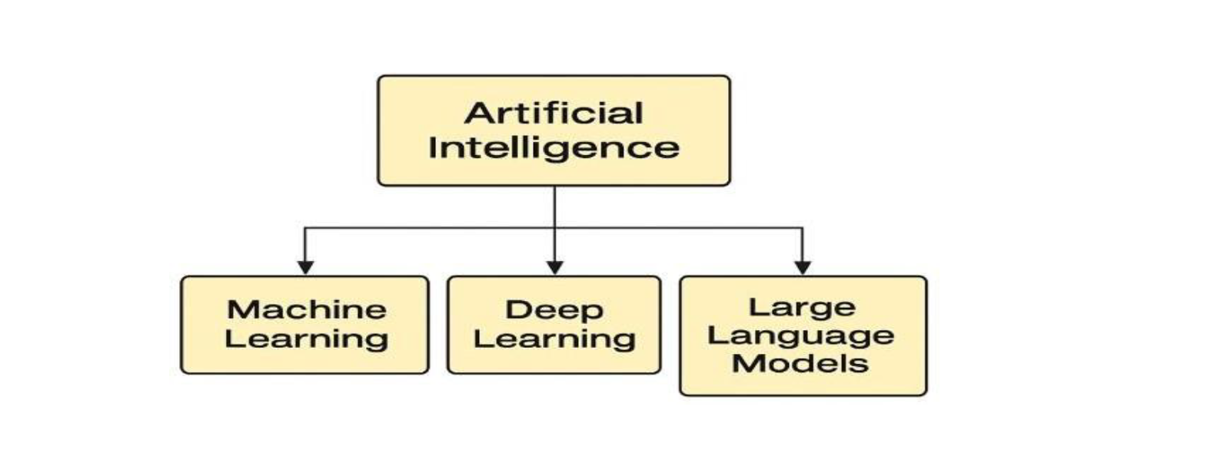

2.3 Machine Learning (ML) and Deep Learning Methods

ML allows computer programs to learn from the data and make predictions based on that data using algorithms without pre-programmed rules. ML applications in metro systems predict crowd behaviors based on analyzed historical and current data.

Deep Learning (DL) is an advanced method of ML involving the usage of multi-layered artificial neural networks able to extract more complicated features and patterns, especially related to images and video. DL techniques such as convolutional and recurrent neural networks are widely used to estimate crowd density and traffic flow.

This approach allows predicting rather than simply observing the crowd's behaviors.

2.5 Explainable AI and Decision Support

It should be noted that even though AI applications might be quite accurate, it is usually hard for people to understand why and how they work. To overcome this challenge, one can employ explainable AI (XAI).

With its help, it is possible to get insights into the reasons for making particular decisions in the processes of crowd detection and analysis.
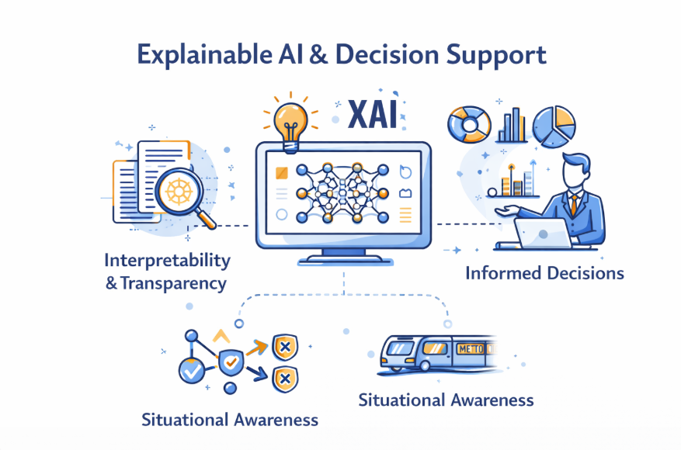

2. 6 Crowd Control Issues in Metro Stations

The metro environment is very complex and dynamic, hence making crowd control difficult. The large numbers of people at peak times, together with the small space available at the station and platforms, contribute to congestion. Incidents such as delays and emergencies create chaos and interrupt any usual pattern of movement. This is further hindered by the inefficiency of manual observation since the operator has to monitor several video streams.

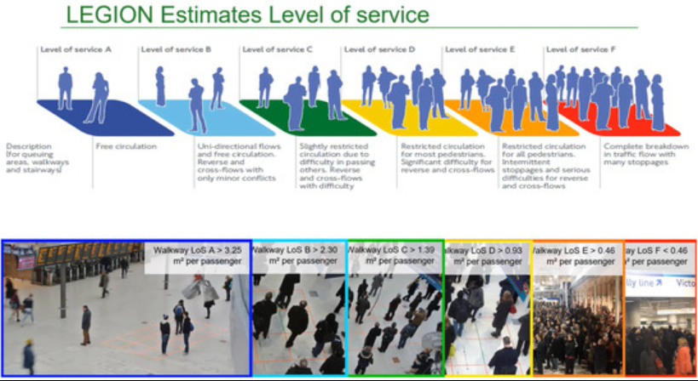

Summary Research Papers:

Paper 1: A Novel Method for Surveillance Video of Crowds on Railway Platforms (2013)
In this paper, the authors propose a technique for surveilling crowds of people on railway platforms by means of background modelling and perspective feature detection in images. The core contribution of the paper is showing how feasible the use of image processing methods for crowd estimation at a rail platform can be.
The paper is highly relevant to the research topic since it considers the rail platform monitoring issue; yet, it only utilizes traditional computer vision techniques that are not efficient when dealing with crowds

Paper 2: Multi-Column Atrous Convolutional Neural Network for Counting Metro Passengers (2020)
According to the paper, a multiple columns atrous CNN is proposed in order to handle varying scales in counting crowds for metro passengers. This paper makes an effort in showing the effectiveness of employing scale aware models in counting passengers in crowded metropolitan environments.
Although this paper is highly relevant due to its metro-centric approach, it is very narrow because it focuses solely on counting passengers without considering any other aspect of the problem.

Paper 3: Convolutional Neural Network for Crowd Counting on Metro Platforms (2021)
This paper proposes a particular methodology for the task of people enumeration on metro stations via CNNs. One of the key aspects addressed in the paper is the justification of the necessity to calibrate the system to account for different camera angles and crowd densities.
Relevance of the research can be attributed to particular applications in Riyadh Metro, although success would require certain conditions to be met.

Paper 4: A Deep Fusion Network for Crowd Counting in High-Density Crowd Scenes (2021)
In this paper, a novel deep fusion network is introduced utilizing the idea of multi-scale convolutional feature combination high density counting. It shows how the application of both shallow and deep visual features improves counting.
It has application in the scenario of metro station where counting is done in peak hours. However, it has nothing to do with railways and counting alone.
Paper 5: Crowd Meter Gauging Congestion in Railway Stations Using Smartphones (2019)
This paper examines an innovative way to measure congestion in railway stations through the use of smartphones. The main contribution of the paper consists of providing the reliability of crowd analysis when dealing with a limited participant.
The use of such an approach would complement CCTV and be beneficial for assessing crowd density and movement; however, it’s possible to rely solely on smartphones sensing.

Paper 6: Dynamic Flow Analysis and Crowd Management of Transfer Station, Suzhou Metro (2024)
In this study, dynamic flow analysis, aided with the help of CCTV video recordings, will be used to streamline passenger traffic at metro transfer stations. The main value of the research is to prove that improvements can be made to queue lengths, travel times, and crowd density.
The paper is very topical due to its practical approach; however, the study's specific context might be a drawback.

Paper 7: Crowding Prediction in Metro Systems Using Deep Learning (2024)
This paper makes use of clustered time series analysis and LSTMs to develop a prediction model of crowd levels based on transit demand data. The unique value of this paper lies in the integration of crowd-level prediction with passenger information system data to manage crowds.
While the model works well in prediction applications for metro systems, it cannot be applied in a setting where CCTV systems alone are used.
Paper 8: SIMCD – Simulated Crowd Data for Anomaly Detection and Prediction (2022)
This paper introduces a simulation technique that generates simulated data to detect anomalies within crowds, addressing the issue of the absence of data availability. The main strength of this paper lies in its ability to create complex scenarios, such as densely populated crowds and contra-flow crowds.
Simulated data can be useful when real data is not available; however, they do not always reflect the actual scenario completely.
Paper 9: An Overview of the Detection of Abnormal Crowd Behaviors (2024)
This study highlights algorithms used for detecting abnormal behavior among crowds. It emphasizes methods for real-time detection, prediction, and correction to enhance public safety.
The study will be instrumental in formulating an anomaly detection algorithm for this thesis work; nonetheless, no data exist on its implementation within metro stations.
Paper 10: Efficient Crowd Anomaly Detection by Sparse Feature Tracking and Neural Network Classification (2024)
The proposed algorithm for crowd anomalies detection is discussed in this paper. The main benefit offered by this algorithm is the low computational cost along with maintaining consistent tracking.
It can be used in the metro control room as an immediate alert system, but the technology was created for generic surveillance systems and requires testing on metro CCTV cameras.
Paper 11: Multimodal Video Analysis for Detecting Crowd Anomalies (2024)
In this paper, multimodal analysis is used for detecting anomalies in crowds through the use of time, motion, and contextual information in video footage. The significance of the paper lies in showing how the integration of multiple sources of information enhances detection.
Although it will be useful for developing CCTV analytics systems, it is not specific to the metro environment and should be validated in practice.

Paper 12: Video analytics by deep learning for crowd analysis: A review (2022)
This paper focuses on the use of deep learning techniques for crowd analysis and its related sub-problems such as crowd counting, density estimation, and abnormal crowd detection. The main contribution is that it sheds light on the difficulties encountered when using general models for analyzing very dense crowds.
The paper will be useful in providing background information for the current study but lacks practical application.

Paper 13: Enhancing Safety Management at Railway Stations via Simulation Based Digital Twin (2024)
In this paper, the authors propose an innovative digital twin concept where station information and predictions from crowds are combined to enhance safety management. The primary achievement of this paper is proving how simulation could provide early alerts, evacuation planning, and effective gate management.
The paper presents an effective link between analytics and operations, but stays more of a conceptual solution and is not yet ready for implementation

Paper 14: Recent Trends in Crowd Management by Deep Learning Techniques: A Systematic Literature Review (2024)
This paper systematically analyzes 45 papers related to the use of deep learning techniques in crowd management (from 2010 to 2023) and proves that supervised and unsupervised methods are equally efficient.
It can be especially useful for the Saudi Arabia case because it covers crowd events on a large scale (like Hajj), but not for metro operation conditions.

Paper 15: An Overview of Passenger Counting Techniques in Public Transport with Image Processing and Machine Learning (2024)
The current paper provides an overview of different passenger counting techniques employed in public transport systems. The core benefit of the paper is the revelation that the use of CCTV cameras together with machine learning can produce accurate results; however, this comes with higher hardware requirements and some privacy concerns.
The current paper is useful for implementation purposes; however, its general focus restricts its practical application to metro settings.

Synthesis of Key Points in Fifteen Papers Reviewed

From the papers analyzed in this review, it becomes obvious that the following trends prevail. Firstly, the transition from conventional computer vision technology to the use of deep learning techniques to tackle issues with handling dense crowds, occlusions, and different views is noticeable. Secondly, high-quality algorithms are necessary but not sufficient for practical application of the technique – the use of the technique also requires proper integration with the existing systems and decision-making tools. Thirdly, despite the progress made towards making anomaly detectors more efficient and multimodal, validation is still performed using generic datasets.
Moreover, it should be noted that video analytics cannot be used separately as a method for managing crowds. Complementary methods, such as the use of ticketing system information and smartphones, simulations, and others, should be employed alongside it to increase the efficiency and accuracy of predictions. Finally, the aspects of privacy and governance are less developed in this research than technical innovations in this area.
Overall, the review shows that a comprehensive approach combining CCTV analysis, predictive modeling, and anomaly detection should be implemented along with privacy policies and decision-making aids to manage crowds in metro effectively.

2.9 Comparative Analysis Table Among Papers

The following table offers a comparative analysis of the 15 analyzed papers based on different academic factors such as the purpose of the research, methodology, results, practicality, and limitations.

No | Year | Paper / Study | Primary Aim | Method | Key Result | Relevance to Riyadh Metro | Main Limitation
1 | 2013 | A novel approach for crowd video monitoring of subway platforms | Subway platform monitoring | Improved background modeling, weighted area features for platform video analysis | Early transit-focused work showing CCTV can estimate crowd conditions on subway platforms using perspective-aware features. | Directly relevant because it targets platform surveillance in rail traffic settings. | The classical vision pipeline is less robust than modern deep learning under severe density and occlusion.
2 | 2019 | Crowd Meter: Gauging congestion levels in railway stations using smartphones | Railway station congestion estimation | Participatory sensing using smartphones and contextual passenger behavior features | Show congestion can be inferred from location and activity patterns even with a limited number of active users. | Useful as a complementary data source beside CCTV for validating crowd states. | It depends on passenger device participation and is not purely CCTV-based.
3 | 2020 | Multi-Column Atrous Convolutional Neural Network for Counting Metro Passengers | Metro passenger counting | Atrous multi-column CNN tailored to metro passenger images | Demonstrate that scale-aware deep models can improve passenger counting in metro scenes with varying density. | Highly relevant to Riyadh Metro because it addresses metro-specific counting rather than generic crowd scenes. | Primarily counting-focused, limited discussion of deployment governance and system integration.
4 | 2021 | Convolutional Neural Network for Crowd Counting on Metro Platforms | Platform crowd counting | Specialized CNN trained on metro platform imagery | Reports improved counting accuracy on metro platform scenes and highlighted the importance of scene-specific calibration. | It is a very strong fit for Riyadh Metro platforms, where camera angles and density patterns vary by station. | Performance is sensitive to dataset quality, camera placement, and local calibration.
5 | 2021 | A Deep-Fusion Network for Crowd Counting in High-Density Crowd Scenes | High-density crowd counting | Deep fusion of multi-scale convolutional features into density maps | Improves dense-scene counting by efficiently combining shallow and deep visual features. | Applicable to peak-hour metro environments where dense platform scenes challenge basic detectors. | Not rail-specific and still focused on counting rather than broader operational decision support.
6 | 2022 | Video analytics using deep learning for crowd analysis: a review | Review of deep learning for crowd analysis | Literature review covering crowd counting, density estimation, and abnormal behavior detection | Synthesizes major deep learning approaches and highlights the challenge of adapting generic methods to highly dense religious and public-event settings. | Useful for positioning Riyadh Metro within the broader surveillance analytics literature. | Survey paper with no original experiment or metro deployment.
7 | 2022 | SIMCD: Simulated crowd data for anomaly detection and prediction | Synthetic datasets for anomaly detection | Mass Motion simulation used to generate crowd anomaly datasets and severity features | Addresses dataset scarcity by creating synthetic data for high-density and contraflow anomaly scenarios. | Real abnormal-event footage from metro stations must be rare, sensitive, or difficult to label. | Synthetic data may not fully capture the real-world noise, behavior, and environmental complexity observed in CCTV.
8 | 2024 | Improving safety management in railway stations through a simulation-based digital twin approach | Railway station safety and decision support | Simulation-based digital twin integrating station data and predictive crowd analysis | Shows digital twins can support early warnings, evacuation planning, and intelligent gate management in railway stations. | Very high, because it links analytics with operational intervention and management decisions. | Prototype-oriented and requires substantial interoperability and data engineering effort.
9 | 2024 | Recent trends in crowd management using deep learning techniques: a systematic literature review | Systematic review of DL crowd management | Review of 45 studies from 2010-2023 | Finds both supervised and unsupervised deep-learning methods effective, while identifying gaps in local and culturally specific crowd research. | Particularly relevant to the Saudi context, as it discusses Hajj and regional gaps in crowd management research. | Does not test methods directly in metro operations.
10 | 2024 | Dynamic flow analysis and crowd management for transfer stations: a case study of Suzhou Metro | Transfer station flow optimization | Dynamic flow analysis with CCTV-informed observations and intervention assessment | Reports reductions in maximum queue length, average time consumption, and average standing density under an improved management scheme. | Extremely relevant because it studies metro transfer stations and translates analysis into actionable operating strategies. | Case-study specificity may limit direct transfer without local calibration.
11 | 2024 | A Review of Passenger Counting in Public Transport Concepts with a Solution Proposal Based on Image Processing and Machine Learning | Passenger counting technologies | Comparative review of 43 APC studies across public transport modes | Concludes that CCTV, combined with machine learning, offers high accuracy but requires stronger hardware and careful privacy management. | Useful for implementation planning and technology trade-off analysis in metro operations. | Broad public-transport scope; not limited to metro stations.
12 | 2024 | A Review of Abnormal Crowd Behavior Recognition | Abnormal crowd behavior recognition | Review of computer-vision approaches for abnormal crowd behavior detection | Emphasizes real-time recognition, prediction, and intervention for public-safety risks in dense crowds. | Supports the anomaly-detection dimension of the Riyadh Metro framework. | Review article without station-specific implementation evidence.
13 | 2024 | Efficient Crowd Anomaly Detection Using Sparse Feature Tracking and Neural Networks | Efficient anomaly detection | Sparse local feature extraction + tracking + neural classification | Presents an efficiency-oriented anomaly detector designed to preserve consistent tracking while lowering computational burden. | Valuable for near-real-time monitoring where metro control rooms need fast alerts. | General surveillance context requires validation in metro CCTV environments.
14 | 2024 | Multimodal Video Analysis for Crowd Anomaly Detection | Multimodal anomaly detection | Time-series extraction from video with multimodal modeling for anomaly detection | Shows that combining multiple information streams can strengthen anomaly recognition beyond single-feature pipelines. | Helpful for designing richer CCTV analytics that combine motion, temporal, and contextual signals. | Not specific to metro stations and needs integration testing with operational workflows.
15 | 2024 | Deep-learning-based model for the prediction of crowding in a public transit system | Crowding prediction for transit information systems | Clustered time-series prediction using ticketing data and LSTM-based modeling | Integrates crowding prediction with passenger information to support route choice and proactive crowd management. | Important for moving from real-time detection to proactive forecasting in Riyadh Metro. | Rely on transit demand data rather than CCTV alone.

2.10 Comparison Based on Methodology Theme

The table below groups the articles based on their methodology in order to facilitate discussion regarding the literature.
Theme | Papers | What the literature shows | The gap remaining for this thesis
Counting and density estimation | Hu (2013), Zhang (2020), Zhang et al. (2021), Khan et al. (2021) | Deep learning improves counting accuracy in dense metro scenes and is more robust than classical vision pipelines. | Most studies stop at measurement and do not link counts to station decisions, governance, or operator workflows.
Congestion sensing and forecasting | Elhamshary et al. (2019), Zhang et al. (2024), Shrivastava et al. (2024) | Crowd states can be inferred and predicted using smartphone, station-flow, and ridership data, enabling proactive control. | Forecasting models are often outside CCTV pipelines and need integration with real-time station operations.
Anomaly detection | Bamaqa et al. (2022), Zhao et al. (2024), Altowairqi et al. (2024), Dionis-Ros et al. (2024) | Anomaly detection is essential for identifying unsafe patterns such as contraflow, panic, or abnormal congregation. | Few studies validate anomaly detection on real metro CCTV footage with operational thresholds and low false alarms.
Deployment and governance | Bhuiyan et al. (2022), Padovano et al. (2024), Alasmari et al. (2024), Radovan et al. (2024) | Implementation requires architecture, privacy compliance, infrastructure sizing, and human-centered decision support. | The literature still under-explains practical governance in public metro environments, especially in regional contexts.

Data Sources

1. CCTV video

2. AFC data and sensors: For validating passenger

3. Operational data: Incident data and dwell time.

References
Hu, X., Zheng, H., Wang, W., & Li, X. (2013). A novel approach for crowd video monitoring of subway platforms. Optik, 124(22), 5301-5306.

Elhamshary, M., Youssef, M., Uchiyama, A., Yamaguchi, H., Higashino, T., & others. (2019). Crowd Meter: Gauging congestion levels in railway stations using smartphones.

Zhang, J., Zhu, G., & Wang, Z. J. S. (2020). Multi-Column Atrous Convolutional Neural Network for Counting Metro Passengers. Symmetry, 12, 682.

Zhang, J., et al. (2021). Convolutional Neural Network for Crowd Counting on Metro Platforms. Symmetry, 13(4), 703.

Khan, S. D., Ullah, H., & others. (2021). A Deep-Fusion Network for Crowd Counting in High-Density Crowd Scenes.

Bhuiyan, M. R., et al. (2022). Video analytics use deep learning for crowd analysis: a review. Multimedia Tools and Applications.

Bamaqa, A., et al. (2022). SIMCD: Simulated crowd data for anomaly detection and prediction. Expert Systems with Applications.

Padovano, A., Longo, F., Manca, L., & Grugni, R. (2024). Improving safety management in railway stations through a simulation-based digital twin approach. Computers & Industrial Engineering, 187, 109839.

Alasmari, A. M., Farooqi, N. S., & Alotaibi, Y. A. (2024). Recent trends in crowd management using deep learning techniques: a systematic literature review. Journal of Umm Al-Qura University for Engineering and Architecture, 15, 355-383.

Zhang, J., Ai, Q., Ye, Y., & Deng, S. (2024). Dynamic flow analysis and crowd management for transfer stations: a case study of Suzhou Metro. Public Transport, 16(2), 619-653.

Radovan, A., Mršić, L., Đambić, G., & Mihaljević, B. (2024). A Review of Passenger Counting in Public Transport Concepts with Solution Proposal Based on Image Processing and Machine Learning. Eng, 5(4), 3284-3315.

Zhao, R., et al. (2024). A Review of Abnormal Crowd Behavior Recognition. Applied Sciences, 14(21), 9758.

Altowairqi, S., et al. (2024). Efficient Crowd Anomaly Detection Using Sparse Feature Tracking and Neural Networks. Applied Sciences, 14(9), 3928.
Dionis-Ros, A., et al. (2024). Multimodal Video Analysis for Crowd Anomaly Detection. Applied Sciences, 14(23), 11075.

Shrivastava, A., Rawat, N., & Agarwal, A. (2024). Deep-learning-based model for the prediction of crowding in a public transit system. Public Transport, 16, 449-484.

